Review Article

Nano-Fertilizers for Sustainable Agriculture: Advances and Future Trajectories

Abstract
The rapid evolution of nano-fertilizers marks a paradigm shift in sustainable agriculture, offering innovative solutions to enhance nutrient use efficiency, crop productivity, and environmental stewardship. Unlike conventional fertilizers, nano-fertilizers are made with very tiny particles and are designed to release nutrients slowly and exactly when plants need them. This means plants get more of the nutrients, and less is wasted. Recent types of nano-fertilizers, like nano-NPK and nano-micronutrients, have shown that they help plants absorb nutrients better, grow stronger roots, and handle stress better. This has led to bigger harvests for important crops like wheat, maize, potatoes, and rice. Nano-fertilizers also help reduce pollution, use resources more efficiently, and improve soil health and helpful bacteria in the soil. These benefits are complemented by reduced environmental pollution, optimized resource utilization, and positive impacts on soil health and microbial activity. Nano-fertilizers thus directly support several United Nations Sustainable Development Goals (SDGs), including zero hunger, climate action, and responsible consumption and production. This review looks at the latest progress in nano-fertilizers, what might happen in the future, and how they fit with global sustainability goals. It also points out that while nano-fertilizers have great potential, we need good rules and research from many fields to use them safely and effectively.
Key words: Nano-fertilizers, Sustainable agriculture, Nutrient efficiency, Environmental impact, Sustainable Development Goals (SDGs)
- Introduction
“Nano-fertilizers represent a significant breakthrough in agricultural technology, leveraging nanotechnology to improve nutrient delivery, uptake efficiency, and environmental sustainability in crop production” (Shang et al., 2019; Liu & Lal, 2015). “By encapsulating essential nutrients within nanomaterials, these advanced fertilizers enable controlled and targeted nutrient release directly to plant roots, markedly reducing nutrient losses from leaching, volatilization, and runoff compared to conventional fertilizers” (DeRosa et al., 2010; Kalia & Sharma, 2020). This precision not only enhances crop nutrient use efficiency but also helps mitigate environmental issues such as waterway eutrophication and soil contamination commonly associated with traditional fertilization practices (Sekhon, 2014). “ However, despite these promising advantages, the widespread adoption of nano-fertilizers in mainstream agriculture is challenged by concerns regarding scalability, long-term safety, and the need for comprehensive regulatory frameworks” (Selvarani et al., 2025). “Using nano-fertilizers supports several United Nations Sustainable Development Goals, especially Zero Hunger (SDG 2), Good health and Well-being (SDG 3), Clean Water and Sanitation (SDG 6), Responsible consumption and Production (SDG 12), Climate Action (SDG 13), and Life on Land (SDG 15). Nano-fertilizers help plants use nutrients more efficiently and increase crop yields, which improves food security and reduces harm to the environment” (Parisi et al., 2015; Prasad et al., 2017). Because they can be applied in smaller amounts and deliver nutrients directly to plant roots, nano-fertilizers also help lower greenhouse gas emissions and keep soil healthy, making farming more sustainable and better for the climate (Lal, 2021).
Even though nano-fertilizers have great potential, using them widely in farming still faces some problems. For example, Nitrogen is vital for life on Earth, but too much of it becomes a harmful pollutant. It is contaminating water, plants, animals, and humans, and also contributes to climate change by releasing the powerful greenhouse gas nitrous oxide (https://www.unep.org/news-and-stories/story/fertilizers-challenges-and-solutions). These include making them on a large scale, making sure they are safe to use for a long time and creating clear rules for their use (Kah et al., 2018). There are also worries about whether the tiny particles in nano-fertilizers might be harmful, how long they stay in the environment, and how they affect the helpful microbes in the soil. More research is needed to make sure nano-fertilizers can be used safely and effectively (Fraceto et al., 2016). Still, nano-fertilizers could help increase food production while also protecting the planet. This shows why it is important to keep improving these fertilizers and to use them responsibly.
This peer review article discusses the following goals:
- To give an overview of nano particle synthesis and the latest progress in how nano-fertilizers are made and used in sustainable farming.
- To carefully compare how nano-fertilizers and regular fertilizers affect the use of nutrients, crop yields, and the environment.
- To point out the current challenges, such as safety, large-scale use, rules and regulations, and possible risks to health and the environment.
- Current status in Nano-Fertilizers for Sustainable Agriculture
According to Kah et al., (2018) a rigorous comparison of nanoagrochemicals with conventional equivalents is required to assess the associated benefits and dangers. Kah et al., 2018 recent critically examined the literature and discussed how nanoagrochemicals differ from traditional products. Our review of 78 published publications found that the median gain in efficacy relative to traditional products is approximately 20-30%. Nutrient runoff from farms using synthetic fertilizers has negatively impacted land ecosystems, according to the United Nations-supported Intergovernmental Science-Policy Platform on Biodiversity and Ecosystem Services (IPBES) (https://www.unep.org/news-and-stories/story/fertilizers-challenges-and-solutions).
“Nano-fertilizers represent a transformative innovation in sustainable agriculture, offering enhanced nutrient delivery, improved crop yields, and reduced environmental impact. Recent advances have helped scientists make many new types of tiny fertilizer particles, called nano-fertilizers. These include: nano-NPK (nitrogen, phosphorus, potassium), nano-nitrogen, nano-phosphorus, nano-potassium, nano-iron, hydroxyapatite (HAP)-modified urea nanoparticles, nano-zeolite composites, and nano-chelated micronutrients” (Eyasu et al., 2025).

  - Synthesis of Nano Fertilizer
Nanoparticles can be synthesised through various methods (Fig.1) but biological synthesis method ensures ecofriendly.
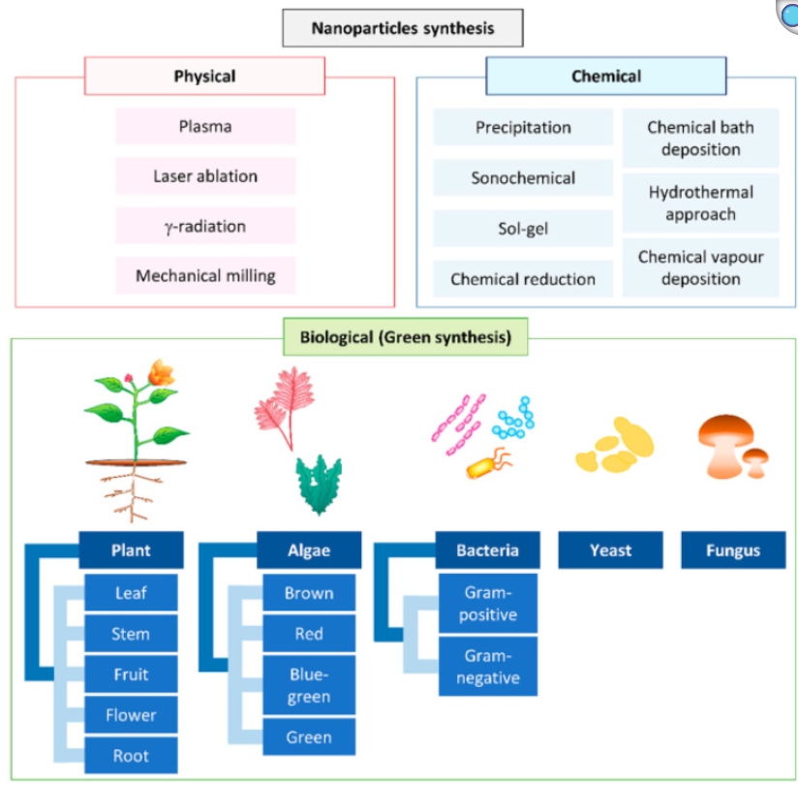
Fig 1. Different approaches used for nanoparticle synthesis. Source: Alsaiari et al., 2023.

    - Green Synthesis Using Plant Extracts and Microorganisms
Microbe-assisted synthesis (e.g., using bacteria or fungi) and plant extract-based synthesis are gaining traction for producing biocompatible and non-toxic nano-fertilizers. These methods often utilize polysaccharides, proteins, or organic acids as reducing and stabilizing agents.
Table 1. Case studies on green synthesis
Case Study | Biological Source | Nanoparticle | Key Findings | Reference
Pistacia atlantica | Plant extract (leaf & fruit) | AuNPs | Antibacterial, antioxidant, non-cytotoxic | Antunes Filho et al.,2023
Tectona grandis | Plant extract (seeds) | AgNPs | Antimicrobial activity, cell permeability disruption | Rautela et al., 2019
Musa balbisiana, A. indica. O. tenuiflorum | Plant leaf extracts | AgNPs | Safe, antimicrobial, eco-friendly | Banerjee et al., 2014
Diospyros lotus | Plant extract (leaves) | AgNPs | Antibacterial, catalytic activity | Alsaiari et al., 2023
Lactobacillus plantarum, L. brevis | Lactic acid bacteria | AgNPs | Strong against Gram-negative bacteria | Syame et al., 2020.
Enterobacter cloacae | Bacteria | ZnO NPs | Green zinc oxide NP synthesis | Shabani et al., 2024
    - Sol-Gel and Hybrid Nanostructures: In-situ sol-gel synthesis is used to create hybrid materials, such as humic acid-silica hybrids, which combine organic and inorganic components for improved stability and functionality in aqueous environments. Modified sol-gel methods are used to synthesize urea-silica nanohybrids, allowing urea (a major nitrogen fertilizer) to be gradually released. Such nanohybrids have demonstrated a significantly slower, sustained release of urea compared to commercial granular urea, reducing leaching and improving nitrogen availability to plants. This technology offers potential for more efficient fertilizer application and reduced environmental impact. Living agricultural microorganisms can be encapsulated in hybrid sol-gel matrices to protect them and deliver them effectively to fields. These systems are used in biotechnology and agriculture for improved biofertilizers and biopesticides. (Madhavi et al.,2020).

    - Polymer-Based Nanoformulations: Biodegradable polymers like chitosan, polylactide, and cellulose are employed to encapsulate nutrients, iopolymeric nanoparticles derived from natural polymers such as chitosan, alginate, cellulose, and pectin are developed to encapsulate and control the release of fertilizers, pesticides, and herbicides. These nanoformulations improve the solubility and targeted delivery of agrochemicals, reducing toxicity and environmental contamination while increasing efficacy. Chitosan-based nanoparticles encapsulating pesticides have shown enhanced plant protection and growth promotion by improving bioavailability and reducing harmful effects. (Shakiba et al., 2020).
    - Humic Acid-Nano-Hydroxyapatite (HA-HAP) Hybrids: These hybrids combine the nutrient-holding capacity of hydroxyapatite with the soil conditioning properties of humic acids, resulting in slow nutrient release and improved soil health. A novel biocompatible nanofertilizer combining humic substances and hydroxyapatite nanoparticles was developed by self-assembling natural or synthetic humic substances with nano-hydroxyapatite via a simple dipping process. This HA-HAP nanofertilizer was tested on maize (Zea mays) and showed significant improvements in early plant growth, productivity, stimulation of rhizosphere bacteria growth, and resistance to salt-induced abiotic stresses compared to commercial fertilizers and bare hydroxyapatite nanoparticles. The synergistic effect comes from the co-release of phosphate ions (from hydroxyapatite) and humic substances, which act as plant nutrients and stimulants, respectively. The amount of humic substances adsorbed can tune the nutrient release pattern. Under salt stress, maize treated with HA-HAP maintained better plant health, chlorophyll content, and growth metrics than controls, highlighting enhanced abiotic stress tolerance linked to humic acid presence. This multifunctional nanofertilizer combines nutrient delivery, plant growth stimulation, and microbial rhizosphere enhancement via a scalable, environmentally benign synthesis procedure, promising for large-scale agricultural use (Yoon et al., 2020).
    - Chitosan-NPK Nanostructures
Chitosan is used as a carrier for NPK (nitrogen, phosphorus, potassium) nutrients, enabling slow release and reducing synthetic fertilizer use. Chitosan nanoparticles (ChNPs) can be used as carriers for controlled release of fertilizers like nitrogen, phosphorus, and potassium (NPK). For example, Abdel-Aziz et al. (2018) studied the foliar application of Chitosan-NPK nanoparticles on wheat seedlings. The nanoparticles were quickly taken up through stomata and transported via phloem tissue, leading to significant improvement in wheat yield parameters such as plant height, spike weight, and crop yield compared to controls using conventional bulk NPK fertilizers. Chitosan-based nanofertilizers improved wheat yield where the Chitosan-polymethacrylic acid-NPK nanoparticles showed better plant height, spike weight, and harvesting index than bulk NPK fertilizers at equivalent nutrient levels.

    - Microbe-Assisted Nanofertilizers
Enterococcus-based silver nanoparticles (SR9AgNPs) have demonstrated improved germination and biomass gain in wheat, with no apparent toxicity at tested concentrations. Upadhyay et al.,2024 conducted a field study on wheat and maize at the Indian Agricultural Research Institute explored the combined use of nano nitrogen (nano-urea) and nano zinc fertilizers along with conventional fertilizers. This approach maintained or improved soil microbial biomass carbon and microbial community diversity, especially boosting beneficial groups like Actinobacteria and Proteobacteria. Crop yields improved, and nitrogen fertilizer use could be reduced by up to 25% with nano-fertilizer inclusion, demonstrating sustainable nutrient management linked to enhanced soil microbial health. Bionanofertilizers—nanoparticles combined with biofertilizers—show great promise in enhancing agricultural productivity. Several studies have illustrated that microbes such as Pseudomonas aeruginosa and Trichoderma sp. delivered with nanocarriers improve plant seed germination, growth, nutrient uptake, and stress tolerance. For example, in Zea mays (maize), the application of nano-Zn combined with biofertilizer improved grain yield by 1.5 to 2 times. In Vigna radiata, growth and survival were enhanced using nanostructured NPK fertilizers combined with beneficial microbes (Arora et al., 2024).

  - Application and Impact in Agriculture
2.2.1. Enhanced Nutrient Delivery: Nano-fertilizers are engineered for controlled and targeted nutrient delivery, allowing deeper soil penetration and more efficient plant absorption compared to conventional fertilizers (ShivamKumar et al., 2025). Case study by Zhang et al.,2018. utilized an anion-responsive nanofertilizer based on hollow mesoporous carbon nanoparticles modified with polyethylenimine to deliver selenium in a controlled manner. This targeted nutrient delivery approach increased selenium utilization efficiency, resulting in a 60% increase in plant growth without nutrient loss. The study of Saurabh et al.,2024 evaluated the impact of integrating nanofertilizers, specifically nano-urea, with conventional fertilizers on rainfed maize production. Soil application combined with foliar sprays of nano-urea was shown to significantly improve nutrient uptake, plant growth, and crop yield while reducing environmental impacts. Applying 75% of the recommended nitrogen dose with two foliar sprays of nano-urea produced grain yields comparable to 100% nitrogen application using conventional fertilizers. This approach led to a 25% reduction in nitrogen fertilizer use without yield loss, promoting efficient nutrient use. Nano-urea enhanced nitrogen uptake through controlled and sustained release, improving biomass accumulation and photosynthetic activity. Environmental benefits included a 25% reduction in greenhouse gas emissions and improved energy use efficiency.
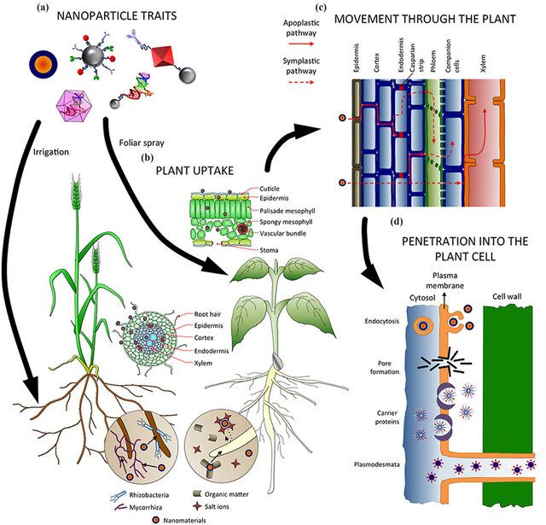
Fig.2. Effect of different factors on absorption, uptake, transport and penetration of nanoparticles in plants. (a) Nanoparticle traits affect how they are uptaken and translocated in the plant, as well as the application method. (b) In the soil, nanoparticles can interact with microorganisms and compounds, which might facilitate or hamper their absorption. Several tissues (epidermis, endodermis…) and barriers (Casparian strip, cuticle…) must be crossed before reaching the vascular tissues, depending on the entry point (roots or leaves). (c) Nanomaterials can follow the apoplastic and/or the symplastic pathways for moving up and down the plant, and radial movement for changing from one pathway to the other. (d) Several mechanisms have been proposed for the internalization of nanoparticles inside the cells, such as endocytosis, pore formation, mediated by carrier proteins, and through plasmodesmata. Reproduced from Pérez-de-Luque (https://www.frontiersin.org/journals/environmental-science/articles/10.3389/fenvs.2017.00012/full)

2.2.2. Improved Crop Yields
The growing global need for agricultural products has caused farmers to use too many traditional fertilizers. This has led to pollution, damage to soil and water, and health problems for people. Globalization has made these problems worse, so there is a need for better and more sustainable farming methods. Nanotechnology offers a new way to improve how nutrients are delivered to plants while reducing harm to the environment. Application of nano-fertilizers has led to significant yield improvements in major crops:
Wheat: 20–55% yield increase
Potato: 20–35% yield increase
Maize: 20–40% yield increase
Rice: 13–25% yield increase (Goyal et al., 2025)
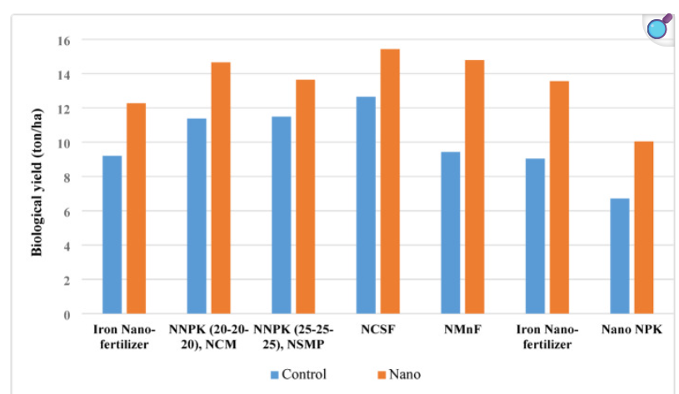
Fig 3- Biological yield of wheat plants treated with various nano-fertilizers (in ton/ha) Source: (Goyal et al., 2025).
Report showed that wheat plants treated with nano-fertilizers grew taller than the plants that were not treated (control group) (Fig 3). The nano-fertilized plants were consistently taller during the entire growth period. This means that using nano-fertilizers help the plants grow better, probably because the plants can absorb and use nutrients more efficiently (Goyal et al., 2025).
2.2.3. Plant Growth and Metabolism
Nano-fertilizers accelerate seed germination, seedling development, photosynthetic activity, and the synthesis of carbohydrates and proteins, resulting in healthier, more robust plants (Shivam Kumar et al.,2025). Using nano fertilizers in sustainable farming can help increase crop yields and protect the environment. They reduce the loss of nutrients through runoff and leaching, which lowers pollution. Nano fertilizers help plants use nutrients more effectively and reduce harmful effects on the environment. Because of this, nano fertilizers are very important for developing better and more sustainable farming methods in the future.
3. Integration with Biofertilizers: Nano-Biofertilizers
  - Synergistic Effects
Combining nanoparticles with biofertilizers (nano-biofertilizers) enhances plant growth, nutrient uptake, and stress tolerance under both biotic and abiotic stresses. Using nanoparticles together with biofertilizers helps plants grow stronger and tolerate stress better. When combined, they form a new tool called nano-biofertilizers (NBF), which is more affordable, eco-friendly, and useful for farming. These NBFs are made by coating tiny particles of minerals like silicon, zinc, copper, iron, nickel, titanium, and silver, along with natural materials such as chitosan, cellulose, and starch. This helps avoid pollution caused by regular fertilizers. Although NBFs are still new in farming, they have great potential to change traditional farming into smarter and better methods (Sharma et al. 2022).

  - Microbial Encapsulation
Encapsulation of beneficial microbes with nanoparticles improves their survival, colonization, and efficacy in the rhizosphere, further boosting nutrient cycling and plant health (Kannikka et al., 2024). a biofertilizer is ideally defined as a beneficial strain(s) of microorganism(s) that generates plant growth promoting properties, can be included in a carrier, and possess nutrient storage and release properties specified by the producer and can be readily applied to the soil or the plant (Malusá et al., 2012). Looking at the advantages, biofertilizers are now considered as fundamental to modern agriculture because of its low cost, renewable and eco-friendly nature.
  - Sustainability: Nano-biofertilizers offer a promising, long-lasting, and versatile solution for precision and smart agriculture, addressing the limitations of both conventional fertilizers and standalone nanomaterials6.
  - Critical Assessment: Impact of Nano-Fertilizers vs. Conventional Fertilizers
Nutrient Use Efficiency (NUE)
- Nano-fertilizers:
  - Exhibit a significantly higher surface area and improved solubility, allowing for better contact and interaction with plant roots (Demeke et al., 2025)
  - Enable controlled and targeted nutrient release, reducing losses from leaching and volatilization, and synchronizing nutrient availability with plant demand.
  - Studies show that nano-fertilizers lead to more efficient absorption and utilization of nutrients, resulting in higher NUE compared to conventional fertilizers.
  - For example, products like NanoCote™ Core demonstrated improved nitrogen stabilization, reducing nitrogen loss to 5.8% compared to 15.1% for standard urea after 36 hours (Brooke Rosqvist, 2023 https://www.nano-yield.com/nanocote-core-compared-to-conventional-fertilizers-alone)
Sharma et al. 2023 reported that Integrating nanoparticles with biofertilizers to create nano-biofertilizers (NBF) presents a promising approach to safeguarding global food security amid the rising population. The combined application of nanoparticles and biofertilizers enhances plant growth and stress resilience. As a hybrid technology, NBFs offer a more economically viable, environmentally sustainable, versatile, and long-lasting agricultural solution. The microbe-mediated green synthesis of NBFs involves encapsulating inorganic nanoparticles such as silicon, zinc, copper, iron, nickel, titanium, and silver, alongside organic materials like chitosan, cellulose, and starch. This formulation helps overcome the limitations and contamination issues of conventional fertilizers. Although the use of NBFs in agriculture is still in its early stages, its potential for sustainable farming is increasingly recognized.
Conventional fertilizers:
  - Often suffer from low NUE due to immediate nutrient release, which leads to significant losses via leaching, runoff, and volatilization.
  - A large fraction of applied nutrients is not absorbed by plants, contributing to inefficiency and environmental pollution.
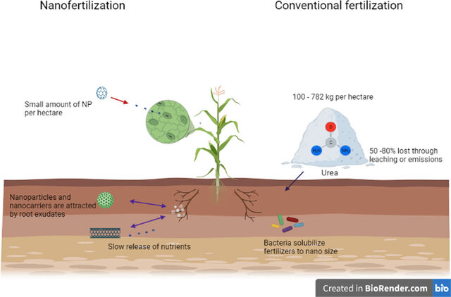
Fig.4. Nanofertilizers versus conventional fertilizers (Avila Quezada et al., 2022)
Conclusion
The article concludes that nano-fertilizers represent a major advancement in sustainable agriculture by improving nutrient use efficiency, boosting crop yields, and reducing environmental harm compared to conventional fertilizers. Nano-fertilizers deliver nutrients more precisely and slowly, which helps plants absorb them better and reduces nutrient loss through leaching and runoff, protecting soil and water quality. They have shown significant yield increases in key crops like wheat, maize, potatoes, and rice, while also supporting soil health and beneficial microbes. Combining nano-fertilizers with biofertilizers to form nano-biofertilizers further enhances plant growth, stress tolerance, and sustainable farming practices. However, challenges remain, including large-scale production, long-term safety, environmental impact, and regulatory guidelines. Continued research and careful management are necessary to realize their full potential for global food security and environmental sustainability.
Declaration of Competing Interest
The other authors declare no competing financial or personal interest.
Data availability
Data and images were described with original source.
Disclaimer (Artificial intelligence)
Option 2:
Author(s) hereby declare that Perplexity AI has been used during the writing and editing of this manuscript. The technology was utilized for tasks such as content refinement, structuring, summarization and enhancement of technical descriptions.
Details of the AI usage are given below:
1. Perplexity AI

References
[1] Shang, Y., Hasan, M. K., Ahammed, G. J., Li, M., Yin, H., & Zhou, J. (2019). Applications of nanotechnology in plant growth and crop protection: A review. Molecules, 24(14), 2558.
[2] Liu, R., & Lal, R. (2015). Potentials of engineered nanoparticles as fertilizers for increasing agronomic productions. Science of the Total Environment, 514, 131-139.
[3] DeRosa, M. C., Monreal, C., Schnitzer, M., Walsh, R., & Sultan, Y. (2010). Nanotechnology in fertilizers. Nature Nanotechnology, 5(2), 91.
[4] Kalia, A., & Sharma, S. (2020). Nanotechnology: A tool for sustainable agriculture. Journal of Applied and Natural Science, 12(4), 625-634.
[5] Sekhon, B. S. (2014). Nanotechnology in agri-food production: An overview. Nanotechnology, Science and Applications, 7, 31-53.
[6] Selvarani, K., Theivasanthi, T., & Ajitha, M. (2025). Nanotechnology in Agriculture: Enhancing Seed Quality, Yield and Contribution to Sustainable Development Goals (SDGs). Journal of Advances in Biology & Biotechnology, 28(1), 22–30. https://doi.org/10.9734/jabb/2025/v28i11857
[7] Parisi, C., Vigani, M., & Rodríguez-Cerezo, E. (2015). Agricultural nanotechnologies: What are the current possibilities? Nano Today, 10(2), 124-127.
[8] Prasad, R., Bhattacharyya, A., & Nguyen, Q. D. (2017). Nanotechnology in sustainable agriculture: Recent developments, challenges, and perspectives. Frontiers in Microbiology, 8, 1014.
[9] Lal, R. (2021). Sustainable intensification of food production on agricultural land in the United States. Journal of Environmental Quality, 50(1), 1-23.
[10] Kah, M., Kookana, R. S., Gogos, A., & Bucheli, T. D. (2018). A critical evaluation of nanopesticides and nanofertilizers against their conventional analogues. Nature Nanotechnology, 13(8), 677-684.
[11] Fraceto, L. F., Grillo, R., de Medeiros, G. A., Scognamiglio, V., Rea, G., & Bartolucci, C. (2016). Nanotechnology in agriculture: Which innovation potential does it have? Frontiers in Environmental Science, 4, 20.
[12] Eyasu Derbew Demeke, Natei Ermias Benti, Mintesnot Gizaw Terefe , Teshome Taye Anbessa , Wondimagegne Mamo Mengistu and Yedilfana Setarge Mekonnen. (2025) A comprehensive review on nano-fertilizers: preparation, development, utilization, and prospects for sustainable agriculture in Ethiopia. Nanoscale Advances 7, 2131-2144. DOI: 10.1039/D4NA01068J
[13] Alsaiari NS, Alzahrani FM, Amari A, Osman H, Harharah HN, Elboughdiri N, Tahoon MA. (2023) Plant and Microbial Approaches as Green Methods for the Synthesis of Nanomaterials: Synthesis, Applications, and Future Perspectives. Molecules. Jan 3;28(1):463. doi: 10.3390/molecules28010463.
[14] Antunes Filho S, Dos Santos MS, Dos Santos OAL, Backx BP, Soran ML, Opriş O, Lung I, Stegarescu A, Bououdina M. 2023. Biosynthesis of Nanoparticles Using Plant Extracts and Essential Oils. Molecules. Mar 29;28(7):3060. doi: 10.3390/molecules28073060.
[15] Rautela, A., Rani, J. & Debnath (Das), M. (2019) Green synthesis of silver nanoparticles from Tectona grandis seeds extract: characterization and mechanism of antimicrobial action on different microorganisms. J Anal Sci Technol 10, 5 . https://doi.org/10.1186/s40543-018-0163-z
[16] Banerjee, P., Satapathy, M., Mukhopahayay, A. et al. 2014. Leaf extract mediated green synthesis of silver nanoparticles from widely available Indian plants: synthesis, characterization, antimicrobial property and toxicity analysis. Bioresour. Bioprocess. 1, 3. https://doi.org/10.1186/s40643-014-0003-y.
[17] Syame SM, Mansour AS, Khalaf DD, Ibrahim ES and Gaber ES (2020). Green Synthesis of Silver Nanoparticles Using Lactic Acid Bacteria: Assessment of Antimicrobial Activity. World Vet. J., 10 (4): 625-633. DOI: https://dx.doi.org/10.54203/scil.2020.wvj75.
[18] Shabani, M.H., Jafari, A., Manteghian, M. et al. (2024) Green synthesis of zinc oxide nanoparticles using Enterobacter cloacae microorganism and their application in enhanced oil recovery. Sci Rep 14, 29409. https://doi.org/10.1038/s41598-024-80819-y
[19] Madhavi de Silva, Dumindu P. Siriwardena, Chanaka Sandaruwan, Gayan Priyadarshana, Veranja Karunaratne, Nilwala Kottegoda(202).Urea-silica nanohybrids with potential applications for slow and precise release of nitrogen,Materials Letters, Volume 272,2020,127839,ISSN 0167-577X,https://doi.org/10.1016/j.matlet.2020.127839.
[20] Shakiba, S., Astete, C. E., Paudel, S., Sabliov, C. M., Rodrigues, D. F., & Louie, S. M. (2020). Emerging investigator series: polymeric nanocarriers for agricultural applications: synthesis, characterization, and environmental and biological interactions. Environmental Science: Nano, 7(1), 24-72. https://doi.org/10.1039/c9en01127g
[21] Yoon, H. Y., Lee, J. G., Degli Esposti, L., Iafisco, M., Kim, P. J., Shin, S. G., Jeon, J.-R., & Adamiano, A. (2020). Synergistic release of crop nutrients and stimulants from hydroxyapatite nanoparticles functionalized with humic substances: Toward a multifunctional nanofertilizer. ACS Omega, 5(22), 12784–12793. https://doi.org/10.1021/acsomega.0c01205
[22] Abdel-Aziz, H. M. M., Hasaneen, M. N. A., & Omer, A. M. (2016). Nano chitosan–NPK fertilizer enhances the growth and productivity of wheat plants grown in sandy soil. Spanish Journal of Agricultural Research, 14(1), e0902. https://doi.org/10.5424/sjar/2016141-8205
[23] Upadhyay, P.K., Dey, A., Singh, V.K. et al. (2024) Changes in microbial community structure and yield responses with the use of nano-fertilizers of nitrogen and zinc in wheat–maize system. Sci Rep 14, 1100. https://doi.org/10.1038/s41598-023-48951-3.
[24] Arora, P.K., Tripathi, S., Omar, R.A. et al. Next-generation fertilizers: the impact of bionanofertilizers on sustainable agriculture. Microb Cell Fact 23, 254 (2024). https://doi.org/10.1186/s12934-024-02528-5
[25] ShivamKumar, Yagyavalkya Sharma, Vishal Khandelwal, Kalpana Rawat, Anjali Patil,2025. Applications of nanotechnology in fertilizers: A review study, Sustainable Chemistry for the Environment, Volume 10, 100247,ISSN 2949-8392, https://doi.org/10.1016/j.scenv.2025.100247.
[26] Zhang, G., Zhou, L., Cai, D., & Wu, Z. (2018). Anion-responsive carbon nanosystem for controlling selenium fertilizer release and improving selenium utilization efficiency in vegetables. Carbon, 129, 687-695. https://doi.org/10.1016/j.carbon.2017.12.057
[27] Saurabh, K., Prakash, V., Dubey, A.K. et al. Enhancing sustainability in agriculture with nanofertilizers. Discov Appl Sci 6, 559 (2024). https://doi.org/10.1007/s42452-024-06267-5.
[28] Goyal A, Chavan SS, Mohite RA, Shaikh IA, Chendake Y, Mohite DD. Emerging trends and perspectives on nano-fertilizers for sustainable agriculture. Discov Nano. 2025 Jun 20;20(1):97. doi: 10.1186/s11671-025-04286-8. PMID: 40540087; PMCID: PMC12181588.
[29] Shivam Kumar, Yagyavalkya Sharma, Vishal Khandelwal, Kalpana Rawat, Anjali Patil.2025. Applications of nanotechnology in fertilizers: A review study, Sustainable Chemistry for the Environment, Volume 10, 100247, https://doi.org/10.1016/j.scenv.2025.100247.
[30] Sharma B, Tiwari S, Kumawat KC, Cardinale M. 2023. Nano-biofertilizers as bio-emerging strategies for sustainable agriculture development: Potentiality and their limitations. Sci Total Environ.20;860:160476. doi: 10.1016/j.scitotenv.2022.160476. Epub 2022 Nov 24. PMID: 36436627.
[31] Kannikka Behl, Pranita Jaiswal, Sunil Pabbi. 2024. Recent advances in microbial and nano-formulations for effective delivery and agriculture sustainability, Biocatalysis and Agricultural Biotechnology, Volume 58,103180, https://doi.org/10.1016/j.bcab.2024.103180.
[32] Malusá E, Sas-Paszt L, Ciesielska J. 2012. Technologies for beneficial microorganisms inocula used as biofertilizers. ScientificWorldJournal.:491206. doi: 10.1100/2012/491206.
[33] Demeke, Eyasu Derbew and Benti, Natei Ermias and Terefe, Mintesnot Gizaw and Anbessa, Teshome Taye and Mengistu, Wondimagegne Mamo and Mekonnen, Yedilfana Setarge", 2025. A comprehensive review on nano-fertilizers: preparation{,} development{,} utilization{,} and prospects for sustainable agriculture in Ethiopia. Nanoscale Adv. 7.(8).2131-2144. doi =10.1039/D4NA01068j .
[34] Avila Quezada, G., Ingle, A., Golinska, P., & Rai, M. (2022). Strategic applications of nano-fertilizers for sustainable agriculture: Benefits and bottlenecks. Nanotechnology Reviews, 11(1), 2123-2140. https://doi.org/10.1515/ntrev-2022-0126
[35] Sharma B, Tiwari S, Kumawat KC, Cardinale M.(2023) Nano-biofertilizers as bio-emerging strategies for sustainable agriculture development: Potentiality and their limitations. Sci Total Environ. 2023 Feb 20;860:160476. doi: 10.1016/j.scitotenv.2022.160476.
[36] Abdel-Aziz, H. M. M., Hasaneen, M. N. A., & Omar, A. (2018). Effect of foliar application of nano chitosan NPK fertilizer on the chemical composition of wheat grains. Egyptian Journal of Botany. https://doi.org/10.21608/ejbo.2018.1907.1137
[37] Brooke Rosqvist, 2023 https://www.nano-yield.com/nanocote-core-compared-to-conventional-fertilizers-alone

