Stability and Yield Performance of Groundnut (Arachis hypogaea L.) Genotypes Across Diverse Environments Using AMMI and GGE Biplot Analysis

ABSTRACT
In groundnut crop improvement, Genotype (G) × environment (E) interaction is very important for the evaluation of cultivars to identify highly stable, adaptable and location specific genotypes. Present study was conducted to assess the effect of environment on dry pod yield stability of nine genotypes (PGN 1, PGN 2, PGN 3, PGN C1, PGN C2, PGN C3, PGN C4, PGN C5 and PGN C6) of groundnut at three test environments i.e., Palem (E1), Jagtial (E2) and Thornala (E3). Data was analyzed using the additive main effects and multiplicative interaction (AMMI) and genotype main effects and genotype by environment (GGE) biplot methods. Analysis of variance indicated highly significant variation in genotypes, environments and genotype × environment interactions (G×E). Partitioning of the GxE interaction into interaction principal component axes (IPCA) showed that IPCA1 explained a major and significant portion of the GEI (85.8%). The GGE biplot explained 100 % of the total variation relative to Genotype and Genotype environment interaction. The AMMI2 biplot revealed that genotypes PGN 2 and PGN C2 are the most stable with minimal Genotype environment interaction (GEI), making them suitable for broad adaptation. Hence, the integration of mean performance and stability indices suggests that PGN C3 and PGN 2 are the most promising genotypes, offering high yield with acceptable stability. Meanwhile, PGN C2 was the most stable but relatively low yielding, making it more suitable for low-input or marginal environments. These stable lines can be used as parents in breeding programs.

Key words: Groundnut, genotype by environment interaction, stability, AMMI, GGE-Biplot.

Introduction
Groundnut (Arachis hypogaea L.) (2n=4x=40) is an important oilseed and protein crop cultivated on approximately 41.57 million hectares with a production of about 59.64 million tons worldwide (FAOSTAT 2024). Groundnut is one of the important oilseed crops of India and World. It is a herbaceous legume that is native to South America (Brazil) and belongs to the Fabaceae family. The crop consists edible oil (45-55%), protein (22-30%), carbohydrate (12-21%) and various nutritious components such as vitamin E, niacin, calcium, magnesium, phosphorus, zinc, iron, riboflavin, thiamine and potassium in its seeds. Groundnut fat consists of mono unsaturated fatty acid, oleic acid (38-81.3%) poly unsaturated fatty acid, linoleic acid (3.9-401.2%) (Janila et al., 2016). In semi-arid regions of the world including India the productivity and quality are likely to be impaired in coming years owing to fluctuating climatic conditions. The incidence of fungal disease like late leaf spot have increased in the recent years due to continuous cultivation of K6 and TAG24 varieties. The occurrence of late leaf spot is common in rainfed ecologies world over and studies showed that in India they cause 52 per cent reduction in pod yield (Pande et al., 2003 and Singh et al., 2011). The fungal pathogen (Phaeoisariopsis personata) causes late leaf spot disease in groundnut. (Delacy et al. 1996). Understanding the GEI and stability analysis can help plant breeders select stable genotypes. Several stability procedures have been developed to explain the GE interaction. These stability methods can be divided Significant G×E interactions (GEI) reduce the association between genotype and phenotype, making it hard to identify superior genotypes, thus affecting breeding progress
To identify promising stable genotypes in mega-environments, multi-environment trials (MET) are frequently being used. Two powerful statistical tools viz., additive main effects and multiplicative interaction (AMMI) and genotype main effect and genotype-by-environment interaction (GGE) are used for MET analysis. The AMMI model combines analysis of variance for the genotype and environment main effects with principal components analysis of the G×E interactions (Gauch and Zobel, 1996). The GGE had the genotypic main effect coupled with the G×E interaction effect (Yan et al., 2000). GGE biplot analysis evaluates the performance of the genotypes in terms of both mean performance and their stability across environments and provides an easy and comprehensive solution to genotype by environment data analysis (Yan and Tinker, 2006).
The AMMI model increases the probability of selection of high yielding genotypes. The other stability statistics like AMMI stability value (ASV) was considered (Purchase et al., 2000) because AMMI model does not make quantitative stability measure, which is essential to quantify and rank the genotypes in terms of their stability. Along with this, another stability statistics i.e. Genotype selection index (GSI) was also used which incorporates both mean yield and stability in a single criterion (Farshadfar, 2011) to measure the stability of genotypes. Hence in the present study, different stability statistics were used to identify the stable genotypes across the environments, to find out the association among stability statistics and to validate stability of tested genotypes through GGE biplot.
Materials and Methods
The experiment was carried out at the AICRP on Groundnut Supporting Centre, Regional Agricultural Research Station, Palem, Nagarkurnool, Telangana state during the Rabi season, 2023-24. The experimentation site has a semi-arid climate and is located at 16º351 latitude, 78º11 longitude and 642 m above mean sea level in the Southern Telangana Zone. Nine genotypes were raised in a randomised block design with three replications with spacing of 30 cm between rows and 10 cm between the plants, together with advanced breeding lines and checks (PGN 1, PGN 2, PGN 3, PGN C1, PGN C2, PGN C3, PGN C4, PGN C5 and PGN C6) to study the influence of genotype x environment interaction on the yield, stability of genotypes evaluated at three environments viz., Palem (E1), Jagtial (E2) and Thornala (E3) locations (Table 1) with AMMI model and GGE Biplot.
The observations of Hundred pod weight (g), Hundred pod kernel weight (g), Hundred kernel weight (g), Sound mature kernel %, Days to maturity, shelling outturn (%), Dry halm yield (g/plot), Kernel yield (g/plot), Dry pod yield (g/plot), were recorded and the mean values were considered for analysis. Analysis of variance for Randomized Complete Block Design was done initially to find out the genotypic differences between the lines based on the method given by Panse and Sukhatme, (1954).

Statistical analyses
In this paper data on dry pod yield of nine genotypes collected from three environments i.e., Palem, Jagtial and Thornala were utilized. ANOVA for dry pod yield for each environment from nine genotypes was analyzed using R-Studio. The Bartlett's test of homogeneity of error variances showed a non-significant Chi-square, accepting the hypothesis of homogeneous error variance (Gomez and Gomez, 1984). The AMMI analysis (Gauch, 2006) and GGE analysis based on two principal components (Yan and Kang, 2003) were done using the data of three environments with R software. The AMMI model first fits additive effects for the main effects of genotypes and environments followed by multiplicative effects for GE interaction using principal component analysis. The results of the analysis were interpreted on the basis of tables and bi-plots that showed the main and first multiplicative axis term (PC1) of both genotypes and environments in terms of their mean production, and stability in terms of GE interaction with PC1. Further, AMMI bi-plot with PCI and PC2 were constructed to evaluate genotypes in terms of their stability and specific adaptability to environments, and vice versa.
AMMI stability value (ASV)
AMMI model does not provide quantitative measure of stability; but genotypes have to be quantified and ranked according to their yield stability. The AMMI stability values (ASV) were calculated to study the stability of genotypes across the environments (Purchase et al., 2000). The lower stability value indicated high stability and vice versa.
The AMMI Stability Value (ASV) = √[((SSIPCA1 / SSIPCA2) x (IPCA1 score))² + (IPCA2 score) ²], where SSIPCA1 and SSIPCA2 are the sums of squares for the first and second interaction principal component axes (IPCA1 and IPCA2), respectively, and the IPCA1 and IPCA2 scores are the genotype scores in the AMMI model.
Genotype selection index (GSI)
GSI incorporates both the ASV index and mean dry pod yield in single criteria (GSI_{i}) and was calculated for each genotype (Farshadfar and Sutka, 2003):
GSI_{i}=RY_{i}+RASVi,
where GSI_{i} is genotype selection index for i-th genotype, RY_{i} is the rank of mean dry pod yield for the i-th genotype, RASV_{i} is the rank for the AMMI stability value of the i-th genotype.

Results and Discussion

The AMMI analysis revealed substantial variation among genotypes for mean performance and stability indices. The grand mean dry pod yield was 1448 g/plot, with genotypic means ranging from 1277 g/plot (PGN C2) to 1618 g/plot (PGN C3). PGN C3 recorded the highest mean yield (1618 g/plot), followed by PGN C6 (1529 g/plot) and PGN 1 (1583 g/plot), indicating superior productivity across environments. Stability, as measured by the AMMI Stability Value (ASV) and the Genotype Selection Index (GSI), revealed that PGN C2 (ASV = 3.2 and GSI = 0.446) was the most stable genotype with broad adaptability, despite its lower mean yield. PGN 2 (GSI = 1.23) and PGN C3 (GSI = 1.864) combined relatively high yield with favorable stability, making them promising candidates for both productivity and adaptability. Conversely, PGN C6 (ASV = 109.6 and GSI = 15.479) and PGN C4 (ASV = 101.4 and GSI = 14.318) exhibited very high ASV values, indicating poor stability and specific adaptation rather than wide adaptability. PGN C1 and PGN C5 showed intermediate yield levels with moderate stability. Hence, the integration of mean performance and stability indices suggests that PGN C3 and PGN 2 are the most promising genotypes, offering high yield with acceptable stability. Meanwhile, PGN C2 was the most stable but relatively low yielding, making it more suitable for low-input or marginal environments (Table 2).

AMMI Analysis of Variance

The combined AMMI ANOVA over three environments (Table 2) revealed that environments contributed significantly (p < 0.01) to the total variation in pod yield, indicating strong environmental influence. Genotypic differences were also significant (p < 0.01), reflecting inherent variability among the nine genotypes. Importantly, the genotype × environment (GE) interaction was highly significant (p < 0.001), confirming differential genotypic responses across environments. Partitioning of the GE interaction into interaction principal component axes (IPCA) showed that IPCA1 explained a major and significant portion of the GEI (85.8%), while IPCA2 was not significant, contributing only marginally (14.2%). This result indicates that IPCA1 is sufficient to explain most of the interaction pattern among genotypes and environments.
Combined analysis of variance:

The combined analysis of variance of nine genotypes for dry pod yiled (g/plot) had shown highly significant effects for environments, genotypes and significant effects for G×E interactions. Highly significant differences in environments and genotypes may be attributed to changes in environment conditions and genetic makeup that differ from one environment to the other. Significant G×E interactions revealed that rank of genotypes varied in the three test environments. In the analysis of variance, replications within environments are not significantly different, which suggests experimental error is relatively small. Genotypes differ significantly in mean performance indicates genetic variability exists, which is useful for selection. Interaction Principal Component Axes (IPCA1) ccaptured (6.93) the largest portion of G×E interaction. Whereas Interaction Principal Component Axes (IPCA2) Explains little extra G×E variation. The residuals are still quite large, and this indicates some unexplained noise beyond IPCA1 (Table 2). In the present study, significance of G×E interaction and genotype effect indicated the certainty of the presence of diverse multi environments with diverse and high yielding genotypes. Genotypes with small IPCA1 scores (close to zero) are stable across environments. Genotypes with large IPCA1 scores show strong specific adaptation to certain environments. The relative magnitude and direction of genotypes along the abscissa and ordinate axis in bi-plot is important to understand the response pattern of genotypes across environments. The best genotype should combine high yield and stable performance across range of production environments and the genotypes with PC1 score close to zero expressed general adaptation while the larger scores with PC1 score of the same sign depicted more specific adaptation to environment (Muhammad et al, 2020; Gauch and Zobel, 1997).

In Fig.1 of AMMI biplot, the Y-axis represents the IPCA1 score, while the x-axis represents the dry pod yield which is the main effect of the genotype. The first Interaction Principal Component Axis (IPCA1) was explaining 85.9% of the genotype × environment interaction (GEI). The genotype PGN 2 is very close to the origin, so it was most stable across environments with average yield. While, the genotypes PGN 1 and PGN C3 are high yielders (right side) but further from the axis are good yielders but less stable. PGN C2, PGN 3 and PGN C5 are exhibited below average yield (left side) and having moderate interaction. PGN C4 is has below average yield (far left and negative PC1) and unstable. The checks, PGN C6 and PGN C1 are exhibited above average yield but highly interactive and suitable for specific environments. The best stable genotype is PGN 2 with average yield, recommended for wide adaptation. The genotypes, PGN 1, PGN C3, PGN C6, PGN C1 are higher yielders but interact strongly with specific environments (niche adaptation). Whereas the genotypes, PGN C2, PGN 3, PGN C4, and PGN C5 having below average yield, weakest and most unstable (Gauch, 1996; Farooq Fadakar Navrood et al.2023).
With regard to environments, the environment 3 had strong positive IPCA1 and highly interactive environment, discriminates genotypes well. The environment 2 also has strong negative IPCA1, opposite interaction direction compared to Environment 3. Whereas environment 1 was near zero IPCA1, hence, relatively less interactive. Environment E3 favors genotypes with positive PC1 (PGN C6 and PGN C1). Environment E2 favors genotypes with negative PC1 (PGN 3 and PGN C4). E1 is neutral and discriminates less. PGN 2 is the best stable genotype. PGN 1, PGN C3, PGN C6, PGN C1 high-yield but environment-specific. E3 is highly discriminating, E2 interacts strongly in the opposite direction, and E1 is relatively neutral.

In Fig.2 of AMMI2 biplot, which explains genotype × environment interaction (GEI) using the first two interaction principal component axes (PC1 and PC2). This type of plot is especially useful for identification of both stability and specific adaptation.The X-axis (PC1 = 85.9%) captures the major proportion of GEI. While, the Y-axis (PC2 = 14.1%) captures additional GEI variation. Together, they explain 100% of the GEI (85.9% + 14.1%). From the above fig. the genotypes, PGN 2 & PGN C2 are located very close to the origin indicating the most stable genotypes, with little interaction across environments. Whereas the genotypes, PGN 1, PGN C1 and PGN C6 are positioned further from the origin on PC1/PC2 are good yielders but with high interaction, indicating they perform well in specific environments. The genotypes PGN C3, PGN C4 and PGN C5 are located far from the origin, unstable and environment-specific, they may perform poorly in some environments but could be suited for niche conditions (Farshadfar, 2008).

The environment 3 lies far along positive PC1 is highly discriminating and strongly interactive, favoring genotypes in the same direction (PGN C6 and PGN C1). The environment 2 lies on negative PC1 and PC2, interacts oppositely, favoring genotypes on the left (PGN C3 and PGN C4). While the environment 1 is nearer the origin compared to others indicating more stable environment, less discriminating.

Based on specific genotype × environment adaptation, the genotypes, PGN C6 and PGN C1 are best adapted to environment 3. The genotypes, PGN C3 and PGN C4 are specifically adapted to environment 2. PGN 2 and PGN C2 genotypes are broadly adapted across all environments (stable but gives average yield). PGN 1 genotype was adapted to environment 1 and partially in environment 3, but not stable. The AMMI2 biplot revealed that genotypes PGN 2 and PGN C2 are the most stable with minimal GEI, making them suitable for broad adaptation. Genotypes, PGN C6, PGN C1 and PGN 1 expressed high productivity but were strongly interactive, suggesting their suitability for specific environments, particularly in environment E3. Conversely, PGN C3 and PGN C4 were highly interactive in the opposite direction, showing adaptation to environment 2 but poor stability overall. Thus, AMMI analysis effectively distinguished between generally adapted and specifically adapted genotypes, while also highlighting environment 3 as the most discriminating environment (Bonchev et al.2018).

GGE –Biplot
The GGE biplot is modification of AMMI analysis which provides graphical display and is considered as an innovative methodology for applied plant breeding. GGE bi-plot used to rank the genotypes on the bases of yield and stability and correlation vector among environments was done. Further, the test location vector length, the cosine value of the angle between the location and the average location, and the distance between the positions of a location and the “ideal” test location were used as measures for the location discrimination ability, representativeness, and desirability indices for each test location for grain yield was generated. The which-won-where pattern (Gauch and Zobel, 1997; Yan 2002), relationships among test environments (Cooper et al. 1997) and genotypes (Yan, 2001) were visualized using their respective GGE biplots. An average environment coordinate (AEC) was drawn on the genotype focused biplot to visualize the mean and stability of the hybrids (Yan and Kang, 2003). The ideal environments and hybrids were identified using the AEC (Cubukcu, et al. 2021).

From the Fig.3 the GGE biplot explains 71.41% of the variation by PC1 and 21.46% by PC2, together accounting for 92.87% of the total variation, which is sufficient to reliably visualize genotype performance across environments. The polygon view of the GGE biplot identifies the "which-won-where" pattern, dividing the plot into different sectors. Genotypes positioned at the vertices of the polygon (PGN C2, PGN C3, PGN C4, PGN C6 and PGN C8) are the most responsive and show either the best or worst performance in particular environments.the genotypes PGN C2, PGN C3 and PGN C4 are associated with environments lying in their sectors, indicating superior performance in those respective environments. Whereas, the PGN C6 and PGN C8 are also called vertex genotypes, but their performance is specific to different environments or they may show unstable performance depending on the environmental conditions. The genotypes located near the origin, PGN C1, PGN C5 and PGN 2 are relatively stable, showing average performance with less interaction across environments. Among the environments, Environment 3 is clearly separated on the negative side of PC1, indicating strong discriminating ability and differential response of genotypes in this environment. Environment 2 and Environment 1 cluster closer to the origin, suggesting lower discriminating power and more similarity in their representation of genotypic performance.
Thus, the biplot reveals both the best-performing genotypes for specific environments and the relative stability of others. It highlights mega-environment differentiation, where PGN C2, PGN C3 and PGN C4 are identified as winning genotypes in distinct sectors.

The AMMI biplot (Mean vs. Stability) provides insights into both the average performance (mean yield) of genotypes and their stability across environments. The first principal component (PC1) explained 71.41% of the variation, while the second component (PC2) explained 21.46%, together capturing 92.87% of the total genotype × environment interaction. The average environment coordination (AEC) (green horizontal line) represents the mean performance of genotypes, while the AEC ordinate (perpendicular line) indicates their stability. Genotypes closer to the abscissa with shorter projection lines are more stable across environments, while those with longer projections are less stable. The genotypes, PGN C2 and PGN C4 showed high mean performance but with moderate interaction, suggesting good adaptability though with some instability. PGN C5 genotype also performed above average with relatively better stability, making it a desirable genotype. PGN C1 and PGN C6 genotypes positioned close to the origin with shorter projections, exhibited average yield but higher stability, thus suitable for broad adaptation. While the genotype PGN C3, located away from the mean axis, showed below-average performance and instability, indicating poor adaptation. Among environments, Environment 2 showed the highest discriminating ability, while Environment 3 was placed far on the negative side of PC1, suggesting differential genotypic responses. Overall, PGN C5 emerged as a promising genotype, combining above-average yield with acceptable stability, while PGN C1 and PGN C6 demonstrated broad adaptability though with moderate yield levels (Fig.4).

The discriminativeness vs. representativeness biplot explains 71.41% of variation by PC1 and 21.46% by PC2, cumulatively accounting for 92.87% of the total GEI, indicating that the model adequately represents the genotype × environment interaction. The length of the environment vectors indicates their discriminating ability, while the angle with the average environment axis (AEC) reflects representativeness. The environment 2 had the longest vector and was oriented close to the AEC, signifying that it was both highly discriminative and representative. Thus, it is the most effective test environment for selecting superior genotypes. While, the environment 3 was highly discriminative (long vector) but formed a wide angle with the AEC, indicating poor representativeness. Hence, useful for detecting specific genotype responses, it is not ideal for identifying generally adaptable genotypes. The environment 1, positioned closer to the origin, had a shorter vector, indicating limited discriminating ability, although it was reasonably representative. Regarding genotypes, PGN C2, PGN C5 and PGN C4 performed well under environments aligned with the AEC, indicating broad adaptability. In contrast, PGN C3 was positioned farther from the AEC, reflecting instability and poor adaptation. Genotypes such as PGN C1 and PGN C6, nearer to the origin, showed average performance but greater stability across environments (Yan, 2011).
Overall, the biplot identified Environment 2 as the ideal test environment, while PGN C5 combined desirable mean performance and adaptability, making it a promising candidate for recommendation. (Fig.5).
Conclusion

From the above results, it is evident that, PGN C3 and PGN 2 genotypes were the most promising genotypes coupled with high yield and showed stability across environments. PGN C2 genotype was the most stable but least productive genotype, thus suitable for marginal or stress-prone environments. PGN C6 and PGN C4 genotypes exhibited high instability and may be recommended only for specific environments. These stable lines can be used as parents in breeding programs.Whereas, the environment two emerged as the most suitable test environment for groundnut breeding trials, as it was both discriminative and representative. Thus, it is the most effective test environment for selecting superior genotypes.

Abbreviations
AMMI: Additive main effects and multiplicative interaction
ASV: AMMI Stability Value
GGE: Genotype main effects and genotype by environment
GSI: Genotype Selection Index
GY: Grain yield
IPCA1: Interaction Principal Component Analysis Axis 1
IPCA2: Interaction Principal Component Analysis Axis 2
PC: Principal Component

Disclaimer (Artificial intelligence)
Option 1:
Author(s) hereby declare that NO generative AI technologies such as Large Language Models (ChatGPT, COPILOT, etc) and text-to-image generators have been used during writing or editing of this manuscript.
COMPETING INTERESTS
Authors have declared that no competing interests exist.

References

Ajay, B.C., Bera,S.K., Singh,A.L., Kumar, N., Gangadhar. K. & Kona. P. (2020). Evaluation of genotype x environment interaction and yields tability analysis in peanut under phosphorus stress condition using stability parameters of AMMI Model. Agricultural Research. 3: 477-486.

Bonchev, B., Velcheva, N., & Stamatov, S. (2018). Assessment of productive potential of peanut varieties (Arachis hypogaea L.) from the Bulgarian breeding program and opportunities for genetical improvement. International Journal of Agriculture Environment and Biotechnology. 3(5): 1700-1703.

Braşoveanu, M., Sabbaghi, H., & Nemţanu, M. R. (2023). Synthesis of natural-inspired materials by irradiation: data mining from the perspective of their functional properties in wastewater treatment. Materials, 16(7), 2686.

Crossa, J, Gauch, J. H.G., & Zobel, R.W (1990). Additive main effects and multiplicative interaction analysis of two international maize cultivar trials. Crop Science. 30(3): 493-500.

Cubukcu, P., Kocaturk, M., Ilker, E., Kadiroglu, A., Vurarak, Y., Sahin, Y., Karakus, M., Yildirim, U.A., Goksoy, A.T., & Sincik M. (2021). Stability analysis of some soybean genotypes using parametric and non-parametric methods in multienvironments. Turkish Journal of Field Crops. 26: 262-271.

Delacy, I.H., Basford, K.E., Cooper, M., Bull, J.K., &Mclaren, C.G. (1996). Analysis of multi-environment trail an historical perspective. In: Plant adaptation and crop improvement (Cooper M., Hammer G.L., eds). CAB International: Wallingford, UK. pp. 39-124.

Ebdon, J.S., & Gauch, J. H.G. (2002). Additive main effect and multiplicative interaction analysis of national turfgrass performance trials. Crop Science. 42(2):497-506.

Farshadfar, E. (2008). Incorporation of AMMI stability value and grain yield in a single non-parametric index (GSI) in bread wheat. Pakistan Journal of Biological Sciences.11: 1791-1796.

Farooq Fadakar Navrood, Rasool Ashghari Zakaria , Marefat Mostafari Rad , Naser Zare Mina & Moghaddaszadeh Ahrab. (2023). Stability analysis of groundnut (Arachis hypogaea L.) genotypes using AMMI and GGE biplot models and ideal genotype selection indicator. 2023.. Indian Journal Genetics and Plant Breeding. 83(4): 518-525.

Falconer, D.S &Mackay,T.F.(1996). Introduction to quantitative genetics, Longman. Essex, England. 254-6.

Gauch, J. H.G. (2006). Statistical analysis of yield trials by AMMI and GGE. Crop Science. 53: 1860 1869.

Gauch, J. H.G & Zobel, R.W. (1996). AMMI analysis of yield trials. In Kang MS, Gauch (eds.) Genotypes by environment interaction. CRC Press. Boca Raton, EL.

Gauch, J. H.G & Zobel, R.W. (1997). Identifying mega environments and targeting genotypes. Crop Science. 37(2): 311-326.

Gomez, K.A & Gomez, A.A. (1984). Statistical Procedures for Agricultural Research. 2nd Edition, John Wiley and Sons, New York, 680 p.

Janila, P., Nigam, S.N., Pandey, M.K., Nagesh, P., & Varshney, R. (2013). Groundnut improvement: Use of genetic and genomic tools. Frontiers in Plant Science. 4 (1):21-33.

Kona, P., Ajay, B.C., Gangadhar, K., Narendra, K., Raja, C., Mahesh, M., Sushmita, S., Kiran, R., Bera, S.K., Sangh, C., Rani, K., Chavadam Z & Solanki, K. (2024). AMMI and GGE biplot analysis of genotype by environment interaction for yield and yield contributing traits in confectionery groundnut. Scientific Reports. 14(1): 2943.

Muhammad, I., Rafii, M.Y., Ramlee, S.I., Nazli, M.H., Harun, A.R., Oladosu, Y., Musa, I., Arolu, F., Chukwu, S.C., Sani Haliru, B. & Silas Akos, I. (2020). Exploration of bambara groundnut (Vigna subterranea (L.) Verdc.) an underutilized crop to aid global food security: Varietal improvement, genetic diversity and processing. Agronomy, 10(6): 766.

Oral E, Kendal E & Dogan Y. (2018). Selection the best barley genotypes to multi and special environments by AMMI and GGE biplot models. Fresenius Environmental Bulletin, 27(7): 5179-5187.

Olivoto, T & Lucio, A.D. (2020). metan: an R package for multienvironment trial analysis. Methods. Ecology and Evolution. 11: 783-789.

Panse,V.G., & Sukhatme, P.V.(1954). Statistical methods for agricultural workers.

Upadhyaya, H. D., Swamy, B. P. M., Goudar, P. V. K., Kullaiswamy, B. Y. & Singh, S. 2005. Identification of diverse groundnut germplasm through multi environment evaluation of a core collection for Asia. Field Crops Research. 93:293-299

Yan, W &Tinker, N.A. (2006). Biplot analysis of multi–environment trial data: Principles and applications. Canadian Journal of Plant Science. 86: 623–45.

Yan, W. (2001). GGE biplot—A Windows application for graphical analysis of multienvironment trial data and other types of two‐way data. Agronomy Journal. 93(5): 1111-1118.

Yan, W., Pageau, D., Frégeau‐Reid, J. & Durand, J. (2011). Assessing the representativeness and repeatability of test locations for genotype evaluation. Crop Science. 51(4): 1603-1610.

Yan, W & Kang, M.S. (2003). GGE biplot analysis: A graphical tool for breeders, geneticists, and agronomists. CRC Press, Boca Raton, FL. 213 pp.

Yan, W., Hunt, L.A., Sheng, Q & Szlavnics, Z. (2000). Cultivar evaluation and mega-environment investigation based on the GGE biplot. Crop Science. 40: 597-605.

Table 1 - Environment Sites orientations, altitude, rainfall & temperature.
Location/Parameters | Thornala | Jagtial | Palem
Altitude (MSL) | 542.00 | 259.15 | 662.00
Latitude | 18 º 79’ N | 18 º 30’ N | 16 º 35’ N
Longitude | 78 º 23’ E | 79 º 15’ E | 78 º 10’ E
Total Rainfall (mm) | 906 | 994 | 772
Average Temp ºC (Max) | 33 ºC | 31ºC | 31ºC
Average Temp ºC (Min) | 19ºC | 23ºC | 24ºC

Table 2 - AMMI analysis of variance over three environments

Source | Df | Sum Sq | Mean Sq | F value | Pr(>F)
Environments | 2 | 12,05,030.69 | 6,02,515.35 | 16.95 | <0.01**
Replications (Env) | 6 | 2,13,278.00 | 35,546.33 | 1.131 | 0.36
Genotypes | 8 | 9,94,844.47 | 1,24,355.56 | 3.956 | <0.01**
Interactions | 16 | 22,83,093.31 | 1,42,693.33 | 4.539 | <0.001***
IPCA1 | 9 | 19,60,827.37 | 2,17,869.71 | 6.93 | <0.001***
IPCA2 | 7 | 3,22,265.94 | 46,037.99 | 1.46 | 0.2
Residuals | 48 | 15,09,042.67 | 31,438.39
Total | 96 | 84,88,382.44 | 88,420.65
*- Significant at 0.05 probability level; **- Significant at 0.01 probability level

Table 3 – Mean dry pod yield (g/plot), IPCA1 and IPCA2 scores and AMMI stability values of nine genotypes.
Sno. | Genotypes | Mean | IPCA1 | IPCA2 | ASV | GSI
1 | PGN 1 | 1,583 | 4.19 | 3.58 | 25.8 | 3.636
2 | PGN 2 | 1,461 | 0.27 | 8.56 | 8.7 | 1.23
3 | PGN 3 | 1,317 | −8.38 | 8.95 | 51.7 | 7.305
4 | PGN C1 | 1,481 | 9.04 | −2.07 | 55.1 | 7.772
5 | PGN C2 | 1,277 | 0.52 | −0.04 | 3.2 | 0.446
6 | PGN C3 | 1,618 | −1.08 | −11.46 | 13.2 | 1.864
7 | PGN C4 | 1,368 | −16.66 | −2.85 | 101.4 | 14.318
8 | PGN C5 | 1,395 | −5.93 | −4.20 | 36.3 | 5.125
9 | PGN C6 | 1,529 | 18.02 | −0.47 | 109.6 | 15.479
 | Mean | 1448

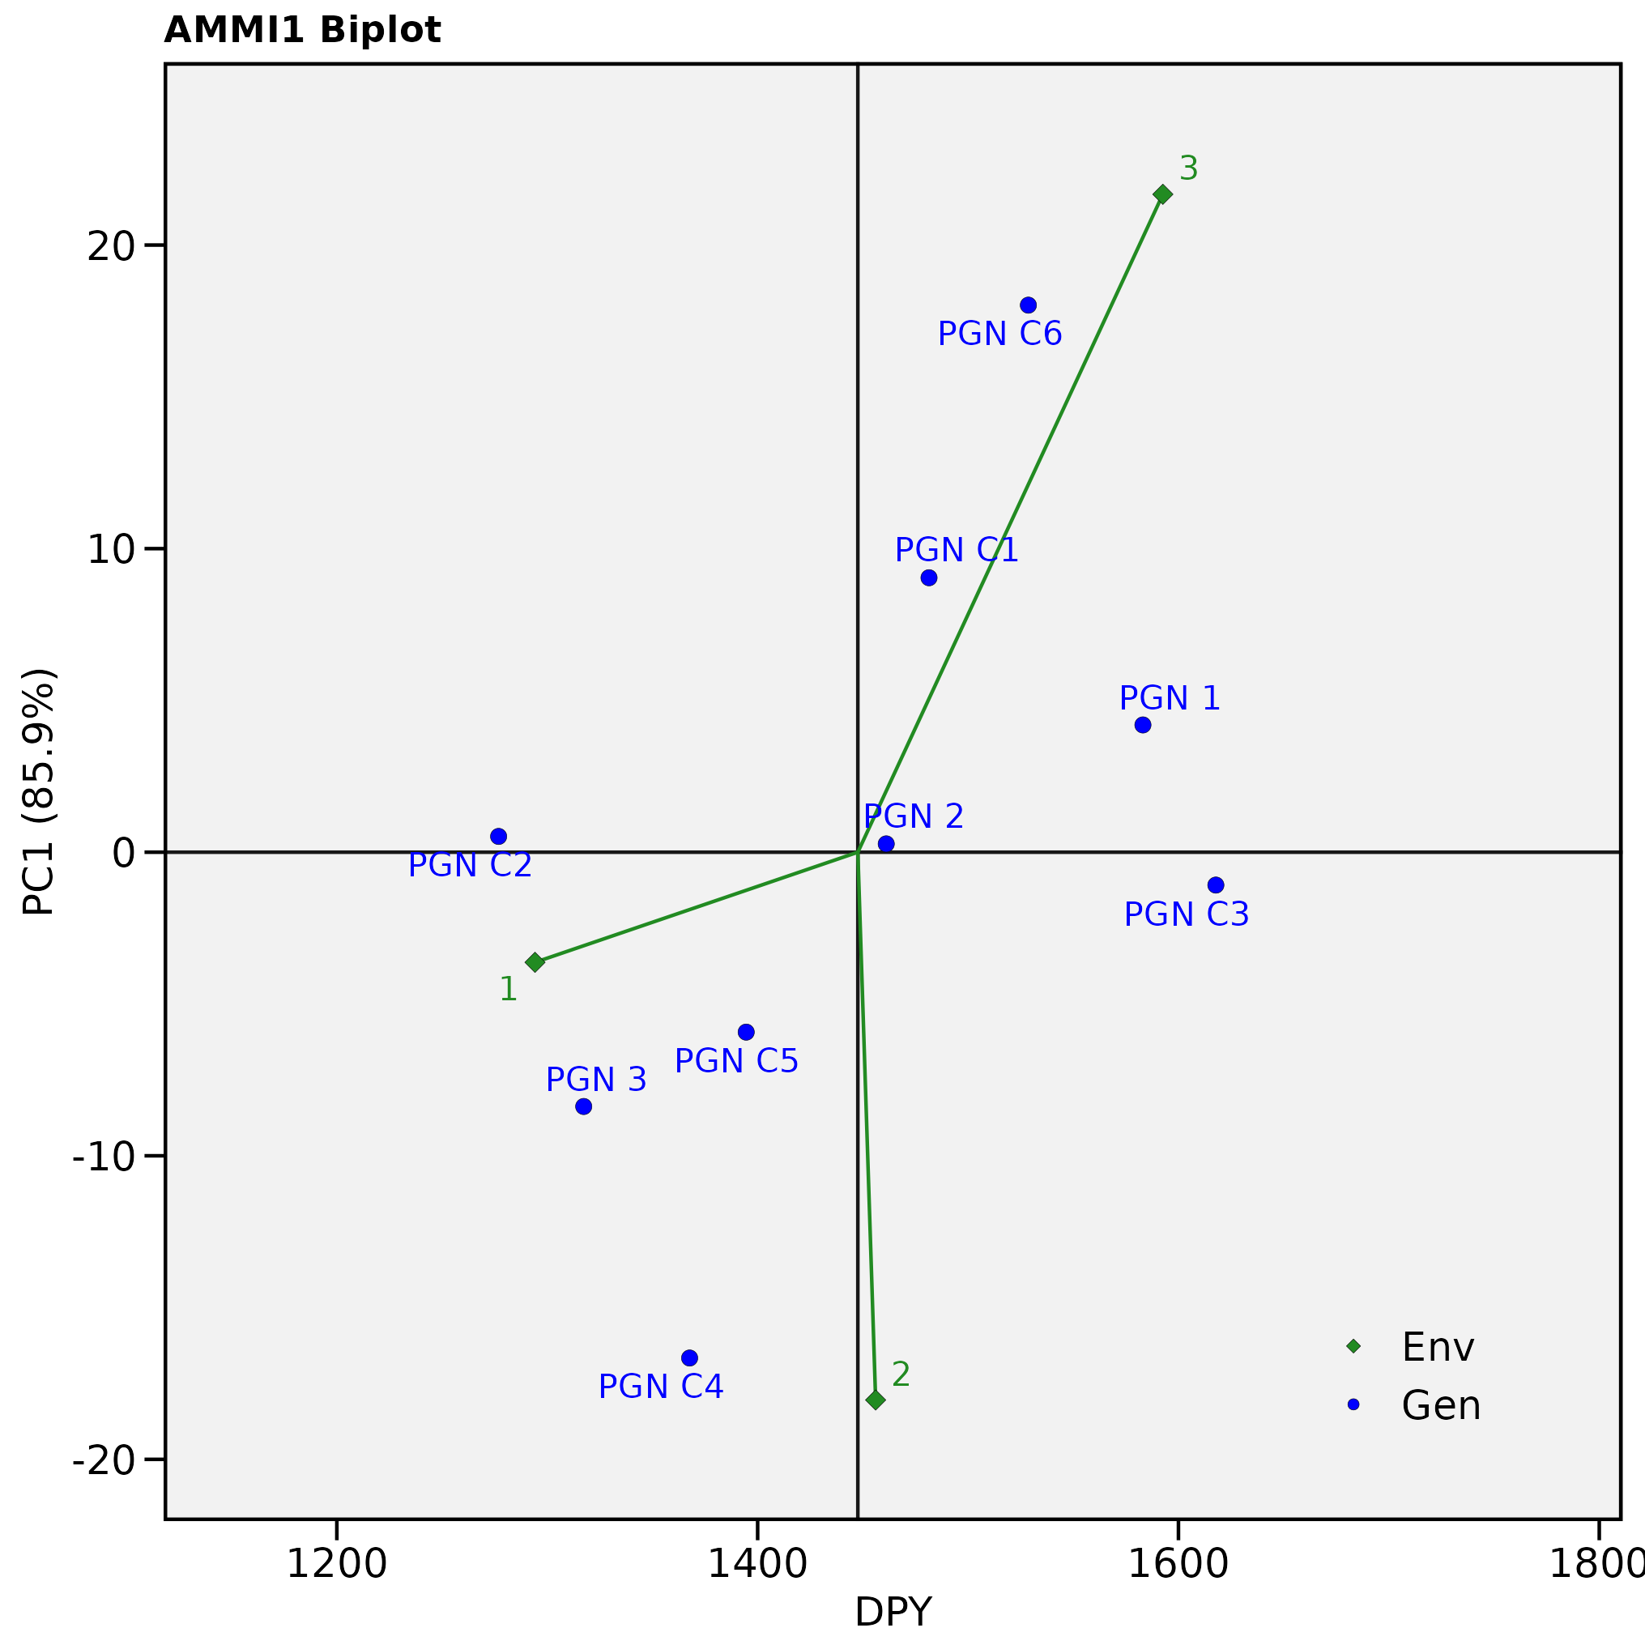

Fig. 1 - AMMI-bi-plot for mean kernel yield of 9 groundnut genotypes evaluated at three environments.

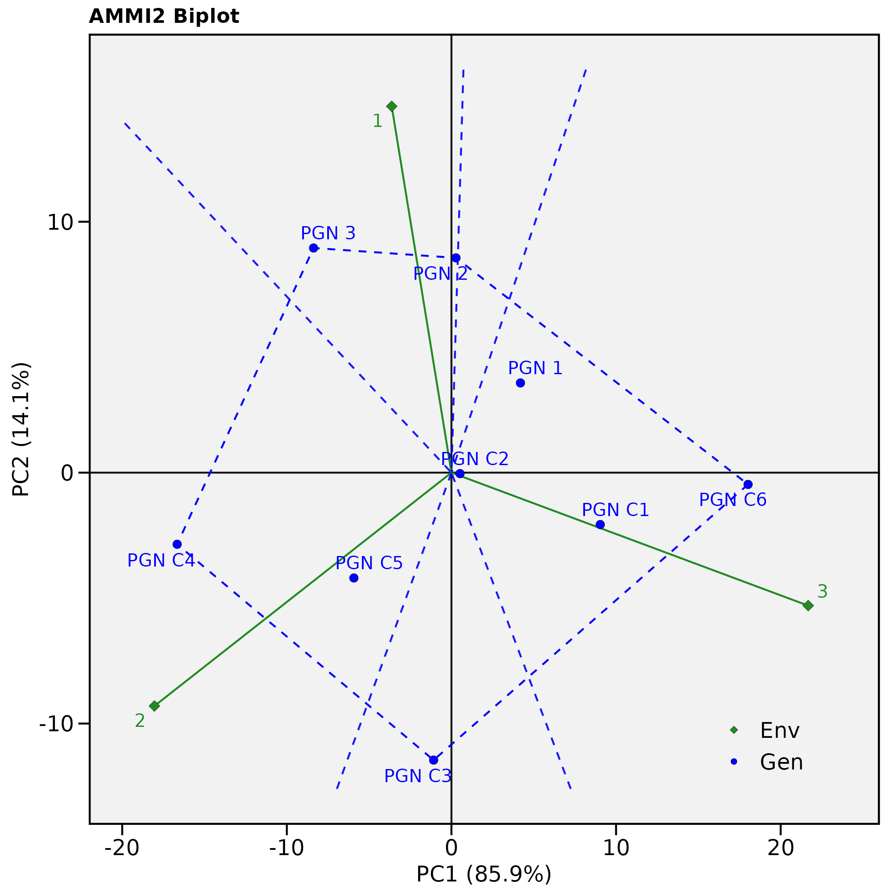

Fig. 2 - AMMI-bi-plot (PC1 vs PC2) for mean kernel yield of nine groundnut genotypes evaluated at three environments.

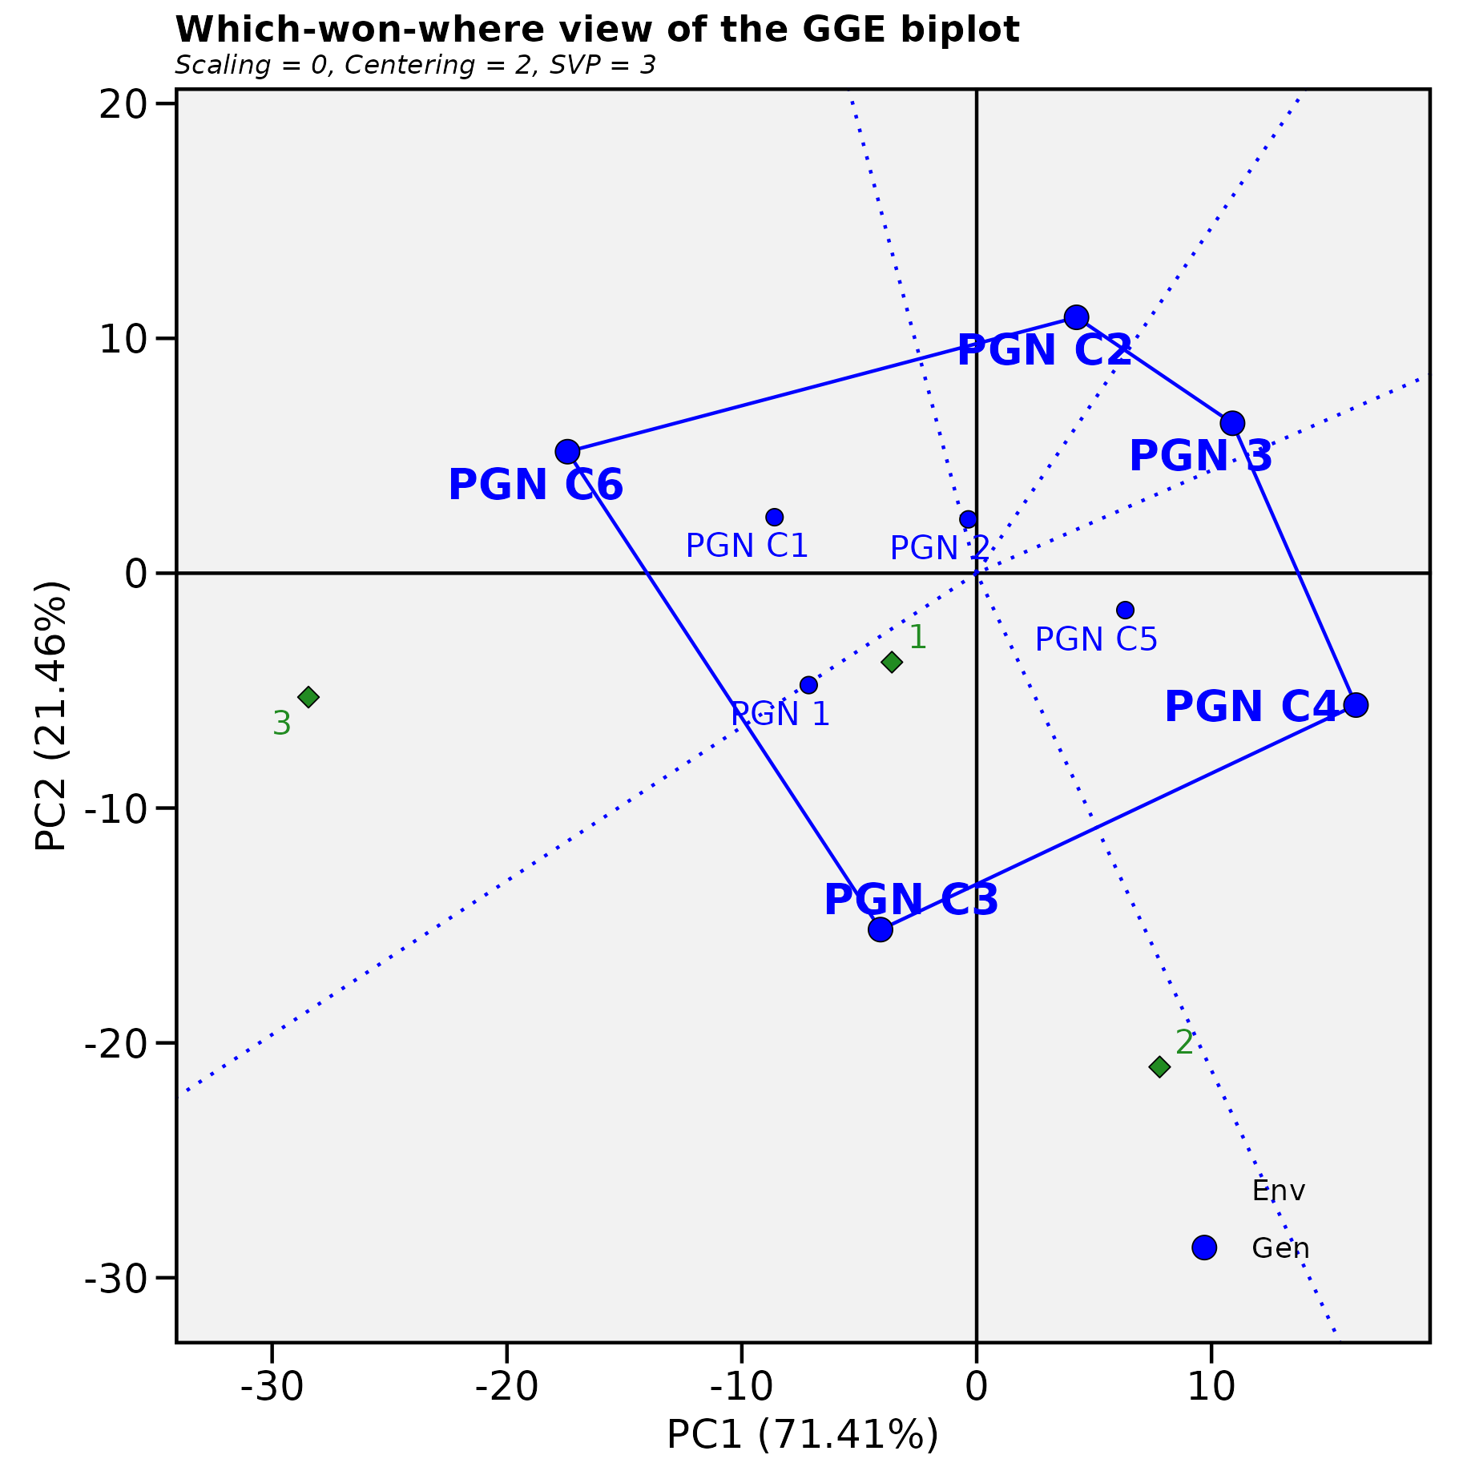
Fig. 3 - Which won where bi-plot

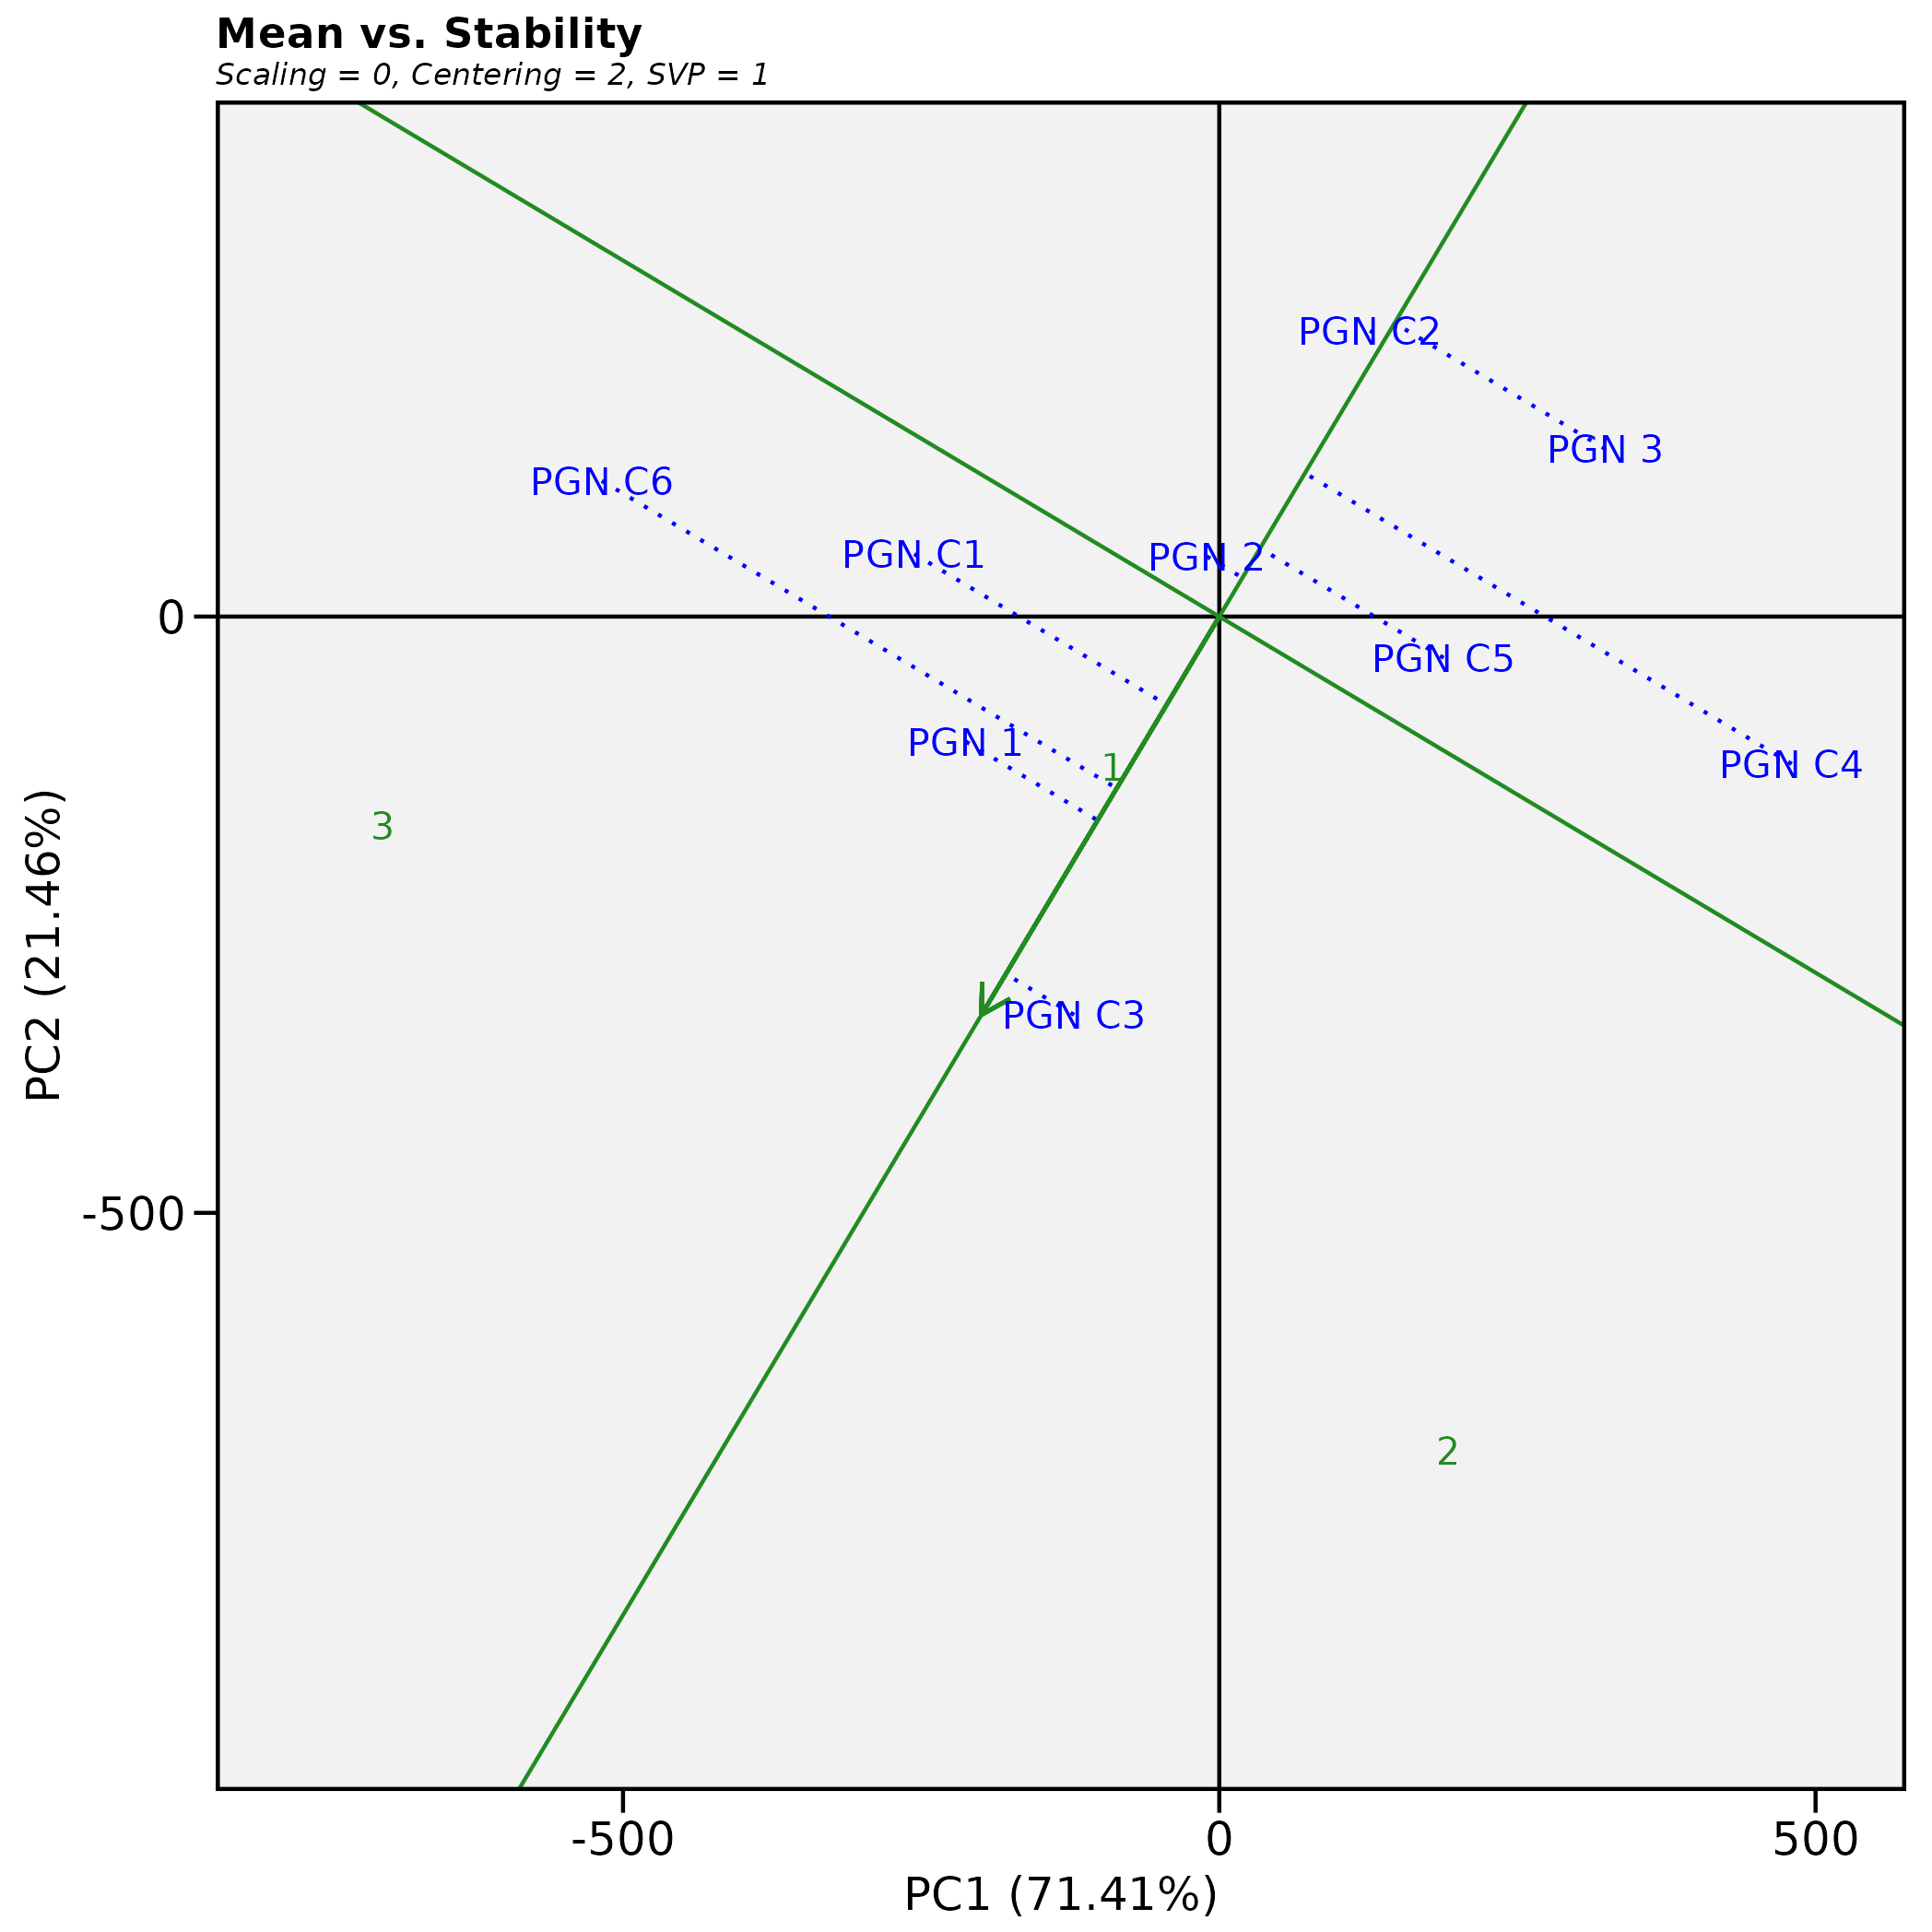

Fig. 4 - Mean Vs Stability bi-plot

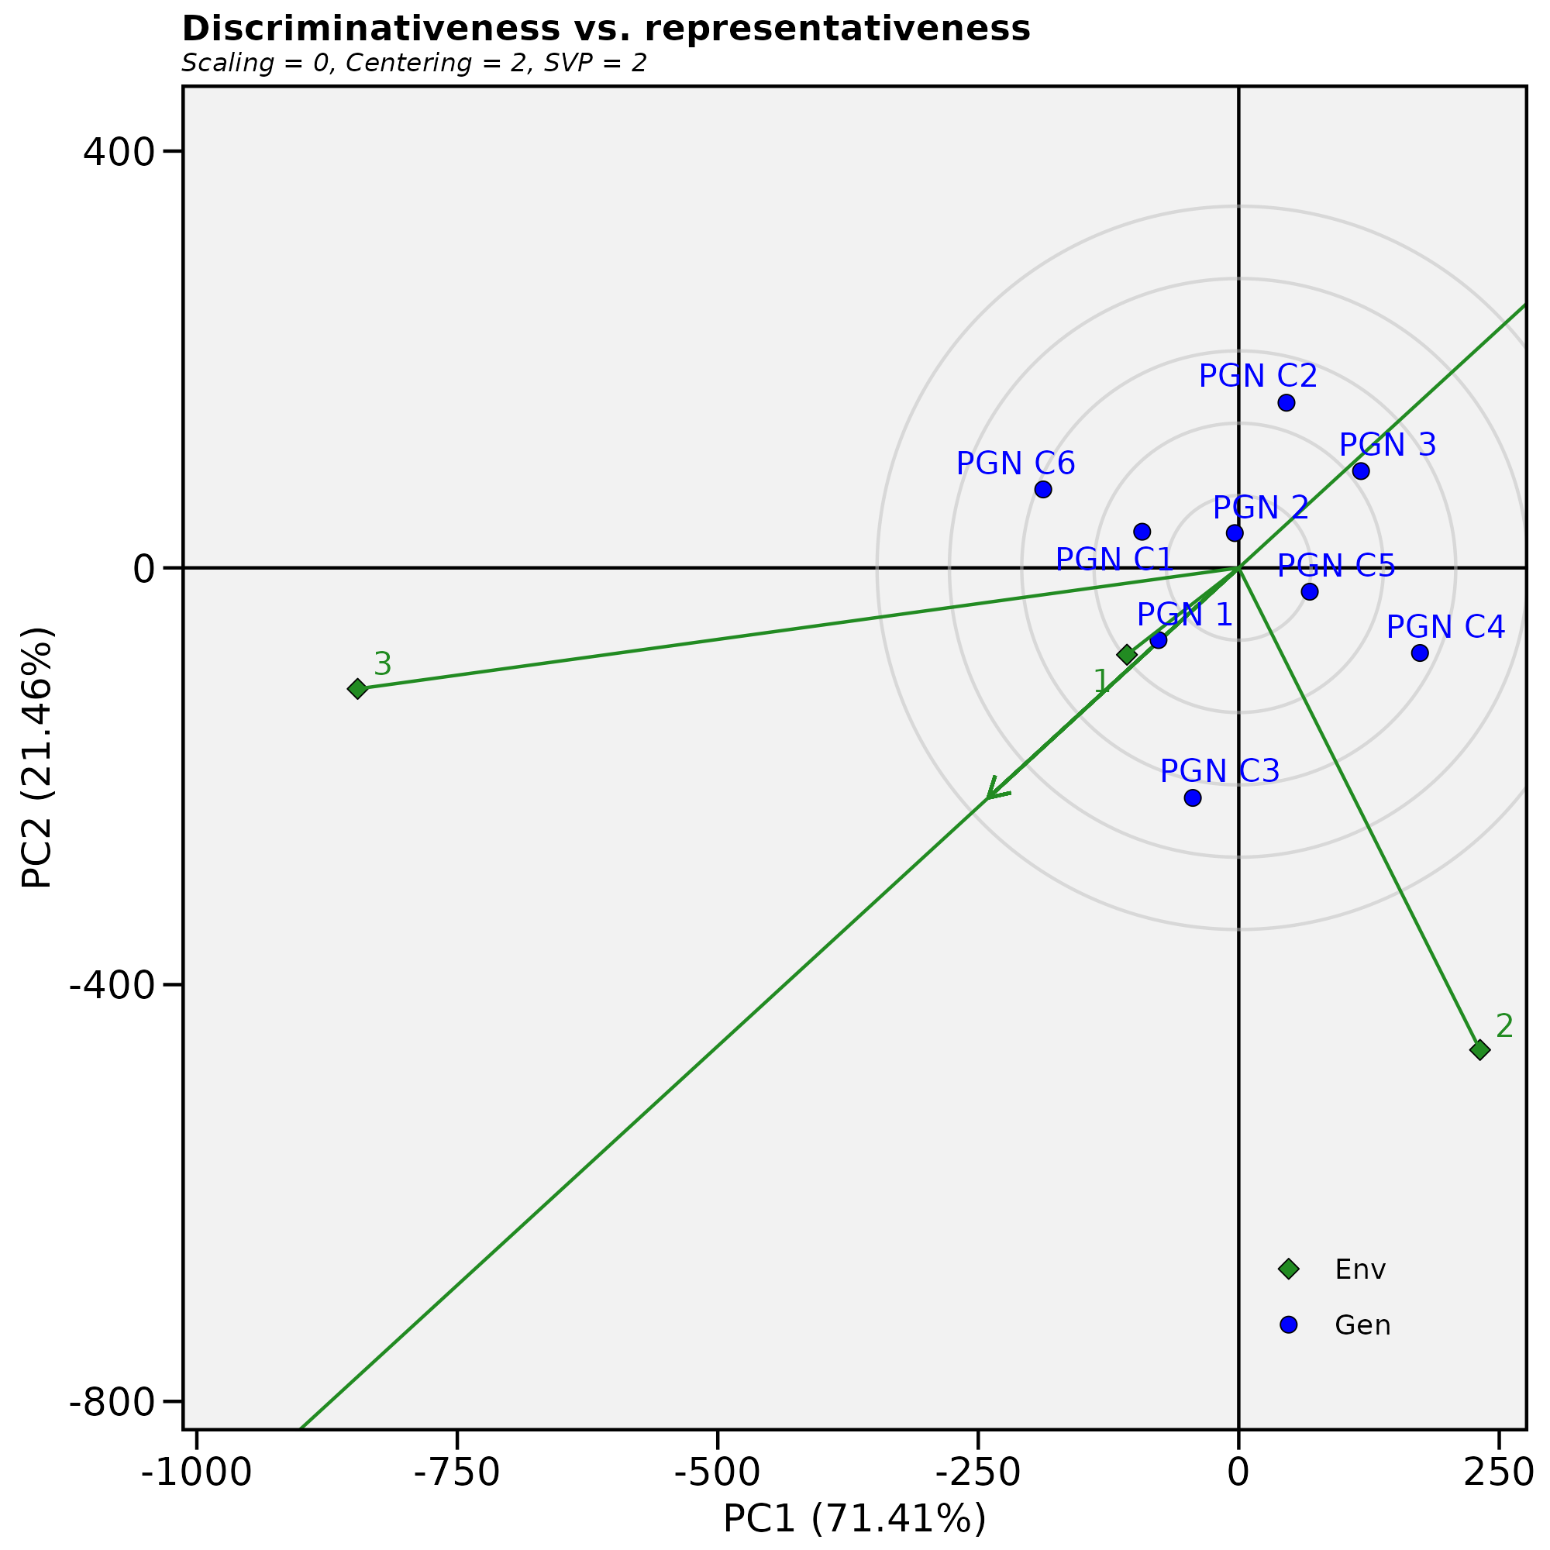

Fig. 5 - Discriminative Vs. representative biplot

