Original Research Article
CROSS-SPECIES SSR MARKER TRANSFERABILITY AND GENETIC DIVERSITY ASSESSMENT IN ASHWAGANDHA

Abstract
Ashwagandha (Withania somnifera L. Dunal), also known as “Indian Winter Cherry” or “Indian Ginseng,” is an important medicinal plant of the Solanaceae family. The present study evaluated genetic diversity among 24 W. somnifera genotypes using simple sequence repeat (SSR) markers. Of the 79 primer pairs screened, 20 successfully amplified target regions, and 15 displayed polymorphism with amplicon sizes ranging from 100 to 952 bp. Genetic diversity parameters including polymorphic information content (PIC), expected heterozygosity, effective multiplex ratio, mean heterozygosity, marker index, discriminating power, and resolving power averaged 0.33, 0.38, 1.07, 0.01, 0.01, 0.82, and 1.12, respectively. Cluster analysis grouped all genotypes into five major clusters with similarity coefficients between 0.43 and 1.00. Notably, primers SSR22, WS_SSR08, SSR20, CaES5301, WS_SSR06, and T-44 showed higher diversity indices and resolving ability. The observed polymorphism and cross-transferability of SSRs highlight their efficiency for genetic relationship studies and provide valuable resources for W. somnifera improvement and breeding programs.

Keywords: Ashwagandha, Cross-genera transferability, Expressed sequence tags, SSR, Withania somnifera.

INTRODUCTION
“Withania somnifera (L.) Dunal, commonly known as Ashwagandha, “Indian Winter Cherry,” or “Indian Ginseng,” is one of the most significant medicinal plants in traditional Indian medicine. It belongs to the family Solanaceae and is a cross-pollinated diploid species (2n = 48). The crop is native to North-western and Central India and also occurs in parts of the Mediterranean region and North Africa. It thrives in dry and subtropical climates, with major cultivation areas in Indian states such as Maharashtra, Madhya Pradesh, Gujarat, Rajasthan, Uttar Pradesh, Haryana, Punjab, Odisha, Sikkim, and Assam” (Chauhan et al., 2018; Patel and Desai, 2017). In India, two species of Withania are commonly found W. somnifera and W. coagulans. Among these, W. somnifera holds greater commercial and therapeutic significance.
Ashwagandha's medicinal properties are attributed to its bioactive compounds, primarily alkaloids and steroidal lactones, collectively referred to as withanolides. The roots are rich in pharmacologically active constituents, including withaferin A, withanolide D, somniferine, withananine, and withasomnine, with total alkaloid content ranging from 0.16% to 0.66% (Patel and Desai, 2017; Nagar et al., 2022). “These compounds exhibit a wide array of pharmacological activities such as anti-inflammatory, anti-stress, anti-ulcer, immunomodulatory, neuroprotective, aphrodisiac, and adaptogenic effects” (Singh et al., 2011).
Traditionally, Ashwagandha is processed into a powdered form (churna), often consumed with water, ghee (clarified butter), or honey. It is considered a powerful rasayana in Ayurveda, believed to rejuvenate the body, enhance vitality, and improve cognitive and reproductive functions. “It has been used to manage a wide range of conditions including rheumatism, insomnia, anxiety, hysteria, memory loss, nervous disorders, sexual dysfunction, and even envenomation” (Mandlik et al., 2021).
Recent research has also explored Ashwagandha's potential antiviral and immunomodulatory properties. Compounds such as withanone have been shown to interfere with viral replication, offering potential therapeutic avenues against viruses like COVID-19 (Gayen et al., 2021). Its immuno-enhancing effects, low toxicity, cost-effectiveness, and antioxidant properties make it a promising candidate for both preventive and therapeutic health applications.
Despite its vast therapeutic potential and increasing global demand, genetic improvement of Ashwagandha remains limited. There is a lack of well-characterized and improved cultivars, hindering efforts to enhance yield, phytochemical content, and stress tolerance. Traditionally, breeding efforts have been hampered by inadequate genetic information and the reliance on phenotypic and phytochemical data, which are often influenced by environmental and edaphic factors. While studies have examined variability in withanolide content, such analyses are limited by the environmental dependency of metabolite expression.
Morphological traits have also been used to assess diversity, but like phytochemical markers, they are highly susceptible to environmental influence. Therefore, DNA-based molecular markers offer a more reliable alternative for genetic analysis, as they are stable, heritable, and unaffected by environmental conditions. These markers enable accurate evaluation of genetic diversity, population structure, and phylogenetic relationships and are indispensable tools for crop improvement and breeding programs (Parmar et al., 2015).
Molecular marker technologies have revolutionized plant breeding by enabling precise and efficient selection of desirable traits. Among the various marker systems available, such as RAPD, AFLP, and RFLP, Simple Sequence Repeats (SSRs) or microsatellites are particularly favored due to their high reproducibility, polymorphism, and co-dominant inheritance (Mondini et al., 2009). SSRs are short tandemly repeated motifs (1-6 base pairs) distributed throughout both coding and non-coding regions of the genome. Their high frequency, locus-specificity, and ease of detection make them ideal for genetic fingerprinting, diversity analysis, and marker-assisted selection.
Microsatellites exhibit variation primarily in the number of repeat units at a given locus, resulting in length polymorphisms detectable via PCR (Kalia et al., 2011). Their high mutation rate, random distribution across the genome, and multi-allelic nature make them especially useful for detecting genetic variability among closely related genotypes (Smith and Devey, 1994; Vosman et al., 1992). “Furthermore, SSRs derived from expressed sequence tags (EST-SSRs) can provide insights into functional diversity, aiding in the identification of genes linked to adaptive or economically important traits” (Russell et al., 2004).
Additionally, cross-transferability of SSR markers from related species in the Solanaceae family such as tomato, eggplant, chili, and tobacco has been demonstrated, providing a cost-effective means to expand marker availability in under-researched crops like Ashwagandha (Ashraf et al., 2016). These cross-genera SSRs enhance the potential for comparative genomics and evolutionary studies, allowing researchers to bridge the gap between model and non-model species. “Despite the demonstrated utility of SSR markers, very few molecular studies have been conducted on the genetic diversity of W. somnifera” (Tripathi et al., 2012; Bamhania et al., 2013; Khanna et al., 2016; Khan et al., 2016). The limited genomic resources available for this species underscore the need for comprehensive molecular characterization using reliable and transferable SSR markers.
The objective of this study was to identify and evaluate the cross-species transferability of different SSR markers in Ashwagandha (Withania somnifera) genotypes. The study further aimed to assess genetic diversity and analyse phylogenetic relationships to generate useful insights for the genetic improvement and breeding of Ashwagandha
MATERIALS AND METHODS
Plant Materials and DNA Extraction
A total of 24 genotypes of Ashwagandha (Withania somnifera) were selected as part of breeding programme at Department of Genetics and Plant Breeding, C. P. College of Agriculture, Sardarkrushinagar Dantiwada Agricultural University, Sardarkrushinagar (Table S1). Genomic DNA was isolated from the newly emerged leaves using CTAB method (Doyle and Doyle 1990) with required modification. The quantity and quantity of genomic DNA were assessed using 0.8% agarose gel electrophoresis and Nanodrop UV- Spectrophotometer (Bio Tek instrument, USA), respectively.
SSR and EST-SSR Markers Analysis
A total of 79 SSR markers (13 developed from W. somnifera and other solanaceous crops, Tomato (16), Chilli (14), Tobacco (7), Eggplant (8), and Potato (21) were used to amplify SSR loci in twenty-four genotypes of W. somnifera (Table S2). PCR amplification reactions for both SSR and EST-SSR markers were carried out in a total volume of 15.0 μl, comprising 7.5 μl of 2X TopTaq Master Mix (Qiagen), 0.5 μl each of forward and reverse primers (10 pmol/μl), 2.5 μl of template DNA (20 ng/μl), and 4.0 μl of nuclease-free water. For SSR primers, PCR amplification was carried out in a thermal cycler under the following conditions: an initial denaturation at 94°C for 5 minutes, followed by 35 cycles of denaturation at 94°C for 30 seconds, primer-specific annealing at 55-58°C for 30 seconds, and extension at 72°C for 1 minute, with a final extension at 72°C for 7 minutes and a final hold at 4°C. EST-SSR amplification followed a touch-down protocol, beginning with 5 cycles of annealing temperatures decreasing from 55°C to 45°C, followed by 33 cycles at a fixed annealing temperature of 50°C, and a final extension at 72°C for 5 minutes. The PCR products were electrophoresed on a 3% agarose gel (stained with 1 mg/10 mL ethidium bromide solution) alongside a 100 bp or 50 bp DNA ladder.
Data Scoring and Analysis
The amplified bands were scored as presence (1) or absence (0). NTSYSpc version 2.02 was used to examine the data once it had been entered into a binary matrix (Rohlf, 1994). The Polymorphic Information Content (PIC) was assessed using the Powell et al. (1996) method. The expected heterozygosity (H) for each marker was determined using the iMEC (Online Marker Efficiency Calculator) (Liu, 1998). Additional marker efficiency indicators were calculated, including the Effective Multiplex Ratio (E), Mean Heterozygosity, and Marker Index (MI) (Powell et al., 1996). Furthermore, Discriminating Power (DP) was computed as stated by Tessier et al. (1999), while Resolving Power (RP) was measured according to the approach presented by Prevost and Wilkinson (1999).
RESULTS AND DISCUSSION
Genetic diversity characterization is crucial for conserving and utilizing plant resources. PCR-based molecular markers offer greater accuracy than morphological or biochemical methods (Sharma et al., 2011), but their development remains costly and limited for Withania somnifera. Assessing SSR marker transferability from related Solanaceous crops is therefore valuable (Mishra et al., 2011; Kumar et al., 2014). In this study, 79 markers (55 SSRs and 24 EST-SSRs) were used to generate DNA profiles of 24 W. somnifera genotypes to evaluate polymorphism, genetic diversity, and phylogenetic relationships.
Withania somnifera and Cross-species Amplification of SSR Primers
A total of 79 SSR primer pairs including 13 from ashwagandha and 66 from allied Solanaceous crops (tomato, eggplant, chili, potato, and tobacco) were utilized to amplify SSR loci in W. somnifera. Total 20 SSR primers were amplified, out of which 15 primers gave polymorphism (Table 1 and Table 2). Among 13 primers of W. somnifera, six did not consistently amplify, while seven generated steady amplification across all genotypes (Table 1). The size of the amplified products varied; the largest fragment was found in WS_SSR09 (885-952 bp), while the smallest was found in WS_SSR06 (147-215 bp). Primer quality was assessed based on band clarity (++ for strong, + for weak) and specificity (+ for expected size, – for non-specific) (Table 1). Similar observations were made by Parita et al. (2018), who explored the use of EST-SSR markers in Ashwagandha and found that only EMS-35 displayed polymorphism. The transferability of SSR markers from related Solanaceous species to W. somnifera was systematically evaluated. Out of 66 primers tested, 13 (19.69%) produced successful amplification, including one from eggplant (12.5%), six from tomato (37.5%), five from chili (35.71%), and one from potato (4.76%) (Table 1). Among these, nine primers were polymorphic and four were monomorphic. These results are consistent with earlier findings by Parmar et al. (2015), who reported a 21% transferability rate when screening 95 SSRs from Solanaceae against W. somnifera ESTs, with varying amplification success across species. The slightly reduced transferability observed in the present study may be attributed to factors such as evolutionary divergence, mutations in flanking regions, differences in source species, and variation in SSR motif types and repeat numbers. Nonetheless, the comparable amplicon sizes between donor and target species reinforce the genetic affinity within Solanaceae and underscore the potential utility of cross-species SSR markers in W. somnifera. The amplicon size for each primer observed in this study is almost similar to that reported in source species (Table 1).
Polymorphism in Ashwagandha Using SSR markers
Out of the 79 SSR primers evaluated, 15 exhibited polymorphism- comprising six from Withania somnifera, four from tomato, two from chili, and one from potato. Detailed marker efficiency metrics, including polymorphic information content (PIC), expected heterozygosity (He), effective multiplex ratio (EMR), marker index (MI), discriminating power (DP), and resolving power (RP), are summarized in Table 2.
Among the W. somnifera-specific primers, WS_SSR01 produced 25 bands with three alleles (501-584 bp, PIC=0.145, RP=0.2500), while WS_SSR02 yielded 24 bands (two alleles, 252-262 bp, PIC=0.275, He=0.329, DP=0.7553, RP=0.8333). WS_SSR06 amplified 24 bands (147-215 bp, PIC=0.368, He=0.486, RP=1.6667), and WS_SSR08 showed high efficiency with 29 bands (254-310 bp, PIC=0.548, He=0.627, EMR=1.2083, MI=0.0081, DP=0.8412, RP=2.4167). WS_SSR09 generated 22 bands (885-952 bp, PIC=0.318, RP=1.1667), and EMS-35 amplified 19 bands (322-872 bp, PIC=0.230, DP=0.8484, RP=0.9167).
Among the cross-species primers, SSR20 produced 30 bands (100-331 bp, PIC=0.466, EMR=1.2500, RP=1.5000), while SSR22 showed the highest efficiency with 38 bands (170-892 bp, PIC=0.637, He=0.693, EMR=1.5833, MI=0.0079, DP=0.8458, RP=2.5000). T-44 and T-45 amplified 40 and 18 bands respectively, with moderate PIC and RP values. Additional transferable primers such as SSR43, STI0003, CaES4072, CaES5301, and LSS009 also contributed to the diversity assessment. Overall, WS_SSR08 and SSR22 demonstrated the highest polymorphism and resolving power, making them particularly effective for evaluating genetic variation and phylogenetic relationships in W. somnifera. The amplification of 20 out of 79 tested SSR primers (with 15 polymorphic) is broadly consistent with earlier reports of moderate SSR success rates in W. somnifera and related taxa (Parmar et al., 2015; Parita et al., 2018).
Pooled SSR data analysis
PCR amplification using 15 SSR primers across 24 Withania somnifera genotypes resulted in 388 scorable bands, with an average of 25.87 bands per primer and approximately 2.5 alleles per locus. Fragment sizes ranged from 100 to 952 bp. Among the primers, SSR22 demonstrated the highest level of polymorphism, producing 38 bands and four alleles (PIC= 0.637, He=0.693, RP=2.500), followed by WS_SSR08 (29 bands, three alleles, PIC=0.548, He=0.627, RP=2.417), SSR20, CaES5301, and T-44, all of which showed substantial polymorphic potential. Moderate polymorphism was observed with WS_SSR06, WS_SSR09, T-45, EMS-35, and LSS009, while SSR43, STI0003, and CaES4072 exhibited the lowest PIC and heterozygosity values.
The overall averages for PIC, expected heterozygosity, effective multiplex ratio, mean heterozygosity, marker index, discriminating power, and resolving power were 0.33, 0.38, 1.07, 0.01, 0.01, 0.82, and 1.12, respectively (Table 2). The observed fragment size ranges (100-952 bp) and alleles count (average ~2.5 alleles per locus) indicate adequate resolution for diversity analyses in this species. That only ~19–25 % of SSRs from allied Solanaceous crops succeeded in amplification (and fewer in polymorphism) is consistent with the expectation that flanking-region divergence and mutational changes reduce cross-genera transferability (Singleton et al. 2020 on Solanum). The modest transferability in this study likely reflects evolutionary distance, insertion/deletion events in flanking sequences, and differences in repeat motif conservation. Still, the success of cross-species markers such as SSR22, SSR20, CaES5301, and T-44 strengthens the toolkit available for W. somnifera genomics and supports the phylogenetic affinity among Solanaceae members.
Table 1. Result of amplified Withania somnifera and cross-species transferred primers with their sequences
Sr. No. | Primer Name | Primer Sequence | Tm (ºC) | Product Size (bp)¹ | Poly-morphism | Quality² | Specificity³
1 | WS_SSR01ª | F: TCTGAATGACTCCCATCTTTTG | 56.2 | 501-584  (510-520) | Yes | ++ | +
1 | WS_SSR01ª | R: TGGTGATGGTGATGTTGATGT
2 | WS_SSR02ª | F: TGGGATGAACACAGACATCAA | 57.1 | 252-262  (250-260) | Yes | ++ | +
2 | WS_SSR02ª | R: CTTGGAGGTGAACTAGCAAGAA
3 | WS_SSR04ª | F: TATTTCCTGATCCGCTCAATC | 56.2 | 300-374  (290-300) | No | + | +
3 | WS_SSR04ª | R: TTTCAGAGAACCAACAAGTCCA
4 | WS_SSR06ª | F: TGTTAAGGGTGATGCAGGAGA | 57.2 | 147-215  (150-190) | Yes | ++ | +
4 | WS_SSR06ª | R: CATACACAAACCAAGCCCTAAA
5 | WS_SSR08ª | F: GTGATGTTGGATACGGTGGAG | 58.1 | 254-310  (185-190) | Yes | ++ | +
5 | WS_SSR08ª | R: CGGAACTTGAACAAAACTTGGA
6 | WS_SSR09ª | F: GCAATTTCCTCTGAGTTTGGT | 57.3 | 885-952  (770-800) | Yes | ++ | +
6 | WS_SSR09ª | R: CCTCTGTTTTCTCTTCTTCCTTG
7 | EMS-35ª | F: ACACAACAGGATCCTTCGAAAT | 57.6 | 322-872  (207-805) | Yes | + | +
7 | EMS-35ª | R: AAGCGAGGCTGCCAAGAAC
8 | SSR20^{b} | F: GAGGACGACAACAACAACGA | 57.8 | 100-331  (120-140) | Yes | ++ | +
8 | SSR20^{b} | R: GACATGCCACTTAGATCCACAA
9 | SSR22^{b} | F: GATCGGCAGTAGGTGCTCTC | 59.3 | 170-892  (185-200) | Yes | ++ | +
9 | SSR22^{b} | R: CAAGAAACACCCATATCCGC
10 | T-44^{b} | F: GCAACATTCCCAAGTCCAAAGA | 57.8 | 139-207 | Yes | + | -
10 | T-44^{b} | R: TCGATGACCGCTAATAACCC
11 | T-45^{b} | F: GTGAGGGAGTGGGATTCAAAT | 57.5 | 274-304 | Yes | ++ | -
11 | T-45^{b} | R: AATTAGGGGATACGGGATCG

Sr. No. | Primer Name | Primer Sequence | Tm  (ºC) | Product Size (bp)¹ | Poly-morphism | Quality² | Specificity³
12 | SSR43^{b} | F: CTCCAAATTGGGCAATAACA | 54.5 | 176-188  (100-200) | Yes | ++ | +
12 | SSR43^{b} | R: TTAGGAAGTTGCATTAGGCCA
13 | STI0003^{b} | F: ACCAATCCACCATGTCAATGC | 57.5 | 103-145  (180) | Yes | ++ | +
13 | STI0003^{b} | R: CTCATGGATGGTGTCATTGG
14 | CaES4072^{c} | F: CAGCACGCTTGCTAATTCAA | 56.2 | 116-147  (125-130) | Yes | ++ | +
14 | CaES4072^{c} | R: AGCAGGCTTGGAATCCACTA
15 | CaES5301^{c} | F: TGTAAAATCCGGGTGGAAGA | 54.2 | 641-736  (640-650) | Yes | ++ | +
15 | CaES5301^{c} | R: TTTTCCATGGTTTCAAAGGC
16 | CAMS 647^{c} | F: CGGATTCGGTTGAGTCGATA | 57.3 | 169-450 | No | + | -
16 | CAMS 647^{c} | R: GTGCTTTGGTTCGGTCTTTC
17 | Hpms1-173^{c} | F: TGCTGGGAAAGATCTCAAAAGG | 57.1 | 146-186  (163) | No | + | +
17 | Hpms1-173^{c} | R; ATCAAGGAAGCAAACCAATGC
18 | Hpms1-172^{c} | F: GGGTTTGCATGATCTAAGCATTTT | 57.9 | 212-296  (344) | No | + | +
18 | Hpms1-172^{c} | R: CGCTGGAATGCATTGTCAAAGA
19 | EEMS28^{d} | F: GACGATGACGACGACGATAA | 58.3 | 156-523  (180-236) | No | + | +
19 | EEMS28^{d} | R: TGGACTCACAACTCAGCCAG
20 | LSS009e | F: GCTGCTAAACACTCAAGCAGAA | 58.3 | 222-259  (200-250) | Yes | ++ | +
20 | LSS009e | R: GCTCAGCTTTCAGAAGAAACCA
Source species: ªAshwagandha, ^{b} Tomato, ^{c}Chilli, ^{d} Egg plant, ^{e} Potato
¹ Value in parenthesis is amplicon size in source species
²++= Strong signal and easy to score; += Weaker signal able to score
³ + = Amplified product of a similar size (within 100 bp) to that of source species; - =Amplified product not of similar size
Table 2. Result of 15 SSR primers showing polymorphism among 24 Ashwagandha genotypes
Primer Name | Amplified Product Size (bp) | Total Number of Bands | Total Number of Alleles | PIC  Value | H | E | H avp | MI | D | RP
WS_SSR01 | 501-584 | 25 | 3 | 0.145 | 0.150 | 1.042 | 0.006 | 0.007 | 0.883 | 0.250
WS_SSR02 | 252-262 | 24 | 2 | 0.275 | 0.329 | 1.000 | 0.010 | 0.010 | 0.755 | 0.833
WS_SSR06 | 147-215 | 24 | 2 | 0.368 | 0.486 | 1.000 | 0.010 | 0.010 | 0.755 | 1.667
WS_SSR08 | 254-310 | 29 | 3 | 0.548 | 0.627 | 1.208 | 0.007 | 0.008 | 0.841 | 2.417
WS_SSR09 | 885-952 | 22 | 2 | 0.318 | 0.396 | 0.917 | 0.010 | 0.009 | 0.795 | 1.167
EMS-35 | 322-872 | 19 | 2 | 0.230 | 0.265 | 0.792 | 0.010 | 0.008 | 0.848 | 0.917
SSR20 | 100-331 | 30 | 3 | 0.466 | 0.540 | 1.250 | 0.007 | 0.008 | 0.830 | 1.500
SSR22 | 170-892 | 38 | 4 | 0.637 | 0.693 | 1.583 | 0.005 | 0.008 | 0.846 | 2.500
T-44 | 139-207 | 40 | 3 | 0.410 | 0.523 | 1.667 | 0.007 | 0.011 | 0.695 | 0.833
T-45 | 274-304 | 18 | 2 | 0.345 | 0.444 | 0.750 | 0.010 | 0.007 | 0.864 | 1.500
SSR43 | 176-188 | 24 | 2 | 0.076 | 0.079 | 1.000 | 0.010 | 0.010 | 0.755 | 0.167
STI0003 | 103-145 | 26 | 2 | 0.183 | 0.204 | 0.917 | 0.010 | 0.009 | 0.795 | 0.333
CaES4072 | 116-147 | 22 | 2 | 0.083 | 0.086 | 1.000 | 0.010 | 0.010 | 0.755 | 0.333
CaES5301 | 641-736 | 24 | 3 | 0.423 | 0.486 | 1.000 | 0.006 | 0.006 | 0.892 | 1.333
LSS009 | 222-259 | 23 | 3 | 0.374 | 0.415 | 0.958 | 0.006 | 0.006 | 0.901 | 1.083
Total | - | 388 | 38 | - | - | - | - | - | - | -
Average | - | 25.87 | 2.53 | 0.325 | 0.382 | 1.067 | 0.008 | 0.009 | 0.817 | 1.122
PIC = Polymorphism information content; H = Expected heterozygosity; E = Effective multiplex ratio; H avp = Mean heterozygosity; MI = Marker index; D = Discriminating power; RP = Resolving power.

Of the 15 SSR primers used, six were developed specifically for W. somnifera, generating 143 scorable bands (average 23.83 bands per primer, size range 147-952 bp). WS_SSR08 was the most polymorphic among these (PIC=0.548, He=0.627), while WS_SSR01 showed the least variability (PIC=0.145, He=0.150). The remaining nine primers were cross-transferable SSRs sourced from Solanaceous crops, producing 245 scorable bands (average 27.22 bands per primer, size range 100-892 bp). SSR22 emerged as the most informative among these (PIC=0.637, He=0.693), whereas SSR43 showed minimal polymorphism (PIC=0.076, He=0.079). These findings confirm the utility of both species-specific and cross-transferable SSR markers in assessing genetic diversity and phylogenetic relationships in W. somnifera, with SSR22, WS_SSR08, SSR20, CaES5301, WS_SSR06, and T-44 identified as particularly effective (Fig. 1).
Among the polymorphic markers, SSR22 and WS_SSR08 emerged as highly informative, exhibiting high PIC, heterozygosity, and resolving power. These loci are likely to be most effective for distinguishing closely related genotypes, constructing reliable fingerprint profiles, and anchoring future linkage or association studies. The moderate average PIC (0.33) and expected heterozygosity (0.38) suggest moderate diversity within the sampled germplasm. Compared to recent broader diversity surveys Chawla et al. (2024), which employed EST-SSR and SSR to assess diversity in W. somnifera populations.

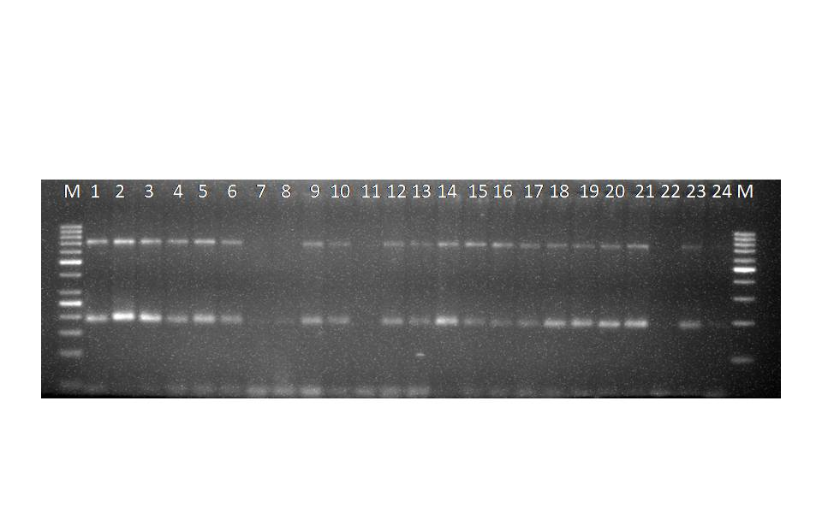(A)

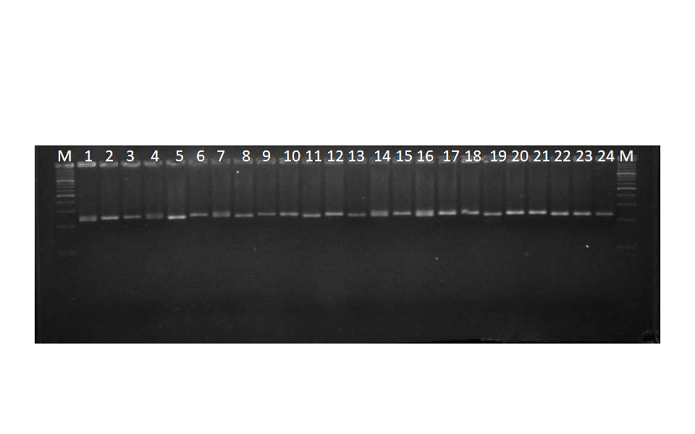
(B)
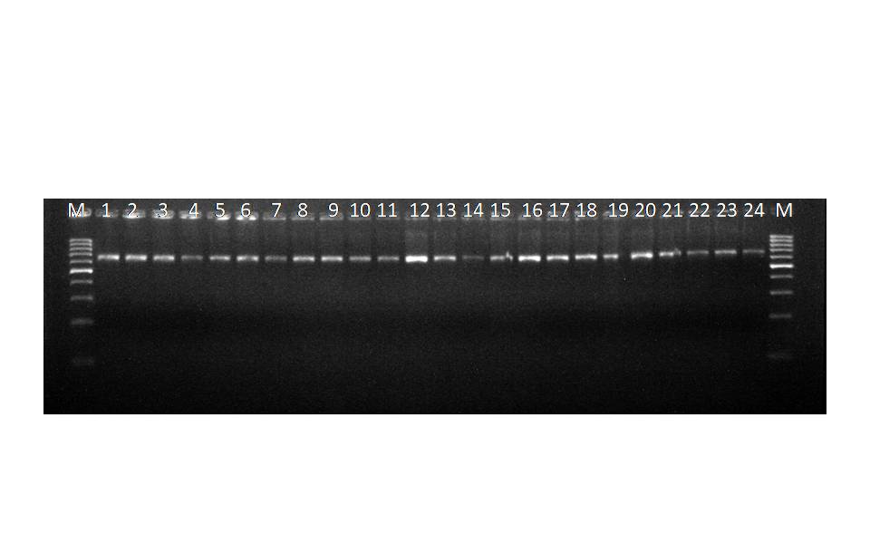
(C)
Fig 1. Amplification profile of different SSR markers for 24 genotypes of Ashwagandha (A) SSR profiling of primer SSR22, (B) EST-SSR profiling of primer WS_SSR08 and (C) SSR profiling of primer caES5301
Clustering Pattern and Dendrogram
Genetic diversity among the 24 Withania somnifera genotypes was further examined through a construction of dendrogram generated using UPGMA clustering (Fig 2). All the genotypes were clustered into five groups having similarity coefficient of 0.43 to 1.00 (Table 3). Cluster 1 (C1) comprised SKA-01, SKA-28, and three cultivars; GAA-1, JA-20, and JA-134. Cluster 2 (C2) included SKA-03, SKA-04, and MWS-1, while Cluster 3 (C3) contained SKA-06 and SKA-10. Cluster 4 (C4) was the largest, consisting of twelve genotypes (SKA-11, SKA-12, SKA-17, SKA-19, SKA-21, SKA-23, SKA-25, SKA-26, SKA-27, SKA-34, SKA-35, SKA-36), and Cluster 5 (C5) grouped SKA-24 and SKA-31 (Fig 2).
Jaccard’s similarity coefficients, calculated using data from 15 SSR primers, ranged from 0.20 (between SKA-03 and JA-134) to 1.00 (between SKA-23 and SKA-25, and SKA-23 and SKA-35), indicating a broad spectrum of genetic relationships among the genotypes. The observed polymorphism and successful cross-species amplification of SSR markers underscore their effectiveness in assessing genetic variation in Ashwagandha. Both native and transferable SSR loci proved to be valuable resources for genetic studies, breeding strategies, and phylogenetic investigations, offering meaningful insights into the diversity and structure of W. somnifera germplasm.

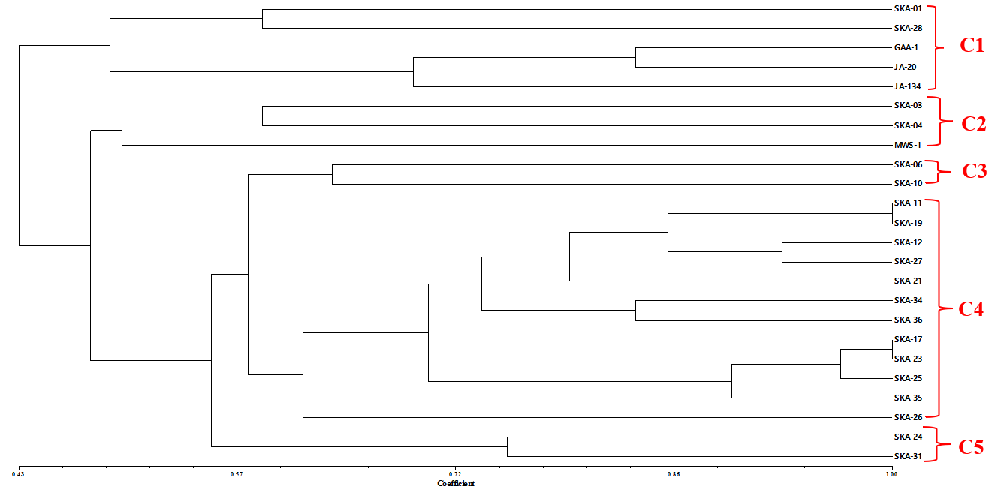
Fig 2. Dendrogram depicting the genetic relationships among 24 Ashwagandha genotypes based on SSR markers

The clustering of 24 genotypes into five groups (similarity coefficients 0.43-1.00) demonstrates meaningful genetic structuring, which can reflect geographic origin, breeding history, or other sources of differentiation. The high similarity (1.00) observed among some genotype pairs suggests possible redundancy or close kinship, indicating that the fingerprinting database can help identify duplicates or near-identical accessions in germplasm collections. The lower similarity pairs reflect good discriminatory ability of the marker set.
From a breeding and conservation standpoint, the molecular insights can guide the selection of genetically distant parents for hybridization, help maintain broad allele representation in core collections, and inform strategies to avoid genetic bottlenecks. To strengthen future work, one could (i) expand the number of SSR/EST-SSR loci (perhaps via transcriptome or genome sequencing), (ii) complement SSR data with SNP (single nucleotide polymorphism) markers using high-throughput sequencing, and (iii) increase geographic and seasonal sampling to capture more allelic richness.
CONCLUSION
This study established a reliable DNA fingerprinting database for 24 Withania somnifera genotypes using species-specific and cross-transferable SSR markers, demonstrating substantial genetic diversity and clear phylogenetic relationships. Among the 15 polymorphic primers, SSR22, WS_SSR08, SSR20, CaES5301, WS_SSR06, and T-44 exhibited superior efficiency, making them valuable for genetic characterization. The successful cross-genera transferability from solanaceous crops emphasizes the broader applicability of these markers, offering robust molecular tools for breeding, conservation, germplasm management, and future genomic studies in this medicinally important species.
Table 3. Jaccard’s similarity coefficient of Ashwagandha genotypes based on SSR markers
 | 1.00
 | 0.26 | 1.00
 | 0.40 | 0.59 | 1.00
 | 0.59 | 0.40 | 0.38 | 1.00
 | 0.46 | 0.40 | 0.33 | 0.64 | 1.00
 | 0.40 | 0.52 | 0.38 | 0.57 | 0.64 | 1.00
 | 0.38 | 0.69 | 0.56 | 0.67 | 0.56 | 0.87 | 1.00
 | 0.38 | 0.53 | 0.36 | 0.50 | 0.63 | 0.76 | 0.63 | 1.00
 | 0.40 | 0.52 | 0.38 | 0.57 | 0.64 | 1.00 | 0.87 | 0.76 | 1.00
 | 0.42 | 0.62 | 0.46 | 0.46 | 0.52 | 0.84 | 0.69 | 0.71 | 0.84 | 1.00
 | 0.33 | 0.57 | 0.35 | 0.53 | 0.64 | 0.77 | 0.62 | 1.00 | 0.77 | 0.69 | 1.00
 | 0.46 | 0.40 | 0.33 | 0.44 | 0.44 | 0.57 | 0.47 | 0.50 | 0.57 | 0.52 | 0.35 | 1.00
 | 0.42 | 0.48 | 0.35 | 0.59 | 0.67 | 0.84 | 0.69 | 0.93 | 0.84 | 0.79 | 1.00 | 0.52 | 1.00
 | 0.40 | 0.59 | 0.57 | 0.64 | 0.57 | 0.57 | 0.87 | 0.67 | 0.57 | 0.46 | 0.77 | 0.29 | 0.59 | 1.00
 | 0.42 | 0.48 | 0.46 | 0.59 | 0.52 | 0.84 | 0.93 | 0.71 | 0.84 | 0.79 | 0.69 | 0.52 | 0.79 | 0.59 | 1.00
 | 0.59 | 0.40 | 0.29 | 0.57 | 0.44 | 0.50 | 0.56 | 0.50 | 0.50 | 0.52 | 0.35 | 0.57 | 0.52 | 0.44 | 0.52 | 1.00
 | 0.48 | 0.42 | 0.40 | 0.40 | 0.52 | 0.75 | 0.59 | 0.71 | 0.75 | 0.70 | 0.57 | 0.75 | 0.70 | 0.40 | 0.70 | 0.46 | 1.00
 | 0.36 | 0.60 | 0.43 | 0.59 | 0.65 | 0.83 | 0.71 | 0.80 | 0.83 | 0.78 | 0.75 | 0.65 | 0.78 | 0.50 | 0.78 | 0.43 | 0.68 | 1.00
 | 0.26 | 0.67 | 0.50 | 0.45 | 0.50 | 0.63 | 0.67 | 0.92 | 0.63 | 0.58 | 1.00 | 0.43 | 0.76 | 0.72 | 0.58 | 0.41 | 0.50 | 0.61 | 1.00
 | 0.46 | 0.52 | 0.44 | 0.57 | 0.71 | 0.71 | 0.65 | 0.67 | 0.71 | 0.67 | 0.64 | 0.64 | 0.67 | 0.50 | 0.67 | 0.44 | 0.75 | 0.83 | 0.50 | 1.00
 | 0.26 | 0.48 | 0.52 | 0.40 | 0.40 | 0.52 | 0.50 | 0.61 | 0.52 | 0.48 | 0.50 | 0.40 | 0.48 | 0.46 | 0.48 | 0.25 | 0.42 | 0.60 | 0.71 | 0.46 | 1.00
 | 0.56 | 0.41 | 0.60 | 0.60 | 0.41 | 0.39 | 0.44 | 0.44 | 0.39 | 0.50 | 0.38 | 0.26 | 0.50 | 0.56 | 0.50 | 0.47 | 0.33 | 0.35 | 0.47 | 0.33 | 0.47 | 1.00
 | 0.50 | 0.27 | 0.42 | 0.64 | 0.42 | 0.48 | 0.47 | 0.47 | 0.48 | 0.43 | 0.40 | 0.48 | 0.57 | 0.42 | 0.57 | 0.48 | 0.43 | 0.50 | 0.50 | 0.42 | 0.50 | 0.83 | 1.00
 | 0.58 | 0.20 | 0.38 | 0.64 | 0.36 | 0.36 | 0.42 | 0.46 | 0.36 | 0.29 | 0.45 | 0.29 | 0.50 | 0.58 | 0.50 | 0.36 | 0.38 | 0.31 | 0.45 | 0.38 | 0.42 | 0.60 | 0.78 | 1.00
1=SKA-01, 2=SKA-03, 3= SKA-04, 4= SKA-06, 5= SKA-10, 6= SKA-11, 7=SKA-12, 8=SKA-17, 9=SKA-19, 10=SKA-21, 11=SKA-23, 12=SKA-24,13=SKA-25, 14=SKA-26, 15=SKA-27, 16=SKA-28, 17=SKA-31, 18=SKA-34, 19=SKA-35, 20=SKA-36, 21=MWS-1, 22=GAA-1, 23=JA-20, 24=JA-134.
Consent for publication:
By submitting this research paper for publication, all authors consent to its dissemination and acknowledge that it has not been previously published nor is it under consideration elsewhere.
Availability of data and material:
The data that has been used is confidential and raw data available as supplementary file.

Disclaimer (Artificial intelligence)
The authors declare that they have not used generative AI technologies for the writing or editing of manuscripts.

REFERENCES
Ashraf, J., Malik, W., Iqbal, M. Z., ALI, K. A., Qayyum, A., Noor, E., & Ahmad, M. Q. (2016). Comparative analysis of genetic diversity among bt cotton genotypes using EST-SSR, ISSR and morphological markers. Archive of SID, 18, 517-531.
Bamhania, K., Khatakar, S., Punia, A., & Yadav, O. P. (2013). Genetic variability analysis using ISSR markers in Withania Somnifera L. Dunal genotypes from different regions. Journal of herbs, spices & medicinal plants, 19(1), 22-32.
Chauhan, S., Joshi, A., Rajamani, G., & Jain, D. (2018). Genetic Diversity Analysis in Ashwagandha [Withania somnifera (L.) Dunal] Genotypes. International Journal of Current Microbiology and Applied Sciences, 7(1), 1574-1583.
Chawla. R., Sharma, H., Dadheech, A., Jattan, M., Devi, S., Kumar, P., Sachin, & Singh T. (2025). Genetic insights into diversity and population structure of ashwagandha (Withania somnifera (L.) Dunal) using EST-SSR, ISSR and SSR markers: Implications for enhancing agricultural and industrial value. Industrial Crops and Products, Volume 224, 120-242.
Doyle, J. J., & Doyle, J. L. (1990). Isolation of plant DNA from fresh tissue. Focus, 12(13), 39-40.
Gayen, K. C., Jana, P., & Giri, A. (2021). Use of Ashwagandha to Boost Immunity to Combat COVID-19. Immunity Boosting Functional Foods to Combat COVID 19. pp. 47-52.
Kalia, R. K., Rai, M. K., Kalia, S., Singh, R., & Dhawan, A. K. (2011). Microsatellite markers: an overview of the recent progress in plants. Euphytica, 177(3), 309-334.
Khan, S., & Shah, R. A. (2016). Assessment of genetic diversity among India Ginseng, Withania somnifera (L.) Dunal using RAPD and ISSR markers. Research in Biotechnology. 7, 1-10.
Khanna, P. K., Chandra, R., Kumar, A., Dogra, N., Gupta, H., Gupta, G., & Verma, V. (2016). Development of microsatellite markers and their correlation with morphological and chemical markers in Withania somnifera (L.) Dunal. Journal of BioScience & Biotechnology, 5(1), 53-60.
Kumar, S., Mahendi, H. A., Fougat, R. S., Sakure, A. A., & Mistry, J. G. (2014). Transferability of carrot (Daucus carota) microsatellite markers to cumin (Cuminum cyminum). International Journal of Seed Spices. 4(1), 88-90.
Liu, B. H. (1998). Statistical genomics: linkage, mapping, and QTL analysis. CRC press.
Mandlik, D. S., & Namdeo, A. G. (2021). Pharmacological evaluation of Ashwagandha highlighting its healthcare claims, safety, and toxicity aspects. Journal of Dietary Supplements, 18(2), 183-226.
Mishra, R. K., Gangadhar, B. H., Yu, J. W., Kim, D. H., & Park, S. W. (2011). Development and characterization of EST based SSR markers in Madagascar periwinkle (Catharanthus roseus) and their transferability in other medicinal plants. Plant Omics, 4(3), 154-162.
Mondini, L., Noorani, A., & Pagnotta, M. A. (2009). Assessing plant genetic diversity by molecular tools. Diversity, 1(1), 19-35.
Nagar, K. K., Meena, M. B., & Dubey, R. B. (2022). Multivariate Analysis of Genetic Diversity in the Ashwagandha (Withania somnifera (L.) Dunel) Genotype. Journal of Experimental Agriculture International, 44(8), 37-47.
Parita, B., Kumar, S. N., Darshan, D., & Karen, P. (2018). Elucidation of genetic diversity among ashwagandha [Withania somnifera (L.) Dunal] genotypes using EST-SSR markers. Research Journal of Biotechnology, 13(10), 52-59.
Parmar, E. K., Fougat, R. S., Patel, C. B., Zala, H. N., Patel, M. A., Patel, S. K., & Kumar, S. (2015). Validation of dbEST-SSRs and transferability of some other solanaceous species SSR in ashwagandha [Withania Somnifera (L.) Dunal]. Biotech, 5(6), 933-938.
Patel, A. I., & Desai, B. S. (2017). Genetic divergence in Ashwagandha [Withania somnifera (L.) Dunal.]: A review. Journal of Medicinal Plants, 5(3), 119-122.
Powell, W., Morgante, M., Andre, C., Hanafey, M., Vogel, J., Tingey, S., & Rafalski, A. (1996). The comparison of RFLP, RAPD, AFLP and SSR (microsatellite) markers for germplasm analysis. Molecular Breeding, 2, 225-238.
Prevost, A., & Wilkinson, M. J. (1999). A new system of comparing PCR primers applied to ISSR fingerprinting of potato cultivars. Theoretic and Applied Genetics, 98, 107-112.
Rohlf, F. (1994). NTSYS PC: numerical taxonomy and multivariate analysis for the IBM PC microcomputers (and compatibles), Version 1.80. User Manual. Stony Brook, New York, USA. 240, 1-6.
Russell, J., Booth, A., Fuller, J., Harrower, B., Hedley, P., Machray, G., & Powell, W. (2004). A comparison of sequence-based polymorphism and haplotype content in transcribed and anonymous regions of the barley genome. Genome, 47(2), 389-398.
Sharma, V., Sharma, S., Pracheta, & Paliwal, R., (2011). Withania somnifera: A rejuvenating ayurvedic medicinal herb for treatment of various human ailments. International Journal of Pharm Tech Research, 3, 187-192.
Singh, N., Bhalla, M., de Jager, P., & Gilca, M. (2011). An overview on ashwagandha: a Rasayana (rejuvenator) of Ayurveda. African Journal of Traditional, Complementary and Alternative Medicines, 8(S), 208-213.
Singleton, J. J., Mangat, P. K., Shim, J., Vavra, C., & Angeles-Shim, R. B. (2020). Cross-species transferability of Solanum spp. DNA markers and their application in assessing genetic variation in silverleaf nightshade (Solanum elaeagnifolium) populations from Texas, USA. Weed Science, 68(4), 396–404.
Smith, D. N., & Devey, M. E. (1994). Occurrence and inheritance of microsatellites in Pinusradiata. Genome, 37(6), 977-983.
Tessier, C., David J., This P., Boursiquot J. M., & Charrier A. (1999). Optimization of the choice of molecular markers for varietal identification in Vitis vinifera L. Theoretical and Applied Genetics, 98, 171–177.
Tripathi, N., Saini, N., Mehto, V., Kumar, S., & Tiwari, S. (2012). Assessment of genetic diversity among Withania somnifera collected from central India using RAPD and ISSR analysis. Med Aromatic Plant Sci Biotechnology, 6(1), 33-39.
Vosman, B., Arens, P., Rus-Kortekaas, W., & Smulders, M. J. M. (1992). Identification of highly polymorphic DNA regions in tomato. Theoretical and Applied Genetics, 85(2-3), 239-244.

