Association Studies on Grain Yield and its Determining Characters in Bread Wheat (Triticum aestivum L.)

Abstract:
Correlation analysis in wheat helps identify relationships among agronomic, physiological, and yield traits, guiding crop improvement. A major contributing element to crop improvement can be found by evaluating the degree of relationship between variables like plant height, number of tillers, spike length, grain weight, and yield. Understanding these relationships enables plant breeders to optimize trait selection, and enhance wheat productivity under diverse climatic conditions. Grain yield per plant showed strong positive associations with key yield traits such as productive tillers, biological yield, 1000-grain weight, and harvest index, indicating their importance in yield improvement. Negative correlations with maturity traits and plant height suggest that early, compact genotypes are more productive, supporting trait-based selection in wheat breeding.
Keywords: Correlation analysis, crop improvement, genotypic correlation, grain yield, plant breeding, trait association, wheat.
Introduction:
“Wheat is one of the most important cereal crops in the world, serving as a staple food for a large portion of the global population. Belonging to the genus Triticum, wheat is primarily cultivated for its grain, which is ground into flour and used to make bread, pasta, noodles, cakes, pastries, and many other food products. The domestication of wheat is believed to have started around 9,000–10,000 years ago in the Fertile Crescent, a region of the Near East known for early agricultural development” (Salamini et al., 2002). “In 2023, around 733 million people faced hunger globally, with Asia seeing a continued rise to 8.1% of its population”. (The State of Food Security and Nutrition in the World, 2024). “In this context wheat is a crucial staple food for over half of the world's population, providing 80% of their food needs”. (UN DESA, 2024). In India, wheat is one of the most important staple food crops, and its production has shown a steady upward trend in recent years. During 2022–23, the total area under wheat cultivation was about 31.40 (M/ha), which further increased to 31.83 (M/ha) in 2023–24, reflecting the continued expansion of wheat acreage in the country. Along with the increase in cultivated area, wheat production also recorded significant growth. In 2022–23, the total production was around 110.55 MT, while in 2023–24 it rose to nearly 113.29 MT with key producing states including Uttar Pradesh, Punjab, Haryana, Madhya Pradesh, and Rajasthan.
The primary goal of wheat breeding programs worldwide is to develop cultivars with superior yield potential (Ehdaie and Waines, 1989). Genetic variability plays a pivotal role in this process, as greater diversity within plant populations ensures wider adaptability across years and environments (Rasmusson et al., 1997), Such variability not only enhances the probability of obtaining highly heterotic crosses but also provides a broad spectrum of traits in segregating generations, which can be effectively harnessed for genetic improvement. Examining the variability of traits and understanding how a specific character is associated with other yield-contributing traits is crucial for designing an effective breeding program (Mary and Gopalan, 2006). In wheat breeding, the primary goal has consistently been the development of varieties with high yield potential coupled with favorable trait combinations.
According to Falconer (1981), “correlations among traits are influenced by both genetic makeup and environmental conditions. Genetically, these correlations may arise due to pleiotropy, where a single gene affects multiple traits, or linkage disequilibrium, where genes controlling different traits are inherited together”. Environmentally, factors such as soil fertility, temperature, moisture availability, and agronomic practices can modulate trait expression and their interrelationships. These combined influences determine the strength and direction of trait correlations, which is critical for effective selection in breeding programs. Variability caused by the environment affects not only the expression of individual traits but also the nature of their interrelationships. The present study, therefore, aimed to determine the interrelationships among different wheat components and their association with grain yield. Correlation analysis holds great significance in plant breeding since it reveals the strength and direction of the relationship between yield-contributing traits and overall yield. A positive correlation among desirable traits is advantageous, as it assists breeders in simultaneous selection, whereas negative correlations pose challenges in combining favorable characters. As noted by Dixet and Dubey (1984), correlation studies offer valuable insights into how different traits are associated with grain yield, thereby facilitating more effective selection strategies in wheat improvement.
Material and methods:
Basic material consisting of 10 lines morphological diverse genotypes viz., PBW 852, HD 3386, PBW826, HD3388, K607, DBW187, K1317, DBW316, PBW833 and PBW835 were obtained from the germplasm maintained at Section of Rabi Cereals in the month of November 22 of the university in order to develop material to be evaluated for the study. These parental lines were crossed to develop 45 F1s and F2s using diallel mating design. A total of 100 treatments (10 parents + 45 F1s + 45 F2s) were evaluated for the study of genetical analysis of sixteen traits in wheat. Crosses were made in diallel fashion and resultant seeds of 45 hybrids as well as parental lines were harvested separately. The final trial, which involved 100 lines (10 parents + 45 F1 and 45 F2), was carried out in Rabi season 2024–2025 at the Nawabganj farm of C.S. Azad University, Kanpur, using a Randomised Block Design (RBD) with three replications.
Estimation of Correlation coefficients
According to Dewey and Lu (1959), the estimates of phenotypic and genotypic correlation were calculated as follows:
Genotypic correlation:
rxy(g) = Cov.xy(g) / [Vx (g).Vy (g)]^{0.5}
Where,
Cov.xy (g) = genotypic covariance between character X and y was obtained as follows:

Cov.xy (g) = [Cov. Xy (p) – Cov. Xy (e)]/r
Vx (g) and Vy (g) = Genotypic variance for the characters x and y
respectively
r = number of replications.
Phenotypic correlation:
rxy (p) = Cov. Xy (p) / [Vx (p). Vy (p)]^{0.5}
Where,
Cov.Xy (p) = Phenotypic correlation between the character x and y and this was obtained as follows:
Cov.xy (p) = Cov. xy (g) + Cov. xy (e)
Vx (p) and Vy (p) = Phenotypic variance for the characters x and y, respectively.
xy (e) = the error variance obtained from the ANOVA of x and y characters.
Test of significance of correlation coefficients:
The significance of phenotypic coefficient was tested against r‟ values from r‟ Table of Fisher and Yates (1938) for (n-2) degree of freedom where n‟ is number of treatments.
Result:
Correlation study was carried out between all the sixteen characters at genotypic and phenotypic levels. The phenotypic and genotypic correlation coefficient of F₁ and F₂ computed among the thirteen characters under study has been presented in Table 1 and Table 2 respectively.
Genotypic Correlation (F₁ and F₂ Generation):
The genotypic correlation of grain yield per plant (GYPP) showed a highly significant positive correlation with number of productive tillers (0.9313), biological yield (0.9198), 1000-grain weight (0.8682), grains per ear (0.8307), number of tillers (0.8037), number of spikelets (0.6713), harvest index (0.633) and canopy temperature (0.3838), while spike length (0.3515) was significantly and positively associated with grain yield per plant. Moreover, a significant negative genotypic correlation was observed with days to 50% heading (-0.1379) and days to maturity (-0.1298). (Table:1 - In Upper half diagonal)
In the F2 generation, genotypic correlation of grain yield per plant showed a highly significant positive association with biological yield (0.8258), grains per ear (0.7723), number of tillers (0.7681), 1000-grain weight (0.6052), number of spikelets (0.5749), number of productive tillers (0.5417) and harvest index (0.4473) (Table :2 – In Upper half diagonal).
1. Days to 50% heading
In the F1 generation, days to 50% heading showed a highly significant positive correlation with days to maturity (0.65) and significant negative correlation was observed with grain yield per plant (-0.1379). In the F2 generation, days to 50% heading exhibited a significant positive correlation with days to maturity (0.3421) and negative and non-significant correlations were found with gluten content (-0.2863), spike length (-0.1136) and other traits, which were negligible.
2. Days to maturity
In the F1 generation, days to maturity had a highly significant positive association with days to 50% heading (0.6543) and significant negative correlation was observed with spike length (-0.3388) and grain yield per plant (-0.1298). In the F2 generation, days to maturity showed a significant positive association with days to 50% heading (0.3421) and Significant negative associations were observed with spike length (-0.3786) and harvest index (-0.333).
3. Plant height (cm)
In the F1 generation, plant height exhibited a positive and significant association with canopy temperature depression (0.6764), days to maturity (0.3323), and days to 50% flowering (0.2949) and also showed significant negative correlations with protein content (-0.5895), harvest index (-0.5300), and spike length (-0.3534). In the F2 generation, plant height was positively and significantly associated with grain content (0.3122) and but negligible association with harvest index, spike length, test weight, biological yield, number of spikes, number of productive tillers, and total number of tillers.
4. Total No. of tillers per plant
In the F1 generation, total number of tillers exhibited a significant and positive correlation with Number of grains/ear (0.893) and positive but negligible association was observed with spike length and canopy temperature depression. In the F2 generation, total number of tillers maintained a positive and significant relationship with Number of grains/ear (0.8255), biological yield per plant (0.7814), grain yield per plant (0.7681), number of spikes (0.7663), number of productive tillers (0.7168), harvest index (0.6333), and 1000-grain weight (0.6002).
5. Productive tillers/plant
In the F1 generation, the trait number of productive tillers per plant had a positive and highly significant association with grain yield per plant (0.9313), biological yield per plant (0.824), 1000-grain weight (0.9125) and a negative but negligible correlation was noted with days to 50% heading. In the F2 generation, the trait number of productive tillers per plant had a positive and highly significant association with total number of tillers per plant (0.7168) and Negative but negligible associations were recorded with days to maturity, canopy temperature, plant height, and days to 75% heading.
6. Number of spikelets/spike
In the F1 generation traits, the number of tillers per plant (0.8162), number of grains per spike (0.7682), harvest index (0.684), grain yield per plant (0.6713), 1000-grain weight (0.6371) showed a positive and significant association with the number of spikelets per spike. In the F2 generation, the number of tillers per plant (0.7663), number of grains per spike (0.6245) showed positive and significant correlation with the number of spikelets per spike. Plant height (-0.0778), canopy temperature (-0.153), days to maturity (-0.1964), and protein content (-0.067) showed negligible negative correlation.
7. Spike length
In the F1 generation, Positive but non-significant correlations were observed with biological yield per plant (0.2938) and significant negative correlations were found with plant height (-0.3534), days to maturity (-0.3388), and canopy temperature (-0.3319). In the F2 generation, spike length exhibited a positive and significant correlation with 1000-grain weight (0.4854) and significant negative correlations were observed with gluten content (-0.4298) and days to maturity (-0.3786), while plant height (-0.2343), protein content (-0.2015).
8. Number of grains/ear
In the F1 generation, the trait number of grains per ear exhibited a positive and significant association with number of tillers per plant (0.893), number of productive tillers per plant (0.8478), grain yield per plant (0.8307) and non-significant negative associations with gluten content (-0.1856), days to maturity (-0.0855). In the F2 generation, number of grains per spike had a positive and significant correlation with number of tillers per plant (0.8255) and grain yield per plant (0.7723).
9. Biological yield/plant (g)
In the F1 generation, biological yield per plant showed a positive and significant association with number of productive tillers per plant (0.824), grain yield per plant (0.9313) and 1000-grain weight (0.8951) and biological yield per plant exhibited a significant negative association with gluten content (-0.4568). In the F2 generation, biological yield per plant had a positive and significant correlation with grain yield per plant (0.8258) and days to 50% heading showed non-significant negative associations with days to maturity (-0.1704), plant height (-0.1008), and gluten content (-0.0025).
10. 1000-grain weight (g)
in the F1 generation, the trait 1000 grain weight had a positive and significant relationship with number of productive tillers per plant (0.9125), biological yield per plant (0.8951), grain yield per plant (0.8682), grains per ear (0.7314) and number of tillers per plant (0.717). In the F2 generation, thousand-grain weight exhibited a positive and significant association with number of productive tillers per plant (0.6768), grains per ear (0.6677), biological yield per plant (0.6268) and grain yield per plant (0.6052) while non-significant negative correlations were found with canopy temperature (-0.1929), gluten content (-0.1815).
11. Harvest index
In the F1 generation, harvest index showed a positive and significant association with number of tillers per plant (0.8689) and harvest index exhibited a significant negative association with plant height (-0.53). In the F2 generation, harvest index was positively and significantly correlated with biological yield per plant (0.7289) and number of productive tillers per plant (0.6928) while significant negative correlations were found with canopy temperature (-0.4478) and days to maturity (-0.333).
12. Protein content
In the F1 generation, protein content showed a positive and significant association with spike length (0.6389) while significant negative correlations were found with plant height (-0.5895) and canopy temperature (-0.5866). In the F2 generation, protein content exhibited a positive and significant association with gluten content (0.4863).
13. Gluten content
In the F1 generation, gluten content exhibited a positive but negligible genotypic correlation with spike length (0.0875) and plant height (0.0676) and Significant negative correlations were observed with number of productive tillers per plant (-0.4643). In the F2 generation, gluten content had a positive and significant relationship with protein content (0.4863) and plant height (0.3122) and significant negative correlations were recorded with number of spikelets per spike (-0.4298) and number of spikelets per spike (-0.4319).
Phenotypic Correlation (F₁ and F₂ Generation):
In the F1 generation, the trait grain yield per plant showed a positive and highly significant association with biological yield per plant (0.7146), number of grains per spike (0.6773), number of productive tillers per plant (0.6653), 1000-grain weight (0.6244) and total number of tillers per plant (0.6234) and significant negative correlation was found with gluten content (-0.2899), days to 75% heading (-0.1259), days to maturity (-0.1179). Table :1 (Lower half diagonal).
In the F2 generation, the trait grain yield per plant showed a highly significant and positive correlation with number of grains per ear (0.7031), biological yield per plant (0.5788), total number of tillers per plant (0.5675), number of spikelets per spike (0.4557), 1000-grain weight (0.433), number of productive tillers per plant (0.4221), and harvest index (0.2569). Table :2 (Lower half diagonal).
1. Days to 50% heading
In the F1 generation, days to 50% heading showed a positive and significant association with days to maturity (0.5686), plant height (0.2567), and number of spikelets per spike (0.1718). In the F2 generation, days to 75% heading had a positive and significant association with days to maturity (0.2871) while non-significant negative associations were observed with gluten content, spike length, canopy temperature, harvest index, protein content, number of productive tillers per plant.
2. Days to maturity
In the F1 generation, days to maturity had a positive and significant association with days to 75% heading (0.5686), plant height (0.2996), and canopy temperature (0.2602) while significant negative associations were recorded with spike length (-0.2944) and protein content (-0.2161). In the F2 generation, days to maturity showed a positive and significant association with days to 50% heading (0.2871), plant height (0.1955), and protein content (0.1725).
3. Plant height (cm)
In the F1 generation, plant height showed a positive and significant correlation with days to maturity (0.2996) and canopy temperature (0.4431) while days to 50% heading (0.2567) Significant and negative correlation was noted with protein content (-0.3795). In the F2 generation, plant height showed a positive and significant correlation with days to maturity (0.1955) and protein content (0.1706).
4. Total No. of tillers per plant
In the F1 generation, number of tillers showed a significantly correlated with number of grains per spike (0.7084), grain yield per plant (0.6234), number of spikelets (0.6099) and number of productive tillers (0.5178) while Significant and negative correlation was observed with gluten content (-0.3362). In the F2 generation, number of tillers showed a positive and significant correlation with grain yield per plant (0.5675) and number of grains per spike (0.5582) while a negligible negative relation was noted with days to 50% heading and plant height.
5. Productive tillers/plant
In F1 number of productive tillers per plant had a positive and significant association with biological yield per plant (0.7704) and grain yield per plant (0.6653) while the trait exhibited a significant and negative correlation with gluten content (-0.2815). In the F2 generation, the present investigation unveiled that number of productive tillers per plant had a positive and significant association with number of tillers per plant (0.5564) and number of grains per spike (0.5276) while number of productive tillers per plant showed a non-significant and negative association with days to maturity (-0.1442) and plant height (-0.0731).
6. Number of spikelets/spike
In the F1 generation, the traits number of grains per spike (0.626), number of tillers per plant (0.6099) and grain yield per plant (0.497) showed a positive association with number of spikelets per spike. In the F2 generation, the traits number of grains per spike (0.4769) and number of tillers per plant (0.4668) showed a positive association with number of spikelets per spike.
7. Spike length
In the F1 generation, the study revealed that trait spike length had a positive relationship with protein content (0.3515), number of spikelets per spike (0.2707) and thousand grain weight (0.2687) and the trait exhibited a negative correlation with days to maturity (-0.2944) and plant height (-0.2588). In the F2 generation, the study revealed that trait spike length had a positive relationship with number of spikelets per spike (0.3106) and thousand grain weight (0.3026) while the trait exhibited a negative correlation with days to maturity (-0.2944), plant height (-0.2199) and gluten content (-0.1826).
8. Number of grains/ear
In F1 trait number of grains per ear had a positive association with number of tillers per plant (0.7084), grain yield per plant (0.6773) and number of spikelets per spike (0.626) while number of grains per spike showed a non-significant and negative association with gluten content (-0.1564) and days to maturity (-0.0771). In the F2 generation, the present investigation unveiled that trait number of grains per spike had a positive association with grain yield per plant (0.7031) and number of grains per spike showed a non-significant and negative association with days to maturity (-0.1413), gluten content (-0.1211) and canopy temperature (-0.0278).
9. Biological yield/plant (g)
In the F1 generation, the traits number of productive tillers per plant (0.7704), grain yield per plant (0.7146) and thousand grain weight (0.6885) showed a positive association with biological yield per plant. In the F2 generation, the traits grain yield per plant (0.5788), number of grains per spike (0.5184), thousand grain weight (0.5029) and number of tillers per plant (0.4871) showed a positive association with biological yield per plant.
10. 1000-grain weight (g)
In the F1 generation, the study revealed that trait thousand grain weight had a positive relationship with biological yield per plant (0.6885), number of productive tillers per plant (0.6255) and grain yield per plant (0.6244) while the trait exhibited a negative correlation with gluten content (-0.2432). In the F2 generation, the study revealed that trait thousand grain weight had a positive relationship with biological yield per plant (0.5029) while 1000-grain weight showed a non-significant and negative association with gluten content (-0.1409), days to maturity (-0.0927), plant height (-0.0754) and days to 75% heading (-0.0295).
11. Harvest index
In the F1 generation, the present investigation unveiled that trait harvest index had a positive association with number of grains per ear (0.5327) while the trait exhibited a negative correlation with plant height (-0.188). In the F2 generation, the present investigation unveiled that trait harvest index had a positive association with number of grains per spike (0.3903)and number of productive tillers per plant (0.3743) while the trait exhibited a negative correlation with days to maturity (-0.2294) and canopy temperature (-0.2019).
12. Protein content
In the F1 generation, the traits spike length (0.3515) and number of spikelets per spike (0.316) showed a positive correlation with protein content and the protein content exhibited a negative correlation with plant height (-0.3795), canopy temperature (-0.3707), days to maturity (-0.2161), and gluten content (-0.1815). In the F2 generation, the traits gluten content (0.3765), days to maturity (0.1725), and plant height (0.1706) showed a positive correlation with protein content.
13. Gluten content
In the F1 generation, the correlation of gluten content was positive but non-significant with spike length (0.0888) and plant height (0.0543). Gluten content showed a significant negative correlation with number of tillers per plant (-0.3362) and biological weight (-0.3227). In the F2 generation, the study revealed that gluten content had a positive and significant relationship with protein content (0.3765).
Table 1: Genotypic (upper half diagonal) and Phenotypic (lower half diagonal) correlation among 15 characters of F₁s generation in wheat.

Genotypic  Phenotypic | Days to 50% heading | Days to maturity | Plant height (cm) | No. of tillers/plant | No. of productive tillers/plant | No. of spikelets/spike | Spike length (cm) | No. of grain/spike | Biological yield /plant (g) | 1000-grain weight (g | Harvest index (%) | Protein content (%) | Gluten content(%) | Canopy Temperature | Grain yield/plant (g)
Days to 50% heading | 1 | 0.6543 ** | 0.2949 * | -0.0557 | -0.1957 | 0.1733 | -0.1918 | -0.0003 | -0.0969 | 0.0447 | -0.2074 | 0.0282 | -0.2492 | -0.0779 | -0.1379*
Days to maturity | 0.5686 ** | 1 | 0.3323 * | -0.1432 | 0.051 | -0.0496 | -0.3388 * | -0.0855 | -0.0098 | 0.1006 | -0.0217 | -0.2753 | -0.0964 | 0.4327 ** | -0.1298*
Plant height (cm) | 0.2567 ** | 0.2996 ** | 1 | -0.1579 | 0.0729 | -0.1727 | -0.3534 * | 0.0097 | 0.1691 | -0.0465 | -0.53 ** | -0.5895 ** | 0.0676 | 0.6764 ** | 0.0842
No. of tillers/plant | 0.0014 | -0.1295 | -0.111 | 1 | 0.8578 ** | 0.8162 ** | 0.2471 | 0.893 ** | 0.7076 ** | 0.717 ** | 0.8689 ** | 0.3379 * | -0.4479 ** | 0.0409 | 0.8037 **
No. of productive tillers/plant | -0.0783 | 0.0161 | 0.0569 | 0.5178 ** | 1 | 0.6314 ** | 0.2889 | 0.8478 ** | 0.824 ** | 0.9125 ** | 0.7186 ** | 0.0343 | -0.4643 ** | 0.6459 ** | 0.9313 **
No. of spikelets/spike | 0.1718 * | -0.0496 | -0.1233 | 0.609 ** | 0.3864 ** | 1 | 0.3918 ** | 0.7682 ** | 0.5391 ** | 0.6371 ** | 0.684 ** | 0.5192 ** | -0.3648 * | -0.1368 | 0.6713 **
Spike length (cm) | -0.1491 | -0.2944 ** | -0.2588 ** | 0.1761 * | 0.148 | 0.2707 ** | 1 | 0.2348 | 0.2938 | 0.367 * | 0.4186 ** | 0.6389 ** | 0.0875 | -0.3319 * | 0.3515 *
No. of grain/spike | 0.0342 | -0.0771 | 0.0317 | 0.7084 ** | 0.607 ** | 0.626 ** | 0.1988 * | 1 | 0.7464 ** | 0.7314 ** | 0.7089 ** | 0.125 | -0.1856 | 0.0771 | 0.8307 **
Biological yield /plant (g) | -0.0585 | -0.0086 | 0.095 | 0.5164 ** | 0.7704 ** | 0.3831 ** | 0.2411 ** | 0.6024 ** | 1 | 0.8951 ** | 0.5772 ** | 0.0562 | -0.4568 ** | 0.5702 ** | 0.9198 **
1000-grain weight (g | 0.0588 | 0.0621 | -0.034 | 0.466 ** | 0.6255 ** | 0.3714 ** | 0.2687 ** | 0.6183 ** | 0.6885 ** | 1 | 0.6137 ** | 0.1312 | -0.3343 * | 0.2329 | 0.8682 **
Harvest index (%) | -0.0384 | -0.0453 | -0.188 * | 0.4352 ** | 0.4278 ** | 0.4055 ** | 0.2088 * | 0.5327 ** | 0.0708 | 0.3529 ** | 1 | 0.2371 | -0.0818 | -0.1208 | 0.633 **
Protein content (%) | 0.0092 | -0.2161 * | -0.3795 ** | 0.1287 | 0.0049 | 0.316 ** | 0.3515 ** | 0.0641 | 0.0136 | 0.0672 | 0.0758 | 1 | -0.23 | -0.5866 ** | 0.0834
Gluten content(%) | -0.2185 * | -0.0893 | 0.0543 | -0.3362 ** | -0.2815 ** | -0.3047 ** | 0.0888 | -0.1564 | -0.3227 ** | -0.2432 ** | -0.0668 | -0.1815 * | 1 | -0.0376 | -0.3153
Canopy Temperature | -0.0581 | 0.2602 ** | 0.4431 ** | -0.06 | 0.2084 * | -0.145 | -0.1416 | 0.0109 | 0.2778 ** | 0.0432 | -0.0861 | -0.3707 ** | -0.0384 | 1 | 0.3838 **
Grain yield/plant (g) | -0.1259* | -0.1179* | 0.0628 | 0.6234 ** | 0.6653 ** | 0.497 ** | 0.2266 ** | 0.6773 ** | 0.7146 ** | 0.6244 ** | 0.3616 ** | -0.0205 | -0.2899 ** | 0.225 ** | 1

**highly significant, * significant.

Table 2: Genotypic (upper half diagonal) and Phenotypic (lower half diagonal) correlation among 15 characters of F₂s generation in wheat.
Genotypic  Phenotypic | Days to 50% heading | Days to maturity | Plant height (cm) | No. of tillers/plant | No. of productive tillers/plant | No. of spikelets/spike | Spike length (cm) | No. of grain/spike | Biological yield /plant (g) | 1000-grain weight (g | Harvest index (%) | Protein content (%) | Gluten content(%) | Canopy Temperature | Grain yield/plant (g)
Days to 50% heading | 1 | 0.3421 * | 0.0515 | -0.0381 | -0.0737 | 0.0501 | -0.1136 | 0.077 | 0.0206 | -0.01 | 0.0795 | -0.0909 | -0.2863 | -0.0764 | 0.0408
Days to maturity | 0.2871 ** | 1 | 0.2128 | -0.2215 | -0.1962 | -0.1964 | -0.3786 * | -0.1985 | -0.1704 | -0.087 | -0.333 * | 0.2394 | 0.188 | 0.1309 | -0.0593
Plant height (cm) | 0.0604 | 0.1955 * | 1 | -0.0459 | -0.0752 | -0.0778 | -0.2343 | 0.0066 | -0.1008 | -0.1026 | -0.269 | 0.1979 | 0.3122 * | 0.0518 | 0.0877
No. of tillers/plant | -0.036 | -0.1968 * | -0.0338 | 1 | 0.7168 ** | 0.7663 ** | 0.2521 | 0.8255 ** | 0.7814 ** | 0.6002 ** | 0.6333 ** | 0.0667 | -0.0433 | -0.0129 | 0.7681 **
No. of productive tillers/plant | -0.0475 | -0.1442 | -0.0731 | 0.5564 ** | 1 | 0.6206 ** | 0.274 | 0.6824 ** | 0.6874 ** | 0.6768 ** | 0.6928 ** | 0.0919 | 0.0836 | -0.0863 | 0.5417 **
No. of spikelets/spike | 0.0734 | -0.1469 | -0.0577 | 0.4668 ** | 0.3972 ** | 1 | 0.356 * | 0.6245 ** | 0.5813 ** | 0.5232 ** | 0.5321 ** | -0.067 | -0.4319 ** | -0.153 | 0.5749 **
Spike length (cm) | -0.0916 | -0.2944 ** | -0.2199 * | 0.1715 * | 0.1943 * | 0.3106 ** | 1 | 0.2611 | 0.2284 | 0.4854 ** | 0.3219 * | -0.2015 | -0.4298 ** | -0.0612 | 0.0335
No. of grain/spike | 0.0707 | -0.1413 | 0.0103 | 0.5582 ** | 0.5276 ** | 0.4769 ** | 0.2149 * | 1 | 0.7511 ** | 0.6677 ** | 0.5711 ** | 0.0397 | -0.214 | -0.0299 | 0.7723 **
Biological yield /plant (g) | -0.018 | -0.1346 | -0.0755 | 0.4871 ** | 0.433 ** | 0.3411 ** | 0.1423 | 0.5184 ** | 1 | 0.6268 ** | 0.7289 ** | 0.1742 | -0.0025 | 0.0067 | 0.8258 **
1000-grain weight (g | -0.0295 | -0.0927 | -0.0754 | 0.3266 ** | 0.4507 ** | 0.2652 ** | 0.3026 ** | 0.427 ** | 0.5029 ** | 1 | 0.5241 ** | 0.0277 | -0.1815 | -0.1929 | 0.6052 **
Harvest index (%) | -0.0739 | -0.2294 ** | -0.1516 | 0.2954 ** | 0.3743 ** | 0.2664 ** | 0.1978 * | 0.3903 ** | 0.3194 ** | 0.3079 ** | 1 | -0.1277 | -0.2017 | -0.4478 ** | 0.4473 **
Protein content (%) | -0.0643 | 0.1725 * | 0.1706 * | 0.047 | 0.0735 | -0.0507 | -0.1572 | 0.0224 | 0.0669 | 0.0121 | -0.0243 | 1 | 0.4863 ** | 0.1618 | 0.0336
Gluten content (%) | -0.1077 | 0.0714 | 0.1572 | 0.0106 | 0.0504 | -0.2101 * | -0.1826 * | -0.1211 | -0.1022 | -0.1409 | -0.0631 | 0.3765 ** | 1 | 0.1301 | -0.1159
Canopy Temperature | -0.0809 | 0.1277 | 0.0475 | 0.0116 | -0.0128 | -0.1376 | -0.0526 | -0.0278 | 0.0546 | 0.008 | -0.2019 * | 0.1418 | 0.0526 | 1 | -0.007
Grain yield/plant (g) | 0.0491 | -0.0532 | 0.0991 | 0.5675 ** | 0.4221 ** | 0.4557 ** | 0.0205 | 0.7031 ** | 0.5788 ** | 0.433 ** | 0.2569 ** | 0.0158 | -0.0725 | 0.0016 | 1

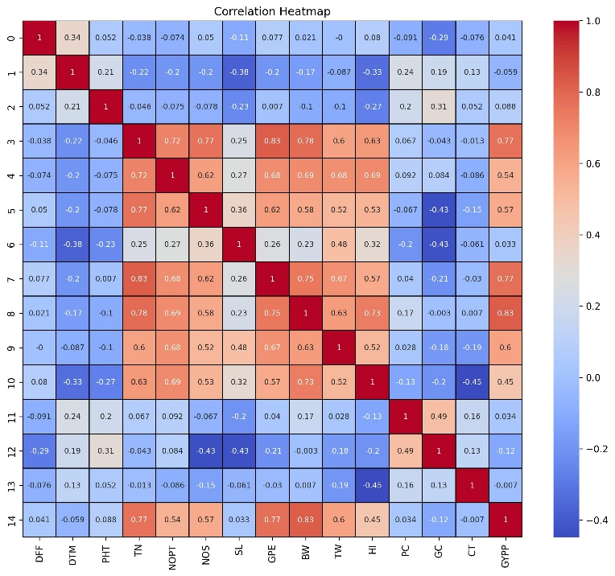
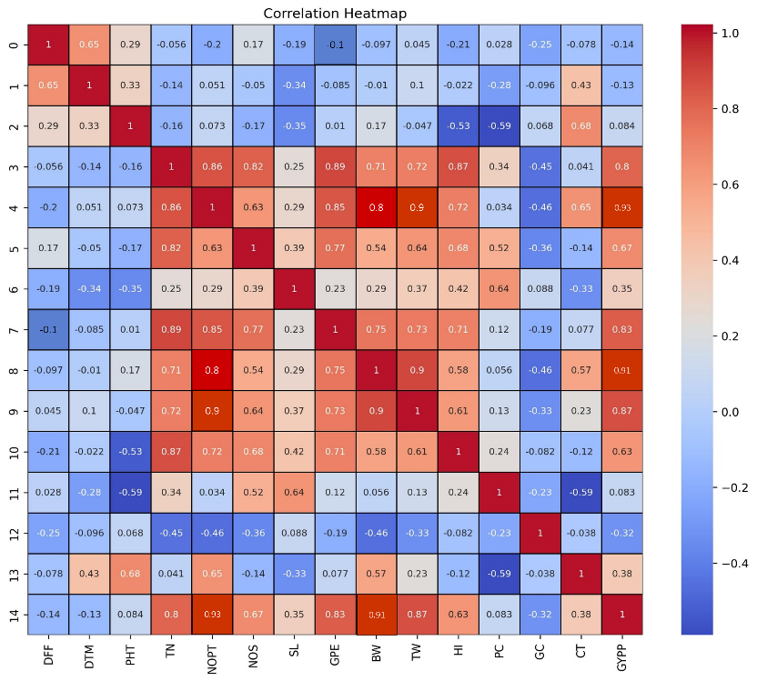
B
A

Figure 1: Genotypic (A) and (B) correlation in F₁ and F₂ among 15 traits in Wheat.
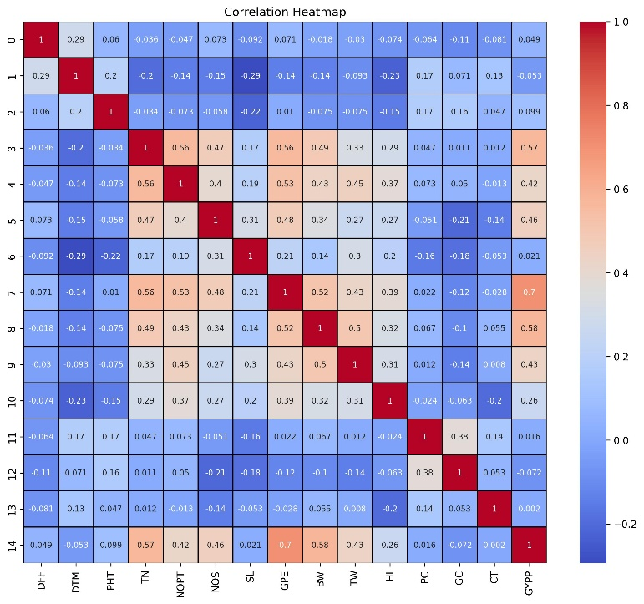
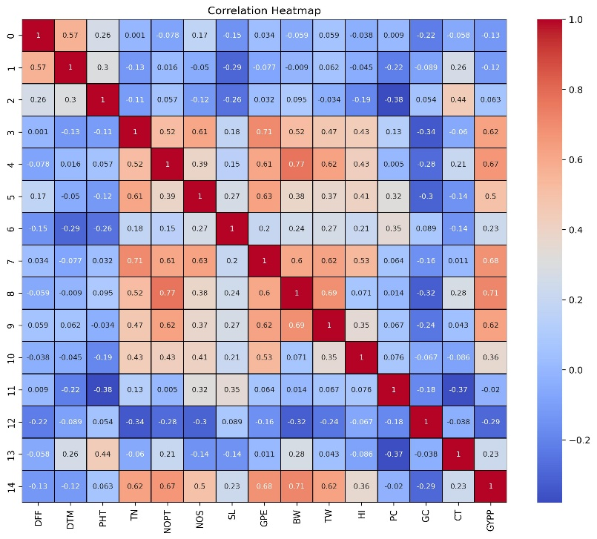
DFF = Days to 50% heading, DTM = Days to maturity, PHT = Plant height (cm), TN = Number of tillers/plant, NOPT = Number of productive tillers/plant, NOS = Number of spikelets/ear, SL = Spike length (cm), GPE = Number of grains/ear, BW = Biological yield/plant (g), TW = 1000-grain weight (g), HI = Harvest index (%), PC = Protein content (%), GC = Gluten content (%), CT = Canopy Temperature, GYPP = Grain yield/plant (g).
B
A

Figure 2: Phenotypic (A) and (B) correlation in F₁ and F₂ among 15 traits in Wheat.
Figure 1 and Figure 2:
A correlation heatmap (Figs. 1 & 2) shows the correlation coefficients among traits, with Fig. 1 (A, B) for genotypic correlations in the F₁ generation and Fig. 2 (A, B) for the F₂ generation. Warm colors indicate strong positive correlations (eg., red/orange), cool colors (eg., blue) strong negative correlations, and neutral shades (eg., white/gray) weak or no correlation.
Discussion:
At the genotypic level, GYPP exhibited strong and significant positive correlations with number of productive tillers, biological yield, 1000-grain weight, number of grains per ear, total tillers, spikelets per spike, and harvest index. The strength of these correlations indicates that improving one trait may positively influence others, thereby accelerating genetic gains. Similar findings have been reported by Yousaf et al. (2017), Kaur et al. (2019), and Sokoto et al. (2012), who emphasized “the importance of these traits in wheat breeding programs. Negative genotypic correlations were observed with days to heading, days to maturity, gluten content, and plant height, indicating that early maturing and compact genotypes with lower gluten content may be more favorable for achieving higher grain yield”. These trends are consistent with the observations of Tsenov (2009), Singh et al. (2024), Lama et al. (2023), and Sharma et al. (2021), who also reported that delayed maturity and excessive vegetative growth can negatively impact yield.
Phenotypic correlations give many of the genotypic trends, highlighting the reliability of these associations under field conditions. There were notable positive phenotypic associations with grain yield per plant with biological yield, number of grains per spike, productive tillers, 1000-grain weight, total tillers, spikelets per spike, and harvest index in both generations. Negative phenotypic correlations with gluten content, days to heading, and days to maturity further support the preference for early maturing genotypes with optimized grain composition for yield enhancement. These results align with previous studies by Mason et al. (2006); Kuru et al. (2025), confirming the practical relevance of these traits in breeding programs. Overall, the combined correlation analysis highlights the importance of selecting traits with strong positive associations to grain yield, both genetically and phenotypically.
Conclusion:
Grain yield per plant showed strong positive genotypic and phenotypic correlations with productive tillers, biological yield, 1000-grain weight, number of grains per ear, total tillers, spikelets per spike, and harvest index, confirming their importance in yield enhancement. Moderate positive correlations with spike length and canopy temperature suggest supportive roles in yield expression. Negative correlations with days to heading, days to maturity, gluten content, and plant height favor early maturing, compact genotypes for higher productivity. These associations provide a reliable basis for trait-based selection in wheat breeding.
Disclaimer (Artificial intelligence)
Option 1:
Author(s) hereby declare that NO generative AI technologies such as Large Language Models (ChatGPT, COPILOT, etc.) and text-to-image generators have been used during the writing or editing of this manuscript.
Option 2:
Author(s) hereby declare that generative AI technologies such as Large Language Models, etc. have been used during the writing or editing of manuscripts. This explanation will include the name, version, model, and source of the generative AI technology and as well as all input prompts provided to the generative AI technology
Details of the AI usage are given below:
1.
2.
3.
References:
Dewey, D.R. and Lu, K.H. 1959. A correlation and path coefficient analysis of components of crested wheat grass seed production. Agron. J., 51: 512-515.
Dixet, P. and Dubey, D.K. 1984. Path analysis in lentil (Lens culinaris Med.). Lens Newsletter, 11: 15- 17.
Ehdaie, B., Waines J.G. 1989. Genetic variation, heritability, and path-analysis in landraces of bread wheat from southwestern Iran. Euphyt. 41: 183–190.
Falconer, D.S.1981. Introduction to quantitative genetics. Longman Inc. London and New York.
Fisher, R. A., & Yates, F. (1938). Statistical tables for biological, agricultural and medical research. London, England: Oliver and Boyd.
Food and Agriculture Organization of the United Nations, International Fund for Agricultural Development, United Nations Children’s Fund, World Food Programme, & World Health Organization. (2024). The State of Food Security and Nutrition in the World 2024: Financing to end hunger, food insecurity and malnutrition in all its forms (Report No. CD 1254 EN). Rome, FAO. https://doi.org/10.4060/cd1254en
Kaur, S., Avinashe, H. A., Dubey, N., Kalubarme, S., & Kumar, M. (2019). Assessment of genetic variability and association analysis for yield and yield attributing traits in bread wheat (Triticum aestivum L.).
Kuru, B., Menzir, A., & Kassa, M. (2025). Genetic parameters, association of traits and selection of durum wheat genotypes (Triticum turgidum L. var. durum) advanced lines at Injibara, Northwestern Ethiopia. Agrosystems, Geosciences & Environment, 8(2), e70143.
Lama, S., Leiva, F., Vallenback, P., Chawade, A., & Kuktaite, R. (2023). Impacts of heat, drought, and combined heat–drought stress on yield, phenotypic traits, and gluten protein traits: capturing stability of spring wheat in excessive environments. Frontiers in Plant Science, 14, 1179701.
Mary, S.S., Gopalan, A. 2006. Dissection of genetic attributes yield traits of fodder cowpea in F3and F4. J. Applied Sci. Res., 2(10): 805-808.
Mason, H. E., & Spaner, D. (2006). Competitive ability of wheat in conventional and organic management systems: a review of the literature. Canadian journal of plant science, 86(2), 333-343.
Rasmusson, D. C., & Phillips, R. L. (1997). Plant breeding progress and genetic diversity from de novo variation and elevated epistasis. Crop science, 37(2), 303-310.
Salamini, F., Özkan, H., Brandolini, A., Schäfer-Pregl, R., & Martin, W. (2002). Genetics and geography of wild cereal domestication in the Near East. Nature Reviews Genetics, 3(6), 429–441. https://doi.org/10.1038/nrg817
Sharma, R., Crossa, J., Ataei, N., Lodin, R., Joshi, A. K., Vargas, M., Braun, H. J., Singh, R. P., & Bentley, A. R. (2021). Plant breeding increases spring wheat yield potential in Afghanistan. Crop Science, 62(1), 167–177. https://doi.org/10.1002/csc2.20653.
Singh, C., Yadav, S., Khare, V., Gupta, V., Kamble, U. R., Gupta, O. P., ... & Tiwari, R. (2024). Unraveling the secrets of early-maturity and short-duration bread wheat in unpredictable environments. Plants, 13(20), 2855.
Sokoto, M. B., Abubakar, I. U., & Dikko, A. U. (2012). Correlation analysis of some growth, yield, yield components and grain quality of wheat (Triticum aestivum L.). Nigerian Journal of Basic and Applied Sciences, 20(4), 349-356.
Tsenov, N. (2009). Relation between time to heading and date of maturity of winter common wheat varieties (Triticum aestivum L.).
United Nations Department of Economic and Social Affairs. World Social Report 2024: Social Development in Times of Converging Crises: A Call for Global Action. United Nations, 2024. Web. Retrieved from https://www.un.org/development/desa/dpad/wp-content/uploads/sites/45/DESA-World-Social-Report_2024_FINAL_WEB.pdf
United Nations Department of Economic and Social Affairs. World Social Report 2024: Social Development in Times of Converging Crises: A Call for Global Action. United Nations, 2024. Web. Retrieved from https://www.un.org/development/desa/dpad/wp-content/uploads/sites/45/DESA-World-Social-Report_2024_FINAL_WEB.pdf
Yousaf, M. I., Akhtar, N., Mumtaz, A., Akbar, W., Javeed, H. M., Bhatti, M. H., & Mehmood, A. (2017). Contribution of spike-related traits for grain yield in spring wheat. J. Agric. Basic Sci, 2(2), 30-36.

