Original Research Article

MORPHOLOGICAL CHARACTERIZATION OF DUS TRAITS IN TOMATO (Solanum lycopersicum L.) INBRED LINES

ABSTRACT
Tomato (Solanum lycopersicum L.) is one of the most important vegetable crops globally, where varietal identification and protection rely heavily on Distinctiveness, Uniformity, and Stability (DUS) testing. The present study aimed to evaluate the morphological characterization of DUS traits in a set of tomato inbred lines to establish their utility for varietal differentiation and genetic improvement. The Distinctness, Uniformity and Stability (DUS) characterization of farmers, extant and novel varieties is mandated by the Protection of Plant Varieties and Farmers’ Rights Authority (PPV&FRA) which also suggests that varieties be registered for any one particular novel character. A total of 11 inbred lines were assessed during kharif-rabi 2023-24 at Main Vegetable Research Station, Anand Agricultural University, Anand using the Protection of Plant Varieties and Farmers’ Rights Authority (PPV&FRA) recognized DUS guidelines. Observations were recorded on seventeen different DUS traits. Significant variation was observed among the lines for several key descriptors, which facilitated clear discrimination of genotypes. The UPGMA dendrogram based on DUS traits grouped the inbred lines into four distinct clusters revealing notable variation among 11 inbred lines which can be utilized in selection for further breeding programme.
Key words: Solanum lycopersicum, DUS, Inbred, Morphological characterization.
Introduction
Tomato (Solanum lycopersicum L., formerly Lycopersicon esculentum Mill., 2n = 2x = 24) is one of the most widely grown vegetable crops in both tropics and sub tropics of the world. The tomato belongs to the family Solanaceae (also known as the nightshade family), genus Solanum, sub-family Solanoideae and tribe Solaneae (Knapp et al., 2004). It is also known as “Love Apple” and “Apple of Peru”. The centre of origin of tomato believed to be the tropical America from Peruvian and Mexican regions (Thompson and Kelly, 1957). Tomatoes contain folic acid, pantothenic acid, biotin, vitamin K, lycopene and β-carotene. Because of its rich nutrient profile and antioxidant properties, tomatoes are considered important “Protective food” (Benor et al., 2008).
Wild tomatoes and traditional landraces serve as important genetic reservoirs, offering traits of significant value for evolutionary studies and crop improvement programs (Corrado et al., 2014). Their integration into breeding pipelines, however, is often constrained due to inadequate information on their morphological attributes, geographical distribution, and genetic relationships with related populations. A clear understanding of both parental lines and their hybrids is therefore necessary for developing effective breeding strategies (Vishwanath et al., 2014). Morphological characterization plays a pivotal role in assessing genetic diversity, supporting germplasm conservation, and ensuring the efficient use of resources (Osei et al., 2014; Sacco et al., 2015). The use of diverse morphological descriptors allows the identification of variation, separation of varietal groups and exploration of phenotypic diversity, which can be further complemented by biochemical and molecular analyses (Shanmugabhavatharani et al., 2024).
The descriptors provided by the Protection of Plant Varieties and Farmers’ Rights Authority (PPV&FRA) for Solanum species are essential tools for varietal identification, assessment of purity and differentiation of newly developed cultivars. Through the evaluation of distinctness, uniformity and stability (DUS) traits, it becomes possible to identify genetically diverse tomato inbred lines, which can then be effectively utilized in breeding programs. This approach supports the development of novel varieties that incorporate desirable characteristics for commercial cultivation (Tejaswini et al., 2023).
Tomato landraces frequently display considerable morphological variability, with closely related morphotypes differing in specific traits. Documenting these distinguishing features is valuable not only for taxonomic purposes but also for highlighting their agricultural and economic potential. The use of standardized tomato descriptors captures this variability, enabling the classification of varietal groups and providing insights into phenotypic and morphological diversity. Morphological characterization generally relies on highly heritable traits that are visually discernible and consistently expressed across diverse environments. Consequently, the systematic evaluation of parental lines and their hybrids serves as an efficient strategy for identifying valuable genetic sources and exploiting them in the development of superior tomato cultivars (Grozeva et al., 2020 and Corrado et al., 2014).
According to the Protection of Plant Varieties and Farmers’ Rights Act (PPV&FRA), annual crops as well as perennial species such as trees and vines are eligible for registration, with protection granted for 15 and 18 years, respectively (Anonymous, 2025). For a variety to be registered, it must fulfill the criteria of Distinctness, Uniformity, and Stability (DUS). This necessitates a thorough evaluation of the variety to ensure compliance with DUS testing standards. In this context, morphological characterization of tomato inbred lines was carried out to differentiate them based on DUS descriptors, following the guidelines outlined by PPV&FRA (2001) (Tejaswini et al., 2023).

Materials and Methods
This study was carried out at the Main Vegetable Research Station, Anand Agricultural University, Anand during kharif-rabi 2023-24. A total of 11 inbred lines of tomato were procured from Main Vegetable Research Station and Department of Agricultural Biotechnology, Anand Agricultural University, Anand and were grown with a spacing of 90 × 45 cm in randomized complete block design with three replications (Table-1).
Table-1: List of tomato inbred lines used in the experiment
Sr. No. | Inbred lines | Source
1. | ATL 17-06 | Main Vegetable Research Station,  Anand Agricultural University, Anand
2. | ATL 23-06
3. | ATL 18-04
4. | GAT 5
5. | ATL 97-26
6. | Anand Roma
7. | ATL 21-01
8. | GP 19
9. | ATL 21-18
10. | DHTO 61 | Department of Agricultural Biotechnology,  Anand Agricultural University, Anand
11. | DHTO 65
During crop growth observations were taken on total seventeen different DUS traits like; Leaf: Intensity of green colour, Leaflet serration, Leaf: Attitude of petioles of leaflets in relation to main axis, Flower: Pubescence of style, Flower: stigma, Flower: Nature of stigma, Peduncle: Abscission layer, Fruit: Green shoulder (before maturity), Fruit: Size, Fruit: Length, Fruit: Ribbing at peduncle end, Fruit: Shape in longitudinal section, Fruit: Depression at peduncle end, Fruit: Shape at blossom end, Fruit: Thickness of the pericarp, Fruit: Number of locules and Fruit: Total soluble solids (ºBrix). All traits were documented using predetermined guidelines specific to each trait state, adhering to the standards outlined by PPV and FRA (2001) for DUS assessment. Morphological characteristics of all inbred lines were evaluated in the field from the seedling stage to harvest, covering various crop growth stages.
Measurement by a single observation of a group of plants or parts of plants (MG) were performed on traits including, Fruit: Size, Fruit: Thickness of the pericarp and Fruit: Total soluble solids (ºBrix). Measurement of a number of individual plant or parts of plants (MS) were performed for Fruit: Length.
Visual assessments by a single observation of a group of plants or parts of plants (VG) were conducted to evaluate traits such as Leaf: Intensity of green colour, Leaf: Attitude of petioles of leaflets in relation to main axis, and Flower: Pubescence of style. Visual assessments by observations of individual plant or parts of plants (VS) were conducted to evaluate traits such as Leaflet serration, Flower: stigma, Flower: Nature of stigma, Peduncle: Abscission layer, Fruit: Green shoulder (before maturity), Fruit: Ribbing at peduncle end, Fruit: Shape in longitudinal section, Fruit: Depression at peduncle end, Fruit: Shape at blossom end and Fruit: Number of locules.
All the data were analysed through DARwin version 6 and an UPGMA dendrogram has been constructed.
Results and Discussion
In this study, total seventeen DUS characters were observed among eleven inbred lines of tomato. For leaf intensity of green colour, out of 11 inbred lines, three of them had dark green colour, five had medium green colour and remaining three had light green colour (Table-2). Three types of leaflet serration were observed among all inbred lines. Three lines showed high serration, seven lines showed less serration, while in GAT 5 leaflet serration was found absent (Table-2). While observing attitude of petioles of leaflets in relation to main axis, semi-erect position was observed in all inbred lines except for ATL 97-26 in which it was horizontal (Table-2). These all three leaf characteristics had shown closer proximity with the findings observed by Tejaswini et al. (2023).
Table-2: Characterisation of tomato inbred lines based on leaf characteristics.
Sr. No. | Character |  | No. of inbred lines | Name of inbred lines
1. | Leaf: Intensity of green colour | Dark | 3 | ATL 17-06, GAT 5, ATL 21-18
1. | Leaf: Intensity of green colour | Medium | 5 | ATL 18-04, ATL 21-01, GP 19, DHTO 61, DHTO 65
1. | Leaf: Intensity of green colour | Light | 3 | ATL 23-06, Anand Roma, ATL 97-26
2. | Leaflet serration | Highly serrated | 3 | ATL 17-06, ATL 18-04, DHTO 65
2. | Leaflet serration | Less serrated | 7 | ATL 23-06, ATL 97-26, Anand Roma, ATL 21-01, GP 19, ATL 21-18, DHTO 61
2. | Leaflet serration | Absent | 1 | GAT 5
3. | Leaf: Attitude of petioles of leaflets in relation to main axis | Semi-erect | 10 | ATL 17-06, ATL 23-06, ATL 18-04, GAT 5, Anand Roma, ATL 21-01, GP 19, ATL 21-18, DHTO 61, DHTO 65
3. |  | Horizontal | 1 | ATL 97-26
In flower, style pubescence, lobes on stigma and nature of stigma were studied at the time of 50% flowering. Most of the inbred lines did not have any visible pubescence on style of the flower but in GAT 5, Anand Roma and DHTO 65, style pubescence was observed (Table-3). Multilobed stigma was observed in parent GP 19 and ATL 21-18 and bilobed stigma was observed in parent GAT 5 and Anand Roma while rest of the inbred lines had unilobed stigma (Table-3). Exserted stigma was observed in ATL 21-18 and in remaining inbred lines non-exserted stigma was found (Table-3). This kind of findings has been observed by Shanmugabhavatharani et al. (2024). Peduncle abscission layer was present in all the inbred lines under study (Table-3).
Table-3: Characterisation of tomato inbred lines based on flower characteristics.
Sr. No. | Character |  | No. of inbred lines | Name of inbred lines
1. | Flower: Pubescence of style | Absent | 8 | ATL 17-06, ATL 23-06, ATL 18-04, ATL 97-26, ATL 21-01, GP 19, ATL 21-18, DHTO 61
1. | Flower: Pubescence of style | Present | 3 | GAT 5, Anand Roma, DHTO 65
2. | Flower: stigma | Unilobe | 7 | ATL 17-06, ATL 23-06, ATL 18-04, ATL 97-26, ATL 21-01, DHTO 61, DHTO 65
2. | Flower: stigma | Bilobe | 2 | GAT 5, Anand Roma
2. | Flower: stigma | Multilobe | 2 | GP 19, ATL 21-18
3. | Flower: Nature of stigma | Non-exserted | 10 | ATL 17-06, ATL 23-06, ATL 18-04, GAT 5, ATL 97-26, Anand Roma, ATL 21-01, GP 19, DHTO 61, DHTO 65
3. | Flower: Nature of stigma | Exserted | 1 | ATL 21-18
4. | Peduncle: Abscission layer | Present | 11 | ATL 17-06, ATL 23-06, ATL 18-04, GAT 5, ATL 97-26, Anand Roma, ATL 21-01, GP 19, ATL 21-18, DHTO 61, DHTO 65

Among fruits, ten DUS characters were studied viz., green shoulder, size, length, ribbing at peduncle end, shape in longitudinal section, depression at peduncle end and shape at blossom end, thickness of the pericarp, number of locules and total soluble solids (ºBrix). Out of eleven inbred lines, only the lines viz., GAT 5 and ATL 21-18 had presence of green shoulder on fruit, while in rest of the lines green shoulder was absent (Table-4). For fruit size, all the eleven inbred lines were classified into three categories, two inbred lines had medium size (201-700 g), five inbred lines were having large fruit size (701-1000 g) and four inbred lines had large size with more than 1000 g (Table-4). Among all the inbred lines DHTO 65 were having small fruit length (3.0 to 5.0 cm), whereas six inbred lines were found to have medium fruit length (5.1-7.0 cm) and four lines had large fruit length (7.1-9.0 cm) (Table-4). Seven of the 11 inbred lines had no ribbing on fruits, while GP 19 showed weak and GAT 5, Anand Roma and ATL 21-18 showed medium ribbing (Table-4). Five types of fruit shape in longitudinal section were observed, out of nine categories. ATL 17-06, GAT 5 and DHTO 61 had circular shape, ATL 23-06, ATL 97-26 and Anand Roma had cylindrical shape, ATL 21-18 had slightly flattened shape, ATL 21-01 and GP 19 had flattened shape and remaining inbred lines had obovoid shape (Table-4). Fruit depression at peduncle end is categorized into four group viz., absent, shallow, medium and deep. Seven inbred lines possessed shallow depression and two inbred lines showed medium depression. Only GP 19 had deep depression at peduncle end, whilein Anand Roma depression at peduncle end was absent (Table-4). In the present study, three types of fruit shape were observed at blossom end. Out of 11 inbred lines used in study, six of them had flat, three lines had flat to pointed and remaining two (ATL 21-01, GP 19) had intended to flat shape at blossom end (Table-4). Out of eleven inbred lines, three inbred lines were having medium pericarp thickness (0.3-0.6 cm) and remaining eight inbred lines were having thick pericarp thickness (>0.6 cm) (Table-4). Number of locules vary among the inbred lines, five inbred were having 2 locules, three lines were having 3 to 4 locules and remaining inbred lines were found to have >4 locules (Table-4). Total soluble solids content among the fruits of inbred lines were classified into four categories as low, medium, high and very high. Each category had one, one, two and seven inbred lines respectively (Table-4). Similar result has been found out by Tejaswini et al. (2023) and Shanmugabhavatharani et al. (2024).
Table-4: Characterisation of tomato inbred lines based on fruit characteristics.
Sr. No. | Character |  | No. of inbred lines | Name of inbred lines
1. | Fruit: Green shoulder (before maturity) | Absent | 9 | ATL 17-06, ATL 23-06, ATL 18-04, ATL 97-26, Anand Roma, ATL 21-01, GP 19, DHTO 61, DHTO 65
1. | Fruit: Green shoulder (before maturity) | Present | 2 | GAT 5, ATL 21-18
2. | Fruit: Size (g) | Medium (201-700) | 2 | DHTO 61, DHTO 65
2. | Fruit: Size (g) | Large (701-1000) | 5 | ATL 17-06, ATL 18-04, GAT 5, ATL 97-26, Anand Roma
2. | Fruit: Size (g) | Very large (>1000) | 4 | ATL 23-06, ATL 21-01, GP 19, ATL 21-18
3. | Fruit: Length (cm) | Small (3.0- 5.0) | 1 | DHTO 65
3. | Fruit: Length (cm) | Medium (5.1 -7.0) | 6 | ATL 17-06, GAT 5, ATL 21-01, GP 19, ATL 21-18, DHTO 61
3. | Fruit: Length (cm) | Large (7.1 -9.0) | 4 | ATL 23-06, ATL 18-04, ATL 97-26, Anand Roma
4. | Fruit: Ribbing at peduncle end | Absent | 7 | ATL 17-06, ATL 23-06, ATL 18-04, ATL 97-26, ATL 21-01, DHTO 61, DHTO 65
4. | Fruit: Ribbing at peduncle end | Weak | 1 | GP 19
4. | Fruit: Ribbing at peduncle end | Medium | 3 | GAT 5, Anand Roma, ATL 21-18
5. | Fruit: Shape in longitudinal section | Circular | 3 | ATL 17-06, GAT 5, DHTO 61
5. | Fruit: Shape in longitudinal section | Cylindrical | 3 | ATL 23-06, ATL 97-26, Anand Roma
5. | Fruit: Shape in longitudinal section | Obovoid | 2 | ATL 18-04, DHTO 65
5. | Fruit: Shape in longitudinal section | Slightly flattened | 1 | ATL 21-18
5. | Fruit: Shape in longitudinal section | Flattened | 2 | ATL 21-01, GP 19
6. | Fruit: Depression at peduncle end | Absent | 1 | Anand Roma
6. | Fruit: Depression at peduncle end | Shallow | 7 | ATL 17-06, ATL 23-06, GAT 5, ATL 97-26, ATL 21-01, DHTO 61, DHTO 65
6. | Fruit: Depression at peduncle end | Medium | 2 | ATL 18-04, ATL 21-18
6. | Fruit: Depression at peduncle end | Deep | 1 | GP 19
7. | Fruit: Shape at blossom end | Flat | 6 | ATL 17-06, ATL 18-04, GAT 5, ATL 21-18, DHTO 61, DHTO 65
7. | Fruit: Shape at blossom end | Flat to pointed | 3 | ATL 23-06, ATL 97-26, Anand Roma
7. | Fruit: Shape at blossom end | Intended to flat | 2 | ATL 21-01, GP 19
8. | Fruit: Thickness of the pericarp (cm) | Medium (0.3 to 0.6) | 3 | ATL 21-01, DHTO 61, DHTO 65
8. | Fruit: Thickness of the pericarp (cm) | Thick (>0.6) | 8 | ATL 17-06, ATL 23-06, ATL 18-04, GAT 5, ATL 97-26, Anand Roma, GP 19, ATL 21-18
9. | Fruit: Number of locules | 2 | 5 | ATL 17-06, ATL 23-06, GAT 5, ATL 97-26, DHTO 65
9. | Fruit: Number of locules | 3-4 | 3 | ATL 18-04, Anand Roma, ATL 21-01
9. | Fruit: Number of locules | >4 | 3 | GP 19, ATL 21-18, DHTO 61
10. | Fruit: Total soluble solids (ºBrix) | Low (<3) | 1 | DHTO 65
10. | Fruit: Total soluble solids (ºBrix) | Medium (3.1 -4) | 1 | DHTO 61
10. | Fruit: Total soluble solids (ºBrix) | High (4.1-5.0) | 2 | ATL 23-06, ATL 21-18
10. | Fruit: Total soluble solids (ºBrix) | Very high (>5) | 7 | ATL 17-06, ATL 18-04, GAT 5, ATL 97-26, Anand Roma, ATL 21-01, GP 19

The UPGMA dendrogram constructed using DARwin version 6 software based on DUS characterization grouped the evaluated inbred lines into four distinct clusters, reflecting the extent of morphological diversity among them. Cluster I comprised three closely related lines (DHTO 65, DHTO 61, and ATL 17-06), which exhibited high similarity and therefore appear to share common morphological features. Cluster II contained two inbred lines (ATL 97-26 and
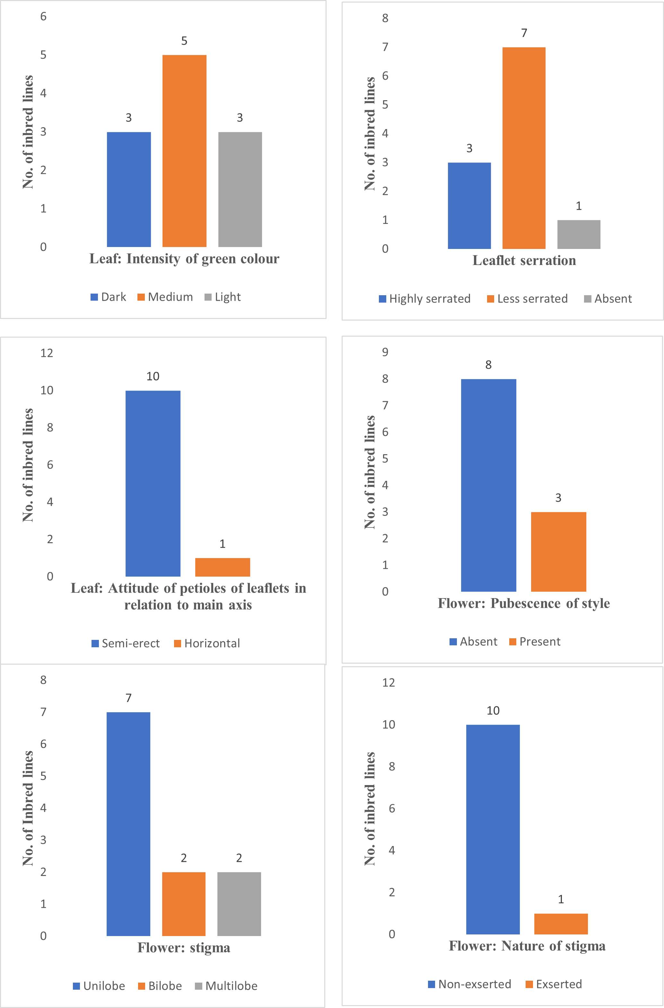
Figure-1: Graphical representation of morphological characteristics of tomato inbred lines.
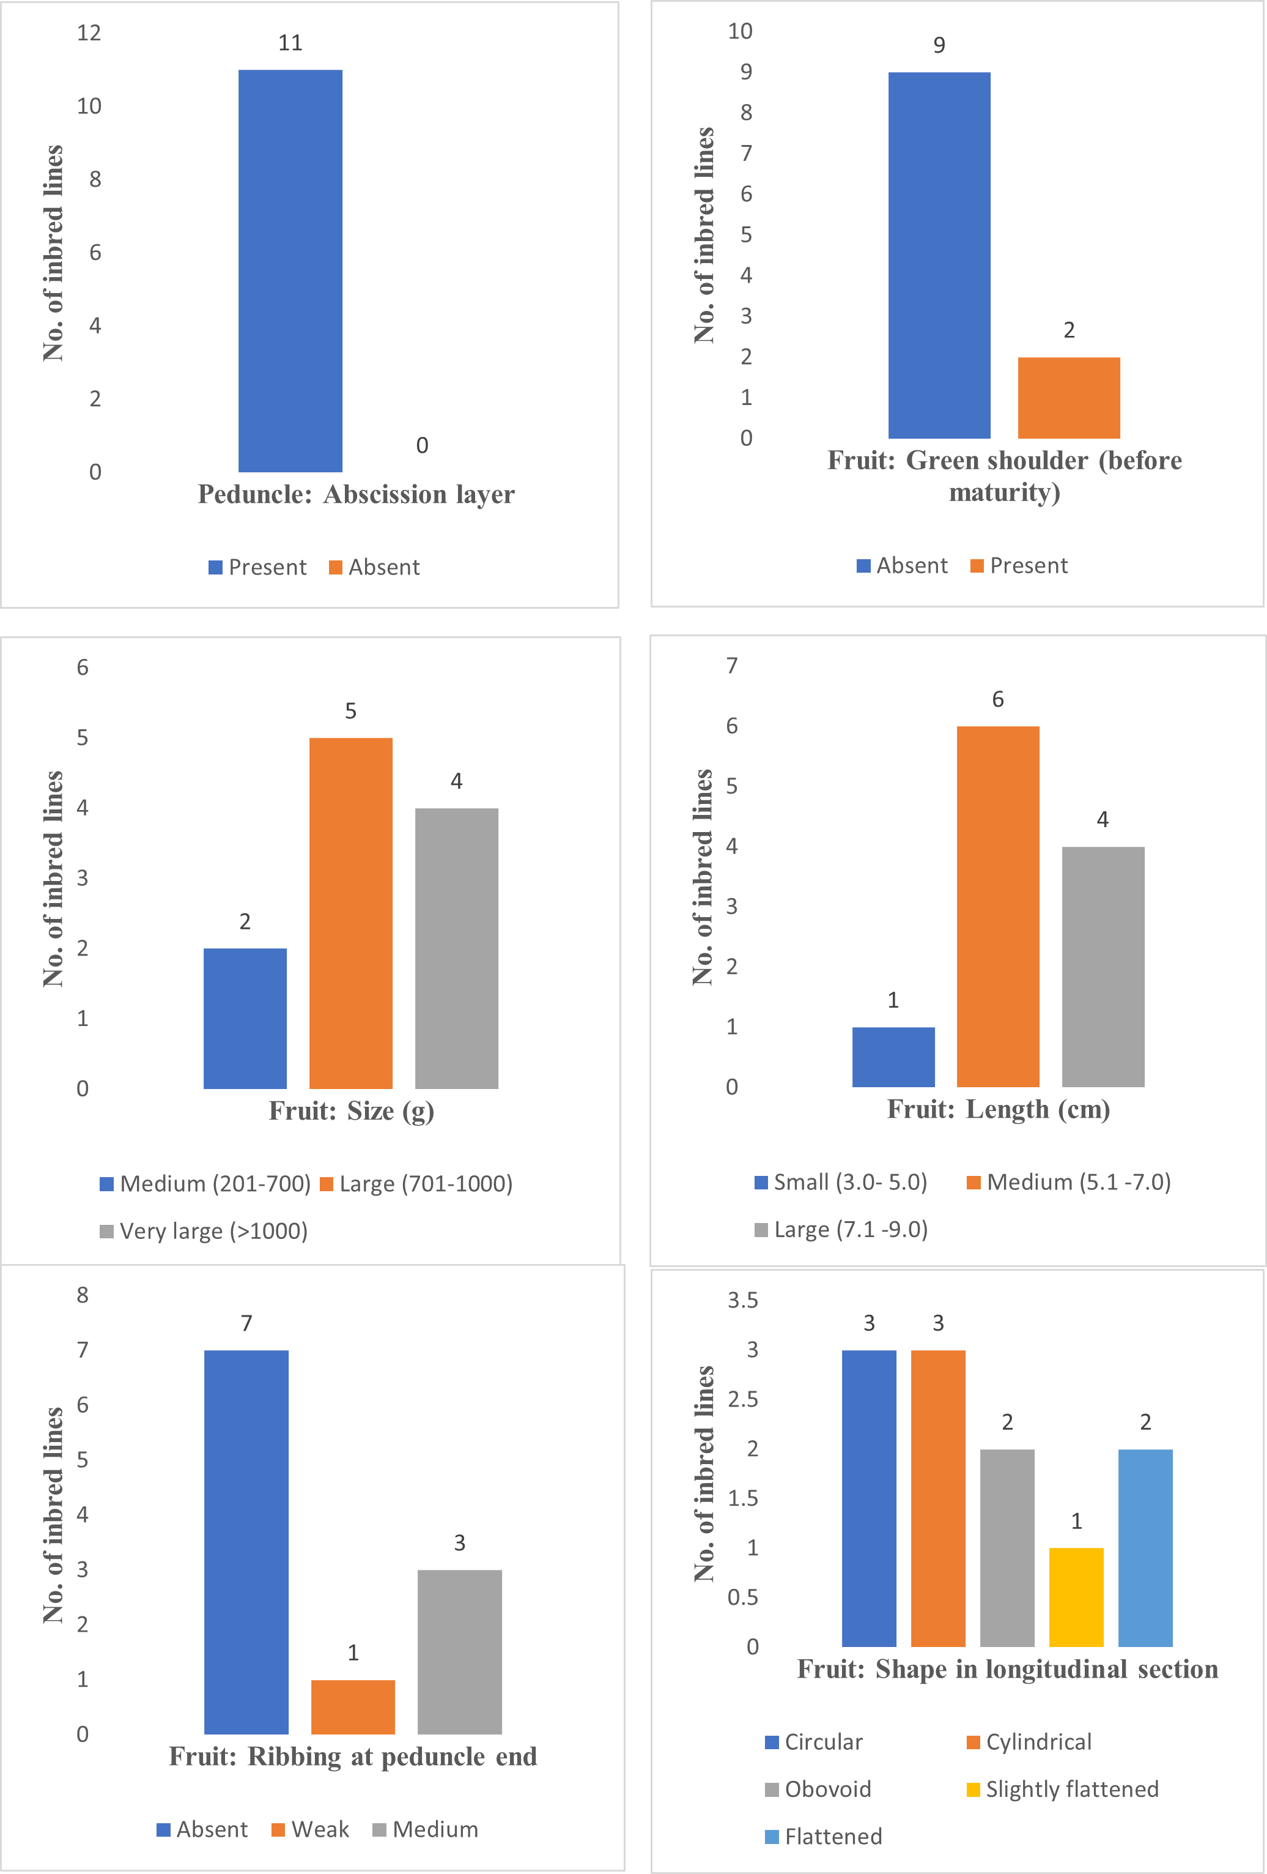
Figure-1 continued…
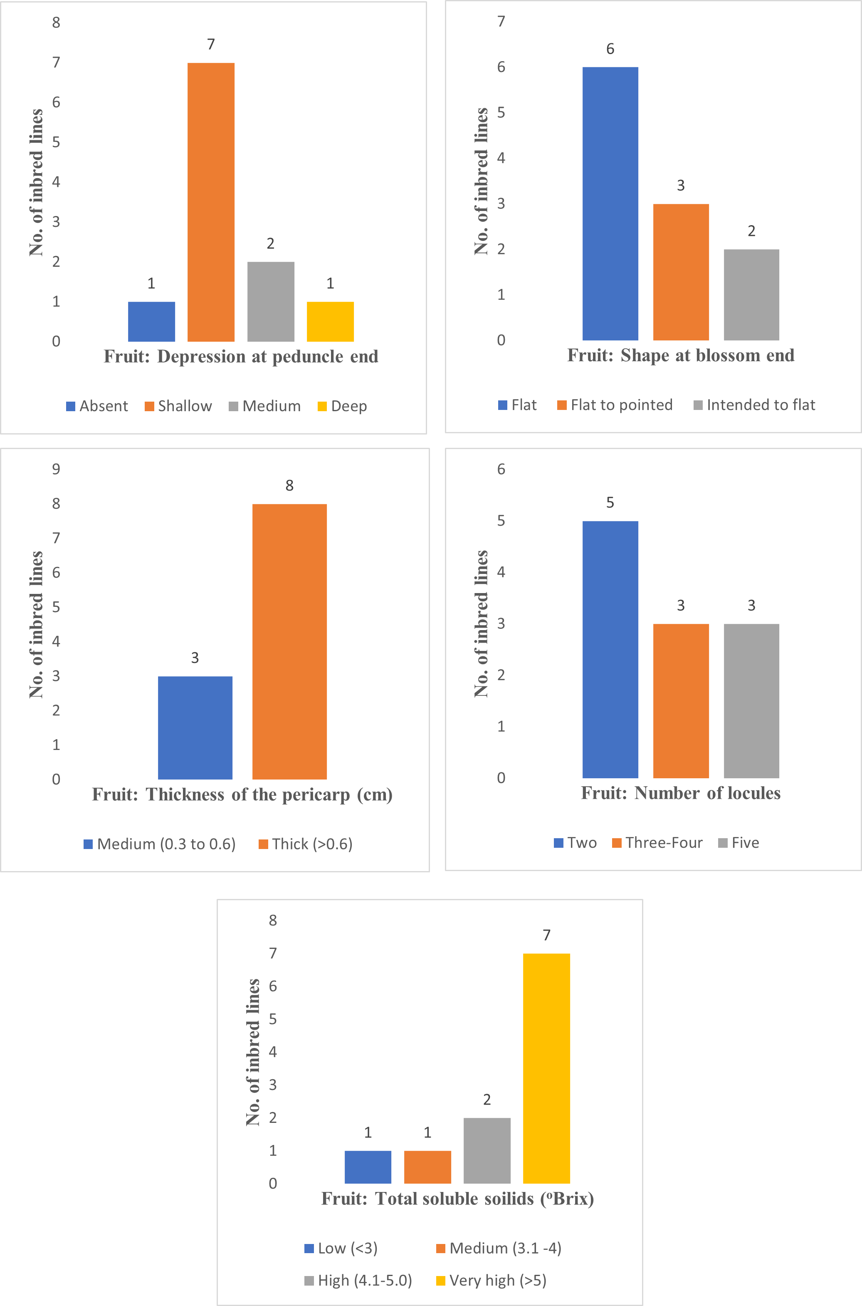
Figure-1 continued…
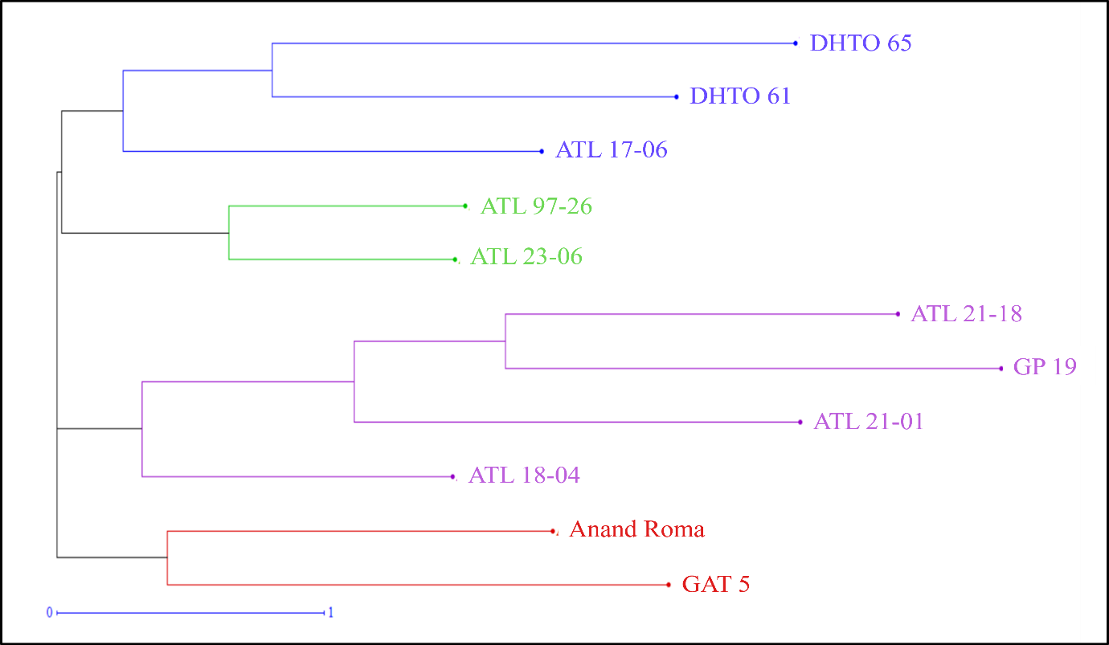

Figure-2: UPGMA Dendrogram of 11 tomato inbred lines.
ATL 23-06) that were also tightly associated, indicating strong resemblance in their phenotypic traits. Cluster III included four inbred lines (ATL 21-18, GP 19, ATL 21-01, and ATL 18-04), representing a moderately diverse group with intermediate levels of similarity. In contrast, Cluster IV consisted of Anand Roma and GAT 5, which were positioned on a separate branch with high dissimilarity values, signifying their distinctiveness from all other genotypes (Figure-2).
Conclusion
Among all the selected inbred lines characterized morphologically during kharif-rabi 2023-24, most of the inbred lines were having medium leaf colour, less serrated leaflet and semi-erect attitude of petioles of leaflets in relation to main axis. Maximum number of inbred lines had found flower with no pubescence, unilobed and non-exserted stigma. Peduncle abscission layer was present in all the inbred lines under study.
Fruit of majority of the inbred lines were found to have no green shoulder, large fruit size, medium fruit length, no ribbing at peduncle end, circular and cylindrical shape in longitudinal section. Depression at peduncle end had found shallow and had flat shape at blossom end in these selected inbred lines. Most of the lines having fruits with thick pericarp (>0.6 cm). Number of locules and total soluble solids (ºBrix) were found >4 and >5, respectively in many of the inbred lines.
The dendrogram analysis revealed the inbred lines within the same cluster had relatively low dissimilarity indices, while inbred lines of the different cluster had great divergence. Such clustering clearly demonstrates the presence of considerable variation in the studied material, which is valuable for distinctness assessment under DUS testing and for selecting genetically diverse parents in crop improvement programs.
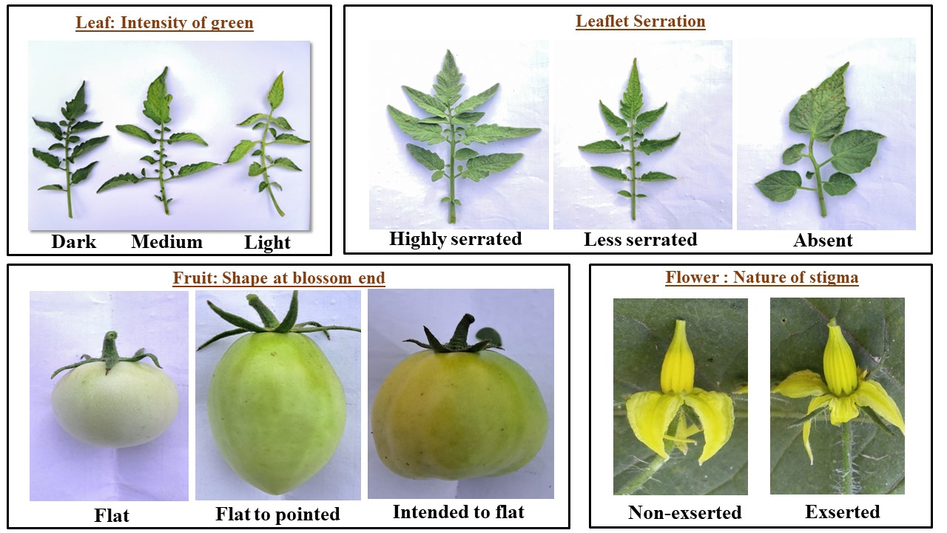
Figure-3: Descriptors of 11 tomato inbred lines.
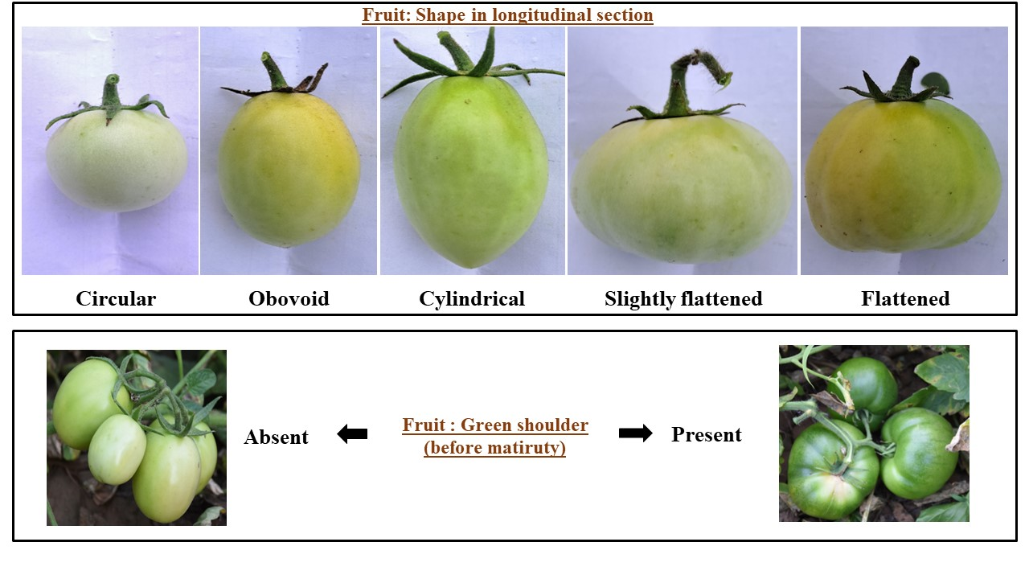
Figure-3 continued…
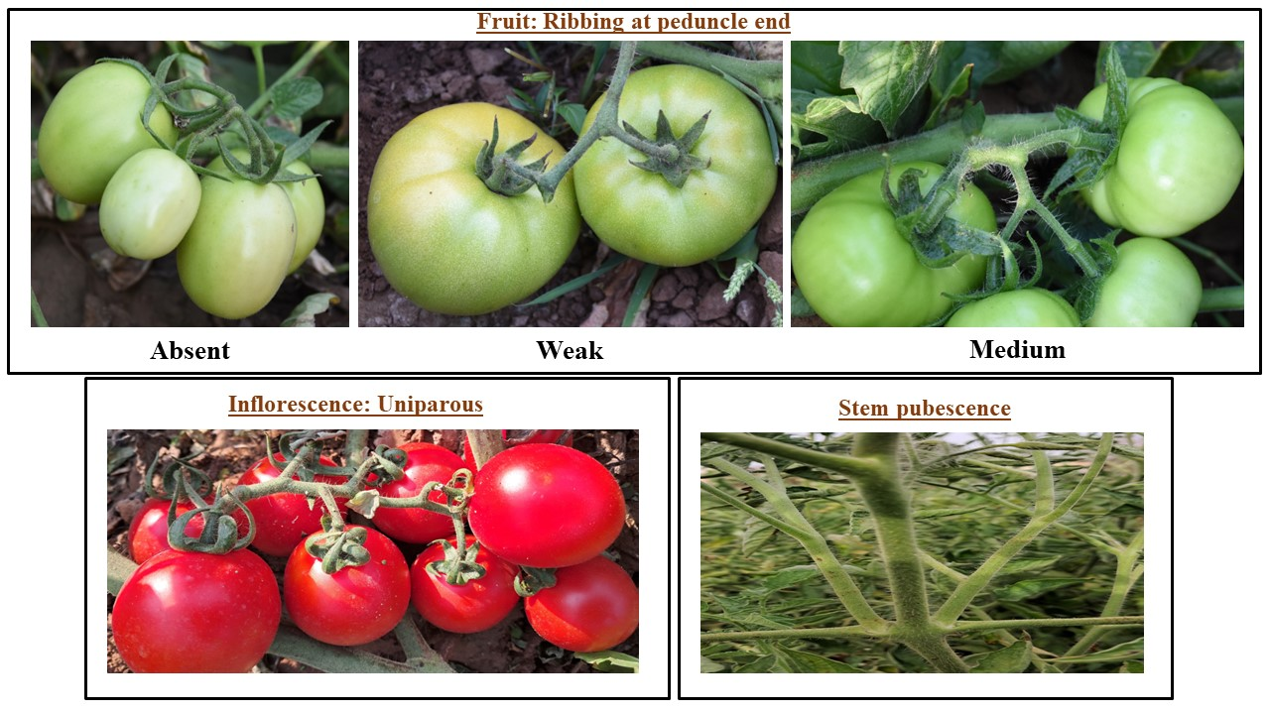
Figure-3 continued…

Disclaimer (Artificial intelligence)
Option 1:
Author(s) hereby declare that NO generative AI technologies such as Large Language Models (ChatGPT, COPILOT, etc.) and text-to-image generators have been used during the writing or editing of this manuscript.
Option 2:
Author(s) hereby declare that generativ AI technologies such as Large Language Models, etc. have been used during the writing or editing of manuscripts. This explanation will include the name, version, model, and source of the generative AI technology and as well as all input prompts provided to the generative AI technology
Details of the AI usage are given below:
1.
2.
3.

References
Anonymous. 2025. Guidelines for the conduct of tests for distinctness, uniformity and stability on tomato (Solanum lycopersicum L.). The Protection of Plant Varieties and Farmers’ Rights authority, New Delhi. https://plantauthority.gov.in/sites/default/files/ftomato.pdf
Benor, S., Zhang, M., Wang, Z., & Zhang, H. (2008). Assessment of genetic variation in tomato (Solanum lycopersicum L.) inbred lines using SSR molecular markers. Journal of Genetics and Genomics, 35(6), 373-379. https://doi.org/10.1016/S1673-8527(08)60054-5
Corrado, G., Caramante, M., Piffanelli, P., & Rao, R. (2014). Genetic diversity in Italian tomato landraces: Implications for the development of a core collection. Scientia Horticulturae, 168, 138-144. https://doi.org/10.1016/j.scienta.2014.01.027
Grozeva, S., Nankar, A. N., Ganeva, D., Tringovska, I., Pasev, G., & Kostova, D. (2020). Characterization of tomato accessions for morphological, agronomic, fruit quality, and virus resistance traits. Canadian Journal of Plant Science, 101(4), 476-489. https://doi.org/10.1139/cjps-2020-0030
Knapp, S., Bohs, L., Nee, M., & Spooner, D. M. (2004). Solanaceae - a model for linking genomics with biodiversity. Comparative and Functional Genomics, 5(3), 285-291. https://doi.org/10.1002/cfg.393
Osei, M. K., Bonsu K. O., Agyeman A., & Choi H. S., (2014). Genetic diversity of tomato germplasm in Ghana using morphological characters. International Journal of Plant Science, 3(3), 220-231. https://doi.org/10.9734/IJPSS/2014/6466
Sacco, A., Ruggieri, V., Parisi, M., Festa, G., Rigano, M. M., Picarella, M. E., & Barone, A. (2015). Exploring a tomato landraces collection for fruit-related traits by the aid of a high-throughput genomic platform. PLoS One, 10(9), e0137139. https://doi.org/10.1371/journal.pone.0137139
Shanmugabhavatharani, R., Saraswathi, T., Kavitha, M., Manivannan, N., Seenivasan, N., & Harish, S. (2024). Unveiling genetic variation in tomato (Solanum lycopersicum L.) using DUS Characteristics. Journal of Applied Horticulture, 26(2), 225-230. https://doi.org/10.37855/jah.2024.v26i02.43
Tejaswini, U., Parashivamurthy P., Siddaraju R., Vishwanath K., Ramanappa T. M., Srinivasappa K. N., & Nagaraju N. (2023). Characterization of tomato (Solanum lycopersicon Mill.) parents and hybrids for morphological and disease resistance traits. Environment Ecology, 41(1C), 698-708. https://doi.org/10.37855/jah.2024.v26i02.43
Thompson, H. C., & Kelly, W. C. (1957). Vegetable Crops (5th Ed., pp. 471-502). McGraw Hill Book Company, New York.
Vishwanath, K., Rajendra, P. S., Pallavi, H. M., & Prasanna, K. P. R. (2014). Characterization of tomato cultivars based on morphological traits. Annals of Plant Sciences, 3(11), 854-862.

