DUS CHARACTERIZATION IN MAIZE INBRED LINES (Zea mays L.)

Abstract
A field investigation was conducted during Rabi 2024–25 at the Agricultural Research Station, Peddapuram, Andhra Pradesh, to characterize 70 maize inbred lines based on Distinctness, Uniformity, and Stability (DUS) traits. The experiment was laid out in an Alpha Lattice Design with two replications, following standard spacing and agronomic practices. Observations were recorded on 27 DUS traits, including phenological, morphological, leaf, tassel, ear, kernel and root characters. Ear traits such as length, diameter, shape, and position revealed significant diversity. Genotypes like PL 23681, PL 23605, PL 23569, and IMLSB 343-3 exhibited long ears, which are beneficial for yield. The variation observed among all the DUS traits in the maize inbreds provides a valuable resource for hybrid development, varietal registration, and trait-based breeding programs. This diversity supports future research aimed at improving maize for yield, adaptability, and the identification of superior and protectable varieties suited to varied agronomic conditions.
Keywords: Inbred, phenological, morphological and maize
Introduction
Maize (Zea mays L.) is one of the most important cereal crops globally, serving as a staple food, livestock feed, and a raw material for diverse industrial applications such as starch, ethanol, and oil. In India, maize is cultivated over an area of approximately 9.96 million hectares with a production of 35.67 million tonnes and an average productivity of 3.58 tonnes per hectare during 2023–24 (Ministry of Agriculture & Farmers Welfare, 2024). Andhra Pradesh have emerged as major contributors, with productivity exceeding 6.5 tonnes per hectare (AP Seeds, 2024). Given the rising demand and the pressures of climate change, the development of high-yielding, resilient maize varieties has become a major focus in crop improvement programs. Effective breeding strategies rely heavily on understanding the genetic diversity and morphological variability among genotypes, as these provide the foundation for selecting desirable traits such as early maturity, improved ear morphology, and yield potential.
In the context of modern maize improvement programs, understanding genetic diversity and morphological variation among inbred lines is critical. Morphological characterization continues to play a key role as the first step in germplasm evaluation and variety classification, despite advances in molecular marker technology (Camussi et al., 1983). It helps breeders identify desirable traits such as earliness, disease resistance, and improved ear characteristics, and aids in avoiding duplication of genetic resources (Saritha et al., 2024).
An essential component in varietal evaluation and registration is DUS testing (Distinctness, Uniformity, and Stability), which is mandated under the Protection of Plant Varieties and Farmers’ Rights (PPV&FR) Act, 2001. This process ensures that new varieties are distinguishable from existing ones, exhibit uniform expression of traits, and maintain genetic stability across generations (UPOV, 2002, Yadav & Singh, 2010). The PPV&FR Authority requires DUS testing as a prerequisite for variety protection, seed certification, and maintaining genetic purity in seed production.
Recent studies have demonstrated the effectiveness of DUS-based characterization in identifying and differentiating maize inbred lines using traits such as plant height, tassel branching, ear placement, kernel row number, and grain type (Saritha et al., 2024, Plant Archives.,2024). Furthermore, the DUS testing process supports germplasm conservation, prevents duplication in collections, and enhances breeding efficiency through the identification of genetically pure and distinct lines. Thus, DUS characterization forms the foundation of modern maize breeding programs, supporting varietal identification, intellectual property protection, and long-term crop improvement. The present study was undertaken to evaluate selected maize inbred lines based on DUS descriptors, with the objective of developing a reliable morphological identification key to support variety registration and breeding efforts.

MATERIALS AND METHODS
The present investigation was conducted at the Agricultural Research Station (ARS), Peddapuram, Kakinada District, Andhra Pradesh, during the Rabi season of 2024–25. A total of 70 maize inbred lines, including LM 13 and LM 14, were used as test genotypes for the study. The experiment was laid out in an Alpha Lattice Design with two replications, using a spacing of 60 cm between rows and 20 cm between plants.
Observations were recorded on a total of 27 morphological, phenological, and yield-related traits, based on DUS (Distinctness, Uniformity, and Stability) guidelines. These traits were recorded at appropriate growth stages using standard descriptors. The evaluated parameters included: 50% Anthesis, 50% Silking, Leaf angle, Leaf attitude, leaf width, Sheath colour, Brace root, root colour, Glume base colour, Glume colour, Anther colour, Spikelet density, Tassel angle, Tassel attitude, Tassel length, Plant height, Ear height, Ear length, Ear diameter, Ear shape, Ear colour, Number of grain rows per ear, Row arrangement on ear, grain type, grain colour, glume colour of cob, kernel shape, no.of grain rows and row arrangement. Each trait was carefully assessed to ensure accuracy and consistency in line with DUS testing protocols.
Table 1: DUS Character to Be Recorded
# | Characterstics | Data recorded
1 | Leaf: Angle between blade and stem | √
2 | Leaf: Attitude of blade | √
3 | Stem: Anthocyanin colouration of brace roots | √
4 | Tassel: Time of Anthesis | √
5 | Tassel: Anthocyanin colouration of glumes | √
6 | Tassel: Anthocyanin colouration of glumes excluding base | √
7 | Tassel: Anthocyanin colouration of anthers | √
8 | Tassel: Density of spikelet | √
9 | Tassel: Angle between main axis and lateral branch | √
10 | Tassel: Altitude of lateral branches | √
11 | Ear: Time of silk emergence | √
12 | Ear: Anthocyanin colouration of silks | √
13 | Ear: Anthocyanin colouration of Sheath | √
14 | Tassel: Length of main axis above lowest side branch | √
15 | Plant: Length | √
16 | Plant: Ear placement | √
17 | Leaf: Width of blade | √
18 | Ear: Length without husk | √
19 | Ear: diameter | √
20 | Ear: Shape | √
21 | Ear: Number of rows of grains | √
22 | Ear: type of grain | √
23 | Ear: Colour of top of grain | √
24 | Ear: Colouration of glumes of cob | √
25 | Kernel row arrangement | √
26 | Kernel shape | √
27 | Kernel 100 weight | √
28 | Kernel waxiness | －
29 | Kernel Poppiness | －
30 | Kernel Sweetness | －
31 | Kernel Opaqueness | －

Results and Discussion

Phenological Characterization of Maize Genotypes
The phenological traits, specifically 50% anthesis and 50% silking, were recorded to assess the flowering behaviour of maize genotypes. Ideal flowering ensures proper synchronization between the male (anthesis) and female (silking) phases. If flowering occurs too early or too late, it can lead to asynchronous pollination, resulting in poor kernel set and reduced grain yield. Three genotypes MAI 214, ENT-2-3, CM 400, and MAI 2 recorded 50% anthesis in 53–55 days and 50% silking in 55–58 days, which falls within the optimum flowering range (51–55 days). The remaining genotypes exhibited late flowering, taking 56–69 days to reach 50% anthesis and silking. These phenological traits are vital indicators of a hybrid’s agronomic fitness and help in predicting maturity timing, which is essential for planning crop management and harvesting strategies.

Fig.1 Days to 50% flowering

Leaf characterization in Maize Genotypes
Leaf traits in maize are vital indicators of photosynthetic efficiency, plant architecture, and suitability for different planting densities. The key DUS characters assessed included leaf angle, leaf attitude, and leaf length and width.
Leaf Angle: Leaf angle in maize refers to the angle between the stem and the leaf blade. A narrow leaf angle indicates that the leaves are more upright or erect, while a wide angle means the leaves are more horizontal. Genotypes such as PL 23672, PL 23691, PL 23568, PL 23688, PL 23689, PL 23656, PL 23569, PL 23681, P-JCYSR37, PFSR 63, IMLSB 317-1, and PL 23571 show a narrow leaf angle (<45°), allowing better light penetration in dense plantings and promoting uniform light distribution across the plant canopy, thereby improving photosynthesis. The remaining genotypes exhibit a wide leaf angle, which can intercept maximum sunlight early in the season when plants are smaller.
Fig 2:
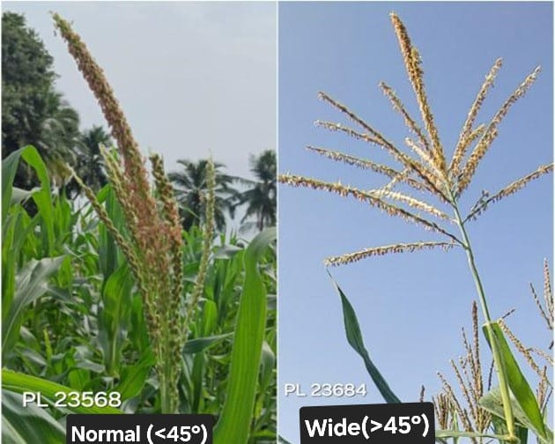
Leaf Attitude: A total of 27 maize genotypes exhibited a straight leaf attitude, including MAI 2, PML 137, KDM 70938, PL 23569, PL 23689, IMLSB 2051, PL 23572, PL 23685, PL 23571, PL 23568, PL 23688, and PL 23691. In contrast, 17 genotypes showed a dense leaf attitude, characterized by closely packed foliage around the stem. The remaining genotypes displayed a drooping leaf attitude, which may be beneficial in low-input or drought-prone conditions due to its role in water conservation and stress response.
Fig 3:
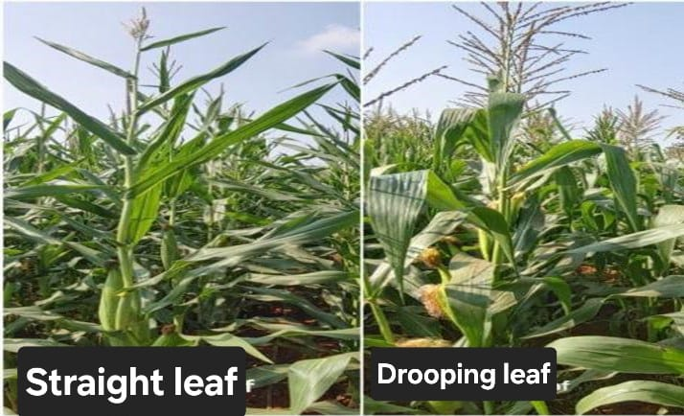
Leaf Width: Leaf width is typically measured at the 6–8 leaf stage or at flowering on the fully expanded leaf below the cob. Sixteen genotypes exhibited narrow leaf width (<8 cm), including MAI 214 (6.0 cm), IMLSB 1376 (6.0 cm), IMLSB 748-1 (6.5 cm), JCY 2-7 (7.5 cm), and PL 23569 (7.5 cm), while 36 genotypes exhibited medium leaf width, which is considered the most agronomically balanced trait in maize, combining the benefits of both narrow and broad leaves. The remaining genotypes exhibited broad leaf width. Leaf width in maize is an essential trait affecting photosynthesis, canopy dynamics, yield potential, and stress adaptation.

Fig 4:
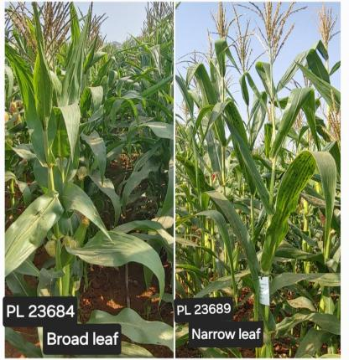
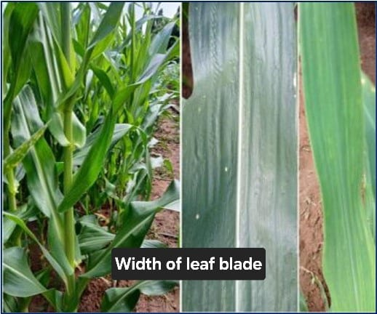

Root Characterization in Maize Genotypes
Root traits, particularly brace roots and root color, are crucial morphological descriptors in DUS testing. These traits significantly influence plant anchorage, strength, lodging resistance, and nutrient uptake efficiency in maize.
Brace Roots: A total of 37 genotypes displayed prominent brace root development, including PML 137, MAI 725, CM 202, PL 23688, PL 23685, IMLSB 334 B-2, PL 23571, NAI-178A, PL 23672, PL 23577, among others. Genotypes with well-developed brace roots exhibited strong anchorage and enhanced lodging resistance, especially under conditions of high wind or heavy rainfall. Additionally, these roots support improved nutrient and water absorption from the upper soil layers, contributing to overall plant stability and performance.
Fig 5: Sheath and root characters
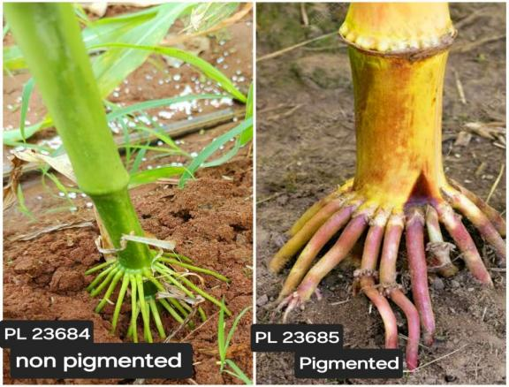
Sheath Colour: Out of the total genotypes, six namely IMLSB 334 B-2, PFSR-R3, PFSR-R9, IMLSB 380-1, MIL 2-334 B-1, and MAI 214 exhibited sheath pigmentation, while the remaining 63 genotypes showed absence of sheath colour. Sheath pigmentation is a valuable trait used in varietal identification, genetic purity maintenance, and breeding decisions.
Fig 7:
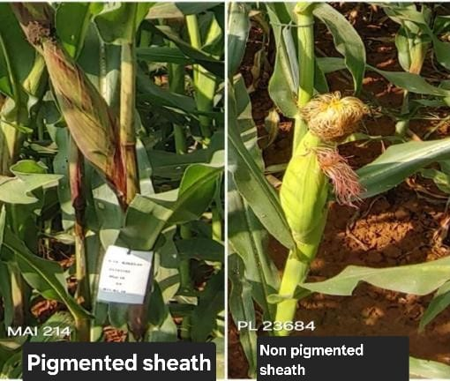
Table 2: DUS Charecterstrics of maize inbreds
# | Genotype | Leaf angle | Leaf Attitude | leaf width | Sheath colour | Brace root colour | 50% Anthesis | 50% Silking
1 | MAI 214 | Wide | Drooping | 6 | Present | Present | 53 | 55
2 | CM 400 | Wide | Drooping | 9 | Absent | Present | 55 | 56
3 | ENT-2-3 | Wide | Dense | 10 | Absent | Present | 55 | 56
4 | MAI 2 | Wide | Straight | 8 | Absent | Absent | 55 | 58
5 | PML 137 | Wide | Straight | 8 | Absent | Present | 57 | 59
6 | IML12 | Wide | Drooping | 9 | Absent | Present | 59 | 60
7 | IMLSB 282-2 | Wide | Dense | 10 | Absent | Absent | 59 | 61
8 | MAI 21 | Wide | Drooping | 9 | Absent | Present | 59 | 62
9 | PL 23681 | Narrow | Drooping | 10 | Absent | Absent | 59 | 61
10 | SKV 50-tall | Narrow | Drooping | 8 | Absent | Present | 60 | 62
11 | MAI 105 | Wide | Dense | 8 | Absent | Absent | 60 | 61
12 | 42048-2-2-1-1-2 | Wide | Dense | 9 | Absent | Present | 60 | 62
13 | IMLSB 748-1 | Wide | Drooping | 7 | Absent | Absent | 60 | 62
14 | VL 19192 | Wide | Dense | 9 | Absent | Present | 60 | 61
15 | KDM 70938 | Narrow | Straight | 10 | Absent | Absent | 60 | 62
16 | Check 2 | Wide | Drooping | 9 | Absent | Absent | 61 | 62
17 | PFSR-R3 | Wide | Dense | 7 | Present | Present | 61 | 63
18 | NAI-178A | Narrow | Straight | 8 | Absent | Present | 61 | 63
19 | PL 23569 | Narrow | Straight | 8 | Absent | Absent | 61 | 62
20 | IMLSB 334 B-2 | Wide | Drooping | 7 | Absent | Present | 62 | 63
21 | PFSR 63 | Narrow | Straight | 8 | Absent | Absent | 62 | 64
22 | JCY 3-7-1-2-1 | Wide | Drooping | 8 | Absent | Absent | 62 | 63
23 | PL 23689 | Narrow | Straight | 8 | Absent | Absent | 62 | 65
24 | MIL 2-334 B-1 | Narrow | Straight | 9 | Present | Present | 62 | 64
25 | IMLSB 380-1 | Wide | Dense | 9 | Present | Absent | 62 | 66
26 | IMLSB 1376 | Wide | Drooping | 6 | Absent | Present | 62 | 68
27 | JCY 2-7 | Wide | Drooping | 8 | Absent | Present | 62 | 63
28 | PL 23685 | Wide | Straight | 8 | Absent | Present | 62 | 64
29 | BLS 42050-1 | Wide | Drooping | 9 | Absent | Absent | 62 | 64
30 | PL 23572 | Wide | Straight | 9 | Absent | Absent | 62 | 64
31 | P-JCYSR37 | Narrow | Straight | 9 | Absent | Absent | 62 | 63
32 | IMLSB 2051 | Narrow | Straight | 10 | Absent | Absent | 62 | 64
33 | P-JCYSR21 | Wide | Drooping | 8 | Absent | Present | 63 | 64
34 | IMLSB 57-2 | Wide | Dense | 8 | Absent | present | 63 | 65
35 | PL 23656 | Narrow | Drooping | 8 | Absent | Absent | 63 | 64
36 | Check 1 | Wide | Drooping | 9 | Absent | Absent | 63 | 64
37 | DML 16 | Wide | Dense | 9 | Absent | Present | 63 | 64
38 | PL 23577 | Wide | Dense | 10 | Absent | Present | 63 | 64
39 | IMLSB 246-2 | Wide | Drooping | 8 | Absent | Present | 63 | 65
40 | PL 23684 | Wide | Drooping | 8 | Absent | Absent | 63 | 67
41 | NAI 137-3 | Wide | Straight | 8 | Absent | Absent | 63 | 65
42 | IMLSB 1041-4 | Wide | Dense | 8 | Absent | Present | 63 | 64
43 | PFSR 90 | Wide | Dense | 9 | Absent | Present | 63 | 64
44 | PL 23571 | Narrow | Straight | 10 | Absent | Present | 63 | 65
45 | PFSR-R9 | Wide | Dense | 7 | Present | Present | 64 | 65
46 | PL 23568 | Narrow | Straight | 8 | Absent | Absent | 64 | 66
47 | IMLSB 334 B-2 | Wide | Dense | 9 | Present | Present | 64 | 66
48 | IML 11 | Wide | Dense | 9 | Absent | Present | 64 | 66
49 | PL 23605 | Wide | Drooping | 9 | Absent | Absent | 64 | 66
50 | MGC 137 | Wide | Drooping | 9 | Absent | Absent | 64 | 66
51 | MGW 295 | Narrow | Straight | 9 | Absent | Absent | 64 | 68
52 | PL 23690 | Wide | Drooping | 9 | Absent | Absent | 64 | 66
53 | PML 21 | Narrow | Drooping | 9 | Absent | Present | 64 | 67
54 | IMLSB 955-1 | Wide | Dense | 8 | Absent | Present | 65 | 67
55 | IMLSB 317-1 | Narrow | Straight | 9 | Absent | Absent | 65 | 67
56 | PL 23688 | Narrow | Straight | 9 | Absent | Present | 65 | 66
57 | UMI 1210 | Wide | Drooping | 10 | Absent | Present | 65 | 66
58 | CM 202 | Wide | Drooping | 11 | Absent | Present | 65 | 68
59 | IMLSB 334 B-2 | Wide | Straight | 8 | Present | Present | 65 | 67
60 | PL 23691 | Narrow | Straight | 9 | Absent | Absent | 65 | 64
61 | PL 23672 | Narrow | Dense | 9 | Absent | Present | 65 | 68
62 | IML 21 | Wide | Straight | 10 | Absent | Absent | 65 | 67
63 | MAI 725 | - | Straight | 8 | Absent | Present | 66 | 67
64 | IMLSB 1043-1 | Wide | Straight | 10 | Absent | Absent | 66 | 67
65 | CM 202 | Narrow | Straight | 9 | Absent | Present | 66 | 68
66 | CMI-CR-01 | Narrow | Straight | 9 | Absent | Absent | 67 | 69
67 | IMLSB 343-3 | Narrow | Straight | 9 | Absent | Absent | 67 | 67
68 | MIL 1-11 | Wide | Straight | 10 | Absent | Absent | 67 | 69
69 | CM 202 | Narrow | Straight | 10 | Absent | Present | 68 | 69
70 | IMLSB 343-3 | Narrow | Straight | 10 | Absent | Absent | 69 | 67
Tassel Characterization in Maize
The tassel, which is the male flowering part of the maize plant, plays a critical role in pollen production, pollen dispersal, pollination efficiency, and overall reproductive success. Tassel morphology is an essential part of DUS characterization and is also important for understanding the yield potential, stress tolerance, and genetic stability of genotypes.
Tassel Attitude: A majority of the genotypes (51), including PL 23690, P-JCYSR37, PL 23568, MIL 1-11, JCY 3-7-1-2-1, PL 23688, and others exhibited a straight tassel attitude. In contrast, 19 genotypes displayed a curved tassel attitude. This trait is particularly beneficial in high-yielding hybrids cultivated under dense planting and well-managed systems, as it promotes efficient pollination, better canopy light interception, and contributes to overall plant health and yield performance.
Fig 8:
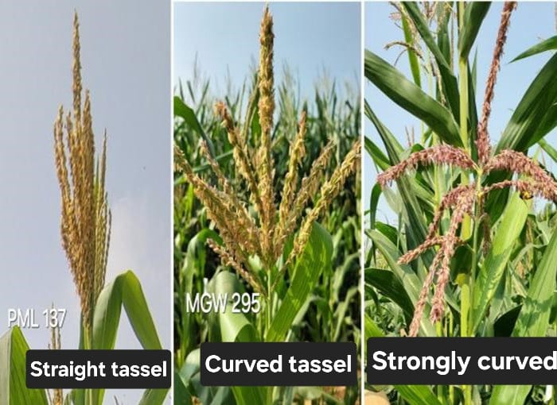
Tassel Angle: A wide tassel angle is a helpful trait in maize, contributing to effective pollen dispersal and reproductive success, especially in areas with limited water or fertilizer inputs. It is useful in both breeding and variety identification. A total of 36 genotypes, such as MGW 295, PL 23577, PL 23572, MIL 2-334 B-1, PL 23685, IMLSB 1041-4, PL 23605, PL 23684, PL 23689, PL 23656, and PL 23569, exhibited a wide tassel angle, while others exhibited a narrow tassel angle.
Tassel Length: A total of 29 maize genotypes exhibited medium tassel length (20–30 cm), which is considered optimal for balanced pollen production and efficient energy use. These include PL 23685 (20 cm), IMLSB 334 B-2 (24 cm), IMLSB 1376 (24 cm), NAI 137-3 (25 cm), MGC 137 (25 cm), PFSR 63 (25 cm), MAI 214 (26 cm), IML 12 (27 cm), IMLSB 1041-4 (27 cm), CM 400 (27 cm), PL 23691 (27 cm), P-JCYSR37 (28 cm), PL 23656 (28 cm), IMLSB 748-1 (28 cm), DML 16 (28 cm), PFSR-R3 (29 cm), and PL 23572 (29 cm). The remaining genotypes exhibited long tassel length, which, although supporting high pollen production, may lead to increased energy use and possible shading of upper leaves, making them more suitable for specific breeding purposes or open-pollinated systems.
Spikelet Density: A total of 46 maize genotypes exhibited dense spikelet density, a desirable trait that enhances pollen availability, improves fertilization, and ensures uniform seed set. These genotypes include PL 23571, 42048-2-2-1-1-2, IML 11, IMLSB 282-2, ENT-2-3, PL 23577, IMLSB 380-1, PL 23572, MIL 2-334 B-1, PL 23685, IMLSB 1041-4, IMLSB 57-2, PML 21, CM 202, IML 12, IMLSB 343-3, PFSR 90, PL 23605, MGC 137, and PL 23681, among others. The remaining genotypes exhibited sparse spikelet density, which, while producing less pollen, may be beneficial in systems where resource conservation or stress tolerance is a priority.
Fig 9:
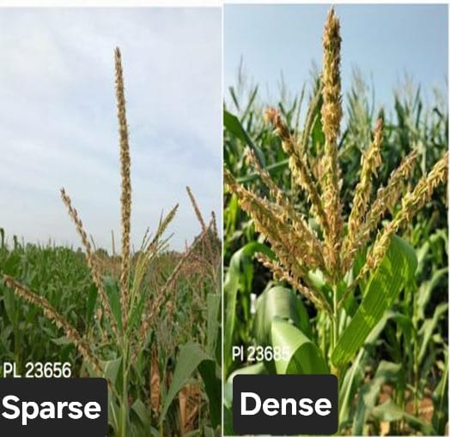
Anther Colour: IML 21, MAI 2, and MAI 725 exhibited visible anther colour, while the remaining 58 genotypes showed no anther pigmentation.
Glume Colour: Genotypes such as PL 23672, PFSR 90, PL 23568, P-JCYSR21, PL 23605, MGC 137, PL 23681, Check 1, IMLSB 748-1, PML 137, IMLSB 955-1, PFSR-R9, DML 16, IMLSB 334 B-2, MIL 1-11, and MAI 725 exhibited glume colour, while the remaining 45 genotypes showed no glume pigmentation. Glume colour in maize genotypes highlights their genetic uniqueness and potential utility in varietal identification.
Fig 10:
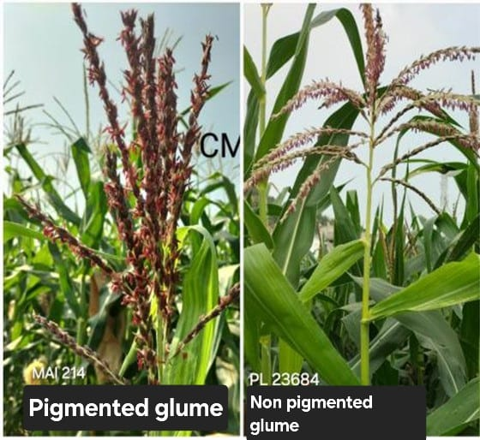
Glume Base Colour: A total of 14 maize genotypes P-JCYSR37, IMLSB 748-1, IMLSB 343-3, CMI-CR-01, PML 137, IMLSB 955-1, PFSR-R9, MAI 105, DML 16, IMLSB 334 B-2, MIL 1-11, MAI 214, and MAI 725 exhibited glume base colour, while the remaining genotypes showed no glume base colour. This trait is useful in hybrid breeding programs to track and confirm the identity and purity of parent lines, especially when crossed lines differ in pigmentation.

Morphological Characterization in Maize
Morphological characterization, especially traits like plant height and ear height, is fundamental to maize breeding, variety development, and crop management.
Plant Height: Among the studied maize genotypes, 4 genotypes exhibited short plant height (<120 cm), 19 genotypes showed medium height (120–150 cm), while the remaining genotypes displayed tall plant height (>150 cm), indicating a wide range of plant stature among the evaluated lines.

Fig 11:
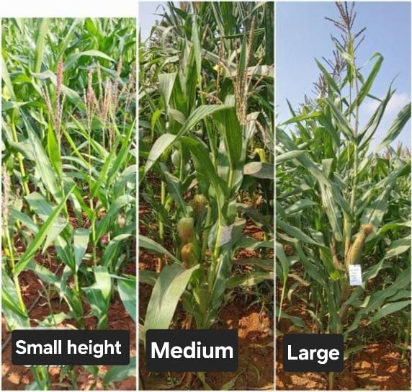
Ear Placement: Out of the 70 maize genotypes evaluated, 34 exhibited low ear placement, 31 showed medium ear placement, and 5 exhibited high ear placement, reflecting significant variation in this trait.
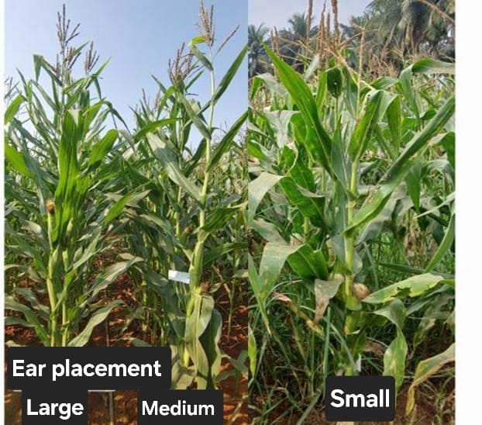

Fig 12:
Table 2. Cont...
# | Genotype | Tassel angle | Tassel Attitude | Tassel length | Anther colour | Spikelet Density | Plant Height | Ear placement
1 | MAI 214 | Wide | Straight | 26 | - | Dense | 125 | 0.34
2 | CM 400 | Narrow | Curved | 27 | - | Dense | 118 | 0.40
3 | ENT-2-3 | Narrow | Straight | 41 | Absent | Dense | 143 | 0.37
4 | MAI 2 | Wide | Curved | 35 | Present | Dense | 95 | 0.34
5 | PML 137 | Wide | Straight | 32 | Absent | Sparse | 158 | 0.43
6 | IML12 | Wide | Straight | 27 | Absent | Dense | 155 | 0.42
7 | IMLSB 282-2 | Wide | Straight | 40 | Absent | Dense | 125 | 0.44
8 | MAI 21 | Wide | Curved | 34 | Absent | Sparse | 160 | 0.41
9 | PL 23681 | Narrow | Straight | 32 | Absent | Dense | 200 | 0.48
10 | SKV 50-tall | Narrow | Curved | 33 | Absent | Dense | 133 | 0.32
11 | MAI 105 | Wide | Straight | 32 | Absent | Sparse | 153 | 0.41
12 | 42048-2-2-1-1-2 | Narrow | Straight | 43 | Absent | Dense | 155 | 0.50
13 | IMLSB 748-1 | Narrow | Curved | 28 | - | Sparse | 125 | 0.44
14 | VL 19192 | Wide | Curved | 34 | Absent | Sparse | 123 | 0.41
15 | KDM 70938 | Narrow | Curved | 42 | Absent | Sparse | 165 | 0.52
16 | Check 2 | Wide | Straight | 31 | Absent | Dense | 175 | 0.44
17 | PFSR-R3 | Wide | Curved | 29 | Absent | Sparse | 148 | 0.46
18 | NAI-178A | Narrow | Curved | 33 | Absent | Sparse | 135 | 0.37
19 | PL 23569 | Wide | Straight | 30 | Absent | Sparse | 165 | 0.56
20 | IMLSB 334 B-2 | Narrow | Curved | 30 | Absent | Dense | 145 | 0.52
21 | PFSR 63 | Narrow | Straight | 25 | Absent | Dense | 168 | 0.49
22 | JCY 3-7-1-2-1 | Narrow | Straight | 30 | Absent | Sparse | 195 | 0.49
23 | PL 23689 | Wide | Straight | 34 | Absent | Sparse | 153 | 0.33
24 | MIL 2-334 B-1 | Wide | Straight | 30 | Absent | Dense | 145 | 0.55
25 | IMLSB 380-1 | Wide | Straight | 33 | Absent | Dense | 125 | 0.32
26 | IMLSB 1376 | Narrow | Straight | 24 | - | Sparse | 143 | 0.42
27 | JCY 2-7 | Narrow | Straight | 32 | Absent | Dense | 185 | 0.45
28 | PL 23685 | Wide | Straight | 20 | Absent | Dense | 155 | 0.37
29 | BLS 42050-1 | Wide | Straight | 32 | Absent | Dense | 190 | 0.50
30 | PL 23572 | Wide | Straight | 29 | Absent | Dense | 165 | 0.52
31 | P-JCYSR37 | Narrow | Straight | 28 | - | Dense | 193 | 0.47
32 | IMLSB 2051 | Narrow | Straight | 33 | Absent | Dense | 133 | 0.36
33 | P-JCYSR21 | Wide | Straight | 30 | Absent | Sparse | 183 | 0.41
34 | IMLSB 57-2 | Wide | Curved | 35 | Absent | Dense | 130 | 0.48
35 | PL 23656 | Wide | Straight | 28 | Absent | Sparse | 215 | 0.48
36 | Check 1 | Narrow | Straight | 31 | Absent | Dense | 195 | 0.45
37 | DML 16 | Wide | Straight | 28 | Absent | Dense | 118 | 0.34
38 | PL 23577 | Wide | Straight | 36 | Absent | Dense | 175 | 0.49
39 | IMLSB 246-2 | Wide | Straight | 34 | Absent | Sparse | 158 | 0.37
40 | PL 23684 | Wide | Straight | 35 | Absent | Sparse | 150 | 0.42
41 | NAI 137-3 | Narrow | Curved | 25 | - | Dense | 150 | 0.48
42 | IMLSB 1041-4 | Wide | Straight | 27 | Absent | Dense | 163 | 0.42
43 | PFSR 90 | Narrow | Straight | 31 | Absent | Dense | 170 | 0.43
44 | PL 23571 | Narrow | Straight | 33 | Absent | Dense | 188 | 0.49
45 | PFSR-R9 | Wide | Curved | 33 | Absent | Sparse | 153 | 0.46
46 | PL 23568 | Narrow | Straight | 31 | - | Dense | 155 | 0.42
47 | IMLSB 334 B-2 | Wide | Curved | 24 | Absent | Dense | 165 | 0.41
48 | IML 11 | Wide | Straight | 30 | Absent | Dense | 160 | 0.47
49 | PL 23605 | Wide | Straight | 33 | Absent | Dense | 158 | 0.56
50 | MGC 137 | Wide | Curved | 25 | Absent | Dense | 145 | 0.47
51 | MGW 295 | Wide | Curved | 43 | Absent | Dense | 165 | 0.44
52 | PL 23690 | Narrow | Straight | 33 | - | Dense | 153 | 0.39
53 | PML 21 | Narrow | Straight | 32 | Absent | Dense | 158 | 0.49
54 | IMLSB 955-1 | Wide | Straight | 31 | Absent | Sparse | 103 | 0.56
55 | IMLSB 317-1 | Wide | Curved | 29 | Absent | Dense | 153 | 0.39
56 | PL 23688 | Narrow | Straight | 31 | Absent | Sparse | 170 | 0.31
57 | UMI 1210 | Narrow | Straight | 37 | Absent | Dense | 180 | 0.50
58 | CM 202 | Narrow | Straight | 41 | Absent | Dense | 148 | 0.47
59 | IMLSB 334 B-2 | Narrow | Straight | 29 | Absent | Dense | 160 | 0.44
60 | PL 23691 | Narrow | Curved | 27 | Absent | Sparse | 160 | 0.48
61 | PL 23672 | Narrow | Straight | 33 | Absent | Sparse | 185 | 0.53
62 | IML 21 | Wide | Straight | 39 | Present | Dense | 170 | 0.46
63 | MAI 725 | Narrow | Straight | 32 | Present | Sparse | 165 | 0.41
64 | IMLSB 1043-1 | Wide | Curved | 32 | Absent | Dense | 183 | 0.44
65 | CM 202 | Narrow | Straight | 39 | Absent | Dense | 158 | 0.46
66 | CMI-CR-01 | Narrow | Straight | 31 | Absent | Sparse | 160 | 0.50
67 | IMLSB 343-3 | Narrow | Straight | 33 | Absent | Dense | 163 | 0.58
68 | MIL 1-11 | Narrow | Straight | 30 | - | Dense | 155 | 0.45
69 | CM 202 | Narrow | Straight | 43 | Absent | Dense | 183 | 0.48
70 | IMLSB 343-3 | Wide | Straight | 31 | Absent | Sparse | 150 | 0.57

Ear (Cob) Characterization in Maize
Ear traits in maize, such as ear shape, color, size, length, and diameter, are crucial components of DUS testing because they offer stable, distinguishable, and heritable markers for variety identification and breeding selection. These traits not only ensure varietal protection but also support the development of high-yielding and market-preferred genotypes.
Ear colour (silk): A total of 33 maize genotypes, including UMI 1210, 42048-2-2-1-1-2, IMLSB 334 B-2, JCY 2-7, PFSR 90, PL 23681, Check 1, PL 23690, P-JCYSR37, PL 23672, MAI 725, IMLSB 1376, Check 2, PL 23577, PL 23572, PL 23685, BLS 42050-1, IML 12, PL 23605, IML 21, PL 23656, PL 23569, P-JCYSR21, SKV 50-tall, NAI 137-3, KDM 70938, IMLSB 748-1, IMLSB 317-1, IMLSB 57-2, MGC 137, IMLSB 334 B-2, PFSR-R3, and PFSR-R9, exhibited silk pigmentation, a trait often associated with anthocyanin presence and stress responsiveness. The remaining genotypes showed no visible silk pigmentation, indicating a lack of anthocyanin expression in the silks.
Fig 13:
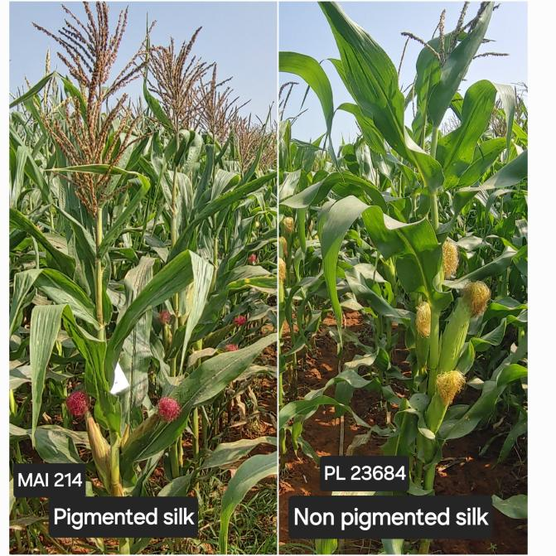
Ear Shape: In the present study, 19 genotypes showed a cylindrical ear shape, characterized by a uniform diameter from base to tip. This shape is preferable for mechanical harvesting, allows uniform kernel distribution, and typically correlates with higher yield potential. Fifteen genotypes, namely PL 23572, PFSR-R9, IMLSB 317-1, 42048-2-2-1-1-2, IMLSB 1043-1, PL 23656, PL 23691, and others, exhibited a conical ear shape. The remaining genotypes exhibited a conico-cylindrical ear shape, an intermediate form combining features of both conical and cylindrical types.
Ear Length: Most genotypes displayed medium ear length (10–15 cm). A total of 8 genotypes, including IMLSB 343-3 (16 cm), PL 23681 (16 cm), IMLSB 2051 (16 cm), PL 23605 (16 cm), PL 23571 (16 cm), PL 23577 (16 cm), and PL 23569 (17 cm), were categorized as having long ears (>15 cm). Long ear length is generally associated with higher yield potential due to an increased number of kernels per ear and reflects vigorous growth, good pollination, and better resource utilization. Meanwhile, 4 genotypes IML SB 1376 (7 cm), MAI 214 (8 cm), CM 400 (8 cm), and SKV 50-Tall (9 cm) exhibited short ear length (<10 cm).
Ear Diameter: All genotypes exhibited large ear diameters, ranging from SKV 50-tall (9 cm) to PL 23681 (15 cm), indicating robust ear development and potentially higher grain-bearing capacity. A larger ear diameter is generally associated with greater kernel density and yield potential in maize. Genotypes with larger diameters are usually preferred in breeding programs aimed at improving grain productivity and market quality.
Fig 14:
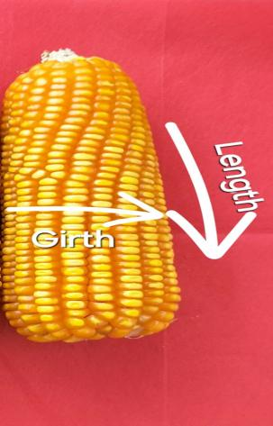
Glume Colour of Cob: Glume color of the cob varied among genotypes, with 2 genotypes, namely PL 23688 and PL 23568, showing dark purple; one genotype (CM 202) exhibiting light purple; and the remaining 62 genotypes exhibiting white glumes. This trait is also useful in genetic purity assessment and breeding line differentiation.
Fig 15:
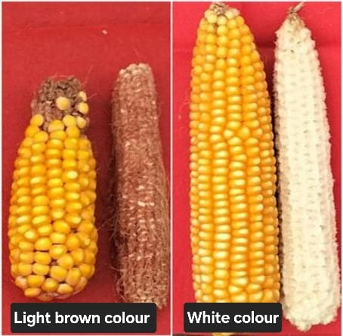

Fig :16
Table 2. Cont...
# | Genotype | Ear colour (silk) | Glume base colour | Glume colour | Ear length | Ear diameter | Ear Shape
1 | MAI 214 | Absent | Present | Absent | 8 | 12 | cylindrical
2 | CM 400 | Absent | - | - | 8 | 10 | conical
3 | ENT-2-3 | Absent | Absent | Absent | 14 | 11 | conical
4 | MAI 2 | Absent | Absent | Absent | 10 | 9 | conico-cylindrical
5 | PML 137 | Absent | Present | Present | 13 | 10 | conico-cylindrical
6 | IML12 | Present | Absent | Absent | 12 | 10 | conico-cylindrical
7 | IMLSB 282-2 | Absent | Absent | Absent | 11 | 14 | cylindrical
8 | MAI 21 | Absent | Absent | Absent | 11 | 12 | cylindrical
9 | PL 23681 | Present | Absent | Present | 16 | 15 | conico-cylindrical
10 | SKV 50-tall | Present | Absent | Absent | 9 | 9 | conico-cylindrical
11 | MAI 105 | Absent | Present | Absent | 13 | 13 | cylindrical
12 | 42048-2-2-1-1-2 | Present | Absent | Absent | 13 | 13 | conical
13 | IMLSB 748-1 | Present | Present | Present | 11 | 10 | conical
14 | VL 19192 | Absent | Absent | Absent | 12 | 12 | cylindrical
15 | KDM 70938 | Present | Absent | Absent | 14 | 14 | conico-cylindrical
16 | Check 2 | Present | Absent | Absent | 15 | 13 | conico-cylindrical
17 | PFSR-R3 | Present | Absent | Absent | 10 | 11 | conico-cylindrical
18 | NAI-178A | Absent | Absent | Absent | 10 | 11 | cylindrical
19 | PL 23569 | Present | Absent | Absent | 17 | 13 | conico-cylindrical
20 | IMLSB 334 B-2 | Absent | Absent | Absent | 11 | 11 | conical
21 | PFSR 63 | Absent | Absent | Absent | 12 | 12 | conico-cylindrical
22 | JCY 3-7-1-2-1 | Absent | Absent | Absent | 12 | 12 | cylindrical
23 | PL 23689 | Absent | Absent | Absent | 14 | 13 | conico-cylindrical
24 | MIL 2-334 B-1 | Absent | Absent | Absent | 12 | 12 | cylindrical
25 | IMLSB 380-1 | Absent | Absent | Absent | 14 | 11 | conico-cylindrical
26 | IMLSB 1376 | Present | Absent | Absent | 7 | 10 | conico-cylindrical
27 | JCY 2-7 | Present | Absent | Absent | 15 | 13 | conico-cylindrical
28 | PL 23685 | Present | Absent | Absent | 14 | 10 | conico-cylindrical
29 | BLS 42050-1 | Present | Absent | Absent | 13 | 12 | conico-cylindrical
30 | PL 23572 | Present | Absent | Absent | 14 | 12 | conical
31 | P-JCYSR37 | Present | Present | Absent | 14 | 12 | conico-cylindrical
32 | IMLSB 2051 | Absent | Absent | Absent | 16 | 12 | conico-cylindrical
33 | P-JCYSR21 | Present | Absent | Present | 13 | 11 | conico-cylindrical
34 | IMLSB 57-2 | Present | Absent | Absent | 13 | 12 | cylindrical
35 | PL 23656 | Present | Absent | Absent | 14 | 13 | conical
36 | Check 1 | Present | Absent | Present | 13 | 11 | conico-cylindrical
37 | DML 16 | Absent | Present | Present | 10 | 12 | conical
38 | PL 23577 | Present | Absent | Absent | 16 | 13 | conico-cylindrical
39 | IMLSB 246-2 | Absent | Absent | Absent | 12 | 11 | conical
40 | PL 23684 | Absent | Absent | Absent | 12 | 13 | cylindrical
41 | NAI 137-3 | Present | Absent | Absent | 11 | 13 | cylindrical
42 | IMLSB 1041-4 | Absent | Absent | Absent | 14 | 13 | conico-cylindrical
43 | PFSR 90 | Present | Absent | Present | 14 | 12 | conico-cylindrical
44 | PL 23571 | Absent | Absent | Absent | 16 | 14 | conico-cylindrical
45 | PFSR-R9 | Present | Present | Present | 14 | 12 | conical
46 | PL 23568 | Absent | Absent | Present | 15 | 14 | conico-cylindrical
47 | IMLSB 334 B-2 | Present | Present | Present | 15 | 13 | conico-cylindrical
48 | IML 11 | Absent | Absent | Absent | 13 | 11 | conical
49 | PL 23605 | Present | Absent | Present | 16 | 14 | conico-cylindrical
50 | MGC 137 | Present | Absent | Present | 11 | 14 | cylindrical
51 | MGW 295 | Absent | Absent | Absent | 11 | 12 | cylindrical
52 | PL 23690 | Present | Absent | Absent | 12 | 13 | conico-cylindrical
53 | PML 21 | Absent | Absent | Absent | 13 | 12 | conico-cylindrical
54 | IMLSB 955-1 | Absent | Present | Present | 11 | 11 | conico-cylindrical
55 | IMLSB 317-1 | Present | Absent | Absent | 12 | 13 | conical
56 | PL 23688 | Absent | Absent | Absent | 12 | 12 | conico-cylindrical
57 | UMI 1210 | Present | Absent | Absent | 15 | 13 | cylindrical
58 | CM 202 | Absent | Absent | Absent | 14 | 14 | cylindrical
59 | IMLSB 334 B-2 | Present | Absent | Absent | 12 | 12 | cylindrical
60 | PL 23691 | Absent | Absent | Absent | 11 | 15 | conical
61 | PL 23672 | Present | Absent | Present | 15 | 14 | conico-cylindrical
62 | IML 21 | Present | Absent | Absent | 14 | 14 | conico-cylindrical
63 | MAI 725 | Present | present | Present | 13 | 12 | conico-cylindrical
64 | IMLSB 1043-1 | Absent | Absent | Absent | 13 | 13 | conical
65 | CM 202 | Absent | Absent | Absent | 15 | 14 | cylindrical
66 | CMI-CR-01 | Absent | Present | Absent | 12 | 14 | conico-cylindrical
67 | IMLSB 343-3 | Absent | Present | Absent | 16 | 12 | cylindrical
68 | MIL 1-11 | Absent | Present | Present | 13 | 9 | conical
69 | CM 202 | Absent | Absent | Absent | 14 | 13 | cylindrical
70 | IMLSB 343-3 | Absent | Absent | Absent | 16 | 12 | cylindrical

Kernel (grain) Characterization in Maize
Kernel characterization in maize is not just a morphological evaluation but a foundation for quality improvement, market targeting, and genetic purity. It is indispensable in breeding programs, varietal release, and commercialization particularly in the context of value-added and climate-resilient agriculture.
Grain Type: Out of the total genotypes evaluated, 62 genotypes exhibited the flint grain type, while 2 genotypes, PL 23672 and CM 202, showed the dent grain type. Additionally, 6 genotypes PFSR 90, P-JCYSR37, PL 23691, KDM 70938, PFSR 63, and PL 23681 exhibited a semi-dent grain type. Grain type in maize is a crucial trait influencing economic value, storability, and end-use suitability.
Fig 17:
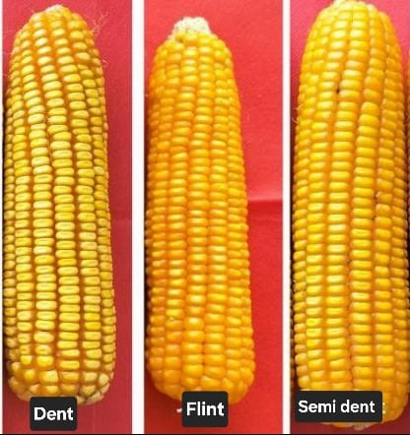
Grain Colour: Among the genotypes evaluated for grain colour, 26 genotypes showed orange kernels, 25 had yellow, 17 exhibited yellow with a white cap, and only one genotype (CM 400) had pure white kernels. Grain colour in maize is important not only for visual appeal and market acceptance but also for enhancing nutritional value and targeting specific consumer preferences.

Fig 18:
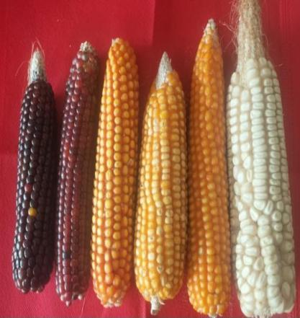
Kernel Shape: In the evaluated maize genotypes, 7 genotypes exhibited indented kernels, 16 genotypes showed tooth-shaped kernels, and 44 genotypes displayed round-shaped kernels, making round the most dominant kernel shape observed. Kernel shape is a vital character for classifying grain types, understanding quality traits, and targeting specific end-use applications.

Fig 19:
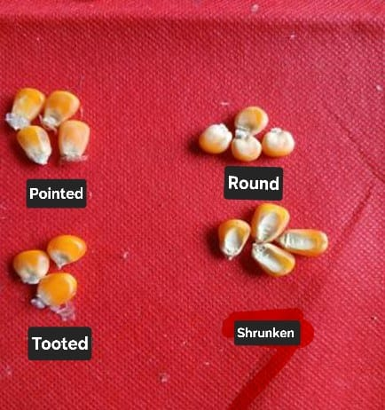
Number of Grain Rows: Grain row number varied from medium (10–12 rows) in 46 genotypes such as MAI 725 (11 rows) to NAI 137-3 (13 rows) to large row numbers (>14) observed in 23 genotypes, such as IMLSB 246-2 (14 rows) to PL 23681 (16 rows). This variation indicates a diverse genetic base and highlights genotypes like PL 23681 for their superior yield traits. This trait is crucial for breeding high-yielding, stable maize varieties and plays a significant role in optimizing productivity and grain quality in commercial maize cultivation.
Fig 20:
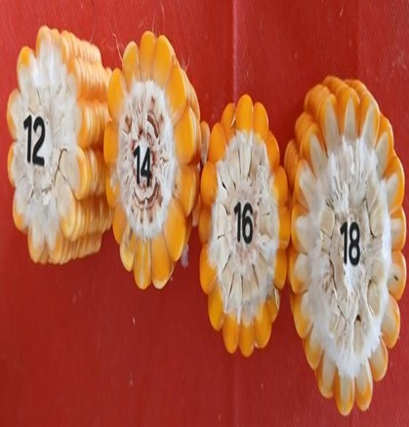
Row Arrangement: In the evaluated genotypes, 3 genotypes PFSR-R3, IMLSB 246-2, and CM 400 exhibited an irregular row arrangement, while 2 genotypes PL 23572 and PL 23681 showed a spiral row pattern. The remaining 64 genotypes displayed a straight row arrangement, which was the most common and preferred for uniform kernel development and mechanical harvesting.
Fig 21:
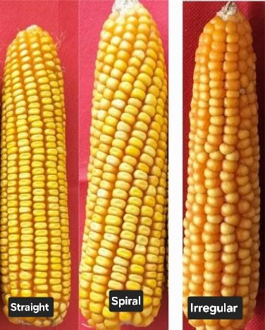
1000 Kernel Weight: Among the 70 maize genotypes evaluated, IMLSB 334 B-2 exhibited a very small kernel weight; 19 genotypes showed small, 38 medium, and the remaining 12 exhibited large kernel weight. This trait shows clear variation and is critical for establishing distinctness in DUS characterization and in selecting high-yielding, market-oriented cultivars.
Fig 22:
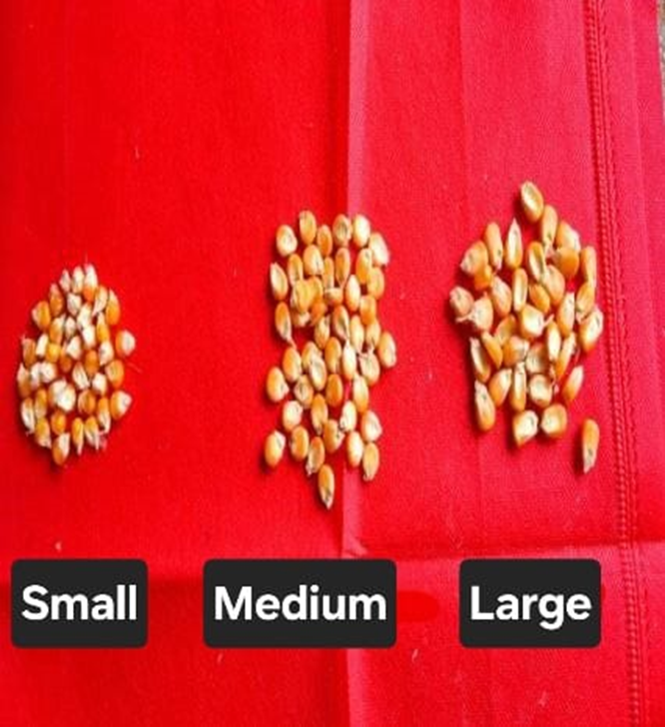
Table 2. Cont...
# | Genotype | Glume colour of cob | No.of grain rows | Grain type | Grain colour | Row arrangement | Kernel shape | 1000 kernel weight
1 | MAI 214 | white | 15 | Flint | Yellow | Straight | indented | 13
2 | CM 400 | white | 13 | Flint | White | Irregular | round | 15
3 | ENT-2-3 | - | 12 | Flint | Orange | Straight | round | 22
4 | MAI 2 | white | 12 | Flint | Yellow | Straight | round | 19
5 | PML 137 | white | 11 | Flint | Orange | Straight | round | 22
6 | IML12 | white | 15 | Flint | Orange | Straight | round | 16
7 | IMLSB 282-2 | white | 14 | Flint | Orange | Straight | indented | 32
8 | MAI 21 | white | 13 | Flint | Orange | Straight | round | 28
9 | PL 23681 | white | 16 | Semi dent | Yellow with cap | Spiral | indented | 32
10 | SKV 50-tall | white | 12 | Flint | Orange | Straight | round | 22
11 | MAI 105 | white | 14 | Flint | Orange | Straight | round | 23
12 | 42048-2-2-1-1-2 | white | 12 | Flint | Orange | - | round | 23
13 | IMLSB 748-1 | white | 13 | Flint | Orange | Straight | round | 19
14 | VL 19192 | white | 12 | Flint | Yellow with cap | Straight | round | 26
15 | KDM 70938 | white | 13 | Semi dent | Yellow with cap | Straight | toothed | 24
16 | Check 2 | white | 13 | Flint | Yellow | Straight | toothed | 28
17 | PFSR-R3 | white | 14 | Flint | Orange | Irregular | round | 16
18 | NAI-178A | white | 12 | Flint | Orange | Straight | indented | 20
19 | PL 23569 | white | 15 | Flint | Orange | Straight | toothed | 24
20 | IMLSB 334 B-2 | white | 12 | Flint | Yellow | Straight | toothed | 9
21 | PFSR 63 | white | 13 | Semi dent | Yellow | Straight | round | 34
22 | JCY 3-7-1-2-1 | white | 13 | Flint | Yellow | Straight | round | 29
23 | PL 23689 | white | 12 | Flint | Yellow | Straight | round | 21
24 | MIL 2-334 B-1 | white | 12 | Flint | Orange | Straight | round | 21
25 | IMLSB 380-1 | white | 13 | Flint | Yellow | Straight | round | 17
26 | IMLSB 1376 | white | 12 | Flint | Yellow | Straight | toothed | 20
27 | JCY 2-7 | white | 12 | Flint | Yellow with cap | Straight | round | 34
28 | PL 23685 | white | 14 | Flint | Yellow with cap | Straight | round | 22
29 | BLS 42050-1 | white | 12 | Flint | Yellow with cap | Straight | round | 30
30 | PL 23572 | white | 11 | Flint | Orange | Spiral | toothed | 24
31 | P-JCYSR37 | white | 12 | Semi dent | Yellow | Straight | indented | 35
32 | IMLSB 2051 | white | 13 | Flint | Orange | Straight | round | 20
33 | P-JCYSR21 | white | 11 | Flint | Yellow with cap | Straight | round | 29
34 | IMLSB 57-2 | white | 14 | Flint | Yellow with cap | Straight | round | 21
35 | PL 23656 | white | 13 | Flint | Yellow | Straight | round | 31
36 | Check 1 | white | 11 | Flint | Yellow | Straight | toothed | 32
37 | DML 16 | white | 12 | Flint | Orange | Straight | toothed | 23
38 | PL 23577 | white | 15 | Flint | Yellow | Straight | round | 25
39 | IMLSB 246-2 | white | 14 | Flint | Orange | Irregular | round | 14
40 | PL 23684 | purple | 14 | Flint | Yellow | Straight | round | 28
41 | NAI 137-3 | white | 13 | Flint | Orange | Straight | toothed | 22
42 | IMLSB 1041-4 | white | 14 | Flint | Orange | Straight | toothed | 25
43 | PFSR 90 | white | 12 | Semi dent | Yellow with cap | Straight | round | 33
44 | PL 23571 | white | 13 | Flint | Orange | Straight | toothed | 33
45 | PFSR-R9 | white | 13 | Flint | Yellow | Straight | toothed | 31
46 | PL 23568 | dark purple | 14 | Flint | Yellow with cap | Straight | round | 27
47 | IMLSB 334 B-2 | white | 13 | Flint | Orange | Straight | round | 22
48 | IML 11 | white | 12 | Flint | Orange | Straight | indented | 19
49 | PL 23605 | white | 15 | Flint | Yellow with cap | Straight | indented | 21
50 | MGC 137 | white | 14 | Flint | Yellow | Straight | round | 23
51 | MGW 295 | white | 14 | Flint | Orange | Straight | round | 17
52 | PL 23690 | white | 13 | Flint | Yellow with cap | Straight | toothed | 22
53 | PML 21 | white | 13 | Flint | Orange | Straight | round | 20
54 | IMLSB 955-1 | white | 14 | Flint | Yellow | Straight | round | 20
55 | IMLSB 317-1 | white | 13 | Flint | Yellow | Straight | - | 19
56 | PL 23688 | dark purple | 13 | Flint | Yellow | Straight | round | 29
57 | UMI 1210 | white | 13 | Flint | Yellow | Straight | round | 34
58 | CM 202 | light purple | 15 | Dent | Yellow with cap | Straight | round | 20
59 | IMLSB 334 B-2 | - | 12 | - | - | Straight | - | 17
60 | PL 23691 | white | 13 | Semi dent | Yellow with cap | Straight | toothed | 28
61 | PL 23672 | white | 15 | Dent | Yellow | Straight | round | 24
62 | IML 21 | white | 14 | Flint | Yellow with cap | Straight | round | 22
63 | MAI 725 | white | 11 | Flint | Yellow with cap | Straight | round | 19
64 | IMLSB 1043-1 | white | 13 | Flint | Yellow | Straight | toothed | 15
65 | CM 202 | light purple | 15 | Flint | Yellow | Straight | round | 19
66 | CMI-CR-01 | white | 14 | Flint | Orange | Straight | toothed | 24
67 | IMLSB 343-3 | white | 12 | Flint | Yellow | Straight | round | 22
68 | MIL 1-11 | white | 12 | Flint | Orange | Straight | round | 20
69 | CM 202 | dark purple | 16 | Flint | Yellow with cap | Straight | round | 20
70 | IMLSB 343-3 | white | 13 | Flint | Yellow | Straight | round | 20

Conclusion
The DUS characterization of 70 maize inbred lines revealed substantial phenotypic diversity across morphological, phenological, and yield-related traits. Variation in leaf angle and attitude suggests potential for optimizing canopy architecture to improve light interception and photosynthetic efficiency. Root traits, particularly brace root development, contribute to anchorage strength and adaptability under stress conditions. Tassel traits such as attitude, angle, and spikelet density are critical for pollination efficiency and reproductive success. Ear characteristics, including length, diameter, and shape, showed strong associations with yield potential, while kernel traits such as grain type, color, shape, and row arrangement are essential for market differentiation and breeding targets.
Notably, genotypes such as IMLSB 2051, PL 23605, and PL 23569 emerged as distinct, uniform, and stable, combining favorable morphological traits with high agronomic value. These lines hold promise for use in hybrid development, varietal registration, and trait-specific breeding strategies.
Overall, the study underscores the importance of comprehensive, multi-trait DUS evaluation as a foundational tool for maize improvement programs. It supports the identification and protection of elite maize genotypes suited for diverse agro-climatic conditions and evolving breeding objectives, including yield enhancement, stress relience, and genetic purity.
References
AP Seeds. (2024). Annual Report 2023–24: Seed production and productivity statistics. Andhra Pradesh State Seeds Development Corporation Ltd.
Camussi, A., Ottaviano, E., Calinski, T., & Kaczmarek, Z. (1983). Genetic distances based on quantitative traits. Genetics, 105(2), 437–450.
Ministry of Agriculture & Farmers Welfare. (2024). Agricultural Statistics at a Glance 2024. Government of India.
Plant Archives. (2024). Morphological characterization and dendrogram analysis of DUS traits in maize inbred lines (Zea mays L.). Plant Archives, 24(1), 234–240. Retrieved from
Protection of Plant Varieties and Farmers’ Rights Authority (PPV&FRA). (2001). DUS Guidelines for Maize (Zea mays L.). Government of India. Retrieved from
Reddy, B. V. S., Ramesh, S., & Reddy, P. S. (2022). Importance of inbred lines in hybrid maize breeding. Journal of Cereal Research, 14(1), 12– 19.
Saritha, B., Rani, S. U., & Kumar, P. R. (2024). Morphological characterization of maize inbred lines using DUS descriptors. Journal of Advances in Biology & Biotechnology, 27(2), 68–75.
Smith, J. S. C., & Smith, O. S. (1989). The description and assessment of distances between inbred lines of maize: II. The utility of morphological, biochemical, and genetic descriptors and a scheme for the testing of distinctiveness between inbred lines. Maydica, 34(2), 151–161.
UPOV (International Union for the Protection of New Varieties of Plants). (2002). Guidelines for the conduct of tests for distinctness, uniformity and stability: Maize (Zea mays L.). UPOV, Geneva.
Yadav, V. K., & Singh, J. (2010). Distinctness, Uniformity and Stability testing in field crops: Principles and practices. Indian Journal of Agricultural Sciences, 80(10), 845–850.

