Original Research Article
Bio-pesticidal Potential of Soapnut Saponins as a Sustainable Alternative for Managing Cowpea Web Blight: An In-vitro Evaluation

.
ABSTRACT
The present study examined the antifungal potential of saponin extracted from Sapindus species against the web blight pathogen of cowpea. The causal organism, identified as Rhizoctonia solani, was isolated from naturally infected cowpea plants exhibiting typical web blight symptoms. Comprehensive characterization of the pathogen was conducted through cultural, morphological, and molecular approaches and identified as R. solani. For the evaluation of soapnut saponins, the compounds were extracted from the fruit pericarp using two different solvents: ethanol and water, followed by lyophilisation. Ethanol proven to be the more efficient solvent in saponin extraction with an efficiency of 79.26%. The antifungal efficacy of the extracts was tested under in vitro conditions. The poisoned food technique was employed to determine their inhibitory effect on the mycelial growth of R. solani under different concentrations including 0.1%, 0.2%, 0.5%, 1.0% and 2.0%. The study demonstrated that Sapindus saponins exhibited significant antifungal activity, achieving up to 68.8% growth inhibition at 2%, indicating their potential as an eco-friendly alternative to conventional fungicides.

Keywords: Sapindus sp.; pericarp extract; lyophilisation; saponin; antifungal activity; web blight

- INTRODUCTION
Cowpea (Vigna unguiculata) is an important multipurpose grain crop widely cultivated in India valued both as a food source and as fodder. It is often referred to as “vegetable meat,”, the cowpea is valued for its rich protein content which ranges from 27 to 43% , with the protein level in the dry grain varies between 21 to 33% (Ddamulira et al., 2015, Abudulai et al. 2016). In addition to its protein content, cowpea provides important complex carbohydrates, dietary fiber, and essential nutrients like iron, magnesium, folate, along with various B vitamins. Despite its importance, several biotic and abiotic factors affect cowpea production, with fungal diseases posing significant threat to crop yield.

Among these diseases, web blight, caused by the soil-borne fungus R. Solani, stands out as a major concern. This pathogen is highly persistent and it is capable of surviving for many years, due to the sclerotium production during the off season, causing significant stand loss and subsequent yield reductions. In India, web blight caused by R. Solani (AG-1A) is a principal fungal disease affecting urd bean, another vital legume, with reported grain yield losses of up to 30%. This pathogen is an emerging threat in cowpea cultivation areas globally, responsible for an annual yield loss of approximately 30% (Kankam et al., 2016).

Traditionally, synthetic chemical fungicides have been used to manage plant diseases, resulting in improved crop yields and effective disease control. However, the indiscriminate use of these chemicals is associated with risk to human health and the environment, including the accumulation of harmful residues, development of pathogen resistance (Chapman et al., 2011), and adverse effects on beneficial soil microorganisms. This has led to a shift towards more sustainable and eco-friendly alternatives, with a growing focus on plant-derived compounds, or botanical pesticides, which are biodegradable and present minimal risks to human and ecosystems.

Sapindus species commonly called as soapnut or washnut, belongs to the Sapindaceae family. They have long been recognized for their natural surfactant properties. Recent phytochemical studies on various parts of the S. mukorossi have revealed the presence of triterpenoid saponins including oleanane, dammaranes, tirucullanes etc. (Góral and Wojciechowski, 2020). These saponins are found in multiple parts of the plant such as fruits, galls and roots. The saponin content ranges from 10.1 to 11.5% in the fruit pericarp and increases to 56.5% in the drupe (Upadhyay and Singh, 2012). The inhibitory activity of Sapindus saponin extracts against Candida albicans and Trichophyton rubrum, has been well-documented (Heng et al., 2014). For instance, an aqueous pericarp extract showed complete (100%) inhibition of Venturia inaequalis and 54% inhibition of Botrytis cinerea at a concentration of 30,000 ppm (Porsche et al., 2018). Soapnut extract concentration at 10% reduced the pathogen’s colony diameter of Cercospora canescens by 41.67% while a 20% concentration achieved a modest increase in inhibition to 43.85% (Ganesh, 2022).

Despite the well documented antifungal properties of Sapindus spp., its specific efficacy against the cowpea web blight pathogen, R. solani, has not been thoroughly investigated. Therefore, this study aimed to evaluate the in vitro bio-pesticidal activity of soapnut fruit pericarp extracts against this pathogen. The research involved isolating and characterization the pathogen, followed by extracting saponin from soapnut using two solvents, aqueous and ethanol via lyophilization technique. Subsequently the antifungal activity of these extracts was tested at various concentrations. We hypothesized that the soapnut extract would effectively suppress the mycelial growth of R. solani in a dose-dependent manner.

2. material and methods

2.1 Isolation of web blight causing pathogen
Naturally infected cowpea plants with typical symptoms of web blight were collected from fields of Panjal, Thrissur, Kerala. Diseased leaf and collar samples were rinsed thoroughly to remove surface debris, and cut into 8 mm segments containing both diseased and adjacent healthy tissues. The segments were surface-sterilized in 1% sodium hypochlorite solution for 30 seconds, followed by three rinses with sterile distilled water. Excess moisture was removed by blotting the segments on sterile filter paper. These sterilized pieces were then aseptically placed onto potato dextrose agar (PDA) plates and incubated at 28°C. The fungal colonies that developed were subcultured onto fresh PDA plates to obtain pure cultures for further analysis.
2.2 Pathogenicity test for pathogen associated with cowpea web blight
Pathogenicity test of the isolated culture was done using Koch’s postulate. Four leaf staged cowpea seedling as well as detached leaves of anaswara variety was selected for the inoculation of pathogen. A pure culture of the web blight pathogen, R. solani was incubated on Potato Dextrose Agar (PDA) for five days before inoculation. Leaf surface as well as collar region were gently cleaned with sterile water. Pin-prick was created on the leaf surface and the collar region to facilitate infection. An 8mm sized mycelial bit was cut from actively growing edge of the culture, was placed in sterile moisten cotton and was kept in the pinpricked region of the plant. The inoculated plant was covered with a polythene bag having holes to maintain a humid environment. Plant without pathogen inoculation was kept as control. Sterile water was sprayed in the inoculated region and daily observations were recorded to note the number of days for symptoms development. The symptoms developed on the artificially inoculated plants was compared with those found in the natural field settings. The pathogen was re-isolated from the artificially inoculated plant and compared with the original culture to confirm that the same pathogen was responsible for the observed disease symptoms.
2.3 Identification of pathogen
The pathogen associated with web blight of cowpea was isolated, purified, and its cultural, morphological, and molecular characteristics were studied for accurate identification.

2.4 Solvent extraction of soapnut pericarp
2.4.1 Drying and powdering of soapnut
Soapnut fruits were collected from the College of Forestry, Thrissur. Ripe fruits were dried in a hot air oven at 60°C for three days. After drying, the seeds were removed and the pericarp was ground into fine powder. As the power is highly hygroscopic, it was stored in an airtight container.

2.4.1 Saponin extraction
The soapnut powder was extracted using two different solvents: double distilled sterile water (aqueous) and ethanol. For the extraction, 50 g of soapnut powder was mixed with 500 ml of either solvent in a 1:10 ratio (Kose and Bayraktar, 2016). The mixture was agitated in an orbital shaker for six hours, to improve the extraction efficiency and ensuring thorough mixing of powder with the solvent. The undissolved powder was filtered using sterile double-layered muslin cloth. The solvents were then removed by lyophilization to yield the dry extract. The final product was weighed and stored in a sterile airtight vessel for further analysis.

2.5 In-vitro evaluation of soapnut against web blight causing pathogen in cowpea
The antifungal activity of soapnut against pathogen causing web blight was evaluated using the poisoned food technique. The crude soapnut ethanol extract (SEE) and soapnut aqueous extract (SAE) were diluted in sterile water to make different working concentration, such as 0.1%, 0.2%, 0.5%, 1.0% and 2.0%. The diluted samples were sterilized by passing them through a sintered filter to remove any microbial contamination. Double-strength PDA was prepared and sterilized by autoclaving. The required concentrations of the soapnut extract were incorporated into the double-strength PDA to obtain single-strength PDA containing the desired levels (0.1%, 0.2%, 0.5%, 1.0%, and 2.0%). The amended medium was then poured into sterile 90mm Petri plates under aseptic conditions and allowed to solidify. A seven-day-old R. solani culture was taken and a 5 mm disc of the pathogen was place at the centre of the media. PDA media poisoned with carbendazim (0.1%) and inoculated with the fungus was used as the positive control. A control plate containing only PDA media and fungal inoculum served as negative control. All plates were wrapped with parafilm and incubated at 28±2°C. Daily observations were taken until the mycelial growth in the negative control plate reached full growth.
Design: CRD
Treatment: 12
Replication: 3
T1: Soapnut ethanol extract (SEE) 0.1%
T2: Soapnut ethanol extract (SEE) 0.2%
T3: Soapnut ethanol extract (SEE) 0.5%
T4: Soapnut ethanol extract (SEE) 1%
T5: Soapnut ethanol extract (SEE) 2%
T6: Soapnut aqueous extract (SAE) 0.1%
T7: Soapnut aqueous extract (SAE) 0.2%
T8: Soapnut aqueous extract (SAE) 0.5%
T9: Soapnut aqueous extract (SAE) 1%
T10: Soapnut aqueous extract (SAE) 2%
T11: Carbendazim 0.1%
T12: Absolute control
Percentage inhibition was calculated using standard formulae.
Percentage inhibition = $\frac{C-T}{C}×100$

C = Mycelial growth diameter in the negative control plate (cm)
T = Mycelial growth diameter in the treatment plate (cm)

- results

3.1 Isolation and pathogenicity of web blight causing pathogen
The pathogen causing cowpea web blight was isolated and the mycelial growth was observed from the diseased tissue pieces within 24 hours. The isolated pathogen was pure-cultured using hyphal tip culture method and the pure culture was maintained on PDA slant and stored in refrigerator for subsequent studies.
The initial symptoms of web blight started to appear on the cowpea seedlings after the third day of artificial inoculation. However, detached leaves, showed symptoms one day earlier, on the second day post-inoculation.
The characteristic symptoms of web blight were consistent with those observed in natural infections. The disease began with the formation of water-soaked lesions on the leaves. These lesions quickly expanded, leading to widespread leaf necrosis. In the collar region of the seedlings, the first signs were sunken, dark brown lesions that developed at or just above the soil line. These lesions later enlarged, forming cankers that eventually spread around the stem, effectively girdling the collar region. Figure 1 shows the natural and artificial symptoms of cowpea web blight.
Re-isolation of the pathogen was done from artificially inoculated plant tissues and cultured on sterile PDA media under aseptic conditions. The same pathogen, with identical morphological and cultural characteristics as the original culture, was recovered, proving Koch’s postulates.

3.2 Identification of pathogen Cultural, Morphological and Molecular characterization
The isolated pathogen displayed distinct morphological characteristics on PDA media. Figure 2 shows the cultural and morphological characteristics of R. solani. The mycelial growth was initially white and later turned light brown. The culture exhibited a rapid growth rate, with an average radial growth of 2.9 cm per day. The colony margins were irregular, and the growth pattern was consistent and uniform across replicates.
As the culture matured, white mycelial thickenings developed, which later transformed into brown, irregularly shaped structures. These structures eventually turned into distinct sclerotial bodies. The sclerotia, with a size range of 1-5 mm, were characteristically located along the periphery of the Petri plate, and typically formed within 5-7 days of subculturing. The number of sclerotia produced varied from 12 to 29. Dark brown exudates were produced during the early stage of sclerotia formation. The pathogen also produced a light brown pigmentation in the PDA medium during maturation.
Morphological characterization revealed that, hyphae were septate and hyaline when young, turning brown upon maturation. The average hyphal width observed was 2.89 μm. Hyphal anastomosis was observed under the microscope. Hyphae branched at right angles, with constrictions at the points of branching. The fungus does not produce asexual spores or conidia. Based on the features describes above, the fungal isolate was identified as Rhizoctonia solani, the causal agent of cowpea web blight, and this identification was confirmed through ITS rDNA sequencing.

3.3 Extraction and preparation soapnut powder
The extraction of saponin from 50 g of dried soapnut pericarp powder was performed using two distinct solvents to compare extraction efficiency. The ethanol extract yielded 39.63 g of lyophilized powder, achieving an extraction efficiency of 79.26%. In comparison, the aqueous extract yielded 25.86 g, corresponding to an efficiency of 51.72%. The higher yield obtained with ethanol suggested that it is a more effective solvent for extracting the bioactive compounds from the pericarp.
The resulting extracts, were expected to be rich in saponins, flavonoids, and other phytochemicals. Due to its hygroscopic nature, the extract were stored in airtight containers to prevent moisture absortion. For subsequent in-vitro studies, five different concentrations of the lyophilized powder (0.1%, 0.2%, 0.5%, 1.0%, and 2.0% w/v) were prepared in sterile double-distilled water. The solutions were sterilized by filtration through a sterile sintered filter prior to their use in biological assays.

3.4 In-vitro analysis of soapnut extract against R. solani
The antifungal efficacy of soapnut extracts was evaluated against R. solani, and the results are presented in Table 1. Both the ethanol and aqueous extracts demonstrated significant inhibitory activity against the radial growth of the pathogen. The most significant inhibition among soapnut extracts was observed at a concentration of 2% (w/v), with the ethanol extract reducing the mycelial growth to 2.8 cm, while the aqueous extract limited the growth to 3.0 cm. Carbendazim (0.1%), the positive control, showed 100% inhibition. All the soapnut extract treatment exhibited a marked superiority over the negative control, where the pathogen attained complete radial growth.
Interestingly, despite the difference in extraction yield, both solvent types yielded extracts with comparable antifungal activity. The minimal difference in mycelial growth observed between the ethanol and aqueous extracts (2.8 mm vs. 3.0 mm) suggests that the solvent type has a negligible impact on the fungicidal efficacy of the crude extract. This indicates that the primary inhibitory effect is likely due to the saponin content itself, rather than other solvent-specific compounds. The positive control, 0.1% carbendazim solution, completely inhibited mycelial growth, validating the sensitivity of the pathogen to the known fungicide. These findings collectively confirm the significant bio-pesticidal potential of soapnut against R. solani. The percent inhibition of R. solani under different concentrations of soapnut extract is graphically represented in figure4.

Table. 1. Percentage inhibition of R. solani under different concentrations of soapnut extract
Treatments | Radial growth in (cm) | Inhibition (%)
T1: Soapnut ethanol Extract (SEE) 0.1% | 5.5 | 38.9
T2: Soapnut ethanol Extract (SEE) 0.2% | 5.1 | 43.3
T3: Soapnut ethanol Extract (SEE) 0.5% | 4.5 | 50
T4: Soapnut ethanol Extract (SEE) 1% | 3.6 | 60
T5: Soapnut ethanol Extract (SEE) 2% | 2.8 | 68.8
T6: Soapnut aqueous extract (SAE) 0.1% | 5.7 | 36.6
T7: Soapnut aqueous extract (SAE) 0.2% | 5.2 | 42.2
T8: Soapnut aqueous extract (SAE) 0.5% | 4.6 | 48.8
T9: Soapnut aqueous extract (SAE) 1% | 3.7 | 58.8
T10: Soapnut aqueous extract (SAE) 2% | 3.0 | 66.6
T11: Carbendazim 0.1% | 0 | 100
T12: Absolute control | 9 | 0

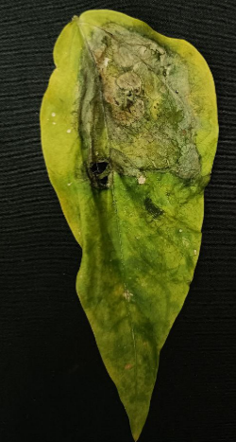
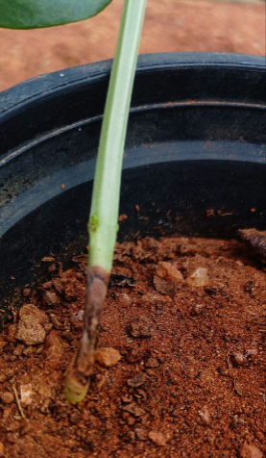
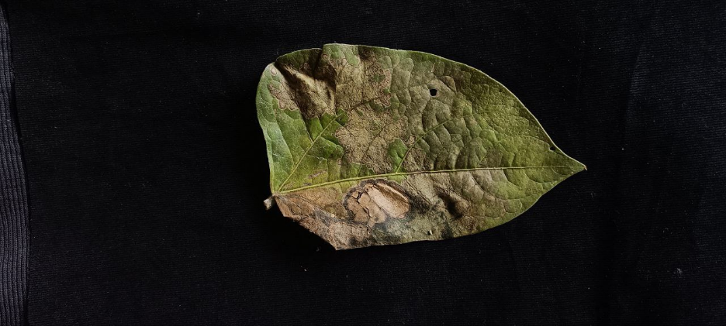

1a. Natural symptoms of web blight of cowpea
1b. Artificially produced symptoms of web blight of cowpea

Fig 1: 1a.natural and 1b.artificial symptoms of web blight in cowpea

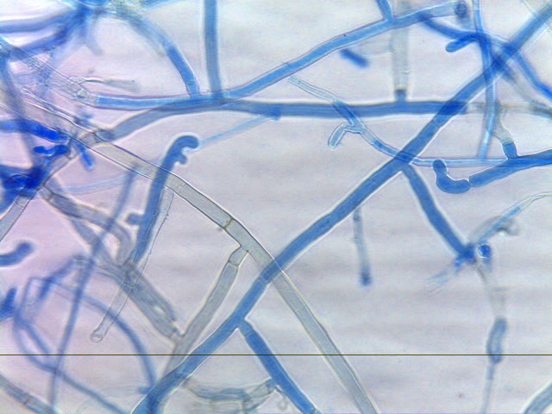
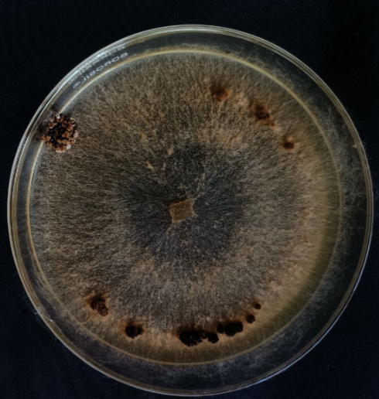

Fig 2: Cultural and morphological characteristics of R. solani

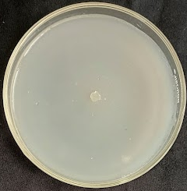
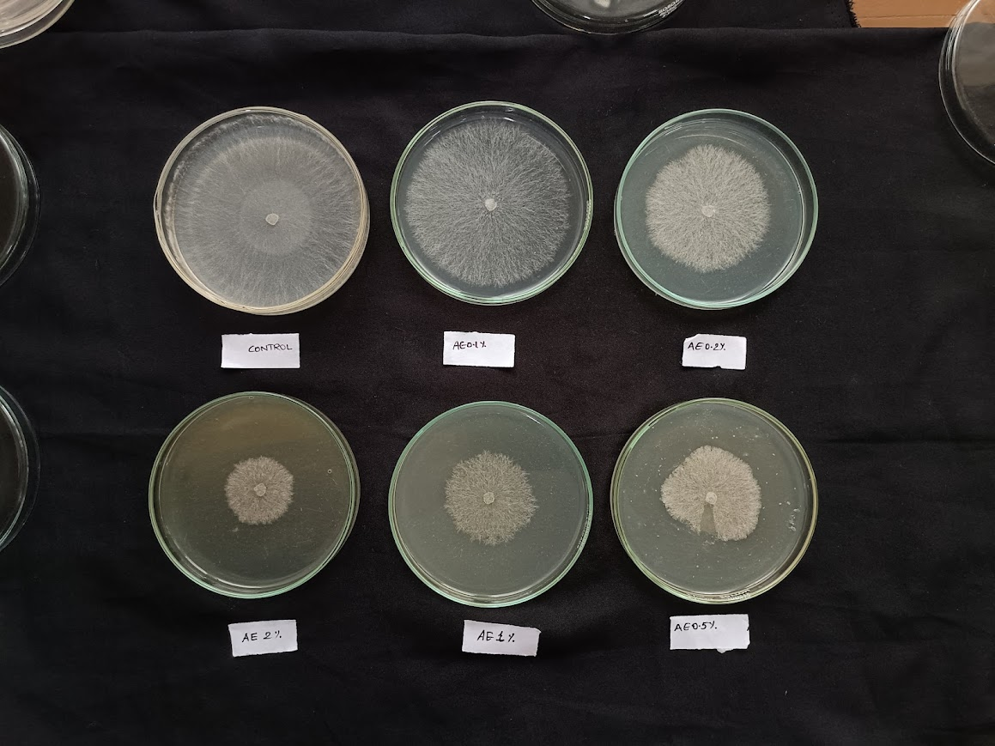
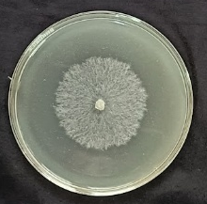
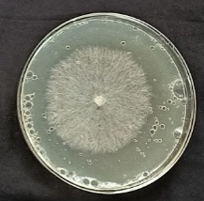
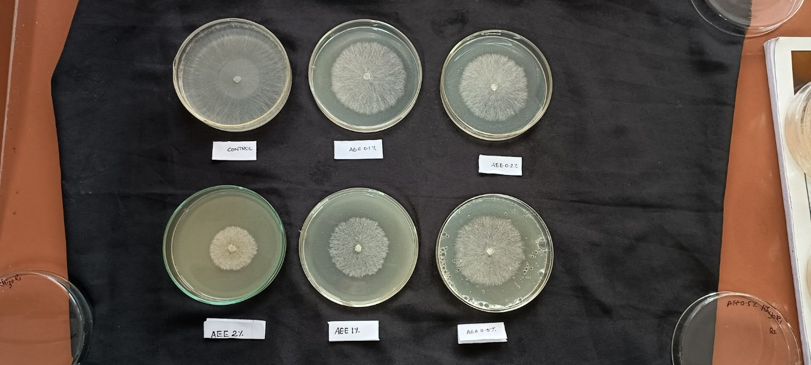
SEE 2%
SEE 1%
Control
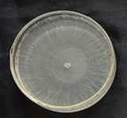

SEE 0.5%
SEE 0.2%
SEE 0.1%
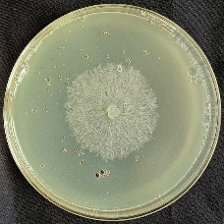
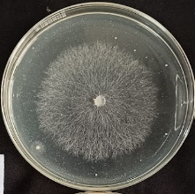
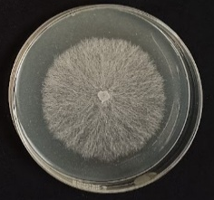
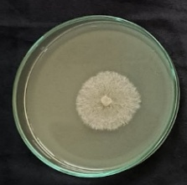

Carbendazim
SEE 0.2%
SEE 0.1%
SAE 2%
SAE 1%
SAE 0.5%

Fig3: in-vitro evaluation of soapnut extract against R. solani

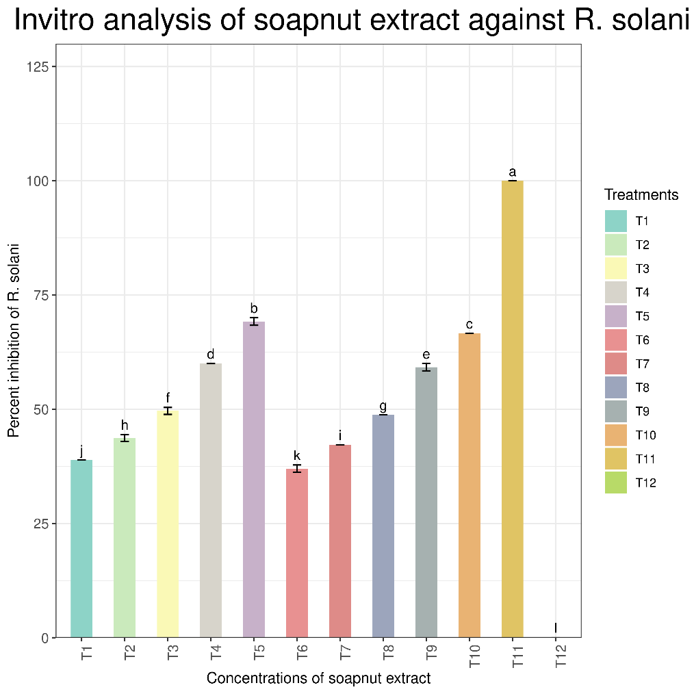

4.

Fig 4: In vitro analysis of soapnut extract against R. solani

discussion
The present study evaluated the antifungal activity of soapnut saponin as a sustainable alternative for managing the cowpea web blight causing pathogen. The fruit pericarp extracts exhibited antifungal activity against R. solani. A comparative analysis of extraction efficiency revealed that the ethanol-based method yielded a substantially higher amount of extract (78.8%) compared to the aqueous method (51.72%), confirming that ethanol is a more effective solvent for extracting the bioactive compounds. All the tested concentrations showed dose-dependent inhibition of pathogen’s mycelial growth of the pathogen with highest concentration (2% soapnut ethanol extract) achieving a maximum percentage inhibition of 68.8%. These findings strongly support the potential of soapnut as a natural and effective alternative for managing this significant fungal disease.
Prior to testing, the web blight causing pathogen was isolated, and its detailed morphological and cultural characters were studied and compared with standard descriptions. Molecular analysis confirmed its identity as R. solani which is widely recognized as a predominant cause of web blight in legumes across India. Pathogenicity of the isolate was proven using Koch’s postulates. The accurate identification of the specific pathotype is a crucial prerequisite in developing targeted disease management strategies.
The antifungal potential of soapnut revealed in this study is mainly due to the high saponin concentration present in the fruit pericarp. As noted by Augustine et al. (2011) and Murgu et al. (2008), the saponin content is the primary driver of soapnut's antifungal properties. Various triterpenoid saponins, including those of the oleanane, dammarane, and tirucallane types, have been identified from the galls, fruits, and roots of Sapindus spp. (Suhagia et al., 2011). Although saponins are distributed throughout different parts of S. mukorossi, their concentration is particularly high in the fruits. Chemically, saponins represent high-molecular-weight secondary metabolites characterized by strong polarity and a wide range of biological activities (Evans, 2009).
Key mechanism underlying the antifungal property of saponins is, their binding to the fungal membrane sterols, ergosterol which results in the formation of pores in the cell membrane. This causes to ions leakage and ultimately disrupts the fungal cell. This mechanism provides a plausible explanation for the significant growth inhibition of R. solani observed at concentrations as low as 0.1%. This aligns with recent findings by Huang et al. (2024), who reported that saponin treatment triggers autophagy-like vacuole formation, disturbs organelle homeostasis, and compromises membrane potential and integrity in B. cinerea. Similar studies conducted by Zou et al., (2025) demonstrated the antifungal activity of soapberry pericarp extracts against Verticillium dahliae and Fusarium oxysporum. While the general fungicidal properties of Sapindus spp. have been previously noted, this study specifically establishes the effectiveness of soapnut extracts against a virulent and economically important pathogen of cowpea.
Increasing reliance on synthetic fungicides to combat this disease has raised serious concerns regarding their harmful effects on both environmental and human health. Moreover, the increasing use of the chemical fungicides results in residual toxicity and fungicide resistance among pathogens, highlighting the need for biodegradable alternative to mitigate these issues. This work represents a crucial step towards developing a sustainable and locally sourced bio-pesticide for the management of cowpea web blight, thereby contributing to both food security and environmental protection.
The current study was limited to in-vitro analysis. The efficacy of the soapnut saponin must be evaluated under field conditions, where factors such as sunlight, rainfall, soil microbial activity, and temperature fluctuate, to understand its potential, stability and bioactivity. The impact of soapnut saponin extract on seed germination and plant growth should be thoroughly assessed to determine any potential phytotoxic effects. Therefore, further research is warranted to evaluate its performance through field trials and to identify the optimal application methods. Further purification and chemical characterization of the extract are needed to identify the precise bioactive compounds responsible for the antifungal effect.

5. CONCLUSION
The experimental findings presented the potent antifungal potential of soapnut saponin against R. solani under in-vitro conditions. The observed efficacy provides a strong foundation for the future development of a bio-pesticide. The findings suggest that soapnut extract can serve as a readily prepared and effective antifungal solution for protecting crops, offering a promising, sustainable alternative to synthetic fungicides.

Disclaimer (Artificial intelligence)
Option 2:
The author(s) hereby declares that generative AI technology such as Perplexity Pro was utilized during the preparation of this manuscript to assist with grammatical corrections and to improve the readability and clarity of certain sections. All the research work, methodologies and results presented in this manuscript were independently conducted and developed by the author(s) without the use of AI technologies. The author takes full responsibility for the accuracy and integrity of the content.
Details of the AI usage are given below:
- Name: Perplexity Pro
Version: Current as of 2025 (latest update April–September 2025)
Models included: Primarily GPT-5 by OpenAI; also capable of using Claude 4.0 Sonnet, Sonar Large (LlaMa 3.1-based), Gemini 2.5 Pro by Google, and others depending on usage. For writing assistance, GPT-5 is the typical model used.
Source: Perplexity AI platform (https://www.perplexity.ai)
Input prompts: Prompts requesting grammatical corrections, clarity improvements, and language refinements on manuscript sections

References
- Ddamulira G, Santos CA, Obuo P, Alanyo M, Lwanga CK. (2015). Grain yield and protein content of Brazilian cowpea genotypes under diverse Ugandan environments. Am J Plant Sci., 6(13):2074-84. DOI: 10.4236/ajps.2015.613208
- Abudulai M, Seini SS, Haruna M, Mohammed AM. (2016). Farmer participatory pest management evaluations and variety selection in diagnostic farmer field fora in cowpea in Ghana. Afr J Agric Res.,11(19):1765-71. DOI: https://doi.org/10.5897/AJAR2016.10887
- Kankam, F., Qiu, H., Pu, L., Long, H., Zhang, C., He, J., & Zhang, H. (2016). Isolation, purification and characterization of phytotoxins produced by Rhizoctonia solani AG-3, the causal agent of potato stem canker. Am. J. Potato Res., 93(4), 321–330. DOI: https://doi.org/10.1007/s12230-016-9506-8
- Chapman KS, Sundin GW, Beckerman JL. (2011). Identification of resistance to multiple fungicides in field populations of Venturia inaequalis. Plant Dis., 95(8):921-6. DOI: 10.1094/PDIS-12-10-0899
- Góral, I., & Wojciechowski, K. (2020). Surface activity and foaming properties of saponin-rich plants extracts. Adv. Colloid Interface Sci., 279, 102145. DOI: 10.1016/j.cis.2020.102145
- Upadhyay, A., & Singh, D. K. (2012). Pharmacological effects of Sapindus mukorossi. Rev. Inst. Med. Trop. Sao Paulo, 54, 273–280. DOI: 10.1590/s0036-46652012000500007
- Heng, W., Ling, Z., Na, W., Youzhi, G., Zhen, W., Zhiyong, S., Deping, X., Yunfei, X., & Weirong, Y. (2014). Analysis of the bioactive components of Sapindus saponins. Ind. Crops Prod., 61, 422–429. DOI: 10.1016/j.indcrop.2014.07.026
- Porsche, F. M., Molitor, D., Beyer, M., Charton, S., André, C., & Kollar, A. (2018). Antifungal activity of saponins from the fruit pericarp of Sapindus mukorossi against Venturia inaequalis and Botrytis cinerea. Plant Dis., 102(5), 991–1000. DOI: https://doi.org/10.1094/PDIS-06-17-0906-RE
- Ganesh, D. S. (2022). Studies on management of green gram leaf spot caused by Cercospora canescens (Ellis and Martin) (Master’s thesis, Vasantrao Naik Marathwada Krishi Vidyapeeth, Parbhani).
- Kose, M. D., & Bayraktar, O. (2016). Extraction of saponins from soapnut (Sapindus mukorossi) and their antimicrobial properties. World J. Res. Rev., 2(5), 262952.
- Augustine JM, Kuzina V, Andersen SB, Bak S. (2011). Molecular activities, biosynthesis and evolution of triterpenoid saponins. Phytochemistry, 72(6):435-57. DOI: 10.1016/j.phytochem.2011.01.015
- Murgu, M., Santos, L. F., Souza, G. D., Daolio, C., Schneider, B., Ferreira, A. G., & Rodrigues-Filho, E. (2008). Hydroxylation of a hederagenin-derived saponin by a xylareaceous fungus found in fruits of Sapindus saponaria. J. Braz. Chem. Soc., 19, 831–835. https://doi.org/10.1590/S0103-50532008000500004
- Suhagia, B. N., Rathod, I. S., & Sindhu, S. (2011). Sapindus mukorossi (Areetha): An overview. Int. J. Pharm. Sci. Res., 2(8), 1905. DOI: http://dx.doi.org/10.13040/IJPSR.0975-8232.2(8).1905-13
- Evans, W. C. (2009). Trease and Evans' pharmacognosy (16th ed.). Edinburgh: Elsevier Health Sciences.
- Huang, X., Liu, W., Dong, F., Xu, Y., Tian, S., & Chen, T. (2024). Sapindus mukorossi saponins inhibit gray mold on strawberry fruit by impairing membrane integrity and organellar homeostasis of Botrytis cinerea. Postharvest Biol. Technol., 207, 112594. DOI: 10.1016/j.postharvbio.2023.112594
- Zou, R., Yuan, J., Wang, Y., Peng, X., Ye, T., Han, L., Cheng, Z., & Xie, C. (2025). Antifungal activity of soapberry pericarp extracts: An effective approach against plant pathogenic fungi. Pest Manag. Sci. Advance online publication. https://doi.org/10.1002/ps

