Epidemiology and molecular dynamics of cassava mosaic viruses in Côte d’Ivoire: Current agronomic challenges in Côte d’Ivoire

.
ABSTRACT

Aims: This study aimed to characterize cassava mosaic viruses and assess the factors influencing the dynamics of this disease in central and central-western Côte d'Ivoire in order to support effective management strategies.
Study design: Descriptive transversal epidemiological survey.
Place and Duration of Study: Conducted from November 2019 to August 2020 in the departments of Bouake, Yamoussoukro, and Daloa, the main cassava-producing areas, the study combined in-depth field surveys and molecular diagnostics.
Methodology: A total of 183 cassava plantations in 15 villages were randomly sampled. In each selected field, one sample was collected per variety and per case, depending on whether it was symptomatic or asymptomatic to mosaic disease. CMD symptoms were assessed on 5,896 plants using a severity scale of 1 to 5. Agronomic data were recorded. Approximately 200 symptomatic and asymptomatic leaf samples were subjected to DNA extraction and PCR testing targeting African cassava mosaic virus (ACMV) and East African cassava mosaic virus (EACMV).
Results: The results showed a relatively high phenotypic prevalence of CMD. Informal exchange of planting cuttings was a major factor in infection compared to cuttings from official sources. Crop age and season influenced vulnerability. Symptom severity was generally moderate, although hot spots with severe symptoms were identified. Molecular analyses confirmed the predominance of ACMV followed by ACMV-EACMV co-infections.
Of the 200 plants analyzed, 35% of asymptomatic cassava mosaic plants (18 plants) and 77% of symptomatic plants (115 plants) were infected by the virus. It is significant that many asymptomatic plants tested positive for CMD viruses, highlighting the challenge of latent infections in disease management.
Conclusion: The study highlights the complex epidemiology of a serious cassava disease in Côte d'Ivoire. In addition, viruses are uniformly distributed across the different cassava production areas. It recommends integrated control strategies such as certification of cuttings, vector control and molecular surveillance. Together, these measures are essential to reduce the impact of the disease, maintain cassava yields, and ensure food security for vulnerable populations that depend on this staple crop.

Keywords: Cassava, Cassava Mosaic Disease, vegetative propagation, Molecular diagnosis, Food security, Côte d’Ivoire)

1. INTRODUCTION

Cassava, an Euphorbiaceae scientifically known as Manihot esculenta Crantz, constitutes a fundamental staple food for numerous populations (Alamu et al., 2019). It is predominantly cultivated for human consumption and animal feed, but also finds diverse industrial applications including pharmaceuticals and textiles. Specifically, cassava plays a crucial role in the food security of several African countries, including Côte d’Ivoire, where it constitutes a cornerstone of subsistence farming systems (Amoakon et al., 2023). However, its production has been continuously threatened for decades by cassava mosaic disease (CMD). This viral disease causes substantial agricultural yield losses, severely affecting both the quality and quantity of harvests (Kimno et al., 2023). CMD is caused by a complex of geminiviruses from the Begomovirus genus, primarily including African cassava mosaic virus (ACMV) and East African cassava mosaic virus (EACMV), which infect the plant through various viral strains exhibiting differing levels of virulence (Doungous et al., 2022; Combala et al., 2024). The virus spreads mainly through vegetative propagation using infected cuttings, as well as biologically transmitted by the major insect vector, the polyphagous whitefly Bemisia tabaci, which persistently and circulatively transmits the virus. Bemisia tabaci deserves particular attention due to its dual role, not only as the primary vector of CMD but also because of its intrapopulation genetic diversity, which influences the transmission efficiency of different viral strains (Legg et al., 2014). CMD symptoms are diverse and include mosaic chlorosis on leaves, leaf deformation, dwarfism, and overall stunted growth. These symptoms, though indicative, are not specific to a single viral strain. Such manifestations can severely compromise photosynthesis and thus plant productivity, leading to significant economic losses. In Côte d’Ivoire, recent studies showed that CMD-induced losses seriously threaten local food security (Amoakon et al., 2023; Ahoya et al., 2025). This urgent problem of food security would be due to variable genetic diversity and increasing severity of CMD viral strains, as well as their epidemiological dynamics between different departments. This study aims to contribute to CMD virus control in order to improve cassava production through an epidemiological survey on a large scale. Thus, the cassava mosaic viruses will be characterized in order to determine their geographical distribution and assess the factors influencing their dynamics in Côte d'Ivoire.

2. methodology

2.1 Study areas and sample collection
The study was conducted in the central and central-western regions of Côte d’Ivoire, specifically in three major departments known for their significant cassava production: Bouake, Yamoussoukro and Daloa. These regions experience a climate characterized by two distinct seasons (dry season and rainy season) from November 2019 to August 2020, to take account of seasonal impacts on the Cassava Mosaic Desease.
For optimal representativeness of departmnents, five villages were selected by department. There are Bribouo, Kibouo, Zaguiguia, Zakaria, and Zakoua in the Bouake department; Apkessekro, Assanou, Lolobo, Ngbessou, and Oufouediekro for Yamoussoukro; and Diabo, Ndjebonoua, Kekrekouakoukro, Kogodekro, and Yebouekro for the Bouaké department. These villages were chosen because of their geographical location, which is representative of the different departments studied, as well as for the diversity of cassava varieties grown there. For each surveyed site, prior sampling consent was obtained from the respective farmers. Between 5 and 12 cassava fields per village were randomly chosen for sampling. Thus, a total of 183 plantations were visited during the sampling. It should be mentioned that data collection was carried out in two stages (a & b).
a- For this stage of sampling, all cassava plants present in the fields, 5896 plants, were taken into account. To assess the rate of diseased plants, the number of plants showing phenotypic symptoms was counted in each field, as well as the total number of plants in the plantation. In large fields, a representative sample area comprising 30 plants was selected to perform this same count, in accordance with the method described by Sseruwagi et al. (2004). This data collection was carried out using a pre-established questionnaire, which also collected additional information such as GPS coordinates, varieties grown, age of plantations, origin of cuttings, season of collection, and severity of cassava mosaic disease (CMD) in each field. This severity was assessed on a scale of 1 to 5, following the method proposed by Bakuzezia (2019) below.

Grading scale of CMD severities
- Sev. 1: Absence of visible symptoms on leaves or stems
- Sev. 2: The leaves exhibit mild yellowing along the veins and chlorotic spots, with an absence of brown streaks or lesions on both the green stems and foliage
- Sev. 3: The leaves exhibit mild yellowing along the veins and chlorotic spots, while the green stem sections show mild brown streaks and lesion formations
- Sev. 4: Leaves exhibit severe vein yellowing and widespread chlorotic blotches, while the green stem sections show prominent brown streaks and dark lesions. The infection is also associated with defoliation and low growth stunting.
- Sev. 5: Leaves display extensive and severe vein yellowing with chlorotic spots, while the green stems showed pronounced brown streaks and dark lesions. The infection is also associated with defoliation, stem die-back, and growth stunting

b- In each selected field, one or two samples were collected randomly per each variety and per each case, depending on whether it was symptomatic or asymptomatic to mosaic disease. The collected leaves were individually and carefully stored in herbariums and then transported to the laboratory molecular analyses at the Research Unit for Genetics and Molecular Epidemiology (URGEM), located at Jean Lorougnon Guede University, Daloa, Côte d'Ivoire.

2.2. DNA extraction
DNA extraction was performed using a modified CTAB protocol (Rustérucci et al., 2008), optimized by replacing the conventional lysis buffer with a mixture of PBS and ASL buffer, enhancing the release and purity of nucleic acids. Before the actual extraction step, for each plant, 2g of leaves were mixed with NaCl 1g in a sterile mortar and then transferred in Eppendorf 1.5 ml containing buffer. After extraction, DNA was resuspended in Tris-EDTA buffer. To verify extraction quality, a random quality control was conducted on 10 samples per batch. DNA quality and integrity were assessed by electrophoresis on a 1% agarose gel stained with ethidium bromide, run at 100 volts for 30 minutes. Visualization under UV transillumination confirmed the absence of degradation and sufficient DNA concentration, essential conditions to ensure the reliability of downstream molecular analyses.

2.3. PCR diagnosis of cassava mosaic viruses
Cassava leaf samples were analyzed using classic PCR (Mullis, 1983) with specific primers targeting African Cassava Mosaic Virus (ACMV) and East African Cassava Mosaic Virus (EACMV). For ACMV detection, primer pairs JSP001/F with JSP002/R and ACMV-AL1/F with ACMV-AR0/R were employed, while EACMV was identified using primers JSP001/F and JSP003/R, as detailed in Table 1. The PCR reaction mixture (50 µL total volume) contained 5 µL of DNA template, 5 µL of 10X amplification buffer with MgCl2, 3.2 µL of dNTPs at 200 µM, 2.6 µL of each primer (10 pM), 0.1 µL of Taq DNA polymerase (5 U/µL), and 31.5 µL of nuclease-free water. Amplifications were performed in a BioRad T100™ thermal cycler (Singapore) using the following cycling conditions: an initial denaturation at 94°C for 5 minutes; 35 cycles of denaturation at 94°C for 45 seconds, annealing at 55°C for 45 seconds, and extension at 72°C for 55 seconds; followed by a final extension at 72°C for 10 minutes. The amplified products were separated by electrophoresis on a 2% agarose gel stained with ethidium bromide and run at 100 volts for 45 minutes in 0.5X Tris-Borate-EDTA (TBE) buffer. Gels were visualized under UV illumination, and presence or absence of expected PCR bands was recorded as positive (+) or negative (-) for cassava mosaic viruses.

Table 1. Diagnostic primers of cassava mosaic viruses
Primers | Sequence | Expected size (pb) | Virus detected
JSP001/F | 5ʼATGTCGAAGCGACCAGGAGAT 3ʼ | 783 | ACMV
JSP002/R | 5ʼTGTTTATTAATTGCCAATACT 3ʼ | 783 | ACMV
ACMV-AL1/F | 5ʼGCGGAATCCCTAACATTAT 3ʼ | 1030 | ACMV
ACMV-AR0/R | 5ʼGCTCGTATGTATCCTCTAAGGCCTG 3ʼ | 1030 | ACMV
JSP001/F | 5ʼATGTCGAAGCGACCAGGAGAT 3ʼ | 780 | EACMV
JSP003/R | 5ʼCCTTTATTAATTTGTCACTGC 3ʼ | 780 | EACMV

2.4. Statistical analysis
The percentage of phenotypically affected plants in each field was assessed by the ratio between symptomatic plants and all plants examined, and this formula was applied to all plants observed, as shown in the following formula:
The phenotypic prevalence of cassava mosaic disease (CMD) across the different departments was compared using pairwise proportion tests. To assess factors potentially influencing CMD development, Odds Ratios (OR) with 95% confidence intervals were calculated for variables such as cutting origin, crop age and climatic seasonality. To visualize the distribution and intensity of symptom severity across departments, heatmaps were generated; The infection rates were compared between symptomatic and asymptomatic plants across departments, using Chi-square tests. All statistical analyses were performed using R software version 3.3.1. Differences were considered statistically significant at a threshold of P < 0.05.
3. results
3.1. Phenotypic identification of cassava plants affected by mosaic
Fig 1 shows the different severity level of cassava mosaic disease observed during sampling. Based on symptom profiles, diagnosis of CMD in the central and central-western regions of Côte d'Ivoire revealed an average phenotypic prevalence or disease rate 43.37% among the 5,896 cassava plants examined. This infection rate shows no statistically significant difference between the villages in the three departments studied (Bouake, Yamoussoukro, and Daloa), as indicated by P = 0.23, reflecting a homogeneous distribution of the disease in these key cassava production areas (Table 2).

Table 2. Phenotypic prevalence of cassava mosaic disease in the departments of Bouake, Yamoussoukro and Daloa
Areas | Plants observed | Symptomatic | plant affected rates (%) | X2 | P
Bouake | 1946 | 844 | 43.37 | 2.93 | 0.23
Yamoussoukro | 2010 | 845 | 42.04 | 2.93 | 0.23
Daloa | 1940 | 868 | 44.74 | 2.93 | 0.23
Total | 5896 | 2557 | 43.37 | 2.93 | 0.23
Chi-square constant, P: Probability associated at x2 test

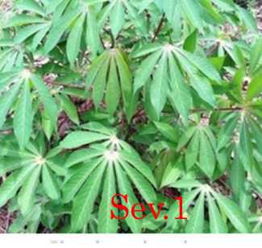 | 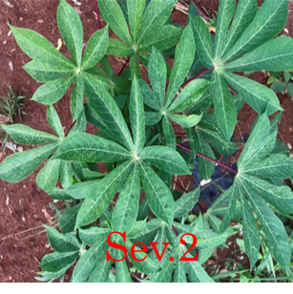 | 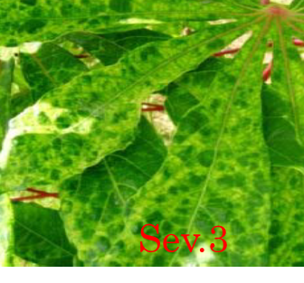 | 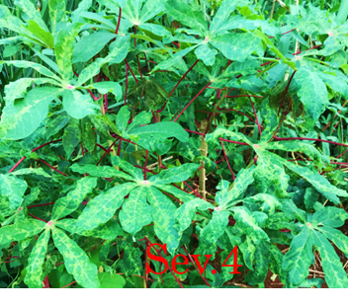
Fig 1. Intensities of symptoms observed during the study
3.2. Factors influencing CMD development
This study identifies several key factors contributing to the development of cassava mosaic disease, notably the origin of planting cuttings, crop age, and climatic seasonality, with the latter two being closely interconnected. Data presented in Table 3 indicate that the majority of severely affected plants originate from informal exchanges of cuttings among farmers. Conversely, cuttings supplied by official agricultural organizations such as CNRA and ANADER exhibit significantly lower infection rates, with strong statistical significance (P < 0.001) and an odds ratio (OR) of 6.53. Additionally, crop age is a critical determinant of susceptibility, with cassava fields aged between 3 and 6 months showing significantly higher infection rates, particularly during the dry season, evidenced by infection rates of 78% and 73.88% and ORs of 6.38 and 5.86, respectively (Table 3).

Table 3. Factors associated with cassava mosaic development
Factors | Plants observed | Symptomatic (%) | P | OR (IC_{95%})
Cutting origin |  |  | <0.001a | 6.53 (3.34-12.76
Agricultural structures | 58 | 20 (34.48) | <0.001a | 6.53 (3.34-12.76
Exchanges | 142 | 110 (77.46) | <0.001a | 6.53 (3.34-12.76
Age (month) |  |  | <0.001  0.04a | 6.38 (2.58-15.80)  2.52 (1.02-6.22
1-2 | 28 | 4 (14.28) | <0.001  0.04a | 6.38 (2.58-15.80)  2.52 (1.02-6.22
3-6 | 100 | 78 (78) | <0.001  0.04a | 6.38 (2.58-15.80)  2.52 (1.02-6.22
>7 | 72 | 42 (58.33) | <0.001  0.04a | 6.38 (2.58-15.80)  2.52 (1.02-6.22
Season |  |  | <0.001a | 5.86 (2.82-12.17)
Rainy | 43 | 14 (32,56) | <0.001a | 5.86 (2.82-12.17)
Dry | 157 | 116 (73.88) | <0.001a | 5.86 (2.82-12.17)
Total | 200 | 130 (65) | <0.001a | 5.86 (2.82-12.17)
P: Probability associated at x2 test, OR: Odds Ratio, (IC95%), 95% Confidence Interval, a: Independence Chi-square approximation

3.3. Cassava mosaic severities and their distributions in villages in central and central-western Côte d'Ivoire
The distribution of cassava fields affected by mosaic disease according to different severity levels, ranging from 1 for healthy fields to 4 for the most severely affecte dis presented in Fig. 2. The color intensity of the squares illustrates the relative frequency of fields at each severity level: a bluish hue indicates a low proportion, while a reddish shade reflects a high prevalence. The results reveal that severity level 2 is the most frequently observed across all sites, indicating a moderately widespread infection. Severity level 3, although present in all surveyed departments, generally appears at low frequencies, except in the village of Kekrekouakoukro in the Bouaké department, where this severity exceeds 60%, indicating a notable epidemic hotspot. Furthermore, in several villages within the Daloa department, 30 to 50% of fields also exhibit this intermediate level of severity. Finally, severity level 4, which indicates a high degree of disease severity, is also recorded in the Daloa and Yamoussoukro departments but at marginal proportions (Fig 2).
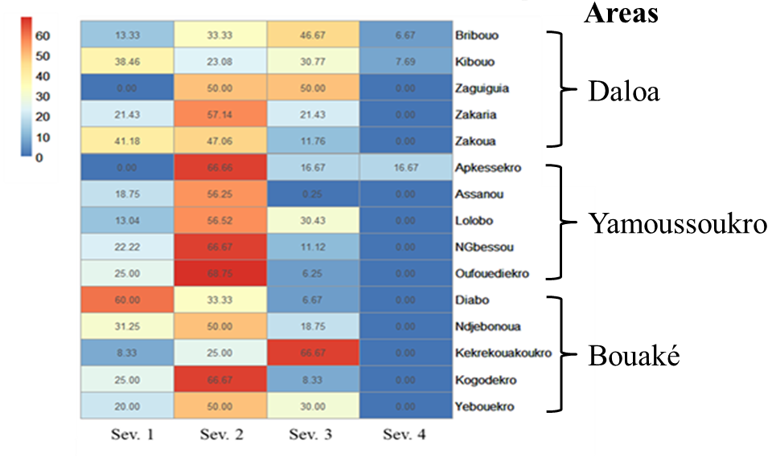Fig 2. Distribution of severities of cassava mosaic disease in the surveyed villages

3.4. Molecular detection of cassava mosaic viruses and distribution in study areas

Two (02) mosaic viral strains were identified: African Cassava Mosaic Virus (ACMV) and East African Cassava Mosaic Virus (EACMV) with allele sizes 783 pb and 1030 pb for ACMV and 780 for EACMV (Fig 3). In order to confirm that the samples suspected of exhibiting mosaic symptoms were indeed infected, a molecular analysis was conducted to diagnose a presence of the virus. Among the 200 samples tested for viral infection, 133 (66.5%) tested positive for at least one of these viruses. Infection rates were similar across the three departments, with 70.71% in Daloa, 62.86% in Bouake, and 66.15% in Yamoussoukro, showing no statistically significant difference (P = 0.93). Of the 133 infected samples, 91 (68.42%) were solely positive for ACMV, 25 (18.80%) were positive only for EACMV, and 17 samples (12.78%) were co-infected with both viruses. Notably, ACMV was significantly more prevalent than EACMV across all study sites (P = 0.03), underscoring ACMV as the dominant viral agent affecting cassava in the surveyed regions.

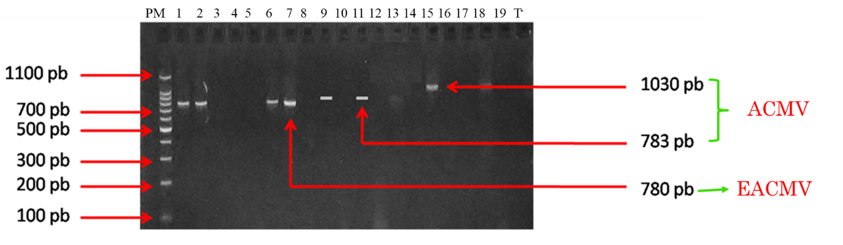Fig 3. Electrophoretic gel showing ACMV and EACMV viruses in the collected sample

3.5. Detection of cassava mosaic viruses in symptomatic and asymptomatic plants
A distinct identification of cassava mosaic viruses was also carried out on both symptomatic and asymptomatic plants in order to distinguish true positives from healthy carriers. Out of a total of 200 plants analyzed, including 51 asymptomatic and 149 showing symptoms of cassava mosaic disease, 35.29 % of asymptomatic plants were infected by virus, i.e. 18 plants, while 77.18 % of symptomatic plants were infected, corresponding to 115 plants.
In the surveyed areas, concerning symptomatic plants, 78 % of plants in Bouake, 77 % in Yamoussoukro, and 80% in Daloa were genuinely infected. Furthermore, a significant proportion of apparently healthy samples tested positive for the viral diagnosis, with rates ranging from 27% to 40% across the different regions of Bouake, Yamoussoukro and Daloa (Fig 4).

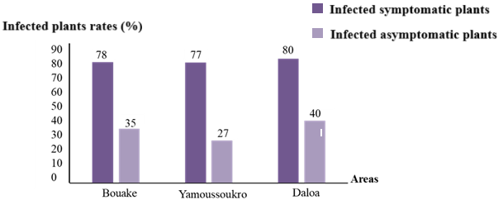Fig 4. Cassava mosaic virus in symptomatic and asymptomatic plants
3.6. Agronomic challenges related to the increasing spread of cassava mosaic disease
Based on the results obtained, it would appear that CMD is increasingly becoming a major obstacle to the productivity of cassava cultivation, which is essential to national food security. As a result, the current agronomic challenges posed by this disease in Côte d'Ivoire include mainly:
- the need to improve the sanitary management of plantations
- control virus vectors, specially Bemisia tabaci
- produce and distribute virus-resistant varieties.
- control of the quality of seeds made available to producers in order to limit the spread of the disease.
- agricultural mechanization and varietal innovations could also be considered.
This approach will not only limit yield losses, which can reach nearly 50% due to CMD, but also improve producers' incomes, thereby contributing to socioeconomic development.

4. discussion
The present study provides comprehensive insights into the phenotypic characterization and molecular detection of Cassava Mosaic Disease (CMD) in central and central-western Côte d’Ivoire. An relatively high overall CMD infection rate was recorded across 5,896 cassava plants, with no significant differences among villages in Bouake, Yamoussoukro, and Daloa, reflecting a widespread and relatively uniform disease distribution in these key cassava-producing areas. This prevalence is consistent with regional CMD surveys in West Africa, such as in Cameroon, where Doungous et al. (2022) reported a nationwide CMD incidence of 66.93%, and studies in Ghana and Benin documenting incidences between 40% and 60%, confirming CMD as a major yield-limiting factor in the region (Ahoya et al., 2025).
Key epidemiological factors identified namely the origin of cuttings, plant age, and seasonality mirror established regional patterns. Notably, plants propagated from informal cuttings exhibited markedly higher infection rates compared to those grown from certified, virus-free planting material sourced from formal institutions. The informal exchange of cuttings has been confirmed as the main vector for propagation, which reinforces the need to intensify the production and distribution of certified and healthy plant material. However, resistance to the adoption of certification practices, often linked to producers' socio-economic constraints, constitutes a major obstacle. It is therefore imperative to develop appropriate awareness campaigns, combined with training programs that can be supported by mobile diagnostic tools. This finding aligns with earlier research underscoring farmer-to-farmer exchange of infected cuttings as a principal driver of CMD dissemination (Kwibuka et al., 2021; Munguti et al., 2023). Furthermore, the highest infection rates occurred in plants aged 3 to 6 months, particularly during the dry season, which is consistent with increased vulnerability due to active vegetative growth and environmental stress, as previously observed in other countries (Ikaa & Musanga, 2024; Nazarov et al., 2020).
Symptom severity was predominantly moderate (level 2) across surveyed villages, with localized hotspots exhibiting severe symptoms (levels 3 and 4) notably in Kekrekouakoukro (Bouake) and certain Daloa areas. These epidemic clusters correspond with patterns reported, where vector population dynamics and local management practices influence symptom severity distributions (Ikaa & Musanga, 2024).
Molecular diagnostics confirmed the concurrent presence of African Cassava Mosaic Virus (ACMV) and East African Cassava Mosaic Virus (EACMV), with ACMV being significantly more prevalent. This mirrors West African trends where ACMV predominates, often associated with milder symptomatology, while EACMV or ACMV-EACMV co-infections contribute to greater virulence and yield reductions (Legg et al., 2014; Doungous et al., 2022). Detection of co-infections involving mild symptoms suggests complex virus-host dynamics, potentially including less aggressive viral strains or host tolerance mechanisms.
The notable presence of asymptomatic carriers, with 27-40% of apparently healthy plants testing positive for CMV, aligns with extensive virological evidence indicating that symptom expression is not always predictive of viral infection (Mivedor et al., 2020). Such latent infections pose significant epidemiological challenges, as asymptomatic plants may serve as reservoirs for virus transmission via whitefly vectors. In other words, The significant presence of infected symptomless plants poses a crucial challenge for disease control as these plants act as silent reservoirs allowing the vector Bemisia tabaci to transmit the virus without any obvious visual indication.The disparity between symptom expression and viral presence is influenced by a range of factors including virus strain variability, host genotype, and environmental interactions, with some cassava genotypes harboring high viral loads yet exhibiting mild or no visible symptoms (Were et al., 2021). This highlights the key role of molecular diagnostic techniques in surveillance programs, as they allow for earlier and more reliable detection compared to observation methods based solely on symptoms (Chisholm et al., 2018).
Finally, the integration of combined measures such as the fight against the vector, the spread of resistant varieties, the sanitary control of cuttings, and agricultural mechanization is the best approach to limit the dissemination of CMD. These measures, together with rigorous epidemiological surveillance and active participation of farmers, are essential to preserve yields, improve agricultural incomes and ensure food security in the regions concerned.

4. Conclusion
Cassava Mosaic Disease (CMD) in central and central-western Côte d’Ivoire, revealing a high and relatively uniform prevalence across major cassava-producing regions. The predominance of African Cassava Mosaic Virus (ACMV) and the detection of co-infections with East African Cassava Mosaic Virus (EACMV) underscore the complex viral landscape driving CMD in the country. Key factors such as the origin of planting material, crop age, and seasonality were identified as major drivers influencing disease dynamics, with informal exchange of cuttings prominently contributing to virus dissemination. The notable presence of asymptomatic yet infected plants highlights the challenges of managing CMD based solely on symptom observation and reinforces the necessity of sensitive molecular diagnostics.
Collectively, these findings emphasize the urgent need for integrated disease management strategies that prioritize the use of certified virus-free planting materials, effective whitefly vector control, and comprehensive surveillance systems. Implementing these approaches will be essential to reduce CMD impact, safeguard cassava production, and ensure food security for vulnerable communities reliant on this staple crop in Côte d’Ivoire

Disclaimer (Artificial intelligence)
Option 1:
Author(s) hereby declare that NO generative AI technologies such as Large Language Models (ChatGPT, COPILOT, etc.) and text-to-image generators have been used during the writing or editing of this manuscript.
Option 2:
Author(s) hereby declare that generative AI technologies such as Large Language Models, etc. have been used during the writing or editing of manuscripts. This explanation will include the name, version, model, and source of the generative AI technology and as well as all input prompts provided to the generative AI technology
Details of the AI usage are given below:
1.
2.
3.
References
Ahoya, D. K. D., Yabi, J. A., Houngue, J. A., Houedjissin, S. S., Zandjanakou-Tachin, M., Adjei, E. A., Sawadogo-Compaore, E. M., Pita, J. S. & Ahanhanzo, C. (2025). Towards sustainable management of cassava mosaic disease: The impact of awareness campaigns in Benin. Journal of Agricultural and Food Research, 21, 101827. DOI/ https://doi.org/10.1016/j.jafr.2025.101827.
Alamu E., Ntawuruhunga O.P., Chibwe T., Mukuka I. & Chiona M. (2019). Evaluation of cassava processing and utilization at household level in Zambia. Food Security, 11:141 150. DOI: https://doi.org/10.1007/s12571-018-0875-3.
Amoakon, W. J. L., Yao A. H. & Soro, B. G. (2023). Occurrence of cassava mosaic begomoviruses in national germplasm of Côte d’Ivoire. Plant Pathology, 72(1), 87-97. DOI: 10.1111/ppa.13723.
Bakuzezia, M. M. (2019). The impact of African Cassava Mosaic in Kindu and its surroundings (Dr Congo). International Journal of Innovation and Applied Studies, 2 : 445-456. Link: https://ijias.issr-journals.org/authid.php?id=10456.
Chisholm, R. H., Nishiura, H. & Ritchie, S. A. (2018). Implications of asymptomatic carriers in infectious disease transmission dynamics: A modeling perspective. Epidemiology & Infection, 146(11), 1355-1363. DOI: 10.1098/rsos.172341.
Combala, M., Kouamé, S. A. & Soro, B. G. (2024). An alarming eastward front of cassava mosaic disease in West Africa. Journal of Plant Pathology, 106(2), 235-248. DOI: 10.3390/v16111691.
Doungous, O., Masky, B. & Levai, D. L. (2022). Cassava mosaic disease and its whitefly vector in Cameroon: Incidence, severity and whitefly numbers from field surveys. Plant Pathology. 71(5):987-1000. DOI: 10.1016/j.cropro.2022.106017.
Ikaa, L F & Musanga, M J (2024). The African Cassava Mosaic in Gimbi/Central Kongo (DR Congo): Influence of age and behavior of some improved varieties. Journal of Oasis Agriculture and Sustainable Development 6(3): 1 - 8. DOI: https://doi.org/10.56027/JOASD.212024.
Kimno, L. C., Were, J. O., Bimpong, I. K., Kinyua, M. G. & Kimno, S. (2023). Virulence and Molecular Detection of Cassava Mosaic and Brown Streak Virus Genes on Elite Mutant Cassava Lines. Biotechnology Journal International, 27 (6) : 1-11. DOI: https://doi.org/10.9734/bji/2023/v27i6701.
Kwibuka, Y, Bisimwa, E, Blouin, A G, Bragard, C, Candresse, T, Faure, C, Filloux, D, Lett, J M, Maclot, F, Marais, A, Ravelomanantsoa, S, Shakir, S, Vanderschuren, H, & Massart, S, (2021). Novel Ampeloviruses Infecting Cassava in Central Africa and the South West Indian Ocean Islands. Viruses, meye 13 : 1030-1047. DOI : 10.3390/v13061030.
Legg JP, Ndunguru J & Maruthi MN (2014). Cassava virus diseases: Biology, epidemiology and management. Advances in Virus Research, 91, 85-142. DOI: https://doi.org/10.1016/bs.aivir.2014.10.001.
Mivedor, A S, Dansou-Kodjo, K A, Adjata, D K. & Pita, J S. (2020). Identification and incidence of Cassava Mosaic Begomoviruses in Togo. Asian Journal of Plant Pathology 14: 11-20. DOI: https://scialert.net/abstract/?doi=ajppaj.2020.11.20.
Mullis, K. B., Erlich, H. A., Arnheim, N., Horn, G. T., Saiki. R. K., Scharf, S. J. (1987). Process for amplifying, detecting and/or cloning nucleic acid sequences. United States Patent and Trademark Office, 31 p.
Link: https://patentimages.storage.googleapis.com/05/52/78/abd6d789369d5c/US4800159.pdf.

Munguti, F M, Nyaboga, E N, Kilalo, D C, Yegon, H K, Macharia, I & Mwango’mbe, A W (2023). Survey of cassava brown streak disease and association of factors influencing its epidemics in smallholder cassava cropping systems of coastal Kenya. Frontiers in Sustainable Food Systems 6 : 1015315. Doi: https://doi.org/10.3389/fsufs.2022.1015315
Nazarov, P A., Baleev, D N., Ivanova, M I., Sokolova, L M. &. Karakozova, M V (2020). Infectious Plant Diseases: Etiology, Current Status, Problems and Prospects in Plant Protection. Acta Naturae, 12(3): 46-59. DOI: 10.32607/actanaturae.11026.
Sseruwagi, P., Sserubombwe, W. S., Legg J. B., Ndunguru, J. & Thresh, J. M. (2004). Methods of surveying the incidence and severity of Cassava Mosaic Disease and whitefly vector populations on cassava in Africa: A review. Virus Research, 100 : 129-142. DOI: https://pubmed.ncbi.nlm.nih.gov/15036844/.
Were, M, Ndong'a, M, Ogemah, Vitalis, Mabele, Anthony, Were & Hassan (2021). Diversity of cassava mosaic disease causal viruses in Kenya. East African Agricultural and Forestry Journal. 85. 423-430. DOI: https://www.researchgate.net/publication/369503835.

