Original Research Article
CHITOSAN MODULATES TIME-DEPENDENT LIPID PROFILES AND LIPASE ACTIVITY IN INFECTED SILKWORMS
ABSTRACT
Flacherie, a serious bacterial disease affecting Bombyx mori, poses a substantial threat to sericulture by disrupting larval lipid metabolism and reducing silk productivity. This study investigated the effects of Staphylococcus aureus and Bacillus thuringiensis infections on lipid content and lipase activity in silkworm haemolymph and the therapeutic potential of chitosan derived from silkworm pupae and exuviae in mitigating these effects. Chitosan was extracted via deproteinization, demineralization, deacetylation and purification, mirroring established protocols. In-vivo treatments involved mulberry leaves coated with chitosan at 3500-5000 ppm, commercial chitosan (1000 ppm), ampicillin (1000 ppm) and appropriate controls, administered at multiple time points post-inoculation. Haemolymph samples were collected daily during the fifth instar to assess lipid levels and lipase activity. Results showed that early application of higher-dose chitosan significantly increased haemolymph lipid content in infected larvae, suggesting enhanced metabolic stability. Early application of pupal chitosan at 5000 ppm elevated lipid content (34.6 mg/mL in S. aureus and 32.8 mg/mL in B. thuringiensis) compared with infected controls (27.4 and 26.1 mg/mL). Lipase activity peaked at 0.185 U/mL on day six before declining toward pupation. Cocoon weight also improved, reaching 1.64 g at 5000 ppm versus 1.44 g in untreated controls, closely approaching the antibiotic effect (1.77 g). These results demonstrate that timely, high-dose chitosan application stabilizes metabolism, enhances silk yield and serves as an eco-friendly alternative to antibiotics in sericulture.
Keywords: Bombyx mori, Chitosan, Flacherie, Lipid Metabolism, Lipase Activity, Silkworms.
- INTRODUCTION
Sericulture, a significant sector in India's rural economy, is hampered by the vulnerability of silkworms (Bombyx mori L.) to diseases like pebrine, muscardine, flacherie and grasserie, which can severely affect productivity. Flacherie, a highly infectious disease, poses a major risk to sericulture, threatening the livelihoods of those dependent on it (Anantha Selvi et al., 2023).
Pathogen infection in silkworms sets off a series of biochemical and physiological responses. The dynamic interaction between the invading pathogen and host cells elicits a multifaceted reaction, ultimately leading to notable alterations in the silkworm's physiology and characteristics (Ma et al., 2018). In particular, host defences involving iron regulation, such as deployment of the ferritin 1 heavy chain homolog, play a crucial role in mitigating bacterial infection by restricting iron availability, thereby limiting pathogen growth and enhancing silkworm survival (Otho et al., 2016).
Proteins, carbohydrates, lipids and enzymes are vital biomolecules that orchestrate a wide range of cellular processes. In silkworms, lipids serve as a key energy reserve, playing a pivotal role in supporting metamorphosis and silk production. They're also essential for cell membrane structure and hormone regulation. Lipase activity breaks down lipids into usable energy sources, regulating lipid reserves and influencing immune response. The balance between lipid storage and lipase activity maintains energy homeostasis, impacting growth, development and productivity. Effective lipid metabolism is vital for successful sericulture, ensuring healthy silkworms and optimal silk production (Fangying et al., 2024).
Silkworm pupae, a valuable byproduct of sericulture, are packed with nutrients, including proteins, lipids and energy. With India producing approximately 40,000 MT of dry pupae each year (Mahesh et al., 2015), these pupae offer a significant opportunity for utilization in various industries. Notably, they can be harnessed to produce chitosan, a versatile compound with biocompatible and antibacterial properties, suitable for applications in medicine, agriculture and food preservation.
Chitosan [(C₆H₁₁NO₄)n], a linear polysaccharide derived from chitin, functions by disrupting bacterial cell membranes, chelating essential nutrients and activating insect immune pathways. Its high degree of deacetylation enhances solubility and antimicrobial activity and has potential as a natural growth enhancer making it highly suitable for silkworm disease management (Priyadarshini et al., 2018).
This research examines the interplay between lipids and lipase activity in the haemolymph of silkworms infected with pathogens (S. aureus and B. thuringiensis) and assesses the efficacy of chitosan derived from silkworm pupae as a potential therapeutic agent to mitigate infection.

- MATERIALS AND METHOD
The extraction of chitin and chitosan involved a three-step process, specifically deproteinization, demineralization and deacetylation. The methodology developed by Suresh et al. (2012) was adopted for chitosan extraction.
For the experiment, twenty-five Disease Free Layings (DFLs) of the third instar FC1×FC2 silkworm hybrid were obtained from the Registered Chawki Rearing Centre. The silkworms were reared until the fourth moult on untreated mulberry leaves, following standard practices outlined by Dandin and Giridhar (2014). After the fourth moult, the silkworms were orally inoculated with pathogens by feeding them mulberry leaves smeared with bacterial suspensions.
The mulberry leaves used for inoculation were prepared by washing them in running water, sterilizing them with 70 per cent alcohol and shade-drying them. The leaves were then evenly smeared with a bacterial suspension of 10⁸ CFU/mL (0.27 mL/replication of 50 worms) using non-absorbent cotton. Control batches of silkworms were fed only with non-inoculated, surface-sterilized mulberry leaves, as per the method described by Manjunath Gowda (2009).
The experiment was designed as a completely randomized design with nine treatments, each replicated thrice. The treatments consisted of chitosan at concentrations of 3500 ppm, 4000 ppm, 4500 ppm and 5000 ppm, along with standard ampicillin at 1000 ppm, commercial chitosan at 1000 ppm, solvent control, absolute control and bacteria-uninoculated silkworms. The sterilized mulberry leaves were dipped in the respective treatments for ten minutes and shade-dried. The treated leaves were fed to the silkworms at 6 hours post-inoculation (hpi), 12 hpi, 18 hpi, 24 hpi and 30 hpi of bacterial suspension. For subsequent feedings, inoculum-free leaves suitable for the age were provided to both treated and untreated batches.
Daily haemolymph samples were taken from normal and treated larvae during the fifth instar stage post-treatment for about seven days. Haemolymph was collected by cutting a pro-leg of anesthetized larvae and gathering the fluid in pre-chilled vials with phenyl thiourea (Fig. 1). The samples were then analyzed for various biochemical and physiological parameters, such as lipid content and lipase activity.

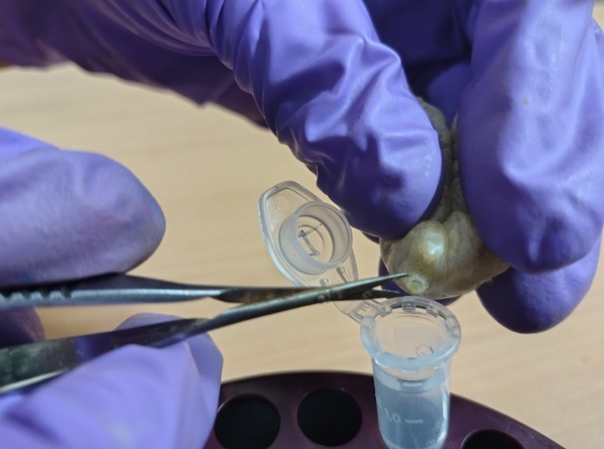

Fig. 1: Collection of the silkworm haemolymph

A colorimetric method for determination of total lipids was done using the standard procedure given by Frings and Dunn (1970) based on the sulpho-phospho-vanillin reaction and the method for the quantification of lipase activity assays was performed according to Kilcawley et al., (2002).
Further, the data was analysed statistically for the test of significance using Fisher’s method of analysis of variance as outlined by Hobbs et al. (2024). The level of significance of F-test was at 5 per cent. The interpretation of data was done using critical difference (CD) values.
3. RESULTS AND DISCUSSION
3.1. Lipid content (mg/mL)
There was a significant effect of bacterial strains (A), treatments (B), time of chitosan application after bacterial inoculation (C) and some of their interactions (A×B, B×C, A×C and A×B×C) on lipid content (mg/mL) from second day to eighth day in silkworms infected with S. aureus and B. thuringiensis. All the interactions on eighth day, AC interactions on second, third and seventh day and the treatment effect on first day were found non-significant. The treatments with chitosan at 3500 ppm, 4000 ppm, 4500 ppm and 5000 ppm, as well as ampicillin at 1000 ppm and commercial chitosan at 1000 ppm, resulted in a significant increase in total lipid content from the first to the fourth day of the fifth instar and thereby it was fluctuated among all the batches infected with both the pathogens. In the bacteria un-inoculated groups, the total lipid content significantly increased from the first day to seventh day. Contrary, in solvent control and absolute control groups, the total lipid content fluctuated from the first day and found to the least on the eighth day of the V instar silkworms compared to the other treatments. Lipid content levels were significantly higher in S. aureus inoculated silkworms compared to B. thuringiensis inoculated silkworms across all treatments. However, lipid content levels varied significantly in batches of silkworms fed with chitosan at different timings after bacterial inoculation. A decreasing trend in carbohydrate levels was observed in batches where chitosan application was delayed (Fig. 2 and 3).
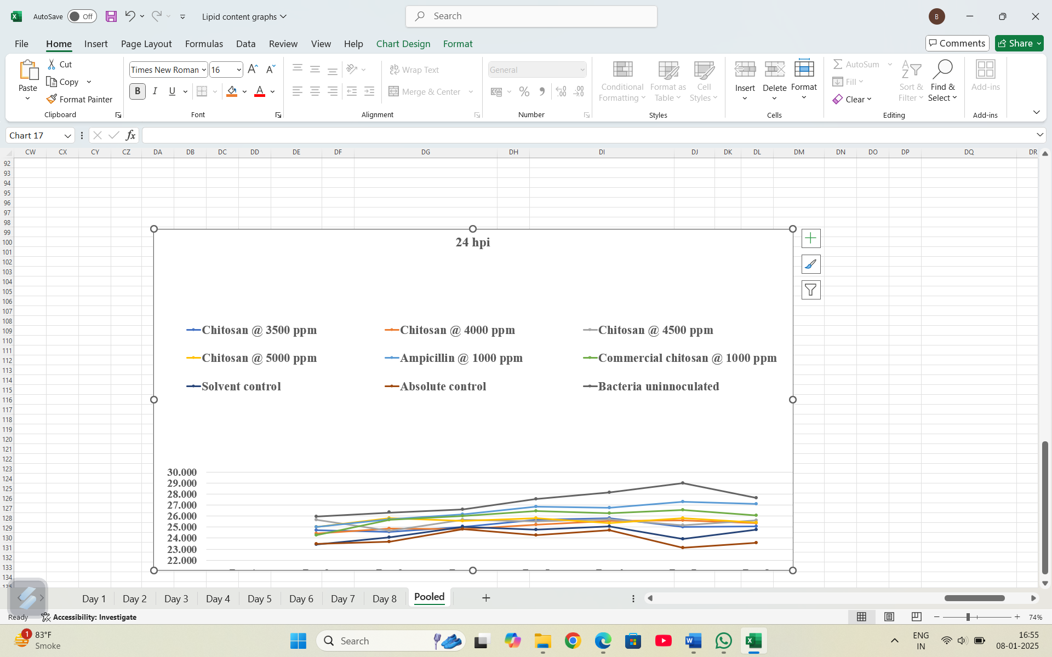

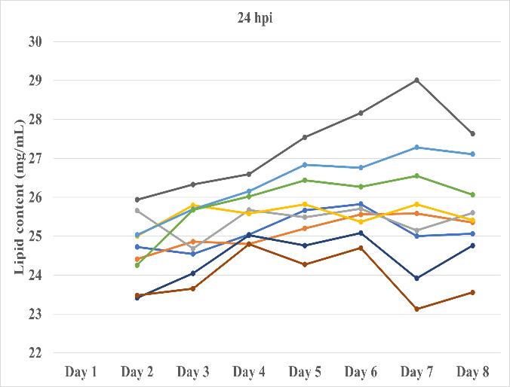
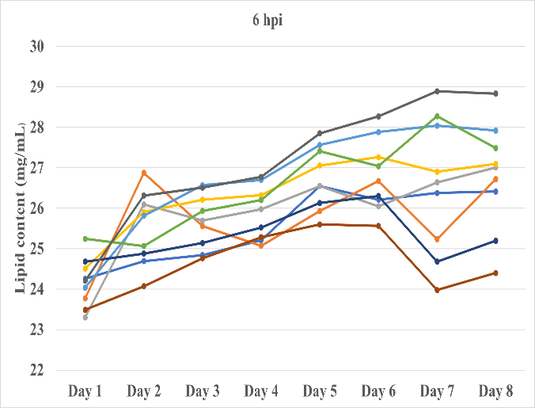

Fig 2: Effect of chitosan on lipid content (mg/mL) in haemolymph of fifth instar silkworm inoculated with S. aureus

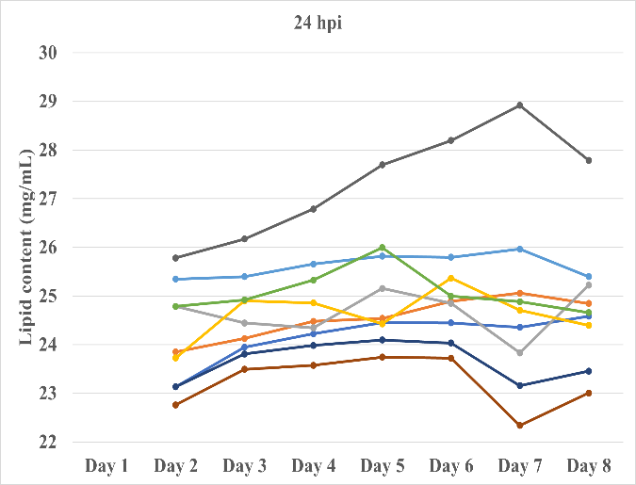
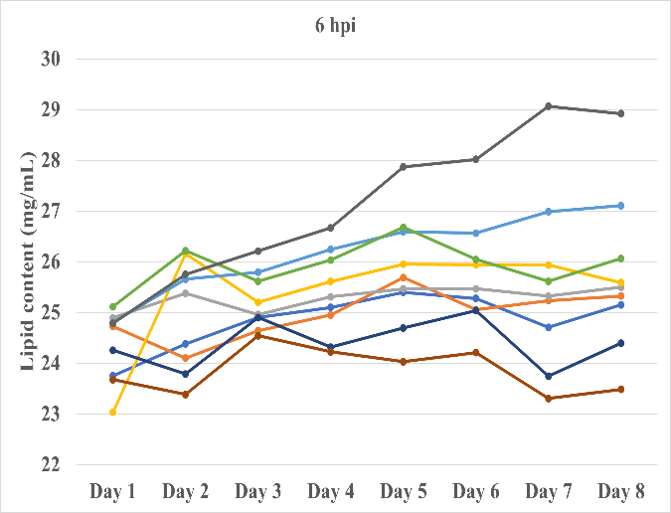

Fig 3: Effect of chitosan on lipid content (mg/mL) in haemolymph of fifth instar silkworm inoculated with B. thuringiensis
Haemolymph lipid content was strongly affected by pathogen infection and treatment. Early chitosan application at 5000 ppm maintained higher levels, reaching 34.6 mg/mL in S. aureus and 32.8 mg/mL in B. thuringiensis groups, compared with 27.4 and 26.1 mg/mL in infected controls. Lower doses (3500-4000 ppm) showed moderate improvement, while delayed application caused marked lipid depletion, highlighting the importance of both dose and timing.
The profound impact of bacterial strains suggests that B. thuringiensis infection, potentially due to its heightened virulence and pathogenicity, may trigger a more robust stress response in silkworms, leading to decreased lipid mobilization for energy production and immune defence mechanisms. Chitosan treatments, particularly at higher concentrations, initially stimulated lipid accumulation, possibly by augmenting nutrient absorption, modulating metabolic pathways, or enhancing digestive efficiency. However, the subsequent fluctuations and overall lower levels in control groups indicate that these treatments might not consistently provide sustained lipid support or maintain optimal lipid homeostasis. Delayed chitosan application likely resulted in decreased carbohydrate availability, impacting energy production and subsequently influencing lipid levels, which underscores the importance of timely interventions. These findings emphasize the significance of considering both the type of bacterial infection and the timing of chitosan interventions when evaluating the impact on silkworm lipid metabolism, overall health and well-being.
Mamatha and Balavenkatasubbaiah (2014) conducted studies that were in accordance with the present findings, which revealed that as the larval age increased, there was a consistent increase in the level of total lipids in both control and batches treated with BmIFV in the silkworm breed CSR2. Similar to the present study, Rajitha and Savithri (2013) examined day to day changes in lipids in the haemolymph of fifth instar silkworms (Bombyx mori L.) during the progression of the fungal pathogen (Beauveria bassiana) and revealed that an increasing trend of lipid content was observed in the haemolymph of control batches (31.44 mg/mL to 34.8 mg/mL), whereas a decreasing trend of lipid content was noticed in fungal infected batches (31.06 mg/mL to 27.39 mg/mL).
Antibiotics not only prevent disease, but they also promote silkworm growth by reshaping the gut microbiome and enhancing nutrient absorption, highlighting the need for judicious use (Rittick et al., 2025). A similar mechanism may have been influenced by chitosan and antibiotic treatments, which not only prevent disease but also potentially modulate the lipid content in chitosan-treated, bacterially infected silkworms compared to those without treatment. Rajasekhar et al. (1992) expressed a similar view to our present results, suggesting that the decreased lipid content in infected silkworms is attributed to the utilization of lipid components by the pathogen. Furthermore, Mallikarjuna et al. (2002) noticed a reduction in lipid content in the haemolymph of Beauveria bassiana inoculated larvae and attributed this to the fact that lipids are used as a source of energy required for the growth and development of the fungus. This might be the reason why, in the present study, bacterial infection diminished the lipid content in bacterial inoculated silkworms.
3.2. Lipase activity (Units/mL)
The lipase activity (Units/mL) varied significantly among the treatments (B) from the second to the fifth day, the seventh day and the eighth day of the fifth instar silkworms infected with S. aureus and B. thuringiensis. There were also significant differences among the bacterial strains (A) on all days, except the first and sixth days, where the differences were non-significant. The time of chitosan application after bacterial inoculation (C) also strongly affected lipase activity, which was significant only on the second, fourth, fifth and seventh days, while remaining non-significant on other days. Furthermore, most interactions of different factors (A×B, A×C, B×C and A×B×C) were non-significant. There was a significant increase in lipase activities day by day but do not indicate which treatments had the highest and lowest lipase activities on a particular day, as the activities fluctuated. The mean lipase activity increased significantly up to the sixth day and then decreased until the eighth day. The effects of treatments, bacterial strains and time of application of chitosan treatment on lipase activity could not be determined, as the activities were non-significant or fluctuated day by day (Fig. 4 and 5).
Lipase activity showed dynamic fluctuations during infection and treatment. Activities increased progressively, peaking at 0.185 U/mL on day six before declining to 0.142 U/mL by day eight, reflecting metabolic shifts toward pupation. Chitosan moderated these trends, with early applications reducing enzyme overactivation compared to delayed treatments. This suggests that chitosan not only stabilized lipid reserves but also regulated lipolytic activity under bacterial stress.
The observed variations in lipase activity across bacterial strains, treatments and time points suggest a dynamic regulation of lipid metabolism in silkworms. While significant differences were observed among treatments, bacterial strains and time of chitosan application after bacterial inoculation, the overall pattern of lipase activity fluctuated, making it difficult to pinpoint the consistent effects of individual factors. The increase in lipase activity up to the sixth day likely reflects the physiological demands of growing silkworms. The subsequent decrease may be associated with the onset of pupation and a shift in metabolic priorities. The observed variations in lipase activity likely reflect the complex interplay of various factors, including the immune response to infection, nutrient availability and hormonal regulation.
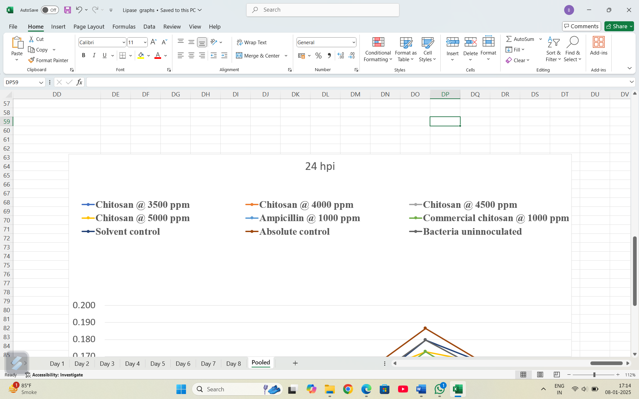
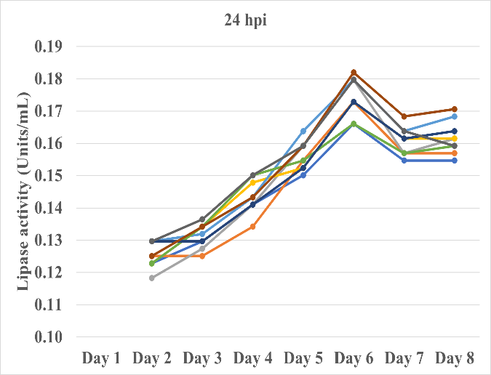
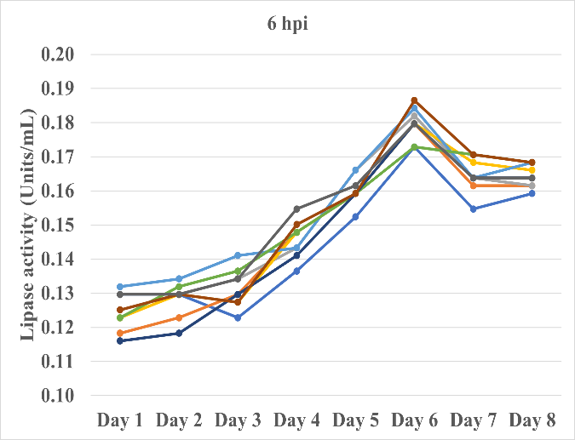

Fig 4: Effect of chitosan on lipase activity (Units/mL) in haemolymph of fifth instar silkworm inoculated with S. aureus

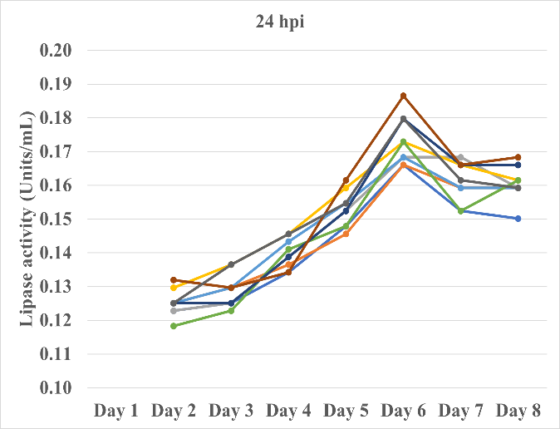
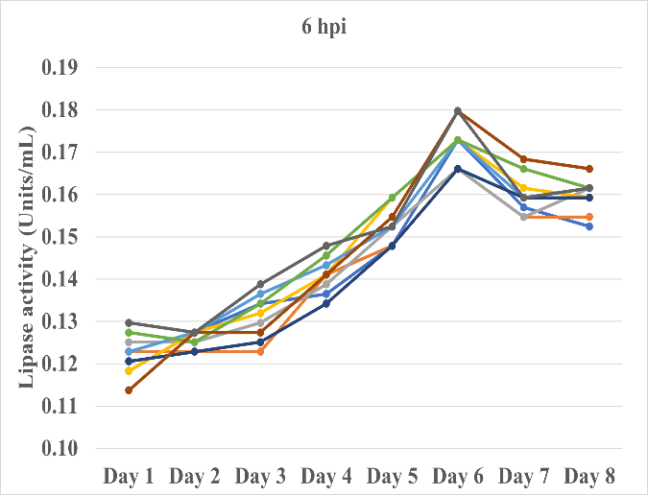

Fig 5: Effect of chitosan on lipase activity (Units/mL) in haemolymph of fifth instar silkworm inoculated with B. thuringiensis

Zhang et al. (2022) expressed a similar view to the present study, suggesting that the increased levels of lipase enzyme activity in the haemolymph of Beauveria bassiana infected larvae could be due to a higher rate of lipolysis to cope with the stress induced by the fungal pathogen. Increased lipase activity indicates decreased lipid levels in the haemolymph, which was also observed in the present study, where lipase activities increased day by day, resulting in diminished lipid content. Lipase activity increased in infected larvae to meet the energy demands for the growth and development of both the host and the pathogen. The results were also in accordance with the findings of Costa et al. (2018) who observed that an increased trend of lipase activity in haemolymph correlated with virulence in Pieris brassicae larvae, confirming that lipase-mediated lipid hydrolysis supports fungal pathogenicity and nutrient acquisition. The results were also in accordance with the findings of Rajitha and Savithri (2013) who observed that, increased trend of lipase activity in haemolymph of both inoculated (Beauveria bassiana) (0.137 to 0.186 µ moles/mL) and control (0.137 to 0.178 µ moles/mL) up to the fifth day during the progress of fungal pathogen. Kumar et al. (2024) explained that entomopathogenic fungi produce lipases that hydrolyse insect cuticular lipids, facilitating fungal penetration and simultaneously providing essential nutrients, which might be the reason for the increase in lipase activity in the pathogen-inoculated silkworms.

Table 1: Effect of chitosan application on cocoon weight (g) in silkworm infected with Staphylococcus aureus and Bacillus thuringiensis
Treatments (B) | Time of chitosan application following bacterial inoculation (hpi) (C) |  |  |  |  |  |  |  |  |  | Bacterial strains (A) mean |  | Treatments (B) mean
Treatments (B) | 6 hpi |  | 12 hpi |  | 18 hpi |  | 24 hpi |  | 30 hpi |  |  |  | Treatments (B) mean
Treatments (B) | Sa | Bt | Sa | Bt | Sa | Bt | Sa | Bt | Sa | Bt | Sa | Bt
Chitosan @ 3500 ppm | 1.666 | 1.585 | 1.589 | 1.551 | 1.536 | 1.507 | 1.600 | 1.560 | 1.595 | 1.443 | 1.597 | 1.529 | 1.563
Chitosan @ 4000 ppm | 1.667 | 1.637 | 1.624 | 1.595 | 1.670 | 1.468 | 1.695 | 1.560 | 1.566 | 1.441 | 1.644 | 1.540 | 1.592
Chitosan @ 4500 ppm | 1.746 | 1.659 | 1.629 | 1.560 | 1.638 | 1.546 | 1.533 | 1.502 | 1.541 | 1.529 | 1.617 | 1.559 | 1.588
Chitosan @ 5000 ppm | 1.796 | 1.686 | 1.654 | 1.608 | 1.622 | 1.602 | 1.669 | 1.565 | 1.656 | 1.545 | 1.679 | 1.601 | 1.640
Ampicillin @ 1000 ppm | 1.916 | 1.808 | 1.851 | 1.771 | 1.794 | 1.722 | 1.810 | 1.713 | 1.688 | 1.660 | 1.812 | 1.735 | 1.773
Com. chitosan @ 1000 ppm | 1.791 | 1.701 | 1.818 | 1.719 | 1.772 | 1.632 | 1.709 | 1.569 | 1.658 | 1.642 | 1.750 | 1.653 | 1.701
Solvent control | 1.591 | 1.481 | 1.520 | 1.455 | 1.472 | 1.452 | 1.485 | 1.450 | 1.505 | 1.386 | 1.515 | 1.445 | 1.480
Absolute control | 1.466 | 1.422 | 1.466 | 1.422 | 1.466 | 1.422 | 1.466 | 1.422 | 1.466 | 1.422 | 1.466 | 1.422 | 1.444
Bacteria un-inoculated | 2.047 | 2.034 | 2.047 | 2.034 | 2.047 | 2.034 | 2.047 | 2.034 | 2.047 | 2.034 | 2.047 | 2.034 | 2.040
Mean | 1.706 |  | 1.662 |  | 1.633 |  | 1.633 |  | 1.601 |  | 1.681 | 1.613
Mean A, B, C | 1.647 |  |  |  |  |  |  |  |  |  | 1.647 |  | 1.647

 | A | B | AB | C | AC | BC | ABC
F-Test | * | * | * | * | NS | * | *
SEm ± | 0.0025 | 0.0052 | 0.0074 | 0.0039 | - | 0.0117 | 0.0166
CD @ 5% | 0.0049 | 0.0104 | 0.0146 | 0.0077 | - | 0.0232 | 0.0328
Note: * Significant; NS - Non-significant; A- Bacterial strains; B- Treatments; C- Hours of post inoculation (hpi); Sa- Staphylococcus aureus; Bt- Bacillus thuringiensis; Com.- Commercial chitosan

Cocoon weight was significantly influenced by bacterial strain, chitosan concentration and timing of application. Larvae infected with Staphylococcus aureus produced heavier cocoons (1.706 g) than those infected with Bacillus thuringiensis (1.662 g), reflecting the stronger metabolic stress caused by B. thuringiensis. Uninfected larvae maintained the highest cocoon weight (2.040 g), while absolute and solvent controls recorded the lowest (1.444 g and 1.480 g), highlighting the detrimental effect of untreated infections. Chitosan treatments improved cocoon weight in a dose-dependent manner. At 5000 ppm, pupal chitosan yielded 1.640 g compared with 1.563 g at 3500 ppm. Ampicillin (1.773 g) produced the highest weight, followed by commercial chitosan at 1000 ppm (1.701 g). These results indicate that high-dose pupal chitosan approaches the protective effect of antibiotics, supporting larval growth under bacterial stress. Timing of application was equally critical. Treatments at 6 hpi achieved the best outcomes (1.706 g), while delayed applications at 18-24 hpi reduced cocoon weight (1.633 g). Early treatment with either ampicillin or high-dose chitosan was consistently effective across both pathogens. Interaction analysis confirmed that pathogen type, chitosan concentration and application timing together determined cocoon weight. The highest value (1.916 g) occurred with ampicillin at 6 hpi after S. aureus infection, but pupal chitosan at 5000 ppm applied at the same time (1.796 g) performed nearly as well.

The efficacy of chitosan can be explained by its direct antibacterial action. The cell walls of both S. aureus and B. thuringiensis are composed of peptidoglycans with acetylmuramic acid, amino acids and teichoic acid. The positively charged amino groups of chitosan bind to teichoic acid, disrupting the cell wall, exposing the membrane to osmotic stress and causing leakage of cytoplasmic contents (Vishu Kumar et al., 2005). Combined with the removal of membrane lipids, this leads to bacterial death, thereby reducing pathogen load and protecting larval metabolism. In addition to its antibacterial effects, chitosan modulates insect physiology by enhancing gut integrity, metabolic balance and enzyme activity, while boosting immunity through antimicrobial and antioxidant effects, aiding disease resistance in sericulture (Rehman et al., 2023; Mei et al., 2024).

Overall, bacterial infections reduced cocoon weight, but timely chitosan application-especially at 4500-5000 ppm significantly alleviated this loss. By stabilizing haemolymph lipids, moderating enzyme activity and directly inhibiting pathogens, chitosan enhanced cocoon productivity. These findings validate pupal-derived chitosan as an environmentally safe alternative to antibiotics, with strong potential to safeguard silk yield and ensure the long-term sustainability of sericulture. The integration of cocoon parameters with biochemical findings confirms the functional benefits of chitosan treatment. Infections suppressed both haemolymph lipids and cocoon weight, while early chitosan application at higher doses mitigated these losses. The parallel increase in lipid stability and cocoon weight demonstrates that metabolic regulation translates directly into economic traits. Although ampicillin remained most effective, pupal-derived chitosan at 5000 ppm provided near-comparable protection, validating its potential as a sustainable alternative for maintaining silk yield under pathogenic stress.

- CONCLUSION
In conclusion, our study demonstrates that chitosan extracted from silkworm pupae and exuviae via standardized protocols effectively modulates lipid metabolism, lipase activity and cocoon traits in Bombyx mori larvae infected with S. aureus and B. thuringiensis. Application of higher concentrations (3500–5000 ppm) shortly after bacterial inoculation elicited a significant rise in haemolymph lipid content, reaching nearly 25 per cent higher than infected controls, while lipase activity peaked at 0.185 U/mL on day six before declining toward pupation. Delayed applications, however, led to depleted carbohydrate reserves and unstable lipid homeostasis, underscoring the importance of timely intervention. Cocoon weight was also significantly improved by chitosan. At 5000 ppm, pupal chitosan supported 1.64 g compared with 1.44 g in untreated controls, closely approaching the antibiotic effect (1.77 g). Early application at 6 hpi consistently produced heavier cocoons, while delayed treatments resulted in reduced yield. These findings confirm that chitosan’s metabolic regulation directly translates into enhanced cocoon productivity, a critical economic trait in sericulture.
Mechanistically, chitosan acts by binding to teichoic acids in bacterial cell walls, disrupting structural integrity, exposing membranes to osmotic stress and causing cytoplasmic leakage, ultimately leading to bacterial death (Vishu Kumar et al., 2005). In addition, it indirectly strengthens silkworm immunity by stimulating phenol-oxidase activity and enhancing haemocyte function, collectively reducing mortality and improving silk yield.
Overall, the integration of biochemical and cocoon parameter data validates pupal-derived chitosan as an eco-friendly and effective alternative to antibiotics. By stabilizing metabolism, suppressing pathogens and sustaining cocoon weight, chitosan enhances disease resilience and farmer profitability. Future work should aim to refine application strategies for sustainable sericulture through the use of biocompatible chitosan derived from silkworm pupae. Beyond reducing bacterial infection, chitosan also serves as an eco-friendly alternative to antibiotics, aligning with global efforts toward green pest management. By enhancing immune resilience and supporting overall larval health, silkworm-derived chitosan represents a promising, sustainable tool for improving productivity and disease resistance in sericulture.
Conflict of Interest:
I confirm that, I or my relative have a financial or other interest in the subject / matter of the work in which I will be involved, which may be considered as constituting a real, potential or apparent conflict of interest
Disclaimer (Artificial intelligence)
We hereby declare that NO generative AI technologies such as Large Language Models (ChatGPT, COPILOT, etc.) and text-to-image generators have been used during the writing or editing of this manuscript.

- REFERENCES
ANANTHA SELVI, G. S., CHELLADURAI, D., PATTU KUMAR, V. AND NAVIN CHANDRAN, M., 2023, Bacterial flacherie in Bombyx mori L.: Isolation and identification of pathogenic organism. Uttar Pradesh J. Zool., 44 (14): 52-61.
COSTA, A. F., BATISTA, B. G., SOUZA, A. Q. AND SOUZA, J. V., 2018. Enzymatic comparison and mortality of Beauveria bassiana strains against Pieris brassicae larvae. Brazilian J. Microbiol., 49 (2): 369-376.
DANDIN, S. B. AND GIRIDHAR, K., 2014, Handbook of Sericulture Technologies, CSB, Madivala, Bangalore, pp. 335-385.
FANGYING, Y., XIAOYAN, X., BO, H., ZHONGJIE, Z., KAI, C., YE, Y., HUA, B. AND ANJIANG, T., 2024, Lipid homeostasis is essential for oogenesis and embryogenesis in the silkworm, Bombyx mori. Cellular Mol. Life Sci., 81 (1):127-135.
FRINGS, C. S. AND DUNN, R. T., 1970, A colorimetric method for determination of total serum lipids based on the sulfo-phospho-vanillin reaction. Oxford J., 53: 89-91.
HOBBS, J., KATZFUSS, M., NGUYEN, H., YADAV, V. AND LIU, J., 2024, Functional analysis of variance (ANOVA) for carbon flux estimates from remote sensing data. Geoscientific Model Development, 17: 1133-1151.
KILCAWLEY, K. N., WILKINSON, M. G. AND FOX, P. F., 2002, Determination of key enzyme activities in commercial peptidase and lipase preparations from microbial or animal sources. Enzyme Microb. Technol., 31 (3): 310-320.
KUMAR, S., GUPTA, R. AND SHARMA, A., 2024, Enzymes of entomopathogenic fungi: Advances and insights into cuticle degradation and host invasion. Int. J. Biol. Macromol., 242: 124763.
MA, L., ZHOU, L., LIN, J., JIUYUAN, J., YANG, W., HAOBO, J., XIHUI, S. AND ZHIQIANG, L., 2018, Manipulation of the silkworm immune system by a metalloprotease from the pathogenic bacterium Pseudomonas aeruginosa. Devp. Comp. Immunol., 24 (90):176-185.
MAHESH, D. S., VIDHATHRI, B. S., NARAYANASWAMY, T. K., SUBBARAYAPPA, C. T., MUTHURAJU, R. AND SHRUTHI, P., 2015, Bio-nutritional science of silkworm pupal residue to many new ways for utilization. Int. J. Adv. Res. Biol. Sci., 2 (9): 35-40.
MALLIKARJUNA, M., BALAVENKATASUBBAIAH, M., NATARAJU, B. AND THIAGRAJAN, V., 2002, Effect of systematic fungicide on total haemocyte count and haemolymph biochemical changes in silkworm, Bombyx mori L. infected with Beauveria bassiana. Int. J. Indust. Entomol., 5: 189-194.
MAMATHA, M. AND BALAVENKATASUBBAIAH, M., 2014, Biochemical changes during the progressive infection of Bm IFV in the silkworm, Bombyx mori L. Intl. J. Pl. Ani. Envi. Sci., 4 (2): 372-378.
MANJUNATH GOWDA, 2009, Inheritance of tolerance to BmNPV among popular breeds of silkworm, Bombyx mori L. Ph. D. Thesis, UAS, Bangalore, P.182.
MEI, Z., KUZHIR, P. AND GODEAU, G., 2024, Update on chitin and chitosan from insects: sources, production, characterization and biomedical applications. Biomimetics, 9 (5): 297.
OTHO, S. A., CHEN, K., ZHANG, Y., WANG, P. AND LU, Z., 2016, Silkworm ferritin 1 heavy chain homolog is involved in defence against bacterial infection through regulation of haemolymph iron homeostasis. Devp. Comp. Immunol., 55; 152-158.
PRIYADHARSHINI, P., MAHALINGAM, C. A., PRABHU, S., THANGAMALAR, A. AND UMAPATHY, G., 2018, In-vivo antibacterial effect of chitosan against S. aureus and B. thuringiensis and its impact on economic parameters of silkworm, Bombyx mori. L. J. Pharmacognosy Phytochem., 7 (2): 2448-2451.
RAJASEKHAR, R., PRASAD, B., SUBRAMANYAM REDDY, C., BHASKAR, M., MURALI, K. AND GOVINDAPPA, S., 1992, Variations in the tissue biochemical composition in the muscardine infected silkworm larvae Bombyx mori L. Indian J. Comp. Anim. Physiol., 10: 24-27.
RAJITHA, K. AND SAVITHRI, G., 2013, Day to day analysis of lipids and lipase activity in the haemolymph of silkworm, Bombyx mori L. infected with fungal pathogen Beauveria bassiana (Bals.) Vuill. Indo American J. Pharma. Res. 3 (11): 9213-9217.
REHMAN, K. U., HOLLAH, C., WIESOTZKI, K., HEINZ, V., AGANOVIC, K., REHMAN, R. U., PETRUSAN, J., ZHENG, L., ZHANG, J. AND SOHAIL, S., 2023, Insect-derived chitin and chitosan: a still unexploited resource for the edible insect sector. Sustainability, 15 (6): 4864.
RITTICK, M., DIPANJAN, D. AND AMIT KUMAR, M., 2025, Antibiotic stewardship in silkworms: navigating the pros and cons. Bacteria, 4 (2): 111-122.
SURESH, H. N., MAHALINGAM, C. A. AND PALLAVI, 2012, Amount of chitin, chitosan and chitosan based on chitin weight in pure races of multivoltine and bivoltine silkworm pupae Bombyx mori L. Int. J. Sci. Nature, 3: 214.
VISHU KUMAR, A. B., VARADARAJ, M. C., GOWDA, L. R. AND THARANATHAN, R. N., 2005, Characterization of chito-oligosaccharides prepared by chitosanolysis with the aid of papain and pronase and their bacterial action against Bacillus cereus and Escherichia coli. Biochem. J., 391: 167-175.
ZHANG, Y., WANG, C. AND FENG, M., 2022, A secretory phospholipase A₂ contributes to lipid metabolism and immune evasion in Beauveria bassiana. Frontiers in Microbiology, 13: 857143.

