Effect of different Liquid Bio - fertilizers on Seed Quality Parameters of Wheat (Triticum aestivum L.)

Abstract
This study investigates the comparative effects of different liquid biofertilizers and the chemical fungicide Thiram on seed quality parameters of wheat (Triticum aestivum L.), using variety K1317 under laboratory conditions over two years (2023–2025) at Chandra Shekhar Azad University of Agriculture and Technology, Kanpur. 10 treatment combinations, including 5 liquid biofertilizers (EM culture, PSB, KSB, Pseudomonas, Azospirillum), Thiram, and an untreated control, were evaluated in a Completely Randomized Design (CRD) with three replications. Key parameters—physical seed quality, germination dynamics, seedling growth, and vigour indices—were measured and statistically analyzed using ANOVA at a 5% significance level and 95% confidence interval. Results revealed that seeds treated with Azospirillum + PSB (T8, 20 ml/kg seed) consistently performed best, demonstrating significant improvements in test weight, seed L/B ratio, germination rate, seedling length, seedling dry weight, and vigour indices compared to control. These findings underscore the dual benefits of liquid biofertilizer application: sustainable crop production and enhanced seed physiological quality. The study concludes that adopting liquid biofertilizer treatments, particularly Azospirillum + PSB, provides an environmentally responsible pathway for producing high-vigour, nutrient-rich wheat seeds, offering superior alternatives to conventional chemical seed treatments.
Keywords: Wheat, Biofertilizer, Seed Treatment, Growth Parameters, RBD, Azospirillum, PSB, Thiram, Python, MATLAB

INTRODUCTION
Recent climate change dynamics are substantially impeding wheat production, necessitating modifications to conventional agricultural practices for sustainable yield maintenance. Wheat (Triticum aestivum L.), which delivers approximately 20% of global dietary protein and calories, is second only to maize in total world grain output, underpinning food security across Asia, Europe, and North Africa. In 2023, worldwide wheat production reached an estimated 790 million tonnes, marginally surpassing the five-year average, primarily due to favourable climatic conditions in principle growing regions (FAO, 2024). As the world’s second-leading wheat producer, India contributed 13–14% of global output, with roughly 30.5 million hectares cultivated in the 2023–24 cycle and a harvest exceeding 112 million tonnes (MoAFW, 2024).
Liquid biofertilizers, comprising beneficial microbial consortia, facilitate nutrient availability via nitrogen fixation, phosphorus solubilization, and synthesis of plant growth-promoting substances. These formulations surpass solid carrier-based biofertilizers in microbial population density, shelf life, and application ease, aligning with advanced agronomic techniques (Seenivasagan et al., 2021).Seed treatment, a cornerstone strategy for enhancing germination and early seedling vigor, shows that while chemical fungicides like Thiram effectively mitigate seed- and soil-borne pathogens, they offer limited benefits to nutrient cycling and may disrupt key soil microbiomes. Thus, integrating liquid biofertilizer seed treatments holds promise for both environmental sustainability and improved crop establishment. This research systematically evaluates the impact of diverse liquid biofertilizer treatments alone and in combination relative to Thiram and untreated controls on wheat growth, focusing on physiological seed traits and establishment efficacy (Seenivasagan et al., 2021).
material and Methods
The experiment was carried out using consists of wheat variety K1317 and five different liquid bio fertilizers, alone and in combination with Azospirillum, for the check control was used. The first crop was sown on 9th Nov. 2023 and second crop on 9th Nov. 2024 during the Rabi season was conducted at the C. S. Azad University of Agriculture and Technology, Kanpur. The laboratory experiment was conducted using a Completely Randomized Design (CRD) to ensure unbiased allocation of treatments.
The trial sites located at Kanpur district of Uttar Pradesh, their hot summers and chilly winters due to its semi-arid climate. With sporadic showers throughout the winter, the monsoon season (up to September) receives about 80% of the yearly rainfall. To carry out the experiment in lab condition design used Completely Randomized Design. The climate of district Kanpur is semi-arid with hot summer and cold winter. Nearly 80 per cent of total rainfall is received during the monsoon (July to September) with a few showers in the winter.
For data collection different methods were used for different parameters:
- Physical Seed Quality Parameters
- Test Weight 1000 Seed (g)
. For taking test weight one thousand randomly sampled seeds from each treatment in each of the four replications were weighed and expressed in gram.
- Seed L: B ratio
One hundred intact wheat kernels per treatment were randomly selected. Kernel length (L) and breadth (S) were measured with a digital vernier caliper (0.01 mm least count). Length was the longest intercept; breadth was the equatorial width perpendicular to length. We calculated the aspect ratio as S/LS/LS/L for each kernel.
- Germination and Germination dynamics
- Standard germination (%)
The germination test was conducted according to ISTA rules (Anon, 1999). Four replications of 100 seeds for each treatment were evenly distributed on germination paper. Standard germination was carried out in the laboratory of the Department of Seed Science and Technology on moist germination paper and rolled in butter paper to avoid moisture evaporation during the test period. Samples were placed in plastic trays in slightly tilted position and transferred to a seed germinator at 20±2°C and 90±3% relative humidity. After eight days, the final count was done. The seedlings with normal roots and shoots were counted as normal seedlings.
Standard Germination (%) = (Germinated seeds / Total seeds tested) ×100
- Peak value of germination
Peak value of germination or the maximum quotient derived from all of the cumulative full-seed germination percentages on any day divided by the number of days to reach these percentages.
- Mean daily germination (%)
Mean daily germination is the average percentage of seeds germinated per day. It was calculated using following formula:
$$Mean Daily Germination=\frac{Standard Germination (\%)}{Total number of days}$$
- Germination value
Germination value was calculated using formula mentioned below:
Germination Value = Mean Daily Germination X Peak Value of germination
- Seedling Growth Parameters
- Seedling length (cm)
Seedling length (cm) was calculated for the 10 randomly selected normal seedling from each treatment and each replication at final count day. It was measured using centimetre scale, from base of the seedling to tip.
- Seedling dry weight (g)
Randomly taken ten normal seedlings which were used for recording seedling length were placed in a container and dried for 24 hours in a hot air oven maintained at 80 °C. The dried seedlings were removed and cooled in desiccator for 30 minutes and then the dry weight of seedling was measured with the help an electronic balance and average weight was computed and expressed in gram per ten seedlings.
- Seed Vigour Parameters
- Vigour index- I
This index is calculated by multiplying the percentage of germinated seeds by the average length of seedlings. Seedling vigour index-1 was calculated as per the following formula (Abdul Baki and Anderson, 1973).
Seed Vigour Index- I = Standard Germination (%) x Seedling Length (cm)
- Vigour index – II
Similar to Vigour Index I, but this index uses the average seedling dry weight. The seedling vigour index-II was calculated as per the following formula (Abdul Baki and Anderson, 1973).
Seed Vigour Index-II = Standard Germination (%) x Seedling Dry Weight (g)
3. RESULTS
As there are number of liquid bio fertilizers are available for different crops, so there is a need to find out the specific bio fertilizer which is performing best for the wheat crops among the liquid bio fertilizers used.
The data of physical seed quality parameters which includes test weight 1000 seed (g) and seed L:B ratio in wheat seeds, impacted by different liquid bio-fertilizers treatments, are given in table 1 and fig. 1. All the treatments varied significantly in comparison to control T₁ (Control) for the test weight 1000 seed (g). The treatment T₈ (Azospirillum + PSB @ 20 ml/kg of seed) (55.62) showed highest test weight 1000 seed (g) during both the year followed by T₇ (Azospirillum + KSB @ 20 ml/kg of seed) (54.09) whereas the least test weight 1000 seed (g) was observed in the T₁ (Control) (45.59). These results are in agreements with the findings of Mohapatra et al., (2024) in sunflower. Similarly, all the treatments varied significantly in comparison to control T₁ (Control) except T₁₀ for the seed L: B ratio. The treatment T₈ (Azospirillum + PSB @ 20 ml/kg of seed) (2.38) showed highest seed L:B ratio during both the year followed by T₇ (Azospirillum + KSB @ 20 ml/kg of seed) (2.26), the least seed L:B ratio was observed in the T₁ (Control) (1.79). These results are in line with the findings of Thakare et al., (2024) in sorghum.

Table 1. Beneficial effect of Liquid Bio-fertilizers on physical Seed Quality Parameters
TREATMENTS | Test Weight 1000 Seed Weight (g) | Seed L: B Ratio
Control | 45.59 | 1.79
Em Culture @ 10 ml/kg of Seed | 48.66 | 1.88
KSB @ 20 ml/kg of Seed | 51.42 | 1.94
PSB @ 20 ml/kg of Seed | 53.75 | 2.14
Pseudomonas @ 20 ml/kg of Seed | 52.69 | 2.01
Azospirillum @ 20 ml/kg of Seed | 51.85 | 1.97
Azospirillum + KSB @ 20 ml/kg seed | 54.09 | 2.26
Azospirillum + PSB @ 20 ml/kg seed | 55.62 | 2.38
Azospirillum + KSB + PSB @ 30 ml/kg seed | 49.47 | 2.01
Thiram @ 1.3 g/kg seed | 46.98 | 1.84
SE (m±) | 0.30 | 0.01
CD (P=0.05) | 0.87 | 0.04
CV (%) | 1.18 | 1.48

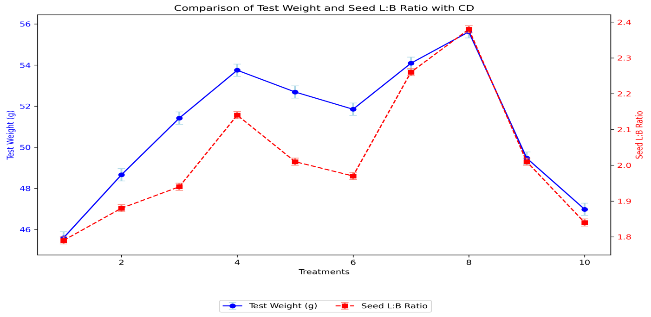
Fig.1. Beneficial effect of Liquid Bio-fertilizers on physical Seed Quality Parameters
The data collected for germination and germination related dynamics are included in table 2 and fig. 2. It is clear from the table that all the treatments varied significantly in comparison to control T₁ (Control) except T₁₀ for the standard germination (%). The treatment T₈ (Azospirillum + PSB @ 20 ml/kg of seed) (97.37 %) showed highest standard germination (%) followed by T₇ (Azospirillum + KSB @ 20 ml/kg of seed) (96.87 %), least standard germination (%) was observed in the T₁ (Control) (88.75 %) during both the year. Similarly, all the parameters related to standard germination viz., peak value of germination, mean daily germination and germination value has sowed highest value in treatment T8 (Azospirillum + PSB @ 20 ml/kg of seed) (43.44), (12.17), (528.73) followed by T7 (Azospirillum + KSB @ 20 ml/kg of seed),(41.94), (12.11), (507.84) and least value was observed in T1 (control) (23.04), (11.09), (255.74), respectively. These results are in agreement with the findings with Yaadesh et al., (2023) in maize, Budhbaware and Rai (2023) in Maize, Pathak et al., (2016) in Wheat.
Table 2. Beneficial effect of Liquid Bio-fertilizers on Germination and Germination Dynamics
TREATMENTS | Standard Germination (%) | Peak value of Germination | Mean daily Germination | Germination value
Control | 88.75 | 23.04 | 11.09 | 255.74
Em Culture @ 10 ml/kg of Seed | 92.00 | 24.71 | 11.65 | 287.98
KSB @ 20 ml/kg of Seed | 94.62 | 25.79 | 11.90 | 307.09
PSB @ 20 ml/kg of Seed | 96.75 | 39.87 | 11.84 | 472.39
Pseudomonas @ 20 ml/kg of Seed | 96.62 | 27.42 | 12.09 | 331.59
Azospirillum @ 20 ml/kg of Seed | 95.37 | 29.42 | 11.92 | 350.80
Azospirillum + KSB @ 20 ml/kg seed | 96.87 | 41.94 | 12.11 | 507.84
Azospirillum + PSB @ 20 ml/kg seed | 97.37 | 43.44 | 12.17 | 528.73
Azospirillum + KSB + PSB @ 30 ml/kg seed | 94.62 | 26.75 | 11.82 | 316.43
Thiram @ 1.3 g/kg seed | 89.12 | 24.79 | 11.14 | 276.30
SE (m±) | 0.59 | 0.35 | 0.05 | 5.18
CD (P=0.05) | 1.72 | 1.02 | 0.15 | 15.04
CV (%) | 1.55 | 2.29 | 0.91 | 2.85
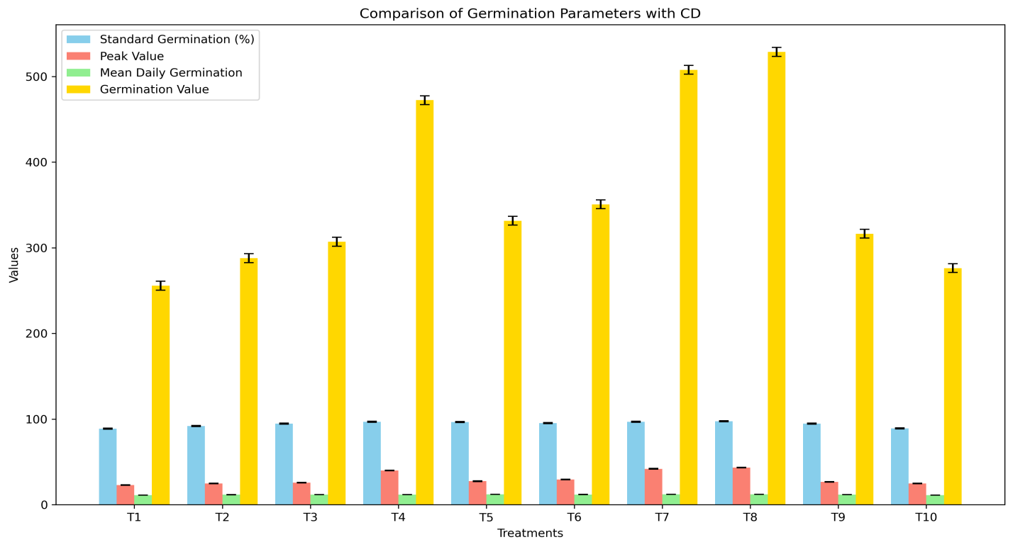
Fig.2. Beneficial effect of Liquid Bio-fertilizers on Germination and Germination Dynamics
Seedling growth parameters data is included in table 3 and fig. 3. It is clear from the table that all the treatments varied significantly in comparison to control T₁ (Control) for the seedling growth. The treatment T₈ (Azospirillum + PSB @ 20 ml/kg of seed) showed highest seedling length (29.71 cm) followed by T₇ (Azospirillum + KSB @ 20 ml/kg of seed) (28.82 cm), least seedling length was observed in the T₁ (Control) (23.86 cm) during both the year. Similarly, seedling dry weight had showed highest value in treatment T₈ (Azospirillum + PSB @ 20 ml/kg of seed) (11.46 mg) followed by T₇ (Azospirillum + KSB @ 20 ml/kg of seed) (11.42 mg), and least value was observed in T₁ (control) (8.20 mg). These results are in agreement with the findings with Yaadesh et al., (2023) in maize, Iswariya et al., (2019) in banyard millet, Balaji and Narayana (2019) in proso millet.
Table 3. Beneficial effect of Liquid Bio-fertilizers on Seedling Growth Parameters
TREATMENTS | Seedling length (cm) | Seedling dry weight (mg)
Control | 23.86 | 8.20
Em Culture @ 10 ml/kg of Seed | 25.19 | 9.36
KSB @ 20 ml/kg of Seed | 25.81 | 9.66
PSB @ 20 ml/kg of Seed | 27.58 | 10.47
Pseudomonas @ 20 ml/kg of Seed | 26.46 | 10.34
Azospirillum @ 20 ml/kg of Seed | 26.61 | 9.91
Azospirillum + KSB @ 20 ml/kg seed | 28.82 | 11.42
Azospirillum + PSB @ 20 ml/kg seed | 29.71 | 11.46
Azospirillum + KSB + PSB @ 30 ml/kg seed | 25.28 | 8.71
Thiram @ 1.3 g/kg seed | 24.23 | 8.44
SE (m±) | 0.18 | 0.08
CD (P=0.05) | 0.55 | 0.23
CV (%) | 1.42 | 1.65
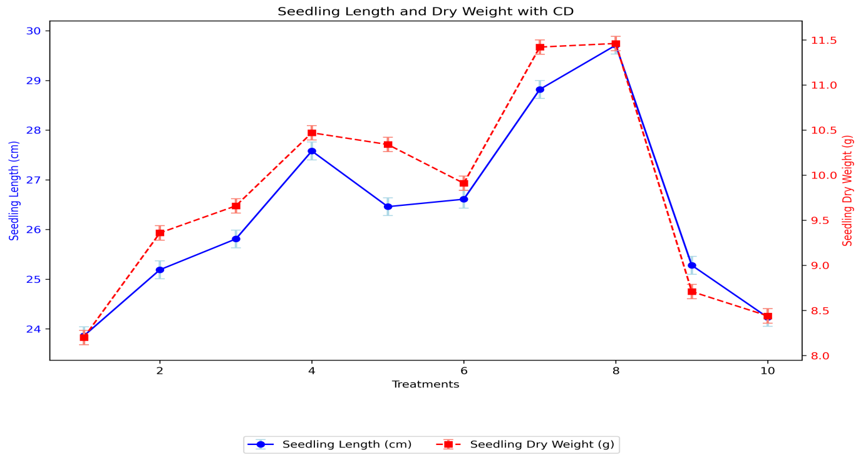
Fig.3. Beneficial effect of Liquid Bio-fertilizers on Seedling Growth Parameters
Seed vigour parameters data is included in table 4 and Fig. 4. It varied proportionally with the germination and seedling growth parameters. All the treatments varied significantly in comparison to T₁ (Control) for the seedling vigour index-I except T_{10.} The treatment T₈ (Azospirillum + PSB @ 20 ml/kg of seed) (2891.37) showed highest seedling vigour index-I followed by T₇ (Azospirillum + KSB @ 20 ml/kg of seed) (2792.54) of seed whereas the least seedling vigour index-I was observed in the T₁ (Control) (2119.11) (Image1.). Similarly, the treatment T₈ (Azospirillum + PSB @ 20 ml/kg of seed) (1115.93) showed highest seedling vigour index-II followed by T₇ (Azospirillum + KSB @ 20 ml/kg of seed) (1106.72) of seed whereas the least seedling vigour index-II was observed in the T₁ (Control) (727.91) during both the year. The results are in line with the findings of Sivakumar et al., (2017) in rice, Balaji and Narayana (2019) in foxtail millet cv. CO 6, little millet cv. CO 3 and proso millet cv. CO 4.
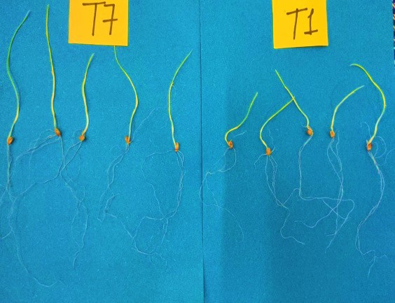
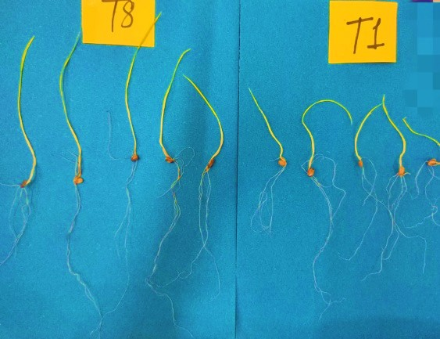
Image1: Comparative image of seedling length of best treatments with control

Table 4. Beneficial effect of Liquid Bio-fertilizers on physical Seed Quality Parameters
TREATMENTS | Seedling Vigor Index (I) | Seedling Vigor Index-II
Control | 2119.11 | 727.91
Em Culture @ 10 ml/kg of Seed | 2317.64 | 861.41
KSB @ 20 ml/kg of Seed | 2443.66 | 914.35
PSB @ 20 ml/kg of Seed | 2669.07 | 1013.61
Pseudomonas @ 20 ml/kg of Seed | 2547.77 | 998.94
Azospirillum @ 20 ml/kg of Seed | 2546.17 | 945.39
Azospirillum + KSB @ 20 ml/kg seed | 2792.54 | 1106.72
Azospirillum + PSB @ 20 ml/kg seed | 2891.37 | 1115.93
Azospirillum + KSB + PSB @ 30 ml/kg seed | 2392.75 | 824.56
Thiram @ 1.3 g/kg seed | 2159.93 | 752.00
SE (m±) | 21.18 | 9.00
CD (P=0.05) | 61.47 | 26.14
CV (%) | 1.70 | 1.94
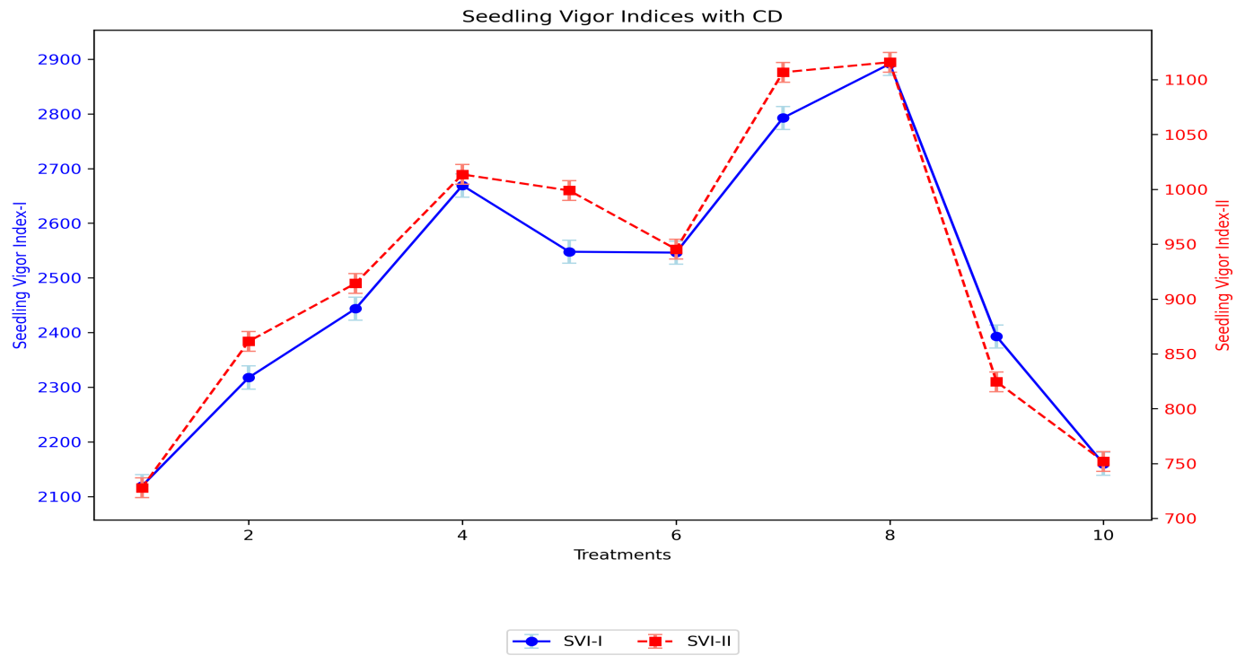
Fig.4. Beneficial effect of Liquid Bio-fertilizers on physical Seed Quality Parameters
4. DISCUSSIONS
According to the current study, the seeds treated with liquid biofertilizer showed higher physiological quality in a lab setting in comparison to control as well as thiram.
This improvement in biofertilizers' impact on improving the parental plants' nutrient uptake and metabolic activity. At the same time, PSB improve ATP synthesis and energy flow during seed development by increasing phosphorus availability through phosphatase activity and organic acid secretion (Zhang et al., 2019). Consequently, seeds from inoculated plants tend to be heavier, richer in stored metabolites, and more nutrient-dense (Raja et al., 2019). Improved seed performance in controlled germination studies directly results from nutrient enrichment during seed filling.
Microbial inoculation may affect physiological and biochemical processes linked to seed vigour and provide nutritional advantages. There have been prior reports of increased antioxidant activity and membrane integrity in seeds obtained from infected plants. The improved seedling growth seen in this study can be explained by these alterations linked to decreased solute leakage, increased enzyme activity during germination, and quicker mobilization of reserves.
The ability of beneficial microorganisms to remain as seed-borne endophytes may also play a role in the enhanced performance. Numerous investigations have demonstrated the ability of Azospirillum and other rhizobacteria to colonize productive organs and spread via seeds (Compant et al., 2010).
Generally, the results demonstrate that Azospirillum and PSB are not only beneficial for the growth of the crop but also for improving seed quality in the next generations. Incorporating liquid biofertilizer seed production programs may be an environmentally responsible way to generate high-vigour seeds with improved storability and field performance, as seed quality is a crucial factor in field establishment and productivity (Verma et al., 2016).

5. CONCLUSIONS
From the experimental findings, it has been concluded that wheat seed treated with ( Azospirillum + PSB @ 20 ml/kg of seed) increased all the seed quality parameters viz., germination, peak value of germination, mean daily germination, germination value, seedling length (cm), seedling dry weight (mg), vigour index-I and vigour index-II. Thus, the seed treated with liquid biofertilisers is the best alternative to chemical seed treatment, as it can be an environmentally friendly alternative, assuring environmental sustainability. Hence, seed treated with ( Azospirillum + PSB @ 20 ml/kg of seed) can be recommended for commercialisation as it could improve the yield and quality of wheat seeds.

COMPETING INTERESTS DISCLAIMER:
Authors have declared that they have no known competing financial interests OR non-financial interests OR personal relationships that could have appeared to influence the work reported in this paper.

Disclaimer (Artificial intelligence)
Option 1:
Author(s) hereby declare that NO generative AI technologies such as Large Language Models (ChatGPT, COPILOT, etc.) and text-to-image generators have been used during the writing or editing of this manuscript.

References

Abdul-Baki, A. A., & Anderson, J. D. (1973). Vigor determination in soybean seed by multiple criteria. Crop Science, 13(6), 630–633. https://doi.org/10.2135/cropsci1973.0011183X001300060013x.
Balaji, D. S., & Narayana, G. S. (2019). Effect of various bio-priming seed enhancement treatments on seed quality in certain minor millets. Plant Archives, 19(1), 1727–1732. https://doi.org/10.5555/20209904318.
Budhbaware, S., & Rai, P. K. (2023). Standardization of Pre-sowing Seed Treatment with selected Botanical, Biofertilizers and Plant Growth Regulator on Seedling parameters of Maize (Zea mays L.). Journal of Cereal Research 15 (2): 403-407. http://doi. org/10.25174/2582-2675/2024, 143120.
Compant, S., Clément, C., & Sessitsch, A. (2010). Plant growth-promoting bacteria in the rhizo- and endosphere of plants: Their role, colonization, mechanisms involved, and prospects for utilization. Soil Biology and Biochemistry, 42(5), 669–678. https://doi.org/10.1016/j.soilbio.2009.11.024
Food and Agriculture Organization (FAO). (2024). Crop Prospects and Food Situation –Quarterly Global Report. FAO. https://www.fao.org/markets-and-trade/publications/crop-prospects-and-food-situation/en/
International Rules for Seed Testing. Seed Science and Technology, 27(1), 25–30.
Available at: https://www.seedtest.org/en/publications/international-rules-seed-testing.html.
Iswariya, S., Sujatha, K., & Subhashini, R. (2019). Enhancement of seedling vigour through bio-priming for Barnyard Millet var. MDU 1. International Journal of Current Microbiology and Applied Sciences, 8(4), 2254–2261. https://doi.org/10.20546/ijcmas.2019.804.263.
Mahapatra, A., Barik, A. K., & Mishra, G. C. (2018). Effect of Integrated Nutrient Management (INM) on growth and yield of baby corn (Zea mays L.). Environment and Ecology, 36(1A), 338-342. https://doi.org/10.23910/IJBSM/2018.9.1.1855.
Ministry of Agriculture & Farmers Welfare. (2024, August 28). Final advance estimates of major crops for 2023-24. Press Information Bureau, Government of India. https://pib.gov.in/PressReleasePage.aspx?PRID=2058534.
Pathak, A., Chakrabarti, S. K., Das, R., & Mandal, M. K. (2016). Response of different wheat varieties towards Azospirillum and phosphate solubilizing bacteria (PSB) seed inoculation. Journal of Applied and Natural Science, 8(1), 213–217. https://doi.org/10.31018/jans.v8i1.775.
Raja, K., Anandham, R., & Sivasubramaniam, K. (2019). Seed and seedling vigour improvement through seed infusion with liquid microbial consortia in sorghum (Sorghum bicolor L. Moench). Research on Crops, 20(3), 652–656. https://www.researchgate.net/publication/340527184
Seenivasagan, R., Aruna, S., & Praveen Kumar, G. (2021). Liquid biofertilizers: A viable alternative to solid formulations. 3 Biotech, 11(11), 505. https://doi.org/10.1007/s13205-021-03035-9.
Sivakumar, T., Ambika, S., & Balakrishnan, K. (2017). Biopriming of rice seed with phosphobacteria for enhanced germination and vigour. ORYZA – An International Journal on Rice, 54(3), 346-349. https://doi.org/10.5958/2249-5266.2017.00048.0.
Thakare, G., Gangaiah, B., Bhutada, P., Dahipale, A., & Konde, N. (2024). Quantifying response of Azospirillum and phosphate solubilizing bacteria liquid inoculants seed treatment on productivity and profitability of kharif grain sorghum (Sorghum bicolor). Indian Journal of Agronomy, 69(1), 48–53. https://doi.org/10.59797/ija.v69i1.5481
Verma, J. P., Yadav, J., & Meena, V. S. (2016). Microbial inoculants in sustainable agricultural productivity. Springer. https://doi.org/10.1007/978-3-319-30665-8
Yaadesh, S., Tomar, G. S., Kaushik, R., Prasanna, R., & Grover, M. (2023). A zospirillum–Bacillus associations: synergistic effects on in vitro PGP traits and growth of pearl millet at early seedling stage under limited moisture conditions. 3 Biotech, 13(3), 90.
Zhang, T., Hu, F., & Ma, L. (2019). Phosphate-solubilizing bacteria from safflower rhizosphere and their effect on seedling growth. Open Life Sciences, 14(1), 246–254. https://doi.org/10.1515/biol-2019-0028.

