Original Research Article
Reproductive Barriers in Interspecific Capsicum Hybrids: A Comparative Study of F₁ Interspecific Hybrids and Parental Lines

ABSTRACT
Interspecific hybridization is a powerful technique for introducing new genes into cultivated crops like Capsicum, especially to integrate desirable traits from wild relatives. A common challenge, however, is the presence of reproductive barriers that can lead to infertility in hybrid offspring. This study investigated the reproductive viability of five F₁ interspecific hybrids created by crossing Capsicum frutescens and Capsicum annuum lines, comparing their performance to that of their parent plants. The experiment was designed as a Randomized Block Design, and we measured pollen fertility, seed viability, and seed germination percentage.
Our analysis revealed a substantial drop in pollen fertility for all F₁ hybrids, with percentages ranging from 34.00% to 57.00%, in contrast to the high fertility of the parental lines (54.99%–78.30%). This indicates significant post-zygotic barriers in the hybrids. Seed germination also showed a wide range, from a low of 8.57% to a high of 64%, reinforcing the presence of reproductive obstacles. Notably, one hybrid (IC208580 × AP-1) exhibited the highest pollen fertility, suggesting a promising level of genetic compatibility. Another hybrid (IC208580 × Pandalam local 1) displayed the most successful seed germination. Interestingly, seed viability, as determined by the tetrazolium test, remained high across all genotypes, ranging from 76% to 96%.
The findings of this study confirm that reproductive barriers pose a challenge to hybridizing C. frutescens and C. annuum. Nevertheless, the identification of specific hybrid combinations with higher reproductive success, such as those evaluated in this research, offers valuable guidance for future breeding programs focused on developing improved chilli varieties with enhanced traits.
Keywords: Capsicum frutescens, Capsicum annuum, interspecific hybridization, pollen fertility, seed germination, F₁ hybrids, reproductive barriers.
- INTRODUCTION
The genus Capsicum includes many species, recognized worldwide for their various culinary and economic uses as vegetables, spices, and sources of useful bioactive compounds. Among the most economically important are cultivated species like Capsicum annuum L. and Capsicum frutescens L., which play a major role in global chilli production. Globally, chilli pepper (primarily C. annuum) is one of the world's most valuable spice and vegetable crops, with production of fresh fruit exceeding 36 million tons annually (FAOSTAT, 2023). C. annuum is characterized by its vast phenotypic diversity, ranging from bell peppers to jalapeños, and typically exhibits mild to moderate pungency. In contrast, C. frutescens (e.g., Tabasco pepper) is known for its high pungency and smaller, erect fruits. Both species are diploid (2n=24) and are vital sources of capsaicinoids, carotenoids, and essential vitamins (Arimiyadi et al., 2022). While existing cultivated varieties have many desirable traits, wild and semi-domesticated relatives often provide valuable genetic resources for unique characteristics. These include resistance to biological and environmental stresses, stronger pungency, and new fruit aromas (Hajjar & Hodgkin, 2007; Bhatt et al., 2021; Ganeva et al., 2020).
Interspecific hybridization is a useful method in plant breeding for transferring valuable genes from wild relatives to cultivated plants, expanding the genetic base and creating new varieties (Pickersgill, 1997). Recent efforts have successfully utilized wild Capsicum relatives to introgress genes for tolerance against stresses like salt and drought into commercially important C. annuum lines, demonstrating the practical value of bridging these species (Lal et al., 2023). However, successful hybridization between different Capsicum species can be hindered by several reproductive barriers. These barriers can be pre-zygotic, such as pollen-pistil incompatibility, or post-zygotic, like embryo abortion or hybrid sterility. These barriers may result in low fruit set, non-viable seeds, or infertile offspring (Monteiro et al., 2011).
Understanding and overcoming these barriers is vital for effective chilli breeding programs (Nimmakayala et al., 2021; Bhatt et al., 2021). Hybrid sterility, a key post-zygotic barrier, often stems from meiotic irregularities due to chromosomal differences between the parent species (Rodrigues et al., 2020). A major sign of this sterility is a decrease in pollen fertility. Pollen viability, which can be measured using staining techniques, is an important indicator of a hybrid's reproductive stability, giving insight into its potential for producing future generations (Adeyemi et al., 2016). Likewise, the ability of F₁ seeds to germinate and grow into healthy seedlings indicates the viability of the seeds and the overall success of the cross. However, it is crucial to distinguish between seed viability (the metabolic state of the embryo and its potential to germinate under ideal conditions) and seed germination (the actual sprouting of the seed). Sometimes, seeds may be viable but fail to germinate due to dormancy or other factors, making it essential to assess both parameters for a comprehensive evaluation.
Research shows that while some interspecific crosses may produce fruits, the resulting seeds often have a much lower germination percentage and seedling survival rate compared to the parent plants (Pradeepkumar, 2007; Costa et al., 2010). Although C. annuum and C. frutescens belong to different species complexes, successful crosses between them usually create hybrids with varying levels of fertility and viability, suggesting that genetic barriers still exist that limit gene flow (Yumnam et al., 2023). Therefore, a thorough comparative analysis of the reproductive performance of these hybrids and their parental lines is important to identify promising combinations for future breeding.
The goal of this study was to evaluate and compare the pollen fertility, seed viability percentage, and seed germination percentage of five F1 interspecific hybrids, created from crosses between C. frutescens and C. annuum, along with their respective parental lines. The results will help assess the reproductive viability of these specific hybrid combinations, providing useful information for their potential use in breeding programs aimed at producing new and better chilli varieties.

- MATERIALS AND METHODS
2.1. Experimental Site and Plant Material
The experiment was conducted during the years 2024–2025 at the College of Agriculture, Vellayani, Thiruvananthapuram. The experimental material consisted of five F₁ hybrids evolved through interspecific hybridization between C. frutescens and C. annuum along with their respective parental lines. The parental lines used were a Capsicum frutescens - IC208580 and four Capsicum annuum -JNTBGRI 2, Unda chilli, AP-1, IC570376, and Pandalam local 1. Five F₁ interspecific hybrids were developed through a direct cross, with the Capsicum frutescens line IC208580 serving as the female parent and the five Capsicum annuum lines as male parents. The five F₁ hybrids were designated as follows: IC208580 × JNTBGRI 2, IC208580 × Unda chilli, IC208580 × AP-1, IC208580 × IC570376, and IC208580 × Pandalam local1.
2.2. Experimental Design
The experiment was laid out in a Randomized Block Design (RBD) with a total of eleven treatments and three replications. The treatments were as follows:
- Treatments 1–5 (F₁ Hybrids):
  - T₁: C. frutescens (IC208580) × C. annuum (JNTBGRI 2)
  - T₂: C. frutescens (IC208580) × C. annuum (Unda chilli)
  - T₃: C. frutescens (IC208580) × C. annuum (AP-1)
  - T₄: C. frutescens (IC208580) × C. annuum (IC570376)
  - T₅: C. frutescens (IC208580) × C. annuum (Pandalam local1)
- Treatments 6–11 (Parental Lines):
  - T₆: C. frutescens (IC208580)
  - T₇: C. annuum (JNTBGRI 2)
  - T₈: C. annuum (Unda chilli)
  - T₉: C. annuum (AP-1)
  - T₁₀: C. annuum (IC570376)
  - T₁₁: C. annuum (Pandalam local1)
The randomization of treatments within each of the three blocks was carried out independently to account for any spatial heterogeneity in the experimental plot. Each treatment was represented by a single plot with 5 plants within each block.
2.3. Pollen Fertility Assessment
Pollen fertility of the F₁ hybrids and their parents was evaluated at the full bloom stage according to the method described by Gulyas et al. (2006). For each treatment and replication, five freshly opened flowers were randomly selected. Anthers were separated from the flowers with forceps and placed on a glass slide containing a drop of 2% acetocarmine stain. The anthers were then gently crushed with a needle to release the pollen grains. After removing the debris, a coverslip was placed on the slide, and the sample was examined under a fluorescent microscope. Round, well-stained pollen grains were considered fertile, while shrunken, deformed, amorphous, and poorly stained grains were considered sterile.
Pollen fertility percentage was estimated using the formula below, as per the method of Rajendra et al. (2017):
Pollen fertility (%) $=$ $\frac{No. of fertile pollen grains}{Total no. of pollen grains}$ $×100$
Based on pollen fertility percentage parents are classified into Maintainer (M), Partial Maintainer (PM), Partial Restorer (PR) and Potential Restorer (R). This criterion of classification of pollen parent first proposed by Virmani (1997), has followed in this investigation.
Table 1. Classification based on pollen fertility
S. No. | Pollen fertility % | Category
1 | 0-1 | Perfect Maintainer (M)
2 | >1-50 | Partial Maintainer (PM)
3 | >50-80 | Partial Restorer (PR)
4 | >80 | Potential Restorer (R)

2.4 Seed germination (%)
The germination test was conducted as per the ISTA procedure using between
paper methods. The rolled papers were placed at slant position and maintained at a constant temperature of 25±1ᴼC and 95±1 per cent relative humidity. The number of normal seedlings were counted and expressed in percentage.
Germination percentage (%) $= \frac{Number of seeds germinated}{Total number of seeds sown} ×100$
2.5. Seed viability (%)
Seed viability Tetrazolium test was used for testing the seed viability using 2,3,5-triphenyl tetrazolium chloride. Hundred seeds were tested in replicates of fifty and they were hydrated between paper towel sheets moistened to approximately 2-5 times their actual dry weight for 3hr at 40ᴼc. After preconditioning, seeds were bisected longitudinally through the midsection of the embryonic axis and then placed in plastic cups, covered with 0.5 per cent 2,3,5-triphenyl tetrazolium chloride solution and incubated for three-four hours. After this, the solution was discarded and the seeds were rinsed thoroughly with cool, running tap water and left immersed in water until evaluation. Seeds were evaluated individually and classified into viable seeds and non-viable seeds (Santos et al., 2007).
- RESULT
This study aimed to assess the impact of interspecific hybridization on reproductive fitness by examining the pollen fertility and seed germination percentages of five F₁ hybrids and their parents. The key findings for three parameters are detailed in the following sections.
  - Pollen Fertility Classification
Analysis of variance revealed a significant variation in pollen fertility among the eleven treatments. The parental lines consistently displayed higher pollen fertility compared to the F₁ interspecific hybrids. Specifically, the C. frutescens parent (T₆) exhibited the highest fertility at 78.3%, falling into the Partial Restorer category. The five C. annuum parental lines (T₇-T₁₁) also demonstrated high fertility, ranging from 55% to 67.4%, and were all classified as Partial Restorers.
In contrast, pollen viability in the F₁ hybrids showed a notable decline. Pollen fertility percentages for the five F₁ crosses ranged from a low of 34% (T₄: 35 × 43) to a high of 57% (T₃: 35 × 31). This places all F₁ hybrids in the Partial Maintainer category. The reduction in fertility points to post-zygotic barriers, which likely caused meiotic abnormalities. Among the hybrids, T₃ (C. frutescens 35 × C. annuum 31) had the highest pollen fertility, suggesting it was the most compatible cross.
  - Seed Germination Percentage
Similar to pollen fertility, a significant difference in seed germination rates was observed across the treatments. The F₁ hybrids generally had lower germination rates compared to their parental counterparts. The most successful hybrid for seed germination was T₅ (C. frutescens 35 × C. annuum 8) with a rate of 64%. The next highest was T₃ (C. frutescens 35 × C. annuum 31) with 38.5%. The lowest germination was found in T₄ (C. frutescens 35 × C. annuum 43) at just 8.57%.
The parental lines exhibited a wide range of germination rates. The C. frutescens parent (T₆) showed a 60% germination rate. The C. annuum parents varied from a low of 20.53% (T₁₀) to a high of 63.33% (T₉).
  - Seed Viability Percentage
The seed viability percentages varied across the eleven treatments, ranging from a low of 76% to a high of 96%. Treatments T₃, T₆, and T₁₁ showed the highest seed viability at 96%, indicating the most effective conditions for germination. Following closely were T₂ and T₁₀, with a viability of 92%, and T₅ and T₉ at 88%. The lowest viability was observed in T₇ (76%), while T₄ and T₈ were at 80% and T₁ was at 84%.

Table 2. Pollen Fertility, Seed Germination Percentage and Seed Viability Percentage of F₁ Interspecific Chilli Hybrids and Their Parents
Treatment | Genotype | Pollen Fertility (%) | Seed Germination (%) | Seed viability  (%)
T₁ | C. frutescens (IC208580) × C. annuum JNTBGRI 2 | 42.3 | 13.33 | 84
T₂ | C. frutescens (IC208580) × C. annuum (Unda chilli) | 46.5 | 32.0 | 92
T₃ | C. frutescens (IC208580) × C. annuum (AP-1) | 57.0 | 38.5 | 96
T₄ | C. frutescens (IC208580) × C. annuum (IC570376) | 34.0 | 8.57 | 80
T₅ | C. frutescens (IC208580) × C. annuum (Pandalam local1) | 41.0 | 64.0 | 88
T₆ | C. frutescens (IC208580) | 78.3 | 60.0 | 96
T₇ | C. annuum JNTBGRI 2 | 55.0 | 50.0 | 76
T₈ | C. annuum (Unda chilli) | 60.8 | 25.0 | 80
T₉ | C. annuum (AP-1) | 67.4 | 63.33 | 88
T₁₀ | C. annuum (IC570376) | 59.6 | 20.53 | 92
T₁₁ | C.annuum (Pandalam local1) | 63.7 | 32.0 | 96
Figure 1. Microscopic images of pollen grains of all treatments
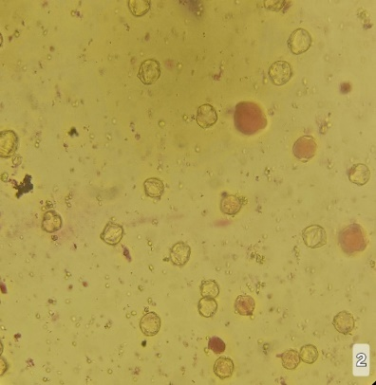
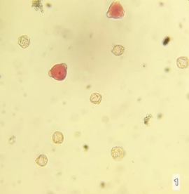

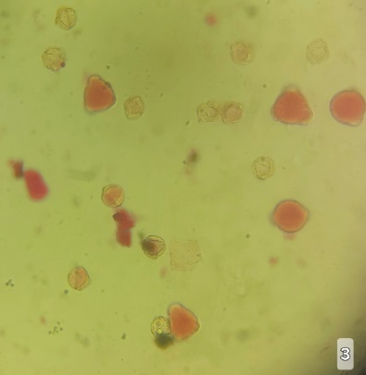
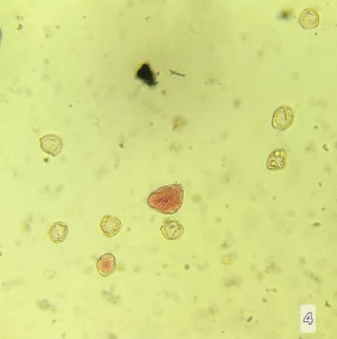
T₁ T₂

T₃ T₄
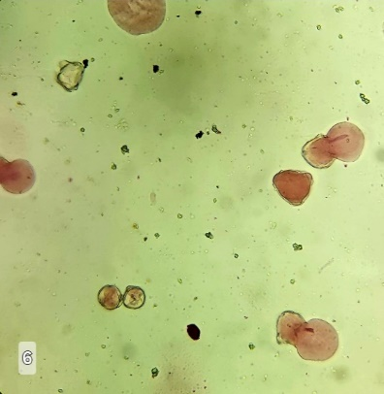
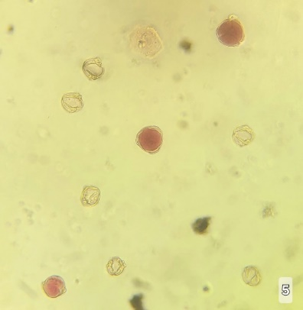

T₅ T₆
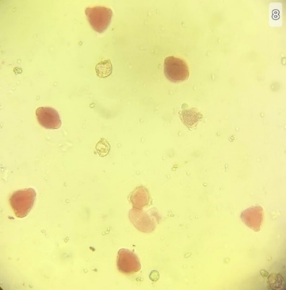
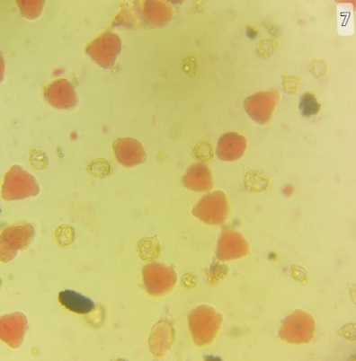

T₇ T₈
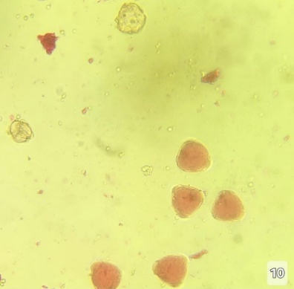
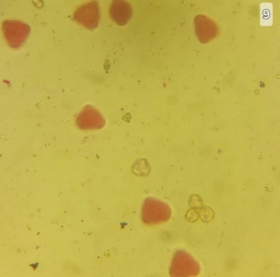

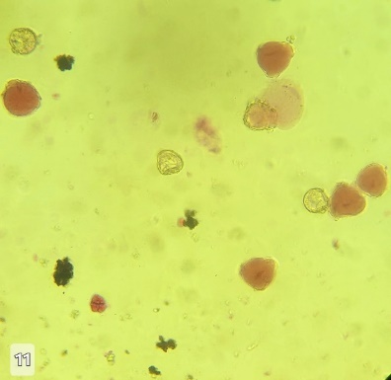
T₉ T₁₀

T₁₁

Figure 2. Microscopic images of viable and non-viable seeds
Treatment | Viable seed | Non-viable seeds
T₁ | 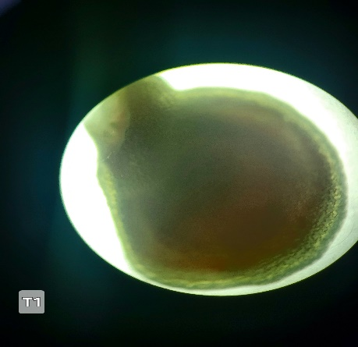 | 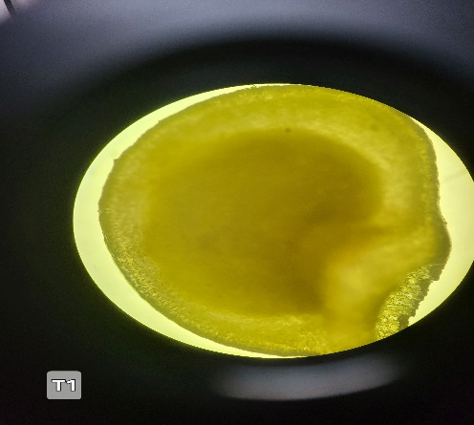
T₂ | 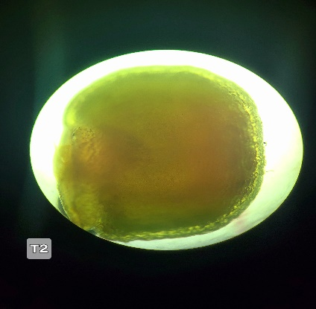 | 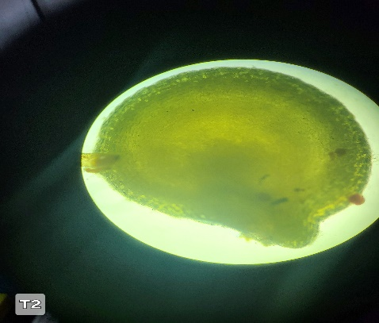
T₃ | 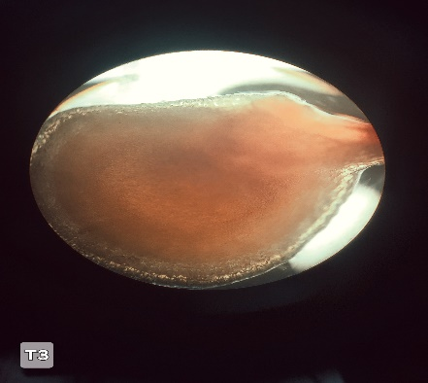 | 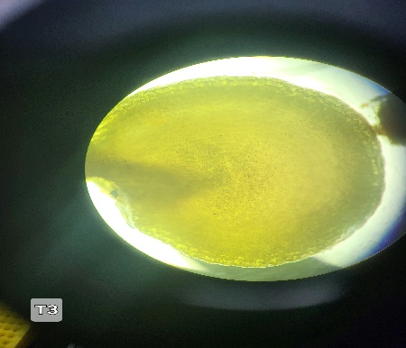
T₄ | 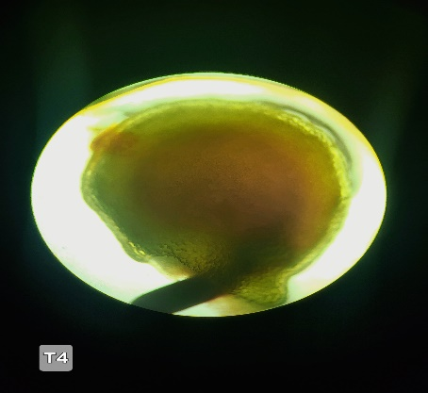 | 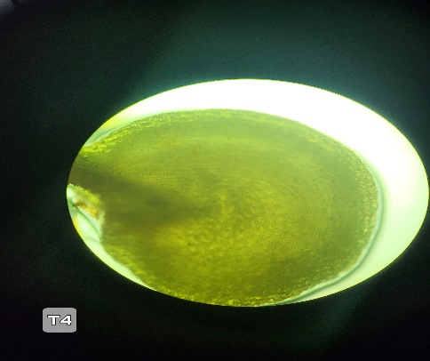
T₅ | 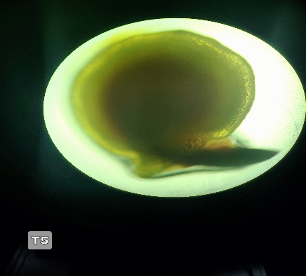 | 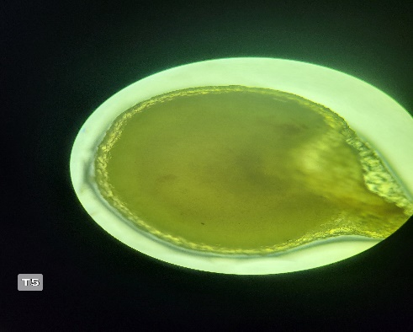
T₆ | 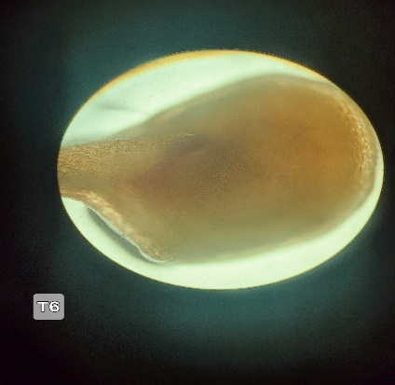 | 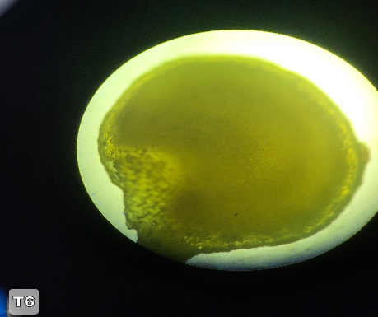
T₇ | 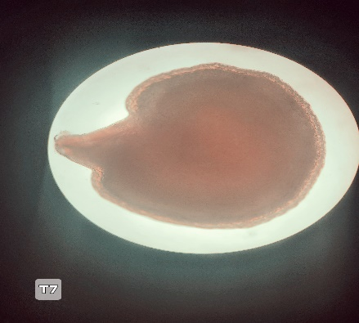 | 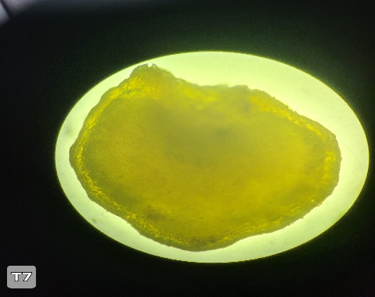
T₈ | 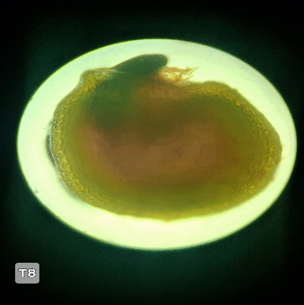 | 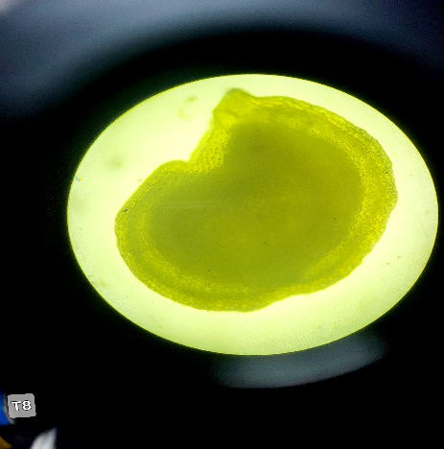
T₉ | 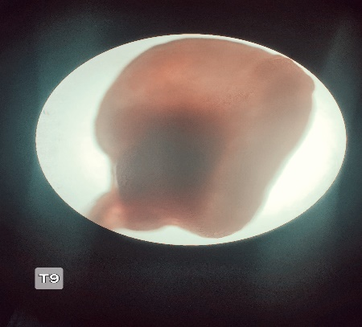 | 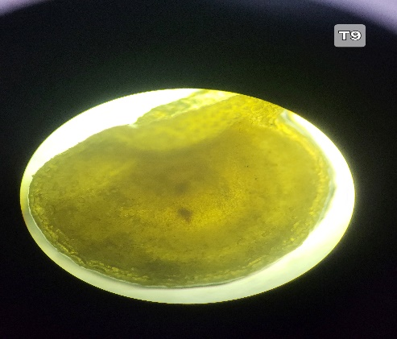
T₁₀ | 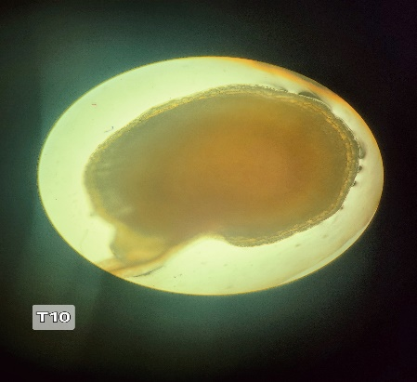 | 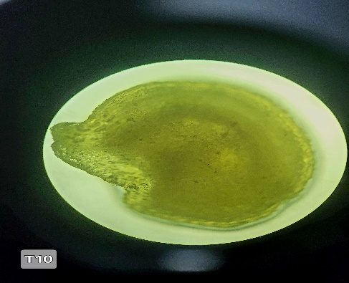
T₁₁ | 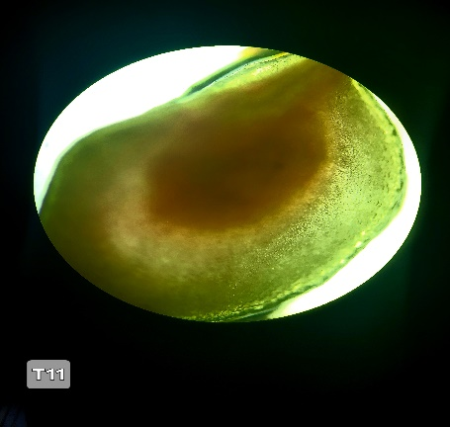 | 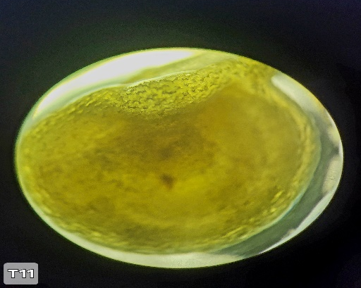

Figure 3. Graph showing pollen fertility%, seed germination%, seed viability % of treatments.

3.3 Summary of Findings
The reproductive characteristics of all eleven genotypes are summarized in Table 2. The data clearly illustrates that while the parental lines maintain robust reproductive efficiency, interspecific hybridization significantly impacts both pollen fertility and seed germination in the F1 generation. The hybrids T3 (C. frutescens IC208580 × C. annuum AP-1) and T5 (C. frutescens IC208580 × C. annuum Pandalam local 1) appear to be the most promising crosses, based on their comparatively higher pollen fertility and seed germination rates, respectively, suggesting their potential utility in future breeding programs.
- DISCUSSION
The evaluation of pollen viability and seed germination rates offers crucial insights into the reproductive compatibility and potential for genetic exchange within Capsicum interspecific hybridization programs. Our observations regarding the F₁ interspecific chilli hybrids and their parental lines generally align with the known complexities of wide crosses.
4.1. Pollen Fertility
Pollen fertility varied considerably across the tested genotypes, highlighting differences in their reproductive competence. As anticipated, the established parental lines exhibited robust pollen fertility. The C. frutescens parent (IC208580) demonstrated the highest fertility (78.30%), a characteristic consistent with healthy, non-hybridized accessions. Similarly, the C. annuum parental lines (JNTBGRI 2, Unda chilli, AP-1, IC570376, Pandalam local 1) maintained strong fertility levels, ranging from 54.99% to 67.39%. These high percentages in the parental lines are indicative of unimpaired meiotic processes and effective pollen development, which are essential for their role in breeding initiatives (Adeyemi et al., 2016).
In stark contrast, all five F₁ interspecific hybrids displayed a significant reduction in pollen viability, with fertility percentages spanning from 34.00% to 57.00%. This diminished fertility is a common outcome of post-zygotic reproductive barriers encountered in interspecific crosses (Monteiro et al., 2011; Rodrigues et al., 2020). Such reduced viability is frequently attributed to genetic incompatibilities between the parental genomes, leading to irregularities during meiosis (e.g., aberrant chromosome pairing or segregation) that result in the formation of non-viable or malformed pollen grains. The microscopic examination revealing shrunken, deformed, and poorly stained pollen grains further supports the occurrence of these meiotic aberrations.
Among the F1 hybrids, C. frutescens (IC208580) × C. annuum (AP-1) (T3) exhibited the highest pollen fertility (57.00%). This suggests a relatively higher degree of genetic compatibility between these specific parental lines compared to other hybrid combinations, making this F1 a more promising candidate for subsequent backcrossing or further generation advancement in breeding programs. Conversely, the hybrid C. frutescens (IC208580) × C. annuum (IC570376) (T4) showed the lowest pollen fertility (34.00%), indicating a more pronounced reproductive barrier between these particular parents.
The observed range of pollen fertility in the F1 hybrids underscores the variable success of interspecific crosses, even among species generally considered to be within the same gene complex, such as C. annuum and C. frutescens (Adeyemi et al., 2016). This variability emphasizes the critical importance of genotype-specific selection in hybridization programs to minimize reproductive isolation and maximize the potential for desirable gene introgression. These findings are consistent with previous reports in Capsicum, where interspecific hybrids often exhibit reduced pollen viability due to genetic divergence and chromosomal differences (Monteiro et al., 2011; Pradeepkumar, 2007). The successful identification of F1 hybrids with comparatively higher pollen fertility, despite the overall reduction, provides a foundation for developing strategies, such as embryo rescue or bridge crosses, to facilitate the transfer of valuable traits from wild or underutilized Capsicum germplasm into elite cultivated varieties.
4.2. Seed Germination Percentage
The observed patterns in seed germination percentage further substantiate the presence of reproductive barriers in interspecific chilli hybrids. The numerical data clearly indicates a general decline in germination rates for the F1 hybrids when compared to their parental lines. This is a well-known phenomenon in interspecific crosses, where post-fertilization issues, such as embryo abortion or impaired endosperm development, can lead to non-viable or poorly germinating seeds (Pradeepkumar, 2007; Costa et al., 2010).
The C. frutescens parent (IC208580) and several C. annuum parents (e.g., AP-1) demonstrated robust seed germination, reflecting their inherent reproductive stability. In contrast, the F1 hybrids exhibited considerable variation, with germination percentages ranging from a low of 8.57% (T4: IC208580 × IC570376) to a high of 64% (T5: IC208580 × Pandalam local 1). The particularly low germination in certain crosses suggests severe post-zygotic incompatibility, where even if fertilization occurs, the subsequent development of the embryo or endosperm is compromised, resulting in non-viable seeds.
Interestingly, the hybrid T5 (C. frutescens IC208580 × C. annuum Pandalam local 1) displayed the highest seed germination among the F1 hybrids (64%). This rate even surpassed that of the C. frutescens parent (60%) and was comparable to the high-germinating C. annuum parent AP-1 (63.33%). This suggests that despite potential challenges with pollen viability, this specific cross combination may possess genetic mechanisms that support more successful embryo and seed development. This could be attributed to particular gene interactions or a lesser degree of genetic divergence between these specific parental lines at loci influencing seed development.
The correlation between reduced pollen fertility and compromised seed germination in interspecific hybrids is widely documented (Bhatt et al., 2021). Our results generally support this trend, as hybrids with lower pollen fertility often also exhibited lower seed germination. However, the relatively strong seed germination in T5, despite its moderate pollen fertility (40%), indicates that reproductive barriers can manifest at different developmental stages and with varying degrees of severity. This highlights the intricate nature of interspecific compatibility and the necessity of evaluating multiple reproductive parameters.
In summary, while interspecific hybridization between C. frutescens and C. annuum presents inherent challenges to reproductive viability, the identification of F1 hybrids with comparatively higher pollen fertility (e.g., T3) and/or seed germination (e.g., T5) offers promising avenues for future breeding endeavors. These specific hybrids could serve as valuable genetic bridges or donor parents for introgressing desirable traits, provided that appropriate strategies, such as recurrent backcrossing or biotechnological interventions, are employed to mitigate the observed reproductive barriers in subsequent generations.
4.3. Seed Viability Percentage
The data on seed viability across the various treatments provides a clear and compelling insight into the factors affecting germination success. The results show that seed viability varied significantly, ranging from 76% to 96%. The highest viability percentages were observed in T3, T6, and T11, each at 96%. This high level of success strongly suggests that the conditions or substances used in these particular treatments were optimal for enhancing seed vitality and preparing the seeds for germination. It is likely that these treatments effectively broke seed dormancy, activated key metabolic processes, and repaired any cellular damage, resulting in a robust and uniform germination. These findings align with established literature on seed priming, which has shown that treatments can improve seed vigor by initiating pre-germinative metabolic activities (Bradford, 1986).
In contrast, the lowest viability was recorded for T7 at 76%. This may due to pre-zygotic, such as pollen-pistil incompatibility, or post-zygotic, like embryo abortion or hybrid sterility (Monteiro et al., 2011). The intermediate viability percentages observed in other treatments (e.g., T2 and T10 at 92%, T5 and T9 at 88%) highlight the sensitivity of seeds to their pre-germination conditions. These results suggest a dose-response relationship, where a slight variation in the treatment protocol—such as concentration, duration, or temperature—can lead to a notable difference in the final germination rate.
CONCLUSION
This study demonstrates that specific treatments can significantly enhance seed viability, with T3, T6, and T11 standing out as the most effective. These findings provide a valuable foundation for future research to precisely identify the components of these successful treatments and determine the mechanisms responsible for the improved viability. Further studies could also explore the long-term effects of these treatments on seedling vigor and crop yield.
DISCLAIMER (ARTIFICIAL INTELLIGENCE)
Author(s) hereby declare that during the editing of the review article, the author(s) used Gemini AI tool in order to improve the readability and language of the manuscript. After using this tool/service, the author(s) reviewed and edited the content as needed and takes full responsibility for the content of the published article.
ACKNOWLEDGEMENT
We thank Kerala Agricultural University for the support and facilities provided.
COMPETING INTERESTS
Authors have declared that no competing interests exist.
References
Adeyemi, A. T., Ado, S. G., & Tanimu, S. M. (2016). Evaluation of pollen viability, stigma receptivity, and fruit set in interspecific crosses of Capsicum species. Journal of Crop Science and Biotechnology, 19(3), 195–201.
Arimiyadi, S. A., Abdullahi, S. A., & Bawa, A. (2022). Evaluation of nutritional and phytochemical properties of different species of Capsicum. Bayero Journal of Pure and Applied Sciences, 15(1), 161–166.
Bhatt, D., Srivastava, K., Aseri, G. K., & Gupta, P. K. (2021). Capsicum genus: A review on its diversity, cultivation, breeding, and utilization. Journal of Applied Horticulture, 23(1), 1–17.
Bradford, K. J. (1986). Manipulation of Seed Water Relations Via Osmotic Priming to Improve Germination Rates. HortScience, 21(5), 1105–1110.
Costa, L. V., Lopes, R., Lopes, M. T. G., de Figueiredo, A. F., Barros, W. S., & Alves, S. R. M. (2010). Compatibility of crosses between C. chinense and C. annuum and the seed vigor and germination of interspecific hybrids. Crop Breeding and Applied Biotechnology, 10(1), 1-8.
FAOSTAT. (2023). Crops and livestock products. Food and Agriculture Organization of the United Nations. Retrieved from [Insert relevant FAOSTAT URL here]
Ganeva, D., Grozeva, S., & Tringovska, I. (2020). Assessment of genetic diversity in wild and cultivated Capsicum species using morphological and molecular markers. Euphytica, 216(2), 1–14.
Gulyas, G., Pakozdi, K., Lee, J. S., & Hirata, Y. (2006). Analysis of restorer-of-fertility by using cytoplasmic male-sterile red pepper (Capsicum annuum L.) lines. Breeding Science, 56(4), 331–334.
Hajjar, R., & Hodgkin, T. (2007). The use of wild relatives in crop improvement: a case for gene exchange. Euphytica, 154(1-2), 241-247.
Lal, H., Yadav, S. S., & Kumar, R. (2023). Recent progress in breeding chilli pepper (Capsicum spp.) for enhanced abiotic stress tolerance: A review. Frontiers in Plant Science, 14, 1163456.
Monteiro, A. M., de Oliveira, M. F., da Silva, A. M., & de Almeida, C. C. (2011). Reproductive barriers in interspecific crosses of Capsicum species. Crop Breeding and Applied Biotechnology, 11(3), 253–259.
Nimmakayala, V., Billore, P., Singh, S., & Jain, S. (2021). Progress and prospects in chilli pepper breeding: Overcoming reproductive barriers and enhancing traits through biotechnology. Planta, 253(6), 1–18.
Olatunji, T. L., & MORAKINYO, J. A. (2016). Pollen grain and hybridization studies in the genus Capsicum. Notulae Scientia Biologicae, 8(1), 134-138.
Pradeepkumar, T. (2007). Overcoming reproductive barriers in interspecific hybridization of Capsicum annuum and C. frutescens. Scientia Horticulturae, 112(3), 302–306.
Rajendra, M., Kumar, D. V., & Rao, K. K. (2017). Pollen viability and in-vitro germination of chilli (Capsicum annuum L.) cultivars. Journal of Plant Breeding and Genetics, 15(1), 32-38.
Rodrigues, R. L., Pereira, M. G., Vivas, M., Silva, L. V., de Almeida, F. S., & de Oliveira, A. C. B. (2020). Meiotic behaviour and fertility of Capsicum interspecific hybrids. Journal of Biotechnology, 10(2), e202002010.
Santos, M. A. O., Novembre, A. D. D. L. C., & Marcos-Filho, J. (2007). Tetrazolium test to assess viability and vigour of tomato seeds. Seed Science and Technology, 35(1), 213-223.
Virmani, S. S. (1997). Hybrid rice breeding manual. International Rice Research Institute.
Yumnam, D., Sharma, R. K., & Prakash, M. (2023). Assessment of genetic relationship and reproductive compatibility among different species of Capsicum using molecular markers. Molecular Breeding, 43(10), 1–12.

