MANAGEMENT OF LIGNIN RICH CROP RESIDUE FOR SOIL HEALTH AND SUSTAINABILITY

ABSTRACT
Soil health underpins terrestrial ecosystem sustainability and global food security, yet one-third of the world’s soils are already degraded, with projections of up to 90% degradation by 2050. Sustainable management of lignin-rich lignocellulosic biomass, produced in vast quantities as crop residues and industrial by-products, offers significant opportunities for improving soil fertility and reducing environmental impacts. In-situ management strategies such as mulching, straw incorporation, composting, biochar application, and microbial inoculants (e.g., Pusa Decomposer) enhance soil organic matter, nutrient availability and water retention while mitigating greenhouse gas emissions. Ex-situ approaches involve lignin extraction from black liquor and other pulping processes, enabling its conversion into value-added products. These include lignin nanoparticles for controlled- release agrochemicals, carbon fibers, polyurethanes, biofuels and aromatic compounds with diverse industrial applications. Beyond its agronomic and industrial potential, lignin utilization contributes to climate change mitigation by reducing fossil fuel dependency and lowering greenhouse gas emissions. This review synthesizes current knowledge on the management and valorization of lignin-rich residues, highlighting their role in sustainable soil management, circular bioeconomy and climate resilience, while identifying research needs for unlocking their full potential.
Key words: Biofuels, Bioproducts, Crop residue, Lignocellulosic biomass, Lignin valorization, Organic amendments, Soil health and Sustainable agriculture.

Introduction

“Soil health is the ability of the soil to sustain the productivity, diversity and environmental services of terrestrial ecosystems” (FAO, 2021), “and sustainability of soil refers to the long-term ability of soil to function as a vital living ecosystem that sustains plants, animals and humans. Nearly 33% of the Earth's soils are already degraded and over 90% could become degraded by 2050” (FAO, 2015). Erosion, salinization, compaction, acidification and chemical pollution being the possible reasons of degradation.
“There are so many organic amendments to maintain soil health viz., application of green manure, animal manure, seed weeds, compost, fish manure etc. Lignocellulosic biomass is one among them, which is produced abundantly i.e, 200 billion tons per year” (Nguyen et al., 2019).
“The name “lignin” is derived from Latin word lignum (wood), which was first used by F. Schulze in 1865. Lignin is biopolymer, present in plants along with cellulose and hemicellulose and is considered as second most abundant biopolymer on earth after cellulose” (Zor et al., 2022). “Lignin rich crop residues are nothing but crop residues that accumulate more lignin in them. Amount of lignin that accumulates depends on plant species, varieties and origin (herbaceous -1 to 15%, softwood 25 to 35%, and hardwood- 20 to 25%)” (del Rio et al., 2020).
“It has been estimated that more than 2 × 10¹¹ tons of lignocellulosic material are produced as agricultural byproducts each year, including straw, roots, husks, bagasse, shells” (Tuck et al., 2012). “Cereal production alone produces roughly 2.8 × 10⁹ tons of lignocellulosic crop residue each year” (Lal, 2005). A large portion of these crop residues are traditionally incorporated into soils, but some are used as animal feed; lignocelluloses have recently been identified as an abundant source of feedstock for bioenergy production. This review characterizes the processing and applications of lignin rich agricultural wastes and its role from the point of view of soil health and sustainability.

- Residue generation and management
2.1. Crop residue generation potential of India

The annual Gross Crop Residue (GCR) potential of India was 696.38 Mt, based on the annual crop production data from 2011-12 to 2015-16. Cereals alone contributed 364.3 Mt to the total GCR generated annually in India, followed by sugarcane (119 Mt). The contribution of pulses and oilseeds was only 13.58 Mt and 43.57 Mt of crop residues annually (Venkataramanan et al., 2021). Both cereals and sugarcane residue contain more lignin and are leading crop residue generated in India. In terms of crop residue generation, Uttar Pradesh tops the chart (60 Mt), followed by Punjab (51 Mt) and Maharashtra (46 Mt) (Biswas and Das, 2023).
2.2. Properties of lignin
“Lignin is a complex, irregular polymer made up of three phenylpropanoid monomers coniferyl alcohol, p-coumaryl alcohol, and sinapyl alcohol” (Nabuqi et al., 2020). “The main difference between these three monomers is the number of methoxy groups attached to the phenolic ring, as show in fig.1”. (Abdelaziz et al., 2016). “These monomers are connected by carbon-carbon (5- 5, β-5, β-1 y β-β), and ether (β-O-4, α-O- 4, 4-O-5) linkages” (Ralph et al., 2004). This structure provides rigidity and resistance to degradation. It is hydrophobic and rich in aromatic subunits. Lignin contains 63.4% Carbon, 30% Oxygen, 5.9% Hydrogen and 0.7% ash.
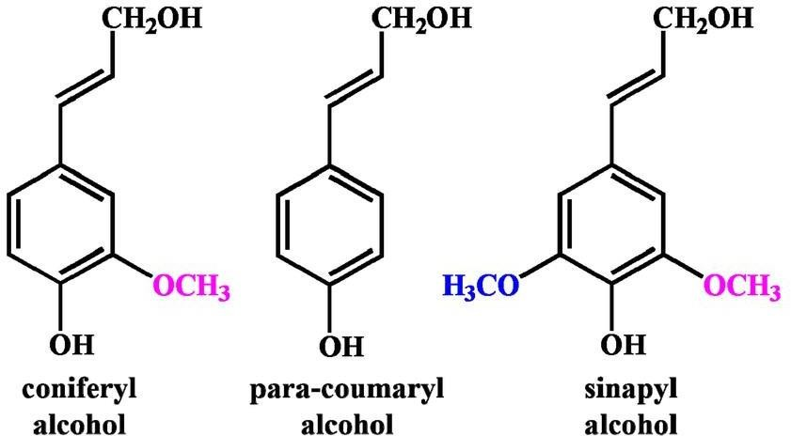“There are numerous properties which make lignin qualify as a unique natural resource. These properties include biodegradability, structural integrity, antioxidant/fungal/microbial behavior, abundance, chemical/biological/enzymatic stability, fire/UV resistance and hydrophobicity. Moreover, lignin is known to possess strong film-forming capacity and good compatibility with many industrial chemicals compared to cellulose and hemicellulose” (Sharma et al., 2023).
Fig.1. Monomers of lignin (Zhang et al., 2021)

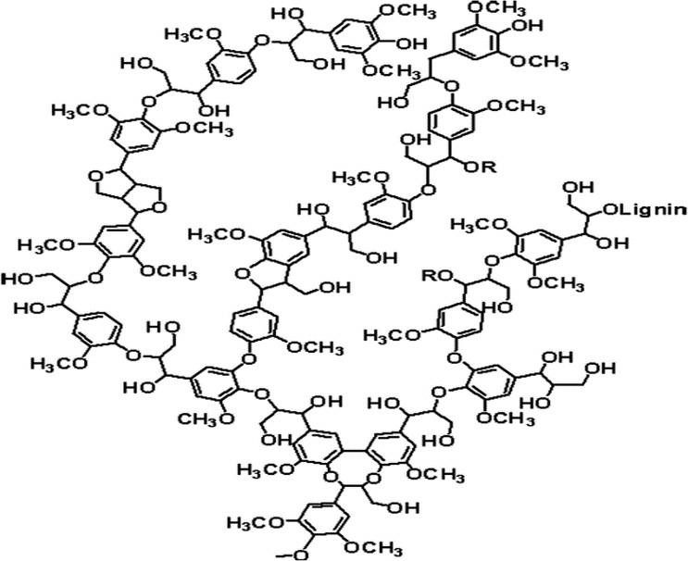

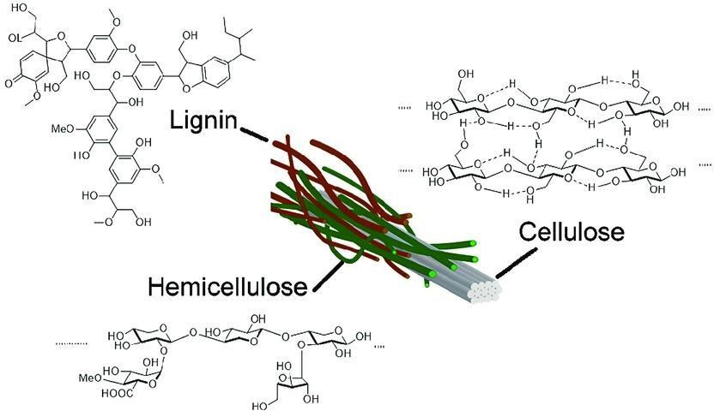Fig.2. Structure of lignin. (Prieur et al., 2017)
Fig.3. The nature of lignin presence in plants (Chai et al., 2022)

2.3. Sources of lignin
“The main sources of lignin are woody biomass and non-woody biomass sources that includes agricultural byproducts like coconut coir, straw from crops such as wheat, maize and rice, as well as empty fruit bunches from palm trees” (Abolore et al., 2024). “The second-generation bioethanol is produced from lignocellulosic materials and it is evaluated annually about 316000 tons, it is estimated that 1 kg of ethanol produces approximately 0.5 kg of lignin, during the process of bioethanol production biomass is
pre-treated to break down cellulose and hemicellulose for more accessibility. Enzymes are used to break down cellulose and hemicellulose into simple sugars. The sugars are fermented by yeast or other microorganisms to produce ethanol. Lignin does not ferment like cellulose and hemicellulose, so it remains as a solid residue after the ethanol is extracted. This lignin can then be separated and collected as a by-product.” (Tribot et al., 2019).

Table.1. Crop residues and lignin generating potential of India

Plant source | India’s annual productivity  (MT) | Lignin sources | Agro  - waste (MT) | Lignin (MT) | Reference
Rice | 106.5 | Rice husk | 21.3 | 5.112 | Canakci, et al.  (2015)
Wheat | 94.88 | Wheat  straw | 54 | 9.45 | Ministry of  Textiles (2018)
Sugar  Cane | 167 | Bagasse | 66.8 | 18.37 | IISR (2017)
Bamboo | 4.6 | Bamboo  straw | 0.8 | 0.208 | Rajesh et  al. (2014)
Corn | 24.6 | Corn stover | 11.8 | 2.183 | Moral and Mendez. (2006)
Banana | 14.2 | Banana peal | 5.396 | 1.4 | Shankar et al. (2020)

2.4. Significance of managing lignin rich crop residues
“Properly managed lignin-rich residues can contribute to soil organic matter over time, improving soil structure, water retention and microbial activity, which are essential for long-term soil health and can help prevent soil erosion. Improper management, such as burning lignin-rich residues, can lead to the release of significant amounts of greenhouse gases (GHGs), particularly carbon dioxide (CO₂). Managing these residues properly can help mitigate climate change impacts” (Lal, 2025).
Lignin can be isolated and utilized for biofuel, biochemical production, which is bonus for both industries in reducing greenhouse gas emission (GHGs) because of carbon neutrality of biofuels (Mandlekar et al., 2018). Generally, crop residues can be managed on-farm and off-farm.

2.5. Management of lignin rich crop residues

2.5.1. In-situ management of lignin rich crop residues
In-situ management of crop residues includes mulching, incorporation into soil and composting, in situ microbial management of crop residues, biochar making, using lignin rich crop residue as soil amendments.

2.5.1.1. Mulching
“Mulching is the practice of covering the soil surface with organic or synthetic materials to improve soil productivity. Crop residue mulching can be defined as a technology whereby at the time of crop emergence at least 30 per cent of the soil surface is covered by organic residue of the previous crop” (Santosh and Maitra, 2022).
A study was conducted by Kar and Kumar (2007), to assess the effects of irrigation and straw mulch on water use and tuber yield of potato, in Odisha. Rice straw mulch was applied at a rate of 6 t ha⁻¹ after the first earthing up at 24 days after sowing. Potato crop responded well to phenology-based irrigation scheduling in combination with rice straw mulching. The soil temperature had impact on tuber production because, under the same irrigation treatments, tuber production was higher in mulched than in non-mulched plots. Reduction of soil temperature, conservation of soil moisture, increased available phosphorous, potassium and organic carbon through mulching might have enhanced crop growth and tuber yield production in the mulched treatments.
Rice straw mulch application increased the potato tuber production by 24–42 per cent (2 years pooled data) depending on the irrigation treatments. The crop evapotranspiration was reduced by 77–103 mm with the application of rice straw mulch in the various irrigation treatments. Application of straw mulch significantly increased the available phosphorus and potassium in the soil (Fig 4).

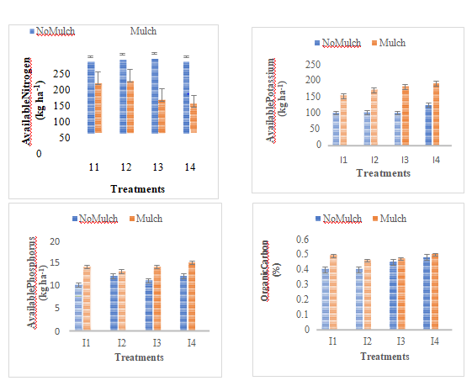

Fig.4. Soil parameters as affected by mulching (Kar and Kumar, 2007)

Lasmini et al. (2021) conducted a factorial randomized block experiment in Central Sulawesi, Indonesia, to evaluate the combined effect of mulching and liquid organic fertilizer derived from coconut husks on shallot growth and yield. The treatments included two mulch types—silver-black plastic mulch (M1) and straw mulch (M2)—and four levels of liquid organic fertilizer application (S0: no fertilizer, S1: 500 L ha⁻¹, S2: 750 L ha⁻¹, S3: 1000 L ha⁻¹). Results indicated that plant height, number of leaves per plant, number of tillers per plant, and tuber yield were highest under the M2S3 treatment (straw mulch with 1000 L ha⁻¹ fertilizer). The enhanced performance was attributed to the potassium release from coconut husk liquid fertilizer combined with the beneficial microclimate created by straw mulching.

2.5.1.2. Incorporation into soil
Residue incorporation is defined as the use of tillage implements to bury remnant plant residues into soil. It is one of the traditional methods adopted to return organic matter to the soil and protect it against erosion.
Kumari et al. (2018) studied the long-term effect of crop residue incorporation on yield and soil physical properties under rice – wheat cropping system in a Zn deficient calcareous soil in Pusa, Bihar. The residual effects of graded levels of residual starter Zn, continuous incorporation of graded levels of crop residue of previous crop (wheat) on grain and straw yield of rice (33rd and 35th crops) and their interaction under rice-wheat cropping system were found statistically significant. The highest grain yield was observed with 100 per cent crop residue incorporation along witha residual starter dose of Zn (10 kg ha⁻¹). The increase in grain yield of rice following crop residue incorporation was attributed as either due to the addition of nutrients through crop residue incorporation or increase in availability of nutrients by complexing properties of crop residues.

However, farmers do not prefer in-situ incorporation as the stubble takes time to decompose in the soil because of lignin content which may adversely affect the sowing time of crops. In a two-year rice–wheat rotation study on sandy loam soil in Jiangsu Province, China, straw incorporation (STR) was compared with straw removal (CK). STR increased wheat yield by 58% but had no significant effect on rice yield. In the 0–20 cm soil layer, STR enhanced soil fertility, with available N, P, and K increasing by >15%, and total N and P by 24% and 16%, respectively (Fig 5). STR also improved soil CEC (+8%) and SOC (+22%), while nutrient levels and CEC declined with depth. Interestingly, available P was higher under CK at 20–30 cm, and no treatment effect was observed on soil C/N ratio (Zhao et al., 2019).

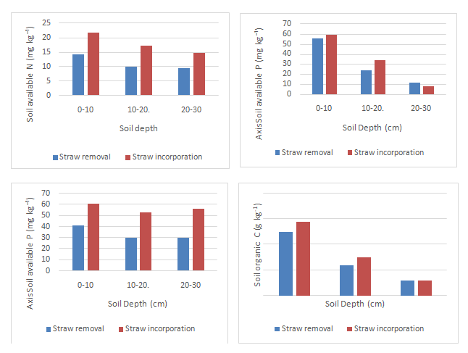

Fig 5. Effect of full straw incorporation in rice-wheat crop rotation (Zhao et al., 2019)

2.5.1.3.Composting
Composting is a natural process of decomposition by aerobic and anaerobic micro-organisms under controlled conditions and they convert crop residue into a valuable manure or compost with additional advantage in terms of nitrogen, phosphorous sand potassium (NPK) (Mishra et al., 2003). “Lignin contributes to its recalcitrance by binding the cellulose strands and hemicellulose together” (Batt, 1999). “Out of these three biopolymers, lignin is most resistant to chemical and biological degradation due to its structural complexity” (Li et al., 2009).
Wide C:N ratio and recalcitrant nature of agricultural residues resulting in slow decomposition (120 – 150 days for quality compost) is one of the major constraints in composting. Coir pith, which is abundantly available as a by-product from coir industries, is found to be a good source of organic manure after decomposing it with Pleurotus sajor-caju and Schizophyllum commune (Reeja, 2002). “Highest N, P, K and least lignin content was observed in coir pith, composted with cow dung, vegetable market waste, poultry waste, mixed microbial culture (Trichoderma viridae +Pleurotus sajor-caju)” (Muthurayar and Dhanarajan, 2013).

A study conducted by Parmar et al. (2019) at Anand Agricultural University, Gujarat, investigated the composting of banana pseudostem waste and maize fodder waste using eight different treatment combinations. Each treatment utilized cow dung slurry (5 kg of cow dung mixed with 10 L of water), Anubhav Biodegradable Bacterial Consortium (ABBC) (100 mL dissolved in 10 L of water), and the earthworm Eudrilus eugeniae (500 g) as composting agents, applied to 100 kg of the waste material. The results indicated that treatments 4 and 8 demonstrated the highest nutrient concentrations, including nitrogen (N), phosphorus (P), potassium (K), organic carbon (OC), and organic matter (OM), as outlined in Table 2. Eudrilus eugeniae was used in all treatment groups as the primary vermicomposting agent.

Table.2. N, P, K % of different treatments used.

Treatment | N% | P% | K%
T1: BP | 0.944d | 0.267d | 0.880f
T2: BP+ABBC | 1.146b | 0.326c | 1.005c
T3: BP + CD | 1.109c | 0.360b | 0.977d
T4: BP+CD+ABBC | 1.246a | 0.426a | 1.127a
T5: MF | 0.844e | 0.245e | 0.844a
T6: MF+ABBC | 1.096c | 0.319c | 0.930e
T7: MF+CD | 1.091c | 0.334c | 0.906e
T8: MF+CD+ABBC | 1.217a | 0.409a | 1.051b
BP = Banana psedostem, CD = Cow Dung, ABBC = Anubhav Biodegradable Bacterial Consortium, MF= Maize Fodder. (P=0.05), Parmar et al. (2019).

At the Onattukara Regional Agricultural Research Station, Kerala, Limnocharis flava, an invasive aquatic weed, was recycled through different composting methods, including conventional composting, vermicomposting, Kerala Agricultural University (KAU) inoculum-based composting, and composting with Pleurotus florida. All approaches produced quality compost, though vermicomposting gave the highest recovery (12.47%), while Pleurotus florida compost was richest in N and P. Composting with KAU inoculum enhanced Mg content, attributed to its diverse microbial community (Jayapal et al., 2021)

2.5.2. In-situ microbial management of lignin rich crop residues
Since lignin cannot be decomposed easily, special group of microorganisms are required to decompose the biomass in less time. Microbial-based degradation of lignocellulosic materials has been gaining momentum due to their being eco-friendly, non-toxic and economic in nature (Wan and Li, 2012).
Pusa bio-decomposer or Pusa decomposer is a low-cost microbial consortium developed (both in liquid and capsule forms) by a team of scientists headed by Dr. Livleen Shukla, ICAR, New Delhi for accelerated decomposition of crop residues, including paddy stubbles and straw. It is a cocktail of seven fungi, potentially containing Aspergillus nidulans, Aspergillus awamori, Phanerochaete chryosporium and Trichoderma viride, although the exact composition has not been publicly released (Balakrishnan, 2022). The micro-organisms can thrive at 30ºC to 32ºC which is prevalent during harvest of paddy. Commercially it is available in the form of capsules (one packet containing four capsules). These four capsules can be used to make up 25L liquid formulation which can be applied in- situ to 1.0 ha of rice field having 5- 6 tonnes of paddy straw.
A study conducted by Sruthy et al. (2023) revealed that a consortium of three soil ascomycetes (Aspergillus terreus, Aspergillus fumigatus, Alternaria spp.) was efficient in colonizing rice stubble and degrading it. As the dosage of inoculum increased, degradation of lignin and cellulose was also observed to be increased. Maximum lignin degradation was observed when the consortium was applied at 15 per cent volume by weight of rice stubble with maximum activity of different lignolytic enzymes such as lignin peroxidase, laccase and total phenols.

Pachauri et al. (2022) evaluated “the effect of four residue management practices viz. residue burning (R1), residue removal (R2), residue treated with Pusa Decomposer (R3) and residue treated with Trichoderma (R4) on the weed dynamics of late sown wheat. The highest weed population was recorded with residue removal (R2). Application of Pusa decomposer (R3) significantly suppressed the weed flora at 60 DAS and at 90 DAS in wheat crop” .

2.5.2.1.Lignin rich crop resides as biochar
“Crop residues such as sugarcane bagasse, maize stover, and rice husk are promising sustainable resources as a feedstock for biochar. Crop residue-based biochar can contribute to decreasing the carbon footprint of agriculture because the carbon remains in biochar for longer duration” (Tagade et al., 2021).
“Biochar typically has a well-developed pore structure, huge surface area and high degree of stability and great adsorption properties” (Yuan et al., 2019). The commonly used methods are thermochemical processes - pyrolysis, torrefaction (thermochemical process to decrease the water and volatile contents), hydrothermal treatment, and gasification (Len et al., 2022).
Bhattacharyya et al. (2021) reported that “biochar could be prepared from rice straw under controlled pyrolysis. About 50 per cent of the C would be released as gas or other volatile compounds, and the left-out recalcitrant C compounds in biochar would help to sequestrate 40–50 per cent C from rice straw.”
Gopal et al. (2020) successfully pyrolysed the lignin-rich recalcitrant biomass residues of coconut palms viz., mature coconut husk, tender (immature or green) coconut husk, coconut leaf petiole and coir-pith (Table 3). The field trial with tender coconut husk biochar + coconut leaf vermicompost was able to improve chilli yield by 50 per cent compared to non-amended soils. They concluded that tender coconut husk biochar could be added as amendment at the rate of 2 t ha⁻¹ along with coconut leaf vermicompost for aiding regenerative agriculture by enhancing soil health and consequently improve crop yield.
Table.3. Physico-chemical properties of biochars produced from coconut biomass residues.
Type of biochar | BD  (Mg m⁻³) | Ash (%) | pH | EC  (µS m⁻¹₎ | CEC  (meq 100g⁻¹)
Tender coconut husk | 0.3 | 22.3ª | 9.3ª | 281 | 28^{b}
Mature coconut husk | 0.3 | 24.8ª | 9.7ª | 254 | 31^{b}
Coconut leaf petiole | 0.4 | 10.3^{b} | 9.2ª | 226 | 23^{b}
Coir pith | 0.2 | 21.1ª | 7.9^{b} | 315 | 46ª
CD (0.05) | NS | 8.78 | 0.88 | NS | 10.8
Type of biochar | Moisture  (%) | Org. C  (%) | Total N  (%) | Total P  (%) | Total K  (%)
Tender coconut husk | ₉b | 23ª | 0.9 | 0.4ª | 3.6
Mature coconut husk | 16ª | 19^{b} | 1.0 | 0.4ª | 2.8
Coconut leaf petiole | 14ª | 10^{c} | 0.6 | 0.5ª | 2.8
Coir pith | 10^{b} | 15^{b} | 0.7 | 0.2^{b} | 3.1
CD (0.05) | 2.7 | 3.8 | NS | 0.18 | NS

The effects of application of biochar made from paddy husk and coconut frond on physical properties of laterite soil and yield of ginger crop was studied by Jabin and Rani (2023). Least BD, highest WHC and highest WSA are observed in T4 as compared to Kerala Agricultural University Package of Practices Recommendations for crops (KAU POP, 2017). The reduction in soil bulk density (BD) was greater with PHB than CFB (Table 4), likely due to the inherently lower BD of PHB. Biochar's ability to retain water may result from an increased overall soil surface area after its application. The higher concentrations of calcium (Ca) and magnesium (Mg) following biochar incorporation enhance soil particle flocculation, contributing to improved water-stable aggregates (WSA). Additionally, electrostatic attraction between organic amendments and soil particles helps form microaggregates, further enhancing WSA (Jabin and Rani, 2023).

Table.4. BD, WHC and WSA as influenced by treatments at 60DAP.

Treatments | Description | BD Mgm⁻³ @60 DAP | WHC (%) @60DAP | WSA (%) @  60DAP
T1 | Absolute control (soil alone) | 1.34 | 29.09 | 47.67
T2 | PHB@10t ha⁻¹ +NPK | 1.25 | 46.65 | 53.30
T3 | PHB@ 20t ha⁻¹+ NPK | 1.22 | 53.65 | 55.86

T4 | PHB @ 30t ha⁻¹ + NPK | 1.18 | 58.61 | 57.39
T5 | CFB @ 10 t ha + NPK | 1.32 | 38.54 | 51.22
T6 | CFB @ 20 t ha⁻¹+ NPK | 1.28 | 42.09 | 53.59
T7 | CFB @ 30 t ha⁻¹ + NPK | 1.24 | 48.02 | 55.90
T8 | KAU POP (30 t FYM + 75: 50: 50 kg NPK ha⁻¹ | 1.33 | 48.02 | 48.84
NPK as per KAU POP (30t FYM+75:50:50 kg NPK ha⁻¹), PHB: Paddy Hush Biochar, CFB: Coconut Frond Biochar, (Jabin and Rani, 2023).

2.5.2.2. Lignin rich crop residues as soil amendment

“Press mud (filter mud or filter cake) is the residue remaining after clarification and filtration of the sugarcane juice. Press mud yield varies from 10 kg to 70 kg t⁻¹ of sugarcane processed” (Diaz, 2016). “Press mud is mostly used as soil conditioner, fertilizer and for wax production. It is also used as feed component, notably for ruminants because of its sugar and mineral content and as a compacting agent for ensiling” (Kumar and Chopra, 2016)

Prabhavathi and Parama (2019) studied the effect of pressmud and biocompost (combination of pressmud and spentwash) on the soil physical and chemical properties, with finger millet as the test crop. The results indicated significantly lower bulk density and increased maximum WHC with the application of pressmud (10 t ha⁻¹) along with the recommended dose of fertilizers (RDF). Maximum water holding capacity (MWHC) of the soil increased with higher rates of pressmud, bio compost, and further with FYM. The increase in WHC may be due to increased pore volume due to higher doses of organic solid waste. Application of organics lead to production of polysaccharides which improved soil aggregation and decreased bulk density.
A study was conducted using corn stalk juice application to soil to test its capacity to reduce water runoff by forming aggregates because of its binding nature due to presence of high lignin. Reduction benefit was 32%, 35%, 39%, 56%, 63% and 76%, respectively, for T1, T2, T3, T4, T5 and T6 treatments (Table 5). Runoff rates was more significant in treatments with higher concentrations and volumes of corn stalk juice for soil conservation and erosion control on sloped agricultural land (Wei et al., 2017).

Table.5. Effect of corn stalk juice on soil runoff

Treatment | Description | Cumulative erosion (g) | Erosion reduction benefit (%)
T1 | 0.1L CSJ + 0.3L DW | 147.58 | 38
T2 | 0.2L CSJ + 0.2L DW | 91.62 | 42
T3 | 0.3L CSJ + 0.1L DW | 85.61 | 65
T4 | 0.2L CSJ + 0.6L DW | 53.23 | 77
T5 | 0.4L CSJ + 0.4L DW | 33.62 | 89
T6 | 0.6L CSJ + 0.2L DW | 16.87 | 96
CSJ: Corn Stalk Juice, L: Liter, DW: Distilled Water.
P< 0.05, (Wei et al., 2017)

2.5.3. Ex-situ management of lignin rich crop residues

Paper and pulp industries uses lignin rich crop residues for making paper through a process called pulping. Pulping is the process of breaking down the fibrous parts of wood or other plant materials to produce pulp, which is then used to make paper, cardboard and other cellulose-based products. The main goal is to separate cellulose fibers from lignin, hemicellulose and other compounds present in the raw material (Nguyen et al., 2019).
The water used in the process of extraction of pulp (cellulose) contains separated lignin, hemicellulose and other inorganic chemicals used in the process such as sodium hydroxide and sodium sulfite, technically called black liquor. Then lignin is purified using acid treatment followed by precipitation and filtration. The type and amount of lignin separated in black liquor differs based on the lignin % in raw material used, type of chemicals and temperature used during the process of pulping.
Black liquor can be subjected to evaporation, recovery boiler, membrane filtration to recover the chemicals used and processes like gasification and anaerobic digestion for production of biofuels or lignin can be extracted from black liquor by acidification and filtration (Morya et al., 2022) which will be discussed in detailed in the following sections

2.5.3.1. Types of lignin, based on method of pulping (Table 6) (Bilal et al., 2021)
- Kraft lignin
Kraft pulping is the most dominating pulping process and constitutes approximately 85% of total lignin production. Kraft lignin is currently often burned for internal energy demand and pulping chemical regeneration. Na2 and NaOH (white liquor) are used at high temperature (150-180ºC) for several hours to depolymerize lignin into smaller soluble fragments.

Sulfite lignin
Sulfite lignin is produced when pulp is cooked with salts of sulfites (SO3²⁻⁾ or bisulphates (HSO₄⁻ ) and bases like calcium (Ca²⁺), magnesium (Mg^{2+),} ammonium (NH⁴⁺) or sodium (Na⁺) etc.

Soda lignin
Soda lignin is generated from flax straw, non-wood fibers, etc., through the soda anthraquinone process. The soda pulp mills have very low production capacity due to annual feedstock variability and the reduction of chemical oxygen demand (COD) has been observed about 50% as lignin removed from the effluent and increase the economic rational of the mill.

Organosolv lignin
“In this process, the lignin is obtained by using delignifying solvents and is an alternative process for pulping technology. Instead of highly phenolic, organosolv lignin is considered as relatively hydrophobic, low molecular weight, and pure i.e., low in ash and carbohydrates and free of sulfur. Usually, lignin obtained through organosolv extraction is less contaminated than other processes” (Mastrolitti et al., 2021).

Table. 6. Types of industrial lignin based on process of extraction from biomass every year.
Process of extraction | Solvent used | Temperature | Sulphur impurity | Volume of lignin  Generated
Sulphur
containing
Kraft lignin | Sodium hudroxide, sodium sulphite | 170ºc | 1-3% | 55 million tons/ year
Lignosulphonates | Metal sulphite or sulphur dioxide with Ca²⁺, Mg²⁺ or  Na²⁺ | 120-  180º c | 4-8% | 1million tons/year
Sulphur free
lignin
Organosolv  lignin | Ethanol, | 170 -  190ºc | -

Soda lignin | Aqueous sodium hydroxide | 140-  170ºc | - | 6  million tons/year
(Bajwa et al., 2019, Bilal et al., 2021).

2.5.3.2. Valorization of extracted lignin
Recent studies of Kaur and Goyal (2024) highlight the potential of lignin as a valuable feedstock for high-value applications. Its complex macromolecular structure enables conversion into diverse products, broadly categorized as nanoparticles, bioenergy (power/fuel), macromolecules and aromatic compounds.

2.5.4. Lignin nanoparticles in agriculture

Traditional crop production involves high dosage, repeated application, uncontrolled delivery, short term protection, contamination of food, soil and water. Lignin is a natural, green material that can be used to create biocide delivery systems. It helps in slow release of biocides over time. Lignin based biocides are released in response to specific environmental triggers (e.g., pH, temperature).
A study was conducted using kraft lignin with 10% copper ions represented as HMW@ Cu 10% to test the efficiency in controlling Pseudomonas syringaeon tomato leaves under greenhouse condition. Results showed that, HMW @ Cu10% 10L/ha initially controls the leaf attacks, but its effectiveness diminishes significantly over time. Copper Hydroxide 3kg/ha shows moderate effectiveness throughout, but not as effective as HMW@Cu10% 3L/ha. HMW@Cu10% 3L/ha shows a consistent performance with lower percentages of attacked leaves across all time intervals and can be considered as most effective treatment and showed 20times reduction in copper usage compared to commercial products (Gazzurelli et al., 2020).

Zhang et al (2020) conducted a study using Lignosulfonate-Modified Epoxy Resins with Abamectin, a common nematicide. Abamectin has less mobility in soil and absorption by plant roots, because of its complex molecular structure. Three pesticide formulations with sulphate lignin were created for comparison: a microemulsion (ME) composed of oil-in-water droplets of less than 100 nm; a suspension concentrate (SC) composed of solid particles of approximately 1 μm; microcapsule (MC) and Nano Capsule (NC) that were encapsulated Aba into a micron-diameter ER carrier. High encapsulation efficiency (93.4%) and slower release rate was shown by MC. High absorption into plants and mortality and nematode were shown by NC plants (Fig.6) compared to other formulations.
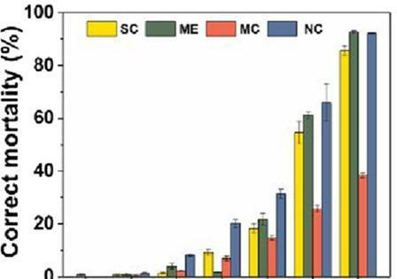

CK 0.1 0.2 0.4 0.8 1.6 3.2 CONCENTRATION mg/L

Fig.6. Mortality percentage of nematodes against different formulation concentrations of abamectin, (Zhang et al., 2020).
Tolisano et al. (2024) reported that lignin nanoparticles (25–100 mg L⁻¹) enhanced tomato root development, with all treatments increasing root tip number and fresh weight compared to the control, while the highest concentration (LN100) significantly improved root surface area.

2.5.5. Power/ biofuels from black liquor

Power from lignin rich crop residues can be generated either with cellulose and hemicellulose after lignin extraction or with extracted lignin. Lignin is extracted from black liquor by acidification and followed by filtration. After extraction of lignin it can be used for conversion into biofuels, through multiple pathways like anaerobic digestion, pyrolysis, gasification and fermentation (Guddaraddi et al., 2023).

2.5.5.1. Bioethanol
“The most common biofuel produced from crop residues is cellulose-based ethanol. Bioethanol is a renewable alternative to fossil fuel in the transportation sector. As a fuel, bioethanol has two major advantages over petrol: (1) high octane number (108), which helps in early ignition of engine and (2) high oxygen content (34.7%). High oxygen content helps in complete combustion of fuel leading to lower emission of nitrogen oxide and particulate matter” (Krylova et al., 2008).
Das et al. (2020) studied the potential of postharvest rice crop residues as a source of biofuel and elucidated the production of bioethanol and biogas (Fig.7).
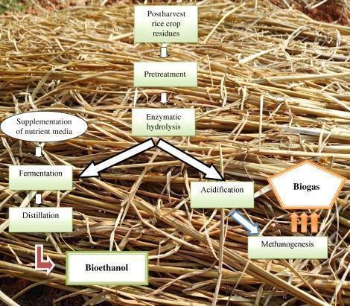

Fig.7. Production of bioethanol and biogas from postharvest residues of rice (Das et al., 2020).

2.5.5.2. Biomethane
“Biomethane / biogas is a gaseous biofuel and renewable alternative to commercial fuels. Agricultural residues which are rich in carbohydrate, protein, lipid, cellulose, and hemicellulose can be used as a substrate for biogas production” (Surra et al., 2019).

2.5.5.3. Biohydrogen
“The hydrogen produced from renewable sources is known as biohydrogen. In molecular form (H₂), it contains the highest energy and is the only carbon-free fuel, which produces water as a clean byproduct after combustion” (Kotay and Das, 2008). “It is used directly as a combustion fuel in combustion engines or for generation of electricity via fuel cells” (Alves et al., 2013). Biohydrogen can be produced from crop residues (rice straw, wheat straw, etc.).

2.5.5.4. Biodiesel
“Agricultural processed wastes or agro-industrial wastes like rice bran, coffee ground, waste vegetable oil, de-oiled cakes of edible and non-edible oil seeds are potential feedstocks for biodiesel production. One renowned example is glycerol, a co-product of biodiesel production. Instead of being discarded, glycerol can be processed to produce value-added products such as bioplastics, and antifreeze, or even converted into other forms of bioenergy” (Kumar et al., 2024).

2.5.5.5. Biofuels from extracted lignin
- Combustion
“Combustion is the simplest technology for utilization of isolated lignin. The average heat value of dry lignin is around 25 MJ kg⁻¹, which is comparable to that of coal 24– 30 MJ kg⁻¹” (Rosillo and Woods, 2015). “Lignin is cofired with coal and it is used in greatly used in fired pulping boilers. Cofiring of fossil fuels with lignin was reported to increase the combustion system efficiency by 38%, and decrease GHG emission by as much as 60%” (Scown et al., 2014).

Gasification

“Gasification represents a key thermochemical route for lignin valorization, involving its conversion in the presence of oxygen, air, or steam to produce syngas or producer gas. Theoretically, up to 62 mol H₂ and 53 mol CO can be generated from 1 kg of lignin” (Azadi, 2013).

Pyrolysis

“Pyrolysis of lignin is a thermal depolymerization treatment in the absence of oxygen, and produces non-condensable gases, liquid oil, and solid as products. There is a wide temperature range for pyrolysis, which is generally from 623 K to as high as 1273 K” (Li et al., 2015). “Technically, pyrolysis can be subdivided into six different categories, based on different process conditions: fast pyrolysis, slow pyrolysis, intermediate pyrolysis, flash pyrolysis, vacuum pyrolysis, and ablative pyrolysis. Among them, fast pyrolysis is the most widely used technique in terms of lignin valorization into liquid bio-oils. It is called fast pyrolysis because its high temperature 450ºC – 600ºC requirement and low residence time taking” (Isahak et al., 2012). Liquid bio-oil is the main product from lignin fast pyrolysis.

2.5.5.6. Macromolecules from lignin

“The recalcitrant nature of lignin makes the depolymerization process energy intensive and economically costly. Thus, the direct use of lignin polymer as precursor for the production of value-added materials without additional depolymerization is promising” (Upton and Kasko, 2016). “Some of the lignin-based macromolecular materials include carbon fiber and polyurethane” (Strassberger et al., 2014).

Carbon fiber

“Price of carbon fiber is more because of its precursor Polyacrylonitrile (PAN). Lignin as a natural low-cost carbon source with high carbon content (over 60% carbon by mass), has been proven to be an ideal low-price precursor for carbon fiber synthesis” (Mainka et al., 2015). Compared with PAN, lignin has two advantages as a precursor, they are lower melting temperature and faster stabilization capability.

Polyurethane

“Polyurethane exists both in a rigid form and a flexible form. Rigid polyurethanes are commonly used as insulation and floating material, while the flexible variants are usedmore for cushioning and packaging material” (Zhang et al., 2015). “lignin incorporated polyurethanes show superior physical properties. One drawback of using lignin or modified lignin in producing polyurethane is that the resulting product exhibited more rigid and brittle characteristics compared to conventional polyurethane” (Aniceto et al., 2012).

Other macromolecules

Lignin can also be used for making other macromolecular materials such as polymer modifiers, adhesives, and resins as given below.
I. Lignin used in textile Industries
“Due to its phenolic nature, lignin absorbs UV light. UV rays may damage, discolor, and degrade materials, shortening their lifespan. Researchers suggested that by adding UV-blocking lignin particles to textiles, manufacturers may protect their products from UV rays. This precaution improves the longevity and efficiency of fabrics and compositions by keeping their quality, appearance, and functionality” (Kwon et al., 2023).
II. Lignin in food packing
“Lignin has drawn an interest in the packaging industry due to its hydrophobicity and biodegrade properties. Lignin's complex phenolic structure gives it antioxidant properties, making it a useful biopolymer. The water repellency of film is improved due to the presence of lignin's hydrophobic functional groups” (Boarino and Klok 2023). “Utilizing lignin in food packaging may reduce plastic waste and give sustainable alternatives” (Hararak et al., 2022).

III. Lignin based Phenolic resigns
“Phenolic resins are widely employed in plastic molding, foam manufacture, coating application, and semiconductor packaging due to their resistance to corrosion, heating” (Li et al., 2023). Organosolv lignin improves phenolic resin adhesiveness, solidification rate, and thermal/mechanical properties (Gao et al., 2021).

IV. Lignin based 3-D printing
“Lignin improves mechanical characteristics, thermal stability, and biocompatibility in 3-D printing materials, making them acceptable for many applications” (Fazeli et al., 2024). “Bioproducts made from Organosolv lignin (OSL) alter the bioproduct’s sustainability and biodegradability. Sustainable biomass is used to make OSL, which promotes the manufacturing of ecologically friendly products” (Ebers et al.,2021).

2.5.5.7. Aromatics from lignin

“Vast majority of aromatic products are produced from petroleum feedstock. New technological developments for efficient depolymerization of lignin and upgrading into aromatics can contribute to reduce the reliance on fossil resources. To form lignin particle form lignin depolymerization of lignin is needed, which breaks the interunit linkages within the lignin macromolecule, converting complex lignin polymers into oligomers or monomeric aromatic products to be upgraded to specialty fuels and chemicals” (Wang et al., 2013). Examples of some high-value aromatic products that can be derived from lignin depolymerization include benzene, toluene, xylene (BTX), phenol and vanillin.

Benzene, toluene, xylene (BTX).

“The technology to convert lignin into BTX is a two-step process, the first step includes lignin depolymerization into oxygenated monomer aromatics through C-O bond cleavage; followed by a second step of hydrodeoxygenation (HDO) and demethoxylation” (Jongerius, 2013). Thus, formed BTX are used as precursors for the production of a series of materials, such as resins, nylon fibers, polyurethane, and polyester.

Phenols

“Lignin is rich in both aliphatic and phenolic hydroxyl groups, the HDO of lignin produces phenolic products. Phenols are widely used in the formation of formaldehyde resins as well as polyurethane” (Smolarski, 2012).

Vanillin

“About 20% of the synthetic vanillin comes from valorization of lignin, and the remaining 80% comes from crude oil” (Smolarski, 2012). “Vanillin is well known for its use as the world’s largest flavoring agent” (Strassberger et al., 2014). The increased demand for natural vanillin is driving industrial interest in efficient production of high- quality vanillin form lignin.

2.6. Environmental and sustainable benefits

“Fossil fuels are not renewable and will eventually reach unsustainable levels, moreover they cause GHGs emission which is a threat to our global energy system. Using nonedible lignocellulosic biomass to provide fuels and materials is part of the solution to sustainability” (Zakzeskiet al., 2010). “Lignin combustion or co-combustion with different fossil fuels presents the near-term opportunity to reduce a significant amount of gaseous pollutants such as CO, CO₂, NO_{x}, and SO₂. A general GHG emission by gasoline combustion is 95 g CO2 eq MJ⁻¹, while using lignin as a substitute energy source, this emission is reduced by 60%. Lignin cofiring with coal in a general power plant can also result in a 40% reduction in life-cycle water consumption” (Scown et al., 2014).

3. Conclusion
Lignocellulosic biomass is produced in large quantities globally each year, with much of it being burnt in fields, leading to nutrient loss and greenhouse gas emissions. Proper management of lignin-rich crop residues is crucial for sustainable agriculture, as these residues enhance soil physical properties and release nutrients gradually after decomposition, reducing the need for chemical fertilizers. The high lignin content in these residues makes them difficult to decompose, requiring specific microorganisms for effective breakdown. The paper and pulp industries produce significant amounts of lignin, which can be extracted and utilized to produce biofuels, carbon fiber, polyurethane, and aromatic chemicals like vanillin and phenol, offering both environmental benefits and additional income streams. Lignin nanoparticles also hold promise for creating slow-release pesticides, herbicides, and insecticides, which could decrease reliance on chemical fertilizers and improve soil health. The future of lignin-based materials is bright, with ongoing research expected to uncover new applications and refine existing technologies.
Competing interest
There is no conflict of interest.

Disclaimer (Artificial intelligence)
Option 1:
Author(s) hereby declare that NO generative AI technologies such as Large Language Models (ChatGPT, COPILOT, etc.) and text-to-image generators have been used during the writing or editing of this manuscript.
Option 2:
Author(s) hereby declare that generativ AI technologies such as Large Language Models, etc. have been used during the writing or editing of manuscripts. This explanation will include the name, version, model, and source of the generative AI technology and as well as all input prompts provided to the generative AI technology
Details of the AI usage are given below:
1.
2.
3.

References:

Abdelaziz, O. Y., Brink, D. P., Prothmann, J., Ravi, K., Sun, M., García-Hidalgo, J., et al. (2016). Biological valorization of low molecular weight lignin. Biotechnol. Adv. 34(8): 1318-1346.
Abolore, R.S., Jaiswal, S. and Jaiswal, A.K. (2024). Green and sustainable pretreatment methods for cellulose extraction from lignocellulosic biomass and its applications: a review. Carbohyd. Polym. Technol. Appl. 23: 100-396.
Alves, H. J., Junior, C. B., Niklevicz, R. R., Frigo, E. P., Frigo, M. S., and Coimbra- Araujo, C. H. (2013). Overview of hydrogen production technologies from biogas and the applications in fuel cells. Int. J. Hydrogen Energy. 38(13): 5215-5225.
Aniceto, J. P. S., Portugal, I. and Silva, C. M. (2012). Biomass-based polyols through oxypropylation reaction. Chem Sustain. Minireview. 5(8): 1358–1368.
Azadi, P., Inerwildi, O.R., Farnood, R. and King, D.A. (2013). Liquid fuels, hydrogen and chemicals form lignin: A critical review. Renewable and Sustain. Energy Reviews. 21: 506-523.
Bajwa, D. S., Pourhashem, G., Ullah, A. H. and Bajwa, S.G. (2019). A concise review of current lignin production, applications, products and their environmental impact. Int. Crops Products. 139: 111522-111530.
Balakrishnan, V. S. (2022). Fungi solution for field fires. Nat. Biotechnol. 40:1262-1308.
Batt C. A. (1999). Biomass. In: Mosses V. and Cape R.E. (eds), Biotechnology, The Science and the Business. CRC Press, Boca Raton, Florida, USA. pp. 25-36.
Bhattacharyya, P., Bisen J., Bhaduri, D., Priyadarsini, S., Munda, S., Chakraborti, M.,et al. (2021). Turn the wheel from waste to wealth: economic and environmental gain of sustainable rice straw management practices over field burning in reference to India. Sci. Total Environ. 775: 145896 Available: https://doi.org/10.1016/j.scitotenv.2021.145896
Bilal, M., Qamar, S.A., Yadav, V., Cheng, H., Khan, M., Adil, S.F., et al . (2021). Exploring the potential of ligninolytic armory for lignin valorization–A way forward for sustainable and cleaner production. Journal of Cleaner Production, 326, p.129420.
Biswas, S. and Das, R. (2023). Pusa bio-decomposer: a promising option to stop crop residue burning. Trends Agric. Sci. 2(4): 272-275.
Boarino, A. and Klok, H.A. (2023). Opportunities and challenges for lignin valorization in food packaging, antimicrobial, and agricultural applications. Biomacromolecules. 24(3): 1065-1077.
Canakci, H., Aziz, A. and Celik, F. (2015). Soil stabilization of clay with lignin, rice husk powder and ash. Geomechanics and Eng. 8(1): 67-79.
Chai, Y.D., Pang, Y.L., Lim, S., Chong, W.C., Lai, C.W., and Abdullah, A.Z. (2022). Recent progress on tailoring the biomass-derived cellulose hybrid composite photocatalysts. Polym. 14(23): 5244-5248.
Das, P. K., Das, B. P. and Dash, P. (2020). Potentials of postharvest rice crop residues as a source of biofuel. In: Kumar, R. P., Gnansounou, E., Raman, J. K. and Baskar, G. (eds), Refining Biomass Residues for Sustainable Energy and Bioproducts – Technology, Advances, Life Cycle Assessment, and Economics. Academic Press, Massachusetts, USA. pp275-301.
del Rio, J.C., Rencoret, J., Marques, G., Li, J., Gellerstedt, G., Jimenez-Barbero, et al. (2020). Structural characterization of the lignin from jute (Corchorus capsularis) fibers. J. Agric. Food Chem. 57(21): 10271-10281.
Diaz, P. (2016). Consequences of compost press mud as fertilizers. Int. J. Adv. Microbiol Res. 1(1): 23-48.
Dormaar, J. F., Pittman, U. J. and Spratt, E. D. (1979). Burning crop residues: effect of selected soil characteristics and long-term wheat yields. Can. J. Soil Sci. 59: 79-86.
Ebers, L.S., Arya, A., Bowland, C.C., Glasser, W.G., Chmely, S.C., Naskar, A.K. et al. (2021). 3D printing of lignin: Challenges, opportunities and roads onward. Biopolymers. 112(6): 2343.
FAO [Food and Agriculture Organization of the United Nations]. 2015. Soildegradation.Available: http://www.fao.org.soilsportal/soil degradation[31 July 2024].
FAO [Food and Agriculture Organization of the United Nations]. 2021. Global symposium on soil erosion. Available: http://www.fao.org/areasofwork/soilerosion [31 July 2024].
Fazeli, M., Mukherjee, S., Baniasadi, H., Abidnejad, R., Mujtaba, M., Lipponen, J.et al. (2024). Lignin beyond the status quo: recent and emerging composite applications. Green Chem. 26(2): 593-630.
Gao, Z., Lang, X., Chen, S. and Zhao, C. (2021). Minireview on the synthesis of lignin- based phenolic resin. Energy & Fuels. 35(22): 18385-18395.
Gazzurelli, C., Migliori, A., Mazzeo, P.P., Carcelli, M., Pietarinen, S., Leonardi, G. et al. (2020). Making agriculture more sustainable: an environmentally friendly approach to the synthesis of Lignin Cu pesticides. ACS Sustain. Chem. Eng. 8(39): 14886-14895.
Gopal. M., Gupta, A., Hameed, K. S., Sathyaseelan, N., Rajeela, T. H. K. and Thomas,G. V. (2020). Biochars produced from coconut palm biomass residues can aid regenerative agriculture by improving soil properties and plant yield in humid tropics. Biochar. 2: 211-226.
Guddaraddi, A., Singh, A., Amrutha, G., Saikanth, D.R.K., Kurmi, R., Singh, G., et al. (2023). Sustainable biofuel production from agricultural residues an ecofriendly approach: a review. Int. J. Environ. Clim. Chang. 13 (10): 2905-2914.
Hararak, B., Winotapun, C., Wanmolee, W., Leelaphiwat, P., Boonruang, K., Chinsirikul, W. and Chonhenchob, V. (2022). Emerging challenges on viability and commercialization of lignin in biobased polymers for food packaging: A review. Food Packaging and Shelf Life. 34: 100-969.
IISR [Indian institute of Sugarcane Research]. (2017). Package of Practices for Different Agro-Climatic zones. Available: https://iisr.icar.gov.in64.pdf.[27.July 2024].
Isahak, W.N.R.W., Hisham, M.W.M. and Yarmo, M.A. (2012). A review on bio-oil production from biomass by using pyrolysis method. Renewable & Sustain. Energy Rev. 16: 5910–5923.
Jabin, P.P. and Rani, B. (2023). Effect of biochar produced from paddy husk and coconut frond on soil physical properties and productivity of ginger in a laterite soil. Int J. Environ. Clim. Change. 13(9): 2089-2098.
Jayapal, A., Mini, V., Resmi, A.R. and Lovely, B. (2021). Composting Limnocharis flavabuchenau: A comparative analysis. J. Krishi Vigyan. 10(1): 28-32.
Jongerius, A.L. (2013). Catalytic conversion of lignin for the production of aromatics.Doctoral dissertation. Utrecht University, Netherlands. 12: 282-302.
Kar, G. and Kumar, A. (2007). Effects of irrigation and straw mulch on water use and tuber yield of potato in eastern India. Agric. Water Manag. 94(3): 109-116
KAU [Kerala Agricultural University]. (2016). Solid waste management facility.Available: https://kau.in/solid-waste-management-facility.[22 Sep 2024].
Kaur, H. and Goyal, D. (2024). Alkaline treatment for targeted lignin breakdown in rice straw: Maximizing phenolic content and product characterization. Food and Bioproducts Processing, 148, pp.478-490.
Kotay, S. M. and Das, D. (2008). Biohydrogen as a renewable energy resource: prospects and potential. Int. J. Hydro. Energy. 54: 150-155.
Krylova, A. Y., Kozyukov, E. A. and Lapidus, A. L. (2008). Ethanol and diesel fuel from plant raw materials: a review. Solid Fuel Chem. 42(6): 358-364.
Kumar, S., Mishra, P., Sachan, H., Saxena, R., Rahul and Lal, A.K., (2024). Biodiesel production from agricultural waste biomass. In From Waste to Wealth (pp. 205-224). Singapore: Springer Nature Singapore.
Kumar, V. and Chopra, A.K. (2016). Effects of sugarcane pressmud on agronomical characteristics of hybrid cultivar of eggplant (Solanum melongena L.) under field conditions. Int. J. Recycling Org. Waste Agric. 5:149-162.
Kumari, K., Prasad, J., Solanki, I. S. and Chaudhary, R. (2018). Long-term effects of crop residues on yield and soil physical properties under rice – wheat cropping system in calcareous soil. J. Soil Sci. Plant Nutr. 18(1): 27-40.
Kwon, G.J., Cho, S.W., Bandi, R., Yang, B.S., Dadigala, R., Han, S.Y., et al. (2023). Production of lignocellulose nanofibrils by conventional and microwave-assisted deep-eutectic-solvent pretreatments: mechanical, antioxidant, and UV-blocking properties. Cellulose. 30(7): 4277- 4292.
Lal R. World crop residues production and implications of its use as a biofuel. Environment International. 2005;31(4):575–584. doi: 10.1016/j.envint.2004.09.005.
Lasmini, S.A., Rosmini, R., Lakani, I., Hayati, N. and Nasir, B.H. (2021). Increasing shallot production in marginal land using mulches and coconut husk fertilizer. Int J Design & Nature and Ecodynamics. 16(1): 05-110.
Len, T., Bressi, V., Balu, A. M., Kulik, T., Korchuganova, O., Palianytsia, B., et al. (2022). Thermokinetics of production of biochar from crop residues: an overview. Green Chem. 24: 7801-7817.
Li, C., Zhao, X., Wang, A., Huber, G.W. and Zhang, T. (2015). Catalytic transformation of lignin for the production of chemicals and fuels. Chem. Rev. 115:11159-11624.
Li, J., Yuan, H. and Yang, J. (2009). Bacteria and lignin degradation. Front. Biol. 4: 29-38.
Li, W., Sun, H., Wang, G., Sui, W., Dai, L. and Si, C. (2023). Lignin as a green and multifunctional alternative to phenol for resin synthesis. Green Chem. 25(6): 2241- 2261.
Mainka, H., Tager, O., Korner, E., Hilfert, L. and Busse, S. (2015). Lignin-an alternative precursor for sustainable and cost-effective automotive carbon fiber. J. Materials Res. Technol. 4: 283–296.
Mandlekar, N., Cayla, A., Rault, F., Giraud, S., Salaün, F., Malucelli, G. and Guan, J.P. (2018). An overview on the use of lignin and its derivatives in fire retardant polymer systems. Lignin-trends and Appl. 9: 207-231.
Mastrolitti, S., Borsella, E., Giuliano, A., Petrone, M.T., De Bari, I., Gosselink, R.J.A., et al. (2021). Sustainable lignin valorization: Technical lignin, processes and market development. IEA Bioenergy Task. 42: 32-48.
Ministry of Textiles. (2018). Brief/Background Note on Jute Sector. Available: https://texmin.nic.in23.pdf. [27 July 2024]
Mishra, R.V., R.N. Roy. and H. Hiraoka. (2003). Onfarm composting methods. Food and Agriculture Organization of the United Nations. Land and Water Discussion Paper. 2: 1-37.
Moral, P.S.and Mendez, M.V.R. (2006). Production of pomace olive oil. Grasasyaceites. 57(1): 47-55.
Morya, R., Kumar, M., Tyagi, I., Pandey, A.K., Park, J., Raj, T., et al. (2022). Recent advances in black liquor valorization. Bioresource Technol. 350: 126-916.
Muthurayar, T. and Dhanarajan, M. S. (2013). Biochemical changes during composting of coir pith waste as influenced by different agro industrial wastes. Agric. sci. 4(5B): 28-30
Nabuqi, N., Wu, S., Takata, N., Sakamoto, S., Yamamoto, M., Uesugi, M., Dejardin, A., et al. (2020). Simultaneous manipulation of lignin structure and secondary cell wall formation in transgenic poplar. J. Wood Sci. pp 66. 1-9.
Nguyen, S.T., Murray, P.R. and Knowles, R.R. (2019). Light-driven depolymerization of native lignin enabled by proton-coupled electron transfer. Acs Catalysis. 10(1): 800-805.
Pachauri, R. K., Yadav, R. B., Naresh, R. K., Kumar, M., Dhyani, B. P., Singh, A. and Nath, A. (2022). Influence of rice residue and weed management on weed dynamics in latesown wheat (Triticum aestivumL.) Pharma Innov. J. 11(8): 1622-1626.
Parmar, H.C., Mor, V.B. and Patel, S.R. (2019). Vermicomposting of Banana Pseudostem and Maize Fodder (Waste) Using Eudriluseugeniae. Current J. App. Sci. Technol. 36(1): 1-9.
Prabhavathi, N. and Parama, V. R. R. (2019). Effect of sugar industry solid waste pressmud and bio compost on soil physical and chemical properties at different intervals during finger millet crop. J. Pharmacogn. Phytochem. 8(3): 3038-3042.
Prieur, B., Meub, M., Wittemann, M., Klein, R., Bellayer, S., Fontaine, G. and Bourbigot,S. (2017). Phosphorylation of lignin: characterization and investigation of the thermal decomposition. RSC Adv. 7(27): 16866-16877.
Ragauskas, A.J., Beckham, G.T., Biddy, M.J., Chandra, R., Chen, F., Davis, M.F., et al. (2014). Lignin valorization: improving lignin processing in the biorefinery. Sci. 344(6185): 1246- 1258.
Rajesh S, K., Binu, N.K., Nity, N., Suneesh, B. and Sinha, G.N. (2014). Review of bamboo based agroforestry models developed in different parts of India, productivity and marketing aspects. Bamboo Prod. in Forest and Non - Forest Areas. Pp1-8.
Ralph, J., Lundquist, K., Brunow, G., Lu, F., Kim, H., Schatz, P.F., et al. (2004). Lignins: natural polymers from oxidative coupling of 4-hydroxyphenyl-propanoids. Phytochem. Rev.3: 29-60.
Reeja, R.S. (2002). Comparative efficiency of lignocellulolytic fungi for bioconversion of coir pith. M.Sc. (Ag.) thesis, Kerala agricultural University, Thrissur, 97 p.

Rosillo-Calle, F. and Woods, J. (2015). Overview of bioenergy. In the Biomass Ass. Handb. pp25-51.
Santosh, D. T. and Maitra, S. (2022). Effect of drip irrigation and plastic mulch on yield and quality of ginger (Zingiber officinale). Res. Crops 23(1): 211-219.
Scown, C.D., Gokhale, A.A., Willems, P.A., Horvath, A. and McKone, T.E. (2014). Role of lignin in reducing life-cycle carbon emissions, water use, and cost for United States cellulosic biofuels. Environ. Sci. technol. 48(15): 8446-8455.
Shankar, K., Kulkarni, N.S., Sajjanshetty, R., Jayalakshmi, S.K. and Sreeramulu, K. (2020). Co-production of xylitol and ethanol by the fermentation of the lignocellulosic hydrolysates of banana and water hyacinth leaves by individual yeast strains. Industrial Crops and Products. 155: 112809p.
Sharma, V., Tsai, M.L., Nargotra, P., Chen, C.W., Sun, P.P., Singhania, R.R. et al. (2023). Journey of lignin from a roadblock to bridge for lignocellulose biorefineries: A comprehensive review. Sci. Total. Environ. 861(4):160560p.
Smolarski, N. (2012). High-value opportunities for lignin: unlocking its potential. Frost & Sullivan. 1: 1-15.
Sruthy, K.S., Shukla, L., Kundu, A., Singh, S.K., Abdulrahman Alodaini, H., Hatamleh, A.A. et al. (2023). Effect of Microbial Consortium Constructed with Lignolytic Ascomycetes Fungi on Degradation of Rice Stubble. J. of Fungi. 9(5): 567p.
Strassberger, Z., Tanase, S. and Rothenberg, G. (2014). The pros and cons of lignin valorisation in an integrated biorefinery. Rec. Adv. 4(48): 25310-25318.
Surra, E., Bernardo, M., Lapa, N., Esteves, I.A., Fonseca, I. and Mota, J.P., (2019). Biomethane production through anaerobic co-digestion with Maize Cob Waste based on a biorefinery concept: A review. Journal of environmental management, 249, p.109351.
Tagade, A., Kirti, N. and Sawarkar, A. N. (2021). Pyrolysis of agricultural crop residues: an overview of researches by Indian scientific community. Bioresour. Technol. Rep. Available: https://doi.org/10.1016/j.biteb.2021.100761 [18 July 2024].
Tolisano, C., Priolo, D., Brienza, M., Puglia, D. and Del Buono, D. (2024). Do Lignin Nanoparticles Pave the Way for a Sustainable Nanocircular Economy? Biostimulant Effect of Nanoscaled Lignin in Tomato Plants. Plants. 13(13): 1839- 1848.
Tribot, A., Amer, G., Alio, M.A., de Baynast, H., Delattre, C., Pons, A., Mathias, J.D., Callois, J.M., Vial, C., Michaud, P. and Dussap, C.G. (2019). Wood-lignin: Supply, extraction processes and use as bio-based material. Eur. Polymer J. 112: 228-240.
Tuck CO, Perez E, Horvath IT, Sheldon RA and Poliakoff M. (2012). Valorization of biomass: deriving more value from waste. Science. 337:695–699. doi: 10.1126/science.1218930
Upton, B.M. and Kasko, A.M. (2016). Strategies for the conversion of lignin to high-value polymeric materials: review and perspective. Chem Rev. 116(4): 2275-2306.
Venkataramanan, V., Shah, S., Prasad, S., Singh, A. and Prasad, R. (2021). Assessment of bioenergy generation potential of agricultural crop residues in India. Circular Econ. Sustain. 1: 1335-1348.
Wan, C. and Li, Y. (2012). Fungal pretreatment of lignocellulosic biomass. Biotechnol. Adv. 30:1447-1457.
Wang, H., Tucker, M. and Ji, Y. (2013). Recent development in chemical depolymerization of lignin: a review. J. Appl. Chem. 20(1): 838645p.
Wei, X., Li, X. and Wei, N. (2017). Reducing runoff and soil loss using corn stalk juice at plot scale. Soil Tillage Res. 168: 63-70.
Yuan, H., Zhu, Z., Wei, X., Liu, S., Peng, P., Gunina, A., et al. (2019). Straw and biochar strongly affect functional diversity of microbial metabolism in paddy soils. J. Integr. Agric.18:1474-1485.
Zakzeski, J., Bruijnincx, P.C., Jongerius, A.L. and Weckhuysen, B.M. (2010). The catalytic valorization of lignin for the production of renewable chemicals. Chem Rev. 110(6): 3552-3599.
Zhang, D.X., Liu, G., Jing, T.F., Luo, J., Wei, G., Mu, W. and Liu, F. (2020). Lignin- modified electronegative epoxy resin nanocarriers effectively deliver pesticides against plant root- knot nematodes (Meloidogyne incognita). J. Agric. Food Chem. 68(47): 13562-13572.
Zhang, Q., Zhang, G., Xu, J., Gao, C. and Wu, Y. (2015).Recent advances on lignin- based polyurethane polymers. Rev. Adv. Materials Sci. 40(2): 211-258.
Zhang, Z., Terrasson, V. and Guenin, E. (2021). Lignin nanoparticles and their nanocomposites. Nanomaterials. 11(5): 1336p.
Zhao, X., Yuan, G., Wang, H., Lu, D., Chen, X. and Zhou, J. (2019). Effects of full straw incorporation on soil fertility and crop yield in rice-wheat rotation for silty clay loamy cropland. Agron. 9(3): 133p.
Zor, M., Mengeloglu, F., Aydemir, D., Şen, F., Kocatürk, E., Candan, Z. and Ozcelik, O. (2022). Wood plastic composites (WPCs): Applications of nanomaterials. Springer Int. Publishing. pp97-13.

