Agromorphological and technological characterization of two type of Pepper (Piper nigrum) in Côte d’Ivoire

Abstract
Black pepper (Piper nigrum) is one of the most consumed spices in the world. This study aims to characterise pepper varieties installed in collections. Four (4) Lampong clones (C1, C2, C3 and C4) and two (2) Muntok clones (C1 and C3) from the CNRA (National Agronomic Research Center) pepper collections in Divo and Azaguié, were characterised agromorphologically and technologically. The data collected covered 19 qualitative traits and ten (10) quantitative traits such as mature leaf color, ripe fruit color, ear filling, lateral branch behavior, ear length, number of grains per ear, fresh/dry grain diameter, grain weight, water content and density. In general, the Muntok were characterised by short spikes with an average of 58.98 berries/spike, large berries with 6.48 mm and 4.53 mm in diameter, respectively for fresh and dry grains, a dark green color at maturity and compact. As for the Lampong, they were characterised by long spikes with 10.79 cm, small light green berries at maturity and scattered or moderately scattered on the spike. These results, although preliminary, constitute a working basis for the genetic improvement of pepper in Côte d'Ivoire.
Keywords. Agromorphological, Characterization, Côte d’Ivoire, Pepper.

Introduction
Pepper (Piper nigrum) is a climbing, perennial, woody plant (Nair et al., 2003; Kurien et al., 1994). Black pepper is the most widely cultivated species with more than 450,000 tons per year (Weil, 2018; Jaramillo & Manos, 2001; Ramos et al., 1986). It is known as the king of spices due to its multifaceted use and distinctive aroma (Scott et al., 2005; Srinivasan, 2007; Kumar & Vinay, 2017; Sivaraman et al., 1999; Scott et al., 2008).
However, in Côte d'Ivoire, unlike other perennial crops such as coffee and cocoa, pepper has so far benefited from very few development programs, thus limiting its production to a handful of producers (FIRCA, 2017).
Faced with this situation, a pepper industry development program was implemented in Côte d'Ivoire. In this context, the existence of a pepper collection with a broad genetic base is essential for developing new, high-performance varieties with traits of agronomic and technological interest. This study therefore, aims to determine the distinctive phenotypic traits of the Muntok and Lampong types available in the CNRA collections in Divo and Azaguié. Specifically, the aim will be to determine the morphological traits of the Muntok and Lampong types in the collections.
Material and Methods
Study Site
The study was conducted within the pepper collections installed at the Azaguié and Divo stations. The CNRA station at Azaguié is located between 5°38 north latitude and 4°05 west longitude, 7 km from the town of Azaguié and 50 km north of Abidjan (Figure 1). The vegetation is dense with sandy-clay soil (Lassoudière et al., 1978), suitable for pepper plants. Over the course of a year, the average temperature is 25.5°C and rainfall averages 1814 mm. The CNRA Divo research station is located 200 km from Abidjan and 17 km from the city of Divo in a forest area in the south-central part of the country, between 5°48° north latitudes and 5°18° west longitudes. It covers an area of 3,570 ha (Figure 2). Rainfall in this area averages 1,388 mm per year, while the average temperature is around 25.3°C and humidity is relatively high, with humidity levels sometimes exceeding 80% (Ehounou et al., 2019).
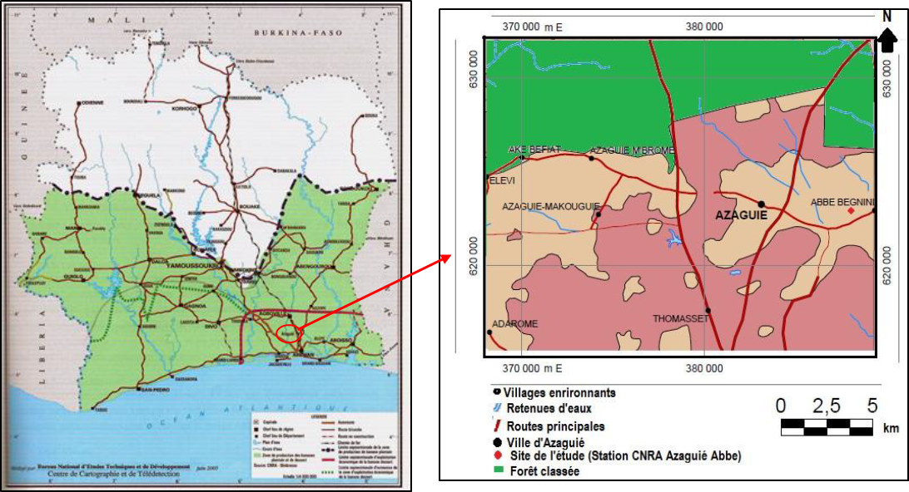
Figure 1. Geographical location of the CNRA station in Azaguié

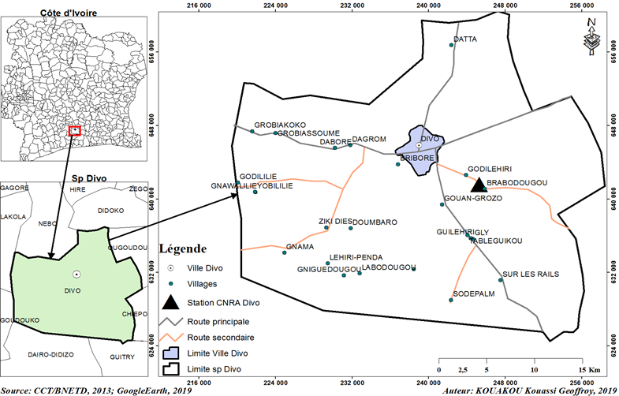
Figure 2. Geographical location of the CNRA station in Divo

Plant material
The plant material consists of six (6) pepper (Piper nigrum) clones, four (4) of which belong to the Lampong type or variety (C1, C2, C3 and C4) (Figure 3A) and two (2) to the Muntok variety (C1 and C3) (Figure 3B).

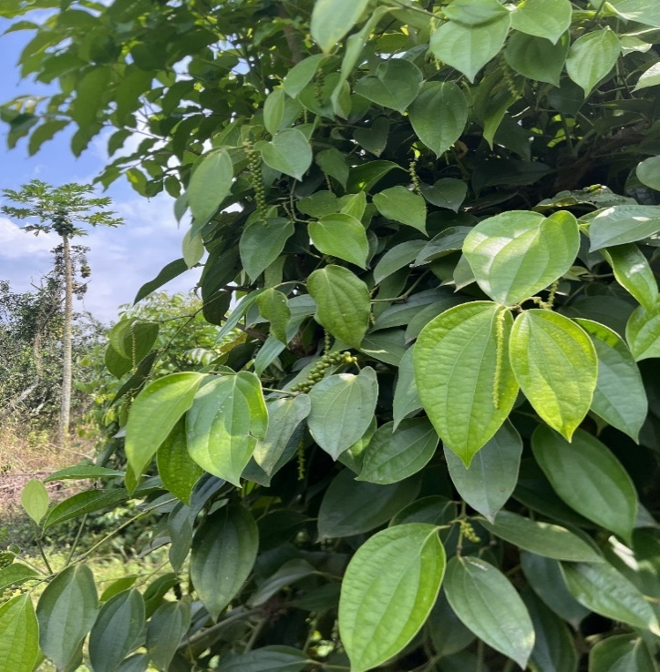
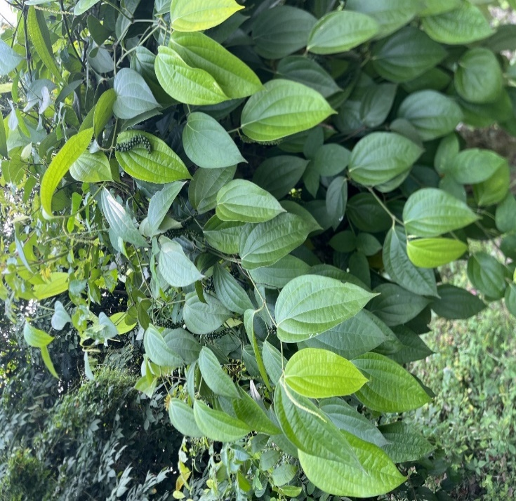
A
B

Fig 3 : Lampong (A) and Muntok (B)

Agromorphological Data Collection

Leaf Length and Width
Length and width measurements were taken from the second leaf of plagiotropic branches. Twenty (20) leaves were randomly sampled from each plant. The length of a given leaf was measured from the base of the main vein to the tip of the leaf. Leaf width was measured at the widest part of the leaf.
Leaf Area
Leaf area was calculated using the formula:
Leaf Area = Length x Width x K (where K = 0.75 for unfolded leaves).
Length of the ear (also called cluster)
Ear length was measured from the base of the ear to the tip of the ear, on ten (10) ears of approximately the same physiological age, chosen at random per plant.
Number of berries per ear
The berries were counted on ten (10) ears of approximately the same physiological age, randomly selected from each of the plants evaluated. Each ear was deseeded before counting the berries.
Grain diameters
Grain diameters were measured using a caliper on twenty (20) mature berries and twenty (20) grains randomly sampled.
Fresh Berry Weight
A batch of 100 mature berries was randomly sampled from different ears of each clone. The berries were weighed using a precision balance.
Weight of black grains and white grains
Batches of 100 black grains and 100 white grains were weighed using a precision balance.
Water Content Measurement
Water content is the amount of water expressed as a percentage by mass.
The content was calculated as follows:
Water content (W) = (Fresh weight - dry weight) / dry weight.
Density Measurement
This involved weighing the quantity of black peppercorns needed to fill a 1000 ml container. Due to the quantity of our samples, a 100 ml container was used and the results were converted to l/g (1000 ml/g) (CTHT protocol..
Leaf blade shape
Leaf blade shape was assessed by visual observations of twenty (20) mature leaves collected at random from plagiotropic branches of each plant. Leaf blade shape was scored as follows:
- ovate, ovoid in shape with the widest axis below the midpoint;
- ovate-lanceolate, elongated, oval in shape that tapers to a point;
- ovate-elliptical, oval in shape but with the widest axis at the midpoint;
- elliptical-lanceolate, elliptical in shape at the base with a narrow, pointed tip;
- cordate, heart-shaped, with rounded lobes at the base.
Leaf tip
The leaf tip was assessed as sharp or rounded.
Leaf Base Shape
The shape of the leaf base was recorded as rounded (margins forming a smooth arc), cordate (rounded lobes with a sinus depth 1/8 to 1/4 of the distance from the main vein of the leaf blade), oblique (asymmetrical lobes each forming a different angle with the petiole), or acute (straight to convex margin forming a terminal angle of 45° to 90°).
Leaf Surface
The leaf surface has been characterized as smooth, smooth-shiny, glabrous (hairless), or hairy.
Leaf Vein Types
The vein types have been characterized as:
-Acrodromous, the secondary veins curve in an arc to converge towards the tip of the leaf blade, they curve towards the leaf apex.
-Campylodromous, the leaf has a series of more or less equal main veins that all originate from the base of the leaf, arch upwards, and converge towards the apex;
-amptodromous, the leaf has secondary veins that diverge from the main vein and end before the leaf margin, curving.
Spike shape
The shape of the spikes has been characterized as filiform, cylindrical, globular, or conical.
Ear Fill
Ear fill was characterized as scattered, moderately scattered, or compact, depending on the ear's berry filling.
Flower Type
Flowers have been characterized as pedicellate, shortly stipulate, or sessile.
Fruit Shape
The shape of the berries was recorded as round, oval, or oblong.
Seed Texture
Seed texture was assessed as smooth or rough.
Nature of the fruit
The fruits were characterized as pedicellate, shortly stipulated, or sessile.
Behavior of side branches
Lateral branch behavior was recorded as erect, horizontal, or pendulous.
Organ Color
The color of the juvenile leaf, mature leaf, flower, young fruit, mature fruit, young stems, and mature stems was determined.
Data analysis
Given the uniformity of qualitative data across varieties, data analysis was conducted using the descriptive (observational) method. Quantitative data were subjected to analysis of variance (ANOVA) to compare clones for each variable. These data were previously tested for normality (Jacques Bera test) and homogeneity of variance (Fisher and Levene test). Significantly different means were separated using the Newman-Keuls test at the 5% threshold to classify clones and varieties into homogeneous groups. These data were also subjected to Principal Component Analysis (PCA) and Hierarchical Ascending Clustering (HAC) under the condition of Bartlett's 5% sphericity test, to classify clones based on all variables. The data were analyzed using SAS 9.4 and XLSTAT 2014 software.
Results
Observation of qualitative morphological traits showed a lack of variability for all traits, except for mature leaf color, ear fill, ripe berry color, and lateral branch behaviour. For ripe berry color, the Lampong variety had light green fruits, and the Muntok variety had dark green fruits. Regarding ear fill, the Lampong variety had scattered or moderately scattered berries, while the Muntok variety had compact berries. Regarding lateral branch behavior, the Lampong variety had horizontal branches, while the Muntok variety had pendulous branches. Regarding leaf color, all clones of the different varieties were dark green, with the exception of clone C3 of the Lampong variety, which was dark green with small yellow spots (Table 1).

Table 1. Qualitative characteristics of the Muntok and Lampong varieties from the Azaguié and Divo collections
Localities | Azaguié |  |  |  |  | Divo
Varieties | Lampong |  |  |  | Muntok | Muntok
Clones | C1 | C2 | C3 | C4 | C1 | C1 | C3
Limb shape | oval elliptical | oval elliptical | oval elliptical | oval elliptical | oval elliptical | oval elliptical | oval elliptical
Leaf tip | acute | acute | acute | acute | acute | acute | acute
Leaf base shape | round | round | round | round | round | round | round
Leaf surface | smooth | smooth | smooth | smooth | smooth | smooth | smooth
Leaf veins | camptodromous | camptodromous | camptodromous | camptodromous | camptodromous | camptodromous | camptodromous
Juvenile leaf color | greenish-yellow | greenish-yellow | yellow-green | greenish-yellow | greenish-yellow | greenish-yellow | greenish-yellow
Mature leaf color | dark green | dark green | dark green mottled | dark green | dark green | dark green | dark green
Shape of the ear | filiform | filiform | filiform | filiform | filiform | filiform | filiform
Nature of the flower | sessile | sessile | sessile | sessile | sessile | sessile | sessile
Flower color | greenish-yellow | greenish-yellow | yellow-greenish | greenish-yellow | greenish-yellow | greenish-yellow | greenish-yellow
Nature of the fruit | sessile | sessile | sessile | sessile | sessile | sessile | sessile
Fruit shape | round | round | round | round | round | round | round
Seed texture | smooth | smooth | smooth | smooth | smooth | smooth | smooth
Ear fill | moderately scattered | moderately scattered | moderately scattered | scattered | compact | compact | compact
Color of young berries | light green | light green | light green | light green | light green | light green | light green
Color of ripe berries | light green | light green | light green | light green | dark green | dark green | dark green
Lateral branch behavior | horizontal | horizontal | horizontal | horizontal | pendulous | pendulous | pendulous
Color of young stems | green | green | green | green | green | green | green
Color of ripe stems | brown | brown | brown | brown | brown | brown | brown

• Morphological characterisation of the Muntok and Lampong varieties of Azaguié
Analysis of variance showed a significant difference between the two varieties for all the characteristics studied. With the exception of the "ear length" characteristic, where the Lampong variety had the highest value with 10.79 cm, for all other variables, the Muntok variety had the highest values. Thus, for the Muntok variety, 58.98 berries per ear, 6.48 mm fresh grain diameter, 4.53 mm dry grain diameter, 14.94 cm leaf length, 8.15 cm leaf width and 92.58 cm² leaf area were recorded (Table 2).

Table 2: Quantitative morphological characteristics of the Muntok and Lampong varieties of Azaguié
Varieties | Lepi | NGrepi | DGr frais | DGr sec | LF | lF | SF
Lampong | 10,79ª | 53,99^{b} | 5,65^{b} | 3,73^{b} | 12,56^{b} | 6,97^{b} | 66,64^{b}
Muntok | 9,28^{b} | 58,98ª | 6,48ª | 4,53ª | 14,94ª | 8,15ª | 92,58ª
Mean | 10,4 | 54,84 | 5,87 | 3,94 | 13,18 | 7,28 | 73,33
Cv (%) | 15,52 | 20,81 | 8,95 | 11,84 | 14,64 | 41,5 | 43,87
F | 51,8 | 14,2 | 216,71 | 259,67 | 179,26 | 18,19 | 77,2
P | <0,0001 | 0,0002 | <0,0001 | <0,0001 | <0,0001 | <0,0001 | <0,0001
Lepi = length of the ear; NGrepi = number of grains per ear; DGr = grain diameter; LF= leaf length ; lF = sheet width ; SF = Leaf area. Means followed by the same letters in the same column are not significantly different at the 5% level.

• Morphological characterization of the Muntok varieties of Divo and Azaguié
Analysis of variance showed a significant difference between the two zones (Azaguié and Divo) for the character’s number of berries per spike, fresh grain diameter, dry grain diameter and leaf width as well as homogeneity for the character’s length of the spike, length of the leaf and leaf area. With the exception of the character number of berries per spike, where the Muntok variety from Divo had the highest value with 65.75 grains, for all other significant variables, the Muntok variety from Azaguié had the highest values. Thus, it obtained 6.48 mm for the diameter of fresh grains; 4.53 mm for the diameter of dry grains and 8.15 cm for the width of the leaves (Table 3).

Table 3. Quantitative morphological characteristics of the Muntok varieties of Divo and Azaguié
Varieties | Lepi | NGrepi | DGr frais | DGr sec | LF | lF | SF
Muntok Divo | 9,5ª | 65,75ª | 5,96^{b} | 4,08^{b} | 15,2ª | 7,7^{b} | 89,44ª
Muntok Azaguié | 9,28ª | 58,98^{b} | 6,48ª | 4,53ª | 14,94ª | 8,15ª | 92,58ª
Mean | 9,41 | 62,74 | 6,19 | 4,28 | 15,08 | 7,9 | 90,84
Cv (%) | 14,2 | 19,85 | 9,6 | 10,38 | 15,85 | 15,84 | 29,3
F | 1,41 | 13,14 | 51,4 | 69,4 | 1,1 | 11,76 | 1,24
P | 0,24 | 0,0004 | <0,0001 | <0,0001 | 0,3 | 0,0007 | 0,27
Lepi = length of the ear ; NGrepi = number of grains per ear ; DGr = grain diameter ; LF= leaf length ; lF = sheet width ; SF = leaf area. Means followed by the same letters in the same column are not significantly different at the 5% level.

• Study of the morphological characteristics of clones C1, C2, C3 and C4 of the Lampong variety from Azaguié
Analyses of variance showed that the clones were significantly different for the traits ear length, fresh grain diameter, dry grain diameter, leaf width, leaf length, and leaf area, and were homogeneous for the trait number of berries per ear.
For ear length, clones C1 (11.21 cm) and C4 (11.41 cm) had the highest values, while clone C2 had the lowest value, at 10.17 cm. For fresh grain diameter, clone C4 (5.98 mm) had the highest value, while clone C2 had the lowest value, at 5.29 mm. For dry grain diameter, clones C3 (3.92 mm) and C4 (4 mm) had the highest values, while clone C2 had the lowest value, at 3.3 mm. Regarding leaf length, clone C1 with 13.59 cm had the highest value, while clones C2 with 12.27 cm and C3 with 12.01 cm had the smallest value. For leaf width, clone C4 with 7.87 cm had the highest value, while clone C3 with 6.4 cm had the smallest value. Regarding leaf area, clones C1 with 75.02 cm² and C4 with 77.37 cm² had the largest values, while clone C3 had the smallest value with 58.23 cm² (Table 4).

Table 4: Quantitative morphological characteristics of clones C1, C2, C3 and C4 of the Lampong variety from Azaguié
Clones | Lepi | NGrepi | DGr frais | DGr sec | LF | lF | SF
C1 | 11,21ª | 52,39ª | 5,63^{c} | 3,77^{b} | 13,59ª | 7,22^{ab} | 75,02ª
C2 | 10,17^{b} | 53,94ª | 5,29^{d} | 3,3^{c} | 12,27^{c} | 7,17^{ab} | 66,90^{ab}
C3 | 10,77^{ab} | 54,78ª | 5,81^{b} | 3,92ª | 12,01^{c} | 6,4^{b} | 58,23^{b}
C4 | 11,41ª | 49,9ª | 5,98ª | 4ª | 13,11^{ab} | 7,87ª | 77,37ª
Mean | 10,79 | 53,4 | 5,66 | 3,74 | 12,54 | 6,98 | 66,64
Cv (%) | 14,35 | 19,85 | 7,78 | 9,85 | 12,81 | 48,88 | 50,21
F | 6,06 | 1,87 | 34,35 | 61,2 | 24,35 | 3,37 | 7,94
P | 0,0006 | 0,13 | <0,0001 | <0,0001 | <0,0001 | 0,019 | <0,001
Lepi = length of the ear; NGrepi = number of grains per ear; DGr = grain diameter; LF= leaf length ; lF = sheet width ; SF = Leaf area. Means followed by the same letters in the same column are not significantly different at the 5% level.

Morphological Characteristics of Clones C1 and C3 of the Muntok de Divo Variety
Analysis of variance showed a significant difference between the two clones of the Muntok de Divo variety for the traits number of berries per spike, fresh grain diameter, and dry grain diameter. However, it showed homogeneity for the traits spike length, leaf length, leaf width, and leaf area. For all significant traits, clone C1 obtained the highest values. Thus, it had 65.75 grains per spike, 5.95 mm for the fresh grain diameter, and 4.74 mm for the dry grain diameter (Table 5).

Table 5 : Quantitative morphological characteristics of clones C1 and C3 of the Muntok variety from Divo
Clones | Lepi | NGrepi | DGr frais |  | DGr sec |  | LF | lF | SF
C1 | 9,52ª | 65,75ª |  | 5,95ª |  | 4,74ª | 15,2ª | 7,7ª | 89,44ª
C3 | 9,36ª | 61^{b} |  | 5,37^{b} |  | 4,41^{b} | 15,39ª | 7,86ª | 92,56ª
Mean | 9,47 | 64,39 |  | 5,79 |  | 4,65 | 15,26 | 7,75 | 90,33
Cv (%) | 10,68 | 16,97 |  | 9,78 |  | 12,25 | 15,03 | 18,18 | 31,97
F | 0,68 | 5,42 |  | 46,06 |  | 13,82 | 0,39 | 0,78 | 0,67
P | 0,41 | 0,02 |  | <0,0001 |  | 0,0003 | 0,53 | 0,038 | 0,42
Lepi = length of the ear ; NGrepi = number of grains per ear ; DGr = grain diameter ; LF= leaf length ; lF = sheet width ; SF = leaf area.

Grain Weight
Study of the technological characteristics of the Muntok and Lampong varieties from Azaguié
The analysis of variance showed homogeneity between the two varieties for all the technological characteristics studied. The average fresh grain weight was 12.73 g, that of black grains 4.35 g, that of white grains 3.06 g and the water content 1.99% (Table 6).
Table 6: Technological characteristics of the Muntok and Lampong varieties from Azaguié
Varieties | pgrf | pgrn | pgrb | teneau
Lampong | 12,59ª | 4,27ª | 3,033ª | 2,01ª
Muntok | 13,16ª | 4,60ª | 3,14ª | 1,94ª
Mean | 12,73 | 4,35 | 3,06 | 1,99
Cv (%) | 14,24 | 20,93 | 24,76 | 21,74
F | 0,59 | 0,81 | 0,12 | 0,14
P | 0,44 | 0,38 | 0,73 | 0,71

Lepi = length of the ear; NGrepi = number of grains per ear; DGr = grain diameter; LF= leaf length; lF = sheet width; SF = leaf area

Study of the technological traits of the Muntok de Divo and Azaguié varieties
Analysis of variance showed a significant difference between the varieties for all the traits studied. Apart from the moisture content trait, where the Muntok d'Azaguié variety had the highest value at 1.61%, for all other variables, the Muntok de Divo variety had the highest values. Thus, it obtained 14.7 g for the weight of its fresh berries; 5.65 g for the weight of its black peppercorns; and 4.86 g for the weight of its white pepper (Table 7).

Table 7: Technological characteristics of the Muntok varieties of Divo and Azaguié

Varieties | pgrf | pgrn | pgrb | teneau
Muntok Divo | 14,7ª | 5,65ª | 4,86ª | 1,61^{b}
Muntok Azaguié | 13,16^{b} | 4,60^{b} | 3,14^{b} | 1,94ª
Mean | 14,02 | 5,19 | 4,09 | 1,76
Cv (%) | 8,35 | 14,04 | 10,68 | 18,85
F | 7,67 | 9,24 | 68,47 | 4,5
P | 0,01 | 0,008 | <0,0001 | 0,05

pgrf: fresh grain weight; pgrn: black grain weight; pgrb: white grain weight; teneau: water content. Means followed by the same letters in the same column are not significantly different at the 5% threshold.

Study of the technological traits of the clones
Analysis of variance showed a significant difference between the Lampong clones for fresh grain weight, black grain weight, and white grain weight. However, it showed homogeneity among the four clones for the water content trait. Thus, for the fresh grain weight trait, clones C1 with 13.68 g, C3 with 13.16 g, and C4 with 13.45 g, had the highest values. Clone C2 had the lowest value at 10.41 g. For the black grain weight trait, clones C1 with 4.55 g and C3 with 4.73 g had the highest values. Clone C2 also obtained the lowest value at 3.35 g. For the white grain weight trait, clone C3 had the highest value at 3.63 g and clone C2 the lowest at 2.21 g (Table 8).

Table 8. Technological characteristics of clones C1, C2, C3 and C4 of the Lampong variety from Azaguié
Clones | pgrf | pgrn | pgrb | teneau
C1 | 13,68ª | 4,55ª | 2,98^{ab} | 2,03ª
C2 | 10,41^{b} | 3,35^{b} | 2,21^{b} | 2,2ª
C3 | 13,16ª | 4,73ª | 3,63ª | 1,81ª
C4 | 13,45ª | 4,26^{ab} | 2,98^{ab} | 2,16ª
Mean | 12,59 | 4,27 | 3,03 | 2,01
Cv (%) | 11,8 | 16,65 | 19,2 | 21,03
F | 5,99 | 4,9 | 7,21 | 1,22
P | 0,0047 | 0,01 | 0,002 | 0,33
pgrf: fresh grain weight; pgrn: black grain weight; pgrb: white grain weight; teneau: water content. Means followed by the same letters in the same column are not significantly different at the 5% threshold

As for the Muntok de Divo clones, the analysis showed no significant differences for any of the traits studied. The average fresh grain weight was 14.5 g, the average black grain weight was 5.56 g, the average white grain weight was 4.76 g, and the average moisture content was 1.63% (Table 9).
Table 9: Technological characteristics of the C1 and C3 clones of the Muntok variety from Divo
Clones | pgrf | pgrn | pgrb | teneau
C1 | 14,7ª | 5,65ª | 4,85ª | 1,69ª
C3 | 14ª | 5,32ª | 4,53ª | 1,61ª
Mean | 14,5 | 5,56 | 4,76 | 1,63
Cv (%) | 6,33 | 9,86 | 3,22 | 19,06
F | 1,66 | 1,09 | 13,07 | 0,22
P | 0,22 | 0,32 | 0,4 | 0,65

pgrf: fresh grain weight; pgrn: black grain weight; pgrb: white grain weight; teneau: water content. Means followed by the same letters in the same column are not significantly different at the 5% threshold.

Water content ranged from 1.61 to 2.2%, with a mean of 1.92% and a standard deviation of 0.23. Clone C2 of the Lampong d'Azaguié variety obtained the highest content, and clone C3 of the Muntok de Divo variety obtained the lowest content (Figure 4).
Density ranged from 528.63 g/L to 758 g/L, with a mean of 636.60 g/L and a standard deviation of 68.88 g/L. Clone C1 of Muntok de Divo obtained the highest content, while clone C2 of Lampong d'Azaguié obtained the lowest content (Figure. 5).

Fig 4: Water content of clones
MDC1= Clone C1 of Muntok de Divo ; MDC3=Clone C3 of Muntok of Divo ; MAC1= Clone C1 of Muntok d’Azaguié ; LAC1= Clone C1 of Lampong d’Azaguié ; LAC2= Clone C2 of Lampong d’Azaguié ; LAC3= Clone C3 of Lampong of Azaguié ; LAC4= Clone C1 of Lampong d’Azaguié

Fig 5: Density of clones
MDC1= Clone C1 of Muntok de Divo ; MDC3=Clone C3 of Muntok of Divo ; MAC1= Clone C1 of Muntok d’Azaguié ; LAC1= Clone C1 of Lampong d’Azaguié ; LAC2= Clone C2 of Lampong d’Azaguié ; LAC3= Clone C3 of Lampong of Azaguié ; LAC4= Clone C1 of Lampong d’Azaguié.

Structuring clones based on morphological and technological traits
Choice of axes for Principal Component Analysis and contribution of variables to the formation of factorial axes
The information returned by the two axes selected by the Principal Component Analysis of clones represented 81.15% (Table 10). All variables were well represented on the F1 axis (64.52%), with the exception of fresh grain diameter and leaf width. However, only leaf width was well represented on the F2 axis (16.63%) (Table 11).
Table 10: Eigenvalue and percentage of variability explained by the factor axes of the Principal Component Analysis
 | F1 | F2 | F3 | F4 | F5 | F6
Eigenvalue | 7,097 | 1,830 | 1,266 | 0,686 | 0,076 | 0,045
Variability (%) | 64,519 | 16,633 | 11,513 | 6,235 | 0,690 | 0,410
Total (%) | 64,519 | 81,152 | 92,665 | 98,900 | 99,590 | 100,000

Table 11: Factorial coordinates of variables
 | F1 | F2 | F3 | F4 | F5 | F6
longepi | -0,699 | -0,208 | 0,606 | -0,300 | 0,034 | 0,096
nbgrain | 0,871 | -0,133 | -0,386 | 0,209 | 0,015 | 0,174
dgrainf | 0,366 | 0,408 | 0,618 | 0,563 | -0,019 | 0,011
dgrains | 0,965 | 0,065 | 0,200 | 0,134 | 0,076 | -0,035
Longueur | 0,921 | 0,287 | -0,100 | -0,197 | -0,140 | 0,012
largeur | 0,569 | 0,774 | 0,030 | -0,240 | 0,138 | 0,002
sfoliair | 0,836 | 0,500 | -0,075 | -0,208 | -0,049 | -0,004
pgrf | 0,782 | -0,254 | 0,519 | -0,226 | -0,063 | 0,013
pgrs | 0,903 | -0,379 | 0,182 | -0,078 | -0,038 | -0,013
pgrb | 0,875 | -0,451 | -0,014 | -0,091 | 0,147 | -0,015
teneau | -0,849 | 0,506 | 0,094 | -0,108 | 0,012 | 0,059
In bold the maximum factorial coordinate of each variable.
Structuration of clones
The Hierarchical Ascending Classification (HAC) on the components of the Principal Component Analysis (PCA) made it possible to highlight three classes of clones. The first class consists of clones C1 and C4 of the Lampong variety from Azaguié. The clones of this class are characterized by long ears and large leaves. The second class consists of clones C2 and C3, themselves belonging to the Lampong variety from Azaguié. This class presented individuals with medium clusters, large berries and small leaves. The last class consists of the three Muntok clones from Divo and Azaguié. These clones were characterized by short ears, numerous grains and large berries (Figure 6).
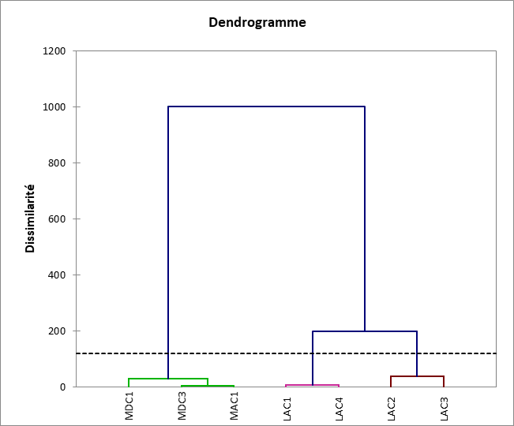
Fig 6: Dendrogram of pepper clones based on morphological and technological characteristics

Discussion
This study focused on the agro-morphological and technological evaluation of pepper plants in Côte d'Ivoire. The results of this study showed that the qualitative morphological traits were almost identical for the two varieties studied, with the exception of ripe berry color, ear filling, lateral branch behavior, and leaf color. The Muntok variety had dark green berries, while the Lampong variety had light green berries. Berry color distinction is a key diagnostic factor for identifying the two varieties. Observation of the ear revealed compact berries in the Muntok variety and scattered or moderately scattered berries in the Lampong variety. The Muntok and Lampong varieties were identified using this trait. Another important diagnostic factor was the behavior of the lateral branches (Ahmad et al., 2012). The Muntok variety had drooping branches, and the Lampong variety had horizontal branches. These data are consistent with the results of Maistre (1964) and Borget (1991) who described some characteristics of the Muntok and Lampong varieties.
In the Muntok varieties of Azaguié and Divo (clone C1), all the traits presented the same modalities. This could be explained by the fact that qualitative traits are little influenced by the environment (Andersson et al., 2006). Within the Lampong variety, clone C3 presented all the traits of Lampong with the addition of small yellow spots on its leaves. This was the case for the Lampong variety from Cambodia which was described with spotted leaves (Escap, 2017). The analyses showed that the Lampong variety had a longer spike than that of the Muntok variety. However, the Muntok variety had higher values for the traits number of grains per spike, fresh grain diameter, dry grain diameter, leaf length, leaf width and leaf area. Our results are consistent with those of Maistre (1964) and Borget (1991), who described Muntok and Lampong types in their work. According to these authors, the Lampong variety has long, irregularly arranged clusters of small peppercorns, and the Muntok variety has short clusters with large, regular peppercorns on the spike. According to Bermawie et al. (2019) and Krishnamurthy et al. (2010), the higher the percentage of hermaphrodite flowers, the higher the number of fruits. It is possible that the Muntok variety has a higher percentage of hermaphrodite flowers, which would explain why its spikes are full of fruits. Failure of fruit set (incorrect ear filling) or failure of ovules to develop in pepper varieties has been associated with insufficient pollination, unfertilized ovaries or imperfect fertilization, loss of stigma receptivity before pollination, either individually or by a combination of these factors (Satheeshan, 2000; Parthasarathy et al., 2007). This could explain the number of fruits and their dispersion on the ear in the Lampong variety.
Analysis of the quantitative morphological characteristics of the Muntok variety showed a significant difference between the Divo and Azaguié areas with regard to the number of grains per spike and grain diameter. The number of fruits per spike was higher in Divo than in Azaguié while the fruit diameter was higher in Azaguié than in Divo. These differences can be attributed to environmental conditions according to the work of Bermawie et al., 2019. Continuous droughts, heavy or irregular rainfall can reduce pollination, affect crop physiology, and also lead to either intensive berry loss or failure of fruit set (Krishnamurthy et al., 2016). Thus, the abundance of rainfall in Azaguié could influence fruit set in the Muntok variety. Moreover, according to Ibrahim et al. (1985), fruit number is more sensitive to changes in environmental conditions than ear length. Berries are larger when the pepper plant is planted on irrigated land (Krishnamurthy et al., 2010). This likely explains the large berry diameter in Azaguié. Indeed, Azaguié is agroecologically wetter than Divo.
The results showed that clone C3 had small leaves. This trait is contrary to the characteristics of the Indonesian Lampong variety described by Maistre (1964), who presented this variety with large leaves. However, clone C3 shares the same characteristics as the Cambodian Lampong variety. This variety has small, spotted leaves, medium clusters, and less dispersed berries that are larger than the average Lampong variety (ESCAP, 2017). The analyses conducted in this study showed that qualitative traits are more effective in distinguishing the two (2) varieties than quantitative traits. This is supported by Khan et al. (2015), Olakojo & Adetula (2014) and Stephan et al. (2016).
The results showed a significant difference between the Muntok varieties from Divo and Azaguié for all the traits studied. Apart from the water content trait which was higher in Azaguié, for all other variables, the Muntok variety from Divo had the highest values. The high weight values in Divo could probably be explained by the adaptation of the Muntok variety to the environmental conditions of Divo (cultivated for about 60 years). However, the same variety has only been cultivated for about 16 years in Azaguié. Our results are in agreement with those of Bermawie et al. (2019). Kandiannan et al. (2007) also showed that weight is influenced by many factors, including soil fertility, cultural practices and crop age.
The results showed that the moisture content ranged from 1.61 to 2.2%, with an average of 1.92%. According to Afnor (1999), the maximum desirable moisture content for black pepper is 13%. The low moisture content of the clones in this study ensures good preservation and prevents the growth of mold, yeast, and bacteria.
The results showed that the density ranged from 528.63 g/l to 758 g/l, with an average of 636.60 g/l. According to Afnor (1999), the minimum acceptable density for black pepper is 490 g/l. The values ​​obtained for all the clones studied exceeded the minimum limit for black pepper. The results of this study are above the ideal normative density for black pepper, which is 500 g/l.
Structuring the diversity of pepper clones based on their technological and morphological characteristics allowed us to identify three homogeneous groups. The results of the CAH are consistent with those of the biomolecular analysis. The first class was made up of clones C1 and C4 of the Lampong variety from Azaguié. The clones of this class were defined by long spikes, small grains and large leaves. They have the same characteristics as those described by Maistre (1964) and Borget (1991) who defined the standard characteristics of Lampong. The second class, made up of clones C2 and C3 of Lampong from Azaguié, presented individuals with medium clusters, large berries and small leaves. The pepper plants of this class have different characteristics from those highlighted by Maistre (1964) and Borget (1991). Nevertheless, they present characteristics of the Lampong described by Escap. (2017). The last class was made up of Muntok clones from Divo and Azaguié. These clones were characterized by short ears, numerous grains and large berries. These have the characteristics of the Muntok presented by Maistre (1964) and Borget (1991).
Conclusion
This study highlighted the agromorphological and technological variability of pepper clones from the CNRA collections in Azaguié and Divo. The results highlighted the distinguishing traits of Lampong and Muntok.
Clones (C1 and C3) of the Muntok variety were characterized by short spikes and large, dark green berries when ripe, compact on the spike. Clone C3 also had small yellow spots on its leaves. Clones C1 and C4 of the Lampong variety had long spikes and small, light green berries when ripe, scattered or moderately scattered on the spike. Clones C2 and C3 of the Lampong variety had small leaves.
The results of this study, although preliminary, provide a working basis for launching a solid pepper breeding program in Côte d'Ivoire.
Declaration
This manuscript is original because it constitutes one of the rare studies of phenotyping of Piper nigrum of breeding program in Côte d’Ivoire. The aim is to determine the agromorphological characteristics of the pepper selected of CNRA collection, with a view to a better appreciation of the genotypes presenting a genetic make-up and improvement of genetic characteristics. We found that two types of pepper are significantly different for specific agromorphological traits.

Data Availability
Data presented in this study will be available on a fair request to the corresponding author
Disclaimer (Artificial intelligence)
Option 1:
Author(s) hereby declare that NO generative AI technologies such as Large Language Models (ChatGPT, COPILOT, etc.) and text-to-image generators have been used during the writing or editing of this manuscript.

References
Ahmad, N. H., Fazal, H., Abbasi, S., Farooq, M., & Ali, K. M. (2012). Biological role of Piper nigrum L. (Black pepper). Asian Pacific Journal of Tropical Biomedicine 2 (3): 1945-1953
Andersson, M. S., Schultze-Kraft, R., Peters, M. B., Hincapie, C., & Lascano, E. (2006). Morphological, agronomic and forage quality diversity of the Flemingia macrophylla world collection. Field Crops Research 96:387-406
French Standardization Association (AFNOR) (1999). Food ingredients and additives. Volume 2. 571 p.
Bermawie, N., Wahyuni, S., Heryanto, R., & Darwati, I. (2019). Morphological characteristics, yield, and quality of the Ciinten variety of black pepper in three agroecological conditions. IOP Conference Series: Earth and Environmental Science, Semarang, Indonesia, 292:1-9
Borget, M. (1991). Tropical Spice Plants. Maisonneuve et Larose, Paris, 182 p
Ehounou, A.E., Kouakou, A.M., N’Zi, J.C., Dibi, K.B., Bakayoko Y., Essis, B.S., N’Zue, B.G., Arnau, E., Maledon, A., Asfaw, P., Adebola, A., N’guetta S.P. (2019). Production of hybrid seeds by intraspecific crossing in yam Dioscorea alata L. International Journal of Science and Research 8(9): 1212-1221.
ESCAP (2017). Trade Integration within ASEAN: the role of non-tariff measures for Cambodia, the Lao people’s democratic republic, Myanmar and Vietnam, Report of Economic and Social Commission for Asia and the Pacific (ESCAP), Bangkok, 291 p
Ibrahim, K., Pillay, V., & Sasikumaran, S. (1985). Variability, heritability and genetic advance for certain quantitative characteristics in black pepper. Agricultural research journal of Kerala 23: 45-48
Jaramillo, M. A., & Manos, P. S. (2001). Phylogeny and patterns of floral diversity in the genus Piper (Piperaceae). American Journal of Botany 88 (4), 706-716
Kandiannan, K, Krishnamurthy, K. S., Thankamani, C. K., & Mathew, P. A. (2007). Pattern and variability of black pepper yields in tropical humid climatic conditions. Indian Journal of Horticulture 64 (3): 314-319
Khan, S. A., Shah, A., Abbasi, F., Javed, A., Rahman, I. U., & Ahmad, H. (2015). Quantitative and qualitative traits analyzes in the advance breeding lines of rice. International Journal of Biosciences 6 (8): 50-61
Krishnamurthy, K. S., Parthasarathy, V. A. & Saji, K. V., Krishnamoorthy, B. (2010). Ideotype concept in black pepper (Piper nigrum L.). Journal of Spices Aromat Crops 19:1-13.
Krishnamurthy, K. S., Ankegowda, S. J., Umadevi, P. George, J. K. (2016). Black pepper and water stress. In: Rao N, Shivashankara K, Laxman R (Eds.). Abiotic stress physiology of horticultural crops. Springer India, 321-322
Kumar, A.S., Vinay, K.S., (2017). Biological action of Piper nigrum - the king of spices. European Journal of Biological Research 11: 223-233
Kurien, S., Cheeran, A., Babu, N.M. (1994). Major pepper varieties on Erythrina indica live standard competition under different spacings. Journal of Indian Cocoa Arecanut Spices, 18 (3): 75-79.
Lassoudière, A., Frossard, P.J., & Sarah, L. (1978). Bananas and Their Cultivation in Côte d'Ivoire, Part 2: Cultivation Techniques, IRFA-DOC, 247 p.
Maistre, J. (1964). Spice Plants. Maisonneuve et Larose, Paris, 289 p.
Nair, R.R., & Gupta, S.D. (2003). Somatic Embryogenesis and Plant Regeneration in Black Pepper (Piper nigrum L.): Direct Somatic Embryogenesis from Tissues of Germinating Seeds and Ontogeny of Somatic Embryos. The Journal of Horticultural Science and Biotechnology, 78: 416-421.
Olakojo, S.A., & Adetula OA (2014). Comparison of qualitative and quantitative traits of some advanced breeding lines of tomato (Lycopersicon esculentum L.). African Journal of Plant Science 8 (10): 457-461
Parthasarathy, V., Sasikumar, B., Nair, R.R., & George, K.J. (2007). Black pepper: botany and horticulture. Horticultural reviews, 33: 173-266.
Ramos, J.V., Arunjo, A.C., & Santos, N.D. (1986). Economic evaluation of different spacings in black pepper in South Bahia. Centro de Pesquisas do Cacau, Brazil, 145 p.
Satheeshan, K., (2000). Physiological and biochemical aspects of flowering, berry set, and development in black pepper (Piper nigrum L.). Thesis for Award of PhD Degree, Kerala Agricultural University, Kerala, India, 172 p.
Scott, M., N. Gagnon, L., Lesage, B., Philogene, T., & Arnason. (2005). Efficacy of botanical insecticides from Piper species (Piperaceae) extracts for control of Eu ropean chafer (Coleoptera: Scarabaeidae). Journal of Economic Entomology 98: 845-855.
Scott, M., Jensen, H., & Philogene, A.T. (2008). A review of Piper spp. (Piperaceae) phytochemistry, insecticidal activity and mode of action. Phytochemistry Reviews, 7 (1): 65-75.
Sivaraman, K., Kandiannan, K., Peter, K., & Thankamani, C. (1999). Agronomy of black pepper (Piper nigrum L.). Journal of Spices and Aromatic Crops, 8 (1) : 1-18.
Srinivasan, K. (2007). Black pepper and its pungent principle-piperine : A review of diverse physiological effects. Critical Reviews in Food Science and Nutrition 47 (8): 735-748.
Stephan, N., Hussein, S., Julia, S., & Kiddo, M., (2016). Screening of Tanzanian sweet potato germplasm for yield and related traits and resistance to sweet potato virus disease. Acta Agriculturae Scandinavica, 66 (1) : 52-66.
Weil, M. (2018). Study of processing methods for wild peppers from Indian Ocean islands: impact on quality (spiciness, aroma, and color). Doctoral thesis in Agro-resources, processes, food, and bioproducts, University of Montpellier, 172 p.

