Original Research Article
Characterization and evaluation of tomato (Solanum lycopersicum L.) genotypes for distinctness, uniformity, stability and yield attributes

Abstract
The present study evaluated 57 tomato (Solanum lycopersicum L.) genotypes for their growth, yield and quality traits, alongside DUS (Distinctness, Uniformity and Stability) characterization. Significant variation was observed for plant height (79.53 to 192.81 cm), number of fruits per plant (36.0 to 159.50), fruit weight (7.80 to 82.10 g), pericarp thickness (2.33 to 7.83 mm), TSS (3.07 to 5.20 °Brix), lycopene content (2.33 to 4.11 mg/100g) and yield per plant (846.0 to 3908.73 g). Genotypes Khori leikai, EC-620498 and EC-620543 exhibited superior yield and quality traits. DUS analysis revealed wide morphological diversity in growth habit, leaf type, fruit shape and coloration. Most genotypes had determinate growth, serrated leaves and smooth fruit surfaces. Traits such as pericarp thickness, TSS and locule number are valuable for processing and shelf life considerations. The findings highlight the potential of these genotypes for varietal improvement, genetic conservation and commercial tomato breeding programs aimed at yield, processing quality and market adaptability.
Keywords: Tomato, Distinctness, Stability, Uniformity

Introduction
Tomato (Solanum lycopersicum L.) is an important solanaceous crop widely consumed as vegetable in world. It consists of 96 genera and over 3000 species. Tomato is native to the Andean region encompassing Ecuador and Peru of South America and thereafter it spread around the world following the Spanish colonization of the Americas (Lone et al., 2021). It is economically important for its edible fruits and preserved products like ketch-up, sauce, chutney, soup, paste, puree etc. Tomato is rich source of minerals, vitamins and organic acids, essential amino acids and dietary fibers and also rich in vitamin A and vitamin C (Vishwanath et al., 2014). For any breeding program planned by breeders, morphological characterization of genotypes serves as a fundamental step in assessing genetic diversity and is crucial for effective planning in breeding programs. It also plays a vital role in the conservation and sustainable utilization of genetic resources (Tejaswini et al., 2023).
In order to introduce a new plant variety commercially, it is necessary to register a newly bred variety, which relies upon the results of DUS tests; that is, for a new genotype to be registered as a commercial variety, it needs to be distinct (D) from all other released varieties, uniform (U), and stable (S) in morphological and other assessed characters. Therefore, DUS test has been established to be the foundation of plant variety protection and also to identify a new variety from collection.
The new variety should pass legal investigations to be commercialized and obtain the certificate for the plant breeder’s rights, a part of which comprises of DUS tests allowing to morphological characteristics (Sharma and Singh, 2018). Record of qualitative characters as per the guidelines of protection of plant varieties and farmer’s right (PPV & FR Act, 2001) authority is a proficient and most essential spectacle to conserve large number of germplasm. It specifies strong distinctness between genotypes and helpful in their maintenance as true to type and also use for upcoming breeding program (Patidar, 2015).
The primary characters are recorded based on morphological characters to ease DUS criteria and mean performance of various genotypes of tomato is discussed in present communication.
Materials and Methods
Experimental details
The experimental material consisted of 57 genotypes and study was carried out at farmer’s field of Madanapalle, Chittoor district of Andhra Pradesh, India in summer season, 2023. The experiment was laid out in a Randomized Block Design (RBD) with three replications. Geographically, farm is located at 13°.44’ North latitude, 78°.54’ East longitude and at an altitude of 746 meters above mean sea level.
This study was undertaken as part of a research project affiliated with the Department of Horticulture, Faculty of Agriculture, Annamalai University, Tamil Nadu. The trail aimed to evaluate morphological and agronomic variability among tomato genotypes under open-field conditions representative of the regional agro-ecology.
Sources of seed
Among 57 genotypes, fifty genotypes are received from NBPGR, New Delhi. Three genotypes i.e., Anagha (KAU, Kerala); PKM-1 (TNAU, Tamil Nadu); Kasi Adarsh (IIVR, Varanasi). And remaining genotypes are local landraces i.e., local kerala (Kerala), Kashi Tomato (Andhra Pradesh), Miryalaguda Tomato (Telangana) and Khori Leikai (Manipur).
Characters studied
The observations were recorded on ten randomly selected plants from each genotype for all the 13 characters of tomato viz., plant height (cm), number of primary branches, days to 50% flowering, number of fruits per plant, fruit weight (g), fruit length (cm), fruit width (cm), pericarp thickness (mm), total soluble solids (°Brix), lycopene content (mg/100g), ascorbic acid (mg/100g), titrable acidity (%) and yield per plant (g).
Observations recorded as per DUS guidelines
The quality characters were recorded as per the DUS guidelines viz., plant growth habit, leaf type, leaf colour, leaf pubescence, leaf/foliage cover, petiole pubescence, stem type, stem thickness, stem pubescence, stem pigmentation, flower size, flower colour, fruit shape longitudinal section, intensity of green colour (light, medium, dark), presence of green (shoulders) tips on the fruits, fruit colour, fruit surface, fruit depression at peduncle end, blossom-end fruit shape, pericarp thickness, number of locules, TSS (°Brix).
Data analysis
The statistical parameters like mean, standard error and coefficient of variation were calculated as per the standard methods of analysis (Panse and Sukhatme, 1967).
- General mean (GM) = $\frac{\text{Total of all values}}{\text{n}}$
Where, n = number of observations
- Variance = $\frac{\text{SS-CF}}{\text{DF}}$
Where, SS = Sum of squares of all the observations of a variate
CF = Correction factor
DF = Degrees of freedom
Correction Factor (CF) = $\frac{{\left(\text{Grand total}\right)}^{\text{2}}}{\text{n}}$
- Standard Deviation (SD) = (Variance)^{1/2}
- Standard Error (SE) = $\frac{\text{SD}}{√n}$
- Coefficient of Variation (CV) = $\frac{\text{SD}}{\text{Varietal mean}}\text{×100}$
Results and Discussion
Mean performance
The mean performance, general mean and range of fifty seven entries for thirteen characters are presented in Table 1.
Variance in plant height among genotypes is by virtue of their plant growth types i.e., determinate, semi determinate and indeterminate. Certain genes were control the morphological differences. The range for plant height varied from 79.53 cm to 192.81 cm. The grand mean for plant height was 128.82 cm. The genotype EC-620552 exhibited the highest plant height (192.81 cm), followed by EC-631371 (187.89 cm) and EC-617060 (186.74 cm). The lowest plant height was recorded in EC-631427 (79.53). These results are coinciding by Spaldon and Hussain, (2017).
Among the genotypes, the number of primary branches ranged from 4.80 to 8.87. The genotype EC-690982 and EC-631409 (8.87) expressed the maximum number of primary branches, followed by EC-687604 (8.80), EC-631401 and EC-620552 (8.67).
The range in days to 50% flowering was from 40.67 to 57.47. The genotype EC-692347 (40.67) expressed the minimum days to 50% flowering and shown earliness than other genotypes, followed by PKM-1 (41.00) and EC-620388 (41.47). The result was in conformity of the findings of Srivastava et al., (2023).
The mean number of fruits per plant ranged from 36.00 to 159.50. The genotypes EC-620385 recorded the maximum fruits per plant (159.50), followed by EC-687604 (138.50) and EC-620552 (128.00), while the genotype Anagha (36.00) recorded the minimum number of fruits per plant. The genotypes exhibited wide variation for fruit weight, ranging from 7.80 to 82.10 g. Among the genotypes, Local Kerala (82.10) recorded the highest fruit weight, followed by Khori Leikai (78.13 g) and EC-620498 (77.70 g), whereas lowest fruit weight appeared in EC-620385 (7.80 g).
Fruit length was found to be the highest in the genotype Khori Leikai (6.29 cm), followed by EC-631406 (6.24 cm) and EC-631359 (5.95 cm). The least value of fruit length was recorded by EC-631415 (0.83 cm). The range for fruit width varied from 1.24 to 6.07 cm. The grand mean for fruit width was 3.95 cm. The genotypes Local Kerala exhibited the highest fruit width (6.07 cm), followed by Khori Leikai (5.47) and EC-620498 (5.14 cm). The least fruit width was recorded in EC-620531 (1.24 cm).
The mean of pericarp thickness ranges from 2.33 mm to 7.83 mm. The genotypes EC-620404 (7.83 mm) expressed the maximum pericarp thickness, followed by EC-638522 (7.70 mm) and EC-631406 and EC-620382 (7.33 mm). The genotypes with thick pericarp have long shelf and better to withstand for long distance transportation.
Total soluble solid is an important character for tomato processing industry and required to decide the fermentation methods during seed extraction (Vishwanath et al., 2014). TSS content was varied significantly among the genotypes. The mean of total soluble solids ranged from 3.07 to 5.20 °Brix. The genotypes EC-631438 (5.20 °Brix) recorded the maximum total soluble solids, followed by EC-620404 (5.17) and EC-620382 (5.13). The mean of lycopene content ranged from 2.33 to 4.11 mg/100g.
The genotypes EC-620543 and EC-620382 (4.11 mg/100g) recorded the maximum lycopene content, followed by EC-620508 (4.06 mg/100g), EC-631409 (4.06 mg/100g) and EC-638522 (4.02 mg/100g), EC-63135 (4.02 mg/100g) and Khori Leikai (4.02 mg/100g). The genotypes EC-631415 (2.33 mg/100g) revealed least amount of lycopene content. When the green stage breaks, devastation of chlorophyll occurs to turner and ripe stage. It could be due to the widespread accumulation of carotenoids like like β-carotene and lycopene content at red ripe stage (Kaur et al., 2006). Simultaneously, acidity content in tomato decreases, rises the level of lycopene content.
The mean range of ascorbic acid was from 14.20 to 29.52 mg/100g. The highest ascorbic acid (29.52 mg/100g) was recorded in the genotypes EC-620543, followed by EC-617060 (29.31 mg/100g) and EC-688516 (28.98 mg/100g) while, the lowest ascorbic acid was recorded in the genotype EC-620510 (14.20 mg/100g).
Among the fifty seven tomato genotypes evaluated, the genotype Anagha registered the highest titrable acidity (0.85%), followed by Miryalaguda (0.70%) and Khori Leikai (0.64%) while, the lowest titrable acidity was recorded in the genotype EC-631957 (0.29%).
The genotype exhibited wide variation for yield per plant, ranging from 846.00 g to 3908.73 g. Among the genotypes, Khori Leikai produced the highest yield per plant (3908.73 g). This was followed by the genotypes EC-620498 (3882.70 g) and Kasi Adarsh (3770.87 g), whereas the lowest yield per plant was recorded in the genotype EC-620484 (846.00 g).
DUS characterization of 57 genotypes of tomato
The Distinctness, Uniformity and Stability (DUS) characterization of 57 tomato genotypes revealed significant morphological variability across vegetative, floral and fruit traits, demonstrating the genetic diversity within the germplasm. Such phenotypic variation is crucial for varietal identification, selection in breeding programs, and protection under plant variety rights as outlined by PPV&FRA (2001).
The growth habit observed among the genotypes was predominantly determinate (thirty four genotypes), followed by indeterminate (thirteen genotypes) and semi-determinate (ten genotypes). Determinate genotypes are generally preferred for mechanical harvesting and synchronized fruiting, whereas indeterminate types are suited for prolonged harvest periods due to their continuous flowering and fruiting behaviour (Tigist et al., 2013). Semi-determinate types, although less understood, may combine the advantage of both growth habits, offering potential flexibility in cultivation (Vicente et al., 2015).
Leaf morphology exhibited clear variation, with forty seven genotypes possessing serrated leaves and ten genotypes showing the potato leaf type. Leaf type and colour, particularly the consistent dark green pigmentation, serve as important descriptors for photosynthetic efficiency and plant vigor (Hazra et al., 2011).
Foliage density ranged from good to excellent, contributing to canopy architecture and microclimate regulation around the plant, which may affect pest incidence and fruit quality (Fig. 1). The leaf pubescence observed twenty six genotypes was sparse, one genotype was medium and thirty genotypes was absent of pubescence. Petiole pubescence was sparse in thirty eight genotypes, medium pubescence in ten genotypes, and high pubescence in four genotypes and absent in five genotypes.
Among the flowering characters, eleven genotypes was exhibited small flower size, twenty two genotypes exhibited medium flower size and twenty four genotypes exhibited large flower size (Fig. 3). The flower colour of tomato shown, eighteen genotypes was light yellow and thirty nine genotypes was deep yellow in colour. Flower related traits such as flower size and colour are critical for pollination dynamics and hybrid seed production. A majority of the genotypes had medium to large flower size and deep yellow coloration, which are associated with enhances attractiveness to pollinators and better fruit set (Yogesh et al., 2020).
Among the fruit characters, the longitudinal section of fruit shape was exhibited nine flattened genotypes, seven slightly flattened, nineteen circular, two rectangular, one cylindrical, two heart shaped, sixteen obovoid and one ovoid genotype (Fig. 4a). Fruit morphological descriptors such as shape, pericarp thickness, surface and blossom end characteristics are important for market classification and consumer preference. The diversity observed from circular to heart shaped fruit, from shallow to absent fruit depression provides breeders with options for targeting specific market segments. Pericarp thickness, observed to be medium in most genotypes, is directly associated with shelf life and transportability (Tadesse et al., 2015).
The intensity of green colour in tomato, exhibited thirteen light green colour, nineteen medium green and twenty five dark green colour of genotypes. Presence of green tips on fruits was present in seventeen genotypes and absent in 40 genotypes (Fig. 4a).
Tomato colour is the important trait of fruit quality and ripened tomatoes exhibits a diverse carotenoids pigment and the appearance is acclimatised by the specific pigment and concentration. The colour of ripened fruits was predominantly red (fifty one genoytpes), followed by orange (five) and pink (one), indicative of the underlying carotenoid biosynthesis pathways, especially lycopene and β-carotene, which determine both market value and nutritional content (Flores et al., 2016). Presence or absence of green shoulders is a known varietal trait that influences visual appeal and ripening uniformity. The fruit surface of tomato genotypes exhibits fifty six smooth and one corrugated type (Fig. 4a).
Fruit depression at peduncle end was exhibited thirty five shallow, fourteen medium and eight genotypes was absence of fruit depression (Fig. 4b). Blossom end fruit shape was observed five genotypes were indented, ten genotypes were indented to flat, twenty nine genotypes were flat type, ten genotypes were flat to pointed and three genotypes were pointed. The pericarp thickness of tomato was exhibits five genotypes were thin pericarp, thirty seven genotypes were medium pericarp and fifteen genotypes were thick pericarp (Fig. 4b). Pericarp thickness, observed to be medium in most genotypes, is directly associated with shelf life and transportability (Tadesse et al., 2015).
Stem characters such as type, thickness and pubescence also showed considerable variation (Fig. 2). The presence of angular stem in thirty one genotypes could be linked to improved mechanical strength and lodging resistance, while pubescence on stems and petioles, though sparse in most cases, plays a role in insect resistance and water conservation.
Number of locules in tomato shown thirty two genotypes observed two number of locules, seventeen genotypes observed three number of locules and nine genotypes observed more four number of locules (Fig. 4b). The TSS of tomato in fifty seven genotypes, three genotypes were revealed low TSS, thirty one genotypes were revealed medium TSS, eighteen genotypes were revealed high TSS and five genotypes revealed very high TSS (Fig. 4b). The number of locules and total soluble solids (TSS) varied considerably, with higher TSS content observed in a subsequent of genotypes. These traits are crucial for processing tomatoes, especially for sauce and paste industries where higher sugar concentration and thicker consistency are desired (Salazar et al., 2025). Locule number also correlated with fruit size and internal structure, impacting consumer preference and slicing quality.
Phenotypic variation is essential for cultivar identification, selection in breeding programs and protection under plant variety rights. Determinate genotypes are generally preferred for mechanical harvesting and synchronized ripening, while indeterminate types are suitable for extended harvest periods due to their continuous flowering and fruiting. Leaf density was rated as good to excellent, contributing to canopy structure and regulating the microclimate around the plant, which can influence pest infestation and fruit quality. Pericarp thickness, which was observed to be moderate in most genotypes, is directly related to shelf life and transportability.
Overall result demonstrate a broad range of phenotypic diversity within the 57 tomato genotypes, which can be exploited for both varietal registration and targeted improvement programs. The observed diversity in DUS characters confirms the potential of these genotypes to contribute toward varietal distinction and breeding for specific horticultural and industrial needs.
Conclusion
The present study revealed extensive phenotypic and morphological variability among 57 tomato genotypes, indicating a rich genetic resource for future breeding and varietal development. Significant differences were observed across key horticultural traits such as plant height, fruit yield, fruit morphology, biochemical composition and flowering behaviour. Genotypes like Khori leikai, EC-620498 and EC-620543 emerged as superior in terms of yield and nutritional attributes, making them promising candidates for both commercial cultivation and genetic enhancement programs.
DUS characterization further confirmed the distinctiveness and stability of the evaluated genotypes, showcasing considerable variation in the traits such as growth habit, leaf type, flower type, fruit size, fruit shape, colour and surface texture. The broad genetic base highlighted by this study can be strategically utilized for varietal registration, hybrid development and targeted trait improvement. Overall, the findings emphasize the importance of systematic germplasm evaluation to exploit genetic diversity for the advancement of tomato cultivation and industry. This study indicates presence of genetic variability in respect of DUS characters as well as yield attributes which can be further utilised for selection and of better genotypes.

Disclaimer (Artificial intelligence)
Option 1:
Author(s) hereby declare that NO generative AI technologies such as Large Language Models (ChatGPT, COPILOT, etc.) and text-to-image generators have been used during the writing or editing of this manuscript.
REFERENCES
- Flores, P., Sanchez, E., Fenoll, J. & Hellin, P. (2016): Genotypic variability of carotenoids in traditional tomato cultivars. Food Research International 100(3): 510-516. http://dx.doi.org/10.1016/j.foodres.2016.07.014.
- Ortega-Salazar, I., Ozminkowski Jr, R.H., Adaskaveg, J.A., Sbodio, A.O. & Blanco-Ulate, B. (2025): Genetic basis of fruit quality traits in processing tomatoes. Journal of Agriculture and Food Research 22: 102096. https://doi.org/10.1016/j.jafr.2025.102096.
- Hazra, P., Chattopadhyay, A., Karmakar, K. & Dutta, S. (2011): Modern Technology in Vegetable Production. New India Publishing Agency, New Delhi.
- Kaur, D., Sharma, R., Wani, A.A., Gill, B.S. & Sogi, D.S. (2006): Physiochemical changes in seven tomato (Lycopersicon esculentum) cultivars during ripening. International Journal of Food Properties 9: 747-757.
- Lone, S., Hussain, K., Masoodi, K.Z., Narayan, S., Hussain, S.M., Rashid, M. & Kumar, H. (2021): Distinctness, uniformity and stability testing of various cherry tomato accessions. Journal of Pharmacognosy and Phytochemistry 10(2): 2776-2788.
- Panse, V.G. & Sukhatme, P.V. (1967): Statistical Methods for Agricultural Workers, 2nd ed. Indian Council of Agricultural Research, New Delhi.
- Patidar, D. (2015): DUS and qualitative characters inheritance studies of brinjal (Solanum melongena L.) genotypes. Trends in Biosciences 8(1): 178-180.
- PPV & FR. (2001): Protection of Plant Varieties and Farmers’ Rights Act (No.53 of 2001). Ministry of Agriculture, Government of India, Krishi Bhavan, New Delhi.
- Sharma, D. & Singh, S. (2018): DUS characterization of rice farmer’s varieties under PPV and FRA in Chhattisgarh. Frontiers in Crop Improvement 6(2): 102-115.
- Spaldon, S. & Hussain, S. (2017): Performance of tomato (Solanum lycopersicum L.) genotypes for yield and quality traits under Jammu subtropical condition. International Journal of Agricultural Innovations and Research 6(1): 28-32.
- Srivastava, R., Meena, K., Rai, A., Singh, A.P., Tiwari, A., Chaturvedi, A.K. & Karketta, A. (2023): Performance of tomato (Solanum lycopersicum L.) genotypes for earliness and yield traits in late Kharif and summer season under North Eastern region of Uttar Pradesh, India. International Journal of Plant and Soil Science 35(19): 664-669.
- Tadesse, T.N., Ibrahim, A.M. & Abtew, W.G. (2015): Degradation and formation of fruit color in tomato (Solanum lycopersicum L.) in response to storage temperature. American Journal of Food Technology 10(4): 147-157. https://doi.org/10.3923/ajft.2015.147.157.
- Tejaswini, U., Parashivamurthy, R., Siddaraju, R., Vishwanath, K., Ramanappa, T.M., Srinivasappa, K.N. & Nagaraju, N. (2023): Characterization of tomato (Solanum lycopersicon Mill.) genotypes for morphological and disease resistance traits. Environment and Ecology 41(1C): 698-708.
- Tigist, M., Workneh, T.S. & Woldetsadik, K. (2013): Effects of variety on the quality of tomato stored under ambient conditions. African Journal of Agricultural Research 8(45): 5673-5680.
- Vicente, M.H., Zsogon, A., de Sá, A.F.L., Ribeiro, R.V. & Peres, L.E.P. (2015): Semi-determinate growth habit adjusts the vegetative-to-reproductive balance and increases productivity and water-use efficiency in tomato (Solanum lycopersicum). Journal of Plant Physiology 177: 11-19. https://doi.org/10.1016/j.jplph.2015.01.003.
- Vishwanath, K., Prasad, R.S., Pallavi, H.M. & Prasanna, K.P.R. (2014): Characterization of tomato cultivars based on morphological traits. Annals of Plant Sciences 3(11): 854-862.
- Yogesh, K., Singh, D., Kumar, R. & Sharma, R. (2020): Morphological characterization and diversity analysis in tomato (Solanum lycopersicum L.) germplasm. Scientia Horticulturae 263: 109090. https://doi.org/10.1016/j.scienta.2019.109090.

Table 1. Mean performances for thirteen characters in tomato
S. No | Characters | Plant height (cm) | Number of primary branches | Days to 50% flowering | Number of fruits per plant | Fruit weight (g) | Fruit length (cm) | Fruit width (cm) | Pericarp thickness (mm) | TSS (°Brix) | Lycopene | Ascorbic acid | Titrable acidity | Yield per plant (g)
S. No | Characters | 1 | 2 | 3 | 4 | 5 | 6 | 7 | 8 | 9 | 10 | 11 | 12 | 13
1 | EC-620388 | 88.70 | 6.27 | 41.47 | 38.33 | 30.00 | 3.59 | 3.87 | 4.33 | 3.83 | 2.60 | 20.40 | 0.36 | 1145.33
2 | EC-638302 | 91.38 | 7.60 | 47.47 | 36.67 | 28.80 | 3.93 | 4.04 | 2.90 | 3.37 | 3.41 | 15.24 | 0.58 | 1071.60
3 | EC-620378 | 123.93 | 6.67 | 45.27 | 38.67 | 58.80 | 4.72 | 5.01 | 6.27 | 3.23 | 3.07 | 22.90 | 0.37 | 2272.00
4 | EC-692338 | 95.37 | 5.67 | 49.80 | 37.67 | 49.63 | 4.24 | 4.10 | 5.43 | 5.03 | 3.81 | 26.52 | 0.35 | 1868.00
5 | EC-631359 | 105.67 | 8.60 | 51.40 | 43.67 | 64.27 | 5.95 | 4.63 | 4.23 | 3.27 | 3.26 | 25.68 | 0.47 | 2819.27
6 | EC-615039 | 170.53 | 8.07 | 45.40 | 56.00 | 53.83 | 4.33 | 4.34 | 3.77 | 4.03 | 3.48 | 14.24 | 0.36 | 3013.37
7 | EC-631406 | 101.87 | 7.07 | 46.67 | 48.67 | 68.10 | 6.24 | 4.41 | 7.33 | 4.00 | 3.46 | 24.08 | 0.37 | 3307.87
8 | EC-620495 | 116.78 | 5.93 | 46.73 | 53.67 | 35.13 | 3.82 | 3.93 | 6.57 | 3.27 | 3.17 | 24.28 | 0.44 | 1881.00
9 | EC-620484 | 91.41 | 5.53 | 47.40 | 48.33 | 17.60 | 2.84 | 3.00 | 2.73 | 4.07 | 3.75 | 25.82 | 0.38 | 846.00
10 | EC-620510 | 168.63 | 7.00 | 49.20 | 47.00 | 45.60 | 4.18 | 4.22 | 4.53 | 4.23 | 3.41 | 14.20 | 0.53 | 2142.53
11 | EC-631957 | 110.10 | 6.33 | 44.93 | 47.00 | 53.00 | 5.09 | 4.46 | 6.60 | 4.03 | 3.55 | 15.30 | 0.29 | 2503.00
12 | EC-620414 | 87.20 | 7.67 | 42.40 | 43.00 | 39.47 | 3.44 | 4.42 | 3.30 | 3.13 | 3.22 | 22.70 | 0.41 | 1698.27
13 | EC-692347 | 97.99 | 7.00 | 40.67 | 49.33 | 67.63 | 4.95 | 4.49 | 4.77 | 4.03 | 3.49 | 14.38 | 0.33 | 3325.30
14 | EC-620489 | 151.97 | 7.13 | 44.33 | 54.67 | 34.80 | 3.04 | 4.14 | 5.33 | 3.07 | 2.86 | 19.88 | 0.43 | 1901.53
15 | EC-631409 | 114.10 | 8.87 | 45.93 | 43.33 | 50.40 | 5.12 | 4.04 | 6.33 | 5.00 | 4.06 | 26.23 | 0.32 | 2173.60
16 | EC-620552 | 192.81 | 8.67 | 51.67 | 128.00 | 8.53 | 2.25 | 2.39 | 2.33 | 5.00 | 3.81 | 27.95 | 0.39 | 1091.07
17 | EC-632926 | 139.27 | 7.67 | 46.27 | 55.67 | 49.50 | 4.37 | 4.38 | 4.07 | 5.07 | 3.45 | 14.46 | 0.52 | 2752.33
18 | EC-617055 | 150.50 | 8.33 | 46.53 | 44.00 | 36.53 | 4.58 | 3.52 | 4.00 | 3.90 | 2.49 | 20.27 | 0.39 | 1601.80
19 | EC-620531 | 134.45 | 8.20 | 52.67 | 49.00 | 23.63 | 1.88 | 1.24 | 3.77 | 3.20 | 3.11 | 22.59 | 0.37 | 1150.90
20 | EC-620543 | 142.69 | 7.93 | 46.13 | 48.67 | 64.10 | 4.97 | 3.28 | 5.83 | 4.87 | 4.11 | 29.52 | 0.54 | 3136.07
21 | EC-631371 | 187.89 | 8.00 | 44.47 | 45.00 | 47.83 | 4.35 | 4.54 | 5.17 | 4.10 | 3.61 | 14.75 | 0.34 | 2145.97
22 | EC-631369 | 178.07 | 7.60 | 46.07 | 53.00 | 29.13 | 3.55 | 3.93 | 3.40 | 4.07 | 3.26 | 26.81 | 0.53 | 1544.87
S. No | Characters | 1 | 2 | 3 | 4 | 5 | 6 | 7 | 8 | 9 | 10 | 11 | 12 | 13
23 | EC-632944 | 124.76 | 7.87 | 44.40 | 56.00 | 38.30 | 4.38 | 3.96 | 5.50 | 3.63 | 2.73 | 18.51 | 0.36 | 2138.50
24 | EC-631401 | 159.17 | 8.67 | 46.33 | 53.33 | 28.47 | 3.47 | 3.88 | 4.63 | 3.60 | 3.34 | 21.54 | 0.49 | 1522.63
25 | EC-631427 | 79.53 | 7.53 | 46.00 | 47.33 | 57.50 | 4.47 | 4.61 | 5.13 | 3.20 | 3.51 | 14.68 | 0.48 | 2714.67
26 | EC-631378 | 114.15 | 7.53 | 47.13 | 43.00 | 53.23 | 5.52 | 4.58 | 6.40 | 3.87 | 3.36 | 23.15 | 0.44 | 2300.57
27 | EC-688516 | 117.51 | 7.47 | 48.47 | 49.33 | 50.43 | 5.28 | 4.29 | 6.50 | 4.03 | 3.97 | 28.98 | 0.40 | 2500.70
28 | EC-620425 | 113.47 | 7.87 | 44.40 | 48.67 | 36.50 | 4.83 | 4.06 | 3.83 | 3.93 | 2.60 | 20.53 | 0.36 | 1781.33
29 | EC-690982 | 96.83 | 8.87 | 44.93 | 50.67 | 49.53 | 3.53 | 4.49 | 3.93 | 4.17 | 2.56 | 19.56 | 0.42 | 2482.13
30 | EC-620382 | 118.87 | 8.53 | 51.27 | 45.00 | 68.77 | 5.49 | 4.47 | 7.33 | 5.13 | 4.11 | 27.45 | 0.36 | 3058.63
31 | EC-631404 | 105.93 | 8.00 | 48.20 | 47.00 | 62.63 | 5.64 | 4.57 | 6.13 | 4.47 | 3.69 | 28.26 | 0.55 | 2937.83
32 | EC-635533 | 167.21 | 8.13 | 50.93 | 53.00 | 26.17 | 3.05 | 3.59 | 3.17 | 3.17 | 3.59 | 15.19 | 0.31 | 1377.27
33 | EC-631412 | 139.01 | 8.53 | 45.20 | 61.33 | 37.70 | 3.69 | 3.85 | 4.83 | 5.03 | 3.66 | 28.33 | 0.36 | 2292.33
34 | EC-687604 | 171.74 | 8.80 | 46.20 | 138.50 | 8.67 | 2.06 | 2.21 | 2.70 | 4.00 | 3.52 | 28.11 | 0.54 | 1199.75
35 | EC-635526 | 118.39 | 8.13 | 51.93 | 47.00 | 67.07 | 5.34 | 4.97 | 6.20 | 3.07 | 2.77 | 22.96 | 0.47 | 3143.77
36 | EC-615040 | 123.59 | 7.60 | 46.93 | 48.00 | 24.57 | 1.03 | 1.55 | 3.77 | 4.10 | 2.49 | 18.60 | 0.52 | 1177.57
37 | EC-617060 | 186.74 | 7.40 | 44.93 | 50.00 | 41.20 | 1.39 | 2.38 | 4.67 | 4.17 | 3.41 | 29.31 | 0.41 | 2039.73
38 | EC-620376 | 133.38 | 7.00 | 47.60 | 43.00 | 50.43 | 4.45 | 4.20 | 5.30 | 3.10 | 2.83 | 26.45 | 0.56 | 2180.13
39 | EC-631438 | 170.80 | 8.33 | 46.00 | 48.33 | 27.90 | 1.55 | 1.58 | 3.47 | 5.20 | 3.92 | 23.95 | 0.49 | 1340.80
40 | EC-631415 | 120.97 | 7.53 | 46.73 | 53.00 | 26.03 | 0.83 | 1.53 | 3.80 | 3.13 | 2.33 | 23.67 | 0.42 | 1363.17
41 | EC-638522 | 169.35 | 7.27 | 50.53 | 45.33 | 65.60 | 5.22 | 4.58 | 7.70 | 4.13 | 4.02 | 27.19 | 0.36 | 2968.20
42 | EC-620508 | 101.90 | 8.00 | 48.40 | 45.67 | 54.63 | 5.52 | 4.31 | 5.77 | 5.07 | 4.06 | 23.42 | 0.58 | 2496.43
43 | EC-620404 | 150.83 | 7.47 | 47.53 | 43.33 | 59.07 | 5.50 | 4.53 | 7.83 | 5.17 | 3.43 | 26.78 | 0.57 | 2565.17
44 | EC-636877 | 141.23 | 7.87 | 47.07 | 70.67 | 20.87 | 3.98 | 2.88 | 4.60 | 5.07 | 3.93 | 26.57 | 0.50 | 1477.77
45 | EC-620385 | 130.57 | 7.53 | 47.87 | 159.50 | 7.80 | 2.20 | 2.42 | 2.90 | 4.03 | 3.64 | 25.64 | 0.52 | 1253.10
46 | EC-692388 | 154.89 | 8.00 | 47.20 | 61.67 | 26.77 | 3.66 | 3.44 | 4.70 | 3.17 | 3.99 | 23.23 | 0.52 | 1644.67
47 | EC-620516 | 105.80 | 7.73 | 47.00 | 41.67 | 46.83 | 4.55 | 4.44 | 5.77 | 4.00 | 3.99 | 27.83 | 0.47 | 1963.37
48 | EC-631351 | 121.09 | 4.80 | 48.00 | 45.67 | 40.53 | 4.47 | 4.24 | 5.27 | 3.23 | 4.02 | 23.19 | 0.56 | 1855.70
49 | EC-620498 | 137.57 | 8.20 | 47.07 | 50.00 | 77.70 | 4.84 | 5.14 | 6.93 | 4.17 | 3.74 | 19.31 | 0.46 | 3882.70
S. No | Characters | 1 | 2 | 3 | 4 | 5 | 6 | 7 | 8 | 9 | 10 | 11 | 12 | 13
50 | EC-620361 | 99.33 | 7.47 | 44.27 | 45.00 | 39.97 | 4.42 | 3.88 | 5.03 | 4.97 | 3.57 | 22.78 | 0.61 | 1802.00
51 | Local Kerala | 99.37 | 8.00 | 54.07 | 37.50 | 82.10 | 4.91 | 6.07 | 3.43 | 3.07 | 3.72 | 27.60 | 0.56 | 3080.80
52 | Anagha | 103.00 | 8.07 | 47.33 | 36.00 | 36.10 | 3.69 | 3.92 | 4.27 | 4.03 | 3.43 | 14.35 | 0.85 | 1297.00
53 | PKM-1 | 109.80 | 7.93 | 41.00 | 67.50 | 45.07 | 4.12 | 4.44 | 5.00 | 4.23 | 3.75 | 26.69 | 0.39 | 3050.28
54 | Kashi Tomato | 141.53 | 8.00 | 55.80 | 40.50 | 58.20 | 3.45 | 5.02 | 3.50 | 4.00 | 3.45 | 25.22 | 0.56 | 2360.20
55 | Miryalaguda | 103.47 | 8.47 | 57.47 | 43.00 | 45.90 | 3.67 | 4.50 | 4.60 | 4.17 | 3.65 | 20.21 | 0.70 | 1972.97
56 | Khori Leikai | 124.69 | 7.93 | 53.07 | 50.00 | 78.13 | 6.29 | 5.47 | 7.23 | 4.73 | 4.02 | 26.54 | 0.64 | 3908.73
57 | Kasi Adarsh | 144.87 | 7.00 | 47.67 | 58.33 | 64.63 | 4.79 | 4.61 | 5.33 | 3.97 | 3.73 | 23.54 | 0.55 | 3770.87
Grand Mean |  | 128.82 | 7.64 | 47.40 | 53.21 | 44.94 | 4.08 | 3.95 | 4.92 | 4.04 | 3.46 | 22.76 | 0.46 | 2180.58
C.V. |  | 9.90 | 9.28 | 4.99 | 14.42 | 6.40 | 6.79 | 7.49 | 6.58 | 3.45 | 4.07 | 1.23 | 5.88 | 20.05
C.D. 5% |  | 20.63 | 1.15 | 3.83 | 12.41 | 4.65 | 0.45 | 0.48 | 0.52 | 0.23 | 0.23 | 0.45 | 0.04 | 707.42
Range Lowest |  | 79.53 | 4.80 | 40.67 | 36.00 | 7.80 | 0.83 | 1.24 | 2.33 | 3.07 | 2.33 | 14.20 | 0.29 | 846.00
Range Highest |  | 192.81 | 8.87 | 57.47 | 159.50 | 82.10 | 6.29 | 6.07 | 7.83 | 5.20 | 4.11 | 29.52 | 0.85 | 3908.73

Figure 1. Plant growth characters of tomato

Figure 2. Stem characters of tomato Figure 3. Flower characters of tomato

Figure 4(a). Fruit characters of tomato

Figure 4(b). Fruit characters of tomato

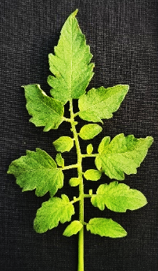
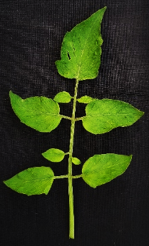
Figure 5. Leaf Pubescence

Figure 6. Leaflet: Serration

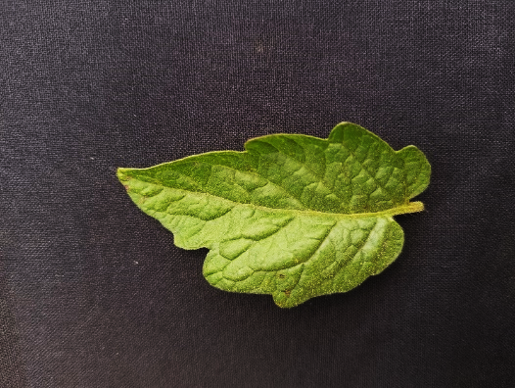
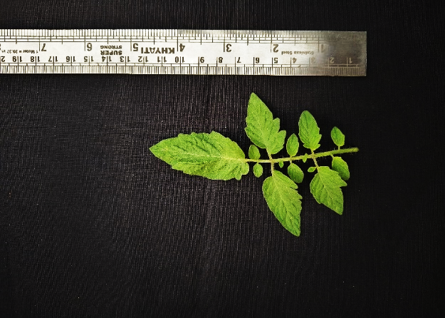
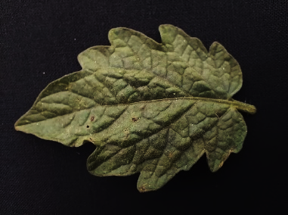
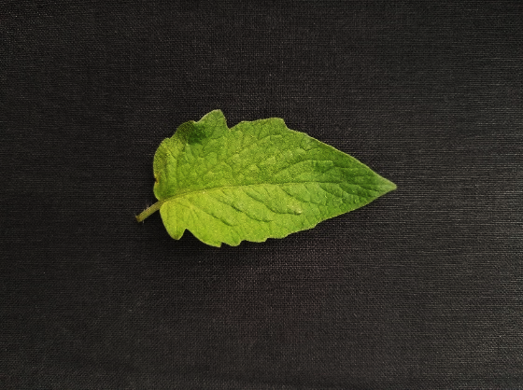
Less serrated
Highly serrated
Absent (Potato type)
Medium
Sparse
Absent

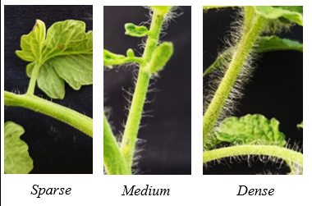

Figure 7. Petiole Pubescence
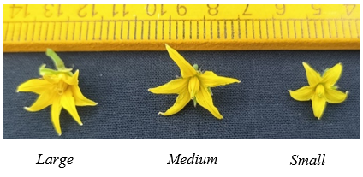
Figure 8. Flower size
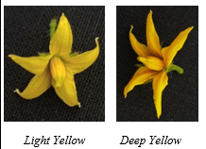
Figure 9. Flower Colour
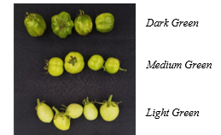
Figure 10. Immature fruit skin colour
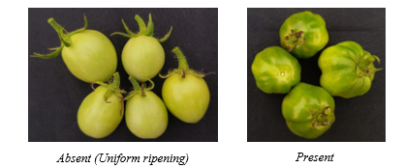
Figure 11. Fruit: Presence of green (shoulders) tips on the fruits
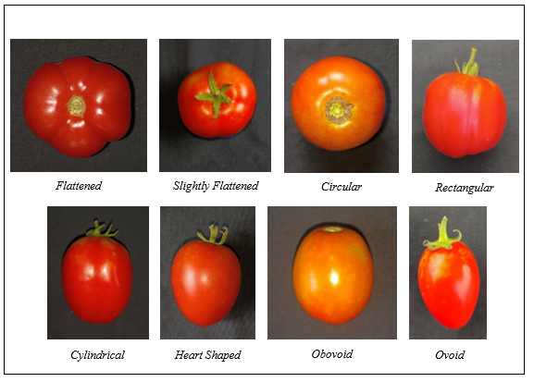
Figure 12. Fruit shapes
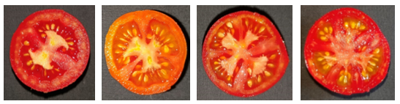
Figure 13. Fruit: Number of locules
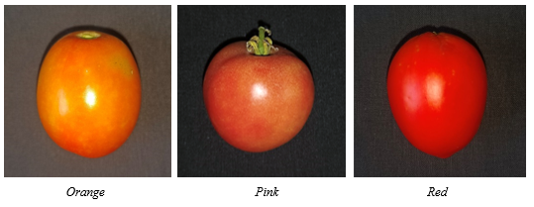
Figure 14. Fruit: Colour at maturity

