Original Research Article
In vivo efficacy of ZnO nanoparticles against root-knot nematode (Meloidogyne incognita) in Brinjal

ABSTRACT
Brinjal (Solanum melongena L.) is a perennial plant of subtropical and tropical areas. Brinjal is rich in alkaloids, flavonoids and other bioactive compounds like arginine and aspartic acids. Nanotechnology is a rapidly advancing and intriguing field of research with applications spanning a wide range of disciplines. Nanoparticles and nanocapsules provide an efficient approach for targeted and controlled delivery of pesticides and fertilisers, minimising unintended environmental effects while improving site-specific effectiveness. The present investigation was carried out to determine the efficacy of zinc oxide nanoparticles extracted from Azadirachta indica against root-knot nematode, Meloidogyne incognita in Brinjal under pot conditions. The experiment was carried out in the net house of the “Department of Nematology” during 2025 to know the effect of ZnO NPs on controlling M. incognita in brinjal. The results revealed that all the treatments were effective in increasing plant growth parameters. All the treatments significantly decreased the galls, egg masses and the final nematode population in the soil over the control. The treatment with a combination of seedling root dip and soil treatment using Azadirachta indica-based ZnO nanoparticles significantly improved plant growth, with shoot length increasing to 21.792 cm compared to 15.032 cm in the control group. This treatment also achieved remarkable reductions of 74.5% in gall formation, 75.43% in egg masses, and 50.77% in the final population in soil compared to untreated controls. Among the tested concentrations, plants treated with 500 ppm showed the greatest shoot length (197.13 cm), root length (17.22 cm), fresh shoot weight (387.76 g), earliest flowering time (29 days), and the lowest number of galls (8.23), outperforming both the untreated inoculated control and lower concentration treatments of 50, 100, and 200 ppm. The study showed that green-synthesised ZnO nanoparticles, particularly those produced using Azadirachta indica extract, provide an eco-friendly and sustainable approach for controlling root-knot nematodes in brinjal cultivation, effectively managing pests while also promoting plant growth. Research studies exploring the effect of ZnO nanoparticles in the management of root-knot nematode in brinjal are very scarce, with specific reference to brinjal. So, this investigation will help to develop innovative solutions for nematode management in brinjal, enhancing production.
Keywords: Nanoparticles, root-knot nematode, Meloidogyne incognita, root dip treatment, Solanum melongena L.

INTRODUCTION
The brinjal (Solanum melongena L.), often known as eggplant and aubergine, is a member of the Solanaceae family and possesses the chromosomal number (2n=24). It is a non-tuberiferous Solanum species and a generally day-neutral plant (Verma et al., 2023; Gehlot et al., 2024). Brinjal is one of the most prevalent and common vegetable crops cultivated in Northeast India. Brinjal (Solanum melongena L.) is a perennial plant of subtropical and tropical areas. Brinjal is rich in alkaloids, flavonoids and other bioactive compounds like arginine and aspartic acids. In India, it ranks second in vegetable production, occupying 752300 hectares with an annual productivity of 13023000 metric tons (India-stat. 2021-2022).
Brinjal is frequently affected by various diseases caused by viruses, bacteria, fungi and nematodes. Among these, plant-parasitic nematodes are particularly damaging, often resulting in substantial yield losses. The root-knot nematode is one of the most destructive pests, impacting both field and horticultural crops.. Root-knot nematodes (RKNs) engage in complex parasitic interactions with many different host plants around the world, initiating elaborate feeding sites and disrupting host root architecture. Although RKNs have been the focus of research for many decades, new molecular tools have provided useful insights into the biological mechanisms these pests use to infect and manipulate their hosts (Rutter et al., 2022). Roy (1972) had reported infestation of M. incognita on a number of hosts in Assam. The Brinjal crop is highly susceptible to attack by Meloidogyne spp. The nematode causes a serious threat to brinjal in Assam. The nematode inflicts a 26.5 to 50 % loss of yield of brinjal. Reddy (1986) found 33.7% losses of brinjal yield due to Meloidogyne incognita attack. Hazarika (1990) found a 39.17% yield loss of brinjal due to Meloidogyne incognita. An estimated 12.3% of global crop yields are reduced by plant-parasitic nematodes, causing losses of about $157 billion globally. (Singh et. al., 2015).
Nanotechnology is a rapidly advancing and intriguing field of research with applications spanning a wide range of disciplines. “Nanotechnology involves the manipulation or self-assembly of individual atoms, molecules, and molecular clusters into structures to develop materials and devices with novel or significantly enhanced properties” (Joseph and Morrison, 2006). It has slowly yet deeply taken over different industries worldwide. This rapid pace of technological revolution can especially be seen in the developed world, where nano-scale markets have taken over rapidly in the past decade. Nanotechnology is not a new concept since it has now become a general-purpose technology (Malik et al., 2023). It is the science primarily concerned with the synthesis and application of nanoparticles.
Nanomaterials and nanotechnology have been increasingly used worldwide in this decade. Nanoparticles and nanocapsules provide an efficient approach for targeted and controlled delivery of pesticides and fertilisers, minimising unintended environmental effects while improving site-specific effectiveness. Nanomaterials have received considerable attention in the field of agrochemicals due to their special properties, such as small particle size, surface structure, solubility and chemical composition. The application of NMs and nanotechnology in agrochemicals dramatically overcomes the defects of conventional agrochemicals, including low bioavailability, easy photolysis, and organic solvent pollution etc (An et al., 2022). Nanotechnology offers the means and the technological platforms for studying and transforming biological systems. Limited research has explored the mechanisms and impacts of nanomaterials on plants. However, existing studies have shown that nanoparticles can accumulate within plant tissues. Plants are more prone to exposure to various nanoparticles present in their surrounding environment due to their large size, extensive leaf surface, and stationary nature (Dietz and Herth, 2011).
Nanotechnology and nanoparticles have been applied as biological control approaches that impact the nematodes inflicting damage to the crop and growth managing agents, and also fertilisers.

MATERIALS AND METHODS
The experiment was carried out in the net house of the “Department of Nematology” during 2025 to know the effect of ZnO NPs on controlling M. incognita in brinjal. ZnONPs-treated brinjal (var. JC1) seedlings were sown in a 1 kg capacity pot containing sterilised soil. Following germination, thinning was performed to retain a single healthy seedling in each pot. At ten days old, the plants were inoculated with 1,000 freshly hatched second-stage juveniles (J2) of Meloidogyne incognita, administered either alone or in combination with other treatments. This was done by gently lifting a small portion of soil around the root zone, applying the nematode suspension directly to the exposed roots, and then carefully replacing the removed soil to cover the inoculated area. There were 5 treatments and 5 replications were as follows:
Design: CRD
Treatment: 5
Replication: 5
Treatment:
T1- Seedlings root dip treatment with ZnO NPs @ 0.20 ppm
T2- Soil application of zinc oxide nanoparticles @ 0.20 ppm
T3- Seedling root dip treatment with ZnO NPs + soil application of ZnO NPs @ 0.20 ppm
T4- Fluensulfone 2% GR @ 1.5 gm/pot
T5- Control ( Nematode alone)
Every treatment was repeated 5 times. Watering was regularly carried out until the crop harvesting. Insect pests that appeared, were destroyed manually. Sixty days after inoculating with Meloidogyne incognita, plants from each treatment were carefully uprooted to record observations on various parameters. Observations included measurements of both “fresh and dry weights of shoots and roots, shoot length, the number of root galls, the number of egg masses per root system, and the final nematode population in the soil” surrounding each root system.

RESULTS AND DISCUSSION

“In vivo studies on the application of ZnO nanoparticles for managing Meloidogyne incognita in brinjal revealed that the greatest enhancements in plant growth parameters including shoot length (21.792 cm), fresh shoot weight (17.048 g), dry shoot weight (5.00 g), fresh root weight (8.908 g), and dry root weight (2.088 g) were recorded in the treatment combining seedling root dip and soil application of ZnO NPs at 0.20 ppm, inoculated with 1000 J2 nematodes per kg of soil. All the treatments significantly reduced the number of root galls, egg masses, and final nematode populations in the soil compared to the control, with all treatments showing statistically significant differences from the untreated control. The best results were found in the treatments with combined seedlings' root dip treatment and soil application, followed by the treatments with soil application. Similar findings were observed by Tagi et al. (2025) reported that the combined application of AgNP and ZnONP, each at 50 ppm, was the most effective in improving plant growth parameters. Furthermore, the treatments significantly reduced root galls, egg masses, eggs per egg mass, and the final nematode population in the soil.”
Sharma et al. (2025) also reported significant improvements in growth parameters and a marked decrease in root gall numbers in bitter gourd plants treated with ZnO nanoparticles through soil application. Among the tested concentrations, plants treated with 500 ppm showed the greatest shoot length (197.13 cm), root length (17.22 cm), fresh shoot weight (387.76 g), earliest flowering time (29 days), and the lowest number of galls (8.23), outperforming both the untreated inoculated control and lower concentration treatments of 50, 100, and 200 ppm. Also, Pankaj et al. (2012) reported that the application of AgNPs was effective in increasing shoot length. Hasan et al. (2016) reported that the growth parameters demonstrated a significant increase in shoot length, reaching up to 40 cm when treated with a combination of oxamyl and nanoparticles under greenhouse conditions.
Taha et al. (2016) found that all tested concentrations of AgNPs suppressed gall formation, nematode growth, final nematode population in the soil, and egg hatchability in tomato plants. A more noticeable and substantial effect was found at greater concentrations of 200 ppm, 500 ppm, and 1500 ppm. Sharaf et. al. (2016) also found that the use of AgNPs to control root-knot nematode Meloidogyne incognita in tomato plants led to an 86% reduction in root galls and an 88% decrease in egg masses.
Cromwell et al. (2014) evaluated the effectiveness of AgNPs against Meloidogyne graminis infestations on bermudagrass putting greens. They found that applying 90.4 mg/m² of AgNPs biweekly improved turfgrass quality within one year and significantly reduced gall formation on roots within two years, all without causing any phytotoxic effects. “Kumari et al. (2024) also stated that the application of 0.15 ppm of silver nanoparticles (AgNPs) exhibited the greatest efficacy in improving plant growth parameters, such as “shoot length, fresh and dry weight of both shoots and roots, and nodule formation”. Additionally, the number of galls, egg masses, and the total nematode population in the soil were significantly reduced.
El-Deen and El-Deeb (2018) reported that treatment with AgNPs improved plant growth and reduced nematode infection more effectively than silver nitrate. The highest increases in shoot and root fresh weights (50.8 g and 4.6 g, respectively), alongside the lowest gall count (1.3) and zero egg masses, were observed in tomato plants treated with AgNPs synthesised using ginger extract at a concentration of 1 millimolar.

CONCLUSIONS
In the present investigations, the treatment with a combination of seedlings root dip treatment and soil application @ 0.20 ppm of ZnO NPs was found to be best in increasing the shoot length, fresh weight of shoot and root. All the treatments were found to be effective in increasing the plant growth parameters and reducing the nematode population in soil over the control. The next best treatment was soil application of ZnO NPs @ 0.20 ppm, followed by the treatments with seedlings root dip treatments. Research studies exploring the effect of ZnO nanoparticles in the management of root-knot nematode in brinjal are very scarce, with specific reference to brinjal. So, this investigation will help to develop innovative solutions for nematode management in brinjal, enhancing production.

COMPETING INTERESTS DISCLAIMER:
Authors have declared that they have no known competing financial interests OR non-financial interests OR personal relationships that could have appeared to influence the work reported in this paper.

Disclaimer (Artificial intelligence)
Option 1:
Author(s) hereby declare that NO generative AI technologies such as Large Language Models (ChatGPT, COPILOT, etc.) and text-to-image generators have been used during the writing or editing of this manuscript.
Option 2:
Author(s) hereby declare that generative AI technologies such as Large Language Models, etc. have been used during the writing or editing of manuscripts. This explanation will include the name, version, model, and source of the generative AI technology and as well as all input prompts provided to the generative AI technology
Details of the AI usage are given below:
1.
2.
3.

REFERENCES
1. Cromwell, W. A., Yang, J., Starr, J. L., and Jo, Y. K. (2014). Nematicidal effects of silver nanoparticles on root-knot nematode in bermudagrass. Journal of nematology, 46(3): 261.
2. Dietz, K. J., and Herth, S. (2011). Plant nanotoxicology. Trends in plant science, 16(11): 582-589.
3. El-Deen, A. N., and El-Deeb, B. A. (2018). Effectiveness of silver nanoparticles against root-knot nematode, Meloidogyne incognita infecting tomato under greenhouse conditions. J. Agric. Sci, 10(2): 148-56.
4. El-Sharaf, A.M.M.A., Kailla, A.M., Attia, M.S., Nofal, M.M. (2016). Induced resistance in tomato plant against root-knot nematode using biotic and abiotic inducers. Int. J. Adv. Res. Bio. Sci. 3(11): 31-46.
5. Hazarika, K. (1990). Pathogenicity and management of Meloidogyne incognita on brinjal (Solanum melongena L.) Msc. (Agri.) Thesis, Assam Agricultural University, Jorhat.
6. Hassan, M.E.M., Zawam, H.S., Nahas, S.E.M.E.I. and Desoukey, A.F. (2016). Comparison study between silver against Meloidogyne incognita on tomato seedlings. Plant Pathol. J. 15(4): 144-151.
7. India-stat. Indiastat.com. Area, Production and Productivity of Brinjal in India (1987-1988, 1991-1992 and 1993-1994 to 2021-2022 (2nd advance estimate) (indiastat.com); c2022.
8. Joseph, T. and M. Morrison. 2006. Nanotechnology in Agriculture Food: A Nanoforum report published in 2006. Available: www.nanoforum.org.
9. Kumari, S., Mahanta, B., Borah, A., and Dutta, P. (2024). In vivo Evaluation of Silver Nanoparticles on the Management of Meloidogyne incognita in Green Gram. Journal of Scientific Research and Reports, 30(4): 115-121.
10. Pankaj, Shakil, N. A., Kumar, J., Singh, M. K., and Singh, K. (2012). Bioefficacy evaluation of controlled release formulations based on amphiphilic nano-polymer of carbofuran against Meloidogyne incognita infecting tomato. Journal of Environmental Science and Health, Part B, 47(6), 520-528.
11. Reddy, P. P. 1986. Analysis of crop losses in certain vegetables due to Meloidogyne incognita. Int. Nematol. Network Newsl. 3(4): 3-4.
12. Roy, A.K. (1972) Reaction of some plants to the attack of Meloidogyne incognita in Assam. Indian J. Nematol. 2(1): 86-89.
13. Sharma, R., Sharma, H., Pareek, A., and Lodha, P. (2025). Eco-Friendly Synthesis of ZnO Nanoparticles from Calotropis procera and their in vivo Nematicidal Potential. Int. J. Lif. Sci. 11(2): 71-78 DOI: https://doi.org/10.21276/SSR-IIJLS.2025.11
14. Singh, S., Singh, B. and Singh, A.P. (2015) Nematodes: a threat to sustainability of agriculture. Procedia Environ Sci 29:215–216.
15. Tagi, N., Mahanta, B., Borah, A., and Kaman, P. ( 2025). Nano-Mediated Management of Root- Knot Nematode (Meloidogyne Incognita) in Okra: A Novel Approach for Sustainable Crop Protection. Journal of Scientific Research and Reports 31(2): 219-28. DOI: https://doi.org/10.9734/jsrr/2025/v31i22840
16. Taha, E.H. (2016). Effects of silver nanoparticles on root-knot nematodes ( Meloidogyne incognita) in laboratory and screenhouse. J. plant Prot. Path. Mansoura Univ. 7(5): 333-337.
17. Verma, A. K., Mishra, A. C., & Tripathi, P. K. (2023). Evaluation of brinjal genotypes (Solanum melongena L.) for growth, yield and quality characters in Bundelkhand region of U.P, India. International Journal of Plant & Soil Science, 35(18), 1690–1699.
18. Gehlot, T., Mishra, S. R., Yadav, A. K., & Chaudhary, P. (2024). Studies on crop weather calendar of brinjal crop in Eastern Uttar Pradesh, India. Journal of Experimental Agriculture International, 46(6), 816–823.
19. Malik, S., Muhammad, K., & Waheed, Y. (2023). Nanotechnology: a revolution in modern industry. Molecules, 28(2), 661. 20. An, C., Sun, C., Li, N., Huang, B., Jiang, J., Shen, Y., ... & Wang, Y. (2022). Nanomaterials and nanotechnology for the delivery of agrochemicals: strategies towards sustainable agriculture. Journal of Nanobiotechnology, 20(1), 11.
21. Rutter, W. B., Franco, J., & Gleason, C. (2022). Rooting out the mechanisms of root-knot nematode–plant interactions. Annual Review of Phytopathology, 60(1), 43-76.

Table 1: Effect of ZnONPs on plant growth parameters of Brinjal
Mean of 5 replications
Treatments | Shoot length  (cm) | Fresh weight of shoot (g) | Dry weight of Shoot (g) | Fresh weight of root (g) | Dry weight of root (g)
T_{1:} Seedlings root dip treatment with ZnO NPs @ 0.20ppm | 19.480^{b} | 10.776^{c} | 4.054^{c} | 7.506^{c} | 1.434^{c}
T_{2:} Soil application of ZnO NPs @ 0.20ppm | 19.556^{b} | 12.174^{b} | 4.372^{b} | 8.136^{b} | 1.750^{b}
T_{3:} Seedlings root dip treatment with ZnO NPs @ 0.20ppm + Soil application of ZnO NPs @ 0.20ppm | 21.792ª | 17.048ª | 5.008ª | 8.908ª | 2.088ª
T_{4:} Fluenslfone 2% GR @ 1.5g/pot | 17.384^{c} | 10.214^{c} | 3.540^{d} | 7.476^{c} | 1.454^{c}
T_{5:}Control(Nematodes only) | 15.032^{d} | 7.895^{d} | 1.714e | 5.448^{d} | 0.932^{d}
S. Ed | 0.928 | 0.550 | 0.141 | 0.247 | 0.081
CD (0.05) | 1.950 | 1.155 | 0.297 | 0.520 | 0.170
Means followed by the same letter shown in subscript (s) are not differed significantly

Table 2: Effect of ZnONPs on the development of M. incognita on brinjal
Treatments  With | No. of galls per root system | %decrease over inoculated control | No. of egg masses per root system | %decrease over inoculated control | Final nematode population in soil per 250 cc soil | %decrease over inoculated control
T1: Seedlings root dip treatment with ZnO NPs @ 0.20 ppm  T2: Soil application of ZnO NPs @ 0.20ppm  T3: Seedlings root dip treatment with ZnO NPs @ 0.20ppm + Soil application of ZnO NPs @ 0.20ppm  T4: Fluenslfone 2% GR @ 1.5g/pot | 28.2  (5.40) ^{b}  24.8  (5.07) ^{b}  17.6  (4.30) ^{c}  10.8  (3.40) ^{d} | 59.13  64.05  74.5  84.34 | 24  (4.96) ^{b}  17.4  (4.28) ^{c}  11.4  (3.45) ^{d}  6.2  (2.65) ^{e} | 48.25  62.5  75.43  86.63 | 287.6  (16.97) ^{b}  265.8  (16.32) ^{b}  249  (15.80) ^{c}  202.2  (14.22) ^{d} | 43.13  47.44  50.77  60.00
T5: Control (Nematodes alone) | 69  (8.34) ª | - | 46.4  (6.87) ª | - | 505.8  (22.49) ª | -
S. Ed  CD 0.05 | 0.253  0.531 |  | 0.258  0.542 |  | 0.502  1.055 | -  -
Values of number of galls, egg masses and final nematode population within parentheses are square root √(x + 0.5) transformed data. Mean followed by the same letter in the superscript (s) are not significantly different.”
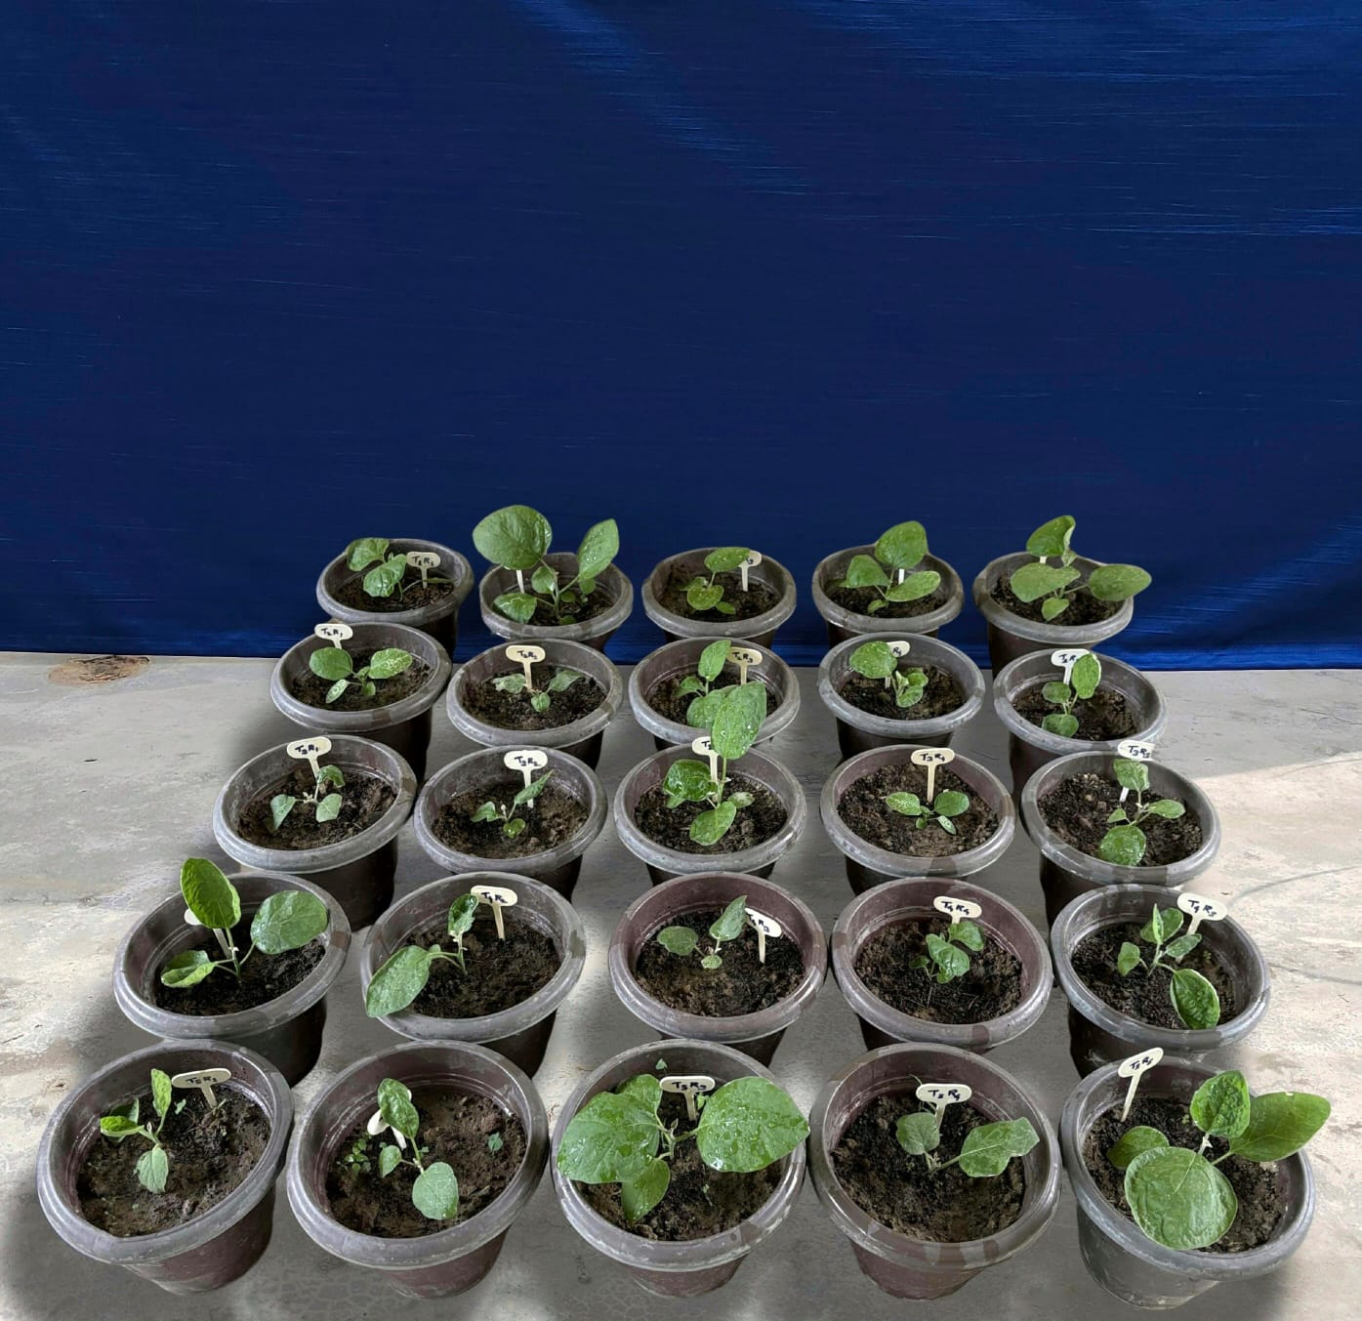
Plate 1: General view of the pot experiment

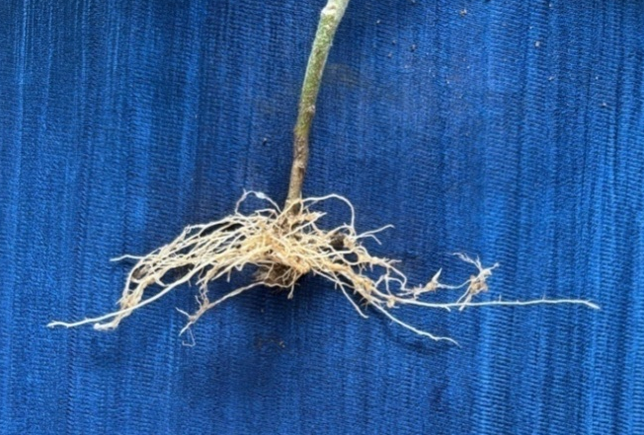
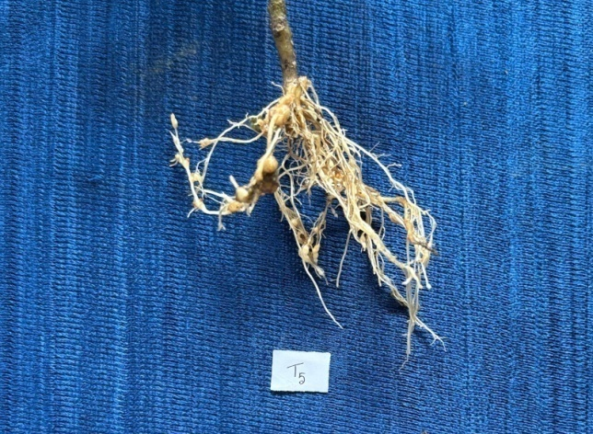
T4
T5 (Control)

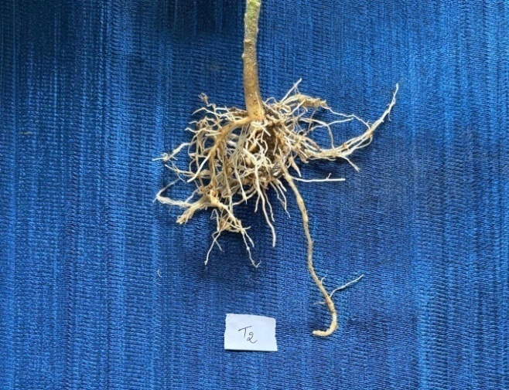
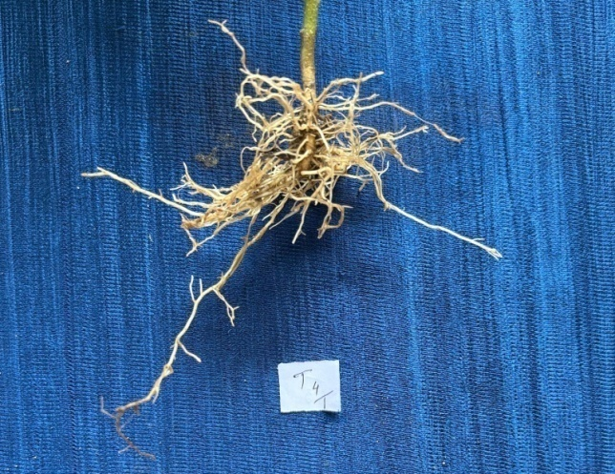
T2
T3

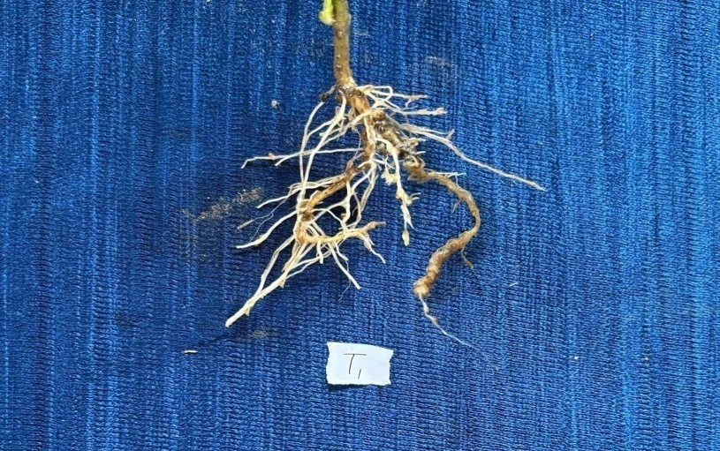
T1
Plate 2: Effect of different treatments on root growth of Brinjal

