Scientific Advances in Tomato (Solanum lycopersicum L.) Cultivation Agronomic Innovation and Genetic Improvement: A Comprehensive Review

ABSTRACT
Tomato (Solanum lycopersicum L.) is one of the world's most significant vegetable crops, appreciated for its high nutritional content, economic relevance, and wide range of industrial applications. It is high in vitamins, minerals, lycopene, and antioxidants, all of which help to improve human health and diet security. Tomatoes are the world's largest crop in terms of area and production, with India among the main producers. Climate change, soil degradation, soil types, pests, illnesses, physiological abnormalities, and post-harvest losses all have an impact on productivity. Recent developments in scientific farming procedures have shown amazing potential for increasing output, quality, and sustainability. Tomato production is being transformed by improved varieties and hybrids that are resistant to major biotic and abiotic challenges, precision farming techniques, drip irrigation and fertigation, integrated nutrition management, and protected culture systems including polyhouses and greenhouses. Plant growth regulators, grafting, and mulching all help to promote fruit set and quality. Integrated pest and disease management systems, together with biocontrol agents and resistant varieties, are critical for decreasing pesticide use and guaranteeing environmental safety. Post-harvest technologies such as better harvesting, grading, packaging, cold storage, and processing provide value to the supply chain while reducing waste. Furthermore, molecular breeding, marker-assisted selection, and CRISPR-based gene editing are emerging as significant genetic improvement technologies in tomato, with the potential to generate climate-resilient, nutrient-rich cultivars. It also emphasizes sustainable ways and future opportunities to increase production and profitability, assuring tomatoes' continued role as a major crop in global horticulture and nutrition security.
Keywords: Tomato, scientific cultivation, protected cultivation, biotic and abiotic stress, post-harvest management
- INTRODUCTION
Tomato (Solanum lycopersicum L.) is one of the world's most commonly grown and consumed vegetable crops, prized not just as a fresh fruit but also for its extensive processing into puree, paste, ketchup, sauce, soup, dehydrated powder, and canned tomato. Tomatoes, which belong to the Solanaceae family, originated in western South America, specifically in the Andean region, before spreading to Europe and then over the world following the Columbian exchange (Ahmad et. al., 2011). Tomatoes have evolved into a basic component of global diets, with plants produced in over 170 nations under a variety of climatic circumstances (Mahendrakar, 2004). Its versatility, high yield potential, and many applications in both residential and industrial sectors make it an essential crop for horticulture and agricultural economies (Rick, 1969).
Tomatoes are commonly referred to as a "protective food" due to their high concentration of vitamins, minerals, and health-promoting phytochemicals (Mc Cue, George Allen, 1952). It contains high levels of vitamin C, vitamin A (β-carotene), folate, potassium, organic acids, and dietary fibre (Bai & Lindhout, 2007). At least vit-A 320 IU, total sugar 3-4%, total solid 4-7%, ascorbic acid 15-30 mg/100 g, titrable acidity 7.5-10mg/100ml, lycopene content 20-50mg/100 g, and tomato seed contains 24% oil that is used in margarine. Lycopene, a carotenoid pigment that gives tomatoes their red color, has been related to antioxidant capabilities and possible roles in lowering the risk of chronic diseases like cancer and cardiovascular disease (Iqbal et al. 2019). With expanding consumer demand for functional foods and nutraceuticals, tomato has become increasingly important not only as a nutritional component, but also as a crop with enormous health-promoting potential (Singh et al., 2024).
Globally, tomato is one of the most important vegetable crops, second only to potato in terms of production. According to the Food and Agriculture Organisation (FAO), global tomato output surpasses 180 million metric tonnes per year, with China, India, Turkey, the United States, and Egypt being the leading producers. India, in particular, plays an important role in tomato farming, producing about 21.32 million tonnes, with key producing states including Madhya Pradesh, Andhra Pradesh, Karnataka, Odisha, Gujarat, Uttar Pradesh, and many others (Anonymous 2023-24). Despite its large agricultural area, India's production falls behind some top nations due to issues such as smallholder farming, low adoption of modern technologies, and sensitivity to pests and illnesses. This productivity disparity emphasises the critical need for scientific interventions in farming practices.
Tomato cultivation is important for more than just its nutritional and economic value; it also creates jobs, supports rural livelihoods, and contributes to the processing sector. The tomato processing sector is steadily developing as a result of increased processed food consumption, urbanization, and diet globalization (Wang et. al., 1998). Furthermore, tomato is an important vegetable with export potential, particularly for fresh produce and processed products. However, the fruit's perishability, combined with post-harvest losses estimated at 20-30% in poor nations, raises severe concerns among both farmers and consumers. Tomato cultivation, while profitable, suffers numerous restrictions. Biotic stressors including tomato leaf curl virus (ToLCV), bacterial wilt (Ralstonia solanacearum), early and late blight, fruit borer (Helicoverpa armigera), and whitefly infestations can have a substantial impact on yield and quality. Abiotic stressors such as heat, drought, salt, and nutrient deficiency all provide additional challenges to sustainable production (Ahmad et. al. 2016). Physiological diseases such as blossom end rot, fruit breaking, sunscald, and puffiness all diminish market value and farmer profits. Addressing these difficulties necessitates a multifaceted strategy that includes sophisticated crop innovation, resource-efficient agronomic approaches, integrated pest and disease management, and post-harvest technologies (Swami, 2023).
Tomato research and development have advanced dramatically during the last few decades. Conventional, molecular, and biotechnological breeding have resulted in improved varieties and hybrids that are resistant to key pests and illnesses (Tanuja & H.M. 2023). Production innovations such as drip irrigation, fertigation, mulching, high-density planting, and the use of plant growth regulators have improved productivity and resource utilization. Protected growing systems, such as polyhouses, greenhouses, and hydroponics, have provided new opportunities for off-season output, quality improvement, and climate-resilient agriculture (Blanca et al., 2015). The rising emphasis on organic farming, integrated nutrient management, and sustainable methods highlights the challenge of balancing productivity and environmental safety (Chetelat & Ji, 2007).
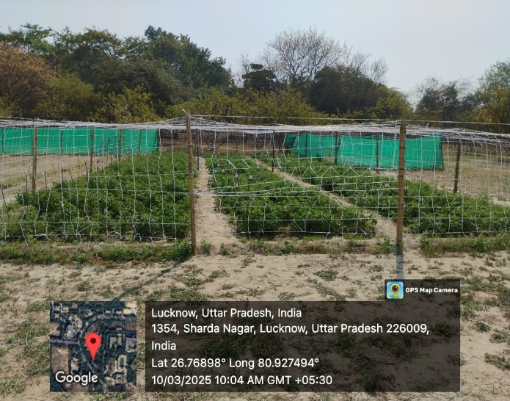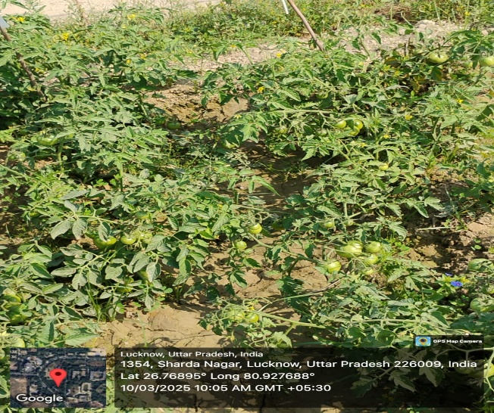
Image 1: General view of Tomato Field Image 2: View of Flowering and Fruiting
- TAXONOMY AND BOTANICAL DESCRIPTION
Tomato (Solanum lycopersicum L.) is a member of the Solanaceae family, which also includes potatoes (Solanum tuberosum), brinjal (Solanum melongena), chilli (Capsicum spp.), and tobacco (Nicotiana tabacum). The genus Solanum is one of the largest in the plant kingdom, with over 1,500 species spread around the globe. The cultivated tomato belongs to the Lycopersicon branch of this genus, which also includes several wild relatives that are rich sources of resistance genes and crop enhancement features (Parugganum & Fuller, 2009). Tomato has a basic chromosomal number of x = 12, a diploid chromosome complement of 2n = 24, and a genome size of around 950 Mbp, which has been fully sequenced, allowing for extensive molecular breeding and genomic investigations (Prasanna et al. 2023).
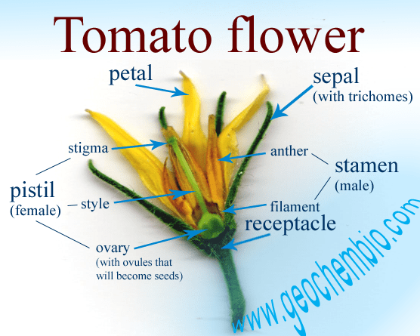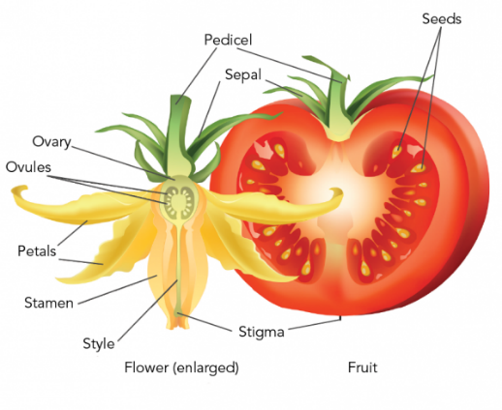
Image 3: Flower Parts of Tomato Image 4: Flower and Fruit Parts

Table 1: Muller (1940) vs Peralta et al. (2008) classification according to some aspects of tomato
Aspect | Muller (1940) | Peralta et al. (2008)
Basis of Classification | Morphological traits (fruit colour, hairiness, cross ability, plant habit). | Molecular phylogeny, morphology, cytogenetics and geographical distribution.
Name of genus | Lycopersicon (separate from Solanum). | All species merged into Solanum (section Lycopersicon of subgenus Potatoe).
Major Groups | Two Subgenera: 1. Eulycopersicon (red-fruited). 2. Eriopersicon (green-fruited) | No subgenera; species grouped within Solanum according to genetic relationship.
Eulycopersicon (Red-fruited group) | - L. esculentum (now S. lycopersicum) – cultivated tomato - L. pimpinellifolium - L. cerasiforme - Other red-fruited allies | All treated as Solanum lycopersicum complex (including S. pimpinellifolium, S. lycopersicum var. cerasiforme).
Eriopersicon (Green-fruited group) | - L. peruvianum - L. chilense - L. hirsutum - L. glandulosum - L. cheesmanii | - S. peruvianum complex - S. chilense - S. habrochaites (formerly L. hirsutum) - S. corneliomulleri (part of peruvianum group) - S. galapagense (split from L. cheesmanii)
Cultivated Tomato | Lycopersicon esculentum | Solanum lycopersicum
Wild Relatives | Divided into red-fruited (cross-compatible) and green-fruited (cross-incompatible). | Classified into distinct species complexes with precise phylogenetic relationships
(Peralta & Spooner, 2008)
Botanically, tomatoes are herbaceous annuals or short-lived perennials with a weak, spreading growth habit. Plants have a variety of growth types, including determinate, indeterminate, and semi-determinate forms, which affect canopy structure, flowering, and fruiting behaviour (Rick, 1978). The root system is shallow but widespread, with a robust tap root and well-developed lateral branches, allowing the crop to be somewhat drought-tolerant when properly managed (Rick, 1995). The stem is angular, covered with glandular and non-glandular hairs, and prone to forming adventitious roots when exposed to soil or high humidity. The leaves are complex and pinnately divided, having a distinct pungent odour due to glandular trichomes that release volatile oils. Flowers are tiny, yellow, and clustered (inflorescence type: cyme) (Du et. al. 2025). They are hermaphroditic and primarily self-pollinated, though cross-pollination by insects such as bees can occur in open-field situations. The floral structure, which includes poricidal anthers and a connate androecium encircling the stigma, favours autogamy, however variation in stigma exertion can promote natural outcrossing (Peralta & Spooner, 2007).
The fruit is a fleshy berry that varies in size, shape, and colour, ranging from round to rectangular, red and pink to yellow, orange, and even purple in certain wild or improved cultivars (Freeman & Reimers, 2011). Lycopene gives the colour red, beta carotene gives the colour yellow, and prolycopene gives the colour tangerine (Pinela et. al. 2022). The seeds are tiny, kidney-shaped, and embedded in mucilaginous pulp. Wild cousins of S. pimpinellifolium, S. cheesmaniae, and S. peruvianum have essential genes for disease resistance, abiotic stress tolerance, and quality features. These genetic resources, combined with the availability of molecular techniques, have significantly aided breeding efforts to create high-yielding, stress-resistant, and nutritionally better tomato cultivars (Peralta & Spooner, 2005).
- SOIL AND CLIMATIC REQUIREMENT
Tomato (Solanum lycopersicum L.) is a warm-season crop that thrives in a wide range of climates, contributing to its global distribution and year-round availability. However, optimal growth, development, and fruit quality require precise environmental conditions. The optimal temperature range for tomato cultivation is 21-27°C during the day and 18-20°C at night. Temperatures below 10°C and above 35°C are deleterious, resulting in poor seed germination, delayed blooming, diminished fruit set, and an increased risk of physiological problems. Lycopene production is maximum between 21 and 24 °C, whereas it rapidly decreases above 27 °C and is entirely destroyed at 40°C. High daytime temperatures combined with warm nights can result in flower drop, pollen sterility, and undersized or malformed fruits, whilst extended cold temperatures can slow growth and predispose plants to disease. Light intensity and duration are also important factors in affecting yield and quality, as tomatoes require plenty of sunshine for photosynthesis, colour formation, and lycopene synthesis.
Rainfall distribution is another key consideration. Tomatoes are susceptible to severe rainfall and high humidity, which promote the growth of fungal and bacterial diseases such early blight, late blight, and bacterial spot. In contrast, extended dry spells cause water stress, reduced fruit size, and blossom end rot. As a result, the optimum places for tomato growing are those with moderate rainfall, low relative humidity, and plenty of sunshine. Tomatoes are successfully grown in tropical and subtropical countries during the cooler months, whereas temperate climates crop them are grown during the summer. Protected farming with polyhouses, shade nets, and greenhouses has increased tomato production in off-seasons and non-traditional locales by reducing climate extremes. Soil conditions have a significant impact on tomato growth, output, and fruit quality. The crop thrives in well-drained sandy loam to clay loam soils with high organic matter levels. Soils with good water-holding capacity but appropriate drainage are ideal. The optimal soil pH is between 6.0 and 7.0, as severe acidity or alkalinity reduces nutrient uptake and plant health (Peter, 2009).
- VARIETIES IMPROVEMENT
The selection of a variety or hybrid is critical to the success of tomato agriculture because productivity, quality, and adaptability are heavily influenced by genetic potential. Tomato variations are divided into three categories: open-pollinated varieties (OPVs), hybrids, and special-purpose cultivars such as cherry, grape, or processing kinds. Tomatoes for processing require special characteristics such as high total soluble solids (TSS), deep red colour, thick pericarp, uniform ripening, and long shelf life. Processing types like as Punjab Chhuhara, Roma, and Arka Saurabh are commonly used for ketchup, puree, and paste manufacturing.
These cultivars are also ideal for mechanized harvesting and long-distance shipping. Breeding programs are heavily focused on developing cultivars that are resistant to biotic stressors such as Fusarium wilt, Bacterial wilt, Early blight, and ToLCV. Public research agencies such as ICAR-IARI, IIHR, and state agricultural colleges have generated a number of resistant cultivars and hybrids. Examples include Arka Rakshak (multiple disease resistance), Arka Samrat, and H-86. With advancements in molecular breeding, marker-assisted selection is being utilized to introduce resistance genes from wild cousins such as S. pimpinellifolium and S. habrochaites (Muthukumar & Selvakumar, 2017).
Table 2: Important Varieties and their characteristic
Characteristic feature | Important Varieties
Introduced | Roma, Sioux, Best of All, Tip Top, Marvel, Ageti, Marglobe,
Long Distance | Roma, Pusa Gaurav, Pusa Uphar, Punjab Chhuhara, Arka Abhijeet
Low temperature tolerant | Pusa Sheetal
High temperature tolerant | Pusa Hybrid-1
Processing | Pusa Gaurav, Pusa Uphar, Punjab Chhuhara, Arka Saurabh, Naveen, Arka Ahuti, Arka Ashish, HS-110, S-152, Melia Shelagh, Melia salsa
High and Low temperature | Pusa Sadabahar
Lycopene Rich | Pusa Rohini
Extreme early | Hissar Arun
Rainfed Condition | Arka Meghali
Drought Tolerant | Arka Vikas
Cherry Tomato | Sun Gold, Grape Tomato, Juane Flamme, Black Cherry, Cherry Pear, VT-95, Indigo Cherry Drops
Sources: Compiled Vegetable Science
Table 3: Improved Resistant Varieties
Resistant to | Important Varieties
Leaf curl | Hisar Anmol, Hisar Gaurav
Nematode and Bacterial Wilt | Arka Vardan
Verticillium and Fusarium wilt | Pant Bahar
Bacterial Wilt | Arka Alok, Arka Aabha, Arka Shresta, Arka Abhijeet, Sakti, Mukti, Manulakshmi, Utkal Kumari, Utkal Urvashi, Anagha
Early Blight, Bacterial Wilt and Leaf Curl | Arka Rakshak
Root Knot Nematodes | Hisar Lalit, Pusa Hybrid 2, Pusa Hybrid 2, Anahu
Sources: Compiled Vegetable Science
Table 4: Some Important Improved Hybrid Varieties
Varieties | Crossing Parents
Pusa Ruby | Sioux x Improved Meeruti
Pusa Early Dwarf | Improved Meeruti x Red Cloud
Hisar Anmol | Hisar Arun x L. hirsutum
Punjab Chhuhara | EC 55055 x Punjab Tropic
Pusa Gaurav | Glamor x Watch
Marglobe | Marvel x Globe
Pusa Red Plum | L. esculentum x L. Pimpinellifolium
Hisar Arun | Pusa Early Dwarf x K1
Hisar Lalima | Pusa Early Dwarf x HS 101
Hisar Lalit | Hs 101 x Resistance Bangalore
Arka Vishal | IHR 837 x IHR 932
Arka Meghali | Arka Vikas x IHR-554
Arka Samrat | IIHR-2835 x IIHR-2832
Sources: Essence of Horticulture
Table 5: Some Important Private Companies Tomato Varieties for Farmers Recommendation
Private Company | Varieties
Syngenta | Saaho, TO-1057, TO-3251, TO-6242, TO-8011
Nunhems/Bayer Crop Science | Arya, Shivalik, Anagha, US 440,
East West Seeds | Rassam 052, Ria 834, Raksha
Bejo Sheetal Seeds | BSS-488, BS-423
Namdhari Seeds | NS-501, NS 4266, NS 852, NS 426, NS 962
VNR Seeds | Swarna, VNR-28, VNR-111, VNR-3348
Seminis/Monsanto | Abhilash, Arka, Himsona, Ansal, Saksham
Golden Seeds | Abhimanyu
Nongwoo Seed India | TO 3340
Hind Agro Seeds | Hamilton

- PROPAGATION AND NURSERY MANAGEMENT
Tomatoes are propagated sexually by seeds, and the success of cultivation is heavily dependent on generating healthy, strong seedlings. Scientific nursery management enables consistent germination, healthy plant growth, and resistance to early pest and disease infestations, all of which have a direct impact on final production and quality.
  - Seed rate and Seed treatment
Use high-quality, certified seeds from recommended types or hybrids to ensure genetic integrity, viability, and vigour. Seed rates range from 400-500 g per hectare for open-pollinated varieties to 125-175 g per hectare for hybrids, depending on seed size and germination %. To prevent seed-borne infections, seeds are treated with fungicides (carbendazim or thiram at a dose of 2-3 g/kg) or bioagents such as Trichoderma viride. To promote germination, use pre-sowing treatments with growth regulators like GA₃ (100 ppm) or halo-priming. Additionally, hot water treatment can help remove bacterial pathogens.
  - Nursery Management
Traditionally, seedlings are raised on well-prepared, raised nursery beds of 3 × 1 m and 10-15 cm in height, to facilitate drainage. To reduce damping-off and nematode occurrence, the soil should be sterilized chemically (formalin, captan soaking) or solarized. A fine mixture of soil, sand, and farmyard manure (FYM) in a 2:1:1 ratio promotes adequate aeration and fertility. Sowing lines with an 8-10 cm spacing, followed by mild watering, promotes consistent seedling emergence. Modern cultivation, particularly for hybrids and greenhouse production, raises seedlings in plastic pro-trays (98 or 104 cells) packed with sterilized cocopeat, vermiculite, and perlite combination. This method prevents root damage during transplantation, enhances consistent seedling growth, and lowers disease incidence. Plug-raised seedlings are ideal for high-value cultivation and advanced farming.
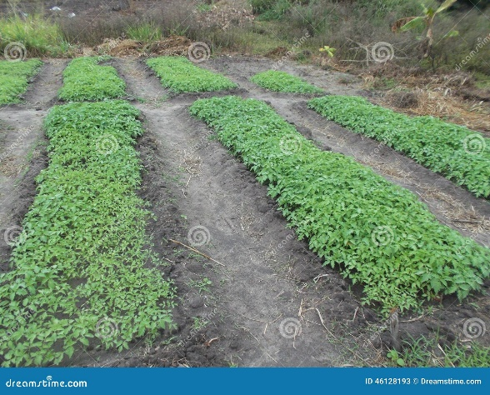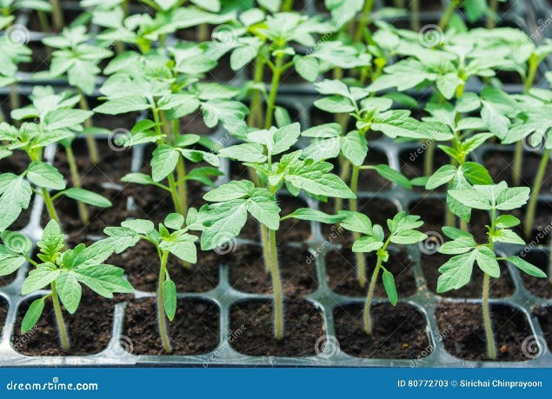
Image 5: Open Field Nursery Image 6: Portray Nursery

  - Nursery care and Transplanting
Regular Watering, weeding, and pest control (whiteflies, thrips, leaf miners) are all necessary during nursery growth. The use of a diluted nutrient solution or biofertilizers such as Azospirillum and PSB improves seedling vigour. Before transplanting, seedlings are toughened by withholding irrigation for 4-5 days and progressively exposing them to direct sunshine, which increases their chances of survival in the field. Healthy seedlings between 25 and 30 days old with 4-5 genuine leaves are appropriate for transplantation onto the main field or sheltered structures. Grafted seedlings with disease-resistant rootstocks are increasingly used to combat soil-borne diseases such as bacterial wilt and root-knot nematodes (Singh, 2010).
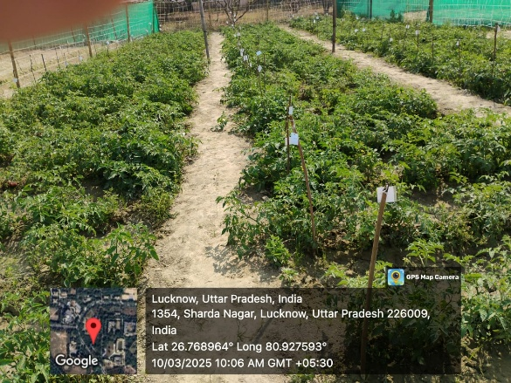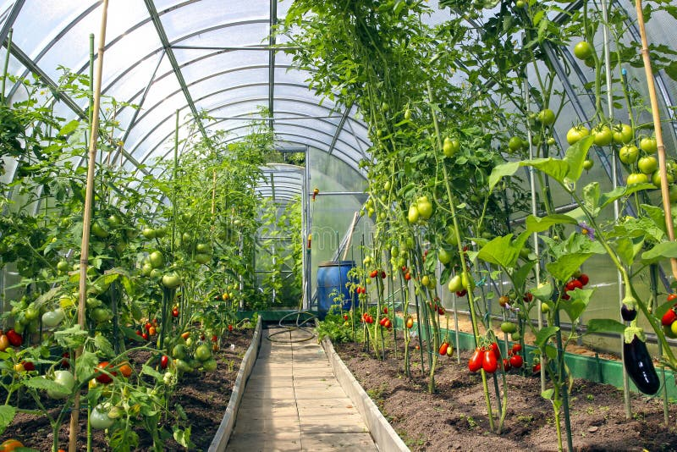
Image 7: Open Field Image 8: Under Protected
- FIELD CULTIVATION PRACTICES
To attain higher output, better fruit quality, and more efficient resource use, tomato cultivation must be carefully integrated with scientific field management approaches. Land preparation, planting systems, nutrition and water management, weed control, training and pruning, mulching, and the use of plant growth regulators are all part of field operations. Each component must be tuned based on the production system (open-field, rainfed, irrigated, or protected cultivation).
  - Land Preparation
Proper land preparation creates optimal soil conditions for root growth, aeration, and nutrient availability. To produce a good tilth, plough the land 2-3 times and then harrow it. To improve soil structure and fertility, add well-decomposed farmyard manure (20-25 t/ha) during the final ploughing. Raised beds or ridges and furrows are recommended to prevent waterlogging, particularly in heavy soils or rainy seasons. In sandy soils, flat beds can be used.
  - Planting Technique
The method of planting tomatoes has a significant impact on crop establishment, growth uniformity, and yield. Proper spacing, planting system, and planting depth ensure that plants make the best use of soil nutrients, water, and light, while also facilitating intercultural operations and pest disease management.
    - Season of Planting
The best time to plant varies depending on the geography and production system. In northern India, the main tomato seasons are kharif (July-September), rabi (October-November), and summer (February-March). Because of the mild temperature, tomatoes are produced virtually all year in the south and along the shore. Protected farming involves staggered planting to provide a consistent supply of fruits, with high-value hybrids moved during the off-season to fetch premium market prices.
    - System of Planting and Spacing
Tomato can be planted using different systems and spacing depending on the production objective:
Flat Bed Planting: A traditional practice in which seedlings are placed into level soil. Suitable for small-scale agriculture, but susceptible to waterlogging and soil-borne illnesses.
Ridge and Furrow System: Commonly used in irrigated fields, particularly in thick soils. Seedlings are transplanted on ridges 60-75 cm apart to increase drainage, root aeration, and decrease collar rot.
Raised Beds: In intensive or sheltered farming, raised beds (15-20 cm height, 1-1.2 m width) coated with plastic mulch are commonly employed. This strategy preserves soil moisture, controls weeds, maintains soil temperature, and improves fruit hygiene.
Portray Plug Planting: Plug-raised seedlings are transplanted directly into the main field or greenhouse beds, reducing transplant shock and ensuring consistent stand establishment.
The optimal plant density is critical for balancing vegetative development and fruit yield. Spacing needs vary based on variety, season, and training system. Plant open-field varieties at 60 × 45 cm, hybrids under staking/training at 90 × 45 cm, and greenhouse indeterminate hybrids in double-rows on raised beds at 40-50 cm inside row and 80-100 cm between rows (Chadha et al., 2001).
  - Fertilization
Fertilizer management is critical in tomato agriculture since the crop is a heavy feeder that requires a steady supply of nutrients for optimal growth, yield, and fruit quality. A tomato crop yielding 50-60 t/ha removes around 120-150 kg nitrogen (N), 60-80 kg phosphorus (P₂O₅), and 60-120 kg potassium (K₂O) each hectare, along with secondary and micronutrients such as calcium, magnesium, boron, and zinc. Organic manures, particularly 20-25 t/ha farmyard manure (FYM) or compost, should be used in field preparation to improve soil structure and microbial activity.
In general, half of the nitrogen, phosphorus, and potassium are provided as a basal dose, with the remaining N and K top-dressed at 25–30 days intervals to synchronize with crop demand. Drip fertigation with water-soluble fertilizers (19:19:19, 12:61:00, 13:0:45) is commonly used in commercial farming to increase nutrient-use efficiency and production by 20-30%. During flowering and fruiting, micronutrient sprays such as boron (20 ppm), zinc sulphate (0.5%), and calcium nitrate help to reduce flower drop, poor fruit set, and blossom end rot. Integrated nutrient management (INM), which includes fertilizers, biofertilizers, and organics, not only maintains productivity but also enhances soil health and long-term viability in tomato farming (Fagaria et al., 2016).
  - Irrigation
Irrigation is crucial in tomato agriculture because the crop is extremely sensitive to both moisture stress and excess water, and its productivity and quality are dependent on maintaining optimal soil moisture throughout the growing season. Tomatoes require approximately 400-600 mm of water per crop cycle, with flowering, fruit set, and fruit enlargement being critical growth stages. Even minor water deficits can result in flower drop, reduced fruit set, blossom end rot, and smaller fruits, whereas excess moisture or waterlogging promotes root diseases, poor aeration, and fruit cracking.
Traditionally, tomatoes have been irrigated with furrow or basin methods at intervals of 7-10 days in winter and 5-6 days in summer, depending on soil type and climate, however such methods frequently result in large water losses due to evaporation and percolation. Modern techniques, such as drip irrigation paired with mulching, are increasingly being used because they enable regular water distribution at the root zone, increase water-use efficiency by 30-40%, reduce weed growth, and maintain stable soil moisture, all of which improve fruit quality and output. Drip irrigation also improves fertigation by allowing for the accurate administration of water-soluble fertilizers straight to the roots, decreasing nutrient losses and increasing output by 20-30% (Kere et al., 2003).
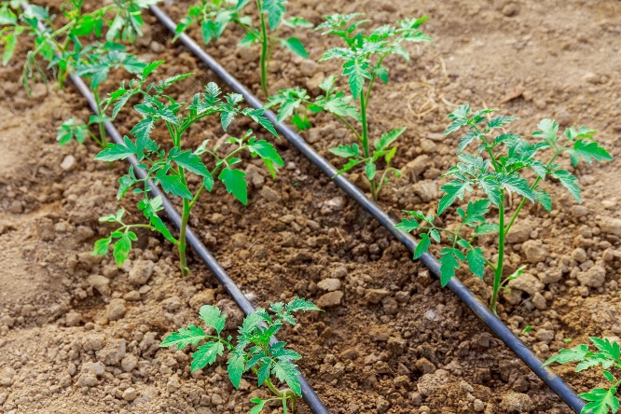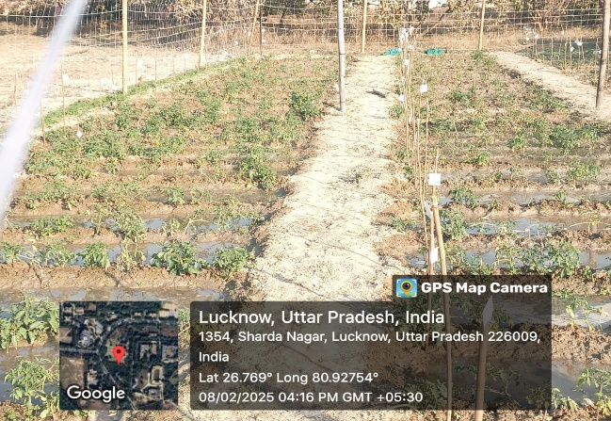
Image 9: Drip Irrigation Image 10: Open Field Irrigation
6.5 Plant Growth Regulator
Plant Growth Regulators (PGRs) are vital tools in current tomato agriculture because they govern growth, blooming, fruit set, ripening, and stress tolerance, resulting in higher output and quality. Pre-sowing seed treatments with gibberellic acid (GA₃, 50-100 ppm) improve seed germination, seedling vigour, and uniformity, whereas auxins like IBA and NAA stimulate root initiation and seedling establishment. Spraying auxins such as NAA (15-20 ppm) or 2,4-D (20-25 ppm) during flowering can improve fruit set and stimulate parthenocarpy. GA₃ (10-20 ppm) promotes early flowering and increased fruit number in hybrids.
Growth retardants such as chlormequat chloride (CCC, 200-500 ppm) and maleic hydrazide can reduce excessive vegetative growth, particularly in indeterminate types and under protected settings, by limiting plant height and balancing vegetative and reproductive growth. Cytokinins like kinetin and benzyladenine delay leaf senescence, increase photosynthetic activity, and improve fruit size and sink strength, whereas ethylene-releasing chemicals like ethephon (500-1000 ppm) expedite uniform ripening, boost lycopene production, and improve marketability. Furthermore, PGRs have a role in stress reduction, with substances such as salicylic acid (50-100 ppm), brassinosteroids, and jasmonic acid increasing tolerance to drought, salinity, and temperature extremes by strengthening antioxidant defense and osmotic adjustment. GA₃ and 1-methylcyclopropene (1-MCP) are post-harvest regulators that delay ripening, suppress ethylene action, maintain firmness, and extend shelf life (Sahu & Pathak, 2025).
6.6 Training and Pruning
Training and pruning are important methods in tomato cultivation, especially for indeterminate and hybrid types, because they assist in regulating plant development, improve light penetration, increase air circulation, and ensure superior fruit quality (Anand et. al., 2018). In open-field circumstances, determinate types typically require little training, however staking is commonly used to keep fruits off the ground and prevent disease incidence. To improve space usage and facilitate cultural operations, indeterminate and greenhouse-grown tomatoes are trained vertically with pegs, wires, or strings that tie and guide plants upward (Septa et al., 2013).
Pruning is the removal of side shoots (suckers) from leaf axils, which inhibits excessive vegetative growth, diverts assimilates to fruit development, and produces larger, more uniform fruits (Shilpa et al., 2024). In protected cultivation, single- or double-stem training methods are widely used, with the main shoot(s) retained and all other suckers removed at regular intervals (Alam et. al., 2016). Pruning on time improves spray penetration, harvest efficiency, and fruit quality. Combined training and pruning procedures not only improve plant architecture but also result in larger yields, higher-quality fruits, and longer harvesting periods, making them indispensable in scientific tomato agriculture, particularly in intensive and protected agricultural systems (Razzak et al., 2013).
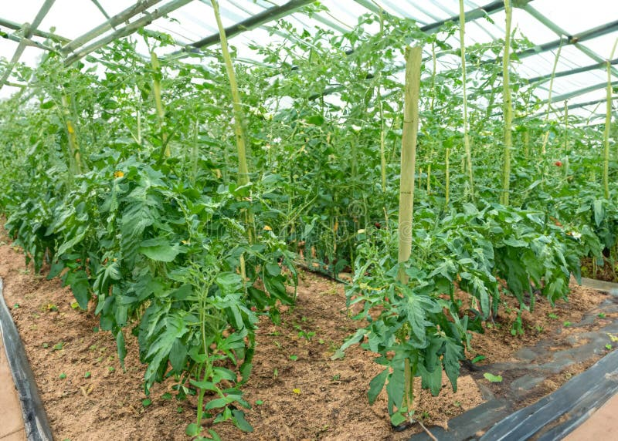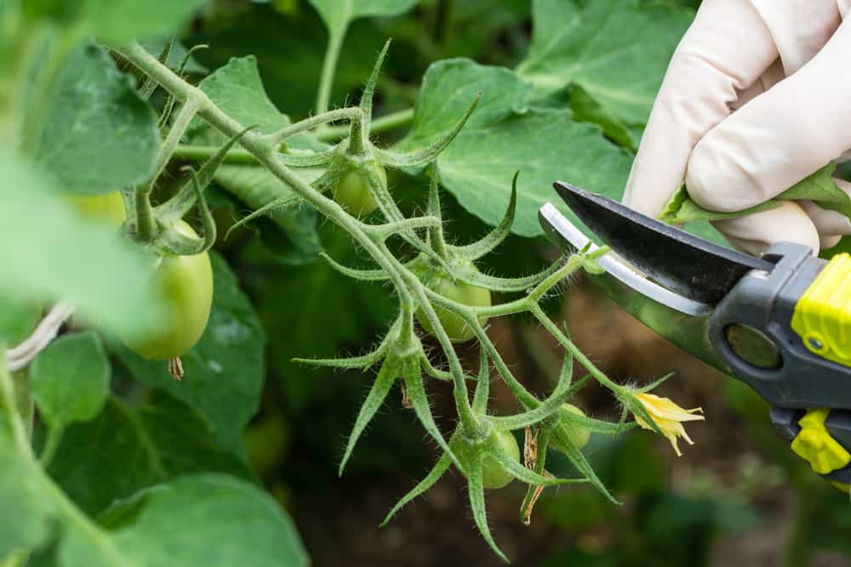
Image 11: Tomato Training Image 12: Tomato Pruning
6.7 Weed Management
Weed management is an important aspect of tomato production since weeds compete strongly for nutrients, moisture, light, and space, especially in the first 45-60 days after transplanting, when crop-weed competition is at its peak. Common weeds in tomato fields include Amaranthus viridis, Cyperus rotundus, Chenopodium album, Phalaris minor, and Parthenium hysterophorus. Weeds, if not controlled, can diminish productivity by 30-60% while also acting as alternative hosts for insect pests and illnesses. Integrated weed management is thus advocated, which combines cultural, mechanical, and chemical techniques. Traditional procedures like hand weeding and hoeing 20-25 and 40-45 days after transplanting are still effective, although they are labour-intensive. Mulching with organic wastes or plastic films effectively reduces weed growth, conserves soil moisture, and improves fruit quality. Pre-emergence herbicides such as pendimethalin (1.0-1.5 kg a.i./ha) and alachlor (1.5 kg a.i./ha) used soon after transplanting efficiently manage annual weeds, but post-emergence alternatives such as quizalofop-ethyl and oxyfluorfen target grasses and broadleaf weeds, respectively. Drip irrigation and mulched systems reduce herbicide use, making the system more sustainable. Adopting a thorough weed management plan minimizes competition and production costs while also improving nutrient-use efficiency, fruit output, and profitability in tomato agriculture .
- DISEASES AND INSECTS
Tomato, as a globally important vegetable crop, are very susceptible to a variety of insect pests and illnesses that considerably affect output and fruit quality, necessitating integrated management measures. The tomato fruit borer (Helicoverpa armigera) is the most destructive of the major insect pests, boring into developing fruits and causing a direct yield loss of 30-50%; its management includes pheromone traps, biological control with Trichogramma and Helicoverpa Nuclear Polyhedrosis Virus (HNPV), and need-based insecticide sprays such as spinosad or emamectin benzoate (Bose et. al., 1993). Whiteflies (Bemisia tabaci) not only suck sap but also transmit Tomato Yellow Leaf Curl Virus (TYLCV), causing severe stunting and yield loss; treatment strategies include yellow sticky traps, neem oil sprays, resistant hybrids, and systemic insecticides like imidacloprid. Thrips (Thrips tabaci, Frankliniella occidentalis) damage leaves and spread Tomato Spotted Wilt Virus (TSWV), which is managed by blue sticky traps, predatory mites, and spinetoram sprays. Aphids (Aphis gossypii) induce curling, diminished vigour, and viral transmission, which can be controlled with cultural sanitation and insecticide treatments. Leaf miners (Liriomyza trifolii) create serpentine mines that limit photosynthesis and predispose plants to illnesses, necessitating neem-based biopesticides and parasitoids such as Diglyphus isaea (Khan et al. 2024).
Other pests include mealybugs, spider mites, and root-knot nematodes (Meloidogyne spp.), which cause galling on roots, nutrient deficiencies, and wilting and can be controlled with resistant rootstocks, crop rotation, and soil solarization. Tomatoes are equally sensitive to a variety of fungal, bacterial, and viral illnesses. Early blight (Alternaria solani) is a widespread fungal disease that causes concentric ring spots on leaves and fruits, limiting photosynthetic activity. It is treated through crop rotation, resistant varieties, and fungicides such as mancozeb or chlorothalonil. Late blight (Phytophthora infestans), which thrives in high humidity and low temperatures, generates water-soaked lesions and fruit rot, resulting in epidemics that can be managed with metalaxyl-mancozeb or dimethomorph sprays. Septoria leaf spot (Septoria lycopersici) causes premature defoliation, necessitating cleanliness and fungicide applications. Fusarium wilt (Fusarium oxysporum f. sp. lycopersici) and Verticillium wilt (Verticillium dahliae) produce yellowing, vascular darkening, and plant collapse, which can be handled by resistant cultivars, crop rotation, and biocontrol agents such as Trichoderma. Damping-off (Pythium, Rhizoctonia solani) harms seedlings and is managed with soil sanitation, raised beds, and seed treatments. Bacterial diseases, such as bacterial wilt (Ralstonia solanacearum), induce abrupt wilting and vascular browning and can be treated through grafting onto resistant rootstocks, crop rotation, and soil amendments. Bacterial spot (Xanthomonas campestris pv. vesicatoria) and bacterial speck (Pseudomonas syringae pv. tomato) cause foliar and fruit lesions, lowering market value, and are managed with copper-based treatments and sanitation. Viral infections are especially damaging, with Tomato Yellow Leaf Curl Virus (TYLCV) spread by whiteflies causing severe stunting, yellowing, and yield losses of up to 100%, necessitating resistant hybrids, vector management, and rouging of diseased plants. Tomato mosaic virus (ToMV) and cucumber mosaic virus (CMV) produce mosaic, mottling, and leaf distortion and are transmitted mechanically or by aphids, demanding seed health, resistance cultivars, and cleanliness. The Integrated Pest and Disease Management (IPDM) approach is promoted, which includes resistant cultivars, crop rotation, sanitation, biological control, pheromone and sticky traps, soil solarization, organic amendments, and pesticide usage. This comprehensive technique decreases crop loss, ensures sustainability, reduces pesticide residues, and increases profitability in tomato production systems (Shankar et al., 2009).

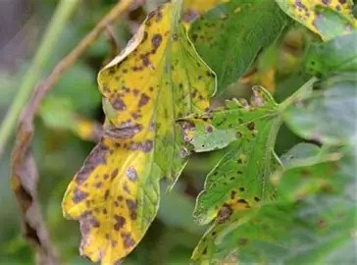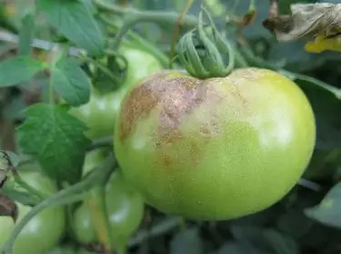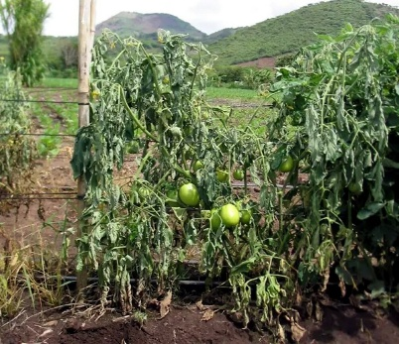
Image 13: Early Blight Image 14: Late Blight Image 15: Bacterial Wilt

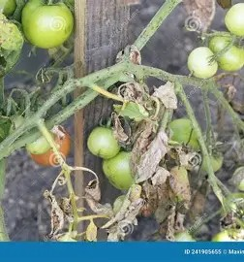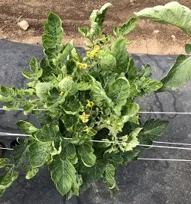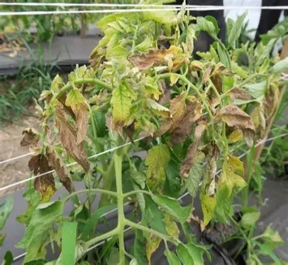
Image 16: Fusarium Wilt Image 17: TLCV Image 18: Spotted Wilt Virus
- PHYSIOLOGICAL DISORDERS
Tomato, despite being one of the most widely cultivated vegetables, is extremely sensitive to changes in environmental conditions, nutrient imbalances, and cultural practices, which frequently result in a variety of physiological disorders that significantly reduce yield, fruit quality, and marketability, even when they are not caused by pathogens or insects. Blossom end rot (BER), characterized by dark, sunken patches at the blossom end of fruits, is primarily caused by localized calcium deficiency exacerbated by irregular irrigation, excessive nitrogen, or high transpiration rates; it is managed through consistent soil moisture, balanced fertilization, and calcium nitrate foliar sprays. Another major disorder is fruit cracking, which occurs when mature fruits develop radial or concentric cracks as a result of sudden fluctuations in soil moisture, high humidity, or excess nitrogen, making them more susceptible to infections; it can be reduced by maintaining uniform irrigation, mulching, and cultivating crack-resistant varieties. Sunscald occurs when fruits are directly exposed to high sunshine, resulting in bleached, leathery patches. It is more common in areas with defoliation or insufficient canopy protection; it can be decreased with correct training, staking, and the use of shade nets. Cat facing, characterized by deformed fruits with uneven scars, has been linked to cool weather during blooming, severe pruning, or high amounts of growth regulators, necessitating stress-free fruit set and balanced cultural practices (Reddy & Kumar, 2022).
Zippering, which causes longitudinal scars resembling a zipper across the fruit, happens as a result of improper anther attachment or high humidity at anthesis, and, while less damaging, diminishes market value. Puffiness, also known as fruit puff, is characterized by light, poorly filled fruits with hollow spaces caused by insufficient pollination, hot temperatures, or excessive nitrogen. It can be reduced by maintaining ideal temperature, pollinator activity, and balanced nutrition. Gold flecking appears as tiny gold flecks on fruit skin as a result of excessive copper fungicide treatments, whereas stalk necrosis is caused by calcium shortage and water stress, both of which require nutritional adjustment. Green shoulder, also known as yellow shoulder disorder, causes uneven ripening with green or yellow areas around the fruit stem as a result of low potassium availability, low temperature, or genetic predisposition, and can be managed through improved potassium fertilization, uniform ripening conditions, and resistant hybrids. Internal white tissue or hardcore condition is caused by high temperature stress and potassium shortage, resulting in white streaks or patches within fruits that alter texture and necessitate correct nutrient management. Blotchy or uneven ripening is prevalent due to low light intensity, nutrient imbalances, or viral infections, resulting in fruits with non-uniform colour patches that limit consumer acceptance; it can be reduced by assuring balanced potassium, magnesium, and light exposure levels (Patil et. al., 2018).
Furthermore, cold injury happens when tomatoes are subjected to chilling temperatures below 12°C, resulting in poor colour development, pitting, and a shorter shelf life, whereas heat injury occurs at extremely high temperatures, resulting in blossom drop, poor fruit set, and reduced pollen viability. Some physiological difficulties are also caused by cultural techniques, such as excessive nitrogen, which promotes lush vegetative growth at the price of fruiting, and waterlogging, which causes poor aeration, nutrient leaching, and diminished root activity. These illnesses underscore the delicate balance needed in tomato production between environmental conditions, nutrient supply, and crop management approaches (Maurya et. al., 2024).
- ADVANCES OF BREEDING AND BIOTECHNOLOGY
Over the last few decades, there has been substantial development in tomato breeding, to develop cultivars that are high-yielding, disease-resistant, nutritionally superior, and climate robust (Fentik, 2017). Traditional breeding techniques like as hybridization, selection, and backcrossing have been widely utilized to increase features such as fruit size, shape, color, and firmness, as well as resistance to important diseases such as Fusarium wilt, Verticillium wilt, and Tomato Mosaic Virus (ToMV). Tomato has a genomic size of 950 Mbp. Tomatoes have 12 chromosome pairs, with the 1st being the largest, the second being the satellite chromosome, the 12th being the shortest, and the TYLCV-resistant Ty-2 gene located on the 11th chromosome (Kaloo, 1991). The introduction of hybrids has transformed commercial tomato production by increasing yield potential, consistency, and marketable quality (Chattopadhyay & Paul 2012). Modern breeding programs increasingly use molecular markers, marker-assisted selection (MAS), and genomic technologies to speed up the introgression of desirable traits. Breeders can better select superior genotypes by mapping quantitative trait loci (QTL) for fruit quality, yield components, and stress tolerance (Brewer et al.,2007). Furthermore, the application of mutagenesis and polyploidy induction has resulted in unique variability in fruit traits and stress response, hence increasing the genetic base of cultivated tomato (Singh et al., 2021). Breeding for abiotic stress tolerance, particularly drought, salinity, and high-temperature stress, is becoming increasingly important in the context of climate change, with suitable germplasm being identified via physiological and molecular screening methods (Sharma et al., 2019).
Table 6: Genes and Their Location
Gene | Located on
Nr (Never Ripe) | 1st Chromosome
Ty-4 | 3rd Chromosome
Ty-5 | 4th Chromosome
Rin (Ripening inhibitor) | 5th Chromosome
Ty-1, Ty-3, Mil 2 and Og^{c} | 6th Chromosome
Tm-2, Ph-3 | 9th Chromosome
Nor (non-ripening) | 10th Chromosome
Ty-2 | 11th Chromosome
Sources: Compiled Vegetable Science
Table 7: Some Important Transgenic Varieties, Traits and Gene Introduced from Genetic Improvement
Transgenic Varieties | Traits/Purpose | Gene Introduced
Flavr Savr | Delayed ripening, Long self-life | Antisense polygalacturonase (PG) gene
Bt Tomato | Resistance to fruit borer | Cry 1 Ac, Cry 2 Ab (Bt genes)
Virus Resistant | Resistance to ToLCV, CMV, TYLCV | Coat protein genes/ RNAi constructs
Purple Tomato | High anthocyanin (antioxidant-rich) | Del and Ros 1 (snapdragon)
High Lycopene Tomato | Nutritional improvement (antioxidant) | Overexpression of phytoene synthase or silencing of competing pathway
Biotechnology has accelerated tomato improvement by allowing very precise genetic alterations that are not achievable with traditional approaches (Ashish et al., 2017). Genetic engineering and transgenic techniques have been effectively used to provide resistance to viruses, nematodes, and fungal diseases, as well as to improve nutritional quality through increased lycopene, vitamin C, and antioxidant content (Khan et al., 2024). RNA interference (RNAi) and CRISPR/Cas genome editing have emerged as effective techniques for targeted gene silencing or editing, enabling the creation of disease-resistant, parthenocarpic, or shelf-stable cultivars. Tissue culture techniques, such as micropropagation and somatic embryogenesis, allow for the rapid multiplication of elite genotypes while also providing virus-free planting material. Furthermore, haploid and doubled haploid technology hastens the production of pure lines, decreasing the breeding cycle significantly (Kumar et. al., 2012). The incorporation of genomics, transcriptomics, and metabolomics into traditional breeding provides a systems-level understanding of gene function, stress responses, and quality attributes, opening the path for precision breeding (Shah, 2020).
Table 8: Single genes useful in Tomato Genetic Improvement
Gene designation | Gene Symbol | Variety
Self-Pruning | sp | Many
Potato leaf | c | Geneva 11
Jointless pedicel | j-1, j-2 | Pen Red and many varieties
Race 1 | I-1 | Pan American
Race 2 | I-2 | Walter
Tangerine | t | Sunray
Colourless peel | y | Traveller
Uniform ripening | u | Heinz 1350
High beta-carotene content | B | Caro Rich
Non-ripening | nor | Long Keeper
Uniform ripening | u | uHeinz-1350
Nematode resistance | Mi | Rossoll, VFN-Bush
Late blight resistance | Ph-1 | New yorker
Septoria resistance | Se | Targinnie Red
High Pigment | hp | Red Bush
Parthenocarpic fruit | Pat-2 | Severianin
Crimson Colour | Og^{c} | Vermillion
Sources: Essence of Horticulture
- FUTURE PROSPECTS
To meet the growing worldwide demand for high-quality, nutritious, and climate-resilient produce, tomato cultivation must use sophisticated breeding, precision agriculture, and sustainable production practices (Singh & Kumar, 2024). The development of high-yielding hybrids and varieties with combined resistance to major pests, diseases, and abiotic stresses will remain a top focus, aided by genomic tools, marker-assisted selection, and CRISPR/Cas-based genome editing for targeted trait modification. Protected culture, hydroponics, and vertical farming are predicted to develop, allowing for year-round production, efficient resource usage, and low post-harvest losses. The integration of digital agriculture tools, such as sensors, remote sensing, and AI-based decision support systems, will improve irrigation, fertilizer management, and pest control, boosting productivity and sustainability. The emphasis on nutritional enhancement, such as increased lycopene, vitamin C, and antioxidant content, will appeal to health-conscious customers.
  - Tomato Grafting
Tomato grafting is a sophisticated technique for improving crop performance, yield, and resistance to soil-borne pathogens and abiotic challenges. It entails crossing a scion of a desirable commercial tomato variety with a rootstock resistant to diseases such as Fusarium, Verticillium, and bacterial wilt, as well as tolerance to salinity and drought. The procedure is carried out using splice, tube, or cleft grafting techniques, usually under controlled nursery circumstances. To guarantee a successful union, seedlings are housed in a healing chamber with optimal humidity and temperature following grafting. Grafted tomato plants have more robust root systems, improved nutrient uptake, and higher fruit quality. This approach is especially useful in intensive cultivation systems, greenhouse production, and places where continuous cropping raises disease burden (Singh et. al. 2017). Although grafting raises seedling costs, the benefits of increased output and lower pesticide use make it a long-term practice in commercial tomato farming. Common tomato rootstocks include Beaufort, Maxifort, Emperador, Dro141TX, Multifort, and Hawaii 7996, which are resistant to Fusarium, Verticillium, nematodes, and bacterial wilt. Wild species such as S. habrochaites and S. peruvianum are also used in grafted tomato cultivation due to their excellent root vigour and stress tolerance (Ramírez-Ojeda et. al., 2007).

- HARVESTING OF TOMATO
Tomato harvesting varies depending on whether the crop is produced in an open field or in a greenhouse. Harvesting in open field agriculture typically begins 60-75 days after transplantation and lasts 2-3 months, depending on the variety and season. Fruits are harvested at three maturity stages: mature green for long-distance transit, breaker or turning stage for local markets, and completely ripe for immediate consumption or processing. Harvesting is done manually with hands or clippers, ideally in the morning to prevent field heat. Proper handling, sorting, and grading are critical for reducing mechanical harm and post-harvest losses. Harvesting begins slightly earlier in greenhouse tomato farming, around 50-60 days after transplanting, due to improved growth circumstances. Fruit is often harvested at the breaker or pink stage to guarantee even ripening during storage and transportation. Fruits are immediately packed in clean plastic boxes and stored in cool, ventilated rooms to maintain their freshness. Frequent and timely harvesting increases output, preserves plant vitality, and provides a consistent supply to the market.
- PROCESSING
It is suitable for both fresh consumption and processing into a variety of value-added products (Sundar et. al., 2024). Because tomatoes are extremely perishable due to their high moisture content, short shelf life, and susceptibility to microbial deterioration, processing is critical in decreasing post-harvest losses and guaranteeing year-round availability of tomato-based goods (Jongen, 2002). Processing begins with the selection of suitable cultivars, such as Roma or San Marzano varieties, which have high total soluble solids (TSS), firm texture, deep red colour, and high lycopene levels. Tomatoes are cleaned, graded, and blanched after harvesting to deactivate enzymes and preserve colour and flavour. One of the most prevalent ways is heat processing, which involves cooking, pulping, and concentrating tomatoes under controlled settings (James & Kuipers, 2003).
It is suitable for both fresh consumption and processing into a variety of value-added products. Because tomatoes are extremely perishable due to their high moisture content, short shelf life, and susceptibility to microbial deterioration, processing is crucial in reducing post-harvest losses and ensuring year-round availability of tomato-based products (Maurya et al., 2024). Processing begins with the selection of suitable cultivars, such as Roma or San Marzano varieties, which have high total soluble solids (TSS), firm texture, deep red colour, and high lycopene levels (Peter, 2007). Tomatoes are cleaned, graded, and blanched after harvesting to deactivate enzymes and preserve colour and flavour. One of the most prevalent ways is heat processing, which involves cooking, pulping, and concentrating tomatoes under controlled settings.
Canning, bottling, dehydration, and aseptic packaging are examples of preservation processes used to extend shelf life while maintaining nutritional and sensory integrity. Processed products not only stabilize surplus output, but they also increase economic value, generate export prospects, and provide greater returns to farmers and industries. The variety of processed tomato products is extensive, catering to both domestic and foreign markets. Tomato juice, puree, paste, and ketchup are the primary products, serving as foundation for a variety of cuisine dishes. Tomato sauce, chutneys, soups, and ready-to-eat gravies are popular convenience foods made with concentrated pulp. Dehydrated tomato powder and flakes are used in fast soups, noodles, and snacks, although freeze-dried tomato slices are gaining popularity in high-end markets (Khan et al., 2023).
On an industrial scale, tomato paste is an important intermediate product that is frequently exported and reconstituted into ketchup and sauces in importing nations. Tomato ketchup and sauces remain the most popular goods worldwide due to their flavour, versatility, and extended shelf life. Furthermore, the extraction of lycopene, a potent antioxidant pigment, has gained attention in the nutraceutical and pharmaceutical industries. Advances in food technology, such as vacuum evaporation, spray drying, and aseptic packing, have enhanced product quality, stability, and storage. Thus, tomato processing not only ensures the efficient use of surplus produce, but also provides consumers with healthy, convenient, and diverse food products, all while contributing considerably to the agri-food industry (Meena & Suresh, 2013).
Processed Product | TSS (%)
Tomato Juice | 5
Tomato Soup | 7
Tomato Puree | 9
Tomato Paste | 25
Tomato Ketchup | 28
Tomato Sauce | 30
Table 9: Tomato Different Processed Products and Their TSS (%)

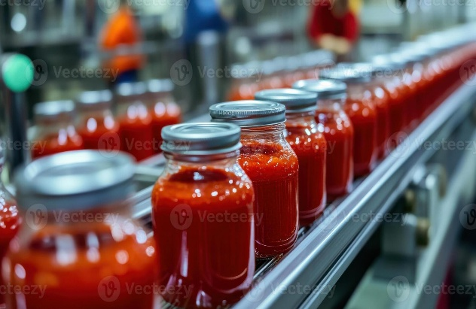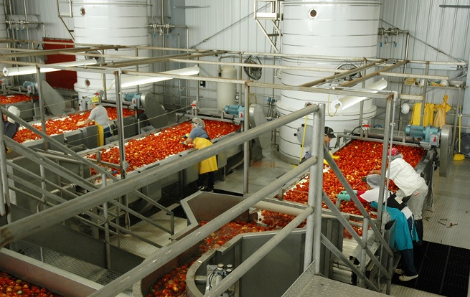
Image 19: Processed Products Image 20: Processed Unit
Conclusion
To summarize, tomato agriculture is an important component of global vegetable production because of its high nutritional value, economic relevance, and tolerance to a variety of agro-climatic situations. Scientific procedures that include varietal selection, enhanced cultural practices, fertilizer and water management, pest and disease control, and post-harvest handling are required to produce high yields, excellent quality, and sustainability. Advances in plant breeding, biotechnology, and molecular tools have enabled the development of high-yielding, disease-resistant, and nutritionally enhanced varieties, while modern protected cultivation techniques, such as greenhouse production, hydroponics, and vertical farming, provide year-round supply and efficient resource utilization. The combination of precision agriculture technologies, digital tools, and decision support systems improves irrigation, nutrient application, and pest management, lowering losses and environmental effects. Understanding and controlling physiological abnormalities, together with appropriate post-harvest management, reduces quality deterioration and increases marketability, boosting farmer profitability.

Disclaimer (Artificial intelligence)
Author(s) hereby declare that NO generative AI technologies such as Large Language Models (ChatGPT, COPILOT, etc.) and text-to-image generators have been used during the writing or editing of this manuscript.

References
Anonymous Data. PIB, Second Advance Estimates 2023–24). Ministry of Agriculture & Farmers Welfare.
Khan, Muvin and Amar Prakash Garg (2024). Phenotypic trait analysis of tomato (Solanum lycopersicum) genotypes in Qatar and Indian agro-climatic conditions. Indian Journal of Agricultural Research. Article no A-6318: 1-10

Khan, Muvin and Amar P. Garg (2023). Evaluation of agricultural marketing of tomato and cucumber in Qatar agro- climatic zone. International Journal of Environment and Climate Change. 13 (9):3046-3057. DOI:10.9734/IJECC/2023/v13i92545.

Jongen, W. (2002). Fruit and vegetable processing Improving quality. Minimal processing of fresh fruits and vegetables. Wood head Publishing Ltd the authors have asserted their moral. 1, 288-306.
Bose, T. K., Som, M. G., & Kabir, J. (1993)- Vegetable Crops (Vol. 1). Naya Prokash.
Singh, J. (2010) - Principles of Horticulture. Kalyani Publishers.
Reddy, K.M. and Kumar, R. (2022). Compiled Vegetable Science. Jain Brothers.
Patil, M.S.; Karale, A.R.; Badgujar, C.D. and Adiga, J.D. (2018). Essence of Horticulture. Nipa Publisher.
Chadha, K. L. (2001)- Handbook of Horticulture. Indian Council of Agricultural Research.
Fageria, M. S., Choudhary, B. R. and Dhaka, R. S. (2016). Vegetable production technology. Vol. II, Kalyani Publisher pp. 40-43.
Peter, K. V. (2009)- Basics of Horticulture. New India Publishing Agency.
Ahmad, S., Quamruzzaman, A. K. M., and Islam, M. R. (2011). Estimation of heterosis in tomato (Solanum lycopersicum L.). Bangladesh Journal Agrilculture Research. 36(3):521-527.
Mahendrakar, P. (2004). Development of F1 crosses in tomato (Lycopersicon esculentum Mill.), Uni. Agric. Sci., Dharwad (India).
Shankar, U., Kumar, D., Singh, S. K. and Gupta, S. (2009) Insect- Pests of tomato and their management. Technical Bulletin No. 2, SKUAST-J, J a m m u.
Singh A. and Kumar S. (2024). Economic analysis of production and marketing of major vegetable crops in Uttar Pradesh. Int J Creative Res Thoughts. ;12(1):2320 288.
Bhashkar Sahu, Hulas Pathak. High-tech tomato farming: A study on economics and profitability in Chhattisgarh. Int J Agric Extension Social Dev 2025;8(8):123-127. DOI: 10.33545/26180723.2025.v8.i8b.2254
Sah, S.K.; Singh, A.K.; Singh, B.K.; Barman, K.; Pal, A.K. and Kumar, A. (2020). Heterosis Studies for Growth and Yield Traits in Tomato (Solanum lycopersicum L.). Int.J.Curr.Microbiol.App.Sci. 9(10): 2732-2738.
Kumar, V., Nandan, R., Srivastava, K., Sharma, S.K., Kumar, R. and Kumar, A. (2012). Genetic parameters and correlation study for yield and quality traits in tomato. Asian J. Hort., 7(2), 454-459.
Wang, L., Wang, M., Ying, S., Shoping, T., and Yu, Q. H. (1998).Genetic and correlation studies on quantitative characters in processing tomato. Advances in Horticulture 2: 378-383.
Chattopadhyay, A., and Paul, A. (2012). Studies on heterosis for different fruit quality parameters in tomato. International Journal of Agriculture Environment Biotechnology 5(4): 405-410.
Choudhary, B., Punia, R. S., and Sangha, H. S. (1965). Manifestation of hybrid vigour in F1 and its correlation in F2 generation of tomato (Lycopersicon esculentum Mill). Indian Journal of Horticulture 22: 52-59.
Singh, R. K., and Singh, V. K. (1993).Heterosis breeding in tomato (Lycopersicon esculentum Mill.). Annals of Agriculture Research 14: 416-420.
Sundaram, K. S., Irulappan, I., and Thamburaj, S. (1994). Heterosis in two parent, three parent and four parent crosses of tomato (Lycopersicon esculentum Mill.). South Indian Horticulture 42 (5): 309-313.
Meena, U. S. and Suresh Kumar, P. (2013). Glimpses of Post-Harvest Technology. New Vishal Publication.
Ashish Kaushal, Anita Singh and Anand Singh Jeena. (2017). Genetic diversity in tomato (Solanum lycopersicum L.) genotypes revealed by simple sequence repeats (SSR) markers. Journal of Applied and Natural Science, 9 (2): 966 – 973.
Bai, Y. and Y. Lindhout (2007), “Domestication and breeding of tomatoes: What have we gained and what have we gain in the future?”, Annals of Botany, Vol.100/5, pp. 1085-1094.
Iqbal, R.K., Saeed, K., Khan, A., Noreen, I. and Bashir, R. (2019). Tomato (Lycopersicum esculentum) fruit improvement through breeding. Sch J Appl Sci Res, 2(7): 21-25.
Peralta, I. E. and Spooner, D. M. (2005). Morphological characterization and relationships of wild tomatoes (Solanum L. Section Lycopersicon). A Festschrift for William G. D'Arcy. T. B. Croat, V. C. Hollowell and R. C. Keating, Missouri Botanical Garden Press. 104: 227-257.
Peralta, I. E. and Spooner, D. (2007). History, origin and early cultivation of tomato ( Solanaceae ). Genetic improvement of Solanaceous crops. M. K. Razdan and A. K. Mattoo. Enfield (NH), Science Publisher. 2: 1-24.
Tanuja Buckseth, H. M. (2023). Improvement in tomato (Solanum lycopersicum L.)- Presentation transcript.
Blanca, J.; Montero-Pau, J.; Sauvage, C.; Bauchet, G.; Illa, E.; Díez, M.J.; Francis, D.; Causse, M.; van der Knaap, E.; Cañizares, J. (2015). Genomic variation in tomato, from wild ancestors to contemporary breeding accessions. BMC Genom. 16, 257. [Google Scholar] [CrossRef]
Ramírez-Ojeda, G., Rodríguez-Pérez, J. E., Rodríguez-Guzmán, E., Sahagún-Castellanos, J., Chávez-Servia, J. L., Peralta, I. E., & Barrera-Guzmán, L. Á. (2022). Distribution and Climatic Adaptation of Wild Tomato (Solanum lycopersicum L.) Populations in Mexico. Plants, 11(15), 2007. https://doi.org/10.3390/plants11152007
Mc Cue, George Allen. (1952). The History of the use of the Tomato : An annotated bibliography.
Purugganan, M. D. and Fuller, D. Q. (2009). The nature of selection during plant domestication. Nature, 457(7231): 843-848.
Rick, C.M. (1978), “The tomato”, Scientific American, Vol. 239, pp. 77-87
Rick, C. M. and Chetelat, R. T. (1995). Utilization of related wild species for tomato improvement. Acta Horticulturae, 412: 21 38.
Peralta, I.E., Spooner, D.M. and Knapp, S. (2008). Taxonomy of wild tomatoes and their relatives (Solanum sect. Lycopersicoides, sect. Juglandifolia, sect. Lycopersicon; Solanaceae). Syst Botany Monogr., 84:186
Swamy, K.R.M. (2023). “Origin, distribution, taxonomy, botanical description, genetic diversity and breeding of tomato (Solanum lycopersicum L.)”. International Journal of Development Research, 13, (04), 62364-62387.
James, I.F, Kuipers, B. (2003). Preservation of fruit and vegetables. Agricultural and Food Sciences. 4, 6-68.
Muthukumar, P. and Selvakumar, R. (2017)- Glaustas Horticulture. New Vishal Publication.
Peter, K.V. (2007). Post-harvest technology of horticultural crops. New India Publishing Agency, Pusa New Delhi, 1, 1-119.
Singh, H., Kumar, P., Chaudhari, S., & Edelstein, M. (2017). Tomato Grafting: A Global Perspective. HortScience, 52(10), 1328–1336. https://doi.org/10.21273/HORTSCI11996-17
Khan M, Gulan F, Arshad M, Zaman A, Riaz A. Early and late blight disease identification in tomato plants using a neural network-based model to augment agricultural productivity. Sci Prog. 2024 Jul-Sep;107(3):368504241275371. doi: 10.1177/00368504241275371.
B. B. Freeman and K. Reimers (2011). Tomato consumption and health: emerging benefits,” American Journal of Lifestyle Medicine, vol. 5, no. 2, pp. 182–191, 2011.
Ahmad M, Khan BA, Iqbal M, Khan ZU, Kanwal A, Saleem M. (2016). Study of genetic variability, heritability and genetic advance in F1 generation of tomato. Food Sci. Quality Management.47:22-25.
Singh, H.; Yadav, G.C.; Maurya, H.K. and Singh, R.P. (2021). Study on genetic variability studies in tomato (Solanum lycopersicum L.). The Pharma Innovation Journal; 10(7): 1422-1425.
Maurya, H. K., Mitra, D. S.; Lata, R.; Yadav, G.C. and Sundar, S. (2024). “A Review on Common Physiological Disorders of Tomato and Their Management”. Journal of Advances in Biology & Biotechnology. 27 (11):221-231. https://doi.org/10.9734/jabb/2024/v27i111607.
Sundar, S.; Dwivedi, D.H.; Kumar, B.; Verma, S. and Maurya, H.K. (2024). Role of Underutilized Fruits for Nutritive Value and Its Value-Added Products. Journal of Advances in Biology & Biotechnology. 27 (12): 95-108. https://doi.org/10.9734/jabb/2024/v27i121758.
Maurya, H. K.; Lata, R.; Mitra, D. S.; Yadav, G.C. and Sundar, S. (2024). A Review on Advanced Preservation Techniques for Post-harvest Quality Maintenance of Fruits and Vegetables. International Journal of Plant and Soil Science. 36 (11):186-197. https://doi.org/10.9734/ijpss/2024/v36i115133.
Singh, H.; Yadav, G.C.; Maurya, H.K.; Maurya, B.K.; Singh, N. and Singh, J. (2024). DETERMINATION OF ASSOCIATION OF YIELD COMPONENTS BY PATH ANALYSIS IN TOMATO (Solanum lycopersicum L.). Plant Archives Vol. 24, Special Issue (GABELS), 2024 pp.533-536. DOI Url : https://doi.org/10.51470/PLANTARCHIVES.2024.v24.SP-GABELS.078.
Chetelat, R.T., Ji, Y. ( 2007) Cytogenetics and evolution, in Razdan MK, and Mattoo AK (eds): Genetic Improvement of Solanaceous Crops. Science Publishers, Enfield, N.H. pp 77–112
(PDF) Biology of Solanum lycopersicum (Tomato). Available from: https://www.researchgate.net/publication/336319341_Biology_of_Solanum_lycopersicum_Tomato [accessed Sep 16 2025].
Kalloo, G. (1991) Interspecific and Intergeneric Hybridization in Tomato. Theoretical and Applied Genetics. 14: 73-82.
Collins, E.J.; Bowyer, C.; Tsouza, A.; Chopra, M. (2022). Tomatoes: An Extensive Review of the Associated Health Impacts of Tomatoes and Factors That Can Affect Their Cultivation. Biology. 11, 239. https://doi.org/10.3390/ biology11020239.
Pinela, J., Petropoulos, S. A., & Barros, L. (2022). Editorial: Advances in tomato and tomato compounds research and technology. Frontiers in nutrition, 9, 1018498. https://doi.org/10.3389/fnut.2022.1018498.
Du, M., Sun, C., Deng, L., Zhou, M., Li, J., Du, Y., Ye, Z., Huang, S., Li, T., Yu, J., Li, C. B., & Li, C. (2025). Molecular breeding of tomato: Advances and challenges. Journal of integrative plant biology, 67(3), 669–721. https://doi.org/10.1111/jipb.13879.
Prasanna, H.C., Rai, N., Hussain, Z., Yerasu, S.R. and Tiwari, J.K. (2023). Tomato: Breeding and Genomics. Vegetable Science50(spl): 146-155.
Rick CM. (1969). Origin of cultivated tomato, current status. International pp.180. and the problem. Botanical Congress.
Fentik DA. (2017). Review on Genetics and Breeding of Tomato (Lycopersicon esculentum Mill.). Advances in crop Science and Technology. 5:5.
Brewer MT, Moyseenko JB, Monforte AJ and Knaap EVD. (2007). Morphological variation in tomato: a comprehensive study of quantitative trait loci controlling fruit shape and development. Journal of Experimental Botany. 58:1339-1349.
Sharma, P.; Thakur, S. and Negi, R. (2019). Recent Advances in Breeding of Tomato- A Review. Inter. J. Curr. Micro. App. Sci.8(3): 1275-1283.
Shilpa, Priyanka, B.; Shukla, Y.R. (2024). Influence of Different Training Levels on Fruit Quality and Yield of Tomato (Solanum lycopersicum L.) under the Mid-hill Conditions of Himachal Pradesh. Indian Journal of Agricultural Research. 58(6): 1266-1270. doi: 10.18805/IJARe.A-5838.
Alam, M.S., Alam, N., Islam, S., Ahmad, M.I., Hossen and Islam, M.R. (2016). Effect of different staking methods and stem pruning on yield and quality of summer tomato. Bangladesh Journal of Agriculture Research. 41: 419-432.
Anand, S.K., Basavaraja, N., Hanchinamani, C.N., Hadimani, H.P., Biradar, I.B. and Satish, D. (2018). Influence of different training and nutrition levels on growth and yield of tomato (Solanum lycopersicum L.) under protected condition. International Journal of Current Microbiology and Applied Sciences. 7(9): 3288-3299.
Kere, G.M., Nyanjage, G., Liu, G. and Nyalala, S.P.O. (2003). Influence of drip irrigation schedule and mulching material on yield and quality of greenhouse tomato (Lycopersicon esculentum. Mill‘Money Maker’). Asian Journal of Plant Sciences. 2(14): 1052-1058.
Razzak, H.A., Ibrahim, A., Wahb-Allah, M. and Alsadon, A. (2013). Response of cherry tomato (Solanum lycopersicum var. cerasiforme) to pruning systems and irrigation rates under greenhouse condition. Asian Journal of Crop Science. 64: 321-332.
Septa, N.K., Septa, S.R., Septa, S. and Kumar, A. (2013). Energy use efficiency and cost analysis of tomato under greenhouse and open field production system at Nubra valley of Jammu and Kashmir. International Journal of Environmental Science. 3(4): 1233-1241.

