Efficient In Vitro Callus Induction and Plant Regeneration from Spindle Leaf Roll Segments of Sugarcane (Saccharum officinarum) cv. Co0238

ABSTRACT
In vitro regeneration is vital for sugarcane improvement as it supports genetic modification and rapid crop enhancement. The sugarcane cultivar Co0238 was in vitro regenerated through callus culture using spindle leaf roll segments. A single medium composition was used for callus induction and subsequent regeneration to validate its efficacy for indirect regeneration in sugarcane, as it was already standardized, providing additional evidence for its application in such studies. Callus was induced on MS medium supplemented with 4 mg/L 2,4-D and 0.5 mg/L kinetin, achieving 51.8% callus induction. Shoot regeneration was optimal on medium containing 5 mg/L NAA and 0.5 mg/L kinetin with regeneration frequency of 41.5%, while rooting was achieved at a frequency of 83.9% on medium containing 5 mg/L NAA and 0.5 mg/L kinetin, with a subsequent survival rate of 69.9%. The established protocol supports large-scale clonal propagation and offers a consistent system for use in genetic transformation studies targeting sugarcane improvement.
Keywords: Acclimatization, callus induction, shoot regeneration, survival frequency
1. INTRODUCTION
Sugarcane (Saccharum officinarum) is a perennial grass belonging to the Poaceae family, subfamily Panicoideae (Watson et al., 1985). It is one of the most important commercial crops globally, cultivated on approximately 27 million hectares across more than 120 countries, and contributes to over 75% of global sugar production (Aslam et al., 2018). Brazil and India are the leading sugar-producing nations, contributing 20% and 19% of global output, respectively (FAO, 2024). In India, sugarcane is grown on 5.03 million hectares, with Uttar Pradesh ranking as the top producer in terms of both cultivated area and sugar yield (Singh et al., 2016). The high economic and nutritional importance of sugarcane underlines the need for continued efforts in its genetic improvement.
Conventional propagation methods in vegetatively propagated crops such as sugarcane are often limited by several inherent constraints. Traditional methods rely on stem cuttings or setts from mother plants, which can carry latent pathogens, including fungi, bacteria, and viruses, leading to disease transmission across generations. Additionally, the quality and uniformity of planting material are often compromised due to environmental stresses, seasonal variability, and physiological aging of the donor plants. These limitations not only reduce crop productivity but also hinder the consistent establishment of high-yielding sugarcane plantations. In contrast, plant tissue culture provides a highly controlled and aseptic environment for the production of high-quality, uniform, and pathogen-free planting material. Through the manipulation of growth regulators, nutrient media, and environmental conditions, tissue culture allows the generation of large numbers of identical plants within a relatively short period, overcoming the temporal and spatial constraints of conventional propagation. This approach is particularly advantageous for elite cultivars, where maintaining genetic fidelity and high agronomic performance is critical.
The first successful attempts at in vitro regeneration in sugarcane were reported by Nickell (1964), followed by Heinz and Mee (1969), who demonstrated callus-mediated plantlet regeneration. Since then, various explants have been successfully used for regeneration, including immature leaf rolls (Soares et al., 2014), apical meristems (Ramgareeb et al., 2010), young leaves (Chengalrayan and Gallo-Meagher, 2001), and axillary buds (Vazquez Molina et al., 2005). These studies highlight the versatility of tissue culture approaches in sugarcane; however, regeneration efficiency varies significantly depending on genotype, explant source, and hormonal regime. This variability emphasizes the need for cultivar-specific optimization to achieve high-frequency callus induction and plant regeneration.
The present study was undertaken to establish a protocol for callus induction, shoot regeneration, rooting, and acclimatization using spindle leaf roll segments of the sugarcane variety Co0238.

2. MATERIALS AND METHODS
2.1 Plant material
Sugarcane variety Co0238 were collected during January-February 2024 from the glasshouse of the School of Agricultural Biotechnology, Punjab Agricultural University, Ludhiana. Spindle leaf roll segments were used as explants for callus induction and regeneration. All in vitro experiments were conducted in the Tissue Culture and Genetic Transformation Laboratory of the same institute.
2.2 Explant source and pre-treatment
The apical tops of six month old, healthy sugarcane plant were selected as explants. A 10 cm long leaf roll was excised from the apical portion using secateur and divided into 2-3 segments. The leaf roll segments were carefully separated into individual layers using a sterile scalpel blade, immersed in Teepol solution for 15 seconds, and subsequently rinsed under running tap water for 15-20 minutes. The explants were then treated with 1% Bavistin solution for 1-2 hours on a rotary shaker (New Brunswick Scientific, USA) at 150 rpm for effective decontamination. This was followed by surface sterilization using 0.1% mercuric chloride for 5 minutes, as described by Sandhu et al (2016), and finally, the explants were rinsed three times with sterile distilled water to remove any traces of sterilants.
2.3 Callus induction
Spindle leaf roll segments excised from sugarcane plants were sliced into 0.5-1.0 cm and cultured aseptically on Murashige and Skoog (MS) medium supplemented with 4 mg/L 2,4-D (2,4-Dichlorophenoxyacetic acid) + 0.5 mg/L kinetin and 8g/L agar and adjusted to pH 5.8. All procedures were carried out under sterile conditions in a laminar airflow cabinet. The spindle leaf segments were placed vertically in culture tubes, with alternate cuts made through the outer layers of the rolls to expose the internal tissue. Cultures were incubated at 25 ± 2 °C in complete darkness for 4-6 weeks, and subculturing was performed every 20 days to enhance callus proliferation.
2.4 Shoot and root regeneration
Callus tissues were transferred to MS medium containing 5 mg/L NAA (Naphthalene Acetic Acid)+ 0.5 mg/L kinetin for shoot induction. The medium was supplemented with 30 g/L sucrose and solidified with 8 g/L agar, and its pH was adjusted to 5.8 prior to autoclaving. The test tubes containing the medium were autoclaved at 121 °C (15 psi) for 15-30 minutes to ensure complete sterilization and prevent microbial contamination. The regenerated shoots were subsequently cultured on rooting medium comprising 5 mg/L NAA + 0.5 mg/L kinetin, along with 30 g/L sucrose and 8 g/L agar, maintained at pH 5.8. All cultures were incubated in a growth chamber maintained at 25 ± 2 °C under a photoperiod regime of 16 h light and 8 h darkness, which provided optimal conditions for plant regeneration and growth.
2.5 Soil transfer and statistical evaluation
Regenerated plantlets were subjected to a two-phase hardening procedure prior to field transfer. In the primary hardening phase, plantlets were placed in plastic trays lined with moist cotton soaked in sterile distilled water and maintained at 28 °C under a 16/8 h (light/dark) photoperiod for three days. This step allowed gradual adaptation of the plantlets to ex vitro conditions by reducing humidity stress and minimizing transplant shock. In the secondary hardening phase, plantlets were carefully transferred to transparent polybags (10 × 15 cm) containing a sterilized substrate mixture of soil and cocopeat in a 3:1 ratio. The polybags were maintained in a glasshouse under controlled temperature and humidity conditions with natural illumination. To ensure adequate nutrition and support root establishment, plantlets were irrigated with sterile water as required and supplemented twice weekly with half-strength MS nutrient solution. Plantlets were regularly monitored for survival, moisture status, and signs of microbial contamination. The survival frequency of acclimatized plantlets was assessed four weeks after their transfer to polybags. Survival was quantified by counting the number of plantlets that remained healthy, green, and actively growing in relation to the total number of plantlets transferred. A plantlet was classified as survived if it displayed normal leaf expansion, visible root growth, and no signs of wilting or necrosis.
3. RESULTS AND DISCUSSION
3.1 Callus formation
Callus initiation was observed from spindle leaf rolls cultured on MS medium supplemented with 4.0 mg/L 2,4-D and 0.5 mg/L kinetin following 15 days of incubation in the dark at 25 ± 2 °C. Initial swelling of explants was visible after 15 days, and by 45 days a creamy white, friable callus mass had developed around the explants (Fig. 1). The treatment resulted in a callus induction frequency of 51.8% as described in table 1. This concentration of 2,4-D has been reported to induce callus in fewer days with larger size and at high induction frequency (Karim et al 2002, Kona 2018). Likewise, Abdelsalam et al (2021) and Jamil et al (2022) reported that 4.0 mg/L 2,4-D yielded an induction frequency of 80% and 84.7%, respectively. Low concentrations of cytokinins such as kinetin or BAP (6-Benzylaminopurine) are known to enhance both the proliferation and quality of callus (Kaur and Gosal, 2009; Ramgareeb et al., 2010). Supporting this, Rao (2015) demonstrated that the combination of 3.5 mg/L 2,4-D with 0.5 mg/L BAP achieved a 100% induction frequency. Similarly, Srivong et al (2015) observed that MS medium supplemented with 2 mg/L 2,4-D and 0.5 mg/L kinetin was effective for callus initiation in sugarcane. The present findings therefore align with earlier reports, confirming that 4.0 mg/L 2,4-D in combination with 0.5 mg/L kinetin provides a highly suitable condition for callus induction in sugarcane.
Table 1: Callus induction from spindle leaf roll segments
Growth hormones | Spindles collected (No.) | Spindle leaf rolls cultured (No.) | Callus obtained (No.) | Callus obtained after one subculture (No.)
4mg/L 2,4-D and 0.5mg/L Kinetin | 7 | 34 | 20 | 90
4mg/L 2,4-D and 0.5mg/L Kinetin | 11 | 54 | 28 | 160
4mg/L 2,4-D and 0.5mg/L Kinetin | 6 | 29 | 10 | 30
4mg/L 2,4-D and 0.5mg/L Kinetin | 4 | 18 | 12 | 50
4mg/L 2,4-D and 0.5mg/L Kinetin | 28 | 135 | 70 | 330
Callus induction frequency (%) |  |  | 51.8

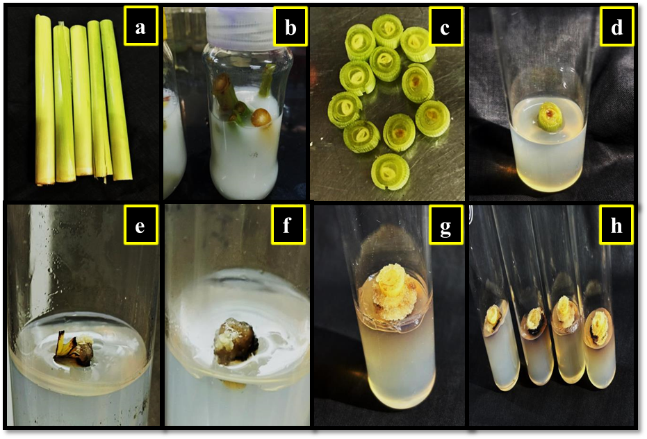
Fig 1: Callus induction from spindle leaf roll segment. a) spindle leaf rolls of sugarcane, b) Treatment of explant with bavistin (1%), c) Preparation of explant in aseptic conditions, d) Placement of explant on callus induction media, e) to f) explant showing swelling g) to h) Appearance of soft creamy friable covering around explant.
3.2 Shoot induction
Shoot regeneration was initiated after 30-40 days of culturing callus of size 0.5-1cm on MS medium supplemented with 5.0 mg/L NAA and 0.5 mg/L kinetin (Fig. 2). This treatment yielded a regeneration frequency of 41.5% (Table 2). Previous reports indicate that relatively low cytokinin concentrations are often more favorable for shoot proliferation. Rao (2015) observed that 1.0 mg/L kinetin enhanced multiple shoot induction, while Ather et al. (2009) noted that 1.0 mg/L BAP promoted a higher number of shoots. Similarly, Gopitha et al. (2010) reported a regeneration efficiency of 94% with 1.0 mg/L BAP combined with 0.5 mg/L NAA. These studies collectively suggest that reduced concentrations of auxins and cytokinins generally promote superior regeneration. The present findings demonstrate that a higher auxin level (5.0 mg/L NAA) in conjunction with a low cytokinin concentration (0.5 mg/L kinetin) also supports efficient shoot regeneration in sugarcane cv. Co0238, highlighting the genotype-dependent nature of regeneration responses.

Table 2: Shoot and root regeneration and survival of plantlets
Experiment No. | Growth hormone for shoot regeneration | Callus cultured on shooting media (No.) | Shoot regeneration (No.) | Growth hormone for root regeneration | Plants obtained including roots and shoots per calli (No.) | Surviving plantlets (No.)
1 | 5mg/L NAA and 0.5mg/L Kinetin | 10 | 0 | 5mg/L NAA and 0.5mg/L Kinetin | 0 | 0
2 | 5mg/L NAA and 0.5mg/L Kinetin | 15 | 4 | 5mg/L NAA and 0.5mg/L Kinetin | 35 | 20
3 | 5mg/L NAA and 0.5mg/L Kinetin | 30 | 17 | 5mg/L NAA and 0.5mg/L Kinetin | 105 | 76
4 | 5mg/L NAA and 0.5mg/L Kinetin | 25 | 15 | 5mg/L NAA and 0.5mg/L Kinetin | 70 | 41
5 | 5mg/L NAA and 0.5mg/L Kinetin | 10 | 3 | 5mg/L NAA and 0.5mg/L Kinetin | 10 | 4
6 | 5mg/L NAA and 0.5mg/L Kinetin | 20 | 15 | 5mg/L NAA and 0.5mg/L Kinetin | 95 | 55
7 | 5mg/L NAA and 0.5mg/L Kinetin | 30 | 22 | 5mg/L NAA and 0.5mg/L Kinetin | 130 | 91
8 | 5mg/L NAA and 0.5mg/L Kinetin | 50 | 27 | 5mg/L NAA and 0.5mg/L Kinetin | 184 | 150
9 | 5mg/L NAA and 0.5mg/L Kinetin | 20 | 11 | 5mg/L NAA and 0.5mg/L Kinetin | 74 | 53
10 | 5mg/L NAA and 0.5mg/L Kinetin | 40 | 23 | 5mg/L NAA and 0.5mg/L Kinetin | 140 | 100
11 | 5mg/L NAA and 0.5mg/L Kinetin | 20 | 0 | 5mg/L NAA and 0.5mg/L Kinetin | 0 | 0
12 | 5mg/L NAA and 0.5mg/L Kinetin | 10 | 0 | 5mg/L NAA and 0.5mg/L Kinetin | 0 | 0
13 | 5mg/L NAA and 0.5mg/L Kinetin | 25 | 0 | 5mg/L NAA and 0.5mg/L Kinetin | 0 | 0
14 | 5mg/L NAA and 0.5mg/L Kinetin | 25 | 0 | 5mg/L NAA and 0.5mg/L Kinetin | 0 | 0
Total | 5mg/L NAA and 0.5mg/L Kinetin | 330 | 137 | 5mg/L NAA and 0.5mg/L Kinetin | 843 | 590
Frequency (%) i.e. shoot regeneration and survival |  |  | 41.5 |  |  | 69.9

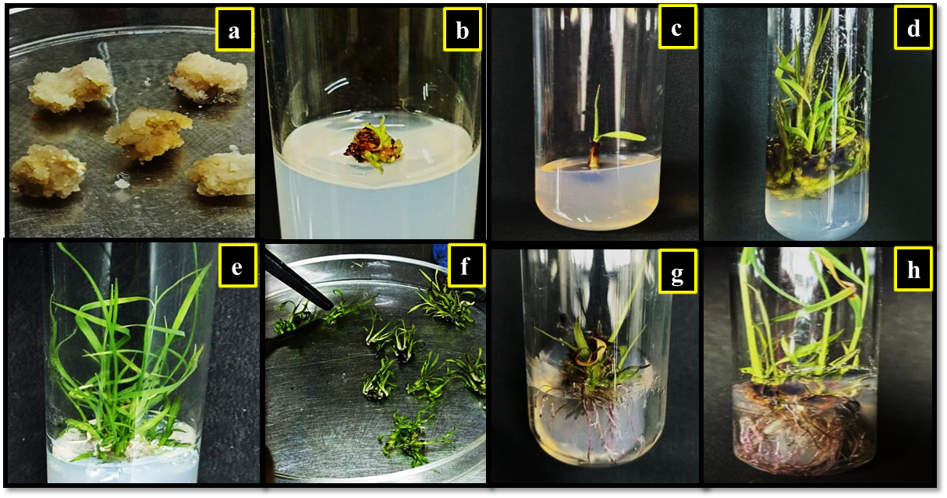
Fig 2: Shoot and root regeneration from callus. a) A creamy white friable callus, b) Green spots visible after 30-40 days, c) to f) Development of healthy green shoots , g) The pink purplish roots colour upon transfer to root induction media, h) Mature roots appearing white brownish after 30-45 days.
3.3 Root formation and survival frequency
Root induction was observed after 30-45 days of culturing regenerated shoots on MS medium containing 5.0 mg/L NAA and 0.5 mg/L kinetin (Fig. 2). The roots initially appeared thin with a purplish-pink coloration, later maturing into white to brown color. This treatment supported a rooting frequency of 83.9%. The well rooted shoots were transferred to moist cotton placed in a plastic tray for 2-3 days for hardening. The plantlets first became feeble and withered after transferring to soil containing cocopeat but after 10-15 days the plants started to rejuvenate (Fig. 3). Out of 843 regenerated plantlets, 590 survived, representing a survival rate of 69.9% as described in Table 2. These observations are in agreement with earlier studies that highlight the pivotal role of auxins in root induction in sugarcane. Rao (2015) reported 100% rooting with 90% survival on MS medium containing 3.0 mg/L NAA, while Awan et al. (2019) achieved 92% rooting at the same concentration. Similarly, Tripathy and Ithape (2020) reported 88% rhizogenic response under identical conditions. Comparable findings have been reported by Gopitha et al. (2010), Mittal et al. (2013), and Behara and Sahoo (2009), where both NAA and IBA (Indole Butyric Acid) were shown to effectively promote root development. Consistent with these reports, the present study demonstrates that a combination of 5.0 mg/L NAA and 0.5 mg/L kinetin is highly effective for root induction, plantlet survival, and successful acclimatization in sugarcane variety Co0238.
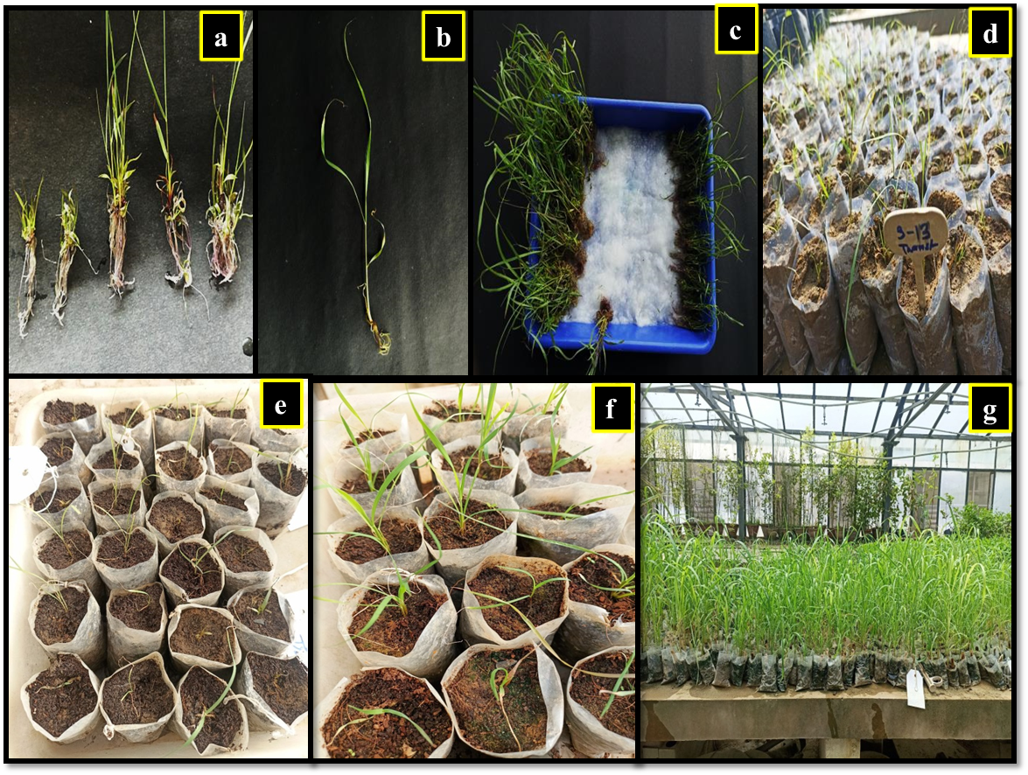
Fig 3: Hardening and transfer to soil. a) and b) The healthy well rooted shoots, c) Plantlets transferred on moist cotton for hardening, d) Plantlets transferred to soil in polybags, e) Plants looked withered after immediate exposure to the harsh environment conditions, f) Rejuvenated plants after 10-15 days in the glasshouse
4. CONCLUSION
The present study establishes an efficient regeneration system for sugarcane cultivar Co0238 using spindle leaf roll explants which holds significant value for the scientific community. Establishing a reliable in vitro system is essential for clonal propagation, conservation, and genetic transformation of elite sugarcane cultivars. The study not only enhances the efficiency of large-scale plant production but also creates opportunities for future research in molecular breeding, stress tolerance, and crop improvement. Such protocols directly contribute to advancing sustainable sugarcane cultivation and biotechnology applications.

Disclaimer (Artificial intelligence)
Author(s) hereby declare that NO generative AI technologies such as Large Language Models (ChatGPT, COPILOT, etc.) and text-to-image generators have been used during the writing or editing of this manuscript.

REFERENCES
Abdelsalam, N.R., Grad, W.E., Ghura, N.S., Khalid, A.E., Ghareeb, R.Y., Desoky, E.S.M., Rady, M.M., Al-Yasi, H.M. & Ali, E.F. (2021). Callus induction and regeneration in sugarcane under drought stress. Saudi journal of biological sciences, 28(12), 7432-7442.
Aslam, U., Tabassum, B., Nasir, I.A., Khan, A. & Husnain, T. (2018). A virus-derived short hairpin RNA confers resistance against sugarcane mosaic virus in transgenic sugarcane. Transgenic Research, 27(2), 203-210.
Ather, A., Khan, S., Rehman, A. & Nazir, M. (2009). Optimization of the protocols for callus induction, regeneration and acclimatization of sugarcane cv-Thatta-10. Pakistan Journal of Botony, 41, 815-820.
Awan, M.F., Iqbal, M.S., Sharif, M.N., Tabassum, B., Tariq, M., Murtaza, S., Ali, S., Raza, A,, Bukhari, S.A.R. & Nasir, I.A. (2019). Evaluation of genotypic and hormone mediated callus induction and regeneration in sugarcane (Saccharum officinarum L). Evaluation, 4, 70-76.
Behara, K.K. & Sahoo, S. (2009). Rapid in vitro micropropagation of sugarcane (Saccharum officinarum L. cv-Nayana) through callus culture. Nature and Science, 7, 1-10.
Chengalarayan, K. & Gallo-Meagher, M. (2001). Effect of various growth regulators on shoot regeneration studies in sugarcane variety CO-86032. Advances in Plant Sciences, 6, 649-651.
FAO (2024) OECD-FAO Agricultural Outlook 2024-2033, 5 Sugar, 159.
Gopitha, K., Bhavani, A.L. & Senthilmanickam, J. (2010). Effect of different auxins and cytokinins in callus induction, shoot, root regeneration in sugarcane. International Journal of Pharma and Bio Sciences, 1, 1-7.
Heinz, D.J. & Mee, G.W. (1969). Plant differentiation from callus tissues of Saccharum species. Crop Science, 9, 324-348.
Jamil, M.W., Ali, S.A., Sabir, W., Nasir, M., Irum, A., Khan, M.E., Naveed, M., Ullah, R., Nawaz, M.S., Saleem, S. & Khan, N.H. (2022). Optimization of protocol for callus formation and shoot development in sugarcane (Saccharum officinarum L.) cultivar CPF-248. Journal of Global Innovations in Agricultural and social Sciences, 10, 229-235.
Karim, M.Z., Alam, R., Baksha, R., Paul, S.K., Hossain, M.A. & Rahman, A.B.M.M. (2002). In vitro clonal propagation of sugarcane (Saccharum officinarum) variety ISD-31. Pakistan Journal of Biological Sciences, 5, 659-661.
Kaur, A. & Gosal, S.S. (2009). Desiccation of callus enhances somatic embryogenesis and subsequent shoot regeneration in sugarcane. Indian Journal of Biotechnology, 8, 332-334.
Kona, P. (2018). Effect of 2,4-D Emson in vitro regeneration in sugarcane cultivar, 2003V46. International Journal of Microbiology Research, 0975-5276.
Mittal, P., Devi, R. & Gosal, S.S. (2013). Direct plant regeneration from spindle leaf roll explants in sugarcane. Indian Journal of Ecology, 40, 67-70.
Nickell, L.G. (1964). Tissue and cell culture of sugarcane: Another research tool. Hawaiian Planters Record, 57, 223-229.
Ramgareeb, S., Snyman, S.J., Van Antwerpen, T. & Rutherford, R.S. (2010). Elimination of virus and rapid propagation of disease-free sugarcane (Saccharum spp cultivar NCo376) using apical meristem culture. Plant Cell, Tissue and Organ Culture, 100, 175-181.
Rao, A.S. (2015). Callus induction and organogenesis in sugarcane (Saccharum officinarum L.) var 93V297. International Letters of Natural Science, 48.
Sandhu, J.S., Kaur, M., Kaur, A. and Kalia, A. (2016). Single step direct transgenic plant regeneration from adventive embryos of agro-infected sugarcane (Saccharum spp) spindle leaf roll segments with assured genetic fidelity. Plant Cell, Tissue and Organ Culture, 125, 149-162.
Singh, S., Singh, P.R., Singh, A.K. & Gupta, R. (2016). Present status and future need of mechanizing sugarcane cultivation in India. Agricultural Mechanization in Asia, Africa and Latin America, 47(1), 75-81.
Soares, R.R., Ferreira, M.E., Gamarano, M.C., Ribeiro, R.C., Sabino, V.M. & Pereira, B.M.H. (2014). The use of histological analysis for the detection of somatic embryos in sugarcane. African Journal of Biotechnology, 13, 762-767.
Srivong, T., Zhu, Y.J., Pongdontri, P., Pliansinchai, U., Sakuanrungsirikul, S., Borthakur, D., Nagai, C. & Kosittrakun, M. (2015). Optimization of callus induction and plant regeneration in sugarcane (Saccharum spp.) for a study of sucrose accumulation in relation to soluble acid invertase expression. Chiang Mai Journal of Science, 42(4), 797-805.
Tripathy, S.K. & Ithape, D.M. (2020). Genotypic response to callus induction and plant regeneration in sugarcane. Journal of Crop and Weed, 16(2), 239-243.
Vazquez Molina, D.E., De Los Santos, A., Lecona Guzman, K.A., Sumano Muniz, O., Velazquez Mendez, M., Rincon Rosales, R., Oliva Llaven, M.A., Dendooven, L. & Gutierrez-Miceli, F.A. (2005). Sugarcane buds as an efficient explant for plantlet regeneration. Biologia Plantarum, 49, 481-485.
Watson, L., Clifford, H.T. & Dallwitz, M.J. (1985). The classification of Poaceae: subfamilies and supertribes. Australian Journal of Botany, 33(4), 433-484.

