Poultry Litter Compost: An Effective Organic Fertilizer for Enhancing Growth and Fruit Yield of Tomato (Solanum lycopersicum L.)

Abstract
This study aimed to improve tomato (Solanum lycopersicum L.) production in Ngaoundere-Cameroon, while ensuring agroecology practices. Field experimentations were carried out during the year 2023. A split-plot experimental design, repeated 03 times was used. The first factor was fertilization, with 05 treatments (negative control: seedlings receiving no fertilizer, positive control: synthetic chemical fertilizer 20-10-10 + Urea 46%, compost derived poultry litter, compost tea derived poultry litter, and mycorrhizal inoculum); the second factor was variety, with 02 tomato varieties (Rio Grande Griffaton, and Roma Savana). The tomato growth parameters and fruit yield were evaluated. Produced compost increased the fruit yield of the Rio Grande Griffaton variety by 364.66% and 26.88% compared to the negative control and chemical fertilizer, respectively. Compost increased the fruit yield of the Roma Savana variety by 444.99% and 16.36% compared to the negative control and chemical fertilizer, respectively. The Rio Grande Griffaton variety produced 1.31-fold more fruits than Roma Savana. The supply of 1 Kg of compost derived poultry litter per hole at sowing time was found to be very promising in improving the tomato fruit yield and therefore, can be used as an alternative to replacing the mineral fertilizers usually employed for the cultivation of this fruit vegetable.
Key words: Solanum lycopersicum L., compost, compost tea, mycorrhizae, fruit yield

INTRODUCTION
Tomato (Solanum lycopersicum L.) is a vegetable crop belonging to the Solanaceae family. It is the second most consumed vegetable in the world and the most consumed in Cameroon. The fruits are rich in minerals, vitamins, essential amino acids, sugars and dietary fiber. Tomatoes contain high levels of vitamins B and C, iron and phosphorus (Shankara et al., 2005). In 2022, world tomato production reached to nearly 186.82 million tons from total area of 5 million hectare with an average productivity of 36.97 t/ha (FAOSTAT 2022). In Cameroon, national tomato production is 889,800 tons per year.
In the Adamawa Cameroon region, soil structure is severely degraded in crop areas, particularly in low-lying areas, due to a high accumulation of chemical inputs (PNDP, 2013). The excessive use of chemical inputs contributes to climate change by releasing tons of nitrous oxide, a greenhouse gas that is more potent than carbon dioxide (Matt Fisher, 2018). It pollutes groundwater and causes soil salinization, which has consequences for soil fertility and fruit quality. It is therefore urgent to use fertilizers that can improve soil fertility while maintaining its ecological balance (Tchuenteu et al., 2018). Organic fertilizers improve soil structure, enrich it with nutrients and maintain soil moisture.
Previous studies have demonstrated the effects of natural fertilizers on tomato growth and yield. Indeed, Kitabala et al. (2016), showed that organic matter can be used as a substitute for mineral fertilizers in crops production. Furthermore, the work of Ziane (2018) on the application of arbuscular mycorrhizal fungi in tomato cultivation in North-Eastern Algeria revealed the positive effect of this biofertilizer to improving tomato fruit yield. To the best of our knowledge, no comparative study has been conducted on several organic fertilizers (compost, compost tea, mycorrhizal inoculum) on tomato growth and yield under High Guinean Savannah climate of Cameroon.
By using natural fertilizers for tomato growing would contribute to improving the productivity of this vegetable crop, cleaning up the environment through the composting of organic waste, which is abundant in Ngaoundere city of Cameroon, and promoting the use of locally available materials in agroecology. Compost improves soil quality, reduces losses due to plant parasites, and improves plant growth and yield (Chabalier et al., 2006). Organic fertilizer improves soil fertility durably, and consequently, in the sustainability of agricultural production. This waste is rich in several mineral elements necessary for plant growth. It improves the physical characteristics of the soil as well as its biological composition (Vilmar, 2012). Furthermore, several authors reported that mycorrhizal symbiosis improves plant productivity (Tchuenteu et al., 2020; Kamdem et al., 2020). According to Lalitha et al. (2017), one of the main properties of mycorrhizae is to facilitate the nutrition of the host plant with low-mobility mineral elements, particularly phosphorus. This study aimed to improve tomato production under High Guinean Climate of Ngaoundere-Cameroon, while ensuring agroecology practices.

Materials and methods
Study area
The study was conducted during cropping season 2023 in the experimental field of Faculty of Science of the University of Ngaoundere (Cameroon) located on its main campus. The area belongs to the agro-ecological zone II of Cameroon and is characterized by a High Guinean Savannah with six months rainy season (May to October) and six months dry season (November to April) (Mandassia et al., 2025). The vegetation of the study area is an herbaceous savannah dominated by Annona senegalensis, Imperata cylindrica, Pennisetum purpureum, and Piliostigma thonningii. The geographical parameters of the field are the following: 1155.80 m altitude, 7°24’61’’ North latitude, and 13°34’24’’ East longitude. The height of shrubs presents in the experimental site ranged between 1.50 m and 2 m height, and these shrubs are scattered throughout the area. Table 1 presents physico-chemical characteristics of the growing soil in the study site.
Table 1: Physico-chemical properties of soil of Bini-Dang and compost derived poultry litter
Parameters | Study site | Compost derived poultry litter
pH | 4.3±0.01 | 7.12±0.01
N _{tot} (g/100g) | 1.07±0.03 | 4.23±0.59
P _{tot} (g/100g) | 0.41±0.02 | 0.51±0.02
Ca (g/100g | 0.49±0.00 | 1.01±0.09
Fe (g/100g) | 0.19±0.06 | 0.50±0.09
Al (g/100g) | 0.32±0.03 | 0.63±0.03
Mg (g/100g) | 0.10±0.02 | 0.20±0.02

Tomato seeds
Two varieties of tomato (Solanum lycopersicum L.) were used (Figure 1). These were the Rio Grande Griffaton and Roma Savana tomato varieties. These two varieties are preferred by tomato growers of Ngaoundere-Cameroon because of their high fruit yield and disease resistance.

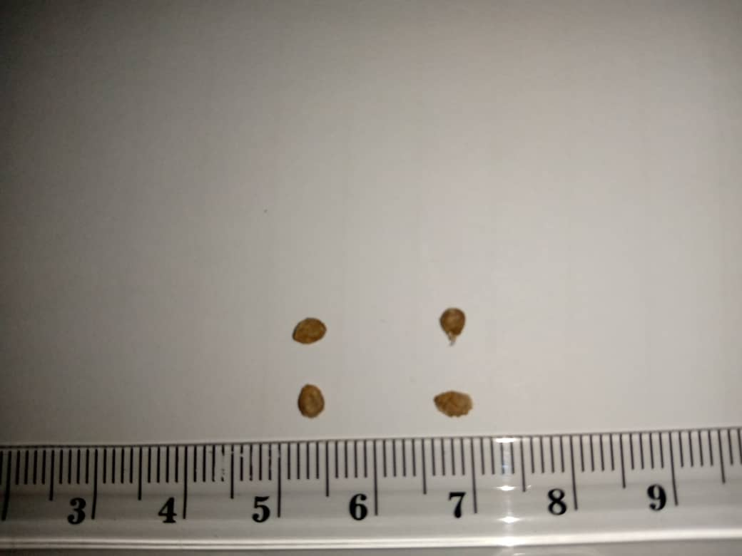  1a) Rio Grande Griffaton variety | 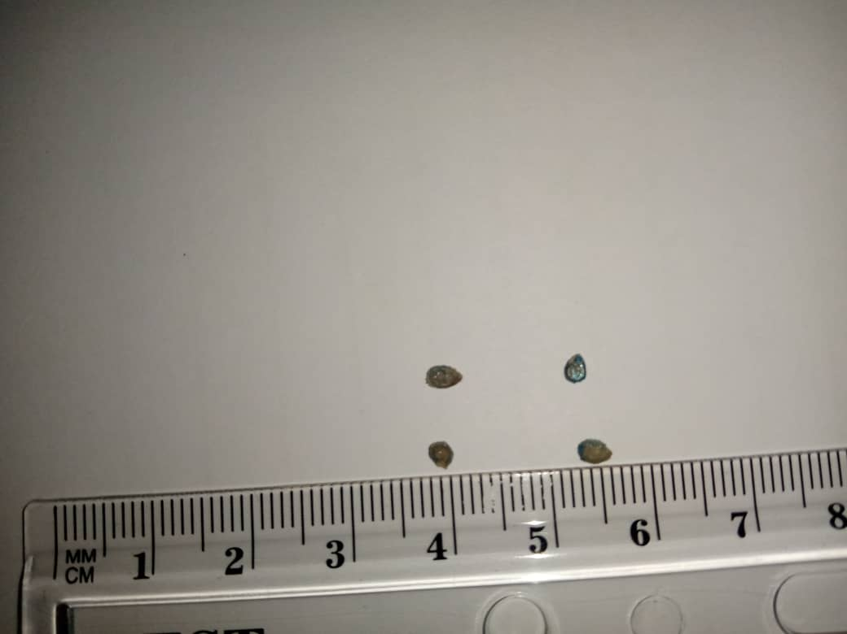  1b) Roma Savana variety
Figure 1: Seeds of Rio Grande Griffaton (1a) and Roma Savana (1b) varieties of tomato

Fertilizers
Fertilizers used are the following: compost, compost tea, chemical fertilizer, and mycorrhizal biofertilizer. Compost derived poultry litter is used (Figure 2A). Litter from Gallus domesticus subspecies comes from a local livestock farm in Dang (Adamawa, Cameroon). The heap composting method according to Tchuenteu et al. (2018) was used. The composting process lasted 06 months. The compost tea (Figure 2B) was derived from compost based poultry litter. The process for making compost tea was inspired by the method described by Deschêne (2007).
The chemical fertilizer (Figure 2C) used as a positive control for this trial was granulated NPK. This fertilizer is an approved synthetic compound, popular for tomato cultivation in Ngaoundere-Cameroon.
The mycorrhizal inoculum used were supplied by the Laboratory of Soil and Microbiology of the Biotechnology Center of the University of Yaounde I (Cameroon) (Figure 2D). Selected isolates were multiplied by sorghum plants (host plants) and tested on maize and sorghum (Nwaga et al. 2007). It contains infective spores and propagules of three genus Glomus, Scutellospora, and Gigaspora species with a concentration of approximately 20 spores/g of substrate.
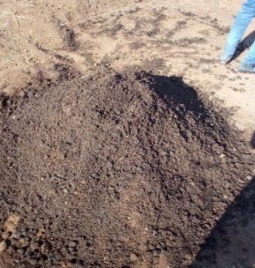  2A) Compost | 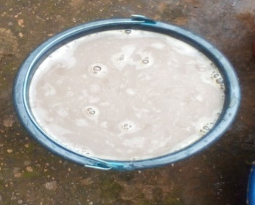  2B) Compost tea | 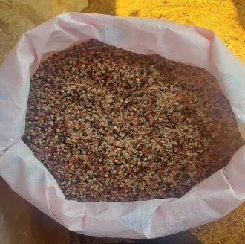  2C) Chemical fertilizer | 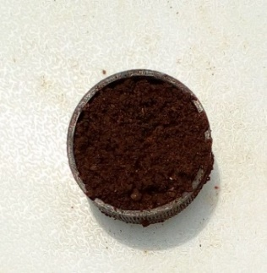  2D) Mycorrhizal inoculum
Figure 2: Fertilizers: compost (2A), compost tea (2B), chemical fertilizer (NPK 20-10-10) (2C), and mycorrhizal biofertilizer (2D)

Assessment of the responses of tomato to compost, compost tea, and mycorrhizae
Experimental design, sowing and crop management
Field experimentation was carried out during the cropping seasons 2023. The experimental design is a split-plot, repeated 03 times. The first factor is fertilization, with 05 treatments (negative control (unfertilized plants), positive control (synthetic chemical fertilizer 20-10-10 + Urea 46%), compost derived poultry litter, compost tea derived poultry litter, and mycorrhizal inoculum); the second factor is variety, with 02 tomato varieties (Rio Grande Griffaton, and Roma Savana). The experimental design includes 30 experimental subunits spaced 0.5 m apart in a block. Each experimental subunit comprises 30 plants spaced 50 cm apart and arranged in the same seedling row. Two consecutive blocks are spaced 1 m apart. 90 plants per treatment are maintained by manual weeding once every two weeks during the trial. On each experimental unit, seven plants are labelled to facilitate data collection.

Data collection, sample and statical analysis
During the vegetative phase, growth parameters such as the number of leaves per plant, plant height, and stem diameter at the collar are assessed at two-week intervals after transplanting on different observation dates (14, 28, 42, 56 and 70 days after transplanting). Production parameters such as the number of flowers and fruits per plant, as well as the estimated fruit yield per hectare are evaluated. Plant height was measured from the plant collar to the last bud using a tape measure. The stem diameter was measured at the collar using a 0.01 mm precision caliper. 30 plants are sample
All the data were statistically analyzed using the Statgraphics Plus Program version 5.0. The significance of differences was determined using the Duncan test.

RESULTS
Tomato growing parameters
The studied growing parameters include: plant height, number of leaves per plant, and diameter of stem at collar. At maturity, the statistical analysis (ANOVA) revealed a highly significant difference (p<0.001) between fertilizers on tomato growing parameters for each used tomato variety. Furthermore, there is a significant difference (p<0.05) between the both tomato varieties (Rio Grande Griffaton, and Roma Savana) on all studied growing parameters. No significant interaction is observed between fertilizers and tomato varieties on plant height. However, there is a significant difference (p < 0.05) in the interaction between fertilizers and varieties on the foliar production, and diameter of stem at collar.
Tomato plant height
Concerning, Rio Grande tomato variety at maturity, the highest plants heights were recorded on C plants (68.85 ± 7.61 cm), followed by T4 plants (52.61 ± 8.57 cm) and TC plants (50.33 ± 6.83 cm) (Figure 3). In contrast, the lowest tomato plant height was observed on M plant (43.80 ± 4.95 cm) and T0 plant (43.71 ± 7.03 cm). The plant height of Rio Grande tomato variety from C-amended plots were 1.30-fold and 1.57-fold taller than the T4 and T0 plants, respectively.
Regarding, the Roma Savana variety, the highest heights at maturity were observed on C plants (66.76 ± 9.88 cm), T4 (48.80 ± 10.55 cm), and TC (46 ± 9 cm), while the lowest heights were observed on M plants (39.76 ± 4.63 cm) and T0 plant (39.66 ± 8.57 cm). The Roma savana tomato plants from C plots were 1.36-fold and 1.68-fold taller than T4 and T0 plants, respectively.
At maturity, T0 plants of the Rio Grande Griffaton tomato variety are taller (43.71 ± 7.03 cm) than those of the Roma Savana tomato variety (39.66 ± 8.57 cm). T0 plants of the Rio Grande Griffaton variety are 1.10-fold taller than those of the Roma Savana variety.

Figure 3: Tomato plant height depending on fertilizers and time
JAR: Days After Transplanting, T0: unfertilized plot (negative control), T4: synthetic chemical fertilizer NPK (20-10-10) (positive control), C: compost derived poultry litter; TC: compost tea derived poultry litter, M: mycorrhizal inoculum, V1: Rio Grande Griffaton variety; V2: Roma Savana variety.

Tomato foliar production
The highest leaf production in the Rio Grande Griffaton variety was recorded on C plants (66.14 ± 15.70 leaves/plant), followed by T4 plants (39.52 ± 7.33 leaves/plant) and M plants (36.47 ± 9.68 leaves/plant). The lowest foliar production was recorded on TC plants (34 ± 7.00 leaves/plant), followed by T0 plants (33.76 ± 6.27 leaves/plant) (Figure 4). Leaf production in Rio Grande tomato plants from C plots was 1.67-fold and 1.95-fold higher than that of T4 and T0 plants, respectively.
Regarding Roma Savana variety, the highest average number of leaves per tomato plant was observed on C plants C (49.85 ± 9.69 leaves/plant), T4 (31.61 ± 10.71 leaves/plant) and TC (30.14 ± 15 leaves/plant). The lowest leaf production was recorded in T0 plants (26.85 ± 6.78 leaves/plant), followed by M plant (22.47 ± 5.27 leaves/plant). Foliar production of Roma Savana tomato variety grown on C plots was 1.57-fold and 1.85-fold greater than that of T4 and T0 plants, respectively.
T0 plants of Rio Grande Griffaton tomato variety exhibited more leaves (33.76 ± 6.27 leaves/plant) than plants of Roma Savana variety (26.85 ± 6.78 leaves/plant). Leaf production of Rio Grande Griffaton variety was 1.25-fold greater than that of the Roma Savana variety.
Figure 4: Tomato foliar production according to fertilizer and time
JAR: Days After Transplanting, T0: unfertilized plot (negative control), T4: synthetic chemical fertilizer NPK (20-10-10) (positive control), C: compost derived poultry litter; TC: compost tea derived poultry litter, M: mycorrhizal inoculum, V1: Rio Grande Griffaton variety; V2: Roma Savana variety. Value of bands relative to a tomato variety and to the same time affected by the same letter are no significant different.

Diameter of stem at collar
The dimeter of stem at collar varied from 1.47 ± 0.39 cm for M plant to 1.32 ± 0.59 cm for TC plant of Rio Grande Griffaton variety of tomato (Figure 5). The diameter of stem of Rio Grande Griffaton from C plots was 1.40-fold and 1.09-fold greater than that of T4 and T0 plants, respectively.
In the Roma savana variety at maturity, the highest collar diameter was recorded on C plants (1.82 ± 0.59 cm), followed by T4 plant (1.51 ± 0.53 cm) and TC plant (1.25 ± 0.43 cm). The lowest values of this growing parameter were recorded on T0 plants (1.21 ± 0.48 cm), followed by M plant (1.19 ± 0.46 cm). The radial growth of the stems of C plants of the Roma Savana variety was 1.20-fold and 1.50-fold greater than that of T4 and T0 plants, respectively.
T0 plants of the Rio Grande Griffaton tomato variety exhibited the greatest diameter of stem (1.81 ± 0.71 cm) compared to that of Roma Savana T0 plant (1.21 ± 0.48 cm). T0 plants of the Rio Grande Griffaton variety are 1.49-fold taller than those of Roma Savana variety.

Figure 5: Diameter of stem at collar depending on fertilizer and time
JAR: Days After Transplanting, T0: unfertilized plot (negative control), T4: synthetic chemical fertilizer NPK (20-10-10) (positive control), C: compost derived poultry litter; TC: compost tea derived poultry litter, M: mycorrhizal inoculum, V1: Rio Grande Griffaton variety; V2: Roma Savana variety.

Tomato production
The statical analysis (ANOVA) revealed significant difference (p ˂ 0.05) between fertilizer relative to tomato production (flower production, number of fruits per plant, and fruit yield (Kg/ha) for each used tomato variety. Also, there is significant difference (p ˂ 0.05) between the both Rio grande griffaton and Roma Savana tomato varieties on studied production parameter. However, there is no significant difference in the interaction between fertilizers and tomato varieties relative to tomato production parameters.

Flowers production
Results showed that, in the Rio Grande Griffaton tomato variety, the highest flower production was recorded on C plant (81.47 ± 19.59 flowers/plant) while the lowest value of this production parameter was from M plant (25.90 ± 7.62 flowers/plant) (Table 2). The flower production of C plants of the Rio Grande Griffaton tomato variety is 1.74-fold and 2.72-fold higher than that of T4 and T0 plants.
The highest flower production in the Roma Savana variety varied from 20.23 ± 8.64 flowers/plant for M plant to 66.61 ± 13.90 flowers/plant for C plant. Plants of Roma Savana tomato variety from C plots had 1.68-fold and 2.19-fold more flowers than T4 and T0, plants respectively.
T0 plants of the Roma Savana produced (30.28 ± 13.61 flowers/plant), the same number of flowers than T0 plants of Rio grande griffaton tomato variety (30.04 ± 17.56 flowers/plant),
Table 2: Flower production depending fertilization
 | Number of flowers/plant
Treatments | V1 | V2
T0 | 30.04 ± 17.56^{b} | 30.28 ± 13.61^{b}
T4 | 46.57 ± 13.70^{c} | 39.47 ± 14.05^{c}
C | 81.47 ± 19.59^{d} | 66.61 ± 13.90^{d}
TC | 39 ± 17b^{c} | 27 ± 14^{ab}
M | 25.90 ± 7.62ª | 20.23 ± 8.64ª
T0: unfertilized plot (negative control), T4: synthetic chemical fertilizer NPK (20-10-10) (positive control), C: compost derived poultry litter, TC: compost tea derived poultry litter, M: mycorrhizal inoculum, V1: Rio Grande Griffaton variety; V2: Roma Savana variety. Values of column affected by the same letter are no significant different.

Tomato fruit production
In the Rio Grande Griffaton variety, the highest yields were recorded on C plants (12800 kg/ha or 12.80 t/ha), followed by T4 plants (10,088.77 kg/ha or 10.08 t/ha) and TC plants (8,487.97 kg/ha or 8.48 t/ha). In contrast, the lowest tomato fruit yields were obtained on M plants (2,887.99 kg/ha or 2.88 t/ha) and T0 plants (2,754.65 kg/ha or 2.75 t/ha) (Figure 6). Treatment C increased the fruit yield of the Rio Grande Griffaton tomato variety at 364.66% and 26.88% respectively compared to treatments T0 and T4 treatments.
Regarding Roma Savana tomato variety, the fruit yield varied from 2087.99 kg/ha (2.08 t/ha) for T0 plant to 11,377.30 kg/ha (11.37 t/ha) for C plant. C fertilizer increased the fruit yield of the Roma Savana variety by 444.99% and 16.36% compared to T0 and T4 treatments respectively.
T0 plants of the Rio Grande Griffaton tomato variety produced more fruits (2.75 t/ha) than T0 plant of Roma Savana tomato variety (2.08 t/ha). The Rio Grande Griffaton tomato variety produced 1.31-fold fruits than Roma Savana variety.

Figure 6: Fruit yield depending on fertilizer
T0: unfertilized plot (negative control), T4: synthetic chemical fertilizer NPK (20-10-10) (positive control), C: compost derived poultry litter; TC: compost tea derived poultry litter, M: mycorrhizal inoculum, V1: Rio Grande Griffaton variety; V2: Roma Savana variety. Value of bands relative to a tomato variety and to the same time affected by the same letter are no significant different.

DISCUSSION
The results obtained on tomato plant height corroborate partially the work of Batamoussi et al. (2016), who studied the effect of organic fertilisers on the growth and yield of two tomato varieties in the municipality of Parakou (Northern Benin), and reported that the tomato plants height varied from 81.5 ± 7.15 cm for F1 Mongal variety to 76.68 ± 7.84 cm for the F1 Jaguar variety. Plant height is considered a good indicator of photosynthetic capacity (Tchuenteu et al., 2013). Furthermore, Tchuenteu et al. (2018) revealed that there is are a positive significant correlation between plant height, leaf production, diameter of stem and crop yield.
The benefit effects of poultry litter on tomato diameter of stem corroborate the work of Anguessin et al., (2021), who studied the effect of organic fertilization using leaf litter from Jatropha curcas L. and Jatropha gossypifolia L. on tomato growth in Guider (Northern Cameroon), and revealed that leaf litter from J. curcas and J. gossypifolia improved tomato diameter of stem. Our results on the number of fruits per tomato plant are comparable to those of Benjamin (2019), who studied the effects of several composts and chemical fertilizers on the growth and yield of zucchini (Cucurbita pepo) in Kenscoff (Haiti). These authors reported that amended plants with compost derived chicken manure produced more fruits (4.00 ± 0.46 fruits/plant) than control plants (1.31 ± 0.22 fruits/plant). The tomato fruit yields obtained in this study are lower than those reported in the literature. The studies of Kitabala et al. (2016) in Congo, revealed that compost-based tomato fruit yields are 15 t/ha and 27 t/ha, respectively. Tomato is grown for its fruits. These fruits are rich in mineral elements, vitamins, essential amino acids, sugars and dietary fiber. Tomatoes contain high levels of vitamins B and C, iron and phosphorus (Shankara et al., 2005)
As for the treated plants with mycorrhizae, they showed no significant difference from the negative control relative to studied growth and yield parameters of tomato. This could be explained by the absence of symbiosis between mycorrhizal fungi and tomato plant roots; however, this needs to be investigated. The growing soil contains the nutrients, which are directly accessible to tomato plant roots, and provide them with adequate nutrition. Consequently, these plants do not need to rely on mycorrhizae for their mineral nutrition, hence the ineffectiveness of mycorrhizal inoculation on the height and tomato foliar production. These results corroborate those of Haro et al. (2012), who showed that plants will not need to form mycorrhizal symbiosis if nutrients are available in the environment and directly accessible to the plant roots.
In this study, treated plants with compost tea grew significantly better (in terms of height and foliar production) than the negative control plants. This is because the presence of soluble nutrients in compost tea improves plant growth and allows for better absorption and retention of nutrients by the plant (Archana et al., 2012).
In this work, it was recorded that all the parameters taken into consideration responded positively when the plots were fertilized by compost as compared to the data from the negative control plot (unfertilized plot). The positive effect of compost on tomato production corroborate data found in literature (Tchuenteu et al., 2020, Kamdem et al., 2020; Mohamed et al., 2025).
This positive effects of compost on tomato growth can be explained by that, the low nutrient element available in the soil of study area (Bini-Dang) was increased by compost derived poultry litter and as the results the growth and production parameters considered were improved accordingly. Produced compost is rich in nitrogen (Table 1). In fact, nitrogen promotes the use of carbohydrates, stimulates root development and activity, thereby promoting the export of other minerals and plant growth (Stevenson, 1986). Compost provides nutrients and improves soil properties by enhancing its physical characteristics (structural stability, erosion control, increased water retention capacity, aeration and warming of the soil), as well as chemical (supplying major nutrients, supplying trace elements, increasing CEC, increasing the pH of acidic soils) and biological (stimulating microbial activity in the soil) properties of the soil. This would contribute to plant growth and thus promote good yields. As for the control, the absence of fertilization and the characteristics of the soil are thought to be the cause of the low yield (Kasongo et al., 2013).
This manuscript addresses a critical issue in sustainable agriculture: reducing reliance on synthetic fertilizers. The study provides valuable, locally relevant data on the efficacy of poultry litter compost as a superior organic amendment for tomato production. By producing, and suppling of 1 Kg of compost derived poultry litter per hole at sowing is very promising in improving the tomato growth, and therefore, can be used as an alternative to replacing the chemical fertilizers usually employed by tomato growers. However, the effects of the compost used in this study on the physico-chemical properties of tomato fruits need to be investigated.

CONCLUSION
Compost derived poultry litter increased the fruit yield of the Rio Grande Griffaton tomato variety by 364.66% and 26.88% compared to the negative control (unfertilized plant) and synthetic chemical fertilizer respectively. Compost increased the fruit yield of the Roma Savana tomato variety by 444.99% and 16.36% compared to the negative control and synthetic chemical fertilizer respectively. The Rio Grande Griffaton tomato variety produced 1.31-fold more fruit than Roma Savana variety. The application of 1 kg of compost per plant at the transplanting time is an alternative to chemical fertilizers for the cultivation of this fruit vegetable.

DISCLAIMER (ARTIFICIAL INTELLIGENCE)
Author(s) hereby declare that NO generative AI technologies such as Large Language Models (ChatGPT, COPILOT, etc.) and text-to-image generators have been used during the writing or editing of this manuscript.

COMPETING INTERESTS
Authors have declared that no competing interests exist.

REFERENCES
Anguessin1 B., Mapongmetsem P. M., Ibrahima A. and Fawa G., 2021. Effect of organic fertilization based on foliar litter of Jatropha curcas L. and Jatropha gossypifolia L. on tomato (Lycopersicon esculentum Mill.) crops in Guider (North/Cameroon). International Journal of Biological and Chemical Sciences, 15(2): 524-535.
Archana P. P., Theodore J. K., Radovich N. V. H. and Robert E. P., 2012. Biochemical properties of compost tea associated with compost quality and effects on pak choi growth. Scientia Horticulturae, 148: 138-146.
Batamoussi M. H., Tovihoudji P. G., Tokore O. M. S. B. J., Boulga J., and Essegnon M. I. 2016. Effect of organic fertilizers on the growth and yield of two tomato varieties (Lycopersicum esculentum) in the commune of Parakou (Northern Benin). Pp 86-93.
Benjamin John, 2019. Effect of three types of composts and chemical fertilizers on the growth and yield of zucchini (Cucurbita pepo) in basaltic and calcareous soils in the commune of Kenscoff, Haiti. Master's thesis: Integrated production and preservation of natural resources in urban and peri-urban areas: Université Gembloux Agro-Bio Tech, 46p.
Chabalier P.F., Van de Kerchove V. and Saint Macary H., 2006. Guide to Organic Fertilization in Reunion. CIRAD, 304p. www.reunion.chambagri.fr
Deschênes A., 2007. Compost Tea for Vigorous and Healthy Cultures. The Pilgrim's Garden, St. Andre Kamouraska. 5p.
FAOSTAT, 2022. https://www.fao.org/faostat/en/#home
Haro H, Sanon BK, Diop I, Kane A, Dianda M. and Houngnandan P., 2012. Response to Mycorrhizal Inoculation of Four Cowpea Varieties (Vigna unguiculata (L.) Walp) Grown in Burkina Faso and Senegal. International Journal of Biological and Chemical Sciences. 6(6): 2097-2112.
Kamdem K.F., Tchuenteu T.L., Maimouna A. and Megueni C., 2020. The Combination of Arbuscular Mycorrhizal Fungi with Rock Powder and Poultry Litter: An Appropriate Natural Fertilizer for Improving the Productivity of Soybean (Glycine max (L.) MERR). Agriculture (Poľnohospodárstvo), vol. 66, no. 3, pp. 108-117.
Kasongo, L.M.E., M.T., Mwamba, M.P., Tshipoya and Mukalay M. J., 2013. Response of soybean (Glycine max L. (Merril)) crops to the addition of Tithonia diversifolia (Hemsley) A. Gray green biomass as organic manure on a Ferralsol in Lubumbashi, D.R. Congo. Journal of Applied Bioscience, 63: 4727-4735.
Kitabala M. A., Tshala U. J., Kalenda M.A., Tshijika I. M and Mufind K. M., 2016., Effects of different doses of compost on the production and profitability of tomato (Lycopersicon esculentum Mill) in the city of Kolwezi, D.R. Congo. of Lualaba (DR Congo), Journal of Applied Biosciences, 102: 9669–9679.
Lalitha M., Anil Kumar K. S., Dharumarajan S., Balakrishnan N., Srinivasan R., Nair K. M., Rajendra H. and Singh S. K., 2017. Role of Vesicular-Arbuscular Mycorrhizae in Mobilization of Soil Phosphorus. In: Meena, V., Mishra, P., Bisht, J., Pattanayak, A. (eds) Agriculturally Important Microbes for Sustainable Agriculture. Springer, Singapore.
Mandassia F., Singnon I. C., Tchuenteu T. L., and Megueni C., 2025. Enriched Compost with Vivianite or Basaltic Pyroclastite Powder: Better Fertilizer to Improve Artemisia Growth under the High Guinean Savannah Climate of Cameroon. Journal of Experimental Agriculture International, 47(8) :54–65.
Mohamed A., Tchuenteu T. L., Simo K. D. and Megueni C., 2025. Enriched Compost with Vivianite and Pyroclastite Powders: Suitable Fertilizer for Better Maize Growth under the High Guinean Savanah Climate of Cameroon. Journal of Plant Biota, 4(1) :89-98.
Matt Fisher. 2018. Reducing greenhouse gas emissions in agriculture through nuclear techniques. IAEA Bulletin, Vienna, Austria, 2 p.
Nwaga D., Fankem H., Essono O. G., Ngo Nkot L. and Randrianangaly J. S., 2007. Pseudomonas and symbiotic microorganisms as biocontrol agents against fungal disease caused by Pythium aphanidermatum. African Journal of Biotechnology, 6 : 190–197.
PNDP, 20013. Plan communal de développement (CPD) de Ngaoundéré III, 14p.
Shankara N., Josep Van Lido de J., Marja G., Martin H. and Van Dama B., 2005. Tomato production, processing and marketing, Ed Prota, 105p.
Stevenson J. F., 1986. Cycles of soil: carbon, nitrogen, phosphorus, sulfur, micronutrients. John Wiley & Sons, New York, 41p.
Tchuenteu T. L., Megueni C. and Njintang Y. N., 2013. A study of the variability for grain and oil yield and yield related traits of castor beans accessions in two savannah agroecological zones of Cameroon. International Journal of Biosciences, 3(8): p. 251-263.
Tchuenteu T. L., Megueni C., Noubissie E. and Wamkoua M. M., 2018. Study on Physicochemical properties of composts and their effects on growth, yield and fruits quality of Capsicum annum L. at Dang locality (Ngaoundéré Cameroon). Journal of Agriculture and Veterinary Science (IOSR-JAVS), 11(11): 26-35.
Vilmar A., Ragagnim D., Geraldode S. J, Danyllo S. D., Weslley F. B. and Phelipe D. M. N., 2012.Growth and no dulation of soybean plants fertilized with poultry litter.Ciênciae Agrotecnologi, 37(1):17-24.

