Optimization of Growth Parameters for Sclerotium rolfsii Sacc. in relation to Media and Temperature

ABSTRACT
Sclerotium rolfsii is a significant soil borne phytopathogenic fungus that leads to considerable yield losses in economically important crops. This study assessed the impact of temperature and culture media on the mycelial growth, sclerotial production, and germination of S. rolfsii. In this present study six different cultural solid media viz. V-8 juice agar, Czapek Dox agar, Potato dextrose agar, Oat meal agar, Cluster bean stem extract agar and water agar were analyzed for in vitro mycelium growth were observed the best radial growth found in Oat meal agar (88.29 mm) followed by Potato dextrose agar media (85.28 mm), Czapek agar (72.24 mm), Cluster bean stem extract agar (70.23 mm) and V-8 juice agar (68.23 mm). Maximum diameter (89.40 mm) and sclerotia count (571.00 per plate) were recorded on Potato dextrose agar (Hi-media) at 30 ⁰C and 20 days after inoculation respectively, followed by 32ºC (77.74 mm) and sclerotia count (471.00 per plate).
Keywords: Sclerotium rolfsii Sacc., different cultural media, mycelial growth and Temperature.
Introduction
Cluster bean (Cyamopsis tetragonoloba (L.) Taub.), commonly known as guar, is a significant leguminous crop of the Fabaceae family. Due to its inherent drought tolerance, it is well-suited for cultivation under rainfed conditions, particularly in the arid and semi-arid regions of northern and northwestern India.
“India leads the world in its area as well as production with 82 and 80 per cent of its global area and production, respectively. Rajasthan, Gujrat, Haryana, Punjab and Uttar Pradesh are major growing states. Among them Rajasthan leads in production with 75 per cent of total production of India. During 2020-21 it was cultivated on an area of 2.71 million ha producing 1.30 million tonnes of seeds with productivity of 481 kg/ha in India. However, it is cultivated on an area of 2.48 million ha with a production of 1.14 million tonnes of seeds and productivity was 458 kg/ha during 2020-21 in Rajasthan” (Anonymous, 2022).
“The important fungal diseases are Alternaria blight and leaf spot (Alternaria cucumerina var. cyamopsidis, Alternaria tenuis, Alternaria tenuissima), Anthracnose (Colletotrichum dematium), dry root rot and charcoal rot (Rhizoctonia bataticola syn. Macrophomina phaseolina, Rhizoctonia Solani), Fusarium wilt, root rot and damping off (Fusarium caeruleum, Fusarium oxysporum, Fusarium semitectum, Fusarium solani), Sothern blight and root rot (Sclerotium roridum), Powdery mildew (Oidiopsis taurica syn. Levillula taurica and Sphaerotheca fuliginea), leaf spot (Curvularia lunata, Choanephora cucurbitarum), damping off (Pythium myriotylum) and vascular wilt (Neocosmospora vasinfecta) causes major losses to yield of cluster bean crop” ( Awurum and Uwajimgba, 2013). Among the fungal diseases stem rot caused by S. rolfsii one of the important diseases of cluster bean. Sclerotium rolfsii is an economically important pathogen on numerous crops worldwide. The yield loss caused by the pathogen ranges from 50 to 70 per cent depending upon the disease incidence and severity.
“S. rolfsii is a common pathogen in tropical and subtropical regions of the world, where high temperature and high humidity is prevalent which favors disease. S. rolfsii is a soil inhabitant, polyphagous and facultative fungal pathogen which have host range of over 500 species in about 100 families including groundnut, green bean, lima bean, garden bean, onion, pepper, potato, sweet potato, tomato and water melon” (Sannajambanna, 2018). Srividya et al. (2018) studied morphological and cultural variability among 20 isolates of Sclerotium rolfsii isolated from major chickpea growing areas of Andhra Pradesh. Their observations based on their growth rate, colony colour and appearance and Sclerotium colour, arrangement and maturity days of sclerotia using two solid media viz., Potato Dextrose Agar and Czapex Dok Agar. The isolates, CSR 14, CSR 18 and CSR 20, had very fast growth on both PDA and CDA. The site of sclerotia formation and its growth were varied with the isolate and most of the isolates showed peripheral formation in CDA while it was scattered in PDA.
Present experiment deals with study of Sclerotium rolfsii growth and sclerotia formation under different culture media and at various temperatures level. To carry out the research, six distinctive culture media viz., Oat meal agar, Potato dextrose agar media, Czapek agar, Cluster bean stem extract agar and V-8 juice agar were used to evaluate the growth and sclerotia formation of pathogen. Later suitable temperature were also analyzed for the pathogen growth and sclerotia formation by incubating at different temperatures level viz., 28ºC, 30ºC, 32ºC, 34ºC, 36ºC and 38ºC.

Materials and Methods
Collection
In May, cluster bean plants exhibiting characteristic stem rot symptoms were collected from fields at ARS, Ummedganj (Kota). These diseased samples were carefully transported to the laboratory, where they underwent detailed examination. Further studies were conducted for isolation, identification, and description of the associated pathogen to establish its role in disease development and confirm pathogenicity under controlled conditions.
Isolation of fungus
Diseased samples were brought to the laboratory and thoroughly washed in tap water. After washing, the infected basal stem of cluster bean showing typical symptoms of the disease was cut into small pieces. Then these pieces were surface sterilized with 0.1% mercuric chloride solution for one minute. Such pieces were washed thoroughly in sterile distilled water three times for 30 seconds in each plate filled with distilled water to remove the traces of mercuric chloride solution and then aseptically transferred to sterilized potato dextrose agar (PDA) plates. These plates were incubated at 28±1°C for 7 days for growth of the fungus. Later, the bit of fungal growth was transferred to PDA slants. The pure culture of the fungus was obtained by further growing the culture and following hyphal tip culture under aseptic conditions.
Identification of fungus
The fungal pathogen Sclerotium rolfsii exhibited typical cultural and morphological characteristics when grown on potato dextrose agar (PDA) medium. Initially, the colonies appeared as cottony, fluffy masses with dull white to pure white mycelial growth, which gradually covered the medium surface. After an incubation period of 8–9 days, the fungus initiated the formation of sclerotia. These sclerotia were small, round to oval structures resembling mustard seeds in shape, and turned light to dark brown in color as they matured. The development of such distinct sclerotial bodies is a key diagnostic feature of S. rolfsii. Based on these cultural traits and morphological features, the pathogen was identified as Sclerotium rolfsii. For confirmation, the culture was further authenticated by the Division of Plant Pathology, ITCC, IARI, New Delhi.
Preparation of culture media
Different culture media namely Oat Meal Agar (OMA), Potato Dextrose Agar (PDA), Czapek Agar, Cluster Bean Stem Extract Agar, V-8 Juice Agar and Water Agar were prepared to assess their suitability for supporting fungal growth and sclerotia production. The media were sterilized at 121.6 °C under a pressure of 1.05 kg/cm² (15 lbs psi) for 15 minutes to ensure complete elimination of contaminants. After sterilization, approximately 20 ml of molten medium was aseptically poured into pre-sterilized Petri plates and allowed to solidify under sterile conditions.
For inoculation, 6 mm diameter discs were aseptically cut from the periphery of an actively growing fungal culture with the help of a sterilized cork borer. Each disc was carefully transferred to the center of the solidified medium in Petri plates. The inoculated plates were then incubated at 25±1 °C under controlled laboratory conditions to ensure uniform fungal growth. Each treatment was replicated four times to maintain experimental accuracy and reliability.
The growth of the fungus was recorded by measuring the radial colony diameter in millimeters at 48-hour intervals until the plates were completely covered or the growth stabilized. In addition to colony diameter, the formation and number of sclerotia were observed and recorded on the 20th day after inoculation. These observations provided valuable insight into the growth dynamics of the fungus under different nutritional and environmental conditions offered by the culture media.
The experimental data obtained from colony growth and sclerotia counts were subjected to statistical analysis, ensuring valid interpretation of results and meaningful comparison of the efficacy of different media for fungal growth and development.
Effect of different temperature level on radial growth of Sclerotium rolfsii, in vitro
To determine growth of Sclerotium rolfsii at different temperatures, the 6 mm discs of the fungus, grown on PDA was cut and placed on the surface of the solidified medium (20 ml for each Petri plate) in a laminar air flow. The inoculated plates were incubated at 28ºC, 30ºC, 32ºC, 34ºC, 36ºC and 38ºC for 21 days. Four replications were maintained for each treatment in different BOD incubators. Radial growth of the colony was recorded by measuring the colony diameter 4th day after inoculation and sclerotia count at 20th day and analyzed statistically.
Results and Discussion
Effect of solid culture media on mycelial growth of S. rolfsii
The effect of various solid media on radial growth of Sclerotium rolfsii was studied using V-8 juice agar, Czapek Dox agar, oat meal agar, water agar, potato dextrose agar (PDA), and cluster bean stem extract agar (host extract medium). The growth pattern of the pathogen showed significant variation across the tested media, indicating that nutrient composition plays a vital role in supporting mycelial proliferation and sclerotia formation. Among the different media tested, oat meal agar proved to be the most suitable for the rapid growth of the pathogen. Maximum colony diameter of 88.29 mm was recorded on oat meal agar within 4 days after inoculation, which was statistically superior over the rest of the media. The findings are consistent with the earlier reports of Singh et al. (2020), who also observed that oat meal agar was highly supportive, facilitating complete mycelial growth of 90 mm within 4 days of inoculation. Potato dextrose agar (PDA) was also found highly favorable for pathogen growth. On this medium, colony diameter reached 85.28 mm within 4 days of incubation, which was at par with oat meal agar. Napte et al. (2021) similarly reported that S. rolfsii exhibited maximum radial growth of 73.00 mm on potato dextrose agar compared to other media. The present results further corroborate the observations of Basamma (2008), who emphasized the superiority of PDA in supporting both mycelial development and sclerotia production. Furthermore, variations in PDA formulations also influenced growth performance. Natural PDA supported radial mycelial growth of 87.00 mm, while Hi-Media PDA facilitated higher sclerotia production with an average of 665 sclerotia per plate. These findings align with the study of Sravani and Chandra (2020), who reported that PDA allowed complete fungal growth (90 mm) within 7 days of incubation. Overall, both oat meal agar and potato dextrose agar emerged as the most effective media in promoting vigorous growth and sclerotia formation of S. rolfsii. However, oat meal agar showed faster radial extension, whereas PDA supported sustained growth and prolific sclerotia production. This suggests that oat meal agar can be recommended for rapid mycelial growth studies, while PDA remains the standard medium for both growth and sclerotia formation studies. The results clearly highlight the importance of selecting suitable culture media for effective isolation, pathogenicity testing, and further research on S. rolfsii. Similar results were also obtained by Ayed et al., (2018) studied the effects of different culture media were evaluated on S. rolfsii mycelial growth, sclerotial production. Kushwaha et al., (2019) examined total of seven media were used for studying the growth of S. rolfsii in Lentil and Archana et al.,(2019) also proved the effect of nine different cultural media like Potato dextrose agar, Host extract agar (Chilli),Oat meal agar, Carrot agar, Plane agar, Richards’s agar, Czapek’s agar, Elliot’s agar, Sabouraud’s agar on mycelial growth of S. rolfsii causing Root rot of chilli.
Effect of different temperature level on radial growth of Sclerotium rolfsii

In the present investigation, the effect of temperature on the growth and sclerotia production of Sclerotium rolfsii was examined. The fungus exhibited growth within a temperature range of 28–34°C, with the maximum radial growth (89.40 mm) recorded at 30°C. This temperature was also found to be optimum for sclerotia production, yielding 571 sclerotia. These observations confirm that both mycelial development and reproductive structures are strongly influenced by environmental conditions, particularly temperature. Earlier studies have also emphasized this relationship. Grover and Chona (1960) reported that the temperature requirements for optimum growth and sclerotia formation varied among different isolates of the pathogen. Similarly, Kushwaha et al. (2019), Prasad et al. (2013), and Dorrance et al. (2003) found that S. rolfsii attained maximum growth at 30°C, whereas growth was significantly reduced below 25°C and above 35°C. In agreement with these findings, the present study reinforces the evidence that 30°C provides the most favorable conditions for pathogen proliferation. However, some variations have also been documented. For instance, Napte et al. (2021) reported maximum growth at 28°C, suggesting that minor differences in experimental conditions, isolates, or cultural practices may alter the optimum range. Such variations highlight the importance of local studies in understanding pathogen behavior under specific agro-climatic conditions. Overall, the results of this study are in close conformity with earlier reports, confirming that 30°C is the most favorable temperature for both growth and sclerotia production of S. rolfsii.

Table 1: Effect of different media on mycelial growth of S. rolfsii causing stem rot disease of cluster bean
S. No. | Medium Name | Radial mycelial growth mm (4 DAI)*
1. | T₁= V-8 juice agar | 68.23
2. | T₂= Czapek Dox agar | 72.24
3. | T₃= Potato dextrose agar | 85.28
4. | T₄= Oat meal agar | 88.29
5. | T₅= Cluster bean stem extract agar | 70.23
6. | T₆= Water agar | 52.17
 | S Em ± | 0.65
 | C. D. at 0.05 | 2.01
*Mean of four replications; DAI: Days after inoculation

Table 2: Effect of different temperature on mycelial growth and sclerotia production of S. rolfsii causing stem rot disease of cluster bean
S. No. | Temperature | Radial mycelial growth in mm (4 DAI)* | Time in days to cover whole plates by fungus | Number of sclerotia per Plate (20DAI)*
1. | 28℃ | 63.79 | 6 | 263.33
2. | 30℃ | 89.40 | 4 | 571.00
3. | 32℃ | 77.74 | 5 | 471.00
4. | 34℃ | 71.76 | 5 | 307.33
5. | 36℃ | 55.81 | 6 | 141.67
6. | 38℃ | 37.87 | 7 | 45.33
 | S Em ± | 0.56 |  | 8.15
 | C.D. at 0.05 | 1.76 |  | 25.40
*Mean of four replications; DAI: Days after inoculation

Fig.1 Radial mycelial growth of S. rolfsii (in mm) on different growth media

Fig. 2 Effect of different temperature level on Sclerotia formation by S. rolfsii 20th days after inoculation

Fiig. 3 Mycelial growth at different temperature of S. rolfsii causing stem rot disease of cluster bean

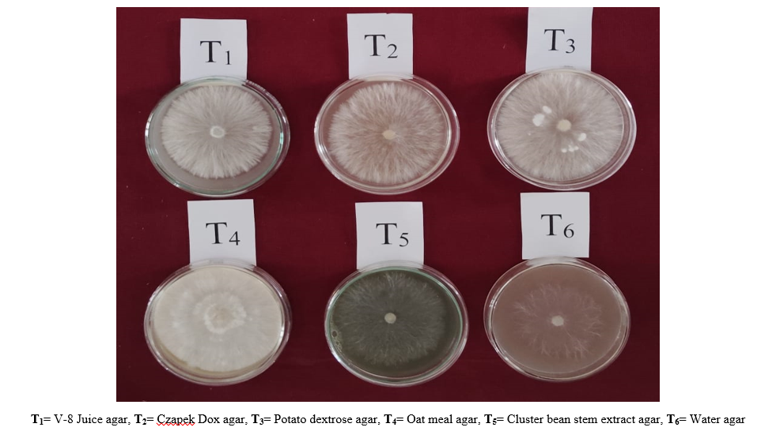
Plate 1: Effect of different solid media on mycelial growth of S. rolfsii causing stem rot disease of cluster bean

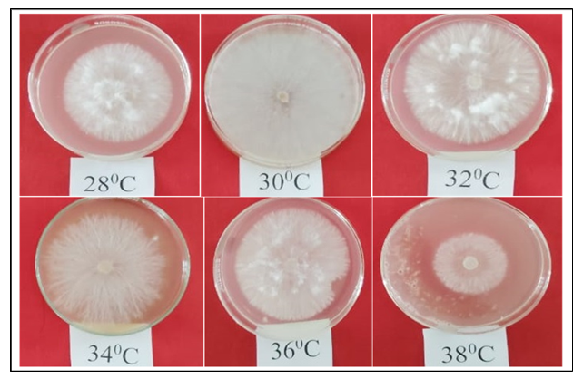
Plate: 2 (a) Effect of different temperature on mycelial growth of S. rolfsii causing stem rot disease of cluster bean

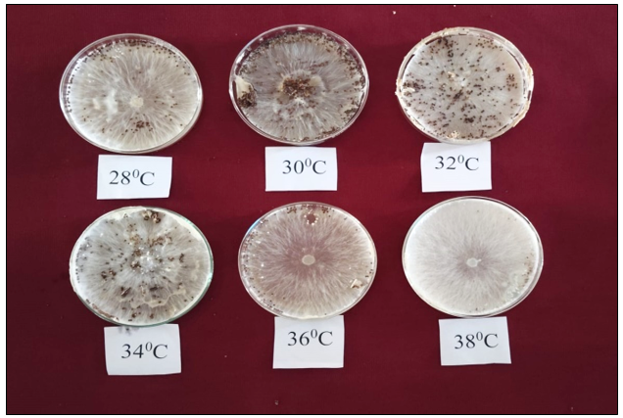
Plate: 2 (b) Effect of different temperature on sclerotia production of S. rolfsii causing stem rot disease of cluster bean

Conclusion
It is thus concluded that the treatments of mycelial growth of Sclerotium rolfsii was significantly affected by both culture media and incubation temperature. The maximum colony diameter (89.29 mm) was observed on oat meal agar, followed by potato dextrose agar, at 4 days after incubation (DAI). Among temperature treatments, the highest colony diameter (89.40 mm) was recorded at 30 °C, which was statistically superior to all other temperature levels, followed by 32 °C (77.74 mm). Similarly, the maximum number of sclerotia per plate (571.00) was produced at 30 °C, which was significantly higher than the rest, followed by 32 °C (471.00 sclerotia per plate). The minimum sclerotia production (45.33 per plate) occurred at 38 °C, which was statistically inferior to all other temperature treatments evaluated.

Disclaimer (Artificial intelligence)
Option 1:
Author(s) hereby declare that NO generative AI technologies such as Large Language Models (ChatGPT, COPILOT, etc.) and text-to-image generators have been used during the writing or editing of this manuscript.
Reference

Anonymous. (2022). Directorate of economics and statistics, Government of India, New Delhi.
Archana, T. S., Pankaj, B., Jagtap, S. D. and Patil, B. S. (2019). Effect of different cultural media on growth of S. rolfsii Sacc. Causing root rot of chilli. International Journal of Current Microbiology and Applied Sciences; 8(2):30193024.
Awurum, A. N. and Uwajimgba J. (2013). Varietal screening and comparative toxicity of some plant extracts for control of fusarium wilt of ground nut (Arachis hypogea L.). Continental Journal of Agricultural Science, 7(1): 11-16.
Ayed, F., Jabnoun-Khiareddine, H., Aydi Ben Abdallah, R., Daami-Remadi, M. (2018). Effect of temperatures and culture media on S. rolfsii mycelial growth, sclerotial formation and germination. Journal of Plant Pathology Microbiology.9:429.
Basamma. (2008). Integrated management of Sclerotium wilt of potato caused by Sclerotium rolfsii Sacc., M.Sc. (Agri.) Thesis, University of Agriculture Science, Dharwad. 1-113pp.
Dorrance, A. E., Kleinhenz, M. D., McClure, S. A., and Tuttle, N. T. (2003). Temperature, moisture, and seed treatment effects on Rhizoctonia solani root rot of soybean. Plant Disease, 87(5): 533-538.
Grover, R. K. and Chona, B. L. (1960). Comparative studies on Sclerotinm rolfsii and Ozonium texanum Neal and Webster var. patasiticum Thirumalachar, Indian Phytopathology, 13(2): 118-129.
Kushwaha, S. K., Kumar, S., Chaudhary, B., Sahu, R. (2019). Effect of different media, pH and temperature on growth and sclerotia formation of S. rolfsii Sacc. Causing collar rot of lentil. Chemical Science Review and Letters. 8(29):01-05.
Napte, N. A., Kumbhar, C. T., Khadtare, R. M., Tele, S. B. and Hasabnis, S. N. (2021). Effect of different media, light conditions and temperature on growth of Sclerotium rolfsii in vitro. The Pharma Innovation Journal, 10(12): 838-841.
Prasad, M. S., Lakshmi, K., Sujata, N., Naresh, K., and Chander Rao S. (2013). Variability in Sclerotium rolfsii associated with collar rot of sunflower. Indian Phytopathology, 65(2): 161-165.
Sannajambanna, B. (2018). Investigation on collar Rot of cluster Bean (Cyamopsis tetragonoloba L.) incited by Sclerotium rolfsii Sacc (Doctoral dissertation, University of Agricultural & Horticultural Sciences, Shivamogga).
Singh, K. (2020). Management of collar rot caused by Sclerotium rolfsii (Sacc.) in Chickpea (Cicer arietinum L.) (Doctoral dissertation, College of Agriculture, Ummedganj, Kota)
Sravani, B. and Chandra, R. (2020). Influence of media, pH and temperature on the growth of Sclerotium rolfsii Sacc. causing collar rot of chickpea. Journal of Pharmacogn Phytochemistry, 9(1): 174-178.
Srividya, P.V., Lal Ahamed, M., Ramana, J.V. and Khayum Ahmmed, S. (2018). Characterization of Sclerotium rolfsii Sacc. causing collar rot in chickpea isolates using cultural and morphological traits. Int. J. Curr. Microbiol. App. Sci, 7(06), pp.3912-3922.

