Development of Value-Added Functional Foods Using Millets and Pulses: A Review

Abstract
The increasing interest in health-enhancing diets and functional foods has driven attention toward traditional crops like millets and pulses. These underutilized food sources offer a promising alternative to conventional cereals owing to their rich nutritional profile, including dietary fiber, resistant starch, quality proteins, essential micronutrients, and phytochemicals. The opportunities for value addition extend to the development of gluten-free baked food products, snacks, and breakfast cereals; improvement of texture and color in gluten-free breads and batters; enhancement of texture and color in fresh and dry gluten-free pasta; development of gluten-free soups, sauces, and gravies; protein enrichment in fruit smoothies and vegan protein drinks; and the creation of egg-replacement products, among others. This review critically examines the nutritional composition, functional properties, processing techniques, product development, and consumer acceptability of functional foods derived from millets and pulses. Furthermore, it discusses the role of these crops in addressing malnutrition, promoting food diversity, and supporting sustainable agriculture in the face of lifestyle-related diseases.
Keywords: Functional foods, Millets, Pulses, Nutritional enhancement, Value addition, Food innovation, Sustainable nutrition
Introduction
In recent decades, global dietary patterns have witnessed a significant transformation, marked by an increasing awareness of the connection between nutrition and chronic disease prevention. With the alarming rise in non-communicable diseases (NCDs) such as diabetes, obesity, hypertension, and cardiovascular ailments, the demand for foods that offer not just sustenance but also health benefits—termed functional foods—has escalated. In this context, there is renewed interest in traditional, underutilized crops like millets and pulses as strategic components in building a resilient and health-oriented food system (Kaur et al., 2025).
Millets—including finger millet (Eleusine coracana), pearl millet (Pennisetum glaucum), and foxtail millet (Setariai talica)—are drought-resistant grains with high nutritional density, rich in complex carbohydrates, dietary fiber, calcium, iron, and phytochemicals. Similarly, pulses such as chickpeas (Cicer arietinum), mung beans (Vigna radiata), and lentils (Lens culinaris) are excellent sources of plant-based protein, resistant starch, and essential micronutrients (Dayakar et al., 2017). India holds the prominent position as the producer, exporter, and consumer of various categories of millet. As a result of the efforts made by the government, there has been a substantial increase in the production of millets, from 14.52 million t in 2015-2016 to 17.96 million t in 2020-2021 (Ministry of Agriculture & Farmers Welfare, 2022). Millets are broadly categorized into major and minor millets. These crops are particularly significant in regions facing dual challenges of malnutrition and climate change, due to their adaptability, low input requirement, and rich nutrient profile (Sarmah and Bora, 2025).
Historically labeled as “coarse grains” or “poor man’s food,” millets and pulses are now being re-evaluated through the lens of functional food science (Singh et al., 2023). Emerging studies have demonstrated their potential in reducing glycemic response, improving gut microbiota, and lowering the risk of degenerative diseases through antioxidant mechanisms. When incorporated into processed or value-added forms—such as multigrain flours, high-protein snacks, or probiotic drinks—these traditional crops can be transformed into modern, convenient, and appealing functional foods that cater to urban and health-conscious consumers (Ceasar and Maharajan (2022). Value addition of millets along with the consumption of its processed products provides the multiple benefits as they are a critical solution to climate change, can generate the market opportunities for farmers and can contribute to food and nutritional security for millions of people (Mahajan et al., 2024). This review aims to synthesize existing research and practical advancements in the formulation and promotion of functional food products using millets and pulses. It evaluates their nutritional and functional potential, explores modern processing and value addition techniques, discusses consumer acceptance, and highlights the role of these crops in achieving sustainable nutrition and food security in developing countries.

Nutritional Composition of Millets and Pulses
Millets and pulses, often underutilized in mainstream diets, are increasingly being recognized for their dense nutritional profiles and potential to address both macro- and micronutrient deficiencies. These crops not only provide essential nutrients but also contain several bioactive compounds with health-promoting properties.

Millets: The Nutritious Grains
Millets such as finger millet (Eleusine coracana), pearl millet (Pennisetum glaucum), and foxtail millet (Setaria italica) are rich in:
- Complex carbohydrates and dietary fiber (Dayakar et al., 2017; Sadh et al., 2024)
- Calcium, especially in finger millet (Sadh et al., 2024)
- Iron and zinc (Khan et al., 2025)
- Polyphenols and antioxidants (Kumar, 2021)
- Low fat content and are naturally gluten-free (Prakash et al., 2024)

Pulses: Protein Powerhouses
Pulses like chickpeas (Cicer arietinum), lentils (Lens culinaris), and mung beans (Vigna radiata) are characterized by:
- High-quality plant-based proteins (18–25 g/100 g) (Gurusamy et al., 2022)
- Resistant starch and soluble fiber (Escobedo & Mojica, 2021)
- Micronutrients such as iron, potassium, folate, and magnesium (Prabhakar et al., 2023)
- Bioactive compounds like phytosterols, flavonoids, and isoflavones (Singh et al., 2017)

Table 1: Comparative Nutrient Profile (per 100g)
Nutrient | Millets | Pulses
Protein (g) | 9 | 22
Dietary Fiber (g) | 10 | 15
Calcium (mg) | 250 | 75
Iron (mg) | 6 | 5
Zinc (mg) | 2.5 | 2.0
Energy (kcal) | 350 | 340
Polyphenols | High | Moderate

Graphical Comparison

Graph 1 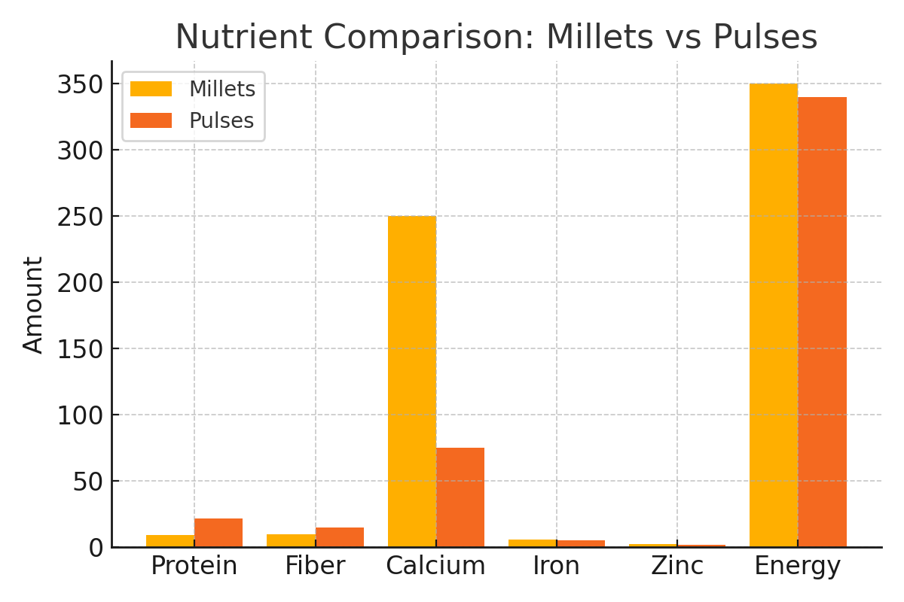

Functional Properties and Health Benefits

- 1. Antioxidant Activity
Millets and pulses are rich in polyphenols, flavonoids, and phytosterols that help scavenge free radicals and reduce oxidative stress. For instance, finger millet has been shown to possess higher antioxidant activity than commonly consumed cereals like wheat and rice. This activity helps prevent cellular damage linked to aging and degenerative diseases such as cancer and Alzheimer's (Namikii, 1990).

2. Glycemic Control
The low glycemic index (GI) of millets and pulses allows for slower digestion and absorption of carbohydrates, resulting in more stable blood sugar levels. This makes them particularly beneficial for individuals with Type 2 diabetes or those at risk. Foods like foxtail millet and lentils are effective in reducing postprandial glucose spikes (Clarke et al., 2022; Anitha et al., 2024).

3. Cardiovascular Health
High levels of soluble dietary fiber in these crops help reduce total and LDL (bad) cholesterol by binding bile acids and promoting their excretion. Moreover, pulses contain saponins and isoflavones, which contribute to heart health by lowering blood pressure and improving endothelial function (Rochfort et al., 2011).

4. Weight Management
Millets and pulses have low energy density and high satiety index, which promote a feeling of fullness and reduce overall calorie intake. The resistant starch and protein content in pulses delay gastric emptying, making them ideal for weight-conscious diets and obesity prevention programs (Clark & Duncan, 2017).

Table 2: Functional Benefits of Millets and Pulses
Health Function | Functional Component | Source Crop | Mechanism of Action
Antioxidant Activity | Polyphenols, Flavonoids | Finger Millet, Lentils | Neutralize free radicals, reduce oxidative stress
Glycemic Control | Complex Carbs, Resistant Starch | Foxtail Millet, Chickpeas | Delay glucose absorption, lower blood sugar
Cardiovascular Health | Soluble Fiber, Saponins, Isoflavones | Pearl Millet, Mung Beans | Lower LDL cholesterol, improve vascular function
Weight Management | Dietary Fiber, Protein | All Millets, Pulses | Increase satiety, reduce total energy intake

Graph 2 : Glycemic Index of Selected Crops
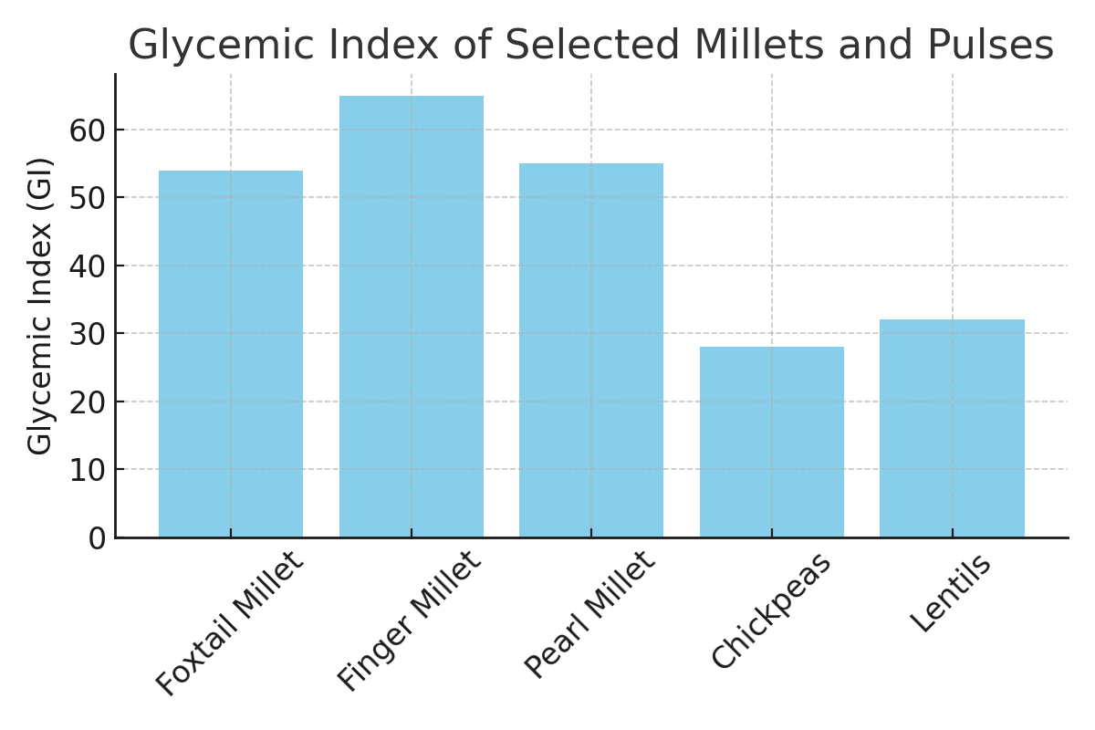
Food Processing Techniques for Value Addition
Value addition through food processing enhances the nutritional, sensory, and shelf-life attributes of raw agricultural commodities. In India, various millets and pulse are consumed in the form of different products like porridge, chapati, laddu, machula, dubkee, churkani, and various geographical location-specific dishes (Kate and Singh, 2021). Millets and pulses, owing to their rich nutritional profiles, respond favorably to a variety of traditional and modern processing techniques. These techniques improve palatability, digestibility, and functional efficacy of the final food products.

A. Germination (Sprouting)
Germination activates enzymes that break down antinutritional factors and increase bioavailability of nutrients such as vitamins B and C. Sprouted pulses and millets show improved protein digestibility and antioxidant activity (Trang et al., 2023).

B. Fermentation
Fermentation improves flavor, texture, and shelf life, and enhances iron bioavailability while reducing phytic acid. Common products include fermented millet-based idli and dosa (Krishnamoorthy et al., 2013).

C. Roasting and Puffing
Roasting imparts flavor and reduces moisture content, while puffing enhances crispiness and preserves nutrients in millets like sorghum.

D. Milling and Dehulling
These processes reduce fiber and antinutrients, improving protein and starch digestibility in pulses and enhancing texture.

E. Extrusion Cooking
A high-temperature process used to produce shelf-stable snacks and cereals, improving starch digestibility and enabling micronutrient fortification.

F. Malting
Involves soaking, germinating, and drying grains to improve flavor and sweetness. Malted millet flours are ideal for dietary supplements.

G. Instantization and Drying
Techniques like freeze-drying and spray drying are used to make ready-to-reconstitute powders for beverages and soups.

H. Blending and Fortification
Biofortification of staple crops is proved to be an economically feasible approach to combat micronutrient malnutrition. Harvest Plus group realized the importance of millet biofortification and released conventionally bred high iron pearl millet in India to tackle iron deficiency. Molecular basis of waxy starch has been identified in foxtail millet, proso millet, and barnyard millet to facilitate their use in infant foods (Vinoth and Ravindhran (2017). Combining ingredients for customized, health-targeted formulations, such as diabetic-friendly flours or iron-rich blends.
Table 3: Food Processing Techniques for Value Addition
Technique | Benefits | Examples
Germination | Enhances vitamins, reduces antinutrients | Sprouted green gram, ragi sprouts
Fermentation | Improves digestibility and flavor | Millet dosa, fermented lentil batter
Roasting/Puffing | Enhances taste, reduces moisture and microbial load | Roasted chickpeas, puffed pearl millet
Milling/Dehulling | Removes hulls, improves texture | Dehulled lentils, milled foxtail millet
Extrusion Cooking | Makes snacks, improves digestibility | Millet-based extruded breakfast cereals
Malting | Increases sweetness and digestibility | Malted finger millet flour
Drying | Improves shelf life, enables instant use | Dried dal mixes, ready-to-eat millet soup mix
Blending/Fortification | Nutritional synergy, addresses deficiencies | Millet-legume mix for school feeding programs

Graph 3
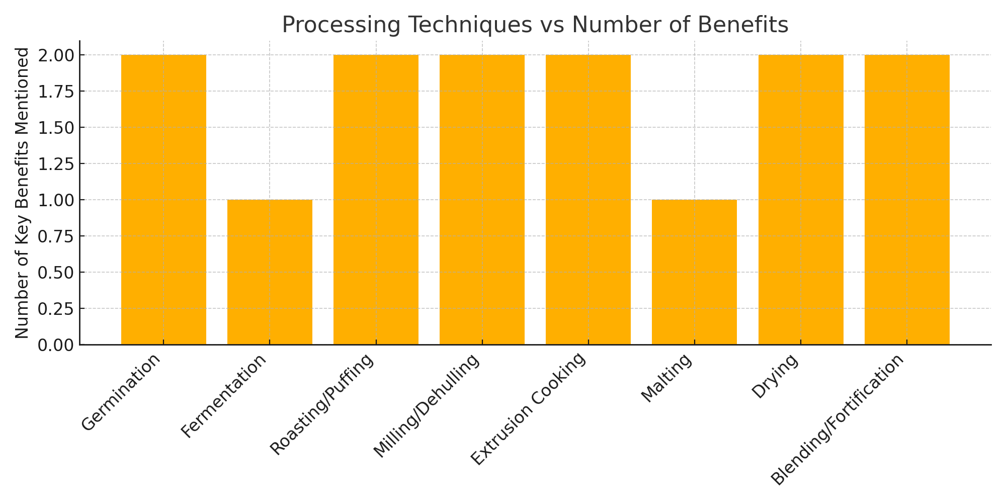

Development of Functional Products
The evolution of food processing and increasing health consciousness among consumers have led to the formulation of a wide range of functional food products. Millets and pulses, known for their rich nutritional composition and functional bioactives, have become key ingredients in developing innovative health-oriented food items. These products not only address basic nutritional needs but also contribute to disease prevention and overall wellness.

Objectives of Developing Functional Products
- To utilize underexploited grains like millets and pulses for mainstream consumption.
- To cater to specific health needs such as diabetes, obesity, cardiovascular wellness, and gut health.
- To enhance the shelf life, taste, and marketability of traditional ingredients.

Some Successfully Developed and Consumer-Tested Functional Products:
- Multigrain Functional Flour
- Composition: A blend of millets (finger millet, foxtail millet), pulses (chickpeas, lentils), flaxseed, and oats.
- Features: Rich in dietary fiber, essential amino acids, and omega-3 fatty acids.
- Benefits: Helps in glycemic control, weight management, and digestive health.
- Use: Can be used to prepare chapatis, porridge, and multigrain bread.
- Protein-Enriched Snacks
- Examples: Baked millet-pulse crackers, roasted chickpea-lentil puffs.
- Features: High protein-to-calorie ratio, minimal oil usage, gluten-free.
- Benefits: Suitable for athletes, children, and individuals with protein-deficient diets.
- Innovation: Inclusion of spices and herbs for added antioxidant and anti-inflammatory benefits.
- Probiotic Millet Drinks
- Composition: Fermented foxtail or finger millet with added probiotic cultures (Lactobacillus spp.).
- Features: Functional beverage with high digestibility and gut flora-enhancing effects.
- Benefits: Boosts immunity, supports gastrointestinal health, and prevents microbial imbalances.
- Market Form: Ready-to-drink bottles or powdered mixes for reconstitution.

Market and Consumer Acceptance
Several studies and pilot-scale trials have demonstrated good consumer acceptance for these functional products, particularly among health-conscious urban populations. Sensory evaluations reveal a preference for mild flavoring, soft texture, and innovative packaging, especially in snacks and drinks. The growing interest in plant-based and sustainable nutrition further amplifies the market scope of these millet and pulse-based functional foods.

Future Scope
- Integration of nutrigenomics for personalized functional foods.
- Fortification with vitamins and minerals for targeted nutritional therapy.
- Use of AI and IoT in shelf-life monitoring and smart packaging.

Consumer Acceptability and Market Trends
Consumer trials show a strong preference toward naturally functional, preservative-free, and eco-friendly food products. The trend reflects growing awareness about health, sustainability, and clean-label food choices. Market research indicates a Compound Annual Growth Rate (CAGR) of 8–10% for functional food categories involving millets and pulses in South Asia. This growth is driven by urbanization, rising middle-class incomes, and increasing incidence of lifestyle-related diseases. Product innovations that emphasize taste, convenience, and nutritional claims are gaining popularity among all age groups.
Key drivers include:
- Rising demand for plant-based and gluten-free diets
- Increasing consumer awareness about the health benefits of millets and pulses
- Government initiatives promoting indigenous grains and functional foods
- Expanding e-commerce and retail penetration in rural and semi-urban areas

Role in Sustainable Nutrition and Food Security
Millets and pulses play a pivotal role in advancing sustainable nutrition and ensuring food security, particularly in resource-constrained regions. Their cultivation is climate-resilient, requiring significantly less water and synthetic inputs compared to major cereals like rice and wheat. This makes them ideal for promoting agricultural sustainability in arid and semi-arid zones. From a nutritional standpoint, these crops are rich in essential proteins, fibers, vitamins, and minerals, addressing multiple forms of malnutrition including protein-energy malnutrition and micronutrient deficiencies. Their integration into daily diets through functional food products can support the achievement of SDG 2 (Zero Hunger) and SDG 3 (Good Health and Well-being).
Moreover, promoting value-added products from millets and pulses enhances income opportunities for smallholder farmers, supports local food systems, and reduces dependency on imported cereals. By encouraging local processing and decentralized value chains, communities gain better control over their food resources, reducing post-harvest losses and enhancing resilience against market shocks. Thus, the development and promotion of millet- and pulse-based functional foods are not just a nutritional strategy but a critical component of sustainable food system transformation.

Challenges and Future Prospects
Despite the growing recognition of millets and pulses as key contributors to functional foods and sustainable diets, several challenges hinder their widespread adoption and market integration.
Major Challenges:
Consumer Awareness-: Limited consumer knowledge about the health benefits and culinary versatility of millets and pulses restricts their inclusion in daily diets.
Taste and Texture Preferences- Some consumers perceive these grains as coarse or inferior compared to refined cereals.
-Processing Constraints-: Lack of modern processing infrastructure and standardization affects product quality, shelf life, and scalability.
Supply Chain Gaps-: Inconsistent raw material quality, inadequate storage, and logistical issues disrupt market linkages.
Policy Support-: Although several government schemes exist, implementation at the grassroots level remains weak.
Future Prospects:
Research and Innovation-: Continued R&D in biofortification, fermentation, extrusion, and hybrid product formulations can enhance product appeal and functionality.
Capacity Building-: Training farmers, entrepreneurs, and processors in best practices will strengthen the entire value chain.
Public-Private Partnerships (PPP)-: Collaborations between academia, industry, and government can accelerate innovation and market reach.
Global Market Expansion-: Export potential for gluten-free, high-protein, and organic millet-based products is significant, particularly in health-conscious markets.
Policy Interventions-: Incentives for processing units, nutritional labeling, and procurement support can catalyze demand.
Addressing these challenges strategically can position millets and pulses as cornerstones of future-ready, resilient food systems.

Conclusion
The resurgence of interest in millets and pulses marks a significant shift toward sustainable and health-driven dietary patterns. These traditional crops, once marginalized in mainstream food systems, are now emerging as key ingredients in the formulation of functional foods that cater to modern nutritional needs and lifestyle-related health challenges. Their dense nutrient profiles—rich in protein, dietary fiber, resistant starch, micronutrients, and bioactive compounds—equip them with the potential to combat malnutrition, regulate glycemic responses, improve cardiovascular health, and support gut wellness. Through the application of diverse processing techniques such as germination, fermentation, extrusion, and fortification, millets and pulses can be transformed into a wide range of value-added products including multigrain flours, protein-rich snacks, and probiotic beverages. These innovations not only improve sensory appeal and consumer acceptance but also provide new avenues for income generation, rural employment, and agribusiness development.
Market trends indicate a growing demand for clean-label, eco-friendly, and plant-based foods, positioning millet- and pulse-based functional foods favorably in both domestic and international markets. However, to fully realize their potential, concerted efforts are required to address challenges related to consumer awareness, processing infrastructure, value chain inefficiencies, and supportive policy frameworks. Looking ahead, integrating scientific research, food technology, and policy support with grassroots entrepreneurship can play a transformative role in mainstreaming these crops. Promoting value-added functional products based on millets and pulses is not only a strategy for improving human health but also a powerful tool for achieving food security, climate resilience, and sustainable agricultural development. As we aim to build future-ready food systems, these ancient grains offer modern solutions.
Disclaimer (Artificial intelligence)

Author(s) hereby declare that NO generative AI technologies such as Large Language Models (ChatGPT, COPILOT, etc.) and text-to-image generators have been used during the writing or editing of this manuscript.

References
Anitha S, Tsusaka TW, Botha R, Givens DI, Rajendran A, Parasannanavar DJ, Subramaniam K, Bhandari RK and Kane-Potaka J (2024) Impact of regular consumption of millets on fasting and postprandial blood glucose level: a systematic review and meta-analysis. Front. Sustain. Food Syst. 7:1226474. doi: 10.3389/fsufs.2023.1226474
Ceasar, S.A. and Maharajan, T. (2022). The role of millets in attaining United Nation’s sustainable developmental goals. Plants People Planet; 4, 345–349.
Clark, Sandra & Duncan, Alison. (2017). The role of pulses in satiety, food intake and body weight management. Journal of Functional Foods. 38. 10.1016/j.jff.2017.03.044.
Clarke ST, Sarfaraz S, Qi X, Ramdath DG, Fougere GC, Ramdath DD. (2022). A Review of the Relationship between Lentil Serving and Acute Postprandial Blood Glucose Response: Effects of Dietary Fibre, Protein and Carbohydrates. Nutrients. 2022 Feb 18;14(4):849. doi: 10.3390/nu14040849.
Dayakar Rao B., Bhaskarachary K., Arlene Christina G.D., Sudha Devi G., Vilas, A. Tonapi, (2017). Nutritional and Health benefits of Millets. ICAR_Indian Institute of Millets Research (IIMR) Rajendranagar, Hyderabad, PP 112.
Escobedo A, & Mojica L. (2021). Pulse-based snacks as functional foods: Processing challenges and biological potential. Compr Rev Food Sci Food Saf, 20:; 4678–4702. https://doi.org/10.1111/1541-4337.12809
Gurusamy, S., Vidhya, C.S., Khasherao, B Y. and Shanmugam, A. (2022). Pulses for health and their varied ways of processing and consumption in India - A review, Applied Food Research; 2(2), 2022,100171. https://doi.org/10.1016/j.afres.2022.100171.
Kate, A. and Singh, A. (2021). Processing Technology for Value Addition in Millets. In: Millets and Millet Technology. Springer Nature Singapore, 239-254, https://doi.org/10.1007/978-981-16-0676-2_11
Kaur, S., Kaur, G., Kumari, A., Ghosh, A., Singh, G., Bhardwaj, R., Kumar, A., Riar, A. (2025). Resurrecting forgotten crops: Food-based products from potential underutilized crops a path to nutritional security and diversity. Future Foods; 11,100585. https://doi.org/10.1016/j.fufo.2025.100585
Khan, T., Azad, A A. and Islam RU. (2025). Millets: A comprehensive review of nutritional, antinutritional, health, and processing aspects, Journal of Food Composition and Analysis, 141,107364, https://doi.org/10.1016/j.jfca.2025.107364
Krishnamoorthy, S., Kunjithapatham S. and Manickam, L (2013). Traditional Indian breakfast (Idli and Dosa) with enhanced nutritional content using millets. Nutrition & Dietetics; 70: 241–246
Kumar A, Rani M, Mani S, Shah P, Singh DB, Kudapa H and Varshney RK (2021) Nutritional Significance and Antioxidant-Mediated Antiaging Effects of Finger Millet: Molecular Insights and Prospects. Front. Sustain. Food Syst. 5:684318. doi: 10.3389/fsufs.2021.684318
Mahajan, M., Singla, P. and Sharma, S (2024). Sustainable postharvest processing methods for millets: A review on its value-added products. J Food Process Eng.;47: e14313. Wiley.
Ministry of Agriculture & Farmers Welfare (2022). Millet production, https://pib.gov.in/PressReleasePage.aspx?PRID=1796559.
Namikii, M. (1990). Antioxidants/antimutagens in food. Crit. Rev. Food Sci. Nutr. 29, 273–300. doi: 10.1080/10408399009527528
Prabhakar Semwal, Sakshi Painuli, Shabaaz Begum J.P, Abhishek Jamloki, Abdur Rauf, Ahmed Olatunde, Md. Mominur Rahman, Nobendu Mukerjee, Anees Ahmed Khalil, Abdullah S.M. Aljohani, Waleed Al Abdulmonem, Jesus Simal-Gandara (2023). Exploring the nutritional and health benefits of pulses from the Indian Himalayan region: A glimpse into the region’s rich agricultural heritage. Food Chemistry, 422, 36259, https://doi.org/10.1016/j.foodchem.2023.136259.
Prakash, S D., Pulivarthi, M K and Siliveru, K. (2024). Pearl Millet: Processing and Value Addition for Gluten-free Markets, In: Pearl Millet: A Resilient Cereal Crop for Food, Nutrition, and Climate Security. Book Series: Agronomy Monographs. https://doi.org/10.1002/9780891184034.ch15
Rochfort, Simone & Ezernieks, Vilnis & Neumann, Nathan & Panozzo, Joe. (2011). Pulses for Human Health: Changes in Isoflavone and Saponin Content with Preparation and Cooking. Australian Journal of Chemistry. 64. 790-797. 10.1071/CH11024.
Sadh, P.K., Kamboj, A., Kumar, S. et al. Perspectives of millets for nutritional properties, health benefits and food of the future: a review. Discov Food 4, 187 (2024). https://doi.org/10.1007/s44187-024-00266-6
Sarmah, A. and Bora D J. (2025). Millets: a resilient solution for a changing climate; Current Trends in Agricultural Research Volume I. Bhumi Publishing, India, pp-33-44.
Singh B, Singh JP, Shevkani K, Singh N, Kaur A. (2017). Bioactive constituents in pulses and their health benefits. J Food Sci Technol.;54(4):858-870. doi: 10.1007/s13197-016-2391-9.
Singh, S., Yadav, R N., Tripathi, A K., Kumar, M., Kumar, M., Yadav, S., Kumar, D., Kumar, S. and Yadav, R. (2023). Current Status and Promotional Strategies of Millets: A Review. International Journal of Environment and Climate Change; 13(9), Page 3088-3095.
Trang H.D. Nguyen, Lien L.P. Nguyen, Laszlo Baranyai (2023). Influence of sprouting on phenolic acids, carotenoids, and antioxidant activity of millet varieties, Journal of Agriculture and Food Research, 14, 100810, https://doi.org/10.1016/j.jafr.2023.100810.
Vinoth A and Ravindhran R (2017) Biofortification in Millets: A Sustainable Approach for Nutritional Security. Front. Plant Sci. 8:29. doi: 10.3389/fpls.2017.00029
.

