Review Article
BIOINSPIRED POLYMER METAL COMPLEX COMPOSITES: DESIGN AND EMERGING APPLICATIONS

ABSTRACT
Polymer–metal complex composites are a versatile class of hybrid materials that Polymer–metal complex composites represent a versatile class of hybrid materials that integrate the structural flexibility of polymers with the functional tunability of metal coordination compounds. This review provides an overview of recent advances in their design, synthesis, and emerging applications, with particular emphasis on the use of natural and bio-based ligands. Key fabrication strategies including in situ complexation, melt blending, sol–gel, electrospinning, 3D printing methods are discussed in relation to their influence on the resulting composite morphology and performance. The incorporation of metal complexes has been shown to significantly improve mechanical strength, thermal stability, barrier behavior, catalytic efficiency, and biological activity, enabling wide-ranging applications in biomedicine, packaging, catalysis, and environmental remediation. Despite these advantages, challenges such as interfacial incompatibility, thermal degradation, and metal ion leaching remain challenges. To overcome these limitations, advanced approaches such as reactive processing, smart ligands, and the integration of metal–organic frameworks (MOFs) are being explored. This review highlights current progress and offers insights into future directions for the development of high-performance polymer–metal complex composites.
Keywords: Polymer composites, Metal complexes, Natural ligands, Material properties, Green synthesis
INTRODUCTION
Polymer–metal complex composites (PMCC) represent a rapidly growing area in materials science, combining the structural flexibility of polymers with the functional versatility of coordination chemistry. The integration of metal complexes into polymer matrices enables the development of multifunctional materials with enhanced thermal, mechanical, optical, barrier, and biological properties[1]. These composites are widely explored for applications in biomedical devices, catalysis, electronics, active packaging, and environmental remediation. By coordinating metal ions with synthetic or natural ligands like EDTA, tannic acid, or flavonoids, their physicochemical and biofunctional characteristics can be precisely tuned. Despite these advantages, challenges such as poor dispersion, interfacial incompatibility, and metal ion leaching often limit performance and stability. Recent progress in processing methods including electrospinning, reactive extrusion, and surface functionalization has significantly improved the uniform distribution and retention of metal complexes in polymer matrices[2,3]. Additionally, the emergence of nanocomposites incorporating metal–organic frameworks (MOFs), graphene–metal complexes, and bioinspired ligands has opened new directions for high-performance and sustainable systems. Susumu Kitagawa, Richard Robson, and Omar M. Yaghi received the 2025 Nobel Prize in Chemistry for pioneering metal–organic frameworks (MOFs), a new class of molecular architectures. MOFs are built from metal nodes and organic ligands, forming highly ordered porous networks. These structures possess exceptionally large, tunable cavities that allow molecules to flow in and out selectively. Their unique porosity and functionality have transformed applications in gas storage, catalysis, drug delivery, and advanced composite materials. This review provides an overview of the current developments, key properties and applications of polymer–metal complex composites, emphasizing their potential in next-generation smart and eco-friendly materials[4].
Ligands
A ligand is a molecule or ion that binds to a metal ion to form a coordination complex. Ligands do this by donating one or more pairs of electrons to the metal, typically through atoms like oxygen, nitrogen, or sulfur[5]. This interaction forms a coordinate (dative) bond, where both electrons in the bond come from the ligand. Synthetic ligands are man-made molecules specifically designed to bind metal ions and form stable coordination complexes. They are engineered in the laboratory with precise molecular structures, denticity (number of donor atoms), and functional groups to achieve desired chemical or physical properties. Synthetic ligands often offer higher stability, predictability, and versatility than natural ligands[6]. Natural ligands used in polymer–metal complex systems are predominantly derived from plant-based polyphenols, flavonoids, alkaloids, and organic acids, which possess abundant electron-donating functional groups such as hydroxyl (–OH), carboxyl (–COOH), and carbonyl (C=O) groups[7]. Common sources include tannins from tree bark and fruits, gallic acid and ellagic acid from berries and tea, curcumin from turmeric, catechins from green tea, and quercetin from onions and apples. These ligands typically exhibit bidentate or multidentate coordination modes, allowing them to chelate metal ions like Fe³⁺, Cu²⁺, Zn²⁺, and Ag⁺ with high stability[8]. Based on their electron-donating ability and coordination behavior, they are classified as neutral ligands (e.g., curcumin), anionic ligands (e.g., gallic acid, tannic acid), or zwitterionic ligands (e.g., amino acids). Their natural origin not only ensures biocompatibility and biodegradability but also introduces intrinsic antioxidant, antimicrobial, and UV-absorbing properties to the resulting metal–polymer complexes, making them suitable for biomedical, food packaging, and catalytic applications. The table: 1 gives the comparison and natural and synthetic ligands[9].
Table:1 Comparison natural and synthetic ligands[10,11]
Feature | Natural Ligands | Synthetic Ligands
Origin | Plant, microbial, animal sources | Laboratory-synthesized compounds
Examples | Tannic acid, curcumin, gallic acid | EDTA, bipyridine, Schiff bases
Coordination | Multi-dentate, via –OH, –COOH, –NH₂ | Customizable mono-/multi-dentate
Bioactivity | High (antioxidant, antimicrobial) | Low (unless functionalized)
Environmental Impact | Biodegradable, eco-friendly | Non-biodegradable, sometimes toxic
Stability | Moderate (may degrade thermally) | High thermal/chemical stability
Applications | Biomedical, packaging, green materials | Catalysis, sensing, industrial materials

Classification of Ligands
Ligands employed in polymer–metal complex composites can be systematically categorized into four major classes natural, synthetic, biopolymeric, and drug-based based on their origin, structural characteristics, and functional relevance to target applications. Figure 1 displays flow chart of types of ligans[12].
- Natural ligands encompass bio-derived molecules such as amino acids, short peptides, polyphenols (e.g., tannic acid, gallic acid), chlorophyll derivatives, and vitamins. These ligands are sourced from plants, microbes, or animal tissues and are favored for their eco-compatibility, intrinsic biocompatibility, and availability of functional groups (–OH, –COOH, –NH₂) that readily participate in metal coordination. They not only stabilize the metal centers but also impart antioxidant or antimicrobial properties. Table 2. provides natural ligands, their metal complexes, coordination properties, and potential applications[13,14].
- Synthetic ligands include structurally engineered molecules like Schiff bases, phosphines, crown ethers, and porphyrins, which are either chemically synthesized or modified from natural templates[15]. These ligands offer superior control over coordination geometry, electronic distribution, and stability of metal complexes. Their tunable steric and electronic environments enable precise modulation of catalytic activity, redox potential, and metal selectivity, which is essential in electronics, catalysis, and sensor applications[16].
- Biopolymeric ligands consist of high-molecular-weight natural polymers such as chitosan, alginate, pectin, silk fibroin, gelatin, and cellulose derivatives. These macromolecular ligands provide multiple coordination sites along their backbone, supporting chelation with multivalent metal ions. Besides coordinating capability, they contribute significantly to the mechanical integrity, film-forming ability, and biodegradability of the composites[17].
- Drug-based ligands represent a class of bioactive small molecules including quercetin, curcumin, isatin, and ciprofloxacin, which not only coordinate with metal ions but also impart therapeutic functionalities. These ligands are widely applied in biomedical composites due to their pharmacological properties such as antimicrobial, anticancer, or anti-inflammatory effects coupled with the controlled metal ion release behavior that enhances their efficacy in localized therapy or bioactive coatings[18].
Types of ligands | Examples | Chemical structure
Natural ligands | Amino acids, peptides, Chitosan, polyphenols, chlorophyll, vitamins  (Plants, microorganisms, animals) | Gallic acid  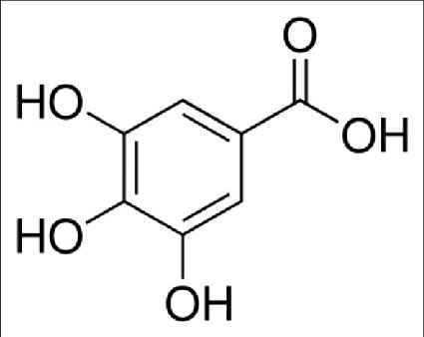
Synthetic ligands | Schiff bases, phosphines,  crown ethers, porphyrins  (Lab-synthesized or modified form  natural precursors) | 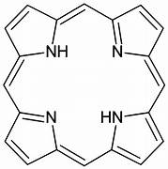
Biopolymeric ligands | Chitosan, alginate, cellulose derivatives  (Natural  Polysaccharides  & proteins) | Sodium alginate  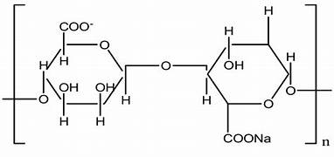
Drug- based  ligands | Quercetin, curcumin, Isatin, ciprofloxacin  (Pharmaceuticals  Or bio actives forming metal complexes) | Quercetin  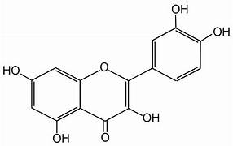
Chart 1: Drug-based ligands

Table: 2 Summary of natural compound or extract–metal ion complexes, showing their metal charge states, coordination behaviors, resulting physicochemical properties, and potential applications [ 19-48]
Natural Compound / Extract | Chemical Formula | Metal Ion (Charge) | Coordination Behavior | Denticity | Properties | Applications
Curcumin (Turmeric) | C₂₁H₂₀O₆ | Cu(II), Zn(II), Fe(III), Ni(II) | Electron donor via β-diketone & phenolic –OH | Bidentate | Enhanced stability, bioavailability, DNA binding | Anticancer, antioxidant, antimicrobial
Quercetin (Onion, tea, peels) | C₁₅H₁₀O₇ | Cu(II), Zn(II), Co(II), Fe(III) | Polyphenolic donor, strong chelator | Bidentate to tridentate | High ROS scavenging, metal ion chelation | Antioxidant, anti-inflammatory, enzyme inhibition
Catechin (Green tea) | C₁₅H₁₄O₆ | Fe(III), Cu(II) | Electron donor via hydroxyl groups | Bidentate | Redox-active complexes, radical scavenging | Antioxidant, neuroprotective
Chlorogenic acid (Coffee, berries) | C₁₆H₁₈O₉ | Co(II), Mg(II), Mn(II), Ni(II), Sr(II) | Donor via carboxyl and phenol | Tridentate | Enzyme inhibition, α-amylase/α-glucosidase | Antidiabetic, antibacterial
Gallic acid (Gallnuts, tea) | C₇H₆O₅ | Ca(II), Cu(II), Zn(III), Cr(III), Se(IV) | Donor via 3 phenolic –OH | Tridentate | Chelation, ROS modulation | Antioxidant, wound healing, anticancer
Aloe vera extract | C₁₀H₁₆O₁₀ₙ (polysaccharides) | Cu(II), Zn(II), Fe(II) | Donor from sugars, carboxyls | Variable (mono–tridentate) | Green reducing/capping agent | Antibacterial, wound healing, larvicidal
Flavonoids (mixed) | C₁₅H₁₂O₆ (general) | Mn(II), Zn(II), Co(II), Ni(II) | π–donor ligands with OH and C=O | Bidentate to tetradentate | Metal-ligand charge transfer | Antiviral, anticancer, enzyme inhibition
Tannic acid (Oak bark, tea) | C₇₆H₅₂O₄₆ | Fe(II), Co(II) | Polyphenolic donor, strong chelator | Polydentate | Crosslinking, precipitation, protein binding | Antimicrobial, water purification
Lignin derivatives | C₉H₁₀O₂ (phenylpropanoid unit) | Fe(III), Cu(II) | Aromatic alcohol donor | Polydentate | Biodegradable, electron transfer | Adsorption, catalysis, antimicrobial
Caffeic acid (Coffee, fruits) | C₉H₈O₄ | Cu(II), Pb, Mg | Phenolic/π-conjugated donor | Bidentate | Radical neutralization | Antioxidant, cytotoxicity
Berberine (Berberis) | C₂₀H₁₈NO₄⁺ | Zn(II), Cu(II) | Nitrogen-containing donor | Bidentate | Intercalates DNA, enhances bioactivity | Antibacterial, anticancer
Rutin (Citrus peel) | C₂₇H₃₀O₁₆ | Zn(II), Cu(II), Ni(II), Zr(II) | Polyphenolic –OH donor | Bidentate | Improved pharmacological action | Antidiabetic, antioxidant
Eugenol (Clove oil) | C₁₀H₁₂O₂ | Co(II), Fe(II), Ni(II) | Electron-rich phenol and ether | Monodentate to bidentate | Lipophilic complexes, bioactive | Antifungal, analgesic
Emodin (Aloe, rhubarb) | C₁₅H₁₀O₅ | Cu(II), Fe(II), Mn(II) | π-conjugated + phenolic OH | Bidentate | DNA damage, antiproliferative | Anticancer, anti-inflammatory
Asiatic acid (Centella asiatica) | C₃₀H₄₈O₅ | Cu(II), Zn(II) | Carboxyl donor, steroid-like | Bidentate | Bio-scaffold, wound healing | Anti-aging, skin regeneration
Thymol (Thyme oil) | C₁₀H₁₄O | Cu(II), Zn(II) | Phenolic donor | Monodentate | ROS induction, permeability | Antibacterial, antifungal
Apigenin (Chamomile, parsley) | C₁₅H₁₀O₅ | Fe(III), Cu(II) | OH/C=O donor | Bidentate | Enhanced cytotoxicity | Anticancer, neuroprotective
Resveratrol (Red wine, grapes) | C₁₄H₁₂O₃ | Cu(I) | Phenolic donor, π-system | Bidentate | DNA protection, ROS scavenging | Antioxidant, anticancer
Piperine (Black pepper) | C₁₇H₁₉NO₃ | Zn(II) | π-electron rich alkaloid | Bidentate | Drug bioenhancer | Antimicrobial, solubility enhancer
Betulinic acid (Birch bark) | C₃₀H₄₈O₃ | Cu(II), Zn(II) | Carboxyl donor, pentacyclic structure | Bidentate | Induces apoptosis | Antiviral, anticancer
Silymarin (Milk thistle) | C₂₅H₂₂O₁₀ (silybin) | Cu(II), Zn(II), Fe(III) | Polyphenol + flavonol donors | Bidentate | ROS neutralization | Hepatoprotective, antioxidant
Isatin (Indole alkaloid) | C₈H₅NO₂ | Cu(II), Ni(II), Co(II) | C=O and N donor | Bidentate | Enzyme inhibition, DNA intercalation | Antiviral, anticancer
Hesperidin (Citrus fruits) | C₂₈H₃₄O₁₅ | Cu(II), Zn(II) | Polyhydroxyl donor | Bidentate | Redox modulation | Antidiabetic, antioxidant
Cinnamic acid (Cinnamon) | C₉H₈O₂ | Zn(II), Cd(II), Hg(I) | Carboxylate and π-electron donor | Monodentate to bidentate | Complex stability, redox activity | Antioxidant, antibacterial
Kaempferol (Broccoli, tea) | C₁₅H₁₀O₆ | Ru(II) | OH and C=O donor | Bidentate | Chelation via phenol groups | Antioxidant, anticancer
Gingerol (Ginger) | C₁₇H₂₆O₄ | Ag(II), Au(II), Cu(II) | Phenolic OH, ketone donor | Bidentate | Bioavailability, wound repair | Anticancer
Myricetin (Berries, tea) | C₁₅H₁₀O₈ | Zn(II), Fe(III) | Multiple OH donors | Tridentate | Improves ROS scavenging | Antioxidant, anticancer
Vanillin (Vanilla bean) | C₈H₈O₃ | Cu(II), Zn(II), Fe(II) | Aldehyde/Schiff base formation | Bidentate (via Schiff base) | Schiff base-metal complexation | Antioxidant, antimicrobial
Alizarin (Madder root) | C₁₄H₈O₄ | Cu(II), Zn(II), Fe(III) | Anthraquinone + OH donor | Bidentate | DNA intercalation, π-stacking | Textile dye, antifungal, anticancer
Luteolin (Celery, thyme) | C₁₅H₁₀O₆ | Fe(III), Al(III), Cu(II) | Polyhydroxy flavone | Bidentate | Enhances brain-targeted delivery | Neuroprotective, antioxidant
Baicalein (Scutellaria root) | C₁₅H₁₀O₅ | Cu(II) | Phenolic groups | Bidentate | Mitochondrial disruption | Antioxidant
Tea polyphenols (Camellia sinensis) | C₁₅H₁₄O₆ (general) | Ag(I), Au(III), Cu(II) | Reducing agent + OH donors | Polydentate | Reduces/stabilizes metals | Anticancer, green nanoparticle synthesis

Processing methods of PMCC
The advancements in ligand engineering, nanotechnology, and green processing techniques have significantly improved polymer–metal complex composites. Bio-based ligands including polyphenols (e.g., tannic acid, gallic acid), amino acids, and flavonoids form stable metal complexes with enhanced biocompatibility and reduced toxicity. In situ complexation improves dispersion and interfacial bonding in polymer matrices such as PLA, chitosan, PVA, and PEG. Sol–gel processing enables the formation of uniform, porous, and thermally stable hybrid networks at low temperatures, ideal for coatings, catalysis, and biomedical films. Melt blending (melt mixing) offers a solvent-free and scalable industrial method, but requires thermally stable metal complexes or compatibilizers to prevent degradation. Electrospinning enables the fabrication of nanofiber mats for wound healing, catalysis, and filtration [49,50]. Meanwhile, 3D printing allows precise control over scaffold architecture, porosity, and localized functionalization, making it suitable for biomedical and catalytic applications. The steps involved in 3D printing of polymer–metal complex composites are illustrated in Figure 1. Metal–organic frameworks (MOFs) and graphene–metal hybrids introduce high surface area, tunable porosity, and adjustable electrical, thermal, and antimicrobial properties. Stimuli-responsive composites further expand functionality by responding to pH, light, or temperature for smart biomedical devices and sensors. Advanced methods including reactive extrusion, supercritical CO₂ processing, and machine learning-guided design enhance scalability, reproducibility, and performance predictability [52,53]. Collectively, these innovations are transforming polymer–metal systems into versatile platforms for environmental, biomedical, packaging, and electronic applications.

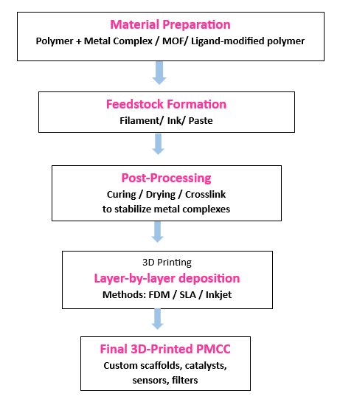

Figure 1. Flow chart of 3D printing processing of polymer–metal complex composites,

Properties of PMCC
These composites exhibit diverse biological, mechanical, thermal, optical, electrical, and catalytic functions. Biologically, they show antimicrobial, antioxidant, anti-inflammatory, and anticancer activity due to interactions between metal ions such as Ag⁺, Zn²⁺, Cu²⁺, and Fe³⁺ and natural ligands like tannic acid and quercetin, enhancing cell compatibility and supporting wound healing and tissue regeneration[54]. Mechanically, metal-ion coordination improves tensile strength, stiffness, and structural stability, while biocompatible plasticizers, including vegetable oils, glycerol, or polyethylene glycol, balance rigid and flexible phases [53]. Thermal stability increases through strong metal–ligand bonds, raising glass transition and decomposition temperatures, which enhances heat resistance and flame retardancy. Excessive metal loading can reduce melt processability, mitigated by green compatibilizers or synergistic nano-reinforcements such as clay, lignin, or biogenic silica. Barrier properties are enhanced, reducing gas and moisture permeability and providing UV protection; systems such as gallic acid–Fe³⁺ and tannic acid–Cu²⁺ reduce water vapor transmission rates by 30–40% while maintaining oxidative stability. Optical properties are governed by UV-absorbing ligands, nanoscale dispersion that preserves transparency, and metal–ligand coordination enabling color changes depending on pH, metal type, or redox conditions, suitable for smart packaging and visual indicators[54]. Electrical behavior is enhanced by redox-active metal centers and coordinated ligands, facilitating charge transfer and tunable conductivity for sensors, flexible electronics, and energy storage. Catalytic activity originates from redox-active metal centers forming accessible active sites for substrate binding[55].
Applications of PMCC
Biomedical applications
The coordination of bioactive metal ions, such as Ag⁺, Cu²⁺, Zn²⁺, Fe³⁺, and Ca²⁺, with biocompatible polymers particularly natural matrices like chitosan, alginate, gelatin, and cellulose derivatives, as well as semi-synthetic matrices such as poly(vinyl alcohol) and poly(ethylene glycol) in combination with polyphenolic ligands, including curcumin and tannic acid, has been shown to impart superior antibacterial, anti-inflammatory, and antioxidant activities [56], enabling versatile biomedical applications in wound healing, tissue regeneration, antimicrobial coatings, and controlled drug delivery. These properties support critical physiological processes such as cellular adhesion, migration, proliferation, and hemostasis, thereby promoting epithelial closure and tissue remodeling. Structurally, the composites enable tunable release of metal ions, allowing localized therapeutic action while minimizing systemic cytotoxicity[57]. The formation of the chitosan–Fe²⁺–tannic acid complex is presented in Figure 2. Advances in nanoscale engineering have further enhanced bioavailability, degradation kinetics, and responsiveness to physiological stimuli, including pH and enzymatic activity. In bone tissue engineering, Fe³⁺- and Ca²⁺-based coordination systems have demonstrated enhanced osteoinductive potential by stimulating alkaline phosphatase expression, collagen matrix deposition, and mineralized nodule formation. Collectively, these developments establish polymer–metal complexes as highly promising candidates for next-generation regenerative therapies and implantable biomedical devices [58].
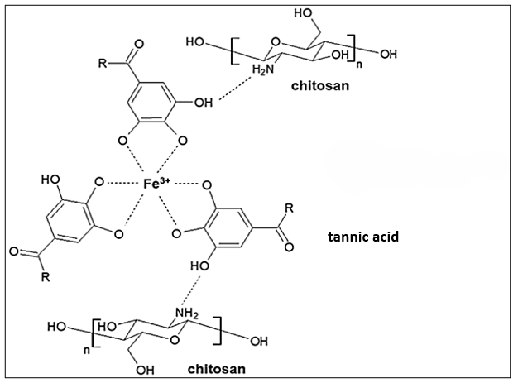

Figure 2. Schematic representation of the Chitosan–Fe²⁺–tannic acid complex formation.
Food Packaging and Preservation
In food packaging applications, polymer–metal complexes offer synergistic barrier, antimicrobial, and antioxidant functionalities. Coordination of metal ions with bioactive ligands particularly natural polyphenols produces matrices capable of reducing oxygen and moisture permeability, thereby retarding lipid oxidation and microbial proliferation[59]. These active packaging systems create an inhospitable environment for spoilage organisms by facilitating the gradual, localized release of metal ions, which disrupt microbial cell membranes and interfere with enzymatic activity. Incorporation of such complexes into biodegradable polymer films, such as polylactic acid and poly(vinyl alcohol), enhances physicochemical stability while maintaining the transparency and flexibility essential for food-contact applications [60]. Moreover, integrating pH-sensitive metal–ligand interactions into packaging films enables the development of intelligent packaging systems that visually indicate spoilage through distinct colorimetric shifts. This dual functionality not only prolongs shelf life but also enhances consumer safety and product traceability. Consequently, these complexes represent a promising strategy for the next generation of sustainable, smart food packaging technologies.

Environmental Remediation
Incorporating redox-active metal ions, such as Fe³⁺, Cu²⁺, and Mn²⁺, into polymeric matrices coordinated with phenolic ligands, including catechin, gallic acid, or tannic acid, imparts intrinsic catalytic activity analogous to natural peroxidases or Fenton-type systems [61]. These coordination complexes facilitate the activation of hydrogen peroxide or persulfate, generating reactive oxygen species (ROS) such as hydroxyl or sulfate radicals. This process drives the efficient oxidative decomposition of persistent pollutants, making the complexes particularly effective for advanced wastewater treatment and the catalytic degradation of organic contaminants, including azo dyes, endocrine disruptors, and pharmaceutical residues[62,63]. The process of catalytic degradation by polymer metal complex system is shown in figure 3. The polymeric immobilization of metal complexes not only enhances catalytic efficiency but also significantly reduces metal ion leaching and promotes controlled electron transfer. Structural confinement improves accessibility to active sites, resulting in higher turnover frequency and operational robustness under varying pH and pollutant concentrations. Furthermore, the electron-donating functionality of natural ligands supports sustainable redox cycling and strengthens complex stability, enabling prolonged catalytic lifespans. Collectively, these polymer–metal hybrids function as heterogeneous, recyclable catalysts with high substrate selectivity and minimal secondary pollution [64].

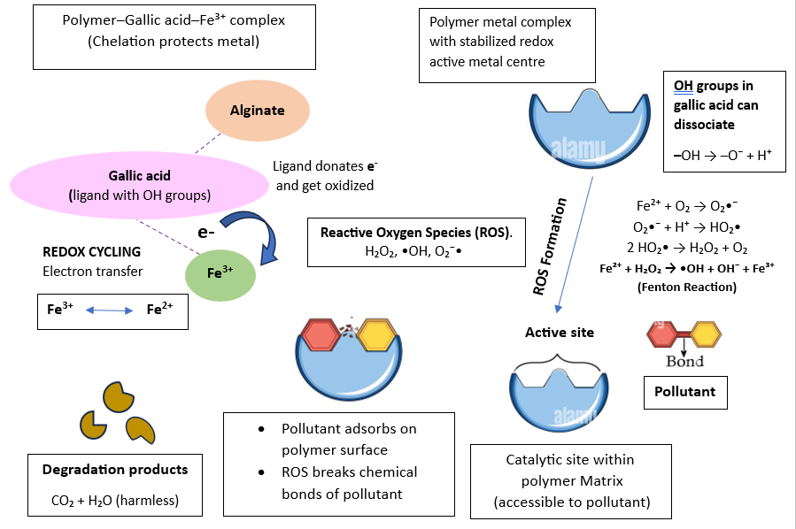
Figure 3. Schematic representation of polymer metal complex catalytic mechanism and pollutant degradation

Electronics and Sensors
The intrinsic redox activity, tunable conductivity, and functional surface chemistry of polymer–metal complexes are increasingly being investigated for applications in flexible electronics, electrochemical sensors, and energy storage devices. The figure 4 show the incorporating transition metal ions, such as Fe³⁺ or Cu²⁺, into polymer matrices via coordination with natural polyphenolic ligands facilitates efficient charge transfer and electron mobility, which are critical for signal transduction in sensing applications[65]. These materials can be engineered into flexible and stretchable films capable of responding to environmental stimuli, including humidity, glucose concentration, or volatile organic compounds, with the redox-active metal centers acting as the transducing elements [66]. Natural ligands improve metal dispersion and interfacial compatibility, enhancing electrochemical stability and measurement reproducibility. Furthermore, coordination-induced doping has been shown to modulate the dielectric, thermal, and electrical conductivity profiles of the polymer matrix, enabling their integration into energy storage systems, such as capacitors and supercapacitors. These modifications also contribute to structural integrity and reliable cycling performance under operational stress. The structural versatility and multifunctionality of polymer–metal complexes thus make them promising candidates for next-generation wearable sensors, bioelectronic interfaces, and smart energy devices [67].
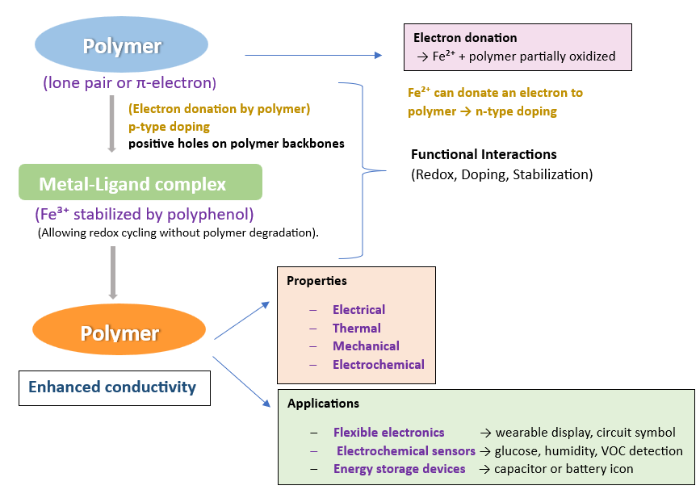

Figure 4. Schematic representation of polymer metal complex conductivity

Catalysis and Smart Coatings
Multifunctional coating technologies are increasingly enhanced by polymer–metal complex composites, which combine anticorrosive, antimicrobial, catalytic, and self-responsive properties. Coordination networks formed between metal ions, such as Fe³⁺ and Cu²⁺, Ni²⁺, Mn²⁺ and bio-derived ligands, including tannic acid, provide durable adhesion, UV shielding, and self-healing capabilities, and concurrently prevent oxidative degradation and corrosion. These coatings have demonstrated particular effectiveness in protecting metal surfaces, biomedical implants, and packaging materials where environmental resilience is essential [68]. In catalytic applications, the redox-active metal centers enable enzyme-mimetic activity, facilitating selective oxidation, reduction, and hydrolysis reactions relevant to biosensing and green synthetic chemistry. Moreover, smart coatings that exploit dynamic metal–ligand coordination can respond to environmental stimuli such as pH, temperature, or redox conditions. These triggers allow controlled release of active agents, adaptive surface wettability, and activation of antimicrobial functions [69]. In industrial applications, polymer–metal complex composites are incorporated into coatings, panels, or films to enhance fire safety. Their char formation and thermal stability, catalyze protective oxide layers that reduce heat release. These properties make them suitable for protective coatings in construction, electronics, transportation, and other sectors requiring flame-retardant materials[70].
Conclusion
These composites represent a promising class of hybrid materials that synergistically combine the processability and flexibility of polymers with the unique functionalities of metal complexes, such as catalytic activity, antimicrobial behavior, electrical conductivity, and structural reinforcement. Recent advances have demonstrated the potential of both natural and synthetic ligands to coordinate metal ions and impart tailored properties to biocompatible or high-performance polymer matrices. However, challenges related to thermal stability, dispersion, interfacial compatibility, leaching, and scalability still limit their widespread application. Overcoming these obstacles through advanced ligand engineering, surface modification, and green processing techniques can significantly enhance composite performance and durability.
DISCLAIMER (ARTIFICIAL INTELLIGENCE)
I hereby declare that no generative AI technologies have been used in the writing, editing, or preparation of this manuscript. All content, text, and figures are original and created solely by the authors.
COMPETING INTERESTS
The authors declare that no competing interests exist in relation to this manuscript.
REFERENCE
- Kumar, S., Mohan, B., Musikavanhu, B., Wang, X., Muhammad, R., Yang, X., & Ren, P., (2025). Metal-polymer-coordinated complexes: An expedient class of hybrid functional materials. Coordination Chemistry Reviews, 524, 216286. https://doi.org/10.1016/j.ccr.2024.216286
- Abtahi, S., Hendeniya, N., Mahmud, S. T., Mogbojuri, G., Iheme, C. L., & Chang, B. (2025). Metal-coordinated polymer–inorganic hybrids: Synthesis, properties, and application. Polymers, 17(2), 136. https://doi.org/10.3390/polym17020136
- Bartczak, P., Szylińczuk, K., Tomaszczak, M., & Borysiak, S. (2024). Sustainable and multifunctional polyurethane green composites with renewable materials. Journal of Materials Science, 59, 13541–13557. https://doi.org/10.1007/s10853-024-09992-9
- Tsuchida, E., & Nishide, H. (2007). Polymer-metal complexes and their catalytic activity. In Molecular Properties (Vol. 24, pp. 1–87). Advances in Polymer Science. https://doi.org/10.1007/3-540-08124-0_1
- Yang, Y., Zhang, C., Zhang, C., Shi, Y., Li, J., Johannessen, B., Liang, Y., Zhang, S., Song, Q., Zhang, H., Huang, J., Ke, J., Zhang, L., Song, Q., Zeng, J., Zhang, Y., Geng, Z., Wang, P.-S., Wang, Z., Zeng, J., & Li, F. (2024). Ligand-tuning copper in coordination polymers for efficient electrochemical C–C coupling. Nature Communications, 15, Article 6316. https://doi.org/10.1038/s41467-024-42679-5
- Ogunbiyi, E. O., Kupa, E., Adanma, U. M., & Solomon, N. O. (2024). Comprehensive review of metal complexes and nanocomposites: Synthesis, characterization, and multifaceted biological applications. Engineering Science & Technology Journal, 5(6), 1935–1951. https://doi.org/10.51594/estj/v5i6.1215
- Marx, F., Beccard, M., Ianiro, A., Dodero, A., Neumann, L. N., Stoclet, G., Weder, C., & Schrettl, S. (2023). Structure and properties of metallosupramolecular polymers with a nitrogen-based bidentate ligand. Macromolecules, 56(18), 7320–7331. https://doi.org/10.1021/acs.macromol.3c00503
- El Hankari, S., Bousmina, M., & El Kadib, A. (2019). Biopolymer@metal-organic framework hybrid materials: A critical survey. Progress in Materials Science, 106, 100579. https://doi.org/10.1016/j.pmatsci.2019.100579
- Nikolić, G. S., Ćakić, M., Mitić, Z., & Ilić, L. (2008). Deconvoluted Fourier-transform LN T-IR study of coordination copper(II) compounds with dextran derivatives. Russian Journal of Coordination Chemistry, 34(5), 322–328.
- Leite, D. C., Peres, G., & Silveira, N. (2016). Biopolymer-metal complexes: Recent advances and applications. In A. Méndez-Vilas (Ed.), Polymer science: Research advances, practical applications and educational aspects (pp. 601–610). Badajoz, Spain: Formatex Research Center.
- Abtahi, S., Hendeniya, N., Mahmud, S. T., Mogbojuri, G., Iheme, C. L., & Chang, B. (2025). Metal-coordinated polymer–inorganic hybrids: Synthesis, properties, and application. Polymers, 17(2), 136. https://doi.org/10.3390/polym17020136
- Reddy, M. S. B., Ponnamma, D., Choudhary, R., & Sadasivuni, K. K. (2021). A comparative review of natural and synthetic biopolymer composite scaffolds. Polymers, 13(7), 1105. https://doi.org/10.3390/polym13071105
- Pei, J., Palanisamy, C. P., Natarajan, P. M., Umapathy, V. R., Roy, J. R., Srinivasan, G. P., Panagal, M., & Jayaraman, S. (2024). Curcumin-loaded polymeric nanomaterials as a novel therapeutic strategy for Alzheimer's disease: A comprehensive review. Ageing Research Reviews, 99, 102393. https://doi.org/10.1016/j.arr.2024.102393
- Fedenko, V. S., Landi, M., & Shemet, S. A. (2022). Metallophenolomics: A novel integrated approach to study complexation of plant phenolics with metal/metalloid ions. International Journal of Molecular Sciences, 23(19), 11370. https://doi.org/10.3390/ijms231911370
- Sharma, Shubham, P. Sudhakara, Jujhar Singh, R. A. Ilyas, M. R. M. Asyraf, and M. R. Razman. (2021). "Critical Review of Biodegradable and Bioactive Polymer Composites for Bone Tissue Engineering and Drug Delivery Applications." Polymers 13 (16): 2623. https://doi.org/10.3390/polym13162623
- T. Lan, Y. Dong, J. Shi, X. Wang, Z. Xu, Y. Zhang, L. Jiang, W. Zhou, X. Sui, (2024), Advancing self-healing soy protein hydrogel with dynamic Schiff base and metal-ligand bonds for diabetic chronic wound recovery, Aggregate 5(6), e639 https://doi.org/10.1002/agt2.639
- Yang, W., Sousa, A. M. M., Thomas-Gahring, A., Fan, X., Jin, T., Li, X., Tomasula, P. M., & Liu, L. (2016). Electrospun polymer nanofibers reinforced by tannic acid/Fe³⁺ complexes. Materials, 9(9), 757. https://doi.org/10.3390/ma9090757
- Patsahan, T., & Pizio, O. (2022). Structural aspects of the clustering of curcumin molecules in water: Molecular dynamics computer simulation study. Condensed Matter Physics, 25(2), 23201. https://doi.org/10.5488/CMP.25.23201
- Tsoupras, A., Pafli, S., Stylianoudakis, C., Ladomenou, K., Demopoulos, C. A., & Philippopoulos, A. (2024). Anti-inflammatory and antithrombotic potential of metal-based complexes and porphyrins. Compounds, 4(2), 376–400. https://doi.org/10.3390/compounds4020023
- Stover, K.; Fukuyama, T.; Young, A.T.; Daniele, M.A.; Oberley, R.; Crapo, J.D.; Bäumer, W. (2016).Topically Applied Manganese-Porphyrins BMX-001 and BMX-010 Display a Significant Anti-Inflammatory Response in a Mouse Model of Allergic Dermatitis. Arch. Dermatol. Res. 308, 711–721.
- Abdel-Rahman, L.H.; El-Khatib, R.M.; Abdel-Fatah, S.M.; Moustafa, H.; Alsalme, A.M.; Nafady, A. Novel Cr (III), Fe (III) and Ru (III) Vanillin Based Metallo-Pharmaceuticals for Cancer and Inflammation Treatment: Experimental and Theoretical Studies. Appl. Organomet. Chem. 2019, 33, e5177.
- Rodríguez-Arce, E., & Saldías, M. (2021). Antioxidant properties of flavonoid metal complexes and their potential inclusion in the development of novel strategies for the treatment against neurodegenerative diseases. Biomedicine & Pharmacotherapy, 143, 112236. https://doi.org/10.1016/j.biopha.2021.112236
- Lungu, I. I., Cioanca, O., Mircea, C., Tuchilus, C., Stefanache, A., Huzum, R., & Hancianu, M. (2024). Insights into catechin–copper complex structure and biologic activity modulation. Molecules, 29(20), 4969. https://doi.org/10.3390/molecules29204969
- Zheng, K., Liu, Y., Peng, L., Li, Z., & Xu, W. (2023). Structural characterization of chlorogenic acid-metal complexes derived from the aqueous extracts of medicinal plants and their DNA cleavage and antibacterial activities. Arabian Journal of Chemistry, 16(7), 104835. https://doi.org/10.1016/j.arabjc.2023.104835
- El-Megharbel, S. M., & Hamza, R. Z. (2022). Synthesis, spectroscopic characterizations, conductometric titration and investigation of potent antioxidant activities of gallic acid complexes with Ca(II), Cu(II), Zn(III), Cr(III) and Se(IV) metal ions. Journal of Molecular Liquids, 358, 119196. https://doi.org/10.1016/j.molliq.2022.119196
- Edo, G. I. (2024). Coordination of bioactive phytochemicals from Aloe vera extracts to metal ions; investigation of the metal complexes and bioactive compound formed. BioMetals, 37, 1379–1391. https://doi.org/10.1007/s10534-024-00593-0
- Kasprzak, M. M., Erxleben, A., & Ochocki, J. (2015). Properties and applications of flavonoid metal complexes. RSC Advances, 5(57), 45853–45877. https://doi.org/10.1039/C4RA13547C
- Kasprzak, M. M., Erxleben, A., & Ochocki, J. (2015). Properties and applications of flavonoid metal complexes. RSC Advances, 5(57), 45853–45877. https://doi.org/10.1039/C5RA05069C
- Wang, Y., Chen, S., Zhao, S., Chen, Q., & Zhang, J. (2020). Interfacial coordination assembly of tannic acid with metal ions on three-dimensional nickel hydroxide nanowalls for efficient water splitting. Journal of Materials Chemistry A, 8(31), 15845–15852. https://doi.org/10.1039/D0TA02229B
- Garcia-Valls, R., & Hatton, T. A. (2003). Metal ion complexation with lignin derivatives. Chemical Engineering Journal, 94(2), 99–105. https://doi.org/10.1016/S1385-8947(03)00007-X
- Baidoo, I., Sarbadhikary, P., Abrahamse, H., & George, B. P. (2025). Metal-based nanoplatforms for enhancing the biomedical applications of berberine: Current progress and future directions. Nanomedicine (London), 20(8), 851–868. https://doi.org/10.1080/17435889.2025.2480051
- Prakash, O., Belal, B., Dhanik, J., Verma, A., Joshi, H. C., & Vivekanand. (2020). Biological activities of metal complexes with rutin and bio-conjugate of citrus extract. Universal Journal of Chemistry, 7(1), 1–24. https://doi.org/10.13189/ujc.2020.070101
- Azez, A., Natheer, R., Mohammed, E., & Saleh, M. Y. (2021). Preparation of new complexes of Fe(II), Co(II), Ni(II) and Cu(II) with mixed ligands of ciprofloxacin or levofloxacin with eugenol and study of their chemical and physical properties. Egyptian Journal of Chemistry, 64, Article ID: 63144. https://doi.org/10.21608/ejchem.2021.63144.3352
- Liu, M.-Y., Pan, X.-L., Li, X.-B., & Wu, B. (2021). Study on the antioxidant activity of aloe-emodin metal complex] [Article in Chinese]. Sichuan Da Xue Xue Bao Yi Xue Ban, 52(2), 241–247. https://doi.org/10.12182/20201160110
- Rasouli, Z., Irani, M., Jafari, S., & Ghavami, R. (2021). Study of interaction of metal ions with methylthymol blue by chemometrics and quantum chemical calculations. Scientific Reports, 11, 6465. https://doi.org/10.1038/s41598-021-85940-w
- Spiegel, M., & Sroka, Z. (2023). Quantum-mechanical characteristics of apigenin: Antiradical, metal chelation and inhibitory properties in physiologically relevant media. Fitoterapia, 164, 105352. https://doi.org/10.1016/j.fitote.2022.105352
- Chiavarino, B., Crestoni, M. E., Fornarini, S., Taioli, S., Mancini, I., & Tosi, P. (2012). Infrared spectroscopy of copper-resveratrol complexes: A joint experimental and theoretical study. The Journal of Chemical Physics, 137(2), 024307. https://doi.org/10.1063/1.4732583
- Parvin, K., Bhattacharya, A., Rasool, M. A., & Pounikar, Y. (2024). Isolation and characterization of piperine from black pepper, zinc-piperine metal complex. International Journal of Research and Analytical Reviews (IJRAR), 11(1), 799. https://www.ijrar.org/viewfull.php?&p_id=IJRAR24A1244
- Batool, A., Muddassir, M., & Shahid, K. (2024). Synthesis of hydrazide derivative of betulinic acid, its organometallic complexes, characterization and bioassay. Chemistry & Biodiversity. Advance online publication. https://doi.org/10.1002/cbdv.202301275
- Paltinean, G.-A., Tomoaia, G., Riga, S., Mocanu, A., & Tomoaia-Cotisel, M. (2022). Silymarin based complexes – A mini review. Academy of Romanian Scientists Annals – Series on Biological Sciences, 11(1), 146–166.
- Hossain, M. S., Khushy, K. A., Latif, M. A., Hossen, Md. F., Asraf, Md. A., Kudrat-E-Zahan, Md., & Abdou, A. (2022). Co(II), Ni(II), and Cu(II) complexes containing isatin-based Schiff base ligand: Synthesis, physicochemical characterization, DFT calculations, antibacterial activity, and molecular docking analysis. Russian Journal of General Chemistry, 92, 2723–2733. https://doi.org/10.1134/S1070363222120222
- Daoud, S., Afifi, F. U., Al-Bakri, A. G., Kasabri, V., & Hamdan, I. I. (2014). Preparation, physicochemical characterization and biological evaluation of some hesperidin metal complexes. Iranian Journal of Pharmaceutical Research, 13(3), 909–918. https://www.ncbi.nlm.nih.gov/pmc/articles/PMC4177651/
- Kalinowska, M., Świsłocka, R., & Lewandowski, W. (2011). Zn(II), Cd(II) and Hg(I) complexes of cinnamic acid: FT-IR, FT-Raman, ¹H and ¹³C NMR studies. Journal of Molecular Structure, 993(1–3), 404–409. https://doi.org/10.1016/j.molstruc.2011.01.063
- Thangavel, P., Viswanath, B., & Kim, S. (2018). Synthesis and characterization of kaempferol-based ruthenium (II) complex: A facile approach for superior anticancer application. Materials Science and Engineering: C, 90, 479–489. https://doi.org/10.1016/j.msec.2018.03.020
- Sungur, Ş., & Uzar, A. (2008). Investigation of complexes tannic acid and myricetin with Fe(III). Spectrochimica Acta Part A: Molecular and Biomolecular Spectroscopy, 69(1), 225–229. https://doi.org/10.1016/j.saa.2007.03.038
- Sharma, V., Ali, S.W. (2023).Nanoarchitectonics of Vanillin-Metal Complexes as Eco-friendly Multifunctional Agents on Cellulosic Fabric. J Inorg Organomet Polym 33, 1932–1945.https://doi.org/10.1007/s10904-023-02611-1
- Fain, V.Y., Zaitsev, B.E. & Ryabov, M.A. (2003). Metal Complexes with Alizarin and Alizarin Red S: Electronic Absorption Spectra and Structure of Ligands. Russian Journal of Coordination Chemistry 30, 365–370 https://doi.org/10.1023/B:RUCO.0000026008.98495.51
- Malacaria, L., La Torre, C., Furia, E., Fazio, A., Caroleo, M. C., Cione, E., Gallelli, L., Marino, T., & Plastina, P. (2022). Aluminum(III), iron(III) and copper(II) complexes of luteolin: Stability, antioxidant, and anti-inflammatory properties. Journal of Molecular Liquids, 345, 117895. https://doi.org/10.1016/j.molliq.2021.117895
- Rajkumar, M., Presley, S. I. D., Govindaraj, P., Kirubakaran, D., Farahim, F., Ali, T., Shkir, M., & Latha, S. (2025). Synthesis of chitosan/PVA/copper oxide nanocomposite using Anacardium occidentale extract and evaluating its antioxidant, antibacterial, anti-inflammatory and cytotoxic activities. Scientific Reports, 15, Article 3931. https://doi.org/10.1038/s41598-025-87932-6
- Zhou, R., Huang, J., Zhang, W., Wang, W., Peng, W., Chen, J., Yu, C., Bo, R., Liu, M., & Li, J. (2024). Multifunctional hydrogel based on polyvinyl alcohol/chitosan/metal polyphenols for facilitating acute and infected wound healing. Materials Today Bio, 29, 101315. https://doi.org/10.1016/j.mtbio.2024.101315
- Mohammed, H. A., Mohammed, P. A., & Aziz, S. B. (2025). Physical characteristics of polymer composites based on PVA doped with Mn²⁺ metal complexes synthesized by green approach: Insights to linear and optoelectronic optical properties. Oxford Open Materials Science, 5(1). https://doi.org/10.1093/oxfmat/itaf003
- Liu, J., Bao, S., Ling, Q., Fan, X., & Gu, H. (2022). Ultra-fast preparation of multifunctional conductive hydrogels with high mechanical strength, self-healing and self-adhesive properties based on Tara tannin–Fe³⁺ dynamic redox system for strain sensors applications. Polymer, 240, 124513. https://doi.org/10.1016/j.polymer.2021.124513
- Roh, H., Kim, D.-H., Cho, Y., Jo, Y.-M., del Alamo, J. A., Kulik, H. J., Dincă, M., & Gumyusenge, A. (2024). Robust chemiresistive behavior in conductive polymer/MOF composites. Advanced materials, 36(27), e2312382 https://doi.org/10.48550/arXiv.2403.08914.
- Liu, Y., Zhang, W., Su, X., He, W., Yang, J., Qin, G., Yu, X., & Chen, Q. (2023). Self-healable, mechanically durable and cold-resistant integrated supercapacitor enabled by dual metallic redox-mediated multiple cross-linking gel polymer electrolyte. Energy, 282, 128777. https://doi.org/10.1016/j.energy.2023.128777
- Altundag, E. M., Ozbilenler, C., Usturk, S., & Kerkuklu, N. R. (2021). Metal-based curcumin and quercetin complexes: Cell viability, ROS production and antioxidant activity. Journal of Molecular Structure, 1245, 131107. https://doi.org/10.1016/j.molstruc.2021.131107
- Anum, S., Sher, M., Khan, M., Shah, L. A., & Yoo, H.-M. (2025). Supramolecular polymer hydrogels through rapid polymerization enabled by tannic acid–silver dual catalysis for next-generation flexible and wearable sensors. ACS Applied Electronic Materials, 7(6), Article e4c02349. https://doi.org/10.1021/acsaelm.4c02349
- Xu, H., Huang, W.-P., Ren, K.-F., & Tang, Y.-M. (2021). Spraying layer-by-layer assembly of tannin–Fe³⁺ and polyethyleneimine for antibacterial coating. Colloids and Interface Science Communications, 42, 100422. https://doi.org/10.1016/j.colcom.2021.100422
- Nalawade, S. P., Picchioni, F., & Janssen, L. P. B. M. (2006). Supercritical carbon dioxide as a green solvent for processing polymer melts. Progress in Polymer Science, 31(1), 19–43.
- Xu, K., Li, H., Huang, X., & Qin, Z. (2022).
Multi-crosslinked network chitosan films containing caffeic acid and Fe³⁺ with high anti-oxidation and anti-UV abilities. International Journal of Biological Macromolecules, 223(Pt A), 1462–1473. https://doi.org/10.1016/j.ijbiomac.2022.11.052
- X. Liang, L. Ding, J. Ma, J. Li, L. Cao, H. Liu, M. Teng, Z. Li, Y. Peng, H. Chen, Y. Zheng, H. Cheng, G. Liu, (2024), Enhanced Mechanical Strength and Sustained Drug Release in Carrier-Free Silver-Coordinated Anthraquinone Natural Antibacterial Anti-Inflammatory Hydrogel for Infectious Wound Healing, Advanced Healthcare Materials 13(23), e2400841. https://doi.org/10.1002/adhm.202400841. Epub 2024 May 15.
- Levy, L., Gurov, A., & Radian, A. (2020). The effect of gallic acid interactions with iron-coated clay on surface redox reactivity. Water Research, 184, 116190. https://doi.org/10.1016/j.watres.2020.116190
- Kumar, S., Mohan, B., Musikavanhu, B., Wang, X., Muhammad, R., Yang, X., & Ren, P. (2025). Metal-polymer-coordinated complexes: An expedient class of hybrid functional materials. Coordination Chemistry Reviews, 524, 216286. https://doi.org/10.1016/j.ccr.2024.216286
- Bouzayani, B., & Sanromán, M. Á. (2024). Polymer-supported heterogeneous Fenton catalysts for the environmental remediation of wastewater. Molecules, 29(10), 2188. https://doi.org/10.3390/molecules29102188
- Zhang, H., Zhang, X., Wang, B., Ren, B., & Yang, X. (2025).
Synergistic multi-crosslinked networks in chitosan/gallic acid/Fe³⁺ composite biofilms with high UV resistance and antioxidant properties. International Journal of Biological Macromolecules, 316(Part 1), Article 144686. https://doi.org/10.1016/j.ijbiomac.2025.144686
- Alkhayer, G. (2021). Alginate metal complexes and their application. IntechOpen. https://doi.org/10.5772/intechopen.98885
- Kumar, V., & Alam, M. N. (2025). Multifunctional polymer composite materials. Polymers, 17(12), 1636. https://doi.org/10.3390/polym17121636
- Akhtar, M., Shahzadi, S., Arshad, M., Akhtar, T., & Janjua, M. R. S. A. (2025). Metal oxide-polymer hybrid composites: A comprehensive review on synthesis and multifunctional applications. RSC Advances, 15, 18173–18208. https://doi.org/10.1039/D5RA01821H
- Simões, S. (2024). High-performance advanced composites in multifunctional material design: State of the art, challenges, and future directions. Materials, 17(23), 5997. https://doi.org/10.3390/ma17235997
- Song, Y., Wang, X., Tang, J., & Li, G. L. (2024). Dynamic polymer/metal–organic framework hybrid microcapsules for self-healing anticorrosion coatings. ACS Applied Materials & Interfaces, 16(49), 68478–68486. https://doi.org/10.1021/acsami.4c16670
- Sathishkumar, G., Gopinath, K., Zhang, K., & Kang, E.-T. (2022). Recent progress in tannic acid-driven antimicrobial/antifouling surface coating strategies. Journal of Materials Chemistry B, 10(14), 2490–2508. https://doi.org/10.1039/D1TB02073K

