Original Research Article
Seasonal Variation and nutrient dynamics in Sediment Physicochemical Characteristics of Douglas Creek, Niger Delta

ABSTRACT
Aims: This study investigated seasonal variations in the physicochemical characteristics of sediments from Douglas Creek, Niger Delta, with emphasis on nutrient dynamics and ecological implications.
Study Design: A cross-sectional seasonal study design was employed.
Place and Duration of Study: Sediment samples were collected from Douglas Creek in Ibeno Local Government Area, Akwa Ibom State, Nigeria, with sampling points desingtaed as SS1, SS2, and SS3 during both the wet (April–October) and dry (November–March) seasons of 2024.
Methodology: Surface sediments (0–10 cm) were collected at georeferenced stations using a Van Veen grab sampler. Samples were air-dried, homogenized, and analyzed for pH, electrical conductivity (EC), redox potential, total organic carbon (TOC), nitrate (NO₃⁻), calcium (Ca), magnesium (Mg), and other ions following standardized methods (APHA, ASTM, EPA). Quality control was maintained with blanks, duplicates, and certified reference materials. Data were subjected to descriptive statistics, t-test, one-way ANOVA, and Pearson’s correlation analysis at a 95% confidence level (P < .05).
Results: Stable parameters with no significant seasonal difference (P > .05) included pH, temperature, chloride, phosphate, sulphate, and total petroleum hydrocarbons (TPH). In contrast, TOC, Ca, and Mg were significantly higher during the wet season (0.79 mg/kg, 79.77 mg/kg, and 286.00 mg/kg, respectively), reflecting enhanced organic and mineral inputs from catchment runoff. Nitrate concentrations peaked in the dry season (22.13 mg/kg), indicating nutrient accumulation under low-flow conditions. Correlation analysis showed that sodium strongly influenced EC and pH buffering during the dry season, while mineral influx dominated ionic interactions in the wet season.
Conclusion: Seasonal hydrology exerts strong control on sediment nutrient dynamics in Douglas Creek. Wet-season enrichment of organic matter and divalent cations increases microbial oxygen demand and buffering capacity, while dry-season nitrate accumulation poses risks of eutrophication. Sediment-based monitoring provides critical evidence for ecological management in oil-impacted creeks of the Niger Delta.
Keywords: Sediments, seasonal variation, Douglas Creek, nutrients, Niger Delta, eutrophication

1.0 INTRODUCTION
Sediments are central to aquatic ecosystem functioning, acting simultaneously as long-term repositories of materials transported from the catchment and as active media for biogeochemical exchange with overlying waters. They integrate signals of organic matter inputs, nutrient loading, ionic strength, and petroleum-related contaminants, often preserving changes that the water column registers only transiently (Chapman, 1996; Onoja et al., 2025). These processes regulate oxygen demand, redox conditions, and nutrient regeneration, robust sediment assessments are indispensable complements to conventional water monitoring, especially in human-impacted estuaries (John et al., 2025).
Seasonality is a primary control on sediment chemistry in tropical systems. Wet-season rainfall accelerates catchment weathering and runoff, increasing delivery of organic matter and dissolved ions to creek beds; dry-season low flows and evaporation concentrate solutes, elevate electrical conductivity, and can intensify oxygen stress. Such hydrologic forcing alters sediment pH–alkalinity buffering, redox potential, and the partitioning of major ions including Ca, Mg, Na, and Cl, with implications for nutrient cycling and benthic habitat quality (Okpoji et al., 2025; Ma et al., 2016). Analytical advances and standardized protocols make these patterns comparable across studies, enabling consistent interpretation of seasonal signals (APHA, 1995; Zhu & Ma, 2020).
The Niger Delta presents an especially complex setting where natural seasonal hydrology intersects with intense anthropogenic pressures from oil exploration, gas flaring, shoreline settlements, and agriculture (Nwilo & Badejo, 2005; Ugochukwu & Ertel, 2008; Nriagu et al., 2016). Evidence from regional studies documents petroleum hydrocarbons and associated stressors in sediments and biota, underscoring the need for sediment-centered diagnostics that can capture cumulative impacts across wet and dry periods (Okpoji, et al., 2025.; Anarado et al., 2023). Within this context, Douglas Creek in Ibeno LGA is both environmentally sensitive and socioeconomically important, supporting fisheries and domestic uses while being proximate to hydrocarbon operations (Ekwere et al., 2025). Recent water-column work in the same system reports seasonal shifts in physicochemical conditions, highlighting the need to examine sediments directly as longer-term indicators of change (Dada et al., 2025; Benson et al., 2017; Ite et al., 2019). The present study addresses this gap by evaluating seasonal variation in sediment physicochemical parameters—with emphasis on total organic carbon (TOC), nitrate (NO₃⁻), calcium (Ca), magnesium (Mg), and related ionic and redox attributes—across wet and dry seasons in Douglas Creek.

2.0 MATERIALS AND METHODS

2.1 Study Area
Douglas Creek is a tidal waterway located in Ibeno Local Government Area, Akwa Ibom State, Nigeria. The creek lies within the lower Niger Delta, an environment subject to both strong seasonal hydrology and extensive anthropogenic pressures including oil exploration, gas flaring, fishing, and shoreline settlements. The climate is humid tropical, characterized by a bimodal pattern of wet (April–October) and dry (November–March) seasons, with annual rainfall ranging between 2,000–3,000 mm and mean temperatures of 26–28°C.
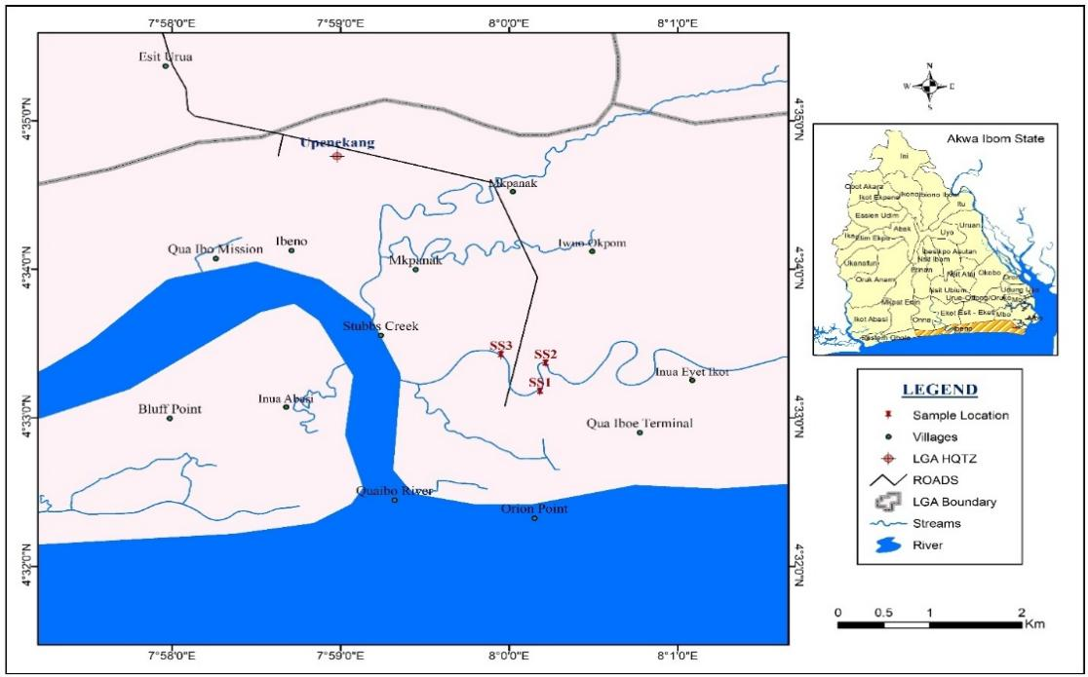
Figure1: Map of the Study Area indicating Douglas Creek and the sample stations

Table 1: GPS Coordinates of the sampling stations
Sampling Station | Latitude | Longitude
Sampling Station 1 (SS1) | Lat 04° 33´ 10.71´´N | Long 008° 0´ 10.50´´E
Sampling Station 1 (SS2) | Lat 04° 33´ 14.7´´N | Long 008° 0´ 11.85´´E.
Sampling Station 1 (SS3) | Lat 04° 33´ 19.1´´N | Long 008° 0´ 10.35´´E

2.2 Sampling Strategy and Collection
Sediment samples were collected during both wet and dry seasons to capture seasonal variability. At each sampling point, surface sediments (0–10 cm) were obtained using a Van Veen grab sampler, transferred into acid-washed polyethylene containers, and stored on ice during transport to the laboratory. Replicates were pooled for composite analysis to reduce small-scale spatial heterogeneity.

2.3 Sample Preparation and Laboratory Analyses
Sediments were air-dried, gently ground with a porcelain mortar, and sieved through a 2 mm mesh prior to analysis. Physicochemical parameters were determined following standardized methods. pH and electrical conductivity (EC) were measured in a 1:2.5 sediment-to-deionized water suspension using a calibrated portable meter (APHA, 1995; Chapman, 1996). Major anions (sulphate, chloride, phosphate, nitrate) were quantified colorimetrically using Hach spectrophotometric procedures (Hach Company, various years; Zhu & Ma, 2020). Total organic carbon (TOC) was determined by wet oxidation with potassium dichromate and titration with ferrous ammonium sulphate (APHA, 1995). Total petroleum hydrocarbons (TPH) were analyzed using infrared spectrophotometry. Cations (Ca, Mg, Na, K) were determined by flame atomic absorption spectrophotometry (Ikpe et al., 2019, 2020, 2023). Quality assurance and control were maintained through the use of blanks, duplicates, and certified reference materials (CRM). Instrument calibration was carried out daily, and recoveries for standards ranged between 85–110%.

2.4 Data Analysis
Descriptive statistics were computed for each parameter as mean ± standard deviation. Seasonal differences were evaluated using Student’s t-test and one-way analysis of variance (ANOVA) at a 95% confidence level (p < 0.05). Pearson’s correlation coefficients were calculated to explore relationships among sediment parameters, and results were visualized in correlation matrices. Data processing was performed using SPSS version 25

3.0 RESULTS AND DISCUSSION

3.1 Seasonal Variation in Sediment Physicochemical Parameters
Table 2. Seasonal variation in physicochemical parameters of Douglas Creek sediments (mean ± SD)
Parameter | Wet Season | Dry Season | P-value | Remark
pH | 6.73 ± 0.25 | 6.65 ± 0.28 | P = .318 | NS
Temperature (°C) | 27.50 ± 1.20 | 28.10 ± 1.15 | P = .212 | NS
EC (µS/cm) | 113.20 ± 5.10 | 116.40 ± 4.85 | P = .165 | NS
Redox (mV) | 125.50 ± 8.75 | 121.70 ± 7.90 | P = .278 | NS
TOC (mg/kg) | 0.79 ± 0.08 | 0.56 ± 0.06 | P = .004 | ↑ Wet
Mg (mg/kg) | 286.00 ± 12.40 | 195.67 ± 10.85 | P < .001 | ↑ Wet
K (mg/kg) | 8.40 ± 0.95 | 8.20 ± 1.05 | P = .658 | NS
Na (mg/kg) | 15.30 ± 1.15 | 16.10 ± 1.25 | P = .394 | NS
Ca (mg/kg) | 79.77 ± 5.60 | 68.83 ± 5.25 | P = .012 | ↑ Wet
Chloride (mg/kg) | 21.70 ± 2.10 | 22.15 ± 2.20 | P = .482 | NS
Sulphate (mg/kg) | 13.20 ± 1.85 | 14.10 ± 1.95 | P = .266 | NS
Nitrate (mg/kg) | 2.47 ± 0.35 | 22.13 ± 2.05 | P < .001 | ↑ Dry
Phosphate (mg/kg) | 3.40 ± 0.65 | 3.55 ± 0.75 | P = .387 | NS
TPH (mg/kg) | 0.62 ± 0.12 | 0.68 ± 0.14 | P = .422 | NS
NS = Not significant; ↑ Wet/Dry = significantly higher in that season

Figure 2: Seasonal Variation of pH of sediment in Douglas creek

Figure 3: Seasonal Variation of Temperature of sediment in Douglas creek

Figure 4: Seasonal Variation of Electrical Conductivity (µS/cm) in sediment of Douglas creek

Figure 5: Seasonal Variation of Chloride (mg/kg) in sediment of Douglas creek

Figure 6: Seasonal Variation of Sulphates (mg/kg) in sediment of Douglas creek

Figure 7: Seasonal Variation of Nitrates (mg/Kg) in water of Douglas creek

Figure 8: Seasonal variation of Phosphates (mg/kg) in sediment of Douglas creek

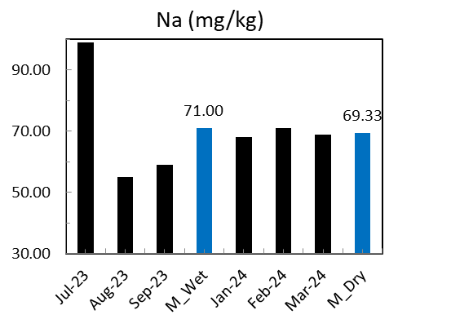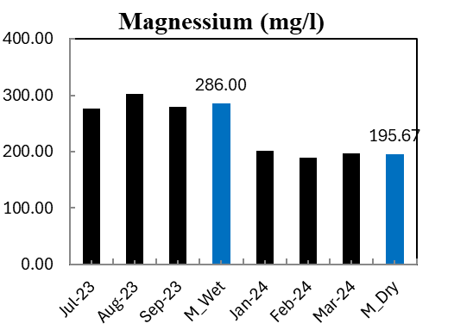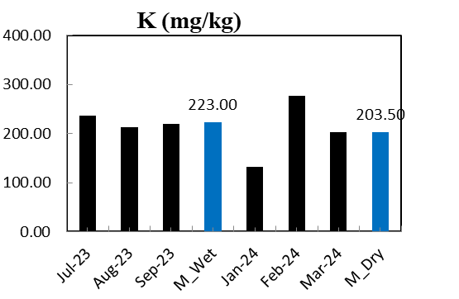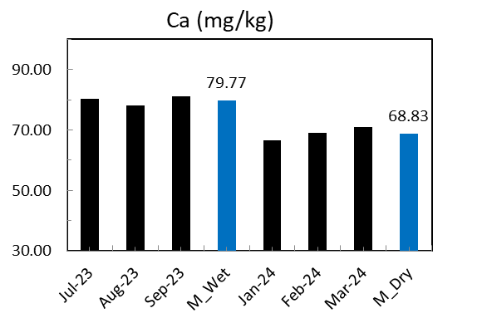
Figure 9: Seasonal variation in the cations (mg/kg) in sediment of Douglas creek

The results from Douglas Creek sediments demonstrated how seasonal hydrological cycles exert strong control over physicochemical dynamics in a tropical estuarine environment. The significantly higher levels of total organic carbon (TOC) during the wet season indicate increased terrestrial input from runoff, vegetation, and erosion, consistent with evidence that rainfall-driven flows deliver organic-rich materials to aquatic sediments (Ekwere et al., 2025). Such enrichment has important ecological implications because elevated organic matter enhances microbial activity and oxygen demand, often leading to hypoxic microzones within sediments (Chapman, 1996). A similar pattern was observed in Niger Delta ecosystems where organic inputs during wet periods promoted oxygen stress and increased sediment organic load (Ikpe et al., 2020; Okpoji, et al., 2025).
In addition to organic enrichment, the wet season was marked by elevated magnesium (Mg) and calcium (Ca) concentrations, reflecting enhanced weathering and mineral mobilization from catchments during rainfall events. These results are consistent with studies from arid and semi-arid regions where seasonal inflows elevate sediment mineral concentrations (Ekwere et al., 2025; Okpoji et al., 2025). Mineral influx contributes to ionic strength and sediment buffering capacity, which influence geochemical partitioning and biological responses (Ma et al., 2016). Conversely, nitrate (NO₃⁻) concentrations were significantly higher in the dry season, suggesting that reduced hydrological flushing and evaporative concentration intensified nutrient accumulation (Okpoji, et al., 2025). This trend aligns with findings from low-flow estuaries in Central Africa, where dry-season conditions favored nutrient build-up and limited dilution (Nienie et al., 2017). Such dynamics are of ecological concern because nitrate-enriched sediments can act as internal nutrient sources during resuspension events, contributing to eutrophication risk (Zhu & Ma, 2020).

3.2 Correlation Analysis of Sediment Parameters (Dry Season)
Table 3. Pearson correlation matrix of sediment physicochemical parameters (Dry Season)
Parameter | pH | EC | Redox | Na | Ca | NO₃⁻
pH | 1
EC |  | 1
Redox |  |  | 1
Na | 0.81* | 0.72* |  | 1
Ca |  | 0.76* |  |  | 1
NO₃⁻ |  |  | –0.64* |  |  | 1
Significant correlations at P < .05
The Pearson correlation matrix revealed strong ionic and nutrient–redox linkages within Douglas Creek sediments. Sodium (Na) displayed a strong positive correlation with both pH (r = 0.81, P < .05) and electrical conductivity (EC; r = 0.72, P < .05). This indicates that sodium enrichment is a key driver of ionic strength and buffering capacity during low-flow conditions. In estuarine sediments, elevated sodium often originates from saline intrusion or evaporative concentration in the dry season, processes that increase alkalinity and conductivity (Ite et al., 2019). The positive correlation with pH suggests that sodium ions contribute to stabilizing sediment acidity, thereby influencing microbial activity and nutrient solubility. Similar findings were reported by Okpoji et al., (2025) and Ekwere et al., (2025), who observed sodium-driven buffering in estuaries with reduced freshwater inputs.
Calcium (Ca) also correlated significantly with EC (r = 0.76, P < .05), reinforcing the role of divalent cations in controlling sediment ionic balance. Calcium is known to enhance sediment flocculation and to bind with phosphate and carbonate species, thereby influencing nutrient availability (Ikpe et al., 2019). Its strong relationship with EC highlights the importance of catchment-derived mineral inputs, which persist in sediments during low discharge periods.
A notable feature of the dry-season data is the negative correlation between nitrate (NO₃⁻) and redox potential (r = –0.64, P < .05). This inverse relationship suggests that as redox conditions become more reducing, nitrate levels increase, reflecting the accumulation of nutrients under limited oxygen conditions. Such a trend is consistent with microbial denitrification pathways, where reducing conditions favor nitrate persistence in sediment pore waters (Nriagu et al., 2016). This pattern indicates that dry-season nitrate enrichment is not only a result of reduced flushing but also linked to microbial processes driven by low redox status. These correlations imply that dry-season ionic dynamics are dominated by sodium and calcium inputs, which enhance conductivity and buffering, while nitrate enrichment is shaped by both reduced hydrological flushing and microbial redox interactions. Ecologically, these conditions may lead to nutrient stress in benthic communities, altering nitrogen cycling pathways and increasing the potential for eutrophication once nitrate is mobilized into the overlying water column (Zhu & Ma, 2020).

3.3 Correlation Analysis of Sediment Parameters (Wet Season)
Table 4. Pearson correlation matrix of sediment physicochemical parameters (Wet Season)
Parameter | pH | EC | Na | Ca
pH | 1
EC |  | 1
Na | 0.75* | 0.70* | 1
Ca |  | 0.68* |  | 1
Significant correlations at P < .05
The wet-season correlation analysis highlighted the dominant influence of mineral influx from rainfall-driven catchment processes on sediment ionic balance. Electrical conductivity (EC) correlated positively with both sodium (Na; r = 0.70, P < .05) and calcium (Ca; r = 0.68, P < .05), reflecting the increased leaching of minerals into the creek during high runoff. These results are consistent with earlier reports from humid tropical estuaries, where seasonal rainfall mobilizes base cations from upstream soils and rocks into aquatic sediments, thereby elevating conductivity (Okpoji et al., 2025). The positive association of EC with Na and Ca suggests that these ions are the principal contributors to ionic strength during the wet months.
Sodium also exhibited a strong positive correlation with pH (r = 0.75, P < .05), indicating its role in buffering sediment acidity under high discharge conditions. Sodium salts, particularly carbonates and bicarbonates, are known to neutralize acidity and stabilize pH in estuarine sediments (Ikpe et al., 2023). This relationship implies that during the wet season, when inputs of organic matter might otherwise increase acidity through microbial respiration, sodium influx helps maintain near-neutral pH. Such buffering is ecologically significant, as pH stability supports benthic organisms sensitive to acidic fluctuations (Dada et al., 2025).
Calcium’s positive correlation with EC (r = 0.68, P < .05) reinforces its importance in sediment geochemistry. In addition to contributing to ionic strength, calcium plays a critical role in precipitation–dissolution dynamics of carbonate and phosphate minerals, thereby regulating nutrient retention and release (Benson et al., 2017). During the wet season, enhanced calcium inputs likely promote sediment binding of phosphate, limiting its mobility into the water column.
Unlike the dry season, nitrate (NO₃⁻) showed no significant correlations in the wet period, likely due to dilution from increased flushing and rapid microbial turnover. This observation aligns with reports from other Niger Delta estuaries, where rainfall reduces nutrient concentrations through enhanced discharge (Ikpe et al., 2020; Okpoji et al., 2025). The lack of nitrate associations underscores the dominance of mineral rather than nutrient controls on wet-season sediment chemistry.
The wet-season correlation structure suggests that mineral leaching and ionic buffering processes, rather than nutrient accumulation, govern sediment quality. These conditions may temporarily reduce eutrophication risk by dispersing nitrate, while simultaneously influencing nutrient cycling through Ca-mediated phosphate retention. This pattern mirrors global findings in rainfall-dominated estuarine systems (Anarado et al., 2023; Benson et al., 2017), reinforcing the central role of hydrological forcing in shaping sediment geochemistry.

CONCLUSION
This study demonstrates that sediment quality in Douglas Creek is significantly influenced by seasonal hydrology. Wet-season enrichment of total organic carbon, calcium, and magnesium reflects enhanced catchment input and organic matter deposition, processes that can intensify microbial activity and oxygen demand. Conversely, dry-season dominance of nitrate highlights nutrient concentration and accumulation risks under reduced flushing conditions. Correlation analyses revealed distinct seasonal interactions, with sodium-driven conductivity buffering in the dry season and mineral influx shaping ionic balance in the wet season. These results provide strong evidence that sediments serve as sensitive indicators of both natural hydrological cycles and anthropogenic pressures in the Niger Delta. The patterns observed underscore the ecological vulnerability of Douglas Creek, where nutrient over-enrichment and ionic stress could compromise benthic habitats and water quality. Future work should integrate trace metal and hydrocarbon monitoring, alongside ecological risk assessments, to inform more comprehensive management and policy interventions in the region.

Disclaimer (Artificial intelligence)
Option 1:
Author(s) hereby declare that NO generative AI technologies such as Large Language Models (ChatGPT, COPILOT, etc.) and text-to-image generators have been used during the writing or editing of this manuscript.

REFERENCES

- American Public Health Association. (1995). Standard methods for the examination of water and wastewater (19th ed.). APHA.
https://www.scirp.org/reference/referencespapers?referenceid=1916575
- Anarado, C. J. O., Okpoji, A. U., & Anarado, C. E. (2023). Bioaccumulation and health risk assessment of lead, cadmium, arsenic, and mercury in blue crabs found in creeks in Bayelsa State of the Niger Delta region of Nigeria. Asian Journal of Environmental & Ecology, 21(4), 46–59.
http://95.179.195.156:8080/handle/123456789/853
- Benson, R., Conerly, O. D., Sander, W., Batt, A. L., Boone, J. S., Furlong, E. T., Glassmeyer, S. T., Kolpin, D. W., Mash, H. E., Schenck, K. M., & Simmons, J. E. (2017). Human health screening and public health significance of contaminants of emerging concern detected in public water supplies. Science of the Total Environment, 579, 1643–1648.
https://doi.org/10.1016/j.scitotenv.2016.03.146
- Chapman, D. (1996). Water quality assessments: A guide to the use of biota, sediments, and water in environmental monitoring (2nd ed.). UNESCO/WHO/UNEP.
https://www.taylorfrancis.com/books/mono/10.1201/9781003062103/water-quality-assessments-deborah-chapman
- Dada, O. J., Obadimu, C. O., Ubuo, E. E., & Ekwere, I. O. (2025). Seasonal variation in some physicochemical parameters of water from Douglas Creek, Ibeno LGA, Akwa Ibom State. Journal of Environment, Climate, and Ecology, 2(2), 44–55.
https://doi.org/10.69739/jece.v2i2.976
- Ekwere, I. O., Okpoji, A. U., Igwegbe, K. C., Okonkwo, C. O., Yekeen, A. A., Obunezi, O. C., Okpanachi, C. B., Garuba, M. H., Ogini, O. R., & Odibo, U. E. (2025). Nutritional–Toxicological Trade-Off: Comparative Study of Polycyclic Aromatic Hydrocarbons in Smoked and Oven-Dried Nile Tilapia (Oreochromis niloticus). Journal of Environment, Climate, and Ecology, 2(2), 90-97. https://doi.org/10.69739/jece.v2i2.952
- Ekwere, I. O., Okpoji, A. U., Ufuoma, V. O., Akinola, A. E., Raymond, C. A., Clement, R. O., Alaekwe, I. O., Etesin, M. O., & Edodi, I. O. (2025). Nutritional evaluation of Nile tilapia (Oreochromis niloticus) processed by different drying methods in Akwa Ibom State, Nigeria. Journal of Sustainable Research and Development, 1(2), 11–17. https://doi.org/10.69739/jsrd.v1i2.1033
- Ikpe, E. E., Ekwere, I. O., Ukpong, E. G., Effiong, J. O., & Okon, O. E. (2020). Assessment of heavy metals and hydrocarbons in Rhizophora mangle, Callinectes sapidus, & sediment in Qua-Iboe River, Akwa Ibom State, Nigeria (wet and dry seasons). Global Journal of Advanced Engineering Technology and Sciences, 7(3).
https://gjaets.com/index.php/gjaets/article/view/23
- Ikpe, E. E., Ekwere, I. O., Ukpong, E. G., Effiong, J. O., & Okon, O. E. (2019). Evaluation of the levels of heavy metals, total petroleum hydrocarbon and total hydrocarbon content in Tympanotonus fuscatus and sediment, Qua Iboe River, Akwa Ibom State, Nigeria (dry vs. wet season comparison). Chemical Science International Journal, 27(4), 1–17.
https://doi.org/10.9734/CSJI/2019/v27i430121
- Ikpe, E. E., Etesin, U. M., Ubuo, E. E., & Ekwere, I. O. (2023). Bioaccumulation of heavy metals and hydrocarbons in sediment, shell and flesh of the fauna in Qua-Iboe River at Ibeno, Akwa Ibom State, Nigeria (samples collected in dry and wet seasons). Asian Journal of Chemical Sciences, 13(6), 71–93.
https://doi.org/10.9734/ajocs/2023/v13i6264
- Ite, A. E., Harry, T. A., Obadimu, C. O., & Ekwere, I. O. (2019). Comparison of indoor air quality in schools: Urban vs. industrial “oil & gas” zones in Akwa Ibom State – Nigeria (rainy vs. dry seasons). Journal of Environment Pollution and Human Health, 7(1), 15–26.
https://doi.org/10.12691/jephh-7-1-3
- John E., E., Emah O., A., Ifiok O., E., Okpoji, A. U., Iyam O., E., Henderson O., O., Akinola A., E., Gloria N., A., & Charles N., O. (2025). Health Risk Implications of Polycyclic Aromatic Hydrocarbons in Smoked and Dried Fish Consumed in Nigeria. Journal of Medical Science, Biology, and Chemistry, 2(2), 192-199. https://doi.org/10.69739/jmsbc.v2i2.1045
- Ma, Y. H., Su, C. L., Liu, W. J., Zhu, Y. P., & Li, J. X. (2016). Identification of sulfate sources in the groundwater system of Zaozhuang: Isotopic and hydrochemical evidence. Environmental Science, 37, 4690–4699.
https://europepmc.org/article/med/29965309
- Nienie, A. B., Sivalingam, P., Laffite, A., Ngelinkoto, P., Otamonga, J. P., Matand, A., Mulaji, C. K., Mubedi, J. I., Mpiana, P. T., & Poté, J. (2017). Seasonal variability of water quality by physicochemical indexes and traceable metals in a suburban area in Kikwit, DRC. International Soil and Water Conservation Research, 5(2), 158–165.
https://doi.org/10.1016/j.iswcr.2017.02.002
- Nriagu, J. O., Udofia, E. A., Ekong, I., & Ebuk, G. (2016). Health risks associated with oil pollution in the Niger Delta, Nigeria. International Journal of Environmental Research and Public Health, 13(3), 346.
https://doi.org/10.3390/ijerph13030346
- Nwilo, P. C., & Badejo, O. T. (2005). Oil spill problems and management in the Niger Delta. Proceedings of the International Oil Spill Conference, 2005(1), 567–573.
https://doi.org/10.7901/2169-3358-2005-1-567
- Okpoji, A. U., Anarado, C. O., Mmuta, E. C., Ekwere, I. O., Alaekwe, I. O., Odibo, U. E., Igwegbe, K. C., Eboj-Ajoku, I. O., & Obunezi, O. C. (2025). Toxicological evaluation of Pb, Cd, As, and Hg in blue crab from oil-polluted creeks in the Niger Delta. Journal of Life Science and Public Health, 1(1), 24–31.
https://doi.org/10.69739/jlsph.v1i1.879
- Okpoji, A. U., Chinyere, U. E., Nwokoye, J. N., Ezekwuemen, O. I., Alaekwe, I. O., Odidika, C. C., Owughara, C. N., Enyi, C. M., & Kolawole, O. O. (2025). Environmental assessment of heavy metals and hydrocarbon pollution in surface waters of oil-bearing communities in Andoni, Rivers State, Nigeria. International Journal of Modern Science and Research Technology, 3(8), 22–30.
http://www.ijmsrt.com
- Okpoji, A. U., Eboh-Ajoku, I. O., Mmuta, E. C., Ndubuisi, J. O., Alaekwe, I. O., Odibo, U. E., Nwoka, N. G., Okafor, C. A., & Obunezi, O. C. (2025). Integrated environmental risk assessment of BTEX and PAHs in water and sediment samples from the Bonny River, Nigeria. ISA Journal of Multidisciplinary (ISAJM), 2(4), 14–21.
- Okpoji, A. U., Ekwere, I. O., Igwegbe, K. C., Anarado, C. J. O., Ogbonna, C., Ewuola, A. A., Odibo, U. E., & Garuba, M. H. (2025). Volatile organic compounds from gas flaring and their atmospheric implications in the Niger Delta. Journal of Life Science and Public Health, 1(1), 32–39. https://doi.org/10.69739/jlsph.v1i1.962
- Okpoji, A. U., Ekwere, I. O., Igwegbe, K. C., Etesin, U. M., Ugwuanyi, G. C., Okpanachi, C. B., Ewuola, A. A., Mojisola, K. M., & Ezekwueme, O. I. (2025). Solar-enhanced photocatalytic degradation of pharmaceutical residues in wastewater using Fe-, Cu-, and Zn-doped TiO₂ nanomaterials. Journal of Environment, Climate, and Ecology, 2(2), 56–62. https://doi.org/10.69739/jece.v2i2.961
- Okpoji, A. U., Emem, J. A., Ekwere, I. O., Odibo, U. E., Alaekwe, I. O., Warder, A. B., & Eboj-Ajoku, O. I. (2025). Bioaccumulation of nickel, lead, and cadmium in tissues of Callinectes sapidus from the Iko River, Nigeria: Implications for human health risk and environmental safety. Journal of Environment, Climate, and Ecology, 2(2), 29–37.
https://doi.org/10.69739/jece.v2i2.844
- Okpoji, A. U., Ndubuisi, J. O., Eboh-Ajoku, I. O., Emem, J. A., Ekwere, I. O., Alaekwe, I. O., Odibo, U. E., Igwegbe, K. C., Onoja, C. R., Warder, A. B., & InyangAbia, A. J. (2025). Trematode infections and histopathological effects in Chrysichthys nigrodigitatus from the polluted Andoni River, Niger Delta, Nigeria. Journal of Agriculture, Aquaculture, and Animal Science, 2(2), 66–72.
https://doi.org/10.69739/jaaas.v2i2.882
- Okpoji, A. U., Nwoka, N. G., Odibo, U. E., Alaekwe, I. O., Okafor, C. A., Ogwu, N. G., & Akatakpo, C. U. (2025). Seasonal variation in hydrochemical characteristics and heavy metal risk assessment of groundwater in Andoni-Isiokwan District, Niger Delta, Nigeria. International Journal of Modern Science and Research Technology, 3(8), 44–51.
http://www.ijmsrt.com
- Onoja, C. R., Ogbaji, H. O., Edodi, I. O., Mmuta, E. C., Igwegbe, K. C., Ogini, O. R., Odibo, U. E., Ewuola, A. A., Mahmoud, A. B., & Okpoji, A. U. (2025). Heavy Metal Contamination and Health Risk Assessment of Smoked-Dried Fish Sold in Eke-Awka Market, Anambra State, Nigeria. Journal of Sustainable Research and Development, 1(2), 18-25. https://doi.org/10.69739/jsrd.v1i2.1044
- Ugochukwu, C. N. C., & Ertel, J. (2008). Negative impacts of oil exploration on biodiversity management in the Niger Delta area of Nigeria. Impact Assessment and Project Appraisal, 26(2), 139–147.
https://doi.org/10.3152/146155108X316397
- Zhu, X., & Ma, J. (2020). Recent advances in the determination of phosphate in environmental water samples: Insights from practical perspectives. TrAC Trends in Analytical Chemistry, 127, 115908.
https://doi.org/10.1016/j.trac.2020.115908

