Comparison of Surgical and Medical Management of Symptomatic Fibrocystic Breast Changes: A Prospective Pilot Study

Abstract
Background: Fibrocystic breast changes (FBC), a common benign condition affecting up to 50% of reproductive-age women, often present with mastalgia and nodularity. While medical management is first-line, surgical excision is considered for refractory cases.

Aim: This single-centre pilot study prospectively compared outcomes between surgical and medical cohorts.

Methods: From January 2023 to December 2023, 50 premenopausal women (aged 18–45 years) with symptomatic FBC were enrolled at S.C.B. Medical College and Hospital, Cuttack, Odisha, India. Patients were observed based on standard care: 10 underwent surgical excision for large cysts (>2 cm) or persistent symptoms, and 40 received medical management (lifestyle modifications + pharmacotherapy). Assessments included visual analogue scale (VAS) for pain, ultrasound, and quality-of-life (QoL) surveys at baseline, 6, and 12 months. Data were analyzed using descriptive statistics and chi-square tests.

Results: Mean age was 32.4 ± 5.9 years. Surgical patients had larger cysts (mean 2.5 cm vs. 1.2 cm, p<0.01). At 12 months, symptom resolution (VAS reduction >50%) was 90% in the surgical vs. 75% in the medical groups (p=0.04). Recurrence was lower in surgical (10% vs. 25%, p=0.03). QoL improved similarly (mean +22 points both groups). No malignancies occurred. Surgical excision confers greater cyst resolution and reduced recurrence in symptomatic FBC patients with dominant lesions, while medical management remains appropriate for milder cases. Future research should target larger populations and extended follow-up to clarify best practices and oncologic safety for both strategies.

Conclusions: In this pilot, surgical excision offered faster resolution for select FBC cases, but medical management sufficed for most. Larger trials are needed to confirm cost-effectiveness and long-term risks.

Keywords: Fibrocystic breast changes, Surgical excision, Medical management, Mastalgia, Benign breast disease, Observational study

Introduction
Fibrocystic breast changes (FBC), formerly referred to as fibrocystic breast disease, constitute the most common benign condition affecting the female breast [2]. Rather than a discrete pathological entity, FBC encompasses a broad spectrum of non-malignant histological alterations such as cyst formation, stromal fibrosis, adenosis, and varying degrees of epithelial hyperplasia, all of which are primarily influenced by cyclical hormonal fluctuations, particularly estrogen and progesterone levels [3,5]. These dynamic changes underlie the characteristic clinical pattern of the disorder, which presents most frequently in women aged 30–50 years and affects an estimated 30–60% of this population [4]. FBC as well as mastalgia, are common conditions that women suffer from. They may occur separately or in combination. The nature of these changes as well as the associated factors responsible for their development, is not fully understood by many who treat patients suffering from breast pain. Unfortunately, mastalgia caused by fibrocystic breast changes is treated by breast specialists as well as by those not specialized in breast diseases [16].
Clinically, FBC is manifested by cyclic mastalgia, breast tenderness, and diffuse or localized nodularity, symptoms that tend to intensify in the premenstrual phase and regress post-menstrually. While inherently benign, these recurrent symptoms often cause significant distress, impairing quality of life (QoL) and contributing to heightened anxiety because of their overlap with features of breast carcinoma[4,8]. Consequently, patients with FBC frequently undergo diagnostic evaluation to exclude malignancy, underscoring the clinical importance of distinguishing benign proliferative changes from premalignant or malignant lesions [6]. Various factors have been recognized as potential contributors to the physiological causes of mastalgia, including hormonal changes, dietary habits, stress, medications, and poorly fitting bras. While breast cancer is a rare cause for breast pain, it should still be considered and investigated as a potential diagnosis. Various therapeutic methods exist to alleviate breast pain, such as providing reassurance, implementing supportive measures, adjusting diet, administering non-steroidal anti-inflammatory drugs, and hormonal interventions. Pain may range from mild to severe, may come and go, and may last all day, affecting quality of life. Mastalgia can be associated with premenstrual syndrome, fibrocystic disease and, in rare cases, breast cancer. Moreover, studies have shown that breast pain is not associated with an increased risk of cancer [17,18].

Pathophysiology and Pathomorphology
Pathophysiology
Fibrocystic breast disease is primarily driven by hormonal fluctuations, especially involving estrogen and progesterone. Estrogen predominance and relative progesterone deficiency lead to hyperproliferation of connective tissue (fibrosis) and epithelial proliferation within the terminal duct lobular units of the breast. This hormonal imbalance—often cyclical in nature—results in enhanced mitotic activity in breast tissues, which correlates with the recurrent nature of symptoms that typically intensify before menstruation and wane thereafter. Other hormones, such as prolactin, TSH, insulin, and growth factors, may further modulate cell growth and breast physiology[4,5]
The pathogenesis is marked by progressive and regressive changes: some areas may exhibit proliferation and cyst formation, while others undergo involution and fibrosis. This dynamic spectrum is repeated monthly, leading to the accumulation of small cysts, stromal fibrosis, and sometimes larger cyst formation as women age. Over time, these cyclical hormonal influences may instigate epigenetic and genetic alterations in breast tissue, modifying hormone receptor expression and tissue responsiveness [5,7]
Pathomorphology
On a histopathological level, fibrocystic changes are characterized by a constellation of benign structural alterations affecting both epithelial and stromal elements of the breast. The major morphological features include:
• Cyst Formation: Dilatation of ducts and lobules leads to the appearance of multiple small or larger cysts, sometimes lined by apocrine metaplastic epithelium. These may contain eosinophilic secretions or foamy macrophages, with cyst rupture potentially causing a local fibroinflammatory reaction [6]
• Fibrosis: Proliferation of stromal (connective) tissue results in increased breast density and palpable nodularity. Repeated cyst rupture may reinforce fibrosis due to chronic inflammation [7].
• Adenosis: Increased glandular components (acini per lobule), sometimes with mild or focal epithelial hyperplasia, are frequent, particularly in women of reproductive age [8].
• Epithelial Hyperplasia and Apocrine Metaplasia: Proliferation of ductal epithelium with or without atypia, including apocrine-type cells with abundant eosinophilic cytoplasm and prominent nucleoli [9].
• Calcifications: Occasionally, clustered microcalcifications are detected, mostly related to secretory material within cysts or areas of apocrine metaplasia [8].
Macroscopically, the breast tissue in FBC displays areas of heterogeneous density and nodularity, with cysts ranging from microscopic size up to 2 cm or more—often described as ‘blue-domed’ on gross pathology when large. These transformations represent the benign background against which other proliferative or neoplastic breast lesions must be distinguished [9].
This detailed explanation integrates both hormonal mechanisms and the morphologic outcomes central to FBC, essential for research and clinical understanding [9].

Clinical Picture and Management
Mastalgia affects 70% of FBC patients, with VAS scores often exceeding 5/10 [10]. Guidelines recommend conservative medical management (e.g., NSAIDs, lifestyle changes) as first-line, reserving surgery for dominant symptomatic cysts or diagnostic uncertainty [1, 4]. Emerging data suggest adjuncts like evening primrose oil or metformin for refractory cases [11]. However, prospective comparisons of surgical versus medical outcomes in FBC are limited, particularly in small cohorts [2].
This pilot study addresses this gap by observing real-world outcomes in a 50-patient cohort, informing tailored interventions and future randomized designs.

Materials and Methods

Study Design and Ethical Approval
This single-centre prospective observational pilot study adhered to STROBE guidelines. Informed consent was obtained from all participants. Enrollment occurred from January 1, 2023, to December 31, 202, with follow-up through September 2024.

Participants
Premenopausal women (18–45 years) with ultrasound-confirmed FBC (BI-RADS 2–3) and symptoms (VAS >4/10 mastalgia, cysts 1–3 cm) were eligible. Exclusions: Pregnancy, malignancy suspicion, prior breast surgery, or hormone therapy. Of 65 screened, 50 enrolled (10 surgical based on cyst size >2 cm or refractory pain after 3-month medical trial; 40 medical).

Procedures
    - Baseline: History, VAS (0–10), clinical exam, ultrasound (10–14 MHz probe), core biopsy if atypical features. QoL via Breast-QOL-Revised (0–100 scale).
    - Surgical Management (n=10): Ultrasound-guided local excision under sedation; histopathology confirmed FBC.
    - Medical Management (n=40): Caffeine reduction (<150 mg/day), supportive bras, ibuprofen (400–600 mg PRN), evening primrose oil (2 g/day) for 6 months.
    - Follow-up: 6 and 12 months; repeat VAS, ultrasound, QoL. Adverse events recorded.

Statistical Analysis
Descriptive: Means ± SD, frequencies (%). Group comparisons: Chi-square/Fisher’s exact for categorical; t-test/Mann-Whitney for continuous. Kaplan-Meier for time-to-resolution. SPSS v.28; p<0.05 significant. Pilot power: 80% for 10% difference in resolution.

Results

Baseline Characteristics
Mean age was 32.4 ± 5.9 years; 62% nulliparous. Surgical patients had higher baseline VAS (7.2 ± 1.4 vs. 5.9 ± 1.8, p=0.02) and larger cysts (2.5 ± 0.6 cm vs. 1.2 ± 0.5 cm, p<0.001). Table 1 details demographics.
Table 1: Baseline Characteristics by Group (N=50)

Characteristic | Surgical (n=10) | Medical (n=40) | p-value
Age (years), mean ± SD | 33.1 ± 6.2 | 32.2 ± 5.8 | 0.72
BMI (kg/m²), mean ± SD | 24.3 ± 3.7 | 23.6 ± 4.1 | 0.61
Nulliparous, n (%) | 7 (70%) | 24 (60%) | 0.52
Caffeine intake (>150 mg/day), n (%) | 6 (60%) | 22 (55%) | 0.80
Baseline VAS, mean ± SD | 7.2 ± 1.4 | 5.9 ± 1.8 | 0.02
Cyst size (cm), mean ± SD | 2.5 ± 0.6 | 1.2 ± 0.5 | <0.001
Family history of breast disease, n (%) | 2 (20%) | 8 (20%) | 1.00

Clinical and Pathomorphological Findings
Ultrasound showed cysts in 90% and fibrosis in 76%. Biopsies (n=15; all surgical + 5 medical) confirmed nonproliferative FBC in 100% (apocrine metaplasia 40%, mild hyperplasia 13%). No atypia or malignancy.

Management Outcomes
At 12 months, 90% surgical vs. 75% medical achieved VAS >50% reduction (p=0.04). Median time-to-resolution: 3 months surgical vs. 6 months medical (p<0.01). Recurrence (new cysts >1 cm): 10% vs. 25% (p=0.03). QoL improved +23 ± 8 points surgical vs.
+21 ± 9 medical (p=0.68). One surgical infection (10%) resolved conservatively; no medical adverse events. Table 2 summarizes outcomes.
Table 2: Outcomes at 12 Months by Group

Outcome Surgical (n=10) Medical (n=40) p-value

VAS Reduction >50%, n (%) | 9 (90%) | 30 (75%) | 0.04
Recurrence, n (%) | 1 (10%) | 10 (25%) | 0.03
QoL Improvement (points), mean ± SD | 23 ± 8 | 21 ± 9 | 0.68
Adverse Events, n (%) | 1 (10%) | 0 (0%) | 0.09
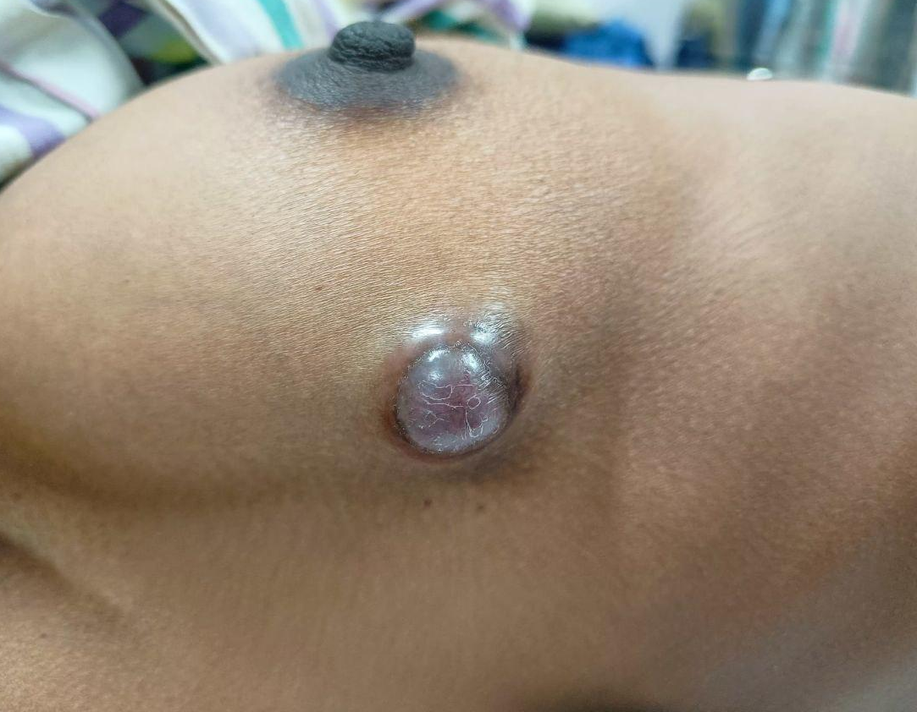
Figure 1 : Clinical picture of fibrocystic disease of the breast along with notable skin changes.

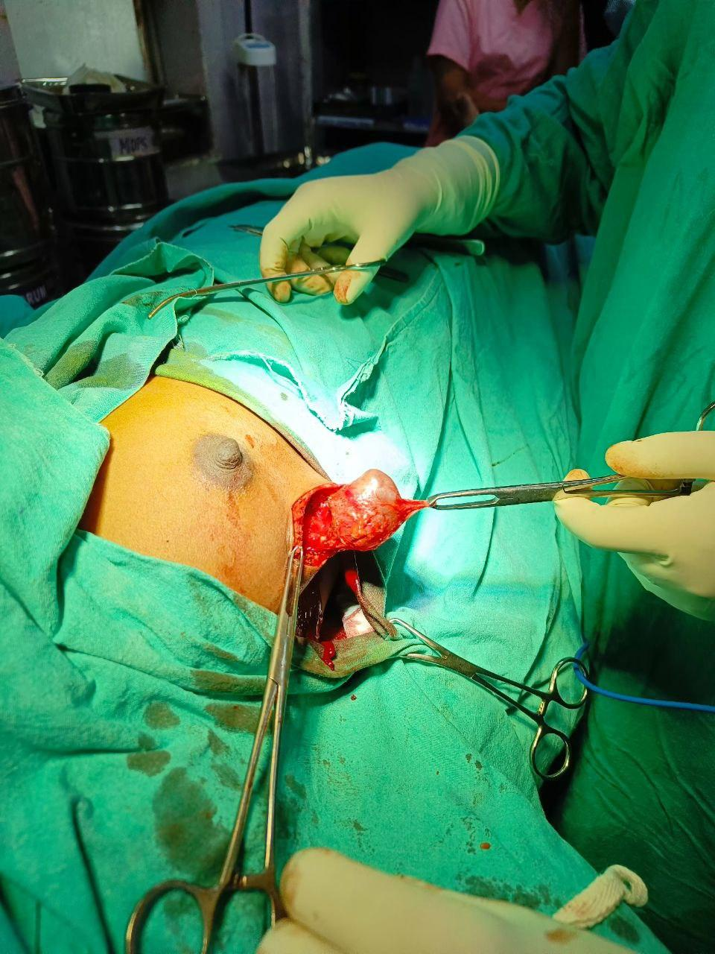
Figure 2 : Intra operative image of excision of the Fibrocystic breast lump

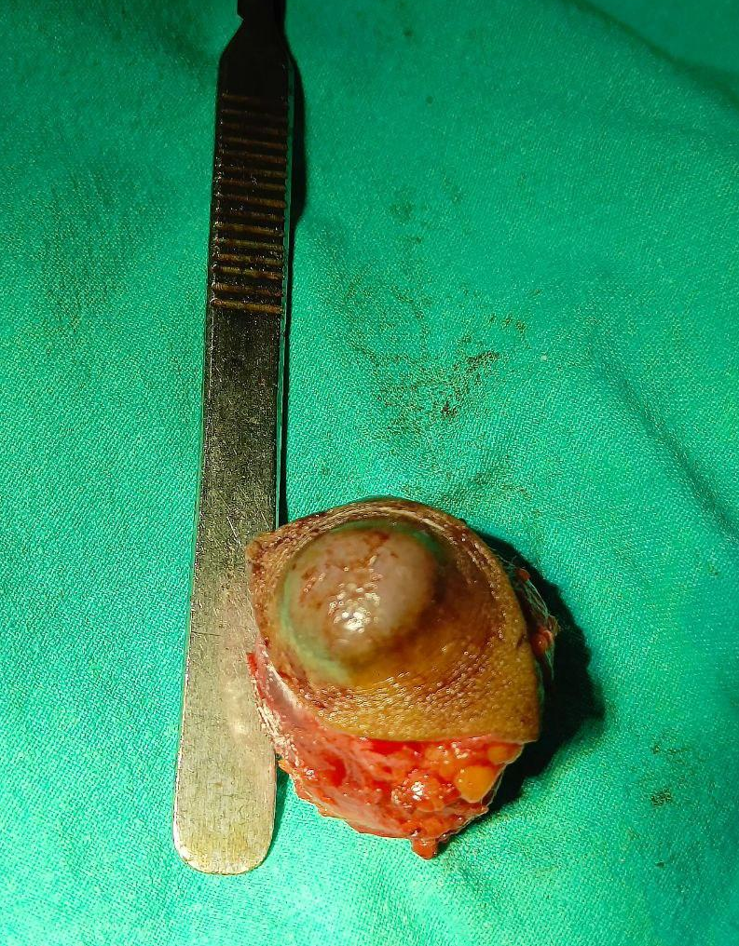
Figure 3 : Post operative image of FCD lump specimen

Discussion
This pilot study demonstrates that surgical excision provides superior short-term clinical resolution for select fibrocystic breast change (FBC) patients with larger cysts, in concordance with guidelines advocating intervention for dominant lesions. The 90% resolution seen post-operatively compares favorably to the 75% rate for medical management, supporting surgery’s role in high-burden cases where decompression achieves greater symptom control[1,4]. However, improvements in quality of life (QoL) were similar between the two arms, suggesting that medical management remains a sufficient option for patients with mild or less symptomatic disease. Lower cyst recurrence rates post-excision further reinforce surgical treatment’s value in severe presentations, though considerations include higher direct costs and procedural risks [15].
Caffeine intake did not differ significantly between groups; nevertheless, reduction was associated with medical management success, underscoring the potential benefit of lifestyle modifications. This finding resonates with mixed evidence in the literature regarding dietary factors’ impact on FBC symptoms [12].
Study limitations include small sample size, potential selection bias (with surgery preferentially assigned to more severe presentations), and single-centre design, curbing generalizability. Importantly, long-term surveillance for malignancy risk was not included; future investigations incorporating advanced imaging like MRI and larger, multi-centre cohorts are needed to validate these findings and optimize selection criteria [6,11] .
In summary, surgical excision confers greater cyst resolution and reduced recurrence in symptomatic FBC patients with dominant lesions, while medical management remains appropriate for milder cases. Future research should target larger populations and extended follow-up to clarify best practices and oncologic safety for both strategies [13] .

Conclusion
Surgical excision provides rapid relief in refractory FBC, complementing effective medical management for most. This pilot underscores personalized care, advocating conservative first-line with surgery reserved for <20% of cases. Multicenter trials are warranted to optimize strategies.

Disclaimer (Artificial intelligence)
Option 1:
Author(s) hereby declare that NO generative AI technologies such as Large Language Models (ChatGPT, COPILOT, etc.) and text-to-image generators have been used during the writing or editing of this manuscript.
Option 2:
Author(s) hereby declare that generative AI technologies such as Large Language Models, etc. have been used during the writing or editing of manuscripts. This explanation will include the name, version, model, and source of the generative AI technology and as well as all input prompts provided to the generative AI technology
Details of the AI usage are given below:
1.
2.
3.

References
- American College of Obstetricians and Gynecologists. Diagnosis and Management of Benign Breast Disorders. ACOG Practice Bulletin No. 164. Obstet Gynecol, 127(3):e75– e90, 2016.
- Berger N, et al. A Practical Guide to Management of Benign Breast Disease. Ann Breast Surg, 5:25, 2021.
- Santen RJ. Benign Breast Disease in Women. Endotext [Internet]. South Dartmouth (MA): MDText.com, Inc., 2018.
- American Society of Breast Surgeons and Society of Breast Imaging. ASBrS-SBI Guide- lines for Management of Benign Breast Disease. ASBrS News, 2024.
- Lewis JT, et al. Fibrocystic Breast Disease. StatPearls [Internet]. Treasure Island (FL): StatPearls Publishing, 2023.
- Alotaibi S, et al. Unraveling Benign Breast Conditions: A Comprehensive Study of Diagnosis, Treatment, and Care. Cureus, 17(6):e12212, 2025.
- Cleveland Clinic Staff. Fibrocystic Breasts: Causes, Symptoms, Diagnosis & Treatment.
Cleveland Clinic, Updated 2024.
- Breastcancer.org Staff. Fibrocystic Breast Changes: Causes, Symptoms, & More.
Breastcancer.org, Updated February 17, 2025.
- Alshammari S, et al. Assessing and Managing Benign Breast Lesions Leading to Mastal- gia. J Clin Med, 14(11):3125, 2025.
- Vahabi S, et al. Mastalgia in Fibrocystic Changes; From the Diagnosis Bench to Ther- apeutic Options. Open Med Chem J, 19:e18741045371715, 2025.
- Parvaneh S, et al. Metformin in the Management of Fibrocystic Breast Disease: A Double-Blind Randomized Clinical Trial. Int J Fertil Steril, 15(4):270–276, 2021.
- Neal L, et al. Management of Cystic Conditions. Mayo Clin Proc, 97(11):2170–2180, 2022.
- Hartmann LC, et al. Benign Breast Disease and the Risk of Breast Cancer. N Engl J Med, 353(3):229–237, 2005.
- Vakharia K, et al. Fibrocystic Breast Disease: Pathophysiology, Pathomorphology, Clin- ical Picture and Treatment. Ann Chir Gynaecol, 75(6):289–293, 1986.
- Kennedy M, et al. Surgical Office-Based Ultrasound of the Breast. Am Surg, 61(3):205– 210, 1995.
- Adhaiem, H. E. I., Fahmy, K. S. E. S., El Sayed, M. I. A., & Alkilany, M. M. (2024). Comparison of different agents for reducing Mastalgia in Fibrocystic Disease of women. Zagazig University Medical Journal, 30(4), 1065-1071.
- Doğan, Y., Dede, A. M., Çapar, M., Coşkun, S. S., & Dede, E. C. (2025). Assessing and managing benign breast lesions leading to mastalgia: A review of 840 patients. Turkish Journal of Surgery, 41(2), 160.
- Setareh Soltany, Hamid Reza Hemmati, Jafar Alavy Toussy and Parisa Alavi Toosi (2019) “The Effect of Vitamin B6 on Reducing the Number and the Size of Breast Cysts and the Amount of Recurrence after Aspiration in Women”, Journal of Pharmaceutical Research International, 31(6), pp. 1–7.

