Prevalence of Active Helicobacter pylori Infection Among Dyspeptic Patients in Jos, North Central Nigeria: A Urea Breath Test-Based Study

ABSTRACT
Background: Helicobacter pylori is seroprevalent globally (about half of the world). It’s a cause of both gastric and extra-gastric conditions. Nigeria has one of the highest prevalences in the world. Demonstrating the presence of an active organism is very important, as not all individuals with a positive serology result have active organisms. The study aimed to determine the prevalence of active organisms in dyspeptic patients using the Urea Breath Test.
Methodology: Dyspeptic patients who had been off antibiotics or bismuth salt for 4 weeks (and PPIs for 2 weeks) were tested. After adequately explaining the procedure to the participants, a ¹⁴C- labelled capsule was given to them to swallow with about 250 ml of water. After 15 minutes, they blew repeatedly into a mouthpiece attached to a Urea-14C Breath test kit collection card. This was continued until the yellow indicator turned orange. The collection card was then immediately inserted into a Headway HUBT-20P Helicobacter pylori test system analyser for 5 minutes.
Results: Two hundred and sixty-six (266) dyspeptic patients participated in the study from April 2021 to December 2022. Only 37.6% of them were males. The mean age of the participants was 38.64 Years (SD 18.75), and most were married (62.7%). Thirty-three per cent (33%) were single, 4% widowed, and only one per cent were divorced. Students made up about 27.5% and civil servants made up 22.5%. The least proportion was health workers (2.9%), while 29.4% were in the category of other professions.
The median Cpm-value was 39.00 (11.0, 132.0) and the mean was 84.01 (102.33). The proportion of patients who tested positive for H. pylori using the UBT was 125/266. This equated to a prevalence of 47.0 %
Conclusion: The prevalence of 47% of dyspeptic patients testing positive for active Helicobacter pylori was obtained using the Urea Breath Test method.

KEYWORDS: Helicobacter pylori, Urea Breath Test, Prevalence

INTRODUCTION:
Helicobacter pylori (H pylori) is a microaerophilic, gram-negative, spiral-shaped bacterium with an abundance of urease enzyme. It’s prevalent globally in both low and high-income countries. People get infected 1st in early childhood and remain so for almost all their lives.^{1–3} H. pylori causes many conditions, such as gastritis, gastric adenocarcinoma, Gastric mucosa-associated B-cell lymphoma (MALT) and peptic ulcerations.⁴ It affects gastric-type tissues only. Since 1994, Mendall et al. have popularised the concept of extra-gastric diseases associated with H. pylori.⁵ These diseases include: Strokes (ischemic type in association with CagA gene), Alzheimer's disease, Parkinson's disease, multiple sclerosis, Guillain-Barré syndrome; rosacea, psoriasis, chronic urticaria, alopecia areata, autoimmune bullous skin conditions, Henoch-Schönlein purpura, allergic conditions; Iron deficiency anaemia, Idiopathic thrombocytopenic purpura, Vitamin B12 deficiency, autoimmune neutropenia, plasma cell dyscrasias; Coronary atherosclerotic diseases, myocardial infarction; diabetes mellitus, Insulin -resistance, metabolic syndrome, Non-alcoholic Fatty Liver Disease, primary biliary cirrhosis; open-angle glaucoma, and blespheritis.⁶
It is found in the saliva and dental plaques of humans in a Nigerian study.⁷ Also, in the stomachs of animals like Sheep and cats and even in the milk of some other animals.⁸ It’s also been demonstrated to be transmitted via water.
The bacterium possesses several virulent factors, including Cytotoxin-associated gene A (CagA), duodenal ulcer-promoting gene A (dupA), Vacuolating cytotoxin A (VacA), sialic-acid binding A (SabA), blood group antigen-binding adhesin (BabA), and Outer inflammatory protein A (OipA).^{9,10} It uses a urease enzyme to break down urea into Carbon dioxide and ammonia. This way, it can subsequently invade the neutralised epithelium and colonise.^{11,12}
There are invasive and non-invasive methods of H pylori detection. The urea breath test (UBT) is a non-invasive method that not only helps in diagnosis but also in follow-up after treatment.¹³ Other tests include Rapid urease test, culture, stool antigen test, Serology, DNA PCR, and Histology. Non-invasive tests are becoming popular because they don’t require procedures like endoscopy to get samples. At endoscopy, samples can be obtained for Histology, Rapid Urease Test (RUT), and culture (which is the gold standard).¹⁴
The prevalence of H pylori differs across the globe. It’s commoner in resource-limited countries like Nigeria (87.7%) in 2015 and as low as 18.9% in Switzerland.¹⁵ Africa bears the largest burden, at 70.1%, and Oceania the least, at 24.4%, according to a pooled meta-analysis by Hooi et al. in 2017.¹⁵ One of the highest prevalences in Nigeria was in Kano state, 96.0 %. This was a serum-based study among dyspeptic patients. A recent study conducted in Jos, Plateau State, Nigeria, had a seroprevalence of 89% and a stool antigen positivity of 37%.¹⁶

Urea breath-test (UBT) uses carbon-13 or carbon-14. Orally administered urea is usually acted upon by gastric H pylori, which contain urease enzymes. The reaction yields alkaline buffers, ammonium and bicarbonate, which are almost immediately taken up from the stomach mucosa into the bloodstream.¹⁷ Volatile Carbon dioxide (CO2) is excreted via the lungs. This (the radio-labelled carbon) is then detected via a spectrometer or laser. The density of the Co2 excretion (obtained as disintegrations per minute, dpm, also described as Carbon-14 count per minute, Cpm ) corresponds to the organism’s burden.¹⁸ Only live organisms can elicit this type of reaction. Hence, the very high specificity (95%) of UBT.¹⁹

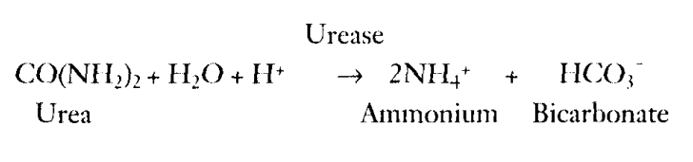

Figure 1: Adapted from Feltz et al. 1997. This shows the reaction which occurs in the stomach, where urea in the presence of water (H20) and acid

However, false negative results could occur in some conditions. Gastrointestinal bleeding^{20,21}, prior use of antibiotics²² or even corpus-predominant gastritis.²³ It's also been noticed that prior use of acid-lowering drugs like PPI or H2-blockers affects the results of UBT and RUT.²⁴ This is because increasing the antral pH reduces bacterial load and even causes proximal migration of the organism away from the antrum and corpus to become more abundant in the fundus.²⁵ On the other hand, false positive results occur in instances where a patient has urease-containing organisms like Helicobacter heilmannii,²⁶ Klebsiella pneumoniae, Proteus mirabilis, Staphylococcus aureus, Citrobacter freundii, Enterococcus cloacae.²⁷
This study aimed to assess the prevalence of Helicobacter pylori positivity among dyspeptic Nigerians in the North-Central region of Nigeria at Jos University Teaching Hospital (JUTH) and Federal Medical Centre Keffi (FMC Keffi).

METHODS
Patients who had dyspeptic symptoms (but devoid of alarm features) participated in this study after obtaining written informed consent. They were all off proton pump inhibitors (PPIs) for ≥ 2 weeks and Bismuth salts or antibiotics for ≥ 4 weeks. An interviewer-administered questionnaire was used to obtain biodata after all signed informed consents.
After adequately explaining the procedure to the participants, a ¹⁴C- labelled capsule was given to them to swallow with about 250 ml of water. After 15 minutes, they blew repeatedly into a mouthpiece attached to a collection card, Urea- ¹⁴C Breath test kit (made by Shenzhen Zhonghe Headway Bio-sci & Tech co., LTD).²⁸ This was continued until the yellow indicator turned orange. The collection card was then immediately inserted into a Headway HUBT-20P Helicobacter pylori test system analyser for 5 minutes.
The result was then printed out in IU/ml. Positivity was taken as any patient with a Cpm-value of ≥50 IU/ml. Cleaned data was entered into an Excel spreadsheet, and subsequently analysed using SPSS version 26.
RESULTS
Two hundred and sixty-six (266) dyspeptic patients participated in the study from April 2021 to December 2022. Only 37.6% of them were males. The mean age of the participants was 38.64 Years (SD 18.75), and most were married (62.7%). Thirty-three per cent (33%) were single, 4% widowed, and only one per cent were divorced. Students made up about 27.5% and civil servants made up 22.5%. The least proportion was health workers (2.9%), while 29.4% were in the category of other professions.
The median Cpm-value was 39.00 (11.0,132.0) and the mean was 84.01 (102.33). The proportion of patients who tested positive for H. pylori using the UBT was 125/266. This equated to a prevalence of 47.0 % as shown in Table 1.
Tables 2 shows bivariate analysis using age, marital status, and occupation. However, they were all not significant (p> 0.05).

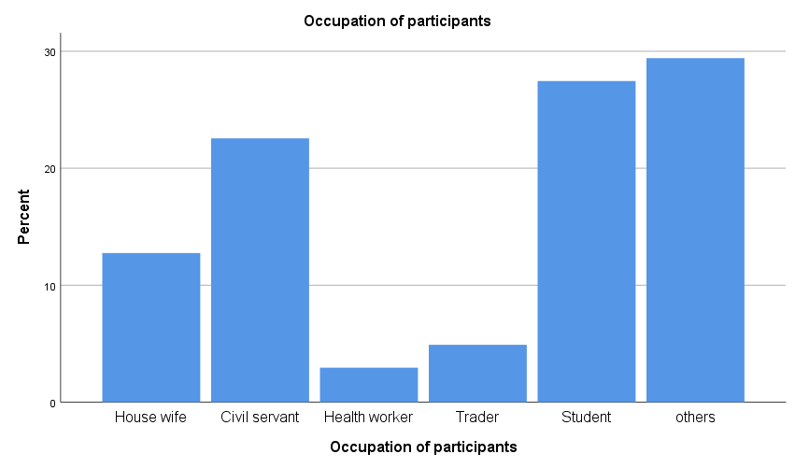
Figure 2: Bar chart showing the occupation of participants. Students, Civil servants and housewives were 28%, 23% and 12.5 % respectively. Traders and Health workers were 3.0 % and 5.0% respectively. The other occupations made up 29.0 % of the total occupations.

Table 1: shows the proportion of Positivity or Negativity to H. pylori using Urea breath test (UBT)
 |  | Frequency | Percent | Valid Percent | Cumulative Percent
Valid | H. pylori Positive | 125 | 47.0 | 47.0 | 47.0
Valid | H. pylori Negative | 141 | 53.0 | 53.0 | 100.0
Valid | Total | 266 | 100.0 | 100.0

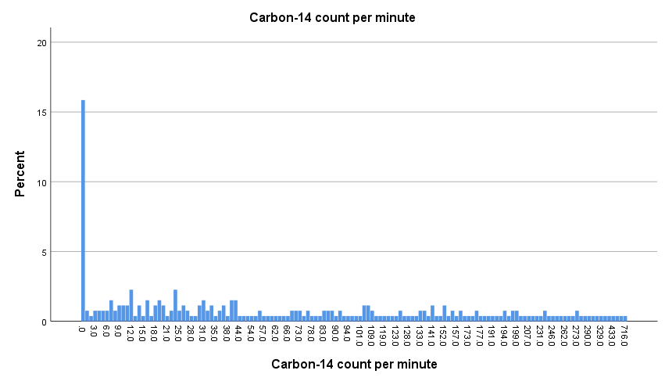

Figure 3: Bar chart showing the densities of the Co2 excretion expressed as Carbon-14 count per minute (Cpm) of the participants.

Table 2: Descriptive Statistics of participants' carbon-14 counts per minute, Cpm, showing the mean, median and range of their individual values.
Carbon-14 count per minute
N | Valid | 265
N | Missing | 1
Mean |  | 84.008
Median |  | 39.000
Mode |  | .0
Std. Deviation |  | 102.3287
Skewness |  | 2.114
Std. Error of Skewness |  | .150
Percentiles | 25 | 11.000
Percentiles | 50 | 39.000
Percentiles | 75 | 132.000

On regression analysis, educational level, occupation, age or marital status did not show a significant difference (p> 0.05).

DISCUSION
The majority (62.4%) of the patients were females, which shows a higher likelihood of dyspeptic complaints in females than males in our environment. The occupation of the participants showed that many of them were students, civil servants and housewives, with proportions of 28%, 23% and 12.5 % respectively. Minority were traders, and Health workers were 3.0 % and 5.0% respectively. The other occupations made up 29.0 % of the total occupations (including lawyers, pastors, priests, drivers, and farmers). See figure 2.
The proportion of those who tested positive for active H. pylori was 47.0%. This study showed a much lower prevalence of 47.0% compared to the global prevalence of H. pylori as reported by Hooi JKY et al in 2017.¹⁵ Nigeria was then reported to be at 87.7% based on the meta-analysis. This lower prevalence can be explained by the fact that this cohort of patients who were mostly urban dwellers with higher educational levels. Studies have shown a higher seroprevalence in poorer, less educated communities, which are more likely to have poor hygiene.^{29,30}
This finding is similar to that published in 2024 in Jos, Plateau State, where of clinic attendees who were screened for h pylori, 89% were seropositive, but only 37% were stool antigen positive.¹⁶ the prevalence value in this study, 47% is lower than the seroprevalence initially documented in Nigeria, 87.7%.¹⁵ It shows the essential need to always check for active organisms in dyspeptic patients before starting triple, quadruple or sequential therapy to eradicate H pylori. This practice would go a long way in mitigating against breeding antibiotic resistance, which can ensue via treating patients with antibiotics who don’t have the active organism.
The fact that educational level, occupation, age or marital status did not show a significant difference probably shows that immunity and exposure across the patients are similar. The median Cpm for the entire participants was not very high, 39.00 (11.0, 132.0). These low values may be due to some initial indiscriminate use of antibiotics that is very common in our environment, or even due to other factors not investigated in this study.

CONCLUSION
The prevalence of H. pylori using Urea breath test (UBT) among dyspeptics was 47.0% and this did not differ significantly across biophysical profiles. The median Cpm was 39.00 IU/ml.
We recommend all dyspeptic patients undergo UBT before commencement of antibiotics and at the end of treatment to demonstrate eradication.

Disclaimer (Artificial intelligence)
Option 1:
Author(s) hereby declare that NO generative AI technologies such as Large Language Models (ChatGPT, COPILOT, etc.) and text-to-image generators have been used during the writing or editing of this manuscript.
Option 2:
Author(s) hereby declare that generative AI technologies such as Large Language Models, etc. have been used during the writing or editing of manuscripts. This explanation will include the name, version, model, and source of the generative AI technology and as well as all input prompts provided to the generative AI technology
Details of the AI usage are given below:
1.
2.
3.

REFERENCES

1. Goodwin CS, Mendall MM, Northfield TC. Helicobacter pylori infection. The Lancet. 1997 Jan 25;349(9047):265–9.
2. Veres: Helicobacter pylori infection in pediatrics - Google Scholar [Internet]. [cited 2022 Sept 23]. Available from: https://scholar.google.com/scholar_lookup?title=Helicobacter%20pylori%20infection%20in%20pediatrics&journal=Helicobacter&volume=12&pages=38-44&publication_year=2007&author=Veres%2CG&author=Pehlivanoglu%2CE
3. Leal YA, Flores LL, Fuentes-Pananá EM, Cedillo-Rivera R, Torres J. 13C-Urea Breath Test for the Diagnosis of Helicobacter pylori Infection in Children: A Systematic Review and Meta-Analysis. Helicobacter. 2011;16(4):327–37.
4. Kusters JG, van Vliet AHM, Kuipers EJ. Pathogenesis of Helicobacter pylori Infection. Clin Microbiol Rev. 2006 July;19(3):449–90.
5. Mendall MA, Goggin PM, Molineaux N, Levy J, Toosy T, Strachan D, et al. Relation of Helicobacter pylori infection and coronary heart disease. Heart. 1994;71(5):437–9.
6. Gravina AG, Zagari RM, De Musis C, Romano L, Loguercio C, Romano M. Helicobacter pylori and extragastric diseases: A review. World J Gastroenterol. 2018 Aug 7;24(29):3204–21.
7. Ogunbodede: Helicobacter pylori in the dental plaque... - Google Scholar [Internet]. [cited 2022 Sept 23]. Available from: https://scholar.google.com/scholar_lookup?title=Helicobacter%20pylori%20in%20the%20dental%20plaque%20and%20gastric%20mucosa%20of%20dyspeptic%20Nigerian%20patients&journal=Trop%20Gastroenterol&volume=23&issue=3&pages=127-133&publication_year=2002&author=Ogunbodede%2CE&author=Lawal%2CO&author=Lamikanra%2CA&author=Okeke%2CI&author=Rotimi%2CO&author=Rasheed%2CA
8. Quaglia: High occurrence of Helicobacter pylori in... - Google Scholar [Internet]. [cited 2022 Sept 23]. Available from: https://scholar.google.com/scholar_lookup?title=High%20occurrence%20of%20Helicobacter%20pylori%20in%20raw%20goat%2C%20sheep%20and%20cow%20milk%20inferred%20by%20glmM%20gene%3A%20a%20risk%20of%20food-borne%20infection%3F&journal=Int%20J%20Food%20Microbiol&volume=124&issue=1&pages=43-47&publication_year=2008&author=Quaglia%2CN&author=Dambrosio%2CA&author=Normanno%2CG&author=Parisi%2CA&author=Patrono%2CR&author=Ranieri%2CG&author=Rella%2CA&author=Celano%2CG
9. Yamaoka: Mechanisms of disease: Helicobacter pylori... - Google Scholar [Internet]. [cited 2022 Oct 3]. Available from: https://scholar.google.com/scholar_lookup?title=Mechanisms%20of%20disease%3A%20Helicobacter%20pylori%20virulence%20factors&journal=Nat%20Rev%20Gastroenterol%20Hepatol&doi=10.1038%2Fnrgastro.2010.154&volume=7&issue=11&publication_year=2010&author=Yamaoka%2CY
10. Nejati: Influence of Helicobacter pylori virulence... - Google Scholar [Internet]. [cited 2022 Oct 3]. Available from: https://scholar.google.com/scholar_lookup?title=Influence%20of%20Helicobacter%20pylori%20virulence%20factors%20CagA%20and%20VacA%20on%20pathogenesis%20of%20gastrointestinal%20disorders&journal=Microb%20Pathog&doi=10.1016%2Fj.micpath.2018.02.016&volume=117&pages=43-48&publication_year=2018&author=Nejati%2CS&author=Karkhah%2CA&author=Darvish%2CH&author=Validi%2CM&author=Ebarhimpour%2CS&author=Nouri%2CHR
11. Dasani: Analysis of risk factors for chronic hepatic... - Google Scholar [Internet]. [cited 2022 Sept 23]. Available from: https://scholar.google.com/scholar_lookup?title=Analysis%20of%20risk%20factors%20for%20chronic%20hepatic%20encephalopathy%3A%20the%20role%20of%20Helicobacter%20pylori%20infection&journal=Am%20J%20Gastroenterol&volume=93&issue=5&publication_year=1998&author=Dasani%2CBM&author=Sigal%2CSH&author=Lieber%2CCS
12. Thaker: Helicobacter pylori: A review of epidemiology,... - Google Scholar [Internet]. [cited 2022 Sept 23]. Available from: https://scholar.google.com/scholar_lookup?title=Helicobacter%20pylori%3A%20a%20review%20of%20epidemiology%2C%20treatment%2C%20and%20management&journal=J%20Clin%20Gastroenterol%20Treat&volume=2&issue=19&pages=1-5&publication_year=2016&author=Thaker%2CY&author=Moon%2CA&author=Afzali%2CA
13. Gisbert JP, Pajares JM. Review article: 13C-urea breath test in the diagnosis of Helicobacter pylori infection – a critical review. Aliment Pharmacol Ther. 2004;20(10):1001–17.
14. Dore MP, Pes GM. What is new in Helicobacter pylori diagnosis. An overview. J Clin Med. 2021;10(10):2091.
15. Hooi JKY, Lai WY, Ng WK, Suen MMY, Underwood FE, Tanyingoh D, et al. Global Prevalence of Helicobacter pylori Infection: Systematic Review and Meta-Analysis. Gastroenterology. 2017 Aug 1;153(2):420–9.
16. Banda JM, David OS, Ida OL, Banda SF, Ede FR, Ndubuisi JC, et al. Helicobacter Pylori Infection and Risk Factors Among Outpatient Attendees of Jos And Bingham University Teaching Hospitals, Jos, Plateau State, Nigeria. Ann Med Lab Sci. 2024;3(1):66–75.
17. Felz MW, Burke GJ, Schuman BM. Breath test diagnosis of Helicobacter pylori in peptic ulcer disease: a noninvasive primary care option. J Am Board Fam Pract. 1997;10(6):385–9.
18. Chey WD, Metz DC, Shaw S, Kearney D, Montague J, Murthy U. Appropriate Timing of The 14C-Urea Breath Test To Establish Eradication ofHelicobacter PyloriInfection. Off J Am Coll Gastroenterol ACG. 2000;95(5):1171–4.
19. Vaira: Blood, urine, stool, breath, money, andHelicobacte... - Google Scholar [Internet]. [cited 2022 Sept 30]. Available from: https://scholar.google.com/scholar_lookup?hl=en&publication_year=2001&author=D+Vairaauthor=N+Vakil&title=Blood%2C+urine%2C+stool%2C+breath%2C+money%2C+and+Helicobacter+pylori.
20. Ontsira Ngoyi: Molecular detection of Helicobacter... - Google Scholar [Internet]. [cited 2022 Oct 3]. Available from: https://scholar.google.com/scholar_lookup?title=Molecular%20detection%20of%20Helicobacter%20pylori%20and%20its%20antimicrobial%20resistance%20in%20Brazzaville&journal=Congo%20Helicobacter&doi=10.1111%2Fhel.12204&volume=20&issue=4&pages=316-320&publication_year=2015&author=Ontsira%20Ngoyi%2CEN&author=Atipo%20Ibara%2CBI&author=Moyen%2CR&author=Ahoui%20Apendi%2CPC&author=Ibara%2CJR&author=Obengui%2CO&author=Ossibi%20Ibara%2CRB&author=Nguimbi%2CE&author=Niama%2CRF&author=Ouamba%2CJM
21. Lee JM, Breslin NP, Fallon C, O’Morain CA. Rapid urease tests lack sensitivity in Helicobacter pylori diagnosis when peptic ulcer disease presents with bleeding. Am J Gastroenterol. 2000 May 1;95(5):1166–70.
22. Chey: American College of Gastroenterology guideline... - Google Scholar [Internet]. [cited 2022 Oct 3]. Available from: https://scholar.google.com/scholar_lookup?hl=en&publication_year=2007&author=Chey+WD%2C+Wong+BCY%2C+Practice+Parameters+Committee+of+the+American+College+of+Gastroenterology&title=American+College+of+Gastroenterology+guideline+on+the+management+of+Helicobacter+pylori+infection.
23. Capurso: Corpus‐predominant gastritis as a risk... - Google Scholar [Internet]. [cited 2022 Oct 3]. Available from: https://scholar.google.com/scholar_lookup?title=Corpus-predominant%20gastritis%20as%20a%20risk%20factor%20for%20false-negative%2013C-urea%20breath%20test%20results&journal=Aliment%20Pharmacol%20Ther&doi=10.1111%2Fj.1365-2036.2006.03143.x&volume=24&issue=10&pages=1453-1460&publication_year=2006&author=Capurso%2CG&author=Carnuccio%2CA&author=Lahner%2CE&author=Panzuto%2CF&author=Baccini%2CF&author=Fave%2CG&author=Annibale%2CB
24. Yakoob J, Jafri W, Abid S, Jafri N, Abbas Z, Hamid S, et al. Role of rapid urease test and histopathology in the diagnosis of Helicobacter pylori infection in a developing country. BMC Gastroenterol. 2005 Nov 25;5(1):38.
25. Logan RP, Walker MM, Misiewicz JJ, Gummett PA, Karim QN, Baron JH. Changes in the intragastric distribution of Helicobacter pylori during treatment with omeprazole. Gut. 1995;36(1):12–6.
26. Garza-González: A review of Helicobacter pylori... - Google Scholar [Internet]. [cited 2022 Oct 3]. Available from: https://scholar.google.com/scholar_lookup?title=A%20review%20of%20Helicobacter%20pylori%20diagnosis%2C%20treatment%2C%20and%20methods%20to%20detect%20eradication&journal=World%20J%20Gastroenterol&doi=10.3748%2Fwjg.v20.i6.1438&volume=20&issue=6&publication_year=2014&author=Garza-Gonz%C3%A1lez%2CE&author=Perez-Perez%2CGI&author=Maldonado-Garza%2CHJ&author=Bosques-Padilla%2CFJ
27. Uotani T, Graham DY. Diagnosis of Helicobacter pylori using the rapid urease test. Ann Transl Med. 2015 Jan;3(1):9.
28. Gisbert JP, Pajares JM. Review article: 13C-urea breath test in the diagnosis of Helicobacter pylori infection – a critical review. Aliment Pharmacol Ther. 2004;20(10):1001–17.
29. Zamani M, Ebrahimtabar F, Zamani V, Miller WH, Alizadeh-Navaei R, Shokri-Shirvani J, et al. Systematic review with meta-analysis: the worldwide prevalence of Helicobacter pylori infection. Aliment Pharmacol Ther. 2018;47(7):868–76.
30. Bruce MG, Maaroos HI. Epidemiology of Helicobacter pylori Infection. Helicobacter. 2008;13(s1):1–6.

