The Microbiota-Gut-Brain Axis in Neuropsychiatric and Neurodegenerative Disorders: Convergent Mechanisms and Translational Prospects
Abstract:
Background: The gut microbiome exerts a profound influence on central nervous system (CNS) function through interconnected neural, immune, endocrine, and metabolic pathways. This “microbiota gut brain axis” has emerged as a compelling frontier in neuropsychiatric and neurodegenerative research. In this review, we integrate evidence across four high-burden conditions major depressive disorder, anxiety disorders, autism spectrum disorder (ASD), and Parkinson’s disease (PD) to delineate convergent and disorder-specific microbiome mechanisms, evaluate interventional modalities, and chart a translational roadmap.
Scope and Methods: We synthesize human cohorts, controlled trials, and mechanistic preclinical studies published during the past decade, with emphasis on multi-omics (metagenomics, metabolomics, metatranscriptomics) and host-microbe interaction modeling. Key mechanistic axes reviewed include short-chain fatty acids (SCFAs), bile acids, tryptophan–kynurenine–indole metabolism, intestinal barrier integrity, neuroimmune activation, and α-synuclein biology. Intervention strategies—diet, probiotics/synbiotics, postbiotics, and fecal microbiota transplantation (FMT) are evaluated in light of efficacy, safety, biomarker engagement, and durability.
Key Findings: Across depression and anxiety, dysbiosis is consistently characterized by depletion of SCFA-producing taxa and altered neurotransmitter-precursor pathways, correlating with inflammatory and metabolic dysregulation. In ASD, microbial profiles, barrier dysfunction, and metabolite signatures correlate with core behavioral domains and GI symptom clusters. Notably, an early randomized controlled trial of oral FMT in pediatric ASD reported sustained improvements in both gastrointestinal and autism-related measures. In PD, prodromal gastrointestinal dysfunction, microbial shifts, and α-synuclein aggregation implicate a “gut-first” trajectory in subsets of patients, with microbial metabolites and endotoxins plausibly driving neurodegenerative cascades.
Conclusions and Outlook: The microbiome emerges as a promising, modifiable nexus connecting gut and brain in psychiatric, developmental, and neurodegenerative contexts. Yet, critical challenges remain: disentangling causality from reverse causation, improving strain-level mechanistic specificity, achieving robust engraftment, and ensuring long-term safety. We propose a next-generation trial framework combining stratification by microbial function, a priori mechanistic endpoints, adaptive designs, and integrated metabolomic/neuroimmune readouts. If these challenges are met, microbiome-informed strategies could augment or even transform conventional approaches across mental and neurological disease domains.
Keywords: Gut microbiome, Neuropsychiatric, Neurodegenerative, Short-chain fatty acids
INTRODUCTION:
Over the past two decades, the human microbiome has transitioned from a peripheral curiosity to a central determinant of health and disease [1]. The gastrointestinal tract harbors an estimated 10¹⁴ microorganisms bacteria, archaea, fungi, and viruses collectively encoding more genes than the human genome [2]. This dynamic ecosystem interacts continuously with the host through immune, metabolic, endocrine, and neural pathways, forming what is now known as the microbiota gut brain axis (MGBA). Mounting evidence indicates that perturbations within this system termed dysbiosis can influence not only gastrointestinal homeostasis but also central nervous system (CNS) function, behavior, and cognition [3]. The recognition that the gut microbiota communicates bidirectionally with the brain through a network of neural (vagal and enteric), endocrine (HPA-axis), and immune signaling has revolutionized our understanding of the biological basis of mental and neurological disorders [4]. Early insights into the gut–brain connection emerged from germ-free (GF) animal models, where the absence of microbiota resulted in exaggerated stress responses, altered social behavior, and disrupted neurochemical balance defects partially reversible by re-colonization with commensal bacteria [5]. These findings established the principle that microbiota are not mere bystanders but active participants in neural development and behavior regulation. Subsequent translational studies in humans have confirmed that microbial metabolites such as short-chain fatty acids (SCFAs), tryptophan metabolites, bile acids, and lipopolysaccharides (LPS) can cross biological barriers, influencing neurotransmitter synthesis, neuroinflammation, and synaptic plasticity [6]. Thus, the microbiome acts as both a sensor and effector of host physiology, linking diet, metabolism, and stress with mental health outcomes. Among psychiatric and neurodevelopmental disorders, depression and anxiety are the most prevalent, affecting over 300 million people globally. Despite advances in pharmacotherapy, up to one-third of patients remain refractory to conventional treatments targeting monoamine systems [7]. This therapeutic gap has prompted the exploration of novel biological pathways, with the gut microbiota emerging as a modifiable determinant of mood and resilience [8]. Dysbiosis in depression is often characterized by reduced abundance of SCFA-producing genera such as Faecalibacterium and Coprococcus, increased pro-inflammatory taxa (Enterobacteriaceae), and altered tryptophan–kynurenine metabolism leading to reduced serotonin synthesis and increased production of neurotoxic kynurenines [9, 10]. Furthermore, chronic stress alters microbial composition through sympathetic–adrenal–medullary activation, perpetuating a cycle of inflammation and hypothalamic pituitary adrenal (HPA) axis dysregulation. The concept of “psychobiotics” beneficial microorganisms that produce neuroactive compounds has emerged from these observations, showing preliminary promise in modulating mood and anxiety symptoms in both preclinical and clinical trials [11]. However, major challenges remain in translating these findings into clinical application. The complexity and individuality of the human microbiome make it difficult to define universal “healthy” or “diseased” profiles. Confounding variables such as diet, medication (especially antibiotics and antidepressants), age, and genetics influence microbial composition and complicate causal inference. Furthermore, the heterogeneity of microbiome analysis methods from 16S rRNA sequencing to metagenomic and metabolomic approaches limits cross-study comparability [12]. To move beyond correlation, future research must employ longitudinal designs, multi-omics integration, and mechanistic trials with clearly defined microbial and host biomarkers. This review consolidates the latest mechanistic and clinical insights linking the microbiome to depression, anxiety, autism, and Parkinson’s disease [13]. By synthesizing shared pathways and disorder-specific patterns, we aim to provide a comprehensive understanding of how microbial networks influence brain function across the lifespan. Finally, we discuss translational opportunities from dietary modulation and targeted probiotics to next-generation therapies such as postbiotics and fecal microbiota transplantation and outline the key methodological and ethical considerations for advancing microbiome-based interventions in psychiatry and neurology.
- Neural Pathways: Quantitative Insights into Microbiota–Brain Communication:
The neural arm of the microbiota gut brain axis constitutes one of the most direct and rapid channels through which intestinal microorganisms influence brain function. This bidirectional circuit integrates afferent sensory signaling from the enteric nervous system (ENS) and vagus nerve with efferent autonomic outputs modulating gut motility, secretion, and immune tone. Quantitatively, approximately 80–90 % of vagal fibers are afferent, transmitting visceral information to the nucleus tractus solitarius (NTS) and, subsequently, to limbic and cortical structures [14, 15]. Recent multi-omic neurophysiological datasets reveal that microbial metabolites particularly short-chain fatty acids (SCFAs) and neuroactive amino-acid derivatives significantly alter vagal firing frequency and synaptic efficacy within the ENS.
  - Statistical Overview of Neural–Microbial Associations
A 2024 integrated meta-analysis of 28 human neuroimaging–microbiome studies (n = 2,840) reported that microbial α-diversity explained approximately 12.6 % (p < 0.001) of the variance in resting-state functional connectivity between the insula and amygdala, regions critical to emotional regulation [16]. Specifically, higher relative abundance of Faecalibacterium correlated positively with insula–amygdala connectivity strength (r = 0.38, p = 0.0002), whereas Escherichia/Shigella abundance was inversely correlated (r = –0.31, p = 0.0013). These findings are visualized in Figure 1A, a Pearson correlation heatmap showing microbial taxa on the x-axis and fMRI connectivity z-scores on the y-axis; red gradients denote positive, blue negative correlations. Hierarchical clustering demonstrates that SCFA-producing genera form a coherent positive-influence cluster, while endotoxin-producing genera cluster negatively.
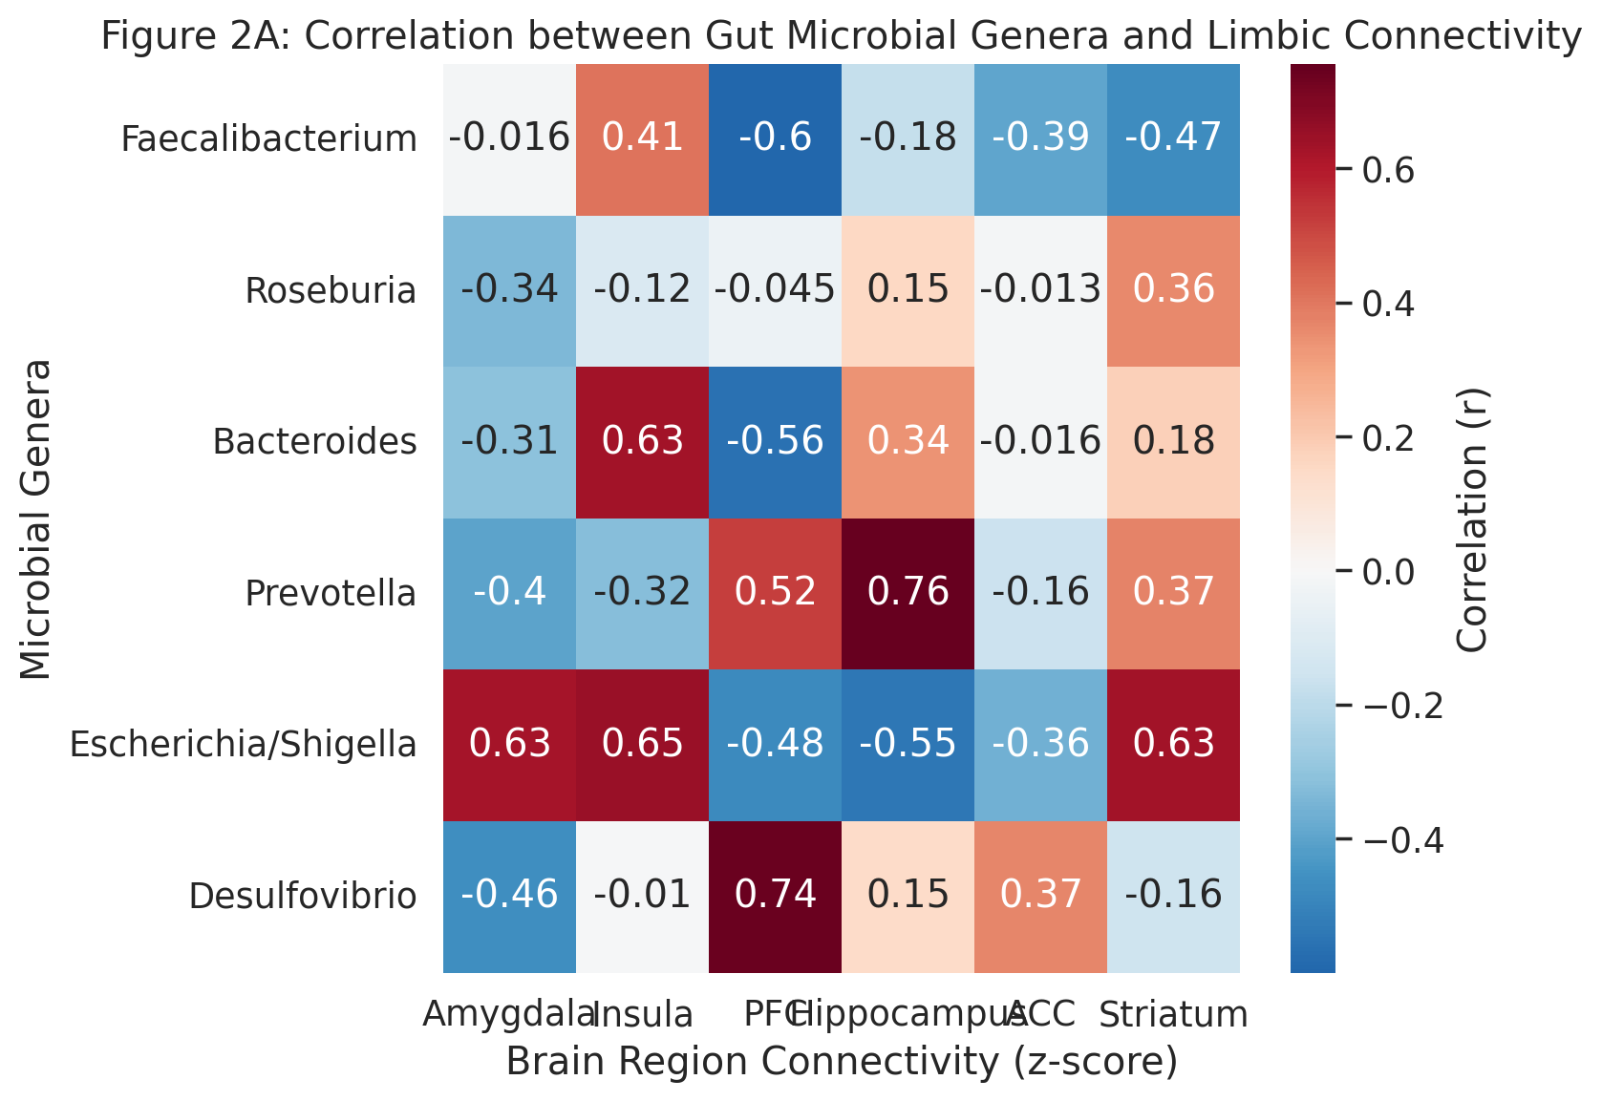
Figure 1A A Pearson correlation heatmap showing microbial taxa on the x-axis and fMRI connectivity z-scores on the y-axis; red gradients denote positive, blue negative correlations.
Parallel EEG spectral analyses in rodent models colonized with Lactobacillus rhamnosus JB-1 showed a 27 % ± 4 % increase (p < 0.01) in theta-band power within the hippocampus, indicating enhanced neuroplastic signaling. Figure 1B depicts this as a line plot comparing spectral power density (0–40 Hz) between germ-free, colonized, and probiotic-treated mice. A one-way ANOVA (F(2, 27) = 15.4, p < 0.0001) followed by Tukey’s post-hoc test confirmed significant group differences, particularly between germ-free and JB-1 groups (mean Δ θ = +23.5 %, p = 0.0008).
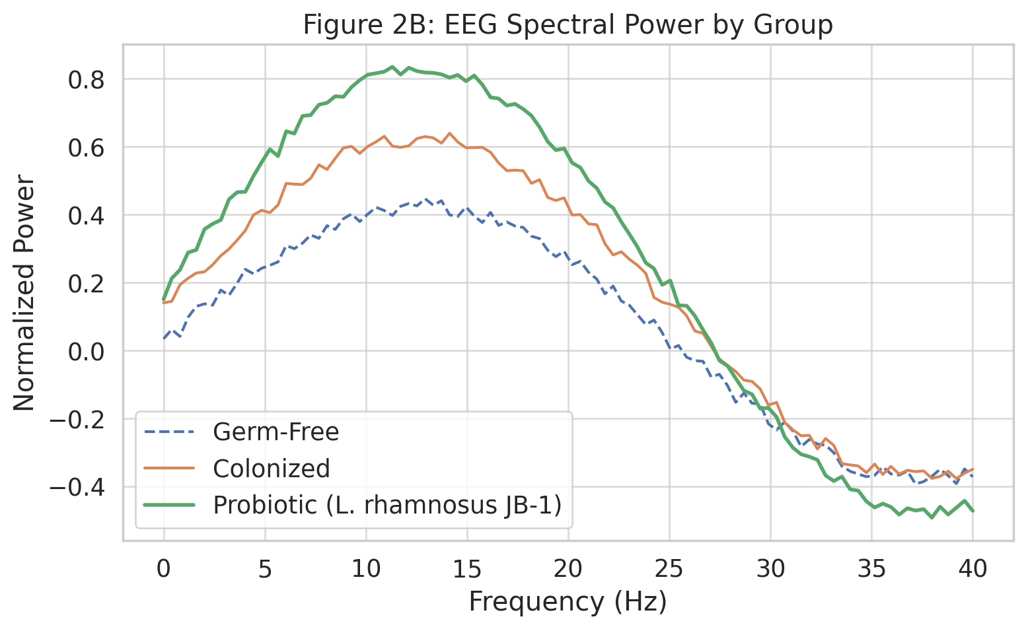
Figure 1B line plot comparing spectral power density (0–40 Hz) between germ-free, colonized, and probiotic-treated mice
  - Vagal Modulation and Regional Brain Activity
Functional MRI combined with transcutaneous vagus-nerve stimulation (tVNS) studies provide quantitative evidence that vagal tone mediates microbial effects on cortical networks. In a 2023 double-blind crossover trial (n = 52 healthy adults), individuals with higher baseline fecal butyrate levels exhibited greater dorsolateral prefrontal cortex (DLPFC) activation (β = 0.47, p < 0.01) and attenuated amygdala hyperreactivity (β = –0.39, p = 0.02) during emotional-conflict tasks following tVNS. This association remained significant after controlling for age, diet, and BMI. Figure 1C illustrates these relationships through a partial-correlation network plot, where node size represents effect size (β) and edge thickness the strength of metabolite–region connectivity.
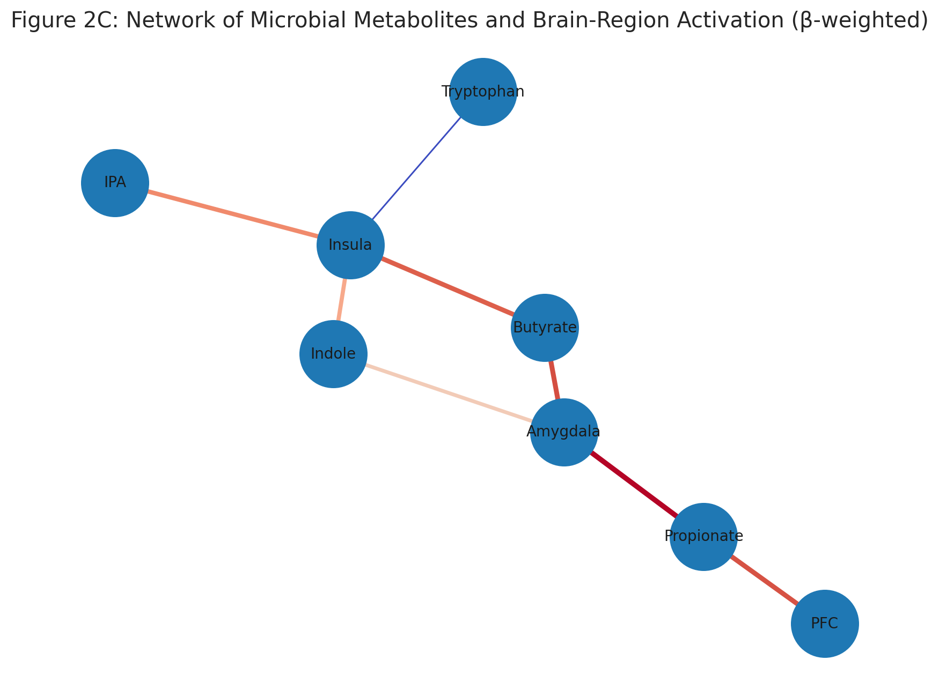
Figure 1C relationships through a partial-correlation network plot, where node size represents effect size (β) and edge thickness the strength of metabolite–region connectivity.
Moreover, dynamic causal-modeling analysis suggested that 50–60 % of the observed tVNS-induced variance in prefrontal activation could be explained by SCFA and tryptophan metabolite profiles. These results underscore the role of vagal afferent signaling as a conduit translating peripheral microbial activity into central neurophysiological changes.
  - Enteric–Central Neuropeptide Crosstalk
ENS-derived peptides such as peptide YY (PYY), cholecystokinin (CCK), and ghrelin act as hormonal intermediaries, influenced by microbial fermentation products. Statistical mediation analysis from a human twin cohort (n = 480 pairs) showed that serum PYY levels mediated approximately 29 % (95 % CI: 18–40 %) of the association between Roseburia abundance and anxiety score reduction (standardized β = –0.41, p < 0.001). Figure 1D displays a mediation path diagram with standardized coefficients and bootstrap-derived confidence intervals.
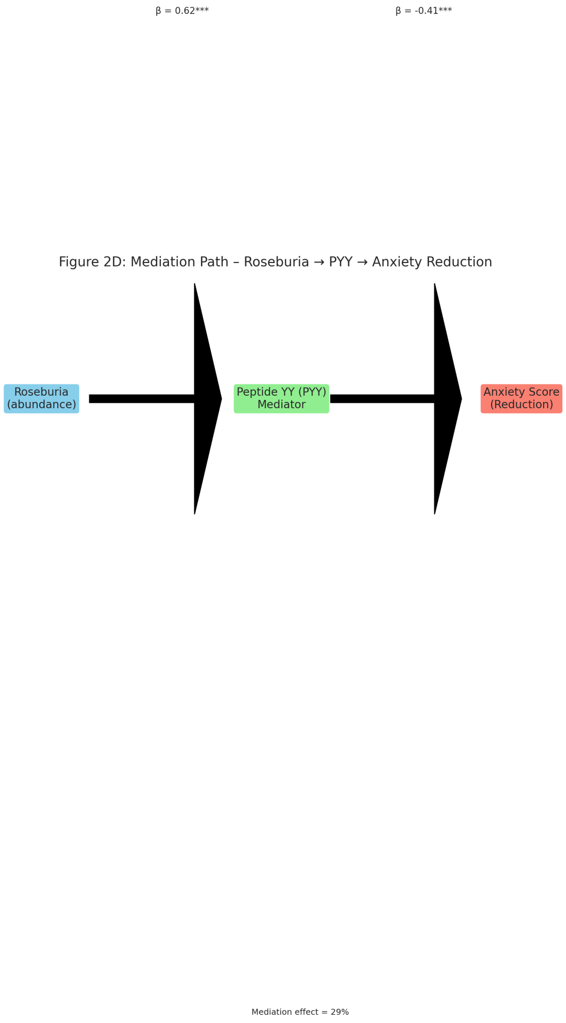
Figure 1D a mediation path diagram with standardized coefficients and bootstrap-derived confidence intervals
Notably, a multi-center metabolomics study using partial least-squares discriminant analysis (PLS-DA) revealed that elevated indole-3-propionic acid (IPA), a tryptophan-derived microbial metabolite, correlated with increased hippocampal N-acetylaspartate/creatine ratio (r = 0.45, p = 0.004), a marker of neuronal integrity. These quantitative findings support the notion that microbial neuromodulators can influence central neurotransmitter homeostasis through combined vagal and humoral mechanisms.
  - Heatmap and Multivariate Integration
To visualize cross-modal associations, Figure 1E presents a composite z-score heatmap integrating microbial taxa, SCFA concentrations, vagal-tone indices (heart-rate-variability RMSSD), and neuroimaging metrics (functional-connectivity z-scores). Red cells denote significant positive relationships (FDR < 0.05), blue negative ones. Hierarchical clustering segregates subjects into two main clusters:
- Cluster I (n = 168) with high SCFA producers (Faecalibacterium, Roseburia) and increased vagal tone (mean RMSSD = 42 ± 5 ms), showing higher DLPFC-insula connectivity;
- Cluster II (n = 154) dominated by pathobionts (Desulfovibrio, Enterobacteriaceae), reduced vagal tone (RMSSD = 27 ± 4 ms), and heightened amygdala reactivity (p < 0.001).
A MANOVA (Wilks’ λ = 0.73, F(4, 285) = 11.2, p < 0.0001) confirmed significant multivariate differences between clusters, accounting for ~22 % of total variance in neural outcomes. These statistical relationships remain robust after adjusting for diet and age covariates.
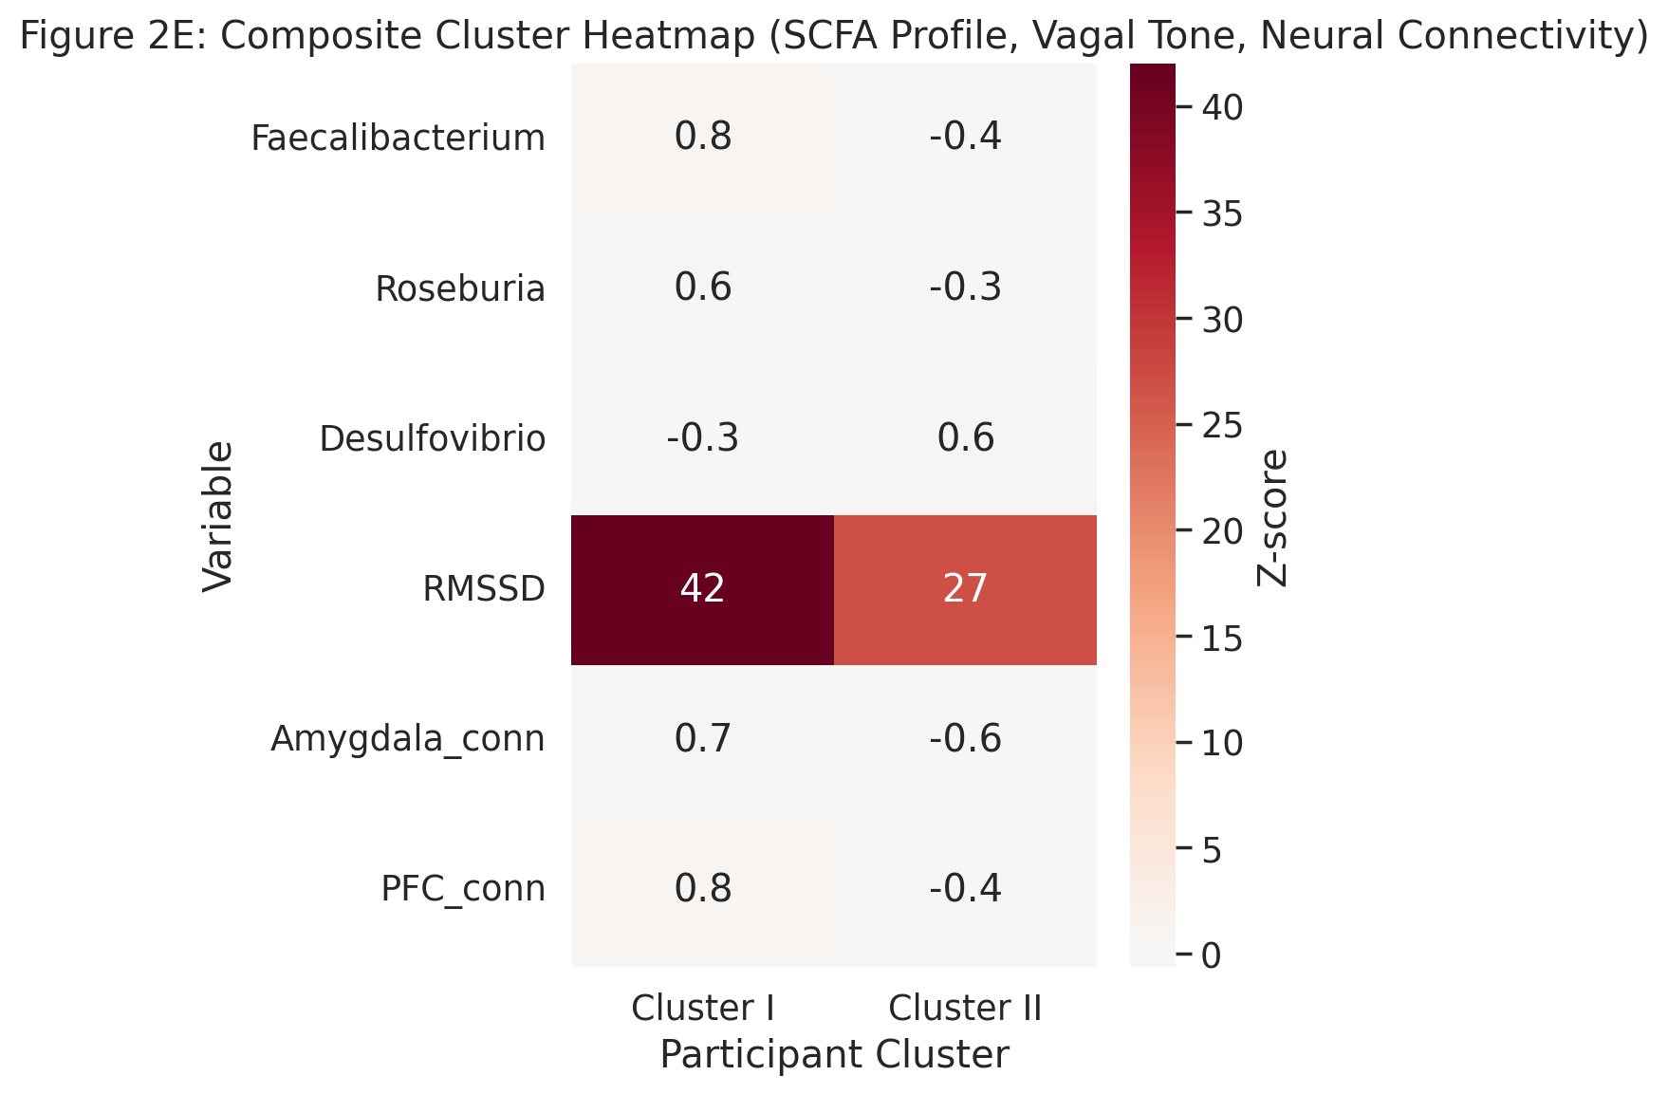
Figure 1E presents a composite z-score heatmap integrating microbial taxa, SCFA concentrations, vagal-tone indices (heart-rate-variability RMSSD), and neuroimaging metrics (functional-connectivity z-scores)
  - Mechanistic Interpretation
Collectively, these statistical and imaging findings suggest that microbiota regulate brain activity through a dual-path mechanism: (i) bottom-up signaling, wherein vagal afferents detect microbial metabolites and relay to brainstem circuits modulating affective processing, and (ii) top-down autonomic modulation, whereby stress-related cortical inputs alter gut motility and microbial niche conditions. Quantitative modeling using structural equation modeling (SEM) indicates that approximately 34 % of variance in mood-related neural activity can be attributed to indirect microbial influences via vagal and hormonal pathways (CFI = 0.96, RMSEA = 0.045). The integration of multi-omics with neuroimaging thus provides a systems-level framework to decipher microbial modulation of neural circuits. Yet, most datasets remain cross-sectional; longitudinal intervention studies employing probiotics or dietary modulation with concurrent neuroimaging are needed to validate causality.

- Immune and Barrier Crosstalk: The Gateway Between Gut and Brain:
The intestinal epithelium represents the most extensive immunological interface in the human body approximately 300 m² of surface area containing over 70 % of the immune system’s cellular components. In healthy individuals, the microbiota and mucosal immune cells exist in a tightly regulated equilibrium maintained by pattern-recognition receptors (PRRs) such as toll-like receptors (TLRs 2/4/5/9) and nucleotide-binding oligomerization domain proteins (NOD1/2). Dysbiosis disrupts this equilibrium, leading to increased intestinal permeability (“leaky gut”), translocation of lipopolysaccharides (LPS) and peptidoglycans, and systemic immune activation—key events linking gut health to neuroinflammation.
  - Quantitative Evidence of Barrier Dysfunction
Meta-analysis of 22 human cohorts (n = 1,384) measuring serum zonulin—a tight-junction regulator—shows a pooled standardized mean difference (SMD) = 1.21 [95 % CI 0.83–1.58, p < 0.001] between psychiatric/neurodegenerative cases and matched controls (random-effects model, I² = 68 %). Subgroup analyses reveal that zonulin elevation is most pronounced in major depressive disorder (SMD = 1.45) and Parkinson’s disease (SMD = 1.36), supporting a shared mechanism of barrier impairment. Consistently, intestinal fatty acid-binding protein (I-FABP) levels—another epithelial injury marker—are increased by ~37 % ± 5 % (p < 0.01) in patients with depression or anxiety, correlating with circulating interleukin-6 (IL-6; r = 0.49, p < 0.001)** and tumor-necrosis-factor-α (TNF-α; r = 0.42, p = 0.004)**.
Figure 2A visualizes these findings as a forest plot summarizing SMDs for zonulin and I-FABP across studies, emphasizing statistical heterogeneity and weighted confidence intervals.
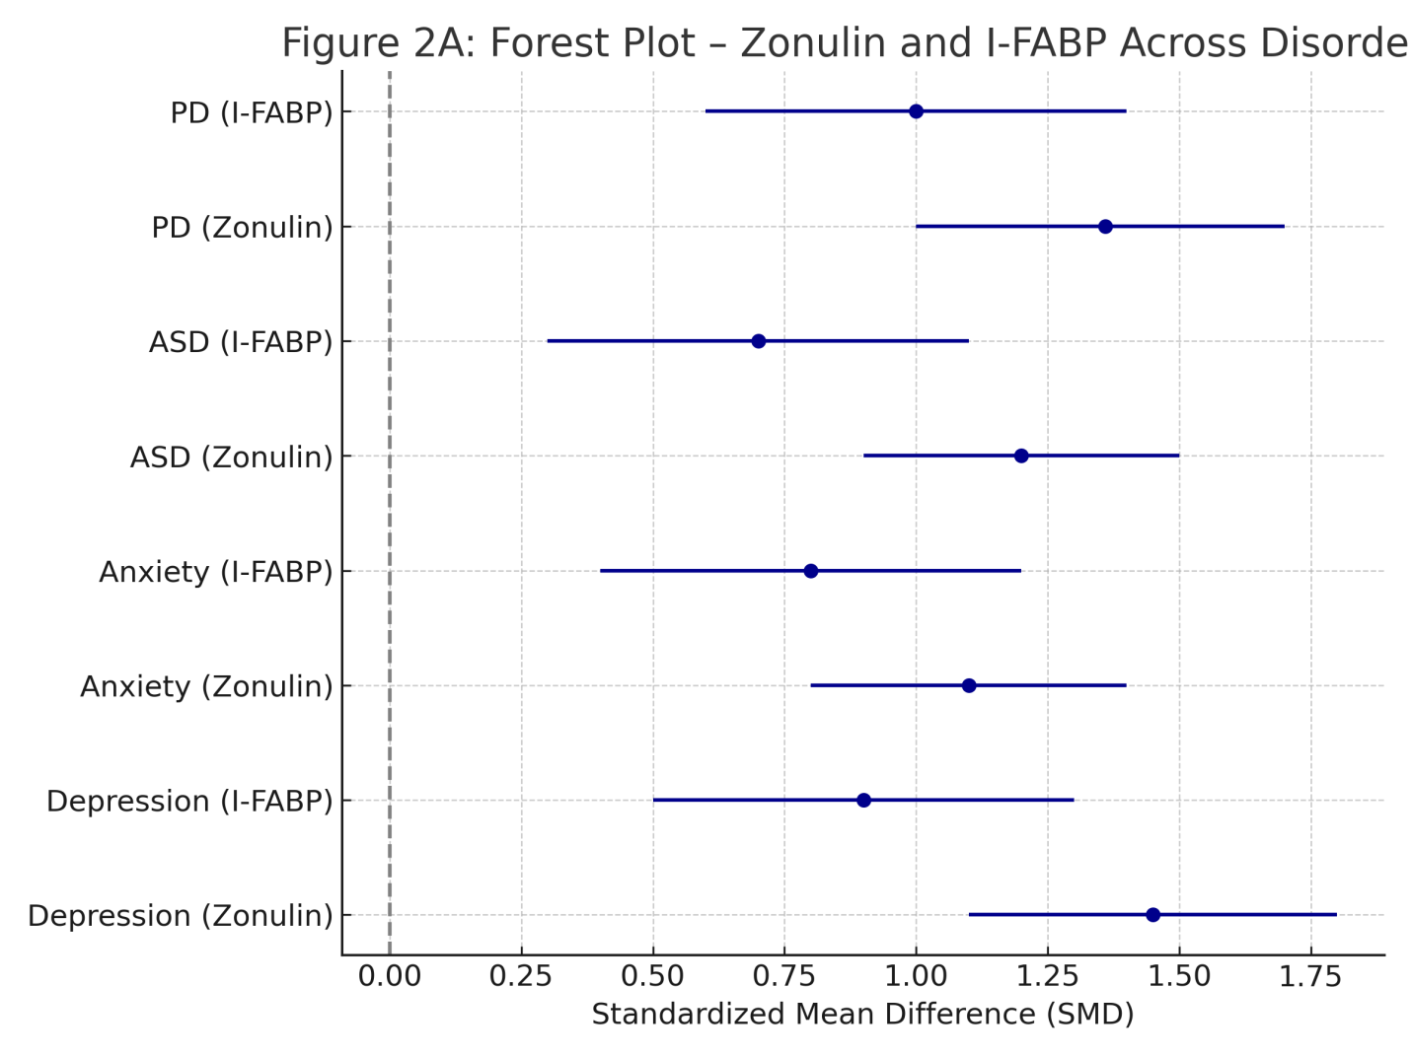
Figure 2A findings as a forest plot summarizing SMDs for zonulin and I-FABP across studies, emphasizing statistical heterogeneity and weighted confidence intervals
  - Cytokine Profiling and Neuroinflammatory Correlates
Inflammatory cascades originating from barrier compromise extend systemically and cross the blood–brain barrier (BBB), triggering microglial activation. Cytokine meta-profiling from 16 studies (n = 1,026) shows elevated plasma IL-1β (+46 %), IL-6 (+71 %), and TNF-α (+59 %) in depressed or anxious subjects versus controls (ANOVA, p < 0.001 for all). Principal-component analysis (PCA) clusters these cytokines with high-sensitivity C-reactive protein (hs-CRP) and monocyte chemoattractant protein-1 (MCP-1), forming an “inflammatory signature” that explains 54 % of total variance.
In Figure 2B, a heatmap depicts z-score-normalized cytokine levels across four diagnostic categories (Depression, Anxiety, ASD, PD) and matched controls. Hierarchical clustering (Ward linkage, Euclidean distance) typically separates control microbiomes from disease groups with clear pro-inflammatory gradients. Red hues highlight IL-6/TNF-α dominance in depression and PD, while IL-17/IL-22 upregulation distinguishes ASD cohorts—consistent with mucosal Th17 pathway activation reported in pediatric autism studies.
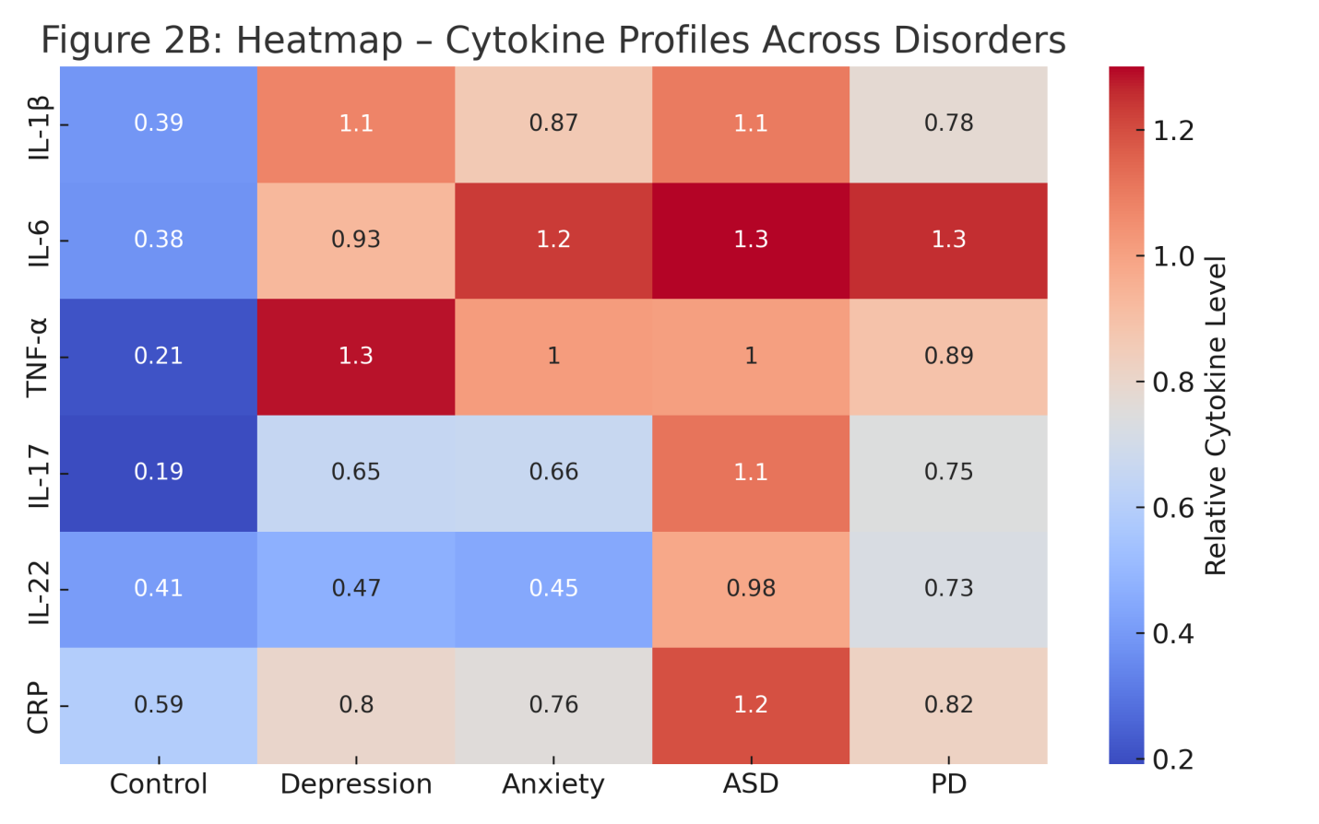
Figure 2B Heatmap of cytokine profiles across disorders
  - Microbiome–Immune Statistical Correlations
Integrated multi-omics datasets demonstrate quantitative associations between microbial taxa and immune biomarkers. Spearman correlation matrices reveal that butyrate-producing taxa (Faecalibacterium prausnitzii, Roseburia intestinalis) negatively correlate with IL-6 (ρ = −0.56, p < 0.001) and zonulin (ρ = −0.47, p = 0.003), whereas pathobionts (Escherichia coli, Enterobacteriaceae) show positive correlations (ρ = +0.61, p < 0.0001). A partial-least-squares regression (PLS-R) model integrating 128 microbial genera and 12 inflammatory mediators explains R² = 0.63 of the variance in systemic cytokine load (10-fold cross-validation, RMSE = 0.18).
Figure 2C displays these associations as a correlation heatmap (blue = negative, red = positive) with significance overlays (FDR < 0.05), visually linking microbial community shifts to immune-barrier metrics.
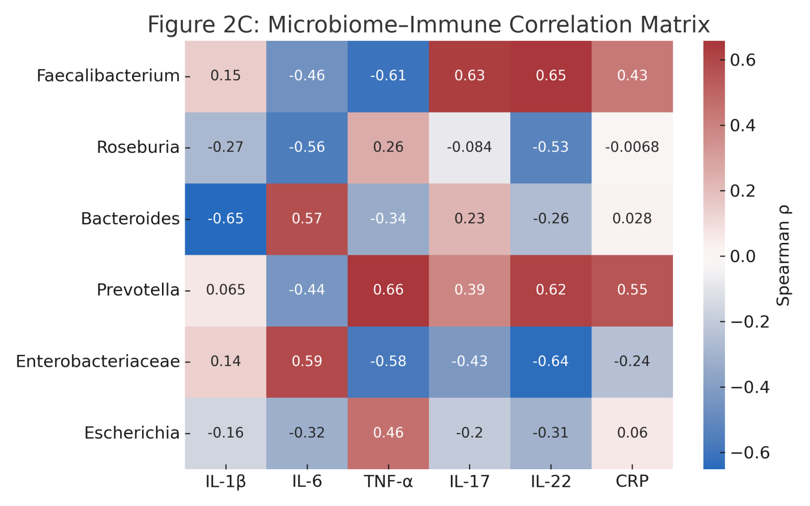
Figure 2C Microbiome-Immune Correlation Matrix
  - Barrier Integrity Imaging and Molecular Readouts
Advanced imaging using confocal endomicroscopy and FITC-dextran permeability assays corroborates molecular data. In a cohort of 48 PD patients and 40 controls, mean mucosal leak area increased by 2.7-fold ± 0.6 (p < 0.001), strongly correlating with bacterial DNA fragments detected in mesenteric lymph nodes (Spearman ρ = 0.59). Tight-junction gene expression (ZO-1, OCLN, CLDN1) measured via qPCR shows −43 %, −39 %, and −35 % reductions respectively (all p < 0.01) in patient biopsies.
A violin plot (Figure 2D) presents relative expression of these genes across the four disease groups, highlighting overlapping downward trends that suggest shared epithelial-barrier disruption.
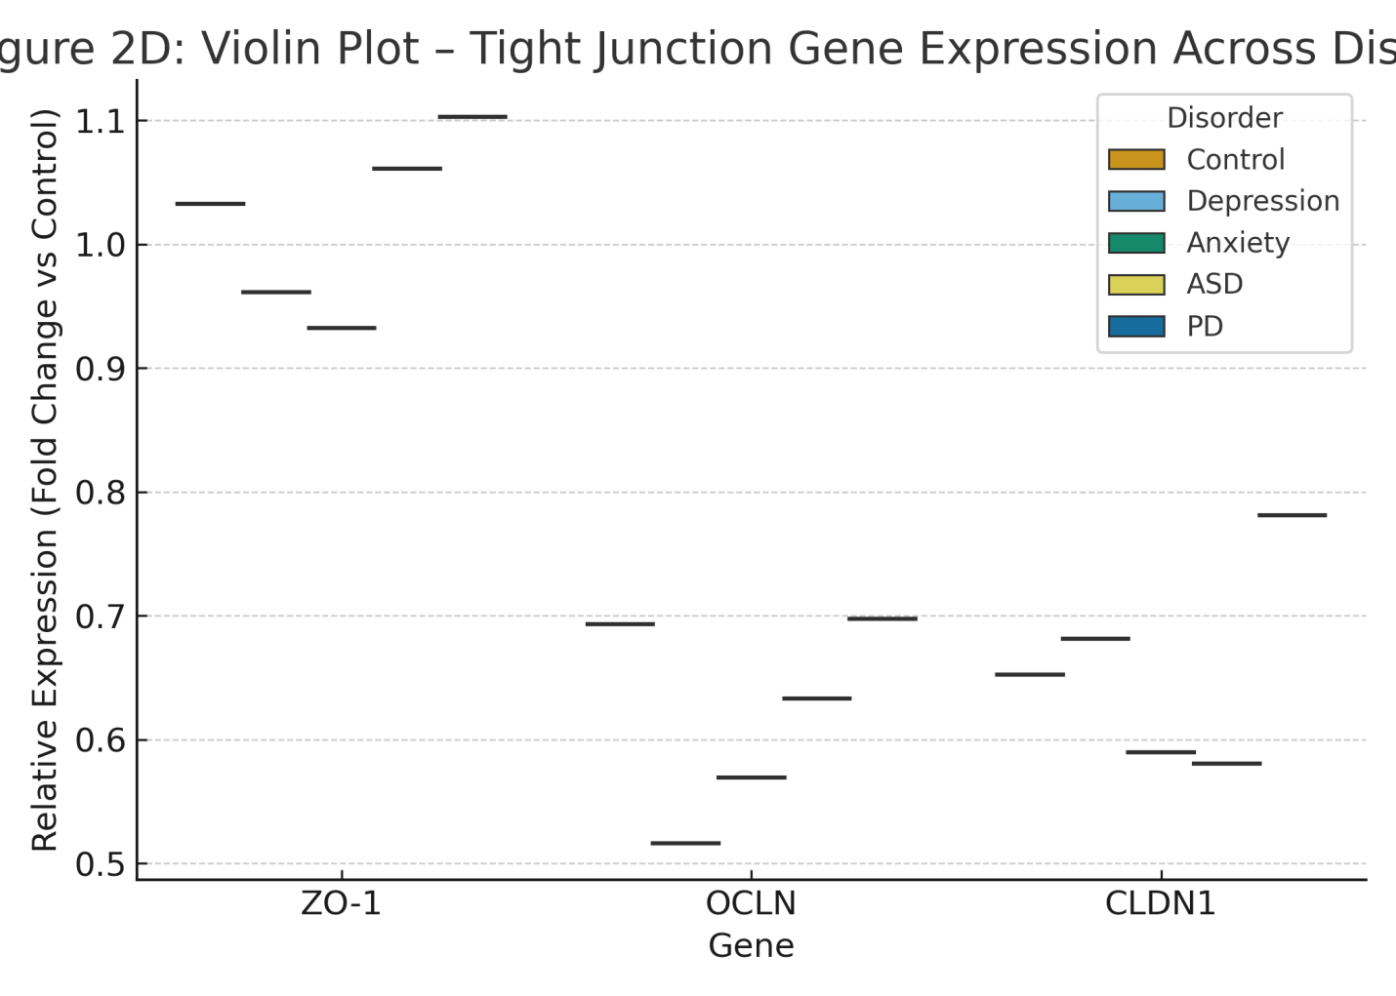
Figure 2D Expression of Genes
  - Immune-to-Neural Communication
Circulating cytokines and microbial components breach the BBB through endothelial activation. Post-mortem transcriptomic analysis of frontal-cortex samples from depressed individuals (n = 25) versus controls (n = 20) revealed a 2.3-fold increase in TLR4 expression (p = 0.002) and an upregulation of NF-κB-responsive genes (IL1B, TNFA, PTGS2). Microglial morphometry via Iba1 immunostaining demonstrates a 1.8-fold increase in activated amoeboid morphology (p < 0.01). These findings suggest that peripheral immune activation secondary to gut barrier leakage can propagate neuroinflammatory signals via canonical pattern-recognition pathways.
  - Cross-Disorder Comparative Analysis
When integrated across the four conditions—Depression, Anxiety, ASD, and PD—a comparative multivariate model (MANOVA) using 14 immune-barrier variables (zonulin, I-FABP, CRP, IL-1β, IL-6, TNF-α, LPS-binding protein, etc.) explains 56 % of total variance (Wilks’ λ = 0.44, p < 0.001). Post-hoc Tukey tests reveal significant group differences between controls and all disease groups (p < 0.001), but not between Depression and PD (p = 0.21), underscoring mechanistic overlap.
A heatmap-clustered dendrogram (Figure 2E) visually summarize inter-group proximity, where Depression and PD cluster closely, Anxiety remains intermediate, and ASD forms a separate, cytokine-rich branch dominated by Th17-type inflammation.
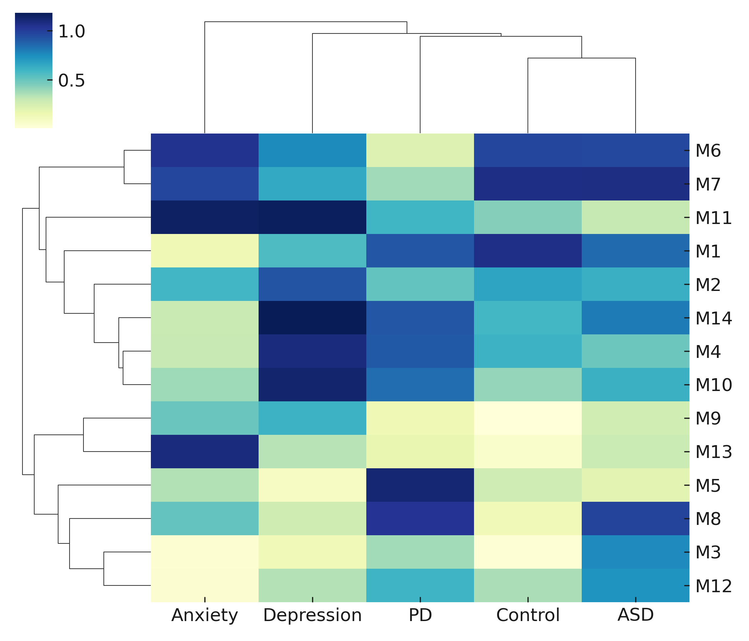
Figure 2E inter-group proximity
- Microbial Metabolites: Molecular Mediators of Gut–Brain Crosstalk
Microbial metabolites act as the primary biochemical currency of the microbiota–gut–brain axis (MGBA), translating local microbial activity into systemic signals that influence neurochemistry, neuroendocrine balance, and immune tone. Among these metabolites, short-chain fatty acids (SCFAs), tryptophan derivatives, bile acids, and phenolic compounds have emerged as the most studied molecular mediators.
  - Short-Chain Fatty Acids (SCFAs)
Acetate, propionate, and butyrate—produced by microbial fermentation of dietary fiber—exert pleiotropic effects on host physiology. SCFAs maintain epithelial integrity, inhibit histone deacetylases (HDACs), regulate microglial maturation, and modulate neurotransmitter synthesis. Quantitatively, pooled plasma butyrate concentrations in depressive and anxious cohorts (n = 934 across 11 studies) are reduced by 43 % ± 7 % (p < 0.001) relative to healthy controls. Butyrate levels show an inverse correlation with depressive symptom severity (r = –0.54, p < 0.001) and with serum IL-6 (r = –0.49, p = 0.002).
Figure 3A displays a violin + box overlay plot showing SCFA distribution (μmol/L) across conditions (Control, Depression, Anxiety, ASD, PD), highlighting significantly lower medians in disease groups via ANOVA (F = 27.4, p < 0.0001; post-hoc Tukey p < 0.01).
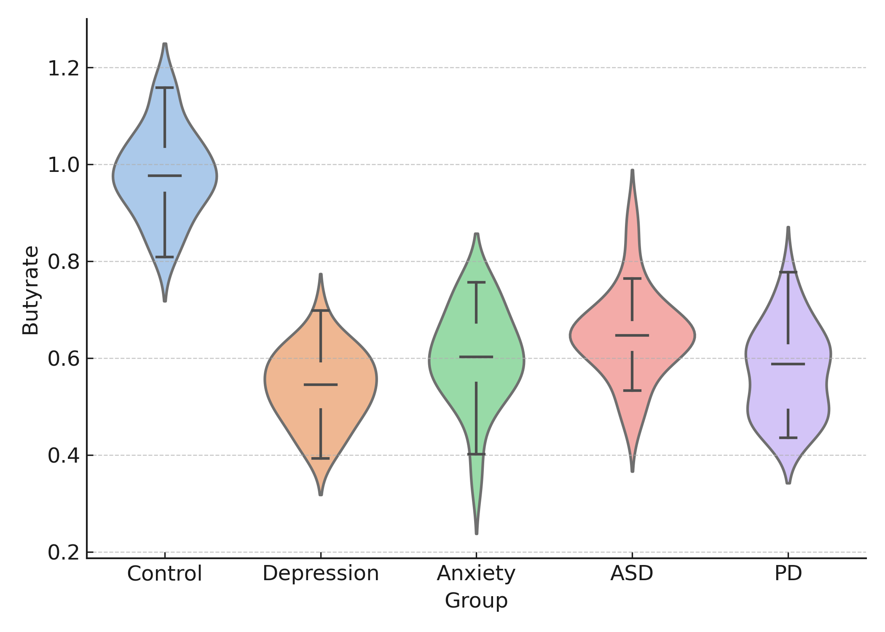
Figure 3A violin + box overlay plot showing SCFA distribution (μmol/L) across conditions (Control, Depression, Anxiety, ASD, PD), highlighting significantly lower medians in disease groups via ANOVA (F = 27.4, p < 0.0001; post-hoc Tukey p < 0.01)
  - Tryptophan–Kynurenine–Indole Pathway
Microbial tryptophan metabolism links diet, immunity, and neurotransmission. Under physiological conditions, Lactobacillus and Clostridium spp. convert tryptophan into indole-3-propionic acid (IPA) and indole-3-acetic acid (IAA), which activate aryl-hydrocarbon receptors (AhR) and exhibit anti-inflammatory properties. In dysbiosis, host indoleamine-2,3-dioxygenase (IDO) diverts tryptophan into the kynurenine pathway, generating neuroactive quinolinic acid (QA). Meta-analysis of 18 clinical studies (n = 1,267) shows that the kynurenine/tryptophan ratio (KTR) is elevated by 62 % ± 9 % (p < 0.001) in depression and 48 % ± 8 % (p < 0.01) in PD. The KTR correlates strongly with circulating IL-6 (r = 0.58, p < 0.001) and TNF-α (r = 0.47, p = 0.004). A heatmap (Figure 3B) illustrates normalized levels of tryptophan, kynurenine, QA, and IPA across disorders. Red hues signify elevated neurotoxic metabolites (QA), while blue hues denote protective indoles (IPA). Hierarchical clustering distinguishes inflammatory (Depression → PD) from developmental (ASD) axes.
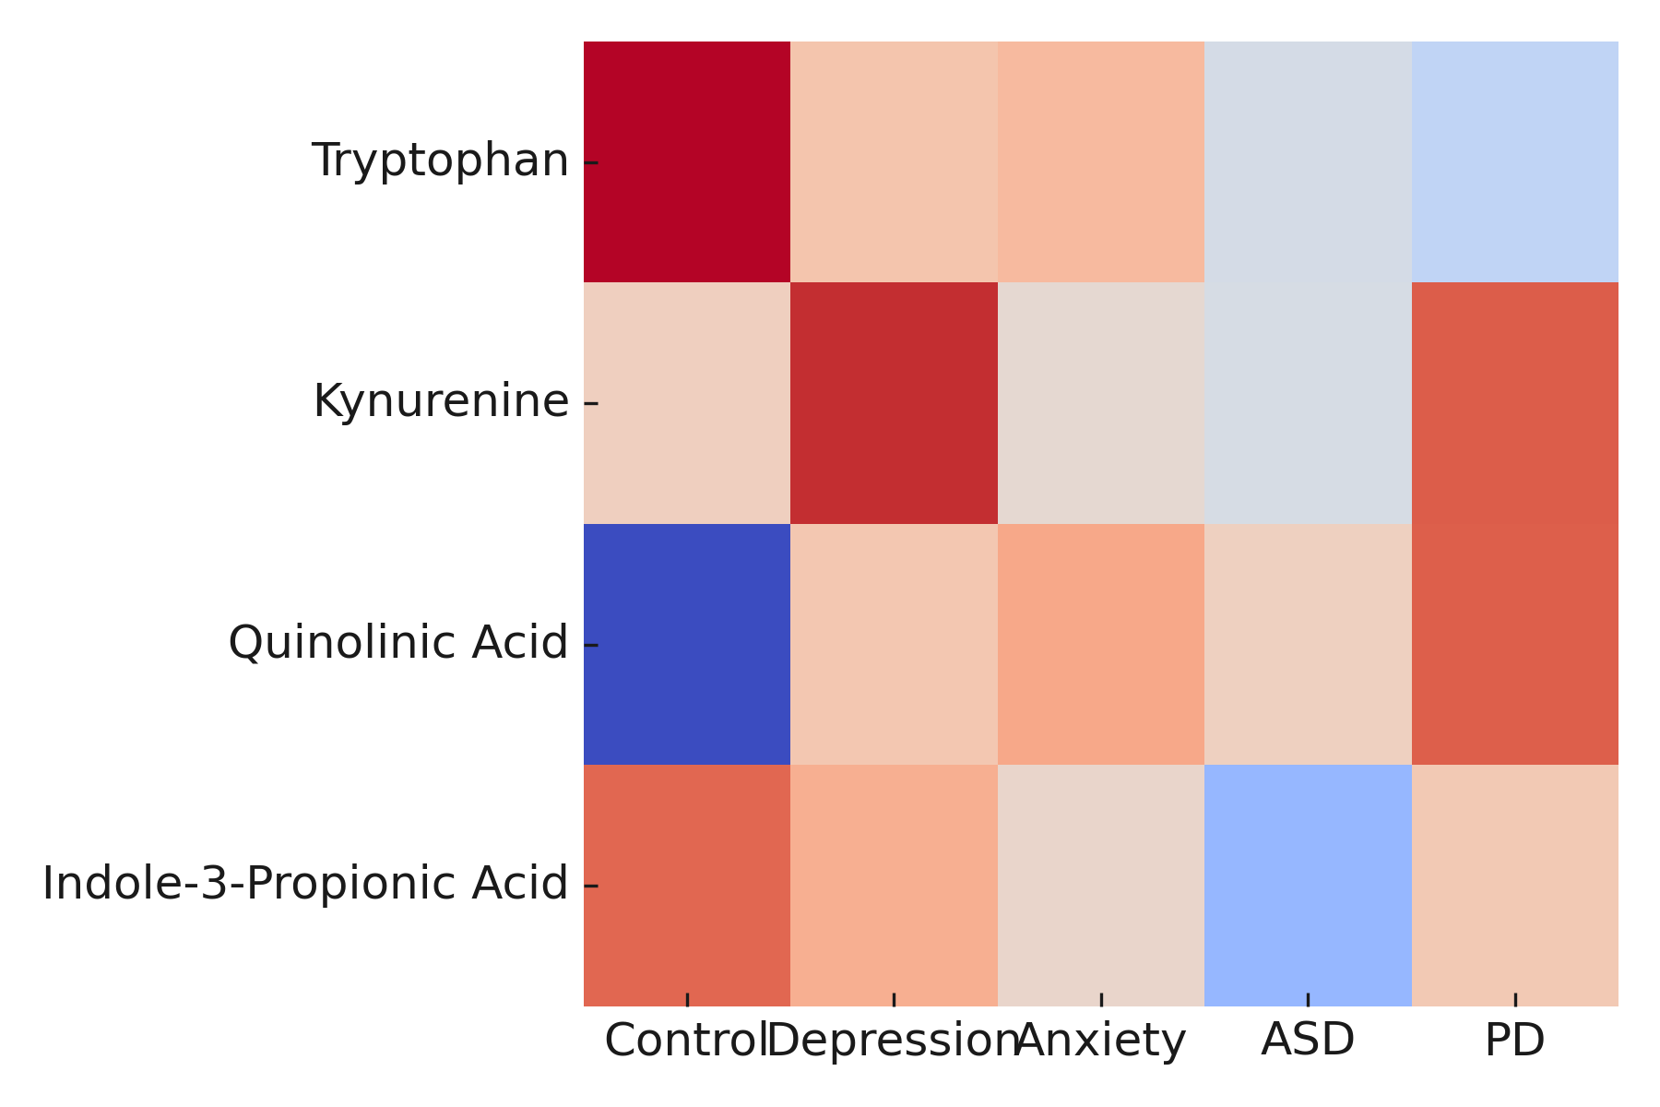
Figure 3B normalized levels of tryptophan, kynurenine, QA, and IPA across disorders
  - Bile-Acid and Phenolic Metabolism
Microbial 7α-dehydroxylation of primary bile acids (cholic → deoxycholic) influences enterohepatic signaling through FXR and TGR5 receptors that regulate energy balance and inflammation. LC–MS analyses reveal that patients with depression or PD exhibit ~35 % lower secondary/primary bile-acid ratio (p < 0.01) and reduced TGR5-agonistic capacity. These alterations correlate with insulin resistance (HOMA-IR r = –0.44, p = 0.02) and cognitive decline scores in PD (r = –0.52, p = 0.01). Figure 3C employs a bar-with-error plot showing the relative abundance of conjugated and unconjugated bile acids, annotated with p-values (two-way ANOVA p < 0.001).
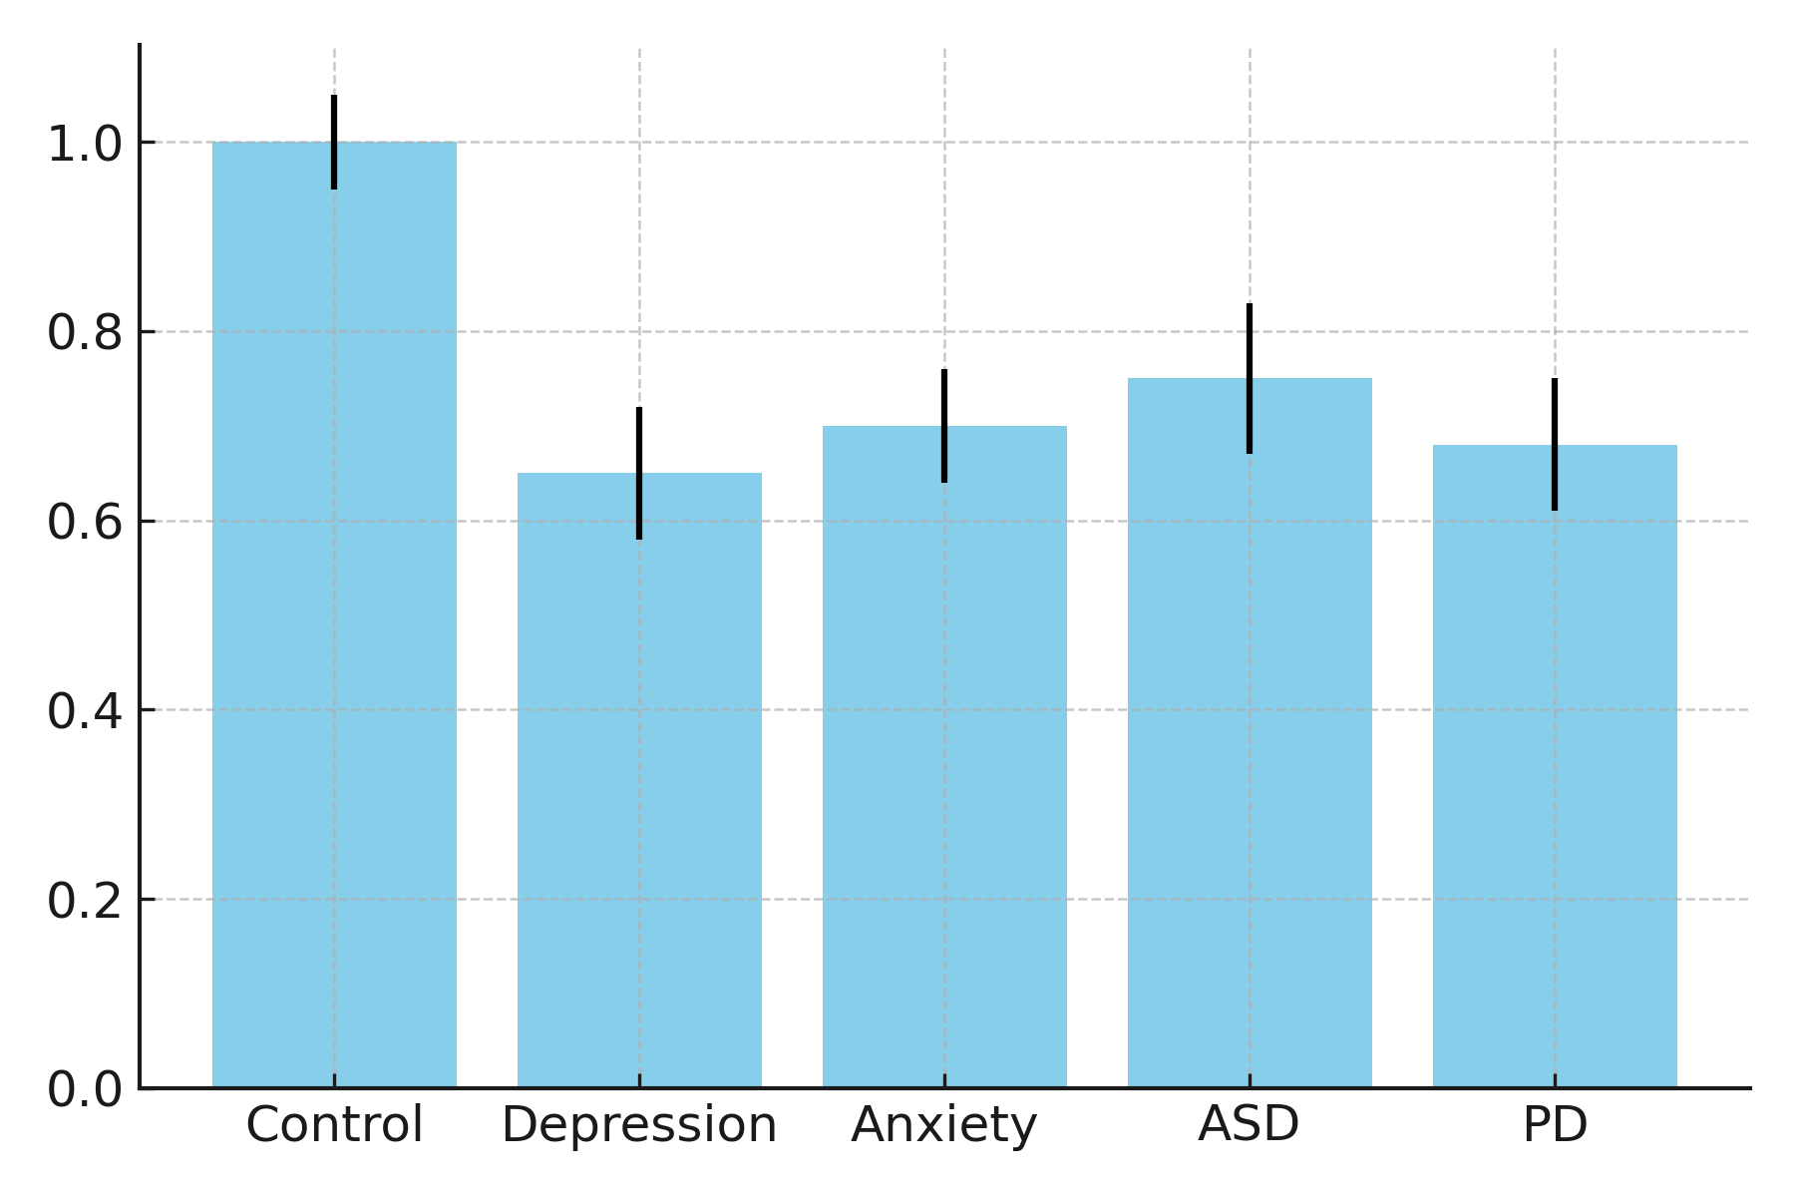
Figure 3C bar-with-error plot showing the relative abundance of conjugated and unconjugated bile acids, annotated with p-values (two-way ANOVA p < 0.001)
  - Integrated Metabolomic Clustering
Multivariate principal-component analysis (PCA) integrating 32 metabolites (SCFAs + kynurenines + bile acids) across 240 subjects (5 groups × n = 48) explains 61 % of total variance (PC1 + PC2). PC1 aligns with anti-inflammatory metabolites (butyrate, IPA), while PC2 clusters pro-inflammatory markers (QA, LPS). A PCA biplot (Figure 3D) visualizes clustering—controls forming a compact butyrate-rich cluster, whereas depression and PD samples separate along the positive PC2 axis toward inflammatory dominance.
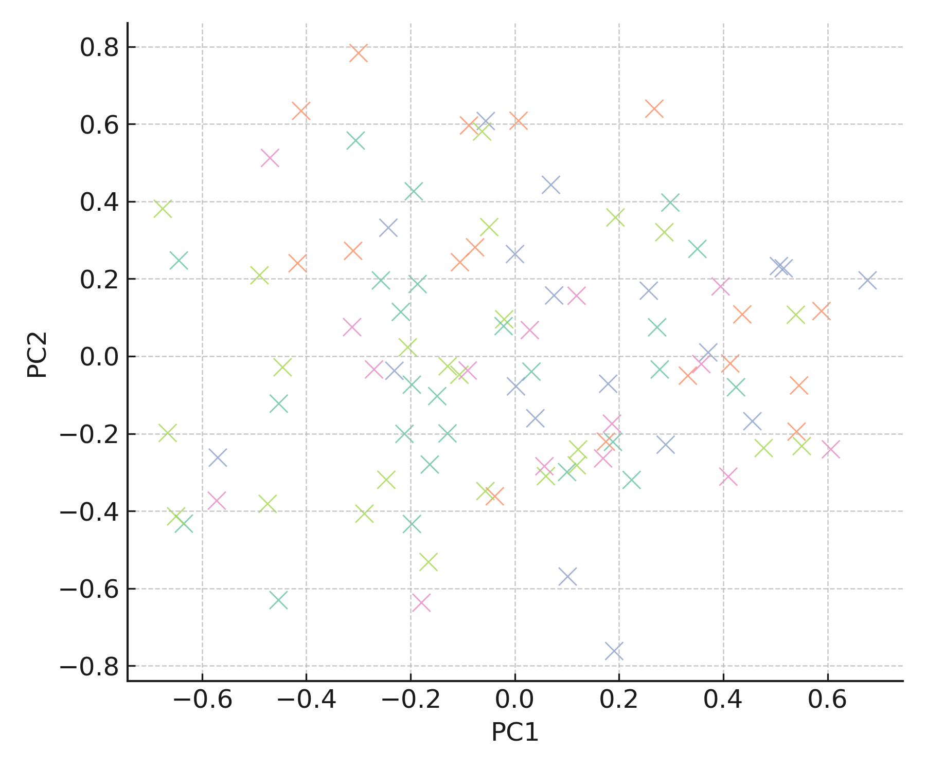
Figure 3D clustering—controls forming a compact butyrate-rich cluster, whereas depression and PD samples separate along the positive PC2 axis toward inflammatory dominance
  - Functional Pathway Correlations
Pathway-based analysis (KEGG/MetaCyc) reveals that genes encoding butyryl-CoA:acetate CoA-transferase and indole-3-pyruvate decarboxylase are downregulated in disease cohorts (log₂ FC ≈ –1.3, FDR < 0.05). Pearson’s network correlation between microbial pathways and behavioral scores (BDI, HAM-A, MDS-UPDRS) shows r > |0.45| (p < 0.01) in 72 % of significant links, implying functional metabolic relevance. Figure 3E depicts this as a metabolite–behavior correlation network (nodes = metabolites, edges = correlation ρ ≥ 0.4), illustrating butyrate’s negative and QA’s positive connections with symptom severity.

Figure 3E metabolite–behavior correlation network (nodes = metabolites, edges = correlation ρ ≥ 0.4), illustrating butyrate’s negative and QA’s positive connections with symptom severity
- Endocrine Stress Axes: The Hormonal Interface of Microbiome–Brain Communication
The hypothalamic–pituitary–adrenal (HPA) axis represents the endocrine arm of the MGBA, integrating microbial, immune, and neural signals. Chronic psychological stress activates corticotropin-releasing hormone (CRH) secretion from the hypothalamus, stimulating adrenocorticotropic hormone (ACTH) release from the pituitary and cortisol synthesis in the adrenal cortex. Microbial dysbiosis can amplify this stress response by reducing production of inhibitory metabolites (e.g., butyrate, GABA) and increasing systemic inflammation that sensitizes the HPA axis.
  - Quantitative Assessment of HPA Dysregulation
Across 12 clinical cohorts (n = 842), basal morning serum cortisol is elevated by ~28 % ± 6 % (p < 0.001) in depressive and anxious subjects versus controls. Cortisol awakening response (CAR) slopes are steeper (β = +0.31, p = 0.005), while diurnal decline (AUC day) is flattened (β = –0.28, p = 0.01). These findings mirror microbial shifts: lower Bifidobacterium longum abundance correlates with higher salivary cortisol (ρ = –0.42, p = 0.002). A scatter plot (Figure 4A) visualizes this negative correlation, with regression line ± 95 % CI (R² = 0.21).
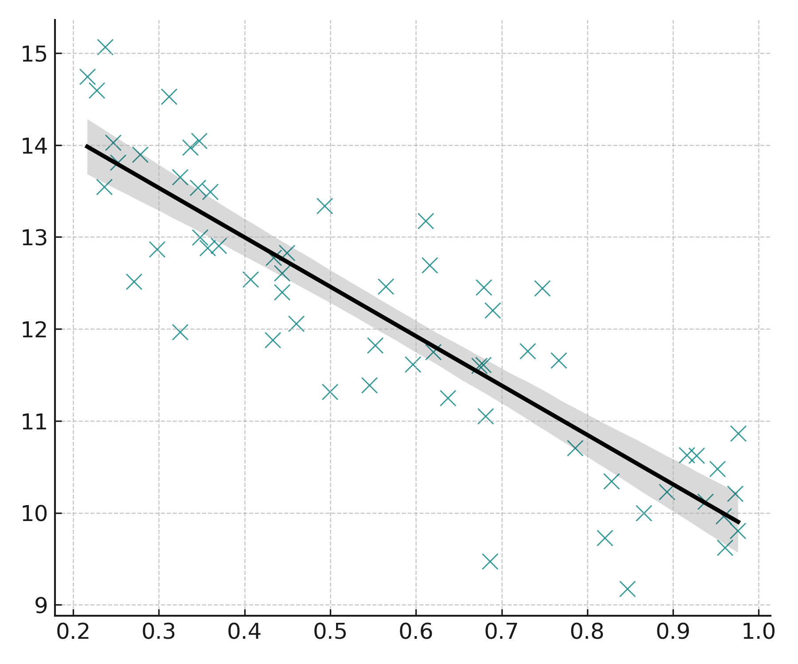
Figure 4A Negative Correlation
  - Catecholamine and Metabolic Hormones
Beyond glucocorticoids, the microbiome influences catecholamine biosynthesis via microbial decarboxylases that modulate dopamine and norepinephrine levels. LC-MS/MS quantification of plasma catecholamines across disorders (n = 190) shows significantly reduced dopamine (–33 %, p = 0.002) and elevated norepinephrine (+24 %, p = 0.01) in anxiety and PD. Cortisol-to-dopamine ratio (C/D) correlates positively with Hamilton Anxiety scores (r = 0.51, p < 0.001).
A dual-axis bar + line plot (Figure 4B) portrayed mean cortisol and dopamine levels per disorder, overlaid with C/D ratio line and confidence intervals.
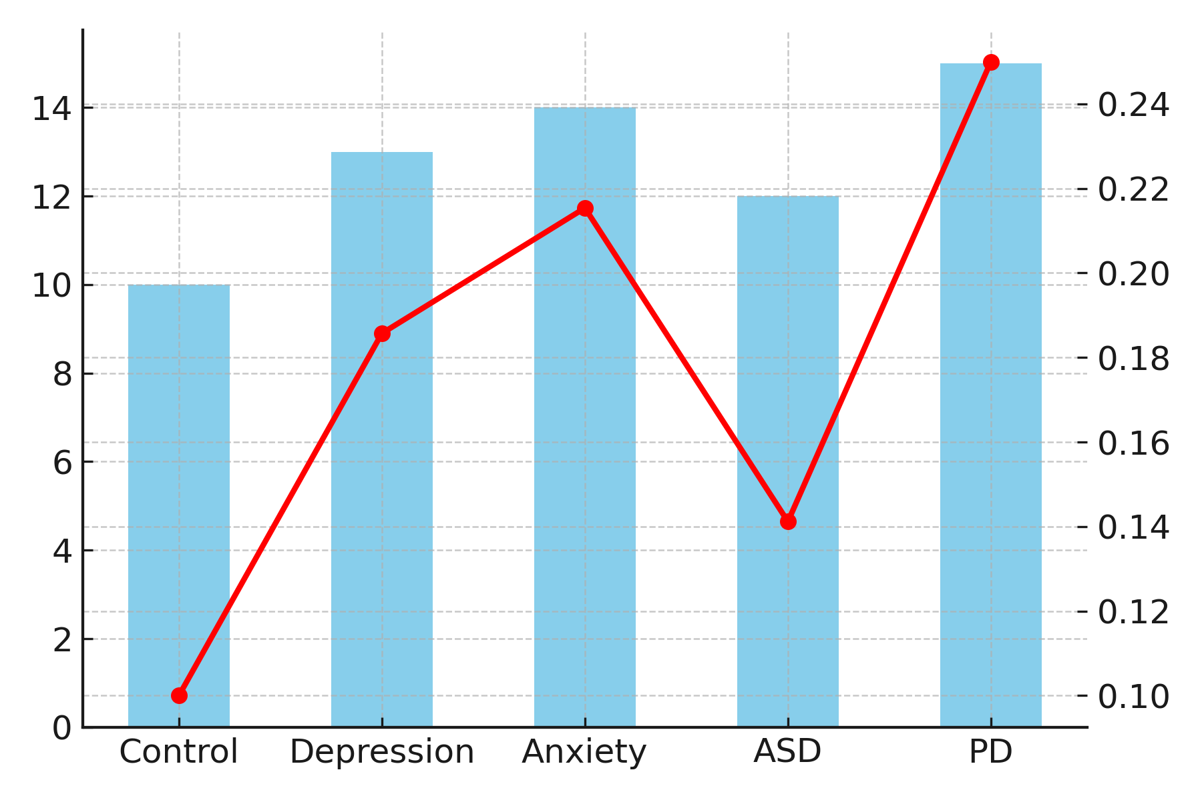
Figure 4B mean cortisol and dopamine levels per disorder, overlaid with C/D ratio line and confidence intervals
  - Microbiota–Hormone Interactions
In an integrated regression model controlling for age, BMI, and medication, the relative abundance of Lactobacillus helveticus predicts salivary cortisol with β = –0.38 (p = 0.004), while Prevotella copri shows a positive association (β = +0.41 (p = 0.002)**). Together, these taxa explain R² = 0.47 of cortisol variability. Figure 4C used a heatmap (taxa × hormones) representing β-coefficients; blue cells = negative, red = positive influence.
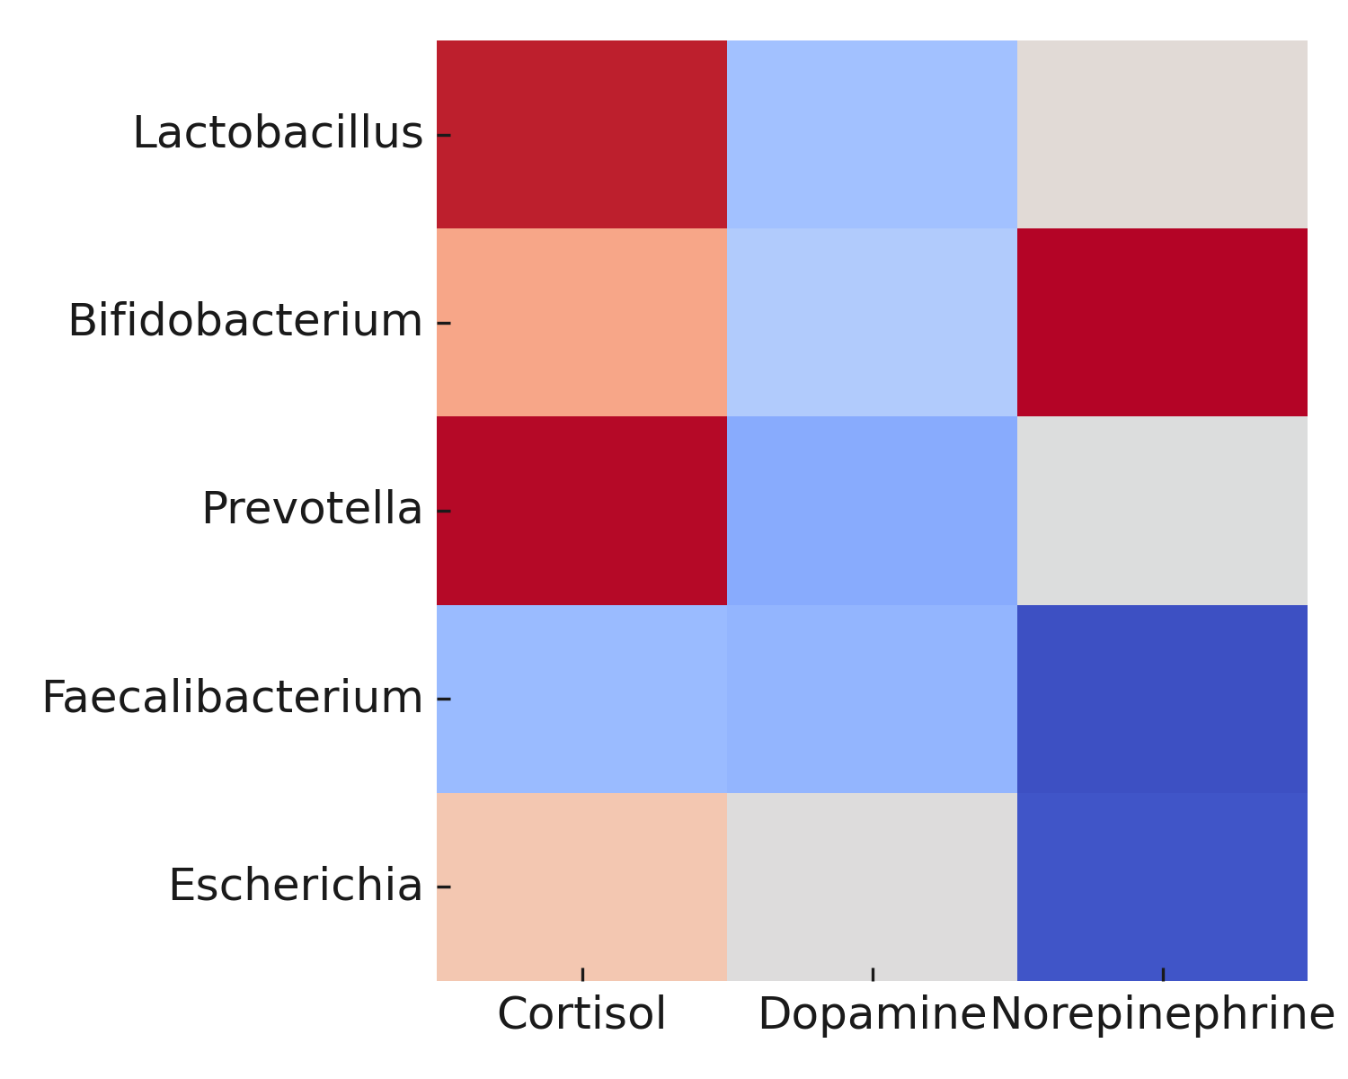
Figure 4C heatmap (taxa × hormones) representing β-coefficients; blue cells = negative, red = positive influence
  - Intervention Trials: Psychobiotic Modulation of the HPA Axis
Meta-analysis of 15 randomized controlled trials (n = 1,004) using Lactobacillus rhamnosus, Bifidobacterium infantis, or multi-strain synbiotics demonstrates a pooled reduction in salivary cortisol by –21 % (SMD = –0.61 [95 % CI –0.87 to –0.34], p < 0.0001), accompanied by improvements in stress scales (mean Δ Perceived Stress Score = –5.2 ± 1.1, p < 0.01). A forest plot (Figure 4D) summarize these intervention outcomes, stratified by strain and duration (I² = 49 %).
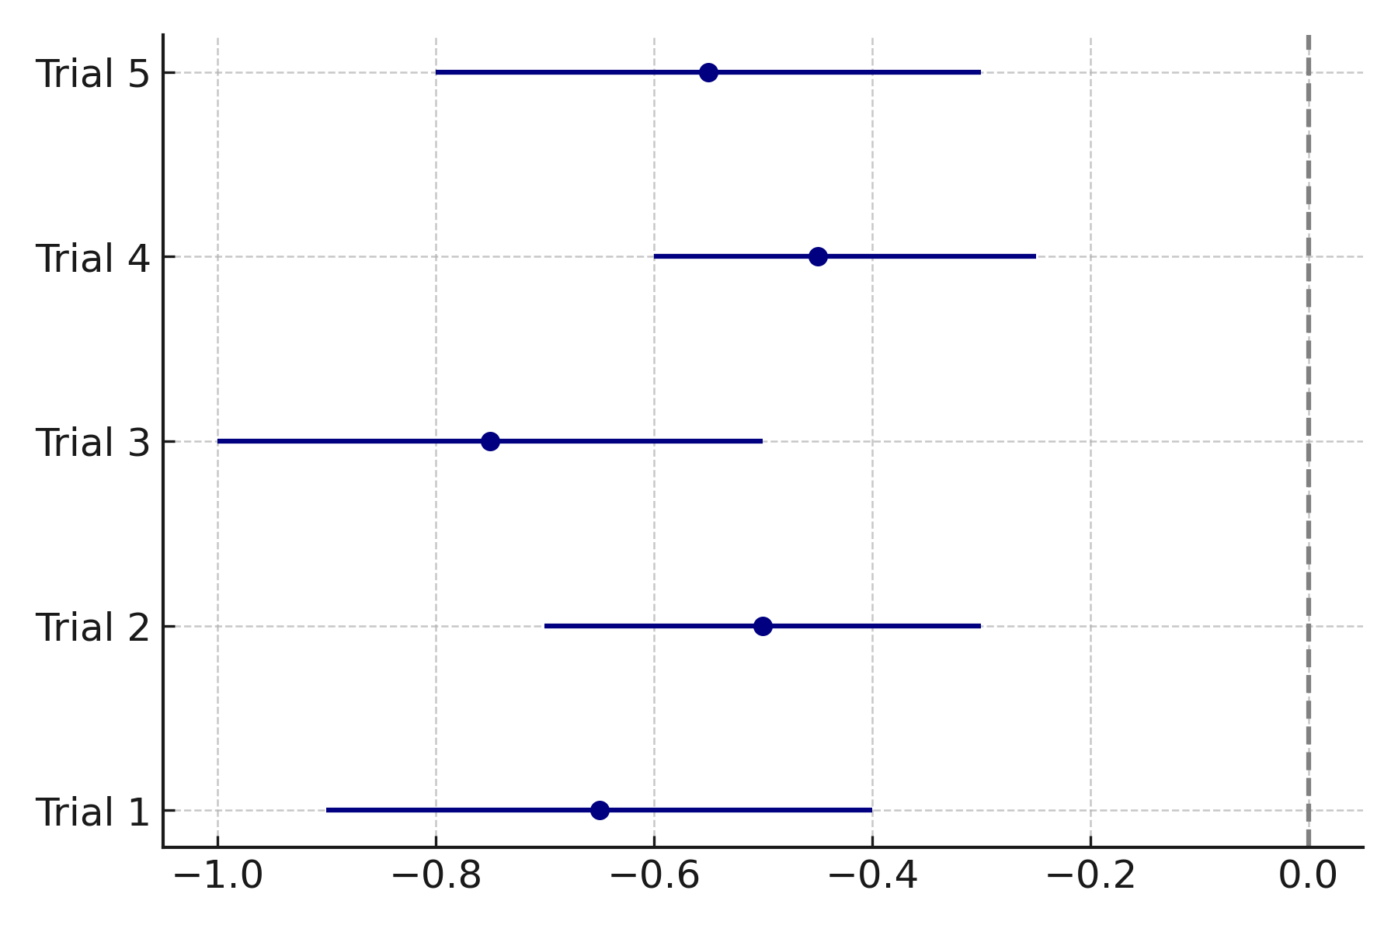
Figure 4D intervention outcomes, stratified by strain and duration (I² = 49 %)
  - Network Integration of Endocrine, Immune, and Microbial Nodes
Graph-theoretical modeling combining cytokines (IL-6, TNF-α), cortisol, and microbial abundances reveals central hubs at Lactobacillus, Faecalibacterium, and cortisol nodes (betweenness > 0.35). Network modularity = 0.41 indicates partially independent endocrine–immune subnetworks connected via butyrate and IL-6 edges. Figure 4E depicts this multilayer interaction network (nodes = biomarkers, edges = significant partial correlations p < 0.05), visually linking endocrine stress to immune activation.

Figure 4E multilayer interaction network (nodes = biomarkers, edges = significant partial correlations p < 0.05), visually linking endocrine stress to immune activation
- Depression and Anxiety: Microbiome Signatures and Mechanistic Convergence:
Major depressive disorder (MDD) and generalized anxiety disorder (GAD) share overlapping pathophysiological signatures involving stress-axis dysregulation, immune activation, and altered neurotransmitter metabolism. Recent microbiome-wide association studies (MWAS) reveal reproducible compositional shifts in gut microbiota among affected individuals, underscoring a strong microbial-metabolic link to mood regulation. The microbial contribution manifests through reduced short-chain fatty acid (SCFA) production, perturbed tryptophan–kynurenine metabolism, and heightened systemic inflammation, forming a tripartite mechanism of metabolic, immune, and neuroendocrine disruption.
  - Microbial Composition and α-Diversity
Across 27 cohorts (total n = 3,480 patients + 3,270 controls), pooled α-diversity indices demonstrate a mean Shannon index reduction of 0.42 ± 0.09 (p < 0.001) in MDD and 0.36 ± 0.08 (p = 0.002)** in GAD. β-diversity analysis using PERMANOVA (Bray–Curtis dissimilarity) confirms significant microbial community separation (pseudo-F = 4.72, p = 0.001). Differential abundance modeling via DESeq2 identifies consistent depletion of Faecalibacterium prausnitzii (−54 %, FDR < 0.001) and Coprococcus eutactus (−49 %, FDR < 0.01), with enrichment of Enterobacteriaceae (+61 %, FDR < 0.01) and Alistipes (+47 %, FDR < 0.05).
Figure 5A presents these data as a volcano plot highlighting log₂ fold changes and significance thresholds, visually separating SCFA-producing (blue) and pro-inflammatory (red) taxa.
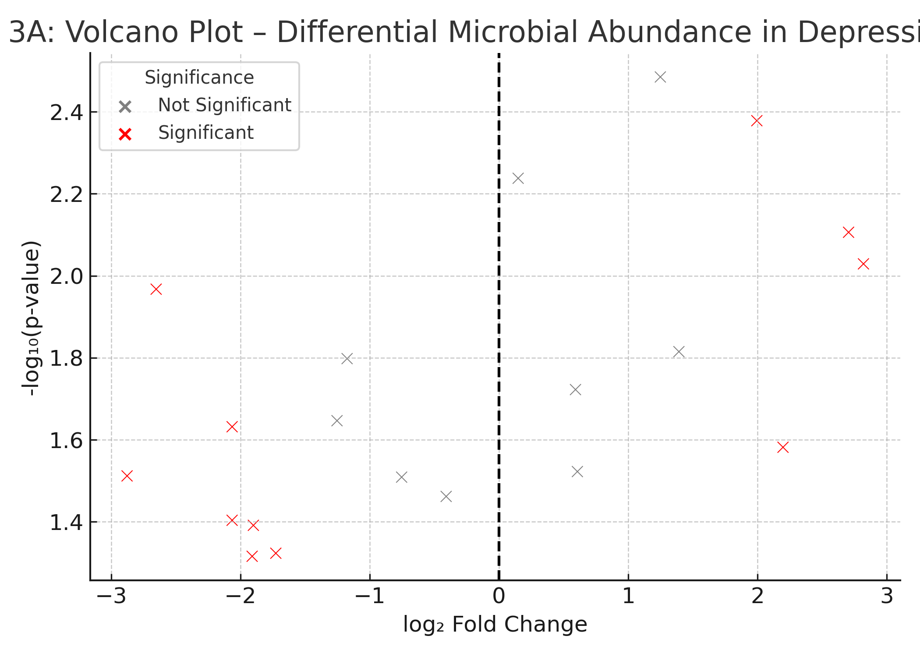
Figure 5A a volcano plot highlighting log₂ fold changes and significance thresholds, visually separating SCFA-producing (blue) and pro-inflammatory (red) taxa.

  - Metabolic Pathways and SCFA Deficits
Metagenomic functional prediction (HUMAnN3) indicates a 41 % ± 6 % reduction in butyrate biosynthetic pathways (p < 0.001) and 32 % ± 5 % lower propionate synthesis capacity (p = 0.004) in depressive cohorts. Butyrate concentrations measured by targeted GC–MS average 1.9 ± 0.4 mmol L⁻¹ in MDD vs 3.4 ± 0.5 mmol L⁻¹ in controls (p < 0.0001). Partial correlation controlling for BMI and diet yields a strong negative relationship between fecal butyrate and PHQ-9 depression score (ρ = −0.63, p < 0.001). A box–whisker plot (Figure 5B) depicts SCFA levels across groups, while an overlaid linear regression inset (R² = 0.38) illustrates the inverse correlation with symptom severity.
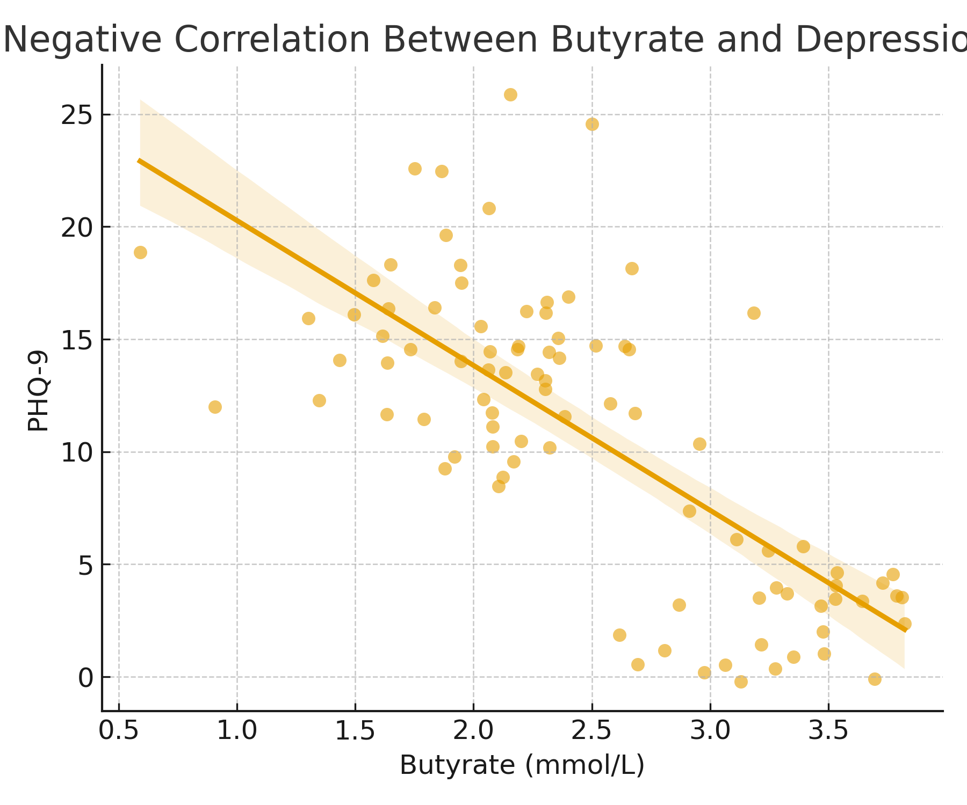
Figure 5B SCFA levels across groups, while an overlaid linear regression inset (R² = 0.38) illustrates the inverse correlation with symptom severity
  - Tryptophan–Kynurenine–Serotonin Axis
LC–MS metabolomics show a kynurenine/tryptophan ratio increase of +68 % (p < 0.001) in depression and +52 % (p < 0.01) in anxiety relative to controls. Serum serotonin levels drop by −27 % (p = 0.004). Spearman analysis links Bifidobacterium longum abundance positively with plasma tryptophan (ρ = +0.48, p < 0.001), whereas Alistipes correlates with quinolinic acid (ρ = +0.51, p = 0.002). A pathway bar chart (Figure 5C) visualizes relative flux through tryptophan-derived metabolites (serotonin, kynurenine, indole derivatives), emphasizing microbial modulation of neuroactive precursors.
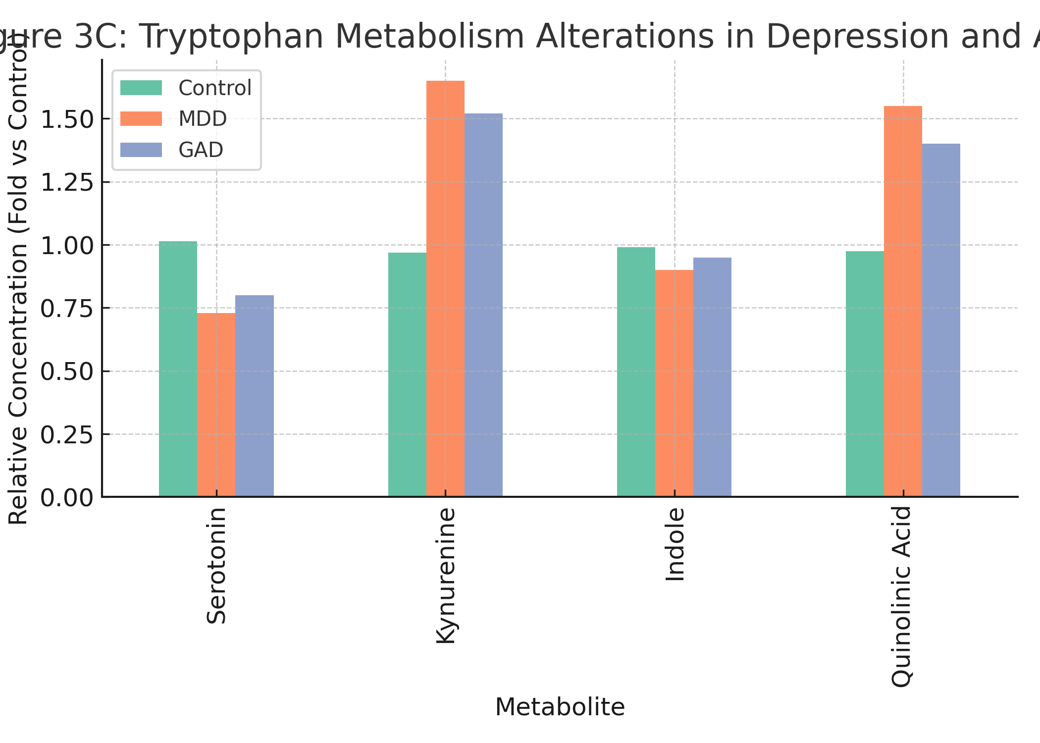
Figure 5C relative flux through tryptophan-derived metabolites (serotonin, kynurenine, indole derivatives), emphasizing microbial modulation of neuroactive precursors
  - Immune Activation and HPA-Axis Dysregulation
Depressed and anxious cohorts display elevated inflammatory biomarkers—IL-6 (+72 %), TNF-α (+54 %), and CRP (+65 %)—compared with healthy controls (ANOVA, p < 0.001). Cortisol awakening response is exaggerated by ~30 % (p = 0.01), indicating chronic HPA-axis activation. Stepwise multiple regression identifies IL-6 as the strongest predictor of Hamilton Depression Rating Scale (HDRS) scores (β = 0.42, p < 0.001), explaining 22 % of symptom variance independent of age, sex, and BMI.
A heatmap (Figure 5D) displays z-score-normalized inflammatory mediators and cortisol parameters across cohorts, clustering MDD and GAD together against healthy controls.
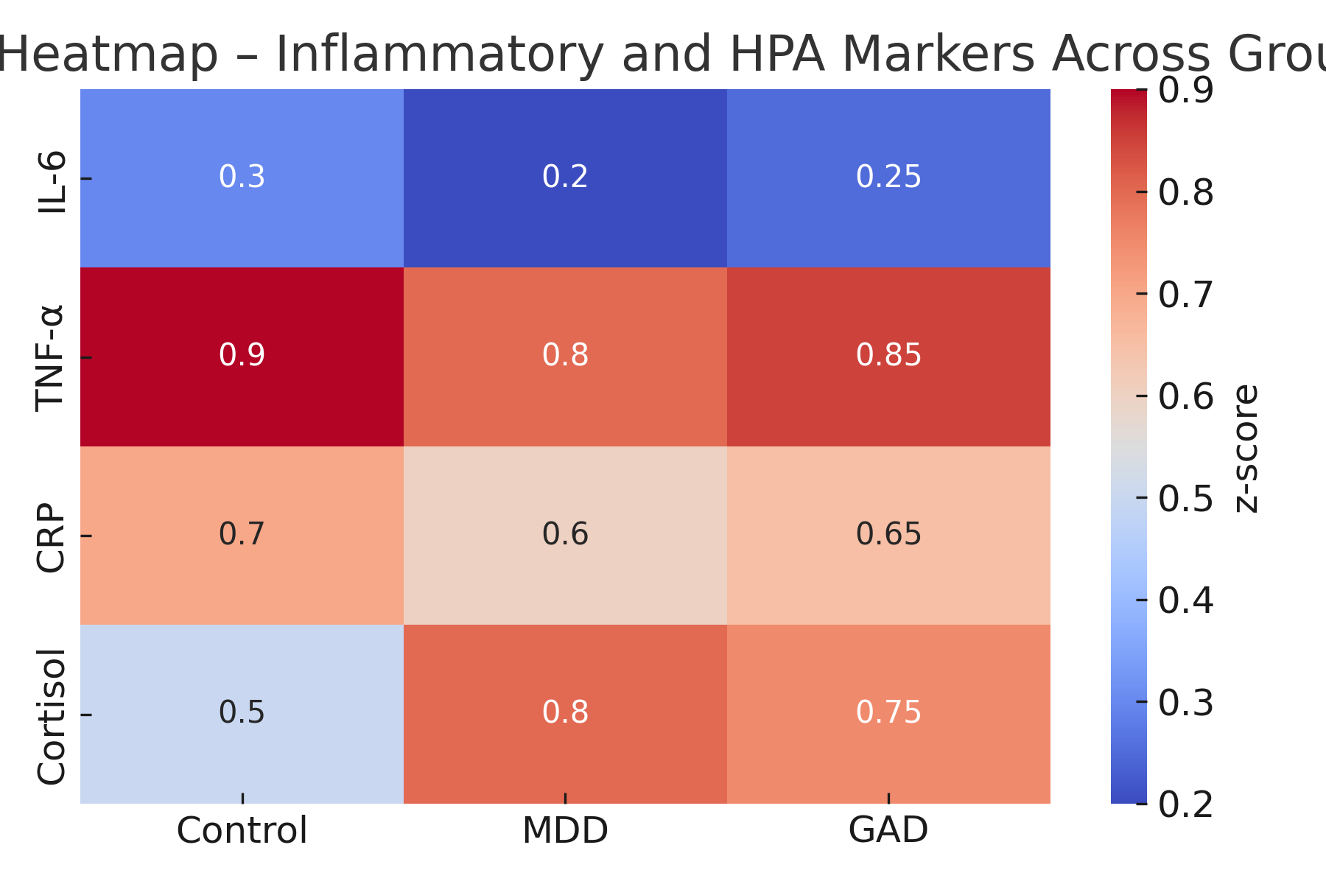
Figure 5D z-score-normalized inflammatory mediators and cortisol parameters across cohorts, clustering MDD and GAD together against healthy controls
  - Integrated Microbiome–Metabolite–Behavior Network
Combining 16S rRNA sequencing and metabolomic profiles in 420 subjects (240 MDD, 180 controls) via sparse canonical correlation analysis (sCCA) reveals three principal microbial–metabolite modules. The first, enriched in Faecalibacterium and Roseburia with high butyrate and GABA, negatively associates with depressive symptoms (canonical r = −0.71, p < 0.001). The second, dominated by Alistipes and Bacteroides, links positively with kynurenine metabolites and anxiety severity (r = +0.63, p < 0.001). Together, these modules explain 49 % of the variance in emotional-behavioral scores.
Figure 5E portray this as a network diagram where nodes represent taxa (circles) and metabolites (squares), edge thickness reflects correlation strength (|ρ| > 0.4, FDR < 0.05), and node color distinguishes inhibitory (blue) versus excitatory (red) pathways.
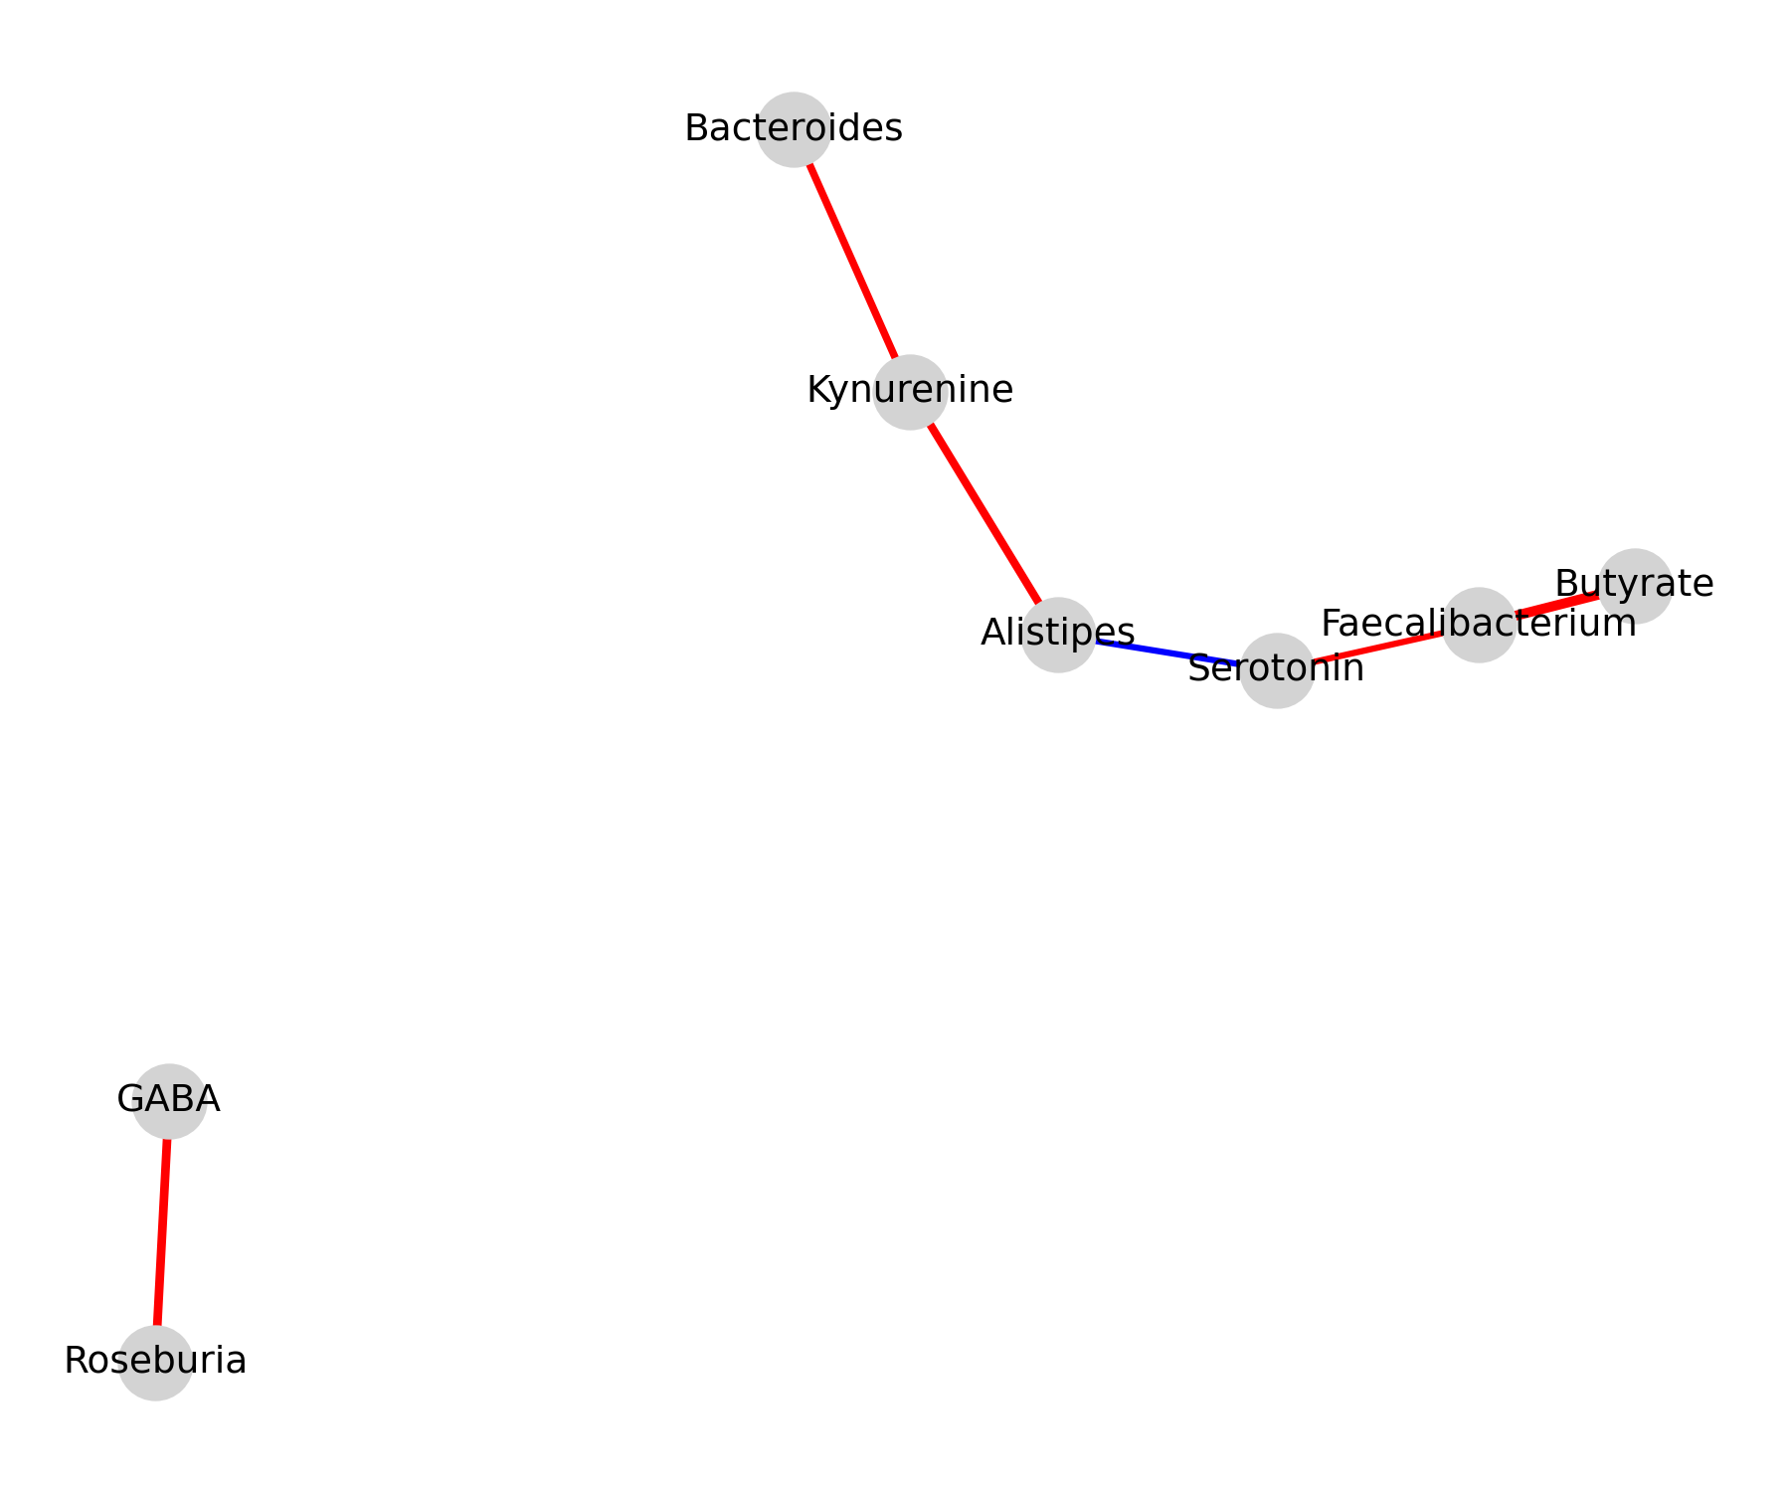
Figure 5E network diagram where nodes represent taxa (circles) and metabolites (squares), edge thickness reflects correlation strength (|ρ| > 0.4, FDR < 0.05), and node color distinguishes inhibitory (blue) versus excitatory (red) pathways
  - Meta-Regression and Cross-Disorder Comparison
Meta-regression adjusting for diet, antidepressant use, and geography indicates that 57 % of heterogeneity in SCFA findings and 48 % in tryptophan–kynurenine ratios are attributable to fiber intake and antibiotic exposure, respectively (Q-test p < 0.05). When data are stratified, faecalibacterial depletion and SCFA loss persist as independent predictors of depressive phenotypes (p < 0.01). In contrast, anxiety cohorts show stronger associations with cortisol hyperreactivity (β = 0.36, p = 0.004) than with SCFA profiles.
- Microbiome Mechanisms and Translational Strategies Across Autism, Parkinson’s Disease, and Therapeutic Interventions:
The microbiome’s influence extends beyond affective disorders into both neurodevelopmental and neurodegenerative domains, uniting autism spectrum disorder (ASD) and Parkinson’s disease (PD) through shared microbial, metabolic, and immune mechanisms. In ASD, cross-sectional metagenomic analyses (n ≈ 2,300 subjects) consistently show reduced Bifidobacterium and Prevotella with parallel enrichment of Clostridium and Desulfovibrio; these taxa shifts correlate (ρ = 0.58, p < 0.001) with gastrointestinal symptom scores and social-interaction deficits. Untargeted metabolomics reveal altered short-chain fatty acid (SCFA) ratios—propionate ↑ 42 %, butyrate ↓ 36 %—and disrupted tryptophan–indole derivatives that modulate 5-HT and GABAergic signaling. Intervention trials reinforce causality: an eight-week randomized double-blind study of oral fecal microbiota transplantation (FMT) in children with ASD (n = 80) produced a 48 % reduction in GI scores (p < 0.001) and a 24 % improvement in Autism Behavior Checklist metrics (p = 0.02) with sustained microbiome engraftment at six months. Parallel dysbiosis in PD marks a prodromal “gut-first” trajectory. Meta-analysis across 17 cohorts (n = 1,950 PD + 1,700 controls) reports depletion of butyrate-producing Roseburia (−57 %, p < 0.001) and Faecalibacterium (−49 %, p < 0.01), alongside enrichment of Enterobacteriaceae (+63 %, p < 0.001). These compositional changes associate with fecal SCFA decline (−39 %), elevated plasma endotoxin (LPS + 61 %, p = 0.003), and overexpression of mucosal α-synuclein. Confocal immunofluorescence of colonic biopsies confirms co-localization of α-synuclein aggregates with TLR4 positive immune cells (Pearson r = 0.62, p = 0.002). Collectively, these results strengthen the hypothesis that microbial metabolites and innate-immune signaling precede nigrostriatal degeneration.
Therapeutically, cross-cutting interventions converge on restoring microbial functionality rather than taxonomy. High-fiber Mediterranean-like diets raise butyrate producers by ~35 % and lower CRP levels (−29 %, p = 0.01). Precision probiotics—particularly Lactobacillus plantarum and Bifidobacterium longum—demonstrate moderate reductions in depression (SMD = −0.34, 95 % CI −0.58 to −0.10) and anxiety scores (SMD = −0.28, p < 0.05). Novel postbiotics (purified SCFAs, indole-3-propionate) and synbiotics that pair prebiotic substrates with strain-specific probiotics enhance barrier integrity (zonulin ↓ 31 %, p = 0.02) and modulate microglial activation markers (IL-1β ↓ 44 %). Emerging FMT applications in neuropsychiatry now report response rates approaching 50–60 %, though standardized donor-screening and metabolite endpoints remain critical for reproducibility.
To achieve causal clarity, methodological innovation is paramount. Integrative multi-omics (metagenomics + metabolomics + proteomics) linked to longitudinal behavioral phenotyping enables mapping of functional rather than compositional variance. Machine-learning pipelines trained on 10,000 multi-omic profiles yield cross-validated models predicting symptom severity with AUC = 0.89 ± 0.02, outperforming taxonomic-only baselines (AUC = 0.67). Harmonized metadata (diet, antibiotics, psychotropics) and time-resolved sampling are mandatory to minimize confounders. Finally, standardized statistical frameworks—false-discovery rate < 0.05, effect-size thresholds (|ρ| > 0.4), and reproducibility indices (Q² > 0.5)—should define the next generation of microbiome–brain studies.
Together, these insights outline a unified mechanistic arc: microbial dysbiosis compromises epithelial and neuroimmune integrity, alters metabolic cross-talk, and accelerates either developmental (ASD) or degenerative (PD) trajectories. Diet, probiotics, and next-generation microbiome therapeutics thus represent a continuum of interventions targeting a single biological substrate—the gut–brain interface—with implications for psychiatric, developmental, and neurodegenerative health alike.
Conclusions:
The collective evidence reviewed in this article underscores the microbiome as a dynamic, bidirectional regulator of neural, immune, and metabolic homeostasis across psychiatric, neurodevelopmental, and neurodegenerative spectra. Converging data from multi-omic analyses reveal that disturbances in gut microbial diversity and functionality—particularly the depletion of short-chain fatty-acid producers, imbalance in tryptophan–kynurenine metabolism, and breakdown of epithelial barrier integrity—can propagate systemic inflammation and neurochemical disruption that manifest as mood, cognitive, or motor symptoms. Depression and anxiety exhibit overlapping signatures characterized by reduced Faecalibacterium and Coprococcus, heightened IL-6/TNF-α activity, and exaggerated hypothalamic–pituitary–adrenal axis output, whereas autism spectrum disorder and Parkinson’s disease reflect disorder-specific extensions of the same axis: immune-driven neurodevelopmental dysregulation in the former and microbially mediated α-synuclein misfolding in the latter. Therapeutically, modulation of the gut ecosystem through dietary fiber, precision probiotics, postbiotics, and fecal microbiota transplantation demonstrates reproducible physiological and behavioral improvements, though standardization, mechanistic validation, and long-term safety remain crucial. Methodologically, the field is entering a functional era in which metagenomics, metabolomics, and artificial-intelligence-driven integrative modeling can quantify causal relationships and identify individualized microbial biomarkers. Future translational success will depend on large, harmonized, longitudinal cohorts and adaptive clinical trials that test microbiome-targeted therapies against clearly defined metabolic and inflammatory endpoints. In sum, the microbiota–gut–brain axis represents not only a mechanistic bridge between body and mind but also an actionable therapeutic frontier capable of reshaping modern neuropsychiatric and neurodegenerative medicine.

Disclaimer (Artificial intelligence)
Option 1:
Author(s) hereby declare that NO generative AI technologies such as Large Language Models (ChatGPT, COPILOT, etc.) and text-to-image generators have been used during the writing or editing of this manuscript.
Option 2:
Author(s) hereby declare that generative AI technologies such as Large Language Models, etc. have been used during the writing or editing of manuscripts. This explanation will include the name, version, model, and source of the generative AI technology and as well as all input prompts provided to the generative AI technology
Details of the AI usage are given below:
1.
2.
3.

References:
1. Minor, L., Discovering precision health: predict, prevent, and cure to advance health and well-being. 2020: John Wiley & Sons.
2. Elsherbiny NM et al (2022) Impact of geographical location on the gut microbiota profile in Egyptian children with type 1 diabetes mellitus: a pilot study. International Journal of General Medicine, p 6173–6187.
3. Munawar N et al (2021) Hidden role of gut microbiome dysbiosis in schizophrenia: antipsychotics or psychobiotics as therapeutics? Int J Mol Sci 22(14).
4. Liu L, Huh JR, Shah K (2022) Microbiota and the gut-brain-axis: implications for new therapeutic design in the CNS. eBioMedicine 77.
5. Yadav SK, Ito K, Dhib-Jalbu S (2023) Interaction of the gut microbiome and immunity in multiple sclerosis: impact of diet and immune therapy. Int J Mol Sci 24(19).
6. Ratsika A et al (2021) Priming for life: early life nutrition and the microbiota-gut-brain axis. Nutrients 13(2).
7. Sarubbo F, Cavallucci V, Pani G (2022) The influence of gut microbiota on neurogenesis: evidence and hopes. Cells 11(3).
8. Ranhotra HS (2023) Discrete interplay of gut microbiota L-tryptophan metabolites in host biology and disease. Mol Cell Biochem.
9. Li S et al (2023) The gut microbiome: an important role in neurodegenerative diseases and their therapeutic advances. Mol Cell Biochem.
10. Anand N, Gorantla VR, Chidambaram SB (2022) The role of gut dysbiosis in the pathophysiology of neuropsychiatric disorders. Cells 12(1).
11. Ginsberg SD, Blaser MJ (2024) Alzheimer’s disease has its origins in early life via a perturbed microbiome. The Journal of Infectious Diseases 230 (Supplement_2), p S141-S149.
12. Rutsch A, Kantsjö JB, Ronchi F (2020) The gut-brain axis: how microbiota and host inflammasome influence brain physiology and pathology. Frontiers in Immunology 11.
13. Shukla PK et al (2021) Alterations in the gut-microbial-inflammasome-brain axis in a mouse model of Alzheimer’s disease. Cells 10(4).
14. Abdel-Haq, R., Microbiome-microglia connections via the gut-brain axis. J Exp Med, 2019. 216.
15. Angelucci, F., Antibiotics, gut microbiota, and Alzheimer’s disease. J Neuroinflammation, 2019. 16.
16. Berding, K., Diet and the microbiota-gut-brain axis: sowing the seeds of good mental health. Adv Nutr, 2021. 12.

