Saponins, Tannins and Alkaloids Fractions of Bridelia Micrantha: Effects on The Prefrontal Cortex of Ketamine-Induced Cognitive Dysfunction in Wistar Rats
Abstract
Cognitive dysfunction represents a continuum of cognitive decline with mild cognitive impairment making the intermediate stage between normal cognitive aging and dementia. Mild cognitive impairment may progress to dementia resulting in a substantial loss of cognitive abilities and the capacity for independent living; hence, individual with mild cognitive impairment are at high risk of progressing to dementia with conversion rate as high as 15%. In this study, we investigated the effect of saponin, Tannins and alkaloids rich Bridelia micrantha on the cytoarchitecture of the prefrontal cortex of ketamine-induced cognitive Wistar rats. Thirty-six adults male Wistar rats were randomly divided into six groups designated A, B, C, D, E and F each containing six rats. Group A received animal feed and water ad libitum while group B served as the positive control. Bridelia micrantha leaves were fractionated into saponin, tannins and alkaloids and were administered to Groups C, D and E respectively while group F received Diazepam for two weeks. The results revealed hypertrophied and hypoplasic cells in groups B and C; group E revealed atrophied and hypoplasic cells while group F revealed cellular hypoplasia. Group D revealed normal cytoachitecture with cellular hyperplasia compared to the control group and the treated groups. In conclusion, the tannins group D only arrested cellular alteration in the prefrontal cortex of ketamine induced-cognitive dysfunction Wistar rats caused by chronic administration of ketamine and restores cellular injury and its proliferations.
Keywords: alkaloids, cognitive dysfunction, ketamine, prefrontal cortex, saponin, tannins
- Introduction
Cognitive dysfunction is one of the leading causes of disability and dependence in older adults and is a major economic burden on the public health system. The pathological stages of cognitive impairment range from mild cognitive dysfunction to dementia (Jongsiriyanyong, 2018) and its main clinical manifestation in patients is a decline in memory function. In 2022, a study predicted that there would be 83.2 million cases of cognitive impairment among elderly individuals globally by 2030 (Nichole et al., 2022). “This disease represents a continuum of cognitive decline with mild cognitive impairment making the intermediate stage between normal cognitive aging and dementia. Mild cognitive impairment may progress to dementia resulting in a substantial loss of cognitive abilities and the capacity for independent living; hence, individual with mild cognitive impairment are at high risk of progressing to dementia with conversion rate as high as 15%” (Petersen, 2016). “A study conducted a systematic evaluation and meta-analysis of cognitive decline in community-dwelling older adults showed that the prevalence of cognitive decline has been increasing in recent years” (Qui et al., 2022). As the global population ages, the prevalence of cognitive impairment and dementia is projected to rise sharply in the coming decades, posing enormous challenges to healthcare system, social services and economies (Song, 2010).
In 2013, prince et al predicted that by 2050, the number of people with dementia will reach 115.4 million with 71% of dementia patients living in low-or middle-income countries. Cognitive dysfunction in older adults is affected by a variety of factors such as age, social interactions, mental health, lifestyle, personality traits, indoor air pollution (Zhang et al., 2019; Jaroudi et al., 2017; Cao, 2021). Cognitive flexibility is the ability to modify established thoughts of behaviour based on feed-back from changing environment. This adaptive execution process is mediated by the prefrontal cortex (Merriam et al., 1999) and is impaired in several stress-related psychiatry disorders (Castaneda et al., 2008; Porter et al., 2015). Neurodegenerative disease caused by chemicals or drug abuse are also clear as they caused significant impairment characterized by an array of physical and behavioural symptoms that may lead to problems related to loss of control, tolerance and withdrawal syndrome (American Psychiatric Association, 2013). Hence, ketamine is one of such drugs.
Ketamine is a medication, primarily used for starting and maintaining anaesthesia. It induces dissociative anaesthesia, a trance-like state providing pain relief, sedation and amnesia (Green et al., 2011). It is used as a recreational drug for hallucinogenic and dissociative effects (Morgan et al., 2012). Psychiatric side effects are frequent and common among regular users of high doses of ketamine (WHO, 2019).
80% of African population depend and uses some form of traditional herbal medicine as primary health care need and those products are gaining significance globally (WHO 2005; 2000). The use of medicinal herbs as an alternative to prevent neurotoxicity which could lead to
neurodegenerative disease is of great interest to many researchers. While some studies have it that some medicinal plants such as Telfairia occidentalis, Talinium triangulare, Averrhoa carambola possess neuroprotective effects on Alzheimer’s type cognitive dysfunction and Diazepam-induced neurotoxicity in Wistar rats respectively, Cyperus esculentus reversed radiation-induced damage testicles in rats (Eru et al., 2024; 2022; 2021a; 2021b; 2020a; 2020b; 2025; Udo et al., 2020; Anani et al., 2024; 2021). Bridelia micrantha is packed with antioxidants and has been proven to possess numerous health benefits including its use in the management and treatment of neurodegenerative disease (Shelembe et al., 2014). Numerous studies involving Bridelia micrantha as an antihelmetic, antibacterial, anticonvulsant and sedative, antidiabetic, antidiarrheal, anti-fungal, antinociceptive, antiplasmodial, antischistosomal, antiviral, hepatoprotective, insecticidal, B-lactamase inhibitory, toxicity, cytotoxicity and its ability to reduce hippocampal glycogen content in Wistar rats have been studied (Eru et al., 2017) and its bioactive constituents possess ameliorative potentials on the hippocampal microstructures in ketamine-induced neurotoxic male Wistar rats (Eru et al.,2023) however, there is paucity on the effects of its active ingredients such as alkaloids, saponin and tannins on the prefrontal cortex of ketamine-induced neurotoxic cognitive dysfunction Wistar rats.
- Materials and Methods
2.1 Experimental protocol
Thirty-six (36) adult albino Wistar rats were used for this experiment. The rats were obtained from
the animal house of the University of Calabar, Calabar with weight ranging from 180-200g. They were housed in plastic cages, placed at room temperature with 12 hours of light and dark cycle. The rats were fed daily with top feeds broiler starter obtained from Akim market, Calabar, Cross River State. They were given with distilled water through plastic bottles, and allowed to acclimatize for a period of 2 weeks. Thereafter, the thirty-six (36) rats were aimlessly ramified into six groups designated A, B, C, D, E and F, each containing six rats.
2.2 LD₅₀ Determination
The LD₅₀ of the phytochemical components of Bridelia micrantha leaves extract were established using Lorke’s method 1983. The established LD₅₀ was above 3000mg/kg
2.4 Extract preparation
The fresh leaves of Bridelia micrantha were obtained at Akamkpa Local Government Area of Cross River. The leaves were identified and authenticated by a Botanist and registered in Botany Department, University of Calabar with voucher number Bot/Herb/UCC/0634. The fresh leaves were washed air-dried evenly, cut into pieces and then blended using an electric blender (Sayona SB-242). The blended leaves were then filtered using a sieve to get the extract and the residue was discarded.
2.4.1 Extraction of alkaloids
500 grams of the sample was added to the mixture of ethanol-chloroform 1:3 with 2% of strong ammonia solution and refluxed for 6 hours. Extraction was done with 2N HCl and the extract was made alkaline with strong ammonia. The solution was extracted with chloroform and washed with distilled water. Chloroform was then evaporated until the solvent was removed at 40ºC using a rotary evaporator (RE-52A). The alkaloids extract was stored in s refrigerator until required.
2.4.2 Extraction of tannins
500 grams of dried and powdered leaf material was defatted with petroleum ether in a mechanical
shaker for 48 hours at room temperature. It was then extracted with aqueous acetone (70% acetone) for 60 minutes at 60°C in a water bath with constant stirring. The mixture was then filtered and centrifuged at 3000 rpm for 10 minutes. The supernatant was allowed to evaporate at room temperature. The acetone free extract was collected, weighed, stored in a sterile container and refrigerated at 4°C until required.
2.4.3 Extraction of saponins
“Crude saponins (CS) from Bridelia micrantha was extracted by heating the powdered sample (500 g) for 4 hours at 55°C with 1200 ml of ethanol (20%). The extract was filtered and residue was re-extracted with 200 ml of ethanol (20%). The extract was concentrated on water bath till the volume reduced to 200 ml, which was mixed with 100 ml diethyl ether in a separating funnel. The mixture was vigorously shaken and then the separating funnel was fixed in a stand till the development of aqueous and diethyl layer. Aqueous portion was collected while the diethyl ether portion was discarded. To the aqueous layer n-butanol (80 ml) was added and properly mixed by vigorous shaking. The n-butanol extract was treated with 10 ml of 5% NaCl solution. The resultant solution was concentrated on a water bath and the crude saponin extract” (Zeb et al., 2014).
2.5 Drug acquisition
The drug ketamine and diazepam were obtained from Maxicare and Bez Pharmacy, Calabar, Cross River State, Nigeria.
2.7 Induction of neurotoxicity
Neurotoxicity was induced via intraperitoneal injection of ketamine (100mg/kg) to adult albino rats in groups B, C, D, E and F for a period of 28 days before the commencement of saponin, tannin and alkaloids rich fractions from Bridelia micrantha administration.
2.8 Saponin, Alkaloids, Tannins and Diazepam Administration
Group A were given feed and distilled water ad libitum; group B were given 100mg/kg of Ketamine only for 28 days; group C received Saponins (750mg/kg BWT) for 14 days only; group D received Tannins (750mg/kg BWT) for 14 days only; group E received Alkaloids (750mg/kg BWT) for 14 days only; group F received 1mg/kg of diazepam for 14 days only.
2.9 Tissue processing
Twenty-four hours after the last administration, the rats were sacrificed, the brain tissues were perfused, fixed in 10% buffered formalin and processed using automated tissue processing machine for microstructural staining.
2.10 Haematoxylin and Eosin Staining Process
The slides were warmed with hot plate and it was first dewaxed which was done by passing the tissue through 2 change of xylene for 5-10 minutes each to remove excess wax. The slides were then hydrated by passing them through descending grades of alcohol (100% (absolute) alcohol, 2 change, 5 minutes, 95% alcohol, 2 changes, 5 minutes,70% alcohol, 2 changes, 5 minutes). After which, the slides were washed in running tap water thoroughly. After this, initial staining was done using haematoxylin for 10-15 minutes. The slides were rinsed in running tap water. Differentiated with 1% acid alcohol and blued in running tap water for 30 minutes. The tissue sections were counter-stain using eosin for 5 minutes, dehydrated through ascending grades of alcohol (two changes of 70% alcohol for 1 minute, two changes of 95% alcohol for 1 minute and two changes of 100% for 1minute), cleared with two changes of xylene for 1 minute and mounted with cover slip using Distyrene Plasticizer and Xylene (DPX). The slides were allowed to dry before viewing under light microscope and photomicrographs were taken.
2,11 Cell Quantification
The number of cells in each slide was quantified using Image J application version …
- Results
3.1 Histological Results
Cytoarchitecture of the prefrontal cortex revealed hypertrophied and hypoplasic pyramidal cells, abundant neuropils and scattered neuroglial cells in group B compared to control group A (plate 2). Group C that was given saponin revealed hypertrophied and hyperplasic cells with enlarged nuclei. Some cells showed distinct nucleoli and scattered among the cells are microglial cells and sparsely populated (plate 3). Groups D that was given tannin revealed cellular hyperplasia. Group E revealed atrophied and hypoplasic pyramidal cells of various sizes and abundant neuropils (plate 4, 5) compared to control group A and positive control group B. while group F revealed hypoplasic cells compared to the negative control group.
3.2 Histomorphometric Results
Cell Count:
A total number of 4206 cells were counted from the control group A of the prefrontal cortex. Following treatment, the total number of cells counted across the test groups were 3584, 3861, 4434, 2705, and 3313 for groups B, C, D, E, and F respectively (figure 1). However, result obtained from the prefrontal cortex showed there was a significant decrease in the number of cells (hypoplasia) in groups B, C, E, and F, with the group E (figure 1) showing the highest decrease in cell population when compared to the control group A (figure 1). On the other hand, there was a slight increase (hyperplasia) in the number of cells from group D (figure 1). Although the increase was not significant.
Average Cell Size (µm):
The average size of cells measured in the control group A of the prefrontal cortex was 438µm. Following treatment, the average size of cells measured in groups B, C, D, E, and F were 605, 227, 287, 726, and 567µm respectively. However, result obtained indicates that while there was a significant increase (hypertrophy) in the volume of cells as seen in groups, B, E, and F respectively when compared to the control group A, there was a significant decrease in the volume of cells (hypotrophy) in group D when compared to the control group A (figure 2).
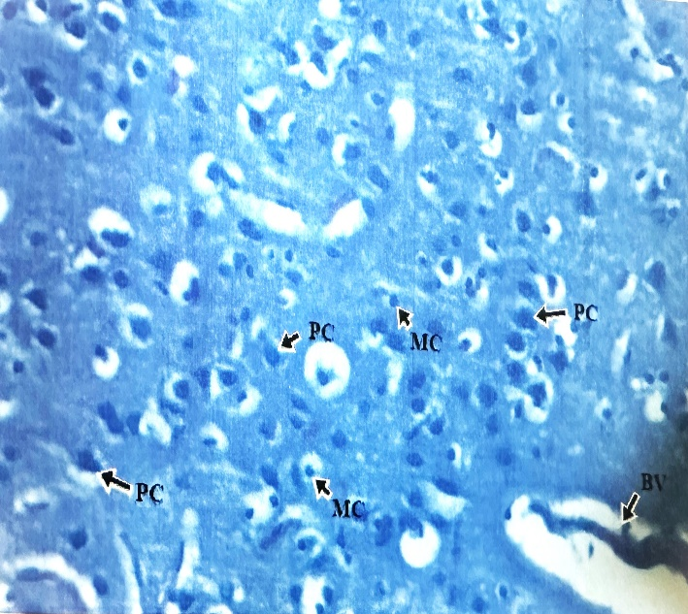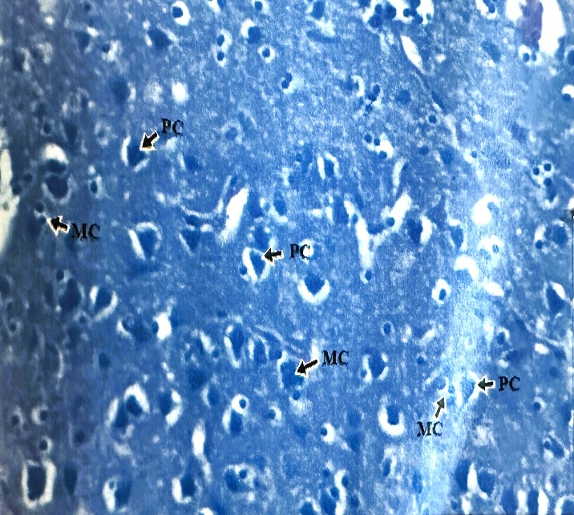
Plate 1: Negative control group A photomicrograph showing the normal cytoachitecture of the prefrontal cortex.
Plate 2: Positive control group B showing hyperplasic and hypertrophied cells

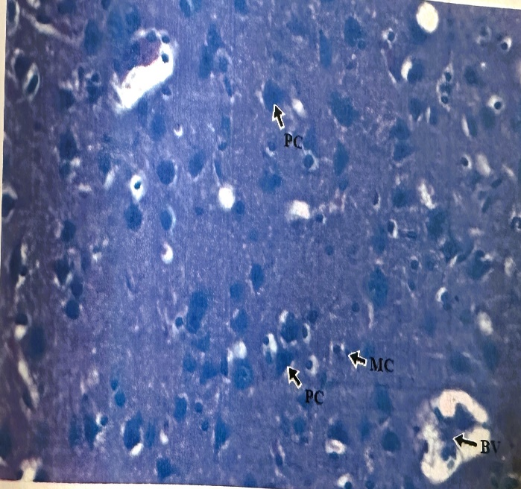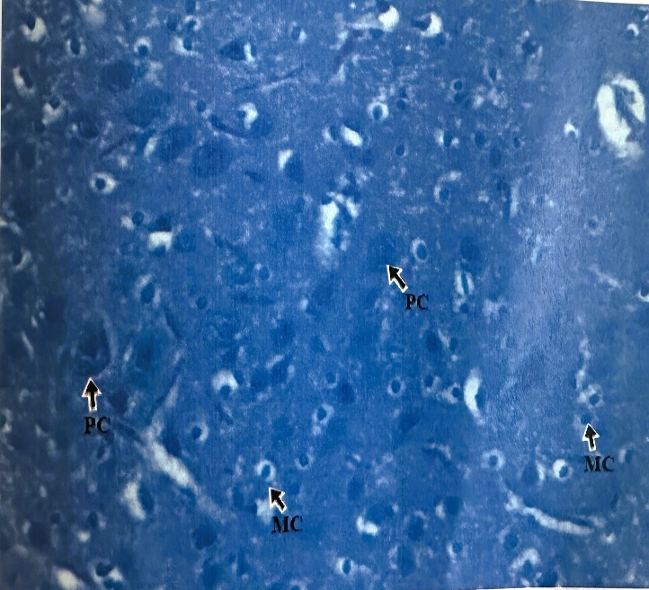
Plate 4: Tannin group D photomicrograph showing the normal and hyperplasic cells in the prefrontal cortex.

Plate 3: Saponin group C photomicrograph showing hypertrophied and hypoplasic cells in the prefrontal cortex.

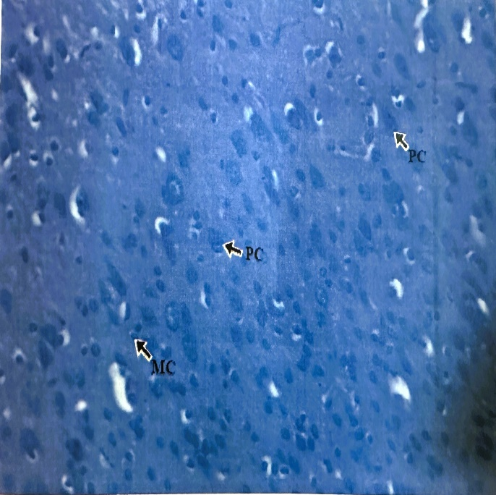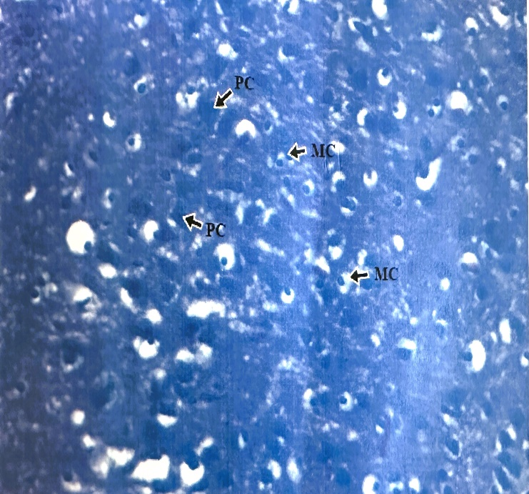
Plate 6: Diazepam group F photomicrograph showing normal and hypoplasic cells in the prefrontal cortex.

Plate 5: Alkaloid group E photomicrograph showing atrophied and hypoplasic cells in the prefrontal cortex.

Cell count (n)

Figure 1: Graph showing The number of cells quantified in the prefrontal cortex o Wistar rats

Average cell size (µm)

Figure 2:Graph showing The average size of cells in the prefrontal cortex of adult Wistar rats

4.0 Discussion
Cognitive dysfunction is one of the leading causes of disability and dependence in older adults as well as a major burden on the public health system. The pathological changes of cognitive impairment range from mild cognitive dysfunction to dementia (Jongsiriyangyong, 2018). These dysfunctions are primary characteristics of Schizophrenia that significantly impact patient functioning (Bowie et al., 2006; Green et al., 2000). It has long been postulated that the primary Cognitive alterations in Schizophrenia are due to dysfunction in the prefrontal cortex specially when there is low dopamine in the prefrontal cortex. “Dopaminergic tone is very important for cognitive functioning. The catechol-o-methyltransferase enzyme is vital for the regulation of dopamine levels in the prefrontal cortex” (Tunbridge et al., 2006). “A functional polymorphism of catechol-o-methyltransferase gene significantly impacts the dopamine levels in the prefrontal cortex. The val allele is associated with greater enzymatic activity and with greater dopamine degradation in the synapses of the prefrontal cortex” (Chen et al., 2004; Lachman et al., 1996).
In this study, rats were exposed to chronic administration of ketamine to induce cognitive dysfunction. Positive control group B that received 100mg/kg body weight of ketamine only exhibited disrupted cytoarchitecture of the prefrontal cortex of adult Wistar rats. The cells in this group were hypertrophied and hypoplasic (plate 2, figure 1 and 2). This is in line with the work of Morgan et al. (2004) who reported that repeated use of ketamine produces chronic impairment to episodic memory while Liao et al. (2010) concluded that chronic ketamine users reduce white matter in fronto-thalamo-temporal tracts. Also studies showed that “acute ketamine administration does not significantly impair cognitive dysfunction” (Howey et al., 2004; 2005; Fu et al., 2005; Daumann et al., 2008). Further studies also revealed that “acute exposure of ketamine yielded inconsistent findings on resting-state functional connectivity particularly prefrontal cortex functional connectivity with subcortical brain region” (Scheidegger et al., 2012; Driesen et al., 2013) and these regions play vital role in executive functions (Bonelli and Cummings, 2007).
Saponin, tannin and alkaloids were fractionated from Bridelia micrantha leaves and alongside Diazepam gotten from a pharmacy were administered to the ketamine-induced cognitive dysfunction rats for two weeks. The saponin group showed hypertrophied and hypoplasic cells of various sizes compared to the negative control groups (plate 3, figures 1 and 2). These cellular alterations may be as a result of cellular reaction from the effect of chronic ketamine exposure to the rats. Saponins are plant derived secondary metabolites and some are also found in marine animals such as sea cucumbers (Van Dyck et al., 2010) as well as starfish (Liu et al., 2008). Studies have it that, the nutrition of both humans and animals depends on saponins which is a common component of many plants and plant-based products. Many foods rich in saponin are suggested as dietary supplements for patients suffering from diabetes or other diseases such as neurodegenerative disease. However, this saponin is well known for its bioactive components which when added to food or administered to rats with degenerative disorder may enhance its nutritional and medicinal values, though in this research the in pact of saponin its ameliorative potential was not seen.
The tannin group revealed normal cytoarchitecture of the prefrontal cortex containing pyramidal cells of various sizes and neuroglial cells though cellular hyperplasia occurred in this group D (plate 4, figures 1 and 2). Tannin is a naturally occurring water soluble polyphenol compound resistant to biodegradation. It is characterized by their ability to form strong complex with different minerals and macromolecules such as proteins, cellulose, carbohydrates and others. The positive effect of tannins in the cytoarchitecture of the prefrontal cortex could be as a result of chemical characteristics and structural differences. Its antioxidant properties may reduce the neurotoxins caused by chronic exposure of ketamine in the prefrontal cortex which result to reversed cellular reaction. This result is in line with the work of Mueller-Harvey et al. (2019) who reported that condensed tannins from furage legumes fed to ruminants improved growth, milk production and fertility and reduced methane emission and ammonia volatilization from the lung and urine. They further postulated that condensed tannins combat the effect of gastrointestinal parasites nematode (Mueller-Harvey et al., 2019; Hoste et al., 2012) and Eru et al. (2017) demonstrated that Bridelia micrantha increase glycogen content in the hippocampus of adult Wistar rats. They further postulated that “alkaloids, saponin and tannins-rich Bridelia micrantha possess ameliorative potentials in the cytoarchitecture of the hippocampus of ketamine-induced neurotoxic male Wistar rats” (Eru et al., 2023).
Atrophied and hypoplasic cells were observed in the alkaloid group (plate 5, figures 1 and 2). Alkaloids are known to be chemical compounds that contain base nitrogen atoms having the ability to work as either hydrogen-acceptor or donor which is important for the interaction between targets and drugs processing alkaloid scaffolds. Alkaloids have been traditionally of great interest to humans because of their pronounced physical and medicinal properties. This plant constituent act on central nervous system in the human body and also affect DNA, RNA, membrane permeability and proteins. It exerts neuroprotective activities in numerous neurodegenerative disorder such as Alzheimer disease and many others according to Amirkia and Heinrich (2014). It attenuates the development of neurodegenerative diseases through their vast mode of action by inhibiting the activity of acetyl-cholinesterase enzymes (Abhijit Dey, 2017), increasing the level of gamma-aminobutyric acid (Cushirie et al., 2014) and acting as antagonist of NMDA (Cortes et al., 2015). In this research work, atrophied and hypoplasic cells were observed, hence affects the prefrontal cortex negatively of adult male Wistar rats.
- Conclusion
In conclusion, tannins-rich Bridelia micrantha showed ameliorative potentials compared to the saponin and alkaloid rich Bridelia micrantha in ketamine-induced cognitive dysfunction Wistar rats.

Ethical approval
This was obtained from the Faculty of Animal Research Ethics Committee (FAREC) of the Faculty of Basic Medical Sciences, University of Calabar, Calabar with the Registration Number: 106ANA1821

Grant and Financial Support
This research was funded by TETFUND Institutional Based Research (IBR)
Disclaimer (Artificial intelligence)
Option 1:
Author(s) hereby declare that NO generative AI technologies such as Large Language Models (ChatGPT, COPILOT, etc.) and text-to-image generators have been used during the writing or editing of this manuscript.
Option 2:
Author(s) hereby declare that generative AI technologies such as Large Language Models, etc. have been used during the writing or editing of manuscripts. This explanation will include the name, version, model, and source of the generative AI technology and as well as all input prompts provided to the generative AI technology
Details of the AI usage are given below:
1.
2.
3.

References
Amirkia, V., Heinrich, M. (2014). Alkaloids as drug leads - A predictive structural and biodiversity-based analysis. Phytochem Lett. 10:xlviii–liiii. [Google Scholar]
Abhijit, D. A. M. (2017). Plant-Derived Alkaloids: A Promising Window for Neuroprotective Drug Discovery. In: Discovery and Development of Neuroprotective Agents from Natural Products; pp. 237–320. [Google Scholar]
American Psychiatric Association (2013). Diagnostic and statistical manual of mental disorders. (5th ed) American Psychiatric Association. Arlington: American Psychiatric Publishing incorporated. https://doi.org/10.1176/appi.books.9780890425596
Anani, S. E., Eru, E. M., Okon, D. E., Uruakpa, K. C., Ugbem, T. I. & Igiri, A. O. (2021). The effect of Averrhoa carambola (star fruit) aqueous fruit extract on the hippocampal astrocyte expression following diazepam-induced neurotoxicity in Wistar rats. Trop J Nat Prod Res,4 (12): 1170-1173
Bonelli, R. M., Cummings, J. L. (2007). Frontal-subcortical circuitry and behavior. Dialogues Clin. Neurosci. 9, 141–151.
Bowie, C. R. & Harvey, P. D. (2006). Cognitive deficits and functional outcome in schizophrenia. Neuropsychiatr Dis Treat. 2006 Dec;2(4):531–536. doi: 10.2147/nedt.2006.2.4.531
Charles, A. M., Gary, H., Anthony, D., Stephan, G., Gary, H., Paul, T., et al (2004). Accuracy of eyewitness memory for persons encountered during exposure to highly intense stress. Int J Law and Psych, 27 (3): 265-279. doi.org/10.1016.

Cao, L., Zhao, Z., Ji, C., Xia, Y. (2021). Association between solid fuel use and cognitive impairment: a cross-sectional and follow-up study in a middle-aged and older Chinese population. Environ Int. 146:106251.
Cushnie, T. P. T., Cushnie, B., Lamb, A. J. (2014). Alkaloids: An overview of their antibacterial, antibiotic-enhancing and antivirulence activities. Int J Antimicrob Agents. Elsevier B.V. 44: pp. 377–86. [DOI] [PubMed]
Cortes, N., Posada-Duque, R. A, Alvarez, R., Alzate, F., Berkov, S., Cardona-Gómez, G. P. et al (2015). Neuroprotective activity and acetylcholinesterase inhibition of five Amaryllidaceae species: A comparative study. Life Sci.122:42–50. doi: 10.1016/j.lfs.2014.12.011.
Casteneda, A. E., Tuulio-Henriksson, A., Marttunen, M., Suvisaari, J., Lonngqvist, J. (2008). A review on cognitive impairments in depressive and anxiety disorders with a focus on young adults. J. Affect Disorder; 106: 1-27.
Daumann, J., Heekeren, K., Neukirch, A., Thiel, C. M., Moller-Hartmann, W., Gouzoulis-Mayfrank, E. (2008). Pharmacological modulation of the neural basis underlying inhibition of return (IOR) in the human 5-HT2A agonist and NMDA antagonist model of psychosis. Psychopharm 200, 573–583. 10.1007/s00213-008-1237-1
Driesen, N. R., McCarthy, G., Bhagwagar, Z., Bloch, M., Calhoun, V., D'Souza, D. C., et al. (2013). Relationship of resting brain hyperconnectivity and schizophrenia-like symptoms produced by the NMDA receptor antagonist ketamine in humans. Mol. Psych 18, 1199–1204.
Eru, E. M., Paulinus, S. O., Igiri, A. O, Akpaso, M. I. (2020). Enhanced effect of aqueous extract of Telfairia occidentalis seed on the microstructure of the hippocampus of scopolamine hydrobromide-induced cognitive dysfunction rats. Asian J of Res in Neuro, 3(1): 5-10.

Eru, E. M., Anani, S. E., Paulinus, S. O., Mesembe, O. E., Uruakpa, K. C., Umoh, N. M., et al. (2022). Scopolamine-Induced Alzheimer’s Disease in Wistar Rats; Aqueous Talinum Triangulare Potency on the Hippocampal Nissl Bodies and Long-Term Learning and Memory. Trop J Nat Prod Res, 6(1):117-122.

Eru, E. M., Udo-Affah, G. U., Samson, O. P., Uruakpa, K. C., Oku, M. E., Anani, S. E., et al. (2021a). Restorative Potentials of Aqueous Telfairia occidentalis Seeds Extract on the Hippocampal Nissl Granules and Short-Term Memory in Scopolamine Hydrobromide-Induced Alzheimer’s Type Cognitive Dysfunction Rats. Trop J Nat Prod Res, 5(1):182-187

Eru, E. M., Paulinus, S. O., Udo-Affah, G. U., Uruakpa, K. C., Oku, M. E., Anani, S. E. et al. (2021b). Hippocampal Astrogliotic Reduction in Scopolamine Hydrobromide-Induced Alzheimer’s Cognitive Dysfunction Wistar Rats Following Administration of Aqueous Extract of Telfairia occidentalis (Hook F.) Seeds. Niger J Physiol Sci, 36: 241 – 244

Eru, E. M., Paulinus, S. O., Udo-Affah, G. U., Uruakpa, K. C., Oku, M. E., Edet, U. I., et al. (2020). Neurobehavioural enhancement in scopolamine hydrobromide-induced alzheimer type cognitive dysfunction in rats following administration of ethanol seed extract of telfairia occidentalis (hook.f.) cucurbitaceae. Trop J Nat Prod Res, 4(7):282-285

Eru, E. M., Igiri, A. O., Udo-Affah, G. U., Akpaso, M. I., Mesembe, O. E., Uruakpa, K. C. (2017). Histochemical demonstration of glycogen in the hippocampus of adult male albino rats on administration of methanol extract of Bridelia micrantha (Hochst.) Baill, J Biopest. Nutri. Food Health Sci. 1 (1): 38-42.
Eru, E. M., Udo-Affah, G. U., Bassey, I. F., Uruakpa, K. C., Paulinus, S. O., Oku, M. E. et al. (2024). Efficacy of aqueous extract of talinum triangulare on the microanatomy of the hippocampus and short-term memory of scopolamine hydrobromide-induced alzheimer’s type cognitive dysfunction rats. Niger. J. Physiol. Sci. 39 (1):101-109

Eru, M. E., Mfon, I. A., Udo-Affah, G. U., Oku, M. E., Uruakpa, K. C., Paulinus, S. O., et al (2023). Modulatory effects of tannin, saponin and alkaloids from bridelia micrantha on the microstructure of the hippocampus from ketamine-induced neurotoxic Wistar rats. Afri.Health Sci, (in press).

Eru M. E, Theresa I. E., Cyril A. A., Christie E. F., Michael E. O., Samson O. P., et al. (2025). “Effect of Alkaloid-Rich Fraction of Dacryodes Edulis Leaves on the Microstructure of the Hippocampus and Blood Glucose Levels of STZ-Induced Diabetic Wistar Rats”. Int Neuropsychia Dis J, 22 (3):17–26. https://doi.org/10.9734/indj/2025/v22i3477.
Fu, C. H., Abel, K. M., Allin, M. P., Gasston, D., Costafreda, S. G., Suckling, J., et al. (2005). Effects of ketamine on prefrontal and striatal regions in an overt verbal fluency task: a functional magnetic resonance imaging study. Psychopharm 183, 92–102. 10.1007/s00213-005-0154-9
Green, S. M., Roback, M. G., Kennedy, R. M., Krauss, B. (2011). Clinical practice guideline for emergency department ketamine dissociative sedation. A Emer Med, 57(5): 449-61.
Green MF, Kern RS, Braff DL, MintzJ. (2000). Neurocognitive deficits and functional outcome in schizophrenia: Are we measuring the “right stuff? Schizophr Bull.;26:119–36. doi: 10.1093
Honey RA., Honey GD., O'Loughlin C., Sharar SR., Kumaran D., Bullmore ET., et al. (2004). Acute ketamine administration alters the brain responses to executive demands in a verbal working memory task: an FMRI study. Neuropsychopharm 29, 1203–1214. 10.1038/sj.npp.1300438
Hoste, H., Martinez-Ortiz-De-Montellano, C., Manolaraki, F., Brunet, S., Ojeda-Robertos, N., Fourquaux, I., et al (2012). Direct and indirect effects of bioactive tannin-rich tropical and temperate legumes against nematode infections. Vet Parasitol. 186:18–27. doi: 10.1016
Jongsiriyanyong, S., Limpawattana, P. (2018). Mild cognitive impairment in clinical practice: a review article. Am J Alzheimers Dis Dement. 33(8):500–7.
Jaroudi, W., Garami, J., Garrido, S., Hornberger, M., Keri, S., Moustafa, A. A. (2017). Factors underlying cognitive decline in old age and Alzheimer’s disease: the role of the hippocampus. Rev Neurosci. 2017;28(7):705–14.
Chen, J., Barbara, K. L., Nader, H., Quang, D. M., Mitsuyuki, M., Samer, M. (2004). Functional Analysis of Genetic Variation in Catechol-O-Methyltransferase (COMT): Effects on mRNA, Protein, and Enzyme Activity in Postmortem Human Brain. Ame J of Human Gen,75(5): 807-821.doi.org/10.1086/425589.
Liao, Y., Tang, J., Ma, M., Wu, Z., Yang, M., Wang, X., et al. (2011). Frontal white matter abnormalities following chronic ketamine use: a diffusion tensor imaging study. Brain 133(7), 2115–2122. Doi:10.1093/brain/awq131.Epub 2010
Lachman, H. M., Papolos, D. F., Saito, T., Yu, Y. M., Szumlanski, C. L., Weinshilboum, R. M. (1996). Human catechol-O-methyltransferase pharmacogenetics: description of a functional polymorphism and its potential application to neuropsychiatric disorders. Pharmacogen, 6: 243–250.

Liao, Y., Tang, J., Corlett, P. R., Wang, X., Yang, M., Chen, H., et al. (2011). Reduced dorsal prefrontal gray matter after chronic ketamine use. Biol. Psychiat 69, 42–48.
Loorke, D. (1983). a new approach to practical acute toxicity testing. Arch Toxicol., 54(4): 275-287.
Merriam, E. P. T., Haas, M. E., Keshavan, G. L., Keshavan, M. S., Sweeney, J. A. (1999). Prefrontal cortical dysfunction in depression determined by Wisconsin card sorting test performance. AM j. Psychiat, 156: 780-2. Doi:101176/ajp.156.5.780
Morgan, C. J., Monaghan, L., Curran, H. V. (2004). Beyond the K-hole: a 3-year recreational who have substantially reduced their use of the drug. Addiction 99, 1450–1461.
Morgan, C. J., & Curran, H. V. (2012). Independent Scientific Committee on Drugs. Ketamine use: a review. Addiction. 107 (1): 27-38. Doi: 10.1111/j.1360-0443.2011.03576.x
Mueller-Harvey, I., Bee, G., Dohme-Meier, F., Hoste, H., Karonen, M., Kölliker, R. et al (2019). Benefits of condensed tannins in forage legumes fed to ruminants: importance of structure, concentration, and diet composition. Crop Sci.59:861–885.
Nichols, E., Steinmetz, J. D., Vollset, S. E., Fukutaki, K., Chalek, J., Abd-Allah, F. et al (2022). Estimation of the global prevalence of dementia in 2019 and forecasted prevalence in 2050: an analysis for the Global Burden of Disease Study 2019. Lan Pub Health,7(2):e105–e125.
Paulinus, S. O, Eru, E. M., Udo-Affah, U. U., Oku, M. E., Bassey, I., Uruakpa, K. C. et al (2024). Lipid peroxidation and glutathione level following scopolamine-induced cognitive dysfunction in rats: potentials of telfairia occidentalis seeds and talinium triangulare leaves aqueous extract. A J. Res. Rep Neuro,7 (1): 98-106.
Prince, M., Bryce, R., Albanese, E., Wimo, A., Ribeiro, W., Ferri, C. P. (2013). The global prevalence of dementia: a systematic review and metaanalysis. Alzh Dement. 9:63–75. e2. doi: 10.1016/j.jalz.2012.11.007
Petersen, R. C. (2016). Mild cognitive impairment. Continuum. 22:404–18. doi: 10.1212/con.0000000000000313
Porter, R. J., Robinson, L. J., Malhi, G. S., Gallagher, P. (2015). The neurocognitive profile of mood disorders-a review of the evidence and methodological issues. Bipola Disord; 17 (S2): 21-40.doi:10.1111/bdi.12342
Qiu, Y., Li, G., Wang, X., Zheng, L., Wang, C., Wang, C., et al. (2022). Prevalence of cognitive frailty among community-dwelling older adults: a systematic review and meta-analysis. Int J Nurs Stud. 125:104112. doi: 10.1016/j.ijnurstu.2021.104112

Song, Y., Wang, J. (2010). Overview of Chinese research on senile dementia in mainland China. Ageing Res Rev. 9:S6–S12. doi: 10.1016/j.arr.2010.08.007
Shelembe, B. G. (2014). Phytochemical and elemental studies of two indigenous medicinal plants of south Africa, bridelia micrantha and sideroxylon inerme. Master’s Thesis, University of Kwazulu Natal Burban, South Africa.
Scheidegger, M., Walter, M., Lehmann, M., Metzger, C., Grimm, S., Boeker, H., et al. (2012). Ketamine decreases resting state functional network connectivity in healthy subjects: implications for antidepressant drug action. PLoS ONE 7: e44799. 10.1371/journal.pone.0044799
Tunbridge, E. M., Bannerman, D. M, Sharp, T., Harrison, P. J. (2004). Catechol-O-Methyltransferase inhibition improves set-shifting performance and elevates stimulated dopamine release in the rat prefrontal cortex. J. Neurosci, 24:5331-5335. Doi:10.1523/JNEUROSCI.1124-04.2004.
Udoh, B. E, Erim, A E., Paulinus, S. O., Eru, E. M., Ukpong, E. V., Efanga, I. et al (2020). Effects of Cyperus esculentus (Tiger Nut) Extract on the Irradiated Testes of Wistar Rats. Trop J Nat Prod Res, 4(11):966-969.
Van, D. S., Pascal, G., Patrick, F. (2009). Elucidation of molecular diversity and body distribution of saponins in the sea cucumber Holothuria forskali (Echinodermata) by mass spectrometry, Comparative Biochemistry and Physiology Part B: Biochem Mol Biol, 152, (2): 124-134.doi.org/10.1016
World Health Organization (2000). General guidelines for methodologies on research and evaluation of traditional medicines. WHO/EDM/TRM2000.1
World Health Organization (2005). National policy on traditional medicine and regulation of herbal medicine. Geneva: report of WHO global survey.
World Health Organization (2019). World Health Organization model list of essential Medicines: 21st list 2019. Geneva: world Health Organization
Zhang, Q., Wu, Y., Han, T., Liu, E. (2019). Changes in cognitive function and risk factors for cognitive impairment of the elderly in China: 2005–2014. Int J Environ Res Public Health.16(16):2847.
Zeb, A., Sadiaq, A., Ulla, F, Amed, S., Ayaz, M., (2014). Phytochemical and toxicological investigations of crude methanolic extract, subsequent fraction and crude saponnims of Isadon rugosus. Biol Res, 47(1):57.

