Case report
Large primary leiomyoma of ovary: a case report

ABSTRACT- Ovarian leiomyoma is a rare ovarian mesenchymal tumor found in young adult to menopausal women. These tumors are suggested to arise from smooth muscle cells of walls of blood vessels in ovary. Pre-operative diagnosis is extremely difficult and is most often misdiagnosed as subserosal fibroid or solid ovarian tumor. Presenting symptoms are also vague. This tumor is mostly diagnosed in frozen section examination during surgery or postoperative histopathological diagnosis. Immunohistochemistry(IHC) is suggested to confirm its diagnosis as it can be confused with many differential diagnoses. In this case also, IHC was used for confirmation which showed Smooth muscle actin(SMA) and H- caldesmon positivity. Though ovariotomy can be done in late adulthood, peri-operative diagnosis of this unusual entity becomes very important in young adults for providing fertility preserving options in management and sparing the ovaries.
KEYWORDS- ovarian leimyoma, mesenchymal, histopathological, immunohistochemistry, smooth muscle actin

INTRODUCTION-
“Primary ovarian leiomyoma is a rare mesenchymal benign tumour of ovary with an incidence ranging from 0.5-1% of all benign ovarian tumors”[1,2]. “First described by Sangralli in 1862, it is found in the age group of 20-60years. Around 85% are found in the perimenopausal group”[1,3]. “These tumors are thought to arise from the smooth muscle cells of walls of ovarian blood vessels. However, some theories also suggest the origin to be smooth muscle metaplasia of cortical stroma, ovarian ligaments, and multipotent ovarian stromal cells” [2,3]. “Primary leiomyomata of the ovary are usually smaller than 3 cm in diameter[4,5]. It is difficult to diagnose preoperatively or even during surgery. Ultrasound may misinterpret it as pedunculated or parasitic fibroid or malignant ovarian tumor”[4,6]. The tumour is most commonly diagnosed unintentionally by histological examination of ovarian tissue after an ovariectomy for solid ovarian mass.
In this case report, a 42year old lady diagnosed pre-operatively as subserosal fibroid and later diagnosed as ovarian fibroid has been described.

CASE PRESENTATION-
A 42 year old lady came with complaints of abdominal discomfort for 1month. She gave history of increased frequency of micturition and feeling of incomplete evacuation of bladder for 1year, for which she had received empirical treatment of UTI on and off. She is Para 2+1, with 2 vaginal deliveries. Her menstrual cycle was regular with normal flow and moderate dysmenorrhoea. On examination, uterus was normal in size and a firm, globular, regular lump was felt in anterior fornix. Ultrasound showed a large 8.6 ẋ 4.2cm subserosal fibroid. With these findings she was operated by laparotomy under spinal anesthesia. Laparoscopy was not done as patient refused minimal access surgeries due to some local cultural beliefs. However, during surgery, 9 ẋ 5 cm solid, vascular ovarian tumor with smooth surface was seen on left side. Figure 1 shows the gross features of the tumor. No ascites present. Uterus, bilateral tubes and right ovary looked absolutely normal. After discussion with the patient and attendants, decision for hysterectomy with bilateral salpingo-ophorectomy was done, as frozen section was not available, and we suspected malignancy due to solid ovarian tumor. Careful inspection of omentum, mesentery, peritoneum and liver surface done. As no suspicious findings were there, radical surgery was not done. Postoperative period was uneventful and patient had complete recovery. Histopathological examination(HPE) report showed that the tumor was actually an ovarian fibroid with typical HPE features of leiomyoma(Figure 2). However, immunohistochemistry was also done which confirmed the diagnosis as Smooth muscle actin(SMA) and H-caldesmon were positive and negative for Desmin, Inhibin, Calretinin & B-Catenin, as evidenced in figure 3.
After discussion with the patient, she was started on HRT(hormone replacement therapy) to delay her menopausal symptoms and then followed up yearly.

DISCUSSION-
Ovarian fibroids are usually unilateral. Usually its asymptomatic, and diagnosed incidentally during surgeries. However, they may present with lower abdominal pain. Sometimes features of Meig’s syndrome may also be seen[1]. CA125 may be marginally elevated in few cases. Rarely, such tumours may undergo torsion around their pedicle, with subsequent haemorrhage and necrosis. The ovary proper may become almost completely absorbed by the tumour, as in our case[7,8].
Ultrasonography is the primary modality of investigation[2]. Most of the literature have reported small ovarian fibroids, around 3cm[1,7]. In our case, the fibroid was much bigger. The features of these lesions are same as that of uterine fibroids, thus giving the false impression of subserosal fibroids as seen in our case. Thus comes the role of MRI in which ovarian tissue cannot be identified separately from the lesion, or ovarian follicles can be seen surrounding the lesion.
Differential diagnoses include fibroma, fibrothecoma, thecoma, cystadenofibroma, Brenner tumor, and sclerosing stromal tumor. Intravenous leiomyomatosis and leiomyomatosis peritonealis disseminata also may have secondary ovarian involvement and can be considered among differentials [1,3,9,10]. Another differential is a wandering fibroid which may become parasitic on the ovary. MRI with gadolinium contrast can help to differentiate between primary ovarian leiomyoma and fibroma, fibrothecoma; in which leiomyoma shows early contrast enhancement whereas fibroma and fibrothecoma shows delayed and weak contrast enhancement[2]. The tumor in our case was ovarian in origin as fibroid replaced the whole ovary and normal ovarian tissue could not be visualised in histopathology.
Surgery is the treatment of choice in these tumors. Oophorectomy or unilateral salpingoophorectomy are usually done. In young patients, enucleation is preferred, if diagnosed peri-operatively[1,2,3,11]. A common surgical approach to ovarian leiomyomas in middle-aged to elderly patients is hysterectomy in conjunction with bilateral salpingo-oophorectomy[9]. However, as this is a histopathological diagnosis, decision should be based on surgical findings as well as frozen section examination; as solid ovarian tumor may be malignant[12].
Grossly, these tumors are solid, firm & round. Cut section may have a grey-white surface with whorled appearance. Histologically these tumors have same appearance as uterine fibroids. Ovarian leiomyoma must be distinguished from leiomyosarcoma, which is mainly determined by mitotic count, cell atypia, and necrosis[9]. Immunohistochemistry is needed for confirmation. Positive staining for alpha-smooth muscle actin (α-SMA) is almost diagnostic[3,11]. In order to distinguish this tumor from sex cord stromal tumors, the combined staining of SMA, desmin and α-inhibin should be performed. If α-inhibin is positive, this suggests sex cord stromal tumors. If SMA or Desmin or H-Caldesmon is strongly positive, and α-inhibin is negative, it can be diagnosed as leiomyoma[13,14].
CONCLUSION- Ovarian fibroid is a rare pathology. It is usually diagnosed by HPE. Awareness about this entity is needed to decide mode of management and counsel patients. Knowing about this entity is especially important in young patients, in whom ovary can be preserved if diagnosed peri-operatively; as it is mostly confused with ovarian neoplasms.

Key take-aways-
- Large primary ovarian fibroids are very rare with non specific clinical presentations.
- It is mostly misdiagnosed as subserosal pedunculated / parasitic fibroid or solid ovarian neoplasms
- It is correctly diagnosed by histopathological & immunochemical examination only.
- Frozen section should be done in all of such suspected cases so that fertlity preserving surgeries can be done.

FIGURES-
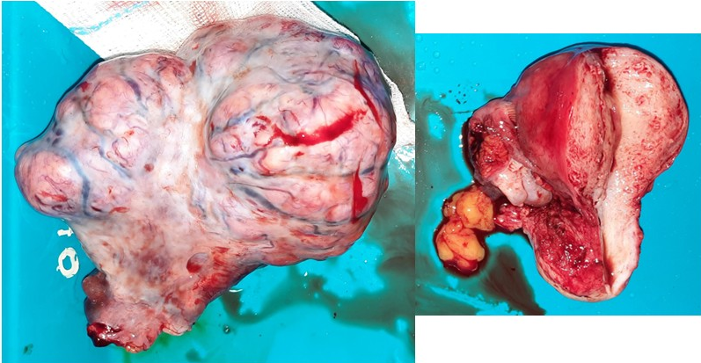
Figure 1: gross feature of the left ovarian solid tumor with smooth surface, intact capsule, showing vascularity with no normal ovarian tissue seen. Uterus and right adnexa look normal.

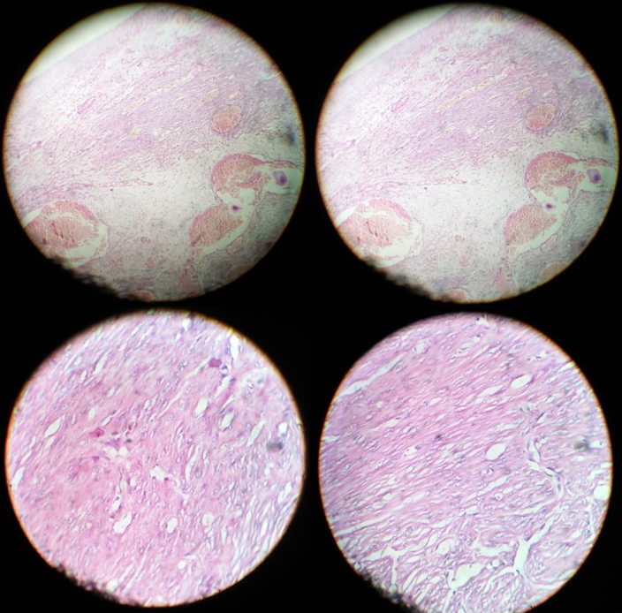
Figure 2: Low-power & high-power microscopic features showing interlacing fascicles of smooth muscle fibres having elongated nuclei and blunt ends. Adjacent ovarian stroma seen in low-power pictures

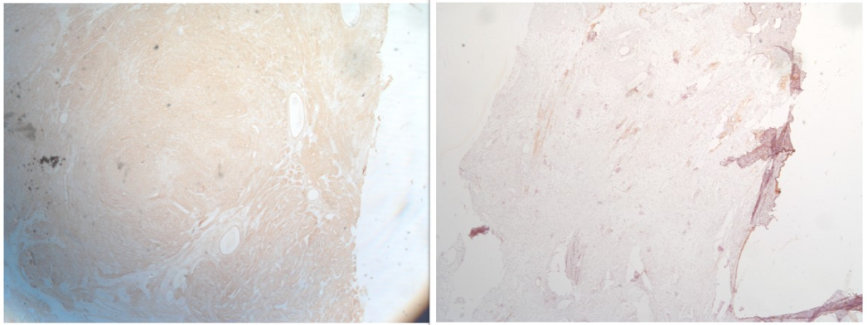
Figure 3: Immunohistochemical studies showing positive staining for SMA (left) and H-caldesmon (right)

IMPORTANCE OF THE MANUSCRIPT- this case report presents a rare entity of primary ovarian leiomyoma; that is usually not diagnosed pre-operatively and mistaken as subserous or parasitic fibroids or solid ovarian tumors. Knowing about this entity and the various differential diagnoses are important so that frozen section can be advised and ovarian sparing surgeries are done in the reproductive age group. The need of adequate histopathological and immunohistochemistry studies is also emphasized in this report. Knowing about this entity will help in making clinical decisions and also in the long run help in formulating management guidelines.

Conflict of Interests- None
Funding- None
Consent- Patient’s consent taken
Disclaimer (Artificial intelligence) - Author(s) hereby declare that NO generative AI technologies such as Large Language Models (ChatGPT, COPILOT, etc.) and text-to-image generators have been used during the writing or editing of this manuscript.

REFERENCES-
[1] Thombare P, Chheda P, Parikh R, Shetty R, Verma M, Patkar D. Primary ovarian leiomyoma: Imaging in a rare entity. Radiol Case Rep. 2020 May 20;15(7):1066-1070.
[2] Fasih N, Prasad Shanbhogue AK, Macdonald DB, Fraser-Hill MA, Papadatos D, Kielar AZ et al. Leiomyomas beyond the uterus: unusual locations, rare manifestations. Radiographics. 2008 Nov-Dec;28(7):1931-48.
[3] Asada T, Yamada T, Kumano R. Primary ovarian leiomyoma with predominant cystic change. Radiol Case Rep 2019;14(11):1315–19
[4] Kim M. Laparoscopic management of a twisted ovarian leiomyoma in a woman with 10 weeks' gestation: Case report and literature review. Medicine (Baltimore). 2016 Nov;95(44):e5319.
[5] C. Zaloudek and M. R. Hendrickson, “Mesenchymal tumors of the uterus, in R. J. Kurman (ed): Blaustein’s Pathology of the Female Genital Tract (ed 5),” New York, Springer-Verlag, Vol. 5, 2002, pp. 561-578.
[6] Ozcimen EE, Oktem M, Zeyneloglu HB, Ozdemir BH, Kuscu E. Primary leiomyoma of the ovary in a young woman: literature review and report of a case. Eur J Gynaecol Oncol. 2006;27(3):310-2.
[7] Agrawal R, Kumar M, Agrawal L, Agrawal KK. A huge primary ovarian leiomyoma with degenerative changes-an unusual. J Clin Diagn Res. 2013 Jun;7(6):1152-4.
[8] Wellmann KF. Leiomyoma of the ovary: report of an unusual case and review of the literature. Can Med Assoc J. 1961 Aug 19;85(8):429-32.
[9] Taskin MI, Ozturk E, Yildirim F, Ozdemir N, Inceboz U. Primary ovarian leiomyoma: A case report. Int J Surg Case Rep. 2014;5(10):665-8.
[10] Yoshitake T, Asayama Y, Yoshimitsu K, Irie H, Aibe H, Tajima T et al. Bilateral ovarian leiomyomas: CT and MRI features. Abdom Imaging. 2005 Jan-Feb;30(1):117-9.
[11] Safaei A , Khanlari M , Azarpira N ,Monabati A . Large ovarian leiomyoma in a postmenopausal woman. Indian J Pathol Microbiol 2011;54(2):413–14
[12] Koo YJ, Cho YJ, Kim JY, Lee JE, Kim ML, Kim JM et al. Ovarian leiomyoma as a potential cause of compromised fertility. Fertil Steril. 2011 Mar 1;95(3):1120.e11-4.
[13] Erdemoglu E, Kamaci M, Bayram I, Güler A, Güler Sahin H. Primary giant leiomyoma of the ovary--case report. Eur J Gynaecol Oncol. 2006;27(6):634-5.
[14] Wei C, Lilic N, Shorter N, Garrow E. Primary ovarian leiomyoma: a rare cause of ovarian tumor in adolescence. J Pediatr Adolesc Gynecol. 2008 Feb;21(1):33-6.

