Bohn’s Nodules and Epstein Pearls in a Neonate: A Case Report

.
ABSTRACT

Introduction: Oral inclusion cysts are frequently occurring developmental anomalies seen in newborns that usually resolve on their own. Depending on their anatomical site, they are categorized as Epstein pearls, Bohn’s nodules, or dental lamina cysts. Although harmless, these lesions can cause anxiety among parents if mistaken for natal teeth or abnormal oral growths.
Case Report: We report a case involving a two-day-old female newborn who exhibited multiple small, white, rounded nodules on the alveolar ridges and palate. Clinical assessment identified the presence of both Bohn’s nodules and Epstein pearls. As the lesions were painless, did not interfere with feeding, and were self-limiting, no intervention was necessary. The caregivers were reassured about the harmless course of the lesions and provided guidance on routine oral hygiene and follow-up monitoring. At the end of three months, complete resolution of the lesions was noted.
Conclusion: Awareness of these commonly occurring lesions is essential among healthcare providers to avoid misdiagnosis and unnecessary interventions. Proper diagnosis and parental reassurance are key components of effective management.

Keywords: Bohn’s nodules; Epstein pearls; oral cysts in neonates; dental lamina cysts; inclusion cysts; newborn oral lesions

1. INTRODUCTION

Oral assessment in newborns plays a vital role in the early recognition of developmental abnormalities. It is important for pediatric dentists and healthcare providers to possess the skills necessary to correctly identify and manage oral lesions in infants. Because several conditions may exhibit similar appearances, establishing an accurate differential diagnosis is crucial. Errors in diagnosis or incomplete evaluation could lead to unwarranted interventions or missed pathological findings (Bezerra and Costa, 2000).

Oral inclusion cysts are common neonatal lesions that are frequently misinterpreted. Although they are benign and tend to resolve spontaneously without any treatment, they can cause concern among caregivers who may confuse them with natal teeth or other pathological growths (Friend et al., 1990).

Neonatal oral inclusion cysts are generally divided into three main types according to their site of occurrence:
- Epstein pearls – situated along the midpalatal raphe.
- Bohn’s nodules – observed near the junction of the hard and soft palate or on the alveolar ridges.
- Dental lamina cysts – located on the alveolar ridge crests.

Epstein pearls were originally identified by Alois Epstein in 1880 as keratin-filled cysts that develop from epithelial remnants entrapped during the fusion of the palatal shelves (Epstein, 1880). Bohn’s nodules, first described by Heinrich Bohn in 1866, are believed to derive from minor salivary glands and typically appear in clusters on the palate or along the alveolar ridges (Bohn, 1866). Dental lamina cysts, also known as gingival cysts of the newborn, originate from residual dental lamina tissue and manifest as white or yellow keratin-filled nodules (Shafer, 2024).

Palatal cysts are reported to occur in nearly 65% of newborns (Paula et al., 2006), whereas alveolar cysts are observed in approximately 25% to 53% of cases (Mira et al., 2025). Although these lesions are relatively common, they are infrequently detected by clinicians because they are asymptomatic and short-lived (Vaid et al., 2023). In most instances, the cysts rupture spontaneously and disappear within a few weeks to months, eliminating the need for any therapeutic intervention (Madathil et al., 2016).

The spontaneous resolution of these cysts is thought to occur through the merging of the cyst wall with the overlying oral epithelium, leading to the release of keratinaceous material (Karimi, 2022). Although typically benign, their resemblance to natal or neonatal teeth may cause diagnostic confusion and result in avoidable treatment measures (Liu and Huang, 2004).

This case report documents a neonate with both Bohn’s nodules and Epstein pearls, aiming to increase clinical awareness and promote appropriate diagnosis and management of these benign conditions.

2. CASE Presentation

A two-day-old female neonate was brought to the Department of Pediatric and Preventive Dentistry by her caregivers, who reported the presence of small, white, rounded elevations on the maxillary and mandibular gingiva. The parents initially mistook these lesions for natal teeth. The infant was delivered vaginally in breech presentation, with a birth weight of 2.5 kg, following an uneventful antenatal period. She was otherwise healthy, full-term, and showed no systemic abnormalities. Extraoral examination revealed no significant findings.

Intraoral evaluation demonstrated multiple firm, whitish nodules measuring approximately 1 to 5 mm, arranged in clusters along the buccal aspects of both the maxillary (Fig. 1) and mandibular (Fig. 2) alveolar ridges, as well as at the junction of the hard and soft palate. The lesions were asymptomatic, non-tender on palpation, and did not interfere with breastfeeding.
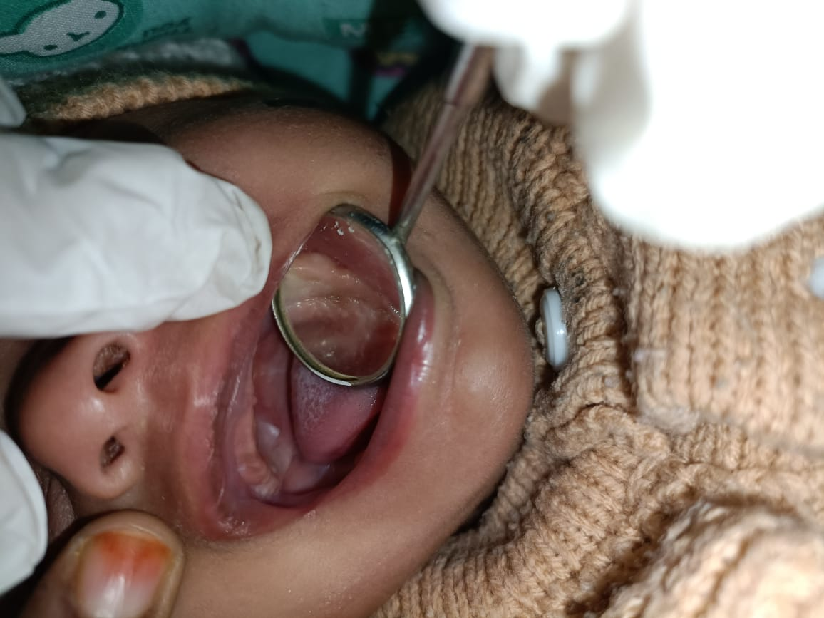
Fig. 1: Multiple firm, white nodules observed on the buccal aspect of the alveolar ridge and junction of the hard palate. Additional small nodules are seen along the alveolar ridge.

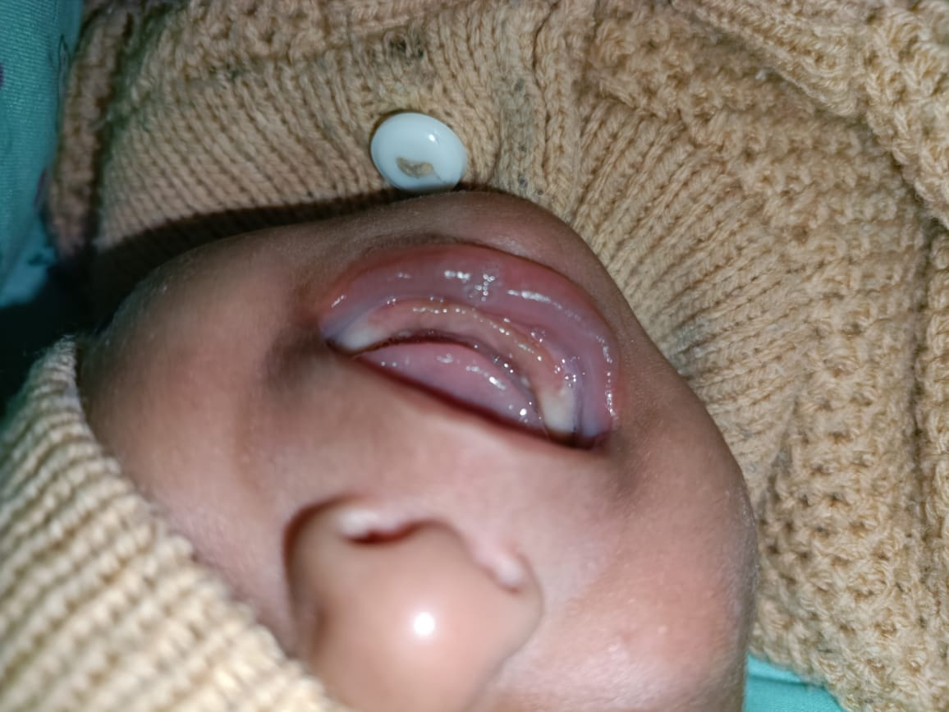

Fig. 2: Two firm, white nodules located on the lingual aspect of the Mandibular alveolar ridge

The infant’s mother noted a prior occurrence of a similar lesion in the maxillary molar region, which had resolved spontaneously before the current examination. Assessment of other intraoral areas—including the tongue, labial and buccal mucosa, lingual surface, and floor of the mouth—showed no additional abnormalities.

Considering the clinical features, distribution, and typical appearance of the nodules, a provisional diagnosis of dental lamina cysts was established. Further evaluation confirmed the simultaneous presence of both Bohn’s nodules and Epstein pearls in this neonate. Owing to their benign and self-resolving nature, no treatment was required. The caregivers were reassured about the harmless course of the lesions and provided guidance on routine oral hygiene and follow-up monitoring. At the four-week review, the cysts were still present but showed no change in size or number. The child continued to feed normally and remained in good health. At the end of three months, complete resolution of the lesions was noted.

3. discussion

Oral inclusion cysts, including Bohn’s nodules and Epstein pearls, are commonly observed during routine neonatal oral assessments, though they are often underreported in clinical practice. In a large study of 1,367 neonates, such cysts were identified in roughly 79% of infants (Fromm, 1967). These lesions originate from residual epithelial tissues involved in oral development. Specifically, dental lamina cysts arise from remnants of the dental lamina capable of forming keratin-filled cysts (Shafer, 2024), Bohn’s nodules develop from minor mucous salivary glands (Bohn, 1866), and Epstein pearls result from epithelial remnants trapped during palatal fusion (Epstein, 1880).

Clinically, oral inclusion cysts appear as white or yellow papules, occurring singly or in clusters, typically measuring 1–3 mm (Paula et al., 2006). In the present case, the nodules were slightly larger, ranging from 1 to 5 mm, which falls within the documented variation (Paula et al., 2006; Mira et al., 2025). Histological studies support their transient nature; Moskow and Bloom reported keratin production and microcyst formation within dental lamina remnants during fetal development (Moskow and Bloom, 1983). These cysts usually resolve spontaneously by rupturing, undergoing atrophy, or becoming integrated into the oral epithelium.

3.1 Differential Diagnosis and Classification
Inclusion cysts of the oral cavity can sometimes be confused with other oral lesions in neonates. Careful clinical assessment is crucial to differentiate these harmless cysts from conditions that may require treatment. Epstein pearls appear along the midline of the hard palate, Bohn’s nodules are typically located near the junction of the hard and soft palate or along the alveolar ridges, and dental lamina cysts are found on the alveolar crest (Epstein, 1880; Bohn, 1866; Shafer, 2024). It is thought that as these cysts grow, they rupture spontaneously, allowing their epithelial lining to merge with the overlying oral mucosa (Moda, 2011; Marini et al., 2014).

On rare occasions, dental lamina cysts may be mistaken for natal or neonatal teeth, which are most commonly located in the mandibular anterior region (Kumar et al., 2008). These teeth often show mobility due to underdeveloped or absent roots and may sometimes require extraction to prevent the risk of aspiration or ingestion during feeding (Merrett and Crawford, 2003).

Therefore, a thorough examination of the oral cavity in newborns is essential when any lesions are present, to differentiate self-limiting conditions—such as dental lamina cysts, Epstein pearls, and Bohn’s nodules, which typically require only monitoring—from lesions that may need more active intervention, such as natal or neonatal teeth and congenital epulis (Neville et al., 2023). Table 1 provides a summary of the clinical features of oral lesions in newborns (Moskow and Bloom, 1983).

Table 1: Summary of Clinical Characteristics of Oral Lesions in Newborns (Moskow and Bloom, 1983)

Types | Epstein Pearls | Bohn’s Nodules | Dental Lamina Cysts | Natal/ Neonatal Teeth
Lesions | 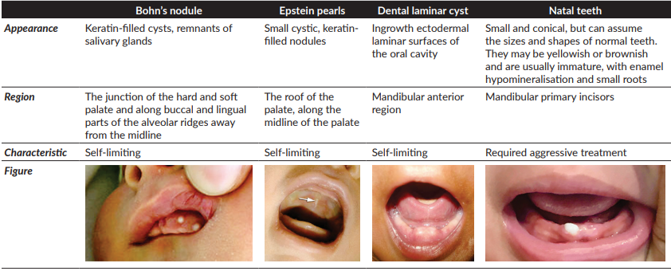
Location | Midline hard palate | Junction of hard and soft palate; alveolar ridges | Alveolar ridges (crest) | Mandibular anterior region
Etiology | Trapped epithelial remnants during palatal fusion | Remnants of minor salivary glands | Remnants of dental lamina | Premature eruption of primary teeth
Treatment | No treatment required | No treatment required | No treatment required | May require extraction if mobile

3.2 Treatment and Outcomes

In most cases, these cysts undergo spontaneous regression within the first few weeks or months of life. The resolution is primarily attributed to the spontaneous rupture of the cyst into the oral cavity or gradual reabsorption of their keratin content. The underlying mechanism is believed to involve the fusion of the cystic wall with the overlying oral epithelium, facilitating the discharge of keratin material. Despite their typical regression, some studies suggest that remnants of the cystic epithelial lining may remain latent within the gingival connective tissue, potentially explaining the rare occurrence of similar epithelial inclusions in adult gingiva (Madathil et al., 2016; Paula et al., 2006).

In most cases, these cysts undergo spontaneous regression within the first few weeks or months of life. The resolution is primarily attributed to the spontaneous rupture of the cyst into the oral cavity or gradual reabsorption of their keratin content. The underlying mechanism is believed to involve the fusion of the cystic wall with the overlying oral epithelium, facilitating the discharge of keratin material. Despite their typical regression, some studies suggest that remnants of the cystic epithelial lining may remain latent within the gingival connective tissue, potentially explaining the rare occurrence of similar epithelial inclusions in adult gingiva (Moda, 2011).

Active intervention is rarely required. Surgical excision or biopsy is indicated only in exceptional situations—such as when the cysts persist beyond infancy, interfere with feeding or suckling, or exhibit atypical size, color, or behavior that raises suspicion of another pathology. In such cases, histopathological evaluation may be warranted to rule out other mucosal lesions (Shafer, 2024).

Overall, the prognosis is highly favorable. The vast majority of oral inclusion cysts resolve spontaneously without leaving any residual scarring or complications, reaffirming the recommendation for reassurance and observation as the standard approach to management (Mira et al., 2025).

4. Conclusion

Bohn’s nodules and Epstein pearls are frequent dvelopmental findings in neonates. Their benign, self-limiting nature and distinct clinical appearance allow for diagnosis through routine examination. Early identification helps avoid unnecessary interventions and reduces caregiver concern. This case underscores the need for pediatric and dental professionals to be familiar with these harmless lesions.

Consent
As per international standards, parental written consent has been collected and preserved by the author(s).

Disclaimer (Artificial intelligence)
Author(s) hereby declare that NO generative AI technologies such as Large Language Models (ChatGPT, COPILOT, etc.) and text-to-image generators have been used during the writing or editing of this manuscript.

References

Bohn, H. (1866). Die Mundkrankheiten der Kinder. Leipzig: W Engelmann.

Bezerra, S., & Costa, I. (2000). Oral conditions in children from birth to 5 years: the findings of a children’s dental program. J Clin Pediatr Dent, 25:79–81.

Epstein, A. (1880). Uber epithelperlen in der mundhohle neu geborener kinder. Z Heilk, 1:59–94.

Fromm, A. (1967). Epstein's pearls, Bohn's nodules and inclusion cysts. J Dent Child, 34:275–87.

Friend, G. W., Harris, E. F., Mincer, H. H., Fong, T. L., & Carruth, K. R. (1990). Oral anomalies in neonates by race and gender. Pediatr Dent, 12:157–61.

Kumar, A., Grewal, H., & Verma, M. (2008). Dental lamina cyst of newborn: a case report. J Indian Soc Pedod Prev Dent, 26(4):175–6.

Karimi, M (2022). Epstein Pearls in Newborn. Inter Ped Dent Open Acc J, 7(4).

Liu, M. H., & Huang, W. H. (2004). Oral abnormalities in Taiwanese newborns. J Dent Child, 71(2):118–20.

Moskow, B. S., & Bloom, A. (1983). Embryogenesis of the gingival cyst. J Clin Periodontol, 10(2):119–30.

Merrett, S. J., & Crawford, P. J. (2003). Congenital epulis of the newborn: a case report. Int J Paediatr Dent, 13:127–9.

Moda, A. (2011). Gingival Cyst of Newborn. Int J Clin Pediatr Dent, 4(1):83-4.

Marini, R., Chipaila, N., Monaco, A., Vitolo, D., Sfasciotti, G.L. (2014). Unusual symptomatic inclusion cysts in a newborn: a case report. J Med Case Rep, 21;8(1):314.

Madathil, J., Negi, B. S., Kumar, N. R. (2016). Gingival cyst of new born: a case report. Int J Contemp Pediatr, 3(3):1129-31.

Mira, R., Abdelhameed, T., Mohamed, A. (2025). Newborn Gingival Cyst: A Case Report. Khalij-Libya Journal of Dental and Medical Research, 8:1-3.

Neville, B. W., Damm, D. D., Allen, C. M., & Chi, A. C. (2023). Oral and Maxillofacial Pathology (5th ed.). St. Louis: Saunders.

Paula, J. D., Dezan, C. C., Frossard, W. T., Walter, L. R., & Pinto, L. M. (2006). Oral and facial inclusion cysts in newborns. J Clin Pediatr Dent, 31(2):127-9.

Shafer, W. G. (2024). Textbook of Oral Pathology (10th ed.). India: W.B. Saunders Co.

Vaid, P. A., Chouhan, L. H., Yadav, N. I., Dogra, S. H. (2023). A Combined Case of Neonatal Teeth, Bohn’s Nodules and Eruption Haematoma in an Infant Presenting as a Diagnostic Dilemma. J Cli Diag Res, 17(2):6-8.

