Unusual Mandibular Incisive Canal behind the curtain of periapical radiolucency using a CBCT-assisted diagnostic approach: A case report and literature review

.
ABSTRACT

Background- Additional neurovascular channels represent a significant anatomical feature in the mandibular anterior region. These neurovascular channels are seldom mentioned in existing literature. It is essential for clinicians to recognize the existence of these additional channels when analyzing radiographs and preparing for surgeries in the anterior mandible. Dental computed tomography (DCT) offers three-dimensional visualization of the lingual neurovascular canal.
Aim- The purpose of this case report is to describe an infrequent course of mandibular incisive canal (MIC) by Cone-beam computerised tomography (CBCT) examination along with its location and morphological characteristics.
Study Design- Case Report
Methodology- A 45-year-old patient presented with pain and discolouration in lower anterior teeth. Periapical radiograph revealed a large periapical lesion with an additional radiolucent line crossing between the mandibular incisors. Limited field of view (FOV) CBCT scan revealed it to be an accessory neurovascular channel traversing from premolar area to extending downward and upward, superimposed over the periapex-periapical area of tooth #32. Non-surgical root canal therapy (NSRCT) was performed and the patient was followed up after 6 months.
Results- Post RCT, the patient was clinically asymptomatic with periapical healing evident at follow up visits after 1 month, 3 months and 6 months. CBCT aided the precise localisation of the MIC.
Conclusion- It is important for the dentist to know the incidence and positions of accessory foramina in the mandible in implant placement and while performing periapical surgery in un healed apical periodontitis cases to prevent complications like nerve damage and incomplete nerve blocks.

Keywords: Apical periodontitis, non-endodontic lesion, cone-beam computed tomography, periapical radiolucency, mandibular incisive canal, neurovascular channel, intraosseous lesions.

- INTRODUCTION

“Apical periodontitis (AP) is the inflammation and destruction of peri-radicular tissues caused by aetiological agents of endodontic origin” [1]. “Radiographically, AP lesions are seen as a widening of the periodontal ligament space or a droplet‐shaped radiolucency located around the apex of the affected tooth (chronic response). At times, lesions of non-endodontic origin, such as periapical cemento-osseous dysplasia, central giant cell granulomas, simple bone cysts and malignancies might radiographically mimic lesions of endodontic origin” [2]. Previous report have described “the occurrence of non-endodontic lesions mimicking apical periodontitis and their misdiagnosis” [3]. “The presence of teeth with a vital pulp excludes the possibility of chronic apical periodontitis. However, teeth associated with pulp necrosis or that have been endodontically treated can lead to misdiagnosis and an ineffective treatment protocol. Also, the incisive and mental foramina overlapping mandibular incisors and premolars mimicking a periapical lesion have to be distinguished” [4].
Clinical endodontic diagnosis relies on subjective and objective information collected during patient examination with adequate radiographic information. Routine 2D radiographs aid in detecting pathoses and assist in evaluating posttreatment healing [5]. Alternative imaging techniques like CBCT have been shown to be superior to conventional imaging in many endodontic applications [6]. It provides a detailed 3D evaluation of the maxillofacial region and related anatomical structures can assist in the differential diagnosis of non-endodontic origin lesions. The 3D radiographic appearance of a periapical lesion provides additional information about the lesion’s relationship to the tooth and other anatomic structures (e.g., the vascular bundle). The present case report delineates an unusual finding of a radiolucent lesion that created a diagnostic dilemma.

- Case PRESENTATION

Case history
A 45-year-old male patient reported to the Division of Conservative and Endodontics, complaining of occasional pain on biting in the lower front teeth region for past 3 months. Patient had a history of road traffic accident 7 years back. The pain was mild and diffuse in anterior mandibular area. Medical history was non-contributory. Clinical examination revealed crown discolouration in tooth #32 with slight lingual inclination, tenderness to percussion and palpation (Figure 1). Cold and electric pulp test were negative for tooth #32, #41 and positive for tooth #31 with normal probing depth. A diagnosis of pulp necrosis with symptomatic apical periodontitis for tooth #32, #41 was confirmed. Digital intra-oral periapical (IOPA) radiography revealed large periapical radiolucency involving teeth #31, #32 and #41 with ill-defined borders (Figure 2a). A well-defined radiolucent channel was traversing up to the junction of the middle/apical third of the roots (Figure 2 b). Three angulated IOPA (SLOB rule) revealed that it was lingual to the periapical radiolucency (Figure 3). Differential diagnosis included fibrous scar, malunion, and non-healed bone fracture because of a previous history of trauma.
Pre-operative CBCT scans
Due to insufficient diagnostic information obtained from conventional periapical radiography, limited field-of-view cone-beam computed tomography (i-CAT; Imaging Sciences International, Hatfield, PA) was employed for enhanced diagnostic assessment and treatment planning, adhering to the ALADA principle. The CBCT acquisition parameters comprised a restricted field of view (8 × 8 cm²), operating at 120 kV and 5 mA, with an exposure duration of 8.9 seconds, slice thickness of 0.1 mm, and voxel dimensions of 0.125 mm. Image data were acquired in DICOM format and subsequently evaluated utilising a 22-inch medical-grade display monitor with 1920 × 1080 pixel resolution, employing Carestream 9300 software (Carestream, Atlanta, GA). Images underwent reorientation to optimise visualisation of the mandibular anterior region across all multiplanar reconstructions, with comprehensive utilisation of available enhancement tools. Three-dimensional imaging utilising axial, coronal, and sagittal planes was employed to examine the anterior mandibular region [Figure 4 (a, b, c, d)]. The inferior margin of the mandible and associated genial tubercles served as anatomical reference points. Scans demonstrated the existence of an additional neurovascular pathway, representing a continuation of the mandibular incisive canal (MIC). The mean distance ±SD from the inferior margin of the incisive canal to the inferior border of the mandible measured 9.3±1.8 mm within the canine region. The canal's trajectory towards the midline exhibited a slight inferior inclination, producing an average measurement of 7.1±1.1 mm in the incisor region. The canal concluded apically to the lateral incisor. The mean length of the MIC was recorded as 8.70±2.30 mm. The distances to the buccal and lingual cortical plates measured 4.16±1.15 mm and 3.13±1.48 mm, respectively.

NSET procedure
The clinical procedure for the involved teeth included multi-visit non-surgical root canal treatment wrt tooth #31, #41 with the use of intracanal medicament calcium hydroxide (Dentokem, faridabad, India) slurry dressing. Following the resolution of clinical signs and symptoms, the teeth underwent obturation with subsequent follow-up examinations conducted at 3 months and 6 months post-treatment (Figure 5).

- discussion

This case report describes an unusual mandibular incisive canal behind the curtain of periapical radiolucency. “The mandibular canal (MDC) divides into the mental and mandibular incisive canal (MIC) at the premolar region, forms the anterior loop (AL), which crosses anterior to the mental foramen (MF), and turns back to reach the MF” [7]. “The lingual foramen (LF) is usually situated in the midline of the internal region of the mandibular symphysis at the level, or superior to the mental spines” [8]. “The neurovascular bundle of the inferior alveolar supply the teeth and periodontium on the respective side of the mandibular arch. The incisive nerve seems to run in a clearly defined MIC in the mandibular interforaminal region. The incisive branch innervates the anterior teeth, including the first premolar” [9]. “The MIC continues forward to the incisive teeth, whereas the mental canal runs upwards and backwards to the MF. The canal terminates at the level of the lateral incisors on the contralateral side might partially explain the debate concerning the neurovascular supply of the incisor teeth” [10].
Prevalence
MIC was present in 76.3 % of the cases. According to the findings of a systematic review, the overall prevalence is 89.6% [11]. Using CBCT imaging, prior research has documented a 100% MIC prevalence [12]. Despite Kong et al.'s 100% MIC prevalence, 63.6% of the scans did not clearly show the MIC [13]. According to Gomes et al., out of 100 Brazilian patients in their sample, 78% of MICs were evident [14].
Gender differences
“The MIC was observed in 76.09% of females and 76.5% of males; as such, gender was not a statistically significant factor in relation to the presence of a MIC. Males exhibited greater mean length values to the alveolar crest (17.23 mm and 19.55 mm, respectively), buccal cortex (2.75 mm and 4.32 mm, respectively), and inferior border of the mandible (9.98 mm and 9.60 mm, respectively) than females. These findings can be explained by the fact that females’ mandibles were smaller than those of males” [15].
Spatial Relationship
“Mean distances from the MIC to the adjacent teeth apexes ranged from 6.97 mm (SD = 1.58 mm) to 9.77 mm (SD = 1.04 mm), which were obtained at the canine and central incisor teeth apexes, respectively” [15]. Similar MIC distances to the apexes of the teeth were found by Kong et al. (11.75 mm and 9.51 mm, respectively) [13].
The distance of the MIC from the vestibular cortical region ranged between 2.2 -5.16 mm [8]. From the lingual cortex, the distance ranged from 4.4 mm to 6.33 mm [13]. Using MRI, Krasny et al. discovered that 70% of incisive canals crossed the midline and anastomosed, with roughly 25% of those being "plexus-like." This contrasts with the current findings, which show that in about half of the specimens, the incisive canal was not visible at the midline .
Age
MIC was mainly found in adults (4th-6th decade of life) with min 11 years to a maximum 89 years of age [11]. Prados-Frutos et al. reported that the loop had a greater mean length and is significantly more prevalent in males (p = 0.014) [17]. On the contrary, in adults with dentition, the MF is situated just below the halfway point between the borders. As a result of bone loss, the MF's position on the mandible of edentulous adults shifted and approached the upper boundary. Additionally, Doh et al. discovered that “the diameter of the MIC in the edentulous group was significantly narrower than that in the dentate group” [18]. Consequently, the age and dentulous state of the patient must be taken into account when applying this data to clinical settings.

Length of MIC
Based on measurements made with the Gendex-CB 500 CBCT scanner for this investigation, the mean length of the MIC was 7.02 mm. Apostolakis and Brown reported a mean CIM length of 8.9 mm in investigations using different image acquisition procedures [12]. This length, however, exceeds the measurements for the left (6.6 mm) and right (7.1 mm) sides that Pires et al. recorded [19]. The mean length of the MIC in dentate groups and edentulous groups was measured as 2.55 mm and 3.08 mm, respectively [7].
Diameter of MIC
The dentate and edentulous groups' well-defined MIC mean diameters were 2.44 ± 0.702 and 2.35 ± 0.652 mm, respectively [7]. The mean diameter of MIC, at the origin, was 2.1– 3.1 mm and at the incisor area was 0.95–1.03 mm. It was ascertained that there was a constant decrease in the inner diameter of the canal as it progresses toward the mid-symphseal region [12].
Imaging technique - Periapical Radiography vs CBCT
“The radiographic visibility of the mandibular incisive canal is largely dependent on the imaging technique utilized for assessment. The ability of conventional two-dimensional radiological methods to reveal the MIC is limited, and their reliability and accuracy, questioned. Different methods have been used in order to establish the diameter, visualisation, and course of the MIC, such as cadaveric anatomical investigations and imaging studies using panoramic radiography, computed tomography (CT), cone-beam computed tomography (CBCT), and nuclear magnetic resonance.
Good visibility of MIC was largely limited to 7.5–39.6% of the cases, even though CT (93%) and CBCT (49.5–100%) were effective in the identification of the canal” [8,10]. Pires et al. showed that “all MIC parameters are better determined by cone beam computed tomography (CBCT) imaging than by panoramic radiography”. “Investigations comparing panoramic radiographs with CBCT, MIC was identified in 83.1% of cases in latter compared to only 11.2% in the former” [8].
Voxel size
Voxel size also has an influence on the visibility of MIC as a voxel size lower than 0.3 mm showed a higher MIC prevalence in comparison with those that used a voxel ≥ 0.3 mm. Similar findings in study by Ferreir et al. in which studies using voxels smaller than 0.3mm, provided an improved picture detail [11].
Clinical Implications
“The existence of the MIC has been investigated in radiographic and anatomical studies, but the prevalence and clinical implications of this canal remain controversial. Clinically, the presence of MIC has been associated with postoperative complications after surgical procedures in the anterior region of the mandible, such as bleeding, sensory disorders, neurosensory disturbances and pain” [20]. The failure of implant osseointegration in the event of a mandibular incisive canal perforation is another possible consequence that has been documented. Similar complications have been reported when implants were placed in the maxillary incisive canal.

- Conclusion
The current anatomical analysis confirmed the presence of the MIC. Thus, doctors must be conversant with periapical lesions that may arise owing to non-endodontic reasons in order to make an accurate diagnosis and, as a result, provide appropriate therapy. A thorough clinical examination, as well as interpretations of various diagnostic tests, should be correlated for a provisional diagnosis and confirmed by histopathological examination. They should be included in the differential diagnosis of periapical lesions.

- DISCLAIMER (ARTIFICIAL INTELLIGENCE)
Author(s) hereby declare that NO generative AI technologies such as Large Language Models (ChatGPT, COPILOT, etc) and text-to-image generators have been used during writing or editing of this manuscript.
CONSENT:
As per international standards or university standards, patient(s) written consent has been collected and preserved by the author(s).

Disclaimer (Artificial intelligence)
Option 1:
Author(s) hereby declare that NO generative AI technologies such as Large Language Models (ChatGPT, COPILOT, etc.) and text-to-image generators have been used during the writing or editing of this manuscript.
Option 2:
Author(s) hereby declare that generativ AI technologies such as Large Language Models, etc. have been used during the writing or editing of manuscripts. This explanation will include the name, version, model, and source of the generative AI technology and as well as all input prompts provided to the generative AI technology
Details of the AI usage are given below:
1.
2.
3.

References
- Karamifar, K., Tondari, A., & Saghiri, M. A. (2020). Endodontic Periapical Lesion: An Overview on the Etiology, Diagnosis and Current Treatment Modalities. European Endodontic Journal, 5(2), 54–67. https://doi.org/10.14744/eej.2020.42714.
- Modi, K., Padmapriya, R., Elango, S., Khandelwal, P., Arul, B., & Natanasabapathy, V. (2022). Nonmalignant nonendodontic lesions mimicking periapical lesions of endodontic origin: A systematic review. Journal of Conservative Dentistry, 25(3), 214–225. https://doi.org/10.4103/jcd.jcd_13_22.
- Leven, A. J., & Sood, B. (2018). Pathosis or Additional Maxillary Neurovascular Channel? A Case Report. Journal of Endodontics, 44(6), 1048–1051. https://doi.org/10.1016/j.joen.2018.02.025.
- Faitaroni, L. A., Bueno, M. R., Carvalhosa, A. A., Mendonça, E. F., & Estrela, C. (2011). Differential diagnosis of apical periodontitis and nasopalatine duct cyst. Journal of Endodontics, 37(3), 403–410. https://doi.org/10.1016/j.joen.2010.11.022.
- Ahmed, H.M.A. (2015). Guidelines to enhance the interpretation of two-dimensional periapical radiographic images in endodontics. European Journal of General Dentistry, 4:106–112. https://doi.org/ 10.4103/2278-9626.163320.
- Khanna, A.B. (2020). Applications of cone beam computed tomography in endodontics. Evidence-Based Endodontics, 5, 1. https://doi.org/10.1186/s41121-020-00020-4.
- Sener, E., Onem, E., Akar, G. C., Govsa, F., Ozer, M. A., Pinar, Y., Mert, A., & Baksi Sen, B. G. (2018). Anatomical landmarks of mandibular interforaminal region related to dental implant placement with 3D CBCT: comparison between edentulous and dental mandibles. Surgical and Radiologic anatomy, 40(6), 615–623. https://doi.org/10.1007/s00276-017-1934-8.
- Pires, C. A., Bissada, N. F., Becker, J. J., Kanawati, A., & Landers, M. A. (2012). Mandibular incisive canal: cone beam computed tomography. Clinical Implant Dentistry and Related Research, 14(1), 67–73. https://doi.org/10.1111/j.1708-8208.2009.00228.x.
- Di Bari, R., Coronelli, R., & Cicconetti, A. (2014). Intraosseous vascularization of anterior mandible: a radiographic analysis. The Journal of Craniofacial Surgery, 25(3), 872–879. https://doi.org/10.1097/01.scs.0000436735.60042.49.
- Cartes, G., Garay, I., Deana, N. F., Navarro, P., & Alves, N. (2018). Mandibular Canal Course and the Position of the Mental Foramen by Panoramic X-Ray in Chilean Individuals. BioMed Research International, 2018, 2709401. https://doi.org/10.1155/2018/2709401.
- Ferreira Barbosa, D. A., Barros, I. D., Teixeira, R. C., Menezes Pimenta, A. V., Kurita, L. M., Barros Silva, P. G., & Gurgel Costa, F. W. (2019). Imaging Aspects of the Mandibular Incisive Canal: A PROSPERO-Registered Systematic Review and Meta-Analysis of Cone Beam Computed Tomography Studies. The International Journal of Oral & Maxillofacial Implants, 34(2), 423–433. https://doi.org/10.11607/jomi.6730.
- Apostolakis, D., & Brown, J. E. (2013). The dimensions of the mandibular incisive canal and its spatial relationship to various anatomical landmarks of the mandible: a study using cone beam computed tomography. The International Journal of Oral & Maxillofacial Implants, 28(1), 117–124. https://doi.org/10.11607/jomi.2372.
- Kong, N., Hui, M., Miao, F., Yuan, H., Du, Y., & Chen, N. (2016). Mandibular incisive canal in Han Chinese using cone beam computed tomography. International Journal of Oral and Maxillofacial surgery, 45(9), 1142–1146. https://doi.org/10.1016/j.ijom.2016.04.019.
- Gomes, L. T., de Almeida Barros Mourão, C. F., Braga, C. L., de Almeida, L. F. D., de Mello-Machado, R. C., & Calasans-Maia, M. D. (2018). Anatomic evaluation of the incisive canal with cone beam computed tomography and its relevance to surgical procedures in the mental region: a retrospective study in a Brazilian population. Oral and Maxillofacial Surgery, 22(4), 379–384. https://doi.org/10.1007/s10006-018-0716-8.
- Barbosa, D. A., Kurita, L. M., Pimenta, A. V., Teixeira, R. C., Silva, P. G., Ribeiro, T. R., Melo, D. P., & Costa, F. W. (2020). Mandibular incisive canal-related prevalence, morphometric parameters, and implant placement implications: a multicenter study of 847 CBCT scans. Medicina Oral, Patologia Oral y Cirugia Bucal, 25(3), e337–e345. https://doi.org/10.4317/medoral.23350.
- Krasny, A., Krasny, N., & Prescher, A. (2012). Study of inferior dental canal and its contents using high-resolution magnetic resonance imaging. Surgical and Radiologic Anatomy, 34(8), 687–693. https://doi.org/10.1007/s00276-011-0910-y.
- Prado, F. B., Groppo, F. C., Volpato, M. C., & Caria, P. H. (2010). Morphological changes in the position of the mandibular foramen in dentate and edentate Brazilian subjects. Clinical Anatomy, 23(4), 394–398. https://doi.org/10.1002/ca.20973.
- Doh, R. M., Choi, D. J., Park, K. S., & Jung, B. Y. (2024). Assessment of the mandibular incisive and mental canal in dentate and edentulous mandibles using cone-beam computed tomography. Heliyon, 10(20), e39487. https://doi.org/10.1016/j.heliyon.2024.e39487.
- Pereira-Maciel, P., Tavares-de-Sousa, E., & Oliveira-Sales, M. A. (2015). The mandibular incisive canal and its anatomical relationships: A cone beam computed tomography study. Medicina Oral, Patologia Oral y Cirugia Bucal, 20(6), e723–e728. https://doi.org/10.4317/medoral.20644.
- Han, J., & Han, J. J. (2025). Risk factors for inferior alveolar nerve injury associated with implant surgery: An observational study. Journal of Dental Sciences, 20(1), 270–277. https://doi.org/10.1016/j.jds.2024.07.025.

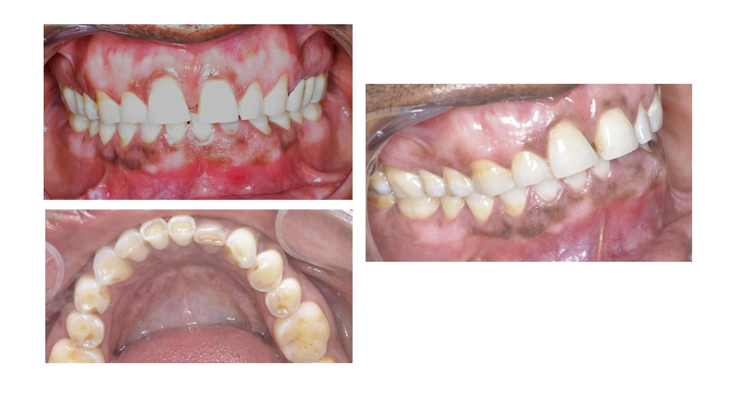
Figure 1- Intra-oral pictures frontal, lateral and occlusal view showing crown discolouration in tooth #32 with slight lingual inclination
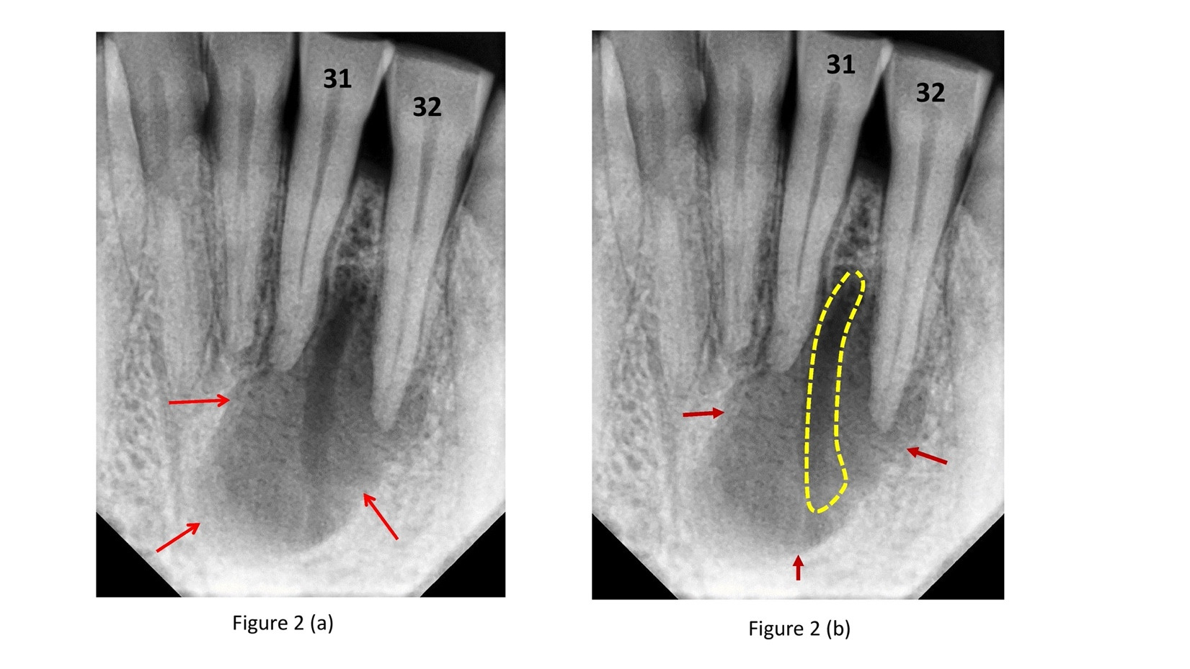
Figure 2- Periapical radiographs (a) IOPA exhibiting large periapical lesion (red arrows) wrt tooth #31,32,41 and (b) Tracing of the radiolucent channel seen in periapical lesion (yellow area)
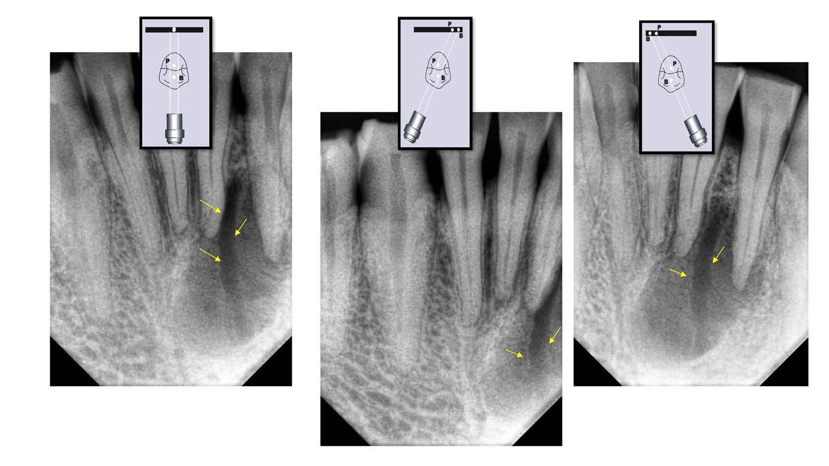
Figure 3- Three angulated IOPAs following the same lingual opposite buccal (SLOB) rule shows the radiolucent channel was lingual to the periapical radiolucency
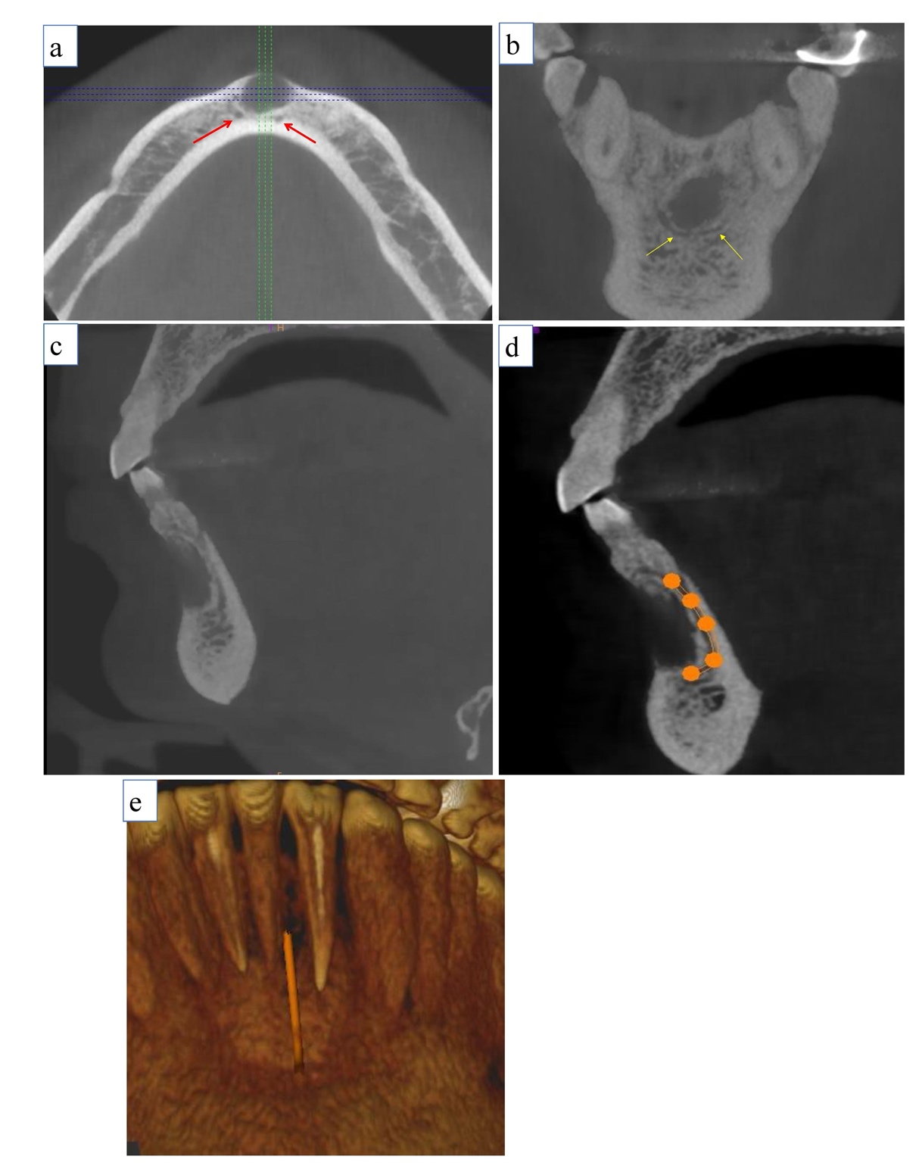

Figure 4- Axial, coronal and sagittal sections showing bilateral positional with the end of mandibular incisive canal (MIC) towards lateral and central incisors, (a) Axial section showing the presence of bilateral MIC (red arrow), (b) Coronal section at the level of lateral incisor showing bilateral looping of canal around the periapical lesion, (c) Sagittal section, (d) Sagittal section depicting the path of incisive canal (orange tracing), (e) Posterior 3D reconstruction of inner surface of mandible shows a canal entrance around lateral incisor periapex area

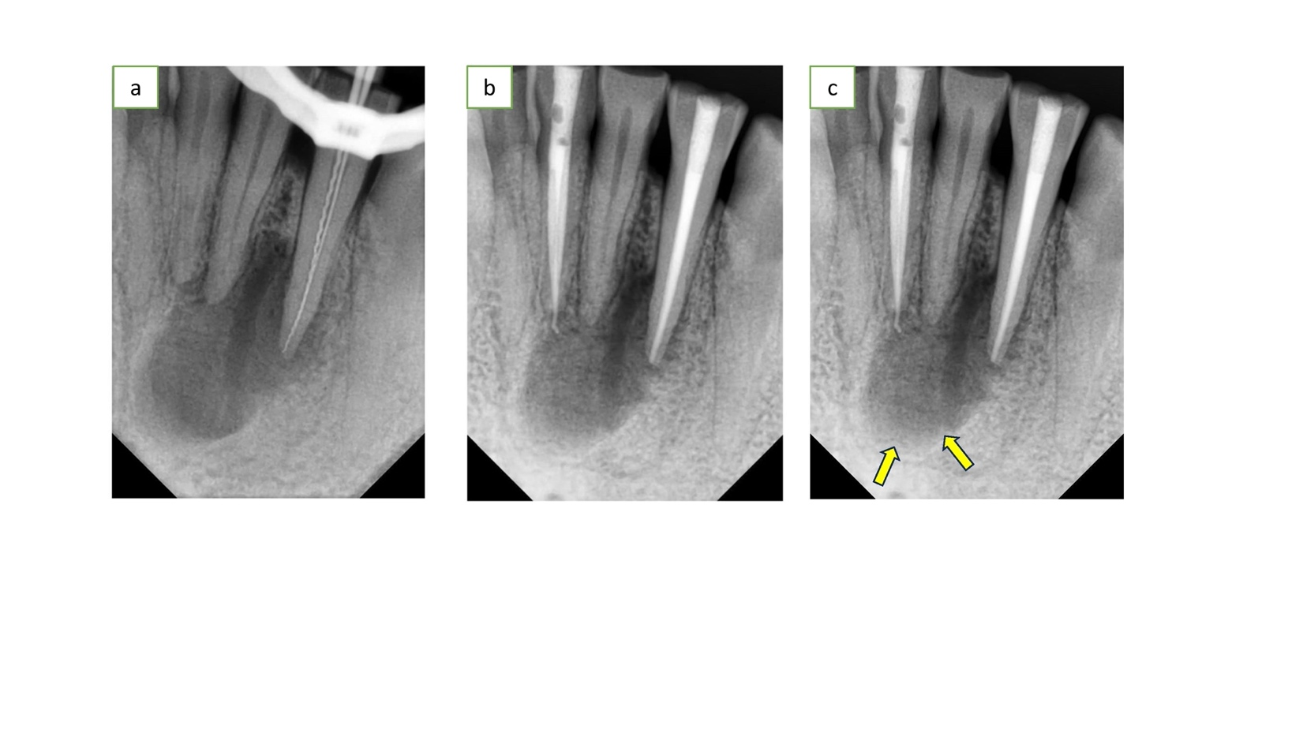

Figure 5- Completion of RCT and follow-up, (a) Working length IOPA, (b) 3month follow-up IOPA, (c) 6 months follow-up IOPA showing marked radiopacity and periapical healing initiation

