Management of Combined Periodontal treatment with endodontic therapy: A Case Report
Abstract:
The management of endo-perio lesions is complex, involving multiple factors from diagnosis to treatment. While some lesions can be managed by endodontic or periodontal therapy alone, others require an interdisciplinary approach with various treatment options.
This case report explores about management of a Palatogingival Groove Through Combined endodontic and Periodontal Therapy. The periodontal disease is a factor for tooth loss in patients with periodontitis; it is pulpal infection, necrosis, and deep caries. A 39-year-old woman reported from the Periodontology Unit, Department of Endodontics, Faculty of Dentistry, with the chief complaint of tooth length and swelling from gums in relation to upper left front tooth for last 1 year. Root canal treatment RCT by Calcium Hydroxide 30 days and then root canal filling by gutta-percha was performed and periodontal open flap technique. Clinical examination showed that PD recovered to within a normal range (approximately 3–4 mm), and tooth mobility was reduced. Imbedded in a subsequent and structured maintenance system in addition to better conformity on the part of the patient, questionable and hopeless teeth could maintain for long. The treatment should follow a suggested protocol, which starts with Root canal treatment by Calcium Hydroxide , immediately followed by RCT of the affected tooth. Subsequently, the surgical periodontal.
Key Words: Palatogingival groove, therapy of periodontal-endodontic lesion maxillary laterals, dental structure, Periodontal Therapy

Introduction:
“Morphological defects occurring in dental structure can be sometimes predisposing factors for the onset of inflammatory processes in the periodontal and pulpal tissues. Palatogingival groove is one such defect, most frequently found on the lingual surface of maxillary laterals. Recognition of such a defect is critical and important, especially because of its diagnostic complexity and its further consequences” [11,12] Combined lesions always been a challenging treatment for the clinicians. This case report signifies the accurate diagnosis, removal of etiological factors and multidisciplinary approach of treatment to restore the functional status of the tooth provide a challenging task into a streamlines approach especially for the hopeless tooth.
This case report describes the successful management of a left maxillary lateral incisor. “The development, pathology, and effectiveness of management approaches in cases involving a combined periodontal-endodontic lesion with peripocket depth (PD 9 mm) and a pulp necrosis. The periodontal classification of teeth is based on the bone of attachment loss and probing pocket depth” [1]. “The periodontal disease is a factor for tooth loss in patients with periodontitis; it is pulpal infection, necrosis, and deep caries” [2]. Anyway, new research has demonstrated that, “even with periodontic-endodontic problems, teeth as hopeless can be successfully treated” [3]. Robison & Cooley (1988) explained that the palato-radicular groove, distolingual groove, radicular lingual groove, corono radicular groove, and palatogingival groove are wrong development malformations that occur in the lingual aspect of maxillary incisors.
Case Report:
A 39-year-old woman reported from the Periodontology Unit, Department of Endodontics, Faculty of Dentistry, with the chief complaint of tooth length and swelling from gums in relation to upper left front tooth N:22 for the last 1 year. Examination revealed a distopalatal deep probing pocket depth (PPD) of 9 mm, which overlapped with the location of a palatogingival groove. The tooth did not react to an electric pulp test and showed tooth mobility (Figs. 1,2). The radiographic examination revealed a periapical lesion on tooth N:22, a radiolucent line indicating a putative accessory root, and bone resorption in the palato area tooth N:22. The diagnosis was localized chronic periodontitis and pulp necrosis, a combined periodontal-endodontic lesion potentially caused by a palatogingival groove. Root canal treatment RCT by Calcium Hydroxide 30 days and then root canal filling by gutta-percha was performed and periodontal open flap technique (Figs. 3,4,5). POF to remove the inflammatory dental alveolar bone treatment and repair pocket depth. To open the flap, local anesthesia was done with 2% lidocaine within epinephrine 1:100.000 in an appropriate dose. A reverse bevel incision is made at the attached gingiva angled to excise the periodontal pocket. Two releasing incisions are made mesial and distal to the defect gingival crest 1-3 mm. After the flap is elevated, pocketing tissues are discarded, osseous surgery can be performed, and the flap is then apically repositioned and suturing with 4-0 nylon. Medicine (drug suspension): Amoxicillin 500 mg, 2 tablets times 3 per day during 7 days; Ibuprofen 400 mg, 1 tablet every 6 or 8 hours after meal during 5 days; Chlorhexidine gluconate 0.12% rinse one a day during 2 weeks; and also asked the patient to give oral health hygiene after that recall for checkup in 10 days and also asked the patient to give oral health hygiene. After treatment, the patient was recalled periodically at 1, 3, 6, 9, 12, 15, 20, 26, and 36 months (Figs 6,7). Clinical examination showed that PD recovered to within a normal range (approximately 3–4 mm), and tooth mobility was reduced.

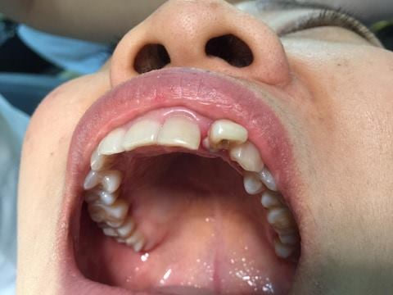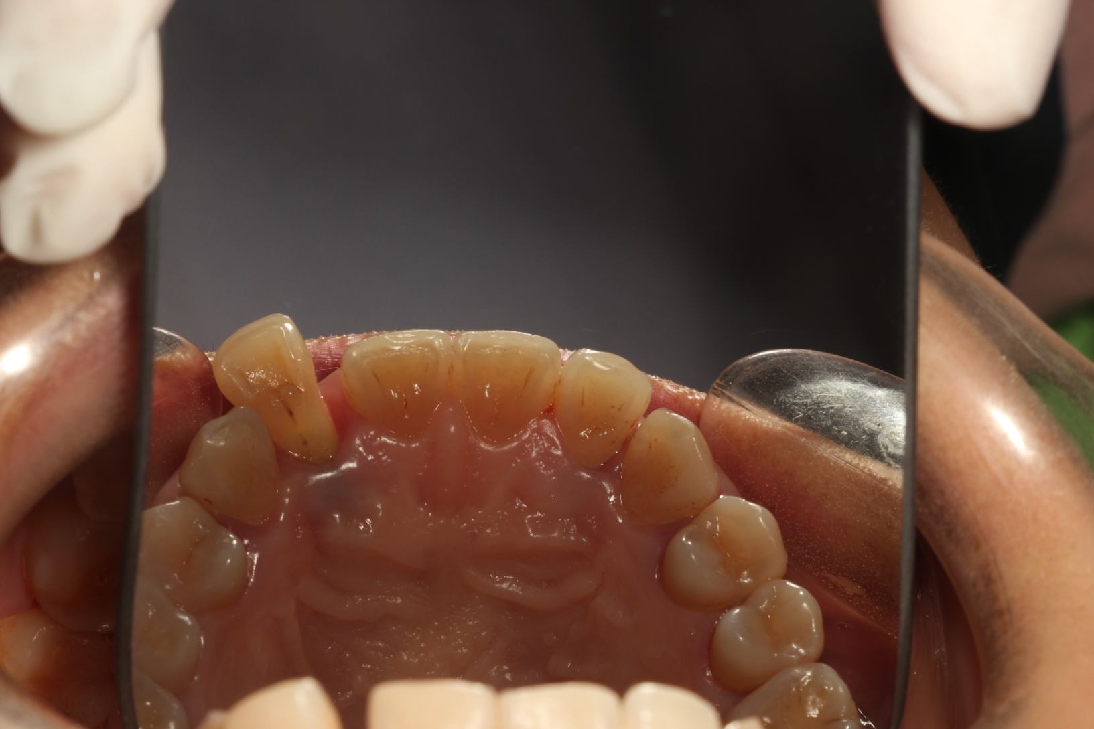
Fig 1. abscess of plaque and calcus under Fig 2. tooth long and swelling of gums in
The gum, peri pocket depth (PD 9 mm) relation to upper left front tooth N:22
In maxillary left lateral and tooth mobility
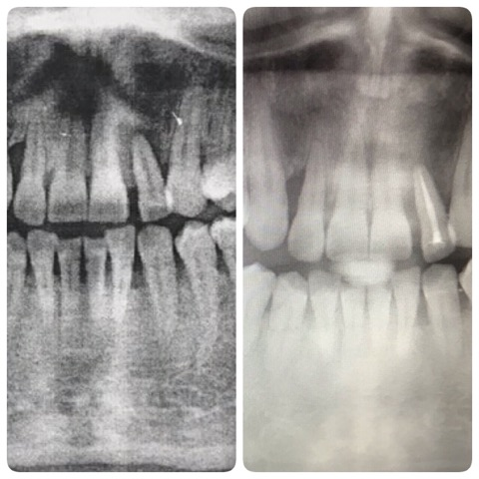
Fig 3. The periapical radiograph of tooth Fig 4. Root canal treatment RCT
N;22 showing a periapical lesion. gingiva around tooth N:22 became healthy,
and the periapical lesion resolved
without any complication

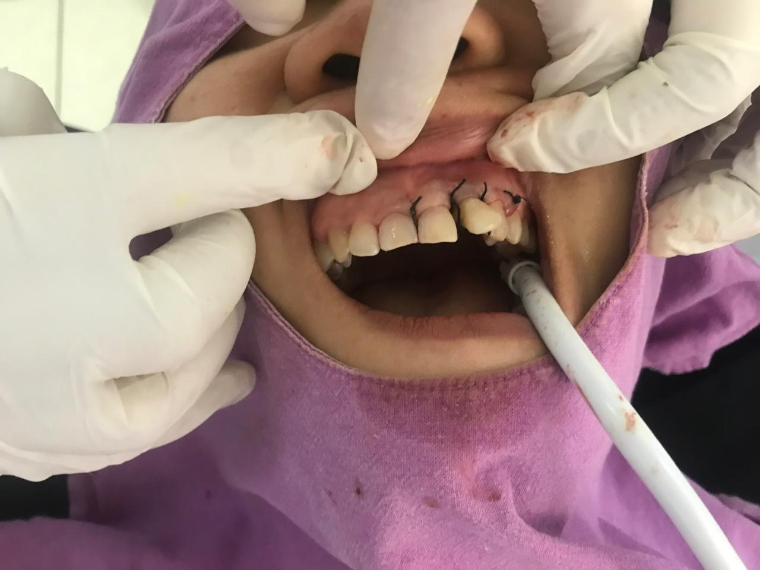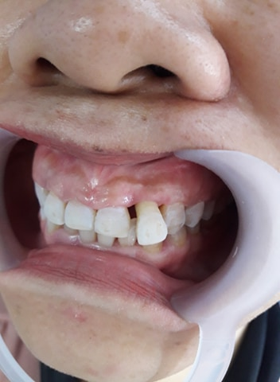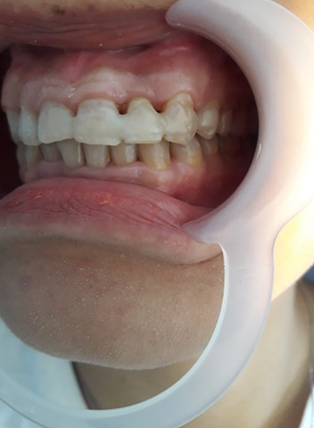
Fig 5. Periodontal open flap Fig 6. Tooth healthy in Fig 7. Follow up 36 months
Technique and suturing three months after treatment and splint
with 4-0 nylon
Discussion:
This report described A cases of periodontal-endodontic conditions involving a palatogingival groove on the palatal surface of a maxillary lateral incisor N:22. This case is follow up 36 months after treatment. Maybe these treatment options may not be the most suitable and most effective at treating the periodontic-endodontic lesion and complications of pulp necrosis. “Palatogingival groove is a morphological aberration known to frequently affect maxillary incisor teeth, with a rate of affliction seen to be higher in lateral incisors (4.4–5.6%) compared to central incisors (0.28–3.4%)”. [4,5]. Present as a structural variation Kogon SL (1986) and Withers JA (1981). In the past, the development of palate radicular groove of mankind is cited, and 12-21% of prevalence during the megalithic period (Robison & Cooley, 1988). A study revealed that “the majority of palatogingival groove in maxillaryn lateral incisor suggest probability that the groove develops from an undesirable position of the lateral incisor during the period of maxillary growth. To date, the best diagnostic method is referred to intraoral radiographs, such as periapical radiographs and horizontal and vertical bitewings” [6]. “The objective of the anti-infective therapy was to overwhelm the bacterial load and to launch a balance between bacterial burden and host response to permit for healing. Hence, due to the periodontic-endodontic lesion at the lower left first molar was crucial, which therapy regimen include endodontic treatment. Vakalis and collaborators indicated that RCT with nonsurgical periodontal treatment show the most efficient result in the enhancement of clinical parameters together with alveolar bone gain” [7]. Cortellini et al. illustrated that “regenerative periodontal care is efficacious even in hopeless teeth and may perhaps be an option to extraction” [3]. “Imbedded in a subsequent and structured maintenance system in addition to better conformity on the part of the patient, questionable and hopeless teeth could maintain for long” [8]. To keep the treatment outcome, several studies reported that “patients who conform with normal periodontal maintenance visits experience less attachment loss and lose fewer teeth than patients who get less periodontal maintenance” [9–10].
Conclusion:
This case study shows that even in teeth with periodontic-endodontic lesions of primary periodontal aetiology and pulp necrosis. The treatment should follow a suggested protocol, which starts with Root canal treatment by Calcium Hydroxide, immediately followed by RCT of the affected tooth. Subsequently, the surgical periodontal.
Consent
As per international standards or university standards, patient(s) written consent has been collected and preserved by the author(s).

Disclaimer (Artificial intelligence)
Option 1:
Author(s) hereby declare that NO generative AI technologies such as Large Language Models (ChatGPT, COPILOT, etc.) and text-to-image generators have been used during the writing or editing of this manuscript.
Option 2:
Author(s) hereby declare that generative AI technologies such as Large Language Models, etc. have been used during the writing or editing of manuscripts. This explanation will include the name, version, model, and source of the generative AI technology and as well as all input prompts provided to the generative AI technology
Details of the AI usage are given below:
1.
2.
3.
References:
[1] Tan B, Sun Q, Xiao J, Zhang L, Yan F. Pulp status of teeth in patients with chronic advanced periodontitis. Int J Clin Exp Pathol. 2020 Apr 1;13(4):635-641.
[2] C. M. Faggion Jr., G. Petersilka, D. E. Lange, J. Gerss, and T. F. Flemmig, “Prognostic model for tooth survival in patients treated for periodontitis,” Journal of Clinical Periodontology, vol. 34, no. 3, pp. 226–231, 2007.
[3] P. Cortellini, G. Stalpers, A. Mollo, and M. S. Tonetti, “Periodontal regeneration versus extraction and prosthetic replacement of teeth severely compromised by attachment loss to the apex: 5year results of an ongoing randomized clinical trial,” Journal of Clinical Periodontology, vol. 38, no. 10, pp. 915–924, 2011.
[4] Kogon SL. The prevalence, location and conformation of palato-radicular grooves in maxillary incisors. J Periodontol. 1986;57(4):231–4.
[5] Withers JA, Brunsvold MA, Killoy WJ, Rahe AJ. The relationship of palato-gingival grooves to localized periodontal disease. J Periodontol. 1981;52(1):41–4.
[6] AAP, “Position paper: diagnosis of periodontal diseases,” Jour- nal of Periodontology, vol. 74, no. 8, pp. 1237–1247, 2003.
[7] S. V. Vakalis, J. M. Whitworth, R. P. Ellwood, and P. M. Preshaw,“A pilot study of treatment of periodontal-endodontic lesions,” International Dental Journal, vol. 55, no. 5, pp. 313–318, 2005.
[8] C. Graetz, C. E. D¨orfer, M. Kahl et al., “Retention of ques-tionable and hopeless teeth in compliant patients treated for aggressive periodontitis,” Journal of Clinical Periodontology, vol.
38, no. 8, pp. 707–714, 2011.
[9] T. G. Wilson Jr., M. E. Glover, A. K. Malik, J. A. Schoen, and D. Dorsett, “Tooth loss in maintenance patients in a private periodontal practice,” Journal of Periodontology, vol. 58, no. 4,
pp. 231–235, 1987.
[10]Harrington GW, Steiner DR. Ammons WF. The
periodontal–endodontic controversy. Periodontology 2001. 2022, 30: 123-130. DOI:10.1034/j.1600-0757.2002.03012.x
[11]Bhatsange, A., Japatti, S., & Attur, K. (2012). Palatogingival groove: management of an innocuous culprit of a perio-endo lesion. Peoples J Sci Res, 5, 43-6.
[12] Cho, Y. D., Lee, J. E., Chung, Y., Lee, W. C., Seol, Y. J., Lee, Y. M., ... & Ku, Y. (2017). Collaborative management of combined periodontal-endodontic lesions with a palatogingival groove: a case series. Journal of endodontics, 43(2), 332-337.

