Odontoma-Induced Impaction: A Case series Based evaluation

Abstract
Compound odontomas are benign odontogenic tumors that frequently interfere with the eruption of permanent teeth, especially in the anterior maxillary region. This article presents a case series of three patients, each exhibiting impacted maxillary central incisors due to the presence of a compound odontoma. All patients were in the mixed dentition stage and showed delayed eruption of one or both permanent central incisors. Radiographic imaging confirmed the presence of multiple tooth-like radiopaque masses obstructing the eruption path. CBCT evaluation done in two cases. Surgical enucleation of the odontoma was performed in all cases under local anesthesia. In two patients, spontaneous eruption of the impacted incisor was observed after post-surgery. One patient needed space creation with removable appliance, as no adequate space was available. This series emphasizes the importance of early diagnosis and intervention. Although odontomas are benign, their role as physical barriers can significantly impact the normal eruption sequence and proper treatment reduces the need for more complex orthodontic treatments later.
`
Key words: Odontoma, compound odontoma, spontaneous eruption, anesthesia

Introduction
“Odontomas are considered to be developmental anomalies resulting from the growth of completely differentiated epithelial and mesenchymal cells that give rise to ameloblasts and odontoblasts. These tumors are basically formed of enamel and dentin but they can also have variables amounts of cement and pulp tissue”.^{1 “}Based on the 2017 World Health Organization classification, odontomas are divided into compound and complex odontomas according to the different compositions of tumor mass”.² Compound odontomas appear more frequently than complex odontomas.³
“The majority of odontomas which are located in the anterior region of the maxilla are compound, while the great majority of odontomas located in the posterior areas, especially in the mandible, are complex odontomas”.¹ “The etiology of the odontoma is unknown. However, it has been suggested that trauma and infection at the place of the lesion can offer ideal conditions for its appearance”.^{4 “}In general they are asymptomatic, have slow growth, and seldom exceed the size of a tooth, but when large can cause expansion of the cortical bone. Odontomas may be diagnosed at any age but they are usually detected during the first two decades of life”.¹ “The mean age of detection on an average is 14.8 years, with the prevalent age being the second decade of life. There is a slight predilection for occurrence in males (59%) compared to females. The compound odontoma is known to occur more commonly in the maxilla (67%) as compared to the mandible (33%), with a marked predilection for the anterior maxillary region (61%)”.⁴ “Odontomas are treated by conservative surgical removal and there is little probability of recurrence”.¹
“The management of odontoma with impacted teeth commonly involves removal of the lesion, followed by creating a path for eruption of the impacted permanent tooth”.^{5,6} In some studies, “the treatment of choice was surgical removal of the odontoma, immediately followed by orthodontic traction to facilitate eruption of the impacted tooth”.⁷ In other studies^{6,8} “after removing the lesion, clinical and radiological follow-up was required due to incomplete root apex closure of the impacted tooth. Fenestration followed by orthodontic traction was indicated only when spontaneous eruption did not occur. Extraction of the impacted tooth was recommended if the patient showed a combination of cystic lesions, ectopic growth, morphological changes, or a lack of space”.
This case series describes three cases with impacted maxillary central incisors and adjacent compound odontoma and various treatment modalities received for each case.

Treatment Procedure for odontoma extraction:
Surgical site is anesthetisized with 2% Lidocaine with 1:200000 through labial infiltration and Nasopalatine block. Crevicular incision is made and Envelope flap is raised in palatal direction for case 1 and case 2, in labial direction for case 3. After raising the flap, Odontome were located and luxated. Extraction of odontoma was done with bone rongeur as adaptability of rongeur's beak with the odontoma surface was better than regular forceps. The flap is then repositioned and simple interrupted sutures were given with 3-0 vicryl.
Case Presentation
Case 1
A 10-year-old girl reported to the Department of Pedodontics with a chief complaint of aesthetically unpleasant appearance because of the delayed eruption of upper front tooth. On clinical examination permanent maxillary right central incisor was missing with inadequate amount of space for its eruption and the predecessor was exfoliated 3.5 years back (Fig-1). According to the mother there was no previous dental trauma,
Occlusal radiograph revealed a radio-opaque mass in the eruption path of maxillary right central incisor and this was not confirmative of odontoma. Cone-Beam Computed Tomography (CBCT) revealed the presence of an odontoma like calcified structure in the palatal region of right maxillary central incisor (Fig.2). After routine blood examination, surgical removal of the odontoma was performed under local anesthesia. A single large odontoma was found as was anticipated from CBCT.
The impacted permanent tooth showed a fully formed root and a favorable path of eruption but with inadequate space in the arch; a maxillary expansion appliance with coffin spring was given to create space. Adequate space was created after 3 months as seen in figure 1. The same coffin-expansion appliance was retained as a space maintainer. 6 weeks later spontaneous eruption of right maxillary central incisor was noted (Fig.1, 2 & 3). Patient is kept under further follow-up.
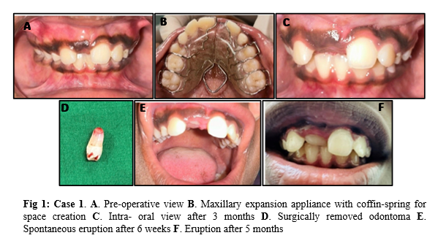
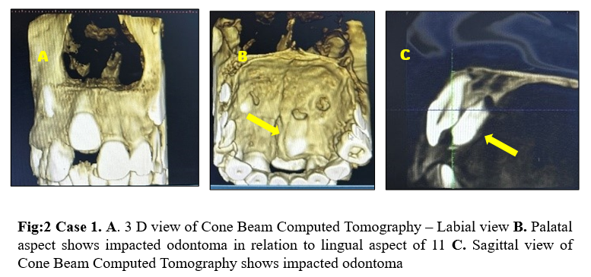
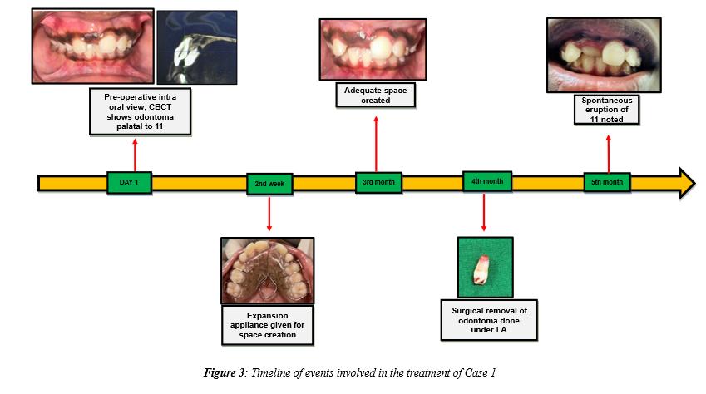
Case 2
A 6-year-old male child with his mother presented to the Pedodontics department with a chief complaint of retained upper left front tooth. On intra-oral examination, the upper left primary central and lateral incisors were found to be present but the central incisor was discolored and on the right side, the permanent central incisor had erupted. No history of dental trauma was reported by the mother.
Radiographic examination (peri-apical radiograph and occlusal radiograph) revealed the presence of an odontoma-like lesion in relation to the unerupted permanent left maxillary central incisor. The position of odontoma was confirmed by CBCT, which showed an incompletely formed odontoma like lesion of approximate size 7.54 x 8.98 x 7.56 mm. After routine blood examination surgery was performed to remove the calcified mass along with the extractions of maxillary left primary incisors. Absorbable 3-0 vicryl suture was given.
The patient's mother received written and spoken postoperative instructions on how to manage pain, maintain good oral hygiene, and eat cold, soft meals throughout the day. In the present case, we anticipated spontaneous eruption of the impacted incisor due to the younger age of the patient and its favorable position. The patient was recalled after 2 weeks of the procedure and healing was found to be uneventful. Then the patient was reviewed after 6 months and the peri-apical radiograph showed favorable path of eruption of the left permanent maxillary central incisor. The patient is under regular follow-up to see whether the tooth erupts spontaneously or not. If no sign of eruption is noticed even after 6 months, further treatment with surgical exposure and orthodontic traction will be carried out (Fig 4, 5 & 6).
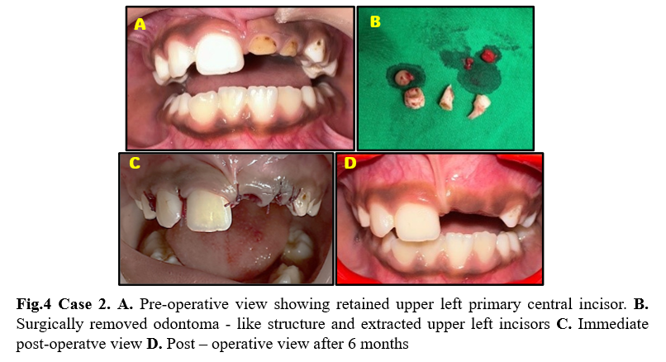
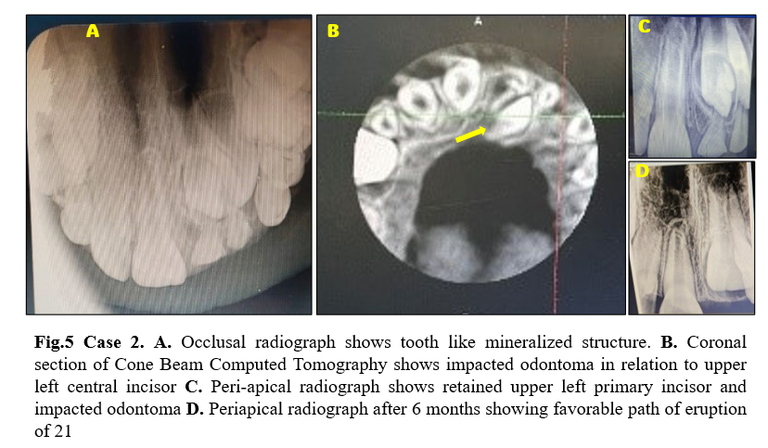
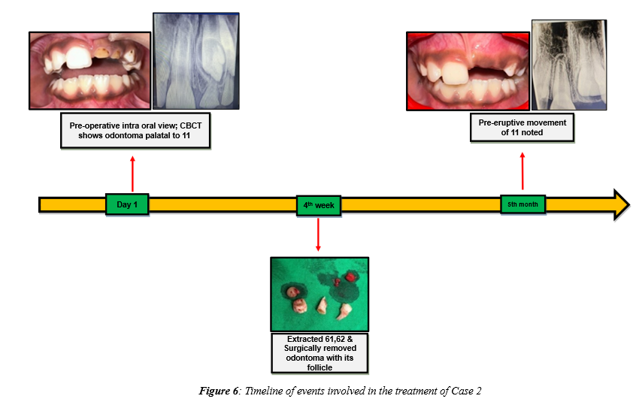
Case 3
A 9-year-old male child reported to the Department of Pedodontics with a chief complaint of unpleasant appearance because of the unerupted upper front tooth. On clinical examination right and left permanent maxillary central incisors were missing, and the deciduous teeth were exfoliated 4 years back. According to the mother there was a dental trauma which had occurred at the age of 4 years. There was inadequate amount of space for the eruption of the incisors and a highly attached maxillary labial frenum was also present.
Radiographic examination revealed the presence of two radio-opaque masses of compound odontomas in the path of eruption of the upper permanent central incisors. After routine blood examination, surgical removal of the odontomas was performed and a single relatively large odontoma was found in relation to both the central incisors. A removable space maintainer was given to manage the space until the eruption of the teeth. The root apices of both the central incisors were open and hence it was decided to wait for their spontaneous eruption. After 3 months the eruption bulges of both central incisors were noted high up in the alveolus. After one year follow up, radiographic examination was done as there was no eruption of the clinically missing teeth. Dilaceration of the roots of both central incisors was noted which was more severe on maxillary left central incisor. After discussing with orthodontists, a decision was made to surgically expose the unerupted teeth and to undertake comprehensive orthodontic treatment after the eruption of the two central incisors figure 7-C). The incision was made just above the labial sulcus exposing the incisal thirds of the crowns of the two unerupted teeth. At 3-month follow-up, only the right central incisor was erupted (figure 7-D) but left one remain unerupted because of the high attached thick maxillary labial frenum. Labial frenectomy along with surgical exposure of left central incisor was done at this stage (figure 7-E) and after 4 weeks it was erupted (Fig-7, 8, 9 &10).
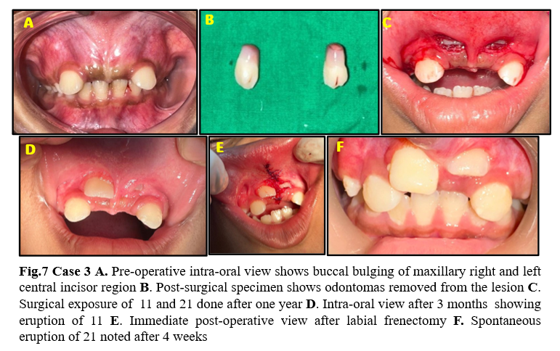
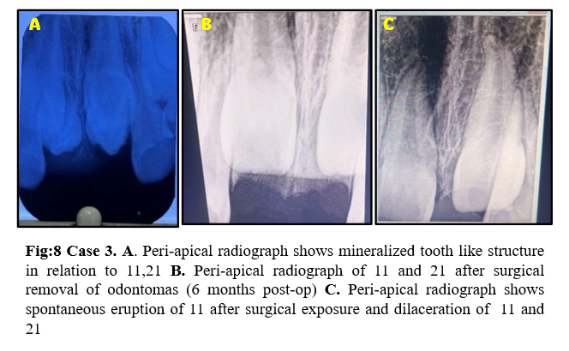
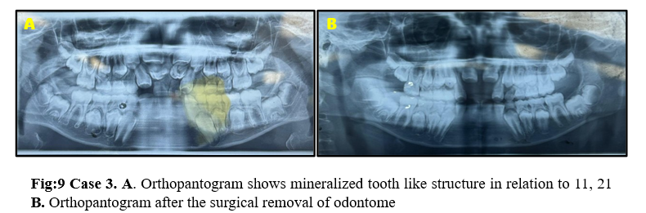
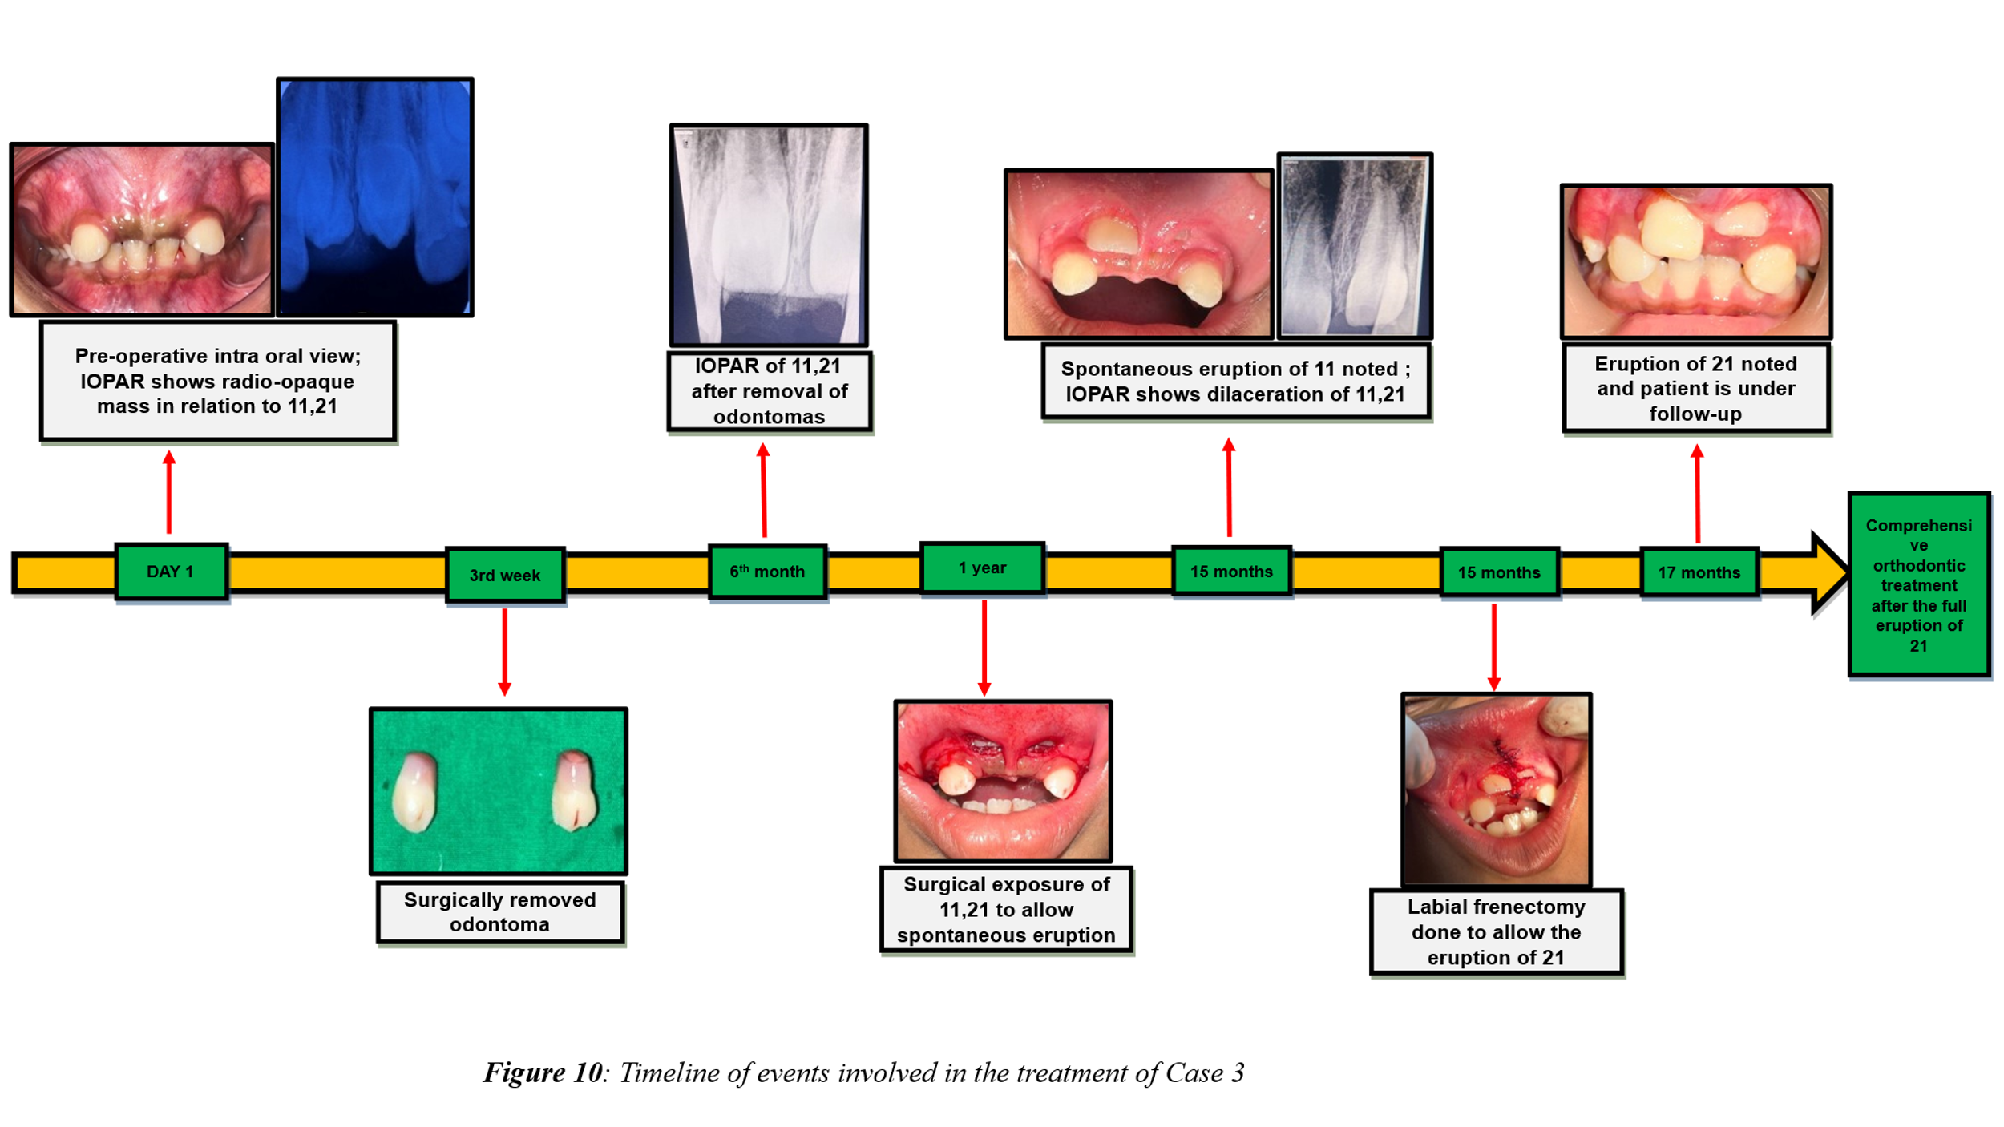
Discussion
“Odontomas are relatively common odontogenic lesions, generally asymptomatic, and are rarely diagnosed before the second decade of life. They frequently lead to impaction or delayed eruption of permanent teeth”.¹
“The three cases described in this study were initially diagnosed as compound odontomas since the radiographic examination of the lesions showed a calcified structures anatomically similar to small teeth. All tumors were found on the anterior region of the maxilla, which, according to many researchers^{4,9} is the most common location. One of the patients had suffered a trauma in the region where the lesion developed. According to the literature, development of odontoma could be related to traumatic dental injury mainly intrusive luxation or exarticulation”.^{4,10} In case 3, the odontoma produced a small swelling of the cortical bone and the observed swelling was possibly related to the size of the lesions. In Case 2, although there were odontomas large enough to displace the primary incisor, there was no mobility of the primary teeth, which prompted the mother to seek dental treatment for the child.
The third case showed large odontomas in the path of eruption of both maxillary central incisors causing impaction of the permanent succedaneous teeth. Inadequate space and high attached maxillary labial frenum hindered the spontaneous eruption of the permanent teeth even after the removal of lesions. Root dilaceration was also noticed in the subsequent radiographs taken during the follow-up visits. Labial frenectomy and surgical exposure of teeth were done to facilitate the eruption. “It may be necessary to use orthodontic traction of the affected tooth in order to guide it to an adequate position in the dental arch. This therapeutic approach is recommended by Bengston et al.¹¹ and Oliver and Hodges”.¹²
In Case 2, the lesion was surgically removed prior to the primary teeth being exfoliated, and the diagnosis was made during the primary dentition stage. In order to protect the healthy permanent teeth and avoid interfering with their emergence, odontomas should ideally be extracted when the permanent teeth next to the lesion show around half of their root growth. Kaban¹³ states that “odontomas are easily enucleated and adjacent teeth that may have been displaced by the lesion are seldom harmed by the excision since they are usually separated from the lesion by a septum of bone”. Since the lesion in Case 2 was discovered at the palatal aspect of the upper permanent incisor crown, which was already fully developed, early treatment was carried out. Iatrogenic harm to these teeth's root development was highly unlikely for the same reason. In this instance, the impaction of the permanent upper incisors was most likely avoided by prompt detection and treatment of the condition.

Conclusion
According to clinical experience and the dental literature, every paediatric patient who exhibits clinical signs of primary tooth displacement or delayed permanent tooth eruption, regardless of whether they have a history of prior dental trauma, should have a customised radiographic examination. This case series demonstrated that early detection of odontomas guarantees a better prognosis and permits the use of a less involved and costly treatment.
Consent
Parental consent was obtained for all patients included in this case series.
Disclaimer (Artificial intelligence)
Author(s) hereby declare that NO generative AI technologies such as Large Language Models (ChatGPT, COPILOT, etc.) and text-to-image generators have been used during the writing or editing of this manuscript.

References
- Neville BW, Damm DD, Allen CM, Bouquot JE: Oral and Maxillofacial Pathology. Philadelphia: Saunders, 5th edition, 2023, pp 531-33
- A.K. El-Naggar, J.K. Chan, J.R. Grandis, T. Takata, P. Slootweg, WHO Classification of Head and Neck Tumours, fourth ed., IARC, Lyon, 2017.
- Owens BM, Schuman NJ, Mincer HH, Turner JE, Oliver FM: Dental odontomas: a retrospective study of 104 cases. J Clin Pediatr Dent 21:261-64, 1997
- Shafer, Hine, Levy. Shafer’s Textbook of Oral Pathology. Rajendran R, Sivapathasundharam B, editors. Cysts and tumors of odontogenic origin. 9th ed. New Delhi: Elsevier; 2020, p. 404-7
- P.W. K€ammerer, D. Schneider, E. Schiegnitz, S. Schneider, C. Walter, B. Frerich, et al., Clinical parameter of odontoma with special emphasis on treatment of impacted teeth-a retrospective multicentre study and literature review, Clin. Oral Invest. 20 (2016) 1827–1835
- G. Serra-Serra, L. Berini-Ayt_es, C. Gay-Escoda, Erupted odontomas: a report of three cases and review of the literature, Med. Oral Patol. Oral Cir. Bucal 14 (2009) E299–303
- N. Khan, N. Shrivastava, T.V. Shrivastava, F.M. Samadi, An unusual case of compound odontome associated with maxillary impacted central incisor, Natl. J.Maxillofac. Surg. 5 (2014) 192–194.
- M. Tomizawa, Y. Otsuka, T. Noda, Clinical observations of odontomas in Japanese children: 39 cases including one recurrent case, Int. J. Paediatr. Dent. 15 (2005)37–43.
- Budnick SD: Compound and complex odontomas. Oral Surg Oral Med Oral Path 42:501-506, 1976.
- Areal-López L, Silvestre DF, Gil LJ: Compound odontoma erupting in the mouth: 4 year follow-up of a clinical case. J Oral Pathol 21:285-88, 1992.
- Bengston AL, Bengston NG, Benassi, LRDC: Odontomas em pacientes pediátricos. Revista de Odontopediatria 2:25-33, 1993.
- Oliver RG, Hodges CGL: Delayed eruption of a maxillary central incisor associated with an odontome: report of case. ASDC J Dent Child 55:368-71, 1988.
- Kaban, LB: Pediatric Oral and Maxillofacial Surgery. Philadelphia: Saunders, 1990, pp 111-12.

