Verruca Vulgaris of the Right Buccal Mucosa: A Case Report

ABSTRACT
Verruca vulgaris, commonly referred to as a wart, is a benign growth that develops due to infection with the human papillomavirus (HPV). While warts are predominantly found on the skin, oral involvement is relatively uncommon. Clinically, oral lesions may appear as verruca plana, filiform warts, or verruca vulgaris. The latter is a self-limiting lesion of the skin and mucosa that can persist for years without intervention. This report highlights the case of a 42-year-old male who presented with a whitish, finger-like lesion on the right buccal mucosa. This lesion was described as slow growing with no symptoms but later difficulty in mastication. Following clinical and histological evaluation, the lesion was diagnosed as verruca vulgaris, and complete excision was performed under local anesthesia

Keywords: Human papillomavirus, Verruca vulgaris, Common warts, filiform warts

INTRODUCTION
Verruca vulgaris (VV), also called common wart, is a lesion associated with HPV infection and is typically observed on the skin and mucosal surfaces [1]. It represents a benign epithelial proliferation, with malignant transformation being extremely uncommon [2]. Clinical presentation can vary depending on the viral subtype and anatomical location. Oral manifestations, though rare, resemble cutaneous lesions and usually appear as sessile or exophytic growths with a papillomatous or rough surface [3,4]. These lesions may develop at any age but are more frequently seen in children. The lips, buccal mucosa, and tongue are the most common intraoral sites [5]. The presence of HPV in oral tissues has been confirmed through electron microscopy, molecular biology, and immunohistochemistry [6,7].

CASE PRESENTATION
A 42-year-old male attended a private dental clinic with a history of a painless growth on the right buccal mucosa that had persisted for three years. The lesion had slowly enlarged over time and was described as whitish, fleshy, and finger-like in appearance. The patient also expressed difficulty in mastication due to the lesion.
On examination, a solitary, irregular growth measuring approximately 2 × 2 cm was observed in the right buccal mucosa. The lesion extended from the commissure of the lip anteriorly to the pterygomandibular raphe posteriorly and from the maxillary to mandibular vestibule vertically. The surface appeared rough and hyperpigmented. On palpation, the lesion was firm, leathery in consistency, non-movable, and non-pinchable, with no associated ulceration or discharge. The patient was scheduled for excisional biopsy under local anesthesia after routine blood investigations. The specimen was preserved and submitted for histopathology examination. All the following procedures were performed with patients' concern.
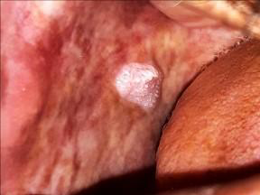

Figure 1: Lesion on right buccal mucosa
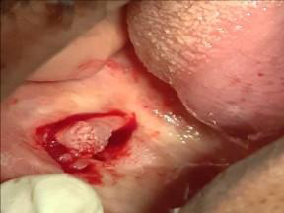

Figure 2: Excision of the lesion
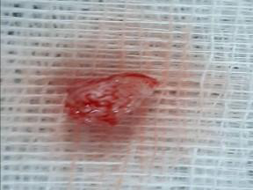

Figure 3: Excised specimen

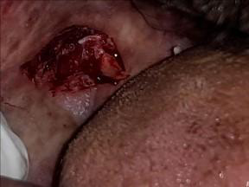

Figure 4: Buccal mucosa showing excised lesion

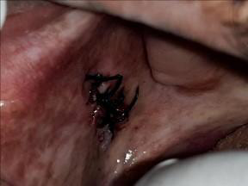

Figure 5: Sutures placed in the excised site

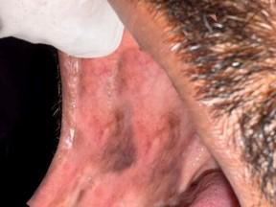 Figure 6: Post-operative healing

HISTOPATHOLOGY
Microscopic examination revealed features consistent with verruca vulgaris. The lesion showed hyperkeratotic stratified squamous epithelium arranged into elongated, finger-like projections supported by connective tissue cores. The underlying connective tissue exhibited a chronic inflammatory cell infiltrate. Rete ridges appeared elongated and converged toward the lesion’s center, producing a characteristic “cupping” configuration [8]. The granular layer displayed hypergranulosis with coarse, clumped keratohyalin granules. Numerous koilocytes (HPV-altered epithelial cells with perinuclear halos and pyknotic nuclei) were present in the superficial spinous layer. Occasional eosinophilic intranuclear inclusions were also identified [9].

DISCUSSION
Oral verruca vulgaris represents a relatively small proportion of papillomatous lesions of the oral cavity caused by HPV types mainly HPV-2 and HPV-4 [5]. These lesions may range from solitary exophytic growths to multiple spreading verrucous proliferations. The presence of koilocytes is a key histopathological feature that supports HPV involvement [9]. Although most cases occur in children, adults may also develop oral lesions [1]. The hands are the most common site of cutaneous infection, while intraorally, the vermilion border, labial mucosa, and tongue are frequently affected [6]. Clinically, oral verruca vulgaris often appears as a painless, rough, or papillary nodule that may be sessile or pedunculated. Oral lesions are generally white, in contrast to cutaneous warts, which can appear pink, yellow, or white and are linked to HPV types 2, 6, 11, and sometimes high-risk types 16 and 18. [2]. HPV, a double-stranded DNA virus, is the causative factor. More than 120 HPV genotypes have been identified, with several types specifically linked to oral and anogenital lesions [3,7].It is the name of 200 groups of viruses[13] The pathophysiology is that the virus gains entry through microtrauma in the skin and infects the basal keratinocytes of the stratified squamous epithelium. HPV DNA enters the host cell nucleus and remains in an episomal (non-integrated) form and leads to keratinocytes proliferation which causes acanthosis (thickening of the epidermis), hyperkeratosis (excess keratin), and papillomatosis (finger-like projections), which give the wart its rough, raised, and exophytic appearance. Treatment options vary but no single method is universally effective. Topical agents such as salicylic acid and cantharidin provide limited benefit, whereas immunotherapy and systemic drugs like cimetidine and levamisole have been tried with inconsistent results [10,11]. Surgical excision remains the most reliable method, providing both diagnostic and therapeutic benefits [12].

Other treatment modalities : [ 12]
- Systemic drugs: Agents such as cimetidine and levamisole have been tried, though their efficacy remains inconsistent.
- Retinoids: Vitamin A–derived compounds that interfere with abnormal epithelial cell proliferation. They are available as topical creams or oral formulations.
- Immunotherapy: Topical agents such as imiquimod (Aldara) are sometimes prescribed for recalcitrant lesions. In severe, treatment-resistant cases,intralesional injections of interferon-α may be considered.
- Salicylic acid: One of the most commonly used topical therapies; available in solutions and medicated patches (typically containing 17% salicylic acid)
- Occlusion therapy (duct tape method): Involves covering the wart with adhesive tape for prolonged periods (usually two months), with periodic changes to promote resolution.
- Cryotherapy: Application of liquid nitrogen to induce tissue necrosis by freezing. It is generally well-tolerated but often requires multiple sessions.
- Laser therapy: Destructive treatment using laser energy; effective but costly and may result in scarring.
- Surgical options: Excision or electrosurgery (electrodessication) may be employed, though they carry risks of scarring and recurrence.

CONCLUSION
Verruca vulgaris is an uncommon but benign lesion of the oral cavity that may mimic other oral or cutaneous pathologies. Accurate diagnosis is essential to avoid unnecessary interventions and ensure proper management. The present case emphasizes the significance of clinical evaluation in conjunction with histopathology to reach a definitive diagnosis. Complete surgical excision under local anesthesia is a practical and effective treatment approach, offering both functional and aesthetic benefits while improving the patient’s quality of life [12].

Consent
As per international standards or university standards, Participants’ written consent has been collected and preserved by the author(s).

Disclaimer (Artificial intelligence):

I hereby declare that NO generative AI technologies such as Large Language Models (ChatGPT, COPILOT, etc.) and text-to-image generators have been used during the writing or editing of this manuscript.

REFERENCES
1.Forman D, de Martel C, Lacey CJ, Soerjomataram I, Lortet-Tieulent J, Bruni L, et al. Global burden of human papillomavirus and related diseases. Vaccine. 2012;30(Suppl 5):F12–23. doi:10.1016/j.vaccine.2012.07.055. [DOI]
2.Bzhalava D, Guan P, Franceschi S, Dillner J, Clifford G. A systematic review of the prevalence of mucosal and cutaneous human papillomavirus types. Virology. 2013;445(1-2):224–231. doi:10.1016/j.virol.2013.07.015. [DOI] [PubMed] [Google Scholar]
3.Orth G, Jablonska S, Favre M, Croissant O, Obalek S, Jarzabek-Chorzelska M, Jibard N. Identification of papillomavirus in butchers’ warts. J Invest Dermatol. 1981;76:97–102. doi:10.1111/1523-1747.ep12525394.
[DOI] [PubMed]
4.Eversole LR, Laipis PJ, Green TL. Human papillomavirus type 2 DNA in oral labial verruca vulgaris. J Cutan Pathol. 1987;14:319–325. doi: 10.1111/j.1600-0560.1987.tb01531.x. [DOI] [PubMed] [Google Scholar]
5.Green TL, Eversole LR, Leider AS. Oral and labial verruca vulgaris: clinical, histologic and immunohistochemical evaluation. Oral Surg Oral Med Oral Pathol. 1986;62:410–416. doi:10.1016/0030-4220(86)90290-2. [DOI] [PubMed]
6.Jenson AB, Lancaster WD, Hartmann D, Shaffer EL. Frequency and distribution of papillomavirus structural antigens in verrucae, multiple papillomas and condylomata of the oral cavity. Am J Pathol. 1982;107:212–218. [PMC free article] [PubMed] [Google Scholar]
7.Jin YT, Toto PD. Detection of human papovavirus antigen in oral papillary lesions. Oral Surg Oral Med Oral Pathol. 1984;58:702–705. doi: 10.1016/0030-4220(84)90039-2. [DOI] [PubMed]

8.Terezhalmy GT, Rilley CK, Moore WS. Oral verruca vulgaris. Quintessence Int. 2002;33(2):162–163. [PubMed]

9.Koss LG, Durfee GR. Unusual patterns of squamous epithelium of the uterine cervix and pathologic study of koilocytotic atypia. Ann NY Acad Sci. 1956;63:1245–1261. doi: 10.1111/j.1749-6632.1956.tb32134.x. [DOI] [PubMed]

10. Harper DM, Franco EL, Wheeler CM, Moscicki AB, Romanowski B, Roteli-Martins CM, et al. Sustained efficacy up to 4.5 years of a bivalent L1 virus-like particle vaccine against human papillomavirus types 16 and 18:Follow-up from a randomised control trial. Lancet. 2006;367(9518):1247–1255. doi: 10.1016/S0140-6736(06)68439-0. [DOI] [PubMed]

- Nagaraj, M. Verruca Vulgaris of the Tongue. J. Maxillofac. Oral Surg. 12, 329–332 (2013). https://doi.org/10.1007/s12663-010-0097-5[DOI]

- .Prasad D, Pandhi R, Juneja A, Negi KS. Verruca vulgaris. Pediatr Dermatol. 2001;18(4):349– 352. doi: 10.1046/j.1525-1470.2001.01951.x. [DOI]

- K. Adler-Storth, J. R. Newland, B. A. Tessin, W. A. Yeudall, E. J. Shillitoe https://doi.org/10.1111/j.1600-0714.1986.tb00613.x [DOI]

