Transforming Market and Slaughterhouse Wastes into Compost for Sustainable Agriculture

ABSTRACT:

Aims: Management of organic waste from markets and slaughterhouses is a major challenge for African cities. The disposal of these wastes in landfills or simple abandonment without treatment constitutes a significant pollution source to surface and groundwater due to the infiltration and runoff of organic and mineral compounds. The present study aims to simultaneously use those wastes for agricultural use through composting to mitigate water pollution and establish sustainable waste management.

Study design: Market and slaughterhouse wastes were firstly collected. One part of these has been dried before composting process. Both dried wastes and composts from the above mentioned process were characterized by weighting and physico-chemical analyses. Then the effect of composts has evaluated on crops development and yields. In fine, this effect has been optimized with biochar produced with rice husks.

Place and Duration of Study: Market wastes were collected at Sinistre Market and slaughterhouse wastes were collected at municipal slaughterhouse of Korhogo, between December 2024 to January 2025. Composting and plot experiments were carried out from February 2025 to March 2025

Methodology: Wastes were collected from Sinistre Market over 22 days and at municipal slaughterhouse of Korhogo over 55 days. Before composting process, wastes have been weighted and one part dried. Composting process have used Berkley method (18 days), which consists in superimposing layers of dry materials rich in carbon and fresh materials rich in nitrogen to form piles (pyramidal pile) of at least 0.90 m³ which will undergo periodic reversals. A sample of 1 kg of each produced compost was taken, dried and following physico-chemical parameters were analyzed: total nitrogen, phosphorus, potassium, pH, cation exchange capacity, electrical conductivity, calcium, sulfur, carbon. Laboratory Analyses were done by using Mehlich 3 method, along with an infrared spectrometer. The influence of resulting compost on okra (Abelmoschus esculentus) crops has been evaluated compared to control and NPK treatment.

Results: Collecting data revealed substantial generated wastes: about 1,244 kg of fresh market wastes was collected and 26,000 kg of fresh viscera from the slaughterhouse collected. Physicochemical analyses confirmed high nutrient content of obtained composts, with concentrations of nitrogen ranging from 4 to 4.3 g/kg, phosphorus contents from 4.6 to 6.3 g/kg, and potassium lelvels from 19.4 to 20.6 g/kg. the application of produced composts improved significantly the growth and yield of okra. The best results has been achieved with compost from slaughterhouse dry matter in association with fresh market matter and ¼ to ½ quantity of biochar, yielding 3.2 kg, compared to 0.42 kg in control plots.

Conclusion: These results indicate that co-composting of market and slaughterhouse wastes reduces the environmental impact of wastes disposal, while providing a viable alternative to chemical fertilizers in agriculture.

Keywords: Agriculture, Compost, Organic waste, Korhogo

1. INTRODUCTION

Rapid urbanisation and uncontrolled population growth in many African cities have led to a dramatic increase in organic waste generation, particularly wastes from markets and slaughterhouses (Sotamenou, 2010). Without a sustainable system for wastes management, these wastes become a problematic source of pollution, increased by traditional economic models with that involves extracting raw materials, manufacturing and consuming products, and then discarding wastes (Kaza et al., 2018). This model is particularly imortant for perishable wastes, which need rapid management, found solutions to avoid public health and environmental hazards (Rockler et al., 2022). When exposed to the weather, leachates from wastes decomposition, infiltrate the soil or run off and contaminate groundwater and surface water with high loads of nitrates, phosphates and organic matter (Dalhatou et al, 2022). However, far from being considered as a nuisance, this waste could offer good opportunities for reuse and circular economy, particularly in the agricultural sector. Rich in essential nutrients such as nitrogen (N), phosphorus (P) and potassium (k), these market and slaughterhouse refusals could be transformed, through appropriate techniques such as composting to produce organic fertilizers, (Guardia et al 2010). In this context of circular economy and sustainable development, organic recovery is part of a perspective of reducing surface water pollution, strengthening food security and improving soil fertility and adapted to local contexts for use in agriculture. The co-composting of several urban organic wastes is a sustainable strategy for creating a balanced and nutrient-rich soil amendment that can improve soil health and structure (Onwosi et al., 2017). This valorisation is crucial in areas where soil degradation and food insecurity threaten the resilience of local agricultural systems, an issue that integrated waste management can help address (Ouro-Salim et al., 2021). This study is situated within the framework of circular economy and sustainable development. It proposes an integrated approach to waste management that not only could reduce surface water pollution but also improve soils fertility and enhance food security (Varalta et al., 2020). The principal objective of the present study is to contribute to reduce surface water pollution by valorizing wastes form markets and slaughterhouses into a high-value organic fertilizer, thereby promoting sustainable waste management. To achieve this aim, the following specific objectives are proposed:
- To characterize the physicochemical properties of the organic waste produced by selected markets and slaughterhouses.
- To produce and assess the agronomic quality of compost derived from the co-composting of market and slaughterhouse waste.
- To evaluate the effect of the produced compost on the growth and yield of a test crop (okra - Abelmoschus esculentus).

2. material and methods

2.1 Presentation of study area

The experimental study was conducted on a site near of University PELEFORO GON COULIBALY OF KORHOGO. (Figure 1), with following GPS coordinates: Latitude 9.4275029, Longitude -5.6424851, Altitude 390, 2084768.

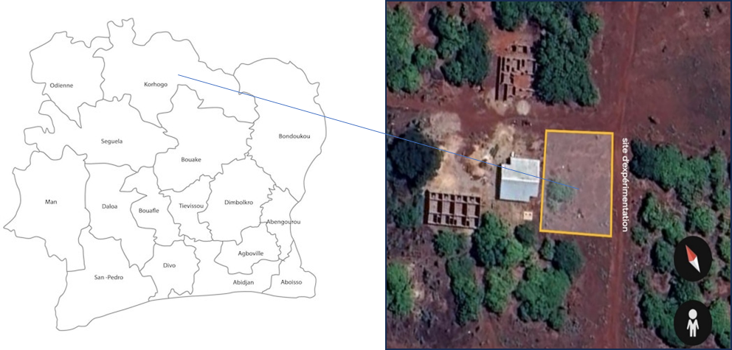

Figure 1: Experimental study area

2.2 Methods
2.2.1 Characterization of market and slaughterhouse waste

The waste collection was carried out at the small market of Sinistré with material presented in figure 2. Two types of garbage bins were distributed to vendors to collect organic waste. The small 30-liter bins are used for personal collections and the large 200-liter bins for collecting large quantities of wastes from small bins. Every morning, the large garbage cans were emptied and transported to the waste treatment site. Once on site, the waste was manually sorted to separate the recoverable materials, quantified and dried before the composting process. At Korhogo slaughterhouse, wastes were collected daily using wheelbarrows and shovels, to effectively collect viscera waste from the slaughterhouse's activities. After collection, fresh waste was weighed to determine the quantities produced and spread on a drying tarpaulin in a space inside the slaughterhouse. To facilitate drying, regular turnovers were carried out. Finally, the waste was bagged and weighed and then transported with a tricycle to the composting site.

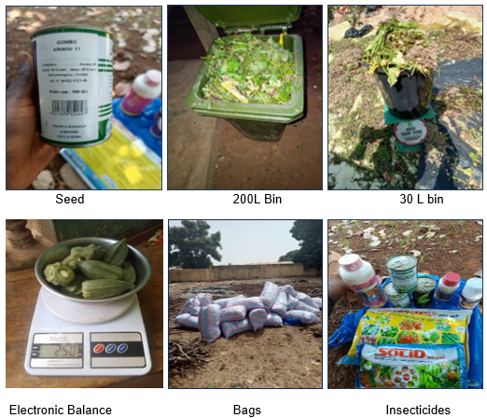

Figure 2: Equipment for collecting, sorting, composting and cultivating the parcel
2.2.1 Composting process with collected wastes
2.2.1.1 Co-composting protocol

Among the various existing methods, the method used for the present study is that of Berkley (Misra et al., 2005). This method was chosen for its ability to accelerate the decomposition process, thanks to a rigorous management of the inputs and a frequent reversal of the pile. The principle of this method consists in superimposing layers of dry matter rich in carbon and fresh matter rich in nitrogen to form piles (pyramidal pile) of at least 0.90 m³ of organic waste from markets and slaughterhouses differentiated by their compositions which will undergo periodic reversals. Composites piles have been made on surfaces of 1m² with 2 layers: 0.5 m³ for the bottom layer and 0.4 m³ for the top layer, according to fresh and dry matter position. Composting took place over a period of 18 days with a first turn-over on the 4th day followed by daily turns-over to promote aeration and homogeneous decomposition of the waste.

2.2.1.2 Composting of dry organic matter from the market and fresh from
slaughterhouse

The materials used at the first layer are the dry organic waste of the market at 140 kg and the second layer located above includes 600 kg of fresh viscera waste. The pile set up with is watered with 180 liters of water to start composting. The pile was supported on a 3 m² tarpaulin and was covered with a 6 m² plastic tarpaulin to conserve heat.

2.2.1.3 Composting of slaughterhouse, fresh market and slaughterhouse dry organic
matter

This second attempt aims to test a different combination of materials, using a base layer of 152kg dry viscera waste, topped by two layers of fresh waste, one from the market 60kg, then the other from the slaughterhouse 42kg to form a pile. Watering is done with 160 liters of water to promote good humidity. The pile was supported on a 3 m² tarpaulin and was covered with a 3 m² plastic tarpaulin to conserve heat.

2.2.1.4 Composting of fresh organic matter from market and slaughterhouse

In the latter experiment, compost is formed only from fresh materials, which considerably modifies the water requirements for initiating the process. Fresh viscera waste has a quantity of 300 kg and fresh organic waste from the market is 75 kg. Watering is done with 15 liters of water due to the natural moisture already present in the fresh materials. The pile was supported on a 3 m² tarpaulin and was covered with a 3 m² plastic tarpaulin to conserve heat. This combination allowed to test the feasibility of composting with fresh materials and a minimum of water addition.

2.2.2 Biochar production process

The biochar production process consisted of the use of a device (pyrolyzer). Dry wood twigs were lit and covered with the device, rice bales from a mill were put in turn to create an incomplete combustion of these woods, in order to carbonize the rice bales under the effect of the heat of the fire contained in the device. A regular reversal was made to spread the carbonization over all the rice bales used in the process. (Figure 3).

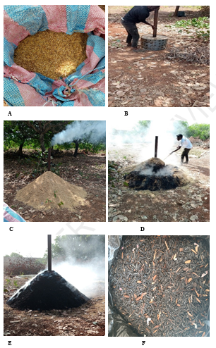
A: Collected rice husks, B: Pyrolyzer filling with wood, C: Rice husks spilling on pyrolyzer, D: Monitoring and turning over, E: End of process, F: Obtained product

Figure 3 : Biochar production process

2.2.3 Physico-chemical characterizations of produced composts

A sample of 1 kg of produced composts was taken, dried and brought to laboratory for analysis using Melhich 3 method combined with an infrared spectrometer analyser, in order to evaluate the fertilizing potentialities (essential nutrients and organic matter content). The following physico-chemical parameters were concerned: total nitrogen, phosphorus, potassium, pH, cation exchange capacity, electrical conductivity, calcium, sulfur, carbon, magnesium, manganese, iron; copper, molybdenum, zinc, lead, arsenic, chromium, nickel, cadmium.

2.2.4 Effect of produced composts on crops (okra) growth and yield

The okra seeds were sown directly by hand on logs made by hoe. The distance between the lines was 50 cm and 40 cm between the pockets which allows for 40 pockets on a line. Watering was done twice a day manually using a watering can that can hold 15 liters of water. Every 10 days, measurements were taken to find out the size of each plant using a tape measure. The plants were treated with the insecticide « kapaas and K optimal » and fungicides to control crop pests. The lines of 40 pockets have received amendments according to the experimental design (Figure 4).

Control
NPK
CSMFA
CF(M+A)
CSAF(M+A)
CSMFA+ ¼ BIO
CSMFA+ ½ BIO
CF(M+A) + ½ BIO
CSAF(M+A) + ¾ BIO
CSAF(M+A) + ¼ BIO

CSAF(M+A)+ ½ BIO
CF(M+A) + ¾ BIO
CF(M+A) + ¼ BIO

CSMFA+ ¾ BIO

CSMFA: Compost made from market dry matter and fresh slaughterhouse material
CSAF(M+A): Compost of slaughterhouse dry matter and market and slaughterhouse fresh matter
CF(M+A): Compost made from fresh market and slaughterhouse material
BIO: Biochar

Figure 4: Experimental design of lines (40 pockets) treated by obtained composts, NPK and control

2.2.5 Analysis of plants growth data

The statistical analysis was carried out with the Origin Pro 8.0. Plant growth data were entered and then means and standard deviations were calculated. A single-factor ANOVA test was used to obtain value F, associated probability (Prob>F) and coefficient of determination (R-square), to check whether the means of different heights showed significant differences. The growth kinetic of okra treated with compost obtained from slaughterhouse dry matter and fresh market-slaughterhouse material adding ½ dosage of biochar. Maximum mean plant heights were determined by fitting a nonlinear curve according to the Slogistic1 model.

3. results and discussion
3.1 Quantity of collected wastes and obtained composts

Characterization of organic wastes at from the market of Sinistré and the slaughterhouse of Korhogo shows significant collected wastes volumes (Figure 5). Slaughterhouse wastes amount was about 26 tons of fresh wastes, compared to 1,244 kg wastes from market. After drying, the mass of slaughterhouse waste decreases to 4634.64 kg, i.e. about 83% of lost mass due to evaporation. This is in accordance with work of Zhang et al. (2010), which relates that organic waste, especially that of animal origin, has very high moisture contents, ranging from 70 to 85%. Concerning market wastes, the mass was reduced by up to 396 kg (a mass loss of 68.2%), which is consistent with several previous studies that indicate that municipal organic wastes generally have a water content of between 60% and 80% (Kaza et al., 2021; Zhang et al., 2010). These above quantities represent only a portion of Korhogo's organic wastes. Taken regionally or even nationally, these quantities become even more important. These wastes are rich in nitrogen, carbon, fats, proteins and pathogens. In the rainy season, runoff carries untreated wastes to waterways, which can cause eutrophication, negatively impacting the lives of aquatic animals. This idea is supported by Parrot (2010) which indicates that the unplanned management of organic waste in African cities is a permanent source of water pollution, making it difficult to treat for human or agricultural consumption.

Figure 5: Market and slaughterhouse wastes collected quantity

The quantity of produced composts varies according to type and the combination of the materials used, varying from 76.35kg to 277.45 kg representing a percentage from 20.36 % to 59.84 % of the initial mass of each pile (Table 1). This could be attributed to the decrease in size of the materials as mentioned by Hashim et al. (2022) following the decomposition of the organic matter by the microorganisms present in the piles. However, special attention must be paid to the choice of materials and their proportion in the co-composting process. According to Lim et al. (2016), a better structuring of the initial mixture, ensuring a more balanced C/N ratio and good aeration, essential elements for a rapid and effective degradation of the organic matter. Figure 6 shows the three types of composts produced.
Table 1: Quantities of organic matter used for composting

 | CSMFA | CSAF(M+A) | CF(M+A)
Organic matters Used Quantities (kg) | 140kg MDM + 600 kg SFM | 152kg SDM + 60kg MFM de 42 kg SFM | 300kg SFM+75kg MFM
Total used Quantities (kg) | 740 kg | 254 kg | 375 kg
Obtained compost Quantities | 277.45 kg | 152kg | 76.35kg
Yield (%) | 37 | 59.84 | 20.36
SFM: Slaughterhouse Fresh Material, MFM: Market Fresh Matter; DMS: Slaughterhouse Dry Matter, MDM: Market Dry Matter

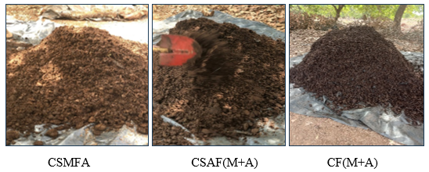
Figure 6: Composts obtained from collected wastes

3.2 Physico-chemical characteristics of composts and biochar

Analysis of physico-chemical parameters reveals that produced organic composts are rich in essential primary macronutrients (Figure 7). Nitrogen content, ranging from 4 to 4.3 g/kg, supports vegetative growth. Phosphorus concentration, from 5.3 to 6.3 g/kg, aids flowering and fruiting, while potassium content, from 19.4 to 20.6 g/kg, enhances plant stress resistance. These values align with quality compost standards (ADAS Consulting Limited, 2005), confirming their suitability as soil amendments. Biochar showed high organic carbon content (43.6%), consistent with its known stability from pyrolysis (Lehmann & Joseph, 2009), but its low nutrient content necessitates combination with compost for effective use. Composts also contained beneficial levels of magnesium from 2.6 to 2.8 g/kg and calcium from 17.4 to 20.4 g/kg, crucial for soil fertility and crop nutrition, related in the works of El-Ramady et al. (2024). Heavy metal concentrations (Pb, Cd, As, Cr) were all below safety thresholds, confirming the composts' safety (ADAS Consulting Limited, 2005). C/N ratios from 9.6 to 10.9 (Figure 8) indicate composts are mature and suitable for immediate agricultural use (ADEME, 2006). pH values from 6.5 to 8.2 are optimal for nutrient availability. Cation Exchange Capacity (CEC) was highest in CSAF(M+A) compost (34.22 cmol/kg) and biochar (25 cmol/kg), indicating excellent nutrient retention potential, critical for tropical soils (Stewart et al., 2020). Electrical conductivity values from 417.11 to 470.65 μS/cm are within safe ranges for plant growth, while biochar (265.69 μS/cm) offering a balancing option when blended with compost (Lou et al., 2022). Recent studies further validate the efficacy of such compost-biochar integrations in enhancing soil health and crop productivity in sustainable agricultural systems (Agegnehu et al., 2017; Zahra et al., 2021; Kaza et al., 2018).

Figure 7: Chemical contents of obtained composts

Figure 8 : Physical characteristics of composts

3.2 Effect of produced compost on okra cultivation

Germination rates vary according to applied treatment (Table 2), indicating that quality of the substrate used plays an important role in seed germination. Treatment with only obtained composts gave about 45 to 90% of germination, while composts combined with biochar gave about 70 to 100% of germination and control only 42.5%. This result is similar of Zucconi et al. (1981) works, which emphasizes that poor or unbalanced substrates can impact seed emergence.

Table 2 : Germination rate
Treatments | Germination rate (%)
Control | 42,5
CSMFA | 45
CSAF(M+A) | 55
CF(M+A) | 90
CSMFA +¾ BIO | 70
CSMFA+ ½ BIO | 70
CSMFA+ ¼ BIO | 92,5
CSAF(M+A) +¾ BIO | 92,5
CSAF(M+A) + ½ BIO | 100
CSAF(M+A) + ¼ BIO | 100
CF(M+A) +¾ BIO | 87,5
CF(M+A) + ½ BIO | 82,5
CF(M+A) + ¼ BIO | 82,5

Figure 9 shows growth of crops treated with organic composts only. In terms of plant growth, results obtained show that plants treated with organic composts, significantly improve plant growth, compared with plants treated with mineral fertilizer (NPK) and control line. In general, control treatment showed the lowest growth over the entire measurement period with an average growth of 17.59 cm on day 43. Treatment with NPK and CSAF(M+A) evolved in almost the same way with growth values of 20.20 cm and 19.56 cm respectively on day 43, while CSMFA and CF(M+A) show improved values of 22.65 and 21.87 cm respectively. The limited effect observed in the control is due to nutrient deficiencies in the soil, this is confirmed by Diacono et al. (2010) who claim that the lack of nutrient intake leads to a low availability of essential elements for plant growth. NPK fertilizer intake improves this growth through the availability of nutrients. This is in line with Edmeades works (2003), where authors emphasize that mineral fertilizers provide nutrients but do not improve the structure of the soil or its ability to retain water and nutrients. Organic composts have shown good growth performance thanks to improved soil organic matter, microbial activity and nutrient availability. This improvement is more visible with the organic composts associated with the biochar in different proportions, especially on the line treated with CSAF(M+A) ½ + BIO which reaches the higher growth value on day 43 (approximately 32.85 cm). (Figure 10). CF(M+A) +¾ BIO and CSMFA+ ¼ BIO composts show relatively good growth results with respective values at day 43 of 30.19 and 28.84 cm. (Figures 11 and 12). This is consistent with results of Lehmann and Joseph (2015), which means that biochar plays a key role in improving nutrient retention, stabilizing organic matter and promoting microbial activity, which prolongs and intensifies the effect of compost, which is clearly seen on Figure 13.

Figure 9: Crops growth treated with composts only

Figure 10: Crops growth treated with compost (CSAF(M+A) and biochar)

Figure 11: Growth of Plants treated with compost (CF(M+A) and biochar)

Figure 12: Growth of plants treated with Compost (CSMFA and biochar)

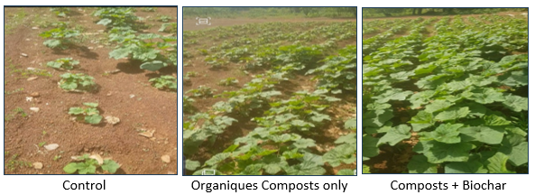

Figure 13: Difference in plant growth after composts application

Growth kinetic of plants treated with CSAF(M+A) + ½ BIO is of sigmoidal regression type (slogistic 1) (Figure 14) compared to slogistic 3 found by Kouakou et al. (2024), represented by the equation below. Descriptive statistics reveal a high variability between tested groups and a strong positive correlation between these variables. ANOVA test reveals a very high F value, indicating that variability between tested groups is highly significant. This value, combined with a critical probability (p=0.00355) below the 5% threshold, attests the strong positive correlation between these tested groups. In line with observations of Pituch and Stevens, (2015), which emphasizes that in statistics, a high F value means that the variation explained by the model is much greater than the unexplained variation (error), which is consistent with the validity of obtained results.

H $=\frac{Hm}{1+e^{-k(n-nc)}}$

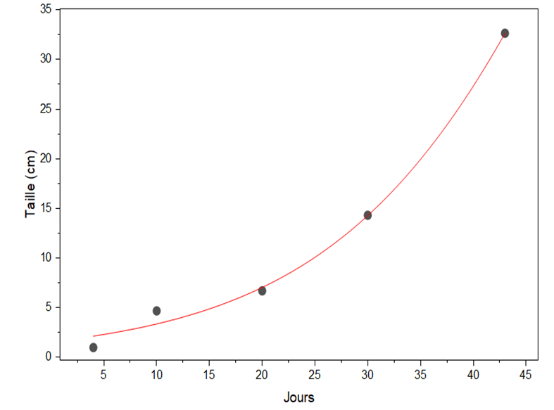

Figure 14: Growth kinetic of Okra plants

Table 3 : Descriptive statistic
Hm | Hm | Xc | Xc | K | k | Statistic
 |  |  |  |  |  | Reduced Chi-Sqr | Adj. R-Square
131,3 | 216,5 | 57,4 | 32,3 | 0,076 | 0,021 | 1,58687 | 0,98999

Table4 : Variance analysis
 | DF | Sum of squares | Mean square | F Value | Prob>F
Model | 3 | 1335,93136 | 445,31045 | 280,62158 | 0,00355
Error | 2 | 3,17374 | 1,58687
Total | 5 | 1339,1051

Cumulative yields vary according to the treatment applied (Figure 15). Control line give the lowest yield (0.45 kg), confirming that experiment soil is poor in nutritive elements. This result is consistent with the work of Nziguheba et al. (2002), which highlights that tropical soils are generally poor in organic matter and essential nutrients. The addition of simple organic composts allowed an improvement in yield compared to the yield of treatment with NPK as found by Kouakou and Negalo (2025) in their study about agricultural valirisation of market organic wastes. Intake of NPK mineral fertilizer improved yield with a total of (1.06 kg). As for treatments with organic composts only, they gave yields of (1kg, 0.98kg and 1.02kg) respectively for CSMFA, CSAF(M+A) and CF(M+A). Crops growth enhancement observed with treatments combining CSAF(M+A) compost with biochar amendments could be due to the synergistic improvement of substrate physicochemical properties. Maximum yield of 3.2 kg obtained with the combination CSAF(M+A) + ¼ Bio and CSAF(M+A) + ½ Bio is a consequency of this synergy.
This enhanced performance could be firstly explained by the high cation exchange capacity (CEC) of CSAF(M+A) compost, which is further amplified by biochar addition. According to physicochemical analysis, biochar also has a significant CEC, which is important for plant growth as it let growing medium to retain essential nutrient cations like ammonium (NH₄⁺), potassium (K⁺), calcium (Ca²⁺), and magnesium (Mg²⁺) (Lehmann & Joseph, 2015). Furthermore, combining biochar with compost anhances soil structure. Biochar is known to be highly porous, which induce aeration and water retention, while compost provides organic matter and nutrients. Works of Agegnehu et al. (2017) shown that crops treatment with biochar and compost improves microbial activity and nutrient availability.
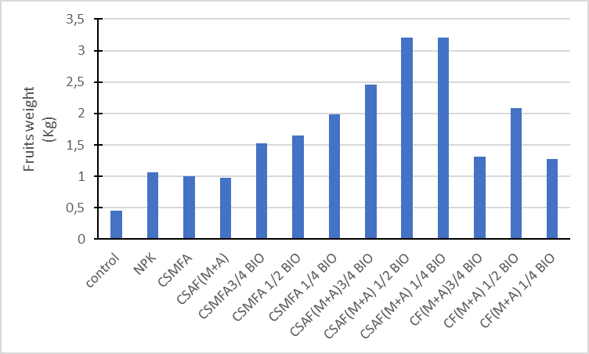

Figure 15: Yields of different Treatments

4. Conclusion

The uncontrolled discharge of waste contributes to environmental pollution in general, especially surface water, and improved waste management would help reduce the impact of such pollution. This study aims to reduce surface water pollution by transforming the quantities of market and slaughterhouse waste into a high value-added product with a view to sustainable waste management. The results obtained confirm that compost produced from organic waste is rich in plant nutrients: nitrogen content varies from 4 and 4.3 g/kg, phosphorus content ranges from 5.3 to 6.3 g/kg and potassium is between 19.4 to 20.6 g/kg). The treatment of these composts on okra (Abelmoschus esculentus) cultivation gave significant results on vegetative parameters, at the level of growth of the line treated with CSAF(M+A) at the dose ½ of the biochar which gave the highest average growth from 43 (about 32.5 cm). The best yield was obtained with the SCAF treatment (M+A) at the ¼ dose of the biochar, reaching a cumulative yield of 3.2 kg, i.e. approximately 4 tons per hectare, while the control shows 0.42 kg, i.e. approximately 411 kg per hectare. Ultimately, the work allowed to collect a significant amount of this waste, to transform this waste into a nutrient-rich compost for the good development and better yield of plants.
Perspectives:
- The establishment of a structure for the recovery of this organic waste
- Energy production via biogas from this waste, which could offer a dual recovery path
- Conduct assessments on large plots and other crops for validation of the outcomes of this study.
COMPETING INTERESTS DISCLAIMER:
Authors have declared that they have no known competing financial interests OR non-financial interests OR personal relationships that could have appeared to influence the work reported in this paper.

Disclaimer (Artificial intelligence)
Author(s) hereby declare that NO generative AI technologies such as Large Language Models (ChatGPT, COPILOT, etc.) and text-to-image generators have been used during the writing or editing of this manuscript.

References

1. ADAS Consulting Limited & Enviros. (2005). Assessment of options and requirements for stability and maturity testing of composts (Final Report No. OFR806). The Waste and Resources Action Programme (WRAP). 21 Horsefair, Banbury, Oxon OX16 0AH, United Kingdom. 145 pp. https://wrap.org.uk/sites/default/files/2021-03/OFR806.pdf
2. French Agency for the Environment and Energy Management (ADEME). (2006). Home Composting (Practical Guide). Angers, France: ADEME Éditions. 48 p. https://librairie.ademe.fr/dechets-economie-circulaire/31-le-compostage-domestique-guide-pratique.html
3. Agegnehu, G., Srivastava, A. K., & Bird, M. I. (2017). The role of biochar and compost in improving soil quality and crop performance: A review. Applied Soil Ecology, 119, 156–170. https://doi.org/10.1016/j.apsoil.2017.06.008
4. Kaza, S., Yao, L., Bhada-Tata, P., & Van Woerden, F. (2018). What a Waste 2.0: A Global Snapshot of Solid Waste Management to 2050. Urban Development. Washington, DC: World Bank. https://doi.org/10.1596/978-1-4648-1329-0
5. Lim, S. L., Lee, L. H., & Wu, T. Y. (2016). Sustainability of using composting and vermicomposting technologies for organic solid waste biotransformation: recent overview, greenhouse gases emissions and economic analysis. Journal of Cleaner Production, 111, 262-278. https://doi.org/10.1016/j.jclepro.2015.08.083
6. Diacono, M., & Montemurro, F. (2010). Long-term effects of organic amendments on soil fertility. A review. Agronomy for Sustainable Development, 30(2), 401–422. https://doi.org/10.1051/agro/2009040
7. Zahra, M. B., Aftab, Z.-E.-H., Akhter, A., & Haider, M. S. (2021). Cumulative effect of biochar and compost on nutritional profile of soil and maize productivity. Journal of Plant Nutrition, 44 (11), 1664 – 1676. https://doi.org/10.1080/01904167.2021.1871743
8. Varalta, F., & Sorvari, J. (2020). Biochar–Compost Mixtures as a Promising Solution to Organic Waste Management Within a Circular Holistic Approach. In H. Hettiarachchi, S. Caucci & K. Schwärzel (Eds.), Organic Waste Composting through Nexus Thinking (pp. 213-232). Springer, Cham. https://doi.org/10.1007/978-3-030-36283-6_10
9. Misra, R. V., Roy, R. N., & Hiraoka, H. (2005). On-farm composting methods. FAO Soils Bulletin No. 31. Rome: Food and Agriculture Organization of the United Nations. 103 p. ISBN 92-5-105233-1. Disponible sur : https://www.fao.org/3/y5104e/y5104e00.htm
10. Edmeades, D.C. (2003). The long-term effects of manures and fertilizers on soil productivity and quality: a review. Nutrient Cycling in Agroecosystems, 66(2), 165–180. https://doi.org/10.1023/A:1023999816698
11. El-Ramady, H., Prokisch, J., Mansour, H., Bayoumi, Y. A., Shalaby, T. A., Veres, S., & Brevik, E. C. (2024). Review of Crop Response to Soil Salinity Stress: Possible Approaches from Leaching to Nano-Management. Soil Systems, 8(1), 11. https://doi.org/10.3390/soilsystems8010011
12. Hashim, S., Waqas, M., Rudra, R.P., Khan, A.A., Mirani, A.A., Sultan, T., Ehsan, F., Abid, M., & Saifullah, M. (2022). On-farm composting of agricultural waste materials for sustainable agriculture in Pakistan. Scientifica, 2022, 5831832. https://doi.org/10.1155/2022/5831832
13. Guardia, A. D., Mallard, P., Teglia, C., Marin, A., & Le Pape, C. (2010). Comparison of five organic wastes regarding their behaviour during composting: part I, biodegradability, stabilization kinetics and temperature rise. Waste Management, 30(3), 402-414. https://doi.org/10.1016/j.wasman.2009.10.019
14 N, M., Dalhatou, S., Wilson, J., Kamdem, B. P., Temitope, M. B., Paumo, H. K., … Assadi, A. (2022). Characterization of slaughterhouse wastewater and development of treatment techniques: A review. Processes, 10(7), 1300. https://doi.org/10.3390/pr10071300
15. Lehmann, J., & Joseph, S. (Eds.). (2015). Biochar for Environmental Management: Science, Technology and Implementation (2nd ed.). London: Routledge. 976 pp. https://doi.org/10.4324/9780203762264
16. Ouro-Salim, O. & Guarnieri, P. (2021). Circular economy of food waste: A literature review. Environmental Quality Management, 30(2), 225-242. https://doi.org/10.1002/tqem.21836
17. Nziguheba, G., Merckx, R., Palm, C. A., & Mutuo, P. (2002). Combining Tithonia diversifolia and inorganic fertilizers for maize production in a phosphorus deficient soil in Kenya. Agroforestry Systems, 55(3), 165–174. https://link.springer.com/article/10.1023/A:1020540411245
18. Rolker, H., Eisler, M., Cardenas, L., Deeney, M., & Takahashi, T. (2022). Food waste interventions in low-and-middle-income countries: A systematic literature review. Resources, Conservation & Recycling, 186, 106534. https://doi.org/10.1016/j.resconrec.2022.106534
19. Onwosi, C. O., Igbokwe, V. C., Odimba, J. N., Eke, I. E., Nwankwoala, M. O., Iroh, I. N., & Ezeogu, L. I. (2017). Composting technology in waste stabilization: On the methods, challenges and future prospects. Journal of Environmental Management, 190, 140-157. https://doi.org/10.1016/j.jenvman.2016.12.051
20. Lou, X., Zhang, Q., & Li, Y. (2022). Distinctive Features of Composts of Different Origin: A Thorough Examination of the Characterization Results. Sustainability, 14(12), 7449. https://doi.org/10.3390/su14127449
21. Pituch, K. A., & Stevens, J. P. (2015). Applied Multivariate Statistics for the Social Sciences: Analyses with SAS and IBM’s SPSS (6th ed.). Routledge. https://doi.org/10.4324/9781315814919
22. L Parrot, J Sotamenou, B K Dia. 2009. Municipal solid waste management in Africa: Strategies and livelihoods in Yaoundé, Cameroon. Volume 29, Issue 2, p 986-995 https://doi.org/10.1016/j.wasman.2008.05.005
23. Stewart, Z. P., Pierzynski, G. M., Middendorf, B. J., & Prasad, P. V. V. (2020). Approaches to improve soil fertility in sub-Saharan Africa. Journal of Experimental Botany, 71(2), 632–641. https://doi.org/10.1093/jxb/erz446
24. Zhang, D. Q., Tan, S. K., & Gersberg, R. M. (2010). Municipal solid waste management in China: Status, problems and challenges. Journal of Environmental Management, 91(8), 1623–1633. https://doi.org/10.1016/j.jenvman.2010.03.012
25. Zucconi, F., Pera, A., Forte, M., & de Bertoldi, M. (1981). Evaluating toxicity of immature compost. BioCycle, 22(2), 54–57. https://www.scirp.org/reference/referencespapers?referenceid=1651299
26. Kouakou Y.S and NEGALO N.A.N (2025). Agricultural Valorization of Organic Wastes from Market of Korhogo City in Côte d’Ivoire. Journal of Experimental Agriculture International Volume 47, Issue 3: 398-407 DOI: https://doi.org/10.9734/jeai/2025/v47i33347
27. Kouakou Y.S, SEYHI B and KONAN N.L (2024). Agricultural Valorization of Treated Effluent from Korhogo Wastewater Treatment Plant. Journal of Agriculture and Ecology Research International, Volume 25, Issue 6: 9-23, DOI: https://doi.org/10.9734/jaeri/2024/v25i6635

