Use of the basin technique for efficient rainwater management on mid-slope rice growth

Abstract
A short research study on rainfed rice production was conducted on the experimental perimeter located a short distance from the University of San Pedro. The objective of the study was to use the basin technique for effective rainwater management in mid-slope rice cultivation. To this end, an experiment was conducted using a Fisher block design with seven treatments and four replicates in order to control these different parameters. The plots were arranged perpendicular to the slope and delimited by ridge structures to obtain basins in which the rice was sown. The basin technique had a positive effect on rice growth compared to the control without basins, with a significant difference (P˂ 0.0001) between treatments in terms of yield and growth. This technique reduced soil erosion, unlike the control, where the roots were exposed and the plants were uprooted. It appears to be a means of facilitating cultivation on the slopes of the hills that dominate the south-west of Côte d'Ivoire.
Keywords : Basin technique, Efficient management, Rainfed rice, Slope

Introduction
Rice is the staple food of more than half the world's population. As such, it accounts for almost a fifth of all the calories consumed by humans worldwide. Today, rice consumption is increasing worldwide, while production is decreasing due to a number of factors (Issoufaly and Hani, 2023). World rice production in 2023-2024 is thus expected to reach a new record of 529.2 million tonnes (in milled rice equivalent), 0.7% higher than the level estimated for 2022-2023 (FAO, 2025). Because of its growing importance as a staple food, rice plays a key role in African diets, accounting for almost 40% of the total volume of cereals consumed (Duvallet, 2023). Rice consumption in Africa has risen sharply to reach, at least in cities, the same level as in Asian countries (Bousten et al., 2013). As water is the driving force behind mineral nutrition, it is important that this water requirement is met for rice to express its production potential (Bouhary 2020). For quality and quantity production, rice needs a quantity of water appropriate to the different development phases of the plant.
Nowadays, rainfall is a major limiting factor for rice production in rainfed ecology, due to its irregularity and the downward trend in the amount of rain received (Doumbia and Depieu, 2013). It is with a view to efficient management of water and mineral elements that our study proposes the trough technique for hilly regions such as San Pedro. The aim of this study is to contribute to achieving rice self-sufficiency in Côte d'Ivoire.

I- Materials and Methods
1-1- Materials
1-1-1- Presentation of the study area
The town of San Pedro is located in the extreme south-west of Côte d'Ivoire, in the San Pedro region in the Bas Sassandra district. The geographical coordinates of the site are: latitude 4°47'10, 224‘, longitude -6°42'6,768’ and altitude 45m. The Department's climate, which is hot and humid, is characterised by two rainy seasons and two dry seasons (Bugre, 2023). The soils of San Pedro District, developed on granitic parent rocks, fall into three categories: the ferralitic soils of the hills and plateaux, poor in organic matter, often stony and
chemically poor, the hydromorphic soils of the lowlands and the alluvial soils of the plains of the San Pedro and its tributaries (Fig. 1).

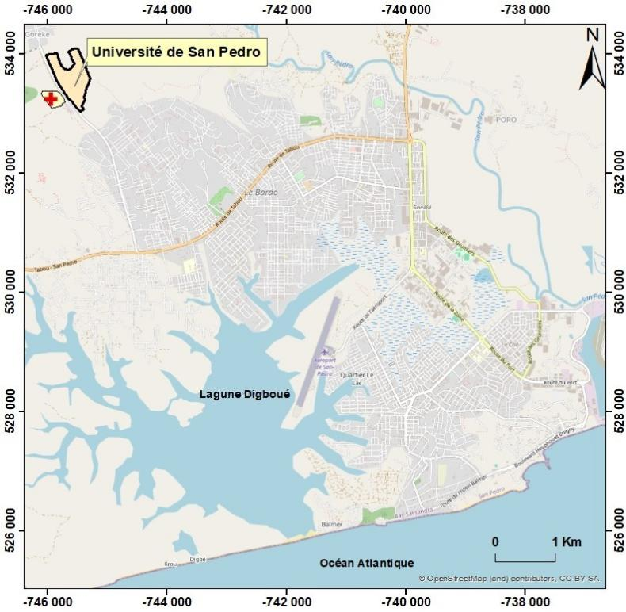
Fig. 1 : Map of the town of San Pedro (Source : OUATTARA et al., 2024)

1-1-2- Vegetable material
The plant material for the trial consisted of a rice variety CRAM 3, a maize variety Ferké 7635 and an upright cassava variety Bocou 5. However, for our study, the measurements focused mainly on rice. The CRAM 3 variety, created in 2005 and originating from Benin. It was developed in a context of climate change to ensure food security (Kindo, 2019). This rice variety is early, highly productive and resistant to diseases such as blast and helminthosporium. It has a 104-day cycle and is drought tolerant. Its potential yield is 4,90 t/ha (Zadi . and al. (2022) he seeds used come from the CNRA in Man (Fig. 2).
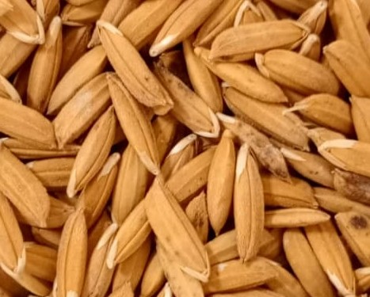
Fig. 2 : CRAM3 rice seed (scale 1/5)

1-1-3- Technical equipment
it consists of :
- a tube for taking soil samples ;
- a hoe and a machete for ploughing, weeding and clearing undergrowth;
- a decameter and ropes for demarcation and sowing (Fig. 4);
- stakes for demarcating microplots;
- bags for soil samples;
-fertilisers, for bottom dressing and top dressing (fig. 3);
-a digital camera for taking photographs;
- a measuring rod, to determine growth heights; - a precision balance;
-a branded precision balance for weighing fertilisers and yields (fig. 5).
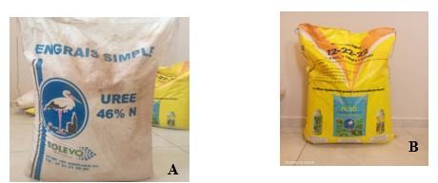
Fig. 3: Fertiliser (A-Urea; B- NPK 12-22-22): Scale: 1/5
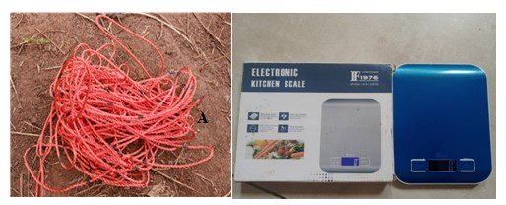
Fig. 4 : Seeding rope Scale: 1/5 Fig. 5: Precision balance Scale: 1/5

1-2- Methods
1-2-1- Experimental set-up
The experimental set-up is a Fisher block with 07 treatments and 4 replicates (figs. 6 and 7).
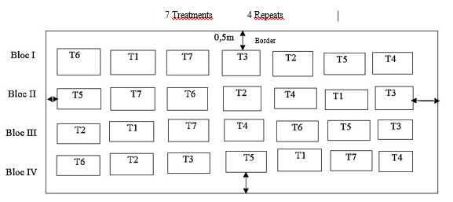
Fig. 6 : experimental setup
T1 : Pure rice
T2 : Cassava in pure culture
T3 : Pure maize
T4 : Combination of maize and rice grown by farmers
T5 : Combination of cassava and rice grown by farmers
T6 : Combination of maize and rice in improved cultivation
T7 : Combination of cassava and rice under improved cultivation
Each elementary plot has an area of 15 m² (3 m × 5 m). The distance between blocks is 1m. The distance between plots is 0.50 m. The trial area is 680 m² (17 m × 40 m).
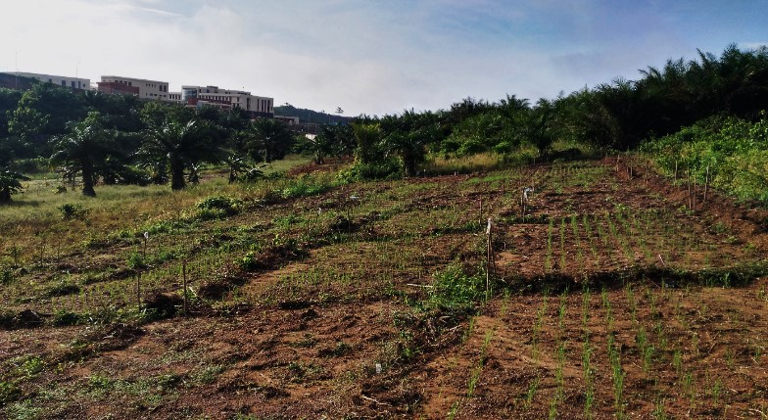
Fig. 7 : Panoramic view of the trial site : Scale : 1/5

1-2-2- Conducting the trial
Site preparation consisted of clearing, ploughing and turning the soil three days before sowing. A 200kg/ha application of NPK 12-22-22 fertiliser preceded the synchronised installation of the various treatments. Maintenance of the trial consisted of manual weeding, the first of which was carried out on 29 days before sowing.
The rice was sown in straight stacks at a density of 0.20 m × 0 .20 m in the improved cropping systems and at the same density in the farmer cropping systems. The two-strand rice plants were mated at 32 JAS under moist soil conditions. Cover fertiliser (urea at 46% N) was applied on 35 days at a rate of 50 kg/ha at the start of tillering (50% of the total quantity of urea) and 50 kg/ha at rice heading. Observations and measurements were made in the yield squares.

1-2-3- Data collection
1-2-3-1- Height of rice plants 42 JAS
Plant height is measured from the collar to the tip of the tallest leaf using a measuring tape. Measurements were taken on 10 rice bunches selected at random from the yield square. The height of the rice in each treatment is given by the average of 04 yield squares.

1-2-3-2- Total number of rice plants per square metre 42 JAS
The number of rice plants per square metre is determined by directly counting the number of rice plants per square metre. The total number of rice plants per square metre is obtained by averaging the 04 yield squares.

1-2-3-3- Number of tillers per cluster 42 JAS
The average number of tillers per plot is given by directly counting the tillers in the 25 plots in the yield square. The average number of tillers per plot is found by dividing the number of tillers per square metre by 50. The average number of tillers per plot in the treatment is obtained by averaging the values for the 04 yield squares.

II- Results and discussion
2-1- Effect of the trough technique on rice growth
❖ Rice height
Fig. 8, shows the effect of the trough technique on rice height. There was a highly significant effect (P˂ 0,0001) of the trough technique on rice plant height. In fact, the treatments with a trough (Pure Rice, Rice-Manioc, Rice-Maize) have a significantly higher rice height than the treatment without a trough. This could be explained by the fact that the troughs act like ponds, preventing run-off or drainage. This favours retention and infiltration, creating good moisture conditions for plant growth. According to Philippe et al, (2011) ; ISCO (2006), the Zaï or ‘Tassa’ technique significantly improves the agronomic performance of cultivated species., this has also been demonstrated iby the studies of these results confirm those of Bouhary (2020), on the effectiveness of the basins in retaining water and minerals for good plant growth.
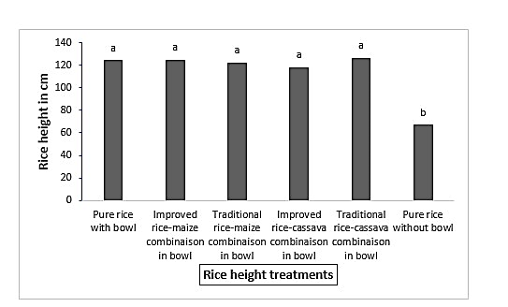
Fig. 8 : Height of rice under different treatments
❖ On rice tillering
Fig. 9 shows the effect of the trough technique on rice tillering. The effect of the trough technique on rice tillering is highly significant. There were 189 tillers per square metre for treatment T5 and 69 tillers per square metre for treatment T6 without troughs. The good tillering results from the favourable growth conditions induced by the agronomic advantages of the troughs as described by Bouhary, (2020) ; Belmin R. et al (2023) ; Tao et al (2006). Fig. 9, shows the effect of the trough technique on rice tillering. There was a highly significant effect of the trough technique on rice tillering. There were 189 tillers per square metre for treatment T5 and 69 tillers per square metre for treatment T6 without troughs.

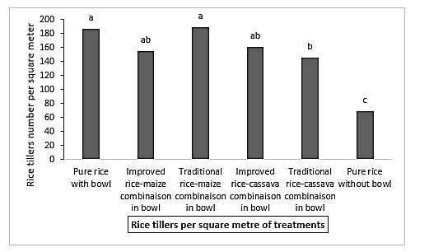
Fig. 9 : Number of rice tillers per square metre for the treatments

Table 1 shows the variance of agronomic parameters recorded at the rice testing station /m² for the different treatments.
Table 1: Variance in agronomic parameters of rice per square metre for the different treatments
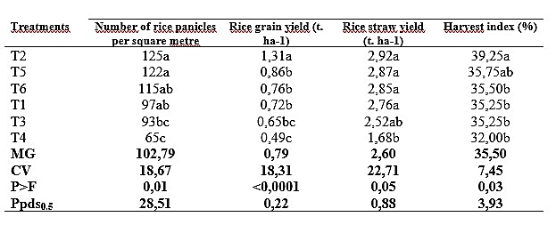MG : overall average ; CV : Variance coefficient; P>F : Probability ; Ppds0.5 : Smallest significant difference

With regard to the number of panicles, there was a significant effect of the trough technique on the fertility of the rice tillers (P < 0.05). In fact, the number of rice panicles per square metre improved under the trough technique, rising from 65 panicles per square metre for the no-trough treatment to 125 rice panicles per square metre for the T3 treatment.
With regard to the average rice grain yield for the different treatments, there was a highl£y significant effect of the trough technique on rice grain yield (P < 0.0001). In fact, the grain yield of rice in the trough treatments was significantly higher than in the treatment without troughs (T6).
As for the rice straw yield of the different treatments, there was a significant effect of the trough technique on the rice straw yield (P < 0.05). Rice straw yields ranged from 2,92 t /ha for the T3 treatment to 1,68 t /ha for the non-vat treatment (T6). With regard to the rice harvest index for the different treatments, there was a significant effect of the trough technique on the rice harvest index (P < 0.05). The rice harvest index changed from 39,25% for treatment T2 to 32% for T4. The Zaï technique led to an improvement in the various production parameters, unlike the control with no trough. These observations were noted by Belmin R. et al, (2023) which noted an improvement in production parameters with the Zaï technique. The trough technique had a significant effect on reducing soil erosion. In fact, this management technique preserved the integrity of the soil, whereas the soil without the troughs was subject to erosion. In addition, this development technique makes it possible to intercept run-off water from small impluviums located upstream of the structure and to encourage its infiltration or drainage outside the protected areas. According to ISCO (2006). this technique helps to maintain soil humidity at around 5% and increases water storage by around 150 mm / year. He rightly argues that individual basins are therefore an effective way of preserving the soil and improving agricultural productivity. In terms of soil fertility, the trough increases the quantity of organic matter in the soil, as well as the quantity of nutrients in the topsoil, notably assimilable phosphorus and potassium, at an average rate of 20%. However, their impact depends on their proper management to preserve soil health, as poor management of this technique and poor design can lead to a concentration of salts and pollutants in the troughs, which can adversely affect soil quality (MAL, 2006).

2-2- Effect of the trough technique in preventing erosion
The trough technique had a significant effect on soil erosion. In fact, compared with Fig. 12b, where the plot is protected by a trough, in Fig. 12a, a plot without a trough, the rice was deprived of the fine soil fraction. This arrangement makes it possible to intercept runoff from the small impluviums upstream of the structure and encourage infiltration. What's more, inside the basins, the infiltration of water significantly reduces run-off and therefore erosion. The troughs therefore help to reduce soil erosion by slowing down water runoff (Philippe et al, (2011). In terms of soil fertility, the trough increases the quantity of organic matter in the soil, as well as the quantity of nutrients in the topsoil, particularly assimilable phosphorus and potassium, at an average rate of 20%. Individual basins are therefore an effective way of preserving soil and improving agricultural productivity. However, their impact depends on how they are used and maintained. It is crucial to manage them correctly to preserve soil health, as poor management and design can lead to a concentration of salts and pollutants in the basins, adversely affecting soil quality.

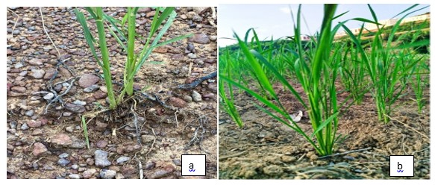
Fig. 10 : Effect of erosion (a: plot without trough; b: plot with trough) Scale: 1/5

Conclusion
The study highlighted the agronomic advantages of the trough technique. Efficient rainwater management on a mid-slope using the trough technique has a positive impact on rice growth. In addition, this technique is a means of combating soil erosion on a slope, as well as improving soil fertility and saving water.

Disclaimer (Artificial intelligence)
Option 1:
Author(s) hereby declare that NO generative AI technologies such as Large Language Models (ChatGPT, COPILOT, etc.) and text-to-image generators have been used during the writing or editing of this manuscript.
Option 2:
Author(s) hereby declare that generative AI technologies such as Large Language Models, etc. have been used during the writing or editing of manuscripts. This explanation will include the name, version, model, and source of the generative AI technology and as well as all input prompts provided to the generative AI technology
Details of the AI usage are given below:
1.
2.
3.

References

Belmin R. Sawadogo H. N'Dieno M. (2023). Cultiver sans eau ou presque : la technique du zaï au Sahel, les actualités du Cirad. https://www.cirad.fr/les-actualites-du-cirad/actualites/2023/cultiver-sans-eau-ou-presque-grace-a-la-technique-du-zai
Access in june 2024

Bouhary A.B. (2020) Sustainable land management and resilience - Effect of zaï on soil restoration and productivity https://reunir.u-naziboni.bf/portfolio/effet-des-zai-sur-la-restauration-des-sols-et-de-la-productivite-des-terres/, Access in june 2024

Bousten S. et Aertsen J. (2013). an we feed West Africa with rice?? Available on https://www.alimenterre.org/system/files/ressources/pdf/575_mo-paper74_riz_fr.pdf
accessed in june 2024.

Doumbia S. et Depieu M. (2013). Farmers' perception of climate change and adaptation strategies in rainfed rice production in central western Côte d'Ivoire. Journal of Applied Bisciences, 64(1) : 4822-4823, https://www.m.elewa.org/JABS/2013/64/6.pdf,

Duvallet M. (2023). Local rice supply in West Africa: analysis of risks and constraints affecting production and their impact on rice farmers' food security. Doctoral thesis, Paris-Saclay University, Paris, 191p. Available on https://pastel.hal.science/tel-04269000v1/document, accessed in march 2024

FAO. (2025). FAO Cereal Supply and Demand Bulletin. In The State of World Food and Agriculture. Available from " https://www.fao.org/worldfoodsituation/csdb/fr" , accessed in may 2025

ISCO (2006). Management and Soil Conservation in Semi-Arid Environment, 14 May, Marrakech, Morocco.C. ISCO (Réd.). International Soil Conservation Organization, Marrakech. pp : 1-5, from https://topsoil.nserl.purdue.edu/isco/isco14/start_isco.pdf , consulted on 19 sptember 2024

Issoufaly h. et Hani j. (2023). Climate, development, commitment, farmers, resilience: challenges and solutions for a sustainable rice supply chain, Resilience. Available from "https://ksapa.org/fr/defis-et-solutions-pour-une-supply-chain-durable-du-riz/ " accessed in may 2024

Kindo O. (2019). Tonkpi Nihidaley Festival/ Food security: The CNRA proposes new crop varieties. Available from " https://man-info.net/2019/12/14/festival-tonkpi-nihidaley-securite-alimentaire-le-cnra-propose-de-nouvelles-varietes-culturales/" accessed in may 2024, man-info.net

Ministry of Agriculture and Livestock (MAL), 2006. Collection of technical data sheets on natural resource management and agro-sylvo-pastoral production, Niamey, Niger, Community Action Programme (PAC). Available from
https://reca-niger.org/IMG/pdf/recueil_de_fiches_techniques_validees_vf.pdf ", access in march 2024.

Ouattara A., Koné B., Konan U. (2024). Morpho-Pedological Diagnosis Of The Hills In South-West Of Côte d’Ivoire : Case Of An Open Trench at University of San Pedro. Australian Journal of Basic and Applied Sciences, 18(1) : 13-18, https://www.ajbasweb.com/old/ajbas_Jan-Feb_2024.html

Philippe B., Salifou T., Fidèle B., Dorkas K. et Adjima T. (2011). Effect of improved zaï on sorghum productivity in the Sahelian zone. https://doi.org/10.4000/vertigo.11497

Tao, H., Brueck, H., Dittert, K., Kreye, C., Lin, S., & Sattelmacher, B. (2006). Growth and yield formation of rice (Oryza sativa L.) in the water-saving ground cover rice production system (GCRPS). Field Crops Research, 95(1), 1-12, DOI: 10.1016/j.fcr.2005.01.019

Zadi F., Bouet A., Bahan F., Noumouha G. Et Beugre I. (2022). Effect of rice straw-based compost on the yield of lowland rice grown at the CNRA research station in Man, western Côte d'Ivoire. 8p. DOI : https://dx.doi.org/10.4314/ijbcs.v16i6.11

