Original Research Article
Genetic Divergence of Cocoa (Theobroma cacao L.) Genotypes Based on Comprehensive Pod and Bean traits

ABSTRACT
Cacao (Theobroma cacao L.) production faces significant global challenges, including low yields, severe disease incidences (e.g., Black Pod, Witches Broom), and the demand for superior quality beans. Genetic improvement is paramount for developing resilient cultivars. This study aimed to assess the magnitude of genetic variability, estimate key genetic parameters (heritability and genetic advance), and determine the phenotypic and genotypic correlations among essential agronomic traits in a diverse collection of 35 cocoa hybrids maintained in Cocoa Research Centre, Vellanikkara. A total of twelve pod and bean quantitative morphological traits including yield components were recorded. The experiment was laid out in a Completely Randomized Design (CRD) with five replications. Analysis of variance (ANOVA) revealed highly significant genetic variability for nearly all traits, confirming a rich resource for selection. High estimates of broad-sense heritability coupled with high Genetic Advance (GA) as percent of mean were observed for traits like pod weight and single wet bean weight, indicating that these characters are primarily controlled by additive gene action and selection based on phenotype will be effective. A significant positive correlations was observed between total wet bean weight and pod weight (0.66), pod length (0.64), pod breadth (0.68), weight of a single wet bean (0.69), single dry bean weight (0.69), single dry bean length (0.40), and single dry bean width (0.36) Correlation analysis identified strong positive correlations between total pod weight and other yield attributes, validating their use as reliable indirect selection criteria. These findings enable the selection of superior genotypes that combine high-yield components and quality traits, providing a critical foundation for broadening the genetic base and expediting the breeding of high-performing, disease-tolerant cocoa.
Keyword : Pod and bean traits, variability analysis, correlation, cluster analysis
- INTRODUCTION
The cacao tree (Theobroma cacao L.) is the source of the world's chocolate, underpinning a multi-billiondollar industry and sustaining the livelihoods of millions of smallholder farmers across the tropics. Despite its global economic importance, global cocoa productivity is sub-optimal due to a narrow genetic base in cultivated materials, susceptibility to major diseases (e.g., Phytophthora spp. causing Black Pod, Moniliophthora perniciosa causing Witches Broom), and vulnerability to climate change stressors (Cilas & Bastide, P., 2020).
Effective crop improvement hinges on the magnitude and nature of genetic variability within the germplasm. A thorough understanding of genetic parameters like Heritability and Genetic Advance is essential for determining the selection strategy and predicting the genetic gain from breeding efforts. Furthermore, correlation analysis is crucial for identifying traits that are genetically linked, allowing breeders to select for a primary trait (like yield) indirectly through a more easily measurable correlated trait (like single bean weight).
Recent studies have utilized multivariate statistics to identify genetic differences among various genotypes. Principal component analysis (PCA) and cluster analysis are used to assess similarities and differences among different genotypes concerning multiple examined traits (Jian et al., 2006). Cluster analysis serves as a powerful method for analyzing familial connections (Mellingers, 1972). Clustering techniques are employed to group genotypes based on their morphological or molecular characters. The formation of distinct clusters confirms the existence of genetic divergence.
- MATERIALS AND METHODS

The study was conducted at the Cocoa Research Centre, Vellanikkara using 35 established hybrids planted during 2009. The experiment was laid out in a Completely Randomized Design (CRD) with five replications. The following morphological and yield characteristics of ripened pods viz. pod weight, pod length, breadth, rind thickness, number of beans per pod, single wet bean weight, single peeled wet bean weight and single dry bean weight on hybrids of cocoa were noted. The rind thickness was determined using a vernier caliper. The descriptor proposed by Bekle and Butler (2000) was used to record the observations. The observations on twelve pod and bean characters were recorded. Correlation analysis was carried out by Pearson coefficient method using GRAPES software (Gopinath et al., 2020). Grouping of genotypes were carried out based on eucledian distance.

- RESULTS AND DISCUSSION

Twelve quantitative characters of pod and bean viz., pod weight (g), pod length (cm), pod breadth (cm), rind thickness (cm), number of beans per pod, total weight of wet beans per pod (g), weight of single wet bean (g), weight of single peeled bean (g), weight of single dry bean (g), dry bean length (cm), dry bean width (cm) and dry bean thickness (cm) were recorded in thirty-five hybrids. The mean values of quantitative characters of pod and beans are exhibited in Table 1.
The hybrid, H27 showed highest pod weight of 1112 g followed by H29 (914 g) and H34 (878 g) among the thirty-five hybrids. The lowest pod weight was observed in H26 (306 g). Except three hybrids, all other among thirty-five were having pod weight more than 350 g. This is evidenced in the selection criteria followed by Sumitha et al. (2025). Thirty hybrids evaluated by Ajmal (2016) also recorded pod weight ranged from 249.64 g to 685 g. This is also on par with the twenty-five hybrids studied by Shilpa (2019) where the pod weight ranged from 292.9 g to 679 g. The maximum pod length was observed in hybrid H27 (22.5 cm) and the minimum length was seen in Hybrid H13 with a length of 12.58 cm. The hybrid H31 exhibited pods with maximum mean breadth which is 10.2 cm and H26 have minimum pod breadth which is 7.2 cm. The maximum rind thickness is observed in hybrid H34 (2 cm). Rind thickness was the lowest in H8 and H16 (0.90 cm).
The total number of beans per pod is highest in H18 with 50.4 and lowest in H28 with 33.8. The highest and lowest total wet bean weight of 210.2 g and 82 g was recorded by H31 and H15 respectively. The wet bean weight of single bean was recorded as high in H29 with 5.5 g and low in H5, H6, H13 with 2.3 g. The single peeled wet bean is ranged from 1.11 g in H1 and 3.2 g in H31. Weight of single peeled dry bean varied from 0.8 g in H1, H12 and H16 to 1.7 g in in H31. These findings were on par with the study revealed by Enriquez and Soria (1966) and Minimol et al. (2024) where wet weight and peeled dry weight of bean ranged from 0.5 g to 2.5g and 0.58 g to 1.72 g respectively. All the hybrids included in the study showed more than 1 g single dry bean weight. According to Monteiro et al. (2009) and Minimol et al. (2015) superior genotypes have single peeled dry bean weight more than 0.8 gram. Sumitha et al. (2018) and Deepa et al. (2019) also employed same criteria (single dry bean weight more than 0.8 gram) for selecting superior genotypes. The dry bean length, breadth and thickness showed maximum in H22, H21, H7 and minimum recorded in H7, H4 and H1 respectively. The hybrid H7 which is inferior in bean length (17.8 cm) shows superiority (7.2 cm) in bean thickness. All the thirty-five hybrids were significantly different at both five per cent and one per cent level of significance.

Table 1. Mean performance of yield attributing characters
Hybrids | PW | PL | PB | RT | NB | TWBW | SWBW | SPBW | SDBW | DBL | DBW | DBT
H1 | 534 | 16.4 | 8.3 | 1.4 | 43.6 | 101.8 | 2.5 | 1.1 | 0.8 | 19.6 | 10.1 | 4.6
H2 | 666 | 21.5 | 9.1 | 1.5 | 39.8 | 117.5 | 3.0 | 1.4 | 1.1 | 20.2 | 8.8 | 6.5
H3 | 518 | 15.9 | 8.1 | 1.2 | 43.2 | 119.8 | 2.8 | 1.3 | 1.1 | 21.5 | 11.5 | 5.4
H4 | 452 | 15.1 | 8.3 | 1.2 | 40.6 | 112.5 | 2.4 | 1.4 | 1.1 | 18.3 | 8.4 | 6.2
H5 | 396 | 14.7 | 7.8 | 1.2 | 35.0 | 97.1 | 2.3 | 1.2 | 1.1 | 18.2 | 9.3 | 7.2
H6 | 508 | 15.8 | 8.2 | 1.1 | 44.8 | 113.1 | 2.3 | 1.2 | 1.0 | 19.3 | 10.2 | 5.0
H7 | 532 | 16.0 | 8.6 | 1.2 | 46.4 | 102.6 | 2.6 | 1.4 | 1.2 | 17.8 | 9.5 | 7.2
H8 | 396 | 15.8 | 7.9 | 0.9 | 45.0 | 113.5 | 2.6 | 1.3 | 1.1 | 20.9 | 10.4 | 7.2
H9 | 504 | 16.3 | 8.3 | 1.4 | 46.2 | 121.4 | 3.7 | 1.3 | 1.0 | 20.6 | 11.2 | 6.7
H10 | 414 | 16.1 | 8.7 | 1.4 | 43.8 | 118.6 | 3.7 | 1.3 | 1.0 | 20.3 | 11.2 | 6.9
H11 | 438 | 17.5 | 7.5 | 1.2 | 48.2 | 109.3 | 3.7 | 1.3 | 1.1 | 19.9 | 10.6 | 5.8
H12 | 352 | 15.9 | 7.4 | 1.1 | 46.0 | 105.1 | 2.4 | 1.2 | 0.8 | 17.9 | 10.0 | 4.9
H13 | 340 | 12.6 | 7.5 | 1.0 | 49.2 | 94.5 | 2.3 | 1.2 | 0.9 | 18.9 | 10.3 | 5.3
H14 | 444 | 16.2 | 7.7 | 1.0 | 49.0 | 113.2 | 3.4 | 1.3 | 1.1 | 18.2 | 10.5 | 6.1
H15 | 336 | 13.5 | 7.2 | 1.1 | 48.6 | 82.0 | 3.1 | 1.4 | 1.0 | 19.7 | 10.8 | 6.2
H16 | 394 | 15.2 | 7.2 | 0.9 | 40.0 | 90.5 | 2.4 | 1.2 | 0.8 | 17.9 | 10.0 | 4.9
H17 | 552 | 17.2 | 8.4 | 1.2 | 50.0 | 132.9 | 3.4 | 1.3 | 1.1 | 20.6 | 10.5 | 5.4
H18 | 450 | 16.1 | 8.0 | 1.4 | 50.4 | 99.3 | 2.4 | 1.2 | 1.0 | 19.4 | 10.3 | 5.6
H19 | 472 | 15.4 | 7.4 | 1.1 | 47.0 | 121.3 | 2.4 | 1.2 | 1.0 | 19.4 | 10.3 | 5.6
H20 | 546 | 18.7 | 8.8 | 1.3 | 40.8 | 129.5 | 3.4 | 2.1 | 1.4 | 22.0 | 12.6 | 6.0
H21 | 420 | 14.4 | 8.0 | 1.2 | 43.2 | 110.6 | 3.1 | 2.4 | 1.5 | 23.0 | 13.3 | 6.2
H22 | 432 | 14.6 | 7.4 | 1.2 | 38.0 | 115.9 | 3.6 | 2.6 | 1.1 | 23.5 | 10.6 | 5.5
H23 | 368 | 14.2 | 8.2 | 1.1 | 41.2 | 102.8 | 2.7 | 1.2 | 1.0 | 19.4 | 10.3 | 5.6
H24 | 516 | 17.7 | 8.1 | 1.3 | 34.8 | 121.3 | 3.4 | 1.9 | 1.2 | 19.3 | 10.5 | 6.7
H25 | 642 | 17.0 | 9.3 | 1.4 | 41.4 | 127.9 | 3.3 | 2.5 | 1.3 | 20.7 | 12.2 | 6.7
H26 | 306 | 15.0 | 7.2 | 1.0 | 41.8 | 105.5 | 2.7 | 1.8 | 1.4 | 22.0 | 12.6 | 6.0
H27 | 1112 | 22.5 | 9.9 | 1.6 | 39.8 | 126.0 | 3.5 | 2.3 | 1.4 | 22.5 | 10.6 | 7.1
H28 | 426 | 15.4 | 7.5 | 1.1 | 33.8 | 98.7 | 2.5 | 1.4 | 1.2 | 22.0 | 12.6 | 6.0
H29 | 914 | 20.0 | 9.9 | 1.9 | 37.8 | 172.3 | 5.5 | 2.4 | 1.6 | 19.9 | 10.7 | 6.1
H30 | 420 | 15.5 | 7.9 | 1.4 | 36.2 | 108.1 | 3.3 | 1.6 | 1.1 | 19.4 | 10.8 | 6.1
H31 | 796 | 20.1 | 10.2 | 1.4 | 44.4 | 210.2 | 4.5 | 3.2 | 1.7 | 22.9 | 12.8 | 6.3
H32 | 396 | 16.8 | 8.2 | 1.1 | 39.8 | 137.8 | 3.7 | 2.6 | 1.1 | 19.6 | 10.4 | 5.4
H33 | 714 | 19.0 | 8.1 | 1.4 | 44.2 | 150.3 | 3.8 | 2.5 | 1.6 | 21.2 | 12.1 | 6.5
H34 | 878 | 20.5 | 10.1 | 2.0 | 44.8 | 161.8 | 4.7 | 2.6 | 1.6 | 22.7 | 12.6 | 7.2
H35 | 612 | 18.1 | 8.3 | 1.1 | 39.8 | 126.8 | 3.2 | 1.7 | 1.4 | 20.3 | 12.0 | 7.0
CV | 10.2 | 5.5 | 5.5 | 7.9 | 7.4 | 8.3 | 7.7 | 8.5 | 7.5 | 3.5 | 5.1 | 7.3
CD | 66.2 | 1.1 | 0.6 | 0.1 | 4.0 | 12.4 | 0.3 | 0.2 | 0.1 | 0.9 | 0.7 | 0.6
PW- Pod weight (g), PL -Pod length (cm), PB - Pod breadth (cm), RT - Rind thickness (cm), TWBW - Total weight of wet beans/pod (g), SWBW - Single wet bean weight (g), SPBW -Single peeled bean weight (g), SDBW - Single dry bean weight (g), DBL - Dry bean length (cm), DBW - Dry bean width (cm), DBT - Dry bean thickness (cm)

The true potential of novel genotypes can be effectively assessed through genetic parameter studies, as these provide a clear understanding of the magnitude and nature of genetic variability and its interaction with environmental factors. According to Falconer and Mackay (1996), an effective response to selection can only be achieved when there is sufficient genetic variation coupled with high heritability for the character under consideration. Bisne et al. (2009) reported that heritability and genetic advance are the most important genetic parameters for predicting the genetic gain expected under selection pressure. In plant breeding programmes, an in-depth understanding of gene action and the components of genetic variance is crucial for developing efficient and sustainable selection strategies. High PCV and GCV were observed for single peeled bean weight (35.72% and 34.80%), pod weight (35.66% and 34.18%) and single wet bean weight (24.41% and 23.38%), indicating significant variability in both genetic and environmental factors. This on par with the study conducted by Nair et al. (2024). Moderate PCV and GCV were noted for rind thickness (20.89% and 19.31 %), pod length (13.99% and 13.37%), single dry bean width (11.79% and 10.62%), and single dry bean thickness (13.81% and 11.73%), suggesting these traits are influenced by both genetic and environmental factors, though genetic contribution remains substantial. High heritability was observed for all traits, single peeled bean weight (95%), single wet bean weight (92%), pod weight (91.9%) and pod length (91%) showing the highest values, indicating that these traits are predominantly determined by genetic factors. Total wet bean weight exhibited the lowest heritability (66%), suggesting greater environmental influence on this trait. Maniee et al. (2009) proposed that high heritability of a character indicates that the role of environment is less in its phenotypic expression and the variability shown by that trait is due to its genotype. High genetic advance was observed for single peeled bean weight (69.86%) and pod weight (67.47%). These traits, with high heritability and genetic advance, are likely to respond well to selection, as they are controlled by additive genes. High genetic advance with high heritability indicates that character is controlled by additive genes and selection for such traits will be effective (Johnson et al., 1955 and Kashif et al., 2003). If genetic advance is low, it indicates that such traits are controlled by non-additive genes.
According to Mary and Gopalan (2006), effective plant breeding requires not only an analysis of variability among traits but also a clear understanding of how different traits are associated, particularly those contributing to yield. Total wet bean weight showed significant positive correlations with pod weight (0.66), pod length (0.64), pod breadth (0.68), weight of a single wet bean (0.69), single dry bean weight (0.69), single dry bean length (0.40), and single dry bean width (0.36) (Figure 1). Kumaran and Amma (1982) and Aikpokpodion (2010) also found positive correlations between total wet bean weight and single bean weight, length, and width.

Table 2. Genetic parameters of yield attributing characters
 | CV (%) | PCV (%) | GCV (%) | H² (%) | GA (%)
PW | 10.18 | 35.66 | 34.18 | 91.90 | 67.47
PL | 4.11 | 13.99 | 13.37 | 91.00 | 26.33
PB | 4.23 | 10.69 | 9.81 | 84.00 | 18.56
RT | 7.98 | 20.89 | 19.31 | 85.00 | 36.76
WBW | 7.21 | 12.27 | 9.93 | 66.00 | 16.55
SWBW | 7.02 | 24.41 | 23.38 | 92.00 | 46.14
SPBW | 8.04 | 35.72 | 34.80 | 95.00 | 69.86
SDBW | 7.69 | 21.47 | 20.05 | 87.00 | 38.57
DBL | 3.48 | 8.41 | 7.66 | 83.00 | 14.37
DBW | 5.12 | 11.79 | 10.62 | 81.00 | 19.70
DBT | 7.29 | 13.81 | 11.73 | 72.20 | 20.53
PW- Pod weight (g), PL -Pod length (cm), PB - Pod breadth (cm), RT - Rind thickness (cm), WBW - Total weight of wet beans/pod (g), SWBW - Single wet bean weight (g), SPBW -Single peeled bean weight (g), SDBW - Single dry bean weight (g), DBL - Dry bean length (cm), DBW - Dry bean width (cm), DBT - Dry bean thickness (cm), CV-Coefficient of variation, PCV - Phenotypic coefficient of variation (%), GCV- Genotypic coefficient of variation (%), H2-Heritability (%), GA-Genetic advance (%)
Figure 1. Correlogram of yield attributing characters
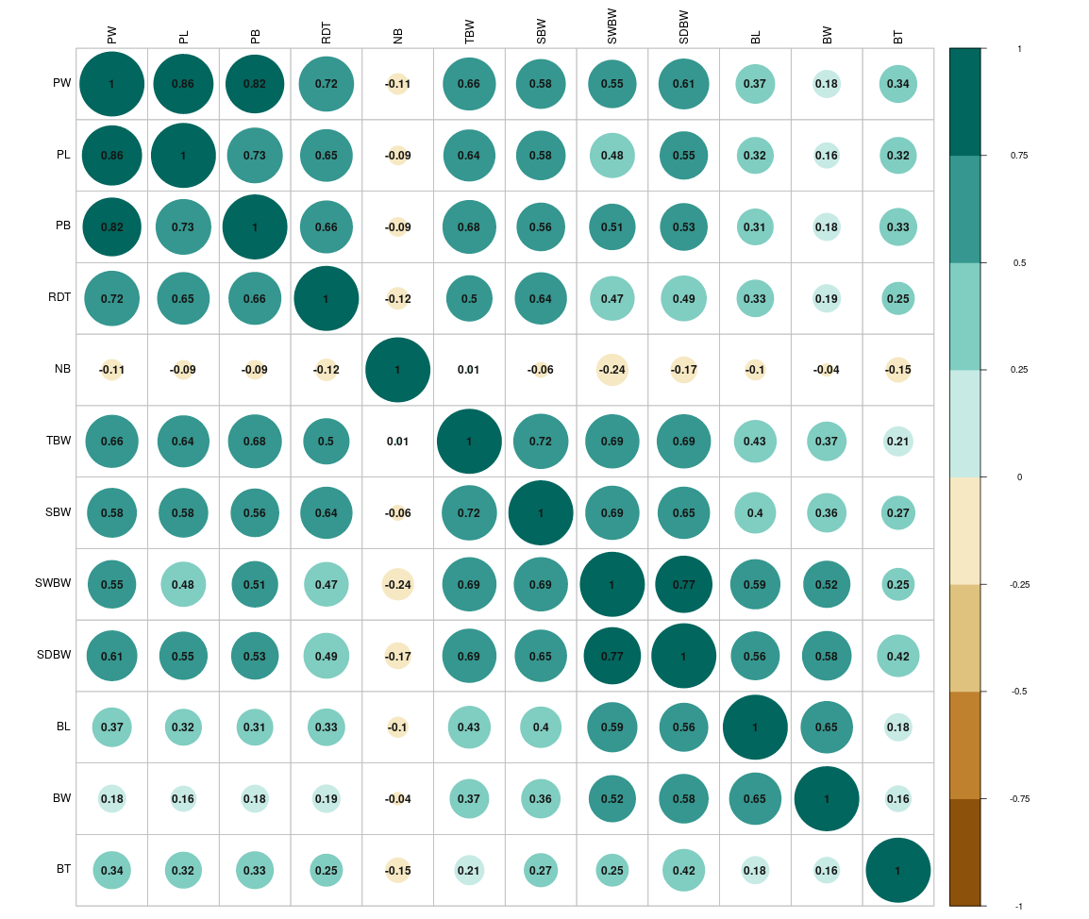
PW- Pod weight (g), PL -Pod length (cm), PB - Pod breadth (cm), RDT - Rind thickness (cm), NB-No. of beans, TBW - Total weight of wet beans/pod (g), SWBW - Single wet bean weight (g), SBW -Single peeled bean weight (g), SDBW - Single dry bean weight (g), BL - Dry bean length (cm), BW - Dry bean width (cm), BT - Dry bean thickness (cm),
Hierarchical cluster analysis (HCA), a robust tool for evaluating relationships between the genotypes (Mellingers, 1972) and was performed on the phenotypic data using the origin pro (version 2025b) software based on euclidean distance. The resulting dendrogram (Figure 2) clearly grouped the thirty five hybrids into five major clusters. Cluster II is the largest cluster with fourteen genotypes which shows more relatedness. The genotypes in different cluster can be further utilised in crop improvement program.
Figure 2. Clustering of genotypes
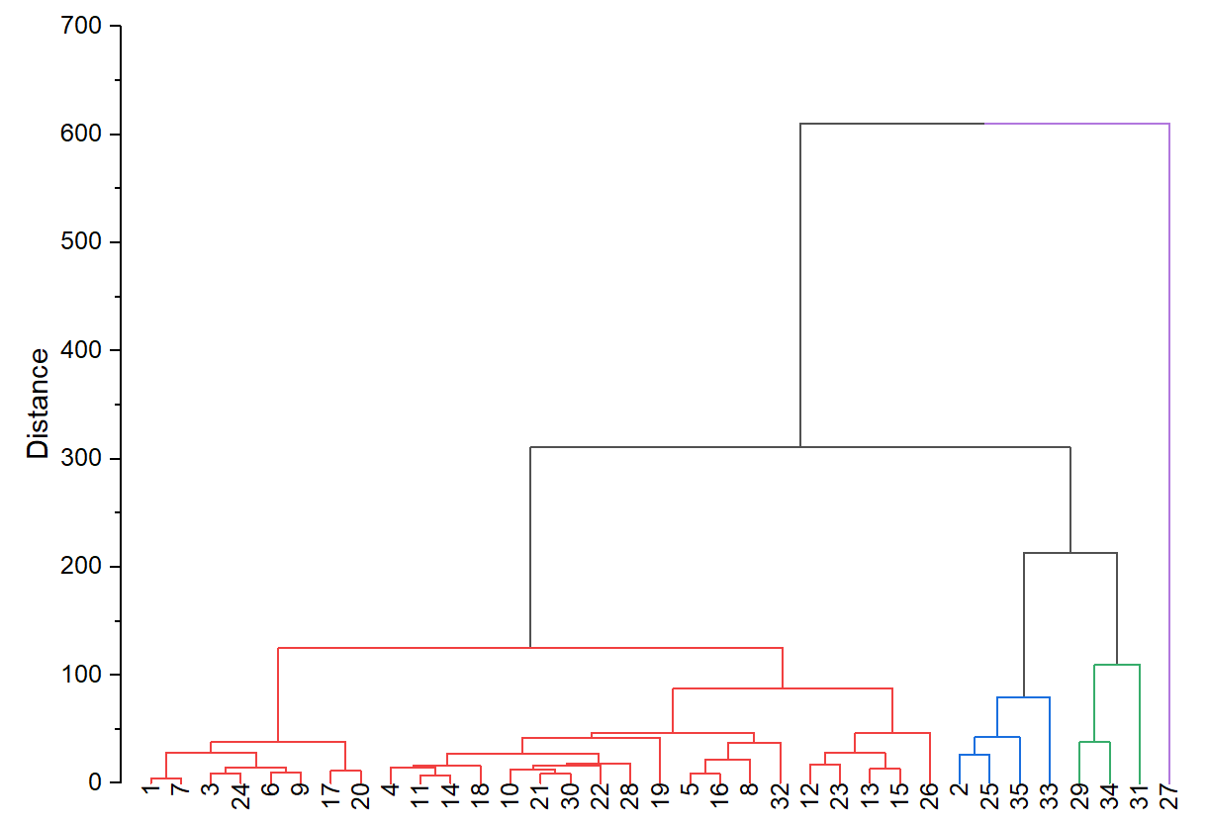
- CONCLUSION
The current study establishes that the population of cocoa hybrids possesses significant genetic variability for commercially important pod and bean characters. The high estimates of GCV, heritability, and genetic advance for traits like single wet bean weight and pod weight signify that the variation in these traits is largely heritable and controlled by additive gene action. This provides a strong rationale for immediate and effective selection of superior hybrid individuals based on their phenotypic performance.
The genetic diversity analysis has successfully identified divergent clusters, suggesting that hybridization programs should target crosses between superior individuals from the most distant clusters (cluster I and IV) to exploit heterosis and generate new variability with a broader genetic base. H31 which is a superior-performing hybrids identified through this analysis, which exhibit a desirable combination of high single seed dry bean weight (1.7 g) and high total wet bean weight (210.2 g), is recommended to use as parental lines in future breeding cycles. This systematic genetic appraisal is key to sustained cocoa improvement and enhancing global cocoa productivity and bean quality.

COMPETING INTERESTS DISCLAIMER:
Authors have declared that they have no known competing financial interests OR non-financial interests OR personal relationships that could have appeared to influence the work reported in this paper.

Disclaimer (Artificial intelligence)
Option 1:
Author(s) hereby declare that NO generative AI technologies such as Large Language Models (ChatGPT, COPILOT, etc.) and text-to-image generators have been used during the writing or editing of this manuscript.

REFERENCES
Cilas, C. & Bastide, P. (2020). Challenges to Cocoa Production in the Face of Climate Change and the Spread of Pests and Diseases. Agronomy, 10(9), 1232.
Gopinath, P. P, Parsad, R, Joseph, B & Adarsh, V. S. (2020). GRAPES: General Rshiny Based Analysis Platform Empowered by Statistics. https://www.kaugrapes.com/home. version 1.0.0. DOI: 10.5281/zenodo.4923220
Jian, C.L., Ruili, W.L. & Feng, L.F.W. (2006). Genetic diversity detected by cluster analysis North of Anhui major wheat cultivars. Chinese Agricultural Science Bulletin, 11: 031.

Mellingers, J.S. (1972). Measures of genetic distance studies in genetics. VII University of Texas Publication 27,145-153
Bekele, F. L., & Butler, D. R. (2000). Proposed short list of descriptors. In A. B. Eskes, J. M. M. Engels, & R. A. Lass (Eds.), Working procedures for cocoa germplasm evaluation and selection: Proceedings of the CFC/ICCO/IPGRI project workshop (pp. 41–48). Montpellier, France.
Sumitha, S., Jegadeeswari, V., & Uchoi, A. (2025). Evaluation of cocoa clones for yield and quality as intercrop in coconut gardens of Western Ghats, India. Bangladesh Journal of Botany, 54(1), 137-144.
Ajmal, P.M. (2016). Evaluation of selected cocoa (Theobroma cacao L.) hybrids bred for quality. M.Sc. (Ag) thesis, Kerala Agricultural University, Thrissur, 123p.
Shilpa K. S. (2019). Genetic analysis of cocoa (Theobroma cacao L.) hybrids and screening superior hybrids for major biotic stress. M.Sc. (Ag) thesis, Kerala Agricultural University, Thrissur, 183p.
Enríquez, G. A., & Soria, J. (1966). Study of the variability of several characteristics of cocoa beans (Theobroma cacao L.). Fitotecnia Latinoamericana, 12(3), 99–117.
Minimol, J. S., Suma, B., Mary, A., Shija, T. K., Jose, S., & Plappallil, S. K. (2024). Evaluating black pod resistance in cocoa (Theobroma cacao L.) and its relationship with phenotypical and biochemical characteristics. Beverage Plant Research, 4(1).
Monteiro, W. R., Lopez, U. V., & Clement, D. (2009). Genetic improvement in cocoa. In S. M. Jain & D. Priyadarshan (Eds.), Breeding plantation tree crops: Tropical species (pp. 589–626). Springer Science & Business Media.
Minimol, J. S., Shija, T. K., Vasanthan, N., Sunil, K. M., Suma, B., & Krishnan, S. (2015). Seasonality in cocoa: Weather influence on pod characters of cocoa clones. International Journal of Plant Sciences, 10, 102–107.
Sumitha, S., Balakrishnan, S., Shoba, N., Kumar, M., Jeyakumar, P., & Jegadeeswari, V. (2018). Growth and yield performance of cocoa (Theobroma cacao L.) varieties under Tamil Nadu condition. Journal of Pharmacognosy and Phytochemistry, 7(5), 591–594.
Deepa, R., Balakrishnan, S., Jegadeeswari, V., Thiribhuvanamala, G., & Kumaravadivel, N. (2019). Evaluation of cocoa half sib selection for morphological and yield traits under Tamil Nadu conditions. Journal of Pharmacognosy and Phytochemistry, 8(3), 768–770.
Falconer, D. S., & Mackay, T. F. C. (1996). Introduction to quantitative genetics (4th ed.). Longman Group, U.K.
Bisne, R., Sarawgi, A. K., & Verulkar, S. B. (2009). Study of heritability, genetic advance and variability for yield contributing characters in rice. Bangladesh Journal of Agricultural Research, 34(2), 175–179.
Nair, R. S., Minimol, J. S., Narayanan, N., Shilpa, K. S., & Joseph, J. (2024). Exploring Genetic Variability and Diversity in Exotic Germplasm Collection of Cocoa (Theobroma cacao L.). Journal of Advances in Biology & Biotechnology, 27(10), 1363-1371.
Maniee, M., Kahrizi, D., & Mohammadi, R. (2009). Genetic variability of some morpho-physiological traits in durum wheat (Triticum turgidum var. durum). Journal of Applied Sciences, 9(7), 1383–1387.
Johnson, H. W., Robinson, H. F., & Comstock, R. E. (1955). Estimation of genetic and environmental variability in soybean. Agronomy Journal, 47, 314–318.
Kashif, W., Siddiqi, N., Dincer, A. P., Dincer, H. E., & Hirsch, S. (2003). Proteinuria: How to evaluate an important finding. Cleveland Clinic Journal of Medicine, 70(6), 535–537
Mary, S. S., & Gopalan, A. (2006). Dissection of genetic attributes of yield traits of fodder cowpea in F₃ and F₄. Journal of Applied Sciences Research, 2, 805–808.
Aikpokpodion, P. E., & Dongo, L. N. (2010). Effects of fermentation intensity on polyphenols and antioxidant capacity of cocoa beans. International Journal of Sustainable Crop Production, 5(4), 66–70.
Kumaran, K., & Prasannakumari Amma, S. (1982). Genetic variability and correlation of some pod and bean characters in cocoa ‘Forastero’. In S. Vishveshwara (Ed.), Proceedings of the IVth Annual Symposium on Plantation Crops (pp. 183–190). Mysore, India.

