A Review on the Management of Shallot Black Mold caused by Aspergillus niger (Van Tieghem)

ABSTRACT

Black mold disease, caused by Aspergillus niger, is a major post-harvest constraint in shallot (Allium cepa var. aggregatum) production, leading to significant economic losses under storage conditions. In Ghana, where shallot cultivation provides both nutritional and economic benefits to smallholder farmers, the disease threatens food security, marketability, and farmer livelihoods. Conventional management relies heavily on synthetic fungicides; however, their overuse raises concerns regarding environmental safety, human health, and fungicide resistance. This review synthesizes current knowledge on the biology, and epidemiology, of A. niger, while critically assessing integrated management strategies for black mould. Cultural practices, biological agents such as Trichoderma harzianum, and the use of plant-derived extracts (e.g., garlic, clove, neem, and pomegranate) have shown promising antifungal potential as sustainable alternatives.

Keywords: Shallot bulb, Black mold, Economic loss, Integrated Management Strategies, Phytochemicals, Biological agents

INTRODUCTION

Shallot (Allium cepa var. aggregatum) is a high-value vegetable crop of significant nutritional and economic importance, particularly for smallholder farmers in Ghana (Benjamin et al., 2017). Its cultivation contributes to food security, income generation, and rural livelihoods. However, the sustainability of shallot production is severely threatened by post-harvest diseases, with black mold caused by the fungus Aspergillus niger being a predominant constraint (Kumar et al., 2018). This pathogen leads to substantial qualitative and quantitative losses, with studies reporting that pests and diseases can cause between 24-100% loss in shallots during storage (Herlina et al., 2019; Safitri et al., 2019; Supyani et al., 2021), thereby directly impacting farmer revenues and food availability.
The conventional management of black mold has heavily relied on the application of synthetic fungicides (Anadani and Vanthana, 2017). While often effective, their continuous use poses significant challenges, including the development of fungicide resistance and potentially harmful chemical residues on produce, which may be harmful to consumers (Prajapati and Patil, 2016a). These concerns have spurred the global search for safer, sustainable, and eco-friendly alternatives for disease management.
In this context, integrated approaches that combine cultural practices, biological control agents like Trichoderma harzianum (Nuray and Levent, 2014), and botanical pesticides offer a promising pathway. Notably, plant-derived extracts from sources such as garlic, clove, and neem, and their constituent phytochemicals such as phenolics, flavonoids, terpenoids, and alkaloids have demonstrated potent antifungal properties against a range of pathogens (Mierziak et al., 2014; Bhattacharyya et al., 2018; Khalid et al., 2019). This review, therefore, aims to synthesize current knowledge on the biology and epidemiology of A. niger and to critically evaluate sustainable strategies for managing black mold in shallots. It places a specific emphasis on the potential of botanicals and their active compounds as effective biocontrol agents, highlighting their role in reducing dependence on synthetic chemicals and promoting a more resilient and sustainable shallot production system in Ghana and beyond.

Economic and Nutritional Importance of Shallot
Shallots are a type of Allium, which is a genus of perennial bulbous plants in the family Amaryllidaceae. They are closely related to onions (Allium cepa), garlic (Allium sativum), and leeks (Allium ampeloprasum var. porrum). Shallots (Allium cepa var. aggregatum) are a smaller and milder variety of onion, with a sweeter and more delicate flavour than onion. They are characterized by their elongated bulbs that are composed of a cluster of small bulbs, called "cloves," which are covered in a thin, papery skin. Their bulbs are usually between 2 and 5 centimeters in diameter and can be white, yellow, or red in color (Miller, 2022). In terms of cultivation, shallots prefer well-drained soil and full sun exposure, They can be grown from seeds or from sets, which are small bulbs that are planted in the soil, shallot production in Ghana is mainly concentrated in the southern part of the country, particularly in the Ashanti, Greater Accra, Eastern, and Volta regions (Benjamin et al., 2017).
Shallot production in Ghana faces several challenges, including poor soil fertility, inadequate irrigation, pests and diseases, and lack of access to credit and markets (Yeboah and Egyir, 2023). In recent years, there has been an increasing demand for shallots in Ghana and other West African countries, driven by changing consumer preferences and the growing popularity of local cuisines (Grundy et al., 2016; Benjamin et al., 2017). This trend presents an opportunity for Ghanaian farmers to increase their incomes and improve their livelihoods through the production and sale of shallots.

Economic and Nutritional importance of shallot
Shallots are important ingredients in cooking due to their unique flavour and nutritional benefits. High levels of anti-oxidants in shallots, like quercetin, have been linked to a number of health benefits including lowering the risk of cancer and heart disease (Panoff, 2019).
In addition, shallots are a significant source of minerals including potassium and iron in addition to vitamins A and C. In culinary applications, shallots are often used in French cuisine as a flavouring agent in sauces, soups, and stews. They are also a common ingredient in Asian cuisine, particularly in Thai and Indonesian dishes. Over all, shallots play a significant role in both cooking and health, making them a valuable ingredient to have in one's pantry.
The production is an important economic activity in Ghana, providing employment opportunities and contributing to the country's food security and export earnings. Shallot cultivation in Ghana is mainly carried out by smallholder farmers, who grow the crop as a cash crop or for household consumption (Folitse et al., 2018). Shallot production has significant economic benefits for farmers in Ghana, as the crop has a high market value probably due to its culinary and medicinal uses (Wenli et al., 2019). Additionally, shallot production provides employment opportunities for both farm and non-farm workers, contributing to poverty reduction and rural development in the country.

Constraint of Shallot Production in Ghana
There are several constraints to shallot production in Ghana, which limit the potential of the industry. Lack of improved and high-yielding varieties, inadequate irrigation facilities, poor post-harvest handling and storage, limited access to credit and finance, limited access to markets are some challenges facing shallot production. In Ghana, production is also constrained by pest and disease problems, including fungal diseases such as black mold, leaf spot and purple blotch, as well as insect pests like onion thrips and onion maggot (Adzraku, 2017; Benjamin et al., 2017; Zeleke,2023).

Pest and Diseases of Stored Shallot Bulbs in Storage
Pests and diseases can have significant impacts on the quality and quantity of shallots in storage in Ghana. Some of the pests that can affect shallots in storage include onion maggots, thrips, and spider mites, these pests can cause damage to the shallots, reducing their quality and nutritional value, and making them susceptible to diseases such as botrytis and Fusarium(Miller, 2022). Several studies (Herlina et al., 2019; Safitri et al., 2019; Supyani et al., 2021) have reported that pests and diseases cause between 24-100 % loss in shallots during storage.
Shallot is an important crop that is susceptible to a variety of insect pests. Some of the major insect pests of shallot include the onion thrips (Thrips tabaci), onion maggot (Delia antiqua), cutworms (Agrotis spp.), and aphids (Aphis spp.)(Swamy and Gowda, 2014; Miller, 2022).

Diseases
Stored shallots can be affected by a variety of diseases, which can lead to significant losses for growers and distributors. Some of the common diseases of stored shallots as reported by (Agrios, 2005) are discussed below;
- Basal rot: It is a serious disease of stored shallots that is caused by the fungus Fusarium oxysporum f.sp. cepae. The disease can cause the crop to completely fail by decaying the basal plate and outer scales.
- Black mould: It can occur in shallots that have been injured or are in poor condition when they are being preserved and are caused by the fungus A. niger. The fungus produces black spores, which can contaminate the entire crop.
- Blue mould: it is caused by the fungus Penicillium hirsutum and can occur in stored shallots that have been damaged or are in poor condition. The fungus produces a blue-green mould, which can spread rapidly throughout the crop.
- Neck rot: it is caused by the fungus Botrytis allii and can occur in stored shallots that have been damaged or are in poor condition. The fungus causes a soft rot of the neck and upper part of the bulb, which can result in significant losses.

Black mold disease of shallot
Aspergillus niger is the pathogen that causes black mold of shallot bulbs. Infected seed bulbs can also spread the fungus, which affects the outer scales of the bulb and releases black spores that give the affected region a black appearance. The fungus can persist in soil and plant waste for a long time (Singh et al., 2022). For infection to happen, free moisture must remain on the bulb’s surface for at least six hours the infected bulbs show no signs of the infection. After A. niger infection, soft rot bacteria may develop as secondary invadors (Pramod et al., 2022).

Symptoms of the black mold of shallot
According to BBC-Gardener (2020), symptoms of black mold disease in shallot bulbs include black, powdery mold on the surface of the bulbs, the mold is often accompanied by a sour smell, and infected bulbs may feel soft or spongy to the touch, the fungus can also cause the shallot bulbs to rot, leading to the development of sunken, dark spots on the surface of the bulbs. Black mold can also affect stored shallots, causing a range of symptoms. Some common symptoms of black mold on stored shallots include: Softening and rotting of the shallot bulbs, formation of black or dark green mold on the surface of the shallot bulbs, musty or moldy smell emanating from the stored shallots. Presence of spores on the surface of the shallot bulbs, loss of flavour and texture in the shallots (Kumar et al., 2018).

Disease cycle and epidemiology of black mould of shallot
Three stages constitute the black mold of shallot disease cycle that caused by A. niger: infection, colonization, and sporulation.
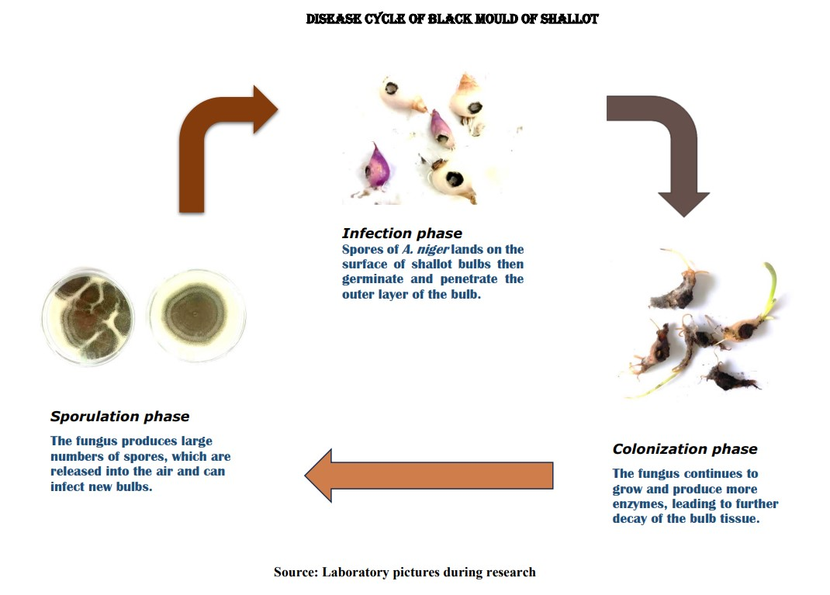

Figure 1. Disease cycle and epidemiology of black mold of shallot

Source: Laboratory pictures during research

The epidemiology of black mold of shallot is influenced by several factors, including the presence of inoculum in the soil, environmental factors like humidity and temperature, and cultural practices such as irrigation and fertilization. The disease is most common in areas with warm, humid climates and in fields where shallot is grown continuously.

The pathogen Aspergillus niger
Aspergillus niger is a common saprophytic filamentous fungus belonging to the family Aspergillaceae, which is ubiquitous in nature and can be found in soil, air, and water (Krijgsheld et al., 2013; Lanette, 2014; Paulussen et al., 2017). It is a well-known organism for its ability to produce a vast array of secreted enzymes, including amylases, pectinases, and proteases, which can be utilized for industrial processes such as food and beverage production, paper and pulp industries, and biofuel production (Lopes et al., 2011; Cairns et al., 2018; Bellaouchi et al., 2021; Laothanachareon et al., 2022). In the fermentation, food, and beverage industries, A. niger is frequently utilized to produce glucoamylases, which accelerate the saccharification of partly processed starch. (Lopes et al., 2011). Moreover, A. niger has a high tolerance to low pH and can thrive at a range of temperatures, making it highly versatile for industrial processes ( Hee-Soo et al., 2017; Cen et al., 2020). Aspergillus niger is a significant pathogen that can cause diseases in both plants and humans.
In humans, A. niger causes fungal infections, particularly in immunocompromised individuals. These infections can range from skin and nail infections to severe diseases such as aspergillosis, which can spread from the lungs to other organs (Person et al., 2010). Aspergillus niger primarily causes respiratory infections, particularly in individuals with weakened immune systems. The fungus may colonize the lungs and enter the body mostly by inhalation of spores, which can cause aspergillosis. In extreme cases, the infection might spread across organs, causing systemic aspergillosis, which is frequently deadly in those with weakened immune systems. The symptoms of aspergillosis vary based on the kind of infection but can include fever, cough, chest discomfort, and trouble breathing ( Georg et al., 2012; Kosmidis and Denning, 2015; Fiema et al., 2022; Okamura et al., 2022).
In plants, A. niger infects fruits, vegetables, and crops, leading to significant economic losses in agriculture (Xin et al., 2023). Aspergillus niger produces a range of toxins such as ochratoxin A, patulin, and fumonisin, which can contaminate food, posing a risk to human health (Palencia et al., 2010; Xin et al., 2023). These toxins are produced by the fungus during the infection process, and their accumulation in plant tissues can cause illness or death in humans, livestock, and wildlife (Palencia et al., 2010; Jasmine, 2014; Xin et al., 2023). For example, ochratoxin A is a carcinogenic mycotoxin that can affect the kidneys, while patulin can cause nausea, vomiting, and diarrhea (Xin et al., 2023).
Therefore, the presence of A. niger in food and feed should be minimized to prevent the risk of human and animal exposure to these toxins. Aspergillus niger can cause post-harvest decay in various crops, including shallots, and can lead to reduced bulb quality and storage life, the colonization of shallot bulbs by A. niger can lead to the production of enzymes that degrade the bulb tissue and changes in the bulb's chemical composition(Cairns et al., 2018).

Identification of Aspergillus niger
Researchers have investigated the cultural, morphological, and microscopic characteristics of A. niger in great detail Here are some key findings:

Cultural and Morphological Features
Aspergillus niger colonies are large and black or dark brown in color, often with a powdery or velvety texture. A variety of substrates, such as fruits, vegetables, cereals, and dairy products are suitable for the fungus to grow on. The septate hyphae of A. niger are primarily yellow in color. It produces carbon black or extremely dark brown spores from biseriate phialides, which distinguishes it from other Aspergillus species. The conidial heads of A. niger are globose and dark brown in color, dividing into columns as the fungus ages. The conidia of A. niger are smooth, black, and spherical or ellipsoidal in shape (Cairns et al., 2022).

Microscopic Features
Aspergillus niger can be distinguished microscopically by the presence of large, round or oval vesicles at the tips of the conidiophores. The hyphae of A. niger often contain dark granules or vacuoles, which are thought to be involved in nutrient storage and metabolism. These features contribute to the identification and characterization of A. niger in various settings, including agricultural, industrial, and medical contexts. . (Bennett, 2010; Amiri et al., 2021).
C
A = Strain 1 (Cultural view of A. niger)
B = Strain 2 (Cultural view of A. niger)
C = Microscopic view
B
A
Figure 2. Cultural and Microscopic view of A.niger

Source: Laboratory pictures during research

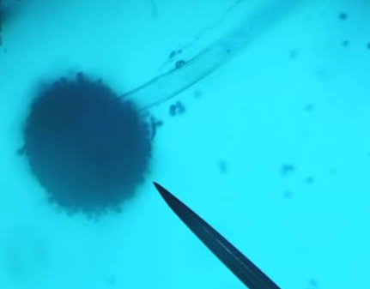
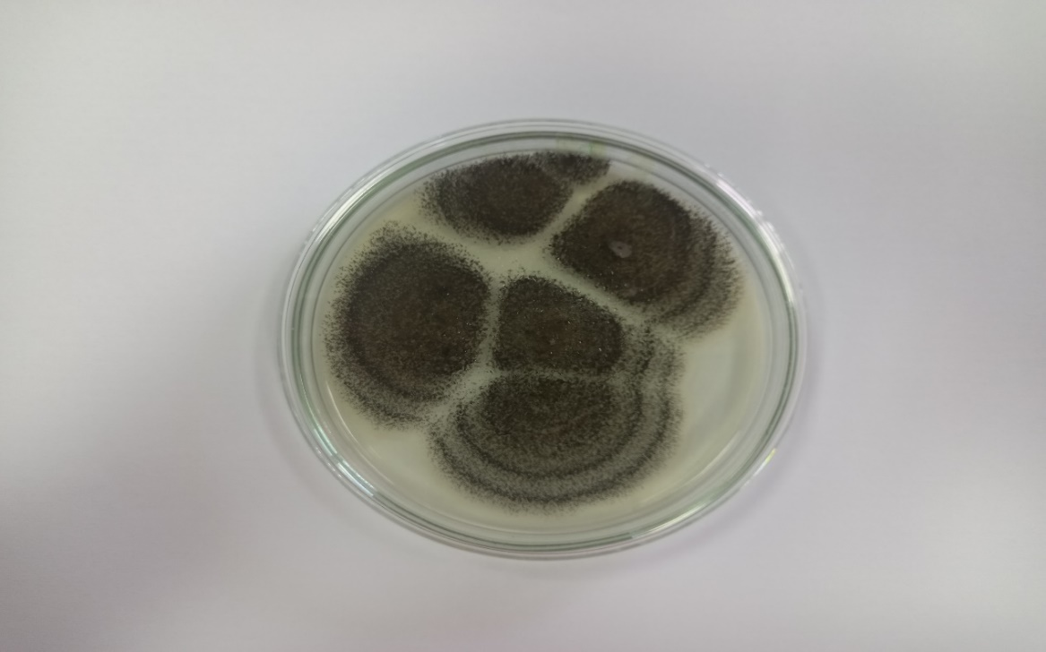
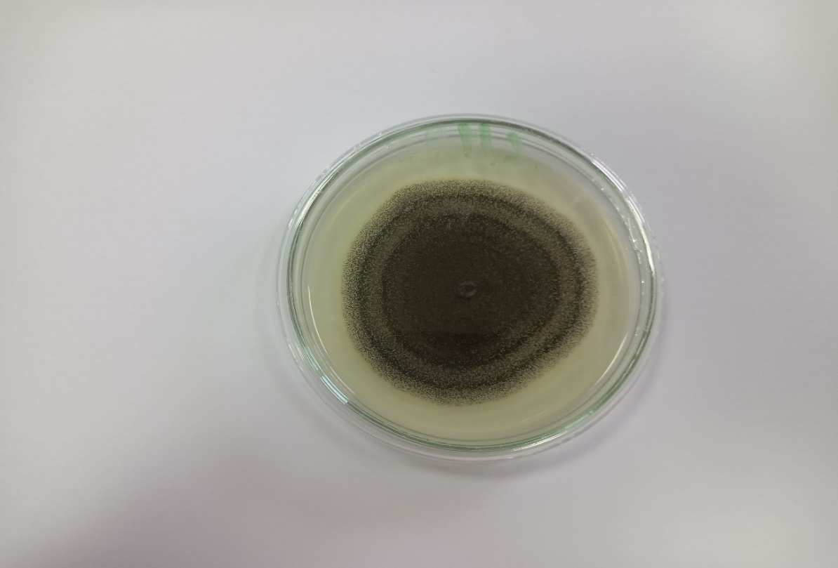

Management of black mold of shallot
Several methods are employed in the management of the black mold disease of shallot, some of these methods are described below;

Biological control
The post-harvest disease known as black mold of shallot, which is caused by the fungus A. niger, degrades the quality and marketability of shallot bulbs. Biological control is a promising approach for managing this disease, as it is environmentally-friendly and sustainable. Some microorganisms have been evaluated as biocontrol agents for black mold of shallot, including bacteria and fungi. Nuray and Levent (2014) reported that application of T. harzianum significantly reduced the incidence and severity of black mold disease in shallot.
Biological control using microorganisms such as T. harzianum can be an effective strategy for managing black mold of shallot. However, further research is needed to optimize the use of these microorganisms in field conditions.

Cultural control
Cultural control of black molds of shallot can be achieved through various practices such as crop rotation, sanitation, and proper irrigation. These practices help to reduce the humidity and moisture levels that promote the growth of black molds on shallots.
Different crops are planted in exactly the same field each year as part of crop rotation, which breaks the life cycle of the pathogens that produce black mold. According to a study by Agrios (2005) crop rotation can help to reduce the incidence of black mold on shallots by up to 50%. Sanitation practices including removal of plant debris, sterilizing tools, proper disposal of infected plant material, proper irrigation practices and ensuring good drainage prevents the growth and spread of black mold disease (Prajapati and Patil, 2016a).

Chemical control
Using synthetic fungicides to manage the disease is one of the most successful methods. Use of nano-sulphur was found to be the most effective against black mold rot (Choudhury et al., 2010). According to a study by Anadani and Vanthana, (2017), systemic fungicides dinocap and thiram, carbendazim and tebuconazole, and combinations of tebuconazole + trifioxystrobin and pyraclostrobin + epoxyconazole all significantly slow down the growth of radial mycelia when tested in vitro. It is important to note that the use of synthetic fungicides may leave residue in the farm produce which may be harmful to consumers.

Use of botanicals
Botanical control methods can be effective in reducing the incidence and severity of black mold. Aspergillus niger, Penicillium citrinum (which causes citrus rust), and Rhizopus oryzae (a disease that affects carrots, pineapples, and mangoes) are all susceptible to the peel and juice extracts from pomegranate (Punica granatum), both in aqueous and alcoholic forms. (Dahham et al., 2010). According to Avasthi et al. (2010), Syzygium aromaticum and Allium sativum completely inhibited mycelia growth of A. niger at a 20% concentration, indicating that spices have antifungal activity and can be used as natural fungi toxicants for managing the growth of storage or spoilage fungi. The growth of A. niger mycelia (the black mold that grows on vegetables) has been found to be inhibited by aqueous extracts from the plants A. nilotica, M. elengi, and P. juliflora. (Satish et al., 2007). As a multispecies natural control, ethanolic extracts of grains of paradise (Aframomum melegueta) and clove basil (Ocimum gratissimum) may inhibit the formation of spores and mycelia of A. flavus and A. niger (Okigbo and Ogbonnaya, 2006).
Other studies (Nehal et al., 2009; Sibi et al., 2013; Anadani and Vanthana, 2017; Srinivas et al., 2019) have also investigated the use of natural products for controlling black mold disease in onions, which may also be applicable to shallots: Indian culinary spices like cardamom, cinnamon, clove, pepper, star anise, and stone flower have been shown to have antifungal activity against A. niger under in vitro circumstances, and peroxyacetic acid (PAA) vapors were discovered to be effective in managing black mold disease in onion bulbs during storage. Garlic and onion oils, Potassium sorbate, and Sodium benzoate have all been evaluated for their inhibitory effect against A. niger, the cause of black mold disease in garlic cloves during storage.
Overall, the use of plant extracts as alternative approaches for managing black mold of shallot holds great promise for reducing the reliance on synthetic fungicides and promoting sustainable agriculture.

CONCLUSION
The management of black mold in shallots, caused by Aspergillus niger, requires a decisive shift away from reliance on synthetic fungicides. As this review has detailed, sustainable and effective alternatives are available. Botanical extracts from plants like garlic, clove, and neem, rich in antifungal phytochemicals such as phenolics, terpenoids, and flavonoids, demonstrate significant potential in suppressing the pathogen. Furthermore, biological control agents like Trichoderma harzianum and proper cultural practices provide a strong foundation for an integrated disease management strategy. The adoption of these eco-friendly approaches is crucial for mitigating economic losses, reducing environmental and health risks, and ensuring the long-term sustainability of shallot production. Future efforts should focus on optimizing the application of these alternatives and promoting their integration into a resilient framework that safeguards both crop yield and farmer livelihoods.

Disclaimer (Artificial intelligence)
Author(s) hereby declare that NO generative AI technologies such as Large Language Models (ChatGPT, COPILOT, etc.) and text-to-image generators have been used during the writing or editing of this manuscript.

REFERENCES
- Adegoke AA, Iberi PA, Akinpelu DA, Aiyegoro OA, M. C. (2011). Studies on phytochemical screening and antimicrobial potentials of Phyllanthus amarus against multiple antibiotic resistant bacteria. Int J Appl Res Nat Prod, 3, 6–12.
- Adzraku, M. E. (2017). Assessing the Role of Small Scale Irrigation Vegetable. 1–182.
- Agrios, G. N. (2005). Plant Pathology (5th ed.) Academic Press San Diego.
- Amiri, Z., Asgharipour, M. R., Campbell, D. E., Azizi, K., Kakolvand, E., & Hassani Moghadam, E. (2021). Conservation agriculture, a selective model based on emergy analysis for sustainable production of shallot as a medicinal-industrial plant. Journal of Cleaner Production, 292, 126000. https://doi.org/10.1016/j.jclepro.2021.126000.
- Avasthi, S., Gautam, A. K., & Bhadauria, R. (2010). Antifungal activity of plant products against Aspergillus niger: A potential application in the control of a spoilage fungus. Biological Forum - An International Journal, 2(1), 53–55.
- BBC-Gardener. (2020). How to grow shallots. In Gardeners’ World.com. BBC Gardeners’ World Magazine. https://www.gardenersworld.com/how-to/grow-plants/how-to-grow-shallots/.
- Bellaouchi, R., Abouloifa, H., Rokni, Y., Hasnaoui, A., Ghabbour, N., Hakkou, A., Bechchari, A., & Asehraou, A. (2021). Characterization and optimization of extracellular enzymes production by Aspergillus niger strains isolated from date by-products. Journal of Genetic Engineering and Biotechnology, 19(1). https://doi.org/10.1186/s43141-021-00145-y.
- Benjamin Yao, F., Grace, O., Simon Kwame, O., & Lucy Payne, D. (2017). The Present Status of Shallot (Allium ascalonicum L.) Farming Enterprise in Ghana: The Case of Keta Municipality. Agricultural Communications, 5(2), 8–16.
- Bennett, J. W. (2010). An overview of the genus Asperillus. Aspergillus. Molecular Biology and Genomics, 1–17.
- Bhattacharya, A., Sood, P., & Citovsky, V. (2010). The roles of plant phenolics in defence and communication during Agrobacterium and Rhizobium infection. Molecular Plant Pathology, 11(5), 705–719. https://doi.org/10.1111/j.1364-3703.2010.00625.x
- Bhattacharyya, D., Sinha, R., and Hazra, S. (2018). Antifungal activity of neem (Azadirachta indica) extract against Fusarium oxysporum and Colletotrichum gloeosporioides. Journal of Plant Protection Research, 58(3), 259–266.
- Cairns, T. C., Zheng, X., Feurstein, C., Zheng, P., Sun, J., & Meyer, V. (2022). A Library of Aspergillus niger Chassis Strains for Morphology Engineering Connects Strain Fitness and Filamentous Growth With Submerged Macromorphology. Frontiers in Bioengineering and Biotechnology, 9(January), 1–15. https://doi.org/10.3389/fbioe.2021.820088.
- Cen Li , Jingwen Zhou , Guocheng Du , Jian Chen , Shunji Takahashi, S. L. (2020). Developing Aspergillus niger as a cell factory for food enzyme production. Biotechnology Advances, Elsevier, 44(107630). https://doi.org/https://doi.org/10.1016/j.biotechadv.2020.107630.
- Choudhury, S. R., Nair, K. K., Kumar, R., Gogoi, R., Srivastava, C., Gopal, M., Subhramanyam, B. S., Devakumar, C., & Goswami, A. (2010). Nanosulfur: A potent fungicide against food pathogen, Aspergillus niger. AIP Conference Proceedings, 1276, 154–157. https://doi.org/10.1063/1.3504287.
- Dahham SS, Ali MN, Tabassum H, K. M. (2010). Studies on antibacterial and antifungal activity of pomegranate (Punica granatum L.). Am-Euras J Agric & Environ Sci, 9(3), 273–281.
- Fiema, M., Wlodarczyk, A., Wojkowska-Mach, J., Garlicki, J., & Gregorczyk-Maga, I. (2022). Atypical Presentation of Aspergillus niger Infection in the Oral Cavity as a Prediction of Invasive Pulmonary Aspergillosis in a Patient with COVID-19: Case Report and Literature Review. Microorganisms, 10(8). https://doi.org/10.3390/microorganisms10081630.
- Georg Maschmeyer, Antje Haas, O. A. C. (2012). Invasive Aspergillosis Epidemiology, Diagnosis and Management in Immunocompromised Patients. Springer Link, 67, 1567–1601.
- Grundy, M. M., Lapsley, K., & Ellis, P. R. (2016). A review of the impact of processing on nutrient bioaccessibility and digestion of almonds. Review 1937–1946. https://doi.org/10.1111/ijfs.13192.
- Hee-Soo Park, Sang-Cheol Jun, Kap-Hoon Han, Seung-Beom Hong, J.-H. Y. (2017). Diversity, Application, and Synthetic Biology of Industrially Important Aspergillus Fungi. In Advances in Applied Microbiology (Vol. 100, pp. 161–202). Elsevier. https://doi.org/https://doi.org/10.1016/bs.aambs.2017.03.001.
- Herlina, L., Reflinur, Sobir, Maharijaya, A., & Wiyono, S. (2019). The genetic diversity and population structure of shallots (Allium cepa var. aggregatum) in indonesia based on R gene-derived markers. Biodiversitas, 20(3), 696–703. https://doi.org/10.13057/biodiv/d200312.
- Khalid, M., Saeed-ur-Rahman, Bilal, M., & HUANG, D. feng. (2019). Role of flavonoids in plant interactions with the environment and against human pathogens — A review. Journal of Integrative Agriculture, 18(1), 211–230. https://doi.org/10.1016/S2095-3119(19)62555-4.
- Kosmidis, C., & Denning, D. W. (2015). The clinical spectrum of pulmonary aspergillosis. Thorax, 70(3), 270–277. https://doi.org/10.1136/thoraxjnl-2014-206291.
- Krijgsheld, P., Bleichrodt, R., van Veluw, G. J., Wang, F., Müller, W. H., Dijksterhuis, J., & Wösten, H. A. B. (2013). Development in aspergillus. Studies in Mycology, 74, 1–29. https://doi.org/10.3114/sim0006.
- Kumar, V., Neeraj, Sharma, S., & Sagar, N. A. (2015). Post Harvest Management of Fungal Diseases in Onion - A Review. International Journal of Current Microbiology and Applied Sciences, 4(6), 737–752.
- Lanette Sobel. (2014). Aspergillus niger. In Bugwood wiki. https://wiki.bugwood.org/Aspergillus_niger.
- Laothanachareon, T., Bunterngsook, B., & Champreda, V. (2022). Profiling multi-enzyme activities of Aspergillus niger strains growing on various agro-industrial residues. 3 Biotech, 12(1), 1–16. https://doi.org/10.1007/s13205-021-03086-y.
- Lopes, F. C., Silva, L. A. D. E., Tichota, D. M., Daroit, D. J., Velho, R. V., Pereira, J. Q., Corrêa, A. P. F., & Brandelli, A. (2011). Production of proteolytic enzymes by a keratin-degrading aspergillus niger. Enzyme Research, 2011(1). https://doi.org/10.4061/2011/487093.
- Mierziak, J., Kostyn, K., & Kulma, A. (2014). Flavonoids as important molecules of plant interactions with the environment. Molecules, 19(10), 16240–16265. https://doi.org/10.3390/molecules191016240.
- Miller, L. (2022). Tips For Growing Shallots That Are Disease And Pest Free Shallots. In Gardening. https://www.gardeningknowhow.com/edible/vegetables/shallot/shallot-problems.htm.
- Nehal el-mougy, dr nadia el-gamal, M. A.-K. (2009). Pre-storage application of some essential oils and food preservatives against black mould incidence of garlic cloves during storage. Taylor & Francis, 42(11), 1059–1068. https://doi.org/10.1080/03235400701621933.
- Nuray Özer, L. A. (2014). Evaluation of fungal antagonists to control black mold disease under field conditions and to induce the accumulation of antifungal compounds in onion following seed and set treatment. Crop Protection, Elsevier, 65, 21–28. https://doi.org/https://doi.org/10.1016/j.cropro.2014.06.027.
- Okamura, K., Noro, R., Fujita, K., Kure, S., Kunugi, S., Takano, H., Miyashita, R., Tozuka, T., Tanaka, T., Sugano, T., Sakurai, Y., Suzuki, A., Suga, M., Hayashi, A., Saito, Y., Kubota, K., Seike, M., & Gemma, A. (2022). Acute respiratory failure due to Aspergillus niger infection with acute fibrinous and organazing pneumonia: A case report. Respiratory Medicine Case Reports, 37, 101641. https://doi.org/10.1016/j.rmcr.2022.101641.
- Okigbo RN, O. U. (2006). Antifungal effects of two tropical plant leaf extracts (Ocimum gratissimum and Afromomum melegueta) on postharvest yam (Dioscorea spp.) rot. Afr J Biotechnol, 5(9), 727–731.
- Palencia, E. R., Hinton, D. M., & Bacon, C. W. (2010). The black Aspergillus species of maize and peanuts and their potential for mycotoxin production. Toxins, 2(4), 399–416. https://doi.org/10.3390/toxins2040399.
- Panoff, L. (2019). What Are Shallots? Nutrition, Benefits, and Substitutes Medically reviewed. In Healthline. https://www.healthline.com/nutrition/what-are-shallots.
- Paulussen, C., Hallsworth, J. E., Álvarez-Pérez, S., Nierman, W. C., Hamill, P. G., Blain, D., Rediers, H., & Lievens, B. (2017). Ecology of aspergillosis: insights into the pathogenic potency of Aspergillus fumigatus and some other Aspergillus species. Microbial Biotechnology, 10(2), 296–322. https://doi.org/10.1111/1751-7915.12367.
- Person, A. K., Chudgar, S. M., Norton, B. L., Tong, B. C., & Stout, J. E. (2010). Aspergillus niger: An unusual cause of invasive pulmonary aspergillosis. Journal of Medical Microbiology, 59(7), 834–838. https://doi.org/10.1099/jmm.0.018309-0.
- Pramod, S.S, Debabandya, M, Manoj, K.T, Saroj, K. G, Adinath K, & Kumar, M (2022). Inactivation of Aspergillus niger and Erwinia carotovora in onion (Allium cepa L) bulbs subjected to pulsed ozone treatment. Postharvest Biologyand Technology, 192.
- Prajapati, B., & Patil, R. K. (2016a). Bio-efficacy of fungicides in management of black mould rot ( aspergillus niger ) of onion. Elsevier
- Prajapati, B., & Patil, R. K. (2016b). Impact of Inoculation Methods on Development of Black Mould Rot of Onion Incited by Aspergillus niger Van Tieghem. Elsevier.
- Safitri, Y. A., Hasanah, U., Salamiah, S., Samharinto, S., & Pramudi, M. I. (2019). Distribution of major diseases of shallot in South Kalimantan, Indonesia. Asian Journal of Agriculture, 3(02), 33–40. https://doi.org/10.13057/asianjagric/g030201.
- Satish S, Mohana DC, Ranhavendra MP, R. K. (2007). Antifungal activity of some plant extracts against important seed borne pathogens of Aspergillus sp. J Agr Sci Tech, 3(1), 109–119.
- Sibi G., Wadhavan R., Singh S., Dhananjaya K., Ravikumar K. R., less H. M.. (2013). Biological control of onion black mold by Indian culinary spices under in vitro conditions. Asian Journal of Pharmaceutical and Clinical Research.
- Srinivas, C., Devi, D. N., Murthy, K. N., Dhananjaya, C., Lakshmeesha, T. R., Singh, B., Kumar, N., Niranjana, S. R., Hashem, A., Alqarawi, A. A., Tabassum, B., Fathi, E., Allah, A., & Nayaka, S. C. (2019). Fusarium oxysporum f . sp . lycopersici causal agent of vascular wilt disease of tomato : Biology to diversity – A review. Saudi Journal of Biological Sciences, 26(7), 1315–1324. https://doi.org/10.1016/j.sjbs.2019.06.002.
- Supyani, Poromarto, S. H., Supriyadi, & Hadiwiyono. (2021). Moler Disease of Shallot in the Last Three Years at Brebes Central Java: The Intensity and Resulting Yields Losses is Increasing. IOP Conference Series: Earth and Environmental Science, 810(1). https://doi.org/10.1088/1755-1315/810/1/012004
- Swamy S., & Godaw A.. (2014). Management of major diseases and insect pests of onion and garlic: A comprehensive review. Journal of Plant Breeding and Crop Science, 6(11), 160–170. https://doi.org/10.5897/jpbcs2014.0467.
- V.B. Anadani, R. S., & M. Vanthana, L. F. A. (2017). Management of Black Mold of Onion [Aspergillus niger (Van Teigh)] by using Various Fungicides. International Journal of Current Microbiology and Applied Sciences, 6(3), 1621–1627. https://doi.org/10.20546/ijcmas.2017.603.187.
- Wenli, S., Mohamad, H. S., & Qi, C. (2019). The insight and survey on medicinal properties and nutritive components of Shallot. Journal of Medicinal Plants Research, 13(18), 452–457. https://doi.org/10.5897/jmpr2019.6836.
- Xin, X., Nan, M., Bi, Y., Xue, H., Zhang, Y., Wang, J., & Lu, Z. (2023). Effects of Aspergillus niger Infection on the Quality of Jujube and Ochratoxin A Cumulative Effect. Toxins, 15(7), 406. https://doi.org/10.3390/toxins15070406.
- Yeboah, T., & Egyir, I. (2023). Children’s Work in Shallot Production on the Keta Peninsula, South-Eastern Ghana. Children’s Work in African Agriculture, 233–250. https://doi.org/10.56687/9781529226072-014.
- Zeleke, A. A. (n.d.). Advances in Crop Science and Technology Shallot Production Status in Ethiopia: A Research Review. 5–7. https://doi.org/10.4172/2329-8863.10005

