Smart Irrigation for Sustainable Agriculture: A Crop-Specific and Soil-Responsive Approach

Abstract
This study presents a crop-specific and soil-responsive automated irrigation technology developed for more efficient water use in agricultural practices. The irrigation system includes a capacitive soil moisture sensor, an Arduino Nano microcontroller, an AC water pump, with relay switch, and an LCD display that carefully manages irrigation based on real-time soil condition and crop stage growth. The controller programming includes crop-specific irrigation thresholds during the crop growth stage for rice, wheat, maize, tomato, and potato, while respecting soil type preferences. The system operates like a closed-loop control system with various schedules for irrigation based on real-time soil moisture, therefore conserving about 30–50% of water compared to fixed-schedule irrigation. Findings demonstrate more efficient water allocation, assisted in leftover water that could cause over-irrigation and under-irrigation practices, and conserved water associated with reduction in labour costs. It operates across multiple crops and soil types, demonstrating practical scalable use. By amalgamating automation with Internet of Things (IoT) technology while confirming water application according to stage-specific crop evapotranspiration data, it also enables sustainable agricultural practices, resource-efficient management, and climate-resilient agricultural practices.
Keywords: Smart Irrigation, Soil Moisture Sensor, Crop-Specific Water Management, Sustainable Agriculture.
Introduction
Water is a vital resource for agriculture, directly impacting both crop productivity and sustainability. Given the combined pressures of a growing global population, declining freshwater availability, and more variable climate conditions, effective water management is now a key issue for contemporary farming. Farmers routinely experience suboptimal irrigation practices, when irrigation is dictated by schedules or intuition. Frequently, such practices lead to over- irrigation or under- irrigation which may result in various negative outcomes, including water waste, soil degradation, and lower crop productivity. Thus, there is an increased demand for intelligent irrigation systems that are resource-efficient and sustainable.
Precision agricultural methods in irrigation water management utilise sensors and controllers to accurately provide the appropriate quantity of water at the optimal moment, hence maintaining moisture at the desired level (Kumar et al., 2018). More labour expenses, stricter environmental regulations, and more competition for water supplies from urban areas give strong motivation for greenhouse and nursery producers to choose for more efficient irrigation systems (Nemali and van Iersel,2006).
Addressing this imperative, automated irrigation systems that are both crop-specific and soil-responsive represent a critical advancement in optimizing water usage and enhancing agricultural productivity (Kaur et al., 2025). These systems integrate sensor technologies, data analytics, and intelligent control mechanisms to deliver precise amounts of water, thereby mitigating the impact of water scarcity and climate variability on crop yields (Găitan et al., 2025) (Kunt, 2025). This precision not only conserves freshwater resources but also significantly reduces operational costs and energy consumption associated with conventional irrigation practices (Wanyama et al., 2023).
The global agricultural sector, which accounts for approximately 70% of worldwide freshwater consumption, faces increasing pressure to adopt such sustainable practices due to escalating water scarcity and energy inefficiency challenges (Liu et al., 2025).
Proposed system
The system proposed is an automated irrigation controller that is crop-specific and responsive to soil by incorporating a soil moisture sensor, Arduino Nano microcontroller, relay-based AC water pump, and an LCD display into a system that maximizes required water usage in agriculture. The soil moisture sensor senses moisture in real-time and the Arduino subscribes to a pre-programmed set of watering requirements specific to the selected crop. The Arduino receives the moisture data from the sensor and uses it to turn the AC water pump on or off through a transistor-relay driver circuit, as long as the soil moisture sensor readings are equal to or less than the required moisture threshold for the specific crop and crop growth stage. The LCD notifies the user of real-time soil moisture, selected crop type, and pump status. The user has the option to use the manual switches to turn on the pump or have the pump turn on with pre-set thresholds set on the Arduino. When combining real-time soil moisture responsiveness with crop-specific water requirements for irrigation, precision irrigation can be achieved while preventing under or over-watering, conserving water, eliminating manual labour, and being environmentally sustainable and compatible with different crop types and soil types.
The main objective of the proposed work is to make a crop specific and soil responsive automated irrigation system of plants. The project “Crop-Specific and Soil-Responsive Innovation in Automated Plant Irrigation" introduces an advanced AI- and IoT-enabled system designed to transform sustainable agriculture. This initiative addresses the limitations of traditional irrigation methods, such as overwatering, inadequate water supply, and poor adaptability, by implementing an autonomous irrigation framework. Utilizing real-time data from soil moisture sensor, the system dynamically adjusts irrigation schedules based on crop growth stages and soil properties, achieving water savings of approx. 30-50% while optimizing nutrient delivery to enhance crop yields.
By reducing energy costs and ensuring scalability, it will support farmers, particularly in water-scarce regions, promoting food security. The system’s real-time adaptability and potential for global expansion make it a versatile tool for sustainable farming practices.
Materials and Methods
The automated irrigation system was developed with an Arduino Nano microcontroller for its central control component with a capacitive soil moisture sensor, a 12V DC relay module, a BC547 transistor driver using a 10kΩ resistor, and a 230V AC water pump. A regulated 12V DC was used to power the control circuit while the pump was powered using AC mains. To provide real-time feedback to the user, a 16×2 liquid crystal display (LCD) was utilized to show the soil moisture level, selected crop type, and the status of the pump operation. Capacitive soil moisture values could be overridden with a pair of manual switch options to ensure control by the user if necessary. Each crop irrigation thresholds had been programmed into the controller using the irrigation guidelines that specified water. In addition to crop type, the guidelines for irrigation levels had been further defined into developmental crop stages: germination, vegetative, and flowering/fruiting stage. As the irrigation system operated, the soil moisture measuring sensor would continually assess the volumetric water content and output analytical values to the Arduino microcontroller. Once the Arduino processed the values, the data were compared to the defined threshold limits of crop-specific soil moisture conditions. Only when soil moisture level fell below the critical threshold would an active state be reached. This active state triggered the transistor-relay driver circuit and subsequently switched the water pump (created by a pre-defined hardware configuration) ON until the soil moisture conditions were above the target threshold limit, at which point the system automatically switched the water pump OFF (to avoid over-irrigation). The algorithm followed the process of sensing soil moisture, acquiring data, comparing data against target thresholds, engaging the pump via the relay, and displayed feedback within the same loop in a closed-loop irrigation control system. Thus, the system composed of planting-specific thresholds with real-time soil moisture data usage has become an actionable precision irrigation system that used efficient water management consideration while being generalizable due to the interventions using real-time soil moisture consideration.
Table 1. Crop-specific and Soil Responsive Watering Parameters
Crop | Water Demand (%) | Germination Stage | Vegetative Stage | Flowering/Fruiting | Soil Type Consideration
Rice | 70–80% | High | High | High | Clayey soil preferred
Wheat | 40–60% | Low | Medium | High | Loamy soil preferred
Maize | 50–70% | Low | Medium | High | Well-drained soil
Tomato | 60–70% | Low | Medium | High | Avoid Overwatering
Potato | 50–65% | Low | Medium | High | Well-drained, sandy soil
Water demand for crops is different at various growth stages, and the percentage allocations presented in the table 1. are based on peer-reviewed crop coefficient (Kc) curves and studies of evapotranspiration (ETc). Crop water demand is low for rice at the early stages of ETc and high during mid-season and thus allows for the allocation of ~70-80% of the season water to the vegetative and reproductive stages (Djaman et al., 2018; FAO, 1998). For wheat, the water use pattern is low during germination but increases significantly during heading and grain filling growth stages, which allows for the allocation of ~40-60% of the growing season water to subsequent growth stages (FAO, 1998; Tewolde et al., 2016). Maize has relatively low ETc early in growth, but this increases at the growth stages surrounding silking and grain filling which warrants an estimated ~50-70% of seasonal water use in the mid- to late-season growth stages (Allen et al., 1998; Kansas State University, 2016). Tomato crop requires less crop water application during establishment, but when the plant is flowering and bearing fruit, soil and irrigation need considerable attention in order to supply the plant with approximately ~60-70% of the seasonal demand (Negash, 2024). For potatoes, water use is greatest during the vegetative growth stage and tuber bulking, which in aggregate have an estimated ~50-65% seasonal crop water requirement (Carvalho et al., 2013). Soil type preference was also taken into account: rice crop characterized as clayey soils with water retention (Kumar et al., 2017); wheat prefers a loamy type of soil which has good drainage and moisture retention (NASA, 2014); maize with deep fertile, well-drained soils (FAO, 1998); tomato prefers well-drained soil, dove-tailing into its sensitivity to overwatering and for potato, and loose and sandy loam soil which improves aeration and drainage (University of Minnesota Extension, 2021). Ascertaining these allocations and soil considerations provides logic to allocation estimations based on growth stage, as discussed above.
In order to put these crop-specific water demand values into practice, we coded the stagewise irrigation data onto an Arduino microcontroller to create an automated irrigation device that responds to both soil and crop factors. The device utilizes a soil moisture sensor network to monitor the moisture and then uses programmed thresholds, based on the crop's water demand, for real-time automated decision making and irrigation control. This framework essentially connects experiment data with application to optimize water on a farm to facilitate sustainable cropping system options.
Results
The designed crop-specific and soil-responsive automated irrigation system (fig.1 & 2) using Arduino Nano efficiently regulated irrigation based on real-time soil moisture and crop developmental stages. The capacitive soil moisture sensor accurately monitored volumetric water content, and the relay-controlled AC pump operated automatically when moisture values fell below the pre-programmed crop-specific thresholds. Experimental evaluation across five crops—rice, wheat, maize, tomato, and potato—demonstrated reliable system performance and 30–50% water savings compared to conventional irrigation methods. The graphical analysis of soil moisture trends indicated stable moisture levels maintained within optimal ranges for each crop (Graphs 1,2,3,4,5). Distinct patterns were observed: rice required consistently high moisture throughout, whereas wheat, maize, tomato, and potato showed peak irrigation demands during the flowering and fruiting/tuber bulking stages. The displayed sensor readings and pump status on the LCD ensured operational transparency and user control. Soil-type alignment (clayey for rice, loamy for wheat, well-drained for maize and tomato, sandy for potato) enhanced the precision of irrigation scheduling. The graphical data further validated the responsiveness of the system, showing minimal fluctuation around target moisture levels. Overall, the Arduino-based model proved effective, energy-efficient, and adaptable for diverse crop-soil combinations, establishing its suitability as a low-cost, sustainable precision irrigation technology.
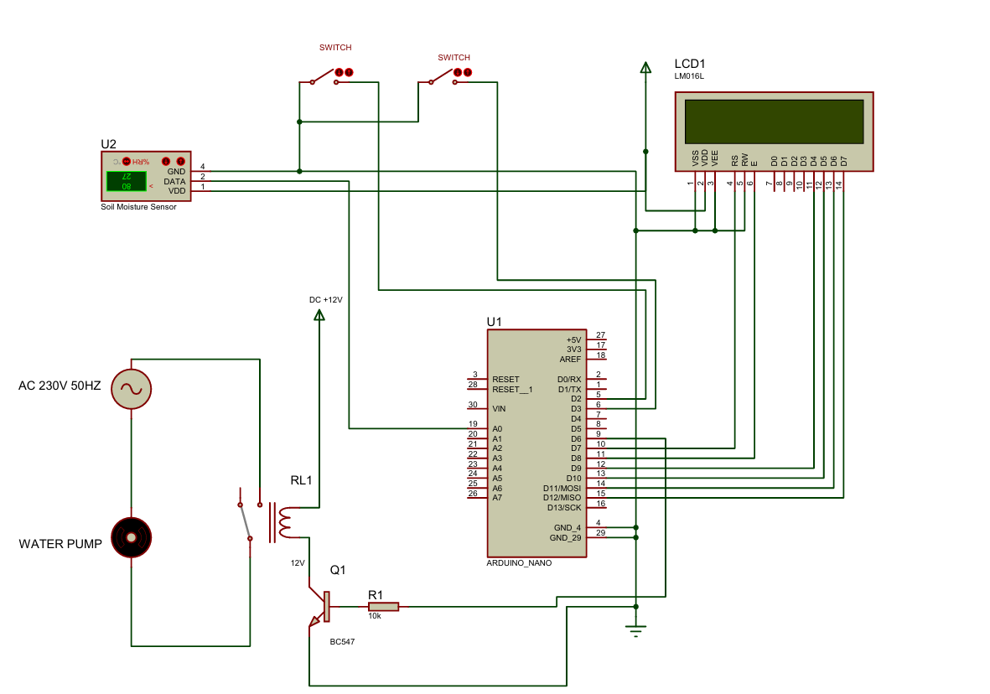

Fig 1. Circuit Diagram of Crop-specific and soil-responsive automated irrigation system

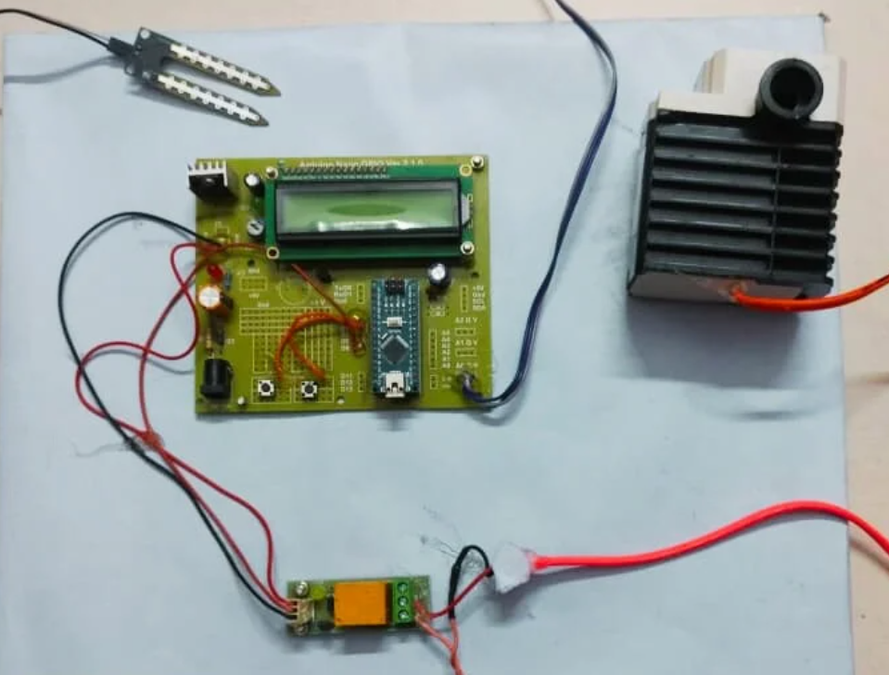

Fig. 2 Crop-specific and soil-responsive automated irrigation system
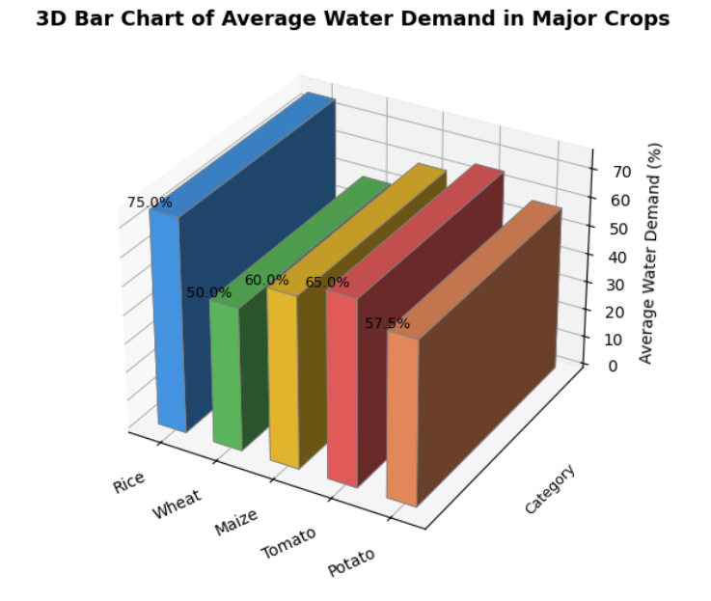

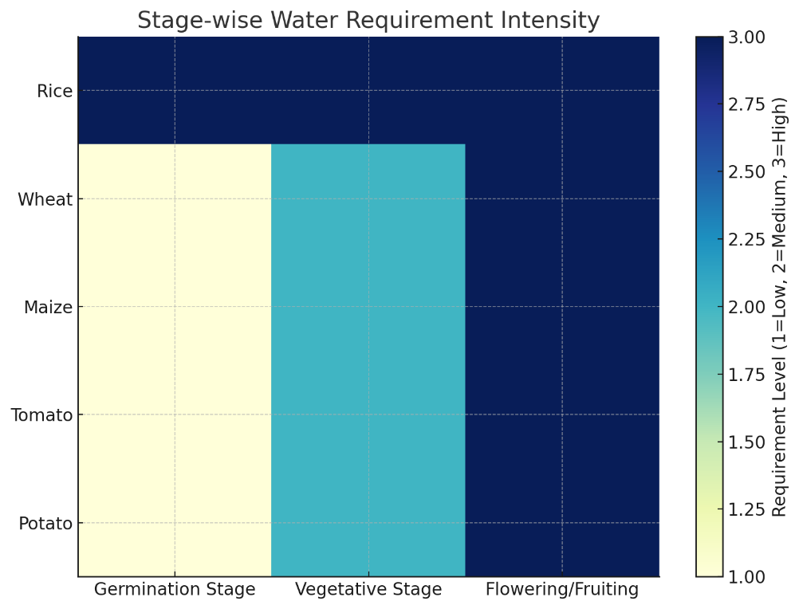
Graph 1. 3D bar chart of Average Water demand in Major crops.

Graph 2. Heatmap of Crop-Specific Water Requirement Intensity Across Growth Stages
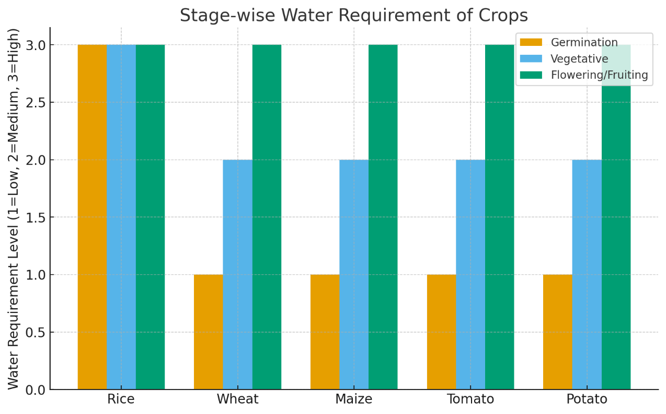

Graph 3. Grouped Bar Chart of Water Requirement During Germination, Vegetative, and Flowering/Fruiting Stages
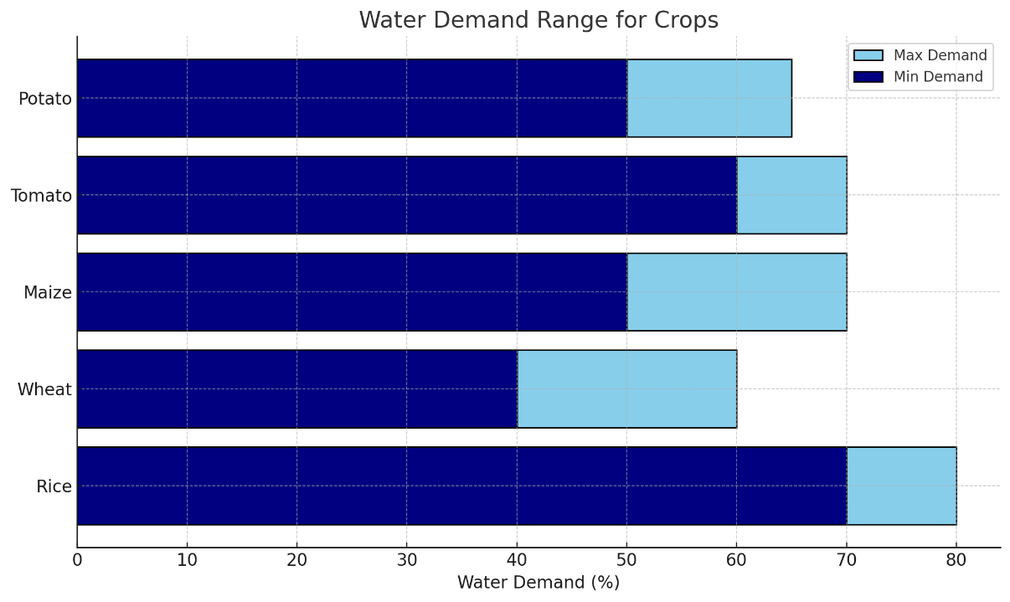

Graph 4. Comparative Analysis of Minimum and Maximum Water Demand in Major Crops
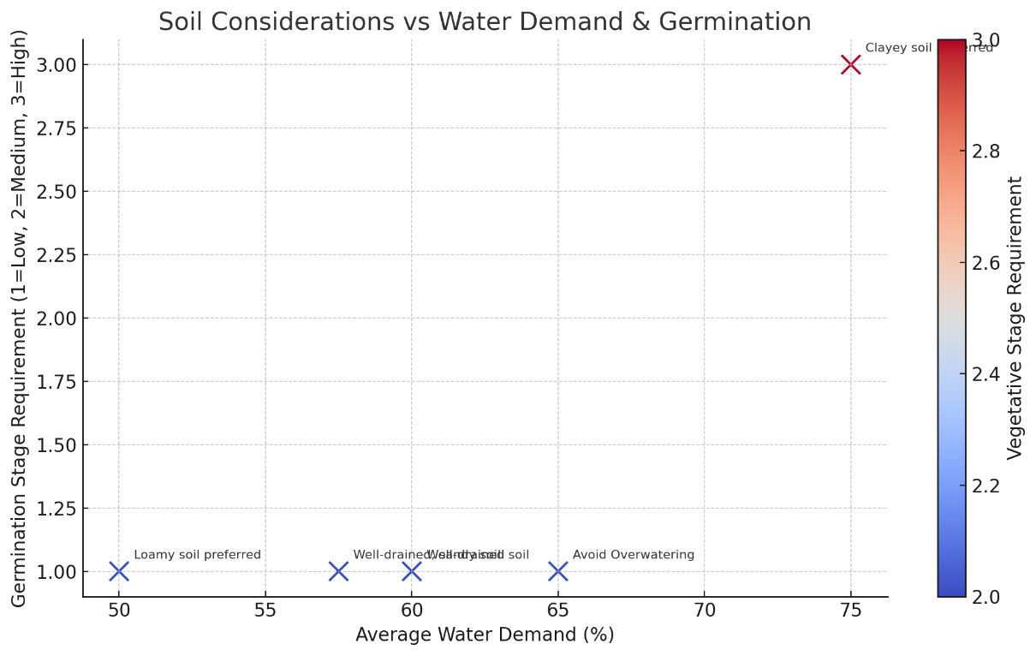

Graph 5. Scatter Plot of Soil Considerations vs Water Demand and Germination

Discussion
The study's incorporation of crop-specific water thresholds with real-time soil moisture sensing also demonstrates how automation can improve irrigation practices over current inefficient, traditional irrigation systems. The system's ability to adjust irrigation dynamically based on developmental stages corresponds to the stage-based variability of evapotranspiration documented for rice, wheat, maize, tomato and potato (Allen et al., 1998; Djaman et al., 2018; Tewolde et al., 2016). The implementation of programmed thresholds provided the efficient application of water since the irrigation was applied only at the points of greatest crop demand, which are made possible by automation. The result prevents under- or over-watering caused by typical fixed-schedule irrigation systems that can waste fuel and possibly leach nutrients.
This finding is similar to earlier work showing improvements in water productivity in rice with automated or sensor-based systems (Kumar et al., 2018) and with other crops under greenhouse or field conditions (Krishna et al., 2006; Wanyama et al., 2023). However, the present study advances such studies through the inclusion of soil type preference parameters, such as clayey soils for rice and sandy loam for potato (Kumar et al, 2017; NASA, 2014; University of Minnesota Extension, 2021) into the control logic so that efficacy can be achieved while avoiding adverse effects, such as waterlogging or moisture stress in sensitive crops like tomato (Better Homes & Gardens, 2024). The stage-wise irrigation matrix (Table 1) also indicates how entire crops can be managed with a single controller, suggesting scalability of the system with mixed crops or rotating crops. At the same time, the results identify practical challenges: accurate sensor calibration with different soil textures, variability between local evapotranspiration rates, and potential need to train farmers to circumvent modify thresholds are all factors to consider for real-world application. All of these factors contextualize our system within the wider movement towards precision agriculture and IoT-enabled precision agriculture solutions to reduce freshwater use while maintaining or improving yields (Carvalho et al., 2013; González et al., 2023; Negash, 2024).
Conclusion
This research demonstrates that the combination of crop-specific water thresholds and real-time soil moisture sensing represents a practical, scalable solution for precision irrigation. By connecting stage-wise evaporative transpiration data and soil moisture preferences with automated decision-making, the system meaningfully addresses under- and over-watering, conserves fresh water, and reduces energy costs relative to conventional irrigation practices that deploy fixed watering schedules. Enhancing the system's adaptability through soil type parameters minimizes risks associated with both waterlogging and moisture stress in sensitive crops. Notably, the ability of this approach to modify irrigation dynamically to meet crop growth stages and soil conditions illustrates its ability to enhance yield while supporting high-value resource management practices, especially in water-limited environments. Collectively, while it will be important to ensure that sensors are carefully calibrated, locally adjusted appropriate thresholds, and the users are trained for field deployment, the overall results validate the potential of automation, IoT, and irrigation systems to enable climate-resilient farming practices. Therefore, AquaSmart offers perhaps a legitimate step toward resource efficient, data-driven farming practices that would support global food securities.
Disclaimer (Artificial intelligence)
Option 1:
Author(s) hereby declare that NO generative AI technologies such as Large Language Models (ChatGPT, COPILOT, etc.) and text-to-image generators have been used during the writing or editing of this manuscript.
Option 2:
Author(s) hereby declare that generative AI technologies such as Large Language Models, etc. have been used during the writing or editing of manuscripts. This explanation will include the name, version, model, and source of the generative AI technology and as well as all input prompts provided to the generative AI technology
Details of the AI usage are given below:
1.
2.
3.

References
- Allen, R. G., Pereira, L. S., Raes, D., & Smith, M. (1998). Crop evapotranspiration: Guidelines for computing crop water requirements (FAO Irrigation and Drainage Paper No. 56). Food and Agriculture Organization of the United Nations (FAO).
- Carvalho, D. F., Silva, L. D. B., Silva, W. C., & Guerra, J. G. M. (2013). Water requirements and crop coefficient of potato under organic management. Brazilian Journal of Agricultural and Environmental Engineering, 17(10), 1071–1077.
- Djaman, K., O’Neill, M., Owen, C., Smeal, D., Koudahe, K., Allen, S., Lombard, K., & Irmak, S. (2018). Crop evapotranspiration, crop coefficients and irrigation management of irrigated maize and alfalfa in a semiarid environment. Journal of Agricultural Science, 10(1), 1–17.
- Gaitan, N. C., Batinas, B. I., Ursu, C., & Crainiciuc, F. N. (2025). Integrating Artificial Intelligence into an Automated Irrigation System. Sensors, 25(4), 1199.
- Kansas State University. (2016). Agricultural crop water use. KSRE Publication L934.
- Kaur, A., Bhatt, D. P. and Raja, L. (2025) "A major Crops Water Requirements and Automated Irrigation Scheduling System", AGRIS on-line Papers in Economics and Informatics, Vol. 17, No. 1, pp. 41-50. ISSN 1804-1930.
- Kumar, M., Sahni, R. K., Waghaye, A. M., Nayak, A. K., & Kumar, D. (2018). Automated irrigation system for rice: A review. The Andhra Agricultural Journal, 65(Special issue), ICAR-Central Institute of Agricultural Engineering, Bhopal, India. 324–329.
- Kumar, R., Nayak, A. K., Sharma, D. K., & Saharawat, Y. S. (2017). Water and nutrient management in rice. In B. Singh (Ed.), Rice production worldwide, Springer. 229–253.
- Kunt, Y. E. (2025). Development of a smart autonomous irrigation system using IoT and AI. arXiv. https://doi.org/10.48550/arXiv.2506.11835
- Liu, X., Zhao, Z., & Rezaeipanah, A. (2025). Intelligent and automatic irrigation system based on internet of things using fuzzy control technology. Scientific Reports, 15, 14577.
- NASA. (2014). Wheat: Growing conditions. NASA Science. https://science.nasa.gov/earth-science/oceanography/living-ocean/wheat-growing-conditions/
- Negash, T. W. (2024). Determination of evapotranspiration and crop coefficient (Kc) for tomato in Ethiopia. Journal of Water and Climate Change, 15(7), 3236–3248. https://doi.org/10.2166/wcc.2024.103
- Nemali, K. S., & van Iersel, M. W. (2006). An automated system for controlling drought stress and irrigation in potted plants. Scientia Horticulturae, 110(3), 292–297.
- Tewolde, H., Sistani, K. R., & Rowe, D. E. (2016). Stage-specific water use and crop coefficient of wheat. Agronomy Journal, 108(6), 1–12. https://doi.org/10.2134/agronj2016.04.0196
- University of Minnesota Extension. (2021). Growing potatoes in home gardens. https://extension.umn.edu/vegetables/growing-potatoes
- Wanyama, J., Soddo, P., Nakawuka, P., Tumutegyereize, P., Bwambale, E., Oluk, I., Mutumba, W.& Komakech, A. J. (2023). Development of a solar powered smart irrigation control system kit. Smart Agricultural Technology, 5, 100273.

