Original Research Article

Contribution to the domestication of Beilschmiedia mannii in Côte d'Ivoire: Effect of cutting size and indole-3-butyric acid (IBA) on rooting and growth

.
ABSTRACT

Beilschmiedia mannii, or spicy cedar, is a tree species of significant food and medicinal value that naturally grows in the tropical forests of Côte d'Ivoire. Unfortunately, severe deforestation and climate change pose a serious threat to the survival of this species, raising concerns about its conservation status. This study aims to develop methods for propagating Beilschmiedia mannii plants through the cutting technique. For this, three categories of cutting (small, medium, and large diameter) were treated with three concentrations (0, 2.5, and 5 mg/L) of Indole-3-Butyric Acid (IBA) and planted in a polypropagator on forest topsoil mixed with construction sand. Once rooted, the cuttings were transplanted into black polyethene bags. As a result, the 100% survival rate observed after plant acclimatisation demonstrates the strong propagation capacity of Beilschmiedia mannii through cutting. The cuttings of small- and medium-diameter exhibited good rooting ability, unlike those with a large-diameter. The 5 mg/L IBA concentration produced the highest rooting success with 36% for small and 53% for medium cuttings, and resulted in the greatest number and length of roots per cutting. The best vegetative growth was observed in plants grown from medium- and small-diameter cuttings treated with 5 mg/L and 2.5 mg/L of IBA, respectively. These findings demonstrate that combinations of IBA and cutting propagation is an effective method for producing uniform, vigorous and healthy seedlings of Beilschmiedia mannii intended for integration into agroforestry systems and sustainable reforestation programs.

Keywords: Beilschmiedia mannii, Cutting, Indole-3-Butyric Acid (IBA), Domestication, Côte d'Ivoire

1. INTRODUCTION

Beilschmiedia mannii (Meisn.) Robyns and Wilczek, commonly known as "spicy cedar," is a tree species of Lauraceae family, endemic to the tropical forests of West and Central Africa. In Côte d'Ivoire, this species mainly grows in secondary forests and riparian vegetation, while domesticated stands are integrated into agroforestry systems (N’zi et al., 2023). It is recognised for its food, medicinal, and artisanal uses, thus contributing to food security, health, and income for rural populations (Olajuyigbe and Adaja, 2020). Its seeds and fruits, which are highly valued in the local diet, are rich in proteins, carbohydrates, minerals, and unsaturated fatty acids (Sahoré et al., 2012; Kouamé et al., 2017; Assi et al., 2017). The seeds are used to prepare a mucilaginous sauce that plays a central role in the cultural and culinary identity of several peoples in western Côte d'Ivoire (Yapo et al., 2018; Yao et al., 2023). Additionally, the high levels of phytochemicals compounds in various plant parts, such as the leaves and bark, are employed in traditional medicine for treating headaches and abdominal pains in humans (Yao et al., 2023). Moreover, these organs are also consumed by animals to booster their immune systems (Ahoua et al., 2015). The wood of B. mannii is used in construction and furniture-making (Mark et al., 2014; Soro et al., 2021). Despite its significant socio-economic potential, there has been a significant decline in natural populations of B. mannii, particularly in Benin (Yevidé et al., 2022) and Côte d'Ivoire (Yao et al., 2023). Although the species is not currently listed as threatened on the International Union for Conservation of Nature (IUCN) Red List, the development of sustainable management strategies is critical for ensuring its long-term survival in Côte d'Ivoire. Moreover, B. mannii has been identified as a priority species for domestication programmes in Africa (Jusu and Cuni-Sanchez, 2017). Since regeneration represents the foundation of any domestication program. B. mannii naturally reproduces through seed. A study carried out around the Taï National Park (Côte d'Ivoire) reported that fruiting occurs between October and December, with an average germination rate of 76.63% (Soro et al., 2021).
However, natural regeneration of B. mannii is severely limited by seeds predation by animals, particularly primates such as chimpanzees (Ahoua et al., 2015) in addition to deforestation and overharvesting by humans. These factors reduce the availability of seeds for both regeneration and domestication. Vegetative propagation has been widely reported as a viable alternative for regenerating woody species (Leakey et al., 2012; Djibo et al., 2020).
To achieve sustainable management of B. mannii, the establishment of efficient vegetative propagation techniques is essential to allow rapid and uniform multiplication.
Nevertheless, the vegetative propagation of this species remains poorly documented and requires further research. Cutting propagation is a vegetative method widely used for woody plants, particularly in tropical agroforestry systems (Leakey, 1999). This technique has the advantage of producing true-to-type plants that preserve the genetic information of the parent trees, thus contributing to genetic resources conservation. The success of cutting propagation in several species, such as Garcinia kola (Kouakou et al., 2016) and Agania spinosa (Metougui et al., 2017), depends on various factors, including the type of cuttings used (Dao et al., 2020) and the application of hormonal treatments to stimulate rooting (Muthoka et al., 2001). The aim of this study is to evaluate the effect of cutting type and Indole-3-Butyric Acid (IBA) concentration on the rooting of Beilschmiedia mannii.

2. METHODOLOGY

2.1 Study site

The experiment was carried out from October 2023 to May 2024 on the experimental plot at NANGUI ABROGOUA University, located in the south of Côte d'Ivoire, within the Abidjan district between 5° 23' 23" N latitude and 4° 00' 49" W longitude. The study area is characterised as a tropical humid climate with four seasons—two rainy and two dry (Ouattara et al., 2023). Average rainfall ranges from 100 to 700 mm during the rainy season, and 25 to 50 mm during the dry season. The mean monthly temperature is between 27 and 30 °C, while the mean relative humidity ranges from 70 to 84% (Kouakou et al., 2016).

2.2 Plant material

The plant material used in this study consisted of cuttings collected from the plagiotropic branches of 5-year-old Beilschmiedia mannii trees growing in the Banco Forest relic located within the NANGUI ABROGOUA University.

2.3 Methods

2.3.1 Collection of branches

The branches used for the making of cuttings were collected during periods of high relative humidity and low ambient temperatures in the day (early morning, between 06:00 and 07:00h). A sterilised pruning shear (using 70% ethanol) was used to harvest lateral branches from young B. mannii trees. Immediately after collection, the branches were placed in a basin containing water to prevent desiccation.

2.3.2 Making of cuttings

The collected branches were cut into fragments measuring 12 to 15 cm in length. The resulting cuttings of B. mannii were classified into three groups according to the diameter (Fig. 1). The first group comprised large-diameter cuttings (10 to 15 mm), which were lignified or hardwood cuttings derived from the basal part of the branches. The second group consisted of small-diameter cuttings (2 to 5 mm) or non-lignified cuttings collected from the apical part of the branches. The third group comprised medium-diameter (5 to 10 mm) cuttings or semi-lignified cuttings taken from the middle part of the branches. For all cuttings, the leaf blades were halved using sterilised scissors (70% alcohol). The bases end of the cuttings were shaped into a bevel cut using a sharp knife sterilised (70% alcohol). After confection, the cuttings were immersed in water to prevent dehydration.

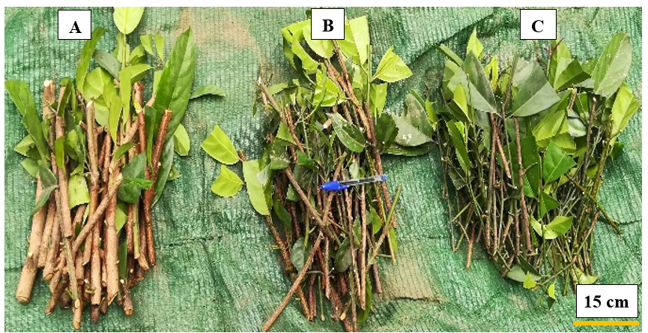

Fig. 1. Diameter classes of Beilschmiedia mannii cuttings studied
A: large-diameter cuttings; B: medium-diameter cuttings; C: small-diameter cuttings

2.3.3 Auxin application on cuttings

The basal ends of B. mannii cuttings of each diameter class were soaked for 1 hour in an auxin solution of Indole-3-Butyric Acid (IBA). For each cutting diameter class, three IBA concentrations were tested: 0 mg/L, 2.5 mg/L, and 5 mg/L. Untreated cuttings (0 mg/L IBA) serve as the control.

2.3.4 Preparation of the rooting medium for cuttings

A polypropagator adapted from Leakey (1990) was used as a rooting environment for the cuttings. The polypropagator was constructed from bamboo, measuring 3.5 m in length, 1.5 m in width and 1.7 m in height. It was filled with a mixture of topsoil and construction sand in a 1:1 (v/v) ratio. The topsoil was collected from fallow plot mainly composed by Chromolaena odorata (L.) and Panicum maximum (Jacq.), due to the role these plants play in maintaining soil fertility. This mixed substrate, with a pH of 5.5, was treated with a fungicide (Mancozeb 880 g/kg) at a rate of 1 g per litre of water according to the method of Kouakou et al. (2016). Subsequently, the polypropagator was subdivided into 27 plots of equal areas corresponding to the experimental treatment replications.

2.3.5 Transplanting cuttings and experimental design

In each plot, planting holes (5 cm apart and 3 cm deep) were made. The cuttings were then transplanted into the holes (Fig. 2) using a wooden stick of similar diameter to the cuttings, immediately after the auxin application. After transplanting, the cuttings were watered using a sprayer, and the top and sides of the polypropagator were covered with a transparent plastic sheet. The experiment followed a randomised complete block design (RCBD) with 3 replications of each treatment. Two factors were studied. The first was cutting type, with three modalities: large-diameter, medium-diameter, and small-diameter. The second factor was IBA concentration with three levels: 0 mg/L, 2.5 mg/L, and 5 mg/L. The combination of these factor levels resulted in nine treatments (Table 1), for a total of 27 treatment plots within the poly-propagator. For each plot, 15 cuttings were used, representing 405 cuttings (3 cutting types × 3 IBA concentrations × 15 cuttings × 3 replications).

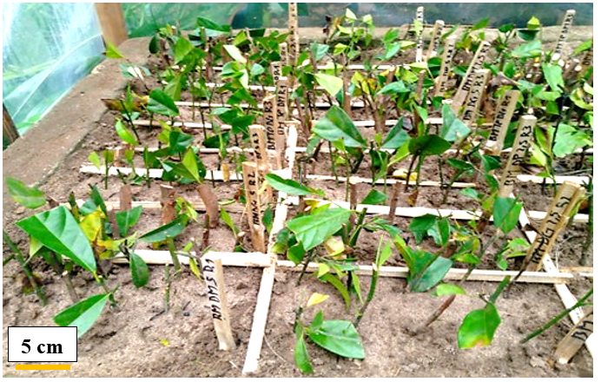

Fig. 2. Cuttings transplanted into the demarcated plots of the polypropagator

Table 1. Characteristics of the treatments studied

Treatments | Characteristics
Treatments | Concentration of IBA applied (mg/L) | Class and diameter (mm) of cuttings used
T1 | 0 | Small (0 to 5)
T2 | 0 | Medium (5 to 10)
T3 | 0 | Large (10 to 15)
T4 | 2.5 | Small (0 to 5)
T5 | 2.5 | Medium (5 to 10)
T6 | 2.5 | Large (10 to 15)
T7 | 5 | Small (0 to 5)
T8 | 5 | Medium (5 to 10)
T9 | 5 | Large (10 to 15)

2.3.6 Monitoring and acclimatisation

Inside the polypropagator, the cuttings were regularly moistened every 2 days, if necessary, using a 3-litre capacity pressure hand sprayer (Sprayer). The mean temperature and relative humidity inside the polypropagator were 28 ± 2 °C and 94%, respectively. Weeds were regularly removed by hand to avoid competition with the young shoots. After 150 days of experimentation, the surviving cuttings were carefully removed from the substrate to observe their rooting. Rooted cuttings were transplanted into black polyethylene bags (15 cm x 12 cm), which were perforated and filled with the same substrate used in the polypropagator. These seeded bags were placed under shade conditions for 45 days acclimatisation period. During acclimatisation, the substrate was moistened as done in the polypropagator.

2.3.7 Data collection

The data recorded at the end of the cuttings' stay in the polypropagator (150 days after planting) included the rooting rate, calculated as the ratio of rooted cuttings to the total transplanted cuttings, expressed as a percentage. For rooted cuttings, the number of roots was counted, and their length was measured with a graduated ruler. The budding rate, which is the ratio of cuttings with buds to total transplanted cuttings, expressed as a percentage, was also recorded. The survival rate was calculated as the ratio of surviving cuttings to the total transplanted cuttings, expressed as a percentage.
For acclimatisation, parameters such as survival rate, plant height, number of leaves emitted, and leaf length were evaluated. The survival rate was determined by dividing the number of surviving plants post-acclimatisation by the total number of acclimated plants, then multiplying by 100. The number of leaves emitted per plant was counted both before and after cuttings. Leaf length was measured from the insertion point of the petiole on the cutting to the apex, using a graduated ruler, before and after acclimatisation. Plant height was measured from the collar to the apex of the aerial axis, before and after acclimatisation, with a graduated ruler.

2.3.8 Statistical analysis

The recorded data were analysed using two-way factorial analyses of variance (ANOVA 2) to assess the influence of cutting diameter, IBA concentration, and their interaction on the parameters related to cutting and acclimatisation. When significant differences were observed, the means were compared using the Newman-Keuls test at the 5% significance level. All analyses were carried out using Statistica 7.1 software.

3. results and discussion

3.1 Results

3.1.1 Effect of cutting diameter on rooting, budding, and survival of Beilschmiedia mannii

The diameter of Beilschmiedia mannii cuttings significantly influenced both rooting and survival rate (P = .017 and P = .000). On the contrary, budding rates were statistically identical regardless of the cuttings diameter, and ranging from 68.67 to 72.22% (Table 2). Overall, medium-diameter cuttings showed the highest rooting and survival rates, 33.00% and 96.67%, respectively. The survival rate (78.89%) for small-diameter cuttings and the rooting rate (0.00%) for large-diameter cuttings were the lowest. The large-diameter cuttings also had the highest survival rate (98.89%).

Table 2. Beilschmiedia mannii budding, rooting, and survival rates according to the cutting diameter

Cutting diameter | Budding rate (%) | Rooting rate (%) | Survival rate (%)
Large-diameter (10 to 15 mm) | 68.67 ± 7.82 ª | 0.00 ± 0.00 ^{c} | 98.89 ± 1.11 ª
Medium-diameter (5 to 10 mm) | 70.00 ± 4.71 ª | 33.0 ± 5.00 ª | 96.67 ± 2.35 ª
Small-diameter (0 to 5 mm) | 72.22 ± 4.34 ª | 26.66 ± 3.33 ^{b} | 78.89 ± 4.54 ^{b}
F | 1.791 | 3.045 | 24.333
P | .195 | .017 | .000
In the same column, means ± standard deviations followed by the same letter are statistically identical to the threshold of P = .05 according to the Newman-Keuls test.

3.1.2 Effect of cutting diameter on the root growth of Beilschmiedia mannii

The numbers and lengths of roots per cutting of Beilschmiedia mannii varied significantly with cutting diameter (P = .027). Regardless of the parameter considered, medium-diameter and small-diameter cuttings, on the whole, exhibited the highest values (1.02 and 1.70 roots per cutting; 1.82 and 1.87 cm per root). In contrast, values recorded for the large-diameter cuttings were zero, and the lowest (Table 3).

Table 3. Beilschmiedia mannii number and roots length according to the cutting diameter

Cutting diameter | Number of roots per cutting | Root length per cutting (cm)
Large-diameter (10 to 15 mm) | 0.00 ± 0.00 ^{c} | 0.00 ± 0.00 ^{b}
Medium-diameter (5 to 10 mm) | 1.70 ± 0.59 ª | 1.82 ± 1.38 ª
Small-diameter (0 to 5 mm) | 1.02 ± 0.49 ^{b} | 1.87 ± 0.77 ª
F | 3.133 | 1.368
P | .047 | .027
In the same column, means ± standard deviations followed by the same letter are statistically identical to the threshold of P = .05 according to the Newman-Keuls test.

3.1.3 Effect of IBA concentration on the rooting and root growth of Beilschmiedia mannii

Significant effects (P = .043 and P = .005) of IBA concentration were observed on rooting rate and number of roots per cutting of Beilschmiedia mannii, whereas length of roots per cutting (P = .055) was unaffected. Root length ranged from 1.07 cm at 0 mg/L to 1.4 cm at 5 mg/L IBA. The highest rooting rate (47.44%) was recorded in cuttings treated with 5 mg/L IBA while the lowest (14.07%) was obtained from untreated cuttings (0 mg/L IBA). Regarding the number of roots per cutting, the concentrations of 2.5 mg/L IBA (1.41 roots per cutting) and 5 mg/L IBA (1.65 roots per cutting) induced the highest values, nearly double those under 0 mg/L concentration IBA (0.82 roots per cutting) (Table 4).

Table 4. Beilschmiedia mannii rooting rate, number, and root length as a function of IBA concentration

IBA concentration (mg/L) | Rate Rooting (%) | Number of roots per cutting | Root length per cutting (cm)
0 | 14.07 ± 1.86 ^{c} | 0.82 ± 0.22 ^{b} | 1.07 ± 0.52 ª
2.5 | 36.11 ± 1.11 ^{b} | 1.41 ± 0.11 ª | 1.21 ± 0.26 ª
5 | 47.44 ± 4.44 ª | 1.65 ± 0.06 ª | 1.40 ± 0.40 ª
F | 0.863 | 6.905 | 3.415
P | .043 | .005 | .055
In the same column, means ± standard deviations followed by the same letter are statistically identical to the threshold of P = .05 according to the Newman-Keuls test.

3.1.4 Combined effect of cutting diameter and IBA concentration on rooting, budding, and survival of Beilschmiedia mannii

Table 5 summarise the combined effects of IBA concentrations and cutting diameter of Beilschmiedia mannii on budding, rooting, and survival rates. Rooting, and survival rates showed significant differences among treatments (P = .000 and P = .032), whereas budding rate did not (P = .85). The best rooting rate (53.33%) was recorded by treatment T8 (5 mg/L IBA × medium-diameter cuttings), followed by T7 (5 mg/L IBA × small-diameter cuttings) and T5 (2.5 mg/L IBA + medium-diameter cuttings), which induced rooting rate of 36.6% and 28.42%, respectively. On the other hand, the lowest rooting rates (0.00%) were observed for all treatments involving large-diameter cuttings (T3: 0 mg/L IBA × large-diameter cuttings; T6: 2.5 mg/L IBA × large-diameter cuttings; T9: 5 mg/L IBA × large-diameter cuttings). Moreover, the rooting of small and medium-diameter cuttings increased with the higher IBA concentration. Concerning the survival rate, with the exception of treatments T1 (0 mg/L IBA × small-diameter cuttings) and T4 (2.5 mg/L IBA × small-diameter cuttings), which resulted in the lowest survival rate (70.00 and 73.33%), all others treatments performed better for this parameter (90 to 100%). Survival rate fluctuated between 50% (T3) and 80% (T8).

Table 5: Beilschmiedia mannii budding, rooting, and survival rates of under the combined effects of IBA concentration and cutting diameter

Treatments | Budding rate (%) | Rooting rate (%) | Survival rate (%)
T1 | 73.33 ± 6.67 ª | 13.23 ± 0.44 ^{d} | 70.00 ± 5.77 ^{b}
T2 | 70.00 ± 10.00 ª | 23.33 ± 3.33 ^{c} | 90.00 ± 5.77 ª
T3 | 50.00 ± 5.77 ª | 0.00 ± 0.00 ^{e} | 100.00 ± 0.00 ª
T4 | 66.67 ± 12.02 ª | 19.30 ± 13.3 ^{c} | 73.33 ± 3.33 ^{b}
T5 | 60.00 ± 5.77 ª | 28.42 ± 0.28 ^{bc} | 100.00 ± 0.00 ª
T6 | 60.00 ± 20.82 ª | 0.00 ± 0.00 ^{e} | 96.67 ± 3.33 ª
T7 | 76.67 ± 3.33 ª | 36.60 ± 6.66 ^{b} | 93.33 ± 6.66 ª
T8 | 80.00 ± 5.77 ª | 53.33 ± 3.33 ª | 100.00 ± 0.00 ª
T9 | 60.00 ± 15.28 ª | 0.00 ± 0.00 ^{e} | 100.00 ± 0.00 ª
F | 0.322 | 1.06 | 3.333
P | .858 | .000 | .032
In the same column, means ± standard deviations followed by the same letter are statistically identical to the threshold of P = .05 according to the Newman-Keuls test.
T1 = 0 mg/L IBA × small-diameter cuttings; T2 = 0 mg/L IBA × medium-diameter cuttings; T3 = 0 mg/L IBA × large-diameter cuttings; T4= 2.5 mg/L IBA × small-diameter cuttings; T5 = 2.5 mg/L IBA × medium-diameter cuttings; T6 = 2.5 mg/L IBA × large-diameter cuttings; T7 = 5 mg/L IBA × small-diameter cuttings; T8 = 5 mg/L IBA × medium-diameter cuttings and T9 = 5 mg/L IBA × large-diameter cuttings.

3.1.5 Combined effect of cutting diameter and IBA concentration on root growth of Beilschmiedia mannii
The mean number of roots per cutting and the mean roots length per cutting of Beilschmiedia mannii varied significantly according to the combined treatment of cutting diameter and IBA concentration (P = .000). The highest number of roots (2.73 roots per cutting) was recorded under treatment T8 (5 mg/L IBA × medium-diameter cuttings). A similar trend was observed for root length, where T8 and, to a lesser extent, T7 (5 mg/L IBA × small-diameter cuttings) produced the highest values, with 4.06 cm per root and 3.42 cm per root, respectively. Both the number and length of roots in small and medium-diameter cuttings increased with increasing IBA concentration. In contrast, all treatments involving large-diameter cuttings (T3: 0 mg/L IBA × large-diameter cuttings; T6: 2.5 mg/L IBA × large-diameter cuttings; T9: 5 mg/L IBA × large-diameter cuttings) exhibited the lowest performances, with null values for both parameters (Table 6). Fig. 3 illustrate the rooting and budding of cuttings under the effect of a few treatments.

Table 6. Mean values of rooting parameters as a function of the combined effects of IBA concentration and diameter of Beilschmiedia mannii cuttings

Treatments | Number of roots per cutting | Root length per cutting (cm)
T1 | 0.88 ± 0.13 ^{c} | 1.09 ± 0.00 ^{c}
T2 | 0.93 ± 0.33 ^{c} | 2.10 ± 2.10 ^{b}
T3 | 0.00 ± 0.00 ^{d} | 0.00 ± 0.00 ^{d}
T4 | 1.71 ± 0.19 ^{b} | 1.21 ± 1.2 ^{c}
T5 | 1.84 ± 0.28 ^{b} | 2.34 ± 0.51 ^{b}
T6 | 0.00 ± 0.00 ^{c} | 0.00 ± 0.00 ^{d}
T7 | 1.88 ± 0.58 ^{b} | 3.42 ± 0.71 ^{ab}
T8 | 2.73 ± 1.33 ª | 4.06 ± 0.26 ª
T9 | 0.00 ± 0.00 ^{d} | 0.00 ± 0.00 ^{d}
F | 2.66 | 0.900
P | .000 | .000
In the same column, means ± standard deviations followed by the same letter are statistically identical to the threshold of P = .05 according to the Newman-Keuls test.
T1 = 0 mg/L IBA × small-diameter cuttings; T2 = 0 mg/L IBA × medium-diameter cuttings; T3 = 0 mg/L IBA × large-diameter cuttings; T4= 2.5 mg/L IBA × small-diameter cuttings; T5 = 2.5 mg/L IBA × medium-diameter cuttings; T6 = 2.5 mg/L IBA × large-diameter cuttings; T7 = 5 mg/L IBA × small-diameter cuttings; T8 = 5 mg/L IBA × medium-diameter cuttings and T9 = 5 mg/L IBA × large-diameter cuttings.

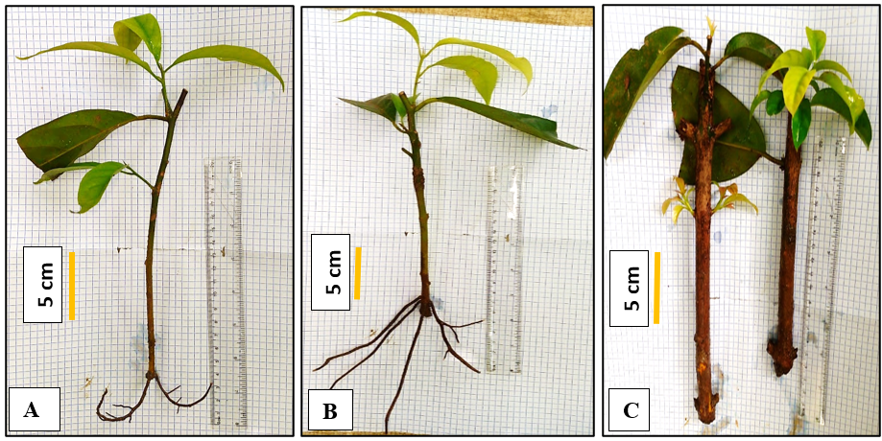

Fig. 3. Overview of budding and rooting of Beilschmiedia mannii cuttings
A: budded and rooted cutting from T7; B: budded and rooted cutting from T8; C: budded and rooted cutting from T9

3.1.6 Plant survival rate after acclimatisation

Rooted cuttings transplanted into black polyethylene bags exhibited an optimal survival rate (100%), regardless of the treatment, after 45 days acclimatisation period. No mortality was recorded during this period (Fig. 4). Fig. 5 shows plants obtained after acclimatisation.

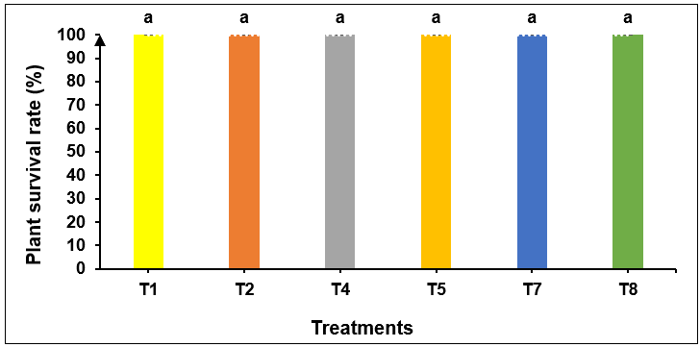

Fig. 4. Beilschmiedia mannii cuttings survival rate after 45 days acclimatisation period
In the histogram, the mean bars ± standard deviations followed by the same letter are statistically identical to the threshold of P = .05 according to the Newman-Keuls test.
T1 = 0 mg/L IBA × small-diameter cuttings; T2 = 0 mg/L IBA × medium-diameter cuttings; T4 = 2.5 mg/L IBA × small-diameter cuttings; T5 = 2.5 mg/L IBA × medium-diameter cuttings; T7 = 5 mg/L IBA × small-diameter cuttings; T8 = 5 mg/L IBA × medium-diameter cuttings.

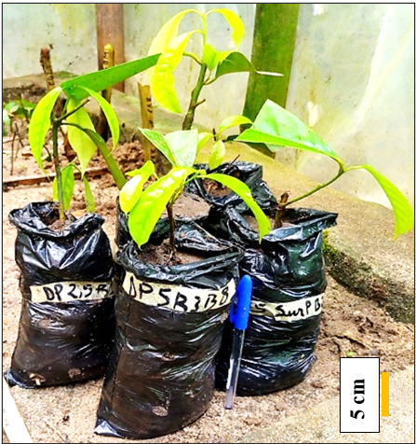

Fig. 5. Beilschmiedia mannii plants obtained from plagiotropic branches cutting after 45 days acclimatisation period

3.1.7 Height of plants in acclimatisation

At the beginning of acclimatisation, plant height was statistically identical across all treatments; however, it varied significantly among treatments at the end of the acclimatisation period (Fig. 6). Initial plant height ranged from 9.84 to 14.96 cm. At the end of acclimatisation, the tallest plants were those from treatment T8 (5 mg/L IBA × medium-diameter cuttings), reaching 18.37 cm, whereas the shortest plants were recorded from treatment T7 (5 mg/L IBA × small-diameter cuttings), measuring 11.78 cm.

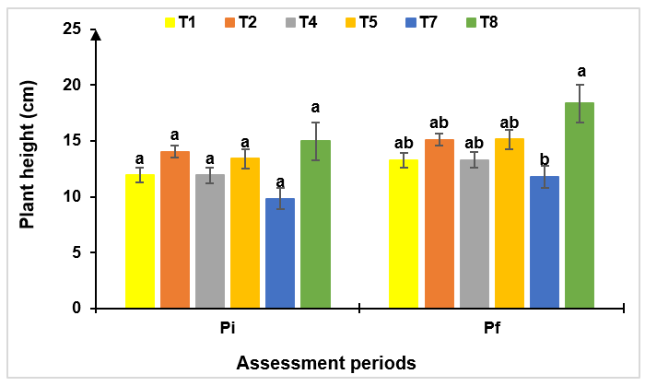

Fig. 6. Evolution in the height of Beilschmiedia mannii plants during acclimatisation period according to the treatments
In the histogram, for an assessment period, the mean bars ± standard deviations followed by the same letter are statistically identical to the threshold of P = .05 according to the Newman-Keuls test.
T1 = 0 mg/L IBA × small-diameter cuttings; T2 = 0 mg/L IBA × medium-diameter cuttings; T4 = 2.5 mg/L IBA × small-diameter cuttings; T5 = 2.5 mg/L IBA × medium-diameter cuttings; T7 = 5 mg/L IBA × small-diameter cuttings; T8 = 5 mg/L IBA × medium-diameter cuttings; Pi = before acclimatisation; Pf = at the end of acclimatisation (after 45 days).

3.1.8 Number of leaves emitted during acclimatisation

The number of leaves produced was statistically similar across treatments, at the beginning of acclimatisation, ranging from 1.33 to 4 leaves per plant. At the end of acclimatisation, the leaf production was treatment-dependent (Fig. 7). The highest number of leaves (8.67 leaves per plant) was obtained from plants of T8 (5 mg/L IBA × medium-diameter cuttings), whereas the lowest number (2.33 leaves per plant) was observed in plants from treatment T2 (0 mg/L IBA × medium-diameter cuttings).

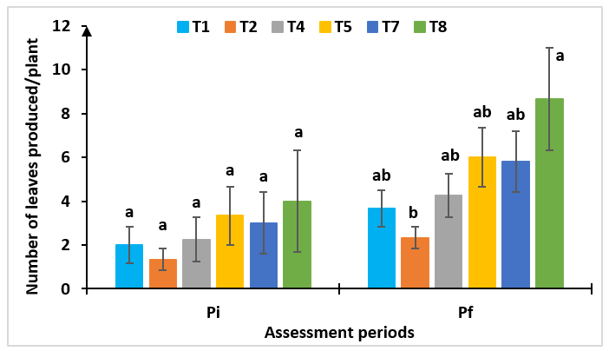

Fig. 7. Evolution in the number of leaves produced by Beilschmiedia mannii plants during acclimatisation period according to the treatments
In the histogram, for an assessment period, the mean bars ± standard deviations followed by the same letter are statistically identical to the threshold of P = .05 according to the Newman-Keuls test.
T1 = 0 mg/L IBA × small-diameter cuttings; T2 = 0 mg/L IBA × medium-diameter cuttings; T4 = 2.5 mg/L IBA × small-diameter cuttings; T5 = 2.5 mg/L IBA × medium-diameter cuttings; T7 = 5 mg/L IBA × small-diameter cuttings; T8 = 5 mg/L IBA × medium-diameter cuttings; Pi = before acclimatisation; Pf = at the end of acclimatisation (after 45 days).

3.1.9 Length of leaves emitted during acclimatisation

The average leaf lengths of Beilschmiedia mannii plants both at beginning and end of acclimatisation, are summarised in Fig. 8. Leaf length differed significantly among treatments. Overall, plants from treatment T8 (5 mg/L IBA × medium-diameter cuttings) exhibited the greatest leaf lengths (9.0 cm and 12.2 cm per leaf at the beginning and end of acclimatisation, respectively). In contrast, the shortest leaves (1.67 to 2.48 cm per leaf) were observed in plants from treatments T1, T2, and T4 at the beginning of acclimatisation, and in treatments T1 and T2 at the end of acclimatisation.

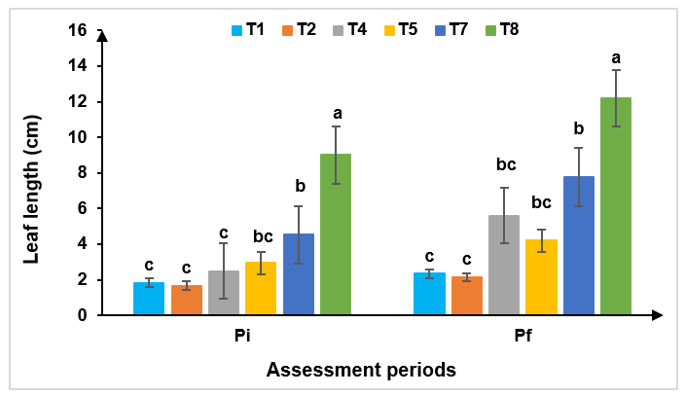

Fig. 8. Evolution in the length of leaves produced by Beilschmiedia mannii plants during acclimatisation according to the treatments
In the histogram, for an assessment period, the mean bars ± standard deviations followed by the same letter are statistically identical to the threshold of P = .05 according to the Newman-Keuls test.
T1 = 0 mg/L IBA × small-diameter cuttings; T2 = 0 mg/L IBA × medium-diameter cuttings; T4 = 2.5 mg/L IBA × small-diameter cuttings; T5 = 2.5 mg/L IBA × medium-diameter cuttings; T7 = 5 mg/L IBA × small-diameter cuttings; T8 = 5 mg/L IBA × medium-diameter cuttings; Pi = before acclimatisation; Pf = at the end of acclimatisation (after 45 days).

3.2 Discussion

This study demonstrated that the rooting capacity of plagiotropic Beilschmiedia mannii shoots depends on cutting diameter and indole-3-butyric acid (IBA) concentration. High survival (78–98%) and budding (70–72%) rates can be attributed to the vigour of the cuttings and the favourable microclimatic conditions provided by the polypropagator (93% relative humidity, 33 ± 2 ºC). The critical role of polypropagators in the successful propagation of forest species has been previously documented (Leakey et al., 1990; Tchoundjeu & Leakey, 1996), as they limit dehydration and nutrient loss (Leakey, 2014).
The high survival and budding rates observed in plagiotropic cuttings indicate their suitability for large-scale propagation of B. mannii, consistent with reports for Griffonia simplicifolia (Bah et al., 2021). However, plagiotropic shoots from adult Garcinia kola trees have been reported as unsuitable for cutting (Kouakou et al., 2016), confirming that rooting potential of plagiotropic shoots is species-dependent.
Rooting and survival varied with cutting diameter. Only small (2–5 mm) and medium (5–10 mm) diameter cuttings rooted, likely due to their lower lignification, which facilitates carbohydrate translocation to the base and promotes root primordia formation. Similar observations were reported by Bah et al. (2021), who obtained 66% rooting from apical plagiotropic segments versus 9% from basal segments. Young, meristem-rich tissues display higher differentiation potential, enhancing vegetative propagation (Moupela et al., 2013; Nguema et al., 2013). In contrast, Dao et al. (2020) reported higher rooting in highly lignified cuttings of 24-month-old G. kola, although these were orthotropic stems.
Survival was higher in large-diameter cuttings, likely due to greater carbohydrate and water reserves, increasing tolerance to water stress, a trend also observed in guava (Costa et al., 2024).
Increasing IBA concentration from 2.5 to 5 mg/L significantly enhanced rooting in small- and medium-diameter cuttings by increasing rooting rate, root number, and mean root length, reflecting its direct effect on rhizogenesis through improved carbohydrate translocation (Haissig, 1974). Large-diameter cuttings were unresponsive, likely due to advanced tissue lignification. IBA concentration and cutting diameter did not affect budding, which is primarily determined by internal factors (vitality, bud dormancy) and environmental conditions (temperature, humidity, photoperiod) rather than exogenous hormones (Otiende et al., 2021; Chalfun et al., 2003).
Low survival of small-diameter cuttings at 0 or 2.5 mg/L IBA improved significantly at 5 mg/L, as sufficient exogenous auxin compensates for limited endogenous reserves and stimulates adventitious root formation, essential for survival (Leakey et al., 1990; Mesén et al., 1997). For medium-diameter cuttings, 5 mg/L IBA provided the optimal combination of hormonal stimulation and physiological potential. Large-diameter cuttings remained poorly responsive at all IBA concentrations, likely due to excessive lignification (Ky-Dembélé et al., 2011; Leakey et al., 1990; Tchoundjeu et al., 2001).
A 100% survival rate after acclimatisation indicates that cutting propagation is a viable method for producing uniform and vigorous B. mannii plants for domestication and integration into agroforestry systems. IBA treatment also enhanced seedling growth in height, shoot emergence, and leaf development, particularly in medium-diameter cuttings at 5 mg/L, likely due to improved nutrient and hormone uptake (Smith et al., 2018). Small-diameter cuttings performed better at 2.5 mg/L, suggesting potential inhibitory effects at higher concentrations. Control cuttings demonstrated that regeneration is possible without exogenous hormones, although results are markedly improved under IBA treatment, as observed in Garcinia kola (Kouakou et al., 2016).

4. Conclusion

This study demonstrated that vegetative propagation through cuttings is an effective method for the regeneration of Beilschmiedia mannii, a woody species with high socio-economic potential but threatened by overexploitation and deforestation. The results showed that cutting diameter and indole-3-butyric acid (IBA) concentration significantly influence rooting, root development, budding, and plant survival. Medium-diameter cuttings treated with 2.5 and 5 mg/L IBA exhibited the best performance, with the highest rooting rate (53.33%), a greater number and length of roots, and optimal seedling growth during acclimatisation (height, leaf number, and leaf length). In contrast, large-diameter cuttings displayed very low rooting capacity despite high survival. Acclimatisation was highly successful, with a 100% survival rate after 45 days, demonstrating the feasibility of this approach for producing uniform and vigorous seedlings.
From a developmental perspective, this approach offers significant potential for the domestication and conservation of B. mannii in Côte d’Ivoire and West Africa, contributing to food security, biodiversity preservation, and income generation for local communities. Standardising cutting propagation with an optimal IBA dose enables the rapid production of high-quality plants, facilitating the integration of this species into agroforestry systems and sustainable reforestation programs. Overall, this study provides a solid scientific basis for the development of vegetative propagation strategies and sustainable management of B. mannii, ensuring its long-term survival while enhancing its use for food, medicinal, and artisanal purposes.

DISCLAIMER (ARTIFICIAL INTELLIGENCE)

Authors hereby declare that NO generative AI technologies such as Large Language Models (ChatGPT, COPILOT, etc.) and text-to-image generators have been used during the writing or editing of this manuscript.

Consent (where ever applicable)

No applicable

Ethical approval (where ever applicable)

No applicable

COMPETING INTERESTS DISCLAIMER:
Authors have declared that they have no known competing financial interests OR non-financial interests OR personal relationships that could have appeared to influence the work reported in this paper.

References

Ahoua, A.R.C., Konan, A.G., Bonfoh, B., & Koné, M.W. (2015). Antimicrobial Potential of 27 Plants Consumed by Chimpanzees (Pan Troglodytes Verus Blumenbach) in Ivory Coast. BMC Complementary and Alternative Medicine, 15 (1), 383. https://doi.org/10.1186/s12906-015-0918-7.
Yapo, A.O., Sidibé, D., Coulibaly, A., Mahan, R.M. & Biego H.M.G. (2017). Vitamins and Essential Minerals Contained in Mucilages of Four Food Plants, Abelmoschus esculentus, Beilschmiedia mannii, Corchorus olitorius and Irvingia gabonensis, from Côte d’lvoire. Journal of Scientific Research and Reports, 15(6), 1–14. https://doi.org/10.9734/JSRR/2017/34476
Bah, A. M., Dembele, A., & Dogbo, D. O. (2021). Contribution to the regeneration of Griffonia simplicifolia Baill (Fabaceae, 1866) by stem cuttings. Journal of Animal & Plant Sciences, 50 (1), 8981-8997. https://doi.org/10.35759/JAnmPlSci.v50-1.3
Chalfun, N.N.J., Pasqual, M., Norberto, P.M., Dutra, L.F., & Cavalcante-Alves, J.M. (2003). Rooting of Fig (Ficus carica L.) Cuttings: Cutting Time and IBA. Acta Horticulturae, 605, 137-140. https://doi.org/10.17660/ActaHortic.2003.605.21
Costa, J. C. F. da., Penso, G. A., Fernandes, D. R., Marques Junior, E., Serafini, G. A. D., & Santos, C. E. M. dos (2024). Rooting of ‘Pedro Sato’ guava cuttings as a function of diameter, types of cuts, and treatment with bioestimulant. Revista Brasileira De Fruticultura, 46, e–793. https://doi.org/10.1590/0100-29452024793
Dao, J.P, Kouakou, L.K., Kouakou, C., Cherif, M., Ouedraogo, H.M., Koffi, K.K, et al. (2020). Effect of Leafy and Leafless Greenwood, Softwood and Hardwood Cuttings Success of Garcinia kola (Heckel). Agricultural sciences, 10 (2020), 897-911. https://doi.org/10.4236/as.2020.1110058
Djibo, M. I, Rabiou, H., Morou, B., Diouf, A., Diallo, I. I., Adamou, A. B., et al. (2020). Boscia senegalensis (Pers.) Lam. ex Poir., a Woody Species with High Ethnobotanical Potential and Well Adapted to Drought in the Sahel: Bibliographic Synthesis. European Scientific Journal, March 2020 edition 16(9), 206. https://doi.org/10.19044/esj.2020.v16n9p206
Haissig, B. E. (1974). Influences of auxin synergists on adventitious root primordium initiation and development. New Zealand Journal of Forestry Science, 4, 311–323. https://www.scionresearch.com/__data/assets/pdf_file/0009/58725/NZJFS421974HAISSIG311_323.pdf

Jusu, A., & Cuni-Sanchez, A. (2017). Priority Indigenous Fruit Trees in the African Rainforest Zone: Insights from Sierra Leone. Genetic Resources and Crop Evolution, 64 (4), 745-60. https://doi.org/10.1007/s10722-016-0397-9.
Kouadio, E.Y.G., Kassi, K.F.J.M., Cherif, M., Kouamé, K.F., Kouamé, K.D., Tuo, S., et al. (2021). Cutting ability and growth of three cover crops [Arachis pintoi (L.) Krapov & W.C. Greg. Arachis repens (L.) Handro Desmodium adscendens (SW.) DC.] in nursery. International Journal of Advanced Research, 9 (Jul), 01-10. https://dx.doi.org/10.21474/IJAR01/13092
Kouakou, K.L., Dao, J.P., Kouadio K.I, Beugré, M.M., Koné, M., Baudoin, J-P., et al. (2016). Propagation of Garcinia kola (Heckel) by stem and root cutting. Silva Fennica, 50 (4). 17 p. https://doi.org/10.14214/sf.1588
Kouamé, A.M., Drogba, A.S., & Amani, N.G. (2017). Fatty acid profile of Beilschmiedia mannii (Lauraceae) seed oil. International Journal of Biology and Innovation, 6(5), 675-700. https://www.jbino.com/docs/Issue05_07_2017.pdf.
Ky-Dembele, C., Tigabu, M., Bayala, J., Savadogo, P., Boussim, I.J., & Odén, P.C. (2011). Clonal Propagation of Khaya senegalensis: The Effects of Stem Length, Leaf Area, Auxins, Smoke Solution, and Stockplant Age, International Journal of Forestry Research, 2011, 281269, 10 pages. https://doi.org/10.1155/2011/281269
Leakey R.R.B. (1999). Agroforestry for biodiversity in farming systems. See Reference, 23, 127–45. https://www.gov.uk/research-for-development-outputs/agroforestry-for-biodiversity-in-farming-systems
Leakey, R.R.B. (2014). Plant Cloning: Macropropagation. In: Encyclopedia of Agriculture and Food Systems, Van Alfen N. (ed.). San Diego, USA, Elsevier, pp. 349-359. https://doi.org/10.1016/B978-0-12-805356-0.00020-9
Leakey, R.R.B., Mesen, J.F., Tchoundjeu, Z., Longman, K.A., Dick, McP., Newton, A., et al. (1990). Low-technology technique for the vegetative propagation of tropical trees. Commonwealth Forest Review, (69), 247-257. https://www.gov.uk/research-for-development-outputs/low-technology-techniques-for-the-vegetative-propagation-of-tropical-trees
Leakey, R.R.B., Weber J.C., Page T., Cornelius J.P., Akinnifesi F.K., Roshetko J.M., et al. (2012). Tree Domestication in Agroforestry: Progress in the Second Decade (2003–2012). In Agroforestry - The Future of Global Land Use, edited by P.K. Ramachandran Nair and Dennis Garrity, 9, 145-73. Advances in Agroforestry. Dordrecht: Springer Netherlands. https://doi.org/10.1007/978-94-007-4676-3_11.
Mark, J., Adrian, N.A.C., Oilfield, S., & River, M. (2014). The international timber trade: A working list of commercial timber species. Botanic Gardens Conservation International Descanso House, Richmond, UK. https://www.bgci.org/resources/bgci-tools-and-resources/a-working-list-of-commercial-timber-tree-species/
Mesén, F. J., Newton, A. C., Leakey, R. R. B., & Grace, J. (1997). Vegetative propagation of Cordia alliodora (Ruiz & Pavon) Oken: the effects of IBA concentration, propagation medium, and cutting origin. Forest Ecology and Management, 92(1–3), 45–54. https://doi.org/10.1016/S0378-1127(96)03960-6
Metougui, M.L., Mokhtari, M., Machati, I., Azeroual, I., & Benlhabib, O. (2017). Vegetative propagation of the argan tree (Argania spinosa L. Skeels) by cuttings and grafting. Moroccan Journal of Agronomic and Veterinary Sciences, 5 (4), 428-436. https://www.agrimaroc.org/index.php/Actes_IAVH2/article/view/499

Moupela, C., Doucet, J. L., Daïnou, K., Meunier, Q. & Vermeulen, C. (2013). Propagation trials of Coula edulis Baill by seed and air layering and prospects for its domestication. Tropical Woods and Forests, 318(4), 3-13. https://doi.org/10.19182/bft2013.318.a20516
N’zi, J., Mbo, K.A.A., Lougue, B., Affessi, W., Kouassi, K.H., & Kouamé, C. (2023). Cocoa (Theobroma cacao) and local fruit species interaction: Case of Beilschmiedia mannii in traditional agroforestry systems in Western Côte d’Ivoire. African Journal of Agricultural Research 19(5), 557-566. https://doi.org/10.5897/AJAR2022.16288
Nguema, N.P., Bouanga, E.B., Massounga, Y.C., & Boussiengui, G. (2013). Comparative study of three multiplication methods of Jatropha curcas L. in the climatic conditions of south-eastern Gabon. Journal of Applied Biosciences, 65, 4989-4998. http://dx.doi.org/10.4314/jab.v65i0.89641
Olajuyigbe, S. O., & Adaja, A. A. (2019). Beilschmiedia mannii Robyns and Wilczek: An underutilized tree crop with great socioeconomic potential. In: Adekunle VAJ, Ogunsanwo OY, Adewole NA, Oni PI (Eds). Sustainable development through appropriate forest management strategies. Proceedings of the 41st Annual Conference of Forestry Association of Nigeria (FAN), Abuja, 7th-11th October 2019, pp 171-177.
Oloyede, F. M., Ola, D. S., & Iwalewa, E. A. (2023). Biodiversity conservation of the neglected and underutilized Nigerian horticultural crops. Acta Horticulturae et Regiotecturae 26(1), 64-72. https://doi.org/10.2478/ahr-2023-0010
Otiende, M.A., Fricke, K., Nyabundi, J.O. Ngamau, K., Hajirezaei, M.R, & Druege, U. (2021). Involvement of the auxin–cytokinin homeostasis in adventitious root formation of rose cuttings as affected by their nodal position in the stock plant. Planta, 254, 65. https://doi.org/10.1007/s00425-021-03709-x
Smith, M. G., Arndt, S. K., Miller, R. E., Kasel, S., & Bennett, L. T. (2018). Trees use more non-structural carbohydrate reserves during epicormic than basal resprouting. Tree Physiology, 38 (12), 1779-91. https://doi.org/10.1093/treephys/tpy099
Soro, K., Diarrassouba, A., Soro, N.A., Kone, L.S.P., Djessou, S.A., Assie, D.R.H. et al. (2021). Harvesting period and seed germination rate of three wild fruit trees: akpi, choco, and bitei, around Taï National Park. African Agronomy, 33 (2), 231-242. https://www.ajol.info/index.php/aga/article/view/217090
Tchoundjeu, Z., & Leakey, R.R.B. (1996). Vegetative propagation of African mahogany: effects of auxin, node position, leaf area, and cutting length. New Forests, 11(2), 125-136. https://doi.org/10.1007/BF00033408

Tchoundjeu, Z., & Leakey, R.R.B. (2022). Vegetative propagation of Lovoa trichilioides: effects of provenance, substrate, auxins, and leaf area. Journal of Tropical Forest Science, 13(1), 116-129. https://jtfs.frim.gov.my/jtfs/article/view/1330.

Yao, C.K., Kouamé, M.T.N., Mangara, A., & Bohi, S.G.A. (2023). Ethnobotanical study on the levels of knowledge and use of Irvingia gabonensis, Beilschmiedia mannii, and Strombosia pustulata in the ecosystem around Taï National Park (Southwest Côte d’Ivoire). International Journal of Biological and Chemical Sciences, 17(6), 2249-2261. https://dx.doi.org/10.4314/ijbcs.v17i6.10

Yevide, S.I.A., Gbesso, G.H.F., Aïdjihounde, S.V.N., & Djossa, B.A. (2022). Ethnobotanical study and conservation of Beilschmiedia mannii (Meisn.) Benth. and Hook. F. in southeastern Benin. Moroccan Journal of Agronomic and Veterinary Sciences, 10 (2), 312-318. https://www.agrimaroc.org/index.php/Actes_IAVH2/article/view/1179

Abbreviations

IBA: indole-3-butyric acid

