Ethnomycological studies and identification of edible wild mushrooms in the Sinfra department, Ivory Coast

Abstract
Edible wild mushrooms are non-timber forest products (NTFP) that are of considerable importance in terms of food, nutrition, economics, and pharmaceuticals. Aims: The objective of this study is to highlight the importance of edible wild mushrooms with a view to promoting their use. Methodology:To this end, an ethnomycological survey was conducted in the localities of Ganoufla and Gonazofla on a sample of 81 people. Resultats: The results of the survey identified 14 species of edible wild mushrooms belonging to six families, namely Psatyrellaceae, Lyophillaceae, Agaricaceae, Strophariaceae, Auriculariaceae, and Pluteaceae. The most commonly consumed species are Volvariella volvacea, Psathyrella tuberculata, and Termitomyces letestui, with estimated proportions of 95.45%, 90.9%, and 70%, respectively. These three mushrooms have a fairly good shelf life, ranging from one to four days depending on their stage of development. Food use, with an estimated proportion of 70.60%, is the most common. Conclusion: Given the extensive use made by the populations of Sinfra Department of wild edible mushrooms, it is necessary to find an alternative for the sustainable exploitation of these wild edible mushrooms through sustainable management of their habitats.
.
Keywords: Ethnomycological survey, Edible wild mushrooms, Non-timber forest products

1.Introduction
Natural products of biological origin other than wood from forest ecosystems are generally classified as non-timber forest products (NTFPs) according to Zanh et al. (2016). NTFPs contribute to poverty reduction and food security, particularly for rural populations (Moupela et al., 2011). These non-timber forest products have an impact on the lives and survival of rural populations, even though they are still harvested using traditional methods. They therefore play a very important role in dietary balance, health, the preservation of cultural identity, etc. Among these non-timber forest products, edible wild mushrooms occupy an important place. Edible mushrooms are heterotrophic organisms found in virtually all ecological ecosystems (forests, savannas). In Côte d'Ivoire, edible wild mushrooms are an excellent source of income and food for many Ivorians. During their fruiting season, mushrooms are harvested for direct consumption or sold by rural populations to support their families (Yian, 2020). Sometimes, these edible mushrooms are used during periods of food shortages as a substitute for vegetables, meat, and fish in meals. Given the importance of edible wild mushrooms around the world in general, and in sub-Saharan Africa and Côte d'Ivoire in particular, several scientific studies have been conducted on these mushrooms with a view to promoting their use. Examples include the work of Kouamé et al. (2018) on the physical and chemical characterization of certain species of edible wild mushrooms and that of Yian et al. (2020) on the use of edible mushrooms in traditional medicine. It is in this context of promotion that this work is being carried out, with the aim of helping to highlight the various uses of edible wild mushrooms. More specifically, the aim was to conduct an ethnomycological survey in the department of Sinfra in order to catalog edible wild mushrooms.
2.MATERIALS AND METHODS
2.1. Materials
2.1.1.Biological material
The biological material consists of various species of edible wild mushrooms harvested from plots belonging to villagers in Ganoufla and Gonazofla in the department of Sinfra (Figure 1).
2.1.2.Technical equipment
The technical equipment used to conduct the study activities consisted of:
- a survey form containing information on the people surveyed;
- a container for transporting mushroom samples;
-a tarpaulin on which to spread the mushrooms out to dry;
-plastic bags for storing the mushrooms after they have dried.
2.2.Methods
2.2.1.Data collection methods
2.2.1.1.Ethnomycological survey
Data collection took place between August and September 2024. An ethnomycological survey was conducted among villagers in two different localities, namely Ganoufla and Gonazofla. In each village, edible wild mushrooms were identified. Based on a pre-designed questionnaire, a few villagers were interviewed using a semi-structured interview technique. The questionnaire was divided into two main sections. The first section presented the sociodemographic characteristics of the respondents (age, gender, nationality, ethnicity, occupation). The respondents were aged between 40 and 50, under 40, and 50 and over. The second part focused on endogenous knowledge of edible wild mushrooms (vernacular names, availability period, organoleptic qualities, categories of use, shelf life, ecological group, seasonal availability).
2.2.1.2.Harvesting edible wild mushrooms
The harvest of edible mushrooms took place on various plots of land belonging to villagers in the localities visited. During the harvest, each specimen was photographed so that it could be identified at the National Floristic Center of Côte d'Ivoire. Each species of mushroom harvested was dried and placed in plastic bags after drying for storage.
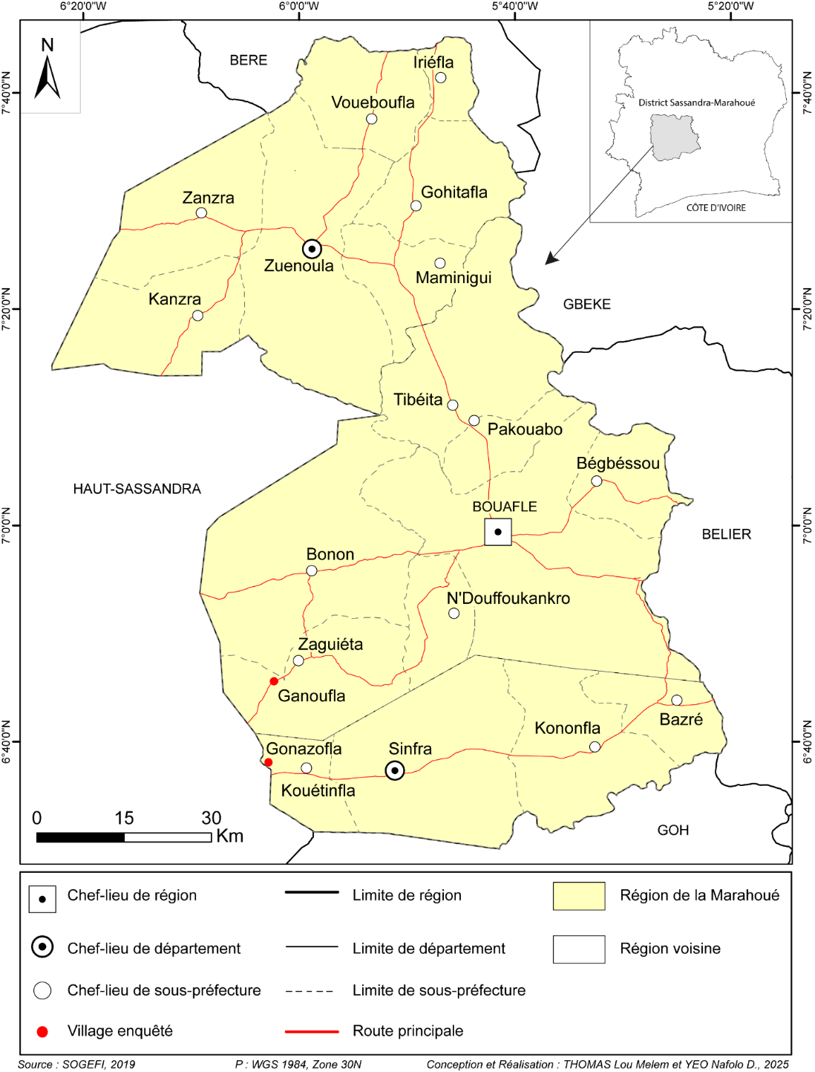
Fig 1: Map showing the study area
2.2.1.3.Analysis of ethnomycological data
The data collected was entered into an Excel spreadsheet. The percentages of social variables (age, gender, level of education, ethnicity, and occupation) of the people surveyed were calculated. The same was done for variables relating to endogenous knowledge of the mushrooms consumed by the populations surveyed (organoleptic quality, category of use, shelf life, seasonal availability, and frequency of consumption, etc.). Graphs were produced for each variable. The mushrooms harvested were identified at the National Center for Floristics at Félix HOUPHOUËT BOIGNY University (Côte d'Ivoire). They were then classified into botanical genera and families. A Chi-square test was performed with certain variables from the survey data. An analysis of variance was carried out in order to compare the average age groups of the populations surveyed. All these analyses were performed using Xlstat software version 2016.
3.RESULTS
3.1.Ethnomycological survey
The survey was conducted on a sample of 81 people, 42 of whom were from Ganoufla and 39 from Gonazofla. The results on sociodemographic variables focused on the gender, age groups, ethnicity, level of education, and occupation of the respondents.
3.1.1.Sociodemographic characteristics of the respondents
- Gender
With regard to gender, the majority of respondents were women, accounting for 92.86% of respondents in Ganoufla. In Gonazofla, the proportions were 89.74% women and 10.26% men. Statistical tests showed that there was no significant difference between the locality and gender of respondents (Khi 2 = 0.011; P-value >0.05) (Figure 2).

Fig 2: Profile of respondents by gender
- Age group
In terms of age groups, villagers aged between 40 and 50 make up the majority, accounting for 44.44% of the population surveyed. Next come the age groups under 40 and 50 and over, with 28.40% and 27.16% respectively (Table 1). Analysis of variance shows that the mean values for the three age groups are not significantly different (Table 2).

Table 1: Proportions of age groups of respondents by location
Localities | Age group | Number | Proportion
Ganoufla | Under 40 years old | 14 | 33,33
Ganoufla | [40 ;50 years old [ | 14 | 33,33
Ganoufla | 50 years old and older | 14 | 33,33
Gonazofla | Under 40 years old | 9 | 23,08
Gonazofla | [40 ;50 years old [ | 22 | 56,41
Gonazofla | 50 years old and older | 8 | 20,51

Table 2: Grouping of age categories of respondents
Methods | Estimated averages | Standard error | Lower bound (95%) | Upper bound (95%) | Groups
[40 ;50 years old [ | 18,000 | 3,227 | 7,729 | 28,271 | A
Under 40 years old | 11,500 | 3,227 | 1,229 | 21,771 | A
Over 50 years old | 11,000 | 3,227 | 0,729 | 21,271 | A

- Ethnic group of respondents
In terms of ethnicity, the indigenous population (Gouro) is in the majority, followed by the non-indigenous population (Baoulé, Bété) and finally the foreign population (Moré and Guineans), with respective proportions of 62.96%, 33.33% and 3.7%. Statistical analysis revealed that there is no significant link between the localities and the ethnic groups of the respondents. (Khi 2 = 3.098; P-value >0.05) (Figure 3).

Fig 3: Distribution of respondents by ethnicity

- Educational level and occupation of respondents
With regard to the educational level of the surveyed population, those with no schooling were the most numerous, with an estimated proportion of 50.62% (Figure 4). They were followed by those with primary and secondary education, with 27.16% and 22.22% respectively. None of the villagers surveyed had attained higher education. In terms of occupation, the majority of respondents were housewives, with an estimated proportion of 69.49%, followed by farmers or planters with a proportion of 27.16% and traders, who had the lowest proportion at 8.64% (Figure 5).

Fig 4: Distribution of respondents by level of education

Fig 5: Distribution of respondents by occupation
3.1.2.Indigenous knowledge of edible wild mushrooms
3.1.2.1.Diversity of edible wild mushrooms
The field survey identified 14 species of edible mushrooms belonging to six families: Lyophillaceae (6 species), Agaricaceae (3 species), Psathyrellaceae (2 species), Strophariaceae (1 species), Auriculariaceae (1 species) and Pluteaceae (1 species). The different genera encountered are as follows: Psathyrella, Volvariella, the genus Termitomyces, Coprinus, the genus Gymnopilus, and Auricularia (Table 3). However, the species most frequently cited by the population in both localities are Psathyrella tuberculata and Volvariella volvacea, with 27.16% each, and Termitomyces letestui, with 12.35% (Figure 6).
Table 3: Classification of edible wild mushrooms into families, genera, and species.
FAMILIES | GENERA | SPECIES
Lyophillaceae | Termitomyces | Termitomyces letestui , Termitomyces schimperi, Termitomyces medius, Termitomyces eurrhizus, Termitomyces microcarpus et Termitomyces fuliginosus
Agaricaceae | Copinus | Coprinus africanus, Coprinus sp1 et Coprinus sp2
Psathyrellacea | Psathyrella | Psathyriella tuberculata et  Psathyriella candolleana
Strophariaceae | Gymnopilus | Gymnopillus zenkeri
Auriculariaceae | Auricularia | Auricularia cornea
Pluteaceae | Volvariella | Volvariella volvaceae

Fig 6: Distribution of different species of edible mushrooms
3.1.2.2.Ecological habitats of edible mushrooms
In terms of the ecological niches of edible mushrooms, the niche with the highest proportion of mushrooms was decaying tree trunks, with an estimated proportion of 35.48%. Soil and termite mounds accounted for 24.13% and 23.81%, respectively. Dead tree roots and the areas surrounding termite mounds had the lowest proportions, at 9.43% and 7.14% (Figure 7).

Fig 7: Distribution of the different ecological habitats of edible mushrooms
3.1.2.3.Categories of edible mushroom use
The mushrooms surveyed are used in several ways by respondents. More than 90% of mushrooms are used for food by the populations surveyed, rather than for other purposes. Among the 14 mushrooms listed, the most consumed and commercialized are Volvariella volvacea, Psathyrella tuberculata, Termitomyces schimperi, and Termitomyces letestui (Figure 8). However, three species of edible mushrooms are used in traditional medicine in our study. These are: Auricularia cornea used to treat (blood pressure), Psathyrella tuberculata used to treat (diabetes, blood pressure, malaria, eye pain, and ear pain), and Termitomyces eurrhizus cited as a remedy for yellow fever (Table 4).

Fig 8: Distribution of mushrooms according to their category of use
Table 4: Mushrooms with medicinal uses
Scientific names of edible mushrooms with medicinal uses | Diseases treated
Psathyrella tubercula | - Eye pain in people who squint and newborns whose eyes bleed- Diabète  - Tension  - Helps heal the umbilical cord  - Malaria  - Earaches
Auricularia cornea | -Tension
Termitomyces eurrhizus | - malaria

3.1.2.4.State of mushrooms consumed
The results showed that mushrooms are consumed more in their fresh state than in their dried state. The respective proportions are as follows: 67.01% for those used fresh and 32.99% for those used dried. In addition, mushroom species such as Volvariella volvacea and Psathyrella tuberculata are consumed fresh rather than dried, with equal proportions of 50% each. However, the species Termitomyces letestui and Termitomyces schimperi are consumed more in dried form (83.33%) than fresh (16.67%). Statistical analyses showed that there is no significant difference between the mushrooms and their consumption states. (Khi 2 =8.191; P-value >0.05) (Figure 9).

Fig 9: Distribution of edible mushrooms according to their state of consumption
3.1.2.5.Organoleptic qualities of edible mushrooms
The mushrooms identified have different tastes depending on the individual. The mushroom species Volvariella volvacea, Psathyrella tuberculata, and Termitomyces letestui were rated as having exceptional organoleptic qualities, with respective proportions of 95.45% for Volvariella volvacea and Psathyrella tuberculata and 80% for Termitomyces letestui. Statistical tests showed that there is no link significant correlation between mushrooms and their organoleptic quality. (Khi 2 =10.108; P-value >0.05)
3.1.2.6.Shelf life of identified edible mushrooms
Surveys have shown that the shelf life of edible mushrooms varies from one species to another. Species such as Termitomyces schimperi, Termitomyces medius, Termitomyces fuliginosus, Termitomyces eurrhizus, Psathyrella candolleana, Coprinus sp2, and Coprinus africanus decompose within one day after harvesting. However, Volvariella volvacea, Psathyrella tuberculata, and Termitomyces letestui can last four days before decomposing. On the other hand, the species Auricularia cornea can be stored for up to a week or more.
3.1.2.7.Availability periods for the edible mushrooms listed
The availability period for edible mushrooms varies from one species to another. Some edible mushrooms are only available during the rainy seasons. These include Auricularia cornea, Psathyrella tuberculata, Coprinus sp2, and Gymnopillus zenkeri. Species such as Volvariella volvacea, Gymnopillus zenkeri, and Coprinus africanus are available in all seasons. However, the availability period of certain edible mushrooms is specific to one or more given months. This is the case for the species Termitomyces medius, Termitomyces schimperi, Psathyrella candolleana, and Coprinus sp1. These mushrooms are found specifically in August and September. The species Termitomyces letestui, Termitomyces fuliginosus, and Termitomyces eurrhizus are specific to March, April, and May.
3.2.Morphological description of some edible wild mushrooms harvested
- Psathyrella tuberculata (Psathyrellaceae)
Description
This species belongs to the Psathyrellaceae family and has a cap that is initially spherical and convex, becoming flat when mature. Psathyrella tuberculata is an edible mushroom species with a dry coating whose color varies depending on the humidity level. It is pale brown in the center; the edge is initially curved and then straight, often finely cracked with a light gray color. The gills are very fragile, uniform with a smooth edge. They are initially whitish in color, then grayish, and finally become blackish (Figure 10).
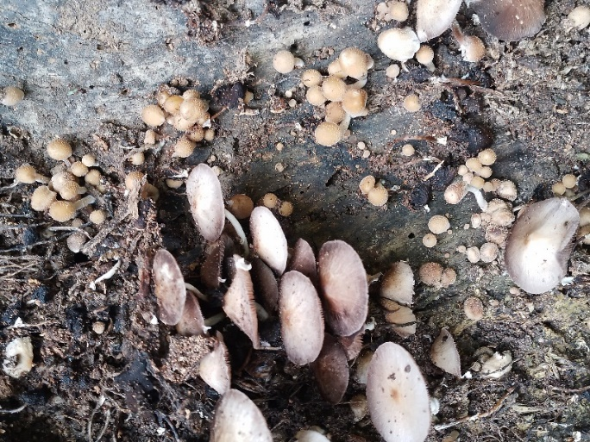
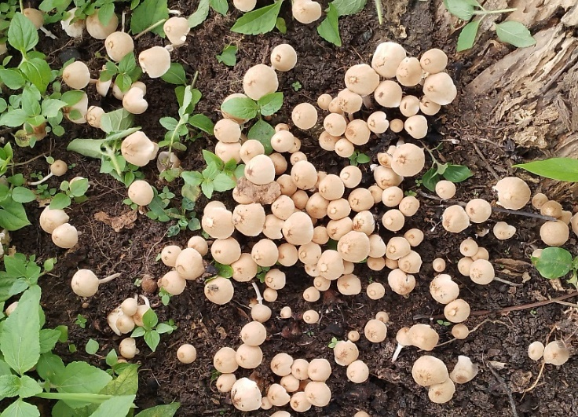

B
A

- Fig 10: Psathyrella tuberculata
(A: young fruiting body, B: mature fruiting body)
- Volvariella volvacea (Pluteaceae)
Description
Volvariella volvacea is an edible wild mushroom species belonging to the Pluteaceae family. The cap is initially subglobular ovoid to convex, then slightly umbonate with a central depression. The surface layer is dry, smooth, and radially arranged fibrillate. This mushroom is dark gray in the center and light gray at the edge. The species is initially curved, then straight when mature. The gills are simple and uniform (Figure 11).
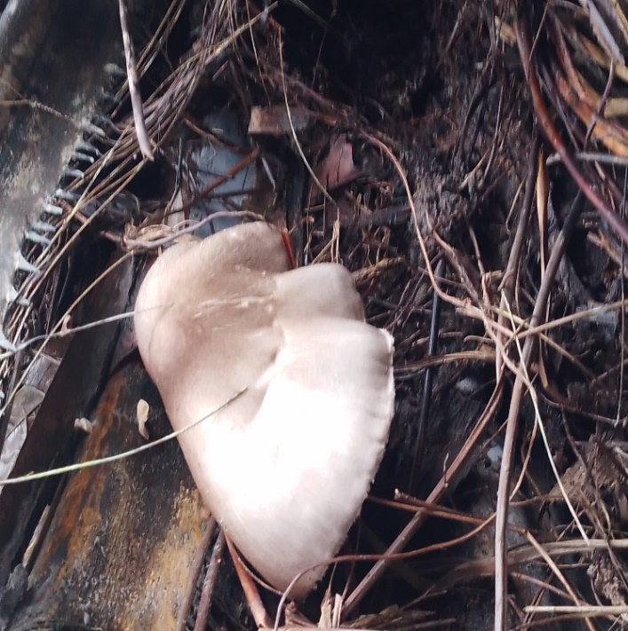

B

Fig 11: Volvariella volvacea
- Termitomyces schimperi (Lyophyllaceae)
Description
Termitomyces schimperi has a hemispherical cap that flattens out over time. The surface layer is smooth, uniform, and white. The margin is initially curved but becomes straight. The flesh is firm and fleshy with tightly packed gills that are whitish to pinkish in color. The stem is central, cylindrical, straight, firm, and tapers toward the bottom (Figure 12).

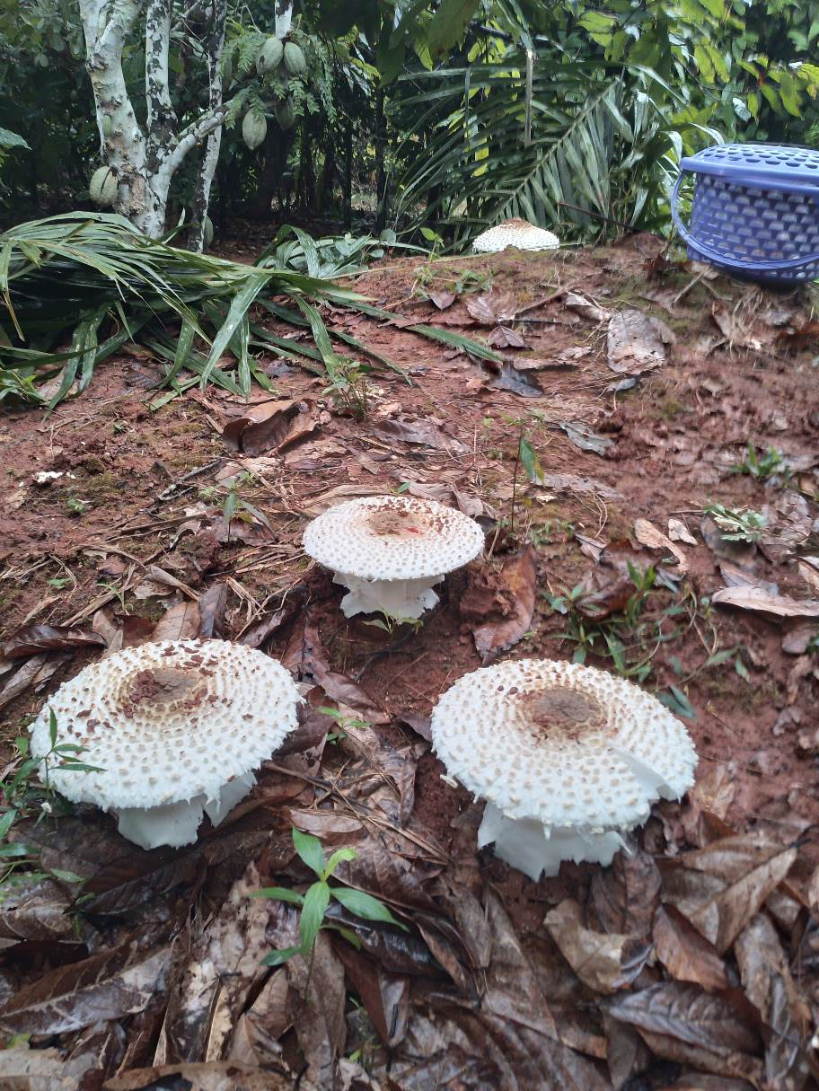
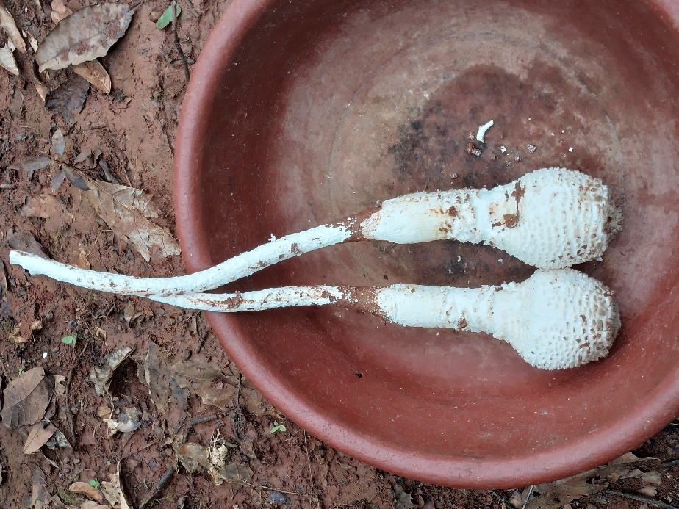
B

B
A

Fig 12: Termitomyces schimperi
(A: Young carpophore, B: Mature carpophore)
- Termitomyces medius (Lyophyllaceae)
Description
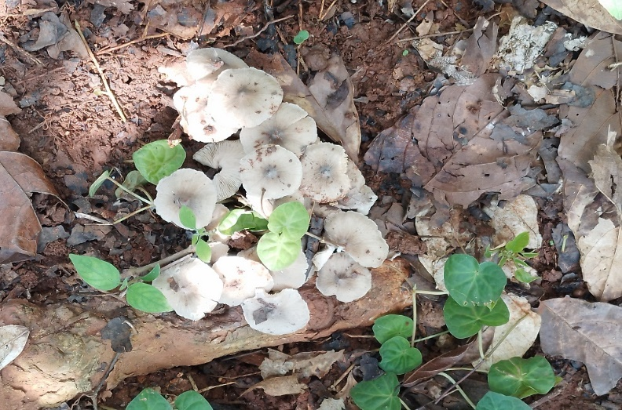
Termitomyces medius belongs to the Lyophylaceae family with a uniform coating, sometimes depressed around the edges, and is grayish brown in color. The curved edge is often straight, cracked up to halfway from the center. Its color is whitish or light gray with a whitish, hollow, cylindrical stem (Figure 13).

Fig 13 : Termitomyces medius
- Gymnopilus zenkeri (Strophariaceae)
Description
A member of the Strophariaceae family, Gymnopillus zenkeri has a subglobular to globular cap that is flat-convex and sometimes depressed. It changes color or appearance when exposed to sunlight. The edge is curved and then straight when mature. The gills are more or less crowded and yellowish in color. The stem is central, cylindrical, striated, and yellow-brown (Figure 14).
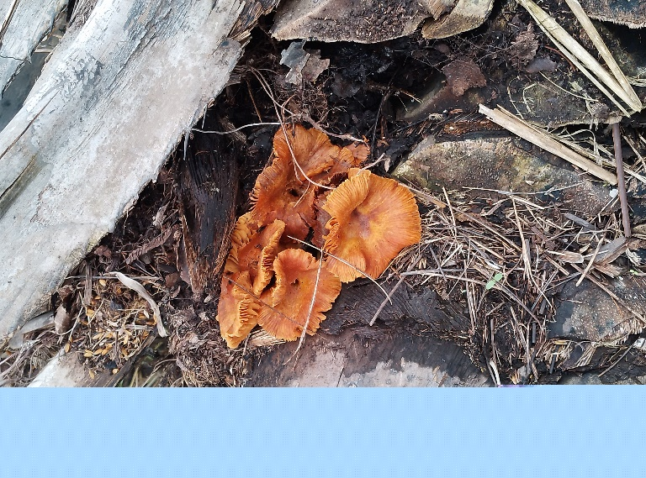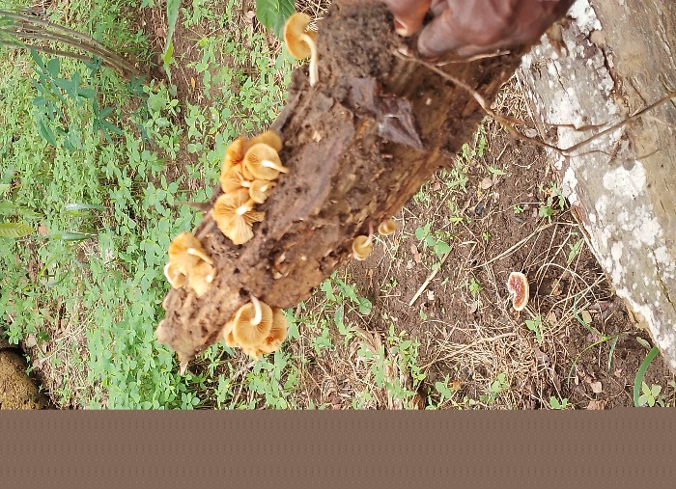
Fig 14: Gymnpilus zenkeri
(A: on a decaying palm tree, B: on a decaying tree trunk)

4.DISCUSSION
The results of the ethnomycological survey conducted among villagers in the Sinfra department showed that the majority of respondents were women. This high proportion of women could be explained by the fact that endogenous knowledge of edible wild mushrooms is held and transmitted by women in this area. Indeed, women know the fruiting period of edible mushrooms and the places where they can be harvested. In addition, women are responsible for the daily subsistence of the family and traditional childcare. As a result, they use edible mushrooms for their culinary flavor, medicinal properties, and also for the family's nutritional balance. Our results are similar to those of Yabi (2022), who reported that 100% of women in the city of Parakou, Benin, are familiar with and eat edible wild mushrooms. Fourteen species of edible mushrooms were cited by the population during the ethnomycological survey. Among these species, the Termitomyces genus is the most represented with six species cited. This high species richness of the Termitomyces genus is thought to be due to a combination of ecological and biological factors and their symbiotic association with termites. Indeed, Côte d'Ivoire has a hot and humid climate favorable to the growth of edible mushrooms, particularly those of the Termitomyces genus, whose development depends on humidity. Termitomyces fungi, which live in symbiosis with termites, break down organic matter that provides food for termites. Consequently, the high diversity of termites in the tropical zone leads to a high presence of these fungi. These results are similar to those of Onguene et al. (2018). who, in their work, identified and catalogued nearly fifteen species of the Termitomyces genus in the humid forests of southern Cameroon. Most of the edible wild mushrooms inventoried in the area were harvested from decaying dead tree trunks. Indeed, decaying dead wood provides essential nutrients for the establishment and survival of almost all of the mushrooms harvested. These results are similar to those of Eyi-Ndong et al. (2014), who collected mushrooms of the genera Psathyrella, Gymnopilus, Auricularia, and Coprinus from stumps or dead tree trunks in the dense forests of Central Africa. The ethnomycological survey enabled us to identify the edible mushrooms most appreciated and traded by the Ivorian population, particularly in rural areas. These are Volvariella volvacea, Psathyrella tuberculata, Termitomyces schimperi, and Termitomyces letestui. This could be due to their availability, abundance, ease of cultivation, and culinary value. Indeed, the species Psathyrella tubercula is generally found in agricultural and forest environments, making it more or less easily accessible and easy to collect. As for the species Volvariella volvacea, it is commonly cultivated on agricultural substrates such as rice straw and cassava husks, which facilitates its supply to the market and then to households. As for the species Termitomyces letestui, Côte d'Ivoire's hot and humid climate favors the growth of edible mushrooms, particularly those of the Termitomyces genus, whose development depends on humidity. In addition, these mushrooms have flavors and textures that are highly appreciated by consumers. These results corroborate the work of Yian (2017) in his study on the diversity of edible mushrooms found in Abidjan. These three mushrooms are commonly preserved for trade and later consumption (Codja, 2013). However, three of the 14 edible mushroom species mentioned are used in traditional medicine: Auricularia cornea is used to treat high blood pressure, Psathyrella tuberculata is used to treat diabetes, high blood pressure, malaria, eye pain, and earaches, and Termitomyces eurrhizus is cited as a remedy for yellow fever. This use is based on traditional knowledge, experience, and observation. These results are similar to those of Yian et al. (2020), who also listed Auricularia cornea and Psathyrella tuberculata among the eleven edible mushroom species used in traditional pharmacopoeia. The survey results revealed that certain edible mushroom species are more resistant to decomposition than others after harvesting. This difference in mushroom storage time could be explained by several factors, such as the water content of the mushrooms and the environmental conditions (humidity or heat) in which they are stored. However, better preservation methods, such as drying and refrigerated storage, can extend the shelf life of an edible mushroom.
5.CONCLUSION
The study undertaken on the value of edible wild mushrooms through an ethnomycological survey of 81 people in the localities of Ganoufla and Gonazofla highlighted the sociodemographic characteristics of the respondents (gender, age, ethnicity, level of education, and occupation), as well as their endogenous knowledge of edible mushrooms and their usefulness in defending the body. This survey not only provided an overview of the demographic characteristics of the respondents, but also revealed that women constitute the population with the most traditional knowledge about edible mushrooms. During this survey, 14 species of edible mushrooms were mentioned by the villagers. These edible mushrooms belong to six families, two of which are predominant (Lyophillaceae and Agaricaceae). The species Volvariella volvacea, Termitomyces letestui, and Psathyrella tuberculata are the wild mushrooms most commonly consumed by rural populations in the department of Sinfra.

COMPETING INTERESTS DISCLAIMER:
Authors have declared that they have no known competing financial interests OR non-financial interests OR personal relationships that could have appeared to influence the work reported in this paper.

Disclaimer (Artificial intelligence)
Option 1:
Author(s) hereby declare that NO generative AI technologies such as Large Language Models (ChatGPT, COPILOT, etc.) and text-to-image generators have been used during the writing or editing of this manuscript.
Option 2:
Author(s) hereby declare that generative AI technologies such as Large Language Models, etc. have been used during the writing or editing of manuscripts. This explanation will include the name, version, model, and source of the generative AI technology and as well as all input prompts provided to the generative AI technology
Details of the AI usage are given below:
1.
2.
3.

REFERENCES
Codjia J. E. I. (2013). Diversity and Use of Wild Mushrooms in the Pobe Commune, 66 p.
Eyi-Ndong C., Mounguengui S., Attéké C., & Ndong G. (2014). Variation in the Consumption of Mushrooms by Pygmies and Bantus in the North of Gabon. Advances in Microbiology, 4: 1212-1221.
Kouame K. B., Anauma C. K., Massé D., Ibrahim K., & Nogbou E. A. (2018). Physicochemical Characterization of Three Species of Edible Wild Mushrooms Commonly Found in the Haut Sassandra Region (Côte d'Ivoire). Journal of Applied Biosciences, 121: 12110-12120.
Moupela C. (2011). African Hazel (Coula edulis Baill.). A Little-Known Non-Timber Forest Product •In Biotechnology, Agronomy, Society and Environment, 15 (3): 485-495.
Onguene A., Tchudjo T. A. N., & Kuyper T. W. (2018). Biodiversity of Edible Wild Macrofungi in the Rainforest of Southern Cameroon. Wood and Forests of the Tropics, 338: 87-99.
Yian G. C. (2017). Diversity of Edible Mushrooms Found in Abidjan (Côte d’Ivoire). IOSR Journal of Pharmacy and Biological Sciences, 15: 35-45.
Yian G. C., Pitta B. M. S., & Tiébré M. S. (2020). Edible Wild Mushrooms and Traditional Pharmacopoeias in the Forest Zone of Côte d’Ivoire. IOSR Journal of Pharmacy and Biological Sciences (IOSR-JPBS), 15(2): 35-45.
Yorou N.S., & A. De Kesel 2001. Ethnomycological knowledge of the Nagot people of central Benin (West Africa). Processifs of the XVI AETFAT congress, Brussels, Systematic and Geographic of Plants. 72: 627-637.
Zanh G. G., Barima Y. S. S., Kouakou K. A., & Sangne Y. C. (2016). Uses of non-timber forest products according to the communities living in the Haut-Sassandra classified forest (Central-West Côte d'Ivoire). International Journal of Pure and Applied. 4 (5): 212-225.

