Original Research Article

Sanitation Gaps, Health Knowledge, and Cultural Resignation: Mapping Parasitic Infections and Diarrhea in a Vulnerable Urban Area of Itacoatiara, Brazilian Amazon

Abstract
Intestinal parasitic infections and diarrheal diseases remain entrenched public health challenges in socially vulnerable urban areas of the Brazilian Amazon. This mixed-methods study investigated two neighborhoods in Itacoatiara using 373 household surveys, 27 semi-structured interviews, municipal stool-test records (3,654 examinations; 43.76% positive for intestinal parasites), and microscopy of 27 household drinking-water samples (22.2% with parasitic-like forms). Findings reveal structural sanitation deficits, widespread misconceptions, and cultural resignation that undermine preventive behaviors. The results indicate that sustainable control will depend on integrated policies that combine infrastructure, routine school-based deworming, and culturally sensitive health education, in line with national frameworks.

Keywords: Intestinal parasitic infections; Diarrheal diseases; Sanitation gaps; Household water quality; Health literacy; Urban Brazilian Amazon.

Introduction
Enteric parasitoses and diarrheal diseases disproportionately affect populations living in poverty in tropical regions due to limited access to safe water, inadequate sanitation, and gaps in health literacy [1–3]. In Brazil, systematic reviews document a substantial burden of intestinal parasitic infections, especially among children, with marked regional heterogeneity that includes Amazonian municipalities [1,4]. Foundational public health and environmental frameworks link pathogen transmission to water, sanitation, and hygiene conditions and caution that behavior change rarely succeeds without supportive infrastructure and services [2,3]. Programmatically, global and national guidance point to integrated strategies—preventive chemotherapy in school-aged children, context-appropriate health education, and expansion of basic sanitation—to curb transmission and reinfection [2,5]. Within this landscape, Itacoatiara (Amazonas State) offers a relevant setting to examine how structural deficits, household practices, and community perceptions shape risk. This study integrates quantitative and qualitative evidence to map determinants of intestinal parasitic infections and diarrhea, aiming to inform territory-aware interventions in low- and middle-income countries (LMICs) and in the Brazilian Amazon [1–5].

Materials and Methods
Study Design and Setting
A cross-sectional mixed-methods study was conducted from January to August 2019 in the Santo Antônio and Tiradentes neighborhoods of Itacoatiara, Amazonas, Brazil. The study area corresponds to the coverage of the Santo Antônio Primary Health Unit (Unidade Básica de Saúde, UBS).
Population and Sampling
We conducted systematic random household surveys (n=373). A brief health-literacy screener stratified respondents (Supplementary Table S1). Twenty-seven women (low=15, intermediate=10, high=2) participated in semi-structured interviews (audio-recorded, fully transcribed, thematically coded). Three interviews had incomplete audio/transcripts and were excluded from the quotations table; all 27 informed the qualitative analysis. A concise set of representative interviews and quotes is summarized in Table 1.
Water Sample Analysis
One 500-mL drinking-water sample was collected per interviewed household (n=27), stored at 4–8 °C, and analyzed within 24 h at the Microbiology Laboratory of the Federal University of Amazonas (UFAM), in Itacoatiara. Sedimentation/centrifugation was followed by wet mounts with Lugol’s iodine; slides were examined under a light microscope at 100× and 400× magnification by two observers to assess the presence of debris and parasitic or free-living forms.
Parasitological and Epidemiological Data (Municipal Records)
We reviewed stool-test records from the Municipal Central Laboratory for patients served by the Santo Antônio UBS (September 2017–September 2018). Stool screening methodology consisted exclusively of routine direct fresh wet mounts of unpreserved stool in normal saline, with Lugol’s iodine added as needed; no concentration techniques (e.g., Hoffman–Pons–Janer), Kato–Katz, or molecular assays were employed. It should be noted that direct wet mounts are widely used for preliminary screening but are less sensitive for low-intensity parasitic infections than concentration or quantitative methods [4–8,20].
Statistics and Data Integration
Descriptive statistics were computed in SPSS v20.0 and Epi Info v7.2.3.1. Group comparisons used chi-square or Fisher’s exact tests; statistical significance was defined as p < 0.05 (two-sided). Triangulation integrated surveys, interviews, laboratory records, and environmental observations.

Results
Spatial coverage and sampling are illustrated in Figure 1, which maps the two neighborhoods and the distribution of the 27 qualitative interviews. Representative qualitative insights are compiled in Table 1, which presents an extract of the 12 most relevant quotes from the semi-structured interviews. Baseline household characteristics and living conditions are summarized in Table 2. Of 3,654 municipal stool examinations, 1,599 (43.76%) were positive for intestinal parasites; the distribution of identified taxa is shown in Figure 2 and detailed in Table 3 (protozoa predominated). Microscopy of 27 household drinking-water samples identified parasitic or protozoa-like forms in 6 samples (22.2%), with representative structures depicted in Figure 3 and summarized in Table 5. Finally, Figure 4 synthesizes the integrated evidence into a triadic model of vulnerability linking structural deficits, behavioral constraints, and cultural normalization; this pattern helps explain the concentration of diarrhea notifications in the municipal hospital (Table 4) and the differences observed in selected preventive indicators between diarrhea and non-diarrhea groups (Table 6).

Table 2. Household survey: demographics and living conditions (n=373)
Variable | Value
Mean age (years) | 35.1 ± 13.8
Female | 75.9%
≥4 residents per household | 53.9%
Masonry houses | 80.4%
Income ≈ 1 minimum wage | 43.4%
Currently employed | 47.7%
Observed environmental risks (open sewage/garbage/flood-prone) | Frequent in peripheral areas (field notes)

Table 3. Municipal stool examinations (September 2017–September 2018)
Total exams | Positives (any intestinal parasite) | Point prevalence
3,654 | 1,599 | 43.76%

Table 4. Diarrhea surveillance (September 2017–September 2018)
Total reported cases | Reported by José Mendes Municipal Hospital | Reported by Santo Antônio UBS
6,885 | 96.72% | 92 cases (1.34%)

Table 5. Household water microscopy (n=27)
Positive samples | % positive | Main findings
6 | 22.2% | Entamoeba-like forms, free-living nematode larvae (Aphelenchus sp.), unidentified protozoa; abundant debris

Table 6. Selected survey indicators (diarrhea vs no-diarrhea)
Indicator | Diarrhea | No-diarrhea | p-value
Municipal water as source | 84.8% | 83.9% | n.s.
Trust in municipal water | 52.0% | 52.4% | n.s.
Treat/purify water | 49.8% | 30.1% | 0.0002
Recognizes handwashing as prevention | 55.9% | 73.2% | 0.0008
Figure 1. Geographic context and distribution of qualitative interviews (single “Figure 1” label; duplicate removed).
Figure 2. Distribution of intestinal parasites in positive stool exams (September 2017–September 2018). Of 3,654 exams, 1,599 (43.76%) were positive by routine microscopy (direct wet mounts). Protozoa predominated (Entamoeba histolytica/dispar, Endolimax nana, Giardia lamblia), with fewer helminths; bars show absolute counts and relative frequencies.
Figure 3. Representative structures observed in household water (400×): (A) larvae compatible with Aphelenchus (free-living), (B) unidentified nematode forms, (C) refringent protozoa-like structures, and (D) debris.
Figure 4. Triadic model of vulnerability (Venn diagram). Overlap of three domains sustaining endemic intestinal parasitic infections (IPIs) and diarrhea in the study area: (A) structural vulnerabilities (lack of sanitation infrastructure, intermittent waste collection, unsafe water supply); (B) behavioral factors (inconsistent hygiene routines, limited water treatment, low adherence to prevention); and (C) cultural normalization (health fatalism, misinformation, resignation to disease). The intersection highlights persistent transmission that is unlikely to change without integrated interventions across infrastructure, behavior, and community engagement.

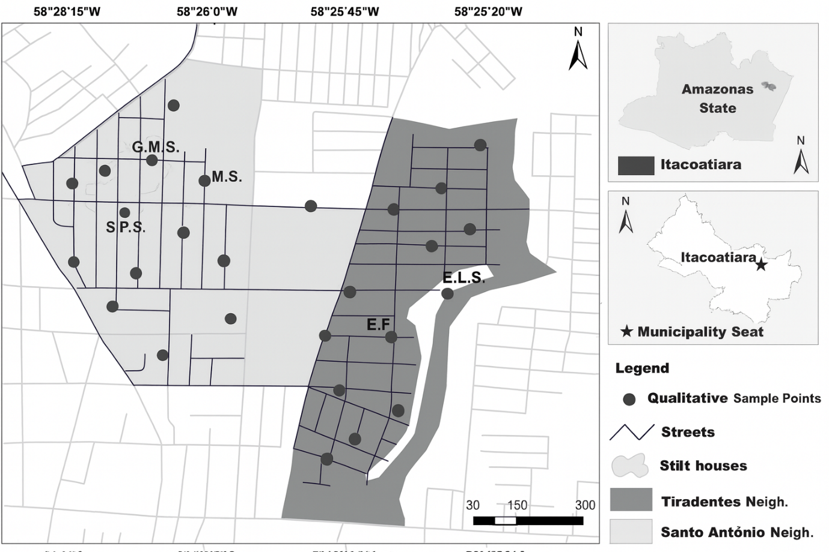
Figure 1. Map showing qualitative sample points in Tiradentes and Santo Antônio neighborhoods of Itacoatiara, Amazonas, Brazil, highlighting streets, stilt houses, and key locations.

Figure 1 Geographic context and distribution of qualitative interviews. The upper inset shows the location of Itacoatiara municipality within the state of Amazonas, Brazil. The main map displays the Tiradentes and Santo Antônio neighborhoods, highlighting the spatial distribution of residences where 27 semi-structured interviews were conducted between January and August 2019. Dots indicate households of participants selected for the qualitative component, which aimed to explore sociocultural and infrastructural factors related to the high incidence of intestinal parasitic infections and diarrheal diseases.

Results
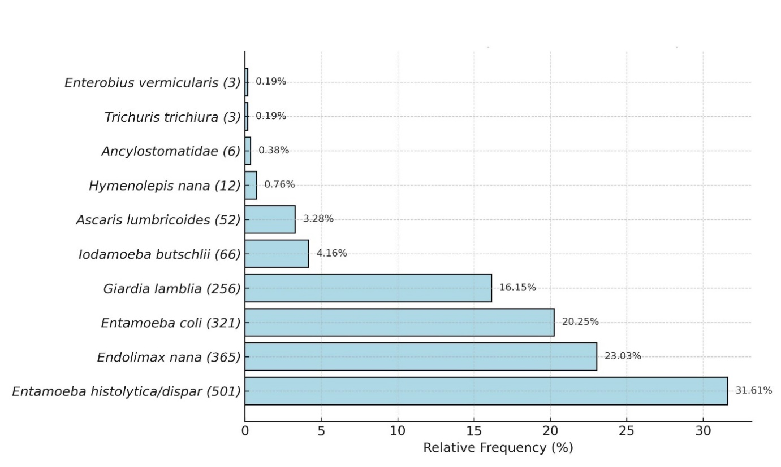
Figure 2. Relative Frequency
Figure 3 presents probable parasitic forms, free-living organisms, and debris observed in household water samples under optical microscopy.
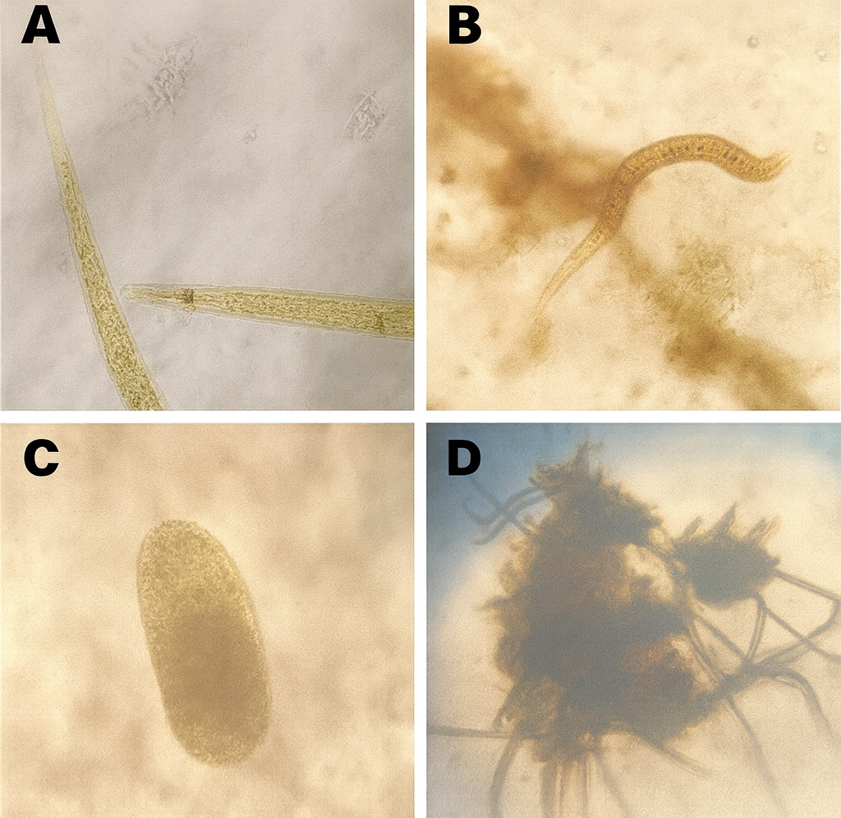
Figure 3. (A) showed an average of 71 larvae per coverslip (based on two slides), identified as belonging to the genus Aphelenchus (free- living larval form). In panel (B), tap water contained a parasitic form with morphological features suggestive of an unidentified free-living nematode, along with abundant particulate debris. Panel (C) presents a refringent cellular structure or an unidentified protozoan, accompanied by crystals, stained cells, epithelial cells, and debris. Panel
(D) shows tap water containing crystals, stained cells, epithelial cells, artifacts, and additional organic debris.
Tap water in panel (A) showed an average of 71 larvae per coverslip (based on two slides), identified as belonging to the genus Aphelenchus (free-living larval form).
In panel (B), tap water contained a parasitic form with morphological features suggestive of an unidentified free-living nematode, along with abundant particulate debris.
Panel (C) presents a refringent cellular structure or an unidentified protozoan, accompanied by crystals, stained cells, epithelial cells, and debris.
Panel (D) shows tap water containing crystals, stained cells, epithelial cells, artifacts, and additional organic debris.

Discussion
This mixed-methods study identified a multifactorial and persistent pattern of vulnerability to intestinal parasitic infections and diarrheal diseases among residents of two low-income neighborhoods in Itacoatiara. Quantitative results (43.76% positive stool tests; 22.2% water samples with parasitic or protozoa-like forms) align with Brazilian and regional evidence that enteric risk remains high where water and sanitation services are fragile and health literacy is limited [1–3]. The reliance on direct fresh wet mounts for routine stool screening is programmatically understandable but diagnostically constrained, likely underdetecting light-intensity helminths in the absence of concentration or quantitative methods [4–8,20]. In clinical and public-health practice, diagnostic workups for persistent or chronic diarrhea often require repeated stool examinations and complementary methods to overcome sensitivity limitations, which were not available in the routine setting analyzed here [20].
Qualitative analysis—summarized in Table 1 and visually synthesized in Figure 4—clarified how knowledge, infrastructure, and culture interact to sustain transmission. Three domains emerged: (1) knowledge gaps and partial understanding, with frequent misconceptions and only a minority explicitly linking hygiene to prevention [2,3,15,16]; (2) structural neglect and environmental exposure, including lack of sewerage and irregular waste collection, corroborated by field observations and aligned with ecological risk frameworks [2–4,14]; and (3) cultural normalization and resignation, which can mute the impact of isolated education campaigns and require sustained, culturally tuned engagement [15–17]. The mixed-methods design was essential: surveys and laboratory data quantified burden, while interviews illuminated how beliefs and lived conditions shape risk, answering calls for socially contextualized public health approaches in tropical settings [2,3,14–17,19].
Policy levers exist in Brazil to address each domain in tandem: school-based preventive chemotherapy and education for children [5]; universal-access principles and investments mandated by the sanitation legal framework and PLANSAB [9–12]; and school-centered health actions through the PSE program [13]. Implementing these in a coordinated, territory-aware manner could shift the system from reactive care to primary prevention.
Limitations include cross-sectional design, potential recall bias for self-reported diarrhea (mitigated by a 30-day window), use of municipal records from the year before fieldwork (no major interim interventions identified), and likely underestimation of helminths due to exclusive use of direct wet mounts.
Conclusion
The persistence of intestinal parasitic infections and diarrhea in Itacoatiara reflects the intersection of environmental degradation, infrastructural deficits, constrained and inconsistent preventive behaviors, and cultural normalization of illness. While some knowledge and practices were present, they were insufficient to overcome contextual barriers. The convergence documented here—quantified by high positivity in stool tests and contamination observed in household water, and qualified by residents’ narratives—demands an integrated response. Priorities include: strengthening routine diagnostics (adding concentration or quantitative techniques where feasible), reinforcing primary-care surveillance and reporting, implementing school-based preventive chemotherapy with tailored health education, and advancing sanitation upgrades under Brazil’s national policy framework [2,4–5,9–13,15–17,20]. Only a coordinated approach addressing infrastructure, education, and community engagement is likely to disrupt the cycle of transmission and promote health equity in vulnerable urban areas of the Brazilian Amazon.

Author Contributions
Conceptualization: M.A.A., J.A.A.; Methodology: M.A.A.; Investigation: J.A.A.; Data curation: J.A.A., M.A.A.; Formal analysis: M.A.A.; Visualization: M.A.A.; Writing—original draft: M.A.A.; Writing—review and editing: M.A.A., J.A.A.; Project administration: M.A.A.

Conflict of Interest
The authors declare no conflicts of interest.

Ethics Statement
Approved by the Research Ethics Committee of the Federal University of Amazonas (UFAM), CAAE 89388018.4.0000.5020; written informed consent obtained.

Generative AI Use
Generative AI was used for language editing, structural reorganization, table and caption drafting and reference formatting. Technology: OpenAI ChatGPT (GPT-5 Thinking), accessed on 01-13 October 2025. All analyses, interpretations, and final decisions were verified by the authors; no non-public patient data were shared with the AI.

Supplementary Material
Supplementary Table S1: Five-item health-literacy screener used to stratify interview participants (low, intermediate, high), cited in Materials and Methods (Population and Sampling).
Table 1: Summary of Representative Qualitative Interviews (n=12).

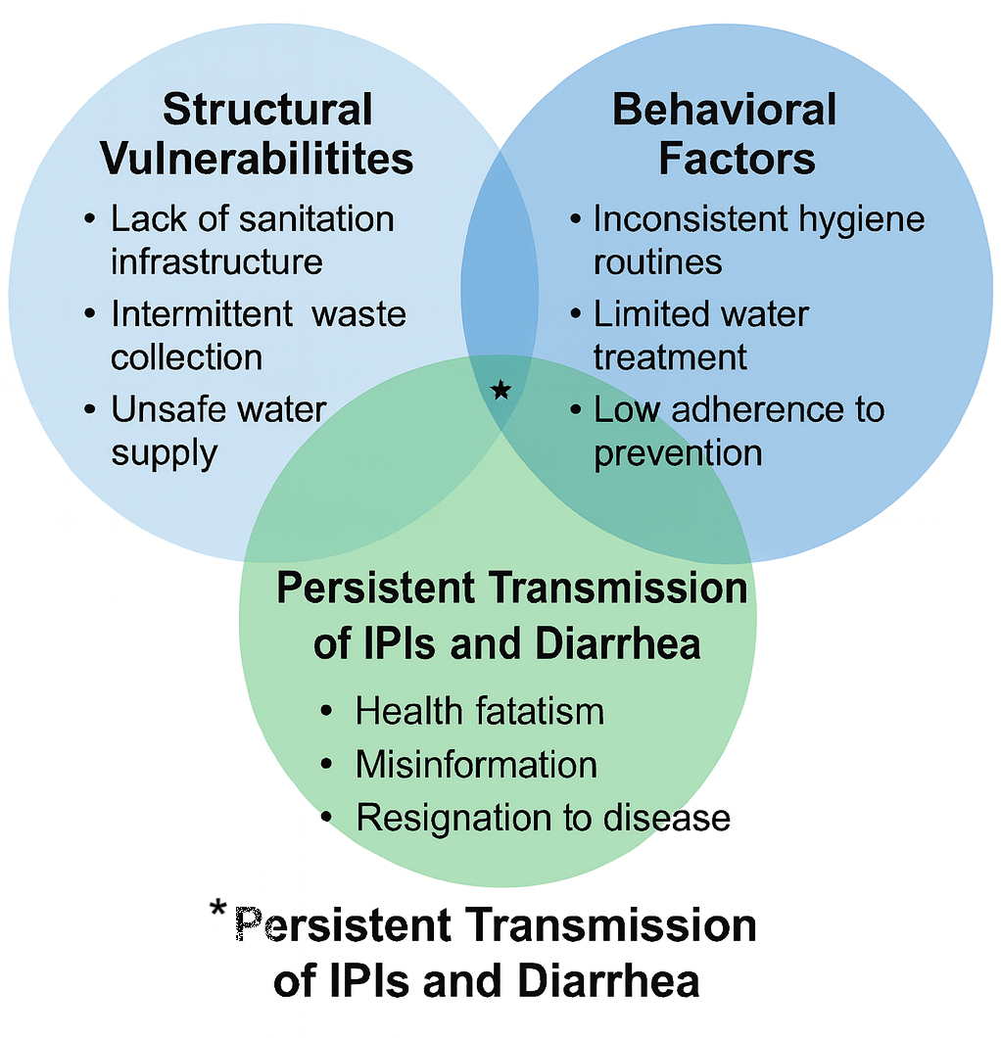 Figure 4 Persistent Transmission of IPIs and Diarrhea

References
- Celestino AO, Vieira SCF, Lima PAS, Rodrigues LMCL, Lopes IRS, França CM, et al. Prevalence of intestinal parasitic infections in Brazil: A systematic review. Rev Soc Bras Med Trop. 2021;54:e0033-2021. doi:10.1590/0037-8682-0033-2021.
- Mock CN, Nugent R, Kobusingye O, Smith KR, editors. Water supply, sanitation, and hygiene. In: Injury Prevention and Environmental Health. 3rd ed. Washington, DC: The World Bank; 2017. doi:10.1596/978-1-4648-0522-6_ch9.
- Eisenberg JNS, Desai MA, Levy K, Bates SJ, Liang S, Naumoff K, et al. Environmental determinants of infectious disease: A framework for tracking causal links and guiding public health research. Environ Health Perspect. 2007;115(8):1216-1223. doi:10.1289/ehp.9806.
- World Health Organization. Bench Aids for the Diagnosis of Intestinal Parasites. 2nd ed. Geneva: WHO; 2019. ISBN: 978-92-4-151534-4.
- Ministério da Saúde (Brasil). Guia prático para o controle das geo-helmintíases. Brasília: Ministério da Saúde; 2018.
- Centers for Disease Control and Prevention (CDC). DPDx—Diagnostic Procedures—Stool Specimens: Microscopic Examination (wet mounts). Atlanta: CDC; 2024. Available from: https://www.cdc.gov/dpdx/diagnosticprocedures/stool/microwetmount.html
- Bärenbold O, Raso G, Coulibaly JT, N’Goran EK, Utzinger J, Vounatsou P. Estimating sensitivity of the Kato-Katz technique for the diagnosis of Schistosoma mansoni and hookworm in relation to infection intensity. PLoS Negl Trop Dis. 2017;11(10):e0005953. doi:10.1371/journal.pntd.0005953.
- DeWorm3 Consortium. Standard Operating Procedure 707: Kato-Katz Preparation and Analysis. London: DeWorm3; 2020.
- Brasil. Lei nº 11.445, de 5 de janeiro de 2007. Estabelece as diretrizes nacionais para o saneamento básico. Diário Oficial da União. 2007 Jan 8.
- Brasil. Lei nº 14.026, de 15 de julho de 2020. Atualiza o marco legal do saneamento básico. Diário Oficial da União. 2020 Jul 15.
- Ministério das Cidades (Brasil). Plano Nacional de Saneamento Básico (PLANSAB). Brasília: Ministério das Cidades; 2019. Available from: https://www.gov.br/cidades/pt-br/assuntos/saneamento/plansab
- Ministério da Saúde (Brasil). Programa Saúde na Escola: passo a passo. Brasília: Ministério da Saúde; 2011.
- Oliveira TCR, Lescher CL, Sato APS, et al. Trends in hospital admission and infant mortality from diarrhea: Brazil, 1995–2005. Rev Saude Publica. 2010;44(1):102-111. doi:10.1590/S0034-89102010000100011.
- Contreras JD, Trangucci R, Felix-Arellano EE, Rodríguez-Dozal S, Siebe C, Riojas-Rodríguez H, et al. Modeling spatial risk of diarrheal disease associated with proximity to untreated wastewater used for irrigation in the Mezquital Valley, Mexico. Environ Health Perspect. 2020;128(7):077002. doi:10.1289/EHP6443.
- Davis SN, Wischhusen JW, Sutton SK, Christy SM, Chavarria EA, Sutter ME, et al. Demographic and psychosocial factors associated with limited health literacy in a community-based sample. Patient Educ Couns. 2019;103(2):385-391. doi:10.1016/j.pec.2019.08.026.
- Hagger MS, Orbell S. The common-sense model of illness self-regulation: A conceptual review and proposed extended model. Health Psychol Rev. 2022;16(3):347-377. doi:10.1080/17437199.2021.1878050.
- Mendenhall E, Kohrt BA, Logie CH, Tsai AC. Syndemics and clinical science. Nat Med. 2022;28:1359-1362. doi:10.1038/s41591-022-01888-y.
- Hailu T, Alemu G. Prevalence of Entamoeba histolytica/dispar and Giardia lamblia and associated factors among schoolchildren in Northwest Ethiopia. Food Waterborne Parasitol. 2024;36:e00241. doi:10.1016/j.fawpar.2024.e00241.
- Guimarães MGS, Braña AM, Oliart-Guzmán H, Castelo Branco FLC, Delfino BM, Pereira TM, et al. Child health in the Peruvian Amazon: Prevalence and factors associated with referred morbidity and healthcare access in Iñapari. J Trop Med. 2015;2015:157430. doi:10.1155/2015/157430.
- Khurana S, Gur R, Gupta N. Chronic diarrhea and parasitic infections: Diagnostic challenges. Indian J Med Microbiol. 2021;39(4):413-416. doi:10.1016/j.ijmmb.2021.10.001.

Table 1-: Summary of Representative Qualitative Interviews (n=12)
Participant | Age / Sex | Health Literacy / Education | Water Analysis | Representative Quotes
P1 | 42 / F | Low / Incomplete Elementary | Tap: plant debris; unidentified parasite | "I know very little about worms, I think it comes from unwashed things." / "We have a toilet, but it drains into the stream behind the house."
P3 | 33 / F | Medium / Completed Elementary | Mineral: fibers, debris (low) | "My son got an abdominal infection, so now we drink bottled water."
P10 | 62 / F | High / Completed High School | Mineral: epithelial cells, debris (high) | "Without proper treatment, diarrhea can kill." / "I know ameba is a dangerous worm."
P14 | 38 / F | Low / Incomplete Elementary | Tap: cyst-like form (Entamoeba), debris (high) | "You have to wash your hands and not walk barefoot." / "I drink tap water, but I boil it for my child."
P25 | 38 / F | Low / Incomplete Elementary | Tap: Aphelenchus larvae; debris (high) | "Our dream is to have Prosamim here like they did in Manaus."
P27 | 43 / F | Medium / Incomplete High School | Tap: nematode-like form, debris (high) | "Parasites are caught from soil contamination." / "You can get it from not washing hands after the bathroom."
P13 | 23 / F | Low / Incomplete Elementary | Tap: fibers; epithelial cells and debris (high) | "Diarrhea is from food; it needs to be well cooked, and water must be boiled."
P16 | 69 / F | Medium / Higher Education | Mineral: cellular elements (high) | "It's a dangerous disease, can severely impact health." / "Worms are tiny microbes that harm us."
P19 | 40 / F | Low / Incomplete High School | Tap: debris (high) | "Worms come when children eat too much candy or put dirty things in their mouth."
P20 | 38 / F | Medium / Incomplete Elementary | Tap: debris, artifacts, epithelial cells (high) | "Often we drink tap water; we can’t afford bottled, so I boil it for my son."
P22 | 46 / F | Medium / Incomplete Elementary | Filtered: epithelial cells and debris (low) | "It can come from inadequate food." / "We are born with these worms."
P24 | 28 / F | Medium / Completed Elementary | Tap: protozoan-like form, crystals, epithelial cells (moderate) | "Sometimes from drinking untreated water or not washing fruits and hands properly."

Supplementary Table 1 – Health Knowledge Questionnaire Used for Participant Stratification
Why should we wash our hands? (select all that apply)
( ) To be clean
(x) To prevent diseases
( ) To be healthy
( ) To reduce bad smell
( ) I don’t know
( ) Other: ____________
How is diarrhea spread? (select all that apply)
(x) Dirty environment
(x) Fecal pathogens
(x) Consumption of unhygienic food
(x) Drinking contaminated water
( ) I don’t know
( ) Other: ____________
Do you think diarrhea can be fatal?
(x) Yes
( ) No
( ) I don’t know
What are the ways people get infected by worms? (select all that apply)
(x) Walking barefoot
(x) Contaminated water or food
(x) Contact with feces
( ) While bathing
How do you treat yourself or family members when stool tests show worms? (select all that apply)
(x) Oral rehydration salts
(x) Homemade saline
( ) Go/take them to the pharmacy
(x) Go/take them to the doctor
( ) Do nothing
(x) Mebendazole

