To study the effect of irrigation water quality on the soil productivity of Pehowa block of Kurukshetra district, Haryana, India
Abstract:
Groundwater is a vital component for agriculture in India, serving as a primary resource for crop irrigation. It is also the most heavily extracted raw material globally. In arid and semiarid regions, assessing groundwater quality for irrigation purposes is essential due to the pressure of increasing population, urban development and industrial expansion. The high salt content in soil and irrigation water poses a significant risk to agriculture's productivity and long-term viability. Soil salinity hinders crop development by impeding water absorption, causing osmotic stress, and altering nutrient accessibility. Similarly, increased salt levels in irrigation water directly impact the water quality used for agricultural irrigation. This can result in reduced crop output, slowed plant development, reduced nutrient absorption, and increased vulnerability to pests and diseases. In 2023, fifty water samples from the villages within Pehowa block of Kurukshetra district were collected to evaluate groundwater quality of that particular block. All the fifty irrigation water samples were analyzed for a range of hydrochemical parameters, including pH, electrical conductivity (EC), cations (Ca²⁺, Mg²⁺, Na⁺, and K⁺), and anions (CO₃²⁻, HCO₃⁻, Cl⁻, and SO₄²⁻) using standardized methods. Additionally, irrigation indices such as Sodium Adsorption Ratio (SAR) and Residual Sodium Carbonate (RSC) were also calculated. The results revealed that groundwater pH ranged from 7.65-8.82, EC varied between 0.44-1.81 dSm⁻¹, SAR was between 2.67-11.40 mmol^{1/2} L⁻¹ and RSC ranged from 0.00 to 5.07meq L⁻¹. The concentration of cations viz., Ca²⁺, Mg²⁺, Na⁺ and K⁺ varied from 0.31-1.00, 0.73-2.73, 2.45-13.24, 0.16-0.45 me L⁻¹ with mean values of 0.47, 1.34, 5.32, 0.28 me L⁻¹, respectively. Likewise, the concentration of anions viz., CO₃²⁻, HCO₃⁻, Cl⁻ and SO₄²⁻ varied from 0.00-1.6, 0.16-6.32, 1.71-6.54, 0.50-3.75 me L⁻¹ with average values of 0.06, 1.46, 3.30, 2.03 me L⁻¹, respectively. It shows the trend among the average ionic concentration of cations and anions were Na⁺>Mg²⁺> Ca²⁺> K⁺ and Cl⁻>SO₄²⁻>HCO₃⁻> CO₃²⁻, respectively. According to AICRP, 1989 in Pehowa block 82, 14 and 4% samples were found in good, marginally alkali and highly alkali categories, respectively. Likewise, soils of village Mohan Nagar and Naya Diwana which are receiving highly alkali irrigation water continuously from last many years have accumulated Na⁺ (26.0 and 25.2 meq L⁻¹), HCO₃⁻ (15.5 and 14.20 meq L⁻¹) and CO₃²⁻ (3.42 and 4.5 meq L⁻¹), respectively in 0-15 cm soil. Due to accumulation of Na⁺, HCO₃⁻ , CO₃²⁻, soil pH is more than 8.5 and SAR is more then 10. The results indicated that the increasing RSC in irrigation water significantly increased the pH, ECe and SAR of the soil. Spatial variability maps of EC, pH, SAR and RSC of irrigated ground water were also prepared for the Pehowa block of Kurukshetra district. The results obtained in this study and the spatial database established in GIS will be helpful for monitoring and managing groundwater quality in the study area.
Keywords: Groundwater, Global positioning system, SAR, RSC, Survey
Introduction:
Water is the most vital component of human life. Majority of the historical civilizations around the world were built on the banks of rivers that used to meet the primary freshwater supply for drinking and agricultural usages. Fresh water is one of the most essential natural resources needed to ensure the survival of all the lives. Fresh water is needed for domestic purposes, agriculture, irrigation, industry and power generation. The demand for water is predicted to rise between 20 to 30% by 2050 (Anuja, 2024). As a result of growing urbanization and population growth, water supplies are depleting more quickly than they were earlier. However, natural and human factors have put groundwater resources under tremendous pressure (Bhat et al., 2016). Generally, the quality and quantity of groundwater mainly depend on the geochemistry of soils and rocks through which water flows before reaching the aquifers (Al-Shaibani, 2008). The irrigation quality of water is expressed by the type and amount of dissolved salt (Etteieb et al., 2017). Poor-quality water containing a high concentration of soluble salts when used to irrigate cropland worldwide, especially in arid and semi-arid regions, the limited rainfall is insufficient to wash away salts from the root zone, which builds up salt in the soil and affects soil properties, causing secondary soil salinization. This risk makes it necessary to monitor the variation of salinization in the irrigated perimeters through physico-chemical analyses.
The continuous monitoring of groundwater resources thus, plays a major role in the sustainable management of water resources. For the sustainable development of society, groundwater is indispensable, hence the survey and characterization of groundwater quality in every region of the country is a prerequisite for its better supervision (Rao, 2018).
In view of above explained facts, the present study was conducted to get a comprehensive picture of the groundwater quality for irrigation purposes of a region/block, for whicha significant number of samples from that area must be evaluated. Considering importance of water quality for agriculture, a drive was initiated to analyze irrigation water samples of all the districts of Haryana state. In this research paper we are presenting the water quality data 50 water samples of Pehowa block of Kurukshetra district of Haryana. Further study of good and poor quality water on soil properties is also conducted. Thus, aim of our study wasto diagnose irrigation water quality, and further investigate their effect on the physicochemical properties of soil.
Materials and Methods
Location and topography of the studied area:
Pehowa is one of the five blocks of Kurukshetra districts of Haryana state. Kurukshetra is located in the northeastern part of Haryana, India, lying between 29°52' to 30°12' North latitudes and 76°25' to 77°04' East longitudes. The district occupies an area of 1530 km². The district has a population of 964,655 (2011 census). The Kurukshetra district is a plain that slopes from the northeast to the southwest. It is a flat plain with narrow, low-lying flood plains called Betre Khadar of Naili. A good network of canals is providing irrigation facilities. Tube well irrigation is also common in the district.

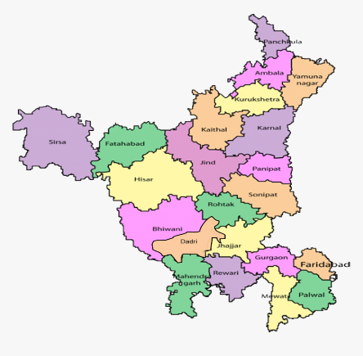
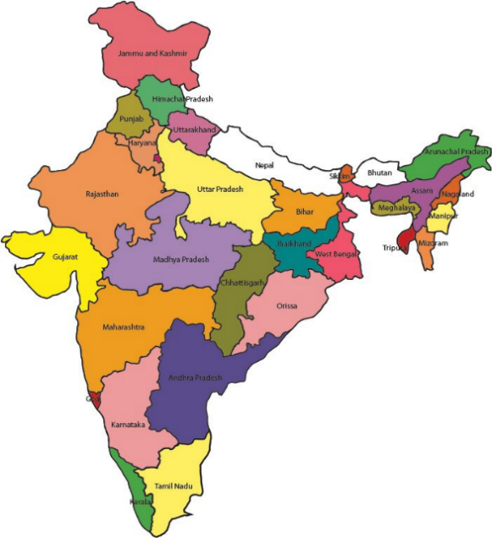

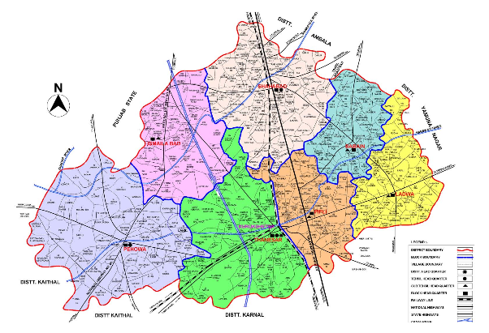

Fig. 1: Location map of five blocks of Kurukshetra district

It is one of the prosperous districts from agriculture point of view. 82% of the district is cultivable and the remaining 21,903 hectares is non-cultivable. Kurukshetra along with Karnal and Kaithal districts are known as the ‘Rice Bowls of India’ and famous for Basmati rice cultivation. Kurukshetra is bordered by the districts of Ambala, Yamuna Nagar, Karnal, and Kaithal in Haryana and Patiala in Punjab. The location map of five blocks is given in Fig. 1.
Climate and rainfall
Kurukshetra is located at an altitude of 260 meters above sea level. Temperature observed throughout year in Kurukshetramay reach as high as 47°C in the summer and as low as 1°C in the winter. Monsoon starts at the end of June and extends up to September. Average 81% of annual rainfall provides fair amount of water in the rainy season. 582 mm of average rainfall occurs annually in Kurukshetra district. Rainfall is not distributed evenly across the district. Pehowa receives less than 500 mm of annual rainfall whereas the region around Shahabad receives more than 500 mm of rainfall.
Soils and cropping system
The soil is generally alluvial; loam and clay constitute average texture of the soil. The predominant cropping system in the region is rice-wheat, utilizing surface irrigation methods such as flooding and basin irrigation. The fertile soil supports multiple cropping cycles, significantly boosting crop yields and improving farmers' socio-economic conditions.

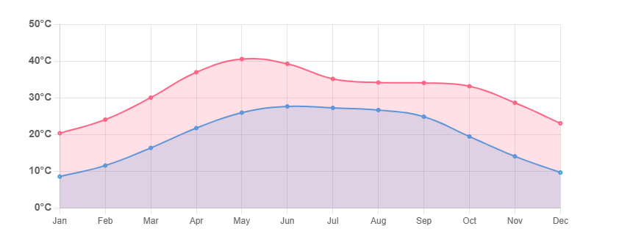
Average maximum day and minimum night temperatures in Kurukshetra in 2023

Collection and analysis of water and soil samples:
Pehowa block of Kurukshetra, district was surveyed during 2023-2024 to classify and quantify the underground water for irrigation. Distribution of all the sampling sites is presented in Fig. 2. Fifty water samples from running tube well were collected randomly throughout the Pehowa block. Water samples were collected in clean wide mouthed plastic bottles which were properly labeled and numbered properly during sample collection. To check the microbial growth one to two drops of toluene was added. After this the water samples were brought to the laboratory for their chemical analysis. The samples were analyzed for EC, pH, CO₃²⁻, HCO₃⁻ , Cl⁻ , SO₄²⁻, Ca ²⁺, Mg ²⁺, Na⁺ and K⁺ by following the procedures outlined in USDA Handbook No. 60 (Richards, 1954). pH was measured by digital pH meter and electrical conductivity (EC) by conductivity meter. Potassium and sodium were determined by flame photometer. Calcium and magnesium were determined with standard ethylene di-amine tetra acetic acid solution titrimetrically. Bicarbonate and carbonate were determined by titration with sulphuric acid, chloride determined by titrating water samples against standard silver nitrate (AgNO₃) solution. Sulphate was determined calorimetrically using spectrophometer. Residual sodium carbonate (RSC) and sodium adsorption ratio (SAR) was calculated using the formula:
- Sodium adsorption ratio (SAR) {Richards 1954}:
SAR (mmol L⁻¹)⁻¹ = $\frac{{Na}^{+}}{}$
- Residual sodium carbonate (RSC) (Eaton 1950):
RSC (meq L⁻¹) = (CO₃²⁻ + HCO₃⁻) – (Ca²⁺ + Mg²⁺)

After the analysis of underground water samples, they were characterized and classified as per the guidelines of All India Coordinated Research Project (AICRP 1989) on “Management of salt affected soils and use of saline water in Agriculture” as shown in Table 1.

Table 1. Irrigation water quality classification criteria
Sr.  No. | Quality of water | Class | Quality Parameter
Sr.  No. | Quality of water | Class | EC (dSm⁻¹) | (SAR mmol L⁻¹)^{1/2} | RSC (meq L⁻¹)
1 | Good | A | <2 | <10 | <2.5
2 | Saline | B
 | Marginally saline | B₁ | 2-4 | <10 | <2.5
 | Saline | B₂ | >4 | <10 | <2.5
 | High SAR saline | B₃ | >4 | >10 | <2.5
3 | Alkali water | C
 | Marginally alkali | C₁ | <2 | <10 | 2.5-4
 | Alkali | C₂ | <2 | <10 | >4
 | Highly alkali | C₃ | Variable | >10 | >4

After the analysis of water samples, soil samples were also collected to study the after affect of different qualities of irrigation water on soil. Soil samples were collected from two different village sites receiving all the three categories of water i.e. good quality, marginally alkali and highly alkali water. Details of all the sampling sites are presented in Table 2. Soil samples were collected from two
Table 2. Detail of sampling sites from where soil samples have been collected
 | Water quality | Site | Village | Latitude | Longitude
1 | Good quality water | Site I | Teokar | 30°03'23.2" N | 76°32'35.1" E
 |  | Site II | Jorasi Khurd | 30°00'25.2" N | 76°34'15.2"E
2 | Marginally alkali water | Site I: | Kanthala | 30°02'18.8" N | 76°39'53.4"E
 |  | Site II | Muqimpura | 29°59'01.9" N | 76°40'50.3" E
3 | Highly alkali water | Site I | Mohan Nagar | 30°02'17.2" N | 76°30'14.7" E
 |  | Site II | Naya Diwana | 30°03'03.2" N | 76°28'22.0" E

different soil depths i.e. 0-15 cm and 15-30 cm after the harvesting of paddy crop during 2023-2024. Subsequently, the collected samples were dried in the shade, ground, and sieved through a 2 mm mesh before being stored in polythene bags for soil chemical analysis. The processed soil samples underwent comprehensive analysis, including determination of pHs, ECe, soluble cations and anions (Richard, 1954).
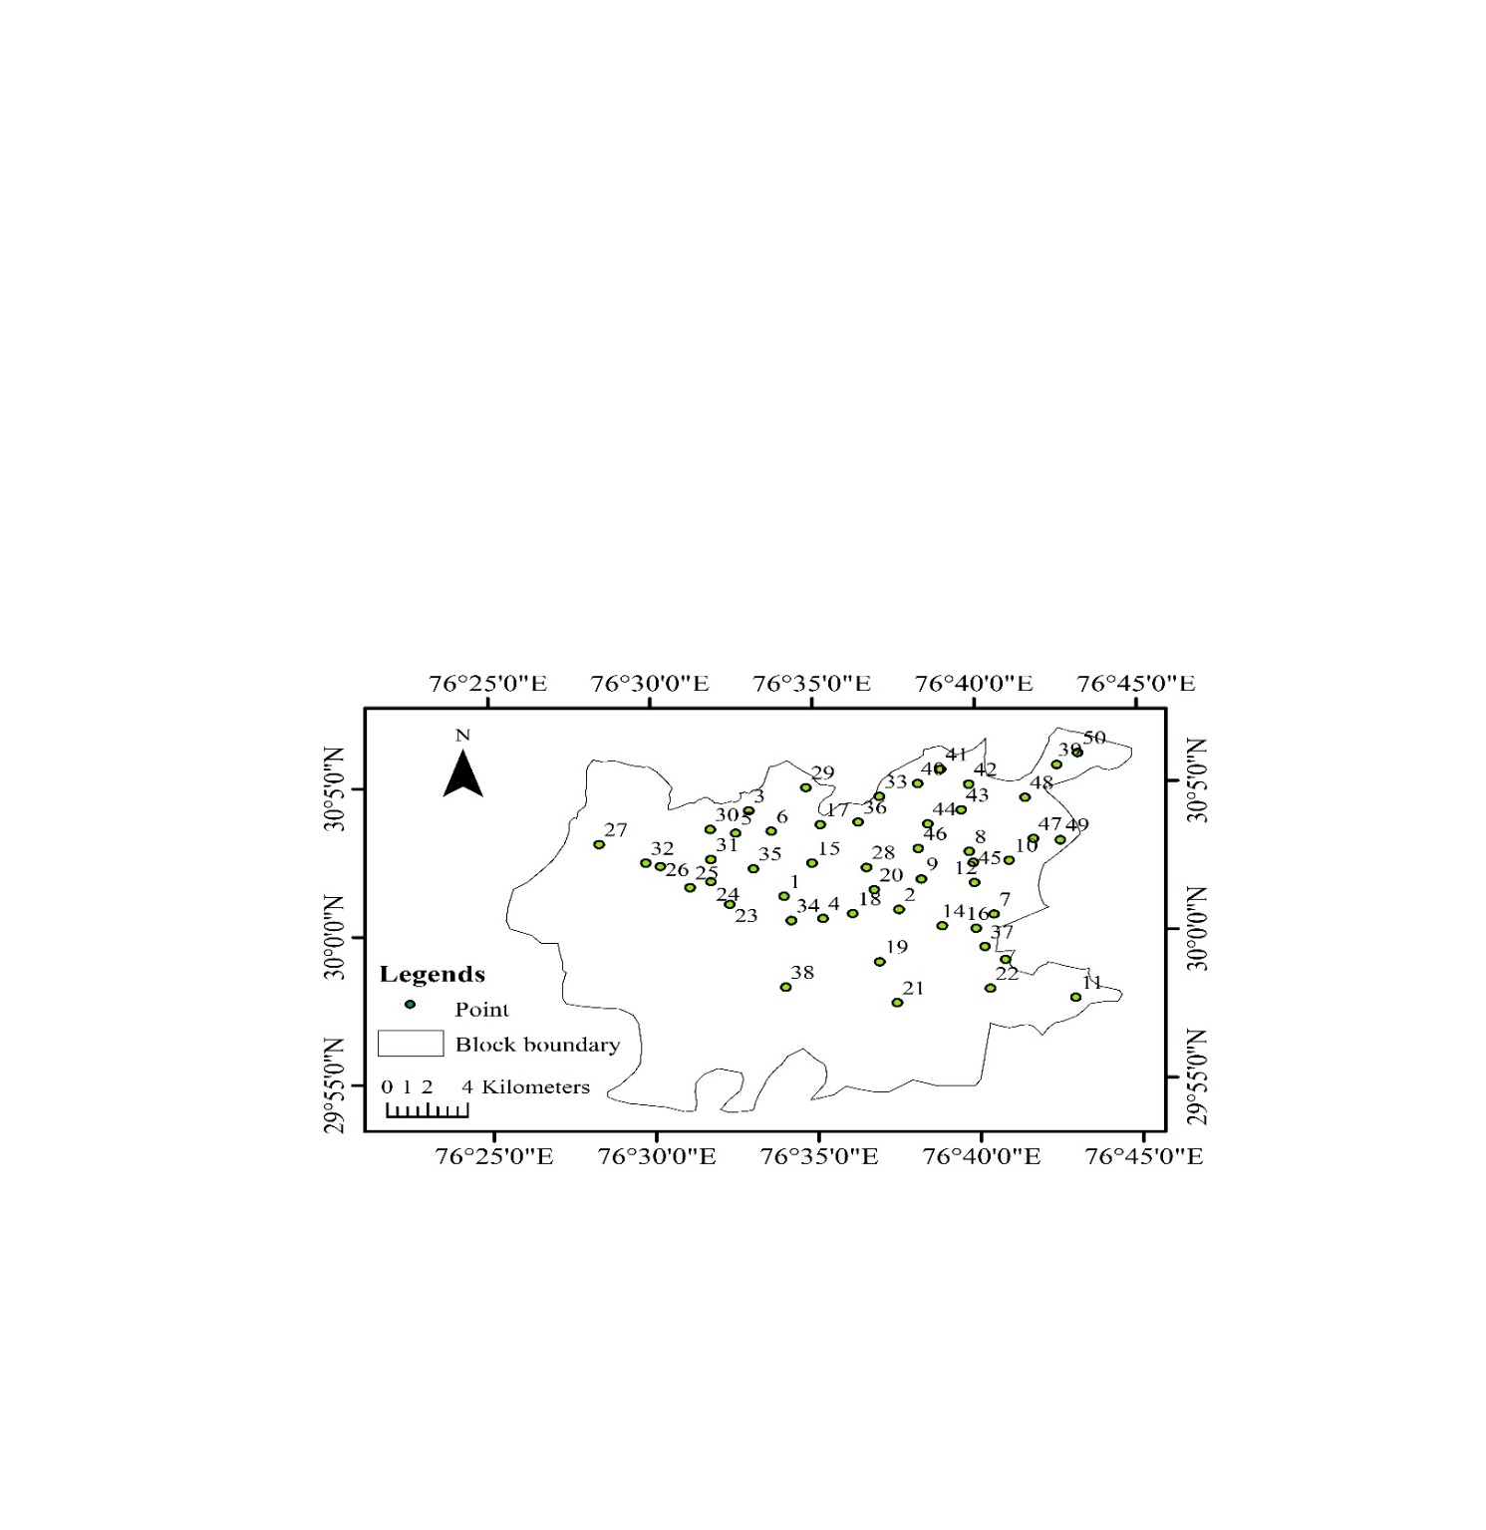

Fig. 2: Sampling points of Pehowa block

Preparation of Maps
To study the spatial distribution of quality parameters in the whole block, a spatial variability maps were prepared by using ArcGIS (Arc Map 9.3 software) through the interpolation of the available data from the sampling points

Results and Discussion
Chemical composition of water samples of Pehowa Block
All the 50 ground water samples collected from Pehowa block were analyzed for various chemical parameters, viz., pH, EC, anions (CO₃²⁻, HCO₃⁻, Cl⁻, SO₄²⁻) and cations (Ca²⁺, Mg²⁺, Na⁺, K⁺). Subsequently, SAR and RSC were also calculated for these samples. The range and mean of different water quality parameters are given in Table 3.

Electrical Conductivity (EC) and pH
Variation in EC reflects the variation in total salt concentration. The EC of the water samples were found to range between 0.44 - 1.81 dSm⁻¹ with a mean of 0.80 dSm⁻¹. The lowest EC in irrigation water sample was recorded in the village Garhi Roran and the highest EC was recorded in village Kanthala. Accurate assessment and monitoring of EC is crucial for understanding groundwater quality and managing salinity issues sustainably. Spatial variability in EC is presented in Fig. 3. Since, in Kurukshetra district of Haryana rice –wheat is the predominant cropping system. On an average 2,500 liters of water is needed to be supplied (by rainfall and/or irrigation) to a rice field to produce 1 kg of rice (Luo, 2022). Water requirement for one acre of rice is calculated to be a significant volume, because average yield of rice varies from 20 to 35 quintals per acre under standard conditions. If such a huge volume of water with significant salt load is applied to agricultural field every year, soils will tend to soon become saline. When saline water is used for irrigation, the water evaporates or is used by plants, leaving behind the dissolved salts in the soil (Sparks, 2002) eventually making the soil saline or sodic or saline sodic based on the salt concentration. Similarly, Rishabh et al., (2025) have studied Shahabad block of Kurukshetra district and almost similar range of pH and EC was observed as that of Pehowa.
The pH of irrigation water is an important parameter which determines its acidic, neutral and alkaline nature. The pH of the irrigation water samples ranged between 7.65 and 8.82 with a mean value of 8.18. The lowest pH was observed in water sample of Galedwa village and highest in Kanthala. The pH value of irrigation water samples of Pehowa block confirms their alkaline nature. It is a very crucial parameter for water quality assessment. The variation in irrigation water pH within blocks and districts in Haryana is influenced by several factors, primarily related to geological formations, land use, and agricultural practices (Singh et al., 2024; Khokhar et al., 2022). These factors can lead to differences in the chemical composition of groundwater, which is a major source of irrigation water in the region. Spatial variability in water pH is presented in Fig. 4.
Soluble Cations and Anions in Groundwater
As far as cation and anion concentration in irrigation water is concerned, it varied significantly across the Pehowa block. Based on the concentration of different cations and anions as presented in table 3 cations are present in the irrigation water of Pehowa block in the order of Na⁺ > Mg²⁺ > Ca ²⁺ > K⁺ likewise anionic composition was observed in order of Cl⁻ > HCO₃⁻ > SO₄²⁻ > CO₃²⁻.
In case of cations Na⁺ was the dominant cation in ground water samples which ranged from 2.45 to 13.24 meq L⁻¹, with a mean value of 5.32 meq L⁻¹. Notably, the highest Na⁺ concentration was observed in Kanthala village and the lowest concentration was recorded in Teokar village. Based on concentration, Na⁺ was followed by Mg²⁺ (0.73 to 2.73 meq L⁻¹), Ca²⁺ (0.31 to 1.00 meq L⁻¹) and K⁺
Spatial variability in soil properties along Pehowa block in Kurukshetra district (0.16 to 0.45 meq L⁻¹). Average concentration of Na⁺, Mg²⁺, Ca²⁺ and K⁺ in Pehowa block was 5.32, 1.34, 0.47 and 0.28 meq L⁻¹, respectively as presented in Table 3.
Among anions Cl⁻ was the dominant anion in the ground water samples and its concentration ranged from 1.71 to 6.54 meq L⁻¹ with the mean value of 3.30 meq L⁻¹. The highest concentration of Cl⁻ was observed in irrigation water samples of village Mohan Nagar and lowest in that of village Jorasi Khurd. Based on concentration Cl⁻ was followed by HCO₃⁻ (0.16 to 6.32 meq L⁻¹), SO₄²⁻(0.50 to 3.75 meq L⁻¹) and CO₃²⁻ (0.00 to 1.60 meq L⁻¹). Average concentration of Cl⁻, HCO₃⁻, SO₄²⁻, and CO₃²⁻ in irrigation water was 3.30, 1.46, 2.03 and 0.06 meq L⁻¹. The variation in cation and anion concentrations in irrigation water may arises due to several factors, including the source of the water (groundwater, surface water, or rainwater), geological composition of the area, and human activities like agriculture and industrial discharges. These variations can significantly impact soil properties, plant growth, and overall irrigation management. Waters high in CO₃ ²⁻ and HCO₃⁻ will tend to precipitate calcium carbonate and magnesium carbonate, when the soil solution becomes concentrated through evapo-transpiration. In such conditions SAR tends to increase since the relative proportion of Na⁺ increases (Zaman et. al., 2018; Prasad et al, 2001).
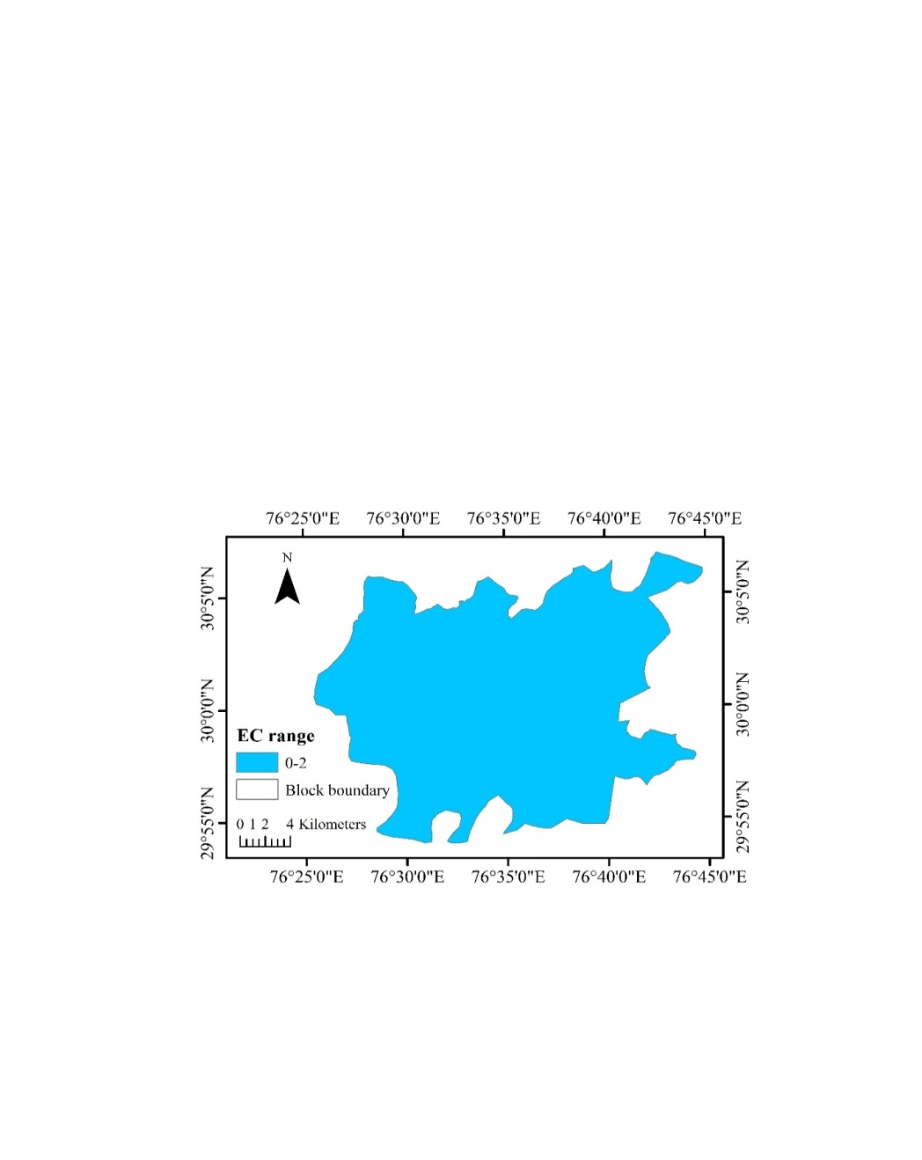
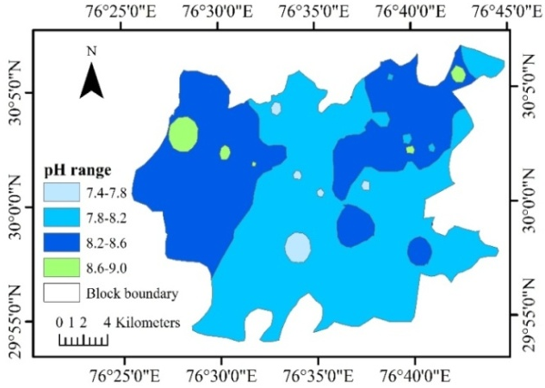

Fig.3: Spatial variability in EC Fig.4: Spatial variability in pH
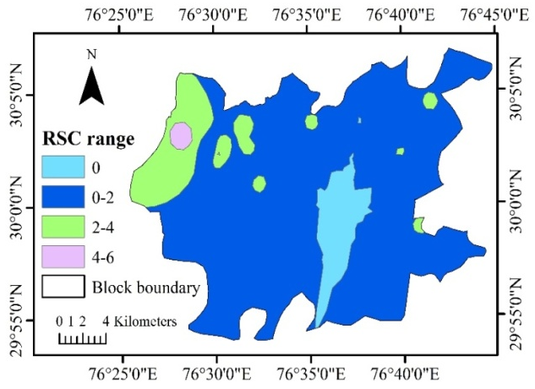
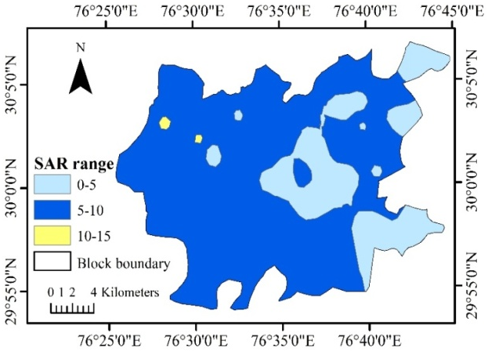

Fig.3: Spatial variability of pH of groundwater in Pehowa block

Fig.5: Spatial variability in SAR Fig.6: Spatial variability in RSC

Main problem associated with high sodium concentration is that it deteriorates the soil structure. As suggested by Yan et. al. (2024)Na⁺-Mg²⁺ dominant irrigation water are least suitable for irrigation, as it posed potential risks of soil clay particle dispersion and soil cracking.
Sodium absorption ratio (SAR)
In Pehowa block SAR of the irrigation water samples ranged from 2.67 to 11.40 (mmol L⁻¹)^{1/2}, with a mean of 5.55 (mmol L⁻¹)^{1/2}. Notably, maximum SAR was observed in the water samples of Mohanpur village, and the lowest SAR was observed in Bakhli village. The spatial distribution of SAR across the Pehowa block's groundwater is visually represented in Fig. 5. SAR serves as a pivotal metric in evaluating groundwater quality, reflecting the relative concentration of sodium ions as compared to other cations especially Ca²⁺ and Mg⁺. Continued use of water with a high SAR leads to accumulation of excessive Na⁺ in soil colloid. As a consequence of which, physical structure of the soil deteriorates resulting in the dispersion of clay particles in the soil (Suvendran et al., 2025). In such conditions soil becomes hard and compact when dry, and increasingly impervious to water penetration when wet. It is, therefore, recommended to avoid using water with an SAR value greater than 10 (m moles L⁻¹)⁻¹, if the water will be the only source of irrigation for long periods (Zaman et al., 2018; Lal et al., 2025).
Residual Sodium Carbonate (RSC)
The results showed that the RSC had a mean value of 0.59 meq L⁻¹ and ranged from nil to 5.07 meq L⁻¹. Majority of the villages had zero RSC, with Naya Diwana village having the highest value. Fig. 6shows the spatial variability of RSC in the Pehowa block’s groundwater resource. High RSC, which indicates an excess of carbonates and bicarbonates over calcium and magnesium, can lead to increased soil sodicity, reduced water infiltration, and decreased crop yields. RSC is considered as an indicator of bicarbonate and carbonate hazards in irrigation water. It is the variation between the weak acids HCO₃⁻, CO₃²⁻ and those of alkaline earth metals (Ca and Mg). RSC usually affects the EC, pH and SAR of the irrigation water (Mogus and Dinka, 2023; Anuja et al., 2024, Arya et al, 2024). The water containing RSC more than 2.5 meq L⁻¹ has been considered unfit for irrigation (Wilcox et al., 1954). Low RSC water is safer for irrigation as it maintains soil structure and nutrient availability. However, contrastingly Gupta (1983) reported that irrigation with water having the RSC as high as 10.0 meq/L (ECiw 2 dS/m, SARe <10) can be practiced continually without affecting the wheat yield on sandy loam calcareous soils.

Average chemical composition of water samples of block Pehowa in different EC classes.
In Table 3, the average chemical composition and associated quality parameters across various EC classes in block Pehowa are detailed. EC classes were categorized into intervals of one unit up to 2 dSm⁻¹, where 84% samples are found under EC class 0-1 dSm⁻¹ and 16% samples are under EC class

Table 3: Range and mean of different water quality parameters of Pehowa block
S. No. | Quality Parameter | Range | Mean
1 | pH | 7.65-8.82 | 8.18
2 | EC (dSm⁻¹) | 0.44-1.81 | 0.80
3 | RSC (meqL⁻¹) | 0.00-5.07 | 0.59
4 | SAR (mmol L⁻¹)^{1/2} | 2.67-11.40 | 5.55
5 | Ca²⁺(meqL⁻¹) | 0.31-1.00 | 0.47
6 | Mg²⁺ (meqL⁻¹) | 0.73-2.73 | 1.34
7 | Na⁺(meqL⁻¹) | 2.45-13.24 | 5.32
8 | K⁺ (meqL⁻¹) | 0.16-0.45 | 0.28
9 | CO₃²⁻ (meqL⁻¹) | 0.00-1.6 | 0.06
10 | HCO₃⁻ (meqL¹) | 0.16-6.32 | 1.46
11 | Cl⁻ (meqL¹) | 1.71-6.54 | 3.30
12 | SO₄²⁻ (meqL⁻¹) | 0.50-3.75 | 2.03

1-2 dSm⁻¹. Notably, all water samples collected from Pehowa block exhibited EC values below 2 dSm⁻¹. According to AICRP's 1989 classification, this indicates the absence of saline water in the block, with the majority of samples falling into the good category. However, upon further analysis based on RSC and SAR, alkali water was detected.
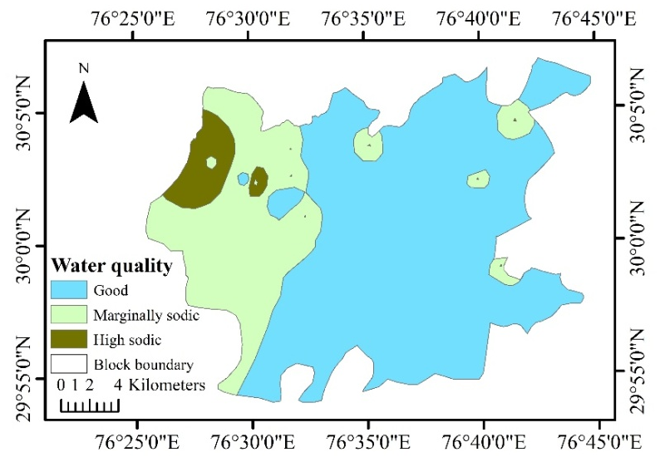
Fig. 7: Spatial variability of water quality of groundwater in Pehowa block

Table 4: Average chemical composition of water samples of block Pehowa in different EC classes
EC  classes | % of  samples | Ca²⁺ | Mg²⁺ | Na⁺ | K⁺ | CO₃²⁻ | HCO₃⁻ | Cl⁻ | SO₄²⁻ | RSC | SAR
(dS m⁻¹) |  | (me L⁻¹) |  |  |  |  |  |  |  |  | (mmol L⁻¹)⁻¹
0-1 | 84 % | 0.26 | 0.49 | 3.84 | 0.01 | 0.32 | 4.03 | 0.52 | 0.06 | 2.72 | 2.51
1-2 | 16 % | 0.74 | 1.83 | 9.17 | 0.27 | 0.39 | 5.50 | 3.83 | 1.97 | 3.31 | 8.06

Classification of groundwater according to AICRP
Water samples were classified into different categories based on their EC, SAR and RSC values, following the classification system established by the All India Coordinated Research Project on Management of Salt Affected Soils and Saline Water Use in Agriculture (1989). Out of the total samples analyzed, 41 were categorized as of good quality, while 7 were classified as marginally alkali and 2 were identified as highly alkali as represented in Table 6. Spatial variability of groundwater quality of Pehowa block is shown in figure 7 and pie chart of distribution of water quality is shown in Figure 9.
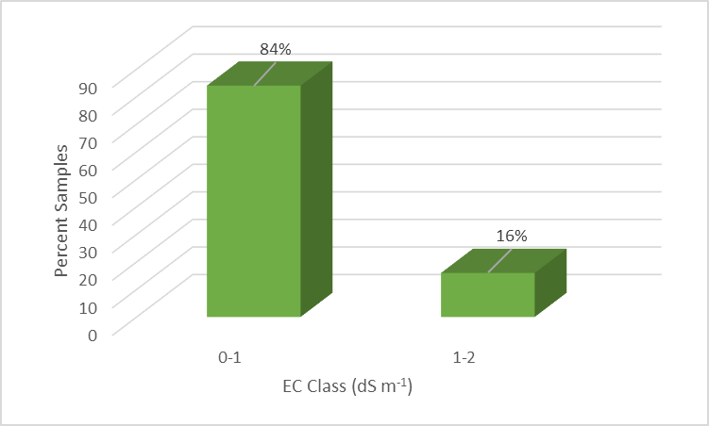
Fig 8: Percent water samples in different EC class of Pehowa block

Table 5: Groundwater quality classification of block Pehowa Samples
Water Quality | Class | No. of Samples | Percentage
Good | A | 41 | 82
Saline | B
Marginally Saline | B₁ | - | -
Saline | B₂ | - | -
High SAR Saline | B₃ | - | -
Alkali | C
Marginally Alkali | C₁ | 7 | 14
Alkali | C₂ | - | -
Highly Alkali | C₃ | 2 | 4

Effect of irrigation water quality on physico-chemical properties of the soil in Pehowa block
Six typical soil sites were chosen, based on irrigation water quality of that area. Details of all the soil sites are presented in table 2. Two sites were selected which received good quality irrigation. Likewise, two sites were selected where marginally alkali and highly alkali water was available for irrigation purpose. Such study was planned to compare the impact of good, marginally alkali and highly alkali irrigation water on soil properties. It is very much evident from the data presented in Table 6 and 7 that soils receiving good quality irrigation water as in village Teokar and Jorasi Khurd do not show too much salt load and pH was also less than 8.5 and the major cation recorded was Na⁺ followed by Mg²⁺> Ca²⁺ > K⁺ and the leading anion recorded was Cl⁻ followed by SO₄²⁻> HCO₃⁻ > CO₃²⁻. Carbonate was found nil in the soils of both the villages. Likewise, soils of village Mohan Nagar and Naya Diwana which are receiving highly alkali irrigation water continuously from last many years have accumulated Na⁺ (26.0 and 25.2 meq L⁻¹), HCO₃⁻ (15.5 and 14.20 meq L⁻¹) and CO₃²⁻ (3.42 and 4.5 meq L⁻¹), respectively in 0-15 cm soil. Due to accumulation of Na⁺, HCO₃⁻ , CO₃²⁻, soil pH is more than 8.5 and SAR is more then 10. The results indicated that the increasing RSC in irrigation water significantly increased the pH, ECe and SAR of the soil.

Fig.9: Distribution of Water Quality in Pehowa block

An element at a given concentration in water may be immediately toxic to a crop or, it may require a number of years to accumulate in the soil before it becomes toxic (Zaman et al., 2018). Irrigation water salinity, as an essential factor influencing salt transport in soil, can significantly affect the distributions of soluble salt and ions in soil. The accumulation of soluble salt not only can modify the physical and chemical properties of soil but also indirectly impact crop growth and development (Zhang, 2024).
However, the effects of sodicity on plant growth are different from those of salinity (Porcelli et al., 1995). Salinities causes a reduction in growth because plants must expend energy on generating cellular osmolytes to generate a water potential gradient adequate to counteract the lower soil water potential generated by dissolved salts (Lauchli and Epstein, 1990; Gad et.al., 2023), while sodicity affects plant growth negatively through its influence on physical and hydrological properties of the soils. In addition, both soil type can affect crop growth and yield due to nutritional disorders and toxic effects (Naidu and Rengasamy, 1993; Brenstein, 1975; Lal et al., 2025). To address irrigation water and subsequent soil salinity and alkalinity, farmers in arid regions must use effective irrigation methods like drip irrigation, precision agricultural methods, gypsum that improves sodicity by supplying calcium ions, and salt-perennial salt-tolerated grass and crop rotation systems (Suvendran, et al., 2024) Integrated management strategies, including efficient irrigation scheduling and soil conservation, can effectively handle soil and water salinity concerns in dryland agricultural regions. These methods encourage sustainable farming systems that maximize resource consumption, increase soil health, and boost crop output (Demo et al., 2025).

Table 6: Chemical composition of tube well water used for irrigation in different villages of Pehowa block based on different categories:
EC | pH | CO₃²⁻ | HCO₃⁻ | Cl⁻ | SO₄²⁻ | Ca²⁺ | Mg²⁺ | Na⁺ | K⁺ | RSC | SAR | Category
(dS m⁻¹) | pH | (me L⁻¹) |  |  |  |  |  |  |  | (me L⁻¹) | (mmol L⁻¹)^{1/2} | AICRP
Good quality water
Site I: Village Teokar
0.70 | 7.85 | 0.00 | 1.65 | 1.98 | 2.32 | 0.43 | 1.52 | 4.56 | 0.43 | 0.00 | 4.62 | A
Site II: Jorasi Khurd
0.59 | 8.20 | 0.00 | 1.12 | 1.71 | 1.38 | 0.36 | 0.73 | 3.35 | 0.17 | 0.00 | 4.52 | A
Marginally alkali water
Site I: Village Kanthala
1.81 | 8.82 | 1.00 | 5.50 | 6.54 | 3.28 | 0.94 | 2.73 | 13.24 | 0.16 | 2.83 | 9.77 | C1
Site II: Village Muqimpura
1.01 | 7.91 | 0.00 | 5.32 | 2.84 | 1.49 | 0.71 | 1.45 | 6.84 | 0.26 | 3.16 | 6.58 | C1
Highly alkali water
Site I: Village Mohan Nagar
1.66 | 8.8 | 0.52 | 5.68 | 3.64 | 3.48 | 0.68 | 1.42 | 11.68 | 0.26 | 4.1 | 11.40 | C3
Site II: Village NayaDiwana
1.68 | 8.77 | 1.60 | 6.32 | 4.85 | 1.49 | 0.71 | 2.14 | 12.35 | 0.44 | 5.07 | 10.35 | C3

Table 7: Chemical composition of saturation extract of soil sample collected from different villages of Pehowa block based on water quality
Soil depth | EC_{e} | pH_{e} | CO₃²⁻ | HCO₃⁻ | Cl⁻ | SO₄²⁻ | Ca²⁺ | Mg²⁺ | Na⁺ | K⁺
(cm) | (dS m⁻¹) | pH_{e} | (meq L⁻¹)
Good quality water
Site I: Village Teokar
0-15 | 1.80 | 7.85 | 0.00 | 2.54 | 7.50 | 1.80 | 3.33 | 5.46 | 8.20 | 1.00
15-30 | 1.65 | 7.88 | 0.00 | 2.18 | 7.10 | 1.20 | 3.00 | 5.12 | 7.50 | 0.80
Site II: Jorasi Khurd
0-15 | 1.50 | 8.10 | 0.00 | 1.50 | 6.20 | 2.89 | 2.26 | 3.32 | 8.82 | 0.53
15-30 | 1.38 | 8.00 | 0.00 | 1.23 | 5.21 | 2.55 | 1.95 | 2.90 | 7.96 | 0.40
Marginally alkali water
Site I: Village Kanthala
0-15 | 2.88 | 8.52 | 1.21 | 9.36 | 8.80 | 4.00 | 2.10 | 3.20 | 22.30 | 1.10
15-30 | 2.76 | 8.50 | 1.10 | 6.15 | 7.00 | 3.50 | 1.63 | 3.22 | 21.10 | 0.68
Site II: Village Muqimpura
0-15 | 2.21 | 8.41 | 1.01 | 10.35 | 7.50 | 2.98 | 0.93 | 1.86 | 18.2 | 0.88
15-30 | 2.01 | 8.30 | 0.98 | 9.50 | 7.50 | 2.88 | 1.01 | 2.02 | 16.0 | 0.82
Highly alkali water
Site I: Village Mohan Nagar
0-15 | 3.30 | 8.78 | 3.42 | 15.50 | 10.00 | 2.75 | 2.34 | 3.68 | 26.00 | 0.98
15-30 | 3.10 | 8.76 | 3.05 | 14.80 | 8.78 | 2.52 | 1.88 | 3.26 | 25.10 | 0.72
Site II: Village NayaDiwana
0-15 | 3.02 | 8.65 | 4.50 | 14.20 | 7.65 | 3.30 | 1.50 | 2.20 | 25.20 | 1.22
15-30 | 2.82 | 8.68 | 3.20 | 13.60 | 6.95 | 2.70 | 1.32 | 2.14 | 23.50 | 1.10

Conclusions:
The results obtained says, 82% water resource of Pehowa block is of good quality and only 14% and 4% water resource were in marginally and highly alkali, respectively. Although, share of marginally alkali and highly alkali water resource is less but it is used for irrigating proportionately larger area. Poor quality irrigation water has detrimental long-term consequences for soil quality and agricultural productivity which ultimately reduce soil health and crop productivity, leading to long-term agricultural challenges.
When irrigation water is saline or sodic, several remunerative measures can be implemented to mitigate its negative impacts and maximize crop production. These include selecting salt-tolerant crops, improving irrigation management practices, and amending the soil with amendments that can neutralize the effects of sodicity. Their indiscriminate use for irrigation often causes excessive accumulation of salts and led to rapid salinization and sodification of the soil profile which adversely affect the crop growth. Poor quality irrigation water, particularly water with high salt content, can severely degrade soil quality. This degradation manifests in several ways, including increased salinity and sodicity, reduced water infiltration and permeability, and ultimately, decreased crop productivity. Good quality and marginally saline waters can be used with management practices depending upon the rainfall, crop to be grown and soil type. The waters rated high SAR saline and highly alkali in general are not suitable for irrigation but can be used in conjunction with canal water by cyclic mode and by adding gypsum to neutralize the RSC of water for irrigation.
Future Scope of the Study:
Our study was conducted in a single block of a district. Such studies must be conducted for the entire district or we may expand to entire state of Haryana. Such study gives us a comprehensive data on irrigation water quality.
Competing interests

Authors have declared that no competing interests exist.

Disclaimer (Artificial intelligence)
Option 1:
Author(s) hereby declare that NO generative AI technologies such as Large Language Models (Chat GPT, COPILOT, etc.) and text-to-image generators have been used during the writing or editing of this manuscript.
References:

Al-Shaibani, A.M. (2008). Hydrogeology and hydrochemistry of a shallow alluvial aquifer, Western Saudi Arabia. Hydrogeology Journal, 16: 155–165.
Anuja, S.A.; Kavitha, P.; Jothi, C.H. and Rose, J. R. (2024). Seasonal assessment of water quality for irrigation using multiple indices in Thamirabarani river, Kanyakumari district, India, Desaline Water Treatment 317:100206, ISSN 1944-3986, https://doi.org/10.1016/j.dwt.2024.100206.
Arya, M.; Kumari, K.; Chaudhary, A.; Singroha, P. and Baljot, A. (2024). Soil fertility mapping of soil nutrients in areas adopting rice wheat cropping system in Karnal, Haryana. International Journal of Research in Agronomy SP-7(2): 102-116
Bernstein, L. (1975). Effects of Salinity and Sodicity on Plant Growth. Annual Review of Phytopathology 13: 295-312. http://dx.doi.org/10.1146/annurev.py.13.090175.001455
Bhat, M.A.; Grewal, M.S.; Ramprakash, Wani,S.A. and Dar, E.A. (2016). Assessment of groundwater quality for irrigation purposes using chemical indices. Indian Journal of Ecology 43(2): 574-579.
Bora, I.P.; Barua, K.N.; Singh, R. and Singh, J. (2007). Enumeration of ethno-medicinal plant wealth of AngamiNagas-a traditional approach. Journal of Medicinal and Aromatic Plant Sciences, 29(4): 191-196.
Demo, A. H.; Gemeda, M. K.; Abdo, D. R.; Guluma, T. N. and Adugna, D. B. (2025). Impact of soil salinity, sodicity, and irrigation water salinity on crop production and coping mechanism in areas of dryland farming. Agrosystems, Geosciences and Environment 8(1), e70072. https://doi.org/10.1002/agg2.70072
Etteieb, S.; Cherif, S. and Tarhouni, J. (2017). Hydrochemical assessment of water quality for irrigation: A case study of the Medjerda River in Tunisia. Applied Water Science 7(1): 469–480.
Gad M, Saleh Ali H, Hussein H, Elsayed S and Farouk M (2023). Water quality evaluation and prediction using irrigation indices, artificial neural networks and partial least square regression models for the Nile River. Water 15 (12): 2244
Grieve, C. M. and Fujiyama, H. (1987). The response of two rice cultivars to external Na/Ca ratio. Plant and Soil 103: 245–250 https://doi.org/10.1007/BF02370396
Gupta, I.C. (1983). Quality of irrigation water and the concept of residual sodium carbonate. Current Agriculture 7: 150-155.
Khokhar, K.K.; Darshana and Kamboj, A. (2024). Assessment of soil fertility status of Radaur block of Yamunanagar district of Haryana for better fertilizer management. International Journal of Plant and Soil Science 34(24): 607-613
Lal, B.; Sengar, S.S.; Kumar, H.; Shukla, A.K.; Ingle, S.N.; Das, S.P.; Praharaj, S.; Ahamad, M.I. and Lu, S. (2025). Impact of Poor-Quality Irrigation Water on Soil Systems: A Hydro geochemical Study from Central India. Earth Systems and Environment.
Lauchli, L. and Epstein, E. (1990). Plant response to saline conditions. Agricultural Salinity Assessment and Management 15: 113-137.
Luo, W.; Chen, M.; Kang, Y.; Li, W.; Li, D.; Cui, Y.; Khan, S. and Luo, Y. (2022). Analysis of crop water requirements and irrigation demands for rice: Implications for increasing effective rainfall. Agricultural Water Management 260: 107285, ISSN 0378-3774, https://doi.org/10.1016/j.agwat.2021.107285.
Moges, S.S. and Dinka, M.O. (2023). Evaluation of Shallow ground water suitability for irrigation purposes: A case study from Doornfontein area South Africa. Journal of Water and Land Development 58: 189-197
Naidu, R. and Rengasamy, P. (1993). Ion interactions and constraints to plant nutrition in Australian sodic soils. Australian Journal of Soil Research 31: 801-819. doi:10.1071/SR9930801
Porcelli C A, Boem FHG and Lavado RS (1995). The K/Na and Ca/Na ratios and rapeseed yield, under soil salinity or sodicity. Plant and Soil175: 251-255,
Prasad, A.; Kumar, D. and Singh, D.V. (2001). Effect of residual sodium carbonate in irrigation water on the soil sodication and yield of palmarosa (Cymbopogon martinni) and lemongrass (Cymbopogon flexuosus). Agricultural Water Management 50(3):161-172, ISSN0378-3774, https://doi.org/10.1016/S0378-3774 (01)00103-2.
Rao, D.K.; Panchaksharjah, S.; Pati, B.N.; Narayana, A. and Raiker, D.L.S. (2018). Chemical composition of irrigation waters from selected parts of Bijapur district, Karnataka. Mysore Journal of Agricultural Science 16: 426-432.
Richards, L.A. (1954). Diagnosis and Improvement of Saline and Alkali Soils. USDA Hand Book, No.60. Washington: US government printing office
Rishabh, Kumari, K.; Prakash, R.; Rajpaul, Kumar, S. and Meena, R.L. (2025). GIS based assessment of groundwater quality for irrigation water in Shahabad block of Kurukshetra district, India. International Journal of Environment and Climate Change 15(6): 391-404
Singh, G.; Singh, M. and Kumar, S. (2024). Groundwater quality scenario and its suitability for domestic and irrigation uses: Special study on water pH value of Rohtak district, Haryana. International Journal of Geography, Geology and Environment 6(1): 290-293.
Sparks, D. L. (2002). The Chemistry of Saline and Sodic Soils. Environmental Soil Chemistry (Second Edition), 285-300. https://doi.org/10.1016/B978-012656446-4/50010-4
Suvendran, S.; Acevedo, M.F.; Smithers, B.; Walker, S.J.; Xu, P. (2025). Evaluating the Effects of Irrigation Water Quality and Compost Amendment on Soil Health and Crop Productivity. Water 17: 2927. https://doi.org/10.3390/w17202927
Suvendran, S.; Johnson, D.; Acevedo, M.; Smithers, B. and Xu, P. (2024). Effect of Irrigation Water Quality and Soil Compost Treatment on Salinity Management to Improve Soil Health and Plant Yield. Water, 16(10): 1391. https://doi.org/10.3390/w16101391
Wilcox, L.V. (1954). Classification and use of irrigation water. U.S. Department of Agriculture Circular 969, Washington, DC.
Yan, S.; Zhang, T.; Zhang, B.; Liu, Z.; Cheng, Y. and Feng, H. (2024). Cation composition of saline water affects soil structure by altering the formation of macropores and cracks in illite soils, Soil and Tillage Research 239: 106052, ISSN 0167-1987, https://doi.org/10.1016/j.still.2024.106052.
Zaman, M.; Shahid, S.A. and Heng, L. (2018). Irrigation Water Quality. In: Guideline for Salinity Assessment, Mitigation and Adaptation Using Nuclear and Related Techniques. Springer, Cham. Pp: 113-131. https://doi.org/10.1007/978-3-319-96190-3_5
Zhang, Z.; Yao, W.; Huang, Y.; Jiang, X.; Gao, Z.; Chen, S. and Tan, S. (2024). Irrigation water salinity affects solute transport and its potential factors influencing salt distribution in unsaturated homogenous red soil. Agronomy 14(11): 2453. https://doi.org/10.3390/agronomy14112453

