Estimation of Chlorophyll-a Concentration in Gulf of Kutch, India using AQUA MODIS Sensor Data

.
ABSTRACT

Introduction
In the recent few years, researchers have used remote sensing technology to study various water quality parameters. One of such parameters is chlorophyll- concentration in the water bodies. Chlorophyll-a is indicative of algal Bloom in water bodies. Algal blooms can decrease the dissolved oxygen concentration in water bodies. Low dissolved oxygen concentration is dangerous for aquatic plants and animals.
AIM
Using remote sensing, near-surface concentration of the photosynthetic pigment chlorophyll-a can be estimated. Using the spatial distribution of chlorophyll-a concentration, concentration of phytoplankton and zooplankton can be correlated.
In the present study, the coastal region around the Gulf of Kutch has been selected as the study area. The Gulf of Kutch is in India, and is spread along the coastal regions up to an approximate length of 150 km.
Methodology
In the present study, AQUA-MODIS sensor has been used to estimate Chlorophyll-a content in the Gulf of Kutch. Level-2 data from the period 2015 to 2022 has been acquired and processing of data has been done using SeaWiFS Data Analysis System (SeaDAS) software, developed by NASA. SeaDAS has been used for processing and analyzing ocean color data.
Results
The results revealed that chlorophyll-a concentration varied from 3 mg/m³ to 18 mg/m³ for the study area. Also, as one moves from Gulf of Kutch towards Arabian sea, the concentration kept on decreasing and reached at 0.4 mg/m³.
Conclusion
The results also suggested that regions where chlorophyll concentration was high, the phytoplankton concentration might also be high in those regions. Thus, near to coastal regions, phytoplankton concentration also dominates.

Keywords: chlorophyll-a, chlorophyll-a in water bodies, SeaWiFS, SeaDAS, Gulf of Kutch, AQUA MODIS Sensor Data

1. INTRODUCTION

Water quality is crucial for the well-being of humans and the balance of both aquatic and terrestrial ecosystems. Over the past few decades, global water quality has deteriorated due to numerous human activities, and India has also experienced this degradation. In recent years, researchers have employed remote sensing technology to assess various aspects of water quality, including the concentration of chlorophyll-a (Chl-a) in water bodies. Chl-a is a vital pigment responsible for photosynthesis in marine phytoplankton and serves as a critical indicator of primary production and the overall health of marine ecosystems. It is also a key parameter in identifying algal blooms in aquatic environments (Wang et al. 2020).
Algal blooms are rapid and excessive growths of algae in bodies of water, often causing ecological imbalances and negatively impacting water quality. Chl-a plays a pivotal role in indicating the presence and intensity of these blooms. Algal cells contain Chl-a, a green pigment essential for photosynthesis. When an algal bloom occurs, there is a significant increase in the concentration of algal cells, resulting in a corresponding rise in Chl-a levels. This pigment is, therefore, used as an indicator for the abundance and biomass of phytoplankton, the primary culprits behind algal blooms.
Algal blooms can lead to a decrease in the concentration of dissolved oxygen in water bodies, which is harmful to aquatic plants and animals. They can substantially degrade the overall water quality in a water body, and their impacts can range from oxygen depletion to toxin production, fish kills, and disruption of aquatic ecosystems. Monitoring Chlorophyll-a levels offers a valuable tool for the detection and prediction of algal blooms, enabling timely management and mitigation strategies. The presence of chlorophyll-a (Chl-a) in the ocean is influenced by a complex interplay of physical, chemical, and biological factors. These factors encompass nutrient availability (such as nitrogen, phosphorus, and micronutrients), the availability of light, temperature, the stability of the water column, and ocean currents. Regions where nutrient-rich waters rise to the surface, known as upwelling zones, frequently exhibit elevated Chl-a levels due to increased nutrient availability.
Various techniques have been developed for quantifying Chl-a content in marine environments. These methods include spectrophotometric techniques like the Lorenzen method and fluorometric methods such as Turner Designs fluorometers. These methods are well-regarded for their precision and sensitivity in measuring Chl-a concentration (Lorenzen, 1967; Gómez-Jakobsen et al. 2025; Wang et al. 2025). Over the past few years, remote sensing technologies, including satellite-based ocean color sensors like MODIS and SeaWiFS, have allowed for extensive monitoring of Chl-a levels across vast marine areas. Through remote sensing, it becomes possible to estimate the concentration of the photosynthetic pigment chlorophyll-a near the surface of the ocean. By examining the spatial distribution of chlorophyll-a concentration, it is possible to establish correlations with the concentrations of phytoplankton and zooplankton. Further exploration of these correlations can be found in recent published literature, such as studies by (Shamshirband et al. 2019; Hu et al. 2020; Kim et al. 2020; Rodriguez-Lopez et al. 2020; Zhu et al. 2023).
In addition to its role in identifying algal blooms, monitoring chlorophyll-a levels in water bodies has far-reaching implications for environmental management and conservation. By tracking Chl-a concentrations, scientists and policymakers can gain insights into the overall health of aquatic ecosystems and the potential risks they face. This information is invaluable for making informed decisions about resource allocation, pollution control measures, and the protection of vulnerable species. It also aids in the development of strategies to prevent or mitigate the harmful effects of algal blooms, such as implementing water treatment methods, adjusting nutrient inputs, and establishing early warning systems (Sinaga et al. 2025).
Moreover, the use of remote sensing technology in monitoring Chl-a levels allows for a more comprehensive and efficient assessment of water quality on a regional or even global scale. This capability is crucial in addressing water quality issues that often transcend geographical boundaries and impact a wide range of ecosystems and communities.
In the present study, chlorophyll-a concentration has been studied using remote sensing technology for Gulf of Kutch India.

2. material and methods

2.1. Study area
In this current investigation, we have chosen the coastal area surrounding the Gulf of Kutch as our research area. This gulf is situated in India and stretches for approximately 150 kilometers along the coastal regions. You can see the location map of the study area in Figure 1. The Gulf of Kutch is renowned for its vast tidal flats and mudflats, which rank among the world's largest. These tidal flats undergo significant tidal fluctuations due to the gravitational influence of the moon and sun. During low tide, substantial portions of the Gulf become exposed; creating a unique landscape characterized by salt pans, sand dunes, and mangrove forests (Goswami et al. 2025).
The Gulf of Kutch boasts a rich biodiversity and provides a habitat for a diverse array of marine life. The intertidal zones and mangrove ecosystems serve as vital habitats for numerous species, including fish, crabs, mollusks, and various other marine organisms (Makwana and Patnaik, 2025). Furthermore, the gulf serves as a breeding ground for many migratory bird species and serves as a critical stopover point along the East Asia-Australasia Flyway. Nevertheless, similar to coastal ecosystems worldwide, the Gulf of Kutch faces various ecological challenges. Issues like industrialization, pollution, overfishing, and habitat degradation threaten the fragile equilibrium of this ecosystem (Lakhmapurkar et al. 2021). To safeguard the environmental well-being of the Gulf, conservation endeavors such as the protection of mangroves and the promotion of sustainable fishing practices are of utmost importance.
Historically and culturally, the Gulf of Kutch holds significance for the local population. It has played a pivotal role in trade, connecting the Indian subcontinent with the Middle East and Africa. Additionally, the ancient city of Dwarka, associated with Lord Krishna in Hindu mythology, is situated near the Gulf's coastline and remains an important pilgrimage site (Pandya and Sanghani, 2025).
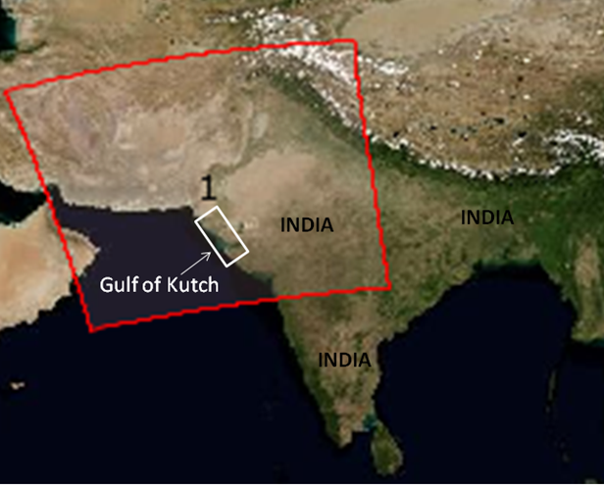
Fig. 1. Geographical Location of Gulf of Kutch

2.2. Data Acquisition using MODIS sensor
The Aqua Moderate Resolution Imaging Spectroradiometer (MODIS) sensor is a crucial instrument carried on NASA's Aqua satellite, which forms part of the Earth Observing System (EOS) program. Launched on May 4, 2002, Aqua is one of a series of satellites purpose-built to observe and monitor multiple aspects of Earth's atmosphere, oceans, land surfaces, and ecosystems. Within the suite of instruments on Aqua, MODIS holds a central role in Earth observation and environmental surveillance. In this current research, AQUA-MODIS sensor to estimate the Chlorophyll-a content present in the Gulf of Kutch has been used (Moutier et al. 2019; Ahmad et al. 2025; Drozd et al. 2025).
The MODIS device is a multispectral radiometer capable of collecting data across 36 spectral bands, encompassing a broad spectrum of wavelengths from the visible to the thermal infrared range. It offers high-resolution data with respect to spatial, spectral, and temporal dimensions, rendering it an invaluable tool for investigating and tracking diverse Earth processes and phenomena. Notably, MODIS data is accessible at no cost to researchers, scientists, and the general public through various online platforms offered by NASA and its collaborative partners (https://earthdata.nasa.gov). For our current study, we have procured Level-2 data spanning the period from 2015 to 2022.
The AQUA-MODIS sensor (Moderate Resolution Imaging Spectroradiometer on the Aqua satellite) is one of the key instruments used for estimating chlorophyll-a content in ocean waters. AQUA-MODIS is designed to measure the radiance (light intensity) reflected by the Earth's surface in a range of spectral bands, including the visible and near-infrared regions of the electromagnetic spectrum. It is sensitive to the colors of light that are absorbed and scattered by substances in the ocean, including chlorophyll-a. Chlorophyll-a is a pigment found in phytoplankton, and it absorbs light in the blue and red parts of the spectrum while appearing relatively bright in the green part of the spectrum. AQUA-MODIS captures the spectral reflectance of the ocean's surface, and the specific spectral bands it measures allow scientists to detect the presence of chlorophyll-a by observing the characteristic absorption features. AQUA-MODIS data are processed with specialized algorithms that correct for atmospheric scattering and absorption, ensuring that the observed signal is primarily influenced by the water's properties.
2.3. Data Processing using SeaDAS
SeaDAS, short for the SeaWiFS Data Analysis System, is a comprehensive software package that NASA has developed for the processing, visualization, and examination of ocean color data acquired from a variety of satellite sensors. Its primary focus centers on the data collected by the Sea-Viewing Wide Field-of-View Sensor (SeaWiFS), a satellite sensor launched in 1997. SeaWiFS measured the radiance of sunlight reflected from the Earth's surface, with a particular emphasis on the oceans, in order to extract valuable information about marine phytoplankton and water quality (Browning et al. 2014). Over the years, SeaDAS has gained widespread adoption among researchers, oceanographers, and environmental scientists for the analysis and interpretation of ocean color data. Its utilization has played a significant role in advancing our comprehension of phytoplankton distribution, ocean productivity, and the overall health of marine ecosystems (McClain et al. 2004; Llodra-Llabres et al. 2023; Apriliani et al. 2024).
In our current study, we have employed the SeaWiFS Data Analysis System (SeaDAS) software, developed by NASA, for the processing and examination of ocean color data. SeaDAS has been instrumental in handling and analyzing this specific type of data.

3. results and discussion

The study focused on assessing the chlorophyll-a (Chl-a) content in Gulf of Kutch using MODIS data processing. The data collected revealed significant variations in Chl-a content across the study area. As shown in Fig.2, chlorophyll-a concentration varied from 3 mg/m³ to 20 mg/m³ for the study area. Also, as one moves from Gulf of Kutch towards Arabian Sea, the concentration keep on decreasing and reached at 0.4 mg/m³. The spatial pattern reveals high concentrations along the northern and eastern coastal margins, gradually decreasing towards the open Arabian Sea. Elevated Chl-a levels (≥ 3 mg m⁻³; orange to red shades) are primarily concentrated near Jamnagar, Kandla, and the Okha coast, which are characterized by extensive intertidal flats, mangrove ecosystems, and tidal creeks. These coastal environments received substantial nutrient inputs from riverine discharge, industrial effluents, and mangrove detritus, creating favorable conditions for phytoplankton growth. The shallow bathymetry and high turbidity in these near shore waters enhance light scattering and nutrient recycling, further supporting elevated primary productivity. Conversely, the offshore region of the Gulf, indicated by cyan and blue tones, exhibits low Chl-a concentrations (< 0.1 mg m⁻³), typical of oligotrophic oceanic conditions. The observed spatial gradient from eutrophic nearshore to oligotrophic offshore zones reflects the transition from nutrient-rich coastal waters to nutrient-depleted open sea conditions governed by hydrodynamic and biological processes.
The spatial variability of Chl-a in the Gulf of Kutch was closely linked to its complex hydrodynamics and seasonal forcing. The Gulf, being semi-enclosed and shallow, experiences strong tidal currents and high tidal amplitudes (up to 6 m) that resuspend bottom sediments and nutrients, particularly in the northern sector. During the southwest monsoon (June–September), enhanced runoff from adjacent catchments introduces additional nutrients, stimulating coastal phytoplankton blooms. Post-monsoon conditions typically favor stratification of the water column and accumulation of phytoplankton biomass, as observed in the higher Chl-a zones along the coast. The offshore decline of Chl-a concentration is largely controlled by horizontal mixing and nutrient dilution. The open-sea waters of the Arabian Sea are relatively nutrient-limited during non-upwelling periods. However, occasional upwelling near the mouth of the Gulf can transport subsurface nutrient-rich waters to the surface, resulting in intermediate Chl-a concentrations (0.5–2 mg m⁻³) in the transition zones. These transient features indicate the dynamic interplay between coastal nutrient enrichment and oceanic exchange processes.

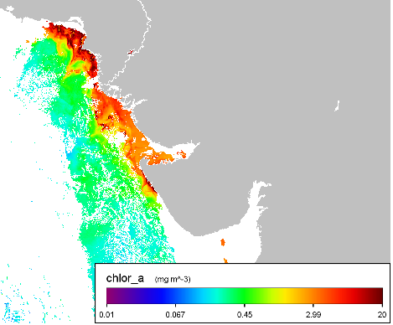
Fig. 2. Spatial variation of Chlorophyll-a in Gulf of Kutch
Chlorophyll-a concentration serves as a key proxy for phytoplankton biomass and primary productivity, which underpin the marine food web. High Chl-a regions along the northern and eastern coast signify biologically productive areas that support fisheries and benthic biodiversity. However, the same zones are vulnerable to eutrophication due to nutrient over-enrichment from industrial outfalls, thermal discharges, and port activities. Sustained monitoring of Chl-a distribution can thus aid in detecting harmful algal bloom (HAB) events, assessing coastal water quality, and supporting marine ecosystem management strategies within the Gulf of Kutch Marine National Park. The Gulf of Kutch supports a significant fishery industry. Understanding chlorophyll-a concentrations helps fisheries managers and scientists predict the availability of primary producers (phytoplankton) and, consequently, the potential productivity of fish populations. This information is vital for sustainable fisheries management and ensuring the livelihoods of fishing communities.

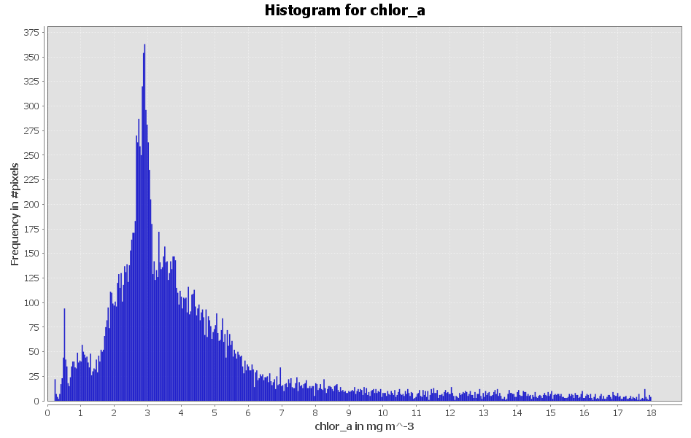
Fig. 3. Histogram for Chlorophyll-a in study area
A histogram plot for chlorophyll concentration in the study area has been shown in Fig.3. It could be observed from Fig.3 that the frequency of pixel having 3 to 3.5 mg/m³ is highest as compared to other concentration. The histogram of chlorophyll-a (Chl-a) concentration revealed a distinct positively skewed distribution, indicating that low to moderate concentrations dominate the study area, while high concentrations occur less frequently. The Chl-a values range from approximately 0.01 to 18 mg m⁻³, with a prominent frequency peak between 2 and 4 mg m⁻³. This suggests that most water pixels within the Gulf of Kutch exhibit moderate phytoplankton biomass, typical of mesotrophic coastal environments. The modal class (2–4 mg m⁻³) represented the most prevalent concentration range, accounting for the majority of pixels in the dataset. These moderate Chl-a values correspond to nutrient-enriched yet well-mixed waters within the central and nearshore zones of the Gulf. This concentration range is characteristic of coastal waters influenced by tidal mixing, organic matter regeneration, and moderate anthropogenic nutrient loading. It reflects balanced ecological conditions, supporting high primary productivity without extensive eutrophication. The lower tail of the histogram (0.01–1 mg m⁻³) represented offshore oligotrophic waters and areas with limited nutrient supply. These regions are typically located near the mouth of the Gulf and adjacent Arabian Sea, where water exchange and dilution reduce nutrient concentrations. The relatively smaller frequency in this range indicates that only a minor fraction of the Gulf’s waters remain low in biological productivity, consistent with the Gulf’s shallow, semi-enclosed, and nutrient-active nature. A long, gradually declining tail towards higher Chl-a values (> 6 mg m⁻³) reflects sporadic bloom events and localized eutrophication zones. Although less frequent, these pixels correspond to highly productive or disturbed sites, often near industrial effluent zones, mangrove-rich creeks, or nearshore sediment resuspension areas. Such high Chl-a occurrences may be linked to post-monsoon phytoplankton blooms or localized nutrient hotspots, confirming the influence of seasonal forcing and anthropogenic activity in shaping primary productivity patterns. The positively skewed distribution demonstrated that the Gulf of Kutch predominantly experienced moderate Chl-a levels, with fewer extreme high concentrations. This skewness indicated a non-uniform productivity regime, driven by spatial heterogeneity in nutrient availability, tidal mixing intensity, and coastal geomorphology. The histogram confirmed that Chl-a concentration in the Gulf of Kutch is not evenly distributed, but rather characterized by a dominant moderate productivity regime with intermittent bloom events.
Further, spatial variation of chlorophyll-a concentration with respect to longitude and latitude has been shown in Fig. 4. The scatter plot of chlorophyll-a (Chl-a) concentration along longitudinal gradients (55°E–80°E) highlights pronounced spatial variability across the Gulf of Kutch and adjoining Arabian Sea waters. The Chl-a values ranged from 0.01 to more than 70 mg m⁻³, with the highest concentrations confined between 66°E and 70°E longitude, corresponding to the core region of the Gulf of Kutch. Within this longitude range, the Chl-a concentration frequently exceeds 20 mg m⁻³, with occasional peaks approaching 70 mg m⁻³. Such elevated levels are indicative of localized eutrophication zones associated with nutrient discharge from anthropogenic activities (e.g., petrochemical complexes, ports, and salt industries around Jamnagar and Kandla), organic matter contribution from mangrove detritus, and enhanced mixing due to tidal oscillations (up to 6 m amplitude) which resuspend bottom sediments and nutrients. These factors collectively sustain high phytoplankton biomass, especially during post-monsoon months, when calm conditions and nutrient availability favor rapid algal growth. The narrow spatial band of high Chl-a in this longitudinal zone highlights the restricted dispersion and strong coastal retention typical of semi-enclosed basins. Moving westward (towards 60°–65°E), the Chl-a values show a sharp decline (< 5 mg m⁻³), reflecting the oligotrophic offshore Arabian Sea waters where nutrient input is limited and biological productivity is comparatively low. Similarly, east of 70°E (beyond the Gulf mouth), a marked reduction in Chl-a is observed, signifying the transition from shallow coastal zones to deeper marine environments with lower nutrient regeneration. This longitudinal decline demonstrates the coastal–oceanic productivity gradient, governed by the distance from nutrient sources, hydrodynamic dilution, and depth-dependent light penetration. The attenuation of Chl-a concentration offshore is consistent with typical tropical marginal seas, where productivity peaks near the coast and decreases rapidly seaward.
The latitudinal distribution of chlorophyll-a (Chl-a) concentration (Figure 4) across the Gulf of Kutch exhibits clear spatial variability, ranging from 0.01 to over 70 mg m⁻³. The highest concentrations are clustered between 22°N and 25°N latitude, corresponding to the core of the Gulf, while both southern (below 21°N) and northern (above 26°N) zones display relatively low values (< 5 mg m⁻³). This pattern indicates that phytoplankton productivity is concentrated in the mid-latitudinal coastal waters, gradually declining towards offshore and northern extremities. The most significant Chl-a enrichment occurs between 22°N and 25°N, encompassing the central and northern stretches of the Gulf of Kutch, where numerous tidal creeks, mangrove forests, and estuarine systems are located. Concentrations often exceed 20 mg m⁻³, with peaks above 60–70 mg m⁻³, reflecting strongly eutrophic conditions in nearshore and intertidal environments. South of 21°N, representing the open Arabian Sea region, Chl-a concentrations drop below 5 mg m⁻³, reflecting oligotrophic offshore conditions dominated by low nutrient availability and greater water depth. Similarly, north of 26°N, near the uppermost limit of the Gulf, Chl-a concentrations are subdued due to shallow hypersaline flats and limited tidal exchange, which restrict water renewal and nutrient diffusion. These low-productivity zones demonstrate the contrast between nutrient-rich estuarine systems and nutrient-poor open waters, emphasizing the influence of hydrography, sediment load, and anthropogenic activity on phytoplankton distribution. The latitudinal variation underscores the Gulf of Kutch as a biologically dynamic system, where productivity is concentrated in intermediate latitudes subject to tidal flushing, nutrient recycling, and human influence. Such high Chl-a regions are ecologically vital for fisheries productivity, mangrove regeneration, and coral reef resilience, but they also indicate zones vulnerable to nutrient overloading and hypoxic events. Continuous monitoring of Chl-a along latitude using satellite-based sensors (MODIS, SeaWiFS, VIIRS) allows for spatio-temporal assessment of coastal productivity and supports sustainable management of the Gulf’s marine ecosystem and industrial coastline. Chlorophyll-a is often used as an indicator of water quality. Elevated chlorophyll-a levels can indicate eutrophication, a process where excess nutrients (such as nitrogen and phosphorus) in the water lead to excessive phytoplankton growth. This can result in harmful algal blooms, which can have negative impacts on water quality, aquatic life, and human health. Studying chlorophyll-a concentrations is part of broader environmental monitoring efforts in the Gulf of Kutch. This includes tracking changes in water temperature, salinity, and nutrient levels, all of which can influence phytoplankton growth and ecosystem dynamics. Monitoring helps detect environmental changes and their potential impacts.
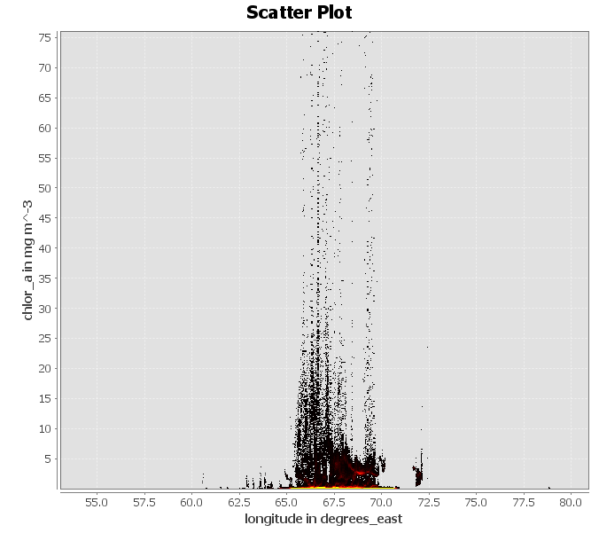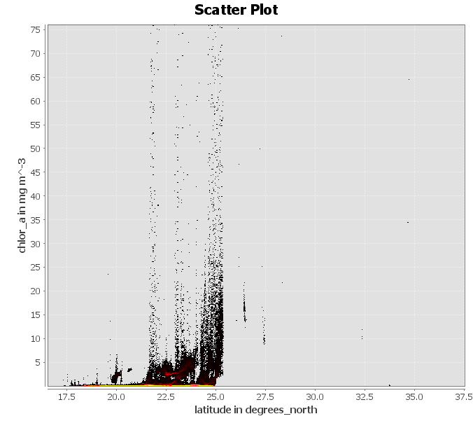
Fig. 4. Longitudinal and latitudinal variation of Chlorophyll-a in study area
Studying chlorophyll-a concentrations in the Gulf of Kutch is essential for understanding and managing its marine ecosystem, supporting fisheries, protecting water quality, and addressing the challenges posed by environmental changes and human activities in the region. It contributes to both ecological conservation and the socioeconomic well-being of local communities.
4. Conclusion
Chl-a content in the sea is a valuable indicator of marine ecosystem health and productivity. Measurement methods, coupled with our understanding of influencing factors and ecological implications, have led to significant insights into the dynamics of marine environments. Continued research in this field is crucial for comprehending the changing patterns of Chl-a distribution in response to ongoing environmental changes, thereby aiding in the conservation and sustainable management of marine resources. For Gulf of Kutch, chlorophyll concentration varied between 3 mg/m3 to 18 mg/m3 .
In conclusion, Chlorophyll-a content serves as a vital indicator of algal blooms, offering insights into the presence and extent of excessive algal growth in aquatic ecosystems. Monitoring Chl-a concentrations, along with understanding the broader environmental factors, assists in assessing and managing the potential impacts of algal blooms on both ecological and human systems. One of the limitations of using SeaDaS is that empirical relation using in the algorithm has its own limitations.

Disclaimer (Artificial intelligence)
Option 1:
Author(s) hereby declare that NO generative AI technologies such as Large Language Models (ChatGPT, COPILOT, etc.) and text-to-image generators have been used during the writing or editing of this manuscript.
Option 2:
Author(s) hereby declare that generative AI technologies such as Large Language Models, etc. have been used during the writing or editing of manuscripts. This explanation will include the name, version, model, and source of the generative AI technology and as well as all input prompts provided to the generative AI technology
Details of the AI usage are given below:
1.
2.
3.

References
Ahmad, H., Jose, F., Dash, P., Shoemaker, D. J., and Jhara, S. I. (2025). Machine learning-based estimation of chlorophyll-a in the Mississippi Sound using Landsat and ocean optics data. Environmental earth sciences, 84(7), 172.
Apriliani, I. M., Dewanti, L. P., Putra, P. K. D. N. Y., and Rokhim, I. N. (2024). Spatio temporal distribution of SST and chlorophyll a in WPP 718 waters during the west season: A case study of Merauke Regency waters, Indonesia. Asian Journal of Fisheries and Aquatic Research, 26(8), 47-54.
Browning, T. J., Bouman, H. A., and Moore, C. M. (2014). Satellite‐detected fluorescence: decoupling nonphotochemical quenching from iron stress signals in the South Atlantic and Southern Ocean. Global Biogeochemical Cycles, 28(5), 510-524.
Drozd, S., Kussul, N., and Shelestov, A. (2025). Improving spatial resolution of Aqua MODIS and GCOM-C chlorophyll-a data for Cyprus coastal waters monitoring. European Journal of Remote Sensing, 58(1), 2551023.
Gómez-Jakobsen, F., Giménez, J. G., Cecilia, J. M., Ferrera, I., Yebra, L., Fraile-Nuez, E., ... and Mercado, J. M. (2025). Monitoring chlorophyll a concentration in the Mar Menor coastal lagoon using ocean color sensors. Remote Sensing Applications: Society and Environment, 38, 101531.
Goswami, S., Goswami, A. K., and Goswami, S. (2025). Rann of Kachchh: A Unique Coastal Wetland Ecosystem. In Marine and Coastal Resources of India: Selected Case Studies (pp. 527-537). Cham: Springer Nature Switzerland.
Hu, C., Feng, L., and Guan, Q. (2020). A machine learning approach to estimate surface chlorophyll a concentrations in global oceans from satellite measurements. IEEE Trans Geosci Remote Sens, 59(6), 4590-4607.
Kim, G., Baek, I., Stocker, M. D., Smith, J. E., Van Tassell, A. L., Qin, J., ... and Kim, M. S. (2020). Hyperspectral imaging from a multipurpose floating platform to estimate chlorophyll-a concentrations in irrigation pond water. Remote Sens.12(13), 2070.
Lakhmapurkar, J., Gavali, D., and Bhatt, N. (2021). Coastal ecosystem services of Gujarat, India: current challenges and conservation needs. In Coastal Ecosystems: Environmental importance, current challenges and conservation measures (pp. 305-324). Cham: Springer International Publishing.
Llodra-Llabres, J., Martinez-Lopez, J., Postma, T., Perez-Martinez, C., and Alcaraz-Segura, D. (2023). Retrieving water chlorophyll-a concentration in inland waters from Sentinel-2 imagery: Review of operability, performance and ways forward. International Journal of Applied Earth Observation and Geoinformation, 125, 103605.
Lorenzen, C. J. (1967). Determination of chlorophyll and pheo-pigments: spectrophotometric equations. Limnol. Oceanogr., 12(2), 343-346.
Makwana, M., and Patnaik, U. (2025). Vulnerability and adaptation to climate change: Experiences of Vagher communities in the Gulf of Kkutch, India. Maritime Studies, 24(4), 1-18.
McClain, C. R., Feldman, G. C., and Hooker, S. B. (2004). An overview of the SeaWiFS project and strategies for producing a climate research quality global ocean bio-optical time series. Deep Sea Res. Part II: Topical Studies in Oceanography, 51(1-3), 5-42.
Moutier, W., Thomalla, S. J., Bernard, S., Wind, G., Ryan-Keogh, T. J., and Smith, M. E. (2019). Evaluation of chlorophyll-a and POC MODIS aqua products in the southern ocean. Remote Sensing, 11(15), 1793.
Pandya, V. B., and Sanghani, P. (2025). Preserving India’s Underwater Cultural Heritage: Navigating the Need, Challenges, and Strategies in Dwarka, Gujarat. Journal of Heritage Management, 10(1), 52-66.
Rodríguez-López, L., Duran-Llacer, I., Gonzalez-Rodriguez, L., Abarca-del-Rio, R., Cárdenas, R., Parra, O., ... and Urrutia, R. (2020). Spectral analysis using LANDSAT images to monitor the chlorophyll-a concentration in Lake Laja in Chile. Ecol. Inform., 60, 101183.
Shamshirband, S., Jafari Nodoushan, E., Adolf, J. E., Abdul Manaf, A., Mosavi, A., and Chau, K. W. (2019). Ensemble models with uncertainty analysis for multi-day ahead forecasting of chlorophyll a concentration in coastal waters. Eng. Appl. Comput. Fluid Mech., 13(1), 91-101.
Sinaga, M. P., and Siburian, D. T. E. (2025). The Impact of Sea Surface Temperature and Containing Chlorophyll-A on The Results of Skipjack Tuna (Katsuwonus Pelamis) Catch in The Indian Ocean Waters. Journal of Geoscience, Engineering, Environment, and Technology, 10(02).
Wang, L., Xu, M., Liu, Y., Liu, H., Beck, R., Reif, M., ... and Wu, Q. (2020). Mapping freshwater chlorophyll-a concentrations at a regional scale integrating multi-sensor satellite observations with Google earth engine. Remote Sens., 12(20), 3278.
Wang, J., Kong, F., Niu, Z., and Yu, R. (2025). Selection of protocols for phytoplankton pigment analysis: a comparative study. Journal of Oceanology and Limnology, 43(3), 817-830.
Zhu, W. D., Kong, Y. X., He, N. Y., Qiu, Z. G., and Lu, Z. G. (2023). Prediction and Analysis of Chlorophyll-a Concentration in the Western Waters of Hong Kong Based on BP Neural Network. Sustainability, 15(13), 10441.

