The Vicious Cycle: Illegal Mining, Climate Vulnerability, and Institutional Failure in Ghana's Peri-Urban Landscapes

Abstract
This study investigates the intricate interplay between illegal mining (galamsey), climate vulnerability, and institutional failure in Ghana, with a specific focus on the Tarkwa-Nsuaem Municipality as a critical case study for both formal and informal gold mining activities. Utilizing a qualitative methodology grounded in an interpretivist paradigm, we conducted four Focus Group Discussions (FGDs) involving diverse stakeholders, including current and former galamsey operators, local farmers, community leaders, and regulatory representatives. Our findings reveal that deep-rooted institutional failures create a permissive environment for illegal mining, which is not merely a criminal act but a rational response to socioeconomic marginalization and historical dispossession. The study underscores the consequent environmental degradation, marked by severe deforestation and water contamination, which disrupts vital Climate-Smart Agricultural practices and exacerbates food insecurity. Furthermore, the compounding effects of climate change amplify community vulnerability, creating a feedback loop that perpetuates socio-economic desperation and maintains a constant labor supply for galamsey. This research highlights the necessity of adopting a holistic approach to address these interconnected crises, emphasizing the need for collaborative governance, environmental restoration, and sustainable livelihood development to break the cycle of institutional failure, environmental degradation, and socio-economic despair.
Keywords: Illegal mining, Climate vulnerability, Institutional failure, Parallel governance systems, Community impact, Sustainability

Introduction
Illegal gold mining, locally known as galamsey, represents a profound and persistent challenge to sustainable development in Ghana, constituting a complex socio-ecological crisis that has defied state-led interventions for over three decades. The consistent failure of militarized government operations since 1989 underscores a deep-seated institutional crisis, characterized by a lack of political will and poor planning, and a fundamental disconnect between formal state institutions and informal customary land authorities (Crawford & Botchwey, 2017,Boafo et al., 2019,Yeboah, 2023) The disconnect between formal state institutions and informal customary land authorities is particularly evident in areas such as land governance and resource allocation. This divide often leads to conflicts over land rights, as formal policies may not align with traditional practices upheld by local communities. Additionally, the inability of state authorities to effectively engage and integrate the perspectives of customary leaders results in a gap in trust and collaboration, ultimately undermining efforts for effective land management and conflict resolution. This institutional disjuncture fosters a governance vacuum that is exploited by a diverse network of actors. Weakened state institutions, often compromised by political interests and corruption, pursue short-term political gains, while local authorities and chiefs frequently collaborate with miners for economic advantages, creating entrenched protection rackets that legitimize illegality (Baddianaah et al., 2022, Kokofu et al., 2022, Ampaw et al., 2023). For socioeconomically marginalized communities, galamsey is not a choice but a critical survival strategy, a direct response to unemployment, a lack of safety nets, and the historical dispossession often experienced from large-scale foreign mining operations (Hilson & Potter, 2003, Andrews, 2015, Baddianaah et al., 2022).
The environmental consequences of this activity are catastrophic and directly undermine climate resilience. Mining operations devastate the very foundations of sustainable livelihoods, competing for agricultural land, polluting water bodies, and disrupting climate-smart practices like terracing, crop rotation, and irrigation (Yiridomoh, 2021, Adranyi et al., 2024). This has led to the degradation of over 78,000 hectares of forest and land in the last two decades alone, with attendant water pollution creating long-term food insecurity and altering local hydrology (Schueler et al., 2011, Mensah et al., 2015, Bansah et al., 2024). The contamination of major rivers with heavy metals like mercury and arsenic exceeding WHO guidelines poses a direct threat to human health and ecosystem functionality, crippling both domestic water supply and agricultural productivity (, Rajaee et al., 2015, Kazapoe et al., 2023, Musah, 2025). This situates galamsey not as an isolated environmental issue, but as a primary threat multiplier that intensifies climate vulnerability, degrades the built environment, and destroys the ecological buffers communities rely on for adaptation.
The persistence of galamsey is thus rooted in a vicious and self-reinforcing cycle: institutional failures enable environmental degradation, which in turn destroys legitimate livelihoods, fueling further socioeconomic desperation and driving more individuals into mining. This cycle is acutely accelerated by climate change, which stresses agrarian livelihoods through erratic rainfall and crop failures, pushing more individuals into mining as a maladaptive response and creating a feedback loop of increased environmental degradation and heightened community vulnerability (Mensah et al., 2015, Owusu & Nursey-Bray, 2018, Adjei et al., 2022). The resulting displacement and loss of farmland act as a significant precursor to migration, funneling vulnerable populations into peri-urban areas where they encounter the conditions of tenure insecurity and social exclusion documented by Akponzele & Dinye (2025) as “urbanization without belonging”, a process where migrants live in cities but are systematically denied secure land rights, political recognition, and social integration.
This paper, therefore, seeks to investigate this self-reinforcing nexus by arguing that illegal mining functions simultaneously as a symptom of institutional failure, a driver of climate vulnerability, and a maladaptive livelihood response to intersecting socioeconomic and climatic stresses. The objective is to move beyond siloed analyses and provide an integrated assessment of the systemic failures that allow this crisis to perpetuate. By examining the interconnected roles of weakened governance, the erosion of climate-smart agricultural systems, and the complex political economy of mining, this research aims to illuminate the pathways through which galamsey undermines sustainable development and to propose a framework for integrated governance that can break this vicious cycle, ensuring that environmental protection, climate adaptation, and equitable economic opportunity are pursued as mutually reinforcing goals rather than competing priorities.

2. Overview of Literature

2.1 The Institutional Failure Nexus: Weak Governance and the Persistence of ‘Galamsey’
The persistence of illegal artisanal and small-scale gold mining (ASM) in Ghana is fundamentally a story of institutional failure. A substantial body of literature attributes the failure of state interventions not to a lack of effort, but to a deep-seated crisis in governance characterized by fragmented authority, corruption, and a lack of political will. Yeboah (2023) meticulously documents how military-style interventions since 1989 have consistently failed due to poor planning and a critical lack of collaboration between government agencies and traditional authorities. This failure is not accidental but systemic, rooted in what Boafo et al. (2019) identify as a debilitating disjuncture between formal state institutions and informal customary land institutions. This uncoordinated interaction creates parallel governance systems that promote illegality and uncertainty, allowing actors to exploit the gaps between them.
Further dissecting this institutional breakdown, scholars point to a network of collusion and corruption that actively undermines enforcement. Crawford & Botchwey, (2017) and Ampaw et al. (2023) provide compelling evidence of how foreign and local miners operate with impunity due to protection from public officials, politicians, and chiefs, facilitated by private payments. This reflects a neopatrimonial state structure where public office is exploited for private gain. Neopatrimonial state structures are systems where political authority is closely linked to personal relationships and patronage, leading to the misuse of public office for private gain. This concept is significant in studies of governance and political science, as it helps explain issues like corruption and ineffective leadership. By analyzing these structures, researchers can better understand the challenges of transitioning to more accountable governance and the implications for economic development and state-building efforts. Consequently, as Baddianaah et al. (2022) argue, all stakeholders, from weakened state institutions seeking political gains to local communities seeking compensation for dispossession by large-scale mining, are complicit in a system where short-term economic interests perpetually trump long-term environmental and social sustainability. This governance vacuum is perhaps most succinctly summarized by the finding that key drivers of illegal mining include a bureaucratic licensing regime, political and traditional leadership failure, and corrupt institutional officials (Kokofu et al., 2022, Ampaw et al., 2023).

2.2 Climate Stress and Socioeconomic Desperation: The Drivers of Maladaptation
On the demand side, the literature reveals that participation in galamsey is primarily driven by socioeconomic marginalization and the absence of viable livelihood alternatives. Andrews (2015) established that the absence of socioeconomic safety nets is a key driver, framing illegal mining not as criminality but as a survival strategy for unemployed youth and economically marginalized families. This sentiment is echoed by Hilson & Potter (2003), who argue that government efforts have failed to regulate the sector effectively because they do not address these underlying economic drivers.
Critically, this socioeconomic vulnerability is increasingly exacerbated by climate change, creating a potent “push” factor. Climate stressors such as erratic rainfall, droughts, and crop failures degrade agricultural productivity, which has long been the backbone of rural livelihoods in Ghana (Yiridomoh, 2021). When climate change diminishes agricultural returns, mining becomes a seemingly rational, albeit maladaptive, alternative. As Adjei et al. (2022) note, the combination of climate change and mining activities could lead to severe water stress, further undermining agriculture and pushing more people into mining. This creates a feedback loop where environmental degradation begets livelihood loss, which in turn drives further degradation. This aligns with the concept of maladaptation, where actions taken to adapt to one stressor (livelihood insecurity) inadvertently increase vulnerability to other shocks (environmental degradation and climate risks) (Mensah et al., 2015, Adranyi et al., 2024).

2.3 Environmental Degradation and the Amplification of Climate Vulnerability
The environmental impacts of galamsey are well-documented and form a critical link in the vicious cycle. The activity is a primary driver of deforestation, with Barenblitt et al. (2021) quantifying a loss of approximately 47,000 hectares of vegetation from 2005 to 2019. This large-scale land clearance eliminates critical carbon sinks and ecological buffers, directly contributing to climate change while simultaneously removing natural defenses against its impacts, such as flood mitigation and landslide prevention (Kuffour et al., 2020).
Furthermore, illegal mining catastrophically pollutes water resources. Studies consistently show that ASM activities result in significant contamination of freshwater resources with heavy metals like mercury, arsenic, and lead, far exceeding World Health Organization guidelines (Rajaee et al., 2015, Musah, 2025). This pollution has a dual impact: it directly destroys aquatic ecosystems and renders water unsafe for drinking and irrigation, thereby crippling climate-smart agricultural practices (Yiridomoh, 2021, Gilbert, 2022). The work of Yiridomoh (2021) is particularly salient here, demonstrating how galamsey operations in Northwestern Ghana have directly disrupted sustainable farming techniques like terracing and crop rotation, thereby undermining food security and community resilience. The degradation of over 78,000 hectares of land, as noted by Bansah et al. (2024), represents a staggering loss of productive landscape that amplifies community vulnerability to climate shocks.

2.4 Synthesis: Towards an Integrated Framework of the Vicious Cycle
The reviewed literature compellingly demonstrates that the crises of illegal mining, climate vulnerability, and institutional failure are not separate issues but interconnected components of a single, vicious cycle. Weak governance enables mining, which causes environmental degradation. This degradation, compounded by climate change, destroys legitimate livelihoods like agriculture, increasing socioeconomic desperation. This desperation, in turn, drives more people into illegal mining, further strengthening the networks that benefit from weak governance and ensuring the cycle continues.
This study seeks to synthesize these disparate strands of literature into an integrated empirical framework. While existing studies have excellently detailed individual components of this cycle, be it governance (Crawford & Botchwey, 2017, Yeboah, 2023)., drivers (Andrews, 2015), or environmental impacts (Rajaee et al., 2015, Barenblitt et al., 2021), there remains a gap in research that explicitly traces and measures the feedback mechanisms between them through in-depth qualitative investigation. Prior studies have often focused on a single node of the cycle, fewer have captured the lived experiences and institutional dynamics that perpetuate the entire system. This research will therefore contribute by providing a holistic, systems-level analysis of this vicious cycle from the perspective of those ensnared within it, moving beyond siloed explanations to propose contextually-grounded pathways for integrated governance that can simultaneously address institutional reform, climate adaptation, and sustainable economic development.

2.5 Conceptual Framework
This study is constructed upon a conceptual framework that synthesizes the extant literature to model the persistence of illegal gold mining (galamsey) in Ghana as a self-perpetuating, vicious cycle. This cycle is composed of four dynamically interlinked components, where the output of one stage directly fuels the input of the next, creating a trap of ecological destruction and socio-economic precarity.
The cycle originates with deep-seated institutional failure, a core theme in the literature. This is not merely bureaucratic inefficiency but a fundamental crisis of governance characterized by a disjuncture between formal state and informal customary land institutions (Boafo et al., 2019), which creates a vacuum exploited by networks of collusion and corruption involving public officials, politicians, and chiefs (Crawford & Botchwey, 2017, Ampaw et al., 2023). This failure manifests in militarized interventions that lack planning and stakeholder collaboration (Yeboah, 2023), ultimately sanctioning illegality.
This permissive institutional environment directly enables the proliferation of illegal mining (galamsey). The literature positions galamsey not simply as crime but as a rational, albeit maladaptive, livelihood response driven by socioeconomic marginalization and a lack of safety nets (Andrews, 2015). For local communities, it is often framed as a form of compensation for historical dispossession by large-scale foreign mining operations (Baddianaah et al., 2022).
The operations of these miners, in turn, trigger the third component: severe environmental degradation and the erosion of climate resilience. As extensively documented, galamsey causes catastrophic deforestation (Barenblitt et al., 2021, Bansah et al., 2024) and widespread contamination of water resources with heavy metals like mercury and arsenic (Rajaee et al., 2015, Musah, 2025). Crucially, this degradation directly disrupts and destroys Climate-Smart Agricultural (CSA) practices such as terracing, crop rotation, and irrigation, which are essential for sustainable food security (Yiridomoh, 2021, Adranyi et al., 2024).
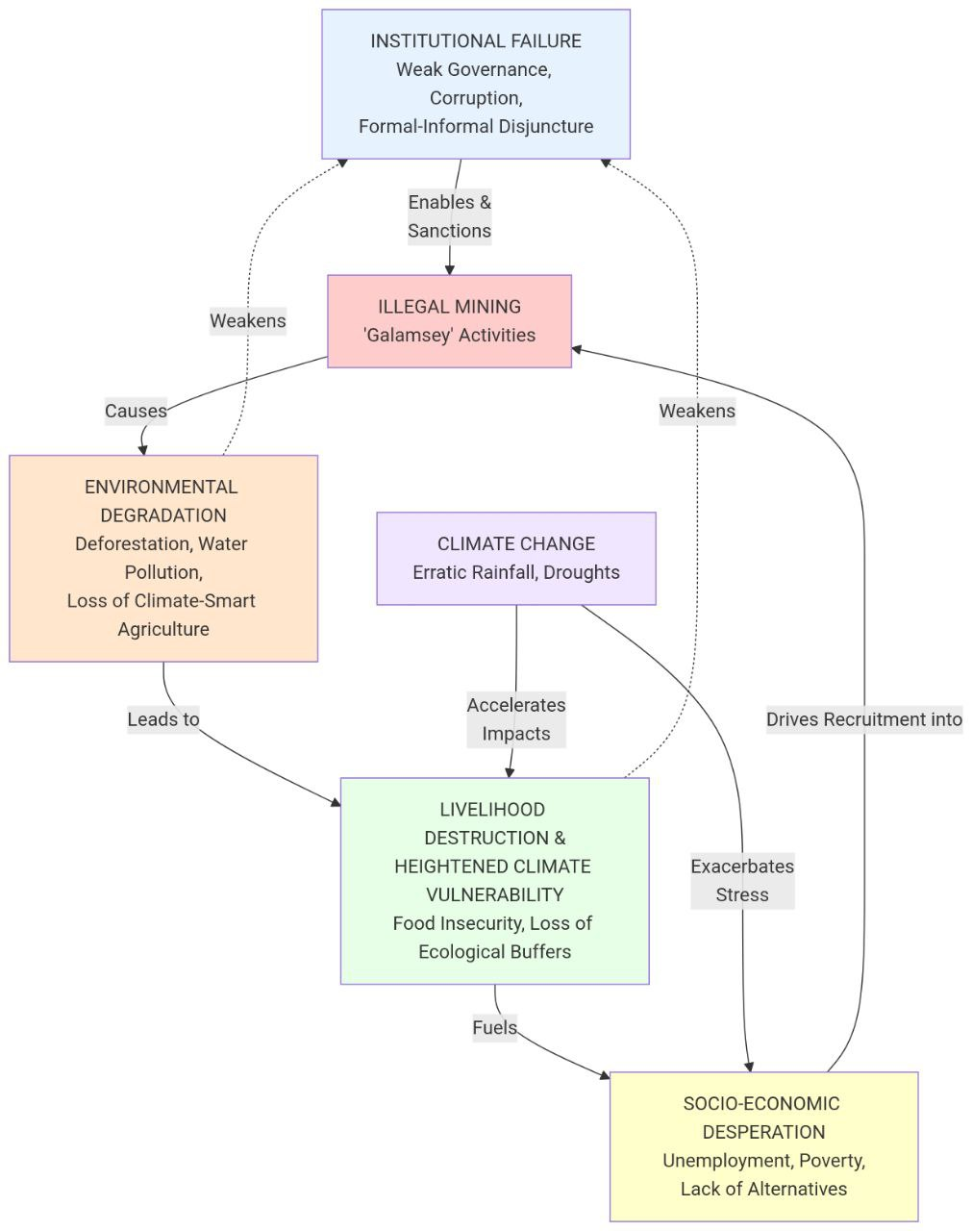
Figure 1. Conceptual Framework
Source: Authors construct (2025)
The confluence of environmental destruction and the external accelerator of climate change (e.g., erratic rainfall, droughts) produces the fourth component: compounded livelihood destruction and heightened climate vulnerability. The loss of farmland and pollution of water sources lead to acute food insecurity and the loss of ecological buffers against floods and landslides (Kuffour et al., 2020, Gilbert, 2022). This creates a desperate population whose adaptive capacity has been systematically dismantled.
This heightened vulnerability, in turn, feeds back into the cycle, fuelling the very socio-economic desperation that drives recruitment into galamsey (Andrews, 2015). This completes the loop, ensuring a constant labor supply that reinforces the practice and, ultimately, further embeds the corrupt networks and institutional weaknesses that began the cycle. Thus, the framework illustrates a closed system where institutional failure, environmental degradation, climate stress, and socio-economic desperation are not isolated issues but mutually reinforcing elements of a singular, devastating crisis.

3. Methodology
This study employed a purely qualitative methodological framework grounded in an interpretivist research philosophy to facilitate a deep, nuanced exploration of the complex social realities and subjective experiences of individuals enmeshed within Ghana's intertwined crises of illegal mining, climate vulnerability, and institutional failure. A descriptive case study design was adopted and executed in the Tarkwa-Nsuaem Municipality, an area selected for its archetypal status as the epicenter of both formal and informal gold mining activity. While this site offers profound insights, its specific history as a mining heartland means findings may not be fully generalizable to all peri-urban landscapes in Ghana, particularly newer mining frontiers or areas with different traditional authority structures. The municipality presented a profound and multi-layered context for investigation, characterized not only by severe environmental degradation, including widespread deforestation, mercury and cyanide contamination of the Bonsa River, and the proliferation of mining pits, but also by the palpable socio-economic tensions between large-scale mining concessions, artisanal mining operators, and local agrarian communities whose livelihoods have been increasingly destabilized by both climatic shifts and land dispossession. This pervasive degradation directly undermined ecological buffers and adaptive capacities, thereby intensifying community vulnerability to climate shocks, a dynamic that made the municipality an ideal locus for examining the feedback loops at the heart of this research.
Primary data were collected through a series of four Focus Group Discussions (FGDs), each composed of 6 to 8 homogenous participants, to capture collective perspectives and stimulate interactive dialogue around shared experiences. The groups were carefully constituted through a purposive sampling strategy to incorporate the distinct viewpoints of current and former galamsey operators, local farmers whose lands and water sources had been directly affected, community leaders and advocates, and local representatives of key regulatory institutions such as the Environmental Protection Agency and the Minerals Commission.
Participants within these categories were identified and recruited with the assistance of a local community liaison to ensure access to knowledgeable individuals with direct experience of the phenomena under study. Prior to each FGD, informed consent was obtained from all participants, who were thoroughly briefed on the study’s objectives, the voluntary nature of their participation, and the measures in place to ensure confidentiality and anonymity. These discussions, which were guided by a semi-structured protocol, probed participants' perceptions of environmental and climatic changes over time, the economic imperatives and social norms driving mining participation, experiences with state-led interventions and traditional authority, and the coding was conducted manually by the primary researcher, with constant comparative techniques used to refine themes and ensure they were firmly grounded in the data. It is important to note the researchers' positionality as academics from an external institution, which may have influenced participant responses and the interpretation of data, efforts were made to mitigate this by building rapport and emphasizing the confidentiality and academic purpose of the study. The analysis identified, refined, and interpreted emergent themes about institutional failure, maladaptive livelihoods, and the compounding nature of climate vulnerability, thereby ensuring that the findings were deeply anchored in the lived realities of the affected populations
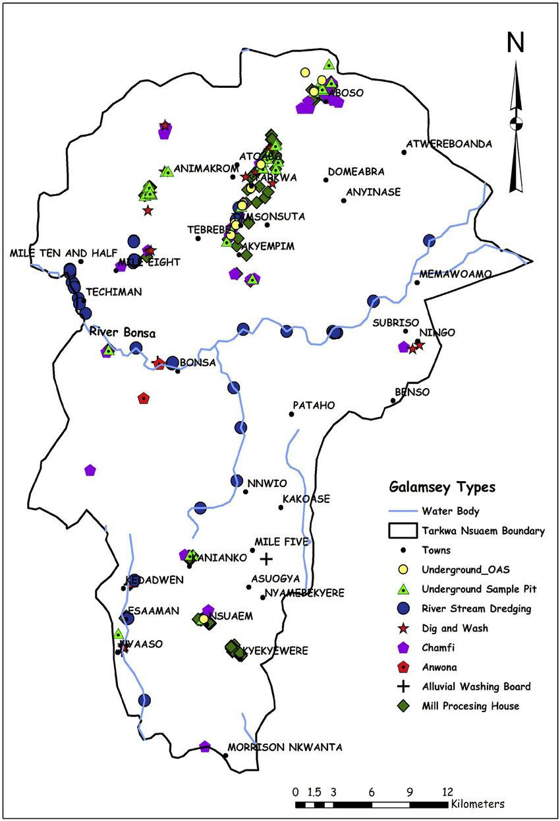
Fig.2. Galamsey operations and towns within the Tarkwa Nsuaem Municipal Assembly boundary
Source: Owusu-Nimo et. al (2018)

4. Analysis and Discussion
This study employed a rigorous thematic analysis of focus group data to interrogate the complex interconnections between illegal mining, climate vulnerability, and institutional failure in Tarkwa-Nsuaem. The analysis, following the iterative process outlined by Braun and Clarke, identified three central themes that collectively articulate the self-reinforcing vicious cycle at the heart of this crisis. Each theme is explored through the triangulated perspectives of the four stakeholder groups, miners, farmers, community leaders, and regulators, ensuring the findings are deeply anchored in the lived realities of the affected population while being critically situated within the existing academic literature on the subject.

4.1. Performative Enforcement and Institutional Collusion
Thematic analysis revealed a stark consensus across all participant groups regarding the cynical nature of state-led enforcement actions. A former galamsey operator articulated a widely held view, stating, “The military ‘galamsey’ taskforce is the biggest mining group. They don’t stop the work; they just come for their share. The machines they burn on television are old and useless. The real ones are sold back to us by the same soldiers after the media is gone.” This account serves as a stark empirical confirmation of the neopatrimonial state structures analyzed by Crawford & Botchwey (2017), demonstrating how public office is weaponized for private gain. The quote illustrates that enforcement is not a genuine regulatory activity but a performative ritual that sustains a lucrative rent-seeking economy, thereby actively perpetuating the very illegality it purports to combat.
Furthermore, the experiences of farmers highlighted the debilitating disjuncture between formal and customary institutions. One farmer described a futile cycle of appeals: “The chief says the Minerals Commission is responsible. The Commission says it is a police matter. The police say it is a chieftaincy issue. We are left in a barren no-man’s-land, watching our heritage be dug away.” This testimony provides a vivid, ground-level perspective on the institutional disjuncture theorized by Boafo et al. (2019). The farmer’s experience of being passed between authorities perfectly encapsulates the “parallel governance systems” that create a vacuum for exploitation. This institutional chaos confirms Baddianaah et al.’s (2022) argument that the system functions not as a failure of governance, but as a highly effective, though predatory, network where short-term economic interests perpetually trump long-term sustainability, leaving communities helpless.

4.2. Climate Stress, Livelihood Precarity, and Maladaptation
Thematic analysis of discussions with farmers and former farmers revealed climate change not as a distant threat, but as an immediate catalyst destroying traditional livelihoods. A former cocoa farmer explained his agonizing calculus with stark clarity: “The rain pattern has changed completely. The sun burns the cocoa pods before they mature. Last year, the flood washed my maize farm into the river. That river is now yellow from galamsey, so I couldn’t even try again. In one week at the site, I earned what my farm would not give me in three months. I hate what I do, but I must feed my family.” This testimony provides the crucial empirical link called for in the literature, directly connecting climate-induced agrarian stress (Yiridomoh, 2021; Adjei et al., 2022) to the decision to enter mining. The farmer’s narrative of climatic shocks (erratic rainfall, floods) destroying his agricultural viability, while polluted water blocks any chance of recovery, powerfully illustrates the compound pressures leading to maladaptation. His rational economic calculation, choosing a destructive but immediate income over a failing farm, empirically validates Andrews’s (2015) foundational framing of galamsey not as criminality, but as a critical survival strategy in the face of systemic marginalization and vanishing alternatives.
The concept of maladaptation was articulated with tragic self-awareness by participants. A woman who processed ore noted, “We know we are poisoning the water our children drink. We know the land is being destroyed. But if the choice is between my child being hungry today or being sick tomorrow, I will choose tomorrow. What mother would not?” This poignant statement is a definitive articulation of the maladaptation paradox described by Mensah et al. (2015) and Adranyi et al. (2024). The participant is fully aware that her livelihood strategy increases long-term vulnerability to environmental and health shocks. Yet, her quote powerfully demonstrates that the immediate, visceral imperative of survival (“hungry today”) rationally overrides concerns about future consequences (“sick tomorrow”). This encapsulates the core of the vicious cycle: the very actions taken to cope with present desperation systematically dismantle the ecological and social foundations for future resilience, thereby locking the community into a path-dependent cycle of degradation and vulnerability.

4.3. Ruined Foundations: Environmental Degradation as a Driver of Systemic Vulnerability
Thematic analysis of all FGDs, particularly those with community advocates and farmers, revealed detailed accounts of how ecological destruction actively dismantles adaptive capacities. A community health worker stated, “The galamsey has destroyed our water and atmosphere. The clinic is full of children with breathing problems and skin diseases from the dust and dirty water. How can we be resilient to climate sickness when our environment is being killed?" This narrative moves beyond simply aligning with quantitative findings on pollution (Kazapoe et al., 2023; Rajaee et al., 2015) and deforestation (Barenblitt et al., 2021). It provides a critical qualitative dimension by showing how environmental degradation directly and physically destroys the infrastructure of resilience (the clinic) while simultaneously increasing the burden of climate-sensitive diseases. The health worker’s rhetorical question underscores the fundamental point that community resilience to climate shocks is impossible when the local environment, the source of clean air, water, and stable land, is systematically degraded, thereby illustrating Gilbert’s (2022) concerns about the erosion of ecological buffers.
Furthermore, the displacement caused by environmental ruin emerged as a key mechanism fuelling the cycle, as illustrated by a young migrant: “There is nothing left for me in the village. The farm is gone. Here in town, I share a room with five others. No steady work. The only thing I know how to do now is work in a pit. So maybe I will find one here.” This account provides powerful empirical grounding for the phenomenon theorized by Akponzele & Dinye (2025) as “urbanization without belonging.” The migrant’s trajectory, from losing his agrarian livelihood due to environmental degradation, to facing tenure insecurity and social exclusion in a peri-urban setting (“share a room with five others”), and finally being funneled back into the galamsey economy, demonstrates how the vicious cycle is geographically expansive. It shows that environmental degradation not only perpetuates the problem locally but also exports vulnerability, creating a displaced population who’s only remaining skillset condemns them to re-enter the very system that caused their displacement, thus ensuring the cycle’s reproduction and expansion.
This dynamic is further compounded by the presence of Large-Scale Mining (LSM) concessions, were often the original source of historical dispossession. While not a primary focus of this study, participants noted that LSM operations continue to consume land and pollute resources, contributing to the overall pressure on livelihoods and limiting the viable land available for alternative uses like climate-resilient agriculture. Large-Scale Mining (LSM) operations significantly contribute to pressures that drive individuals into galamsey, or artisanal small-scale mining, primarily through land displacement and resource degradation. As LSM concessions expand, local communities often lose their traditional lands, which diminishes their access to agriculture and natural resources, pushing them towards alternative livelihoods like galamsey to survive. Additionally, the environmental impacts of LSM, such as water pollution and soil degradation, further limit viable agricultural practices, while economic disparities arise due to fewer job opportunities and local employment loss from mechanization. This intensified competition for resources and the absence of effective regulation lead many to operate in the informal sector, as they seek any means of income in the context of diminishing support and resources. As such, the cycle of dispossession and economic insecurity created by LSM makes galamsey a desperate necessity for those struggling to sustain their lives.
While this study provides a deep, systems-level analysis of the vicious cycle in Tarkwa-Nsuaem, it is important to acknowledge its limitations regarding generalizability. The municipality is a historically established epicenter of both large-scale and artisanal mining. Therefore, the specific dynamics and entrenched nature of the problems documented here may not be fully transferable to newer mining frontiers or regions with different socio-economic and traditional authority structures in Ghana. However, the conceptual framework of the vicious cycle itself, illustrating the feedback between institutional failure, environmental degradation, and livelihood desperation, offers a valuable analytical tool for understanding similar crises in other resource-dependent contexts.

5. Recommendations and Conclusion
The findings of this study underscore that the persistence of illegal mining in Ghana is not a standalone issue but a symptom of deeply entrenched systemic failures, driven by a vicious cycle of institutional collusion, environmental degradation, climate stress, and socioeconomic desperation. To break this cycle, interventions must move beyond fragmented, short-term measures and embrace an integrated governance approach that simultaneously addresses institutional reform, climate adaptation, and sustainable livelihood creation. This requires a fundamental reorientation of policy priorities toward long-term resilience rather than political expediency, recognizing that environmental sustainability, social equity, and economic development are mutually reinforcing objectives rather than competing interests.
Central to this effort is the urgent need for institutional coherence and accountability, which must bridge the critical disjuncture between formal state agencies and traditional authorities. Given the evidence of neopatrimonial collusion, this is a profound political challenge, not merely a technical one. Governance mechanisms should be restructured to foster collaborative land-use planning and enforcement, incorporating community oversight and transparent grievance-redress systems to curb corruption and elite capture. Moreover, licensing regimes for small-scale mining must be simplified and made more accessible, reducing bureaucratic barriers that currently push operators into illegality, while ensuring that environmental and social safeguards are rigorously upheld. This could include supporting the formation of licensed cooperatives that are formally recognized and held accountable. At the same time, policy interventions must directly address the root drivers of participation in galamsey by creating viable economic alternatives through targeted investment in climate-resilient agriculture, vocational training, and green job initiatives that offer sustainable incomes to vulnerable communities. These initiatives must be designed and implemented with direct community involvement to ensure they are appropriate and avoid the pitfalls of top-down planning.
Equally critical is the integration of climate adaptation strategies into local development planning, particularly in mining-affected regions where environmental degradation has severely compromised ecological buffers and community resilience. Programs aimed at land restoration, reforestation, and water-quality rehabilitation should be prioritized, not only to mitigate further damage but also to rebuild the natural capital upon which sustainable livelihoods depend. Such efforts must be coupled with strengthened public health and infrastructure systems to reduce vulnerability to climate-induced shocks and diseases, thereby interrupting the feedback loop that pushes individuals into maladaptive coping strategies like illegal mining. Critically, these restoration and adaptation efforts should be framed as sources of local employment, directly providing "green jobs" as an alternative to mining.
Finally, future policy must explicitly acknowledge and address the role of Large-Scale Mining (LSM) in this cycle. This includes strengthening enforcement of environmental regulations on LSM operations, ensuring fair compensation and livelihood restoration for communities affected by LSM land acquisition, and mandating that LSM companies invest in diversified economic development programs in their host communities as a core part of their social license to operate.
In conclusion, this study has illuminated the self-reinforcing dynamics of a crisis that thrives on institutional failure, ecological destruction, and human vulnerability. The narratives from Tarkwa-Nsuaem reveal a stark reality: that for many, galamsey is not a choice but a necessity born from systemic neglect and compounded by climatic pressures. Effectively addressing this challenge demands a holistic and empathetic approach, one that recognizes the agency and constraints of those caught in the cycle and offers them meaningful pathways out of it. Only through sustained commitment to integrated governance, inclusive development, and ecological restoration can Ghana hope to break this vicious cycle and forge a future where economic prosperity, environmental health, and social justice are aligned.
Although the findings are rooted in the specific context of a long-standing mining heartland, the integrated framework of the vicious cycle has broader relevance for policymakers confronting similar syndromes of environmental degradation and socio-economic marginalization across Ghana and other resource-rich nations. Effectively addressing this challenge demands a holistic and empathetic approach.

Disclaimer (Artificial Intelligence)
Authors hereby declare that generative AI such as Grammarly was used during the editing of manuscript.

6. References
Adjei, V., Amaning, E. F., & Adjokatse, I. (2022). The evil couple: Illegal mining in water bodies and climate change: A case study of Ghana. Journal of Atmospheric Science Research, 5(3), 37-51 https://doi.org/10.30564/jasr.v5i3.4778
Adranyi, E., Stringer, L. C., & Altink, H. (2024). Joined-up governance for more complementary interactions between expanding artisanal small-scale gold mining and agriculture: Insights from Ghana. PLoS ONE 19(4): e0298392.. https://doi.org/10.1371/journal.pone.0298392
Akponzele, R., & Dinye, R. D. (2025). Urbanization without belonging: Land tenure insecurity among migrants in Ghana. Asian Journal of Education and Social Studies, 51(7), 948–966. https://doi.org/10.9734/ajess/2025/v51i72182
Ampaw, E. M., Chai, J., Jiang, Y., Dumor, K., & Edem, A. K. (2023). Why is Ghana losing the war against illegal gold mining (Galamsey)? An artificial neural network-based investigation. Environmental Science and Pollution Research International, 30, 73730–73752 (2023). https://doi.org/10.1007/s11356-023-27265-x
Andrews, N. (2015). Digging for survival and/or justice? The drivers of illegal mining activities in Western Ghana. Africa Today, 62(2), 3–24. https://doi.org/10.2979/AFRICATODAY.62.2.3
Baddianaah, I., Baatuuwie, B., & Adongo, R. (2022). The outbreak of artisanal and small-scale gold mining (galamsey) operations in Ghana: Institutions, politics, winners and losers. Journal of Degraded and Mining Lands Management, 9(3), 3487–3500. https://doi.org/10.15243/jdmlm.2022.093.3487
Barenblitt, A., Payton, A., Lagomasino, D., Fatoyinbo, L., Asare, K. A. B., Aidoo, K., Pigott, H., Som, C. K., Smeets, L., Seidu, O., & Wood, D. (2021). The large footprint of small-scale artisanal gold mining in Ghana. Science of The Total Environment, 781, 146644. https://doi.org/10.1016/j.scitotenv.2021.146644
Bansah, K. J., Acquah, P. J., & Boafo, A. (2024). Land, water, and forest degradation in artisanal and small-scale mining: Implications for environmental sustainability and community wellbeing. Resources Policy, 90,104795. https://doi.org/10.1016/j.resourpol.2024.104795
Boafo, J., Paalo, S. A., & Dotsey, S. (2019). Illicit Chinese small-scale mining in Ghana: Beyond institutional weakness? Sustainability, 11(21), 5943. https://doi.org/10.3390/su11215943
Crawford, G., & Botchwey, G. (2017). Conflict, collusion and corruption in small-scale gold mining: Chinese miners and the state in Ghana. Commonwealth & Comparative Politics, 55(4), 444–470. https://doi.org/10.1080/14662043.2017.1283479
Gilbert, D. (2022). The Effects of Illegal Small-scale Gold Mining in Ghana: A Threat to Food Security. Emerging Challenges in Agriculture and Food Science Vol. 3, 84–98. https://doi.org/10.9734/bpi/ecafs/v3/15339D
Hilson, G., & Potter, C. (2003). Why is illegal gold mining activity so ubiquitous in rural Ghana? African Development Review, 15(2–3), 237–270. https://doi.org/10.1111/j.1467-8268.2003.00073.x
Kazapoe, R. W., Amuah, E. E. Y., Abdiwali, S. A., Dankwa, P., Nang, D. B., Kazapoe, J. P., & Kpiebaya, P. (2023). Relationship between small-scale gold mining activities and water use in Ghana: A review of policy documents aimed at protecting water bodies in mining communities. Environmental Challenges, 12, 100727. https://doi.org/10.1016/j.envc.2023.100727
Kokofu, H. K., Sarfo-Adu, G. K., Dadebo, M. A., Nkrumah, G., & Galley, D. K. (2022). Sustaining the environment in an era of small-scale mining in Ghana: Optimizing the role of institutions. International Journal of Global Sustainability, 6(1), 26–44. https://doi.org/10.5296/ijgs.v6i1.19917
Kuffour, R., Tiimub, B. M., Manu, I., & Owusu, W. (2020). The effect of illegal mining activities on vegetation: A case study of Bontefufuo area in the Amansie West District of Ghana. East African Scholars Journal of Agriculture and Life Sciences.
Mensah, A. K., Mahiri, I., Owusu, O., Mireku, O. D., Wireko, I., & Kissi, E. A. (2015). Environmental impacts of mining: A study of mining communities in Ghana. Applied Ecology and Environmental Sciences, 3(3), 81–94. https://doi.org/10.12691/aees-3-3-3
Musah, B. I. (2025). The impact of artisanal small-scale mining on environmental sustainability: Implications for the attainment of the sustainable development goals (SDGs) in Ghana. Environmental Science and Pollution Research International, 32, 15546-15573 https://doi.org/10.1007/s11356-025-36668-x
Owusu, M., & Nursey-Bray, M. (2018). Socio-economic and institutional drivers of vulnerability to climate change in urban slums: the case of Accra, Ghana. Climate and Development, 11(8), 687–698. https://doi.org/10.1080/17565529.2018.1532870
Owusu-Nimo, F., Mantey, J., Nyarko, K. B., & Aubynn, A. (2018). Spatial distribution patterns of illegal artisanal small-scale gold mining (Galamsey) operations in Ghana: A focus on the Western Region. Heliyon, 4(2), e00534. https://doi.org/10.1016/j.heliyon.2018.e00534
Rajaee, M., Obiri, S., Green, A., Long, R. N., Cobbina, S. J., Nartey, V., Buck, D., Antwi, E., & Basu, N. (2015). Integrated assessment of artisanal and small-scale gold mining in Ghana—Part 2: Natural sciences review. International Journal of Environmental Research and Public Health, 12(8), 8971–9011. https://doi.org/10.3390/ijerph120808971
Schueler, V., Kuemmerle, T., & Schröder, H. (2011). Impacts of surface gold mining on land use systems in Western Ghana. Ambio, 40(5), 528–539. https://doi.org/10.1007/s13280-011-0141-9
Yeboah, R. (2023). Galamsey fight in Ghana: An analysis of failure of government interventions since 1989. E-Journal of Humanities, Arts and Social Sciences, 4(4), 417–431. https://doi.org/10.38159/ehass.20234417
Yiridomoh, G. Y. (2021). “Illegal” gold mining operations in Ghana: Implication for climate-smart agriculture in Northwestern Ghana. Frontiers in Sustainable Food Systems.5:745317 https://doi.org/10.3389/fsufs.2021.745317

