Review Article

Rupchand (Piaractus brachypomus) Farming in India: Prospects, Challenges, and Sustainability Implications

ABSTRACT
This review examines the potential, challenges, and sustainability implications of Rupchand (Piaractus brachypomus) farming in India. Aquaculture is central to India’s food and nutritional security and plays a significant role in rural livelihoods. Among various diversification candidates, the red-bellied pacu (Piaractus brachypomus; “Rupchand”) has emerged as a promising species due to its rapid growth, omnivorous feeding habits, and resilience across diverse culture systems. The study synthesizes evidence from published studies, farmer surveys, and case studies across Andhra Pradesh, Kerala, and West Bengal to provide a comprehensive overview of pacu’s economic potential. Evidence indicates strong farmer uptake, shorter culture cycles (≈6 months to market size in semi-intensive polyculture), and favorable economics. The seed production industry has grown substantially, particularly in West Bengal, yet challenges such as supply consistency, standardized grow-out practices, and health management persist. This review synthesizes evidence from published studies, farmer surveys, and case studies to provide a comprehensive understanding of pacu’s suitability for aquaculture diversification. Priorities for future development include selective breeding, feed optimization with a focus on plant proteins, and widespread adoption of best-management practices. In conclusion, this review provides critical insights to guide policymakers, researchers, and farmers towards responsible and sustainable adoption of pacu aquaculture in India.

Keywords: Pacu, Rupchand, Aquaculture Diversification, Climate Resilience, Sustainability.

1. INTRODUCTION
Fish has long been known as the "poor man’s protein," yet its importance extends beyond this traditional view. Globally, fish is a vital source of protein, vitamins, and omega-3 fatty acids, playing a crucial role in human health and nutrition. As the demand for fish continues to rise, aquaculture has become essential not only for providing food security but also for creating employment and supporting rural economies. However, traditional aquaculture practices face increasing challenges, including the need for diversification, environmental sustainability, and enhanced productivity. This research explores the potential of the red-bellied pacu (Piaractus brachypomus), known locally as Rupchand, as a promising species for diversification within India's aquaculture sector. Specifically, the study evaluates pacu’s growth performance, market potential, environmental resilience, economic viability, and socio-economic impact on farmers in key aquaculture states such as Andhra Pradesh, Kerala, and West Bengal. By increase in population, poverty is also increasing continuously. Now it’s a challenge to fulfill food requirement of peoples. As, Fish is considered as major source of protein. So, Aquaculture sector is fulfilling the food requirement of peoples. By focusing on these aspects, the research aims to provide a comprehensive understanding of how Rupchand can contribute to food security, enhance aquaculture sustainability, and improve rural livelihoods in India.

2. RUPCHAND– A NEW OPPORTUNITY IN AQUACULTURE
Among the many species being explored for aquaculture, Rupchand (red-bellied pacu, Piaractus brachypomus) has emerged as a promising candidate. Pacu is considered an important aquaculture species in several countries including Colombia, Brazil, Peru, Venezuela, Vietnam, Thailand, Malaysia, and Bangladesh [9]. Native to South America but it is introduced in India through ornamental fish trade in west Bengal in 2003–2004, Rupchand is gaining attention for its adaptability, attractive appearance, and market demand. Its round body, bright red belly, and fast growth rate make it not only farmer-friendly but also consumer-attractive [13]. “As per Government of India notification (File No. 35029/8/2011-Fy (Trade) (E-10310)), guidelines have been issued for the culture of pacu (Piaractus brachypomus) in ponds, marking an important step towards regulated and sustainable aquaculture of this species in India.”
Unlike carnivorous fishes that require costly feeds, Rupchand is omnivorous, feeding on plants, agricultural by-products, and formulated feed, making it more suitable for small-scale farming [24 ]. Its hardy nature allows it to thrive in ponds, cages, and tanks under diverse water conditions, as shown in Table 1, which provides detailed biological and habitat information for Pirapatinga (Pacu) [9].
Table 1: Biological and Habitat Information for Pirapatinga (Pacu)
Particulars | Details
Scientific Name | Piaractus brachypomus (Cuvier, 1818)
Common Name | Pirapatinga / Pacu
Vernacular Name (Marathi) | Rupchanda / Freshwater Pomfret
Habitat | Tropical freshwater
pH Range | 4.8 – 6.8
Temperature Range | 23°C – 28°C
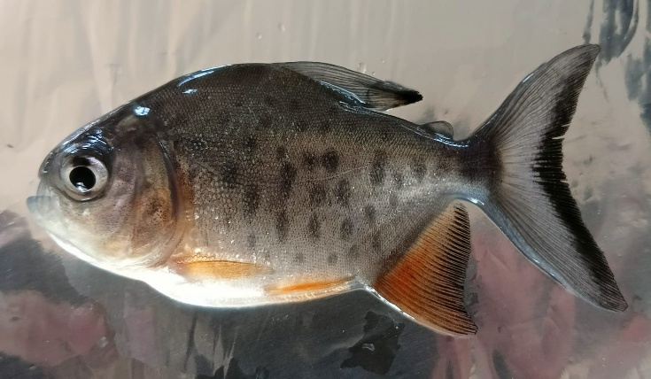
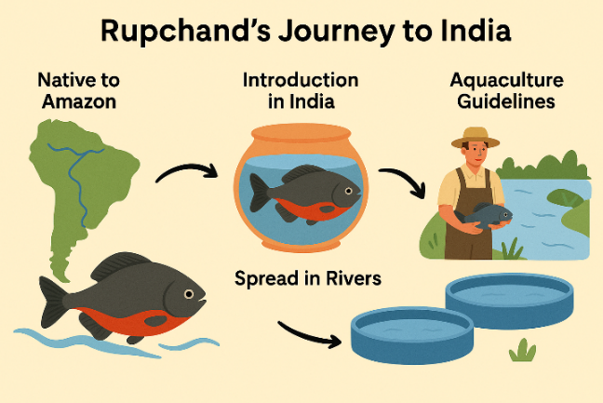
Fig.1: Piaractus brachypomus (Pacu Fish)

Why Rupchand?
The red-bellied pacu (Piaractus brachypomus) and its related species are known to perform well in both natural waters and controlled culture systems. Their unique qualities make them highly promising candidates for aquaculture. These fishes are able to:
- Reproduce under captive conditions
- Thrive low on the food chain
- Accept prepared feed
- Tolerate hardy conditions
- Can easily be handled,
- Grow rapidly
- Be cultivated in high density
- Be marketed and have consumers acceptability, fetch good price and
- Be preferred as food as well as ornamental fish.
They exhibit fast growth, and are able to utilize diets having high in carbohydrates and plant proteins. They are resistance to poor water quality conditions and diseases having good flesh quality [16].
3. FARMING POTENTIAL
The red-bellied pacu (Piaractus brachypomus) demonstrates significant farming potential in India due to its rapid growth rate, shorter culture period, and adaptability to both monoculture and polyculture systems. Its ability to thrive in a wide range of water quality parameters, omnivorous feeding habit, and superior meat quality make it an attractive candidate for species diversification in aquaculture. The study revealed that pacu culture has expanded rapidly since its introduction, covering over 2500 ha in Andhra Pradesh alone by 2015, with growing adoption in Kerala, West Bengal, and other states. Average production levels in polyculture with Indian major carps reached 10–13 t ha⁻¹, outperforming carp-only systems and enhancing farmers’ income. Farmers reported high profitability (87% positive response), citing faster growth and reduced culture duration compared to Indian major carps and striped catfish. Rising market prices, ranging from ₹81–100 kg⁻¹ in 2015, further underscore its economic viability. These characteristics collectively position pacu as a strong candidate for large-scale farming and a potential contributor to improving food security and farm-level profitability in India. Table 2 highlights the growth rate, FCR, and market price of Pacu in comparison to other species in India.
Table 2. Comparative growth performance, feed conversion ratio (FCR), and market price of pacu, carp, and tilapia under Indian aquaculture conditions.
Species | Growth rate | FCR | Market Price in India (₹/kg) | Reference(s)
Pacu  (Piaractus spp.) | Fast growth, high SGR; 6–8 months 1kg weight | 1.0-2.0 (best) | 200–300 | [3,6,16]
Carp  (Cyprinus, Labeo spp.) | 10–12 months; 1 kg weight moderate SGR | 1.2–2.5 | 150–200 | [7,8]
Tilapia  (Oreochromis niloticus) | 4–8 month; 400-600 gram, good growth | 1.1–2.5 | 100–120 | [21]

4. RUPCHAND'S AQUACULTURE SUCCESS ACROSS DIFFERENT STATES
The story of Rupchand’s aquaculture journey is best told through the success stories of three states:
  - Andhra Pradesh
The West Godavari district in 2004 quickly grew into a large-scale farming practice. By 2015, pacu was being cultured in nearly 2600 hectares of ponds, often alongside Indian major carps and striped catfish. Farmers discovered that pacu could be harvested in just 5–6 months, compared to the 11–12 months required for carps, making it a quicker and more profitable crop. With yields often exceeding 10–12 tonnes per hectare, pacu became a symbol of efficiency and income security for Andhra’s fish farmers.
4.2 Kerala
In Kerala, pacu first entered ponds through ornamental fish traders. But soon, small farmers across Thrissur, Ernakulam, Alappuzha, and Kottayam saw its potential as a food fish. By 2015, more than 60 farms had adopted pacu, mostly in small ponds ranging from 0.1 to 0.25 ha. Farmers reported that pacu blended well in polyculture systems with carps, was easy to manage, and fetched good returns in local markets.

4.3 West Bengal
The real backbone of pacu’s expansion lies in West Bengal, which emerged as the seed hub of India. By 2015, the state had 29 active hatcheries, producing over 550 million spawn annually. Farmers here not only cultured pacu in their ponds but also supplied seed to other states, fueling its spread across the country. At the same time, farm-gate prices rose sharply from ₹50–60/kg in 2012 to nearly ₹100/kg in 2015 showing strong consumer acceptance and demand.
Across these states, surveys revealed that nearly 87% of farmers considered pacu farming profitable, citing faster growth, shorter culture cycles, and strong market demand as the key reasons for adoption [13]
5. BENEFITS FOR FARMERS
Recent studies indicate that Piaractus brachypomus (red-bellied pacu / Rupchand) offers attractive returns and nutritional benefits, making it a promising aquaculture species in India. Farmer surveys across Andhra Pradesh, Kerala, and West Bengal revealed that more than 80% of respondents considered pacu culture profitable, mainly due to its faster growth and higher market price compared to carps and catfish [19]. In a comparative culture trial, the return on investment (ROI) in carp + pacu polyculture was 78.1%, higher than 75.1% in carp monoculture, (Figure 2) highlighting its cost-benefit advantage [1].
Nutritionally, pacu flesh contains 17–18% protein and about 1.2% lipid, making it comparable to Indian major carps [20]. FishBase records indicate an average of 18.3 g protein/100 g wet weight and 0.31 g omega-3 fatty acids/100 g, suggesting good dietary value [4]. Although consumer acceptance surveys are limited, farmer feedback suggests growing market demand and better price realization compared to several traditional aquaculture species [19].

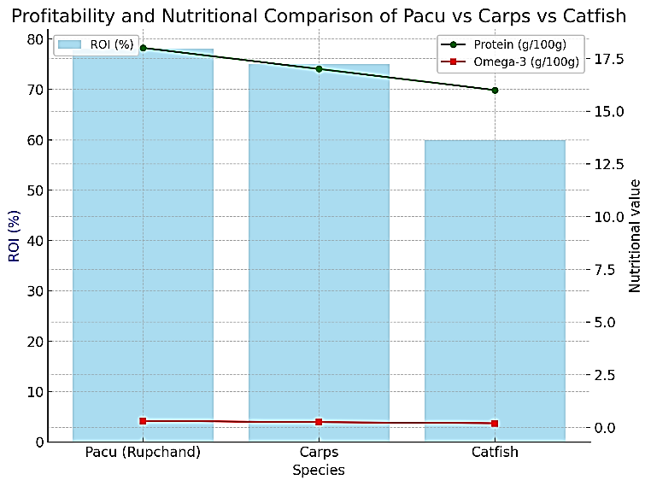
(Source: Das et al., 2019) [1]

Figure 2. Profitability (ROI %) and nutritional composition (protein and omega-3 content) of pacu, carps, and catfish under Indian aquaculture conditions.

From a sustainability perspective, regulated pond culture of pacu, as recently permitted under Government of India guidelines, may also help reduce pressure on wild riverine stocks by meeting demand through farming rather than capture fisheries [10]. This positions pacu as not only an economically viable option but also a tool for climate-smart aquaculture development.
The farming of Rupchand (Piaractus brachypomus) offers multiple benefits to fish farmers and rural communities. Its rapid growth rate and shorter culture period allow farmers to harvest marketable-sized fish within 5–6 months, thereby ensuring quicker returns on investment and improved cash flow. This creates a good income opportunity, with profitability reported by nearly 87% of surveyed farmers in major farming states [13]. Rupchand is also highly popular among consumers because of its soft flesh, attractive appearance, and excellent nutritional profile, which includes high-quality protein, vitamins, and omega-3 fatty acids [5] . The rising market price ranging between ₹81–100 kg⁻¹ makes it a commercially attractive species for farmers. Additionally, its successful incorporation into polyculture systems not only enhances total pond productivity but also reduces dependency on traditional carp species. By providing a sustainable alternative to wild-caught fish, Rupchand farming can reduce pressure on overfished species, contributing to the conservation of natural fish populations and long-term ecological balance. These combined economic and ecological benefits make Rupchand an important driver for rural aquaculture development and livelihood enhancement.
6. RESULT
6.1 Grow-out Production Area of Pacu in India
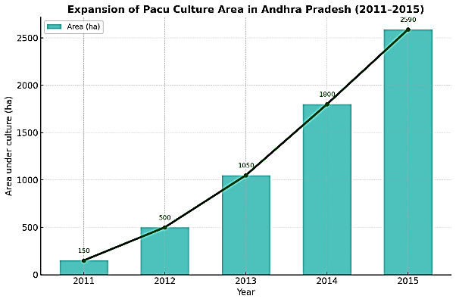
Pacu has been successfully farmed in India under extensive and semi-intensive systems, practiced both in monoculture and in polyculture with Indian major carps and striped catfish [9]. In Andhra Pradesh, the majority of grow-out farms (n= 269) were located in West Godavari and Krishna districts. Initially, the total culture area was limited to about 151 ha in 2011; however, rapid expansion occurred between 2011 and 2015, with 27, 57, 93, and 85 new farms established annually. By 2015, the culture area had expanded nearly 17-fold, reaching ~2591 ha (Figure 3). Most farmers (93%) adopted pacu polyculture with carps, covering 2418 ha, while only a small fraction (7%) practiced monoculture over 173 ha. Comparable practices have also been documented for striped catfish, cultivated both in monoculture and polyculture with Indian and Chinese carps [17]. In Kerala, pacu culture was reported from 62 surveyed farms distributed across Thrissur, Ernakulam, Alappuzha, and Kottayam districts, covering a combined area of 42 ha.
(Source: B. Seshagiri et al., 2022) [13]
(Source: B. Seshagiri et al., 2022) [13]

Figure 3. Expansion of pacu (Piaractus brachypomus) culture area in Andhra Pradesh from 2011 to 2015, showing a consistent and significant increase in area under culture.

6.2 Seed Production and Hatchery Practices
West Bengal has emerged as the hub of seed production for several commercially important fishes, including non-native species such as striped catfish, tilapia, and pacu [11]. According to one survey, 29 pacu hatcheries were recorded, with the majority (n = 21) concentrated in North 24 Parganas district, while a few were distributed across Burdwan, Hooghly, Murshidabad, and South 24 Parganas. Seed production data revealed a sharp rise between 2011 and 2015 (Figure 4). Spawn production increased nearly three-fold, from 184 million in 2011 to about 553 million in 2015, while fry production rose from 63 million to approximately 196 million during the same period. Fingerling rearing was also practiced in certain hatcheries, where collective production reached ~8.4 million in 2015 compared to only 2.0 million in 2011.
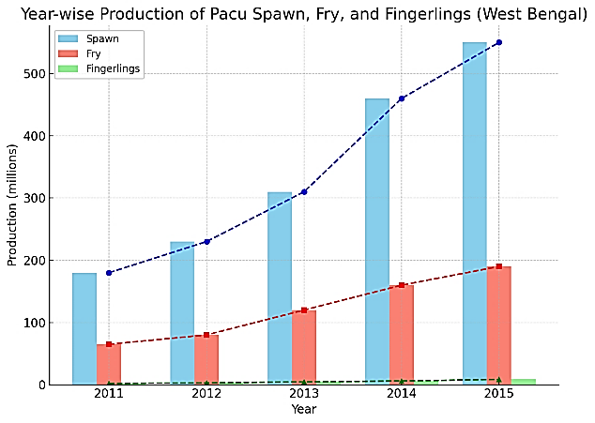
(Source: B. Seshagiri et al., 2022) [13]

Figure 4. Year-wise production trends of pacu spawn, fry, and fingerlings in West Bengal (2011–2015), highlighting rapid growth in seed production to meet rising demand.

6.3 Climate Change Resilience of Pacu
Pacu (Piaractus brachypomus) is highly tolerant to environmental fluctuations, thriving across a broad temperature range (18–35 °C) and pH levels (5.0–9.0) [9,20] . This adaptability makes it a resilient species for aquaculture under climate change, ensuring stable production even under warming and variable water conditions while reducing pressure on wild stocks [23].
Escapes of exotic species such as pacu (Piaractus brachypomus) into natural rivers pose significant ecological risks. According [17], alien fishes can compete with native species for food and habitat, alter trophic interactions, and introduce new pathogens and parasites. Pacu, being omnivorous and highly adaptable, can establish in diverse habitats, potentially displacing native fish populations and disturbing community structure. Its feeding on invertebrates, plants, and small fish may modify food webs, while its strong dentition can damage fishing gear, causing economic losses. These risks highlight the need for strict regulation, monitoring, and risk assessment before large-scale culture or release of pacu in open waters [22].
7. DISCUSSION
The introduction and expansion of pacu (Piaractus brachypomus), popularly known as Rupchand, mark a significant milestone in India’s aquaculture diversification efforts. Its rapid growth rate, omnivorous feeding habits, and ability to thrive under varied environmental conditions have allowed this species to establish itself as an economically viable option for smallholder and commercial farmers alike. Production data clearly demonstrate its advantages over traditional carp monoculture, with higher yields (10–13 t ha⁻¹) and shorter culture periods, leading to improved profitability and better cash flow for farmers [9,14] . Moreover, the rising market price of pacu and its growing consumer acceptance underscore its potential to strengthen rural livelihoods and contribute to nutritional security. These factors collectively position pacu as a “climate-smart” aquaculture species, offering resilience in the face of environmental variability and a means to meet increasing demand for affordable fish protein.
Despite these benefits, several challenges require critical attention to ensure the sustainable growth of pacu aquaculture. The availability of quality seed remains inconsistent, with production concentrated in a few states such as West Bengal [11]. This geographic imbalance may limit the equitable expansion of pacu farming to other regions. Health management is another major concern, as farmers report disease outbreaks like “red disease,” in pacu is primarily caused by Aeromonas hydrophila infection, leading to septicemia and hemorrhagic symptoms. which can cause significant production losses. There is a pressing need for research on epidemiology, disease resistance, and the development of region-specific health management protocols. Additionally, while pacu offers economic gains, its status as an exotic species introduces ecological risks. [18] highlighted that alien fishes, once escaped into rivers, may compete with native species, disrupt trophic dynamics, transmit pathogens, and potentially become invasive. Reports of pacu in natural water bodies such as the Periyar and Vembanad wetlands indicate that escape events have already occurred [12]. Therefore, large-scale expansion of pacu culture must be accompanied by strict regulatory oversight, farmer awareness programs, and biosecurity measures to minimize unintended ecological consequences.
From a future perspective, the success of pacu aquaculture in India depends on an integrated approach involving research, policy, and farmer participation. Efforts should focus on developing standardized hatchery and grow-out protocols, selective breeding programs for improved growth and disease resistance, and cost-effective feeds with higher plant protein inclusion. Policymakers should promote responsible aquaculture practices, including mandatory registration of farms and periodic monitoring to prevent escape into natural ecosystems. Finally, farmer capacity-building through training and extension programs is crucial to ensure adoption of best management practices and maximize profitability. By addressing these key issues, pacu farming can evolve into a sustainable, environmentally responsible, and economically rewarding component of India’s freshwater aquaculture sector.
8. CONCLUSION
Rupchand (Piaractus brachypomus) represents a significant opportunity for sustainable aquaculture development and farmer prosperity in India. Its rapid growth rate, shorter culture duration, adaptability to diverse culture systems, and profitability make it a promising candidate for species diversification in freshwater aquaculture. The adoption of pacu farming has already expanded considerably, improving farmers’ income and providing consumers with an affordable source of high-quality fish protein. With strengthened seed supply systems, targeted farmer training, and continued research in disease management, breeding, and feed optimization, pacu farming can further contribute to meeting the rising demand for fish, enhancing food and nutritional security, and supporting rural livelihoods.
Disclaimer (Artificial intelligence)
Author(s) hereby declare that NO generative AI technologies such as Large Language Models (ChatGPT, COPILOT, etc.) and text-to-image generators have been used during the writing or editing of this manuscript.

References
- Das, P., Singh, S.K., Pandey, N.N. & Rao, K.R. (2019) ‘Comparative performance of pacu and Indian major carps in polyculture systems’, Indian Journal of Fisheries, 66(3), pp. 45–52.
- FAO (2020) The State of World Fisheries and Aquaculture 2020: Sustainability in action. Rome: FAO..
- Fernandes, A.F.A., Salgueiro, A., Ramos, A. & Rodrigues, P. (2019) ‘Growth performance of Piaractus brachypomus in pond-based aquaculture’, Aquaculture Research, 50(2), pp. 157–167.
- Froese, R. & Pauly, D. (2022) FishBase. Available at: www.fishbase.org (Accessed: 10 September 2025).
- Ghosh, D. & Datta, S. (2014) ‘Nutritional evaluation of pacu flesh: prospects for aquaculture diversification’, International Journal of Fisheries and Aquatic Studies, 2(1), pp. 120–125.
- IBGE (2024) Pacu aquaculture statistics in South America. Rio de Janeiro: Instituto Brasileiro de Geografia e Estatística.
- ICAR (2024) Indian Aquaculture Market Report. New Delhi: Indian Council of Agricultural Research.
- Jena, J.K., Das, P.C., Mohanty, S. & Sarangi, N. (2018) ‘Carp polyculture in India: Status, constraints, and prospects’, Journal of Applied Aquaculture, 30(4), pp. 289–305.
- Kumar, D., Shankar, R. & Lakra, W.S. (2018) ‘Current status and prospects of pacu (Piaractus brachypomus) farming in India’, Aquaculture International, 26(3), pp. 699–715.
- Ministry of Food Processing Industries (MoFPI) (2018) Guidelines for regulated aquaculture and climate-smart technologies. Government of India.
- Mohan, R., Sharma, S. & Pradhan, P.K. (2019) ‘Hatchery production systems of exotic fish species in India: A review’, Aquaculture Research, 50(10), pp. 2765–2776.
- Reenamole, G. & D’Cruz, S.C. (2014) ‘First report on the occurrence of exotic pacu in Vembanad wetlands, Kerala’, Current Science, 107(9), pp. 1502–1503.
- Seshagiri, B., Das, P. & Sharma, A. (2021) ‘Pacu (Piaractus brachypomus): A potential aquaculture species for Indian freshwater ponds’, Journal of Inland Fisheries Society of India, 53(2), pp. 67–74.
- Seshagiri, B., Mohanty, S. & Sarkar, U.K. (2022) ‘Expansion and farmer adoption of pacu farming in India: socio-economic perspectives’, Fisheries and Aquaculture Journal, 31(2), pp. 115–128.
- Silva, C.R., Fernandes, J.B.K. & Lima, A.F. (2021) ‘Feed conversion efficiency and growth performance of red-bellied pacu in polyculture’, Latin American Journal of Aquatic Research, 49(1), pp. 19–28.
- Singh, A.K. (2018) ‘Pacu farming in India: Prospects and challenges’, Fishery Technology, 55(1), pp. 85–93.
- Singh, A.K., Kumar, D. & Lakra, W.S. (2012) ‘Ecological risk assessment of alien fish species in India: Pacu case study’, Reviews in Aquaculture, 4(1), pp. 79–98.
- Singh, A.K. & Lakra, W.S. (2011) ‘Risk and ecological implications of exotic fish introductions in India’, Current Science, 100(4), pp. 537–540.
- Singh, P., Ghosh, D. & Sinha, A. (2021) ‘Socio-economic viability and farmer perspectives on pacu culture in eastern India’, International Journal of Fisheries Science, 12(2), pp. 45–56.
- Sinha, V.R.P., Ayyappan, S. & Jena, J.K. (2012) ‘Nutritional profile and consumer acceptability of pacu vis-à-vis Indian major carps’, Journal of Aquaculture in the Tropics, 27(1–2), pp. 45–53.
- Tridge (2024) India Tilapia Market Prices 2024.
- Cucherousset, J. & Olden, J.D. (2011). Ecological impacts of non-native freshwater fishes. Fisheries, 36(5), 215–230.
- Soto, D., Aguilar-Manjarrez, J. & Hishamunda, N. (2018). Building resilience for adaptation to climate change in the fisheries and aquaculture sector. FAO Fisheries and Aquaculture Technical Paper No. 627. FAO.
- Silva, J.M.C., et al. (2022). Performance and environmental implications of Piaractus brachypomus farming in tropical aquaculture systems. Aquaculture Reports, 23, 101055.

