Review Article

An appraisal of the ecology and socio-economic implications of traditionally managed Trees Outside Forests (TOFs) in North East India

ABSTRACT
Trees outside forests (TOFs) play crucial roles through their contributions to biodiversity, timber and non-timber forest products (NTFPs), carbon sequestration, climate moderation and livelihood enhancement, aligning with national and global sustainability goals. An analysis of research on TOFs in Northeast India over the past 35 years (1990-2025) reveals a steady rise in scientific attention. Traditionally managed systems such as home gardens, sacred groves and village community forests dominate the region’s landscape, covering about 32,110 km², with Assam and Arunachal Pradesh accounting for the largest areas. This review synthesizes data from peer-reviewed publications, institutional reports and gray literature retrieved from databases including Scopus, Web of Science and Google Scholar. Studies were categorized by TOF type, state and thematic focus to assess spatial and temporal research trends. Findings indicate that while home gardens and sacred groves are relatively well-documented, community forests remain underrepresented. The deep cultural and traditional roots of TOFs further highlight their significance as heritage systems interlinking people and landscapes. However, major research gaps persist in quantifying ecosystem services, carbon dynamics and livelihood outcomes. Strengthening interdisciplinary and comparative studies across the northeastern states can deepen understanding of their benefits. Recognizing TOFs as an important part of the green cover and including them in regional conservation and development plans is necessary to protect biodiversity, adapt to climate change and support sustainable growth in rural areas of Northeast India.

Keywords: Homegardens, Sacred groves, Phyto-sociology, Carbon sequestration, Livelihood

1. INTRODUCTION
Trees Outside Forests (TOFs) are defined as 'trees on land not classified as forest or other wooded lands' (FAO, 1998), and as 'all tree crops outside designated forest areas, including tree cover smaller than 1 hectare as well as forest cover outside forest areas that may exceed 1 hectare' (FSI, 2021). TOFs have much ecological and socio-economic significance in terms of biodiversity, timber products, NTFPs, carbon sequestration, regulation of climate and other benefits including livelihood support. The total extent of TOFs in North East India is 32,110 km². Assam with a total of 9,939 km² (12.67% of the total TOFs) is having highest area followed by Arunachal Pradesh (8,752 km², 10.45%), Nagaland (3,988 km², 24.05%), Meghalaya (2,946 km², 13.13%), Tripura (2,517 km², 24%), Manipur (1,934 km², 8.66%), Sikkim (1,326 km², 18.69%) and Mizoram (708 km², 3.36%) (FSI, 2021). In rural areas of North East India, Trees Outside Forests (TOFs) are predominantly represented by Schima wallichii, Castanopsis spp., Albizia spp., Areca catechu and Macaranga spp., whereas in urban landscapes, Areca catechu, Artocarpus integrifolia, Mangifera indica, Cocos nucifera and Schima wallichii emerge as the dominant species (FSI, 2019).

2. METHODOLOGY

This review synthesizes existing literature on traditionally managed Trees Outside Forests (TOFs) in Northeast India, emphasizing their ecological and socio-economic significance. Publications from 1990-2025 were compiled from Scopus, Web of Science, Google Scholar and institutional reports using comprehensive keyword combinations, including TOFs, homegardens, sacred groves, community forests, patch vegetation and state-specific terms such as homegardens, sacred groves and community forests in Arunachal Pradesh, Assam, Manipur, Meghalaya, Mizoram, Nagaland, Sikkim and Tripura. Collected data were systematically categorized by TOF type, state and thematic focus. A bibliometric assessment was conducted to examine spatial and temporal trends in research. As the study is based exclusively on secondary sources, some variation in methodological rigour across studies may exist. However, the synthesis provides a coherent and comprehensive overview of TOF diversity, distribution patterns and research gaps across the region. All data used are publicly available and appropriately cited.

3. TREES OUTSIDE FORESTS (TOFs) IN NORTH EAST INDIA

In North East India, Trees Outside Forests (TOFs) are broadly categorized as (1) traditionally managed systems such as homegardens, sacred groves and community forests, and (2) introduced systems including tea estates, commercial plantations and avenue plantations. While traditionally managed TOFs have evolved through generations of local knowledge and cultural practices, providing subsistence resources and conserving biodiversity, introduced TOFs primarily address economic and industrial demands. Collectively, these systems constitute an integral part of the regional landscape, playing a vital role in maintaining ecological stability while strengthening socio-economic resilience among local communities.. This paper focuses on the significance of traditionally managed TOFs, with emphasis on homegardens, sacred groves and community forests.

Homegardens

Homegardens are widely acknowledged for their multifaceted benefits, particularly in enhancing food security and supporting livelihoods, while providing both tangible and intangible ecological and socio-economic values (Roy and Arunachalam, 2014). They are variably referred to as homestead gardens (Tangjang and Arunachalam, 2017), kitchen gardens (Salam et al., 2011) and herbal gardens (Kaushik and Saha, 2020). In Assam, these gardens are commonly referred to as ‘Bari’ by Assamese communities (Figure 1), and as ‘Gharer Bagan’ or ‘Bisra’ by Bengalis in the Barak Valley (Sarma, 2015). Regional names for homegardens also reflect rich ethnic and linguistic diversity - for instance, Bari among Kokboroks in Tripura, Intathingre among the Singpho, Gimrouck among the Tangsa, Nolaihaphai among the Dimasa, Kilou among the Zeme, Kho among the Kuki, Khou among the Hmar, and Shong among the Jaintia. Other regional terms include Baluh (Apatanis), Ghar Bagaicha (Sikkimese), Inghols (Meiteis), and Chuktuah Huan (Mizos) (Devi and Das, 2010; Sahoo et al., 2018).

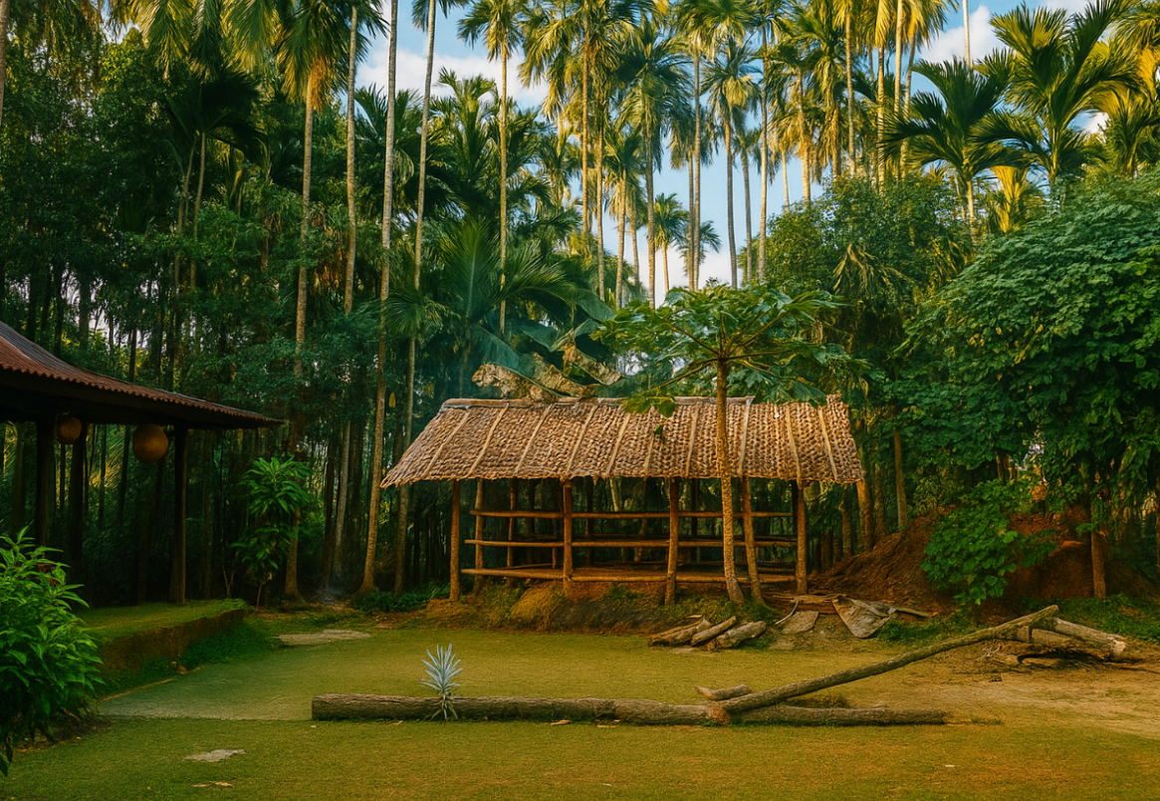
Figure 1: Traditional homegarden landscape in Assam (Sribhumi, erstwhile Karimganj district)

Homegardens, typically suited to warm climatic regions with adequate rainfall, are among the oldest forms of managed agroforestry systems and are characterized by high biological diversity (Kumar and Nair, 2004; Mohan et al., 2007). These systems are typically maintained using family labour, as the average size of homegardens is generally less than 0.5 hectares (Fernandes & Nair, 1986). However, Jeeceelee and Sahoo (2015) reported homegardens in Mizoram ranging from 0.025 to 1.5 hectares. In the Papum Pare district of Arunachal Pradesh, Zimik et al. (2012) documented 205 plant species in homegardens, a number considerably higher than the 57 species reported later by Tangjang and Arunachalam (2017). A similar variation was observed in the homegardens of Lakhimpur district, Assam, where Zimik et al. (2012) documented 230 species, compared to 46 species reported by Tangjang and Arunachalam (2017).

In the districts of Cachar, Hailakandi, and Karimganj in Assam, Das and Das (2005) documented as many as 161 plant species. In Kamrup district, 217 species were recorded by Goswami et al. (2011). A significantly higher diversity - 323 species - was observed in the homegardens of Golaghat and Jorhat districts, where Aquilaria malaccensis emerged as the dominant tree species (Saikia and Khan, 2014).

In Meghalaya, homegardens of the War Khasi community were found to harbor 197 species (Tynsong & Tiwari, 2010b), while 160 species were recorded from the southern region of the state (Tynsong & Tiwari, 2010a). Even degraded karst landscapes supported a diversity of 21 plant species (Bdoor, 2017). Across both Assam and Meghalaya, members of the family Arecaceae emerged as the most dominant among the documented flora (Devi & Das, 2010; Tynsong & Tiwari, 2011).

A study of homegardens of the Meitei community (a Manipuri tribe) in the Barak Valley of Assam documented 92 plant species across two villages, with Parkia timoriana and Areca catechu emerging as the dominant species (Devi & Das, 2010; 2013). In Manipur, the homegardens of the Lois community also exhibited considerable diversity, with 120 species recorded in Thoubal district and 55 species in Ukhrul district ( Maibam & Gupta, 2007; Salam et al., 2011).

In the traditional homegardens of Mizoram, a remarkable 351 plant species were documented by Sahoo and Pebam (2015). In Nagaland, Singh et al. (2014) recorded 122 species from Tanhai, 87 species from Mon and 45 species from Liangnyu. From Dzongu in Sikkim, Lepcha et al. (2019) reported 102 plant species. In Tripura, studies documented significant variation in species richness: 148 species were recorded by Das and Datta (2018a), with Leguminosae and Poaceae as the dominant families; 93 species were reported by Deb et al. (2014), and 69 species by Debbarma et al. (2015). A consolidated summary of the number of plant species documented in homegardens across various north-eastern states of India, as reported by different authors, is provided in Table 1.

Table1: Number of plant species recorded in various home gardens of North East India

State | Mean no. of plant species | Range | References
Arunachal Pradesh | 131.0±104.7 | 57 to 205 | Zimik et al. (2012), Tangjang and Arunachalam (2017)
Assam | 170.1±94.0 | 46 to 323 | Das and Das (2005), Devi and Das (2010), Zimik et al. (2012), Goswami et al. (2011),Saikia and Khan (2014), Das and Das (2015), Tangjang and Arunachalam (2017)
Manipur | 87.5±46.0 | 55 to 120 | Maibam and Gupta (2007), Salam et al. (2011)
Meghalaya | 178.5±26.2 | 160 to 197 | Tynsong and Tiwari (2010 a, b)
Mizoram | 342.0±12.7 | 333 to 351 | Sahoo and Pebam (2015), Barbhuiya et al. (2016)
Nagaland | 84.7±38.6 | 45 to 122 | Singh et al. (2014), Singh and Teron (2015)
Sikkim | 77.3±21.9 | 60 to102 | Sharma (2012), Lepcha et al. (2019)
Tripura | 103.3±40.5 | 69 to 148 | Deb et al. (2014), Debbarma et al. (2015),Das and Datta (2018a)

Bamboo is one of the dominant plant groups commonly found in homegardens across Northeast India. In agroforestry systems of Cachar district, Assam, the aboveground biomass carbon stock of bamboo has been estimated to range between 21.69 to 76.55 Mg ha⁻¹ (Nath and Das, 2012), with another study reporting an average of 34 Mg ha⁻¹ (Singnar et al., 2017). Homegardens also contribute significantly to soil productivity by facilitating atmospheric nitrogen fixation, enhancing soil moisture retention and reducing topsoil erosion (Nath et al., 2015). In Mizoram, homegardens were reported to have a soil organic carbon stock of up to 142.24 Mg ha⁻¹ (Singh & Sahu, 2021), highlighting their significant potential for carbon sequestration and soil health enhancement.

The contribution of homegardens to species conservation has been widely recognized in numerous studies. In the Meitei homegardens of Assam, species such as Meyna laxiflora, Parkia timoriana, and Toona ciliata are actively conserved for their specific uses and cultural significance (Devi and Das, 2017). In Tripura, the endangered medicinal climber Stephania glabra has been preserved in the homegardens of the Reang community (Das and Datta, 2018b). Similarly, the traditional beliefs and cultural practices of the Angami tribe in Nagaland have contributed to the in-situ conservation of floral resources within their homegardens (Singh and Teron, 2015). In Sikkim, homegardens have also been recognized as potential seed banks, playing a crucial role in the preservation of local plant genetic resources (Sharma et al., 2016b).

Homegardens have been recognized as important contributors to livelihood enhancement across various communities in Northeast India. Among the War Khasi community, homegardens generated an average annual gross income of ₹73,748 per hectare (Tynsong and Tiwari, 2010b). In a comparative study, Karbi and Mising homegardens were observed to be larger in size than those of immigrant communities, yet they yielded lower economic returns (Shrivastava and Heinen, 2005). Similarly, in Mizoram, smaller homegardens managed by immigrant households were found to produce higher yields per unit area (Pebam & Sahoo, 2018).
In Upper Assam, Aquilaria malaccensis is widely cultivated in homegardens, offering significant economic benefits with an average annual income of ₹1,14,393 (Saikia and Khan, 2014). In Mizoram, eight local species grown in homegardens were found to contribute over ₹10,000 annually each (Sahoo, 2009). Additionally, Alnus–cardamom agroforestry systems in Sikkim yielded higher annual economic returns compared to other systems (Sharma et al., 2016a), highlighting the income-generating potential of diversified homegarden-based agroforestry models.

The selection of species in homegardens is influenced by a variety of factors, including geographical conditions, garden size, traditional beliefs, financial status of the farmer, ethnicity, and economic needs (Singh and Sahoo, 2019). Women farmers in Mizoram play a crucial role in the domestication of wild plant species for both culinary and medicinal uses (Swain et al., 2020). Cultural preferences also shape species composition-for example, Kalita farmers in Assam prioritize cash crops like rice and areca nut, while farmers in Arunachal Pradesh show a preference for timber species (Tangjang and Arunachalam, 2017). In Mizoram, altitudinal variation was found to influence species dominance, with Parkia timoriana prevailing in higher altitudes and Areca catechu more common in lower elevations (Sahoo and Pebam, 2015).

In Assam, traditional agroforestry systems have been classified into ten distinct types, based on species composition as well as their cultural, regional, and economic significance. These include systems based on areca nut - coconut, Aquilaria, Livistonia, orange - lemon, eri-muga silkworm, multipurpose trees and vegetables, tea, bamboo-areca-betel, taungya, and Bombax-bamboo-Bridelia (Hazarika et al., 2001).

Homegardens also serve as repositories of ethnobotanical knowledge. In Western Assam, Talukdar and Gupta (2018) recorded 70 ethno-pharmacological plant species from the homegardens of the Garo community. In Mizoram, 54 ethno-medicinal plants were identified from agroforestry systems and homegardens (Rai and Lalramnghinglova, 2010). Similarly, in Nagaland, homegardens of the Angami tribe were found to host 84 wild edible plants with ethnobotanical significance (Singh and Teron, 2015).

Sacred Groves

Sacred groves are traditionally protected forest patches dedicated to local deities, ancestral spirits or other spiritual entities (Figure 2) and are safeguarded by indigenous communities owing to their deep religious, cultural and ecological significance (Malhotra et al., 2001). These groves are often regarded as tracts of near-virgin forest ecosystems (Khan et al., 2008), representing one of the oldest forms of community-based conservation in India. They not only embody spiritual reverence but also serve as repositories of biodiversity, supporting a wide array of endemic and threatened species. The size of sacred groves varies considerably, from as small as 0.01 hectares to as extensive as 900 hectares (Swamy et al., 1998), reflecting the heterogeneity of both ecological settings and cultural traditions that govern their protection. Functioning as living symbols of the interdependence between nature and culture, sacred groves provide insights into traditional ecological knowledge systems and highlight the role of cultural values in sustaining natural landscapes across generations. In many communities, restrictions on extraction, hunting, or tree felling within these groves ensure their continuity as reservoirs of biological diversity. Simultaneously, these groves function as cultural landmarks, reinforcing social identity and fostering collective responsibility for conservation. Given their dual role as ecological havens and cultural institutions, understanding their present status becomes essential.

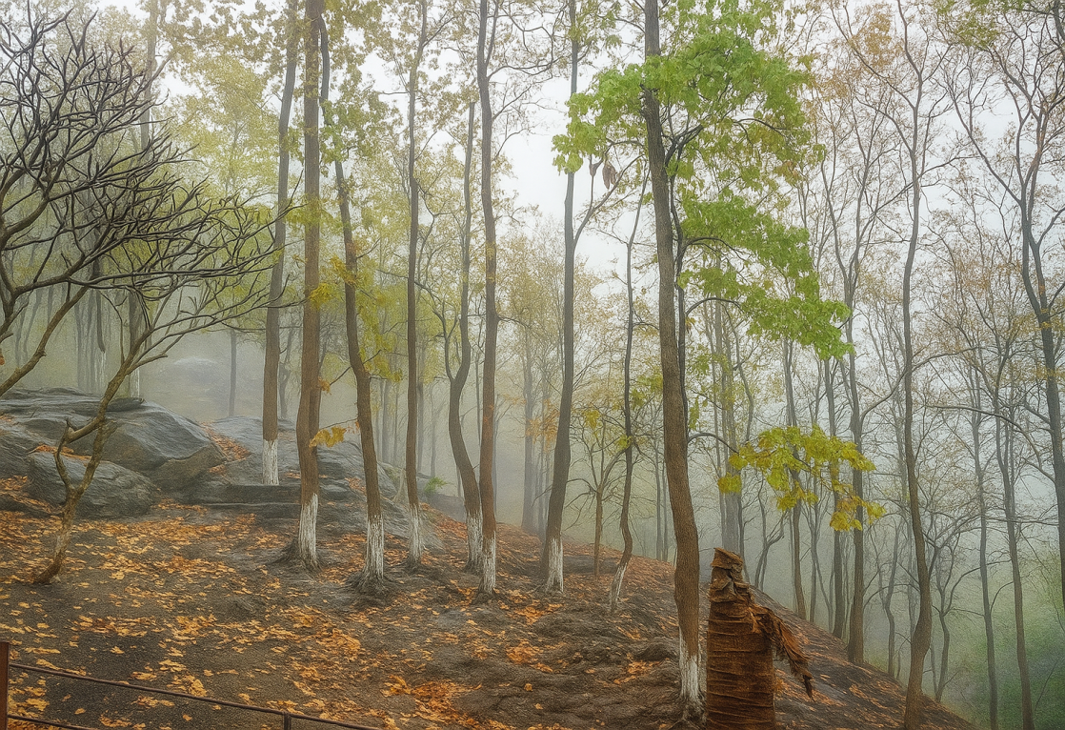
Figure 2: Traditional sacred grove landscape in Assam (Dirgheshwari, Kamrup M district)

The documentation of sacred groves, including their distribution, number, and local nomenclature is summarized in Table 2 and Table 3.

Table 2: Documentation of number of sacred groves

State | Number of Sacred groves/ places | Number of Districts covered | References
Arunachal Pradesh | 101 | 4 | Khan et al.(2008)
Arunachal Pradesh | 58 | 2 | Malhotra et al.(2001)
Arunachal Pradesh | 29 | 2 | Hui et al.(2016)
Assam | 12 | 1 | Medhi and Borthakur (2013)
Assam | 17 | 1 | https://www.cpreecenvis.nic.in
Assam | 40 | all | https://www.thenortheasttoday.com
Manipur | 365 | all | Devi (2000)
Manipur | 166 | 4 | Khumbongmayum et al.(2004)
Meghalaya | 79 | all | Tiwari et al.(2008)
Meghalaya | 101 | all | https://www.cpreecenvis.nic.in
Meghalaya | 56 | 1 | Mohanta et al.(2009)
Nagaland | 27 | all | Ao (2014)
Sikkim | 19 | all | FEWMD (2011)
Mizoram | No documentation on number of sacred groves was found
Tripura

Table 3: Nomenclature of sacred groves

State | Name of Sacred groves/ places | References
Arunachal Pradesh | Gumpa Forest Area (GFA) | Malhotra et al.(2001)
Arunachal Pradesh | Thaan | Barua (2009),Murtem and Chaudhry (2014), Chaudhry and Murtem (2015)
Arunachal Pradesh | Ranthii | Dutta et al. b(2017)
Arunachal Pradesh | Phu | Hui et al.(2016)
Assam | Thaan | Barua (2009)
Assam | Dikhos, Daikhos | Medhi and Borthakur (2013),Gogoi and Kikhi(2023)
Assam | Madaico | http://www.cpreecenvis.nic.in
Manipur | Lai Umang | Khumbongmayum et al.(2004)
Manipur | Gamkhap, Mauhak (sacred bamboo reserves) | https://www.thenortheasttoday.com
Meghalaya | Lao Lyngdoh, Lao Niam, Lao Kyntang | Syngai (1999),Khargongor and Tiwari (2017)
Meghalaya | KhlooBlai | Khargongor and Tiwari (2017)
Meghalaya | Asheng Khosi | Khargongor and Tiwari (2017)
Mizoram | Ngawpui | Amirthalingam (2014)
Mizoram | Mawmund | Malhotra (1990), Gokhale et al.(1998)
Sikkim | Devithans | Acharya and Ormsby (2017)
 | Pandam | https://www.thenortheasttoday.com
 | Gumpa forests | https://www.thenortheasttoday.com, Dash (2005)
Tripura | Groves of Darlong community | Darlong (2015)

Sacred groves play a vital role in maintaining the biodiversity of ecosystems (Amirthalingam, 2014). In the West Karbi Anglong district of Assam, 116 plant species were recorded from two sacred groves (Baidya et al., 2020a). In Manipur, Khumbongmayum et al. (2005a) documented 173 plant species, including 96 woody species, from four sacred groves. The Kabi sacred grove in Sikkim was reported to harbour 214 plant species (Dash, 2005), whereas 47 tree species were documented in the Unakoti sacred grove in Tripura (Banik et al., 2018). A floristic survey conducted by Tiwari et al. (2008) across 79 sacred groves in Meghalaya reported a remarkable 514 plant species. Another study in three sacred groves of Meghalaya identified 114 woody species (Upadhaya et al., 2008). Of the total plant species found in Meghalaya, 133 species (4%) are confined exclusively to sacred forests, including 96 endemic species (Khan et al., 1997). A consolidated summary of plant species diversity recorded in sacred groves across various northeastern states is presented in Table 4.

Table 4: Number of plant species recorded

States | Number of plant species recorded | References
Assam | 116 | Baidya et al. (2020a)
Manipur | 173 | Khumbongmayum et al. (2005a)
Meghalaya | 210.95±118.35  (ranges from 63 to 738) | Khan et al. (1997),Jamir and Pandey (2003), Upadhaya etal.(2003),Upadhaya et al. (2008), Tiwari et al.(2008),Mohanta et al. (2009),Marbaniang et al. (2024)
Sikkim | 214 | Dash (2005)
Tripura | 47 | Banik et al. (2018)

The aboveground biomass carbon stock in the Phayeng sacred grove in Manipur was reported to range between 962.94 to 1130.79 Mg ha⁻¹, indicating a remarkably high carbon storage potential (Waikhom et al., 2017). In comparison, carbon stock in three subtropical natural forests of Manipur ranged from 81.17 to 118.24 Mg ha⁻¹ (Thokchom and Yadava, 2013). The markedly higher carbon stocks in sacred groves compared to unprotected natural forests highlight both the ecological significance of culturally protected forest patches and the effective conservation role played by local communities.

Sacred groves are widely recognized as a traditional, religiously rooted form of in situ conservation (Choudhury et al., 2007). However, in the absence of formal legal protection, they remain highly susceptible to anthropogenic pressures. Resource extraction and encroachment by local communities have been identified as major threats to the effective management of sacred forests, as highlighted by Banik et al. (2018). To address these challenges, Jeeva et al. (2006) recommended the establishment of a protected network of sacred groves in Meghalaya to ensure their long-term conservation. Traditional ecological knowledge has been instrumental in shaping local strategies for natural resource use and management (Rai, 2007), as well as in broader environmental conservation efforts (Barua, 2009).

In Assam, 38 ethnomedicinal plant species have been documented from sacred groves (Baidya et al., 2020b). In Manipur, 120 medicinal plant species were recorded, predominantly from the families Asteraceae, Verbenaceae, Moraceae, Mimosaceae and Anacardiaceae (Khumbongmayum et al., 2005b). Among these, leaves were found to be the most commonly used plant part in traditional healing practices by Maibas and Maibis (traditional healers). In Meghalaya, 80 ethnomedicinal species were recorded from the Khasi Hills and 25 from the Garo Hills (Laloo et al., 2006; Mohanta et al., 2009).
Sacred groves represent an important in situ conservation strategy, safeguarding both biodiversity and cultural values ​​within the religio-cultural frameworks of indigenous communities. However, these groves are increasingly threatened by anthropogenic pressures, including timber extraction, hunting, and resource exploitation driven by economic and commercial demands. Additionally, the rituals and cultural traditions associated with sacred groves are gradually eroding as communities shift from subsistence-based to urbanized and market-oriented economies.
Addressing these challenges necessitates socio-ecological system–specific approaches to the protection and management of sacred groves across all eight northeastern states. Such strategies are vital for maintaining both the ecological integrity and the cultural heritage embedded within these traditional conservation spaces.

Village Community Forests

Village community forests are fragmented patches of natural forests that are conserved, protected, and collectively managed by local communities in rural areas to meet ecological and livelihood needs.These forests have been referred to by various names in literature, including ‘community forests’ (Tiwari et al., 2013), ‘patch vegetations’ (Dutta et al., 2017a), ‘village forests’, ‘family forests’ (Nath et al., 2018), ‘bamboo forests’ (Nath et al., 2018) and ‘floodplain forests’ (Nath et al., 2017). In Assam (Figure 3), they are locally known as Kathonibari (Dutta et al., 2017a).

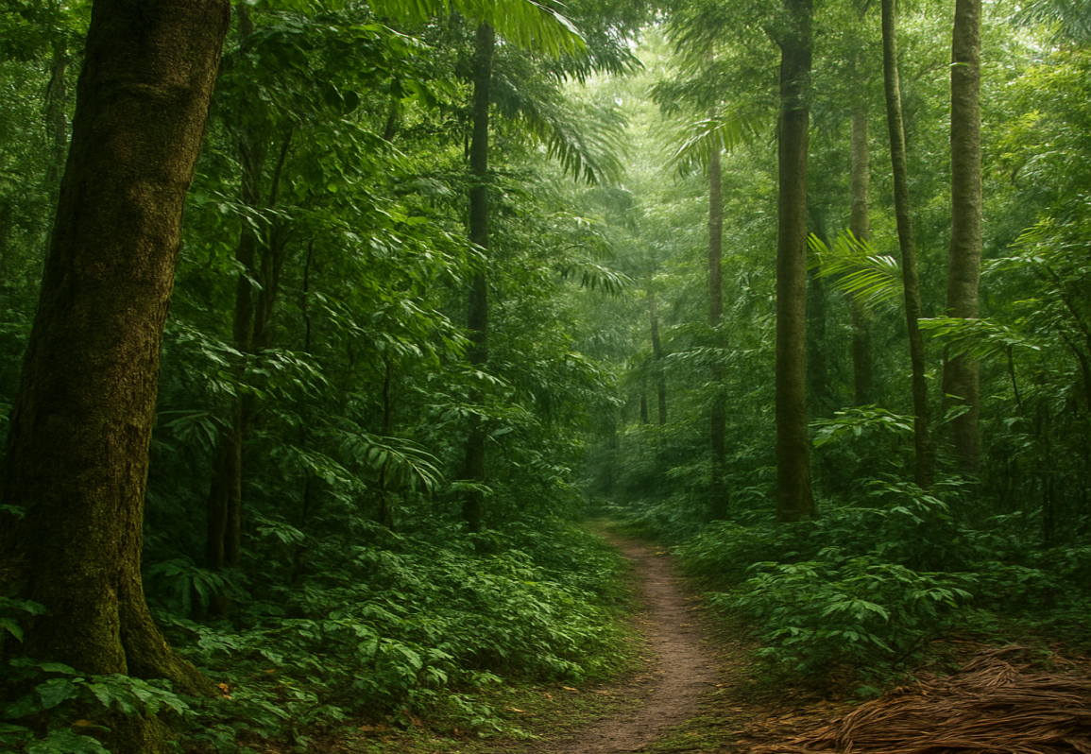
Figure 3: Patch vegetation in Assam (Dibrugarh district)

In Jorhat district of Assam, a total of 432 plant species were recorded in these forests, including notable species such as Terminalia myriocarpa, Aquilaria malaccensis, Dillenia indica and various bamboo species (Dutta, 2013). The biomass carbon stock in bamboo-dominated patches of Barak Valley, Assam, was estimated to range between 16.38 to 38.42 Mg ha⁻¹ (Nath et al., 2018). These bamboo patches are traditionally managed by local communities due to their socio-economic significance in biomass production and their co-benefits for climate change mitigation (Nath et al., 2018).

In Meghalaya, community forests have been effectively protected through traditional management systems, supported by hierarchical institutional arrangements within local tribal societies. However, in Mizoram, traditional institutions have largely been replaced by modern governance structures (Tiwari et al., 2013).

Additionally, community patch vegetation in Upper Assam, particularly around Jorhat, are noted for their rich ethnomedicinal diversity. About 84 medicinal plant species with preventive and curative properties - including Albizia lebbeck, Alstonia scholaris, Aquilaria malaccensis, and Paedaria foetida - were recorded in forest patches (Dutta, 2013). These systems also contribute to rural livelihoods, with an average annual income of ₹16,411 generated from the sale of fuelwood, bamboo, and cane (Dutta, 2013).

4. BIBLIOMETRIC ANALYSIS
A total of 142 research publications related to Trees Outside Forests (TOFs) in eight states of Northeast India were identified during the review. The temporal distribution of publications indicates a steady upward trajectory from 1990 to 2025, suggesting a growing academic and policy interest in TOFs in the region (Figure 4). Among the northeastern states, Among the northeastern states, Assam contributed the highest number of publications (43; 30.3%), followed by Meghalaya (30; 21.1%), Mizoram (17; 12.0%), Manipur (14; 9.9%), Tripura (13; 9.2%), Arunachal Pradesh (11; 7.7%), Sikkim (10; 7.0%) and Nagaland (4; 2.8%).This distribution highlights the uneven spatial focus of TOF-related research, with certain states such as Assam and Meghalaya being comparatively well-documented, while others such as Nagaland remain significantly underrepresented.
In terms of thematic focus, homegardens accounted for the largest share of publications (73; 48.0%), followed by sacred groves (62; 40.8%) and village community forests (VCFs) (6; 3.9%). This clearly indicates the predominant interest of researchers in traditional land-use systems, particularly homegardens and sacred groves, which are recognized as repositories of biodiversity, sources of household sustenance, and custodians of cultural-ecological values. In contrast, VCFs remain a relatively underexplored domain in the literature, despite their importance in community-based resource management and collective forest governance.
Overall, the bibliometric trends reflect an increasing recognition of TOFs as critical socio-ecological systems in Northeast India. However, the pronounced spatial and thematic disparities point to the need for future research in less-studied states and landscapes. In particular, systematic investigations into community-managed forests and comparative analyzes across states could provide a more balanced and comprehensive understanding of the ecological, cultural, and livelihood dimensions of TOFs in the region.

Figure 4: Year wise number of publications (1990-2025)

5. CONCLUSION

Trees Outside Forests (TOFs) in Northeast India hold immense ecological, socio-economic and cultural significance and warrant comprehensive study in their entirety. This review of TOFs from both ecological and socio-economic perspectives provides valuable insights into their diversity, structure, and functionality across the region, while also identifying critical research gaps. The variation in TOF composition and species selection across different communities reflects the region’s diverse ecological settings and socio-cultural contexts.

However, the biodiversity of natural TOFs is reported to be in decline (Upadhyay et al., 2019), primarily due to the increasing prevalence of introduced TOFs involving cash crops and monoculture plantations such as tea, areca nut, coffee, and rubber. This underscores the urgent need to conserve the native biodiversity associated with TOFs through a socio-ecological system-specific approach. TOFs act as reservoirs of endemic, rare and endangered species, playing a crucial role in maintaining the ecological balance of the region.

Despite increasing research efforts, significant gaps persist. Most studies are concentrated in Assam and Meghalaya, leaving other states such as Nagaland, Tripura, Arunachal Pradesh and Sikkim underrepresented. Quantitative data on carbon storage, biomass and ecosystem services remain scarce, while comparative analysis across TOF types and communities are limited. Socio-economic aspects, including livelihood dependence, gender roles and economic valuation are inadequately addressed. Moreover, greater integration of traditional ecological knowledge with scientific research, along with critical assessment of policy influences, is essential to guide sustainable TOF management in the region.

Future research should aim to bridge the existing spatial and thematic gaps identified in this review through comparative studies across all eight northeastern states, assessing ecosystem services, carbon sequestration potential and socio-economic benefits of different TOF systems. Interdisciplinary studies integrating ecological, economic and cultural dimensions can inform sustainable management frameworks and long-term conservation. TOFs in addition to other forest areas together play a critical role in supporting biodiversity, enhancing carbon storage and providing benefits to local communities. Potential areas for further study include evaluating TOFs’ role in climate change mitigation, mapping species diversity and distribution, understanding traditional management practices and assessing their contribution to rural livelihoods and ecosystem services. Recognizing TOFs as integral socio-ecological systems and adopting a holistic, participatory approach to their management is therefore crucial for biodiversity conservation, climate resilience, and sustainable rural development in Northeast India.

Disclaimer (Artificial intelligence)
Option 1:
Author(s) hereby declare that NO generative AI technologies such as Large Language Models (ChatGPT, COPILOT, etc.) and text-to-image generators have been used during the writing or editing of this manuscript.
Option 2:
Author(s) hereby declare that generative AI technologies such as Large Language Models, etc. have been used during the writing or editing of manuscripts. This explanation will include the name, version, model, and source of the generative AI technology and as well as all input prompts provided to the generative AI technology
Details of the AI usage are given below:
1.
2.
3.

REFERENCES
Acharya, A., & Ormsby, A. (2017). The cultural politics of sacred groves: A case study of Devithans in Sikkim, India. Conservation and Society, 15(2), 232–242. https://doi.org/10.4103/cs.cs_14_29
Amirthalingam, M. (2014). Mizoram. In N. Krishna & M. Amirthalingam (Eds.), Sacred groves of India: A compendium (pp. 323–326). C.P.R. Environmental Education Centre. https://doi.org/10.20546/ijcrbp.2016.304.011
Ao, L. (2014). Deforestation in Nagaland: A historical perspective (Ph.D. thesis). Nagaland University, Lumami, Zunheboto, 151 pp.
Baidya, S., Thakur, B., Malunguja, G., & Devi, A. (2020a). Changes of land use land cover and floristic composition in sacred forests of West Karbi Anglong district, Assam, India. Tropical Plant Research, 7(2), 296–308. https://doi.org/10.22271/tpr.2020.v7.i2.035
Baidya, S., Thakur, B., & Devi, A. (2020b). Ethnomedicinal plants of the sacred groves and their uses by Karbi tribe in Karbi Anglong district of Assam, Northeast India. Indian Journal of Traditional Knowledge, 19(2), 277–287.
Banik, B., Majumdar, K., Baishnab, B., & Datta, B.K. (2018). Impact of tourism on forest habitat surrounding in Unakoti: An important archaeological site of Tripura, North-East India. Research & Reviews: A Journal of Life Science, 8(3), 50–66.
Barua, I. (2009). Conservation and management of community and natural resources: A case study from North East India. Studies of Tribes and Tribals, 7(1), 39–46.
Barbhuiya, A.R., Sahoo, U.K., & Upadhyaya, K. (2016). Plant diversity in the indigenous home gardens in the Eastern Himalayan region of Mizoram, Northeast India. Economic Botany, 70(2), 115–131. https://doi.org/10.1007/s12231-016-9349-8
Bdoor, B.S. (2017). Tree diversity in homegarden land use of Mawsmai Village Karst Landscape, Meghalaya, Northeast India. International Journal of Environmental, Ecological, Family and Urban Studies, 7(3), 33–42.
Chaudhry, P., & Murtem, G. (2015). Role of sacred groves, value education and spirituality in conserving biodiversity with special reference to Arunachal Pradesh state of India. International Journal of Society Systems Science, 7(2), 151. https://doi.org/10.1504/IJSSS.2015.069736
Choudhury, H., Goswami, S., & Kumaria, S. (2007). Sacred groves of Meghalaya: A religious way of in situ conservation. In P. Tandon, Y.P. Abrol, & S. Kumaria (Eds.), Biodiversity and its significance (pp. 218–232). I.K. International Publishers, New Delhi.
CPR Environmental Education Centre. (n.d.). CPREEC ENVIS Centre on conservation of ecological heritage and sacred sites of India. Retrieved September 18, 2025, from http://www.cpreecenvis.nic.in
Darlong, B. (2015). Sacred groves: A study of the religious beliefs of the Darlong community in Tripura. Chitralekha International Magazine on Art and Design, 5(1), 147–156.
Das, D., & Datta, B.K. (2018a). An assessment of plant diversity in home gardens of Reang community of Tripura. Pleione, 12(2), 208–222. https://doi.org/10.26679/Pleione.12.2.2018.208-222
Das, D., & Datta, B.K. (2018b). New distributional record of Stephania glabra (Roxb.) Miers (Menispermaceae) in Tripura, India and its domestication in Reang home-gardens. Pleione, 12(2), 337–340. https://doi.org/10.26679/Pleione.12.2.2018.337-340
Das, T., & Das, A.K. (2005). Inventorying plant biodiversity in homegardens: A case study in Barak Valley, Assam, North East India. Current Science, 89(1), 155–163.
Dash, S.S. (2005). Kabi sacred grove of North Sikkim. Current Science, 89(3), 427–428.
Das, T., & Das, A.K. (2015). Conservation of plant diversity in rural homegardens with cultural and geographical variation in three districts of Barak Valley, Northeast India. Economic Botany, 69(1), 57–71. https://doi.org/10.1007/s12231-015-9299-6
Deb, S., Sarkar, A., Deb, D., & Majumdar, K. (2014). Community structure, biodiversity value and management practices of traditional agroforestry systems in Tripura, North East India. Journal of Biodiversity Management and Forestry, 3(3), 1–6. http://dx.doi.org/10.4172/2327-4417.1000129
Debbarma, J., Deb, D., & Deb, S. (2015). Tree diversity and sociocultural significance of homegardens in the Baramura range, Tripura, North-east India. Forest Trees and Livelihoods, 25(1), 33–40. https://doi.org/10.1080/14728028.2015.1076357
Devi, N.L., & Das, A.K. (2017). Plant biodiversity conservation through traditional use and cultivation in Meitei home-gardens in Barak Valley of Assam, India. Pleione, 11(2), 277–289. https://doi.org/10.26679/Pleione.11.2.2017.277-289
Devi, N.L., & Das, A.K. (2010). Plant species diversity in the traditional homegardens of Meitei community: A case study from Barak Valley, Assam. Journal of Tropical Agriculture, 48(1-2), 45–48.
Devi, S. (2000). Sacred groves of Manipur. In Proceedings of National Workshop on Community Strategies on the Management of Natural Resources. Indira Gandhi Rashtriya Manav Sanghralaya, Bhopal.
Dutta, D. (2013). A study on the biodiversity of the plant resources of the patch vegetations around rural homestead in Jorhat district, Assam and its role in socio-economy of the villagers. Project Completion Report, Rain Forest Research Institute, Jorhat, 53 pp.
Dutta, D., Hazarika, P., & Hazarika, P. (2017a). Wild edible plant species in patch vegetations of Jorhat district, Assam, India. International Research Journal of Biological Sciences, 6(3), 14–25.
Dutta, J., Muang, O., Balasubramanian, D., Pangging, G., & Arunachalam, A. (2017b). Sacred groves of Ziro Valley dominated by Apatani tribes in Arunachal Pradesh. Indian Journal of Hill Farming, 30(1), 132–138.
Fernandes, E.C.M., & Nair, P.K.R. (1986). An evaluation of the structure and function of tropical homegardens. Agricultural Systems, 21(4), 279–310. https://doi.org/10.1016/0308-521X(86)90104-6
Forest, Environment and Wildlife Management Department (FEWMD), Government of Sikkim. (2011). Sacred groves of Sikkim. Government of Sikkim, Gangtok.
Food and Agriculture Organization of the United Nations. (1998). FRA 2000 terms and definitions, Forest Resources Assessment Working Paper 1. FAO Forestry Department.
Forest Survey of India. (2019). State of Forest Report. Ministry of Environment and Forests, Government of India, Dehradun.
Forest Survey of India. (2021). State of Forest Report. Ministry of Environment and Forests, Government of India, Dehradun.
Gogoi, P.P., &Kikhi, K. (2023). Conserving human-nature nexuses: Biodiversity, eco-ethics and sacred forests of Assam. Social Change and Development, 20(1), 1–16.
Gokhale, Y., Velankar, R., Subash Chandran, M.D., & Gadgil, M. (1998). Sacred woods, grasslands and waterbodies as self-organized systems of conservation. In P.S. Ramakrishnan, K.G. Saxena, & U.M. Chandrashekara (Eds.), Conserving the sacred for biodiversity management (pp. 365–398). Oxford and IBH Publishing Co., New Delhi.
Goswami, N.K., Saharia, D., & Kar, A. (2011). Homestead gardens diversity of a watershed development project area in Kamrup District, Assam. Pleione, 5(1), 32–42.
Hazarika, P., Tripathi, Y.C., &Zhasa, N.N. (2001). Indigenous and traditional agroforestry in Assam. In B.P. Bhatt, K.M. Bujarbaruah, Y.P. Sharma, &Patiram (Eds.), Proceedings of the National Seminar on Approaches for Increasing Agricultural Productivity in Hill and Mountain Ecosystem (pp. 149–152). ICAR Research Complex for NEH Region, Umiam, Meghalaya.
Hui, T., Hui, P.K., Gogoi, B.J., Tam, N., & Tsering, J. (2016). Phu: High altitude sacred grove in the Monpa cultural landscape of West Arunachal Pradesh (Eastern Himalaya). Journal of Bioresources, 3(2), 28–32.
Jamir, S.A., & Pandey, H.N. (2003). Vascular plant diversity in the sacred groves of Jaintia Hills in northeast India. Biodiversity and Conservation, 12(7), 1497–1510. https://doi.org/10.1023/A:1023682228549
Jeeceelee, L., & Sahoo, U.K. (2015). Plant diversity and vegetation structure in differently sized home gardens of Mizoram, India. International Journal of Research in Agricultural Sciences, 2(5), 229–235.
Jeeva, S., Mishra, B.P., Venugopal, N., & Laloo, R.C. (2006). Traditional knowledge and biodiversity conservation in the sacred groves of Meghalaya. Indian Journal of Traditional Knowledge, 5(4), 563–568.
Kaushik, P.K., & Saha, P. (2020). Home herbal garden for promotion of herbal health care system in Tripura. In S. Sen & R. Chakraborty (Eds.), Herbal medicine in India (pp. 89–100). Springer, Singapore. https://doi.org/10.1007/978-981-13-7248-3_7
Khan, M.L., Khumbongmayum, A.D., & Tripathi, R.S. (2008). The sacred groves and their significance in conserving biodiversity: An overview. International Journal of Ecology and Environmental Sciences, 34(3), 277–291.
Khan, M.L., Menon, S., & Bawa, K.S. (1997). Effectiveness of the protected area network in biodiversity conservation: A case-study of Meghalaya state. Biodiversity and Conservation, 6, 853–868. https://doi.org/10.1023/B:BIOC.0000010406.35667.c0
Kharkongor, B.M., & Tiwari, B.K. (2017). Sacred groves of Meghalaya: A review. International Journal of Scientific Research, 6(3), 346–349.
Khumbongmayum, A.D., Khan, M.L., & Tripathi, R.S. (2004). Sacred groves of Manipur—ideal centres for biodiversity conservation. Current Science, 87(4), 430–433.
Khumbongmayum, A.D., Khan, M.L., & Tripathi, R.S. (2005a). Sacred groves of Manipur, northeast India: Biodiversity value, status and strategies for their conservation. Biodiversity and Conservation, 14, 1541–1582. https://doi.org/10.1007/s10531-004-0530-5
Khumbongmayum, A.D., Khan, M.L., & Tripathi, R.S. (2005b). Ethnomedicinal plants in the sacred groves of Manipur. Indian Journal of Traditional Knowledge, 4(1), 21–32.
Kumar, B., & Nair, P. (2004). The enigma of tropical homegardens. Agroforestry Systems, 61, 135–152. https://doi.org/10.1023/B:AGFO.0000028995.13227.ca
Laloo, R.C., Kharlukhi, L., Jeeva, S., & Mishra, B.P. (2006). Status of medicinal plants in the disturbed and the undisturbed sacred forest of Meghalaya, Northeast India: Population structure and regeneration efficacy of some important species. Current Science, 90(2), 225–231.
Lepcha, D.L., Shukla, G., Chakravarty, S., Vineeta, V., Sarkar, B.C., Manohar, K., Pala, N.A., Chettri, R., & Tamang, M. (2019). Ethno-botanical plant diversity in home gardens based agroforestry system in Kanchendzonga Biosphere Reserve, Sikkim, India. Journal of Tree Sciences, 38(2), 59–69.
Maibam, R.S., & Gupta, A. (2007). Home gardens of Kakching, Manipur—A diverse and sustainable agroecosystem. Journal of Economic and Taxonomic Botany, 31(2), 402–410.
Malhotra, K.C. (1990). Supply and safety forests in Mizoram. In Proceedings of the Vth International Conference on Ecological Sciences (p. 439). Yokohama.
Malhotra, K.C., Gokhale, Y., Chatterjee, S., & Srivastava, S. (2001). Cultural and ecological dimensions of sacred groves in India. Indian National Science Academy, New Delhi, and Indira Gandhi Rashtriya Manav Sangrahalaya, Bhopal, 30 pp.
Marbaniang, K.W., Narzary, D., & Kumar, H. (2024). Ecological attributes of sacred groves in West Khasi Hills, Meghalaya, India. Current World Environment, 19(3), 1333–1344. https://dx.doi.org/10.12944/CWE.19.3.24
Medhi, P., & Borthakur, S.K. (2013). Sacred groves and sacred plants of the Dimasas of North Cachar Hills of Northeast India. African Journal of Plant Science, 7(2), 67–77. https://dx.doi.org/10.5897/AJPS12.038
Mohan, S., Nair, P.K.R., & Long, A.J. (2007). An assessment of ecological diversity in homegardens: A case study from Kerala State, India. Journal of Sustainable Agriculture, 29(4), 135–153. https://doi.org/10.1300/J064v29n04_10
Mohanta, R.K., Bhardwaj, A.K., Adhikari, B.S., & Mathur, P.K. (2009). Distribution and conservation status of sacred groves in Garo hills, Meghalaya. Indian Forester, 135(12), 1627–1649.
Murtem, G., & Chaudhry, P. (2014). Sacred groves of Arunachal Pradesh: Traditional way of biodiversity conservation in Eastern Himalaya of India. Journal of Biodiversity Management and Forestry, 3(2), 1–14. https://doi.org 10.4172/2327-4417.1000125
Nath, A.J., & Das, A.K. (2012). Carbon pool and sequestration potential of village bamboos in the agroforestry system of northeast India. Tropical Ecology, 53(3), 287–293.
Nath, A.J., Lal, R., & Das, A.K. (2015). Ethnopedology and soil properties in bamboo (Bambusa sp.) based agroforestry system in North East India. Catena, 521–522, 372–379. https://doi.org/10.1016/j.catena.2015.07.001
Nath, A.J., Sileshi, G.W., & Das, A.K. (2018). Bamboo based family forests offer opportunities for biomass production and carbon farming in North East India. Land Use Policy, 75(C), 191–200. https://doi.org/10.1016/j.landusepol.2018.03.041
Nath, S., Nath, A.J., Sileshi, G.W., & Das, A.K. (2017). Biomass stocks and carbon storage in Barringtonia acutangula floodplain forests in North East India. Biomass and Bioenergy, 98, 37–42. https://doi.org/10.1016/j.biombioe.2017.01.014
Pebam, R., & Sahoo, U.K. (2018). Traditional homegardens of Mizoram and their socio-economic development. In K.K. Sood & V. Mahajan (Eds.), Forests, climate change and biodiversity (pp. 102–126). Kalyani Publishers, New Delhi.
Rai, S.C. (2007). Traditional ecological knowledge and community-based natural resource management in northeast India. Journal of Mountain Science, 4, 248–258. https://doi.org/10.1007/s11629-007-0248-4
Rai, P.K., & Lalramnghinglova, H. (2010). Ethnomedicinal plants from agroforestry systems and home gardens of Mizoram, North East India. School of Earth Sciences and Natural Resource Management, Mizoram University.
Roy, P., & Arunachalam, A. (2014). Socioeconomic relevance of homegardens in the fringe villages of Clouded Leopard National Park. Journal of Environmental Biology-Sciences, 28(2), 311–314.
Sahoo, U.K., & Pebam, R. (2015). Species composition and plant diversity as influenced by altitude and size of homegardens in Mizoram, North-East India. International Journal of Ecology and Environmental Sciences, 41(3–4), 195–215.
Sahoo, U.K. (2009). Traditional home gardens and livelihood security in North-East India. Journal of Food, Agriculture and Environment, 7(2), 665–670.
Sahoo, U.K., Vanlalhluna, P.C., & Singh, S. (2018). Indigenous technologies and local climate change adaptation practices around East Kawlchaw Watershed, Saiha, Mizoram: A case study. In J. Zothanzama, B.L. Saitluanga, Lalnuntluanga, S.T. Lalzarzovi, & R. Zonunsanga (Eds.), Climate change: Impact, adaptation & response in the Eastern Himalayas (pp. 28–39). Excel India Publishers, New Delhi.
Saikia, P., & Khan, M.L. (2014). Homegardens of upper Assam, northeast India: A typical example of on-farm conservation of Agarwood (Aquilaria malaccensis Lam.). International Journal of Biodiversity Science, Ecosystem Services and Management, 10(4), 262–269. https://doi.org/10.1080/21513732.2014.973449
Salam, S., Singh, P.K., & Jamir, N.S. (2011). Kitchen garden plants of Tangkhul tribe in Ukhrul District, Manipur, India. Pleione, 5(2), 280–285.
Sarma, J.K. (2015). The benefits of a ‘bari’. Nezine, Issue 2, September.
Sharma, G. (2012). Climate change and sustainability of traditional farming systems in Sikkim Himalaya, India. In K.G. Saxena, L. Luohui, K. Tanaka, & S. Takahashi (Eds.), Land management in marginal mountain regions: Adaptation and vulnerability to global change (p. 349). United Nations University, Tokyo, Japan.
Sharma, G., Hunsdorfer, B., & Singh, K.K. (2016a). Comparative analysis on the socio-ecological and economic potentials of traditional agroforestry systems in the Sikkim Himalaya. Tropical Ecology, 57(4), 751–764.
Sharma, G., Partap, U., Sharma, E., Rasul, G., & Awasthe, R.K. (2016b). Agrobiodiversity in the Sikkim Himalaya: Sociocultural significance, status, practices, and challenges. ICIMOD Working Paper 2016/5. ICMOD, Kathmandu, Nepal, and The Mountain Institute, Gangtok, India, 55 pp.
Shrivastava, R.J., & Heinen, J.T. (2005). Migration and home gardens in the Brahmaputra Valley, Assam, India. Journal of Ecological Anthropology, 9(1), 20–34.
Singh, A.B., & Teron, R. (2015). Diversity of wild edible plants used by the Angami-Nagas in Kohima District of Nagaland, India. Pleione, 9(2), 311–324.
Singh, A.K., Arunachalam, A., Ngachan, S.V., Mohapatra, K.P., & Dagar, J.C. (2014). From shifting cultivation to integrated farming: Experience of agroforestry development in the Northeastern Himalayan Region. In J.C. Dagar, A.K. Singh, & A. Arunachalam (Eds.), Agroforestry systems in India: Livelihood security and ecosystem services (pp. 70–78). Springer India. https://doi.org/10.1007/978-81-322-1662-9_3
Singh, L.S., & Sahoo, U.K. (2021). Tree species composition, diversity and soil organic carbon stock in homegardens and shifting cultivation fallows of Mizoram, Northeast India. International Journal of Plant Research, 34, 220–228. https://doi.org/10.1007/s42535-021-00194-1
Singh, S., & Sahoo, U.K. (2019). Socio-economic and demographic factors influencing farmers’ decision on homegarden management practices and carbon storage in Mizoram, Northeast India. International Journal of Ecology and Environmental Sciences, 45(1), 59–69.
Singnar, P., Das, M.C., Sileshi, G.W., Brahma, B., Nath, A.J., & Das, A.J. (2017). Allometric scaling, biomass accumulation and carbon stocks in different aged stands of thin-walled bamboos Schizostachyum dullooa, Pseudostachyum polymorphum and Melocanna baccifera. Forest Ecology and Management, 395, 81–91. https://doi.org/10.1016/j.foreco.2017.04.001
Swain, S., Chakrabarty, S., Zomuankima, & Vanlalhmangaia. (2020). Domestication of wild plant diversity in home gardens for culinary and curative use by the tribal women farmers in Mizoram, India. Biodiversity International Journal, 4(4), 155–159.
Swamy, P.S., Sundarpandian, S.M., & Chandrasekaharan, S. (1998). Sacred groves of Tamil Nadu. In P.S. Ramakrishnan, K.G. Saxena, & U.M. Chandrasekhar (Eds.), Conserving the sacred for biodiversity management (pp. 357–361). UNESCO and Oxford-IBH Publishing, New Delhi.
Syngai, D. (1999). Sacred groves of Meghalaya. In B. Kharbuli, D. Syiem, & H. Kayang (Eds.), Biodiversity: Northeast India perspectives (pp. 70–76). North Eastern Biodiversity Research Cell, North–Eastern Hill University, Shillong.
Talukdar, S., & Gupta, A. (2018). Ethnomedicinal knowledge of the Garo community of two villages in western Assam, India. Journal of Herbal Medicine, 20, 100–229. https://doi.org/10.1016/j.hermed.2018.08.004
Tangjang, S., & Arunachalam, A. (2017). Traditional homegardens in rural landscapes of Northeast India – A model for conserving plant species for sustainability. Indian Journal of Hill Farming, 30(2), 313–325.
The Northeast Today. (n.d.). Northeast Today. Retrieved September 18, 2025, from https://www.thenortheasttoday.com
Thokchom, A., & Yadava, P.S. (2013). Biomass and carbon stock assessment in the sub-tropical forests of Manipur, North East India. International Journal of Ecology and Environmental Sciences, 39(2), 107–113.
Tiwari, B.K., Barik, S.K., & Tripathi, R.S. (2008). Biodiversity value, status, and strategies for conservation of sacred groves of Meghalaya, India. Ecosystem Health, 4(1), 20–32. https://doi.org/10.1046/j.1526-0992.1998.00068.x
Tiwari, B.K., Tynsong, H., Lynrah, M.M., Lapasam, E., Deb, S., & Sharma, D. (2013). Institutional arrangement and typology of community forests of Meghalaya, Mizoram and Nagaland of North-East India. Journal of Forest Research, 24, 179–186. https://doi.org/10.1007/s11676-013-0337-x
Tynsong, H., & Tiwari, B.K. (2011). Diversity and population characteristics of woody species in natural forests and arecanut agroforests of south Meghalaya, Northeast India. Tropical Ecology, 52(3), 243–252.
Tynsong, H., & Tiwari, B.K. (2010a). Diversity of plant species in arecanut agroforests of south Meghalaya, north-east India. Journal of Forest Research, 21, 281–286. Tynsong, H., Tiwari, B.K. Diversity of plant species in arecanut agroforests of south Meghalaya, north-east India. Journal of Forestry Research 21, 281–286 (2010). https://doi.org/10.1007/s11676-010-0072-5
Tynsong, H., & Tiwari, B.K. (2010b). Plant diversity in the homegardens and their significance in the livelihoods of War Khasi community of Meghalaya, North-east India. Journal of Biodiversity, 1(1), 1–11.
Upadhaya, K., Barik, S., Pandey, H.N., & Tripathi, O.P. (2008). Response of woody species to anthropogenic disturbances in sacred forests of Northeast India. International Journal of Ecology and Environmental Sciences, 34(1), 1–13.
Upadhyaya, K., Pandey, H.N., Law, P.S., & Tripathi, R.S. (2003). Tree diversity in sacred groves of the Jaintia Hills in Meghalaya, northeast India. Biodiversity and Conservation, 12(3), 583–597. https://doi.org/10.1023/A:1022401012824
Upadhyay, K.K., Japang, B., Singh, N.S., & Tripathi, S.K. (2019). Status and socio-ecological dimensions of sacred groves in North east India. Journal of Applied and Natural Science, 11(3), 590–596.
Waikhom, A.C., Nath, A.J., & Yadava, P.S. (2017). Aboveground biomass and carbon stock in the largest sacred grove of Manipur, Northeast India. Journal of Forest Research, 29, 425–428. https://doi.org/10.1007/s11676-017-0439-y
Zimik, L., Saikia, P., & Khan, M.L. (2012). Comparative study on homegardens of Assam and Arunachal Pradesh in terms of species diversity and plant utilization pattern. Research Journal of Agricultural Sciences, 3(3), 611–618.

