Original Research Article

Hydrogeochemical Assessment and Irrigation Suitability of Groundwater in Banaskantha’s Vegetation Zone, India

Abstract
Groundwater is the primary source of water for domestic and agricultural needs in the semi-arid Banaskantha district of Gujarat, India. This study presents a comprehensive hydrogeochemical analysis of 207 groundwater samples collected from the vegetation zone in 2021 during the post-monsoon season. pH, EC, TDS, TH, Ca²⁺, Mg²⁺, Na⁺, K⁺, Cl⁻, SO₄²⁻, HCO₃⁻, CO₃²⁻, NO₃⁻, and F⁻ were among the physicochemical parameters that were examined and contrasted with BIS and WHO standards. The majority of the samples have high salinity, excessive hardness, and high levels of carbonate and chloride, according to the results, making the water mostly unfit for human consumption. Rock-water interactions, evaporation, and human inputs have modified the hydrochemical facies characterised by Piper and Durov diagrams, which show the dominance of Ca–Mg–Cl–SO₄ and Na–Cl types. In addition to the Irrigation Water Quality Index (IWQI), indices like SAR, MAR, KR, PI, PS, and RSC were used to assess irrigation suitability. Irrigation use is restricted by high magnesium hazard and heightened potential salinity, even if SAR readings indicate low sodicity hazard. Evaluation of irrigation water quality using IWQi values shows that only 1.45% of samples fall under the ‘no restriction’ category, while 18.84% have ‘low restriction.’ About 35.27% of samples are classified as ‘moderate restriction,’ and 39.61% as ‘high restriction,’ raising concerns about long-term soil and crop health. A further 4.83% fall into the ‘severe restriction’ class, indicating unsuitability for irrigation." Critical salinity and alkalinity danger zones are highlighted by spatial distribution mapping using GIS. To ensure stable agricultural output, the results underscore the crucial need for sustainable groundwater management and soil-water conservation techniques. These findings underscore the urgent need for sustainable groundwater management, soil–water conservation strategies, and policy interventions focused on regulating groundwater extraction, promoting efficient irrigation practices, and ensuring long-term water security in the region.
Key-words: Hydrogeochemical, Irrigation water Quality index, Groundwater Suitability, Water Management
1. Introduction
The world's groundwater resources are one of the most challenging issues of our time and the future. Both the natural demand for water supplies and the continuous growth of the population have led to intense water exploitation. Groundwater is essential, especially in places with scarce water supplies, for residential, drinking, agricultural, and industrial applications (Alao & Abubakar, 2025; Paternoster et al., 2021). As the demand for water use increases, the quantity and quality of water required for the irrigation of cultivated land are deteriorating. The quality of the soil and the water available for irrigation are also related to crop productivity (Alao, 2024, 2025; Etteieb et al., 2017). When surface water is limited, groundwater is frequently utilised for irrigation, and many nations look for alternate sources of water to meet the expanding needs of industry, agriculture, and households in the face of freshwater scarcity (Ghoto et al., 2025; Yifru et al., 2024). For agricultural purposes, industrial growth and manufacturing, and the lives of people, groundwater is more valuable, especially in arid and semi-arid areas (Xu et al., 2019). Water quality encompasses the physical, chemical, and other intrinsic properties of water, as well as the variations arising from anthropogenic influences. Specifically, groundwater quality is determined by a series of natural processes and reactions that occur from the point of recharge to its storage within aquifers. These processes, together with human-induced factors, regulate the physicochemical characteristics by which groundwater quality is routinely assessed (Asadi et al., 2019). To investigate recharge, water–rock interactions, and mineralisation processes, the use of chemical and isotopic tracers, statistical methods, and groundwater evaluations has increased recently. These methods also assist in determining the source, flow, and mixing of groundwater from different sources (Hassen et al., 2016). The Banaskantha district's vegetation zone supports a range of agricultural activities due to its comparatively fertile soils and better water availability than the arid desert region. Important crops, such as wheat, bajra, castor, and cotton, are grown in this area, in addition to horticultural goods like fruits and vegetables (Prakash et al., 2012). Natural vegetation, such as scattered trees, grasses, and shrubs that thrive in semi-arid conditions, also prevents soil erosion (Dahanayake et al., 2024). The agricultural productivity of the area has a significant impact on the district's economy and food supply (Groundwater Brochure of Banaskantha District 2014; Prakash et al., 2012). In the study area (Banaskantha) and its surrounding areas, groundwater is the primary source of both agricultural and drinking water. However, little is understood about its hydrogeochemistry, and issues like declining water levels and salinization highlight the pressing need for a comprehensive system assessment to support sustainable management (Hosseinifard and Mirzaei Aminiyan, 2015). Geology and human activity both influence the quality of groundwater (Alao, 2023, 2025b). As it passes from recharge to discharge zones, its composition is changed by processes like evaporation, transpiration, cation exchange, mineral dissolution, precipitation, and leaching of agricultural inputs (Omeiza et. al., 2018; Omeiza & Dary, 2023). Determining the origins of these chemical properties requires an understanding of hydrochemistry (Srinivasamoorthy et al., 2014).
Sodium adsorption ratio, electrical conductivity, residual sodium carbonate, Kelly's ratio, percentage sodium, and permeability index are examples of commonly used irrigation indices (Kanji et al., 2025). A valuable tool for presenting and summarising water quality for irrigation or drinking is the Water Quality Index (WQI) (Bouteraa et al., 2019). WQI selects and weights the water quality parameters and uses an aggregation function to aggregate many different groundwater chemical components into a single, easily interpretable score (Gao et al., 2020a). The Water Quality Index (WQI) has been used in numerous studies to assess groundwater. Accuracy is increased by taking into account the entire ionic composition as opposed to just a few parameters. By combining several indicators into a single value, the Irrigation Water Quality Index (IWQI) provides a more effective method (Ghazaryan et al., 2020a). Using the same hydrophysical and hydrochemical properties but applying various statistical analyses and interpretations, several studies have investigated various approaches for calculating IWQI (Ahmed et al., 2021; Ghazaryan et al., 2020b; Ghosh and Bera, 2023; Şener et al., 2021; Wang et al., 2023; Zhang et al., 2021). By using a geographic information system (GIS), maps on different chemical parameters can be digitised and then combined to determine whether groundwater quality zones are suitable for irrigation (Aravinthasamy et al., 2020).
The groundwater quality and its spatial distribution in the study area have not been assessed in any previous hydrogeochemical studies. Using hydrogeochemical and statistical techniques, this study provides a comprehensive overview of the Banaskantha aquifer, highlighting key processes such as evaporation, rock weathering, dissolution, and cation exchange. The secondary objectives of this study are to: (i) This study is the first to examine the hydrogeochemistry of the vegetation area in Banaskantha, providing foundational physiochemical data for a region with no previous research. (ii) It employs Piper and Durov diagrams to identify hydrochemical facies and the controlling mechanisms of groundwater. (iii) The study uses established indices, including the recently developed Irrigation Water Quality Index (IWQI), to assess groundwater suitability for irrigation. (iv) Additionally, Geographic Information System (GIS) tools are used to map the spatial distribution within the study area.
2. Study Area’s Profile
Northeastern Gujarat's Banaskantha District is situated along the banks of the Banas River between latitudes 23.33° and 24.45° N and longitudes 72.15° and 73.87° E. Mehsana District borders the desert to the south, Patan District borders it to the west, Sabarkantha District borders it to the east, and the Rajasthani districts of Sirohi and Marwar border it to the north. The desert extends all the way to the Pakistani border. From hilly terrain in the east to sandy deserts and alluvial plains in the west, the district's physiography is diverse. Due to the scarcity of surface water resources and ephemeral rivers in this semi-arid region, groundwater is the primary source of water and is crucial for sustaining agriculture and livelihoods (Groundwater Brochure of Banaskantha District 2014; Prakash et al., 2012). The piedmont and alluvial plains that lie between the sandy/desert zones in the west and the hilly Aravalli ranges in the east make up the majority of Banaskantha's vegetation area (Figure 1). Compared to the saline or desert areas, this zone—which includes talukas like Palanpur, Vadgam, Dhanera, Tharad, Diyodar, Bhabhar, Kankrej, Lakhni, and Deesa—benefits from comparatively better soil conditions and groundwater availability. Physiographically, it is made up of alluvium-formed plains that slope gently. The soils range from non-calcic brown soils to calcareous sandy loams, and they have moderate to good drainage and permeability. The foundation of the local economy is agriculture, which is supported by these traits. Since there is little access to surface water, groundwater—stored in confined and phreatic aquifers—is the main source of irrigation in this area. In addition to canal irrigation from projects like Dantiwada and Sipu reservoirs, tubewells are the primary source of irrigation.
The region has hot summers, mild winters, and unpredictable rainfall due to its semi-arid climate. About 579 mm of rain falls on average each year, with 80–85% of that falling during the southwestern monsoon season (June–September). Since the remainder of the year is dry, irrigation based on groundwater is required to keep agriculture going. With high cropping intensity in canal-irrigated and high-yield aquifer areas, vegetation zone agriculture thrives on comparatively better groundwater quality and availability. While wheat, mustard, cumin, and gramme are the main rabi crops, the main kharif crops are pearl millet, groundnut, castor, cotton, and green gramme. Long-term sustainability is threatened by the cultivation of fodder crops like lucerne and sorghum, as well as onions, garlic, and brinjal (Groundwater Brochure Banaskantha District 2014).
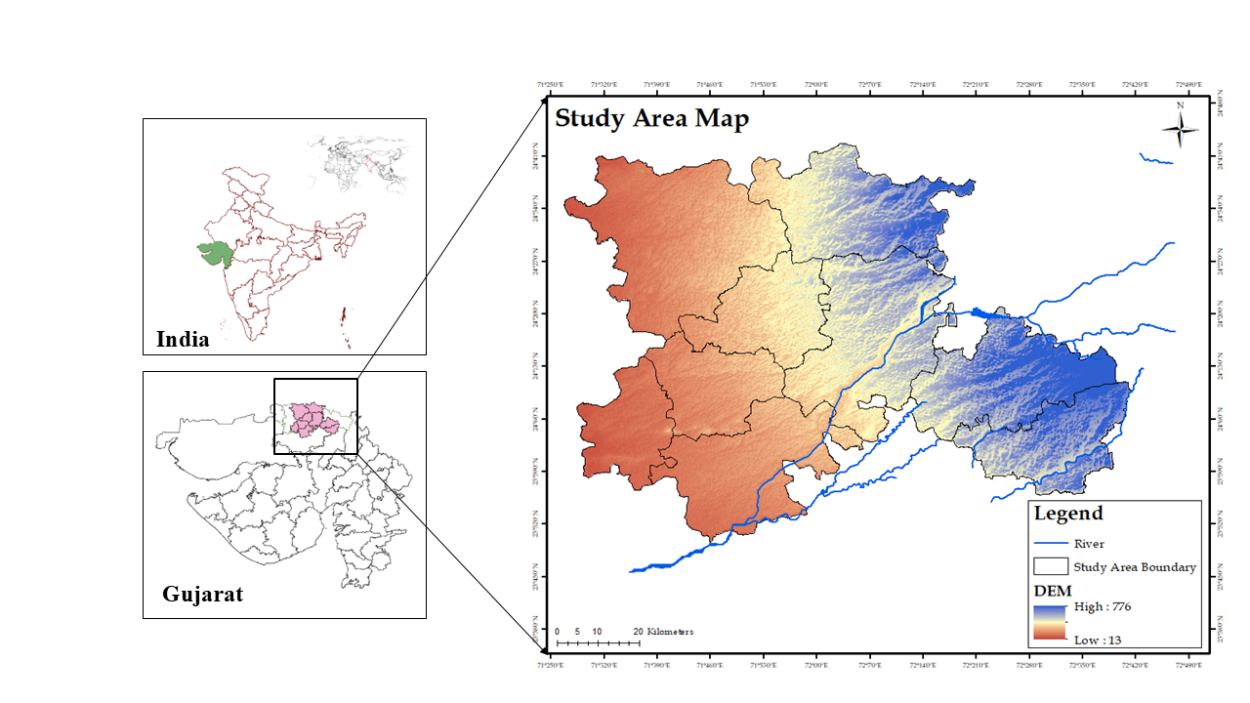
Figure 1: Topological map depicting the vegetation zone of Banaskantha District, highlighting its 9 talukas along with the river bodies within the study area.

3. Groundwater Sampling and Chemical Analyses
Groundwater supplies sustain extensive agricultural activities in the nine talukas that make up the Banaskantha District's vegetation zone. For drinking and irrigation purposes, groundwater is drawn from many aquifer systems in this area. Unconfined to semi-confined aquifers of different
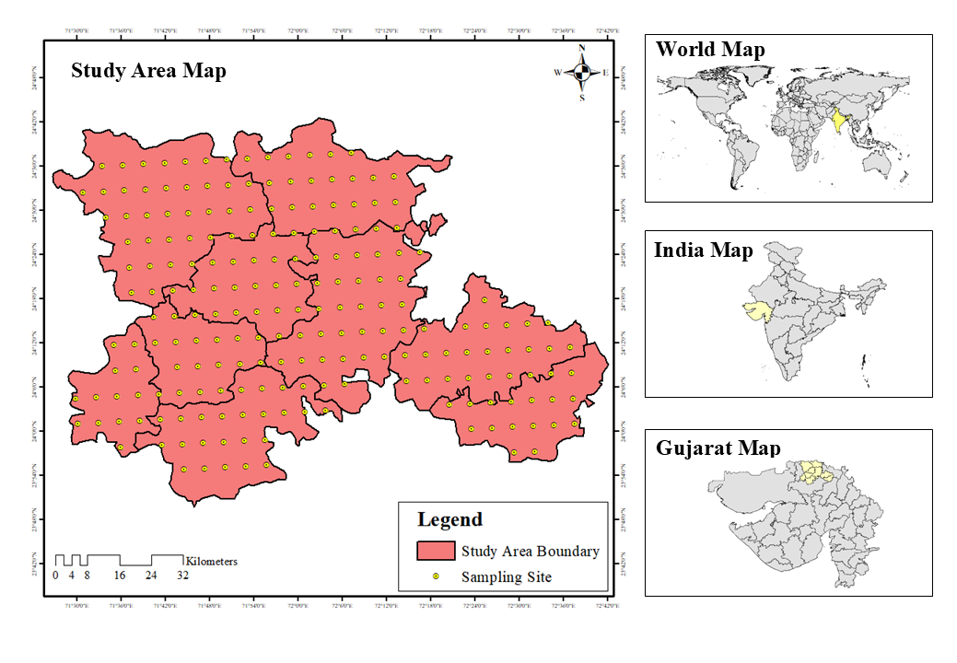
Figure 2: Study area map with 207 sampling locations in vegetation region of Banaskantha.
depths can be accessed by tube wells, bore wells, and dug wells. A total of 207 representative samples (Figure 2) were taken throughout the vegetation zone during the post-monsoon season of 2021 in order to assess the groundwater quality thoroughly. Considering variations in lithology, hydrogeological context, and land-use patterns, the sample network was planned to provide spatial coverage of all nine talukas. The groundwater sources that were sampled represented both shallow and deep aquifer systems, with depths varying from 15 to 250 metres. Tube wells and bore wells were run for 10 to 15 minutes before sampling to remove stagnant water from the column and extract new aquifer water. This procedure reduced the possibility of bias brought on by extended stagnation, temperature fluctuations, or surface contamination. The samples were gathered in 500 mL high-density polythene (HDPE) bottles that had been previously cleaned and labelled. To guarantee sample integrity, each bottle was carefully washed with deionized water before being filled with the corresponding source water. To avoid any outside interference, all sampling procedures were conducted with talc-free lab coats and clean, powder-free latex gloves. Unacidified water was gathered for general physicochemical study at each location and kept at room temperature until it was brought to the lab, were done according to the standard methods of APHA (2017) guideline. Temperature, pH, EC, and TDS were measured on the spot through portable equipment. The evaluation of water quality involved the measurement of other parameters like total hardness (TH), calcium (Ca²⁺), magnesium (Mg²⁺), sodium (Na⁺), potassium (K⁺), chloride (Cl⁻), fluoride (F⁻), nitrate (NO₃⁻), carbonate (CO₃²⁻), bicarbonate (HCO₃⁻) and sulphate (SO₄²⁻). For the analysis, AR-grade reagents and tools were utilised. Table 1 provides an overview of the analysed parameters, the accepted methodologies for analysis, and the standard parameter values used for comparison with the obtained results.
Table 1. Analytical procedures for specific water parameters and their units.
Sr. No. | Category | Parameters | Unit | Method
1 | General | Temperature | °C | Digital multi parameter  (Systronics Water Analyser 371)
2 | General | pH | - | Digital multi parameter  (Systronics Water Analyser 371)
3 | General | TDS | mg/L | Digital multi parameter  (Systronics Water Analyser 371)
4 | General | Salinity | % | Digital multi parameter  (Systronics Water Analyser 371)
5 | General | EC | µS/cm | Digital multi parameter  (Systronics Water Analyser 371)
8 | Cation | Total Hardness (TH) | mg/L | EDTA Titrimetric Method
6 | Cation | Calcium (Ca²⁺) | mg/L | EDTA Titrimetric Method
7 | Cation | Magnesium (Mg²⁺) | mg/L | EDTA Titrimetric Method
9 | Cation | Sodium (Na⁺) | mg/L | Flame Photometry  (Systronics Flame Photometer 128)
10 | Cation | Potassium (K⁺) | mg/L | Flame Photometry  (Systronics Flame Photometer 128)
11 | Anion | Carbonate (CO₃²⁻) | mg/L | Titrimetric Method
12 | Anion | Bicarbonate (HCO₃⁻) | mg/L | Titrimetric Method
13 | Anion | Total Alkalinity (TA) | mg/L | Titrimetric Method
14 | Anion | Chloride (Cl⁻) | mg/L | Argentometric Method
15 | Anion | Fluoride (F⁻) | mg/L | UV-Visible Spectrophotometer  (SPADNS Method)
16 | Anion | Nitrate (NO₃⁻) | mg/L | UV-Visible Spectrophotometer  (Screening Method)
17 | Anion | Phosphate (PO₄³⁻) | mg/L | UV-Visible Spectrophotometer  (Ascorbic Acid Method)
18 | Anion | Sulphate (SO₄²⁻) | mg/L | UV-Visible Spectrophotometer  (Turbiditic Method)
The analysis's findings were confirmed using the Ionic Balance (IB) (Eq. (1)). The total concentrations of cations and anions are equal to each other within a tolerable error range; this is typically 5%, but it can be as high as 10% (Ait Said et al., 2023). The ionic balance of all examined samples is within the tolerance value.
$IB= \frac{(∑Cations-∑Anions)}{(∑Cations-∑Anions)} ×100$ (1)
4. Assessment of Environmental Methods
The Banaskantha vegetation zone relies heavily on groundwater for agriculture, livelihoods, and domestic needs. However, intensive irrigation, diverse cropping patterns, and varying aquifer depths have increased pressure on these resources, further affected by natural hydrogeochemical processes and human activities like excessive fertiliser use and unregulated extraction. To evaluate water safety and sustainability, this study analysed the physicochemical properties of 207 groundwater samples, comparing results with WHO (2017) and BIS (2012) drinking water standards. This assessment identifies parameters that exceed permissible limits and highlights potential health and environmental risks.
For regional assessment of groundwater quality, we employed the IWQI to perform an integrated evaluation of groundwater suitability for irrigation. Before using groundwater for irrigation, evaluating its quality is essential to protect plants and soil. Metrics such as the sodium adsorption ratio (SAR), magnesium hazard (MH), residual sodium carbonate (RSC), potential salinity (PS), percent sodium (%Na), Kelly's index (KI), permeability index (PI), chloro-alkaline indicators (CAI1, CAI2), and corrosivity ratio (CR) were calculated to determine if wetland water is suitable for irrigation. Piper and Durov diagrams were employed as graphical tools to understand hydrogeochemical facies and groundwater dynamics. These diagrams distinguish between evaporation-precipitation influences and rock-water interactions, identify different types of water, and reveal key hydrochemical processes. This study provides a comprehensive assessment of groundwater in the Banaskantha vegetation zone by integrating general hydrochemistry, geochemical mapping, and irrigation suitability, as well as an index-based evaluation of groundwater in the Banaskantha District of Gujarat.
5. Results and Discussion
5.1 General hydrochemistry
The physico-chemical properties of the groundwater samples from the Banaskantha vegetation area are listed in Table 2, along with descriptive statistical measures like the mean, minimum, maximum, and standard deviation values of the different water quality parameters examined and the World Health Organisation (WHO 2017) and Bureau of Indian Standards (BIS 2012) standards.
Table 2: Summary of the physicochemical parameters in the study area.
Paraments | Min. | Max. | Mean | Std. Dev. | BIS (2012) | WHO (2017)
Temp. | 28.10 | 36.50 | 32.16 | 2.26 | - | -
pH | 7.10 | 12.50 | 9.53 | 1.25 | 6.5–8.5 | 6.5–8.5
EC | 366.00 | 9918.00 | 3743.55 | 2658.73 | 500-1500 | 500-1500
TDS | 170.00 | 4915 | 1889.86 | 1354.13 | - | 1000-1500
TH | 52.00 | 1668 | 573.28 | 470.86 | 200-600 | -
Na⁺ | 2.85 | 641.10 | 56.93 | 52.80 | - | 200
K⁺ | 0.51 | 33.89 | 4.47 | 3.82 | - | 10
Ca⁺² | 4.80 | 312.62 | 98.35 | 84.65 | 75-200 | 75-200
Mg⁺² | 5.83 | 346.99 | 120.62 | 107.91 | 30-100 | 50-150
Cl⁻ | 34.99 | 2329.28 | 822.68 | 585.17 | 300 | 300-600
SO₄²⁻ | 10.01 | 493.22 | 172.45 | 126.00 | - | -
CO₃²⁻ | 30.00 | 300 | 1450.00 | 66.87 | 250-1000 | 250
HCO₃⁻ | 0 | 400 | 201.68 | 85.96 | 45 | 45
NO₃⁻ | 0.22 | 67.55 | 5.27 | 6.49 | 200-400 | 400
F⁻ | 0.12 | 2.15 | 1.02 | 0.48 | 1-1.5 | 1.5
All parameters are expressed in mg/L except pH, Temp. (°C) & EC (µS/cm);
EC: Electrical conductivity; TDS: Total dissolved solids; TH: Total hardness.
The Banaskantha vegetation zone's groundwater exhibits traits of a semi-arid climate. The average temperature is 32.17°C, with a range of 28.1 to 36.5°C. Groundwater's pH ranges from 7.1 to 12.5, with an average of 9.53. The higher value of pH in some areas may be due to higher carbonate and bicarbonate concentration. Taste issues, scaling, decreased disinfection effectiveness, and potential risks to drinking and irrigation arise from the mean and maximum values being significantly higher, despite the minimum value being within the BIS (2012) and WHO (2017) acceptable range of 6.5–8.5. The concentration of dissolved salts is represented by electrical conductivity (EC), which ranges from 366.00 to 9918.00 µS/cm, with a mean of 3743.55 µS/cm. Given that natural groundwater typically ranges between 500 and 1500 µS/cm (BIS/WHO), these values seem abnormally low, indicating a unit/notation error. Total dissolved solids (TDS), on the other hand, are incredibly high, with a mean of 3769.86 mg/L and a range of 366 to 9918 mg/L. This indicates excessive salinity, which limits both irrigation suitability and potability, as it is significantly higher than the recommended 1000–1500 mg/L limit. Similarly, total hardness (TH) averages 1913.65 mg/L (range: 170–4915 mg/L), far exceeding the recommended guideline of 200–600 mg/L. Scaling, infiltration, and decreased irrigation efficiency are risks associated with these values, primarily caused by carbonates, bicarbonates, and sulfates, which are abundant calcium and magnesium salts.
The order of cation chemistry is Mg²⁺ > Ca²⁺ > Na⁺ > K⁺. With high local peaks brought on by salinity from evaporation, sodic soil interaction, or irrigation return flow, sodium (Na⁺) typically falls within the safe limit of 200 mg/L, averaging 56.94 mg/L (range 2.85–641.1 mg/L). Potassium (K⁺) concentrations range from 0.51 to 33.89 mg/L (mean 4.47 mg/L); they are typically low due to clay fixation, but higher in agricultural areas due to fertiliser leaching. Calcium (Ca²⁺) levels average 98.35 mg/L (range 4.8–312.62 mg/L), generally within the acceptable range of 75–200 mg/L, but with high outliers resulting from the dissolution of carbonate and gypsum. Magnesium (Mg²⁺) has a mean of 120.63 mg/L (range 5.83–346.99 mg/L), which is marginally higher than the average limit of 50–150 mg/L. Dolomitic lithology, extended water–rock interaction, and evaporative concentration are associated with extreme highs. Overall, the groundwater is of a mixed Ca–Mg–Na type, with hardness dominated by Ca–Mg, and occasional sodium enrichment, which reduces soil suitability for irrigation.
The order Cl⁻ > HCO₃⁻ > SO₄²⁻ > CO₃²⁻ > NO₃⁻ > F⁻ dominates anion chemistry. Chloride (Cl⁻) is much higher than the tolerance of 300–600 mg/L, with an average of 822.68 mg/L (range 34.99–2329.28 mg/L). This suggests that salinity enrichment is caused by anthropogenic return flows, evaporation, and halite dissolution. Higher sulphate (SO₄²⁻) concentrations may taste bitter and have a slight laxative effect. The dissolution of gypsum/anhydrite and industrial/agricultural inputs are most likely the causes of the range of sulphate levels, which range from 10.01 to 493.22 mg/L (mean 172.45 mg/L). Bicarbonate (HCO₃⁻) and carbonate (CO₃²⁻), which represent carbonate lithology, contribute to alkalinity and elevated pH levels. Their respective concentrations range from 0 to 400 mg/L (mean 201.68 mg/L) and 30 to 300 mg/L. There is a possible sodium carbonate hazard in irrigation. Localised exceedances above the 45 mg/L limit, caused by sewage, animal waste, or agricultural runoff, can result in health risks, such as infant methemoglobinemia. Nitrate (NO₃⁻) ranges from 0.22 to 67.55 mg/L (mean 5.27 mg/L). Fluoride (F⁻) is mostly within the 1.0–1.5 mg/L limit, with an average of 1.02 mg/L (range 0.12–2.15 mg/L). However, maximum values indicate that long-term consumption of fluoride can lead to fluorosis, which is exacerbated by an alkaline pH and prolonged residence time. High salinity, hardness, and elevated chloride–carbonate levels, along with sporadic enrichment in nitrate and fluoride, are characteristics of groundwater in the Banaskantha vegetation zone. It is predominantly of the chloride-bicarbonate type and exhibits a mixed Ca-Mg-Na dominance, which renders it mostly unfit for drinking and only partially suitable for irrigation if not properly managed.
5.2 Irrigation Indices for Suitability of Groundwater
Indicators of irrigation water quality are crucial instruments for determining whether surface or groundwater is fit for agricultural use. To evaluate possible risks like soil sodicity, salinity, permeability reduction, and crop toxicity, these indices are computed using the concentrations of essential cations and anions (Rawat et al., 2018). The suitability of groundwater for agricultural use was thoroughly assessed in this study using ten widely employed indices of irrigation water quality (Ali et al., 2024, 2025).
5.2.1 Sodium adsorption ratio (SAR)
The equilibrium of sodium ions in irrigation water concerning calcium and magnesium is shown by the Sodium Adsorption Ratio (SAR) (Eq. (2)). It is used to evaluate the possibility of sodium accumulation in soils, which can lower soil permeability and water infiltration (Rawat et al., 2018).
$SAR=\frac{Na^{+}}{\sqrt{\frac{Ca^{2+}+Mg^{2+}}{2}}}$ (2)
where Na⁺, Ca²⁺ and Mg²⁺ are in meq/l.
Excellent (SAR < 10), good (10–18), doubtful (18–26), and unsuitable (> 26) are the classifications for irrigation water. Lower SAR values are ideal for preserving soil health and promoting sustainable irrigation, as high values impede water movement. Nearly all of the 207 water samples (206 samples, or 99.5% of the total) fall into the excellent category (<10). There are no samples in the good (10–18) or unsuitable (>26) categories, and only one sample, V2 (SAR = 23.91), falls into the doubtful range (18–26) (Table 3). A very low sodium hazard is indicated by the SAR values (0.07–23.91; mean 1.24, median 0.96), which also suggest that irrigation water is generally safe, with little chance of sodicity and good soil permeability.
5.2.2 Magnesium adsorption ratio (MAR)
Magnesium (Mg²⁺) and calcium (Ca²⁺) in groundwater typically balance one another, supporting soil structure and acting as vital crop nutrients, but too much of either can be detrimental (Al-Shammiri et al., 2005). Elevated Ca²⁺ and Mg²⁺ concentrations cause the soil pH to rise, resulting in saline conditions and decreased phosphorus availability. In particular, excessive magnesium can cause soil quality to deteriorate by increasing alkalinity, which negatively impacts crop yield. This risk is frequently assessed using the Magnesium Hazard (MH) index (Eq. (3)), where values higher than 50 are deemed inappropriate for irrigation (Gowd, 2005; Rawat et al., 2018).
$MAR=\frac{{Mg}^{+2}}{{Ca}^{+2}+ {Mg}^{+2}} ×100$ (3)
(all the ion concentrations are expressed in meq/l).
In the majority of irrigation waters, magnesium predominates over calcium, as indicated by the Magnesium Adsorption Ratio (MAR) of the analysed water samples, which shows that only about 27% of samples fall in the safe range (<50), and 73% of samples fall under the unsuitable category (Table 3). Since excessive magnesium can cause poor soil aggregation and decreased permeability compared to calcium-rich waters, such conditions can harm soil quality. Practically speaking, this indicates that while the sodium hazard (SAR) was found to be low for most samples, the magnesium hazard is significantly higher. This can still limit the amount of water that is suitable for irrigation in sensitive soils. Soil structure may be weakened by prolonged use of high-MAR water, becoming less permeable and more compacted.
5.2.3 Kelly’s ratio (KR) or Kelly’s index (KI)
The ratio of sodium (Na⁺) to calcium (Ca²⁺) and magnesium (Mg²⁺) ions is another metric used to assess the quality of irrigation water. Eq. (4) is used to calculate this factor; a value larger than 1 denotes an excess of sodium in the water. A value of less than one indicates that irrigation water is suitable, whereas a value greater than one indicates that it is not, because of possible alkali hazards (Ramesh and Elango, 2012; Rawat et al., 2018). All the ion concentrations are expressed in meq/l.
$KR=\frac{Na^{+}}{Ca^{2+}+Mg^{2+}}$ (4)
With an average of 0.39 and a median of 0.16, the 207 water samples' Kelly's Ratios (KR) range from 0.009 to 10.25. A few outliers exceed 1, implying possible unsuitability, but the majority of values are significantly below 1, suggesting general suitability. According to classification results, only 6.8% of samples are deemed unsuitable for irrigation, with 93.2% falling within the suitable range (KR ≤ 1) (Table 3). This indicates that compared to calcium and magnesium, most groundwater has a low sodium hazard.
5.2.4 Permeability index (PI)
One helpful metric for assessing whether water is suitable for irrigation is the Permeability Index (PI), which is in Eq. (5). The concentrations of sodium (Na⁺), calcium (Ca²⁺), magnesium (Mg²⁺), and bicarbonate (HCO₃⁻) ions affect the water's ability to pass through soil. PI is a crucial metric for irrigation planning since a higher salt content in irrigation water can eventually decrease soil permeability (Rawat et al., 2018).
$PI=\frac{Na^{+}+\sqrt{HCO_{3}}}{Na^{+}+Mg^{2+}+Ca^{2+}}×100$ (5)
All the ion concentrations are expressed in meq/l. Water can be divided into three groups based on PI values: Class I (> 75%, suitable), Class II (25–75%, good), and Class III (< 25%, unsuitable). It is generally advised to use Class I and Class II water for irrigation. The permeability index (PI) of the 207 water samples ranges greatly, from 2.70 to 113.94, with a median of 14.22 and an average of 20.60. With the 90th percentile at 38.74 and the 75th percentile at 27.20, the majority of samples are in the lower to mid-range. According to classification, only a small percentage of samples (~2.4%) fall into Class I (Excellent, >75%), 27% fall into Class II (Good, 25–75%), and the majority (~70%) fall into Class III (Unsuitable, <25%) (Table 3). This suggests that there may be limitations on long-term soil permeability and irrigation suitability, even though some waters are suitable for irrigation and the majority have low permeability index values.
5.2.5 Potential salinity (PS)
PS is an additional index based on water quality parameters used to classify water for agricultural use (Eq. (6)). All ion concentrations are expressed in meq/L in this context. A water's suitability for irrigation is indicated by PS < 3 meq/l (Rawat et al., 2018).
PS = Cl⁻ + 0.5 × SO₄²⁻ (6)
According to Table 3, only 12 samples (5.80%) of the water samples analysed fit into the appropriate category (PS < 3). In comparison, the vast majority of 194 samples (93.72%) are inappropriate (PS > 3) for irrigation. Given that high concentrations of sulphate and chloride
Table 3: Comprehensive Classification of Groundwater Samples Based on Irrigation Water Quality Indices (SAR, MAR, KR, PI, PS and RSC) for Evaluating Agricultural Suitability for the study area.
Sr. No. | Irrigation Indices | Range | Class | No. of sample | % of Sample
1 | SAR | <10 | Exc. | 206 | 100%
 |  | Oct-18 | Go. | 0 | -
 |  | 18-26 | Dou. | 1 | 0.48%
 |  | >26 | UnSu. | 0 | -
2 | MAR | <50 | Su. | 55 | 27%
 |  | >50 | UnSu. | 152 | 73.42%
3 | KR | <1 | Su. | 189 | 91.03%
 |  | >1 | UnSu. | 18 | 8.69%
4 | PI | >75% | Su. | 3 | 1.45%
 |  | 25-75% | Go. | 56 | 27.05%
 |  | <25% | UnSu. | 148 | 71.50%
5 | PS | <3 | Su. | 12 | 5.80%
 |  | >3 | UnSu. | 194 | 93.72%
6 | RSC | ˂ 1.25 | Go. | 137 | 66.18%
 |  | 1.25 - 2.5 | Doc. | 17 | 8.21%
 |  | ˃ 2.5 | UnSu. | 53 | 25.60%

Predominantly, it is evident that the majority of the groundwater presents a significant salinity hazard. If such water is used repeatedly, it can lead to reduced permeability, progressive soil salinisation, and decreased crop productivity.
5.2.6 Residual sodium carbonate (RSC)/residual alkalinity (RA)
The balance between carbonate (CO₃²⁻) and bicarbonate (HCO₃⁻) ions in relation to calcium (Ca²⁺) and magnesium (Mg²⁺) in irrigation water is indicated by residual sodium carbonate, or RSC. Sodicity, decreased permeability, and structural damage result from calcium and magnesium precipitation when CO₃²⁻ and HCO₃⁻ surpass Ca²⁺ and Mg²⁺. RSC is measured in milliequivalents per litre (meq/L) and is categorised as low (less than 1.25, safe), medium (1.25–2.5, marginal), and high (greater than 2.5, inappropriate). RSC (Eq. (7)) values above 2.5 are typically not appropriate for agricultural use, and values above five are strongly discouraged because they have detrimental effects on soil and plant growth. Negative RSC values indicate a surplus of Ca²⁺ and Mg²⁺, whereas positive values suggest possible sodium risks. To neutralise dangerous residual carbonates, RSC assessment also aids in determining whether soil amendments, such as sulfuric acid or gypsum, are necessary (Rawat et al., 2018).
RSC = (HCO₃⁻ + CO₃⁻ ²) − (Ca²⁺ + Mg²⁺) (7)
According to Table 3, the Residual Sodium Carbonate (RSC) classification of the groundwater samples indicates that 137 samples (66.18%) are in the good category (RSC < 1.25 meq/L), suggesting that there is no substantial risk of a carbonate hazard when irrigation is carried out. Depending on the soil and crop type, approximately 17 samples (8.21%) fall into the doubtful range (1.25–2.5 meq/L), which may necessitate vigilance and sporadic management techniques. 53 samples, or 25.60% of the total, are deemed unsuitable (RSC > 2.5 meq/L), indicating a significant risk of sodium buildup due to the precipitation of calcium and magnesium in carbonate and bicarbonate. Such prolonged water use can, over time, weaken soil structure and decrease permeability.
5.3 Irrigation water quality index (IWQI)
The Irrigation Water Quality Index (IWQI) is a quantitative tool used to evaluate the suitability of water for agricultural irrigation. It integrates various water quality parameters to assess potential risks to soil health and crop productivity. This index is particularly crucial in regions where water salinity and ion toxicity can impact long-term agricultural sustainability (Meireles et al., 2010). The IWQI was calculated using five key water quality parameters: Electrical conductivity (EC), SAR, Na⁺, Cl⁻, and HCO₃⁻ concentration (Abbasnia et al., 2018b). Before data analysis, concentration units were converted from mg/L to meq/L using the conversion factors provided by Lesch and Suarez (2009). The IWQI assessment was conducted by calculating the quality index values (qi) and the corresponding weight factors (Wi) (Abbasnia et al., 2018a; Batarseh et al., 2021). The qi values for the five parameters (qEC, qSAR, qNa⁺, qCl⁻, and qHCO₃⁻) were determined using Equation 8. The upper limits of these parameters were used as the highest observed values to evaluate x_{imap}.
q_{i} = q_{max} [ $\frac{\left(X_{ij}-X_{inf}\right)×q_{imap}}{X_{amp}}$] (8)
Where;
q_{max} is the upper boundary of the corresponding qi classification.
X_{ij} represents the observed values of each parameter.
X_{inf} denotes the lower limit of the class to which the observed parameter belongs.
q_{imap} refers to the class range for qi classifications.
x_{imap} corresponds to the class amplitude for the respective parameter classification.
The IWQI was then calculated using Equation 9:
IWQI = $\sum_{1}^{n}{}{ q}_{i }w_{i}$ (9)
where n represents the number of parameters considered (five parameters in this case).
The q_{i} values were multiplied by the corresponding weights w_{i} for each parameter. The IWQI assigns weights to key parameters: EC (0.211), SAR (0.189), Na⁺(0.204), Cl⁻(0.194), and HCO₃⁻(0.202). These weighted values collectively assess water suitability for irrigation (Table 4), ensuring the adoption of sustainable agricultural practices (Meireles et al., 2010).
Table 4: Irrigation Water Quality Parameters and Their Limiting Values for Quality Index (qi) Calculation based on (Abbasnia et al., 2018a).
Sr. No. | qi Range | EC (µS/cm) | SAR | Na⁺ (meq/L) | Cl⁻ (meq/L) | HCO₃⁻ (meq/L)
1 | 85–100 | 200–750 | < 3 | 2–3 | < 4 | 1–1.5
2 | 60–85 | 750–1500 | 3–6 | 3–6 | 4–7 | 1.5–4.5
3 | 35–60 | 1500–3000 | 6–12 | 6–9 | 7–10 | 4.5–8.5
4 | 0–35 | < 200 or > 3000 | > 12 | < 2 or > 9 | > 10 | < 1 or > 8.5
The study area's groundwater quality is mainly limited for irrigation use, according to the Irrigation Water Quality Index (IWQI) results (Table 5). A tiny percentage of samples (1.45%) fall into the "no restriction" category, indicating excellent quality water that is suitable for irrigation without any restrictions, according to the evaluation of irrigation water quality based on the IWQi values. Approximately 18.84% of the samples fall under the category of "low restriction," indicating that most crops can use this type of water safely and with little management concern. A sizable portion of the samples (35.27%) falls into the category of "moderate restriction," meaning that while this water can still be used for irrigation, it may need to be managed carefully by using salt-tolerant crops, blending with higher-quality water, or adding soil amendments to mitigate potential risks. The majority of samples (39.61%) fall into the "high restriction" category, which raises serious concerns because, absent stringent management measures, prolonged use of such water could degrade soil quality, decrease permeability, and have a detrimental impact on crop yields. Lastly, 4.83% of the samples belong to the "severe restriction" class, which means that they are mainly unsuitable for irrigation because, absent corrective action, they seriously jeopardise crop growth and soil health. Overall, the results indicate that most groundwater samples in the study area are subject to moderate to high restrictions, suggesting that unrestricted irrigation use is generally impractical and that sustainable management practices are necessary to maintain crop and soil productivity.
Table 5: IWQI classification, groundwater samples, and recommendations in the study area.
IWQI Range | Classification of samples | Recommendations | No. of samples | % of Samples
85-100 | No restriction | Used for irrigation during normal conditions. | 3 | 1.45%
70-85 | Low restriction | Soils that are irrigated and have a light texture or moderate permeability can be adjusted to fit within this range. | 39 | 18.84%
55-70 | Moderate restriction | Applied in soils with moderate to high permeability values. | 73 | 35.27%
40-55 | High restriction | Suitable for use with high-permeability soils that lack compact layers. | 82 | 39.61%
0-40 | Severe restriction | Not used for irrigation under normal conditions | 10 | 4.83%
A Geographic Information System (GIS) is a spatial system designed to collect, organise, analyse, and store data that relies on geographic location as a key feature or essential component of the study. To create geographical maps and thematic layers, GIS facilitates the statistical interpolation of various experimental data. By removing unclear groundwater parameter components and reducing the creation of statistical correlations, these methods make it possible to represent the groundwater quality in the study area visually (Chaudhari et al., 2024; Vaiphei et al., 2020). In hydrogeochemical investigations like (Nijesh et al., 2021; Tiwari et al., 2016; Zolekar et al., 2021) spatial distribution mapping is frequently used to visualise drainage patterns and groundwater quality. These interpolation maps support conservation planning, aid in identifying contamination sources, inform long-term monitoring efforts, and provide decision-makers with clear and accurate information. Here, Figure 3 shows a Spatial Distribution map for the classification of the Irrigation Water Quality Index (IWQI).
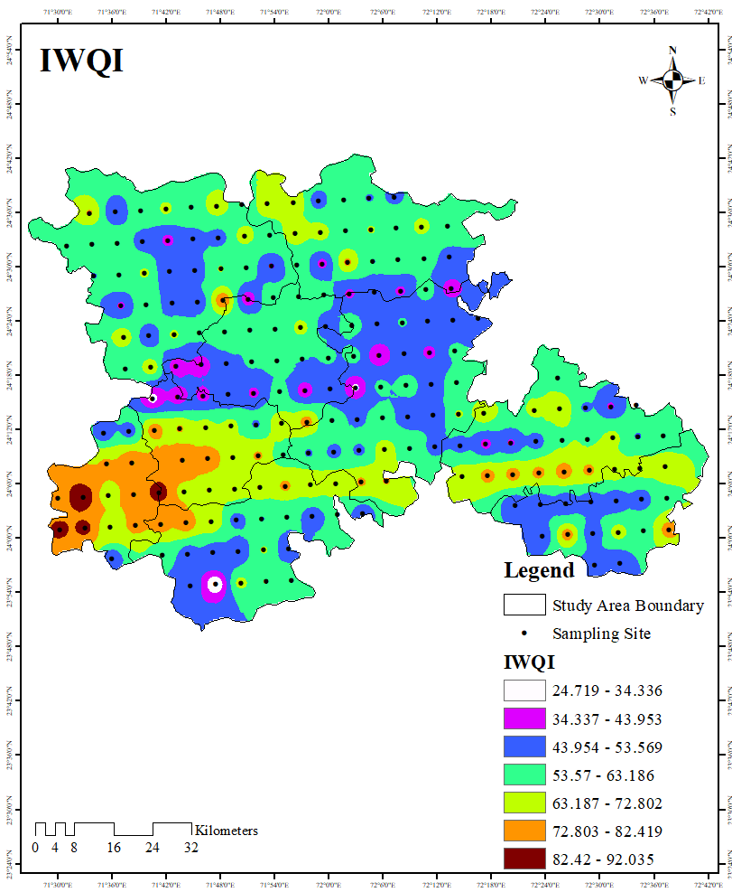
Figure 3: Spatial distribution of Irrigation Water Quality Index (IWQI) in the Study Area.
5.4 Hydrogeochemical Characterisation
To clarify the hydrogeochemical processes affecting the vegetation area of Banaskantha’s groundwater chemistry, graphical methods such as Piper, Durov, and Gibbs diagrams were used with Aquachem 10.0. Additionally, some scatter plots illustrating key geochemical characteristics in this study area were created using Microsoft Excel.
According to one definition, hydrochemical facies "reflect the response of chemical processes in the lithologic framework and the pattern of water flow in it," and they "denote the diagnostic chemical aspect of water solutions occurring in hydrologic systems” (Jain et al., 2018). The Piper diagram distinguishes water types by showing relative concentrations of key cations (Ca²⁺, Mg²⁺, Na⁺+ K⁺) and anions (HCO₃⁻ + CO₃²⁻, SO₄²⁻, Cl⁻). The left and right triangles reflect cation and anion dominance, respectively, while the middle diamond integrates both to define the overall hydrochemical facies and demonstrate general groundwater chemistry properties (Gao et al., 2020b). Using a Piper diagram, the classification of water kinds was visually illustrated in Figure 4. Groundwater in Banaskantha shows four major facies: Ca–Mg–Cl–SO₄, Na–K–Cl–SO₄, Na–K–HCO₃, and Ca–Mg–HCO₃. Recharge signatures arise from carbonate and silicate weathering, with Na–K–HCO₃ indicating localised high-quality recharge. The dominance of Na–Cl and Na–SO₄ facies reflects cation exchange, evaporation, and salinisation processes. Fertiliser use and irrigation return flow further increase salinity and sulphate levels. Ca–Mg–HCO₃ waters are suitable for irrigation and drinking. However, Na–Cl and Ca–Mg–SO₄ waters pose issues related to hardness and salinity, requiring treatment before use. Overall, the chemistry reflects a blend of natural geochemical processes and human influences.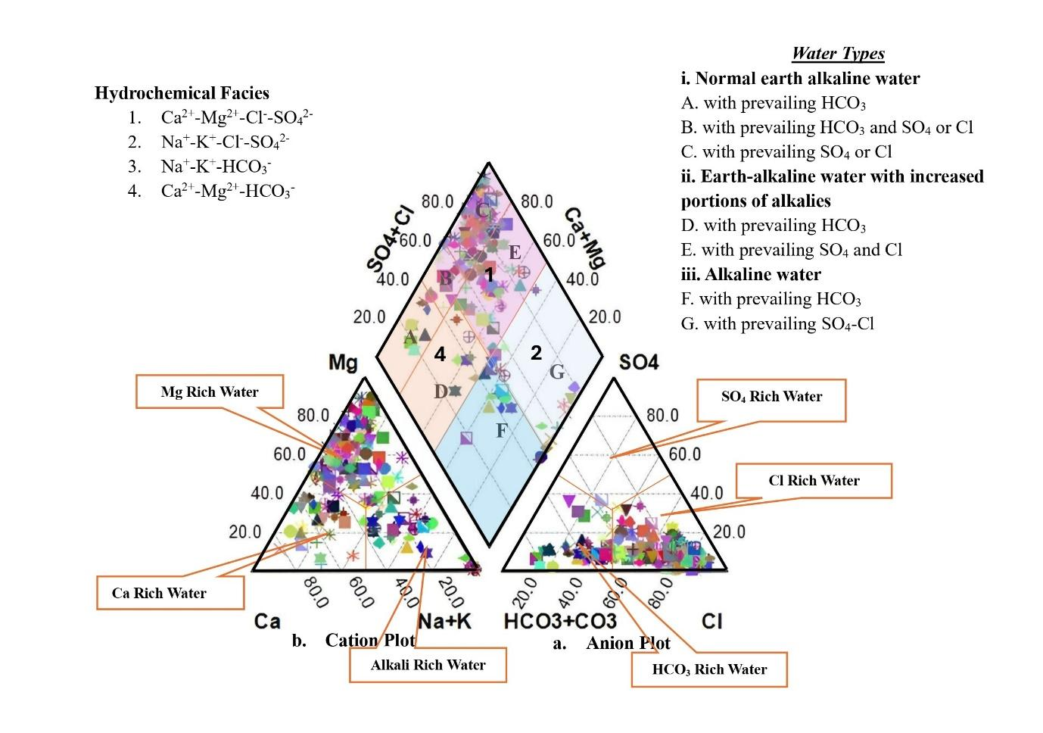
Figure 4: Hydrochemical facies of groundwater in the study area.

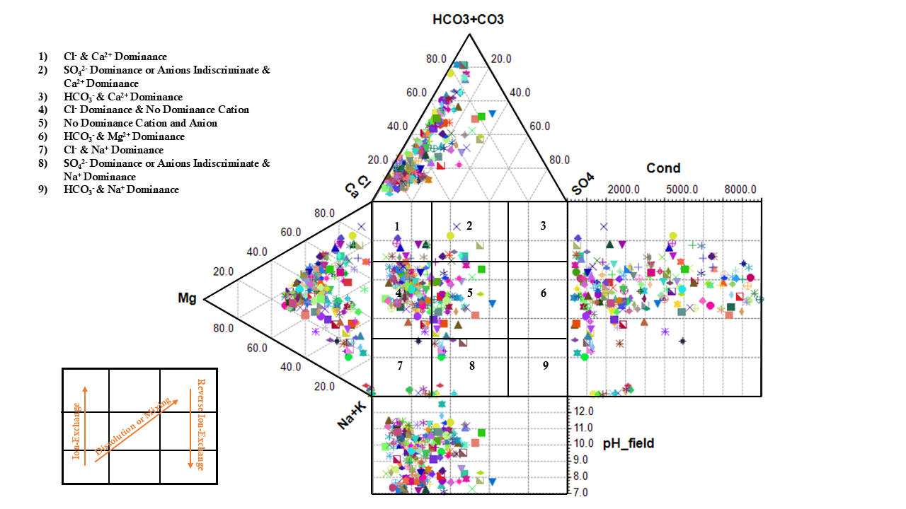
Figure 5: Durov diagram of the groundwater samples of the Vegetation study area.
One popular technique for describing the chemistry of groundwater is the Durov plot. In contrast to the Piper diagram, the Durov plot allows for a more thorough understanding of hydrochemical characteristics by simultaneously representing the pH and TDS levels of water samples in addition to the hydrochemical type (Wu et al., 2024). The groundwater in Banaskantha's Durov diagram (Figure 5) exhibits a broad distribution of samples across various hydrochemical fields, indicating a range of water types and geochemical processes. Indicating carbonate and dolomite weathering during recharge, the majority of groundwater samples are found in the Ca–HCO₃ and Mg–HCO₃ facies. While the Na–HCO₃ and Na–Cl facies indicate ion exchange and salinity, the mixed waters in central fields reflect transitional conditions. The less prevalent Cl–Ca and SO₄–Na types indicate irrigation return flow, evaporation, and dissolution of evaporites. Although conductivity frequently surpasses 2000 μS/cm, indicating high salinity, groundwater is primarily neutral to alkaline (pH 7–9). The transition from fresh bicarbonate recharge waters to mineralised and saline facies influenced by human activity and geochemical processes is confirmed by Piper and Durov diagrams.
6. Conclusion
In the context of the detailed hydrogeochemical assessment, the current study records a crucial disparity between groundwater quality and quantity for irrigation in Banaskantha's vegetation belt. Low sodicity hazard cannot ignore the reality that high salinity, hardness, and magnesium pose long-standing risks to soil productivity and crop yields. The Irrigation Water Quality Index (IWQI) points towards extensive limitations and only moderately suggests safety in samples. Spatial mapping again highlights the heterogeneity of water quality, necessitating site-specific interventions. Use of sustainable groundwater—through crop selection, soil amendment, and blended irrigation—seems essential to ensure agricultural sustainability. This research not only fills an important data gap but also offers strategic foundations for water management and policy formulation in semi-arid Gujarat, keeping informed decisions in mind.
Author(s) hereby declares that NO generative AI technologies such as Large Language Models (ChatGPT, COPILOT, etc) and text-to-image generators have been used during the writing or editing of this manuscript.
Disclaimer (Artificial intelligence)
Author(s) hereby declare that NO generative AI technologies such as Large Language Models (ChatGPT, COPILOT, etc.) and text-to-image generators have been used during the writing or editing of this manuscript. \

Authors’ Contributions
This work was carried out in collaboration among all authors. All authors read and approved the final manuscript.

6. References
D
H
Abbasnia, A., Alimohammadi, M., Mahvi, A.H., Nabizadeh, R., Yousefi, M., Mohammadi, A.A., Pasalari, H., Mirzabeigi, M., 2018a. Assessment of groundwater quality and evaluation of scaling and corrosiveness potential of drinking water samples in villages of Chabahr city, Sistan and Baluchistan province in Iran. Data in Brief 16, 182–192. https://doi.org/10.1016/j.dib.2017.11.003
Abbasnia, A., Radfard, M., Mahvi, A.H., Nabizadeh, R., Yousefi, M., Soleimani, H., Alimohammadi, M., 2018b. Groundwater quality assessment for irrigation purposes based on irrigation water quality index and its zoning with GIS in the villages of Chabahar, Sistan and Baluchistan, Iran. Data in Brief 19, 623–631. https://doi.org/10.1016/j.dib.2018.05.061
Ahmed, M.T., Hasan, M.Y., Monir, M.U., Biswas, B.K., Quamruzzaman, C., Junaid, M., Samad, M.A., Rahman, M.M., 2021. Evaluation of groundwater quality and its suitability by applying the geospatial and IWQI techniques for irrigation purposes in the southwestern coastal plain of Bangladesh. Arab J Geosci 14, 233. https://doi.org/10.1007/s12517-021-06510-y
Ait Said, B., Mili, E.-M., El Faleh, E.M., Mehdaoui, R., Mahboub, A., Hamid, F.E., Tlemcani, J., El Fakir, R., 2023. Hydrochemical evolution and groundwater quality assessment of the Tinejdad-Touroug quaternary aquifer, South-East Morocco. Front. Ecol. Evol. 11, 1201748. https://doi.org/10.3389/fevo.2023.1201748
Alao, J. O. (2023). Impacts of open dumpsite leachates on soil and groundwater quality. Groundwater for sustainable development, 20, 100877.
Alao, J. O. (2024). Determination of the geophysical signature of soft-clay and hard lateritic soils and the implications on geotechnical works using electrical resistivity imaging. Results in Earth Sciences, 2, 100025.
Alao, J. O. (2025). The evolving roles of geophysics in environmental assessment, monitoring, and management of landfill leachate contaminant plumes: An overview. Case Studies in Chemical and Environmental Engineering, 101124.
Alao, J. O. (2025). The factors influencing the landfill leachate plume contaminants in soils, surface and groundwater and associated health risks: A geophysical and geochemical view. Public Health and Environment, 1(1), 20-43.
Alao, J. O., & Abubakar, F. (2025). Groundwater exploration, management strategies and sustainability: Geophysical approaches. Geosystems and Geoenvironment, 100395.
Ali, G., Chaudharı, M., Shah, P., & Shrivastav, P. (2024). Temporal changes in water quality in Leh Ladakh region: Impact of urbanization. Environmental Research and Technology, 7(4), 637-664. https://doi.org/10.35208/ert.1431710
Ali, G., Chaudhari, M. P., Syed, S., Rajpurohit, D., Sanyal, M., & Shrivastav, P. S. (2025). Hydrogeochemical investigation and water quality assessment of the Indus River in the semiarid region of Ladakh, India. Marine Pollution Bulletin, 211, 117413. https://doi.org/10.1016/j.marpolbul.2024.117413
Al-Shammiri, M., Al-Saffar, A., Bohamad, S., Ahmed, M., 2005. Waste water quality and reuse in irrigation in Kuwait using microfiltration technology in treatment. Desalination 185, 213–225. https://doi.org/10.1016/j.desal.2005.02.078
APHA (2017). Standard Methods for the Examination of Water and Wastewater (23rd ed.). Washington DC: American Public Health Association.
Aravinthasamy, P., Karunanidhi, D., Subba Rao, N., Subramani, T., Srinivasamoorthy, K., 2020. Irrigation risk assessment of groundwater in a non-perennial river basin of South India: implication from irrigation water quality index (IWQI) and geographical information system (GIS) approaches. Arab J Geosci 13, 1125. https://doi.org/10.1007/s12517-020-06103-1
Asadi, E., Isazadeh, M., Samadianfard, S., Ramli, M.F., Mosavi, A., Nabipour, N., Shamshirband, S., Hajnal, E., Chau, K.-W., 2019. Groundwater Quality Assessment for Sustainable Drinking and Irrigation. Sustainability 12, 177. https://doi.org/10.3390/su12010177
Batarseh, M., Imreizeeq, E., Tilev, S., Al Alaween, M., Suleiman, W., Al Remeithi, A.M., Al Tamimi, M.K., Al Alawneh, M., 2021. Assessment of groundwater quality for irrigation in the arid regions using irrigation water quality index (IWQI) and GIS-Zoning maps: Case study from Abu Dhabi Emirate, UAE. Groundwater for Sustainable Development 14, 100611. https://doi.org/10.1016/j.gsd.2021.100611
BIS (2012). Indian standard drinking water specifications, IS 10500:1991, edition 2.2.
Bouteraa, O., Mebarki, A., Bouaicha, F., Nouaceur, Z., Laignel, B., 2019. Groundwater quality assessment using multivariate analysis, geostatistical modeling, and water quality index (WQI): a case of study in the Boumerzoug-El Khroub valley of Northeast Algeria. Acta Geochim 38, 796–814. https://doi.org/10.1007/s11631-019-00329-x
Chaudhari, M.P., George, A., Sanyal, M., Shrivastav, P.S., 2024. Hydrochemistry and groundwater quality assessment of Gujarat, India: A compendious review. Physics and Chemistry of the Earth, Parts A/B/C 135, 103635. https://doi.org/10.1016/j.pce.2024.103635
Dahanayake, A. C., Webb, J. A., Greet, J., & Brookes, J. D. (2024). How do plants reduce erosion? An Eco Evidence assessment. Plant Ecology, 225(6), 593-604.
Etteieb, S., Cherif, S., Tarhouni, J., 2017. Hydrochemical assessment of water quality for irrigation: a case study of the Medjerda River in Tunisia. Appl Water Sci 7, 469–480. https://doi.org/10.1007/s13201-015-0265-3
Gao, Y., Qian, H., Ren, W., Wang, H., Liu, F., Yang, F., 2020a. Hydrogeochemical characterization and quality assessment of groundwater based on integrated-weight water quality index in a concentrated urban area. Journal of Cleaner Production 260, 121006. https://doi.org/10.1016/j.jclepro.2020.121006
Gao, Y., Qian, H., Ren, W., Wang, H., Liu, F., Yang, F., 2020b. Hydrogeochemical characterization and quality assessment of groundwater based on integrated-weight water quality index in a concentrated urban area. Journal of Cleaner Production 260, 121006. https://doi.org/10.1016/j.jclepro.2020.121006
Ghazaryan, K., Movsesyan, H., Gevorgyan, A., Minkina, T., Sushkova, S., Rajput, V., Mandzhieva, S., 2020a. Comparative hydrochemical assessment of groundwater quality from different aquifers for irrigation purposes using IWQI: A case-study from Masis province in Armenia. Groundwater for Sustainable Development 11, 100459. https://doi.org/10.1016/j.gsd.2020.100459
Ghazaryan, K., Movsesyan, H., Gevorgyan, A., Minkina, T., Sushkova, S., Rajput, V., Mandzhieva, S., 2020b. Comparative hydrochemical assessment of groundwater quality from different aquifers for irrigation purposes using IWQI: A case-study from Masis province in Armenia. Groundwater for Sustainable Development 11, 100459. https://doi.org/10.1016/j.gsd.2020.100459
Ghosh, A., Bera, B., 2023. Hydrogeochemical assessment of groundwater quality for drinking and irrigation applying groundwater quality index (GWQI) and irrigation water quality index (IWQI). Groundwater for Sustainable Development 22, 100958. https://doi.org/10.1016/j.gsd.2023.100958
Ghoto, S.M., Abbasi, Dr.H., Memon, S.A., Brohi, K.M., Chhachhar, R., Ghanghlo, A.A., Tunio, I.A., 2025. Multivariate hydrochemical assessment of groundwater quality for irrigation purposes and identifying soil interaction effects and dynamics of NDVI and urban development in alluvial region. Environmental Advances 19, 100621. https://doi.org/10.1016/j.envadv.2025.100621
Gowd, S.S., 2005. Assessment of groundwater quality for drinking and irrigation purposes: a case study of Peddavanka watershed, Anantapur District, Andhra Pradesh, India. Environ Geol 48, 702–712. https://doi.org/10.1007/s00254-005-0009-z
Groundwater Brochure Banaskantha District, Gujarat.
Hassen, I., Hamzaoui-Azaza, F., Bouhlila, R., 2016. Application of multivariate statistical analysis and hydrochemical and isotopic investigations for evaluation of groundwater quality and its suitability for drinking and agriculture purposes: case of Oum Ali-Thelepte aquifer, central Tunisia. Environ Monit Assess 188, 135. https://doi.org/10.1007/s10661-016-5124-7
Hosseinifard, S.J., Mirzaei Aminiyan, M., 2015. Hydrochemical Characterization of Groundwater Quality for Drinking and Agricultural Purposes: A Case Study in Rafsanjan Plain, Iran. Water Qual Expo Health 7, 531–544. https://doi.org/10.1007/s12403-015-0169-3
Jain, C.K., Sharma, S.K., Singh, S., 2018. Physico-chemical characteristics and hydrogeological mechanisms in groundwater with special reference to arsenic contamination in Barpeta District, Assam (India). Environ Monit Assess 190, 417. https://doi.org/10.1007/s10661-018-6781-5
Kanji, S., Das, S., Rajak, C., 2025. A comparative hydrochemical assessment of groundwater quality for drinking and irrigation purposes using different statistical and ML models in lower gangetic alluvial plain, eastern India. Chemosphere 372, 144074. https://doi.org/10.1016/j.chemosphere.2025.144074
Lesch, S. M., & Suarez, D. L. (2009). A short note on calculating the adjusted SAR index. Transactions of the ASABE, 52(2), 493-496.
Meireles, A.C.M., Andrade, E.M.D., Chaves, L.C.G., Frischkorn, H., Crisostomo, L.A., 2010. A new proposal of the classification of irrigation water. Rev. Ciênc. Agron. 41, 349–357. https://doi.org/10.1590/S1806-66902010000300005
Nijesh, P., Akpataku, K.V., Patel, A., Rai, P., Rai, S.P., 2021. Spatial variability of hydrochemical characteristics and appraisal of water quality in stressed phreatic aquifer of Upper Ganga Plain, Uttar Pradesh, India. Environ Earth Sci 80, 185. https://doi.org/10.1007/s12665-021-09410-2
Omeiza, J. A., & Dary, M. D. (2018). Aquifer vulnerability to surface contamination: a case of the new millennium city, Kaduna, Kaduna State Nigeria. World J Appl Phys, 3(1), 1-12 . https://doi.org/10.11648/j.wjap.20180301.11
Omeiza, A. J., Adeniyi, L. H., & Shettima, N. M. (2023). Investigation of groundwater vulnerability to open dumpsites and its potential risk using electrical resistivity and water analysis. Heliyon, 9(2). https://doi.org/10.1016/j.heliyon.2023.e13265
Paternoster, M., Buccione, R., Canora, F., Buttitta, D., Panebianco, S., Rizzo, G., Sinisi, R., Summa, V., Mongelli, G., 2021. Hydrogeochemistry and Groundwater Quality Assessment in the High Agri Valley (Southern Italy). Geofluids 2021, 1–15. https://doi.org/10.1155/2021/6664164
Prakash, I., Gupta, K.S., Dey, A., Singh, P.K., Dhote, P., Basheer, H.S., Daliya, A., Modi, V.S., 2012. Geology and Mineral Resources of Gujarat, Daman and Diu. Geological Society of India, Miscellaneous Publication (30 Part 14)
Ramesh, K., Elango, L., 2012. Groundwater quality and its suitability for domestic and agricultural use in Tondiar river basin, Tamil Nadu, India. Environ Monit Assess 184, 3887–3899. https://doi.org/10.1007/s10661-011-2231-3
Rao, G., Lu, C., Su, F., 2007. Sorption of divalent metal ions from aqueous solution by carbon nanotubes: A review. Separation and Purification Technology 58, 224–231. https://doi.org/10.1016/j.seppur.2006.12.006
Rawat, K.S., Singh, S.K., Gautam, S.K., 2018. Assessment of groundwater quality for irrigation use: a peninsular case study. Appl Water Sci 8, 233. https://doi.org/10.1007/s13201-018-0866-8
Şener, Ş., Varol, S., Şener, E., 2021. Evaluation of sustainable groundwater utilization using index methods (WQI and IWQI), multivariate analysis, and GIS: the case of Akşehir District (Konya/Turkey). Environ Sci Pollut Res 28, 47991–48010. https://doi.org/10.1007/s11356-021-14106-y
Srinivasamoorthy, K., Gopinath, M., Chidambaram, S., Vasanthavigar, M., Sarma, V.S., 2014. Hydrochemical characterization and quality appraisal of groundwater from Pungar sub basin, Tamilnadu, India. Journal of King Saud University - Science 26, 37–52. https://doi.org/10.1016/j.jksus.2013.08.001
Tiwari, A.K., Singh, P.K., Singh, A.K., De Maio, M., 2016. Estimation of Heavy Metal Contamination in Groundwater and Development of a Heavy Metal Pollution Index by Using GIS Technique. Bull Environ Contam Toxicol 96, 508–515. https://doi.org/10.1007/s00128-016-1750-6
Vaiphei, S.P., Kurakalva, R.M., Sahadevan, D.K., 2020. Water quality index and GIS-based technique for assessment of groundwater quality in Wanaparthy watershed, Telangana, India. Environ Sci Pollut Res 27, 45041–45062. https://doi.org/10.1007/s11356-020-10345-7
Wang, Y., Li, R., Wu, X., Yan, Y., Wei, C., Luo, M., Xiao, Y., Zhang, Y., 2023. Evaluation of Groundwater Quality for Drinking and Irrigation Purposes Using GIS-Based IWQI, EWQI and HHR Model. Water 15, 2233. https://doi.org/10.3390/w15122233
WHO (2017). Guidelines for drinking water quality. World Health Organization, Geneva, 1, 53–73.
Wu, D., Li, B., Li, Y., Li, Q., Sheng, C., Liu, J., Wang, M., Min, Y., Feng, J., Zhang, Y., Yu, J., 2024. Characterization of Groundwater Hydrochemistry and Temporal Dynamics of Water Quality in the Northern Baiquan Spring Basin. Water 16, 2519. https://doi.org/10.3390/w16172519
Xu, P., Feng, W., Qian, H., Zhang, Q., 2019. Hydrogeochemical Characterization and Irrigation Quality Assessment of Shallow Groundwater in the Central-Western Guanzhong Basin, China. IJERPH 16, 1492. https://doi.org/10.3390/ijerph16091492
Yifru, B.A., Lee, S., Bak, S., Bae, J.H., Shin, H., Lim, K.J., 2024. Estimating exploitable groundwater for agricultural use under environmental flow constraints using an integrated SWAT-MODFLOW model. Agricultural Water Management 303, 109024. https://doi.org/10.1016/j.agwat.2024.109024
Zhang, Q., Qian, H., Xu, P., Hou, K., Yang, F., 2021. Groundwater quality assessment using a new integrated-weight water quality index (IWQI) and driver analysis in the Jiaokou Irrigation District, China. Ecotoxicology and Environmental Safety 212, 111992. https://doi.org/10.1016/j.ecoenv.2021.111992
Zolekar, R.B., Todmal, R.S., Bhagat, V.S., Bhailume, S.A., Korade, M.S., Das, S., 2021. Hydro-chemical characterization and geospatial analysis of groundwater for drinking and agricultural usage in Nashik district in Maharashtra, India. Environ Dev Sustain 23, 4433–4452. https://doi.org/10.1007/s10668-020-00782-2

