Short term changes in soil chemical properties under different organic management protocols

ABSTRACT
The study assessed how ecological and organic farming practices affect soil chemical properties and nutrient dynamics in the short-term rice-wheat cropping system. A randomized block design with five treatments vis. biochar-based ecological farming (BBEF), climate-resilient organic farming (CROF), low-input natural farming (LINF), phosphorus-potassium fertilization (PK) and nitrogen-phosphorus-potassium fertilization (NPK) was evaluated. Post-harvest soils after 5 crops were analysed for pH, electrical conductivity (EC), soil organic carbon (SOC) and available N, P and K at 0-5, 5-15 and 15-30 cm depths. CROF maintained the highest pH in all layers, showing strong buffering, while NPK had the lowest pH due to urea-induced acidification. EC stayed low across treatments, indicating non-saline soils, with slightly higher values in ecological and organic systems from enhanced organic residue mineralization. SOC was greatest under BBEF followed by CROF at all depths, confirming biochar’s role in long-term carbon storage and the contribution of organic manure in CROF to enhancing soil carbon. Available nitrogen (N) was highest in BBEF and NPK, demonstrating the benefits of biochar and mineral fertilization. Higher available phosphorus (P) in PK and NPK reflected mineral P inputs, while biochar (BBEF) stabilized P availability. Available potassium (K) was highest in PK and in organic systems (BBEF and LINF) due to residue recycling and lower crop removal. Overall, biochar-based ecological and organic practices improved soil fertility and nutrient retention, offering a sustainable strategy to maintain soil health and resilience in intensive rice-wheat systems.
Keywords: Biochar; organic farming; natural farming; soil fertility; rice-wheat cropping system.
1. INTRODUCTION
The Green Revolution has been a double-edged sword for Indian agriculture. While it transformed the country from food scarcity to self-sufficiency, it also generated multiple challenges such as declining factor productivity, depletion of natural resources, nutrient imbalances, and environmental degradation (Bharucha et al. 2020; Kitamura et al. 2021). Over-reliance on chemical fertilizers and pesticides not only reduces soil fertility but also affects crop yields, disrupts ecological balance, and endangers human and environmental health (Li et al. 2020). These challenges necessitate ecologically sustainable alternatives to restore soil health, improve nutrient availability, and enhance carbon sequestration.
Among the promising solutions are climate-resilient organic farming, low-input natural farming, and biochar-based ecological farming (Ray et al. 2020). CROF strengthens soil productivity by recycling natural resources such as crop residues, farmyard manure, vermicompost, legumes in rotation, and biofertilizers. Similarly, zero-budget natural farming emphasizes the sole use of locally available resources like Jivamrit, Beejamrit, mulching, soil aeration, crop diversification, and bio-pesticides to rejuvenate soil and crop health. BBEF represents another innovative strategy that integrates modern science with ecological principles. Produced through pyrolysis of crop residues under limited oxygen, biochar is a stable, carbon-rich amendment that improves soil structure, enhances nutrient retention, supports microbial activity, and offers long-term potential for carbon sequestration (Lehmann et al. 2006).
SOC is central to soil fertility and sustainability. Organic amendments such as farmyard manure, compost, biochar, and Jivamrit are known to increase SOC stocks, promote microbial activity, and improve soil aggregation (Piccolo et al. 1996; Glaser et al. 2000). These inputs enhance the labile carbon pool, accelerate nutrient cycling, and serve as sensitive indicators of soil quality (Kaye and Hart 1997; Xu et al. 2011). Increased SOC not only contributes to soil health but also regulates soil pH and EC, key parameters determining nutrient solubility and
plant uptake efficiency.
Nutrient availability, particularly of nitrogen (N), phosphorus (P), and potassium (K), is also strongly influenced by management practices. Natural and organic amendments release nutrients gradually, ensuring their steady availability to plants while reducing leaching and volatilization losses common under chemical fertilizer-based systems. Plant-available N improves through mineralization of organic inputs and microbial processes, while organic acids and enzymatic activity enhance P solubilization. Similarly, the recycling of crop residues and organic manures enriches exchangeable K, essential for sustaining crop growth.
Considering the significance of soil parameters as indicators of soil health, the present study was conducted under the rice-wheat cropping system, one of the most intensive systems sustaining national food security. The focus was on evaluating post-harvest soil properties-particularly pH, EC, SOC, and the availability of N, P, and K-under different ecological and organic management practices.
2. MATERIALS AND METHODS
2.1 Description of experimental site
A field experiment on the rice-wheat cropping sequence was initiated during the kharif season of 2020 at the International Rice Research Institute South Asia Regional Centre (ISARC), Varanasi, Uttar Pradesh, India (25°30′ N, 82°95′ E; 83 m above mean sea level). The site has a semi-arid to sub-humid climate. Annual rainfall averages about 1100 mm, over 90% of which occurs between July and September, with occasional winter showers. Mean annual temperatures range from 15.5 °C to 36 °C. The initial soil properties of the experimental site are presented in Table 1.
Table 1. Description of soil properties at the inception of the experiment
Soil properties | Unit/ Description | Value
Soil type | Inceptisol, Alluvial soil | -
Sand | % | 58
Silt | % | 20
Clay | % | 22
Textural class | Sandy clay loam | -
Bulk density | Mg m⁻³ | 1.45
Particle density | Mg m⁻³ | 2.65
pH (1:2.5, H₂O) | - | 7.53
Electrical conductivity | dS m⁻¹ | 0.156
Soil organic carbon | % | 0.50
Available nitrogen | kg ha⁻¹ | 167.87
Available phosphorus | kg ha⁻¹ | 11.01
Available potassium | kg ha⁻¹ | 129.08

The experiment was conducted in randomized block design (RBD) with five treatments and four replications. The treatment details are as follows: BBEF included biochar, ecozyme, amino acids and humic acid; CROF included Azolla, blue green algae (BGA), vermicompost and vermiwash; LINF included beejamrit, jivamrit, acchadan and whapasa; PK (0:60:60); and NPK (120:60:60) in which N was applied as neem coated urea in 3 split doses. Ecourea, Gibberellic acid and green manuring were applied in BBEF, CROF and LINF, respectively. P and K were applied as basal. These five treatments were selected to compare their effects on soil chemical properties and nutrient dynamics. Solid/liquid inputs were given at basal, active tillering, panicle initiation in rice; basal, 35-40 and 55-60 DAS in wheat and greengram. Azolla, BGA (in rice) and beejamrit (at sowing) were applied only once.
2.2 Organic formulations and bio input details
Humic acid was prepared by fermenting rice water and amino acid was obtained from human hair extract. Ecourea was obtained by fermenting curd with copper and gibberellic acid from fermented cow-dung cakes. Biozymes were prepared from fermented fruit peels. Vermicompost, applied at 3 t ha⁻¹ (in each crop), is an earthworm-processed compost, while vermiwash is its nutrient-rich liquid extract. All liquid organic formulations (humic acid, amino acid, ecourea, vermiwash, gibberellic acid and jivamrit) were applied in 1:10 dilution with water at 200 L ha⁻¹ in each application. Beejamrit was made by fermenting cow dung, cow urine, lime and soil extract for seed treatment. Jivamrit was prepared by fermenting cow dung, cow urine, jaggery, pulse flour and soil. In BBEF, maize biochar was applied in rice, rice + sesbania biochar in wheat and mustard biochar in green gram at the rate 3 t ha⁻¹ each split into three equal doses for each crop. In CROF, rice received fresh Azolla (1 t ha⁻¹) and BGA (15 kg ha⁻¹) with vermicompost. FYM (3 t ha⁻¹) in 2020-21 was later replaced by equal vermicompost splits. In LINF for waphasa, soil porosity and aeration were maintained through need-based irrigation and minimal disturbance, and for acchadan (mulching) rice straw was used in rice and wheat and wheat straw in green gram.
2.3 Field preparation and cultural practices
Rice was grown under conventional tillage (CT) in all treatments; wheat under reduced tillage (RT) and green gram under zero tillage (ZT) in BBEF, CROF and LINF, but under CT in PK and NPK. The cropping sequence was rice-wheat-green gram in BBEF, CROF and LINF while rice-wheat-fallow in PK and NPK. Rice nursery was sown in mid-June and transplanted at 25 DAS; wheat and green gram were sown in November and April, respectively. Seed rates were 25, 100 and 20 kg ha⁻¹ with spacing of 22.5 cm (rice, wheat) and 30 cm (green gram). Plot size was 5 × 3 m². Water management involved 25-30 irrigations in rice, 3-4 in wheat and 1-2 in green gram in BBEF, CROF and LINF while in PK and NPK 30-35 in rice and 3-5 irrigations in wheat. Varieties used were Arize 6444 Gold (rice), HD-2967 (wheat) and Virat (green gram). Residue management involved retention of rice residue as mulch, 10-20% anchored wheat residue and full incorporation of green gram in BBEF, CROF and LINF after 2 pickings, while residues were removed in PK and NPK.
2.4 Soil Sampling and soil analysis
Soil samples were collected after rice harvest (17 Nov 2022) at ISARC, Varanasi. From each replication of five treatments, 2-3 random samples were taken in a zigzag pattern, composited from three depths (0-5, 5-15, 15-30 cm) to assess vertical nutrient distribution and short-term effects of organic inputs on basic soil chemical properties. Analyses were carried out at the Soil Technology and Carbon Sequestration Laboratory, Dept. of Soil Science & Agricultural Chemistry, BHU, Varanasi using standard methods.
2.5 Basic chemical properties of soil
Soil samples were analysed for pH, EC, SOC, and available N, P and K using standard methods. Soil pH and EC were measured in a 1:2.5 soil-water suspension with a digital pH meter and conductivity meter (Jackson 1973). SOC was estimated by Walkley and Black’s wet oxidation (1934). Available N was determined by the alkaline KMnO₄ method (Subbiah and Asija 1956) using a micro-Kjeldahl distillation and titration of released ammonia with 0.02 N H₂SO₄. Available P was extracted with 0.5 M NaHCO₃ (pH 8.5) and measured using spectrophotometer (Olsen et al. 1954). Available K was extracted with 1 N ammonium acetate (pH 7.0) and analysed using a flame photometer (Hanway 1952).
2.6 Statistical analysis
The experiment followed a randomized block design, and data were analysed using analysis of variance (ANOVA) in SPSS software to test differences among the treatment means (Gomez and Gomez 1984). Treatment means were compared by Duncan’s multiple range test at p ≤ 0.05.
3. RESULTS AND DISCUSSION
3.1 Soil pH
Soil pH varied significantly across farming practices and depths (Fig. 1). At 0-5 cm, values ranged from 7.38 (NPK) to 7.79 (CROF), with CROF significantly higher than BBEF and PK, while NPK was lowest. Similar trends were observed at 5-15 cm, with CROF maintaining highest pH (7.74) and NPK lowest (7.23). Organic amendments in BBEF, CROF and LINF buffered pH decline compared to NPK. At 15-30 cm, differences were non-significant (7.42-7.66), indicating stronger influence of organic practices in surface soils (0-15 cm) where biological activity and organic inputs are concentrated (Sihi et al. 2017).
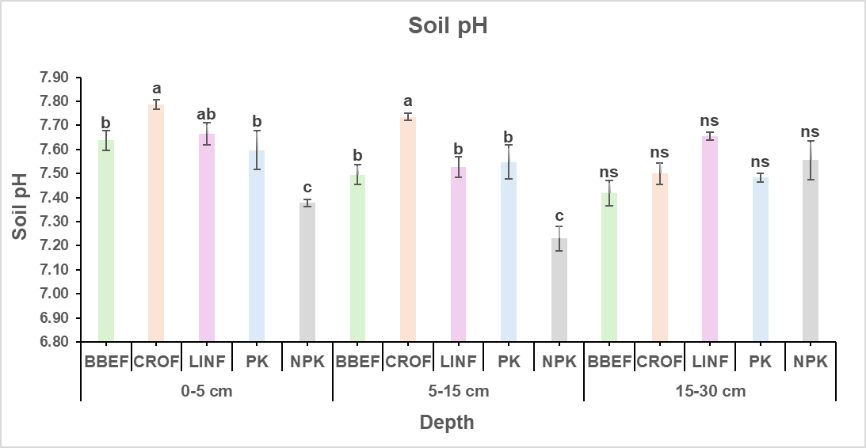
Fig. 1. Depth wise distribution of pH under different farming practices (Vertical bars with different lowercase letters are significantly different at the same depth at p< 0.05 according to Duncan multiple range test. Error bars represent standard error of mean. BBEF: biochar based ecological farming; CROF: climate-resilient organic farming; LINF: low-input natural farming; PK: phosphorus-potassium fertilization; NPK: nitrogen-phosphorus-potassium fertilization; ns: non-significant).

Soil pH was significantly influenced by different farming practices, particularly in the surface and subsurface layers. Higher pH values under CROF can be attributed to the liming effect of organic inputs, which neutralize soil acidity and enhance buffering capacity (Heinze et al. 2010). Organic manures and green manuring release basic cations such as Ca²⁺, Mg²⁺, and K⁺ during decomposition, which help in maintaining soil alkalinity. In contrast, NPK exhibited lower surface pH (0-15 cm) due to the acidifying effect of urea hydrolysis and nitrification (Sheoran et al. 2019). Minimal differences in deeper layers suggest the influence of organic inputs diminishes with depth (Sihi et al. 2017). Overall, incorporation of organic matter effectively moderates soil reaction, creating a favourable environment for nutrient availability and microbial activity. Similar trends were also observed by Meena et al. (2013) and Bhardwaj et al. (2023) in inceptisol of Varanasi.
3.2 Electrical Conductivity
EC values showed minimal variation among the different farming practices across the soil profile (Fig. 2). At the surface layer (0-5 cm), EC ranged from 0.13 dS m⁻¹ in the PK to 0.20 dS m⁻¹ in LINF, with no significant differences among treatments. At the subsurface layer (5-15 cm), EC values varied from 0.27 to 0.36 dS m⁻¹, and again, no significant treatment effects were observed, although LINF recorded a slightly higher mean value. At the 15-30 cm depth, however, small but significant differences were evident. The highest electrical conductivity values were maintained under BBEF, CROF, and LINF (0.25-0.27 dS m⁻¹), whereas the NPK exhibited the lowest EC (0.19 dS m⁻¹) followed by PK (0.20 dS m⁻¹).
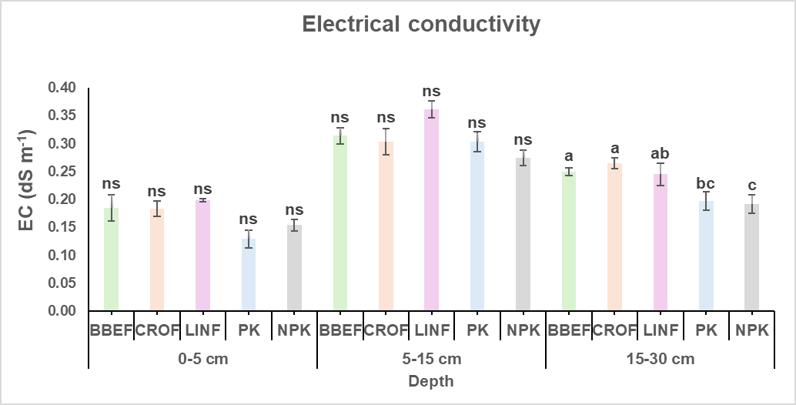
Fig. 2. Depth wise distribution of electrical conductivity under different farming practices (Vertical bars with different lowercase letters are significantly different at the same depth at p< 0.05 according to Duncan multiple range test. Error bars represent standard error of mean. BBEF: biochar based ecological farming; CROF: climate-resilient organic farming; LINF: low-input natural farming; PK: phosphorus-potassium fertilization; NPK: nitrogen-phosphorus-potassium fertilization; ns: non-significant).

EC values remained low across all treatments and depths, reflecting the non-saline nature of the soil. Slightly higher EC in BBEF, CROF and LINF at deeper layers may be due to the gradual mineralization of organic residues and release of soluble salts (Liang et al. 2006; Ikemura et al. 2008; Alotaibi and Schoenau 2016). In contrast, NPK maintained lower EC, possibly due to higher nutrient uptake by crops and reduced organic matter contribution (Lee et al. 2014). The overall EC values, however, remained well below critical thresholds for crop growth, indicating that none of the farming practices posed salinity risks. This highlights that organic and ecological practices enhance nutrient cycling without causing salt accumulation.
3.3 Soil Organic Carbon
SOC content was significantly influenced by farming practices, particularly in the surface and subsurface layers (Fig. 3). At 0-5 cm, the highest SOC was recorded under BBEF (0.80%), CROF (0.77%) and LINF (0.77%), while NPK (0.69%) and PK (0.64%) were significantly lower. At 5-15 cm, CROF maintained the highest SOC (0.63%), followed by BBEF and LINF (0.55-0.57%), whereas PK and NPK showed reduced values (0.43-0.48%), indicating the role of organic and ecological practices in enhancing carbon sequestration. At 15-30 cm, BBEF sustained maximum SOC (0.45%), significantly greater than others, while PK was lowest (0.26%). Overall, BBEF consistently outperformed other treatments across depths, highlighting the positive contribution of biochar and organic inputs in improving soil C storage.
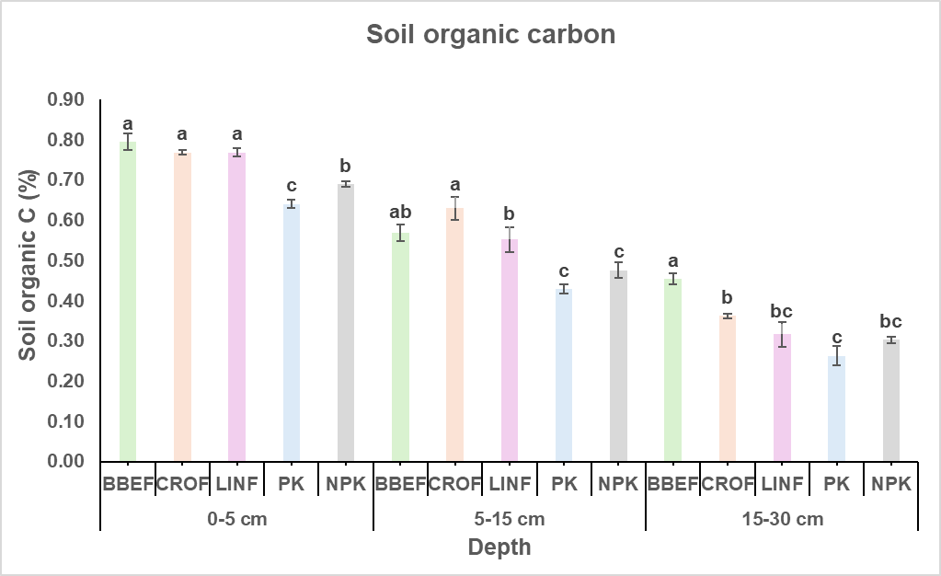
Fig. 3. Depth wise distribution of soil organic carbon under different farming practices (Vertical bars with different lowercase letters are significantly different at the same depth at p< 0.05 according to Duncan multiple range test. Error bars represent standard error of mean. BBEF: biochar based ecological farming; CROF: climate-resilient organic farming; LINF: low-input natural farming; PK: phosphorus-potassium fertilization; NPK: nitrogen-phosphorus-potassium fertilization).

SOC was strongly influenced by the management practices, with BBEF maintaining the highest levels across all depths. This is consistent with the known recalcitrant nature of biochar, which contributes to long-term carbon stabilization in soils (Hu et al. 2021). CROF and LINF also sustained higher SOC at the surface and subsurface layers due to continuous organic matter addition, root biomass, and residue incorporation (Joseph et al. 2020; Verma et al. 2024). In contrast, the PK and NPK showed significantly lower SOC, reflecting limited organic inputs and faster decomposition under intensive fertilization (Singh et al. 2018). The higher SOC under organic systems enhances soil aggregation, microbial activity, and nutrient cycling, confirming their role in improving soil quality and carbon sequestration potential (Drinkwater et al. 1995). A similar trend has been reported by Benbi et al. (2018), where organic farming systems in rice-wheat cropping in Inceptisol maintained higher soil organic carbon compared to conventional management.
3.4 Available N
Available N content varied significantly among the different farming practices and across soil depths (Fig. 4). At the 0-5 cm layer, BBEF (217.43 kg ha⁻¹), LINF (213.25 kg ha⁻¹), and NPK (210.11 kg ha⁻¹) recorded the highest values, which were statistically similar to CROF (194.43 kg ha⁻¹), while the lowest was observed in the PK (169.34 kg ha⁻¹). At 5-15 cm, BBEF and NPK maintained significantly higher available N (200.70 and 197.57 kg ha⁻¹, respectively), while CROF and LINF showed moderate levels (172.48-178.75 kg ha⁻¹). The PK again had the lowest N availability (150.53 kg ha⁻¹). In the deeper layer (15-30 cm), a similar trend was evident, with BBEF and NPK sustaining the highest available N (178.75 kg ha⁻¹ each), followed by LINF (156.80 kg ha⁻¹) and CROF (147.39 kg ha⁻¹), while the PK exhibited the lowest value (122.30 kg ha⁻¹).
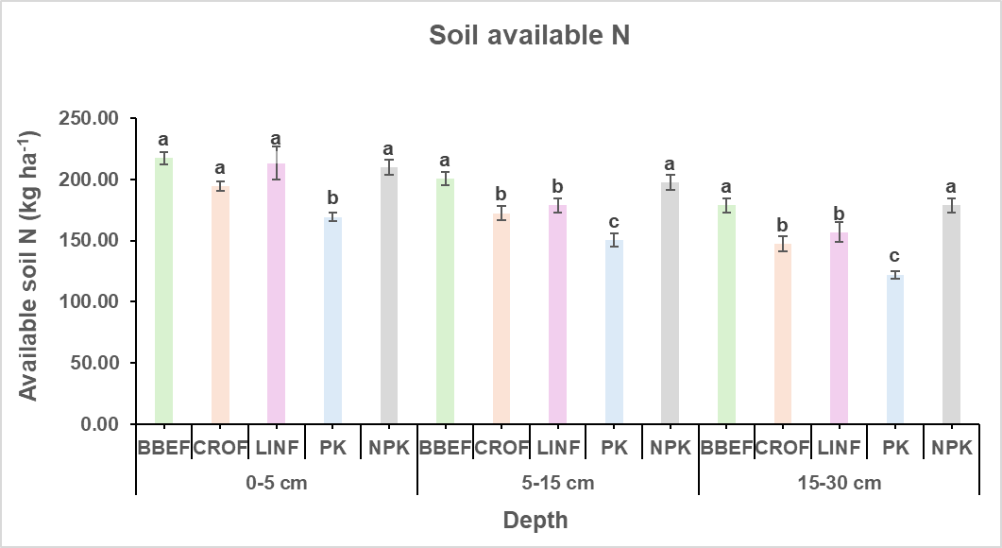
Fig. 4. Depth wise distribution of available nitrogen under different farming practices (Vertical bars with different lowercase letters are significantly different at the same depth at p< 0.05 according to Duncan multiple range test. Error bars represent standard error of mean. BBEF: biochar based ecological farming; CROF: climate-resilient organic farming; LINF: low-input natural farming; PK: phosphorus-potassium fertilization; NPK: nitrogen-phosphorus-potassium fertilization).

Nitrogen availability was highest under BBEF and NPK, indicating that both organic inputs and mineral fertilization effectively supply soil N. The improvement under BBEF is linked to enhanced mineralization, better microbial activity, and biochar’s role in reducing N losses through adsorption and slow release (Xu et al. 2016). NPK benefited from direct and split application of neem-coated urea, ensuring gradual release and sustained N supply. In contrast, lower N levels in PK highlight depletion in the absence of external additions. Organic systems (CROF and LINF) showed moderate values, likely due to slower release and possible immobilization during decomposition (Ikemura et al. 2008; Wang et al. 2013). These findings suggest that ecological practices with biochar can sustain N availability comparable to conventional fertilization, with added soil health benefits.
3.5 Available P
Available P showed significant variation across treatments and soil depths (Fig. 5). At the surface layer (0-5 cm), the highest P content was recorded in the PK (20.14 kg ha⁻¹), followed by the NPK (17.93 kg ha⁻¹) and BBEF (17.38 kg ha⁻¹), while the lowest value occurred under LINF (14.62 kg ha⁻¹). At the 5-15 cm depth, BBEF, CROF, PK, and NPK maintained higher available P (14.62-16.00 kg ha⁻¹), whereas LINF recorded significantly lower P (11.45 kg ha⁻¹). In the 15-30 cm layer, BBEF sustained the highest P content (14.07 kg ha⁻¹), which was statistically similar to PK and NPK. The lowest value was again observed in LINF (9.93 kg ha⁻¹), while CROF maintained a moderate level (11.45 kg ha⁻¹).
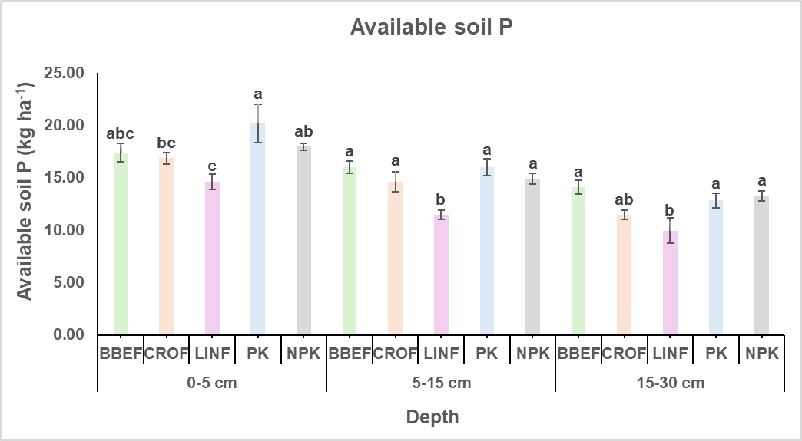
Fig. 5. Depth wise distribution of available phosphorus under different farming practices (Vertical bars with different lowercase letters are significantly different at the same depth at p< 0.05 according to Duncan multiple range test. Error bars represent standard error of mean. BBEF: biochar based ecological farming; CROF: climate resilient-organic farming; LINF: low-input natural farming; PK: phosphorus-potassium fertilization; NPK: nitrogen-phosphorus-potassium fertilization).

Phosphorus availability exhibited variable responses. The highest surface P content was observed in PK and NPK, likely due to direct application of mineral P fertilizers. In contrast, lower values in organic and natural systems (CROF and LINF) may be associated with slow mineralization of organic P and microbial immobilization. However, BBEF sustained P availability across the profile, possibly due to biochar’s ability to reduce P fixation through adsorption onto its surfaces and by modifying soil pH (Mukherjee et al. 2020). The results suggest that while mineral fertilization ensures higher immediate P availability, biochar and organic inputs can contribute to more stable P dynamics in the longer term (Oehl et al. 2002; Sanchez de Cima et al. 2015).
3.6 Available K
Available K exhibited significant differences among the farming practices across soil depths (Fig. 6). At the surface (0-5 cm), the highest K was observed in PK (171.64 kg ha⁻¹) and LINF (167.16 kg ha⁻¹), which were statistically at par with BBEF (162.96 kg ha⁻¹), whereas the lowest values were found under CROF (138.04 kg ha⁻¹) and NPK (136.08 kg ha⁻¹). At 5-15 cm depth, PK maintained significantly higher K availability (159.04 kg ha⁻¹), followed by LINF (145.88 kg ha⁻¹) whereas BBEF, CROF, and NPK recorded comparatively lower values (131-135 kg ha⁻¹). In the 15-30 cm layer, PK and BBEF sustained the highest K contents (173.32 and 168.00 kg ha⁻¹, respectively), which were statistically similar, while NPK showed the lowest K (146.44 kg ha⁻¹). Treatments CROF and LINF exhibited intermediate values.
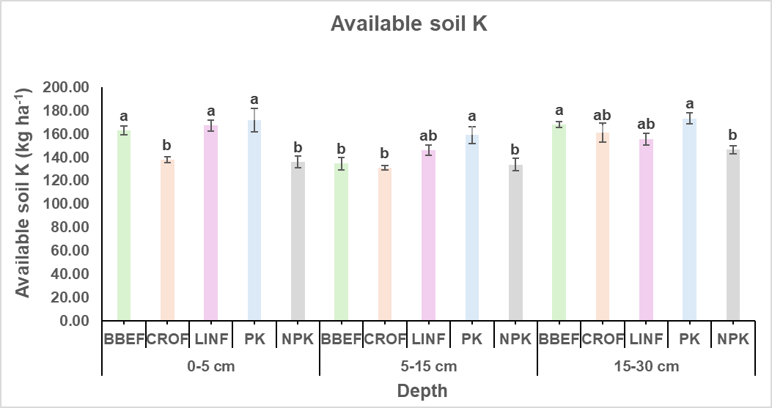
Fig. 6. Depth wise distribution of available potassium under different farming practices (Vertical bars with different lowercase letters are significantly different at the same depth at p< 0.05 according to Duncan multiple range test. Error bars represent standard error of mean. BBEF: biochar based ecological farming; CROF: climate resilient-organic farming; LINF: low-input natural farming; PK: phosphorus-potassium fertilization; NPK: nitrogen-phosphorus-potassium fertilization).

Available K was consistently higher in the PK and organic systems such as BBEF and LINF, whereas the NPK maintained the lowest levels. The higher K in PK reflects residual build-up from continuous P and K fertilization in the absence of N, leading to lower crop removal. Similarly, addition of organic matter and biochar in BBEF and LINF supplied K through mineralization of residues and improved cation exchange capacity, which enhances K retention in soil (Abu-Zahra et al. 2008; Shaaban et al. 2018). The relatively lower values in NPK may be due to greater crop uptake under higher productivity, leading to soil K depletion. Overall, the findings demonstrate that organic systems such as BBEF and LINF, along with PK, were more effective than NPK in maintaining higher available K in the soil.
4. CONCLUSION
The study clearly demonstrates that different farming practices distinctly influence soil chemical properties and nutrient dynamics across soil depths. CROF sustained higher soil pH, indicating its buffering effect against acidification. EC remained low across all treatments, confirming non-saline soils, with slightly higher values in ecological and organic systems due to greater organic residue mineralization. BBEF significantly enhanced soil organic carbon sequestration and maintained consistently higher available N and K throughout the profile, reflecting its long-term potential for soil fertility improvement. NPK, though effective in sustaining available P, was associated with lower SOC and K, suggesting greater nutrient depletion under intensive nutrient-demanding systems. Interestingly, in PK, despite N omission, maintained higher K availability, primarily due to balanced P and K inputs. Overall, BBEF, CROF and LINF systems outperformed NPK in enhancing soil health, nutrient retention, and resilience. These findings emphasize that adopting ecological and organic approaches can be a viable pathway for ensuring soil sustainability, productivity, and environmental resilience in the long run.

DISCLAIMER (ARTIFICIAL INTELLIGENCE)
The authors hereby declare that no generative AI tools (e.g., Large Language Models such as ChatGPT, Copilot, or text-to-image generators) were used in the writing or editing of this manuscript.
COMPETING INTERESTS
The authors declare that they have no competing interests.
REFERENCES
Abu-Zahra, T. R., & Tahboub, A. B. (2008). Effect of organic matter sources on chemical properties of the soil and yield of strawberry under organic farming conditions. World Applied Sciences Journal, 5(3), 383-388.
Alotaibi K.D., & Schoenau J.J. (2016). Application of two bioenergy byproducts with contrasting carbon availability to a prairie soil: three-year crop response and changes in soil biological and chemical properties. Agronomy, 6(1), 13.
Benbi, D. K., Sharma, S., Toor, A. S., Brar, K., Sodhi, G. P. S., & Garg, A. K. (2018). Differences in soil organic carbon pools and biological activity between organic and conventionally managed rice-wheat fields. Organic agriculture, 8(1), 1-14.
Bhardwaj, Y., Reddy, B., & Dubey, S. K. (2023). Organic farming favors phod-harboring rhizospheric bacterial community and alkaline phosphatase activity in tropical agroecosystem. Plants, 12(5), 1068
Bharucha, Z. P., Mitjans, S. B., & Pretty, J. (2020). Towards redesign at scale through zero budget natural farming in Andhra Pradesh, India. International Journal of Agricultural Sustainability, 18(1), 1-20.
Drinkwater, L.E., D.K. Letourneau, F. Workneh, A.H.C., Van Bruggen, A. H. C., & Shennan, C. (1995). Fundamental differences between conventional and organic tomato agroecosystems in California. Ecological applications, 5(4), 1098-1112.
Gomez, K. A., & Gomez, A. A. (1984). Statistical procedures for agricultural research. John wiley & sons.
Glaser, B., Balashov, E., Haumaier, L., Guggenberger, G., & Zech, W. (2000). Black carbon in density fractions of anthropogenic soils of the Brazilian Amazon region. Organic geochemistry, 31(7-8), 669-678.
Hanway, J. J. (1952). Soil analysis methods as used in the iowa state college soil testing laboratory. Iowa agriculture, 57, 1.
Heinze, S., Raupp, J., & Joergensen, R. G. (2010). Effects of fertilizer and spatial heterogeneity in soil pH on microbial biomass indices in a long-term field trial of organic agriculture. Plant and Soil, 328(1), 203-215.
Hu, F., Xu, C., Ma, R., Tu, K., Yang, J., Zhao, S., ... & Zhang, F. (2021). Biochar application driven change in soil internal forces improves aggregate stability: Based on a two-year field study. Geoderma, 403, 115276.
Ikemura, Y., Shukla, M. K., Tahboub, M., & Leinauer, B. (2008). Some physical and chemical properties of soil in organic and conventional farms for a semi-arid ecosystem of New Mexico. Journal of Sustainable Agriculture, 31(4), 149-170.
Jackson, M. L. (1973). Soil chemical analysis-advanced course: A manual of methods useful for instruction and research in soil chemistry, physical chemistry of soils, soil fertility, and soil genesis.
Joseph, U. E., Toluwase, A. O., Kehinde, E. O., Omasan, E. E., Tolulope, A. Y., George, O. O., ... & Hongyan, W. (2020). Effect of biochar on soil structure and storage of soil organic carbon and nitrogen in the aggregate fractions of an Albic soil. Archives of Agronomy and Soil Science, 66(1), 1-12.
Kaye, J. P., & Hart, S. C. (1997). Competition for nitrogen between plants and soil microorganisms. Trends in Ecology & Evolution, 12(4), 139-143.
Kitamura, R., Sugiyama, C., Yasuda, K., Nagatake, A., Yuan, Y., Du, J., ... & Hatano, R. (2021). Effects of three types of organic fertilizers on greenhouse gas emissions in a grassland on andosol in southern Hokkaido, Japan. Frontiers in Sustainable Food Systems, 5, 649613.
Lee, J., Hwang, S., Lee, S., Ha, I., Hwang, H., Lee, S., & Kim, J. (2014). Comparison study on soil physical and chemical properties, plant growth, yield, and nutrient uptakes in bulb onion from organic and conventional systems. HortScience, 49(12), 1563-1567.
Lehmann, J., Gaunt, J., & Rondon, M. (2006). Bio-char sequestration in terrestrial ecosystems–a review. Mitigation and adaptation strategies for global change, 11(2), 403-427.
Li, R., Pang, Z., Zhou, Y., Fallah, N., Hu, C., Lin, W., and Yuan, Z. (2020). Metagenomic analysis exploring taxonomic and functional diversity of soil microbial communities in sugarcane fields applied with organic fertilizer. BioMed Research International, 2020.
Liang B., Lehmann J., Solomon D., Kinyangi J., Grossman J., O’Neill B., Skjemstad J.O., Thies J., Luizao F.J., Petersen J., & Neves E.G. (2006). Black carbon increases cation exchange capacity in soils. Soil Science Society of America Journal, 70(5), 1719-1730.
Meena, V. S., Maurya, B. R., Verma, R., & Meena, S. K. (2013). Effect of concentrate manure and inorganic fertilizers on soil electro-chemical properties and productivity of rice (Oryza sativa L.) under inceptisol of varanasi. Annals of Biology, 29(3), 358-363.
Mukherjee, S., Mavi, M. S., Singh, J., & Singh, B. P. (2020). Rice-residue biochar influences phosphorus availability in soil with contrasting P status. Archives of Agronomy and Soil Science, 66(6), 778-791.
Oehl, F., Oberson, A., Tagmann, H. U., Besson, J. M., Dubois, D., Mader, P., ... & Frossard, E. (2002). Phosphorus budget and phosphorus availability in soils under organic and conventional farming. Nutrient Cycling in Agroecosystems, 62(1), 25-35.
Olsen, S. R. (1954). Estimation of available phosphorus in soils by extraction with sodium bicarbonate. USDA Circular No. 939, Washington, USA.
Piccolo, A., Pietramellara, G., and Mbagwu, J. S. C. (1996). Effects of coal derived humic substances on water retention and structural stability of Mediterranean soils. Soil Use and Management 12(4), 209-213.
Ray, P., Lakshmanan, V., Labbe, J. L., and Craven, K. D. (2020). Microbe to microbiome: A paradigm shift in the application of microorganisms for sustainable agriculture. Frontiers in Microbiology 11, 622926.
Sanchez de Cima, D., Reintam, E., Tein, B., Eremeev, V., & Luik, A. (2015). Soil nutrient evolution during the first rotation in organic and conventional farming systems. Communications in Soil Science and Plant Analysis, 46(21), 2675-2687.
Shaaban, M., Van Zwieten, L., Bashir, S., Younas, A., Nunez-Delgado, A., Chhajro, M. A., ... & Hu, R. (2018). A concise review of biochar application to agricultural soils to improve soil conditions and fight pollution. Journal of environmental management, 228, 429-440.
Sheoran, H. S., Kakar, R., & Kumar, N. (2019). Impact of organic and conventional farming practices on soil quality: A global review. Applied Ecology & Environmental Research, 17(1).
Sihi, D., Dari, B., Sharma, D. K., Pathak, H., Nain, L., & Sharma, O. P. (2017). Evaluation of soil health in organic vs. conventional farming of basmati rice in North India. Journal of Plant Nutrition and Soil Science, 180(3), 389-406.
Singh, V. K., Dwivedi, B. S., Mishra, R. P., Shukla, A. K., Timsina, J., Upadhyay, P. K., ... & Panwar, A. S. (2018). Yields, soil health and farm profits under a rice-wheat system: Long-term effect of fertilizers and organic manures applied alone and in combination. Agronomy, 9(1), 1.
Subbiah, B. V., & Asija, G. L. (1956). A rapid procedure for the estimation of available nitrogen in soils. Current Science, 25, 259-260.
Verma, S., Pradhan, S. S., Singh, A., & Kushuwaha, M. (2024). Effect of organic manure on different soil properties: A review. Int. J. Plant Soil Sci, 36(5), 182-187.
Walkely, A., & Black, T. J. S. S. (1934). Determination of organic carbon by rapid titration method. Soil Sci, 37(29), 165-177.
Wang, X. L., Ye, J., Perez, P. G., Tang, D. M., & Huang, D. F. (2013). The impact of organic farming on the soluble organic nitrogen pool in horticultural soil under open field and greenhouse conditions: a case study. Soil Science and Plant Nutrition, 59(2), 237-248.
Xu, M., Lou, Y., Sun, X., Wang, W., Baniyamuddin, M., and Zhao, K. (2011). Soil organic carbon active fractions as early indicators for total carbon change under straw incorporation. Biology and Fertility of Soils, 47, 745-752.
Xu, N., Tan, G., Wang, H., & Gai, X. (2016). Effect of biochar additions to soil on nitrogen leaching, microbial biomass and bacterial community structure. European journal of soil biology, 74, 1-8.

