Original Research Article

Design and Performance Evaluation of an IoT-Enabled Automated Aeroponic System for Sustainable Crop Production in Kerala, India

.
ABSTRACT
Aeroponics, a soilless cultivation technique that delivers nutrient-rich mist to plant roots, offers a viable solution to increasing food production sustainably while conserving water, reducing land use, and enabling agriculture in urban and resource-scarce environments. Traditional farming faces issues such as inefficient water use, land scarcity, and soil degradation, which are further exacerbated by urbanisation. This research investigates the development and assessment of an IoT-enabled automated aeroponic system for Palak cultivation at the KCAEFT Campus in Tavanur, Kerala. The system includes essential components such as a growth chamber, misting units, PVC fittings, and storage tanks for water and nutrients. A microcontroller-based control unit, integrated with a GSM module and various sensors, viz. pH, EC, TDS, temperature, humidity, and level sensors, facilitates real-time data transmission to the ThingSpeak IoT platform for monitoring and automation. The system maintains optimal conditions, with temperatures ranging from 23°C to 27°C and humidity levels between 75% and 95%. Performance evaluation revealed a yield of 9.29 kg over 80 days, with a water use efficiency of 66.88 kg/m³ and nutrient use efficiency of 2.86 kg per kg of nutrients. The benefit-cost ratio was recorded as 1.19. Integrating IoT with aeroponics enhances precision agriculture by automating irrigation and nutrient management, addressing challenges such as water scarcity and food security. Expanding the system to larger greenhouse setups can further optimise resource utilisation, while small-scale urban applications enable local food production. Despite implementation challenges, aeroponics remains a promising approach to sustainable farming. However, the system’s time efficiency and scalability make it an attractive solution for modern agriculture, particularly in urban or indoor environments. Future research could focus on expanding its application to other crops and enhancing its scalability and energy efficiency.

Keywords: Aeroponics, soilless cultivation, IoT, Palak

- INTRODUCTION
The rapid growth of the global population, projected to reach 9.73 billion by 2050 (FAO, 2017), presents significant challenges for food production, necessitating innovative and sustainable agricultural solutions. Food insecurity, structural changes in the economy, climate change, hunger and poverty, more capital-intensive food systems, and conflicts/crises/natural disasters are other challenges in our society. Traditional farming faces issues such as inefficient water use, land scarcity, and soil degradation, which are further exacerbated by urbanisation. The emerging trends put forward new challenges, while global policies aim to achieve the zero-hunger goal by 2030 (UNCSD, 2012). Consequently, innovative solutions are essential to ensure food security and optimal space utilisation within urban environments.
In horticulture, soilless cultivation refers to the systems that grow plants without soil, relying on nutrient solutions to provide water and minerals. These soilless cultivation techniques have the potential to increase crop yields, make better use of available resources, and enable food production in places where conventional farming is not practical. By using less water and nutrients, these methods not only improve food security but also advance sustainable agriculture. The term "soilless culture" mostly describes hydroponic and aeroponic farming methods (Jasmal et al., 2024; Thapa et al., 2024). These systems can be categorized into three types: (i) solid medium systems, which uses substrates like rockwool, peat, or perlite to support plants, (ii) liquid medium systems, where plant roots are immersed in nutrient solutions without additional support, and (iii) aerated medium systems, where plant roots are suspended in a chamber and sprayed with nutrient solution from below (Winsor and Schwarz, 1990). The different soilless farming methods include a) hydroponics, where plants grow in nutrient-dense water; b) aeroponics, where plant roots are suspended in the air and sprayed with nutrients for accelerated growth; and c) aquaponics, which integrates hydroponics with aquaculture, utilising fish waste to nourish the plants. Among alternative farming methods, soilless cultivation techniques hydroponics, aquaponics, and aeroponics, provide effective solutions by eliminating the need for soil and improving resource utilisation. Aeroponics, a high-tech soilless farming method, suspends plant roots in the air and delivers nutrients through a fine mist, promoting faster growth while reducing water and space requirements (Gopinath et al., 2017). Technology plays a crucial role in the success of aeroponics, enabling the precise control of environmental factors, water conservation, space optimisation, and pest and disease control, all of which contribute to improved food production. Additionally, by leveraging technology, aeroponics can produce high-quality, nutrient-rich crops with a reduced environmental footprint compared to traditional farming methods (Garzón et al., 2023). This approach is particularly beneficial for urban environments with limited arable land. In this regard, the Internet of Things (IoT) has revolutionised various industries by enabling real-time data collection, remote monitoring, and automation. IoT allows for precise control of environmental conditions, which is critical for optimising plant growth.
This approach is particularly beneficial for urban environments with limited arable land. However, manual management of aeroponic systems can be labour-intensive and prone to inefficiencies. Integrating the Internet of Things (IoT) with aeroponics enables real-time monitoring, automation, and precision control of environmental parameters such as humidity, temperature, pH, and nutrient levels. The agricultural sector has been revolutionised by IoT, enabling data-driven approaches through sensors and connected devices. IoT enhances productivity, reduces risks, and supports applications like crop monitoring, greenhouse automation, and livestock management. IoT-driven aeroponics optimises resource use, enhances crop productivity, and minimises human intervention, making it a viable solution for modern agriculture (Priya and Sudha, 2021). Despite its advantages, aeroponic farming remains underutilised in regions like Kerala. This study focuses on developing an IoT-based automated aeroponic system to improve efficiency, reduce resource consumption, and enable remote monitoring and control. The research evaluates the system’s technical and economic feasibility, demonstrating its potential for wider adoption. By integrating IoT technology, aeroponics can revolutionise precision farming, offering a sustainable and scalable solution to address food security and agricultural challenges.

- Materials and Methods
  - Study area
The study was carried out at the KCAEFT Tavanur campus, situated at 10° 51' 13" N latitude and 75° 59' 06" E longitude, with an elevation of 25 meters above sea level. The field experiment took place in a naturally ventilated polyhouse within the research plot of the Department of Irrigation and Drainage Engineering. The polyhouse, covering an area of 213 m², measures 26 meters in length, 8 meters in width, with a centre height of 6 meters and a gutter height of 3 meters.
  - Methodology
The study focuses on the development of an aeroponics system to provide a soil-less growth environment where plant roots are suspended and misted with nutrient-rich water. Aeroponic systems were placed securely on a raised platform to allow free movement of misting devices underneath. High-pressure misting nozzles were connected to a pump and nutrient solution reservoir, ensuring fine and uniform mist delivery to the roots. A drainage and recirculation mechanism was set up to minimise water wastage and maintain nutrient levels. Aeroponic systems were installed properly to support plant growth. IoT integration added real-time monitoring and automation capabilities to the aeroponic system. Sensors were placed for monitoring environmental parameters. Sensors for measuring pH, temperature, humidity, nutrient concentration (TDS, EC), and water levels were strategically installed in the system. A microcontroller PIC was programmed to collect sensor data and send it to the cloud for analysis. Actuators for controlling misting, valves and ventilation systems were connected to the microcontroller, enabling automatic adjustments based on sensor feedback. IoT-enabled modules ensured seamless data transmission between the system and user interfaces such as mobile apps and web dashboards. Chart 1 represents the overall framework of the study.

Chart 1: Overall framework of the study

2.1 Development of an aeroponic system
The system consists of a growth chamber along with its piping connections. The aeroponic setup includes a growth chamber constructed from galvanised iron (GI) sheets, measuring 2.4 m × 1.2 m × 0.75 m (L × W × H), and elevated 0.25 m above the ground. To facilitate efficient water and nutrient management, a drainage outlet is placed at the edge, allowing excess spray to flow back into the nutrient solution tank. The top of the growth chamber is covered with a forex sheet, which supports seedlings placed in 3-inch diameter net pots. Inside the chamber, misters with a capacity of 6 litres per hour (L·h⁻¹) are installed to supply water and nutrients directly to the seedlings. The nutrient tank functions as both a reservoir and a collection unit, where the drained solution is returned via gravity for recirculation. Table 1 represents the components of the aeroponic system. Figure 2 and Figure 3 represent the overall sketch up of the study. Table 1 represents the components used in the study.
Components | Specifications
Growth chamber | - 45 plants (9 rows x 5 columns)  - Plant spacing 25*25 cm  - Width of chamber = 4*25 = 100 cm and free board on both sides 10 cm each = 120 cm  - Length of chamber = 8*25 = 200 cm and free board on both sides 20 cm each = 240 cm  - Height of the chamber = 0.5 to 1 meter  - Inspection window : Inspection window made at one side of the chamber as two compartments  - Dimensions : 1.2 m * 0.5 m (2)
Nozzle unit | - Requirement - irrigating/fertigating the roots - a single nozzle micro mister was selected  - F7GSSH single high pressure nozzle  - Range of Pressure – 3-5 kg/cm²  - 3 number of laterals were selected and 13 number of misters were selected in this study.  - Overlapping percentage 40-65%  - A fixed duration of 10 seconds ON and 5 minutes OFF for spraying nutrient to the plant was scheduled
Nutrient solution tank | - The nutrient mixing tank has 75 L capacity  - To make appropriate concentrations of nutrient solution of plant growth.
Concentrated nutrient tank | - The nutrient mixing tank has 20 L capacity  - It is used to add concentrated nutrients to nutrient solution tank
Water storage tank | - Water storage tank for supplying water to the nutrient solution tank and growth chamber (temperature maintenance).
Solenoid valves | - The solenoid valve only works when it is supplied with 12 VDC voltage.  - It contains two connections: an exit and an inlet for liquid.
Overhead tank | - The overhead water tank will supply sufficient amount of water to the water storage tank.
Pump | - Field star double diaphragm pump MODEL SL-DP16  - Maximum Pressure: up to 0.85 MPa .  - Volts – 12V DC  - AMPS – 4-6.5 A
Fogger | - Four way foggers of flowrate pressure of 4 kg cm-2 were used for evaporative cooling inside the greenhouse.  - They were fitted at 1.5 m x 1.5 m spacing inside the greenhouse.
Ultrasonic atomizer | - Very small respirable droplet sizes can be achieved, less than 4 microns , used for temperature control in chamber
Exhaust fan | - Ultra Gold Hi-Speed Reversible, 1 Unit, 230 V, 50 Hz  - Two exhaust fans were used for the air exchange of greenhouse with that of outside.
Tubings and connections | - PVC Piping  - Endcaps  - Bends  - Valves  - Connectors  - Screens

Table 1- Schematic of the plant growth chamber system with 45-plant layout, micro-misters, nutrient delivery, cooling units, and environmental control components

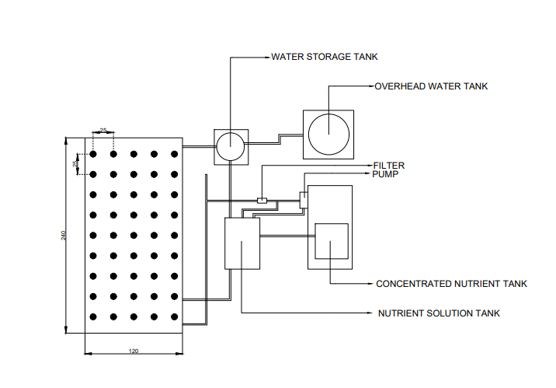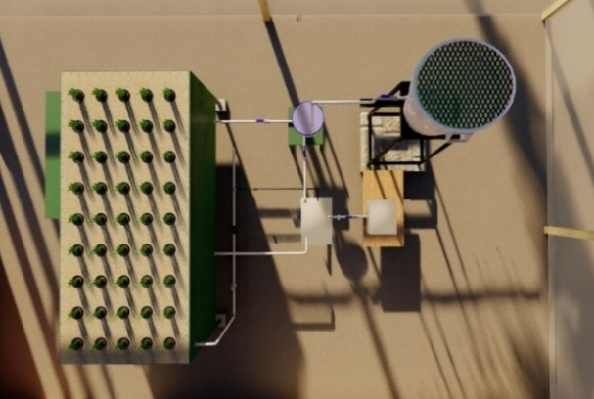
Fig. 1 Top view of the experimental set-up drawn in AutoCAD and Lumion
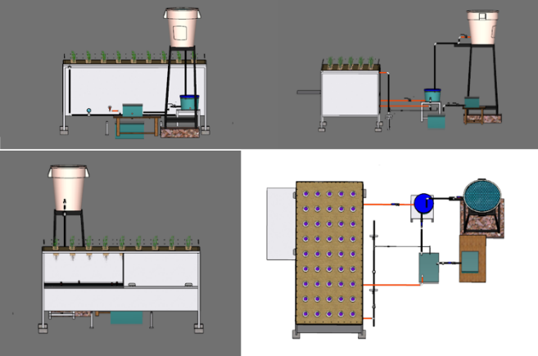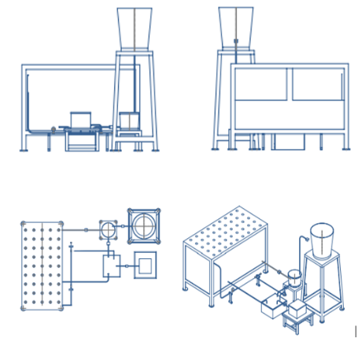
(a)
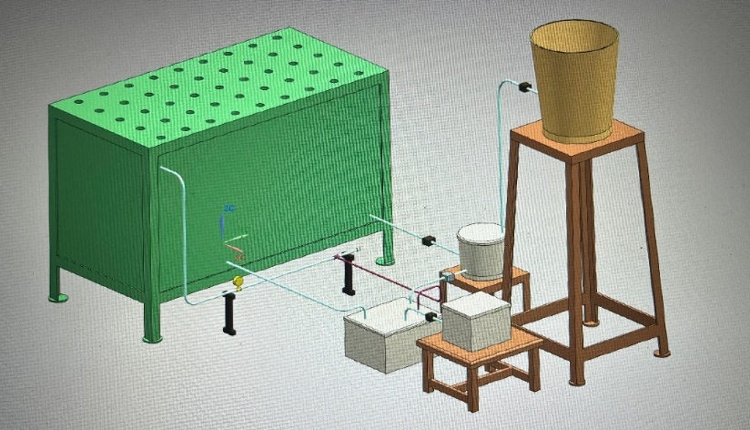
(b)
Fig. 2 (a) Drawing of aeroponic system at different angles (b) Overall view of aeroponic system drawn in SketchUp
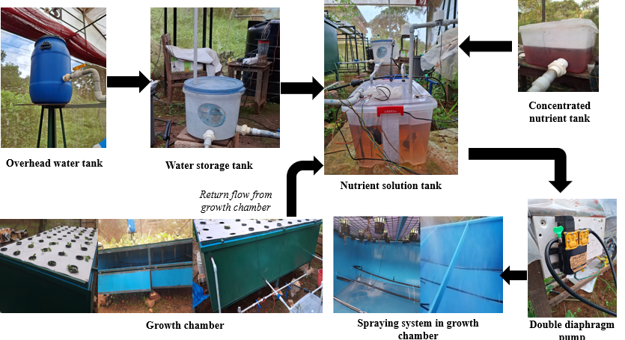
Fig. 3 Flowchart of the process
The process starts with an overhead water tank supplying water to a storage tank that regulates availability. Water is then directed to the nutrient solution tank, where it is precisely mixed with concentrated nutrients. A double diaphragm pump pressurises the nutrient solution and delivers it to the spraying system inside the growth chamber. This system consists of three parallel microtubes with misters spaced 0.40 m apart, which spray atomised nutrients onto the plant roots in a controlled cycle: 10 seconds of spraying followed by a 5-minute pause. The automated system, powered by a 12V, 6Amp DC motor pump, ensures precise nutrient delivery and efficient operation. Excess nutrient solution is collected and recirculated back into the nutrient tank, creating a closed-loop system that enhances sustainability. This setup maintains a continuous supply of water and nutrients, optimising plant growth in the aeroponic system.
2.1 Development of an automation system
The automation system combines hardware and software components to enhance efficiency and streamline operations. The hardware includes sensors for monitoring environmental conditions, actuators for executing control actions, and a microcontroller for data processing. Additional components, such as communication modules, power supplies, display units, and support system functionality. On the software side, embedded programming, control algorithms, and IoT platforms enable real-time data analysis, remote monitoring, and automation. IoT integration enhances the aeroponic system by enabling continuous monitoring and automated adjustments. Sensors for pH, temperature, humidity, nutrient concentration (TDS, EC), and water levels were strategically placed. A PIC microcontroller collects and processes this data, transmitting it to the cloud for analysis. Actuators controlling misting, valves, and ventilation respond to sensor feedback, ensuring optimal growing conditions. IoT modules facilitate seamless data transmission to user interfaces, such as mobile apps and web dashboards, allowing remote monitoring and control. Table 2 represents the components of the automation system. Figure 4 steps provide a detailed overview of the process.

Table 2 Components of the automation system
Components | Specifications
Microcontroller | PIC18F4520 from MICROCHIP | Programmed according to the requirements of the designer
Sensors | Humidity and Temperature Sensor | DHT22
Sensors | Liquid temperature sensor | DS18B20
Sensors | Electrical conductivity | It has a operating voltage DC3-5V and Operating current less than 20mA.
Sensors | pH | Operating voltage 5 ± 0.2 (DC)  Working current 5-10mA  Detection range 0-14 pH  Operating temperature 0-60°C
Sensors | Level sensor | IR Sensor - A beam of infrared light is reflected off an object to measure its distance.
Sensors | Flow sensor | YF-S201 - Water flow sensors are installed at the water source or pipes to measure the rate of flow of water
Sensors | TDS sensor | TDS Measurement Range 0 ~ 1000ppm  TDS Measurement Accuracy ± 10% F.S. (25 ℃)
Power supply | It consists of a 12 V battery, voltage regulator IC 7805 and capacitors as filters. This circuit can provide fixed +5V.
GSM Module | For sending the information of the system to an authorized mobile phone as SMS.
LCD display | Model HD 44780 | For displaying key parameters
ALARM | A buzzer is used here as an audio alarm
LED | A light-emitting diode (LED) is an electronic light source
ELECTRICAL RELAYS | A relay is an electrical switch that opens and closes under the control of another electrical circuit.

Fig.4 Flow chart of automation process
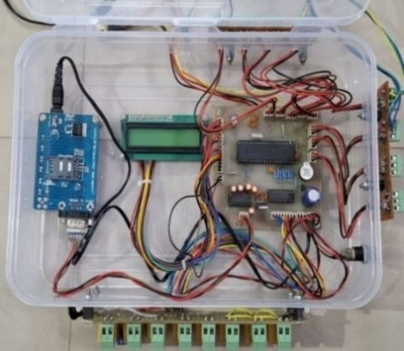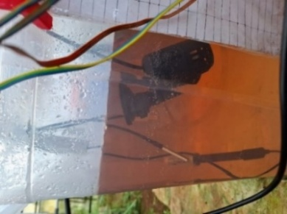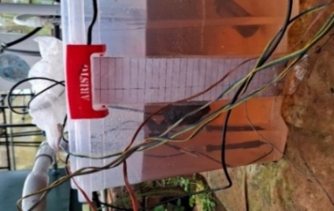
Fig. 5 Hard ware components of the automation system and Placement of sensors in nutrient solution
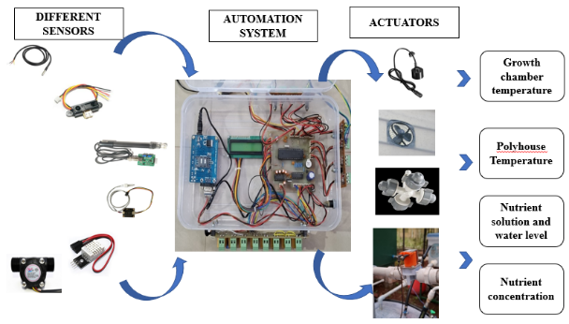
Fig. 6 Representation of installed automation
2.3 Installation and evaluation of the system
The IoT-enabled aeroponic system was developed. The performance of the developed aeroponic system was evaluated with palak. The Palak variety selected for the study was Arka Anupama. In order to evaluate the system, the specified crop was raised in aeroponics inside the greenhouse. The developed system, with its proper coding, maintains the optimum range of parameters. Whenever the parameter varies from the optimum value, the actuators turn ON/OFF automatically to adjust to the required microclimate condition as well as nutrient parameters. The system shows the graphical representation of parameters with respect to date and time with the help of Thingspeak. The time interval for the misting is given on the time step given in coding. Monitoring the growth and yield parameters of the test crop was done manually.
2.4 System parameters
2.4.1 Pump operating pressure.
The pump operating pressure was measured using a pressure gauge and expressed in 3 to 5 kg cm⁻².

2.4.2 Pump discharge
The one metre length of pipe was coupled to the pump outlet, and the pump discharge was collected into a bucket over a three-minute period. The volume collected into the bucket was measured with a measuring cylinder and recorded. This was repeated three times. The mean volume was found by dividing the sum of all the volumes taken by three. Discharge was calculated by dividing the mean volume by the time taken to accumulate the recorded volume and expressed in L·h⁻¹.

2.4.3 Meteorological indicators of temperature and relative humidity
The daily daytime temperature and relative humidity inside and outside the growth chamber data were recorded, Days After Transplanting (DAT) by using a sensor during the study period.

2.4.4 Chemical characterisation of nutrient solution
The nutrient solution was characterised by measuring parameters such as pH, electrical conductivity (EC), total dissolved solids (TDS), and levels. These parameters were measured using sensors and recorded in real-time on ThingSpeak.

2.4.5 Crop water use in an aeroponic system
The seasonal crop water use was calculated by using the water balance equation (Grewal et al., 2011).
CWU = (Q₁-Q₂)/A
Where,
CWU = Seasonally crop water use (m³)
Q₁ = The seasonally inflow volume to the aeroponic system (m³)
Q₂ = The seasonally outflow volume to the aeroponic system (m³)
A = The floor area of the aeroponics system (m²)

2.4.6 Mister droplet size
The mister droplet size was measured using water-sensitivity paper. The droplet size of the mist was measured using Water Sensitive Papers (WSPs), which are yellow-colored rectangular strips with dimensions of 76 × 26 mm. The WSPs were exposed to the spray droplet spectrum, and they changed to blue upon contact with water droplets. After exposure, the WSPs were scanned at a minimum resolution of 600 dpi in grayscale (EPSON M200). The resulting images were then analysed using Droplet scan, an image analysis software developed by the United States Department of Agriculture (USDA). The average droplet size at the mister operating pressure of 5 kg·cm⁻² was observed as 80 µm.

Fig.7 View of droplet size in the sensitivity paper

2.4.7 Mister spray radius
Each mister was allowed to operate without being restricted by the growth chamber to determine the through radius. The radius was calculated as the distance from the centre of the circle to the end of the wetted perimeter using scale, and it was expressed in m.

2.4.8 Electricity utilised
An energy meter was used to measure the electricity utilised during the misting procedure in the aeroponic system and expressed in units of current (kilowatt-hour).

2.5 Observations on crop growth and yield parameters
Sixteen plants were selected randomly and tagged for observations.

2.5.1 Growth parameters
Various growth parameters such as plant height, number of leaves per plant, leaf length, leaf width, stem girth and number of primary branches per plant of the crop inside the polyhouse were noted at a duration of 1 week 1 week after transplanting.

2.5.2 Yield parameters
Harvesting was started 35 days after planting and continued regularly on alternate days. The yield per plant and yield per ha were noted from the 16 tagged plants for each harvest, and the average was taken. The biometric parameters of palak were measured and recorded at intervals of 7,14,21,28,35,42 up to 80 days after transplanting (DAT) from five randomly tagged competitive plants from each of the aeroponic and existing system for studying various characters i.e., shoot length, number of leaves, root length SPAD reading, leaf area and leaf thickness these biometric parameters further described below, and general view of palak grown in aeroponic system.
- Shoot length
The shoot length was measured from observational plants at 7, 14, 28, 35 and 42 up to 80 days DAT by using a meter scale and recorded in centimetres (cm). It was measured from the attachment of the net pot level up to the tip of the growing point, and the average plant height was calculated.
- Number of leaves
The total number of leaves per plant was counted from the observational plants starting from 7 to 80 DAT at 7-day intervals, and the mean number of leaves was calculated.
- Leaf length
The leaf length was measured by using a meter scale. The measurement was taken from base to the tip of the leaf. The average leaf length was taken from ten selected plants. Data were recorded at a 7-day interval from 7 to 80 DAT. Mean leaf length was expressed in centimetres (cm).
- Leaf breadth
The leaf breadth was recorded as the average of observational plants from 7 to 80 DAT at 7-day intervals. Thus, mean breadth was recorded and expressed in cm.
- Root length
After the harvest, root length was measured with the help of a meter scale from the root shoot junction to the root tip and was expressed in centimetres. The average plant root length was calculated.
- Leaf area estimation
Leaf area was calculated by the following formula suggested by Rao (1978), expressed in cm².
A = 0.9817 × B^{1.1270} × L^{0.7503}
Where,
A = Actual area, (cm²)
B = Maximum breadth, (cm)
L = Length of leaf, (cm)
- Crop yield (kg)
The yield per plant, total yield and yield per hectare were recorded, and the average was worked out.
- Yield per plant (g)
The crop yield obtained from the selected plants was weighed separately. The data from these plants was averaged to work out the yield per plant immediately after the harvest and expressed in g.
- Yield per m² (kg m⁻²)
The yield was harvested from the aeroponic system, then weighed and expressed in kg.
- Yield per hectare (t ha⁻¹)
Yield per hectare of palak was calculated by converting the total yield obtained from aeroponics in t ha⁻¹.

RESULTS AND DISCUSSION
An IoT-based automated aeroponic system was installed inside a naturally ventilated polyhouse with a total area of 213 m², located at KCAEFT, Tavanur. A dedicated cultivation area of 2.88 m² was assigned for the experimental growth chamber, which served as the core of the aeroponic setup. The physical infrastructure included a growth chamber, nutrient and water storage tanks, piping system, misting units, solenoid valves, and control electronics. The primary aim of the installation was to establish an automated environment where key microclimatic and nutritional parameters could be monitored and regulated with minimal manual intervention. The plant-holding structure was positioned to ensure optimal root exposure to mist while avoiding excess contact with pooling solution. A diaphragm pump, connected to the nutrient tank, delivered the solution at a controlled pressure through a network of misting nozzles. The mist delivered nutrient-rich droplets directly to the plant root zone in a fine spray of <100 µm particle size, an essential feature for enhancing nutrient absorption efficiency. The misting interval was programmed based on established literature recommendations (Farran and Mingo, 2006), with an ON duration of 10 seconds followed by a 5-minute OFF cycle. This pulse schedule ensured sufficient moisture and nutrient availability without causing waterlogging or excessive nutrient wastage. The mist generated at a pressure of 5 kg·cm⁻² was found to be optimal for forming droplets of approximately 80 µm, as verified using Water Sensitive Papers (WSP) and analysed through USDA DropletScan software. The performance of the diaphragm pump was monitored continuously throughout the crop cycle. Weekly average pressure data indicated consistent operational efficiency during the mid-growth phase (Weeks 4 to 10), with a peak recorded at 5.2 kg·cm⁻² in Week 5. A decline observed in later weeks suggested the onset of maintenance needs, such as filter clogging or nozzle wear, emphasising the importance of periodic system inspection to maintain misting quality and flow rates. The discharge rate of the pump ranged between 7–8 L·min⁻¹, and was directly influenced by the operating pressure. Thirteen misting nozzles were distributed across the chamber, each exhibiting a pressure-dependent flow rate between 7.2 and 14.4 L·h⁻¹. Using the water balance equation proposed by Grewal et al., (2011), the seasonal CWU was calculated as 0.0657 m³ per m², confirming the water-saving potential of the system.
The control and automation system was centred around a PIC18F4520 microcontroller, integrated with a GSM modem for remote SMS alerts and an LCD module for real-time parameter display. Sensors were strategically placed within the growth chamber and in nutrient tanks. Environmental sensors managed foggers and exhaust fans within the polyhouse to stabilise temperature and humidity, while solution-specific sensors governed the solenoid valves to regulate nutrient and water levels. The automation framework was designed to respond dynamically to real-time data inputs. For instance, if the nutrient solution temperature exceeded optimal thresholds, the system adjusted misting frequency and alerted the operator via GSM. Similarly, when pH or TDS values drifted beyond predefined setpoints, corrective actions such as diluting the nutrient solution or adding concentrates were automatically triggered. The LCD displayed live updates on air temperature, humidity, nutrient level, solution temperature, pH, EC, and TDS, while warning messages like “Temp High” or “Low Nutrient Level” were issued for quick user response. The ThingSpeak platform was employed for IoT integration, offering real-time remote visualisation of environmental data and historical trend analysis through MATLAB-based tools. This platform enabled continuous observation of system performance, enhanced with alert-based decision support.
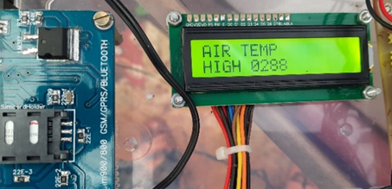 | 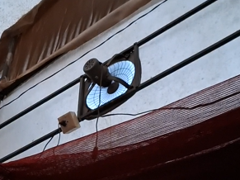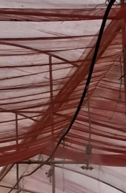
Fig.8 Alarm message in the display | Fig.9 Fan and fogger working status
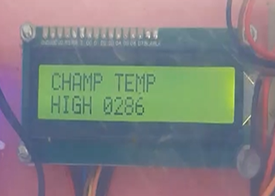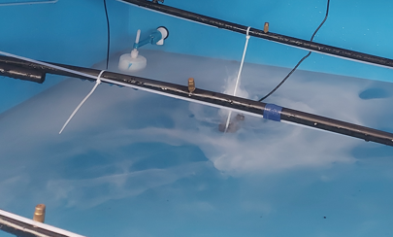
Fig.10 Display and working status of atomiser

3.1 Evaluation of microclimatic conditions inside the growth chamber
Maintaining optimal microclimatic conditions is a cornerstone of aeroponic cultivation, particularly for leafy greens such as palak, which are highly sensitive to temperature and humidity fluctuations. In the present study, the IoT-enabled aeroponic system was continuously monitored to assess its ability to maintain suitable growth conditions. The real-time environmental control was achieved through calibrated sensors and automation logic, ensuring that the internal climate of the growth chamber remained within ideal thresholds throughout the crop cycle. The temperature inside the growth chamber was monitored using a DHT22 sensor and controlled by an ultrasonic atomiser. Over the 80-day growth period, the average recorded temperature within the chamber was 25.84°C, with a maximum of 26.9°C and a minimum of 24.8°C. These values fall well within the optimal range (22–28°C) for palak growth, as supported by existing literature. The stability in thermal conditions was attributed to the system’s responsive atomiser, which activated automatically when chamber temperatures exceeded 25°C, and deactivated once the desired range was restored. The atomiser was also conditioned to deactivate if relative humidity rose above 95%, thereby avoiding excess moisture and potential pathogen development.

Fig. 11 Chamber temperature difference two distinct date (max temp day and min temp day)

Fig. 12 Chamber temperature and chamber humidity on June 9th (09/06/2024)
A detailed diurnal analysis on June 9th (Figure 12) revealed a typical temperature curve: starting at 24.5°C during early morning, peaking at 26.5°C in the afternoon (around 15:00), and tapering back to 24.5°C by midnight. The standard deviation of 0.6°C highlighted the minimal fluctuation, reflecting strong system control and insulation. Such thermal consistency is vital for physiological processes like photosynthesis and transpiration, contributing directly to enhanced biomass accumulation.

Fig. 13 Variation of Relative Humidity, and Temperature
Relative humidity (RH) was another critical parameter regulated in the growth chamber. The system achieved an average RH of 89.18%, with observed values ranging from 84% (minimum) to 90% (maximum). Figure 12 shows the 24-hour RH trend for the same day (June 9th), where humidity peaked at 95% during the early morning hours and gradually declined to a minimum of 75–80% by mid-afternoon, followed by a resurgence in the evening. This cyclic variation is consistent with natural plant transpiration patterns and ambient temperature changes. The foggers and exhaust fans in the polyhouse were also programmed to activate based on these external temperature and humidity levels, helping to buffer against fluctuations. The chamber’s temperature and humidity showed a clear inverse relationship throughout the day, as shown in Figure 13. During peak daylight hours, when temperatures reached their maximum, RH declined due to increased evapotranspiration. Conversely, as temperatures dropped during the evening and night, RH naturally increased. This dynamic equilibrium mirrors outdoor diurnal cycles while remaining within target limits, providing the plants with a stable, stress-free microenvironment.

Fig. 14 Air temperature and relative humidity inside the polyhouse on June 9th

Fig. 15 Air temperature and humidity outside the growth chamber

Fig. 16 Variation of temperature inside and outside the growth chamber
External climatic conditions also played a role in shaping internal conditions, though the system proved effective in mitigating adverse impacts. Figure 16 compares temperature variations inside and outside the growth chamber, confirming that despite external peaks nearing 32°C, the internal environment remained largely unaffected. This demonstrated the system’s insulation capability and the effectiveness of automated responses in minimising stress-induced deviations. Light intensity within the polyhouse ranged from 10,200 lux to 15,500 lux over different weeks, averaging 14,009 lux. While artificial lighting was not introduced, the naturally ventilated structure provided sufficient solar exposure for palak growth. Weekly light intensity data (Table 4) indicated stable levels during the active growth stages, especially between Weeks 5 and 9, corresponding with the highest observed biometric gains.
Humidity and temperature control were further complemented by the system’s ability to respond to sensor feedback via ThingSpeak. Trends from daily monitoring were visualised remotely, allowing for adjustments if anomalies or drift from optimal conditions were detected. The real-time nature of the IoT system also allowed for predictive interventions such as scheduling misting during anticipated high-temperature periods, thereby minimising environmental shock to the plants. These findings align with prior studies, such as Mohamed et al. (2022) and Jamhari et al. (2020), who highlighted the role of closed-loop feedback systems in regulating microenvironments in controlled agriculture. The current system’s ability to maintain stable internal conditions supports its use for cultivating high-value crops under Kerala’s humid subtropical climate.
The IoT-enabled aeroponic system demonstrated precise control over temperature and humidity inside the growth chamber. The automation framework ensured environmental consistency, minimised stress on the plants, and maximised growth potential. These observations validate the effectiveness of integrating real-time feedback and environmental control in modern aeroponic agriculture.

3.2 Monitoring and Control of Nutrient Parameters
In aeroponic systems, nutrient solution parameters such as pH, electrical conductivity (EC), total dissolved solids (TDS), and temperature play a vital role in determining the efficiency of nutrient uptake and, consequently, plant growth. The current IoT-enabled system was designed to continuously monitor and regulate these parameters in real time through sensor feedback loops and automated actuators, including solenoid valves and alarms. The pH of the nutrient solution was maintained within the optimal range of 5.5 to 6.5, which is widely recognised as suitable for leafy vegetables such as palak. pH was measured using a 414 calibrated probe that interfaced with the microcontroller and LCD display. Over the cultivation period, the pH fluctuated slightly due to factors such as nutrient uptake, root exudates, and environmental temperature. However, automated alerts via the GSM module enabled corrective actions whenever deviations beyond set limits occurred.
Fig. 17 Variation of TDS and EC | Fig. 18 Nutrient solution temperature status
Electrical conductivity (EC) and TDS were monitored using independently calibrated sensors with high correlation values (R² = 0.9816 and R² = 0.9984, respectively). These parameters reflect the ionic concentration of the nutrient solution, and maintaining their stability ensures proper nutrient availability. The EC value ranged from 1.2 to 1.8 mS·cm⁻¹, while TDS varied from 250 to 750 ppm, adjusted based on plant growth stages. In early growth, nutrient concentrations were kept lower to avoid root burn, while mid-growth stages utilised more concentrated solutions to support biomass accumulation. The system employed a nutrient regulation mechanism where a solenoid valve, controlled by the microcontroller, was activated when the TDS dropped below a threshold (e.g., 250 ppm). Once the solution concentration reached the upper limit (e.g., 300 ppm or more), the valve automatically closed. Figure 19 shows this feedback loop in action, confirming the system’s ability to modulate nutrient concentration dynamically and autonomously. This ensured that palak plants consistently received optimal nutrition without manual input, reducing labour and error. Nutrient solution temperature was also carefully monitored, as it affects root respiration and nutrient solubility. The DS18B20 sensor installed in the nutrient tank maintained real-time readings throughout the day. Figure 18 shows that the solution temperature remained largely within the desirable range of 24–26°C, with a temporary midday increase to 27–28°C.

Fig. 19 level sensor reading Fig.20 pH variation on June 9th
Nutrient and water levels in the storage tanks were managed using IR level sensors. These sensors operated solenoid valves to refill tanks when the level dropped below 15 cm and stopped inflow at the 10 cm mark, thus preventing overflow and conserving resources. When the nutrient level variation coincided with solenoid valve activation, it confirmed precise automation. This closed-loop system-maintained solution availability and minimised operator involvement. The nutrient solution quality and delivery efficiency were further supported by ThingSpeak-based monitoring. EC and TDS values were particularly stable between Weeks 3 and 8, corresponding with the most vigorous vegetative growth. As shown in Figure 21, a slight rise in TDS during Week 5 matched with the period of maximum yield output (2.21 kg). This indicates a direct correlation between well-regulated nutrient delivery and biomass production.

Fig. 21 Variation of EC, pH and TDS in the growth period
Remote access to real-time EC, TDS, pH, and level data allowed the user to make informed decisions and review historical trends for anomaly detection and system diagnostics. The nutrient monitoring and control subsystem of the IoT-based aeroponic system successfully achieved precision farming objectives. It maintained essential parameters within optimal ranges using real-time data acquisition and response, thereby enhancing nutrient uptake efficiency, reducing wastage, and ultimately contributing to high-yield outcomes.

3.3 Plant Growth and Biometric Observations
Plant growth response serves as a direct indicator of the overall performance and suitability of any controlled environment system. In this study, biometric observations were systematically recorded for palak (Spinacia oleracea) to evaluate how effectively the developed IoT-based aeroponic system supported vegetative development under real-time automated control. Biometric parameters observed included shoot length, leaf length, leaf width, number of leaves, root length, and estimated leaf area. Data were recorded weekly from transplantation through to the first harvest, with sixteen plants selected for observation across all growth stages to ensure consistency and statistical reliability.
a) | b)
c) | d)
e)
Figure 22 Weekly observation: a) Shoot length b) Root Length c) Leaf length d) Leaf Width e) Number of leaves
3.3.1 Shoot Length
Shoot length is a primary growth indicator in leafy vegetables and reflects the plant's overall vigor and response to the environment. As shown in Figure 22a, the shoot length increased steadily throughout the observation period. Initial measurements at the time of transplantation indicated an average shoot length of 4.1 cm. By the end of the first week, this had increased to 4.8 cm, indicating quick acclimatisation to the aeroponic environment. This consistent upward trajectory suggests that the microclimatic conditions and nutrient management provided by the system were optimal for vegetative development.
3.3.2 Root Length
One of the distinctive advantages of aeroponics is the visibility and free development of roots. Figure 22b presents the root length progression over the 5-week observation period. At transplantation, roots were just 4.8 cm long. By Week 1, they had already reached 8.0 cm, and eventually 46.9 cm by the time of harvest.
3.3.3 Leaf Length and Width
Leaf length and width are critical biometric indicators for palak, as the foliage represents the primary economic yield. Figure 22c and 22d illustrate the weekly progression in leaf length. Starting from 3.6 cm at transplantation, leaf length increased to 4.3 cm in Week 1, and subsequently to 6.2 cm, 7.5 cm, and 9.2 cm over the following weeks. At harvest, leaf length averaged 11.0 cm, reflecting robust lamina expansion under the controlled system.
3.3.4 Number of Leaves
The number of leaves per plant was another critical indicator of vegetative proliferation. Figure 22e shows that leaf production steadily increased from an average of 3.6 leaves at transplanting to over 11 leaves by the time of the first harvest. Significant leaf emergence was noted from Week 2 onward, where the number of leaves grew from 6.2 to 9.2 between Weeks 2 and 4. This trend underscores the positive impact of controlled environmental factors on photosynthetic tissue generation.
The increase in leaf number aligns with the observed stability in nutrient solution pH, EC, and temperature during the same period. These findings further validate the correlation between precise environmental regulation and enhanced foliage development. This pattern of exponential root elongation highlights the benefits of high oxygen availability and precise misting. The fine droplet size (<100 µm) ensured adequate aeration and rapid nutrient absorption, promoting healthy root expansion. Unlike soil-based systems, there was no compaction resistance, allowing roots to grow freely in all directions.
3.3.5 Leaf Area Estimation
Leaf area was estimated using the empirical formula proposed by Rao (1978), which accounts for both length and width of the leaves. Measurements at 15, 30, and 45 days after transplanting (DAT) showed that leaf area increased from 22.03 cm² to 43.45 cm² and reached 68.03 cm², respectively. This steady increase in surface area is a direct reflection of favourable environmental and nutritional conditions, promoting cell division and expansion. Larger leaf area implies greater photosynthetic capacity, which directly contributes to higher carbohydrate synthesis and biomass production. The increasing trend in leaf area also mirrored the upward trajectory in root length, suggesting a coordinated allocation of resources above and below ground.

3.4 Yield Performance of Palak
The ultimate metric for evaluating the success of any crop production system lies in its yield. In the case of leafy vegetables like palak (Spinacia oleracea), yield is assessed based on total fresh weight of harvestable foliage, frequency of harvest, and yield per plant. In this study, yield data were recorded across seven harvest dates over an 80-day cultivation period. The results clearly demonstrated the ability of the IoT-based aeroponic system to support consistent and high-yield production under controlled environmental conditions. The first harvest was conducted on July 4, 2024, approximately 35 days after transplanting (DAT) with a recorded yield of 1.95 kg. This early harvest was made possible due to the rapid vegetative growth observed in the system, facilitated by optimised temperature, humidity, and nutrient parameters. Subsequent harvests were carried out weekly, with the highest yield observed on July 25, 2024 (Week 8), totalling 2.21 kg, which corresponded to an average yield of 49.11 g per plant. This peak performance can be attributed to the synergistic effect of favourable microclimatic conditions and stable nutrient supply during the mid-growth phase.
Table 3: Yield parameters from palak
Harvest Date | Avg yield per plant (g) | Yield (kg)
4-Jul | 43.4 | 1.953
11-Jul | 26.89 | 1.21
18-Jul | 25.6 | 1.15
25-Jul | 49.11 | 2.21
3-Aug | 31.1 | 1.4
10-Aug | 20.82 | 0.937
17-Aug | 9.711 | 0.437
Total Yield |  | 9.297
As shown in Table 3, the total cumulative yield obtained across the seven harvests was 9.297 kg from the cultivation area of 2.88 m². The average yield per plant over the full harvesting cycle was calculated at 33.2 g, which is consistent with or higher than those reported in similar controlled-environment cultivation studies. Notably, yield consistency was observed across the first five harvests, with only a slight drop on August 3 (1.4 kg). However, a significant decline occurred in the final two harvests, with yields dropping to 0.937 kg on August 10 and 0.437 kg on August 17.
The decline in yield during the later harvests was associated with the onset of flowering, a natural physiological transition where the plant diverts its energy from vegetative growth toward reproductive processes. This shift was evident from visual observations of floral bud initiation and the slowing rate of new leaf emergence. These findings underscore the importance of harvesting prior to the onset of bolting to maximise leaf biomass, particularly in leafy greens.
The consistent and relatively high yield during the vegetative stage reflects the overall effectiveness of the aeroponic system in maintaining optimal growing conditions. Temperature and humidity were consistently maintained within favourable ranges for palak, while nutrient parameters such as TDS and pH were tightly regulated via automated sensor feedback. Additionally, the precise control over misting frequency and droplet size ensured uniform nutrient delivery to the root zone, minimising stress and promoting healthy foliage development. The water use efficiency of the system also played a role in supporting high productivity. With a calculated seasonal crop water use (CWU) of only 0.0657 m³ per m², the system demonstrated exceptional resource efficiency—especially relevant in regions facing water scarcity. From an agronomic perspective, the system proved capable of supporting multiple cuttings within a single cycle, thereby maximizing output per unit area. The week-to-week yield trend suggests that, under continued vegetative management and by adjusting the planting calendar to avoid flowering onset, total productivity could potentially be enhanced further.
The yield outcomes observed in this study align with findings from other researchers who have evaluated the potential of hydroponic and aeroponic systems for leafy vegetable cultivation under controlled environments. Studies by Kuncoro et al., (2021) and Mohamed et al., (2022) similarly reported increased yield performance in aeroponics compared to conventional cultivation, owing to the enhanced control over growth parameters
Angitha and Joseph (2023) developed an IoT-based greenhouse system and reported that controlled environments could significantly improve crop productivity and resource use efficiency. Their system included environmental sensing and actuator control, but was less focused on root zone management or nutrient automation. In contrast, the present study incorporated pH, EC, TDS, and level sensors, which enabled dynamic nutrient regulation and provided a more complete picture of plant needs. This comprehensive data acquisition strategy likely contributed to the steady biometric improvements observed across all growth stages. An important innovation in this study is the integration of ThingSpeak and GSM modules for dual-mode communication. Many existing studies rely solely on Wi-Fi-based platforms, which can be unreliable in rural or semi-rural areas. The addition of GSM-based SMS alerts enhanced the practical usability of the system, especially for regions with limited internet connectivity. This is in line with the recommendations by Mohamed et al., (2022), who advocated for modular, adaptive systems that could function in diverse operational environments.
Furthermore, the precision and consistency achieved in root growth, with lengths exceeding 46.9 cm by the first harvest, are noteworthy. Root growth is often underreported in field studies, yet it serves as a key indicator of system health. Compared to soil or hydroponic methods, the aeroponic system used here promoted superior root development due to high oxygen availability and uniform nutrient delivery. These findings are supported by the work of Stutte et al., (2023), who demonstrated controlled environment architecture. The present study aligns well with previous findings in controlled environment agriculture while offering several improvements in automation, integration, and reliability. The high yield, stable environmental parameters, and robust biometric performance confirm that IoT-enabled aeroponic systems represent a viable and scalable solution for sustainable vegetable production, particularly in climate-sensitive regions like Kerala. The study adds to the growing body of evidence that automation and sensor-based monitoring are not only feasible but essential for optimising resource use and maximising crop output in modern agriculture.
- SUMMARY AND CONCLUSIONS
An IoT-based automated aeroponic system was developed and tested in Kerala’s climatic conditions within a polyhouse at KCAEFT, Tavanur. The system integrates misting nozzles, a nutrient reservoir, IoT sensors, and a microcontroller with GSM modem functionality for real-time monitoring and control via the ThingSpeak platform. Key parameters such as temperature, humidity, pH, electrical conductivity (EC), total dissolved solids (TDS), and nutrient levels were regulated to ensure optimal plant growth. The growth chamber maintained a temperature range of 23°C to 27°C, with humidity levels between 75% and 95%. TDS was controlled between 250 ppm and 850 ppm, while EC values ranged from 0.5 to 2.4 ds m⁻¹, with a consistent pH of 6.5. The system demonstrated the potential for sustainable and efficient agriculture, particularly in urban settings, by enabling real-time monitoring, remote control, and precise environmental management. The study showed that light intensity inside the polyhouse ranged from 520.46 lux to 35,612.33 lux, supporting healthy plant growth. The aeroponic system’s effectiveness was validated by cultivating palak, which yielded 9.297 kg after 80 days in an area of 2.88 square meters, equivalent to 32.28 t·ha⁻¹. The system achieved a water use efficiency of 66.88 kg/m³ and a nutrient use efficiency of 2.86 kg per kg of nutrients applied. With a benefit-cost ratio of 1.19, the system proved economically viable. the IoT-enabled aeroponic system not only provided a stable and supportive environment for palak cultivation but also delivered impressive yield results. The integration of real-time monitoring, automation, and precision control proved essential in achieving these outcomes, showcasing the potential of such systems for sustainable and scalable food production in controlled environments. Although the system offers high resource efficiency and environmental benefits, the initial investment is significant due to specialised equipment and the risk of system failures, such as pump malfunctions or sensor inaccuracies, poses a challenge. However, the system’s time efficiency and scalability make it an attractive solution for modern agriculture, particularly in urban or indoor environments. Future research could focus on expanding its application to other crops and enhancing its scalability and energy efficiency.
Disclaimer (Artificial intelligence)
Option 1:
Author(s) hereby declare that NO generative AI technologies such as Large Language Models (ChatGPT, COPILOT, etc.) and text-to-image generators have been used during the writing or editing of this manuscript.
Option 2:
Author(s) hereby declare that generative AI technologies such as Large Language Models, etc. have been used during the writing or editing of manuscripts. This explanation will include the name, version, model, and source of the generative AI technology and as well as all input prompts provided to the generative AI technology
Details of the AI usage are given below:
1.
2.
3.

References
Angitha, K. A., and Joseph, A. 2023. An IoT based real time microclimate monitoring and controlling system for green. Mtech (Agrl Engg) thesis. Kerala Agricultural University. 143p.
FAO [Food and Agriculture Organization of the United Nations]. 2017. Global agriculture towards 2050. [on line]. Available https://www.fao.org
Farran, I. and Mingo, A. M. 2006. Potato minituber production using aeroponics: effect of plant density and harvesting intervals. Am. J Potato Res. 83(1): 47-53.
Grewal, H. S., Maheshwari, B. and Parks, S. E., 2011, Water and nutrient use efficiency of a low-cost hydroponic greenhouse for a cucumber crop: An Australian case study. Agrl Water Management. 98(5): 841-846.
Jamhari, C.A., Wibowo, W.K., Annisa, A.R. and Roffi, T.M. 2020. Design and implementation of IoT system for aeroponic chamber temperature monitoring. In 2020 Third International Conference on Vocational Education and Electrical Engineering (ICVEE) IEEE:1-4.
Jinu, A. 2019. Evaluation and refinement of low-cost automation system for naturally
Kuncoro, C.B.D., Sutandi, T., Adristi, C. and Kuan, Y.D., 2021. Aeroponics root chamber temperature conditioning design for smart mini-tuber potato seed cultivation. Sustainability. 13(9):5140.
Mohamed, T.M.K., Gao, J. and Tunio, M., 2022. Development and experiment of the intelligent control system for rhizosphere temperature of aeroponic lettuce via the Internet of Things. Int. J. Agrl and Biological Engg. 15(3):225-233.
Priya, O. V. and Sudha, R., 2021. Impact of Internet of things (IoT) in smart agriculture. In Recent Trends in Intensive Computing (pp. 40-47). IOS Press.
UNSCD [The United Nations Conference on Sustainable Development]. 2012. The 17 goals. [online]. Available https://www.un.org/sustainabledevelopment/ sustainable-development-goals/
Winsor, G. W., Schwarz M., 1990. Soilless culture for horticulture crop production. FAO Plant Production and Protection Paper, Publication No. 101, Rome, Italy.
Stutte, G.W., Parrish, C.H., Bunchek, J.M., Ashton, W.S., Waller, R.E., Liotta, M., de Souza, S.V., Giacomelli, G.A., Weeraratne, T.P., Wilder, C. and Nemeth, B., 2023. Controlled environment agriculture design standards (CEADS): purpose, development, and implementation. In 2023 ASABE Annual International Meeting (p. 1). American Society of Agricultural and Biological Engineers.
UNSCD [The United Nations Conference on Sustainable Development]. 2012. The 17 goals. [online]. Available https://www.un.org/sustainabledevelopment/ sustainable-development-goals/
Winsor, G. W., Schwarz M., 1990. Soilless culture for horticulture crop production. FAO Plant Production and Protection Paper, Publication No. 101, Rome, Italy.

Garzón, J., Montes, L., Garzón, J., & Lampropoulos, G. (2023). Systematic review of technology in aeroponics: Introducing the technology adoption and integration in sustainable agriculture model. Agronomy, 13(10), 2517.
Jasmal, C., Jaglan, P., Shubham, & Kaushal, S. (2024). Optimizing hydroponics farming: A comprehensive review of AI and IoT integration for enhanced efficiency and sustainability. Archives of Current Research International, 24(11), 366–374.
Thapa, U., Hansda, N. N., Kundu, S., Giri, A., Tamang, D., & Rahaman, A. O. (2024). Advancements in hydroponic systems: A comprehensive review. Archives of Current Research International, 24(11), 317–328.

