Effect of Partial Rootzone Drying Irrigation on Growth and Yield of Tomato (Solanum lycopersicum L.)
Abstract
A field study was conducted during summer 2023 at the College of Agricultural Engineering and Technology, Dediapada (Narmada, Gujarat, India) to evaluate tomato (Solanum lycopersicum L.) responses to fixed Partial Root-zone Drying (PRD) under drip irrigation. Four irrigation treatments were compared in a randomized block design: T1 (100% ETc delivered to one side of the root zone), T2 (75% ETc to one side), T3 (50% ETc to one side), and T4 (full irrigation to both sides; control). T1 produced the greatest vegetative growth—plant height (54.20 cm), stem diameter (2.12 cm), branch number (22.0), leaf number (111.2), and leaf area (11.40 cm²)—significantly exceeding T2 and T3 and remaining statistically on par with T4. Soil moisture was highest in T4, followed by T1, and lowest in T3. For yield and fruit attributes, T1 achieved the highest marketable yield (9,258 kg ha⁻¹) and a favorable fruit diameter (8.42 cm), whereas T4 recorded the highest total soluble solids (4.88%). Severe restriction (T3) depressed both growth and yield. Overall, fixed PRD at 100% ETc on one side (T1) offered the best balance between high yield and acceptable fruit quality under semi-arid conditions, while moderate restriction (T2) warrants consideration only where some yield trade-off is acceptable; severe restriction (T3) is not advisable. These findings support PRD as a pragmatic irrigation option for tomato in water-limited environments.

Keywords: Partial Root-Zone Drying (PRD), Tomato (Solanum lycopersicum L.), Deficit Irrigation, Growth Parameters, Yield, Fruit Quality, Water Use Efficiency, Soil Moisture, Sustainable Irrigation; Water Use Efficiency; Soil Moisture; Sustainable Irrigation; drip irrigation.

- Introduction
Water is one of the most vital resources for crop production, and agriculture is the largest water-consuming sector, accounting for nearly 70% of global water use (FAO, 2011). (Dhakad et.al. 2025)The efficiency of agricultural operations is crucial for increasing production and productivity while minimising losses (Dhakad et. al. 2023). According to a report from India, even a modest 10% improvement in the current level of water use efficiency in irrigation projects could bring an additional 14 million hectares under irrigation within the existing capacities (Swaminathan, 2006). This highlights the urgent need to adopt suitable strategies that ensure the judicious utilisation of the limited and increasingly scarce water resources in agriculture, thereby supporting sustained crop production. Water scarcity is closely tied to food security, as agriculture is one of the most immediate sectors affected by groundwater depletion driven by climate change. Addressing this challenge requires the adoption of water-efficient practices that minimise water use in farming while increasing crop productivity to meet the needs of a growing population (Carrijo et al., 2017).
Deficit Irrigation (DI) is an increasingly adopted water-saving strategy, particularly in arid and semi-arid regions. In this approach, irrigation is applied at levels below the full crop water requirement (evapotranspiration, ET), thereby enhancing water productivity (Shukla et. al. 2023). Research suggests that the optimal irrigation level under DI ranges between 60% and 100% of ET (Mabhaudhi et al., 2021). Water productivity improves significantly under DI compared to full irrigation, as moderate irrigation promotes a near-linear increase in crop ET and yield up to an optimum point, beyond which additional water no longer enhances yield. However, many farmers tend to over-irrigate in pursuit of higher yields, which not only fails to improve production but also accelerates unproductive water losses and exacerbates global freshwater scarcity (Liu et al., 2022). Partial root-zone drying (PRD) is a modified form of deficit irrigation (DI) designed to enhance water use efficiency (WUE) through controlled drought stress. The technique involves alternating wet and dry zones within the root system, a condition that can be maintained throughout the crop season (Sonawane et al. 2022). When a plant perceives a drought stimulus, it transmits the signals to its internal genetic system, activating the relevant genes and leading to biochemical and physiological responses in reaction to the drought, regardless of whether this stimulus results in a real or perceived water deficit (Xu et al., 2025; Hassan et al., 2021; Su et al., 2020). The PRD technique is based on understanding the mechanisms that regulate transpiration and involves keeping roughly half of the root system in dry soil while the other half is irrigated. This allows plants to maintain growth with partially reduced stomatal conductance (gs), without experiencing severe drought stress (Kang & Zhang, 2004). The approach was first tested by Grimes et al. (1968) in the USA on cotton using furrow irrigation, and has since been extensively studied across various crops and environments.
Tomato is a leading vegetable and one of the most important horticultural crops (Li et al., 2025; Urlić et al., 2020a). Tomatoes are a kitchen essential across India, forming the base of countless daily dishes—from curries to salads and sauces. They're valued for their essential nutrients, particularly vitamins A and C, and antioxidants like lycopene. They play a significant role in both the fresh fruit market and the processed food industries globally (Gundala et al., 2022). Ranked as one of the country’s major horticultural crops, tomatoes drive significant agricultural income. According to FAOSTAT data, India produced around 19 million tonnes of tomatoes in 2019, highlighting its substantial role in domestic agriculture. India stands as the world’s second-largest producer of tomatoes—with around 11% of global output—and the majority is consumed fresh. The rest is processed into ketchup, sauces, paste, and juices. The domestic tomato processing market reached USD 1.4 billion in 2024, and is expected to grow at a CAGR of 5.14% to USD 2.25 billion by 2033. Tomatoes require a high-water potential for optimal vegetative and reproductive development. The most common irrigation methods for tomato are basin, furrow and drip irrigation. Basin and furrow irrigation not only causes large percolation losses but also restrains the increase in production due to frequent water stress between irrigation intervals and a poor irrigation management strategy.
Applying irrigation water throughout the whole season as per the plant water requirement may cause low water productivity in the crop. However, the plants undergo severe water stress when soil water is very low and the water uptake by roots fails to compensate for the optimal plant water requirement. Water stress in critical growth stages of the crop results in drastically reducing the crop yield, and it may affect the plant health, causing lower yields. However, it has been observed in the case of many crops that water stress at non-critical growth stages of the crop enhances the quality of the yield, besides saving a considerable amount of irrigation water. In the life cycle of the Tomato, flower bud development, peak flowering and fruit setting stages are the main growth stages. The effect of moisture stress on the growth and yield during these growth stages is important to know. The accuracy in water application, creating a desirable stress at non-critical growth stages, may be a crucial strategy for Tomato production in water-scarce areas.
Interestingly, studies on various crops show that controlled water stress during non-critical growth stages can improve yield quality while saving substantial irrigation water. In tomato, the critical stages are flower bud development, peak flowering, and fruit setting. Therefore, understanding the effect of moisture stress during these phases is essential. Accurate irrigation scheduling that introduces mild stress only during non-critical stages can be a key strategy for improving tomato production, particularly in water-scarce regions.
Plenty of literature is available on different aspects of tomatoes. But limited semi-arid field studies in India comparing fixed PRD levels (100/75/50%) under drip with full irrigation across growth and quality metrics. Therefore, the objective of this study was to evaluate the growth and yield of tomato under the PRD irrigation strategy.

- Materials and Methods:
Experiments were carried out to study the effects of partial root-zone drying (PRD) irrigation on drip-irrigated Tomato. The entire methodology is presented in the following sequence:
2.1 Description of the experimental site
2.1.1 Location and Climate
The experiment was carried out at the experimental field plots of the College of Agricultural Engineering and Technology, Dediapada, Dist. Narmada. Dediapada is located at Latitude of 21º37’38” N and Longitude of 73º35’01” E at an average elevation of 169 m from mean sea level. The location of Dediapada in Gujarat state and the satellite image of the experimental site are shown in the Figure 1 below. The climate of Dediapada is a typical tropical type with an average annual rainfall of about 1245 mm. The greatest amount of precipitation occurs in July, with an average of 480 mm. At an average temperature of 32.6ºC, May is the hottest month of the year. The lowest average temperature in the year occurs in January, when it is around 21.2ºC.
2.1.2 Soil
The geology of the area is dominated by Deccan trap, dikes and alluvium deposits. The soil of the experimental area is considered to be clay loam soil with a moderate infiltration rate.
2.1.3 Spacing
90 cm row to row and 45 cm plant to plant spacing was maintained, resulting in twelve plants in one row.
2.2 Treatments and experimental design.
2.2.1 Seed Variety, Cultivation and Fertiliser Application
Abhinav: It is semi-determinate with vigorous plant habit, broad leaves with excellent foliage cover, it has very good fruit shape & colour, it is suitable for long distance transport. Maturity 60 to 65 days after planting, colour is deep red and glossy. As per recommendations, fertiliser dose of 75:37.5:37.5 Kg/hectare of N:P: K was applied after planting. A Second Dose of fertiliser was applied after flowering, a Third Dose of fertiliser was applied after Fruit set. When the crop is in the bearing stage, 13 gm per plant would be applied. The fertiliser dosage would be the same for all the treatments.
NPK fertiliser applied in a ratio of 20:20:20

2.2.2 Treatments and Experimental Design
In the proposed experiment, the effect of four different deficit irrigation strategies on the growth and yield of irrigated tomato will be analysed. The proposed treatments and details are given below in Table 1. RBD with Three replications 90 cm row to row and 45 cm plant to plant spacing was maintained resulting in twelve plants in one row (Figure 1).

Table. 1 Treatments and Description
FPRD (Fixed Partial Root Zone Drying)
Treatment | Description
T1  (FPRD 1) | 100% ETc delivered to one side of the root zone
T2  (FPRD 2) | 75% of ETc delivered to one side of the root zone
T3  (FPRD 3) | 50% of ETc delivered to one side of the root zone
T4  (control) | In this treatment Both Side of the rootzones are irrigated by drip irrigation with 100% of ETc.

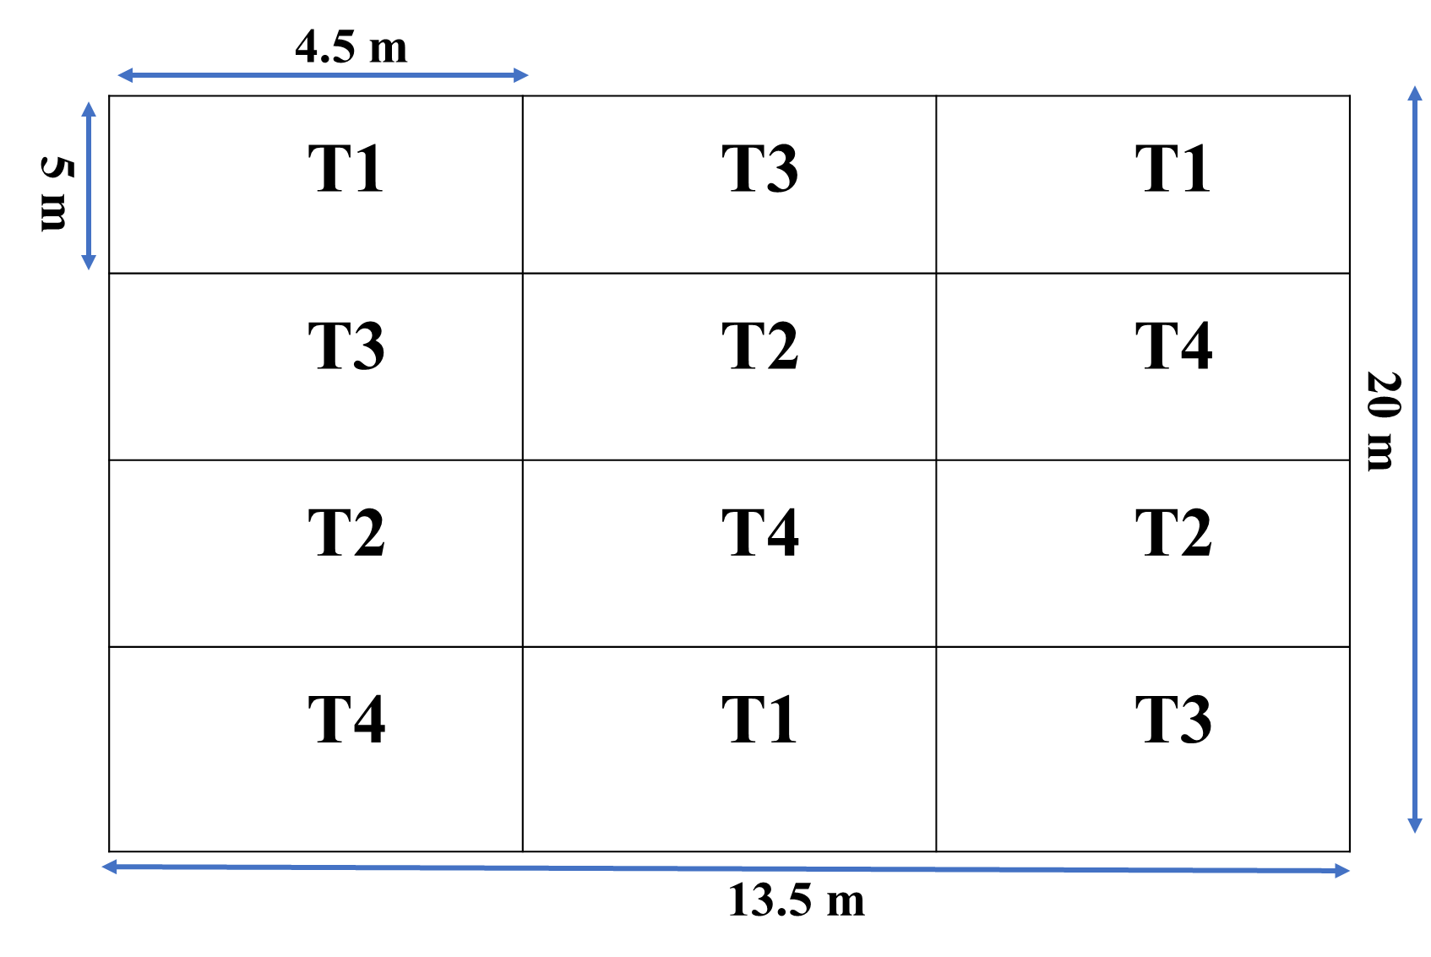
Fig. 1 Experimental Design and Field Layout
2.2.3 Irrigation Scheduling:
In irrigation scheduling, the Tomato was irrigated daily from data collected from the crop wat 8.0 Software.

Table. 2 Irrigation Scheduling
Month | Decade | Stage | Kc | ETc | ETc | Eff rain | Irri. Req.
 |  |  | Coeff. | lit/day | mm/dec | mm/dec | mm/dec
Feb | 1 | Init | 0.6 | 1.71 | 28.6 | 0 | 28.4
Feb | 2 | Init | 0.6 | 1.81 | 30.2 | 0 | 30.2
Feb | 3 | Init | 0.6 | 1.96 | 26.3 | 0 | 26.3
Mar | 1 | Deve | 0.66 | 2.35 | 39.3 | 0 | 39.3
Mar | 2 | Deve | 0.81 | 3.08 | 51.4 | 0 | 51.4
Mar | 3 | Deve | 0.96 | 3.90 | 71.6 | 0 | 71.6
Apr | 1 | Mid | 1.11 | 4.80 | 80.1 | 0 | 80.1
Apr | 2 | Mid | 1.17 | 5.38 | 89.8 | 0 | 89.8
Apr | 3 | Mid | 1.17 | 5.77 | 96.3 | 0 | 96.2
May | 1 | Late | 1.17 | 6.36 | 106 | 0 | 106
*In CROPWAT software the decade means 10 days period. The long-term climatic data was used to calculate crop water requirement using CROPWAT software.

Table 3 Treatment wise Irrigation scheduling
Month | ETc (T1)  Lit/day 100% | ETc (T2)  Lit/day 75% | ETc (T3)  Lit/day 50% | ETc (T4)  Lit/day 100 % (Full irrigation both sides)
Feb | 1.71 | 1.28 | 0.85 | 1.71
Feb | 1.81 | 1.35 | 0.90 | 1.81
Feb | 1.96 | 1.47 | 0.98 | 1.96
Mar | 2.35 | 1.76 | 1.17 | 2.35
Mar | 3.08 | 2.31 | 1.54 | 3.08
Mar | 3.90 | 2.92 | 1.95 | 3.90
Apr | 4.80 | 3.6 | 2.4 | 4.80
Apr | 5.38 | 4.03 | 2.69 | 5.38
Apr | 5.77 | 4.32 | 2.88 | 5.77
May | 6.36 | 4.77 | 3.18 | 6.36

Table 4 Irrigation time (minutes)
Month | ETc (T1)  Lit/day 100% | ETc (T2)  Lit/day 75% | ETc (T3)  Lit/day 50% | ETc (T4)  Lit/day 100 % (Full irrigation both sides)
Feb | 29 | 18 | 16 | 21
Feb | 31 | 19 | 18 | 23
Feb | 34 | 21 | 20 | 25
Mar | 40 | 25 | 23 | 29
Mar | 52 | 33 | 30 | 39
Mar | 66 | 41 | 39 | 49
Apr | 82 | 51 | 48 | 60
Apr | 92 | 57 | 53 | 67
Apr | 99 | 61 | 57 | 72
May | 109 | 68 | 63 | 80
2.2.4 Drip Irrigation Design
Drip laterals of 16 mm size were laid in the field considering plant-to-plant and row-to-row spacing. For a row to run laterally on either side of the plant was laid. A total of eight lateral was laid in four treatments. In case of FPRD T1, T2 and T3, one side of the root-zone is to be irrigated and the other has to be kept dry. On the lateral side of either size would have a blind dripper. In the case of Full irrigation T4, both sides of the root-zone are to be irrigated.

- Results and Discussion
3.1 Soil water content
Soil moisture was estimated using gravimetric method and then converted in volumetric water content using bulk density of soil for estimating irrigation water requirement. Whereas percentage value was used to determine variation in soil moisture content during the crop period as given in table no. 14. Bulk density of the experimental area was around 1.44 g/cc.

3.2 Vegetative growth parameters
Plant vegetative growth parameters such as plant height (distance from ground surface to top of plant crown), stem diameter (measured by Vernier calliper), Number of leaves per plant, Number of branches per plant, leaf area will also be monitored.
3.3 Parameter collected at harvesting time
The Parameters taken at harvesting include size, shape, TSS (Total Soluble Solids), Maturity stages, weight, and yield.
Plant Height:
It was observed that treatment T1 has the highest plant height compared to other treatments. At the time of harvesting, the maximum height was recorded in treatment T1, which is 54.2 cm. The maximum height recorded in treatment T1 (100% water), was given from one side of the root zone, so this may enhance root development and nutrient uptake. In the T2 treatment, 75% water was given from one side of the root zone, so the lack of water affected the growth and yield of the plant. In this treatment, there is less plant height compared to other treatments. In T3 treatment, only 50% water was given from one side of the root zone, with less water, the plant could not grow properly. In this treatment, there is more plant height compared to treatment T2, and less plant height than treatment T1 and treatment T4. In T4 treatment, full irrigation on both sides, water was given, causing leaching of nitrogen and other micro nutrients. As a result, plant height is more compared to treatments 2 and 3, and lower compared to treatment 1. Physiologically, PRD dries part of the root zone to elicit root-sourced ABA signaling, lowering stomatal conductance and transpiration while maintaining turgor and growth in the irrigated half, thereby conserving water without necessarily restricting shoot elongation. This mechanism—well established by other research—helps explain why the T1 (100% PRD on one side) matched or exceeded the height achieved under full irrigation; the irrigated half likely buffered growth despite signaling-induced stomatal control (Kang & Zhang, 2004).
Table 5: Effect of Partial Rot-zone Drying Irrigation on Plant height of Tomato at different days after transplanting
Plant Height (cm)
Days | T1 | T2 | T3 | T4
7 | 25.62 | 26.08 | 22.41 | 23.92
14 | 26.78 | 26.72 | 24.26 | 24.93
21 | 28.77 | 28.71 | 26.09 | 27.11
28 | 31.81 | 28.80 | 28.07 | 31
35 | 37.47 | 28.68 | 27.69 | 34.86
42 | 43.68 | 30.40 | 32.32 | 39.73
49 | 49.48 | 33.69 | 34.13 | 43.62
56 | 52.24 | 35.33 | 36.4 | 45.7
63 | 53.69 | 36.18 | 38.03 | 47.1
70 | 54 | 37.53 | 38.72 | 47.87
Harvest | 54.2 | 38.54 | 39.35 | 48.49
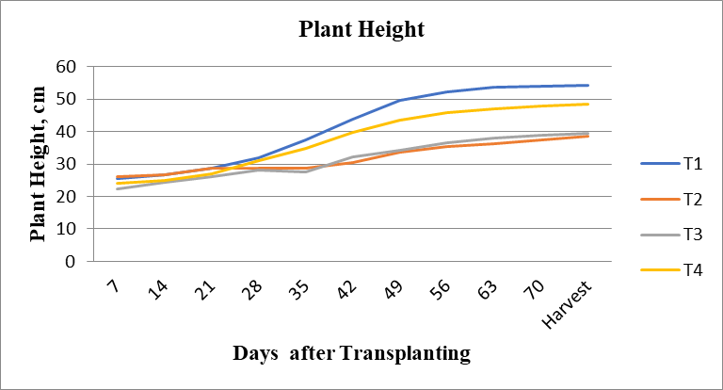
Fig. 2 Plant Height VS Days After Transplanting of Tomato
Table 6 Statistical Analysis of Plant Height Plant Height During 2022-23
Treatment | Plant Height (cm)
T1 | 54.2
T2 | 38.34
T3 | 39.35
T4 | 48.49
SEm± | 7.82
CD or LSD | 27.06
Test of significance (p=0.05) | S
CV% | 9.12
  - Diameter of Stem:
It was observed that treatment T1 has the highest diameter of the Stem compared to other treatments. At the time of harvesting, the maximum diameter of the stem was recorded in treatment T1, which is 6.49 mm. The maximum diameter of the Stem recorded in treatment T1 100% water, was measured from one side of the root zone, so this may enhance root development and nutrient uptake. In the T2 treatment, 75% water was given from one side of the root zone, so the lack of water affected the growth and yield of the plant. In this treatment, the stem has a smaller diameter compared to other treatments. In T3 treatment, only 50% water was given from one side of the root zone; with less water, the plant could not grow properly. this treatment, the stem has a larger diameter of stem compared to treatment T2, and a smaller diameter of stem than treatment T1 and treatment T4. In T4 treatment, full irrigation on both sides, water was given which causes leaching of nitrogen and other micro nutrients resulting of there is more compared to treatment 2 and 3, and less compared to treatment 1. This pattern aligns with controlled greenhouse studies showing stem diameter is highly sensitive to plant water status: as soil moisture decreases, daily stem expansion slows and maximum daily shrinkage increases, reflecting reduced turgor and cambial activity. Meng et al. quantified this relationship in tomato and validated stem-diameter variation as a robust, plant-based water-status indicator for irrigation scheduling (Meng et al., 2017).
Table 7 Diameter of Stem
Diameter of Stem (mm)
Days | T1 | T2 | T3 | T4
7 | 2.53 | 2.88 | 3.12 | 2.97
14 | 2.67 | 3.1 | 3.22 | 3.09
21 | 3.04 | 3.37 | 3.3 | 3.32
28 | 3.21 | 3.69 | 3.72 | 3.82
35 | 4.13 | 3.91 | 4.07 | 4.22
42 | 4.88 | 4.15 | 4.37 | 5.09
49 | 5.3 | 4.3 | 4.75 | 5.46
56 | 5.45 | 4.5 | 5.03 | 5.84
63 | 5.9 | 4.52 | 5.19 | 6.04
70 | 6.21 | 4.8 | 5.45 | 6.25
Harvest | 6.49 | 5.05 | 5.54 | 6.43
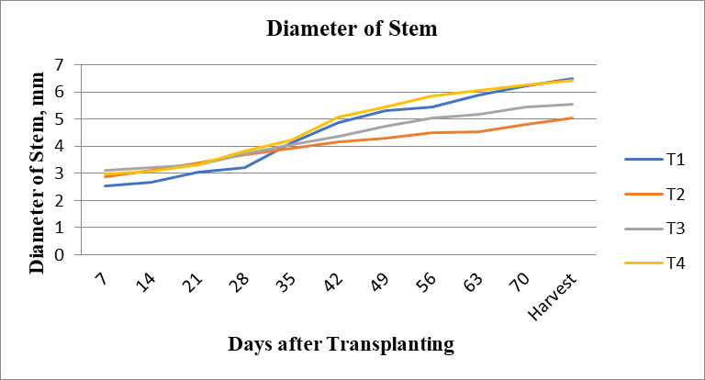
Fig.3 Diameter of Stem VS Days After Transplanting
Table 8 Statistical Analysis of Diameter of Stem During 2022-23
Treatment | Diameter of Stem (mm)
T1 | 6.49
T2 | 5.05
T3 | 5.54
T4 | 6.43
SEm± | 6.7
CD or LSD | 13.6
Test of significance (p=0.05) | S
CV% | 8.2
  - Number of Branches:
It was observed that treatment T1 has a greater number of branches compared to other treatments. At the time of harvesting, the maximum number of branches was recorded in treatment T1, which was 22. The maximum number of branches recorded in treatment T1 100% water, was given from one side of the root zone, so this may enhance root development and nutrient uptake. In the T2 treatment, 75% water was given from one side of the root zone, so the lack of water affected the growth and yield of the plant. In this treatment, it has a smaller number of branches compared to other treatments. In T3 treatment, only 50% water was given from one side of the root zone; dry in less water, the plant could not grow properly. In this treatment, it has a greater number of branches compared to treatment T2, and a smaller number of branches than treatment T1 and treatment T4. In T4 treatment, full irrigation on both sides was given which causes leaching of nitrogen and other micro nutrients resulting, there is more compared to treatment 2 and 3, and less compared to treatment 1.
Table 9: Number of Branches
Number of Branches
Days | T1 | T2 | T3 | T4
7 | 4 | 3 | 3 | 4
14 | 5 | 4 | 4 | 5
21 | 6 | 5 | 5 | 7
28 | 7 | 5 | 5 | 8
35 | 9 | 6 | 7 | 9
42 | 11 | 7 | 8 | 10
49 | 13 | 7 | 9 | 13
56 | 15 | 7 | 10 | 14
63 | 16 | 8 | 12 | 16
70 | 17 | 9 | 11 | 14
Harvest | 22 | 11 | 13 | 16
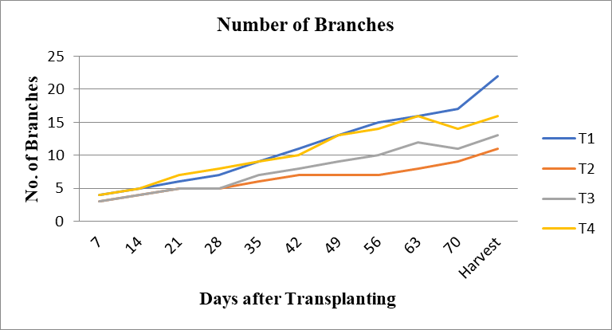
Fig.4 Number of Branches VS Days After Transplanting
Table 10 Statistical Analysis of Number of Branches During 2022-23
Treatment | Number of Branches
T1 | 22
T2 | 11
T3 | 13
T4 | 16
SEm± | 3.14
CD or LSD | 10.85
Test of significance (p=0.05) | S
CV% | 6.14
  - Number of Leave:
It was observed that treatment T1 has a larger number of leaves compared to other treatments. At the time of harvesting, the maximum number of leaves was recorded in treatment T1, which is 111. The maximum number of leaves recorded in treatment T1, 100% water was given from one side of the root zone, so this may have enhanced root development and nutrient uptake. In the T2 treatment, 75% water was given from one side of the root zone, so the lack of water affected the growth and yield of the plant. In this treatment, there are fewer leaves compared to other treatments. In T3 treatment, only 50% water was given from one side of the root zone, dry in less water, the plant could not grow properly. In this treatment, there are more leaves compared to treatment T2, and fewer leaves than treatment T1 and treatment T4. In T4 treatment, full irrigation on both sides, water was given this causes leaching of nitrogen and other micro nutrients resulting of there is more compared to treatment 2 and 3, and less compared to treatment 1.
Table 11: Number of Leaves
Number of leaves
Days | T1 | T2 | T3 | T4
7 | 16 | 17 | 12 | 20
14 | 25 | 19 | 18 | 25
21 | 33 | 17 | 23 | 39
28 | 46 | 24 | 32 | 53
35 | 58 | 29 | 49 | 69
42 | 69 | 32 | 49 | 75
49 | 89 | 43 | 67 | 93
56 | 95 | 47 | 75 | 97
63 | 98 | 52 | 80 | 107
70 | 100 | 51 | 73 | 87
Harvest | 111 | 64 | 81 | 96
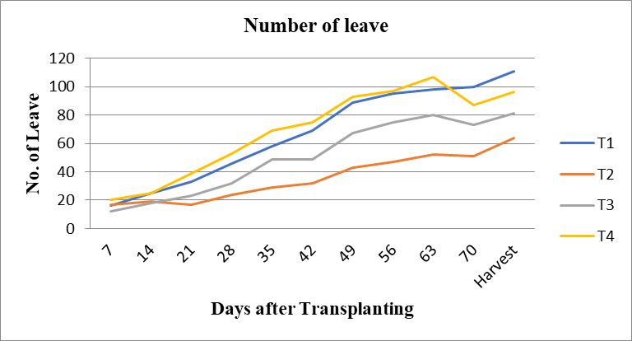
Fig.5 Number of Leaves VS Days After Transplanting
Table 12 Number of leaves during 2022-23
Treatment | Number of Leaves
T1 | 111
T2 | 64
T3 | 81
T4 | 96
SEm± | 19.50
CD or LSD | 67.45
Test of significance (p=0.05) | S
CV% | 8.64
  - Leaf Area:
It was observed that treatment T1 has more leaf area compared to other treatments. At the time of harvesting, the maximum leaf area was recorded in treatment T1, which is 11.4cm2. The maximum leaf area recorded in treatment T1 100% water, was given from one side of the root zone, so this may enhance root development and nutrient uptake. In the T2 treatment, 75% water was given from one side of the root zone, so the lack of water affected the growth and yield of the plant. This treatment resulted in a lower leaf area compared to the others. In T3 treatment, only 50% water was given from one side of the root zone, with less water, the plant could not grow properly. This treatment resulted more leaf area compared to treatment T2, and less leaf area than treatment T1 and treatment T4. In T4 treatment, full irrigation on both sides, water was given, causing leaching of nitrogen and other micro nutrients. This is more compared to treatment 2 and 3, and less compared to treatment 1.

Table 13 Leaf area
Leaf Area (cm²)
Days | T1 | T2 | T3 | T4
7 | 2.5 | 2 | 1.5 | 2.5
14 | 4 | 3 | 2.5 | 3
21 | 4 | 3 | 4.5 | 5.5
28 | 3.5 | 4 | 4.5 | 6
35 | 8.5 | 5.5 | 7 | 7.5
42 | 9.5 | 5.5 | 8.5 | 7.5
49 | 11.5 | 6 | 8 | 9.5
56 | 11.8 | 6.8 | 8.8 | 7.7
63 | 11.5 | 7.2 | 9.2 | 9.8
70 | 11.7 | 7.8 | 8.9 | 9.3
Harvest | 11.4 | 8.3 | 9.3 | 9.4
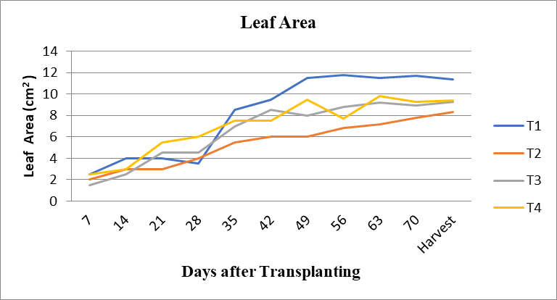
Fig.6 Leaf Area VS Days After Transplanting
In this study, T1 (100% PRD on one side) produced the greatest vegetative development at harvest—branches (22 plant⁻¹), leaves (111 plant⁻¹), and leaf area (11.4 cm²)—and was statistically superior to T2 (75% PRD) and T3 (50% PRD), while performing on par with or slightly above full irrigation on both sides (T4). These patterns accord with the broader evidence that mild, well-managed PRD can preserve vegetative growth relative to full irrigation, whereas reducing total seasonal water tends to suppress branching, leaf production, and leaf expansion. In commercial-greenhouse PRD, Urlić et al. (2020a) observed no significant reduction in leaf area due to PRD and reported leaf number differences driven more by grafting than irrigation per se—consistent with our finding that T1 ≈ T4 for canopy traits (Urlić et al., 2020b). Conversely, under regulated or sustained deficit irrigation (DI/RDI), multiple studies report lower leaf area and fewer leaves (and sometimes fewer branches) compared with fully irrigated controls, mirroring the declines we saw in T2/T3 (Medyouni et al., 2021; Martelli et al., 2024; Alomari-Mheidat et al., 2024).
  - Soil moisture
It was observed that treatment 4 has more soil moisture compared to the other treatments. The maximum soil moisture was recorded in treatment T4, and it is 25.52%. In T1 treatment, 100% water was given from one side of the root zone, so this treatment has more soil moisture than treatment 2 and treatment 3, and less soil moisture than treatment 4. In T2 treatment, 75% water was given from one side of the root zone, so this treatment has more soil moisture than treatment 3, and less soil moisture than treatment 1 and treatment 4. In the T3 treatment, only 50% water was given from one side of the root zone; in this treatment has less soil moisture compared to other treatments.

Table 14 Soil moisture
Soil moisture (%)
Days | T1 | T2 | T3 | T4
7 | 18.57 | 17.64 | 16.27 | 20
14 | 19.04 | 16.73 | 15.83 | 20.48
21 | 19.52 | 15.83 | 15.38 | 20
28 | 22 | 16.18 | 15.9 | 21.77
35 | 26.76 | 25.70 | 20.85 | 26.85
42 | 23.80 | 22.72 | 17.37 | 24.4
49 | 25 | 23.1 | 19.04 | 24.37
56 | 24.40 | 22.54 | 18.48 | 23.76
63 | 23.28 | 20.93 | 17.92 | 25
70 | 25 | 20.96 | 20 | 25.52
Harvest | 25.15 | 22.53 | 19.20 | 25.52
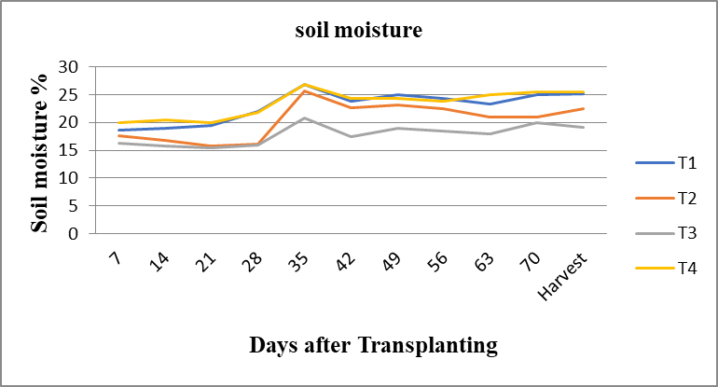
Fig.7 Soil moisture vs. days After Transplanting

Table 15 Weight of tomato

Treatment | Weight of tomato at harvesting time (gm)
T1
R1 | 44
R2 | 54
R3 | 32
AVG | 43
T2
R1 | 49
R2 | 35
R3 | 34
AVG | 38
T3
R1 | 54
R2 | 29
R3 | 25
AVG | 36
T4
R1 | 52
R2 | 33
R3 | 32
AVG | 39

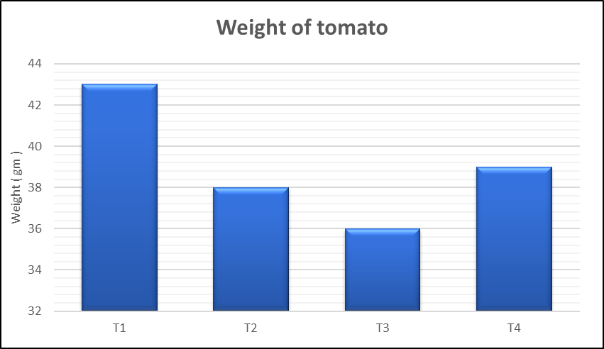
Fig.8 Weight of Tomato vs. Treatment
Soil moisture dynamics under partial root-zone strategies are central to interpreting the physiological and yield responses observed in this study. In our drip system, irrigation on one lateral maintained a consistently higher volumetric water content on the wetted side relative to the opposite, intentionally drier side, creating a deliberate horizontal moisture gradient within the active root zone. Such spatial heterogeneity is an expected feature of partial root-zone drying or alternate partial root-zone irrigation and underpins the root-to-shoot signaling that modulates stomatal conductance and transpiration without completely restricting water uptake (Dodd et al., 2006; Kang & Zhang, 2004). The drier compartment promotes abscisic acid (ABA) export from roots, while the moist compartment preserves leaf water potential and canopy function; this coordinated response is well established for tomato and other crops (Holbrook et al., 2002; Dodd et al., 2006; Kang & Zhang, 2004).
Across phenological stages, the magnitude of the wet–dry contrast is expected to fluctuate with atmospheric demand and crop water use. During periods of high evaporative demand, faster depletion on the dry side accentuates the moisture gradient and strengthens chemical signaling, whereas after irrigation events the gradient narrows as water redistributes near the wet lateral. In practice, maintaining a clear but non-lethal gradient is crucial: if the dry side approaches threshold water contents that cause widespread root desiccation, assimilate supply and fruit set can be impaired; conversely, if the gradient collapses, the signaling advantage of partial root-zone regimes diminishes (Kang & Zhang, 2004; Yao et al., 2023). The present study’s soil moisture pattern—wetter near emitters, markedly drier on the opposite side, and a moderate between-side differential maintained through the season—is therefore consistent with a well-executed partial root-zone schedule.
The temporal behavior of soil water content also helps explain the observed trade-offs between vegetative growth, yield components, and fruit quality. Numerous tomato studies show that, relative to conventional deficit irrigation, partial root-zone strategies can sustain similar or slightly reduced yields while increasing water-use efficiency, often with higher soluble solids when moderate moisture deficits are imposed (Sun et al., 2013; Casa & Rouphael, 2014; Wei et al., 2016). Mechanistically, the moist compartment buffers plant water status and supports carbon assimilation, while signaling from the dry compartment reduces stomatal opening sufficiently to limit non-productive water loss; the result is improved intrinsic water-use efficiency and, frequently, enhanced sugar accumulation per unit fruit water (Holbrook et al., 2002; Wei et al., 2016). However, if the soil in both compartments trends too dry for extended periods—whether through overly severe irrigation cutbacks or prolonged intervals between irrigations—yield penalties comparable to deficit irrigation can arise (Casa & Rouphael, 2014). Thus, the goal is a “moderate” and persistent wet–dry contrast.
A practical consideration is whether sides are alternated or kept fixed. Alternating the wet and dry laterals at a regular cadence refreshes active roots in both compartments and can maintain signaling without chronic impairment of one half of the root system. Experimental evidence indicates that alternation modifies the hormonal profile reaching the shoot and can stabilize gas-exchange responses over time (Dodd et al., 2006). Field studies further suggest that alternate partial root-zone irrigation can raise intrinsic water-use efficiency and, depending on cultivar and truss position, help mitigate yield reductions under moderate water savings (Wei et al., 2016; Yao et al., 2023). Interpreting the soil moisture data in this study within that framework, the sustained between-side gradient we observed is consistent with effective signaling; where alternation was practiced, it likely limited localized root senescence and helped maintain uptake capacity on both sides.
Finally, the spatial sampling of soil moisture must reflect this heterogeneity. Measurements taken only midway between rows or solely near the wetted lateral can misrepresent plant-available water under partial root-zone designs. Positioning probes or gravimetric sampling points in mirrored locations on both sides of the stem, at comparable depths, provides a truer picture of the hydrological contrast driving plant responses (Kang & Zhang, 2004; Holbrook et al., 2002). Interpreted alongside growth and fruiting data, such paired measurements clarify whether treatment differences derive from stronger signaling (larger wet–dry contrasts), insufficient buffering on the wet side (over-deficit), or inadequate contrast (under-deficit), and thereby guide refinement of irrigation frequency, run time, and alternation interval for the target cultivar and soil.

3.9 Parameter at harvesting time
Parameters at harvesting time, such as size, shape, TSS, Maturity stages, and weight were anlysed in this section. At the final harvest, crop performance was assessed using a suite of yield and fruit-quality attributes chosen to capture both agronomic productivity and market acceptability. Marketable yield was defined as the sum of fruit masses per plot that met size and defect thresholds typically used in research on processing and fresh-market tomato, with culls excluded due to cracking, blossom-end rot, sunscald, insect damage, or misshapen form. Because irrigation strategy can shift assimilate partitioning, we also interpreted yield alongside the harvest index (HI), expressed as the ratio of fruit biomass to total above-ground biomass. In tomato, HI is a sensitive integrator of source–sink balance and frequently shifts under water-saving strategies that rely on root-to-shoot signaling (Holbrook et al., 2002; Wei et al., 2016). Although HI is not always reported in field studies of partial root-zone strategies, its inclusion clarifies whether equal yields arise from changes in vegetative growth, fruit set, or single-fruit size (Casa & Rouphael, 2014; Wei et al., 2016).
Average fruit weight and fruit size (length, breadth, and pericarp thickness where available) were computed from representative subsamples at each picking to avoid bias from early or late trusses. These structural measures carry distinct physiological meanings: larger fruits often dilute soluble solids through greater water content if carbon import per fruit does not keep pace, reflecting the frequently observed inverse relation between fruit mass and soluble solids in tomato germplasm (Chaïb et al., 2007). Accordingly, we recorded total soluble solids (TSS, °Brix) as a non-destructive proxy for sugars and soluble metabolites, which tend to rise under moderate soil-water deficits that reduce transpiration more than photosynthesis, thereby increasing intrinsic water-use efficiency (Holbrook et al., 2002; Wei et al., 2016). The distinction between moderate and severe stress is crucial: a broad PRD literature shows that well-managed partial root-zone strategies can sustain yields similar to fully irrigated controls while maintaining or slightly elevating TSS, whereas excessive stress depresses both yield and fruit size (Casa & Rouphael, 2014; Sun et al., 2013; Yao et al., 2023).
Fruit firmness at harvest was measured instrumentally because it predicts mechanical integrity during handling and is strongly associated with consumer texture perception. Tomato studies establish quantitative thresholds that separate fruit suitable for marketing from fruit prone to softening; for example, minimum firmness limits derived from compression testing align with practical acceptability bands and vary with intended use stage (Batu, 2004). Firmness complements TSS by reflecting cell-wall status and turgor at harvest; together with size, it helps disentangle whether irrigation treatments altered fruit water relations or ripening kinetics (Chaïb et al., 2007; Batu, 2004). To contextualize color development, we referenced hue proxies such as the a*/b* ratio when available, which progress predictably with ripening and correlate with lycopene accumulation, though color alone cannot substitute for a combined firmness–TSS evaluation when comparing irrigation treatments (Batu, 2004; Chaïb et al., 2007).
Interpreting the harvesting-time parameters in the framework of partial root-zone irrigation hinges on the soil-moisture contrasts documented earlier. With one side of the root zone drier, chemical signaling—particularly abscisic acid exported from roots—modulates stomata to curb transpirational water loss without necessarily reducing leaf water potential on the wetted side (Holbrook et al., 2002). When this wet–dry gradient is maintained within moderate bounds, studies in field-grown tomato report conservation of marketable yield, modest increases in intrinsic water-use efficiency, and frequent maintenance or enhancement of °Brix, especially at trusses whose sink demand coincides with periods of higher evaporative demand (Casa & Rouphael, 2014; Wei et al., 2016; Yao et al., 2023). Conversely, if both compartments drift too dry or irrigation intervals are extended excessively, reductions in fruit set, average fruit mass, and final marketable yield become evident, often accompanied by only limited quality gains (Sun et al., 2013; Casa & Rouphael, 2014).
Taken together, the harvesting-time dataset—marketable yield, HI, fruit size and weight, TSS, firmness, and color—provides a coherent basis to judge whether water savings under partial root-zone management were achieved without compromising commercial value. Patterns consistent with effective signaling typically include near-control marketable yield with unchanged or slightly higher °Brix, firmness retained within acceptability thresholds, and a stable HI that indicates maintained sink strength rather than vegetative overgrowth or stress-induced abscission (Holbrook et al., 2002; Casa & Rouphael, 2014; Wei et al., 2016; Yao et al., 2023).
Size of a tomato
Size = (L x B x T)^{1/3}
L = length; B = breadth; T = thickness
Table 16 Diameter of tomato
Treatment | Diameter of tomato (cm)
T1 | 8.02
T2 | 8.42
T3 | 6.96
T4 | 8.2
Table 17 Statistical Analysis Diameter of Tomato During 2022-23
Treatment | Diameter of Tomato
T1 | 8.02
T2 | 8.42
T3 | 6.96
T4 | 8.2
SEm± | 9.50
CD or LSD | 5.45
Test of significance (p=0.05) | S
CV% | 8.75

Table 18: Shape of tomato
Shape
Different | Treatment
Type of shape | T1 | T2 | T3 | T4
Cylindrical |  | 3 |  | 1
Oblate | 1 | 1 | 2
Round | 4 |  | 2 | 3
Elongated |  | 1
Heart/Cordate |  |  | 1
Flattened |  |  |  | 1
Table 19 Maturity Stage
Maturity Stage
Type of Maturity stage | Treatment
Type of Maturity stage | T1 | T2 | T3 | T4
Mature green | 1 | 3 | 3
Breaker
Turning
Pink
Light red | 3 | 2 | 1 | 2
Fully red | 1 |  | 1 | 3

Table 20 Total Soluble solids
Treatment | Average TSS (%)
T1 | 4.8
T2 | 4.73
T3 | 4.87
T4 | 4.88

Table 21 Statistical Analysis of Total soluble Solids (TSS) 2022-23
Treatment | TSS
T1 | 4.8
T2 | 4.73
T3 | 4.87
T4 | 4.88
SEm± | 9.50
CD or LSD | 5.45
Test of significance (p=0.05) | S
CV% | 9.64

Table 22 Weight of Tomato
Treatment | Average weight of tomato (g)
T1 | 43
T2 | 38
T3 | 36
T4 | 39

Table 23 Statistical Analysis Weight of tomato during 2022-23
Treatment | Weight of tomato (g)
T1 | 43
T2 | 38
T3 | 36
T4 | 39
SEm± | 4.81
CD or LSD | 16.64
Test of significance (p=0.05) | S
CV% | 7.43

Table 24: Yield of tomato
Treatment | Average yield of tomato (kg/ha)
T1 | 9258
T2 | 6789
T3 | 5554
T4 | 8023
Table 25: Statistical Analysis of Yield of Tomato during 2022-23
Treatment | Yield of tomato
T1 | 9258
T2 | 6789
T3 | 5554
T4 | 8023
SEm± | 56.9
CD or LSD | 4765
Test of significance (p=0.05) | S
CV% | 9.4

4. Study limitations
This field experiment was conducted at a single site over one growing season with one tomato hybrid and a specific drip layout, which limits generalizability across soils, climates, and cultivars. The partial root-zone strategy was implemented under operational constraints that led to modest between-side moisture contrasts at times, and soil water was monitored at discrete positions rather than continuously across the rhizosphere; as a result, short-lived wet–dry dynamics and root-zone heterogeneity may be under-represented. Physiological processes implicated in partial root-zone responses—such as stomatal conductance, canopy gas exchange, xylem ABA, and carbon isotope discrimination—were not directly measured, so mechanistic inferences rely on patterns in growth, yield, and °Brix rather than on causal physiological data. Water productivity was evaluated without a full plot-level water balance (e.g., drainage and evaporation partitioning), which constrains interpretation of true consumptive use and water-use efficiency. Postharvest behavior beyond harvest-day firmness and TSS was not followed, limiting conclusions about storability and supply-chain performance. Finally, the randomized block design and plot size provided adequate but not high statistical power for small treatment differences, and potential confounders such as incidental pest pressure or microclimate variation within blocks were controlled operationally but not quantified. Future work should test multiple cultivars across seasons, combine dense soil-moisture sensing with direct physiological measurements, and include full water balances and postharvest studies to strengthen external validity and mechanistic insight.
5. Summary and Conclusion
- It was observed from the experiment that treatment T1(100%) has a higher plant height than the other treatments. Comparing values at the initial 7 days, treatment T2 (75%) observed more plant height as compared to other treatments.
- At harvesting stage also treatment T1(100%) observed higher plant height as compared to treatment T2(100%), T3(50%) and T4(100%). The Highest value of plant height was observed to be 54.2 cm at the harvesting stage in treatment T1(100%).
- Treatment T1(100%) has a larger diameter of Stem than other treatments. Comparing values at 7 days of treatment, T3(50%) has a larger diameter of the stem as compared to any other treatments. Treatment T1(100%) has more diameter of stem than treatment T2(100%), T3(50%) and T4(100%). At the harvesting stage. The highest value of the diameter of the Stem is 6.49 mm at the harvesting stage of treatment T1(100%).
- Treatment T1(100%) has more branches than other treatments. Comparing values at 7 days also treatment T1(100%) and treatment T4(100%) has more number of branches as compared to treatment T2(75%) and treatment T3(50%). Treatment T1(100%) has more Number of Branch than treatment T2(75%),T3(50%) and T4(75%) at the Harvesting Stage. The highest value of the number of branches is 22, at the harvesting stage of treatment T1(100%).
- Treatment T1(100%) has more leaves than other treatments. Comparing values at 7 days, treatment t4(100%) has a larger number of leaves as compared to any other treatments. treatment 1 has more number of leave than treatment T2(100%), T3(50%) and T4(100%).at the harvesting stage. The highest value of the number of leaves is 111 at the harvesting stage of treatment T1(100%).
- Treatment T1(100%) has more leaf area than other treatments. Comparing values at 7 days, treatment T1(100%) and treatment T4(100%) have more leaf area as compared to any other treatments. Treatment T1(100%) has more leaf area than treatment T2(100%), T3(50%) and T4(100%).at the harvesting stage. The highest value of Leaf Area is 11.4 cm2 at the harvesting stage of treatment T1(100%).
- Treatment T4(100%) has more soil moisture than any other treatment. Comparing values at 7 days, treatment 4(100%) has more soil moisture as compared to any other treatments. Treatment T4(100%) has more soil moisture than treatment 1(100%),T2(75%) and T3(50%) at the harvesting stage. The highest value of soil moisture is 25.52 % at the harvesting stage of treatment T4(100%).
- First flowering in tomato was seen in treatment 1 compared to any other treatment.
- the first tomato developed in treatment 1 compared to any other treatment.
- Treatment 1 has a larger number of flowers per branch than any other treatment. Treatment 4 has a greater number of flowers per branch than treatments 2 and 3.
- Treatment 1 has fewer days of first flowering than any other treatment. Treatment 4 has fewer days of first flowering than treatments 2 and 3.
- Treatment 1 has a larger number of tomatoes compared to any other treatment.
- In the overall scenario, T1 treatment outperformed all other treatments, so it can be concluded that T1 treatment can be adopted for tomato for better yield as compared to all other treatments.
Disclaimer (Artificial intelligence)
Author(s) hereby declare that NO generative AI technologies such as Large Language Models (ChatGPT, COPILOT, etc.) and text-to-image generators have been used during the writing or editing of this manuscript.

5. References
Alomari-Mheidat, M., Corell, M., Martín-Palomo, M. J., Castro-Valdecantos, P., Medina-Zurita, N., de Sosa, L. L., & Moriana, A. (2024). Moderate water stress impact on yield components of greenhouse tomatoes in relation to plant water status. Plants, 13(1), 128. https://doi.org/10.3390/plants13010128
Batu, A. (2004). Determination of acceptable firmness and colour values of tomatoes. Journal of Food Engineering, 61(3), 471–475. https://doi.org/10.1016/S0260-8774(03)00141-9
Carrijo, D. R., Lundy, M. E., & Linquist, B. A. (2017). Rice yields and water use under alternate wetting and drying irrigation: A meta-analysis. Field Crops Research, 203, 173–180. https://doi.org/10.1016/j.fcr.2016.12.002
Casa, R., & Rouphael, Y. (2014). Effects of partial root-zone drying irrigation on yield, fruit quality and water-use efficiency in processing tomato. The Journal of Horticultural Science and Biotechnology, 89(4), 389–396. https://doi.org/10.1080/14620316.2014.11513097
Chaïb, J., Devaux, M.-F., Grotte, M.-C., Robini, K., Causse, M., Lahaye, M., & Marty, I. (2007). Physiological relationships among physical, sensory and morphological attributes of texture in tomato fruits. Journal of Experimental Botany, 58(8), 1915–1925. https://doi.org/10.1093/jxb/erm046
Dhakad, S., Salunkhe, R. C., Dabhi, K. L., & Gupta, P. (2023). Agricultural drone spraying efficiency enhancement via patternater-based effective swath width determination. The Pharma Innovation Journal, 12(10), 952–961. https://www.thepharmajournal.com/archives/2023/vol12issue10/PartL/12-10-113-451.pdf
Dhakad, S., Shalunkhe, R. C., Shukla, K., Seth, N., Dabhi, K. L., & Balas, D. B. (2025). Optimization of operational parameters for agricultural drone spraying in maize crops. Journal of Experimental Agriculture International, 47(1), 105–120. https://doi.org/10.9734/jeai/2025/v47i13208
Dodd, I. C., Theobald, J. C., Bacon, M. A., & Davies, W. J. (2006). Alternation of wet and dry sides during partial rootzone drying irrigation alters root-to-shoot signalling of abscisic acid. Functional Plant Biology, 33(12), 1081–1089. https://doi.org/10.1071/FP06203
Food and Agriculture Organization (FAO). (2011). The state of the world’s land and water resources for food and agriculture (SOLAW): Managing systems at risk. FAO & Earthscan. https://www.fao.org/3/i1688e/i1688e.pdf
Grimes, D. W., Walhood, V. T., & Dickens, W. L. (1968). Alternate-furrow irrigation for San Joaquin Valley cotton. California Agriculture, 22(5), 4–6. https://californiaagriculture.org/api/v1/articles/112660-alternate-furrow-irrigation-for-san-joaquin-valley-cotton.pdf
Lakshmi, G. J., Singh, D., & Raja, G. (2022). Effect of plant growth regulators on growth and yield of tomato (Lycopersicon esculentum L.). International Journal of Plant & Soil Science, 34(20), 709–713. https://doi.org/10.9734/ijpss/2022/v34i2031207
Hassan, A., Amjad, S. F., Saleem, M. H., Yasmin, H., Imran, M., Riaz, M., … Alyemeni, M. N. (2021). Foliar application of ascorbic acid enhances salinity stress tolerance in barley (Hordeum vulgare L.) through modulation of morpho-physio-biochemical attributes, ions uptake, osmo-protectants and stress response genes expression. Saudi Journal of Biological Sciences, 28(8), 4276–4290. https://doi.org/10.1016/j.sjbs.2021.03.045
Holbrook, N. M., Shashidhar, V. R., James, R. A., & Munns, R. (2002). Stomatal control in tomato with ABA-deficient roots: Response of grafted plants to soil drying. Journal of Experimental Botany, 53(373), 1503–1514. https://doi.org/10.1093/jexbot/53.373.1503
Kang, S., & Zhang, J. (2004). Controlled alternate partial root-zone irrigation: Its physiological consequences and impact on water use efficiency. Journal of Experimental Botany, 55(407), 2437–2446. https://doi.org/10.1093/jxb/erh249
Li, G., Cheng, H., Qiao, C., Feng, J., Yan, P., Yang, R., … Zhang, Z. (2025). Root-zone oxygen supply mitigates waterlogging stress in tomato by enhancing root growth, photosynthetic performance, and antioxidant capacity. Plant Physiology and Biochemistry, 222, 109744. https://doi.org/10.1016/j.plaphy.2025.109744
Liu, H., Yuan, B., Hu, X., et al. (2022). Drip irrigation enhances water use efficiency without losses in cucumber yield and economic benefits in greenhouses in North China. Irrigation Science, 40, 135–149. https://doi.org/10.1007/s00271-021-00756-w
Mabhaudhi, T., Nhamo, L., & Mpandeli, S. (2021). Enhancing crop water productivity under increasing water scarcity in South Africa. In D. S.-K. Ting & J. A. Stagner (Eds.), Climate Change Science: Causes, Effects and Solutions for Global Warming. Elsevier. https://doi.org/10.1016/B978-0-12-823767-0.00001-X
Martelli, A., Rapinesi, D., Verdi, L., et al. (2024). Smart irrigation for management of processing tomato: A machine learning approach. Irrigation Science. Advance online publication. https://doi.org/10.1007/s00271-024-00993-9
Medyouni, I., Zouaoui, R., Rubio, E., Serino, S., Ben Ahmed, H., & Bertin, N. (2021). Effects of water deficit on leaves and fruit quality during the development period in tomato plant. Food Science & Nutrition, 9(4), 2180–2193. https://doi.org/10.1002/fsn3.2160
Meng, Z., Duan, A., Chen, D., et al. (2017). Suitable indicators using stem diameter variation-derived indices to monitor the water status of greenhouse tomato plants. PLOS ONE, 12(2), e0171423. https://doi.org/10.1371/journal.pone.0171423
Shukla, K., Gupta, P., Dhakad S. & Panwar, G. (2023). Effect of Auger Size and Depth of Operation on Bulk Density, Cone Index, Germination, Root Length, Root Weight and Cob Weight for Maize Crop. International Journal of Environment and Climate Change, 13(11), 2899–2911. https://doi.org/10.9734/ijecc/2023/v13i113460
Sonawane, A. V., & Shrivastava, P. K. (2022). Partial root zone drying method of irrigation: A review. Irrigation and Drainage, 71(3), 574–588. https://doi.org/10.1002/ird.2686
Su, F., Li, Y., Liu, S., Liu, Z., Nie, S., Xu, Q., Qin, F., Li, F., Lyu, D., & Xu, H.-L. (2020). Application of xerophytophysiology and signal transduction in plant production: Partial root-zone drying in potato crops. Potato Research, 63(1), 41–56. https://doi.org/10.1007/s11540-019-09427-y
Sun, Y., Feng, H., & Liu, F. (2013). Comparative effect of partial root-zone drying and deficit irrigation on incidence of blossom-end rot in tomato under varied calcium rates. Journal of Experimental Botany, 64(7), 2107–2116. https://doi.org/10.1093/jxb/ert067
Swaminathan, M. S. (2006, October 2). Report of Sub-committee on “More Crop and Income per Drop of Water”. Government of India. https://cwc.gov.in/sites/default/files/admin/3-fparp.pdf
Urlić, B., Runjić, M., Žanić, K., Mandušić, M., Vuletin Selak, G., Pasković, I., & Dumičić, G. (2020a). Effect of partial root-zone drying on grafted tomato in commercial greenhouse. Horticultural Science (Prague), 47(1), 36–44. https://doi.org/10.17221/130/2018-HORTSCI
Urlić, B., Runjić, M., Mandušić, M., Žanić, K., Vuletin Selak, G., Matešković, A., & Dumičić, G. (2020b). Partial root-zone drying and deficit irrigation effect on growth, yield, water use and quality of greenhouse-grown grafted tomato. Agronomy, 10(9), 1297. https://doi.org/10.3390/agronomy10091297
Wei, Z., Du, T., Zhang, J., Xu, S., Cambre, P. J., & Davies, W. J. (2016). Carbon isotope discrimination shows a higher water-use efficiency under alternate partial root-zone irrigation of field-grown tomato. Agricultural Water Management, 165, 33–43. https://doi.org/10.1016/j.agwat.2015.11.009
Xu, H., Jing, H., Shi, R., Chen, M., Wang, C., Xu, Q., Bai, J., Liu, X., & Kong, M. (2025). Effect of partial root drying stress on improvement in tomato production. Current Issues in Molecular Biology, 47(2), 84. https://doi.org/10.3390/cimb47020084
Yao, Z., Hou, X., Wang, Y., & Du, T. (2023). Regulation of tomato yield and fruit quality by alternate partial root-zone irrigation strongly depends on truss positions. Agricultural Water Management, 282, 108288. https://doi.org/10.1016/j.agwat.2023.108288

