Assessment of Curacron Toxicity on Liver PUFAs Profile and Histology in a Major Carp, Cirrhinus Mrigala

ABSTRACT
The present finding, evaluated acute toxicity of curacron organophosphate pesticides on the freshwater edible fish Cirrhinus mrigala by assessing its LC₅₀ values at intervals of 24, 48, 72, and 96 hours that is 0. 20 ml/L. Additionally, to observed the acute effects of curacron, sub-lethal concentration (1/10) 0.020 ml/L of calculated LC₅₀ induced in different sets of aquariums, each contain six Cirrhinus mrigala against the control set to evaluated PUFA and alteration of liver histology after 7, 14, 21, and 28 days. Sub lethal level of curacron, showed alterations in fish behavior like hyperactivity, erratic swimming, increased opercula movement surfacing, and cessation feeding, disturbances of normal physiological functions also were noted. In liver Omega-3 and Omega-6 fatty acid resulted progressive structural damage in liver, reduced lipid peroxidase, and changes in PUFA profiles after applying one way ANOVA test (p<0.05) against control set. Histology of liver revealed degradation of nuclei, cell swelling, cytoplasmic breakdown, hepatocytes, the development of vacuoles, expansion of sinusoidal spaces, alterations in the central vein, and deterioration in the sinusoid. These findings indicated that the released of pesticides had a substantial negative effect on aquatic life, decline in water purity and the ecosystem of water resources.
Keyword: Cirrhinus mrigala,Curacron, PUFA profiles, Organophosphate,Toxicity, Water,
Introduction
Water is a renewable resource and a vital component of the life support system. Only 0.002% of fresh water is available, which is appropriate for human consumption purposes (Mishra, 2023). Groundwater plays a crucial role in agriculture, hydropower generation, industrial operations, fisheries, recreational activities, and more. Pesticides, fertilizers, industrial waste, and domestic factors have tainted major sources of water bodies. Over the years, the quality of freshwater resources has continuously been threatened by different types of pollution, especially due to the increasing intensity of agricultural practices. Among the various pollutants affecting water bodies, pesticides have emerged as significant issues.
Pesticides are among the most effective instruments developed by humans to safeguard agricultural products from pest invasions (El-bouhy et al. 2023). While pesticides are used for crop protection and pest mitigation, only 0.1% of the applied pesticides reach the intended pests (Mahboob et al. 2015). Chemically, pesticides are categorized into groups such as organochlorines, organophosphates, carbamates, pyrethrin, and pyrethroids. Although effective, pesticides are toxic or harmful to aquatic life, human, and other living being causing injury or death through ingestion, inhalation, or dermal absorption.
Organophosphate compounds have been extensively utilized as insecticides due to their limited persistence under natural conditions and their environmental persistence (Qian Lin, 2015). Organophosphates are characterized by their ability to inhibit the enzyme acetylcholinesterase, disrupting the normal functions of the nervous system in both target pests and non-target organisms (Rani & Gautam 2012). This inhibition leads to the overstimulation of nerve cells, resulting in a range of negative effects, from impaired behavior to death.
Curacron is commonly used organophosphate pesticides employed the agriculture for insect control. Curacron was often mixed with other pesticides such as phoxim, cypermethrin, beta cypermethrin, imidacloprid, and deltamethrin. Following the ban on organochlorine pesticides, it exhibited a short persistence and decomposed readily, making it widely used in Egypt during those years for selective mite control on cotton, maize, and various vegetables (Sharafeldin et al. 2015). Curacron can enter the body through multiple exposure routes—dermal, inhalation, ingestion, and ocular. Curacron can contaminate water bodies through various pathways, including agricultural runoff, leaching, spray drift, industrial sources, and household waste as well as accidental spills. The solubility of curacron was verified using HPLC, dissolved in the solvent, and assessed in water samples at a concentration of 1 ppm (Ghazla et al. 2019). Through these routes, curacron enters the aquatic environment.
Curacron caused marker hepatotoxic and cytotoxic effects in Cyprinus carpio (Joseph & Raj, 2010). It produced changes in the locomotor behavior and tissue structure of the fish Gambusia affinis (Rao et al. 2006). When curacron contaminated water bodies, it affected not only water chemistry but also presented direct toxicological threats to the organisms living in these ecosystems.
Fish are significant sources of polyunsaturated fatty acid (PUFAs), including Omega-3 (EPA, DHA) and Omega-6 (Arachidonic acid, LA), especially found in the liver. These fatty acids aid in reducing inflammation and lowering blood pressure. They also aid facilitate the absorption of fat-soluble vitamins including A, D, E, and K. Vitamin D is present in fish liver. Cirrhinus mrigala, a freshwater fish species, is important sources of such nutritional—rich in protein, essential minerals (zinc, iron, magnesium, calcium, potassium), and amino acids like leucine, valine, aspartic acid, glutamic acid, glycine, and alanine (Rani & Pandey 2024). Consumption of the fish promotes cardiovascular health, bone strength, and mental wellness.
However, when pesticides such as curacron accumulate in the tissues of C. mrigala, specifically in the liver, they pose health risks to humans through consumption. Eating contaminated fish can result in neurological symptoms, respiratory distress, liver and kidney damage, hormonal imbalances, reproductive disorders, and an elevated risk of cancer (Abdel-Moneim et al., 2012).The present study investigated to assessed the toxicology effect of curacron on relevant biochemical and histological alteration in the liver of freshwater fish C. mrigala, with liver-based biomarkers acting as key indicators for environmental monitoring of pesticide contamination.
MATERIALS AND METHODS-
Fish collection and sampling-Fifty-four healthy freshwater fish Cirrhinus with an average body size of 6 cm and average weight of 50-60 gm were procured with the help of local anglers employing seine nets (70 x 80 m) from the Johila river, Amarkantak to Aquatic toxicology Lab for experimental purposes. The fish were carefully transferred using a net into a clean plastic bucket. Afterward, the fish were transferred to a pond- like structure constructed using tarpaulin of size (12m x 9m) positioned at rear of the autorickshaw to provide natural environment atmosphere for them. After being transported to the Aquatic toxicilogy laboratory, Department of Zoology, Indira Gandhi National Tribal University, Amarkantak, the fish were disinfected by immersing them in a 0.1% KMnO₄ solution. Twenty-four hours prior to the arrival of the fish, six well-ventilated aquariums, each measuring 75 X 37.5 X 37.5 cm with an approximate water capacity of 100 liters, were sanitized using a 1% potassium permanganate (KMnO₄) solution to ensure a clean environment. These aquaria, labelled I, II, III, and VI, each aquarium were filled with 50-60 liters tap water. The temperature of water was maintained at 27$±\text{2}°\text{C}$ and pH was recorded as 7 to 7.2 . After weighing the fish with digital hook weighing machine (GLUN), 6 fish were introduced into each aquarium . The water level was marked and each aquarium was securely covered with a lid. An air filter was used for aeration, ensuring a stress-free acclimatization process for the fish.The fish Cirrhinus mrigala (white carp) identifying by fin formula (Muniya et al., 2019).
Acclimatization and Maintenance-Before the experiment, the fish were acclimatized in disinfected aquarium sets (I, II, III, IV, and V) filled 25 litres water for seven days. During this period, pH (6.8-7.2) and temperature (27±2°C) both were measured. Fishes were feed TAIYO artificial commercial pellets twice a day at 10:00 AM and 5:00 PM within approximately 3-4 grains per fish. All fish were kept under identical conditions and provided the same food. Throughout the acclimatization process, water changes were performed as required to ensure the maintenance of optimal conditions for the aquatic organisms. Any evaporative loss was compensated by adding water to restore the designated level. Additionally, a siphon pipe was employed regularly to remove accumulated faecal matter, thereby preventing contamination and preserving water quality for the well-being of the fish. With the help of a net dead fish are removed.
Test compound: Curacron (profenofos) is an organophosphate insecticide and belongs to organophosphate chemical family, curacron is most often administered to crops like cotton, vegetables, and other agricultural plants to manage pest infestations as aphids and mite, which contains 50% profenofos in an emulsifiable concentrate (EC) form. its crucial role, substances that disrupt the action of acetylcholinesterase are powerful neurotoxins, leading to excessive salivation and eye watering at low doses, subsequently resulting in muscle spasms and potentially death.
EXPERIMENTAL DESIGN- The experiment was conducted following (IAEC -2004/GO/REBi/S/18/CCSEA) in two phase-
Experiment 1 – Determination of LC₅₀ of curacron (Finney et al.,1971) in freshwater fish C. mrigala. Four aquaria I-IV) were set up, each containing 25 liters of tap water. Twenty- four C. mrigala were randomly assigned to the aquaria (six fish per tank). An electronic device weighing balance (Shimadzu) was used to measure accuracy of curacron dosages. Feeding was suspended 24 hours before exposure to the toxicant to ensure accurate assessment of physiological responses. Mortality and survival percentages of fish were recorded at 24, 48, 72, 96 hours in response to different concentrations of the toxicant. To maintain water quality and prevent infection, dead fish were promptly removed from the aquariums with a fish net. Death was confirmed when operculum movement ceased.
Experiment 2 – To evaluate sublethal effect of curacron changes in composition and level of PUFA (Omega-3 and Omega-6 fatty acid) and to evaluating the histology changes in liver of C. mrigala. Acute study of 28 days with 7,14, 21 and 28 days interval, 30 acclimatized C. mrigala fish was randomly selected from stock. Five aquarium were set up and labelled (I) as control other and (II, III, IV, and V) respectively treated. Each aquarium housed six randomly selected fish C. mrigala. The control group(I) remained in natural water conditions, test groups (II,III,IV &V) were exposed to a sub lethal concentration (1/10th of LC₅₀) of curacron after calculating as per water limit i.e, per ml 25 L. The curacron sublethal dose was dissolved in beaker containing aquarium water stirred, and other respective test aquariums against control. To standardize the condition feeding was halted one day prior to the experiment. The weight measured using a Shimadzu ATX224 electronic weighing balance. Water levels were maintained at 25 liters to compensate for evaporation and ensure a constant concentration of the toxicant. Behavioral change also observed throughout the experiment.
Dissection of fish- After each stage of examination (7, 14, 21, and 28 days), the fish were gently taking away from the aquarium sets (II, II, III, and V, ) against the control (Set I). the fish were collected using net and weighed recorded with a digital hook scale (GLUN) against the control group. The fish were then humanely euthanized by a gentle strike to the head while holding the tail. Once fish was humanely sacrificed, an autopsy was performed, and the fish was carefully dissected to extract the liver for analysis. After removal, the liver placed in both ice and fixative bouin’s solution to further examined for its structure and function by the standard methods as -
- Lipid extraction (Folch method 1957 Omega-3 (DHA) and Omega-6 (Gamma linoleic)
- Fatty acid methylation (FAME Preparation).
- Histological study of C. mrigala liver was conducted by using histological techniques described by Porter & Joseph,1953; Carleton, 1967; and Bancroft et al. (2002) and with the help of semi-autonomous rotatory microtome made by MEDIMIAS model no ST, ERMA microtome blade, water bath, hot air oven and light microscope (QUASMO STAR-7) was used to observe the slide at 40X magnitude. The picture was taken with the help of mobile camera.
Statistical analysis-Log dose- probit regression analysis (Finney et al., 1971) was used to determine the LC₅₀ of curacron and antilog value of sublethal were taken to set up experiment ANOVA test was used to analyses the UV-spectrophotometric absorbance readings of Cirrhinus mrigala liver lipid extracted to assess the impact of curacron on polyunsaturated fatty acid in 7, 14,21, and 28 days.
RESULT & DISCUSSION
This study investigated to find out of 96-hour LC₅₀ of curacron in C.mrigala and to investigate its harmful impacts on liver PUFAs through lipid extraction and Fatty acid methyl esters (FAMEs) evaluation, along with examining histological changes in liver tissues after 7, 14, 21, and 28 days against the control group in aquarium set (I, II, III, IV, and V).
Lethal Concentration (LC₅₀) of curacron in liver of C. mrigala- 24 freshwater edible C. mrigala fish were used for the study of intended to assess the comparative toxicity of curacron in the liver by measuring the LC₅₀ across different concentrations over durations of 24, 48, 72, and 96 hours in aquarium set (I, II, III, and IV) calculated 0.20 ml/L and study of relative toxicity sublethal concentration of curacron (1/10th) is 0.020 ml/L . The toxicity of curacron varies among different species and among various strains within the same species. Joseph et al. (2010) reported a low LC₅₀ of 0.1mL of curacron for Cyprinus carpio value. Pandey et al. (2011) reported 96-hour LC₅₀ of profenofos was found to be 2.68 μgL−1 in Channa punctatus. Joseph et al. (2011) reported LC₅₀ of 0.1 mL of curacron for Cyprinus carpio. Maharajan et al. (2013) reported LC₅₀ of profenofos was found in Catla catla is 0.0079 ppm. Verma et al. (2015) reported acute toxicity of chlorpyrifos in 96hr LC₅₀ 0.219 ppm found in freshwater Puntius chola. Pamanji et al. (2015) found that the LC₅₀ value of curacron decreased from 2.04 to 1.56 mg/L over a period of 96 hours. Somaiah et al. (2015) reported the acute toxicity value 96hr LC₅₀ 2.1 mg/L found in Labeo rohita. Tazeen et al. (2018) demonstrated that sub-lethal exposure of LC₅₀ for curacron in Notopterus notopterus was found is 0.7 pp. Rahman et al. (2020) found the 96-hour LC₅₀ for profenofos in common carp was found to be 47. 46 μg/L, showing significant toxicity. El-bouhy et al. (2023) reported LC₅₀ value of profenofos had a 96-hour in grass carp is 7.2 g/L. In safety data sheet Syngenta (2023) reported LC₅₀ value of profenofos had a 96-hour in Oncorhynchus mykiss (rainbow trout) is 0.0024 mg/L. Mishra S et al. (2025) reported LC₅₀ values for Labeo rohita were 0.31 mg/L (Profenofos).
Behavioral alteration -The behavioral changes of Cirrhinus mrigala to sub-lethal doses (0.020ml/l) of curacron observed throughout the testing period of 7, 14, 21, and 28 days in aquarium set (II, III, IV, and V) against the control group aquarium (Set I). A distinct pattern of a typical behavior emerged that was strongly associated with liver damage induced by the toxic substance.
i) Hyperactivity and Erratic Swimming- C. mrigala fish exposed to curacron displayed abrupt bursts of rapid swimming and erratic movement frequentely in aquarium (set II, III, IV, and V) against the control group (Set I) during the whole experiment. Accumulation of toxins in the bloodstream due to compromised liver detoxification. Disruption of neurotransmitter balance caused by liver stress and metabolic acidosis. Ismail et al. (2009) reported same behavioral alterations in Cyprinus carpio after exposure of curacron. Poopal et al. (2021) observed in Zebrafish showed hyperactivity at Isopropylphenyl phosphate (IPPP) and tripropyl phosphate (TPP) exposures. These behavioral changes highlight swimming activity as a key indicator of neurotoxic effects from Organophosphorus flame retardant OPFRs. El-bouhy ZM et al. (2023) Ctenopharyngodon idella that were subjected to curacron exhibited erratic and swift swimming patterns, displaying a semi-circular motion as they attempted to leap out of the tank.
ii) Increased Opercula Movement and Surfacing-A marked increase in opercula (gill) movement and frequent surfacing behavior was observed in C. mrigala during study. Hypoxia, potentially due to impaired oxygen transport related to liver damage in aquarium (set II, III, IV, and V) against the control group (Set I). Maharajan et al. (2013) observed C. catla exposed to sublethal quantities of profenofos, a notable reduction in operculum movement was seen, suggesting decreased respiratory function. This decrease is linked to lower oxygen intake and physical harm to the gills, indicating respiratory distress brought on by pesticide poisoning. Khan et al. (2019) observed operculum movement decreased in O. niloticus with increasing profenofos concentration, indicating respiratory stress and impaired gill function.
iii) Cessation of Feeding Behavior- C. mrigala in curacron-treated groups gradually ceased feeding. This anorexic behavior is a typical stress reaction often connected with hepatic dysfunction and metabolic imbalance in tested aquarium against the control group during the experiment. Nagaraju et al. (2013) observe same alteration in Labeo rohita after exposure of curacron led to marked behavioral alterations in Cyprinus carpio, reduced activity, and altered feeding behavior, indicating neurotoxicity.
Polyunsaturated Fatty Acid (PUFAs) levels in liver tissue of C. mrigala-Six sample of C. mrigala fish were used in each experiment 7, 14, 21, and 28 days from the aquarium sets II, III, IV and V against the control (Set I) for the liver extraction of PUFAs level of Omega-3(DHA) and Omega-6 (Gamma linoleic acid) fatty acids.
In the control group set I, the average concentration of Omega-3 and Omega-6 fatty acid was observed 0.51 and 1.2 this is standard concentration of PUFA in fish liver (Table 1 and 2). The reduction of PUFA levels in the liver of C. mrigala fish exposed to curacron linked to oxidative stress caused by the pesticide. Curacron, which leads to the overproduction of reactive oxygen species (ROS). These ROS target the numerous double bonds present in polyunsaturated fatty acid PUFA molecules. This result in lipid peroxidation, a chain reaction that damage the structural integrity of the cell membrane and accelerated the breakdown of PUFA molecules. Additionally prolong oxidative stress may inhibit PUFA biosynthesis by damaging hepatocytes. This effect contributing to the significant reduction in both omega-3 (DHA) and omega-6 (GLA) PUFA levels observed (Fig I & II). Other researchers have noted similar findings regarding the decrease of liver PUFA during toxic stress in fish. Oruc, E (2012) suggested that chlorpyrifos exposure led to a decrease in liver PUFAs in Oreochromis niloticus due to lipid peroxidation, indicating oxidative damage. Reza et al. (2017) observed exposure to organophosphate pesticides probably played a role in reducing PUFAs in fish by causing oxidative stress and leading to lipid peroxidation in Labeo rohita. Cengiz E.I. et al. (2017) observed deltamethrin exposure caused notable reductions in polyunsaturated fatty acids, specifically (n-3) and (n-6) types, in different phospholipid groups found in the liver and gill tissues of Nile tilapia. This decrease is probably owing to oxidative stress leading to lipid peroxidation, which affects integrity and operation of cell membranes. Olsvik et al. (2019) observed the chlorpyrifos CPF exposure disrupted lipid metabolism in salmon liver cells, reducing PUFA levels and increasing monoacylglycerols MAGs and oxidative stress. Burch et al. (2025) observed lipid metabolism in fish was disrupted by pesticide exposure, resulting in lower levels of vital polyunsaturated fatty acids (PUFAs) like arachidonic acid and docosahexanoic acid. This decrease puts the nutritional value of fish at risk, along with membrane integrity and cell activity, endangering the health of both fish and consumers. Das et al. (2025) observed cypermethrin exposure causes oxidative stress in Catla catla, resulting in lipid peroxidation and a reduction in PUFAs. This reduction in PUFAs could be associated with membrane damage and the triggering of apoptosis pathways, which is evidenced by alterations in gene expression and the activity of antioxidant enzymes.
In contrast of that many researchers assessed the higher value of PUFA, that may be due to the organophosphate levels induced in high level then it showed strong oxidative stress and reactive oxygen species (ROS). ROS attack the PUFAs and damage the cell membrane and increased the lipid peroxidation and decreased PUFAs level. l-Ghanim (2014) observed diazinon exposure led to oxidative stress in Cyprinus carpio, shown by elevated lipid peroxidation, which probably impacted the integrity of polyunsaturated fatty acids in cell membranes. Given that, polyunsaturated fatty acids are very prone to oxidation; their breakdown could weaken both membrane structure and function. Organophosphate exposure raised lipid peroxidation, which decreased the stability of polyunsaturated fatty acids (PUFA) because they are highly susceptible to oxidation observed by Arukwe et al. (2016). Raibeemol et. al. (2018) found the increased lipid peroxidation in liver tissue of Pseudetroplus maculatus following exposure to chlorpyrifos suggests that polyunsaturated fatty acids (PUFAs) are undergoing oxidative degradation. Lower levels of antioxidant enzymes (superoxide dismutase (SOD), catalase (CAT), glutathione reductase (GR) higher levels of hydrogen peroxide and nitric oxide indicate that PUFA stability is compromised, which have an impact on liver function and membrane integrity. Al-Thomali et al. (2022) resulted mercaptophos-induced oxidative stress in Cyprinus carpio impair the stability of liver PUFAs. The liver's ability to perform its functions and maintain its membrane integrity impacted by the increased susceptibility of PUFAs to oxidative damage, as evidenced by higher LPO levels and lower GSH levels
The PUFA levels in liver cells of C. mrigala after exposure of different organophosphate range evaluated increased and decreased. PUFA levels increased due to damages the liver cellular membrane of fish while PUFA level decreased due to breakdown of liver ROS multiple double bonds in fish that may major cause of liver inflammation and damage which has proved in liver histology of fish.
Histological alteration of liver of C. mrigala - In C. mrigala, the liver plays a crucial role in metabolism, detoxifying substances, their polygonal shape, containing centrally placed nuclei and plentiful granular cytoplasm, characterizes the hepatocytes. In control sets of 7, 14, 21, and 28 days of in set I after the observed healthy liver, there are no signs of necrosis, vacuolization, or inflammation. The hepatocytes (H) appeared polygonal with centrally located nuclei (N) and abundant granular cytoplasm. Hepatic cords oriented radially around the central vein (CV). Sinusoids (S) clearly visible between the hepatic cords and showed no signs of dilation or congestion. No signs observed of necrosis, vacuolization (V), or inflammation observed in Set I till 28 days (Plate 1, 3, 5 and 7).
In treated sets (7, 14, 21, and 28 days) liver histology of Cirrhinus mrigala -In treated sets of aquaria curacron exposure of 7, 14, 21, and 28 days in fish sets II, III, IV, and V respectively revealed a time-related, progressive decline in the fish liver. After 7th days, the first signs of liver toxicity appeared, inflammation including moderate vacuolization and cellular swelling, indicating early stress likely resulting from oxidative damage (Plate 2). After 14th days observed an increase in vacuolization and cytoplasmic degeneration observed, along with changes in the shape of hepatocytes, reflecting structural and metabolic disruptions (Plate 4). After 21st days, more notable alterations, including changed hepatocyte morphology, nuclear degeneration, and widening of the sinusoidal spaces, indicated escalating damage and impaired liver function (Plate 6). After 28th days, pronounced degeneration of hepatocytes, sinusoids, and central veins, as well as significant cytoplasmic and nuclear injury, suggested irreversible liver damage (Plate 8).
Several research have analysed the acute toxicity of curacron in different animals after varying duration of exposure. Velmurugan et al. (2009) reported the histopathological changes were seen in the liver tissue of C. mrigala that were exposed to sublethal doses of dichlorvos, such as cloudy swelling of hepatocytes, sinusoidal dilation, vacuolar degeneration, nuclear hypertrophy, karyolysis, karyorrhexis, and vascular congestion. Velisek et al. (2011) and Tazeen et al. (2018) observed the exposure to profenofos in Notopterus notopterus led to significant changes in the liver's microscopic structure, such as cell deterioration, formation of vacuoles, and alteration of liver architecture. These observations suggest that liver injury is probably a result of oxidative stress and the harmful impacts of the pesticide. Malla (2012) observed chlorpyrifos exposure led to a significant, dose-dependent reduction in total liver protein in fish, indicating impaired liver function. As the liver is central to detoxification, this decline reflects metabolic stress and potential histological damage, highlighting its vulnerability to organophosphate toxicity. Kaya et al. (2013) suggested the exposure to phosalone in common carp led to notable tissue alterations in the liver, such as the formation of vacuoles in the cytoplasm, blood congestion, enlargement of cells, and degeneration of the nucleus. Devi and Mishra (2013) chlorpyrifos CPF exposure resulted in dose-related tissue harm in the optic tectum, involving neuronal loss, vacuole formation, cell death, and disarray of tissues, which resulted in compromised vision and movement abilities in Channa punctata liver damage occurs. Nagaraju et al. (2013) observed exposure to harmful and less harmful amounts of profenofos in Labeo rohita resulted in a reduction of enzyme levels, indicating possible liver problems and metabolic strain, which may also suggest potential tissue damage due to pesticide contact. Singh (2014) observed temporary exposure to dimethoate in common carp resulted in significant histological alteration in the liver, such as disorganized hepatocytes, presence of vacuoles, bleeding, and cell death. These alterations indicate immediate liver injury and strain caused by the harmful effects of the pesticide. Mishra (2015) reported profenofos exposure in Channa gachua, changes that depended on the dose, such as vacuolization in the cytoplasm and degeneration of hepatocytes. These alterations suggest liver stress and toxicity because of, underscoring its detrimental impact on non-target aquatic species. Bhuvaneshwari et al. (2015) reported the significant histopathological alterations in Danio rerio, particularly in the liver and gills, were brought about by exposure to pesticides. Liver tissues showed necrosis, sinusoidal congestion, and cytoplasmic vacuolation, whereas gills showed hyperplasia and necrosis.Yancheva et al. (2016) observed histological alterations in fish livers, including vacuolation, congestion, and degeneration, serve as important indicators for evaluating the harmful impacts of pollutants and pesticides in water. These changes reflect disrupted detoxification functions, highlighting the significance of liver histology in ecological toxicity research and environmental oversight. Nataraj et al. (2017) observed curacron exposure resulted in severe liver injury in Labeo rohita, including vacuolization, pyknotic nuclei, nuclear degeneration, and cellular edema. These alterations point to functional impairment and liver stress brought on by pesticide poisoning. Maurya et al. (2019) assessed pesticide exposure from industrial wastewater; Heteropneustes fossilis exhibited considerable liver injury, such as vacuolation, hepatocyte breakdown, and impaired tissue structure. Shira et.al. (2020) resulted sumithion exposure caused dose-dependent liver damage in Cyprinus carpio, which included vacuolation, expanded lumen space, a fractured hepatopancreas, hepatic cell deterioration, and bleeding. Farhan et al. (2021) and Hossain et al. (2022) both noted the exposure to chlorpyrifos (ChF) caused notable histological modifications in the liver of Oreochromis niloticus, which included a rise in Kupffer cells, hydropic degeneration, cell death, and bleeding. These changes underscore the harmful effects of low-level chlorpyrifos exposure on liver tissue. El-bouhy et al. (2023) observed Ctenopharyngodon idella liver, muscle and kidney following exposure to profenofos. The liver displayed signs of cellular degeneration, vacuolation, and the presence of inflammatory cells. Korkmaz (2024) noted the exposure to dicamba (DIC) caused considerable histological alterations in the liver of Cyprinus carpio. These changes involved the degeneration of hepatocytes, increased blood flow, infiltration of mononuclear cells, and the formation of vacuoles in hepatocytes. Such modifications indicate the harmful effects of dicamba on liver functionality. Kaval Oguz et al. (2024) reported that Esfenvalerate exposure led to notable histopathological alterations in the livers of Lake Van fish, such as bleeding, an increase in cell size, tissue death, and cloudy degeneration. These modifications suggest damage at the cellular level and inflammation triggered by the pesticide, impacting liver performance. Patel et al. (2025) noted the exposure phorate resulted in harm to the liver in carp, leading to the breakdown and death of liver cells. When combined with Moringa olifera extract (MPE), these tissue changes were lesion, providing protective benefits and maintaining the integrity of the liver.
Conclusion
This study examined mild exposure to curacron impacted on Cirrhinus mrigala over periods. The curacron sublethal dose 0.020 ml/l toxicity affected liver Omega-3 and Omega-6 fatty acid in declined manner, histopathological liver damage, revealing degenerative changes such as vacuolization, cytoplasmic and nuclear degeneration, enlarged sinusoidal spaces, and central vein damage, all of which are indicative of cellular stress, metabolic imbalance, and severe hepatic injury. In present finding emphasizes that exposure of curacron caused physiological and structural damage in vital species in freshwater ecosystem. Although to gain, a clearer understanding further chronic study is necessary to know the broder impacts of curacron exposure on water bodies, fish health, aquatic ecosystem and different biodiversity. Curacron presents considerable dangers to freshwater species and human well-being, particularly for those working in agriculture and forest. The results highlighted the necessity of observing pesticide applications to evaluate enduring ecological consequences and aid in the creation of regulatory frameworks focused on environmental safety and sustainable fish farming.

Disclaimer (Artificial intelligence)
Author(s) hereby declares that generative AI technologies such as Large Language Models, etc. have been used during the writing or editing of manuscripts. This explanation will include the name, version, model, and source of the generative AI technology and as well as all input prompts provided to the generative AI technology
Details of the AI usage are given below:
1. ChatGPT

References

- Abdel-Moneim, A.M. Al-Kahtani, M.A. & Elmenshawy, O. M. (2012). Histopathological biomarkers in gills and liver of Oreochromis niloticus from polluted wetland environments, Saudi Arabia. Chemosphere, 88(8), 1028-1035. https://doi.org/10.1016/j.chemosphere.2012.04.001.
- Al-Thomali, A.W. Tag, H.M. Mohammadein, A. El-Shenawy, N.S. & El-Naggar, M.S. (2022). Mercaptophos influences redox status biomarkers of common carp (Cyprinus carpio) as an endocrine disruptor. Aquaculture Reports, 22, 100959.
- Anamika. Mishra, A. P. Ranjana. (2015).Histopathological Alterations Of Profenofos On The Liver Of Fresh Water Air-Breathing Fish Channa gachua. International Journal of Scientific Research and Engineering Studies, 2 (1), 2349-8862.
- Arukwe, A. Carteny, C. C. & Eggen, T. (2016). Lipid peroxidation and oxidative stress responses in juvenile salmon exposed to waterborne levels of the organophosphate compounds tris (2-butoxyethyl)-and tris (2-chloroethyl) phosphates. Journal of Toxicology and Environmental Health, Part A, 79(13-15), 515-525.
- Bancroft, J.D. & Gamble, M. (2002). Theory and Practice of Histological and Histochemical Techniques. 5th Edition, Butter Worths, 211-220.
- Burch, E. Hussein, M.A. Zaki, M. Kamal, L.T. Zaki, G. Shoei, T. & Abdelnaser, A. (2025). Assessing the effects of Pesticides on Aquacultured Fish and Ecosystems: A Comprehensive Environmental Health Review. Fishes, 10(5), 223.
- Bhuvaneshwari, R. Padmanaban, K. & Babu Rajendran, R. (2015). Histopathological alterations in muscle, liver and gill tissues of zebra fish Danio rerio due to environmentally relevant concentrations of organochlorine pesticides (OCPs) and heavy metals. International Journal of Environmental Research, 9(4), 1365-1372.
- Carleton, HM. Druruy, RAB. & Wallington, EA. (1967). Carleton’s histological technique.
- Cengiz, E. I. Bayar, A. S. Kızmaz, V. Başhan, M. & Satar, A. (2017). Acute toxicity of deltamethrin on the fatty acid composition of phospholipid classes in liver and gill tissues of Nile tilapia. International Journal of Environmental Research, 11, 377-385.
- Costa, L.G. (2018). Organophosphorus Compounds at 80: some old and new issues. Toxicology sciences, 162(1), 2018, 24-35.
- Das, B. K. Ganguly, S. Adhikari, A. Raut, S. S. Pradhan, S. P. Nag, S. K. & Kumar, V. (2025). Comparative toxicotranscriptomics of long term cypermethrin exposure to aquacultured fish Labeo catla (Catla). Scientific Reports, 15(1), 9479.
- Desai, B. & Parikh, P. (2014). Behavioural responses to acute exposure of Imidacloprid and Curzate on Labeo rohita (Hamilton, 1822). International Journal of Open Scientific Research, 2(1), 1-12.
- Devi, Y. & Mishra, A. (2013). Histopathological Alterations in Gill and Liver Anatomy of Fresh Water, Air Breathing Fish Channa Punctatus after Pesticide Hilban®(Chlorpyrifos) Treatment. Advances in Bioresearch, 4(2), 57-62.
- Devi, V. Janaki, Nagarani N. Babu, M. Y. Vijayalakshimi, N. & Kumaraguru, A.K. (2012). Genotoxic effects of profenofos on the marine fish, Therapon jarbua. Toxicology Mechanisms and Methods, 22(111-117). Doi: 10.3109.15376516.2011.603393.
- El-bouhy, Z. M. Mohamed, F. A. S. Elashhab, W. A. El-Houseiny, W. (2023). Toxicity bioassay and sub-lethal effects of profenofos-based insecticide on behavior, biochemical, hematological, and histopathological responses in Grass carp (Ctenopharyngodon idella). Ecotoxicology,32:196–210. Doi: 10.1007/s10646-023-02628-9.
- Farhan, M. Wajid, A. Hussain, T. Jabeen, F. Ishaque, U. Iftikhar, M. & Noureen, A. (2021). Investigation of oxidative stress enzymes and histological alterations in tilapia exposed to chlorpyrifos. Environmental Science and Pollution Research, 28, 13105-13111.
- Finney, D.J. (1997). Probit analysis. Cambridge University Press, London, 123–125.
- Floch, J., Lee, M. and Stanley, G.H.S. (1957) A Simple Method for the Isolation and Purification of Total Lipids from Animal Tissues. Journal of Biological Chemistry, 226, 497-509.
- Ghazala, G. Sultana, S. Al-Ghanim, K. A. & Mahboob, S. (2019). The Effect of Profenofos on the Nutritive Composition of Major Carp for Estimating Maximum Allowable Toxicant Concentration of the Pesticide. Polish Journal of Environmental Studies, 28(3), 1127 - 1133.
- Hossain, M.A. Sutradhar, L. Sarker, T.R. Saha, S. & Iqbal, M.M.(2022). Toxic effects of chlorpyrifos on the growth, hematology, and different organs histopathology of Nile tilapia, Oreochromis niloticus. Saudi journal of biological sciences, 29(7), 103-316.
- l-Ghanim, K. A. (2014). Effect of an organophosphate insecticide diazinon on the activity of acetylcholinesterase and lipid peroxidation of a common carp, Cyprinus carpio L. Pakistan J. Zool., 46(1), 161-166.
- Ismail, M. Ali, R. Ali, T. Waheed, U. & Khan, Q.M. (2009). Evaluation of the Acute Toxicity of Profenofos and Its Effects on the Behavioral Pattern of Fingerling Common Carp (Cyprinus carpio L.,1758). Bulletin of Environmental Contamination and toxicology, 82(5), 569-573.
- Joseph, B. & Raj, S. (2010). Effect of curacron toxicity on the total serum protein content of Cyprinus carpio. Toxicological and environmental chemistry. 92 (10), 1889-1893.
- Joseph, B. & Raj S. (2011). Effect of curacron toxicity on aminotransferase (ALT & AST) in the serum of the Cyprinus carpio. International journal of biological chemistry. 5(3):207- 211.
- Kaval Oguz, E. Alkan, Z. Oguz, A.R. Ergoz Azizoglu, B. & Orgi, E. (2024). Histopathological determination of changes in tissues of Lake Van Fish (Alburnus tarichi (Guldenstadt, 1814)) exposed to Esfenvalerate. Chemistry and Ecology, 40(1), 22-35.
- Kaya, H. Celik, E. Ş., Gurkan, M. Yilmaz, S. & Akbulut, M. (2013). Effects of subchronic exposure to phosalone on oxidative stress and histopathological alterations in common carp (Cyprinus carpio, L., 1758). Journal of Toxicology and Environmental Health, Part A, 76(14), 853-864.
- Khan, M. P. (2019). Effects of profenofos, an organophosphate pesticide, on the hematological parameters of Nile tilapia (Oreochromis niloticus). Doctoral dissertation, Department of Fisheries Management, Bangladesh Agricultural University.
- Korkmaz, N. (2024). Toxic and histopathological effects induced by exposure to the pesticide dicamba in carp Cyprinus carpio L. Environmental Science and Pollution Research, 1-14.
- Maharajan, A. Usha, R. Paruruckmani, P.S. Vijaykumar, B.S. Ganapiriya, V. & Kumarasamy, P. (2013). Sublethal effect of profenofos on oxygen consumption and gill histopathology of the Indian major carp, Catla catla (Hamilton). International Journal Pure Applied Zoological, 1(1), 196-204.
- Mahmood, A. Ahmad, S. Akmal, H. & Shahzad, K. (2023). Evaluation of Hemotoxic, Hepatotoxic and Nephrotoxic Potential of profenofos-based Insecticide in Freshwater Labeo rohita Fish at Low Concentrations. Pakistan biomedical journal,6(11), 32–40. https://doi.org/10.54393/pbmj.v6i11.920
- Mahboob, S. Al-Ghanim, K. A. Sultana, S. Al-Balawi, H. A. Sultana, T. Al-Misned, F. & Ahmed, Z. (2015). A study on acute toxicity of triazophos, profenofos, carbofuran and carbaryl pesticides on Cirrhinus mrigala. Pakistan Journal of Zoology, 47(2),461-466.
- Malla, F. A. (2012). Assessment of Total Protein Concentration in Liver of Fresh Water Fish, Channa Punctuates (Bloch.) with special reference to an organophosphate insecticide, Chlorpyrifos. International Journal of Pharma and Bio Sciences, 3(2), 567-571.
- Maurya, P. K., Malik D. S., Yadav K. K., Gupta N., & Kumar S. (2019). Hematological and histological changes in fish Heteropneustes fossilis exposed to pesticides from industrial wastewater. Human and Ecological Risk Assessment: An International Journal.
- Mishra, A. P. (2015) Histopathological Alterations Of Profenofos On The Liver Of Fresh Water Air-Breathing Fish Channa Gachua. International Journal of Scientific Research and Engineering Studies 2(1), 2349-8862.
- Mishra, R. K. (2023). Fresh water availability and its global challenge. British Journal of Multidisciplinary and Advanced Studies, 4(3), 1-78.
- Mishra, S., Agrawal, S. K., & Sao, R. (2025). Effect of Organophosphorous Pesticide Stress on Biochemical Parameters in Freshwater Fish Labeo rohita (Hamilton, 1822). Asian Journal of Fisheries and Aquatic Research, 27(3), 100-110.
- Muniya, T. Kardani, H. Gohel, K. Joshi, A. & Vadher, P. (2019). Ichthyofaunal diversity of the Kadana reservoir in Mahisagar district, Gujarat, India. Journal of Entomology and Zoology Studies, 7(6), 20-25.
- Mustafa, G. Mahboob, S. Al-Ghanim, K.A. Sultana, S. Al- Balawi ,H.F. A. Sultan, T.Al-Misned, F. Ahmad, Z. (2015). Study on acute toxicity of triazophos, profenofos, carbofuran and carbaryl pesticides on Cirrhinus mrigala. Pakistan Journal of Zoology, 2015, 47(2), 461-466.
- Nagaraju, B. Rathnamma, V.V. & Asok, M. (2013). Toxicological Effects of Profenofos and Carbosulfan on AAT (EC 2.6. 1.1) and ALAT (EC 2.6. 1.2) Activity Levels of Freshwater Fish Labeo rohita. International Journal of Pharm Tech Research, (5)3, 1307-1314.
- Nagaraju, B. Zenebe, H. Chaitanya, K. Gopala, K. Rathnamma, V. Seetha, K. Nirmala, K.B. (2017). Impact of Profenofos and Carbosulfan on Dehydrogenase activity of Freshwater fish, Labeo rohita (Hamilton). Journal of Biology and Today's World, 6 (1): 9-20. Doi:10.15412/J.JBTW.01060103
- Nataraj, B. Hemalatha, D. Rangasamy, B. Maharajan, K. & Ramesh, M. (2017). Hepatic oxidative stress, genotoxicity and histopathological alteration in fresh water fish Labeo rohita exposed to organophosphorus pesticide profenofos. Biocatalysis and Agricultural Biotechnology, 12, 185-190.
- Olsvik, P. A. Hammer, S. K. Sanden, M. & Softeland, L. (2019). Chlorpyrifos-induced dysfunction of lipid metabolism is not restored by supplementation of polyunsaturated fatty acids EPA and ARA in Atlantic salmon liver cells. Toxicology in Vitro, 61, 104-655.
- Oruc, E. (2012). Oxidative stress responses and recovery patterns in the liver of Oreochromis niloticus exposed to chlorpyrifos-ethyl. Bulletin of Environmental Contamination and Toxicology, 88, 678-684.
- Pamanji, R. Yashwanth, B. Bethu, M.S. Leelavathi, S. Ravinder, K. Venkateswara, Rao J.(2015). Toxicity Effects of profenofos on Embryonic and Larval Development of Zebrafish (Danio rerio). Environmental Toxicology and Pharmacology, 39(2):887-897.https://doi.org/10.1016/j.etap.2015.02.020.
- Pandey, A. K. Nagpure, N. S. Trivedi, S. P. Kumar, R. Kushwaha, B. & Lakra, W.S. (2011). Investigation on acute toxicity and behavioral changes in Channa punctatus (Bloch.) due to organophosphate pesticide profenofos. Drug and chemical toxicology, 34(4), 424-428.
- Pandey, A.K. Nagpure, N.S. Trivedi ,S.P. (2018). Genotoxicity assessment of pesticide profenofos in freshwater fish Channa punctatus (Bloch) using comet assay and random amplified polymorphic DNA (RAPD). Chemosphere. 211, 316-323. Doi: 10.1016/. Chemosphere.2018.07.182.
- Patel, C. & Hundet, A. (2025). Ameliorative potential of moringa olifera plant extract against phorate-induced hepatotoxicity in carp fish, Cyprinus carpio. Journal of Experimental Zoology India, 28(1).
- Porter, K.R. & Joseph, Blum.(1953). A study in microtomy in electron microscopy, The anatomical record.
- Poopal, R.K. He, Y. Zhao, R. Li, B. Ramesh, M. & Ren, Z. (2021). Organophosphorus-based chemical additives induced behavioral changes in zebrafish (Danio rerio): Swimming activity is a sensitive stress indicator. Neurotoxicology and Teratology, 83, 106945.
- Qian, S. Lin, H. (2015). Colorimeter sensor array for detection and identified organophosphate and carbamate pesticide. Analytical chemistry,87(10), 5395-5400, DOi: 10.1021/acs.analchem.5b0073.
- Rahman, ANA. Mohamed, AAR. Mohammed, HH. Elseddawy, NM. Salem, GA. El-Ghareeb, WR. (2020). The ameliorative role of geranium (Pelargonium graveolens) essential oil against hepato-renal toxicity, immunosuppression, and oxidative stress of profenofos in common carp, Cyprinus carpio (L.) Aquaculture,17, 734-777. Doi:10.1016/j.aquaculture.2019.734777.
- Raibeemol, K. P. & Chitra, K. C. (2018). Effects of chlorpyrifos as inducer for oxidative stress in liver, kidney and spleen of freshwater fish, Pseudetroplus maculatus (Bloch, 1795). Research Review: Journal Toxicology, 8(1), 20-29.
- Rani, R. & Gautam, RK. (2012). Assessement of nuvan toxicity to lipids in snake headed fresh water fish Channa punctatus. Environment Conservation Journal.13(3),87-93.
- Rani, R., & Pandey, S. (2024). Alteration in brain histology of fresh water fish Cirrhinus mrigala after acute exposure of aluminium chloride (AlCl3) . Environment Conservation Journal, 25(4), 1021–1029. https://doi.org/10.36953/ECJ.28472881
- Rao, J. V. Begum, G. Jakka, N. M. ,Srikanth K. Rao, R. N. (2006). Sublethal effect of profenofos on locomotor behavior and Gill Architecture of the Mosquito Fish, Gambusia affinis. Drug and chemical toxicology, 29(3) 255-67. Doi: https://doi.org/10.1080/01480540600651543.
- Reza, A.H.M.M., Rakhi S. F. Hossen, M. S. & Hossain, Z. (2017). Organ specific histopathology and brain acetylcholinesterase inhibition in Rohu, Labeo rohita and Silver Barb, Barbonymus gonionotus: Effects of three widely used organophosphate pesticides. Turkish Journal of Fisheries and Aquatic Sciences, 17(4), 821-832.
- Sharafeldin, K. Abdel-Gawad, H. Ramzy, E. Sweilum, M. & Nagy, M. (2015). Harmful impact of profenofos on the physiological parameters in Nile tilapia, Oreochromis niloticus. International Journal Basic Applied Science ,4(1), 19-26.
- Shira, M. Chowdhury, P. Rahman, M.S. Haque, S.M. & Shahjahan, M. (2020). Effects of organophosphate insecticide, sumithion on histopathology of common carp (Cyprinus carpio) in the natural pond condition. International Journal of Agricultural Research, Innovation and Technology , 10(2), 66-75.
- Singh, R. N. (2014). Effects of Dimethoate (EC 30%) on gill morphology, oxygen consumption and serum electrolyte levels of common carp, Cyprinus carpio (Linn). International Journal of Scientific Research in Environmental Sciences, 2(6), 192-198. DOI:10.12983/ijsres-2014-p0192-0198.
- Somaiah, K. & Sunita, K. (2015). Biochemical changes induced by Butachlor, pre-emergent herbicide to sub lethal concentrations in the freshwater fish Labeo rohita (Hamilton). Journal the Africana, 2(4), 99-122.
- Tazeen, S. & Kulkarni, R. (2018). Histopathological impact of profenofos on ovary of the freshwater fish Notopterus notopterus. Asian Journal Research in Zoology, 1, 1-7.
- Tazeen, Safiya, and Kulkarn R. S. (2019) Histopathological Changes in the Kidney of the Freshwater Bronze Feather back Fish, Notopterus notopterus (Pallas, 1769) Exposed to Profenofos. Asian Journal of Research in Zoology, 2(2), 1-4.
- Velisek, J. Stara, A. Kolarova, J. & Svobodova, Z. (2011). Biochemical, physiological and morfological responses in common carp (Cyprinus carpio L.) after long-term exposure to terbutryn in real environmental concentration. Pesticide Biochemistry and Physiology, 100(3), 305-313.
- Velmurugan, B. Selvanayagam, M. Cengiz, E. I. & Unlu, E. (2009). Histopathological changes in the gill and liver tissues of freshwater fish, Cirrhinus mrigala exposed to dichlorvos. Brazilian Archives of Biology and Technology, 52, 1291-1296.
- Verma, V. Qiming, J. Y. & Connell, D. W. (2015). A comparison of Reduced Life Expectancy (RLE) model with Haber's Rule to describe effects of exposure time on toxicity. Environmental Pollution, 204, 26-31.
- Yancheva, V. Velcheva, I. Stoyanova, S. & Georgieva, E. (2016). Histological biomarkers in fish as a tool in ecological risk assessment and monitoring programs: a review. Applied ecology and environmental research, 14(1), 47-75.

Fig 1: linear graph of Omega -3 fatty acid Control and treated group
ANOVA
Source of Variation | SS | df | MS | F | P-value | F crit
Between Groups | 786.8858 | 2 | 393.4429 | 14.45131 | 0.001549 | 4.256495
Within Groups | 245.0288 | 9 | 27.22542
Total | 1031.915 | 11
Table 1 Significant (p< 0.5), Rejected Null hypothesis (H_{o})
There is a highly significant difference between group means.

Fig 2: linear graph of Omega -6 fatty acid Control and treated group
ANOVA
Source of Variation | SS | df | MS | F | P-value | F crit
Between Groups | 708.9874 | 2 | 354.4937 | 12.86932 | 0.002293 | 4.256495
Within Groups | 247.9107 | 9 | 27.54564
Total | 956.8982 | 11
Table-2 Significant (p<0.05), Rejected Null hypothesis H_{o}
There is a highly significant difference between group means.

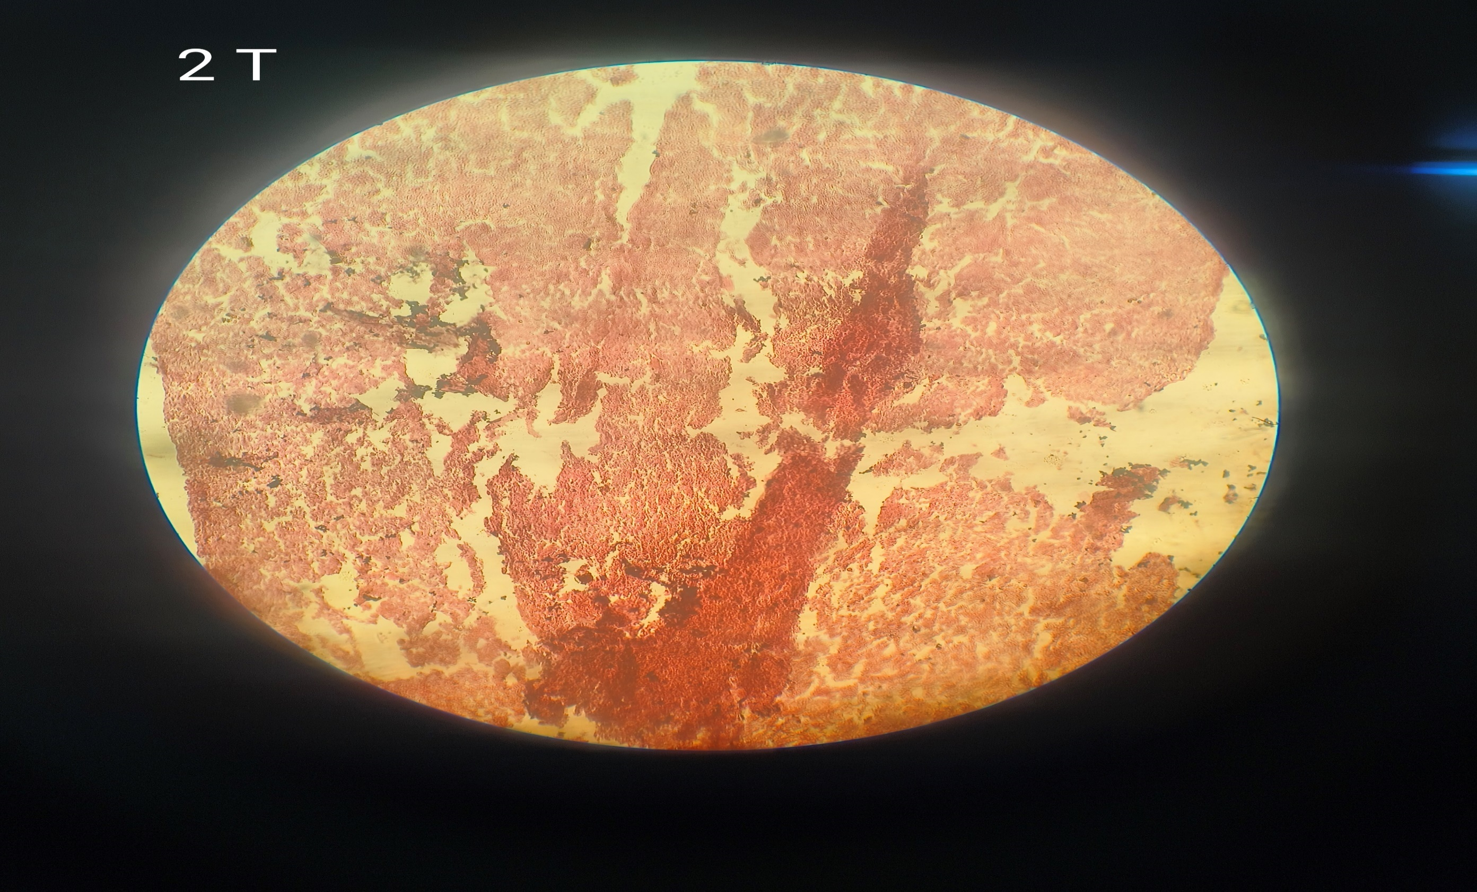
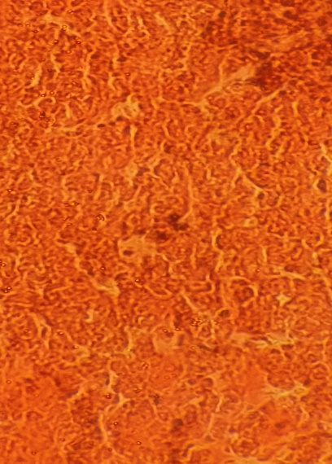
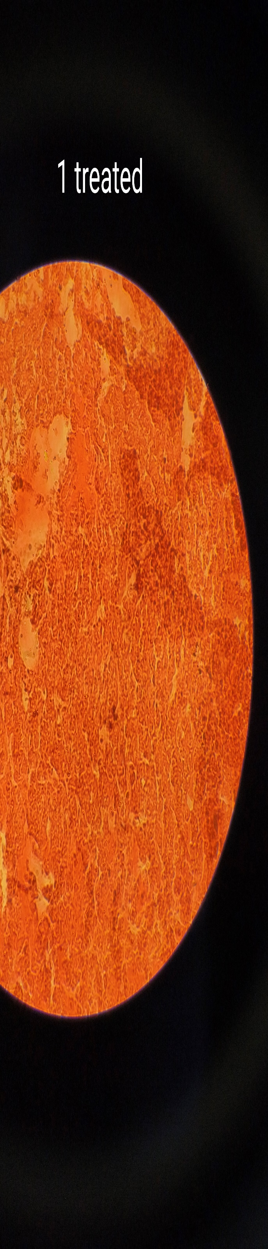
Plate 3 showing image of liver of Cirrhinus mrigala at 40X magnification
Plate 4 showing image of liver of Cirrhinus mrigala at 40X magnification
Control group of 14th days (Set I)
14th days exposure of curacron (Set III)
Plate 2 showing image of liver of Cirrhinus mrigala at 40X magnification
Plate 1 showing image of liver of Cirrhinus mrigala at 40X magnification
7 days exposure of curacron (Set II)
Control group of 7th day (Set 1)
H
H
ND
CD
CV
V
CE
N
V
S
N
CV
N
S
CV

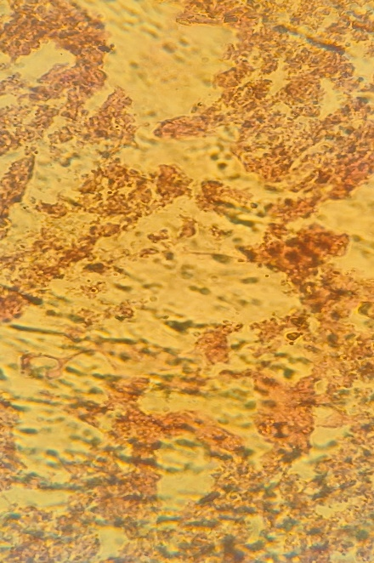
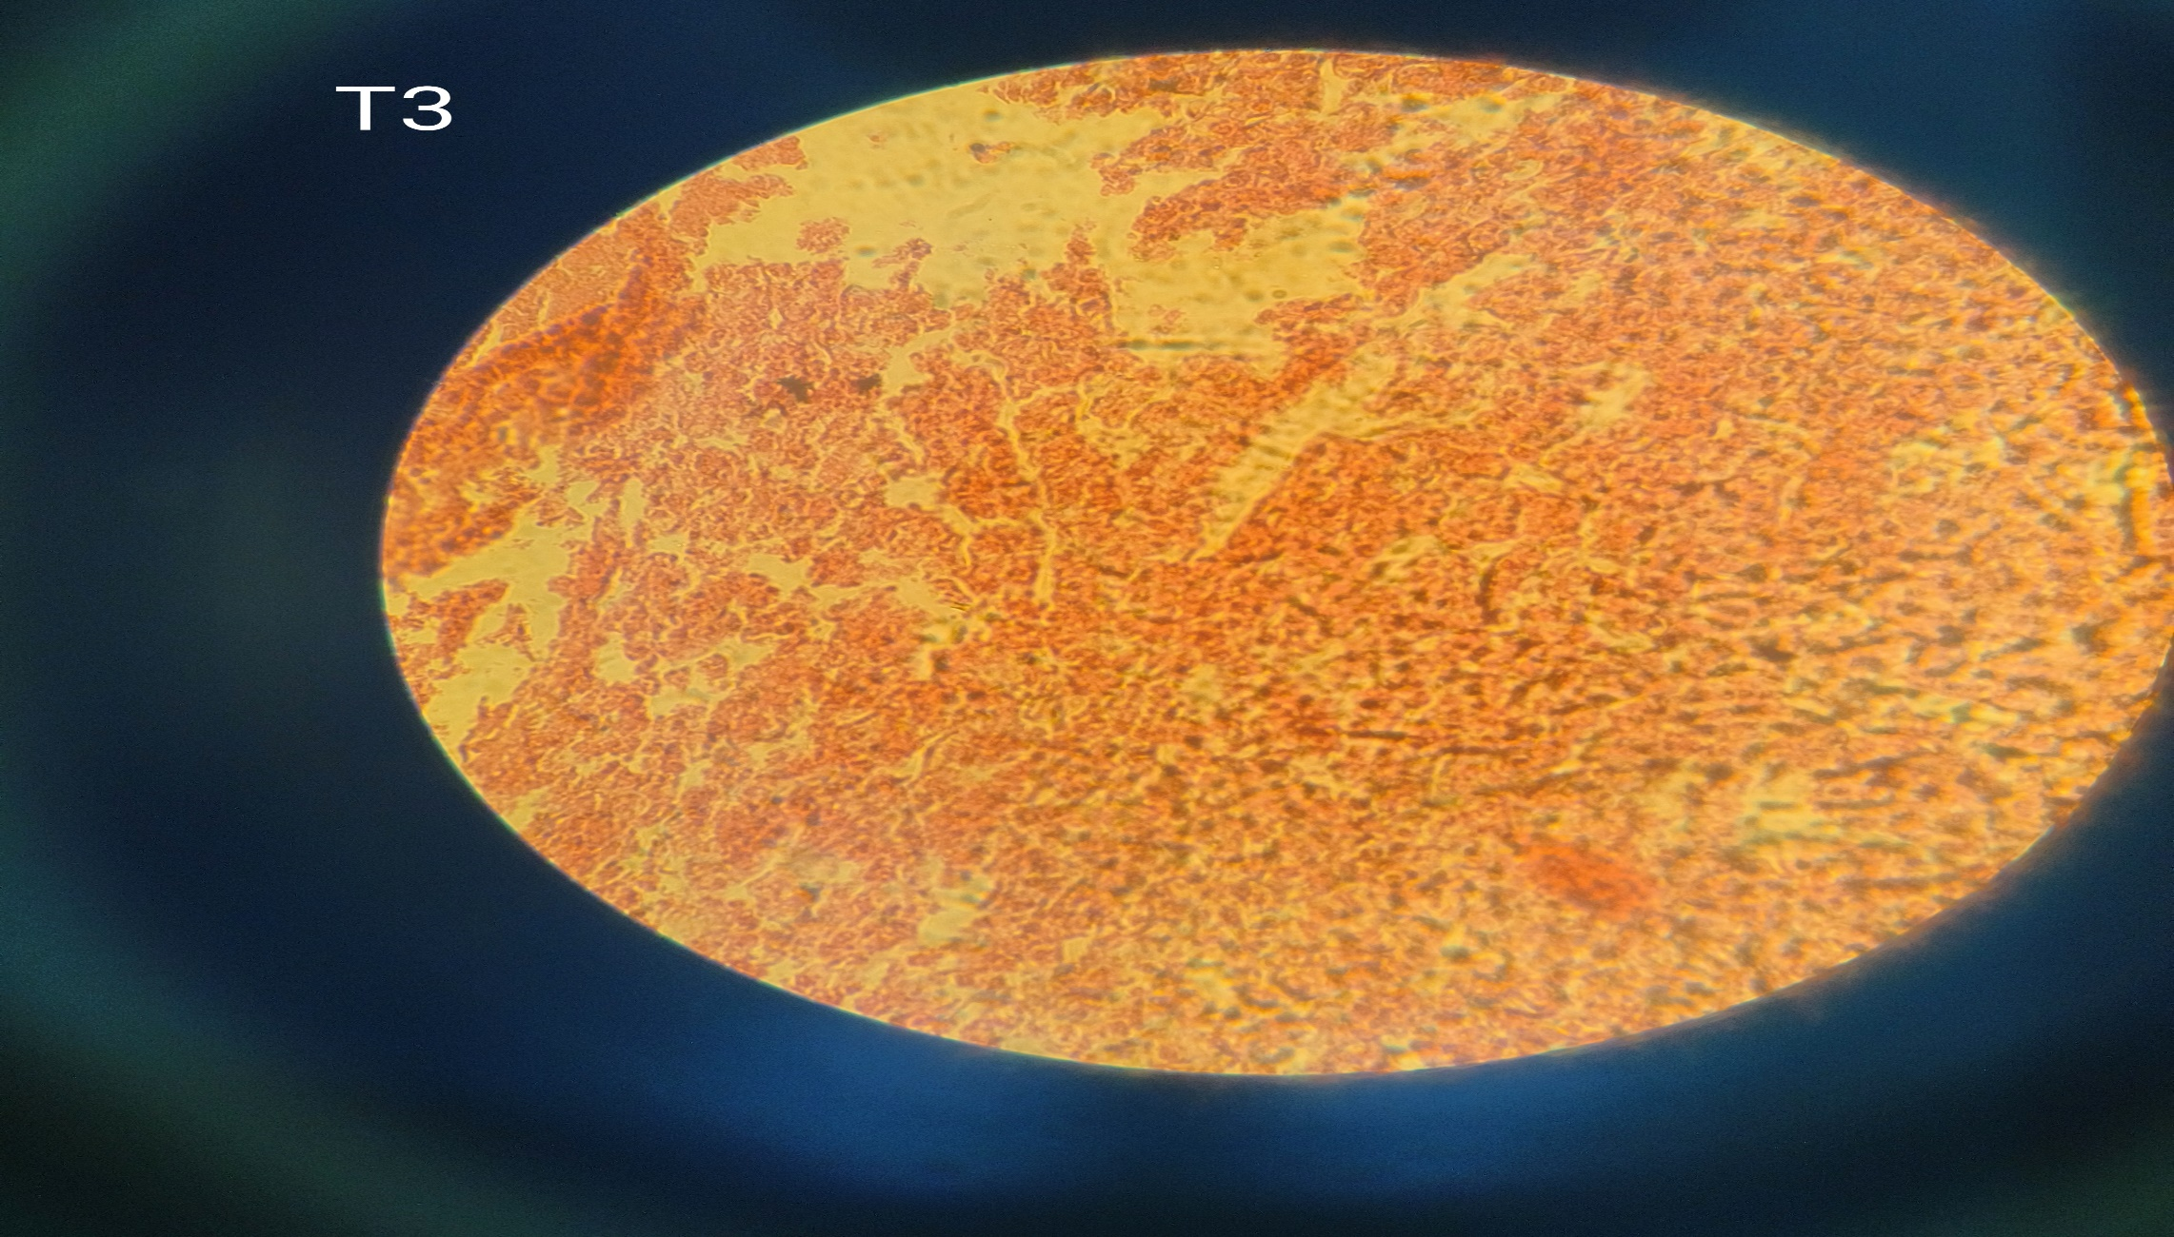
Plate 5 showing image of liver of Cirrhinus mrigala at 40X magnification
Plate 6 showing image of liver of Cirrhinus mrigala at 40X magnification
21 days exposure of curacron (Set IV)
NDD
CD
ISS
AH
ACV
V
S
N
CV
H
V
CD
ISS
DCV
ND
N
S
CV
Control group
Control group of 21st days (Set I)
H

Plate 7 showing image of liver of Cirrhinus mrigala at 40X magnification
Control group of 28th days (Set I)
Fig 3: Histology of the liver Cirrhinus mrigala Control and treated group of 7, 14, 21, and 28 days
Plate 8 showing image of liver of Cirrhinus mrigala at 40X magnification
28 days exposure of curacron (Set V)

